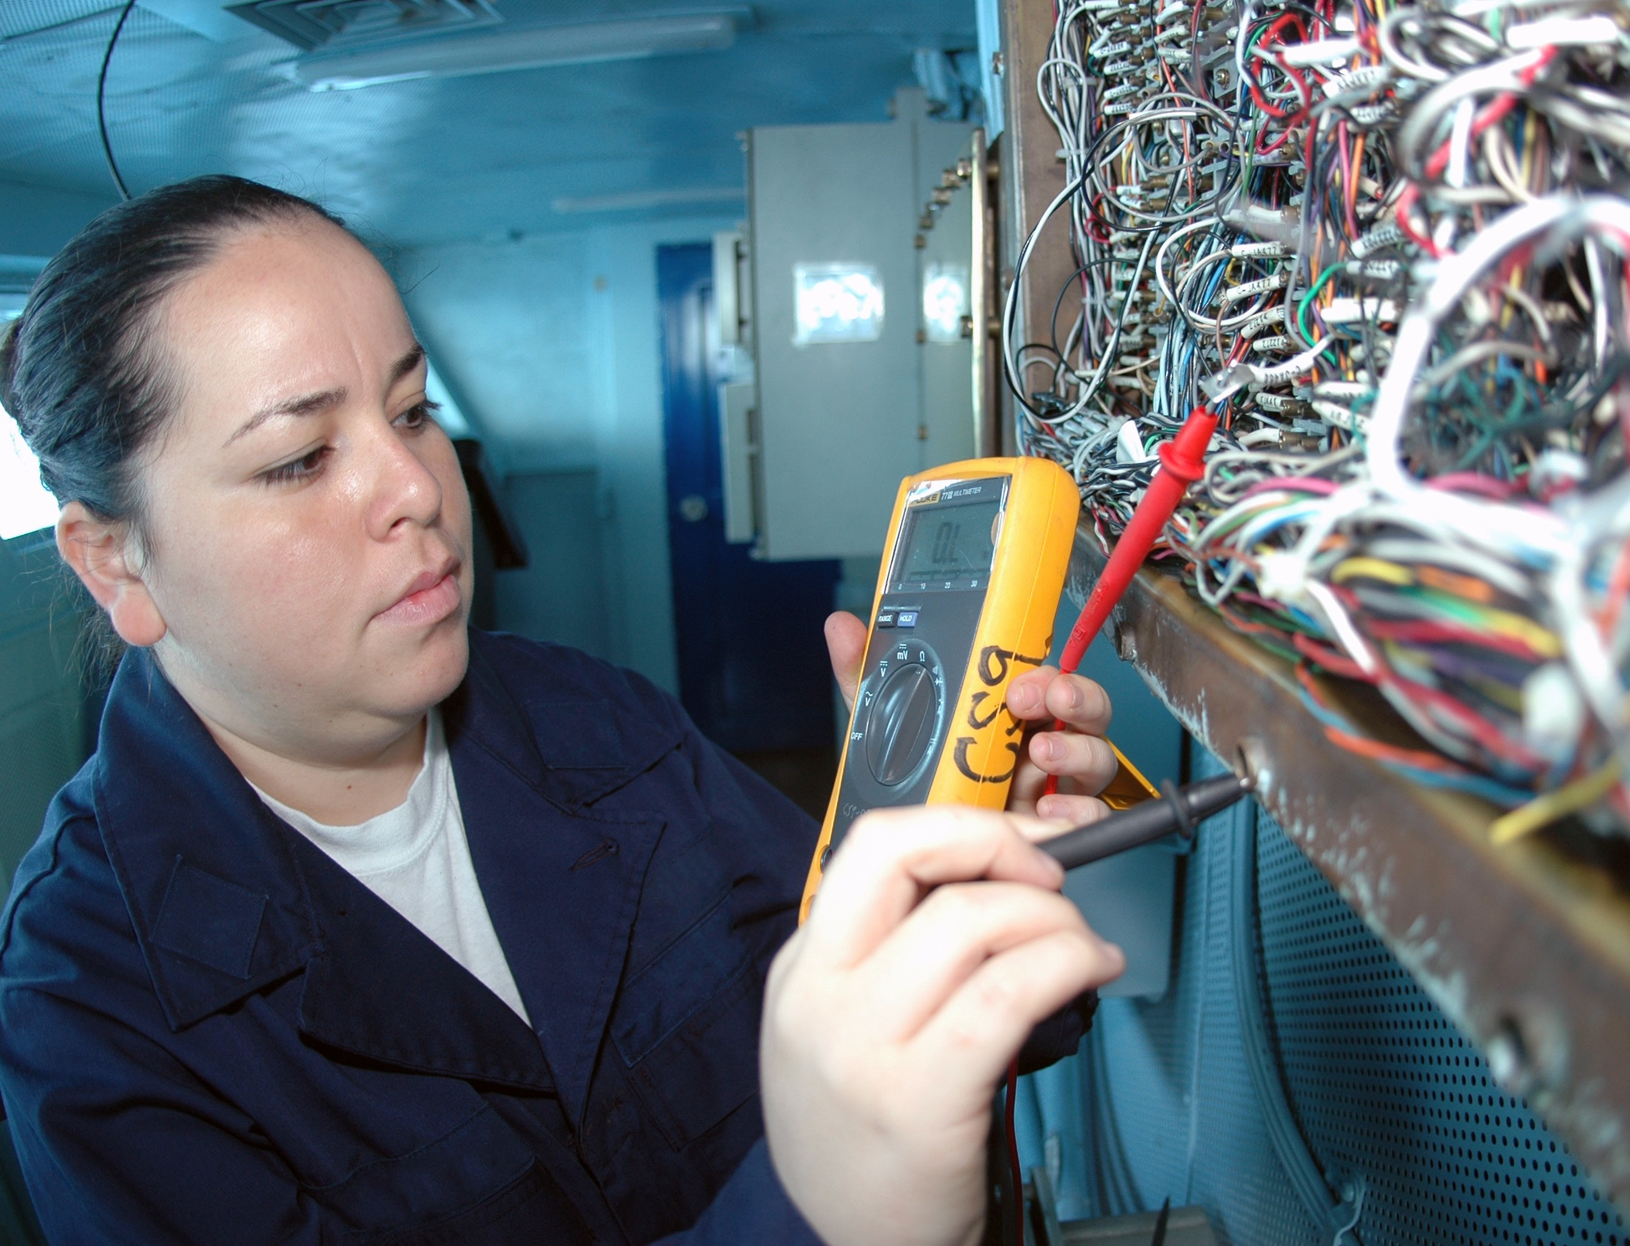

Trades Access Common Core
Line E: Electrical Fundamentals
Competency E-4: Use Multimeters
Image to be placed here.

B.C. Open Textbook Project
OpenEd
open.bccampus.ca

Trades Access
COMMON CORE
Line E: Electrical Fundamentals Competency E-4: Use Multimeters

Acknowledgments and Copyright
To learn more about BCcampus Open Education, visit http://open.bccampus.ca
© 2015 Camosun College
The Trades Access Common Core resources are licensed under the Creative Commons Attribution 4.0 Unported Licence, except where otherwise noted. Under this licence, any user of this textbook or the textbook contents herein must provide proper attribution as follows:
- Trades Access Common Core Competency E-4: Use Multimeters by Camosun College is used under a Creative Commons Attribution 4.0 Licence.
- If you redistribute all or part of this book, it is recommended the following statement be added to the copyright page so readers can access the original book at no cost: Download for free from the B.C. Open Textbook Collection (https://open.bccampus.ca/browse-our-collection/find-open-textbooks/).
- If you use this textbook as a bibliographic reference, then you should cite it as follows: Camosun College. (2015). Trades Access Common Core Competency E-4: Use Multimeters. Victoria, B.C.: Crown Publications.
All images copyright BC Industry Training Authority are licensed under the Creative Commons Attribution-NonCommercial-ShareAlike 4.0 licence.
The issuing/publishing body is Crown Publications, Queen’s Printer, Ministry of Technology, Innovation and Citizens’ Services.
BCcampus would like to acknowledge the following individuals and organizations for their contributions in producing the Trades Access Common Core Open Textbook resources.

BCcampus
Open Education Team Hilda Anggraeni, Graphics

Camosun College
Olaf Nielsen, Chair, Trades Development and Special Projects, School of Trades and Technology Nannette Plant, Manager, Enterprise Point Operations & Special Projects, Office of the VP Strategic Development
Rod Lidstone, Instructor, Plumbing and Pipe Trades, Lead Writer/Reviewer Brian Coey, Instructor, Sheet Metal and Metal Fabrication, Writer/Reviewer Matt Zeleny, Camosun Innovates, 3D imaging

Open School BC
Monique Brewer, Director
Adrian Hill, Instructional Designer
Dennis Evans, Image Coordinator, Photographer, Graphics, Production Technician (layout) Farrah Patterson, Production Technician

Industry Training Authority of BC
The ITA works with employers, employees, industry, labour, training providers, and government to issue credentials, manage apprenticeships, set program standards, and increase opportunities in approximately 100 BC trades. Among its many functions are oversight of the development of training resources that align with program standards, outlines, and learning objectives, and authorizing permission to utilize these resources (text and images).
Erin Johnston, Director of Training Delivery Cory Williams, Manager, Industry Relations

Publishing Services, Queen’s Printer
Spencer Tickner, Director of QP Publishing Services Dwayne Gordon, Manager, Electronic Publishing
October 2015, Version 1
To order print copies of any of the Trades Access Common Core resources, please contact us:
Crown Publications, Queen’s Printer PO Box 9452 Stn Prov Govt
563 Superior St, 3rd Floor Victoria, BC V8W 9V7 Phone: 250-387-6409
Toll Free: 1-800-663-6105
Fax: 250-387-1120
crownpub@gov.bc.ca www.crownpub.bc.ca

Intellectual Property Program
Ilona Ugro, Copyright Officer, Ministry of Technology, Innovation and Citizens’ Services, Province of British Columbia

Creative Commons Attributions
Cover photo:
US Navy 091004-N-8960W-014 Interior Communications Electrician 3rd Class Karla Martinez inspects wiring aboard the aircraft carrier USS Nimitz (CVN 68): U.S. Navy photo by Mass Communication Specialist Seaman Apprentice Robert Winn is in the public domain.

Foreword
The BC Open Textbook Project began in 2012 with the goal of making post-secondary education in British Columbia more accessible by reducing student cost through the use of openly licensed textbooks. The
BC Open Textbook Project is administered by BCcampus and is funded by the British Columbia Ministry of Advanced Education.
Open textbooks are open educational resources (OER); they are instructional resources created and shared in ways so that more people have access to them. This is a different model than traditionally copyrighted materials. OER are defined as teaching, learning, and research resources that reside in the public domain or have been released under an intellectual property licence that permits their free use and repurposing by others (Hewlett Foundation). Our open textbooks are openly licensed using a Creative Commons licence, and are offered in various e-book formats free of charge, or as printed books that are available at cost. For more information about this project, please contact opentext@bccampus.ca. If you are an instructor who is using this book for a course, please let us know.

Preface
The concept of identifying and creating resources for skills that are common to many trades has a long history in the Province of British Columbia. This collection of Trades Access Common Core (TACC) resources was adapted from the 15 Trades Common Core line modules co-published by the Industry
Training and Apprenticeship Commission (ITAC) and the Centre for Curriculum Transfer and Technology (C2T2) in 2000-2002. Those modules were revisions of the original Common Core portion of the TRAC modules prepared by the Province of British Columbia Ministry of Post-Secondary Education in 1986. The TACC resources are still in use by a number of trades programs today and, with the permission from the Industry Training Authority (ITA), have been utilized in this project.
These open resources have been updated and realigned to match many of the line and competency titles found in the Province of BC’s trades apprenticeship program outlines. A review was carried out to analyze the provincial program outlines of a number of trades, with the intent of finding common entry-
level learning tasks that could be assembled into this package. This analysis provided the template for the outline used to update the existing modules. Many images found in ITA apprentice training modules were also incorporated into these resources to create books that are similar to what students will see when they continue their chosen trades training. The project team has also taken many new photographs for this project, which are available for use in other trades training resources.
The following list of lines and competencies was generated with the goal of creating an entry-level trades training resource, while still offering the flexibility for lines to be used as stand-alone books. This
flexibility—in addition to the textbook content being openly licensed—allows these resources to be used within other contexts as well. For example, instructors or institutions may incorporate these resources into foundation-level trades training programming or within an online learning management system (LMS).
Line A – Safe Work Practices
- A-1 Control Workplace Hazards
- A-2 Describe WorkSafeBC Regulations
- A-3 Handle Hazardous Materials Safely
- A-4 Describe Personal Safety Practices
- A-5 Describe Fire Safety
Line B – Employability Skills
- B-1 Apply Study and Learning Skills
- B-2 Describe Expectations and Responsibilities of Employers and Employees
- B-3 Use Interpersonal Communication Skills
- B-4 Describe the Apprenticeship System

Line C – Tools and Equipment
- C-1 Describe Common Hand Tools and Their Uses
- C-2 Describe Common Power Tools and Their Uses
- C-3 Describe Rigging and Hoisting Equipment
- C-4 Describe Ladders and Platforms
Line D – Organizational Skills
- D-1 Solve Trades Mathematical Problems
- D-2 Apply Science Concepts to Trades Applications
- D-3 Read Drawings and Specifications
- D-4 Use Codes, Regulations, and Standards
- D-5 Use Manufacturer and Supplier Documentation
- D-6 Plan Projects
Line E – Electrical Fundamentals
- E-1 Describe the Basic Principles of Electricity
- E-2 Identify Common Circuit Components and Their Symbols
- E-3 Explain Wiring Connections
- E-4 Use Multimeters
All of these textbooks are available in a variety of formats in addition to print:
- PDF—printable document with TOC and hyperlinks intact
- HTML—basic export of an HTML file and its assets, suitable for use in learning management systems
- Reflowable EPUB—format that is suitable for all screen sizes including phones
All of the self-test questions are also available from BCcampus as separate data, if instructors would like to use the questions for online quizzes or competency testing.

About This Book
In an effort to make this book a flexible resource for trainers and learners, the following features are included:
- An introduction outlining the high-level goal of the Competency, and a list of objectives reflecting the skills and knowledge a person would need to achieve to fulfill this goal.
- Discrete Learning Tasks designed to help a person achieve these objectives
- Self-tests at the end of each Learning Task, designed to informally test for understanding.
- A reminder at the end of each Competency to complete a Competency test. Individual trainers are expected to determine the requirements for this test, as required.
- Throughout the textbook, there may also be links and/or references to other resources that learners will need to access, some of which are only available online.
- Notes, cautions, and warnings are identified by special symbols. A list of those symbols is provided below.

Symbols Legend
Important: This icon highlights important information.

Poisonous: This icon is a reminder for a potentially toxic/poisonous situation.

Resources: The resource icon highlights any required or optional resources.

Flammable: This icon is a reminder for a potentially flammable situation.

Self-test: This icon reminds you to complete a self-test.

Explosive: This icon is a reminder for a possibly explosive situation.

Safety gear: The safety gear icon is an important reminder to use protective equipment.

Electric shock: This icon is a reminder for potential electric shock.

Safety Advisory
Be advised that references to the Workers’ Compensation Board of British Columbia safety regulations contained within these materials do not/may not reflect the most recent Occupational Health and Safety Regulation. The current Standards and Regulation in BC can be obtained at the following website: http:// www.worksafebc.com.
Please note that it is always the responsibility of any person using these materials to inform him/herself about the Occupational Health and Safety Regulation pertaining to his/her area of work.
BCcampus January 2015

Disclaimer
The materials in the Trades Access Common Core Open Textbook project are for use by students and instructional staff and have been compiled from sources believed to be reliable and to represent best current opinions on these subjects. These manuals are intended to serve as a starting point for good practices and may not specify all minimum legal standards. No warranty, guarantee or representation is made by BCcampus as to the accuracy or sufficiency of the information contained in these publications. These manuals are intended to provide basic guidelines for trade practices. Do not assume, therefore, that all necessary warnings and safety precautionary measures are contained in this module and that other or additional measures may not be required.

Contents
Introduction 8
Objectives 8
Learning Task 1: Describe the use and storage of meters 9
Meter safety precautions 9
Digital multimeters 10
Introduction to voltage measurements 11
Introduction to current measurements 13
Introduction to resistance measurements 15
Self-Test 1 18
Learning Task 2: Use meters to analyze simple circuits 21
Safety 21
Troubleshooting principles 22
Polarity in a parallel circuit 28
Self-Test 2 30
Answer Key 32

Introduction
Whether you choose to work in an electrical trade, a mechanical trade, or one of the construction trades, you will probably be faced with using and/or maintaining a variety of electrical measuring instruments.

This Competency will introduce you to three basic meters for measuring voltage, current, and resistance. You must have a basic understanding of the purpose and operation of each type of meter before you attempt to use one. If you connect a meter incorrectly, you not only risk
damaging the instrument, but more importantly, you or some innocent bystander could receive a serious electrical shock.

Objectives
When you have completed the Learning Tasks in this Competency, you will be able to:
  - describe the proper handling, use, and storage of electric meters
  - describe the procedures for connecting meters to measure voltage, current, and resistance
  - describe how to use meters to analyze electric circuits

LEARNING TASK 1
Describe the use and storage of meters
A technician is only as accurate as the measurement equipment being used. If the equipment is used incorrectly or is faulty, then the measurements will be inaccurate. If the measurements
are inaccurate, then the technician will draw the wrong conclusions. To avoid getting inaccurate readings, you need to handle, use, and store meters properly.

The two major types of meters are digital and analog (Figure 1). Although both meters perform the same functions, they look different. As you can see, the difference is in the display unit.
Digital meters are usually simpler to use and are more accurate than analog meters, and therefore have become more popular. We will focus on the digital multimeter (DMM), as it is the most common type in use, although analog multimeters may still be preferable in some cases, for example when monitoring a rapidly varying value.
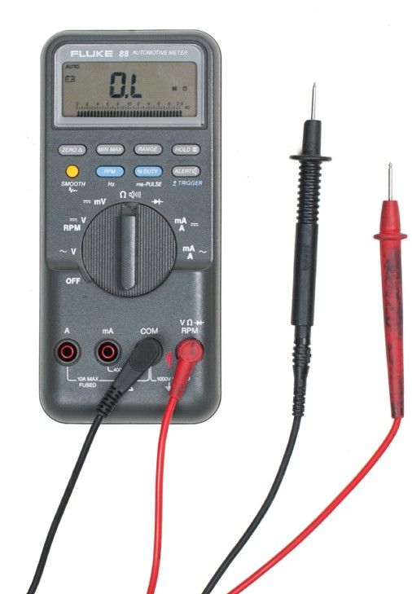
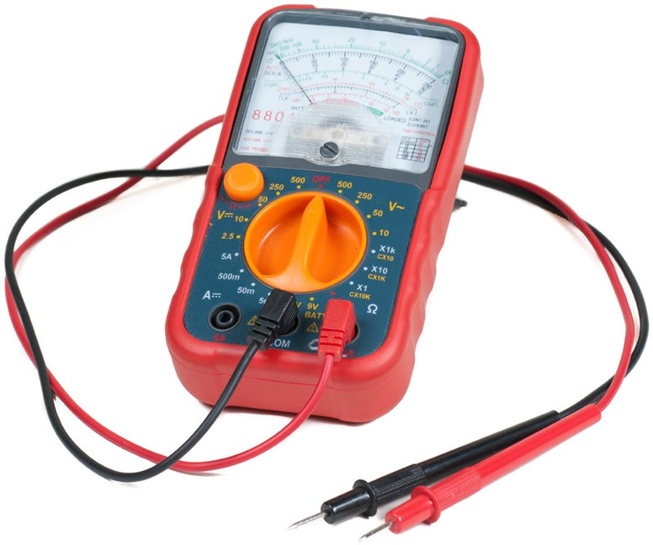
Figure 1 — Digital and analog multimeters

Meter safety precautions
The proper care of test equipment and instruments is of utmost importance, whether they are analog or digital. The length of time an instrument retains its original usefulness and accuracy depends largely on the care it receives in the hands of the user.
Improper connection can cause damage to the circuit or the test instrument, or cause personal injury.

Precautions in handling and using a meter
These precautions apply equally to digital and analog meters.
  - Do not drop any meter.
  - Do not overload any meter. When in doubt, use a high range that you know will not be overloaded. You can always switch to a lower range if necessary.
  - Do not tamper with precision instruments. Let a competent instrument repair person service precision instruments.
  - Before you connect a meter to a circuit, ensure that the range switch is set to an appropriate position.
  - Carefully check circuit connections before applying power to meters.
  - Be careful not to touch any other electronic components within the equipment.
  - Be careful not to touch the probe tips to each other while connected to anything else.

Digital multimeters
All digital multimeters combine the features of an ammeter, a voltmeter, and an ohmmeter. Figure 2 shows a typical DMM, although different models may have a different number of digits in the display unit and the input/output jacks may be in slightly different places. Since a DMM is an important tool, you will want to learn how to use one correctly.

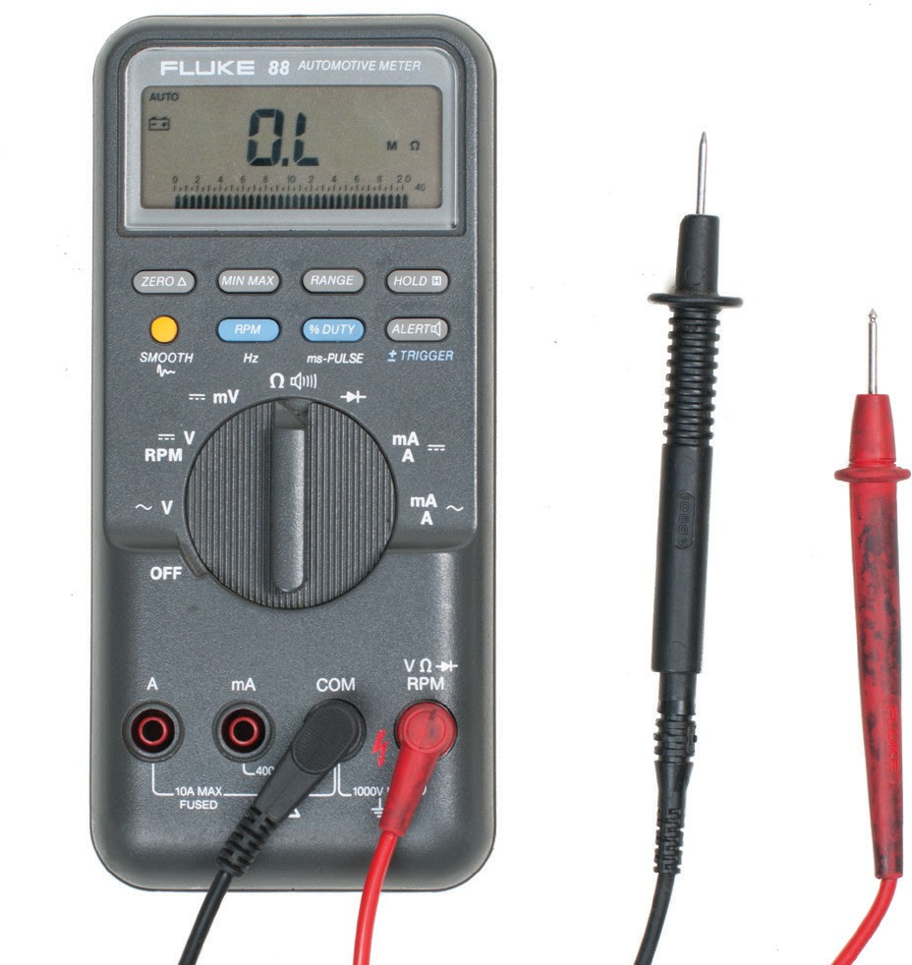Digital display
Probe leads

Function dial

Input jacks

Figure 2 — Typical DMM

The upper portion of the DMM houses the display unit. The middle portion of the DMM houses the function switch, and the bottom portion contains the jacks for test leads.

The function switch normally has positions that will allow a technician to measure AC volts, DC volts, DC amps, and resistance. In addition, some DMMs have function switch positions that will allow a technician to measure AC amps and to test diodes and capacitors. Some DMMs require manual setting of ranges; others have an autoranging feature.

All DMMs may be used to measure voltage, current, and resistance. More advanced DMMs may measure frequency, relative power differences, or other important circuit parameters. Each measurement function has similarities and differences that you need to learn about.

Many meters will use symbols on the display, switch, and connections. Figure 3 lists some of the common symbols you may see.

AC DC
0 Ohms AC or DC
Hz Hertz
+ Positive
– Negative
µF MicroFarad m Milli
M Mega
Low battery
Manual range or automatic touch hold Continuity beeper
– +
Diode
Ground Fuse
Double insulation ( Capacitor
OL Overload

Figure 3 — Common DMM symbols

Introduction to voltage measurements
Voltage measurements are very easy to make with a DMM. On meters with manual range selection, start with a value one setting higher than expected. An autorange DMM will automatically select the range based on the voltage present. Figure 4 shows the process.

Note:

1 V=1 mV
1000
1000 V=1 kV

1. Select the appropriate voltage setting.
4. View the reading and note the
unit of measurement.

MIN MAX PEAK RANGE HOLD

m~A
0 mA

~
V A
~V A

- Plug the black test lead
into the common input jack.

A COM V 0
- Touch the probe tips to the circuit across a
load or power source in parallel with the circuit.

AC

Figure 4 — Using a DMM to measure voltage

Follow these steps to measure voltage:
- Select the DC or AC volts function by turning the function switch to DC or AC volts.
- Plug the test probes into the appropriate probe jacks.
- Connect the tips of the probes across the source or load.
- View the reading on the display unit. Be sure to note the unit of measurement. If you are testing DC voltage and a negative sign appears in the display, the polarity of your probes is incorrect and needs to be reversed.
Use the one-hand technique. Attach test leads one at a time using only one hand. Put your other hand in a pocket or behind your back. Whatever you choose to do with your other hand, keep it well away from a live circuit or associated equipment. Avoid holding test leads in both hands. The one-hand technique decreases the possibility of a dangerous electrical shock by reducing the chance of current flowing through your body across your chest.
Autoranging units display the unit of measurement in the top right corner (annunciator). In manual ranging units, the meter will use the range selected. Autorange will determine the highest setting and automatically display that unit.

Introduction to current measurements
As you have seen, the placement of meter leads for voltage measurements is straightforward. The leads are simply connected across, or in parallel with, the points of voltage to be measured.

For current measurements, however, the process is slightly more complex. First, the circuit must be opened at the test points and the meter inserted in series at that opening (Figure 5). The total current must flow through the meter. To allow the measurement to be made without disturbing the circuit itself, the current meter must have very little internal resistance.

This is where the beginner must be particularly alert. If the meter is inadvertently connected across a P.D. (potential difference) or in parallel with a component instead of in series, the small internal resistance will permit a very large current to flow through the meter. This will most certainly damage the meter severely and perhaps the circuit as well.
With current measurements, shutting off the power before connecting the meter is essential. You will be disconnecting one end of a wire or component in order to connect the meter in series. If you leave the power on, you could easily receive a dangerous shock or do damage to the circuit.
On meters with manual range selection, start with the highest current setting and work your way down.

MIN MAX PEAK RANGE HOLD

m~A
7. View the reading and note the unit of measurement. If the test leads are reversed the reading will show a (–) sign.

0
3. Select the appropriate V
current setting. ~V
mA

~
A 4. Plug the black test lead
into the common input jack. Plug the red or yellow lead in
A
the correct current input jack.

5. Connect the probe tips to the circuit across the break so that the meter is in series.

A COM V 0

1. Turn off power to the circuit.

- Turn on the power to the circuit.

AC 2. Cut or unsolder the circuit to create a place where the meter probes can be attached.
Figure 5 — Using a DMM to measure current

Current measurement procedures
Follow the steps below to measure current:
  - Turn off the power to the circuit that will be measured.
  - Open the circuit by disconnecting or unsoldering a connection at a point where you wish to measure current.
  - Select the DC or AC amps function by turning the function switch to DC or AC amps.
  - Plug the test probes into the appropriate probe jacks. Note that the jacks used may not be the same ones used to measure volts.
  - Connect the tips of the probes across the break in the circuit as shown in Figure 6 so that the current to be measured flows through the meter. Note that this is a series connection. Never connect the ammeter in parallel with the source or load, as this will cause a short circuit and damage the meter.
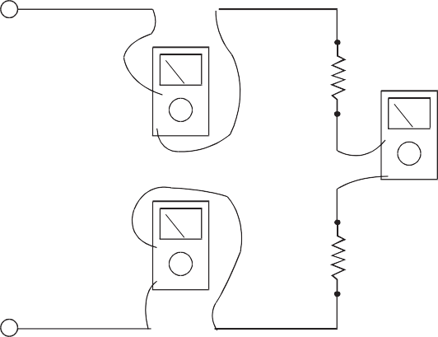
Figure 6 — Ammeter connections to measure the same current at different points in a circuit

  - Turn the circuit power back on.
  - View the reading on the display unit. Be sure to note the unit of measurement.
  - Switch power off and disconnect meter leads from the circuit.
  - If testing is finished at this test point, restore the circuit by reclosing the connection. When current measurements are complete, turn the function switch to the OFF position and remove the test leads.
Some types of DMMs have a clamp-on ammeter or tong tester. These ammeters have two spring- loaded expandable jaws that allow you to clamp around a single conductor (Figure 7). This feature allows you to measure the magnetic field created by the current flowing through the wire to give an ampere reading without having to make physical contact or disconnect the circuit.

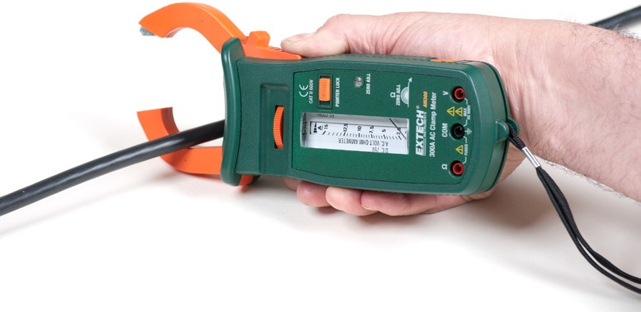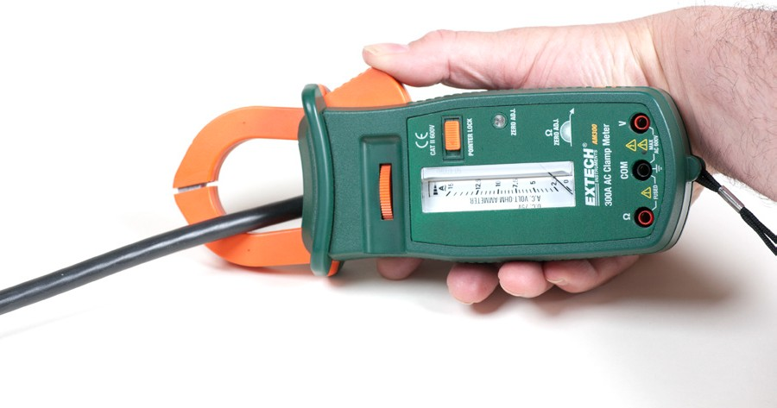
Figure 7 — Using clamp-on ammeter

Introduction to resistance measurements
You have studied voltage and current measurements, but you will find resistance measurements different in several ways. Resistance is measured with the circuit’s power turned off. The ohmmeter sends its own current through the unknown resistance and then measures that current to provide a resistance value readout.

Role of the battery
Even though it reads out resistance, the ohmmeter is still a current-measuring device at heart. The ohmmeter is created from a DC current meter by the addition of a group of resistors (called multiplier resistors) and an internal battery. The battery supplies the current flow that is eventually measured by the meter. For this reason, use an ohmmeter only on dead circuits.

In the process of measuring resistance, the test leads are inserted in the meter jacks. The leads are then attached to the ends of whatever resistance is to be measured. Since current can flow either way through a pure resistance, there is no polarity requirement for attaching the meter leads. The meter’s battery sends a current flow through the unknown resistance, the meter’s internal resistors, and the current meter.

The ohmmeter is designed so that it will display 0 Ω when the test leads are clipped together (zero external resistance). The meter reads infinite (I) resistance or over limit (OL) resistance when the leads are left open. When a resistance is placed between the leads, the readout increases according to how much current that resistance allows to flow.

To conserve its battery, an ohmmeter should never be left on the ohms function when not in use. Since the current available from the meter depends on the state of charge of the battery, the DMM should be zero adjusted to start. This may require no more than a test of touching the two probes together.

Figure 8 shows how resistance measurements are taken. Note:
1000 Ω = 1 kΩ
1 000 000 Ω = 1 MΩ

5. View the reading and
note the unit of measurement, ohms, kilohms, or megohms.

3. Select the resistance setting.
MIN MAX PEAK RANGE HOLD

m~A

0 mA
2. Plug the black test lead V ~
~
A
into the common input
jack. Plug the red or yellow V A
lead into the resistance

input jack.

A COM V 0

- Touch the probe tips across the component or portion of the circuit.

  - Turn off power to the circuit.
Figure 8 — Using a DMM to measure resistance

Resistance measurement procedures
Follow the steps below to measure resistance:
- Turn off the power to the circuit. Remove or isolate the component to be tested.
- Plug the test probes into the appropriate probe jacks. Note that the jacks used may be the same ones used to measure volts.
- Select the ohms function by turning the function switch to ohms. Start with the lowest setting.
- Touch the probes together to check the leads, connections and battery life. The meter should display zero or a very small amount of resistance for the test leads. With the leads apart, the meter should display OL or I, depending on the manufacturer.
- Connect the tips of the probes across the break in the component or portion of the circuit for which you want to determine resistance. If you get an OL (over limit), move to the next level.
- View the reading on the display unit. Be sure to note the unit of measurement.
- After all the resistance readings are complete, turn the DMM off to prevent the battery from draining

To measure the resistance of components in a circuit, disconnect all but one load. This prevents loss of correct orientation when reconnecting.

You can use the same connection procedure to verify that a circuit, wire, fuse, or switch is complete with no open. This is called a continuity test, and most DMMs will have an audible continuity setting ( ). If there is no audible alarm, then the circuit is broken or there is too much resistance. A good example is testing a heating element when the element is burned out.

Now complete the Learning Task Self-Test.

Self-Test 1
- What are multimeters used to test, in addition to amperage and voltage?
  - Pressure
  - Humidity
  - Resistance
  - Temperature

- Analog meters are more popular than digital.
  - True
  - False

- How many volts are in 2200 mV? a. 0.22 V
- 2.2 V
- 22 V
- 220 V

- It is important to turn the circuit off before checking voltage.
  - True
  - False

- What would happen if you connected the probes backwards when checking voltage?
  - Damage to the DDM would occur.
  - Damage to the circuit would occur.
  - A negative voltage would be read.
  - It doesn’t matter which way they go.

- What is one important safety technique when testing electrical circuits?
  - Wearing gloves
  - Wearing safety glasses
  - Using the one-hand technique
  - Using the two-hand technique

- The first step when using an autorange DDM is to select the range required.
  - True
  - False

- A circuit must be broken to test current.
  - True
  - False

- Is an amperage test done in series or parallel?
  - Series
  - Parallel

- When is it important to turn off a DDM to extend battery life?
  - After checking voltage
  - After checking amperage
  - After checking resistance
  - Never; it turns off automatically

- When the probes are touched together in a resistance test, what should the meter read?
  - 0
  - Infinity
  - OL
  - Nothing

- How many ohms are in 2.125 kΩ? a. 21.25 Ω
b. 212.5 Ω
c. 2125 Ω
d. 21 250 Ω

- What is the name of the test used when testing a circuit for an open?
  - Infinity test
  - Overload test
  - Continuity test
  - This test cannot be done.

LEARNING TASK 2
Use meters to analyze simple circuits
The trick to effective troubleshooting electrical equipment and circuits is to zero in as quickly as possible on the problem. Using an electric meter will allow you to effectively test the components that are most likely to be the cause of the problem before you unnecessarily dismantle the equipment and replace parts.

Safety
Even though you may normally deal with small voltages and currents, the values are never far away from lethal levels. You can receive a shock or burn from any common electrical circuit. The severity of the electrical shock depends on a number of factors:
- the amount of current that passes through the body
- the path that the current takes through the body
- type of voltage—AC or DC
- voltage strength
- the length of time that the current flows within the body
- condition of the skin and the body’s chemical makeup
- area of contact
Normal household current (plugs and light circuits) is generally limited by a circuit breaker to a value of 15 amperes. This device has been designed to trip and open a circuit if the 15 ampere value is exceeded, and it is designed to protect against property damage. It is possible to cause a fatal injury with a current flow of only 50 milliamperes (mA) or five one-hundredths of an ampere. The body is sensitive to relatively small values of current. In comparison, a 100 watt lightbulb draws approximately 0.85 ampere (850 mA) of current when connected to a 120 volt source. Remember, there are 15 amperes available in each standard house circuit.

Electrical shocks, electric burns, and other related injuries occur far too often and in most cases go unrecorded. If an accident happens:
- Don’t touch the person and don’t use a conductive tool to free the person that may be electrically energized.
- Shut off the power or pull the plug if it is safe to do so. If you are not able to, get help.
- Remove the person from the contact point using a non-conductive object such as a dry piece of wood or a leather belt.

- Call 911 for help if the person is obviously injured (loss of consciousness, significant trauma, etc.)
- Seek medical attention (first aid) in any case of injury such as an altered mental state (confusion, slow/slurred speech) or other obvious injury (laceration, burn, etc.).
When performing maintenance or doing repair work, or when a machine is in an unsafe state, it is vital to eliminate the possibility of the machine being energized unexpectedly. In order to create a safe work environment, workers need to guard against contact with electrical voltages and control electrical currents.

Make the environment safer by doing the following:
- Protect portable electrical equipment with an approved ground-fault circuit interrupter (GFI) when using the equipment outdoors.
- Ensure all the cords are in good condition, with the caps and plugs well secured on the cables. Ensure the proper U-ground plug is in good working condition.
- Use cords of sufficient gauge for the amount of current used by the tools they are powering. Each tool is labelled with the power that it draws.
- Treat all conductors and bare wires—even apparently de-energized ones—as if they are energized until they are locked out and tagged.
- Do not make any electrical measurements without specific instructions from a qualified person.
- When servicing equipment be sure it is “locked out,” meaning the electrical service is shut off at a disconnect panel whenever possible, the panel is locked, and the only key is kept by the person working on the equipment.
- When replacing components on mobile equipment, disconnect the battery.

Troubleshooting principles
There are really only two rules for troubleshooting using a voltmeter. They are simple and always true:
- If you measure a voltage across a switch, the switch is open.
- If you measure a correct voltage across a load and the load doesn’t work, the load has failed.
With digital meters, voltage readings that are considered as zero will often indicate very small voltage readings. For example, when reading across a closed switch, a very small reading could indicate a very slight resistance across the switch contacts or even a meter inaccuracy.

Notice that the first rule does not say that if you read zero volts across a switch, the switch is closed. There are many situations in which you might read zero volts across an open switch.

The second rule indicates that the load has failed. This only means that the problem is with the load and you don’t have to look anywhere else for the problem. The actual remedy still has to be determined. This may require a replacement of the load, but there may be other possibilities. For example, there may be an overload that needs resetting.

Always look for the easy fix first. Check components that are easily accessible first that might explain the symptom that you have observed. For example, one of the first checks is to verify the power supply.

Voltage tests
You can troubleshoot a problem using either volt or ohms tests. It is most practical to choose voltage testing. With a resistance test, you have to first disconnect the component being tested from the circuit, and while you are removing the wiring you could jostle things and possibly change the circuit, which may temporarily remedy the problem. In other words, you may not really find the problem.

When you use your voltmeter to troubleshoot, you will find either a switch that is open or a load that has failed. You can do this without moving any wires and without changing the circuit in any way. You may then remove the device and double check it with your ohmmeter.

Voltage drops in series circuits
In series circuits, the total voltage is the sum of the individual voltage drops in the circuit, and the equation E = IR is used to calculate the voltage drop across each resistor. Since the current is the same through each resistor, the voltage drop across each resistor is directly proportional to the value of resistance. In other words, the greater the value of a resistor in a series circuit, the higher the voltage drop. Consider the simple series circuit in Figure 1.
Figure 1 — Series circuit

From the values given above, you can easily calculate the voltage drop across each resistor by: E1 = I1 × R1 = 2 A × 40 Ω = 80 V
E2 = I2 × R2 = 2 A × 20 Ω = 40 V

The voltage drop of 80 V across the 40 Ω resistor is twice the voltage drop across the 20 Ω resistor.

Refer to Figure 2. If an open is introduced between resistors R1 and R2 (for example, by disconnecting a lead), current flow through the circuit is, of course, interrupted. If there is no current flow, the voltage drop across each of the resistive elements is zero (since E = I × R).

However, the potential difference of the source still exists across the open. If a voltmeter is connected across the open, the reading is the same as if it were connected directly across the terminals of the supply source.
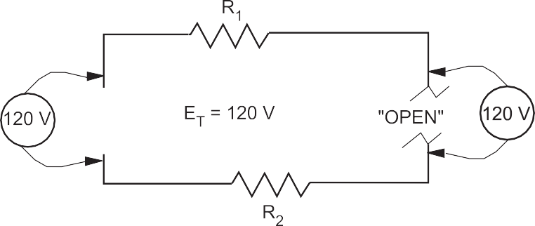
Figure 2 — Voltage across an open

In a series lighting circuit, you could easily determine which lamp was burnt open simply by measuring the voltage across the lamp-holder terminals, in succession, until you have measured the total source voltage.
Caution! Since the source voltage still exists across the open in a series circuit, this represents a shock hazard. Be careful not to touch the live parts of the circuit!

Similarly, if a switch is opened, the full-source voltage will appear across the switch contacts. Even though the voltage across the load devices may be zero, if any of those loads are ahead of the switch they will be energized with full voltage to ground.

Troubleshooting series components
Sometimes you will be required to troubleshoot a piece of equipment that has stopped working. The first thing you would check for is power. Is the breaker off? Is the switch off? Is there a general power outage?

Once you have determined that power is still available you can begin using the multimeter to locate the problem. Starting with the first component or the one easiest to check, work your way through the circuit until you reach the component that shows no voltage reading. This is known as hopscotch voltage readings. Figure 3 illustrates this process. The dashed line indicates where the probe has already been placed and removed.

1
2
3
4
MIN MAX PEAK RANGE HOLD

m~A
n
V
~V
A
mA
~
5
A
COM
A
V n
+
–G
6
Figure 3 — Hopscotch troubleshooting

Follow these steps to complete the voltage test procedures with an autorange meter:
  - Set the selector dial to the type of current to be tested: AC or DC.
  - Once you have determined that the load (shown as a lightbulb) is not working, check for voltage across the light first to verify rule #2 (i.e., if you measure a correct voltage across a load and the load doesn’t work, the load has failed.).
  - If you have voltage across the light, then the light has failed. If there are zero volts across the light, then one of the switches or wiring connections in the circuit has failed. If you have a zero reading across the light, continue with the next steps.
  - Place the black probe at a grounded component.
  - Place the red probe and check for a voltage reading at each test point in order starting at test point 1, verifying power supply.
  - Continue working your way through the circuit until you get a zero reading, which would indicate a break in the circuit just before that point.
▸ Reading at 2 = switch #1 closed, zero at 2 = switch #1 open
▸ Reading at 3 = wiring to switch #2 good, zero at 3 = wiring to switch #2 open
▸ Reading at 4 = switch #2 closed, zero at 4 = switch #2 open
▸ Reading at 5 = wiring to light good, zero at 5 = wiring to light open
▸ Reading at 6 = load is energized, zero at 6 = the load is open (although you have already
checked the load in your first test). If you get to this stage and the load is energized, the only component left that must be faulty is the final wiring from the load to ground.
  - Once the open in the circuit has been identified, you can de-energize the circuit, remove the component, and double check the component with your ohmmeter.
  - If this is the last test you are doing, turn the meter to “off” and store in a safe place.

Testing resistance (ohms) with a digital multimeter
This test, using a digital multimeter, determines whether:
  - an electrical circuit is complete or broken
  - the resistance of a component matches the manufacturer’s specification Follow these steps to complete the resistance test procedure:
  - Make sure all power is off on the circuit you are testing.
  - Make sure that the component that you are testing is isolated from the complete circuit. Either remove the component from the circuit or isolate it with an open switch.
  - Set the selector dial to Ω.
  - Connect the test lead and probes to the component terminals as shown (Figure 4).
  - Observe the readout window to obtain the Ω reading.
  - Compare the results to the manufacturer’s Ω specifications. If the readings match the component, then resistance is not a problem.
▸ If the component is a load, there should be resistance that matches the
manufacturer’s specs.
▸ If the reading is infinite (I) or overloaded (OL), then the component is open.
▸ If the reading is zero, then the component is closed (if it is a load then this is an
internal short).
  - If this is the last test you are doing, turn the meter to “off” and store it in a safe place.
MIN MAX PEAK RANGE HOLD

m~A
0 mA
V
~V
A
COM
A A
V 0
~
+
–G

Figure 4 — Ohm test of a load

There may be other circuits that are energized even though the circuit you are working on is not energized. DO NOT TOUCH THE METER PROBES TO ANY
ENERGIZED COMPONENTS WHEN TESTING FOR CONTINUITY. YOU MAY DAMAGE THE METER.

Continuity test
This is a quick audible alarm test using a digital multimeter to determine whether an electrical circuit or wire is complete or broken.

This test can be applied to a circuit as a whole or in sections—on individual components or sections of wiring. A break in continuity can be caused by mechanical damage, corrosion of components, or simply a switch being left open.

Follow these steps to complete the continuity test procedure with an autorange digital meter:
  - Make sure all power is off in the circuit you are testing.
  - Set the selector dial to Ω (audible alarm symbol).
  - Connect the test lead and probes on the load terminals as shown (Figure 5). The audible alarm will indicate continuity without a need for taking your eyes off the work.
  - Touch the probes together to check the leads, connections, and battery life. The audible alarm should sound. With the leads apart the meter should display OL or I, depending on the manufacturer.
  - If this is the last test you are doing, turn the meter to “off” and store it in a safe place.
MIN MAX PEAK RANGE HOLD

m~A
0 mA
V
~V
A
COM
A A
V 0
~
+
–G
Figure 5 — Wiring for a continuity test

Note: There may be other circuits that are energized even though the circuit you are working on is not energized. DO NOT TOUCH THE METER PROBES TO ANY ENERGIZED COMPONENTS WHEN TESTING FOR Ω (RESISTANCE). YOU MAY DAMAGE THE METER.

Polarity in a parallel circuit
Just as in series circuits, electrical current flows “from negative to positive” through each of the load components in a parallel circuit. As illustrated in Figure 6, electrons leave the negative terminal of the source and flow from negative to positive through each of the load resistors.
Note that the polarity of each of the resistors is the same as the polarity of the source.

Figure 6 — Polarity in a parallel circuit

Polarity is always expressed from one point of a circuit relative to another point with a different electrical potential. Note that in Figure 6 the top side of each resistor, which is marked negative, is in effect the same point. No difference in potential exists between any of these like terminals.

Also notice that the individual currents through each resistor (I1, I2, I3) together constitute the total current (IT) drawn from the source. When the total current required to operate each of these parallel loads exceeds the current output rating of the one source, you will need to increase the source output.

Polarity test for parallel voltage sources
Voltage sources are connected in parallel whenever it is necessary to deliver a current output greater than the current output a single source of supply can provide, without increasing voltage across a load.
  - Power sources are connected in series to increase the voltage output.
  - Conversely, power sources are connected in parallel to increase the current capacity.
An advantage of parallel-connected power sources is that one source can be removed for maintenance or repairs while reduced power to the load is maintained. If a 6 V battery has a maximum current output of 1 A, and if it is necessary to supply a load requiring 2 A, then you can connect a second 6 V battery in parallel with the first.

If there is any doubt about the polarity of the two batteries, then you can do a simple voltmeter test for correct polarity.
- Tie one side of the power sources together.
- Before connecting the paralleling jumper between the remaining two terminals, insert a voltmeter between these two points. See Figure 7.
- If the polarity is incorrect (Figure 7b), the voltmeter indicates two times the source voltage, because the equal EMFs aid each other. Do NOT connect across these terminals.
CAUTION! Since there is a difference in potential between these two points, connecting a paralleling jumper between them would result in a short circuit!
If the polarity is correct (Figure 7a), then the voltmeter indicates 0 V because the EMFs oppose each other. You may connect a paralleling jumper between these two points.

Figure 7 — Polarity test

Now complete the Learning Task Self-Test.

Self-Test 2
- What is the lowest amperage at which fatal injury can occur in a human?
  - 15 A
b. 0.15 A
- 50 mA
- 15 mA

- If you measure voltage across a switch, what state is it in?
  - Open
  - Closed

- If you measure correct voltage across a load but the load doesn’t work, what is wrong?
  - There is no power.
  - There is no current.
  - A switch is open.
  - The load has failed.

- Refer to Figure 1. If you have a reading at point 4, but not at 5, what is the problem?
  - The load has failed.
  - The switch is open.
  - The wiring has failed.
  - The ground has failed.
1
2
3
4
MIN MAX PEAK RANGE HOLD

m~A
n
V
~V
A
mA
~
5
A
COM
A
V n
+
–G
6
Figure 1

- Refer to Figure 1. If you have a reading at 5 and zero at 6, what is the problem?
  - The load has failed.
  - The switch is open.
  - The wiring has failed.
  - The ground has failed.

- What is always the first step when testing for resistance?
  - Check the load.
  - Remove the component.
  - Turn the circuit power on.
  - Turn the circuit power off.

- What is the best test for checking if a heating element is faulty?
  - Voltage test
  - Continuity test
  - Amperage test
  - They cannot be tested.

- What will increase when power sources are connected in series?
  - Voltage
  - Current
  - Resistance
  - Continuity

Answer Key

Self-Test 1
- c. Resistance
- b. False 3. b. 2.2 V
- b. False
- c. A negative voltage would be read.
- c. Using the one-hand technique
- b. False
- b. False
- a. Series
- c. After checking resistance
11. a. 0
12. c. 2125 Ω
13. c. Continuity test

Self-Test 2
- c. 50 mA
- a. Open
- d. The load has failed.
- c. The wiring has failed.
- a. The load has failed.
- d. Turn the circuit power off.
- b. Continuity test
- a. Voltage

The British Columbia Open Textbook Project
The British Columbia Open Textbook Project is funded by the B.C. Ministry of Advanced Education, and managed by BCcampus, a publicly-funded organization that uses information technology to connect B.C. post-secondary institutions under a collaborative service delivery framework. The Open Textbook Project aims to make available
openly-licensed textbooks in the province’s high-impact subject areas. Visit open.bccampus.ca for more information.

7960003696

