Trades Access Common Core
Line A: Safe Work Practices
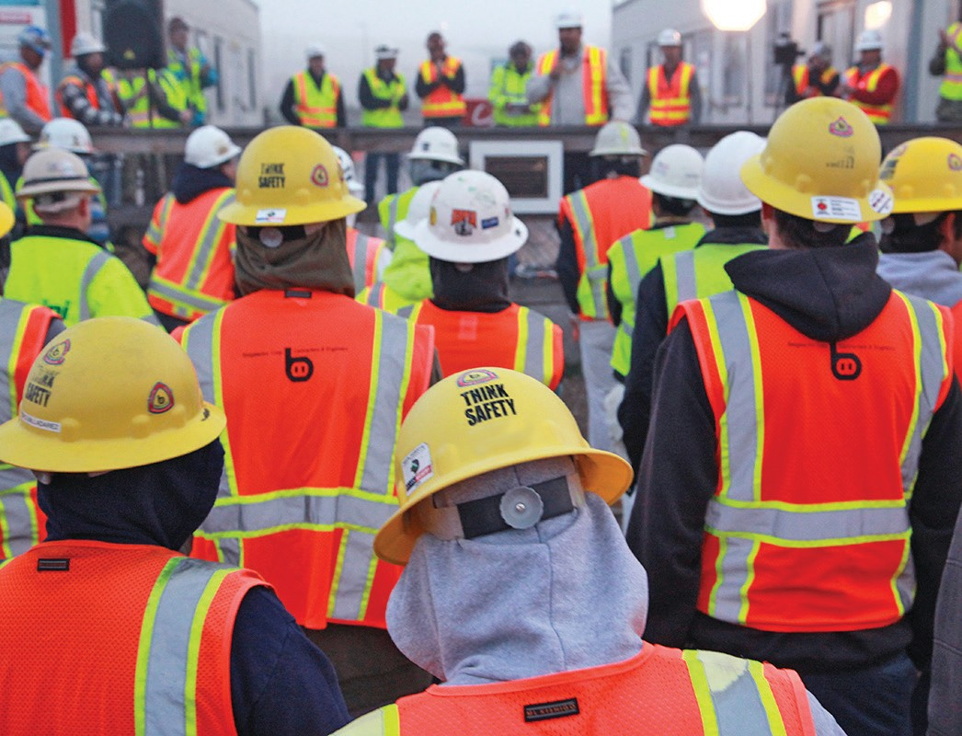
Competency A-1: Control Workplace Hazards

Image to be placed here.

B.C. Open Textbook Project
OpenEd
open.bccampus.ca

Trades Access
COMMON CORE
Line A: Safe Work Practices
Competency A-1: Control Workplace Hazards

Acknowledgments and Copyright
To learn more about BCcampus Open Textbook project, visit http://open.bccampus.ca
© Camosun College. The Trades Access Common Core resources are licensed under the Creative Commons Attribution 4.0 Unported Licence ( http://creativecommons.org/licenses/by/4.0/ ), except where otherwise noted. Under this licence, any user of this textbook or the textbook contents herein must provide proper attribution as follows:
- If you redistribute this textbook in a digital format (including but not limited to EPUB, PDF, and HTML), then you must retain on every page the following attribution: Download for free at http:// open.bccampus.ca/find-open-textbooks/
- If you redistribute this textbook in a print format, then you must include on every physical page the following attribution: Download for free at http://open.bccampus.ca/find-open-textbooks/
- If you redistribute part of this textbook, then you must retain in every digital format page view (including but not limited to EPUB, PDF, and HTML) and on every physical printed page the following attribution: Download for free at http://open.bccampus.ca/find-open-textbooks/
- If you use this textbook as a bibliographic reference, then you should cite it as follows: BCcampus, Name of Textbook or OER. DATE. http://open.bccampus.ca/find-open-textbooks/.
For questions regarding this licensing, please contact opentext@bccampus.ca
All images copyright BC Industry Training Authority are licensed under the Creative Commons Attribution-NonCommercial-ShareAlike 4.0 licence.
http://creativecommons.org/licenses/by-nc-sa/4.0/
The issuing/publishing body is Crown Publications, Queen’s Printer, Ministry of Technology, Innovation and Citizens’ Services.
BCcampus would like to acknowledge the following individuals and organizations for their contributions in producing the Trades Access Common Core Open Textbook resources.

BCcampus
Open Education Team Hilda Anggraeni, Graphics

Camosun College
Olaf Nielsen, Chair, Trades Development and Special Projects, School of Trades and Technology Nannette Plant, Manager, Enterprise Point Operations & Special Projects, Office of the VP Strategic Development
Rod Lidstone, Instructor, Plumbing and Pipe Trades, Lead Writer/Reviewer Brian Coey, Instructor, Sheet Metal and Metal Fabrication, Writer/Reviewer Matt Zeleny, Camosun Innovates, 3D imaging

Open School BC
Monique Brewer, Director
Adrian Hill, Instructional Designer
Dennis Evans, Image Coordinator, Photographer, Graphics, Production Technician (layout) Farrah Patterson, Production Technician

Industry Training Authority of BC
The ITA works with employers, employees, industry, labour, training providers, and government to issue credentials, manage apprenticeships, set program standards, and increase opportunities in approximately 100 BC trades. Among its many functions are oversight of the development of training resources that align with program standards, outlines, and learning objectives, and authorizing permission to utilize these resources (text and images).
Erin Johnston, Director of Training Delivery Cory Williams, Manager, Industry Relations

Publishing Services, Queen’s Printer
Spencer Tickner, Director of QP Publishing Services Dwayne Gordon, Manager, Electronic Publishing
October 2015, Version 1
To order print copies of any of the Trades Access Common Core resources, please contact us:
Crown Publications, Queen’s Printer PO Box 9452 Stn Prov Govt
563 Superior St, 3rd Floor Victoria, BC V8W 9V7 Phone: 250-387-6409
Toll Free: 1-800-663-6105
Fax: 250-387-1120
crownpub@gov.bc.ca www.crownpub.bc.ca

Intellectual Property Program
Ilona Ugro, Copyright Officer, Ministry of Technology, Innovation and Citizens’ Services, Province of British Columbia

Creative Commons Attributions
Cover photo: (https://commons.wikimedia.org/wiki/File:Monthly_Safety_Stand_Down_%288552567928%29.jpg) by NAVFAC
(https://www.flickr.com/photos/39845951@N05/8552567928) by Jesse A. Lora, NAFAC (SW) under CC BY SA 2.0.
(https://creativecommons.org/licenses/by/2.0/)
Figure attributions for Competency A-1, Learning Task 2 include:
Figure 1 - Pre-fabricate hydraulic shoring http://commons.wikimedia.org/wiki/File:Sbh_s600.JPG by Sbhrus under CC BY SA 3.0 https://creativecommons.org/licenses/by-sa/3.0/deed.en
Figure 3 - Trench box
http://commons.wikimedia.org/wiki/File:Trench_box.jpg by the National Institute for Occupational Safety and Health under Public Domain

Foreword
The BC Open Textbook Project began in 2012 with the goal of making post-secondary education in British Columbia more accessible by reducing student cost through the use of openly licensed textbooks. The BC Open Textbook Project is administered by BCcampus and is funded by the British Columbia Ministry of Advanced Education.
Open textbooks are open educational resources (OER); they are instructional resources created and shared in ways so that more people have access to them. This is a different model than traditionally copyrighted materials. OER are defined as teaching, learning, and research resources that reside in the public domain or have been released under an intellectual property licence that permits their free use and repurposing by others (Hewlett Foundation). Our open textbooks are openly licensed using a Creative Commons licence, and are offered in various e-book formats free of charge, or as printed books that are available at cost. For more information about this project, please contact opentext@bccampus.ca. If you are an instructor who is using this book for a course, please let us know.

Preface
The concept of identifying and creating resources for skills that are common to many trades has a long history in the Province of British Columbia. This collection of Trades Access Common Core (TACC) resources was adapted from the 15 Trades Common Core line modules co-published by the Industry
Training and Apprenticeship Commission (ITAC) and the Centre for Curriculum Transfer and Technology (C2T2) in 2000-2002. Those modules were revisions of the original Common Core portion of the TRAC modules prepared by the Province of British Columbia Ministry of Post-Secondary Education in 1986. The TACC resources are still in use by a number of trades programs today and, with the permission from the Industry Training Authority (ITA), have been utilized in this project.
These open resources have been updated and realigned to match many of the line and competency titles found in the Province of BC’s trades apprenticeship program outlines. A review was carried out to analyze the provincial program outlines of a number of trades, with the intent of finding common entry-
level learning tasks that could be assembled into this package. This analysis provided the template for the outline used to update the existing modules. Many images found in ITA apprentice training modules were also incorporated into these resources to create books that are similar to what students will see when they continue their chosen trades training. The project team has also taken many new photographs for this project, which are available for use in other trades training resources.
The following list of lines and competencies was generated with the goal of creating an entry-level trades training resource, while still offering the flexibility for lines to be used as stand-alone books. This
flexibility—in addition to the textbook content being openly licensed—allows these resources to be used within other contexts as well. For example, instructors or institutions may incorporate these resources into foundation-level trades training programming or within an online learning management system (LMS).
Line A – Safe Work Practices
- A-1 Control Workplace Hazards
- A-2 Describe WorkSafeBC Regulations
- A-3 Handle Hazardous Materials Safely
- A-4 Describe Personal Safety Practices
- A-5 Describe Fire Safety
Line B – Employability Skills
- B-1 Apply Study and Learning Skills
- B-2 Describe Expectations and Responsibilities of Employers and Employees
- B-3 Use Interpersonal Communication Skills
- B-4 Describe the Apprenticeship System

Line C –Tools and Equipment
- C-1 Describe Common Hand Tools and Their Uses
- C-2 Describe Common Power Tools and Their Uses
- C-3 Describe Rigging and Hoisting Equipment
- C-4 Describe Ladders and Platforms
Line D – Organizational Skills
- D-1 Solve Trades Mathematical Problems
- D-2 Apply Science Concepts to Trades Applications
- D-3 Read Drawings and Specifications
- D-4 Use Codes, Regulations, and Standards
- D-5 Use Manufacturer and Supplier Documentation
- D-6 Plan Projects
Line E – Electrical Fundamentals
- E-1 Describe the Basic Principles of Electricity
- E-2 Identify Common Circuit Components and Their Symbols
- E-3 Explain Wiring Connections
- E-4 Use Multimeters
All of these textbooks are available in a variety of formats in addition to print:
- PDF—printable document with TOC and hyperlinks intact
- HTML—basic export of an HTML file and its assets, suitable for use in learning management systems
- Reflowable EPUB—format that is suitable for all screen sizes including phones
All of the self-test questions are also available from BCcampus as separate data, if instructors would like to use the questions for online quizzes or competency testing.

About This Book
In an effort to make this book a flexible resource for trainers and learners, the following features are included:
- An introduction outlining the high-level goal of the Competency, and a list of objectives reflecting the skills and knowledge a person would need to achieve to fulfill this goal.
- Discrete Learning Tasks designed to help a person achieve these objectives
- Self-tests at the end of each Learning Task, designed to informally test for understanding.
- A reminder at the end of each Competency to complete a Competency test. Individual trainers are expected to determine the requirements for this test, as required.
- Throughout the textbook, there may also be links and/or references to other resources that learners will need to access, some of which are only available online.
- Notes, cautions, and warnings are identified by special symbols. A list of those symbols is provided below.

Symbols Legend

Important: This icon highlights important information.

Poisonous: This icon is a reminder for a potentially toxic/poisonous situation.

Resources: The resource icon highlights any required or optional resources.

Flammable: This icon is a reminder for a potentially flammable situation.

Self-test: This icon reminds you to complete a self-test.

Explosive: This icon is a reminder for a possibly explosive situation.

Safety gear: The safety gear icon is an important reminder to use protective equipment.

Electric shock: This icon is a reminder for potential electric shock.

Safety Advisory
Be advised that references to the Workers’ Compensation Board of British Columbia safety regulations contained within these materials do not/may not reflect the most recent Occupational Health and Safety Regulation. The current Standards and Regulation in BC can be obtained at the following website: http:// www.worksafebc.com.
Please note that it is always the responsibility of any person using these materials to inform him/herself about the Occupational Health and Safety Regulation pertaining to his/her area of work.
BCcampus January 2015

Disclaimer
The materials in the Trades Access Common Core Open Textbook project are for use by students and instructional staff and have been compiled from sources believed to be reliable and to represent best current opinions on these subjects. These manuals are intended to serve as a starting point for good practices and may not specify all minimum legal standards. No warranty, guarantee or representation is made by BCcampus as to the accuracy or sufficiency of the information contained in these publications. These manuals are intended to provide basic guidelines for trade practices. Do not assume, therefore, that all necessary warnings and safety precautionary measures are contained in this module and that other or additional measures may not be required.

Contents

Introduction 9
Objectives 9
Resources 9
Learning Task 1: Describe the causes and results of accidents 11
Safety culture 11
Main causes of accidents 11
Workplace hazards 12
Hazard assessment 12
Professionalism/housekeeping 13
Role of the Workers’ Compensation Board: Investigate, inspect, educate, and compensate 14 Costs of accidents and injuries 14
Self-Test 1 16
Learning Task 2: Describe short-term hazards in the trades 19
Slips, trips, and falls 19
Excavations 19
Working around vehicles and heavy equipment 23
Elevated work 24
Confined space 24
Electrical hazards 25
Lockout 27
Compressed gas 27
Weather 30
Self-Test 2 33
Learning Task 3: Describe long-term hazards in the trades 37
Airborne hazards 37
Musculoskeletal injury 40
Occupational skin diseases 40
Hearing loss 41
Self-Test 3 42
Learning Task 4: Describe general safety precautions and procedures 45
Safety awareness 45
Horseplay 45
Respect for others’ safety 46
Proximity work 46
Electrical hazard guidelines 46
Tools 47
Ventilation 50
Confined space work 51
Housekeeping 52
Flammable liquids 52
Weather 53
Safety precautions when working at elevations 53
Self-Test 4 57
Learning Task 5: Describe emergency equipment and facilities 61
Utilities 61
Fire control systems 62
Emergency wash stations 63
Emergency exits 63
First aid facilities 63
Emergency contact/phone numbers 63
Outside meeting place 63
Disaster plan 63
Self-Test 5 64
Learning Task 6: Describe how a workplace safety policy is established 67
Process 67
Committees 69
Employee orientation 69
Job safety analysis 69
Job site safety meetings 73
Reporting accidents 74
Investigations 74
First aid 74
Hearing 75
Job task permits 75
Self-Test 6 77
Learning Task 7: Describe lockout and tagout (LOTO) procedures 79
Understanding of system operation 79
Identification requirements 79
Situations where lockout is required 80
Lockout equipment 80
Self-Test 7 86
Answer Key 88

Introduction
Safety is a part of the job. When you take a job, you have a safety obligation to your employer, co-workers, family, and yourself. By recognizing and understanding the hazards in your work area, you can prevent the occurrence of many accidents. Most accidents are preventable. Both employees and employers must take responsibility for making the workplace safe.

Objectives
You must be familiar with the typical hazards that you may encounter in the workplace.

When you have completed the Learning Tasks in this Competency, you should be able to describe:
  - the causes and results of workplace accidents
  - the short- and long-term hazards in the trades
  - general safety precautions and procedures
  - emergency equipment and facilities
  - how a workplace safety policy is established
  - lockout and tagout procedures
  - ladder and scaffold usage

Resources

You will be required to reference publications and videos available online at:
http://www.worksafebc.com/

In addition to this module, online content, links to videos, online quizzes, and Q&A forums are all part of the learning experience.

LEARNING TASK 1

Describe the causes and results of accidents

Safety culture
Your health and well-being are your most valuable possessions. Many laws and regulations have been passed in order to ensure employee safety, yet every year thousands of serious injuries occur—often with serious long-term consequences for both employees and employers.

Safety is a learned behaviour and attitude; it is a way of working that must be incorporated into the company as a culture. Everybody in a company, from management to labourers, must be responsible for safety every day they come to work.

Companies with strong safety cultures usually have:
  - fewer at-risk behaviours
  - lower accident rates
  - less employee turnover
  - lower absenteeism
  - higher productivity

Most work-site safety rules are a matter of common sense, but people tend to forget or ignore them to save time or energy.

The ultimate responsibility for on-the-job safety, however, rests with you. By following the practices in this Competency, you and your co-workers will commit yourselves to safety on the job and everyone will benefits.

Main causes of accidents
An accident is defined as an unplanned event that may or may not result in an injury or property damage. Some of the main causes of accidents include:
  - failure to communicate
  - poor work habits/complacency
  - alcohol or drug abuse
  - lack of skill/training
  - intentional acts
  - unsafe acts
  - rationalizing risks
  - unsafe conditions

Personal injury may be classed as either permanent or temporary. Either way, it is costly in terms of pain and lost time, wages, and production. It is much more benefits to all concerned if injury is avoided from the outset. To ensure this, everything possible should be done to identify all potential hazards.

Workplace hazards
In order to work safely, you must know the kinds of hazards to which you may be exposed and how to minimize the risk of injury. When hazards are identified and assessed they can be addressed quickly, reducing the hazard potential.

Watch the WorkSafeBC video “Understanding Hazards and Risks”
http://www2.worksafebc.com/Publications/Multimedia/Videos.asp?ReportID=36001

These hazards may be of an obvious nature—presenting immediate danger—or they may be very subtle and cause damage through exposure over a longer period of time. For example, many workers in noisy environments gradually lose their hearing without even being aware of the loss. This can be high- or low-frequency hearing loss, depending on the intensity or amount of exposure.

Watch the WorkSafeBC video “The Hearing Video”
http://www2.worksafebc.com/Publications/Multimedia/Videos.asp?reportid=34284

Hazard assessment
A first critical step in developing a comprehensive safety and health program is to identify physical and health hazards in the workplace. This process is known as a hazard assessment. Potential hazards may be physical or health-related, and a comprehensive hazard assessment should identify hazards in both categories. Examples of physical hazards include moving objects, fluctuating temperatures, high-intensity lighting, rolling or pinching objects, electrical connections, and sharp edges. Examples of health hazards include overexposure to harmful dusts, chemicals, or radiation.

There are a number of different ways to recognize hazards on the job site. Some techniques are more complicated than others. Some use methods like job safety analysis (JSA), where each step or part of a task is analyzed for potential hazards. Another approach when doing common or reoccurring tasks is to have workers perform a Task Safety Analysis (TSA), where the worker fills out a pre-printed checklist.

Professionalism/housekeeping
One important part of safety and accident prevention is good housekeeping. We seldom think about it, but many unsafe conditions can be corrected before they result in injury. Good housekeeping is a necessity for a safe job site. When rubbish is allowed to accumulate on the job site or in the shop, it gets in the way and makes operations more dangerous. Time may also be lost if you just move rubbish from one place to another instead of using proper bins or disposal procedures.

A clean work environment also leads to pride in workmanship. An unorganized work area can slow your production and looks unprofessional. Keeping your work area clean and organized has many positive attributes. Some handy work area hints include:
  - Before you begin a project, remove all unnecessary tools and equipment that may be in your way.
  - If you plan your work, the tools needed for one job will flow well into the next and will save you the time of cleaning up or looking for tools.
  - Place your tools conveniently and lay your tools out slightly away from your work so that you do not crowd your workspace.
  - Never place tools inside equipment, as these loose tools may cause damage if allowed to slide into components or if accidentally left behind after job completion.
  - As you work, remove all foreign objects and tools that are no longer required.

  - Use the right tool for the job and never use damaged tools or equipment.

  - Do not eat at your workbench. Grease and crumbs can lead to component and equipment failure.
  - Clean up spills immediately to prevent falls.

  - Remove scrap material regularly to the proper disposal or recycling location.

  - At the end of the job or day, clean up, and you will feel better starting on a fresh new job tomorrow rather than cleaning up after yesterday.

Role of the Workers’ Compensation Board: Investigate, inspect, educate, and compensate
Workers’ Compensation Boards are independent agents that enforce provincial mandates in the area of workers’ health and safety and compensation. WorkSafeBC is the agent for WCB in British Columbia and mandates in four ways:
    - inspect and assess a workplace for safety and health concerns

    - investigate injury claims and incidents

    - educate employers and employees through programs and when necessary assess penalties for infractions
    - compensate workers for time lost due to injury

Workers’ Compensation Boards have the legislative authority to assess penalties for contravention of health and safety regulations. The employer is ultimately held responsible for the actions of their workers and supervisors, although this does not relieve workers or
supervisors of their responsibilities under the regulations. Both workers and supervisors can be held liable for the penalties prescribed under legislation.

Under the legislation, through its officers, the board is charged with the responsibility of inspecting places of employment. Subsequently the board may issue orders and directions specifying the means for preventing injuries and industrial diseases.

Officers of the WCB are responsible for investigating accidents and the causes of industrial diseases, for assisting and advising employers and employees in the development of industrial health and safety programs, and for educating persons employed in industry about industrial health and safety.

Costs of accidents and injuries
The direct costs of an injury are the easiest to see and understand. These costs include emergency room and doctor visits, medical bills, medicines, rehabilitation, and lost wages. These direct costs are covered by a company’s insurance.

Indirect costs of an injury are often overlooked. These costs can amount to up to four times the direct cost of the injury. Indirect costs include administrative time dealing with the injury and medical care, loss of production, raises in premiums, replacing the injured employee’s lost hours of employment by hiring another employee, loss of reputation and confidence in employees and clients, unwanted media attention, and more.

Many projects use a company’s accident history or incident rate during the tender process and compare it to the other potential bidders when deciding which company to select. A higher rate of incidents may mean loss of a bid and therefore loss of work.

WCB assessment and penalty costs
Every employer in British Columbia is issued a fee assessment to cover all of WorkSafeBC’s operating costs. Assessments pay for inspections of the work site, for the training of workers, as well as all of the direct costs of job site injuries.

It’s important that you do not cause your employer to be charged and fined for infractions of the regulations. An employee who takes an unsafe shortcut on the job to save two minutes may end up costing their employer a lot of money. When the assessment goes up, it goes up for everyone on the payroll. In some cases, it can price a company out of business.

New and young workers have the highest accident rates. They’re often eager to please and try to get a job done hastily. You can help yourself and your employer by practising safe working habits, ensuring you are trained properly, and demonstrating a good safety attitude on the job site.

Review WorkSafeBC’s website “Top 7 Dangers for Young Workers”
http://www2.worksafebc.com/Topics/YoungWorker/Top-Seven-Dangers.asp

Now complete the Learning Task Self-Test.

Self-Test 1
- A worker’s personal safety is primarily whose responsibility?
  - Worker
  - Employer
  - Safety committee
  - Occupational Health & Safety officer

- What is commonly found when comparing different types of workplace injury costs?
  - Direct costs are less than indirect costs.
  - Direct costs are greater than indirect costs.
  - Direct costs of injury are the only costs of injury.
  - Indirect costs are the easiest to see and understand.

- Which workers have the highest rate of workplace accidents and incidents?
  - Young workers
  - Part-time workers
  - Soon-to-be-retired workers
  - Temporary foreign workers

- What authorization do Workers Compensation Board officers have at the workplace?
  - All of the choices
  - Issue penalties for safety infractions
  - Inspect workplaces for safety issues
  - Issue orders specifying injury prevention measures

- Which description best reflects a culture of safety?
  - Employers make sure safety is mentioned once a week.
  - Workers use safe work habits when it is efficient to do so.
  - All workers and employers are committed to making safety a part of every day.
  - Workers use safe work habits when they know they are being watched by the Workers’ Compensation Board.

  - Which phrase best describes the act of keeping your work area clean and free of scraps, rubbish, or spills?
  - Managing
  - Organizing
  - Housekeeping
  - Stacking and storing

- A culture of safety means accepting that accidents happen and working the cost of accidents into a business plan.
  - True
  - False

- Employees are responsible for training themselves in safe work practices.
  - True
  - False

- A culture of safety is a daily commitment to safe, conscientious work.
  - True
  - False

- The Workers’ Compensation Board is contracted by the employer.
  - True
  - False

- Some companies may choose to employ a different regulatory body than the Workers’ Compensation Board.
  - True
  - False

LEARNING TASK 2

Describe short-term hazards in the trades
A short-term hazard can be described as any hazard that that may cause injury and/or illness and that may be remedied in a short period of time. This Learning Task will discuss some of the short-term hazards likely to be encountered when working in the trades.

Slips, trips, and falls
Slips, trips, and falls on walking and working surfaces are the cause of many injuries in the workplace. Some of these accidents are the result of environmental conditions and others happen because of poor housekeeping and careless behaviour. You can best avoid slips, trips, and falls by being aware of your surroundings and following some general walking and work surface guidelines:
  - Keep all walking and working areas clean and dry.
  - Keep all walking and working surfaces clear of clutter and debris.
  - Install cables, extension cords, and hoses so that they will not become tripping hazards.
  - Do not run on any work surface.
  - If footing is unstable use short steps with feet splayed out.

Excavations
An excavation is the removal of ground material by digging in order to bury or access pipelines, conduits, foundations, etc. Trenches are special types of excavations in which the depth exceeds the width. Sometimes the terms excavation and trench are used interchangeably, but there is a difference. Because trenches are narrow, workers can easily become trapped.

Hazards involved with trench and excavation work include:
  - cave-ins and crushing
  - water accumulation
  - falling objects
  - collapse of adjacent structures
  - toxic gases in the soil

Cave-ins are the most common and deadly hazard in excavation work. When dirt is removed from an excavation, the surrounding soil can become unstable, with gravity forcing it to collapse. If a trench is deeper than 1.2 metres (4 ft.) you must be protected from cave-ins by either trench shoring or sloping. You must know and follow the appropriate shoring and sloping requirements before entering or working around an excavation.

Shoring
Several methods can be used to shore up a trench. Hydraulic shoring uses hydraulic pistons that are extended outward until they press prefabricated plates against the trench walls as shown in Figure 1.

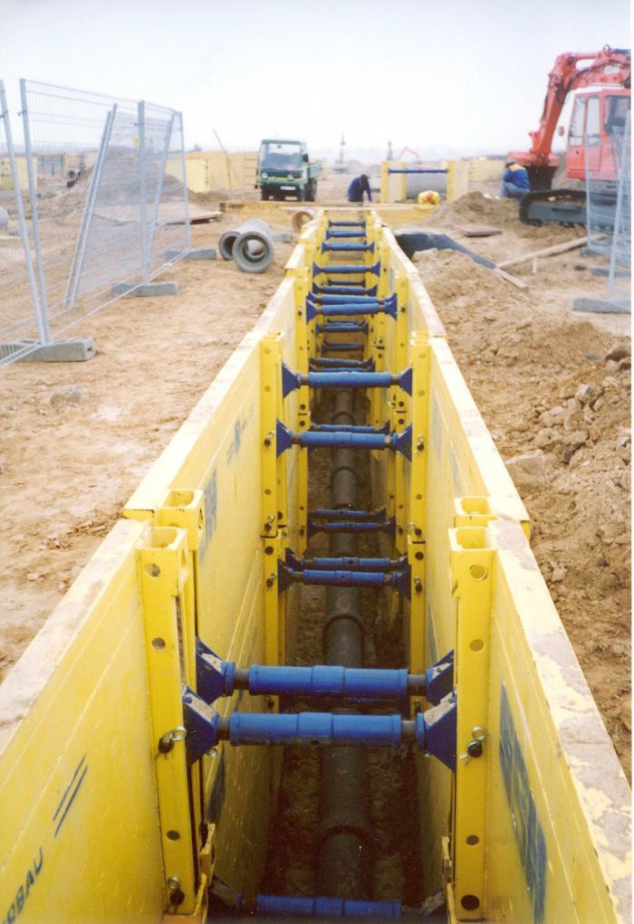
Figure 1 — Prefabricated hydraulic shoring

Timber and plank shoring is used if the trench is too wide or too irregular for prefabricated shoring, as shown in Figure 2.

Planks (uprights)

Cross braces (struts)

Walers (stringers)

Figure 2 — Parts of a timber and plank shoring system

The size and spacing of the parts of a timber and plank system are given in the WorkSafeBC OHS Regulation. Size and spacing vary depending upon the type of soil that the trench is dug into and the depth of the trench.

Planks may be spaced if the soil is stable, but must be close fitting if the soil is loose and free running. Plywood sheathing is sometimes used in place of planks.

Timber shoring is slow to install because it must be installed from the top down. It is unsafe for a worker to enter the trench before it is shored.

Trench shields or trench boxes are prefabricated structures (Figure 3). These are not adjustable within the trench and are designed to protect the workers, should a collapse occur, whereas shoring is designed to prevent the walls from collapsing.

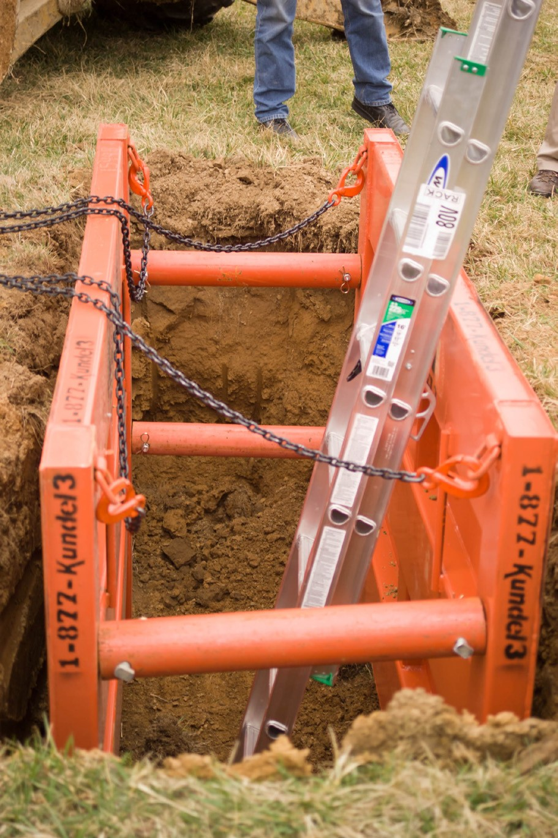
Figure 3 — Trench box

Sloping
Sloping a trench creates a naturally stable slope, similar to that which loose excavated material forms when dumped on a level surface, known as the angle of repose. Unshored trench and excavation walls must be sloped flatter than the angle of repose, but in no case steeper than 3 horizontal to 4 vertical units unless otherwise specified in writing by a professional engineer (Figure 4).

3
3
4
4
Figure 4 — Trench sloping

As demonstrated in Figure 5, sometimes a combination of sloping and shoring is used.

450 mm
(18 in.) min.

H

Shoring must be
h sized for
depth “H”

Figure 5 — Combined sloping and shoring

Another method of sloping is called benching. All benched excavations 6.1 m (20 ft.) or less in depth shall have a maximum rise between benches of 1.2 m (4 ft.). For unrestricted worker access at any level, the width of the bench immediately above any particular rise shall not be
less than 1.5 times the height of that rise. For example, in Figure 6 the minimum bench width for a 1.2 m (4 ft.) rise would be 1.8 m (6 ft.)

1.2 m (4 ft.) Maximum

1.5
1

1.2 m (4 ft.) Maximum

1.2 m (4 ft.) Maximum

Figure 6 — Benched excavation

Keep all piles of material and equipment at least two feet away from the edge of an excavation. Loose rock, soil, materials, and equipment on the face or near the excavation can fall or roll into the excavation, or overload and possibly collapse the excavation walls. When working in a
trench, there has to be a safe means of access and egress for workers, such as a ladder, stairway, or ramp. For long trenches you will require multiple exit points.

Working around vehicles and heavy equipment
Workers are often required to work near vehicles and mobile equipment. It is the workers’ responsibility to keep out of the way. Workers working near moving vehicles and equipment should:
  - stay alert at all times and keep a safe distance

  - stay out of the circle formed by the extended bucket of an excavator (swing)

  - never get into blind spots of operators

  - maintain eye contact with the operator

  - never stand under loads handled by lifting or digging equipment, or near vehicles being loaded or unloaded
  - wear reflective or high-visibility vests, hard hats, steel-toed boots, and appropriate hearing protection while working near equipment
  - alert the operator of any impending hazards, electrical wires, gas lines, sewer or water lines, etc.

Elevated work
Working in elevated situations can be very dangerous. Falls from elevated areas are one of the leading causes of fatalities among workers. While the risk of falls is high, there is much you can do to protect yourself. Using the appropriate personal protective equipment, practising good housekeeping habits, and staying alert at all times will help you stay safe when working at elevations. In later sections we will be covering the OHS Regulation related to scaffolding and fall protection; it is important that you make yourself aware of this before proceeding to work at elevations.

Confined space
A work area that is not meant for human habitation with limited access and egress where there is a potential risk is known as a confined space. A confined space can be any enclosed space where there is a risk of death or serious injury from hazardous substances or dangerous conditions (e.g., lack of oxygen). You must understand the hazards and safety precautions for working in confined spaces.

Some examples of confined spaces that are fairly easy to identify include:
    - storage tanks, silos, vessels, and vats
    - manholes, sewers, and ductwork
    - combustion chambers in furnaces, etc.
    - unventilated or poorly ventilated rooms

Some places must be assessed at their location as confined spaces. It is not possible to provide a comprehensive detailed list of confined spaces, though many of the dangers associated with confined spaces are listed below:
    - A lack of oxygen can occur due to a process or reaction.

    - Poisonous gas, fumes, or vapour can build up in sewers and manholes or enter tanks and vessels from connecting pipes.
    - Liquids and solids can suddenly fill the space.

    - Free-flowing solids such as grain can form a solid section and then suddenly collapse.

    - Flammable vapours or residues left in tanks or vessels can explode or catch fire.

    - Dust may be present in high concentrations in flour or grain silos.

    - Hot conditions can lead to a dangerous increase in body temperature.

Go to the WorkSafeBC website for the most current information:
a. Hazards of conConfi
Spaces
http://www.worksafebc.com/publications/health_and_safety/by_topic/assets/pdf/
confi e_bk80.pdf
b. Read the online Occupational Health & Safety Regulation, Part 9.1 Confi Spaces Definitions
c. Watch the WorkSafeBC video, Confi
Spaces: Safe Yesterday, Deadly Today
http://www2.worksafebc.com/Publications/Multimedia/Videos.
asp?ReportID=35168

Electrical hazards
No matter what your trade, on many jobs you will use or work around electrical equipment. Extension cords, power tools, and portable lights are among the many pieces of equipment that use electricity.

There are different types of electrical accidents, including:
  - burns
  - electric shock
  - explosions
  - falls caused by electric shock
  - fires

While the human body is a conductor of electricity, it is not a good one. Burns caused by electric shock are a result of the heat caused by resistance to electrical current. Electrical burns often occur below the skin surface and can damage muscle and nerve tissue. In severe cases, electrical burns can be fatal.

The extent of injury due to electric shock depends on a combination of voltage and current and the body’s resistance to the electricity passing through it—a condition that changes from person to person. An electric shock occurs when you become part of the electrical circuit; when you contact a live portion of a circuit while in also in contact with a lower potential such as ground.

Even though you may normally deal with small voltages and current, the values are never far away from lethal levels. You can receive a shock or burn from any common electrical circuit. The severity of the electrical shock depends on a number of factors:
  - the amount of current that passes through the body
  - the path that the current takes through the body
  - type of voltage—AC or DC
  - voltage strength
  - the length of time that the current flows within the body
  - condition of the skin and the body’s chemical make-up
  - area of contact

Normal household current (plugs and light circuits) is generally limited by a circuit breaker to a value of 15 amperes. This device has been designed to trip and open a circuit if the 15 ampere value is exceeded and is designed to protect against property damage. It is possible to cause a fatal injury with a current flow of only 50 mill amperes (mA) or 5 one-hundredths of an ampere. The body is sensitive to relatively small values of current. In comparison, a 100-watt light bulb draws approximately 0.85 amperes (850 mA) of current when connected to a 120-volt source. Remember, we have 15 amperes available in each standard house circuit. Industrial circuits may have a required flow of several hundred amperes. In both cases, these are dangerous amounts!

Most fatal shocks occur when current passes through or near the heart. This is possible if the circuit passes from one arm to the other, from the right arm to the left leg, or from the left arm to the right leg. Figure 7 lists the effects of increasing amounts of current on the human body.

Amount of Current | Effect
1 mA or less | No noticeable feeling experienced.
1–3 mA | Shock is just felt.
3–10 mA | Shock is painful. Individual can still use motor functions. Muscular control is not lost.
10–20 mA | Some individuals will experience a loss of voluntary muscular control.
20–50 mA | Individual cannot let go of the circuit. Breathing may become difficult .
50–200 mA | Ventricular fibrillation of the heart may occur, causing death. Severe muscular contraction and nerve damage are possible.
Over 200 mA | Heart paralysis may occur. Severe burns are possible.
Figure 7 — Effects of alternating electric current on the human body

Rescuing shock victims: first aid for electrical shock victims
Consult your employer’s first aid attendant or medical personnel on acceptable procedures for dealing with local electrical shock emergencies. The most important things to know about assisting an electrical shock victim are listed below:
    - Do not touch a victim who is still connected to the power source. If you touch a victim who is in contact with an electrical source, you will become part of the circuit too, resulting in another casualty.
    - Safely remove the power from the victim

    - If you cannot de-energize the circuit, separate the victim from the live circuit by using a piece of non-conductive material such as a stick of lumber or wooden handle.
    - If the shock victim is unconscious and has stopped breathing, start artificial respiration at once. Do not stop until a medical authority instructs you to stop.

Lockout
A lockout or tagout system (LOTO) is designed to protect workers from hazardous energy while they work with machines or equipment. As the name implies, a lockout procedure systematically uses locking devices to completely secure equipment that controls or represent a hazard. It also ensures that equipment is de-energized before being maintained or repaired.

Energy sources can include:
  - hydraulic or pneumatic energy
  - mechanical and kinetic energy
  - gravitational and potential energy
  - electrical energy

The following assumptions are unacceptable where safety is concerned:
  - It is not enough to simply throw a switch and start work.
  - It is not enough to hang a “do not use” sign on a machine.
  - It is not enough to tell everyone not to turn on the power.
  - It is not enough to have everyone assure you that no one will activate the power.

Specific lockout procedures will be covered in Learning Task 7 of this Competency. In addition, Workers’ Compensation Board lockout regulations will be covered in Competency A-2, Learning Task 6.

Compressed gas
Compressed air is used in shops and on-site for operating nailers, staplers, impact tools, equipment, and paint sprayers. However, cleaning objects, machinery, bench tops, clothing, and other items with compressed air is dangerous. Injuries can be caused by the air jet and by
particles made airborne. If compressed air must be used to clean equipment, the nozzle pressure must remain below 10 psi (69 or 70 kPa) and personal protective equipment (PPE) must be worn to protect the worker’s body, especially the eyes, against particles and dust under pressure.

Compressed air must never be used to clean yourself or clothing unless specifically designed for that purpose.

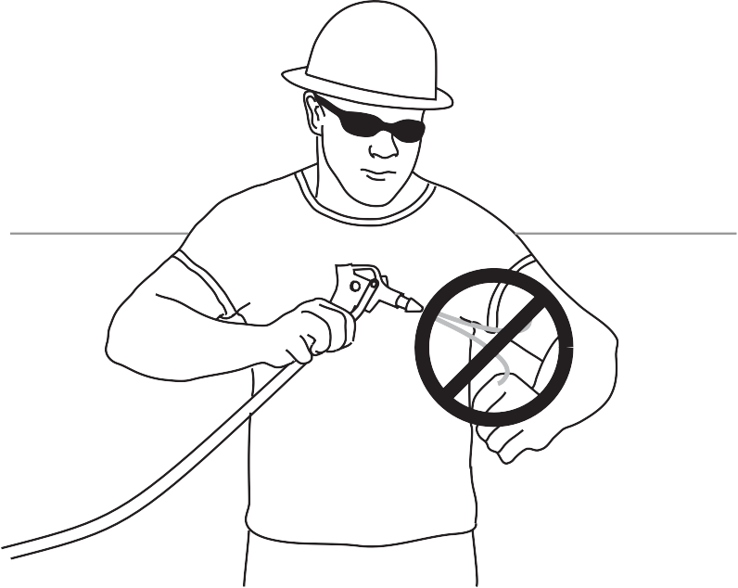

Figure 8 — Do not clean yourself with compressed air

Compressed gases are often supplied to the job site in pressurized cylinders. Extreme caution should be used when working with these cylinders, as a damaged cylinder is an explosion hazard. A screw-on protective cap protects the cylinder valve. The cylinders and protective caps are usually black, although green and other colours are also used. The caps have right-hand threads (like all oxygen fittings) and come in various sizes to match the cylinders.

Removable protective cap
Safety device in valve

Wall thickness 6 mm (¼")

1422 mm (56")

230 mm (9")
Figure 9 — Pressurized cylinder

The following safety procedures must be observed:
  - Do not accept or use any compressed gas cylinder that does not have proper identification of contents.
  - Always treat cylinders as if they are full and handle accordingly.

  - Never drop cylinders or let them strike each other violently.

  - Protect cylinders and any related piping and fittings against damage.

  - Do not use slings or magnets for hoisting cylinders.

  - Transport cylinders securely on a hand truck whenever possible. NEVER drag them.

  - Secure transported cylinders to a suitable cradle or platform to prevent movement or upset.
  - Chalk “EMPTY” or “MT” on cylinders that are empty. Close valves and replace protective caps.
  - For detailed handling procedures, consult the manufacturer, the supplier, and the MSDS.

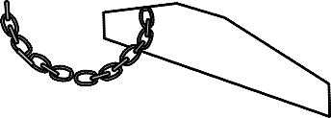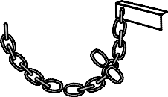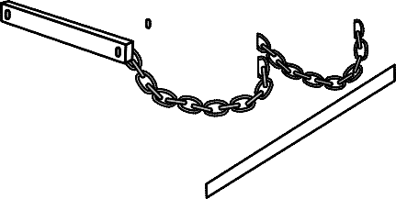
Figure 10 — Oxyacetylene cart with lifting eye

Storing cylinders
These safety measures must be observed when storing gas cylinders:
    - Store cylinders upright in a safe, dry, well-ventilated location that is maintained specifically for this purpose.
    - Never store different flammable and combustible materials such as oil and gasoline in the same area.
    - Do not store cylinders near elevators, walkways, stairwells, or exits, or in places where they could be damaged or knocked over.
    - Do not store oxygen cylinders within 6 m (20 ft.) of cylinders containing flammable gases unless they are separated by a partition at least 1.5 m (5 ft.) high that has a fire- resistance rating of at least 30 minutes.
    - Store empty and full cylinders separately.

    - Prohibit smoking in the storage area.

Weather
Many jobs require that you work outside. Since work often continues during periods of hot, cold, and wet weather, you need to understand the hazards associated with weather and be properly prepared.

Cold weather
When working outdoors during winter, workers need to protect themselves against loss of body heat. When your body temperature drops even a few degrees below normal, you can begin to shiver uncontrollably and become weak, drowsy, disoriented, unconscious, or even fatally ill.
Hypothermia is the condition in which your body loses heat at a rate greater than you are able to produce it.

Cold temperatures, wind, poorly-insulated or wet clothing, immersion in water, and fatigue are some of the main factors that contribute to hypothermia.

The following guidelines can help you keep your body warm and avoid hypothermia, frostbite, and overexposure to the cold:
    - Properly insulated headgear, footwear, and gloves are important. Heat loss is greatest from the head. Dress in layers.
    - Wind causes cooling or “wind chill.” The stronger the wind at a given temperature, the cooler the wind chill will be.
    - Water chills your body far more rapidly than air or wind. When working outdoors, always have proper waterproof clothing and extra dry clothes available.

  - Even on a very cold day, strenuous activities can cause you to perspire. When you slow down to a normal pace, this moisture will add to the chilling effect.
  - Cold-water immersion speeds up the process of cooling down the body. When you’re in the water, heat is conducted away from the body 25 times faster than in cold air. Severe hypothermia can develop rapidly if you are immersed in cold water without the protection of survival gear.

Hypothermia danger signs
The effects of hypothermia can be gradual and often go unnoticed until it’s too late. Early intervention is very important. Work with a buddy. Always stay on the lookout for early signs of hypothermia in both yourself and your buddy.

Classic signs of hypothermia are known as the “umbles”: a worker mumbles, fumbles, and stumbles. Other additional signs of hypothermia are:
  - a drop in body temperature
  - fatigue or drowsiness
  - uncontrollable shivering

Heat stress
Heat stress occurs when abnormally hot air, humidity, or extremely heavy exertion prevents your body from cooling itself fast enough.

Avoid heat stress through the following preventive measures:
  - Drink plenty of water, and avoid very cold water.
  - Avoid alcoholic or caffeinated drinks; coffee and tea are diuretics.
  - Do not overexert yourself.
  - Wear lightweight, light-coloured clothing of natural material.
  - Keep your head covered and face shaded.
  - Wear loose-fitted clothing, so long as it doesn’t create a hazard.
  - Take frequent short breaks.
  - Rest in the shade whenever possible.

Heat exhaustion
Heat exhaustion usually occurs when people exercise heavily or work in warm, humid places where bodily fluids are lost through heavy sweating. When humidity is high, your sweat does not evaporate fast enough to cool your body.

Symptoms of heat exhaustion may include:
  - fatigue
  - irritability
  - headache
  - faintness

    - weak, rapid pulse
    - shallow breathing
    - cold, clammy skin
    - profuse perspiration

Treatment for heat exhaustion is as follows:
    - Ask the person to lie down in a cool, shaded area or air-conditioned room.

    - Elevate the feet. Massage the legs toward the heart. Give cold salt water (½ teaspoon to
½ a glass of water) or a cool sweetened drink every 15 minutes until the victim recovers. Do not let the victim sit up, even after feeling recovered.

Heat stroke
Heat exhaustion is often misinterpreted as heat stroke. Symptoms of heat stroke may include:
    - extremely high body temperature (106°F or higher)
    - hot, red, dry skin
    - absence of sweating
    - rapid pulse
    - convulsions
    - unconsciousness

Heat stroke is a life-threatening emergency—get immediate medical attention!

Treatment for heat stroke is as follows:
    - Remove the victim from the heat.

    - Have the victim lie down.

    - Move all nearby objects, as heat stroke may cause convulsions or seizures.

    - Lower the victim’s body temperature quickly. This can be done by fanning, spraying with a cool mist, wrapping the victim in cold, wet sheets, or wiping with a wet cloth, until the body temperature is reduced. Do not give stimulating beverages such as coffee, tea, or soda. If available a partially filled tub of cool water works best.

Now complete the Learning Task Self-Test.

Self-Test 2
- Which phrase best describes how pointing an air hose at another person should be considered?
  - Safe in most cases
  - Extremely dangerous
  - Okay if the other person agrees
  - Common practice in some shops

- What is the maximum trench depth that a worker can work in before shoring or sloping is required?
a. 3 ft. (0.914 m)
b. 4 ft. (1.2 m)
c. 5 ft. (1.52 m)
d. 20 ft. (6.10 m)

- What is an alternative to shoring to ensure a trench wall will not cave in?
  - Install guardrails to WCB specifications.
  - Cover the trench when it is not occupied.
  - Keep a pump running to remove groundwater.
  - Slope the sides of the trench.

- Which of the following is a danger associated with confined-space work areas?
  - It has no means of entry.
  - It is too small to work in.
  - It has a limited amount of ventilation.
  - It may be entered by untrained employees.

- Which of the following is the best and simplest way to avoid slips, trips, and falls?
  - Avoid winter work.
  - Proper housekeeping.
  - Always work sitting down.
  - Tie off to an engineered anchor point.

- What is your best course of action if you notice a trip hazard?
  - Remove it.
  - Walk around it.
  - Report it to your supervisor.
  - Watch to see if someone else notices it.

- How would you best describe a short-term hazard?
  - A hazard for young workers
  - A hazard for part-time workers
  - A hazard that is immediate and can be remedied quickly
  - A hazard that will soon be assessed for safety by a co-worker

- Which of the following best defines the term excavation?
  - A larger than normal trench
  - A diesel powered mobile equipment
  - Removal of ground materials for an installation or repair
  - A collapse of naturally occurring caverns and/or spaces in the ground

- Your task is to install and bed a 300-m run of a 200-mm water main, 2 m underground in loose, sandy soil. What is your best option for protection from a cave-in?
  - A quick shovel
  - Hydro shoring
  - Hydraulic shoring
  - A single trench box

- Which of the following best defines the term angle of repose?
  - The watchful eye of the site superintendent
  - A slope with a rise of three units and a run of four units
  - The natural slope formed when excavated material is piled
  - The distance from the edge of a trench box to the edge of the trench

- A trench is too wide for prefabricated shoring. What is the best solution?
  - Angle of repose
  - Hydraulic shoring
  - Excavation netting
  - Timber and plank shoring

  - An unshored trench must be sloped flatter than which of the following?
  - 90 degrees
  - The excavator
  - The angle of repose
  - The hydraulic shoring used

- Which of the following would not be considered a confined space?
  - Bilge hold
  - Wheat silo
  - Peanut butter vat
  - Mechanical room

- A confined space is considered safe for human occupation.
  - True
  - False

- Always assume if your workspace was deemed safe yesterday, it is safe today.
  - True
  - False

- Which of the following represents the lowest amperage at which electric shock can be fatal?
  - 50 mA
  - 5 A
  - 50 A
  - 500 A

- What device is intended to protect the user from shock hazard?
  - Multimeter
  - Circuit breaker
  - Ground fault circuit interrupter
  - Trouble light

- Your co-worker has become a part of an electric circuit and is being shocked. What is the best first option for helping him?
  - Call 911.
  - De-energize the circuit.
  - Separate him from the circuit with your hands.
  - Separate him from the circuit with a broom handle.

- Low-pressure compressed air is excellent for removing sawdust from hands and boots.
  - True
  - False

- The majority of body heat loss can occur from the head.
  - True
  - False

- What happens to heat loss when your body is immersed in water?
  - It is very similar to wind chill.
  - It is greatest in the hands and feet.
  - It is radiated away at a slower rate than wind chill.
  - It is conducted away around 25 times faster than in cold air.

LEARNING TASK 3

Describe long-term hazards in the trades
Long-term hazards may be described in two different ways:
- hazards that don’t result in injuries that have immediate effects

- hazards which, through extended exposure, cause negative health effects such as respiratory diseases, repetitive strain injuries, skin diseases, or hearing loss.

Airborne hazards
Some job tasks may expose you to dust or gases that can make you sick or damage your lungs if you breathe them in. These materials can enter the bloodstream and travel to other parts of your body as well. If there is a hazard of airborne material in the workplace, a risk assessment should be conducted and if necessary, an exposure control plan must be implemented.

Dusts
Health hazards are not limited to hazardous materials. For example, inhaling wood dust without proper protection can cause permanent lung damage even though wood is not a hazardous material. Dusts are fine particles that can remain suspended in the air and are less than
10 micrometers in size. Typical dust masks remove 95% of particles 0.3 microns in size or larger.

When hazardous dusts are present in the workplace, WorkSafeBC recommends taking the following actions (in order of importance):
- Control the production of hazardous dust by changing the process that produces it.

- If the process cannot be changed, install adequate ventilation to control the dust.

- If the dust cannot be controlled, restrict access to the area where the dust is present.

- If workers are required to work in areas where hazardous dust is present, they must wear appropriate personal protection. The use of an appropriate respirator for the conditions will ensure the worker’s safety.
The above actions are ordered by level of long-term safety for the workers. Simple dust masks are not adequate to prevent injury from hazardous dusts. Respirator-type masks with double head straps suited to the type of dust must be used.

See Competency A-4, Describe Personal Safety Practices for more information on respirators.

Airborne fibres
Particles classed as airborne fibres are larger than particles in the “dust” class. Both dusts and fibres are carried in the air. Airborne fibres can be even more dangerous than the finest dusts. The composition of the fibres is the factor that determines the hazard—fires from wood are irritants, while asbestos fibres are linked to lung cancer.

Asbestos
Asbestos is a fibrous material that was used in many products up until the late 1980s because it added strength, heat resistance, and chemical resistance. During the past 20 years, exposure
to asbestos is more common when old asbestos is removed or otherwise disturbed, rather than situations where new asbestos is installed. Workers repairing or renovating an old building may be at risk of exposure to asbestos used in the construction of that building.

Asbestos is a very hazardous material and requires extreme safety precautions. Its fibres are extremely fine and can stay in the air for hours. Workers exposed to asbestos-contaminated air can inhale these fibres. If handled without caution, asbestos can cause the serious condition known as asbestosis.

Asbestosis is a chronic lung disease resulting from prolonged exposure to asbestos fibres. The fibres gradually cause the lung to become scarred and stiff, making breathing difficult. Lung cancer may be caused by asbestos fibres in the lung.

For more information on working safely around asbestos, see the WorkSafeBC manual “Safe Work Practices for Handling Asbestos”, available at the website www.worksafebc.ca.

Watch the WorkSafeBC video “Asbestos”:
https://youtu.be/jifoNSXvTuQ

Mould
Mould can grow quickly on damp materials such as cardboard, paper, wood, and drywall. As mould grows, it releases spores into the air. Exposure to mould spores can affect your health, especially if you have allergies, asthma, or a weak immune system.

Watch the WorkSafeBC video “Mould Exposure”:
http://youtu.be/Kj5InS35N24

Toxic metals
The term heavy metals generally refers to the toxic metallic elements:
  - lead
  - mercury
  - arsenic
  - cadmium

These metals, or compounds containing these metals, tend to build up in the bodies of living organisms over a long period of time. Eventually the concentration of the metals reaches
a point where they become toxic and pose a significant health hazard. These heavy metals can get into our bodies when we inhale contaminated dusts or ingest foods that have been exposed to or contain toxins.

Lead
Lead is a heavy metal occasionally found in old paint or plumbing solder. Sanding painted surfaces that contain lead produces airborne lead dust. Workers exposed to this dust risk inhaling it and may suffer from lead poisoning if proper safety precautions are not taken. Although lead has not been used in interior paints since the 1950s, refined lead-painted wood is still a significant hazard.

Symptoms of lead poisoning include:
- digestive discomfort, constipation, anorexia, nausea
- fatigue, weakness
- personality change
- headache
- hearing loss
- tremor, lack of coordination

Mercury
Mercury is a heavy metal that was previously used in switches, fluorescent light bulbs, and many other applications. In 1990, elevated levels of mercury were found in persons exposed to interior latex (water-based) paint containing phenyl mercuric acetate, a preservative used to prolong the paint’s shelf life.

Symptoms of mercury poisoning include:
- muscle cramps or tremors
- headache
- intermittent fever
- personality change

Regardless of whether paint is new or old, latex- or oil-based, always wear a respirator to prevent inhaling hazardous paint dust or vapours when sanding a painted surface.

Arsenic
Arsenic is a heavy metal used in wood preservatives. Workers who are in contact with wood preservatives or pre-treated wood must follow the precautions outlined for the product.

Cadmium
Nickel cadmium (NiCad) batteries contain cadmium, a highly toxic heavy metal. Always read manufacturer’s instructions when charging and disposing of NiCad batteries. As long as NiCad’s are kept sealed and are never short-circuited or severely overcharged, NiCad batteries are perfectly safe to use and do not vent toxic material.

Cadmium can also be found in older brazing material as well as stainless steel electrodes.

Vapours and gases
A gas is a low-density chemical compound that normally fills the space in which it is released. It has no physical shape or form. Vapour is a gas produced by evaporation. Workplace tasks can produce several hazardous vapours and gases. Ultraviolet radiation, surface coatings, shielding gases, and welding electrode coatings are some sources of vapours and gases.

Off-gassing
Off gassing is the release of chemicals from non-metallic substances. As an example, off-gassing is responsible for the distinctive “new car smell” in new automobiles. Anytime there’s an odour from a substance, that’s off-gassing. However, some off-gassing is odourless, which makes detection difficult. Many new construction materials have an off-gassing period in which they emit volatile organic compounds (VOCs). VOCs are chemicals that often come from various household products like paints, lacquer, printers, pesticides, cleaning supplies, carpets, and adhesives. VOCs are known to cause nose and throat irritation, headaches, nausea, and even damage to the central nervous system. You should always increase ventilation during the period of VOC off-gassing and consider using an air purifier.

Musculoskeletal injury
Some of the tasks you will perform at work—such as lifting, reaching, and repeating the same movements—can strain your body. These tasks can result in injury to the muscles, tendons, ligaments, nerves, blood vessels, and joints of the neck, shoulders, arms, wrists, legs, and back. These injuries are called musculoskeletal injuries (MSI), or repetitive strain injuries (RSI), and typically result from overexertion or repetitive motion.

The following WorkSafeBC video describes one of the more common MSIs, called carpal tunnel syndrome: https://www.youtube.com/watch?v=J11EIfiHMYw&feature=player_embedded

Occupational skin diseases
Skin is susceptible to dermatitis caused by exposure to chemicals that strip oils from the skin. To prevent this condition you must minimize contact with these chemicals. Occupational allergic contact dermatitis can be avoided by personal hygiene, engineering control methods, good housekeeping, and personal protection. Personal hygiene—including hand washing—is very

important to prevent contact dermatitis, but workers should be aware that excessive hand washing with soap and detergents can also damage the skin.

Hearing loss
Exposure to loud noise over a long period of time can cause hearing loss, even if the noise is not loud enough to cause pain. Earplugs or earmuffs shall be worn in any shop or job site where the general or steady-state noise level exceeds 85 decibels. Basically, if you have to raise your voice to be heard by someone who is less than two feet away, you need to be wearing hearing protection.

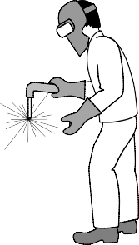
dBa
20 40 60 80 100 120 140 160
leaves rustling 20 dBa

heavy tra c 78 dBa lawn mower 80 dBa motorcycle 85 dBa
bar music 90 dBa

crane operator 90 dBa

framing carpenter 91 dBa welder 92 dBa
concrete worker 92 dBa ironworker 93 dBa
labourer 93 dBa

circular saw 113 dBa

thunderclap 120 dBa

ambulance siren 120 dBa

.22 ri e shot 132 dBa
Figure 1 — Noise levels

Now complete the Learning Task Self-Test.

Self-Test 3
- Which of the following is typically not an airborne hazard?
  - Dust
  - Mould
  - Asbestos
  - Mercury

- In what products can arsenic be found?
  - Paint
  - Cleaners
  - Welding fumes
  - Wood preservatives

- Which of the following is termed a “heavy metal”?
  - Mercury
  - Asbestos
  - Forged steel
  - Ultraviolet radiation

- Which of the following is not considered a potential source of hazardous vapours?
  - Dermatitis
  - Surface coatings
  - Ultraviolet radiation
  - Welding electrode coating

- Always short circuit a NiCad battery before charging.
  - True
  - False

- Cadmium is a heavy metal and is considered very toxic.
  - True
  - False

- What is another term for musculoskeletal injury?
  - Hematoma
  - Concussion
  - Bone fracture
  - Repetitive strain injury

- Dermatitis can be caused by exposure to chemicals at work.
  - True
  - False

LEARNING TASK 4

Describe general safety precautions and procedures
Before you start working at a new job or a new work site, make sure you are given basic safety information. This basic information should include at least the following:
- a guided tour of the work area
- a thorough explanation of your responsibilities
- location of first aid equipment and personnel
- location of emergency equipment
- personal protective equipment if required
- method of reporting injuries
- plant safety rules
- plant safety training/orientation
- muster points/evacuation procedures

Safety awareness
Being constantly aware of conditions that affect health and a safe working environment is the responsibility of all workers. You must be completely alert when you move about the job site and must have a constant awareness of your surroundings.

This should include:
- identifying and fixing potential safety problems
- performing day-to-day work using the proper safety equipment
- checking the condition or operation of safety equipment and tools regularly
- identifying safety problems and unsafe work practices
- performing tasks safely to avoid danger to self or co-workers
- warning co-workers of potential hazards

Horseplay
Horseplay, fighting, and practical jokes are inappropriate behaviour for a job site as they can be extremely dangerous and cause injuries.

Failures to follow known safety procedures or knowingly allowing uncontrolled hazardous situations to develop are safety violations with potentially serious consequences, not the least of which could be losing your job.

Respect for others’ safety
Every person has the right to work in a safe environment. Everyone must work in accordance with good safety practices as discussed, instructed, and posted. Every person must also refrain from any unsafe act that might endanger oneself or fellow workers.

Proximity work
Proximity work is work being performed near a hazard, but not in direct contact with it. Proximity work requires extra caution and awareness of the nearby hazard. The hazard may be hot piping, energized electrical equipment, or running motors and machinery. There may be special clearance requirements that require barricades or having a monitor watch you to maintain safe working distances.

When working with a crane near high-voltage power lines, extreme caution should be used. Although you are not the operator of the crane, you may be doing the rigging or handling the load that the crane lifts.

Keep your distance from power lines! The area surrounding every live power line is referred to as the absolute limit of approach. It is strictly forbidden to move any crane boom, load line, or load into this area unless the power line has been de-energized. There are no exceptions.

This absolute limit of approach varies according to local, provincial, state, and federal laws and to the crane manufacturer’s recommendation, but generally it is as shown in Figure 1.

3 m (10')
4.5 m (15')
6 m (20')

750 – 75000 volts 75000 – 250000 volts over 250000 volts
Figure 1 — Limits of approach to power lines, according to voltage

Electrical hazard guidelines
In order to create a safe work environment, workers need to guard against contact with electrical voltages and control electrical currents. Make the environment safer by doing the following:
  - Protect portable electrical equipment with an approved ground fault circuit interrupter (GFCI) when using the equipment outdoors.
  - Ensure all the cords are in good condition, with the caps and plugs well secured on the cables. Ensure the proper U-ground plug is in good working condition.

- Use cords of sufficient gauge for the amount of current used by the tools they are powering. Each tool is labelled with the power that it draws.
- Wear rubber boots when working in wet conditions and keep your feet dry.

- Tag any faulty tool that may result in a shock as “out of service.”

- Stay clear of overhead power lines and do not use ladders or long-handled paint rollers close to any electrical power line.
- Communicate with the electrician or power company to move or disconnect any cable you need moved or altered.
- Treat all conductors and bare wires—even apparently de-energized ones—as if they are energized until they are locked out and tagged.

Grounding tools and equipment
The WCB Occupational Health & Safety Regulation 19.15 requires that, when used outdoors or in a wet or damp location, portable electrical equipment, including temporary lighting, must be protected by an approved ground fault circuit interrupter (GFCI). Make sure that all the cords are in good condition with the caps and plugs well secured on the cables.

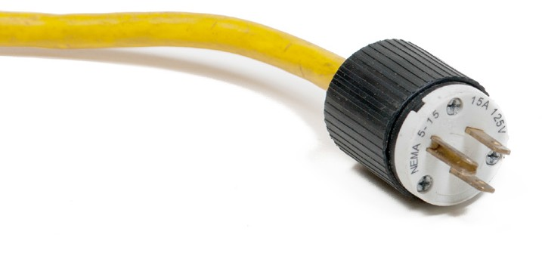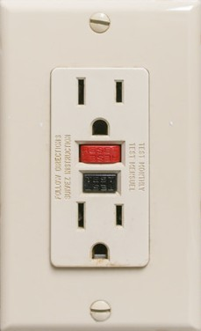
Figure 2 — Grounded plug and socket

It is important that you use a three-wire cord and the proper U-ground prong on the cord. The third wire is connected to ground; therefore, the operator should not receive an electrical shock if the tool or equipment develops a short circuit.

Double-insulated cords and tools are also effective in preventing shocks when using power tools. Before taking any electrical appliance or tool apart, lock out or disconnect the electrical power supply.

Tools
You must think about safety before using any tool. You should know how the tool works and some of the possible dangers of using it incorrectly.

Always protect yourself when you are using tools by wearing appropriate personal protective equipment (PPE), such as safety gloves and eye protection.

Make sure every tool you use is in good condition.

Report any tool or piece of equipment that is broken or does not function properly to your immediate supervisor or tool crib attendant. Also tag the equipment and remove it from service for repair or disposal.

Proper tool use
Only use tools for their intended function. Make sure the tool is the right size for the job. Do not modify or adapt a tool in a manner that might make it unsafe. Do not use power tools that haven’t been tested and certified for use in Canada. Power tools must have a Canadian testing certification label (CSA, ULC).

General hand tool safety
There are a number of general safety rules that you must follow when you use hand tools:
  - Keep tools clean and in good working order. Wipe them with a light oil to prevent rusting.

  - Never leave tools where they protrude or can fall and strike someone, particularly in an area where work is being done above ground level.
  - Return tools to their proper place when not in use.

  - Always wear safety goggles or a face shield to protect your eyes when using hand tools that may produce flying chips or particles, such as chisels and hammers.
  - When using a sharp-edged tool, always cut away from the body.

  - Make sure that all handles on tools (such as axes and hammers) are tight-fi and adequately secured.
  - Keep edge-cutting tools properly sharpened so that they do the job well and do not have to be forced because of dull edges.

General power tool safety
Extreme care should be taken when operating power tools and equipment. Before you attempt to operate any tool or piece of equipment, you must be fully trained by an experienced operator. Make sure that all guards are in place and function properly, and that all electrical connections are properly made.

Observe the following precautions when using equipment:
  - Understand the correct operating procedures and safety precautions before operating a piece of equipment.
  - Ensure the tools are double insulated and properly grounded.

  - Report defective or unsafe equipment to a responsible individual to prevent serious injury.

- Do not distract or interfere with the operator of a machine.

- Ensure cords to electrically powered tools are in good condition, with no frayed parts or bare wires showing.
- Make sure all guards on tools such as saws and grinders are in place, function properly, and are not wedged open.
- Always keep long hair and beards confined and clothing snug to avoid snagging.

It is your responsibility to ensure you are properly trained on a tool or piece of equipment. Remember: if you are not familiar with a piece of equipment, leave it alone!

Make sure that hand and power tools are inspected, serviced, repaired, sharpened, or dressed as required to make them safe for use. Before using any tool, check the condition of all guards, tool retainers, power supply cords, extension cords, and other accessories. It is an unsafe practice
to bypass, disconnect, or remove guards, hoods, or shields. Report any damage or defects and return the tool to the crib for tagout.

Always use the appropriate safety equipment to protect your eyes and face from flying particles during any drilling, grinding, or buffing operations with an electric or pneumatic power tool (Figure 3).

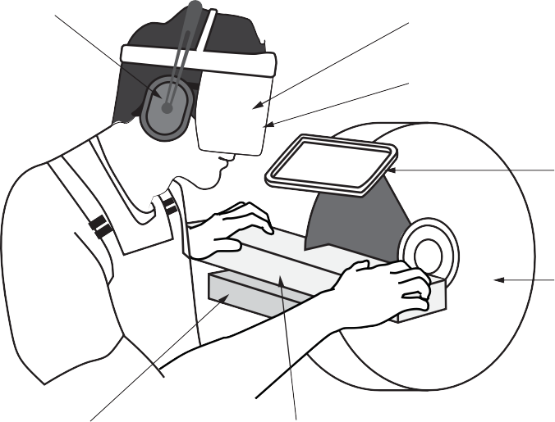
Hearing protection

Safety glasses

Face shield

Spark shield

Wheel guard

Tool rest

Work piece
Figure 3 — Use all safety devices

Be sure the equipment or machine is free from obstruction and that all personnel are clear before the machinery is activated. Hold hand-held power tools firmly and with adequate control and assume a comfortable, balanced body position.

Possible injury comes from the functional or “working” part of the tool, which could be the drill, blade, disk, grinding wheel, or other device. Shut off machinery if you are leaving the immediate area. Always disconnect, unplug, or lock out equipment before changing saw blades or grinding wheels, and before making major adjustments or performing preventive maintenance.

Allow revolving machinery to stop on its own before leaving it. Do not slow down or stop a machine with your hands. Before you begin adjusting or cleaning any machine, make sure it is stopped and LOTO or disconnected from the power source.

Some power tools have arbors (shafts or spindles) for mounting grinding wheels or other rotating tools. Always check to see that the wheel, blade, or other rotating tool is securely mounted on the arbor.

The importance of using power tools safely cannot be overemphasized. The two general types of power tools that you will use are electrical and pneumatically powered tools.

Avoid the use of electrical equipment in wet locations. If you must use electrical equipment in wet areas, make sure that a ground fault circuit interruption device is installed for your protection.

Do not lift or move an electric tool by its power supply cord. Supply cords are easily damaged and malfunctions can result from improper handling. Always remove plugs by grasping the plug and pulling it straight out of the wall receptacle.

Portable pneumatic (air-powered) tools present some of the same hazards as electrically powered tools, plus some that are unique to pneumatic tools. For example, you can trip over air supply hoses just as you can trip over electric tool cords. If an air hose is cut, broken, or disconnected while under pressure, it can whip about and strike or injure someone.

Route air hoses overhead or out of the way so they are not a tripping hazard; do not allow them to lie where they may be cut or run over by vehicles. The air blowing free from a hose can also cause chips, dirt and debris to fly about, causing irritating or dangerous conditions for the eyes and lungs.

Never point an air tool (e.g., an air chisel) in the direction of another person, as the tool may fly out and strike them. Never use compressed air to clean your clothing or blow air at any part of your body or another person. Air penetrating your skin can enter your bloodstream and cause death.

Ventilation
The environment in which you work is very important. The air around you may be filled with smoke from soldering or welding, fumes from chemicals used for cleaning, or mist from cleaners or paint. The pollutants can be harmful to your health.

Adequate ventilation is defined as the use of air movement to:
- reduce concentrations of airborne contaminants to below the acceptable limits in the worker’s breathing zone and work area
- prevent the buildup of combustible gases and vapours

- prevent oxygen-deficient or oxygen-enriched atmospheres from forming

Many types of ventilation equipment may be found in workplaces. Regardless of where you are working, it is important to become familiar with and to use the ventilation equipment or systems.

If you are going to be working in a small, enclosed area or in a shop where fumes or exhaust are a hazard, make sure that there is an extraction system and that it functions properly.

Confined space work
Confined space describes any enclosed temporary working area that has limited access and egress and is not made for continuous human occupancy. Systematic procedures must be followed for any worker to enter a confined space.

If entering a confined space is unavoidable, supervisors are given the responsibility to ensure that all the necessary precautions are taken; to check safety at each stage; to follow all written procedures; and to ensure that all workers are suited for the work and properly trained before they enter the confined space.

Mechanical and electrical isolation of equipment is essential if it could otherwise inadvertently operate or be operated. If gas, fumes, or vapours could enter the confined space, supply piping needs to physically isolate airborne hazards. In all cases, a check should be made to ensure isolation is effective. Check on the provision for ventilation.

You may be able to increase the number of openings and therefore improve ventilation. Mechanical ventilation may be necessary to ensure an adequate supply of fresh air. This is essential where portable gas cylinders and diesel-fuelled equipment are used inside the space because of the dangers from buildup of engine exhaust. Provision must be made for breathing apparatus to be made available if it is not possible to maintain adequate oxygen levels for confined space entry.

Warning: Carbon monoxide in the exhaust from gasoline-fuelled engines is so dangerous that use of such equipment in confined spaces should never be allowed.
Air testing of the environment is necessary to ensure that it is free from both toxic and flammable vapours and that it is fit to breathe.

A competent person should carry out testing using a suitable gas detector that is correctly calibrated. Where the risk assessment indicates that conditions may change—or as a further precaution—continue monitoring the air to detect any changes.

The provision for non-sparking tools and specially protected lighting is essential where flammable or potentially explosive atmospheres are likely. In certain confined spaces (e.g., inside metal tanks), suitable precautions to prevent electric shock include use of extra-low- voltage equipment (typically less than 30 V) and, where necessary, residual current devices such as ground fault circuit interrupters (GFCIs).

Immediate means of communication must be made available for workers in confined spaces to call the standby person, and the standby person must have a means to call rescue personnel.

A rescue team with properly trained personnel and a rescue plan must be in place before any worker is allowed to enter a confined space. All lifelines, harnesses and lifting equipment must be approved for the application, and the standby person must be able to use the equipment to lift the person from the confined space.

See the WorkSafeBC document “Confined Manual”:
Space Entry Program: A Reference

http://www.worksafebc.com/publications/health_and_safety/by_topic/assets/pdf/confined_space_entry_bk84.pdf

Housekeeping
Good housekeeping is a necessity for a safe job site. Some good housekeeping procedures are:
  - Do not block exits.

  - Change burned-out light fixtures in work areas, walkways, and exits.

  - Keep floors and work areas clean and dry.

  - Organize material, equipment, and tools.

  - Keep steps and ladders in serviceable condition.

  - Keep emergency equipment clean and unobstructed.

  - Ensure that all signs and caution labels are in good condition and visible.

  - Put your waste products into properly labelled containers.

Flammable liquids
All flammable liquids are volatile by nature, but it’s the liquid’s vapours (combined with air), rather than the liquid itself, that ignite and burn. The rate of evaporation varies from one liquid to another and increases with temperature. Increased temperature also increases vapour production—this creates a more hazardous condition.

Preventive fire safety precautions will be covered in Competency A-5 “Describe Fire Safety.”

Weather
Since tradespersons may have to work in poor weather, you must have adequate rain gear and warm clothing. Good rain gear is a necessity while working in areas where the annual rainfall is high. Care should be taken to keep the head, legs, and feet dry, as large amounts of body heat are lost from these areas. Ensure that rain gear will breathe so that perspiration is able to escape. Pants and jackets should be loose enough to allow full movement when working.

Rubber boots with steel toes and steel shanks are available to protect the feet. Use kneepads if the tasks require frequent kneeling. Not only do the pads protect knees, but they also help to keep them dry when ground conditions are wet.

Safety precautions when working at elevations
Falls from elevated areas are one of the leading causes of fatalities in the workplace. While the risk of falls is high, there is much you can do to safeguard yourself. Following proper safety procedures and staying alert at all times will help you stay safe when working at an elevation.

Wind
If your work area is exposed to the wind, a windbreak should be constructed from plywood, polyethylene sheets, or tarps. In high-rise construction it is a common practice to provide a windbreak at each floor until the glazing has been completed. Remember, strong winds can cause your body to lose heat much faster than if the air is still, so it’s important to wear windproof clothing.

Wall and floor openings
Any opening in a wall or floor is a safety hazard. For protection, openings can be either covered or guarded. Cover any hole whenever possible. When it is not practical to cover a hole, use barricades or guards. The types of guards and barricades used will vary from job to job.

There are different rules and procedures related to covering and guarding wall and floor openings. You will use the WorkSafeBC regulations as a minimum guideline, but you will also need to become familiar with the policies on your job site.

Guards and barriers
Except for work platforms (scaffolds) where fall protection is provided, guards are required whenever there is a drop of 1.22 m (4 ft.) or more. Guards and rails must be placed at stairways, openings in floors, and the edges of open floors. Guardrails consist of a top rail, a midrail, and a toe-board. The toe-board is to prevent tools and materials from dropping through the openings.

Ladders
Ladders are used to perform work in elevated locations. You may use ladders to do many jobs, and you must be familiar with the safe use of all types of ladders. Types of ladders and the proper use of each are covered in detail later in Competency C-4: Describe Ladders and Platforms.

Do not use metal ladders or wire-reinforced ladders near energized electrical equipment. Use fibreglass or un-reinforced wood ladders where there are electrical hazards. Equipment that might be dangerous if contacted by a metal ladder includes junction boxes, fuse panels, overhead lines, and cable trays.
When climbing or working from a ladder, an important rule to protect yourself against a fall is to maintain three-point contact with the ladder at all times. This means that you either have two hands and one foot or two feet and one hand touching the ladder constantly.

The following precautions and procedures apply to all portable ladders:
  - Inspect all portable ladders before use.

  - Do not use ladders with loose, broken, or missing rungs, split side rails, or other dangerous defects.
  - Ensure that aluminum ladders have all members true and straight.

  - Remove from use any aluminum ladder with bends, kinks, or other damage.

  - Have damaged ladders repaired by an appropriate, reputable firm before putting them back into service.
  - Use only transparent protective coatings or preservatives on wooden ladders, so that possible defects will remain visible on inspection (no paint).
  - Never reach more than one arm’s length beyond the side of the ladder.

  - Do not carry heavy or bulky items while going up or down ladders. Maintain three points of contact.
Always face the ladder when climbing up or down. Ensure that all ladders used:
  - bear the appropriate Canadian Standards Association (CSA) label

  - are placed on a firm and level base

  - are positioned so that the horizontal distance from the base to vertical plane of support observes the 1:4 ratio
  - have sufficient length to project approximately 1 m (3 ft.) above the upper landing to which it provides access, and
  - are secured when necessary to ensure stability during use

Work platforms
The term “work platforms” refers to a variety of different elevated or suspended work surfaces. This includes scaffolding and the more common boom lift or scissor lift. The chart in Figure 4 outlines the common types of work platforms.

Work Platforms
Sca olds
Movable work platforms
Suspended staging
Elevating work platforms
Platforms supported by other equipment
Permanent powered platform
Swing stage
Boatswain’s chair
Lift truck supported
Crane or hoist supported
Powered swing stage (portable powered platform)
Manual swing stage
Self-propelled elevating work platform
Portable elevating work platform
Boom supported
Other than boom supported
Figure 4 — Work platforms

Guardrails
Temporary work platforms require guardrails where there is a drop of 3 m (10 ft.) or more. Guardrails consist of a top rail and a midrail. Toe-boards are also required in cases where materials or tools are placed on the work/travel surface and could fall off. The height
of a guardrail should be between 1020 and 1120 mm (40–44 in.). The midrail should be approximately halfway between the work/travel surface and the top rail.

Figure 5 — Guardrail and midrail

Guardrail construction requirements can be found in Part 4 of the WorkSafeBC OHS Regulation. We will also look more closely at the different types of work platforms and their applications in Competency C-4: Describe Ladders and Platforms.

Now complete the Learning Task Self-Test.

Self-Test 4
- Ventilation is a major consideration when arc welding.
  - True
  - False

- How must electrical cords always be disconnected?
  - By pulling on a sufficient length of cord
  - With a quick jerking movement to avoid arcing
  - By pulling the plug straight out of the receptacle
  - By holding the cord to avoid the finger coming into contact with the plug

- Which of these actions is an important part of safety and accident prevention?
  - Reporting violations
  - Good housekeeping skills
  - Staying away from all hazards
  - Locking up unused tools and equipment

- What describes work that is performed close to an unrelated hazard?
  - Unsafe work
  - Shadow work
  - Proximity work
  - Unrelated hazard work

- What should you do if you spot a hazard on the job site?
  - Flag the hazard.
  - Fix the problem if possible.
  - Perform all of the listed actions.
  - Inform co-workers and supervision.

- Which of the following best describes the area surrounding every high-voltage line?
  - No-fun zone
  - High voltage area
  - Area of extreme caution
  - Absolute limit of approach

- When a tool or piece of equipment is used in wet conditions, which of the following should be used?
  - Fuse box
  - Circuit breaker
  - Energized lockout box
  - Ground fault circuit interrupter

- Which of the following standards ratings should all power tools have?
  - CSA, UPS
  - ULC, CSA
  - FM, ASME
  - CPA, ATME

- If you are asked to work with a tool you are unfamiliar with, what steps should you take?
  - Trial and error.
  - Ask a co-worker to perform the task for you.
  - Leave the tool alone and proceed with another task.
  - Read the user’s manual and inform your foreman that you need instruction.

- What is the purpose of the U-ground prong found on a power cord?
  - It is connected to the ground to protect the user.
  - It is a safety feature important only for wet conditions.
  - It is a redundant safety feature that is more often than not removed.
  - It is used only for identifying which way the plug is inserted into the outlet.

- What is it your responsibility to do if you discover a faulty or damaged tool?
  - Stash it in the van.
  - Return it to the manufacturer for a refund.
  - Tag it as broken and return it to the tool crib.
  - Fix the tool as soon as possible to get it back in use.

- What is the rule of thumb regarding power tool guards and safety covers?
  - Always use them, with no exceptions.
  - Guards are to be used when the safety officer is around.
  - All guards must be used unless it is easier to work without them.
  - Watch a seasoned worker to determine when a guard can be removed.

- Housekeeping is a part of your job, is your responsibility, and is one of your important daily tasks.
  - True
  - False

- Always maintain four points of contact when climbing ladders.
  - True
  - False

- When do temporary work platforms require a guardrail?
  - When the potential drop is 2 m (6.5 ft.) more
  - When the potential drop is 1 m (3.3 ft.) or more
  - When the potential drop is 10 m (33 ft.) or more
  - When the potential drop is 3 m (10 ft.) or more

- Which of the following is not an elevated work platform?
  - Boom lift
  - Scissor lift
  - Scaffolding
  - The mezzanine level in the shop

LEARNING TASK 5

Describe emergency equipment and facilities

Utilities
Each time you have a new work location, check the location of the shutoffs for all of the utilities; that way you will be prepared for an emergency. Before you perform any trench work with power tools or equipment, you must locate any possible underground utility services.

Watch the WorkSafeBC video “Pre-excavation requirements”
http://www2.worksafebc.com/media/videos/popup/Excavations3.htm?

Electrical
Electrical service panels may be temporary or permanent. Temporary service panels at the job site are located in a box mounted on a large pole or post driven into the ground. Inside the box is a panel with breakers and outlets to supply electrical power to the site. It should contain a main shutoff switch at the top and have several breakers that can be tripped when the circuit is overloaded by too many power tools on one circuit. The electrical panel must be properly
grounded with ground rods/plates, according to the Canadian Electrical Code. The box must be waterproof and leak-proof, and the area in front of the box must be kept clear. Water must not be allowed to accumulate underfoot anywhere near the panel.

Electrical cords from the panel should be orderly and not allowed to become tangled. The box should be located at a convenient height so that workers can reach all the switches, breakers, and outlets without using a ladder or other assistance.

On very large jobs you may find temporary electrical service boards on each floor of a high- rise building. A large cable supplies power to these boards. Keep the cable out of water and protect it from damage. Do not drag the cable when moving the service board; lift and carry it. You should know where the temporary service is located and learn how to shut off the power in an emergency.

When permanent services for the building have been completely installed and signed off by the authorized electrician, workers may then use them. Make yourself aware of the location of the main panel or sub-panels being used, and learn how to shut them off in case of an emergency. If you must shut the power off, do so and notify your supervisor immediately.

Water supply
Find out where the water shutoff is located at your job site. If a pipe breaks or bursts under water pressure, the water may damage material, tools and equipment, or work already done. Water may create an electrical hazard if it comes into contact with electrical panels or outlets. If you must shut the water off, do so and notify your supervisor at once.

Gas supply
Locate the gas shutoff at your job site. Escaping gas can cause an explosion that could injure someone or do great damage. Gas shutoff valves are always at the gas meter that will be located outside the building. If you must shut off the gas, do so and notify your supervisor immediately.

Other services
Other services, such as telephone and data, do not usually present any danger to people, and there is no way you can shut them off. If the lines for these services are broken or cut and/or if they must be located and repaired or moved, get in touch with the company that supplies the service.

Emergency shutdown systems
There are emergency shutdown systems or “panic buttons” in many shops. When you enter a shop or an industrial setting for the first time, locate the emergency shutdown. These are installed so that only one switch has to be thrown to kill the power to a large amount of equipment. These systems are to be used in the event of an emergency for immediate response.

Fire control systems
When in shops, you should make yourself aware of the:
    - locations of all fire alarm pull stations

    - locations and class of fire extinguishers

    - fire drill procedures and the location of fire exits/muster points

Be aware of the smoke and heat detectors and automatic sprinkler systems that are installed in your workplace, as they are vital equipment in modern buildings. Take some time to determine how the system in your workplace operates and where the fire extinguishers and hoses are located.

Fire extinguishers are designed to deal with fires when they first start. They are still necessary even though an area is protected by sprinkler systems. If you have any doubt whether you can safely extinguish the fire using a portable extinguisher, evacuate the area.

Emergency wash stations
There may be times when you are working with acids or other substances that may “burn” your flesh. If you accidentally splash or spill some corrosive substance on your skin, you will want to wash the affected area very quickly with large amounts of water to dilute the acid and minimize burning. For this reason it is important to locate special emergency sinks or showers in the work site.

Emergency exits
When working on job sites, identify all emergency exits, stairways, and locations of fire extinguishers in case of an emergency. Ensure these are kept clear at all times.

First aid facilities
Every job site requires a minimum availability of first aid, as defi in the WorkSafeBC
OHS regulation, with a trained attendant usually available to handle a variety of emergencies, from minor cuts to major bleeding. Learn the location of first aid stations and who the first aid attendants are.

Emergency contact/phone numbers
Emergency telephones should be conveniently located throughout the job site or in the plant, so that help can be summoned quickly for any accident. These telephones should be direct lines to the first aid facility. Also, for every employee there should be an emergency contact and phone number on record that can be called in case of an emergency.

Outside meeting place
As part of a job site emergency preparedness plan, an outside meeting place or muster point should be designated so employees can be accounted for and can await further instructions. The muster point should be a safe area and should generally be away from the building, upwind in case of a fire or leak, and out of the way of incoming emergency personnel.

Disaster plan
As part of a job site emergency preparedness plan, all designated inside shelters, exits, evacuation routes and procedures, and outside meeting places should be identified. Exits and evacuation routes should be checked periodically to be sure they are not blocked. Exits should be of sufficient number and width, and in a location that workers can rapidly evacuate.

Now complete the Learning Task Self-Test.

Self-Test 5
- Panic buttons are installed so that equipment can be shut down in an emergency.
  - True
  - False

- Besides fire alarm pull stations and fire extinguishers, what other fire control systems should you know the location of when working in a shop?
  - Fire exits
  - Direct phone lines
  - Computer equipment
  - Emergency shutdown locators

- Why are emergency showers available at some work sites?
  - For use after work
  - In case you didn’t have time to shower at home
  - to clean tools that have been splashed with corrosives
  - To wash off accidental spills or splashes of hazardous materials

- What is one of the first things a worker should do when starting work on a new job site?
  - Locate the clock.
  - Locate your buddy.
  - Locate the lunchroom.
  - Locate all emergency shut-offs.

- When working in a shop, which of the following should you familiarize yourself with?
  - All of the choices
  - Location of fire alarm pull-station
  - Location and class of fire extinguishers
  - Fire drill procedures and muster points

- Where are the minimum standards of job site first-aid facilities described?
  - WorkSafe OHS Regulation
  - National Building Code
  - Workers’ Compensation Act
  - National Fire Protection Code

- Permanent electrical services must be authorized for use by the regulating authority.
  - True
  - False

- The area in front of an emergency exit may be an ideal place to store materials until the exit is required for use.
  - True
  - False

- First aid phones should require the user to dial 911 to prevent accidental calls and false alarms.
  - True
  - False

- If there is an accident with the gas utilities, the proper procedure is shut off the gas and then report to your supervisor as soon as safely possible.
  - True
  - False

- You are required by law to use a fire extinguisher to fight a fire regardless of the fire’s development.
  - True
  - False

LEARNING TASK 6

Describe how a workplace safety policy is established

Process
A health and safety program contains the health and safety elements of an organization, objectives that make it possible for the company to achieve its goal: the protection of its workers at the workplace.

Part 3 of the Occupational Health and Safety Regulation specifies the minimum requirements to be contained in a health and safety program. Some of the requirements specified in the regulation may not be applicable to every workplace. However, in consultation with the occupational health and safety committee, employers should carry out their own health and safety risk assessment to determine what hazards are present at the workplace. Once the hazards have been identified, controls for exposure to these hazards should be detailed in the health and safety program.

Read the following sections from Part 3 of the OHS Regulation now:
  - When program required http://www2.worksafebc.com/publications/OHSRegulation/Part3. asp#SectionNumber:3.1h
  - Small operations http://www2.worksafebc.com/publications/OHSRegulation/Part3. asp#SectionNumber:3.2tt
  - Contents of program http://www2.worksafebc.com/publications/OHSRegulation/Part3. asp#SectionNumber:3.3
Employers may also be required to establish a joint health and safety committee as per the requirement of the Workers Compensation Act the following sections from Part 3 Division 4 of the Act stipulate the requirements of a joint committee:

When a committee is required
Section 125
- in each workplace where 20 or more workers of the employer are regularly employed, and
- in any other workplace for which a joint committee is required by order.

Duties and function of the joint committee
Section 130
A joint committee has the following duties and functions in relation to its workplace:
  - to identify situations that may be unhealthy or unsafe for workers and advise on effective systems for responding to those situations;
  - to consider and expeditiously deal with complaints relating to the health and safety of workers;
  - to consult with workers and the employer on issues related to occupational health and safety and occupational environment;
  - to make recommendations to the employer and the workers for the improvement of the occupational health and safety and occupational environment of workers;
  - to make recommendations to the employer on educational programs promoting the health and safety of workers and compliance with this Part and the regulations and to monitor their effectiveness;
  - ) to advise the employer on programs and policies required under the regulations for the workplace and to monitor their effectiveness;
  - to advise the employer on proposed changes to the workplace or the work processes that may affect the health or safety of workers;
  - to ensure that accident investigations and regular inspections are carried out as required by this Part and the regulations;
  - to participate in inspections, investigations and inquiries as provided in this Part and the regulations;
  - to carry out any other duties and functions prescribed by regulation.

Joint committee procedure
Section 131
    - Subject to this Part and the regulations, a joint committee must establish its own rules of procedure, including rules respecting how it is to perform its duties and functions.
    - A joint committee must meet regularly at least once each month, unless another schedule is permitted or required by regulation or order.
Many companies and industrial operations find that a joint safety and health committee is an excellent means of consultation within their organization. Safety committees are helpful in assigning group and individual responsibilities, in promoting positive attitudes toward safety, and in improving techniques for accident prevention.

Committee members gain valuable knowledge and understanding through the exchange of information at meetings. When appropriate, set aside part of the meeting for education. Invite members, suppliers, and professionals from outside organizations to discuss equipment and materials that relate to safety. Send members to seminars and ask them to report what they have learned. Invite management to address the committee.

Additionally, there is a need to educate new members in the work of the committee and in meeting procedures. To educate other workers it is important for committee members to set an example by working safely.

Committees
As stated earlier, an employer is responsible for setting up a health and safety program. As part of the program, a health and safety committee must be established. The committee has the following responsibilities:
- assisting in creating a safe place to work

- recommending actions that will improve the effectiveness of the health and safety program
- promoting enforcement of regulations

This committee shall generally have at least four members who are experienced in the workplace. The structure of the committee is outlined in the Occupational Health and Safety Regulation, and provisions are made for varying the selection of members according to the special needs of the organization. The membership of the committee must represent both employers and workers. It should encourage enthusiasm and collaboration and promote efficiency through continuity.

Employee orientation
All workers should go through an orientation session the first time they come on each job site. If the job site hazards change, a further orientation is required. Orientations and safety training must be documented.

WorkSafeBC has instructions for conducting the orientation, topics, and examples of hazards that should be covered. The sample checklist can be found at: http://www2.worksafebc.com/PDFs/YoungWorker/sample_yw_orientation_checklist.pdf

Job safety analysis
A job safety analysis (JSA) is a practical safety procedure that focusses on job tasks. The JSA enables workers to identify hazards associated with a job and develop safe work practices and procedures that will reduce or eliminate those risks. The act of creating a JSA encourages workers to be alert and work safely; it is a valuable tool for training new workers to perform a task safely and effectively.

There are three stages in performing a job safety analysis:
- Identify the job steps.

- Identify the potential hazards associated with each of the steps.

- Determine preventive measures for each of the hazards.

Stage 1: Identify the job steps
Once a job has been chosen for a job safety analysis, it should then be broken down into a series of smaller steps. Each step is a part of the job that is necessary, and steps should be listed in the same order that they are performed on the job.

One way to identify the steps of a job is to observe an experienced worker perform that job in the same environment. Another is to gather input from other workers who have performed that same job.

This sequence of steps will become the basis of a safe work plan. It is important not to oversimplify, but at the same time you should not be too specific or you will end up with too many steps to the job. A rule of thumb is that most jobs can be broken into ten steps or less. If a job cannot be limited to ten steps, it may be necessary to break it down into more than one job, each with its own JSA.

Stage 2: Identify the potential job hazards
Once you have recorded the basic job steps, you must next identify any hazards associated with each step. You can determine the hazards using observation and your personal experience; therefore, this stage requires a walk-through survey of the work area. In addition to noting the basic layout of the workplace and reviewing any history of occupational illnesses or injuries, things to look for during the walk-through survey include:
  - sources of electricity

  - sources of load noise

  - sources of motion, such as machines or processes where movement may exist that could result in an impact between personnel and equipment
  - sources of high temperatures that could result in burns, eye injuries, or fire

  - types of chemicals used in the workplace

  - sources of harmful dusts

  - sources of light radiation such as welding, brazing, cutting, furnaces, heat treating, high-intensity lights, etc
  - the potential for falling or dropping objects

  - sharp objects that could poke, cut, stab, or puncture

  - bio hazards such as blood or other potentially infected material

This information will enable you to develop a list of potential hazards in the following basic hazard categories:
- impact
- penetration
- compression (roll-over)
- chemical
- heat/cold
- harmful dust
- light (optical) radiation, and
- biological

Your goal is to determine the worst-case scenario, consider potential consequences and identify how these consequences may change over time.

Stage 3: Determine the preventive measures for each of the hazards
When Stage 2 is complete, the employer should organize and analyze the data so that it may be efficiently used in determining the proper types of controls or preventive measures that are required to reduce or eliminate the potential hazards.

PPE is the last line of defence in protecting workers from hazards in the workplace. Before requiring workers to wear PPE to protect them from a specific hazard, the worker and employer must try to eliminate the hazard or reduce it as much as possible.

The following controls (in order from most to least effective) must be considered first:

Elimination
Can the hazard be eliminated from the workplace completely?
Example: perform a critical lift at night when other workers are not present.

Substitution
Can the hazard be replaced with something non-hazardous or less hazardous? Example: replace a noisy machine with a quiet one; use safer chemicals.

Engineering
Can the physical work environment be changed to control the risk?
For example: Enclose a piece of equipment to contain contaminants or isolate the noise source.

Administrative
Can changes be made to the work activities to make them safer?
Example: reduce the time workers are exposed to a hazard by rotating them to another task.

PPE
When can PPE be used to protect workers?

If elimination, substitution, engineering, and administrative controls do not effectively control the hazard, PPE may be necessary, either alone or in addition to other measures, to help protect workers. Remember, PPE is the last line of defence and is not the most effective safety measure because it places only a barrier between the worker and the hazard. The hazard still exists; so
if the right PPE is not worn properly or when it is needed, or the PPE fails (for example, gloves leak), the worker is not protected.

Be as specific as you can with the recommended procedures. Use statements that describe both what action is to be taken and how it is to be performed—for example, “Stand to the right side of the service box.”

Examine the sample JSA in Figure 1 to see what job steps are necessary to replace a fluorescent light ballast, the associated hazards, and what preventive measures need to be taken. Note that the preventive measures are positioned to match the possible hazard and job steps.

Job Steps | Hazards | Preventive Measures
1. Identify the circuit to be worked on and de-energize it at the electrical panel. | - Shock hazard  - Spark hazard | - Remove all watches, rings, and other current- conducting jewellery.  - Wear electric shock–resistant footwear.  - Wear safety glasses with side shields.  - Lock out and tag out at the panel or switch with your own lock.  - Where several people are working on the circuit, provide for additional locks with the use of a scissor clip.
2. Set up and climb stepladder in the desired work area. | - Back injury or strain | - Use proper lifting techniques. Ask for help when moving heavy or bulky objects.
 | - Tripping while carrying the ladder | - Clear the floor area of any obstructions.
 | - Crushing/pinching of hands and fingers | - Wear gloves when possible.
 | - Falling from ladder | - Inspect the ladder before use. Do not use a damaged ladder.  - Have someone hold the ladder if it will provide more support.  - Be sure to set up the ladder on an even/level surface.  - Do not position the ladder in front of a closed door that can open into the ladder.
 | - Falling objects injuring people below | - Use barricades or signs to warn of the presence of the ladder and the potential of objects falling on workers below.  - Require the use of hard hats.

Job Steps | Hazards | Preventive Measures
3. Verify that the fixture is de-energized. | - Shock hazard  - Spark hazard  - Arc flashes | - Use a voltage tester. Test it first on a known live circuit to make sure it works.
4. Remove old ballast and replace with new one. | - Cut hands/knuckles  - Stab wound | - Apply force away from your body when prying with hand tools (like a screwdriver).  - Use the right tool for the job.  - Wear gloves when practical.
 | - Eye injury | - Wear safety glasses if something may fly into your eye.
 | - Exposure of eyes, skin, etc., to  hazardous materials | - Read and understand the Material Safety Data Sheet (MSDS) for the materials you are using.
5. Re-energize the circuit and test the fixture. | - Arc flashes | - Always stand to the side of a service box when resetting a breaker.
Figure 1 — Sample job safety analysis document

A job safety analysis can help reduce accidents and injuries in the workplace, but only if the information is passed on to all of the workers who will be performing the job. After the JSA is complete, the workers who will perform the task should discuss the hazards and controls listed. Workers should ensure that all safety equipment and PPE that are required by the JSA are available.

Remember: it is important to ensure that all the basic steps that have been noted are in the correct order and suitable preventive measures are in place. The job foreman or supervisor will ensure that workers understand what they are required to do and the reasons for the preventive measures.

Each JSA will need to be reviewed and updated whenever new equipment, materials, or processes are introduced, and after coffee or lunch breaks. Even if no changes have been made, new hazards may be discovered that were previously overlooked. If an injury or illness occurs, the JSA should be reviewed immediately and reassessed to prevent further accidents.

Job site safety meetings
Safety meetings (“toolbox talks”) are a hands-on way to remind workers that health and safety are important on the job. The objective is to help workers recognize and control hazards at the work site. These meeting are a good opportunity to get input on JSAs.

  - The meeting should be focussed on the site and work conditions.

  - The meeting should take place on the site or near the tools and equipment you are talking about.

    - The subject should clearly let workers know exactly what you are going to talk about and why it’s important.
    - Hazards should be pinpointed, and the discussion should include what may happen if proper safety is not followed and how to control or prevent these hazards.
    - Wherever possible, key points should be demonstrated using real tools, equipment, and materials.
    - In some cases you could be asked to demonstrate what you have learned.

    - Each meeting should take about five to ten minutes if held daily or weekly.

Reporting accidents
All accidents must be reported. Report the accident to the shop staff and then to the first aid attendant to ensure coverage, in case Workers’ Compensation benefits are available. The first aid attendant will record all injuries in a log and complete the necessary WCB forms.

Investigations
As a safety precaution, all accidents should be investigated whether there was an injury or not; this way, appropriate changes in work procedure can be identified if needed.

WorksafeBC safety officers will investigate accidents of a serious nature.

First aid
Every job site requires a minimum level of first aid to be available. The requirements are based on the hazard level, surface travel time to a hospital, and the size of the workforce on the site. Because of these variables, the level of first aid requirements may differ from site to site.

Modern industrial settings and all BC training institutions are equipped with a first aid station with a trained attendant. The person who staffs that station is able to perform a wide variety of services, from bandaging minor cuts to stopping major bleeding and splinting broken bones.

Find out where the first aid station is, who staffs it, and what services are available. If you sustain an injury, no matter how minor, ensure that the incident is reported in the first aid station log.
Minor problems often develop into major problems; to ensure the WCB will cover you, report all injuries promptly.

Hearing
A workplace safety program should include a hearing protection program. This should include:
  - noise measurement
  - education and training
  - engineering noise control
  - hearing protection
  - posting of noise hazards
  - annual hearing tests
  - annual program review

Job task permits
Some tasks on a work site are identified as being hazardous enough to require special permits that ensure all safety precautions have been taken. Examples of these tasks include hot work, confined space work, and lockout procedures.

Hot work permits
Special considerations must be made when doing hot work. Hot work is simply any process or temporary work done that could result in a fire. Jobs that require cutting, grinding, drilling, or welding of metals are all examples of hot work. Before starting any hot work it is best
to determine whether the job can be done in a different way so as to avoid the risk of fire altogether. If there is no alternative to doing the hot work, then you will need to obtain a hot work permit from the job site’s health and safety officer or foreman. Complete the permit, follow the precautions on the permit, and post the permit in the work area.

Confined space permit
A confined space entry permit is required and is used to make everyone aware of work that will take place in a confined space. A written procedure must be carried out to assess the risk for working in a confined space by identifying the hazards present and to determine what precautions must be taken. The assessment must include information on:
  - the task
  - working environment
  - working materials
  - tools required
  - the qualifications of the person doing the work
  - the emergency rescue plan

The permit must bear the supervisor’s name and must be posted at the entrance to the confined space. Other information required on the permit includes:
    - the type of work activity

    - names of the workers who are in the confined space

    - what control measures or precautions were in place prior to entry and while workers were inside
    - when the permit expires

Lockout
The workplace safety program must ensure that lockout procedures are established and complied with the next Learning Task covers lockout procedures in detail.

Now complete the Learning Task Self-Test.

Self-Test 6
- When does a work site typically require a joint health and safety committee?
  - If the company is a roofing company
  - If the company has a clean safety record
  - If there are 20 or more regularly employed workers
  - If it is proven the work site is clear of any workplace hazards

- Which of the following is a joint health and safety committee responsibility?
  - Report poor quality work.
  - Get workers to start on time.
  - Identify and remedy unsafe conditions.
  - Recommend ways to improve worker morale.

- What should an occupational health and safety program be designed to do?
  - Reduce insurance premiums.
  - Hold employees accountable for WCB claims.
  - Write WorkSafeBC regulations re worksite safety.
  - Prevent workplace injuries and occupational diseases.

- Which of the following groups is a job safety analysis meant to educate about potential job site hazards?
  - Workers
  - WCB investigators
  - Guests to the worksite
  - Owners and contractors

- What are the three parts typically found in a job safety analysis?
  - Introduction, body, and conclusion
  - Lists of tasks, hazards, and controls
  - Lists of hazards, first aid measures, and toxic materials
  - Minutes of safety meetings, accident reports, investigations

- What is the primary objective of toolbox safety talks?
  - Report accidents.
  - Ensure workers retrieve the proper tools from their toolbox.
  - Give every worker an opportunity to lead a group discussion.
  - Remind workers regularly of common hazards they will encounter.

- Every new worker must be given the opportunity to refuse a site orientation session.
  - True
  - False

- Job safety analyses should be reviewed by all workers after coffee break or if conditions change.
  - True
  - False

- Hot work permits are required if the job site ambient temperature is higher than 30˚C.
  - True
  - False

- Which of the following information would not be found on a confined space permit?
  - Any quality tests done on atmosphere
  - Timeline of work, including length of exposure
  - The name of the worker, spotter and supervisor with contact info
  - Material Safety Data Sheet regarding hazardous material used for the task

LEARNING TASK 7

Describe lockout and tagout (LOTO) procedures

Understanding of system operation
When performing maintenance, or doing repair work, or when a machine is in an unsafe state, it is vital to eliminate the possibility of the machine moving unexpectedly.

Maintenance or repairs on process piping or working with electrical equipment might put a worker at risk of an accidental release of energy. Precautions employed to eliminate these hazards are called lockout or lock-off procedures. Simply locking off the electrical power or
closing a valve is not necessarily enough. A systematic and thorough knowledge of the system and work to be performed is necessary before you can implement any lockout procedure.

WorkSafeBC regulations and lockouts
De-energization and lockout procedures are described in Part 10 of the OHS Regulation.

Note that:
- You must use your own locks and keys.

- You must not borrow another person’s lock. If necessary, get extra locks from your supervisor.

- You must remove your own locks.

- You must not remove someone else’s lock.

- If you apply the first lock, you must ensure that the machinery cannot be operated.

- In an emergency, a senior shift supervisor may remove someone else’s lock, but only after every effort has been made to contact the person who put on the lock. The supervisor must ensure that the equipment will operate safely.

Identification requirements
The following items must be identified and acted on as part of a lockout procedure:
  - Identify all energy sources that influence or are connected to the machinery or equipment.

  - Identify the correct electrical source and disconnect it in the following way:

▸ For plugged-in equipment, pull the plug from the socket and place the male end on the equipment where it is readily visible.

    - Identify the correct breaker and switch it to the off position.

    - Identify the equipment to be shut down.

    - Identify the correct switch and turn it to the off position.

Situations where lockout is required
Depending on the type of machine involved, in addition to electrical power, you must consider the following sources of energy:
    - hydraulic fluids under pressure
    - compressed air or gases
    - energy stored in springs
    - potential energy from suspended parts
    - electrical components that hold a charge
    - any other source that might cause mechanical movement

Lockout equipment
There are many different types of locking systems. Put your personal lock on the switch using a scissor adapter or hasp as shown in Figure 1. While this figure shows a single safety hasp and lock, it is also common to use more than one hasp when locking out.

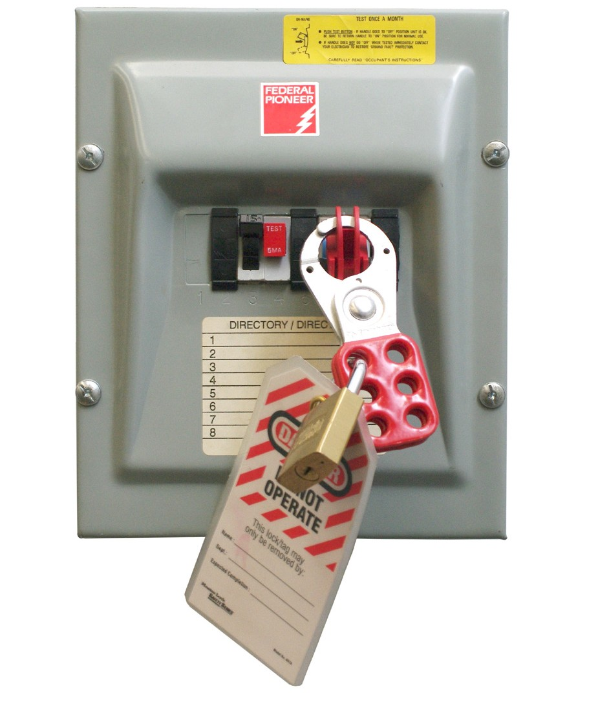
Figure 1 — Safety switch locked out

Chains and or cables
If you need to lock out equipment with more than one energy source, instead of using several locks you could use a lockout cable to lock out several disconnect switches (Figure 2). This cable would be run through the locking hole in each of the safety disconnects you are locking out.
The cable diameter must be large enough to prevent the safety disconnect switches from being operated accidentally. A scissor lock adapter can be used to apply multiple locks.

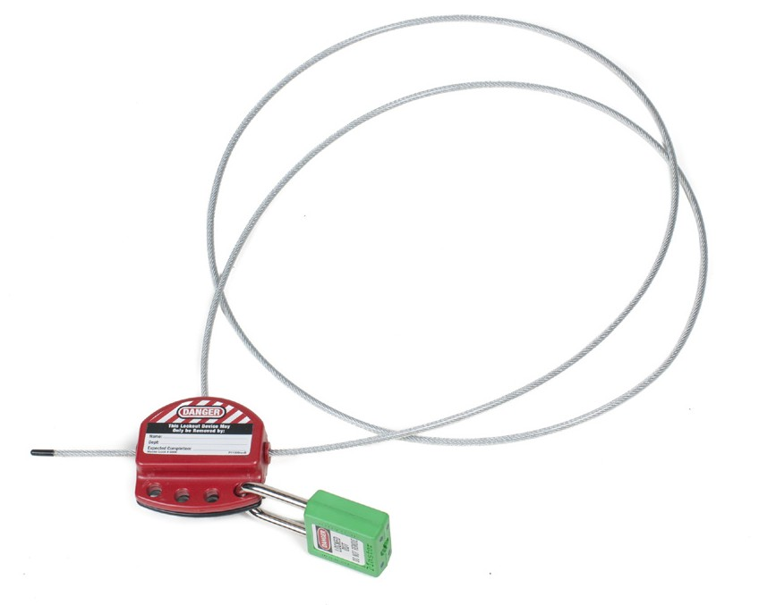
Figure 2 — Cable lockout for multiple disconnects

Chains and cables can also be used be used to make valve handles inoperable (Figure 3).

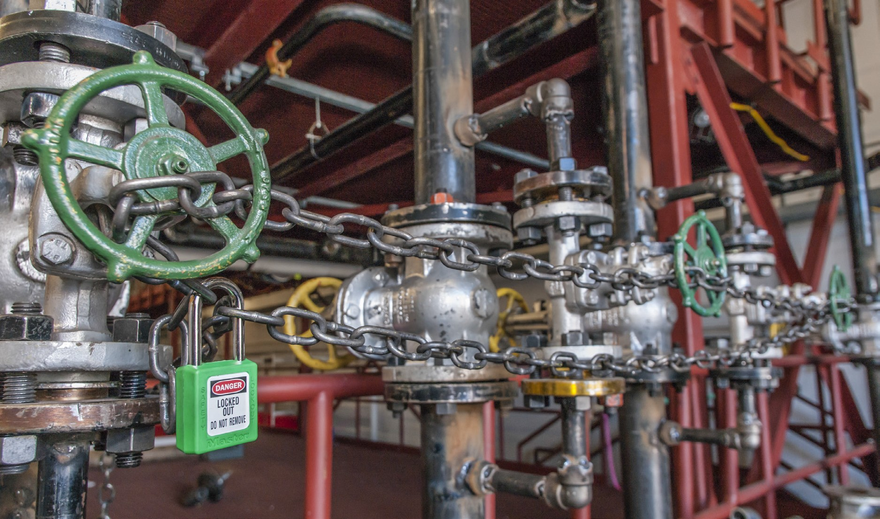
Figure 3 — Chains used to lock out valve handles

Tags, locks, and scissors
Lockout devices must provide a visual verification, must be locked as required, and must have a “DO NOT OPERATE” tag placed on them. The tag must have on it your name, the date and time, and the location and identity of the equipment being worked on.

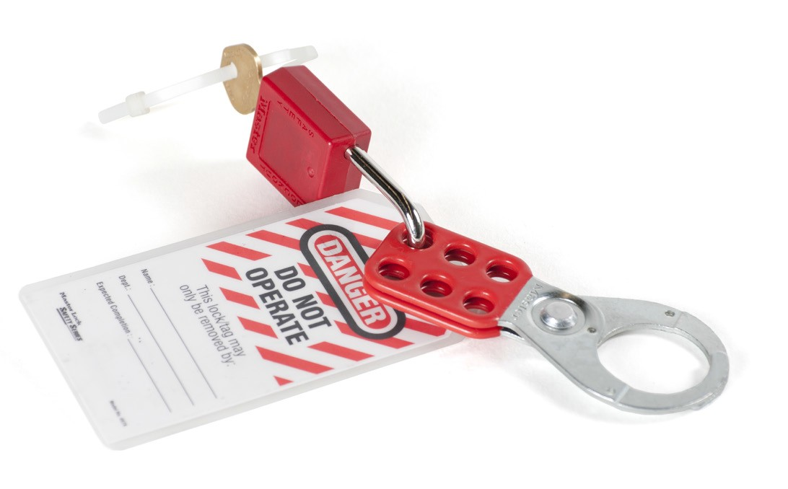
Figure 4 — Safety tag and hasp with lock

Lockout for circuit breakers
Lock out the desired breaker. If there is access to the main breaker or disconnect that kills all power to the panel, and if no other workers need to lock out in that panel, then you may lock the panel door closed (Figure 5).

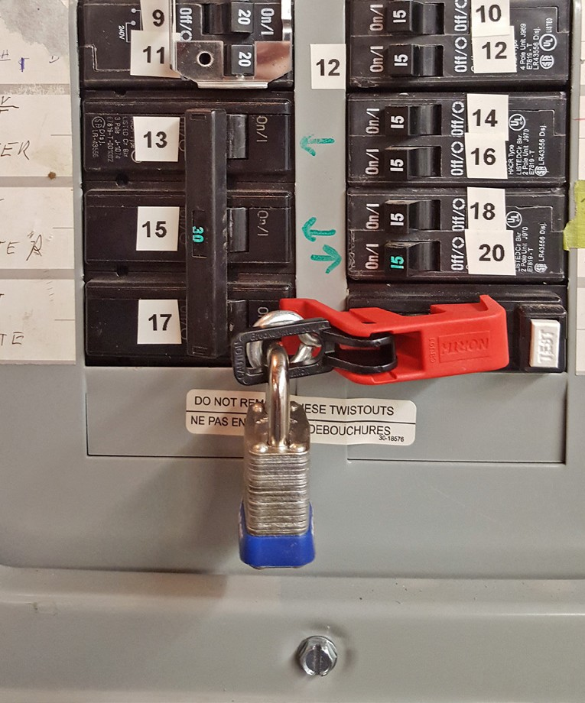
Figure 5 — Breaker lockouts

Cord locks
For plugged-in equipment, if the male end of the plug is in view and you do not leave the machine until you have finished working, a lock is not needed. If the plug is not in view, use an adapter and lock, or lock the cord to an object to prevent it from being reconnected to the circuit. Figure 6 shows a power cord plug lock.

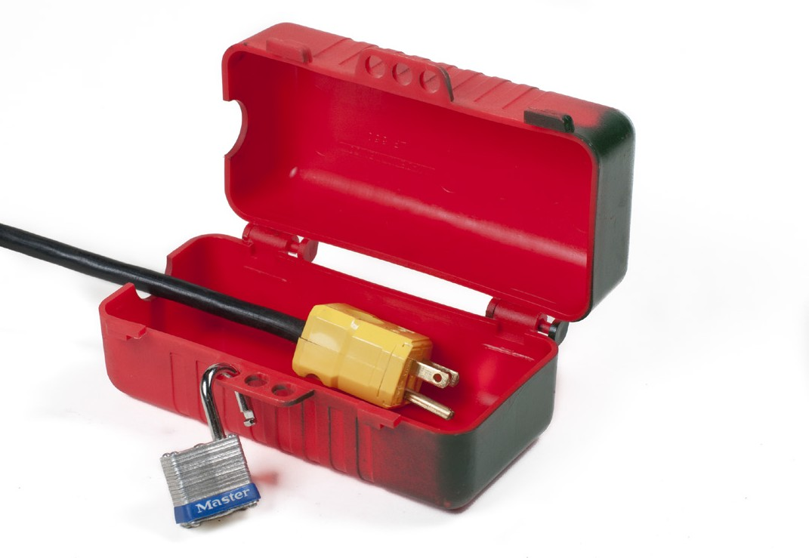
Figure 6 — Power cord plug lock

Lockout station
A lockout station has keyed locks to be used only for equipment lockout. It also contains tags and lockout devices. Locks have one key that is kept with the installer of the lock. Once the work procedure is completed, the lock and key should be returned to the lockout station. These stations can be portable or mounted permanently to the wall where required.

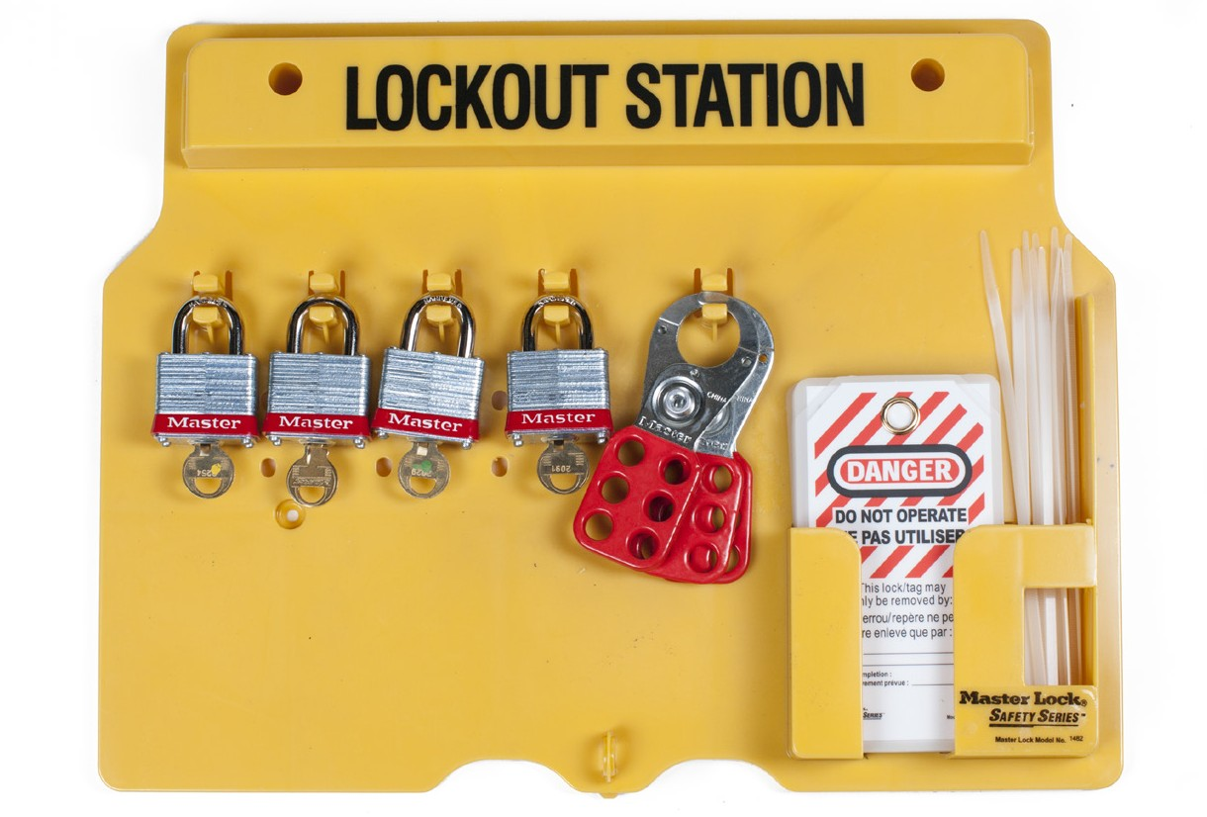
Figure 7 — Lockout station

Key box system
Machines are often powered by several sources, so situations can arise where a single job requires you to lock out more than one power source. This can be done efficiently and safely with a key box system.

A key box is a box mounted on a wall, containing two sets of locks. Lock set A is mastered to a single key and lock set B is mastered to a different single key. The key box is treated as a locked- out power source. All the regulations of a lockout apply to the key box. A key box lockout procedure checklist must be posted at the key box. Also, other workers may add their locks to the key box.

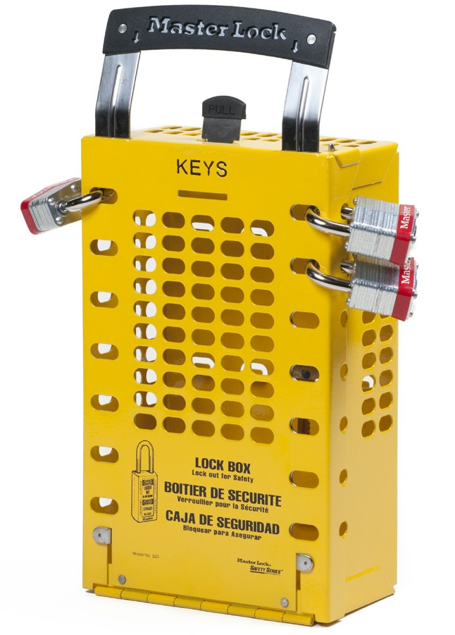
Figure 8 — Key box

Spades and blinds
In the context of lockout, a spade is a round plate with a small tab that is placed between two pipe flanges in order to lock out certain piping sections, and is sometimes referred to as a frying pan (Figure 9). The spade prevents cross-contamination and also allows work to be done on individual piping sections. The small tab lets workers see that the spade is in place, in the same way an indicator valve allows workers see whether a valve is in the open or closed position.

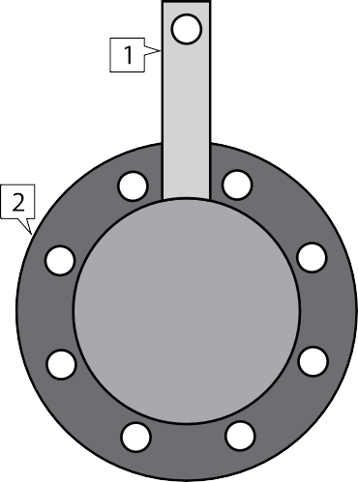

Figure 9 — Spade parts

A blind flange(Figure 10) is used when the end of the pipe or valve is removed. An open flange
can be closed off with a blind flange.

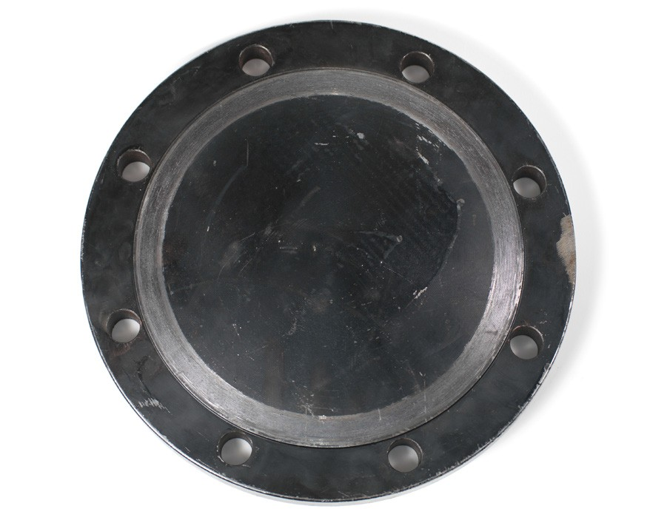
Figure 10 — Blind flange

Now complete the Learning Task Self-Test.

Self-Test 7
- What rules apply when working on equipment requiring lockout procedures?
  - You should apply and tag only your own lock.
  - You should remove all tags other than your own, then apply your own tag.
  - You should remove all locks other than your own, then apply your own lock.
  - You should remove locks and tags other than your own and then apply yours.

- What does it mean to “lock out” machinery or equipment?
  - Turn all switches off.
  - Shut off the electrical supply.
  - Disconnect all energy sources.
  - Disconnect the compressed air.

- Work is to be performed on a live process piping line. What precautions must be initiated before work can begin?
  - The upstream valve must be shut and flagged.
  - New personal protective equipment is distributed.
  - Lockout and tagout procedures must be initiated and performed.
  - A general work site safety meeting must take place to discuss work.

- In a lockout, who is authorized to remove your lock?
  - You
  - Safety officer
  - Site supervisor
  - The next shift worker

- You are to begin lockout procedures on a pump. What is one of your tasks?
  - Ensure the pump cannot operate.
  - Remove locks from the night shift.
  - Ensure flow is unrestricted to the pump.
  - Ensure all workers have a copy of your key.

- Which of the following situations would not require lockout/tagout?
  - Repairing a sump pump.
  - Replacing a hydraulic valve.
  - Removing and repairing a steam trap.
  - Flying a bundle of pipe over a walkway.

- Lockout devices require a visual verification that states: name of worker, date of work, equipment to be worked on. What else must be stated?
  - Danger Do Not Operate.
  - Replacement part to be removed.
  - Grade and quality of scissor hasp.
  - The department the worker is from.

- Which of the following is the safest way to lock out a piece of equipment that plugs into a receptacle?
  - Tell co-workers face to face.
  - Yellow flag the on/off switch.
  - Post a memo in the lunchroom.
  - Use a power cord plug lock box.

- In an emergency, management may remove someone else’s lock, but only if the worker cannot be located.
  - True
  - False

- At shift end, your co-worker must leave the site early. He can give you permission to remove his lock for him.
  - True
  - False

- A blind is used to lock out a section of pipe only if there is not a valve readily accessible.
  - True
  - False

- A spade, also known as a frying pan, is a blind placed between two flanges.
  - True
  - False

Answer Key

Self-Test 1
    - a. Worker

    - a. Direct costs are less than indirect costs.

    - a. Young workers

    - a. All of the choices

    - c. All workers and employers are committed to making safety a part of every day.

    - c. Housekeeping

    - b. False

    - b. False

    - a. True

    - b. False

    - b. False

Self-Test 2
1. b. Extremely dangerous. 2. b. 4 ft. (1.2 m)
- d. Slope the sides of the trench.

- c. It has a limited amount of ventilation.

- b. Proper housekeeping.

- a. Remove it.

- c. A hazard that is immediate and can be remedied quickly

- c. Removal of ground materials for an installation or repair

- c. Hydraulic shoring

- c. The natural slope formed when excavated material is piled

- d. Timber and plank shoring

- c. The angle of repose

- d. Mechanical room

- b. False

- b. False

- a. 50 mA

- c. Ground fault circuit interrupter

- b. De-energize the circuit.

- b. False

- a. True

- d. It is conducted away around 25 times faster than in cold air.

Self-Test 3

1. | d. | Mercury
2. | d. | Wood preservatives
3. | a. | Mercury
4. | a. | Dermatitis
5. | b. | False
6. | a. | True
7. | d. | Repetitive strain injury
8. | a. | True

Self-Test 4
- a. True

- c. By pulling the plug straight out of the receptacle

- b. Good housekeeping skills

- c. Proximity work

- c. Perform all of the listed actions.

- d. Absolute limit of approach

- d. Ground fault circuit interrupter

- b. ULC, CSA

- d. Read the user’s manual and inform your foreman that you need instruction.

- a. It is connected to the ground to protect the user.

- c. Tag it as broken and return it to the tool crib.

- a. Always use them, with no exceptions.

- a. True

- b. False

- d. When the potential drop is 3 m (10 ft.) or more

- d. The mezzanine level in the shop

Self-Test 5
- a. True

- a. Fire exits

- d. To wash off accidental spills or splashes of hazardous materials

- d. Locate all emergency shut-offs.

- a. All of the choices

- a. WorkSafe OHS Regulation

- b. False

- b. False

- b. False

- a. True

- b. False

Self-Test 6
- c. If there are 20 or more regularly employed workers

- c. Identify and remedy unsafe conditions.

- d. Prevent workplace injuries and occupational diseases.

- a. Workers

- b. Lists of tasks, hazards, and controls

- d. Remind workers regularly of common hazards they will encounter.

- b. False

- a. True

- b. False

- d. Material safety data sheet regarding hazardous material used for the task

Self-Test 7
- a. You should apply and tag only your own lock.

- c. Disconnect all energy sources.

- c. Lockout and tagout procedures must be initiated and performed.

- a. You

- a. Ensure the pump cannot operate.

- d. Flying a bundle of pipe over a walkway.

- a. Danger Do Not Operate.

- d. Use a power cord plug lock box.

- a. True

- b. False

- b. False

- a. True

The British Columbia Open Textbook Project
The British Columbia Open Textbook Project is funded by the B.C. Ministry of Advanced Education, and managed by BCcampus, a publicly-funded organization that uses information technology to connect B.C. post-secondary institutions under a collaborative service delivery framework. The Open Textbook Project aims to make available
openly-licensed textbooks in the province’s high-impact subject areas. Visit open.bccampus.ca for more information.

7960003674

