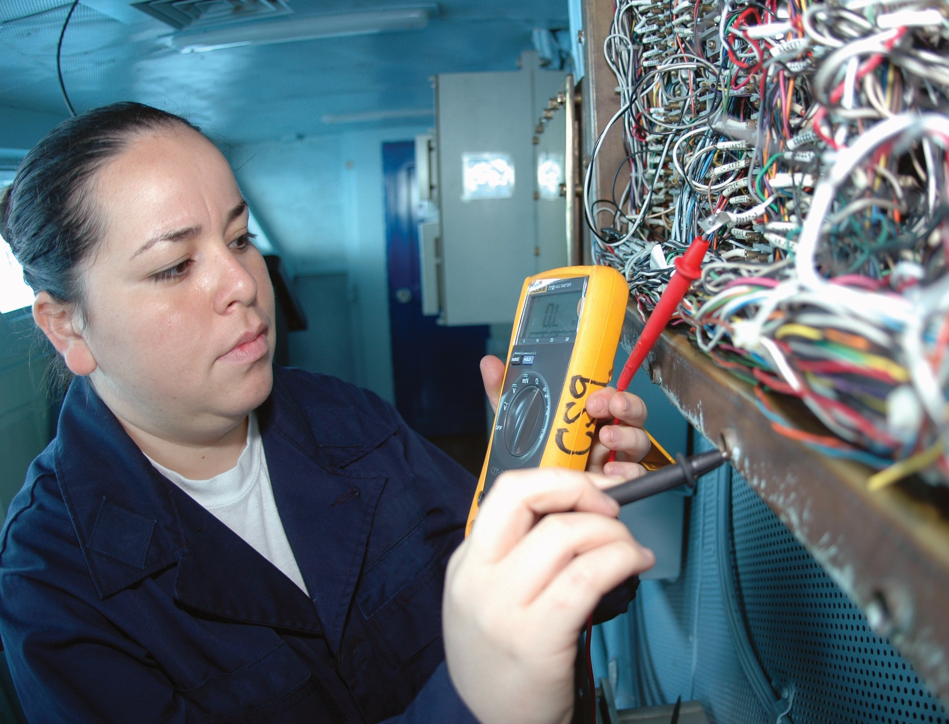

Trades Access Common Core
Line E: Electrical Fundamentals
Competency E-3: Explain Wiring Connections
Image to be placed here.

B.C. Open Textbook Project
OpenEd
open.bccampus.ca

Trades Access
COMMON CORE
Line E: Electrical Fundamentals Competency E-3: Explain Wiring Connections

Acknowledgments and Copyright
To learn more about BCcampus Open Education, visit http://open.bccampus.ca
© 2015 Camosun College
The Trades Access Common Core resources are licensed under the Creative Commons Attribution 4.0 Unported Licence, except where otherwise noted. Under this licence, any user of this textbook or the textbook contents herein must provide proper attribution as follows:
- Trades Access Common Core Competency E-3: Explain Wiring Connections by Camosun College is used under a Creative Commons Attribution 4.0 Licence.
- If you redistribute all or part of this book, it is recommended the following statement be added to the copyright page so readers can access the original book at no cost: Download for free from the B.C. Open Textbook Collection (https://open.bccampus.ca/browse-our-collection/find-open-textbooks/).
- If you use this textbook as a bibliographic reference, then you should cite it as follows: Camosun College. (2015). Trades Access Common Core Competency E-3: Explain Wiring Connections. Victoria, B.C.: Crown Publications.
All images copyright BC Industry Training Authority are licensed under the Creative Commons Attribution-NonCommercial-ShareAlike 4.0 licence.
The issuing/publishing body is Crown Publications, Queen’s Printer, Ministry of Technology, Innovation and Citizens’ Services.
BCcampus would like to acknowledge the following individuals and organizations for their contributions in producing the Trades Access Common Core Open Textbook resources.

BCcampus
Open Education Team Hilda Anggraeni, Graphics

Camosun College
Olaf Nielsen, Chair, Trades Development and Special Projects, School of Trades and Technology Nannette Plant, Manager, Enterprise Point Operations & Special Projects, Office of the VP Strategic Development
Rod Lidstone, Instructor, Plumbing and Pipe Trades, Lead Writer/Reviewer Brian Coey, Instructor, Sheet Metal and Metal Fabrication, Writer/Reviewer Matt Zeleny, Camosun Innovates, 3D imaging

Open School BC
Monique Brewer, Director
Adrian Hill, Instructional Designer
Dennis Evans, Image Coordinator, Photographer, Graphics, Production Technician (layout) Farrah Patterson, Production Technician

Industry Training Authority of BC
The ITA works with employers, employees, industry, labour, training providers, and government to issue credentials, manage apprenticeships, set program standards, and increase opportunities in approximately 100 BC trades. Among its many functions are oversight of the development of training resources that align with program standards, outlines, and learning objectives, and authorizing permission to utilize these resources (text and images).
Erin Johnston, Director of Training Delivery Cory Williams, Manager, Industry Relations

Publishing Services, Queen’s Printer
Spencer Tickner, Director of QP Publishing Services Dwayne Gordon, Manager, Electronic Publishing
October 2015, Version 1
To order print copies of any of the Trades Access Common Core resources, please contact us:
Crown Publications, Queen’s Printer PO Box 9452 Stn Prov Govt
563 Superior St, 3rd Floor Victoria, BC V8W 9V7 Phone: 250-387-6409
Toll Free: 1-800-663-6105
Fax: 250-387-1120
crownpub@gov.bc.ca www.crownpub.bc.ca

Intellectual Property Program
Ilona Ugro, Copyright Officer, Ministry of Technology, Innovation and Citizens’ Services, Province of British Columbia

Creative Commons Attributions
Cover photo:
US Navy 091004-N-8960W-014 Interior Communications Electrician 3rd Class Karla Martinez inspects wiring aboard the aircraft carrier USS Nimitz (CVN 68): U.S. Navy photo by Mass Communication Specialist Seaman Apprentice Robert Winn is in the public domain.

Foreword
The BC Open Textbook Project began in 2012 with the goal of making post-secondary education in British Columbia more accessible by reducing student cost through the use of openly licensed textbooks. The
BC Open Textbook Project is administered by BCcampus and is funded by the British Columbia Ministry of Advanced Education.
Open textbooks are open educational resources (OER); they are instructional resources created and shared in ways so that more people have access to them. This is a different model than traditionally copyrighted materials. OER are defined as teaching, learning, and research resources that reside in the public domain or have been released under an intellectual property licence that permits their free use and repurposing by others (Hewlett Foundation). Our open textbooks are openly licensed using a Creative Commons licence, and are offered in various e-book formats free of charge, or as printed books that are available at cost. For more information about this project, please contact opentext@bccampus.ca. If you are an instructor who is using this book for a course, please let us know.

Preface
The concept of identifying and creating resources for skills that are common to many trades has a long history in the Province of British Columbia. This collection of Trades Access Common Core (TACC) resources was adapted from the 15 Trades Common Core line modules co-published by the Industry
Training and Apprenticeship Commission (ITAC) and the Centre for Curriculum Transfer and Technology (C2T2) in 2000-2002. Those modules were revisions of the original Common Core portion of the TRAC modules prepared by the Province of British Columbia Ministry of Post-Secondary Education in 1986. The TACC resources are still in use by a number of trades programs today and, with the permission from the Industry Training Authority (ITA), have been utilized in this project.
These open resources have been updated and realigned to match many of the line and competency titles found in the Province of BC’s trades apprenticeship program outlines. A review was carried out to analyze the provincial program outlines of a number of trades, with the intent of finding common entry-
level learning tasks that could be assembled into this package. This analysis provided the template for the outline used to update the existing modules. Many images found in ITA apprentice training modules were also incorporated into these resources to create books that are similar to what students will see when they continue their chosen trades training. The project team has also taken many new photographs for this project, which are available for use in other trades training resources.
The following list of lines and competencies was generated with the goal of creating an entry-level trades training resource, while still offering the flexibility for lines to be used as stand-alone books. This
flexibility—in addition to the textbook content being openly licensed—allows these resources to be used within other contexts as well. For example, instructors or institutions may incorporate these resources into foundation-level trades training programming or within an online learning management system (LMS).
Line A – Safe Work Practices
- A-1 Control Workplace Hazards
- A-2 Describe WorkSafeBC Regulations
- A-3 Handle Hazardous Materials Safely
- A-4 Describe Personal Safety Practices
- A-5 Describe Fire Safety
Line B – Employability Skills
- B-1 Apply Study and Learning Skills
- B-2 Describe Expectations and Responsibilities of Employers and Employees
- B-3 Use Interpersonal Communication Skills
- B-4 Describe the Apprenticeship System

Line C – Tools and Equipment
- C-1 Describe Common Hand Tools and Their Uses
- C-2 Describe Common Power Tools and Their Uses
- C-3 Describe Rigging and Hoisting Equipment
- C-4 Describe Ladders and Platforms
Line D – Organizational Skills
- D-1 Solve Trades Mathematical Problems
- D-2 Apply Science Concepts to Trades Applications
- D-3 Read Drawings and Specifications
- D-4 Use Codes, Regulations, and Standards
- D-5 Use Manufacturer and Supplier Documentation
- D-6 Plan Projects
Line E – Electrical Fundamentals
- E-1 Describe the Basic Principles of Electricity
- E-2 Identify Common Circuit Components and Their Symbols
- E-3 Explain Wiring Connections
- E-4 Use Multimeters
All of these textbooks are available in a variety of formats in addition to print:
- PDF—printable document with TOC and hyperlinks intact
- HTML—basic export of an HTML file and its assets, suitable for use in learning management systems
- Reflowable EPUB—format that is suitable for all screen sizes including phones
All of the self-test questions are also available from BCcampus as separate data, if instructors would like to use the questions for online quizzes or competency testing.

About This Book
In an effort to make this book a flexible resource for trainers and learners, the following features are included:
- An introduction outlining the high-level goal of the Competency, and a list of objectives reflecting the skills and knowledge a person would need to achieve to fulfill this goal.
- Discrete Learning Tasks designed to help a person achieve these objectives
- Self-tests at the end of each Learning Task, designed to informally test for understanding.
- A reminder at the end of each Competency to complete a Competency test. Individual trainers are expected to determine the requirements for this test, as required.
- Throughout the textbook, there may also be links and/or references to other resources that learners will need to access, some of which are only available online.
- Notes, cautions, and warnings are identified by special symbols. A list of those symbols is provided below.

Symbols Legend
Important: This icon highlights important information.

Poisonous: This icon is a reminder for a potentially toxic/poisonous situation.

Resources: The resource icon highlights any required or optional resources.

Flammable: This icon is a reminder for a potentially flammable situation.

Self-test: This icon reminds you to complete a self-test.

Explosive: This icon is a reminder for a possibly explosive situation.

Safety gear: The safety gear icon is an important reminder to use protective equipment.

Electric shock: This icon is a reminder for potential electric shock.

Safety Advisory
Be advised that references to the Workers’ Compensation Board of British Columbia safety regulations contained within these materials do not/may not reflect the most recent Occupational Health and Safety Regulation. The current Standards and Regulation in BC can be obtained at the following website: http:// www.worksafebc.com.
Please note that it is always the responsibility of any person using these materials to inform him/herself about the Occupational Health and Safety Regulation pertaining to his/her area of work.
BCcampus January 2015

Disclaimer
The materials in the Trades Access Common Core Open Textbook project are for use by students and instructional staff and have been compiled from sources believed to be reliable and to represent best current opinions on these subjects. These manuals are intended to serve as a starting point for good practices and may not specify all minimum legal standards. No warranty, guarantee or representation is made by BCcampus as to the accuracy or sufficiency of the information contained in these publications. These manuals are intended to provide basic guidelines for trade practices. Do not assume, therefore, that all necessary warnings and safety precautionary measures are contained in this module and that other or additional measures may not be required.

Contents
Introduction 8
Objectives 8
Learning Task 1: Describe various wiring connections 9
Conductors 9
Soldered connections 11
Solderless connectors 13
Self-Test 1 17
Learning Task 2: Describe appropriate soldering techniques 19
Safety 19
Solder bonding 19
Soldering tools 21
Soldering techniques 24
Self-Test 2 29
Answer Key 31

Introduction
It is important for you to be familiar with techniques for soldering electrical connections and how to use wireless connectors. For example, the ends of the finely stranded wires used for power supply cords on most portable power tools are soldered to permit a long-lasting, trouble- free connection. Solder also produces secure, durable electrical connections for switches, plugs, and tools. Wireless connectors are commonly used in many electrical applications because they are quick and easy to use.

Objectives
When you have completed the Learning Tasks in this Competency, you will be able to:
  - define the terms used and explain the principles of soldering
  - describe the methods for making properly soldered connections
  - maintain soldering equipment
  - use wireless connectors

LEARNING TASK 1
Describe various wiring connections
Making tight electrical connections is critical to a safe wiring job. If wires come loose, you could get arcing and overheating, which could lead to a fire. The right connector is determined by a number of variables.

Conductors
A material that allows energy to flow with relative ease is known as a conductor. The most common form of electrical conductor used is the wire. Most electrical wires are made from copper or aluminum and are in one of two forms: solid or stranded.

The term electrical cable usually refers to multiple insulated wires grouped together in a common sheathing (Figure 1).

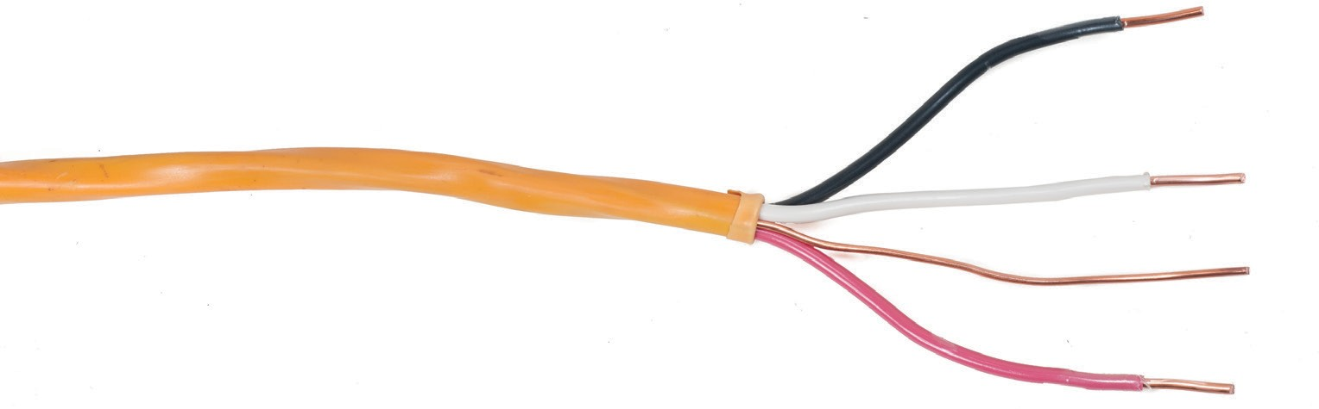Cable jacket

Stripped wire

Wire insulation
Figure 1 — Electrical cable components
Ground

Stranded conductors
Stranded wire is a collection of solid wires twisted or braided together, commonly around a central core (Figure 2).
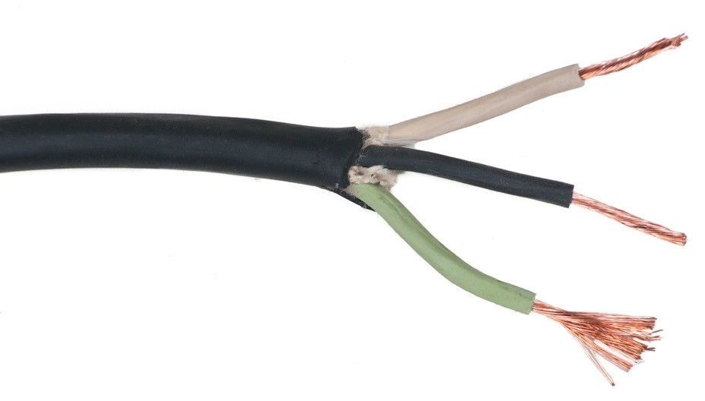
Figure 2 — Stranded flexible conductor

The current-carrying capacity of a stranded wire is close to the current-carrying ability of a single strand. Stranded wires act as a single conductor and carry a single electrical current. Stranded conductors are normally used in thin wire that requires flexibility, such as speaker wire. Ordinarily, a stranded conductor has wires all the same size. The size of the strands used depends on the flexibility required. For example, #00 gauge cable may be made up of seven strands of #7 gauge wire, or 19 strands of #12 gauge, or 37 strands of #24 gauge, the last one being rated “extra flexible.”

Solid conductors
Solid wire consists of one strand of copper metal wire, bare or surrounded by an insulator. Solid wire is normally found in smaller sizes only. Solid wire is cheaper to manufacture than stranded wire and is used where there is little need for flexibility in the wire.

Insulating materials
The purpose of conductor insulation is to prevent unwanted flow of electrical current, such as ground faults, short circuits, or electric shock.

There are various methods used to insulate conductors to satisfy the many conditions encountered in electrical installations, such as temperature, moisture, and different voltage ratings. Insulating materials include:
  - enamel coating
  - rubber
  - thermoplastics
  - minerals

Stripping insulation
In order to make any type of electrical connection, you will need to expose the base wire from the insulated covering. You can do this with wire strippers (Figure 3).
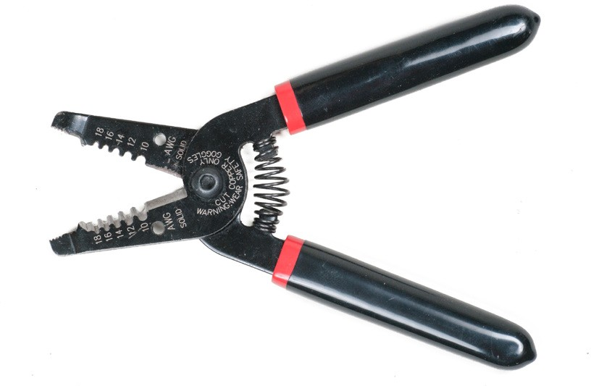
Figure 3 — Wire strippers

With wire strippers, you can strip the amount of wire required for the type of connection being made. It is important to avoid damaging the copper wire by nicking the copper or cutting into it. Nicked wires can lead to overheating and eventually could cause an electrical fire.

Colour coding
Most electrical wiring circuits look complicated because several wires are found at any one point in the circuit. In order to make it easier to know exactly which is which, wires are identified by colour or labelled.

For building construction, the Canadian Electrical Code reserves two colours for specific applications:
  - White or natural grey covering is reserved for insulated, identified conductors; identified common conductors; and identified neutral conductors.
  - Green covering is reserved for the equipment grounding conductor.
When this system of colour coding is followed, at any point in any circuit a white wire always indicates a neutral conductor. A green wire always indicates an equipment grounding conductor. Any other colour wires, such as red, black, or blue, can be assumed to be live or hot, meaning that they will have a voltage on the conductor and are therefore dangerous.

Wire size
Wires are manufactured in sizes according to the American Wire Gauge (AWG) system. The cross-sectional area of each gauge is an important factor for determining the current-carrying capacity of a wire (ampacity). Increasing gauge numbers denote decreasing wire diameters, ranging from the largest 0000 (4/0) to the smallest, 44.

Soldered connections
A variety of joints are used to prepare wires for soldering. These include:
  - Western Union splice
  - tap joint
  - twist joint

Western Union splice
This splice is used to join the ends of two wires in line (compare to the twist joint, below). Strip the wires for a length of 2.5 to 8 cm (1" to 3") as shown in Figure 4. Clean the wire, then twist the ends of the wire tightly together as shown.
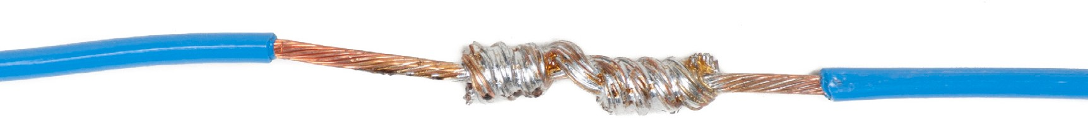
Figure 4 — Western Union splice

Tap joint
The tap joint (Figure 5) is used to connect a stranded wire to an intermediate point along the length of a second wire. Wrap the wire at least six times.
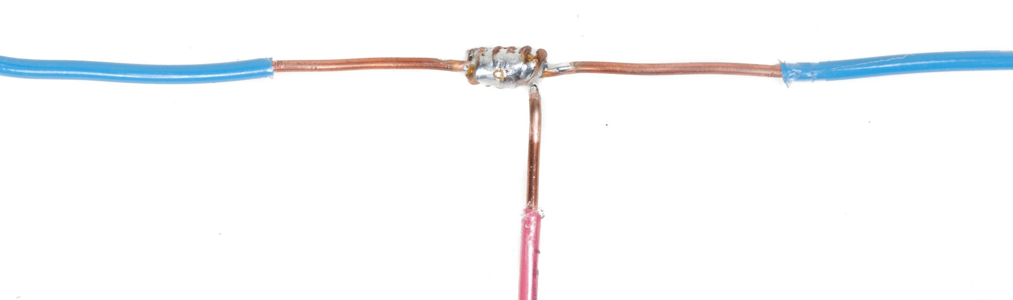
Figure 5 — Tap joint

Twist joint
The twist joint (Figure 6) is used to join wires that are parallel, whereas the Western Union splice is used to connect wires that are in line. Strip the insulation, clean the wires, and twist them together tightly for a length of 2.5 cm (1 in.).
Figure 6 — Twist joint

Tinning stranded wire
In a general sense, tinning is the process of applying a thin layer of solder to something and will be discussed in more detail in Learning Task 2. In the case of stranded wire, you should tin the stripped ends of the wire to prevent the strands from separating while they are bending or connecting. Use only enough solder to make the stripped portion of the wire solid. The strands
of the wire should be visible through the solder. Avoid solder from wicking in a wire underneath the insulation because it will make the wire solid and cause it to break more easily.
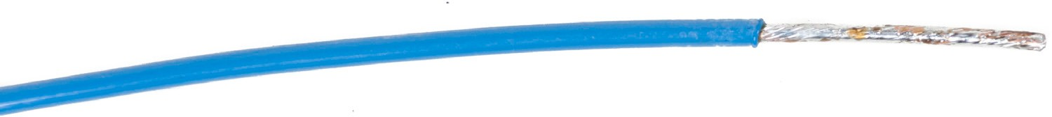
Figure 7 — Tinning stranded wire prior to bending it

Solderless connectors
Soldering is the recommended way to splice, tap, or join wires to make a rigid, permanent connection that is weather-resistant. The process of soldering can be time consuming, awkward, restrictive, and expensive.

In many applications, soldering has been replaced by special connecting devices that simplify wire joining procedures. Solderless connectors are used on both wire and cable connections. Types of solderless connectors include:
  - looped-end
  - twist-on
  - set-screw
  - crimp-on

Looped-end connectors
The most common solderless connection has the looped end of a wire (Figure 8) held in place by a set-screw at an electrical terminal (Figure 9). Note that the direction of the loop is the same as the direction the screw is turned when it is tightened (clockwise). The screw and washer should be made of corrosion-resistant materials such as copper or brass.
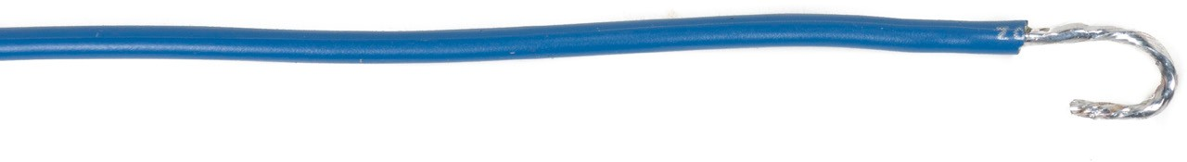
Figure 8 — Good loop (also known as a hook)
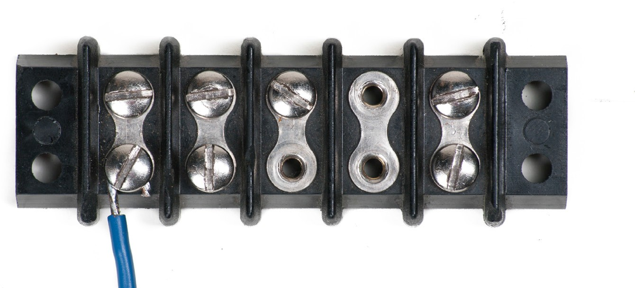
Figure 9 — Proper installation under terminal screw

Twist-on connectors
The twist-on connector is a one-piece connecting device designed to splice aluminum or copper wires. Twist-on connectors are also known as wire nuts, wire connectors, cone connectors, thimble connectors, or Marrettes. Inside the blunt, bullet-like cover of the twist-on connector is a cone-shaped spring insert which threads itself onto conductors when the connector is twisted. When the connector is twisted onto the stripped ends of wires, the wires are drawn, twisted, and

squeezed into the connector’s metal insert. Electrical continuity is maintained both by the direct twisted wire-to-wire contact and by contact with the metal insert.
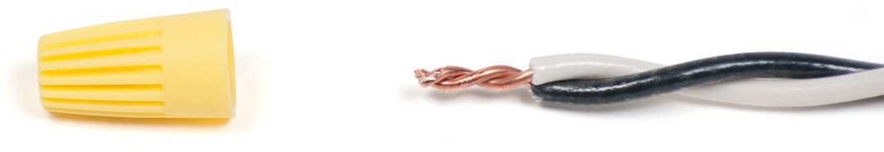
Exposed wires twisted together

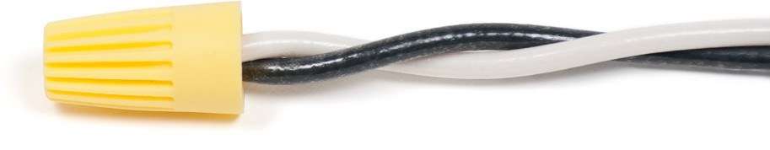
Figure 10 — Completed connection

Wing-like extensions (Figure 11) are moulded into some makes of connectors to reduce operator muscle fatigue when installing a large number of the connectors.
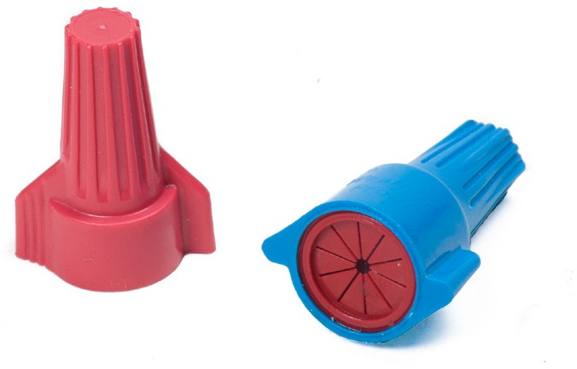
Figure 11 — Winged connector

The shell of the twist-on connector provides sufficient insulation to allow these connectors to be used in circuits carrying up to 600 V.

Twist-on wire connectors are commonly colour coded to indicate the connector size and, hence, their capacity (Figure 12). They are commonly used as an alternative to soldering conductors together since they are quicker to install and, unlike soldered connections, allow easy removal for future modifications.
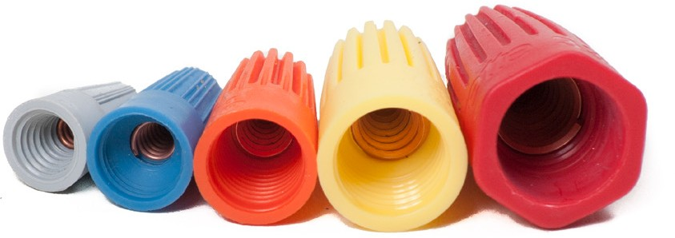
Figure 12 — Twist-on connectors end view showing metal inserts

Twist-on connectors are not often used on wire gauges thicker than AWG #10 (5.26 mm²), because such solid wires are too stiff to be reliably connected with this method. Instead, set-

screw connectors, clamps, or crimp connectors are used.

Set-screw connectors
Set-screw connectors (Figure 13) consist of two parts:
  - a brass connector body into which wires are inserted
  - an insulated cone-shaped cap that is screwed onto the brass connector
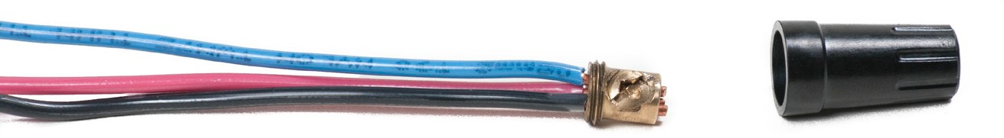
Figure 13 — Set-screw connector

The set-screw connector is most often used as a splice inside a protected electrical box and in lighting fixtures. Although set-screws are a bit more time consuming to install and are more expensive than twist-ons, they may offer a more secure connection than twist-on connectors.

Crimp-on connectors
A crimp-on connector is used for a permanent tight splice. The crimp-on connector (compression connection) can have one or two parts.

The two-part connector (Figure 14) has a conductor retaining sleeve that is compressed by using special crimping pliers and an insulated screw cap into which the crimped retainer is inserted.

The sleeve is composed of copper or zinc-plated steel while the cap is a high dielectric substance. The zinc-plated steel retaining sleeve should not be used with aluminum conductors, as electrolysis can take place between the metals.
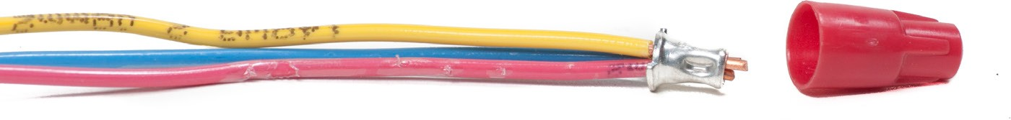
Figure 14 — Two-part crimp-on connector

These devices are available in many sizes. As with other solderless connectors, the correct size two-piece crimp-on connector must be carefully selected for each application.

The one part crimp-on connector (Figure 15) is commonly used as a terminal lug. Both the fork and the ring type greatly simplify connecting stranded conductors to terminal screws. The crimp-on connector sometimes has a soft, hose-like tube that is moulded to the connector. The connector and the insulation are crimped together. After crimping, the insulation returns to its original form.
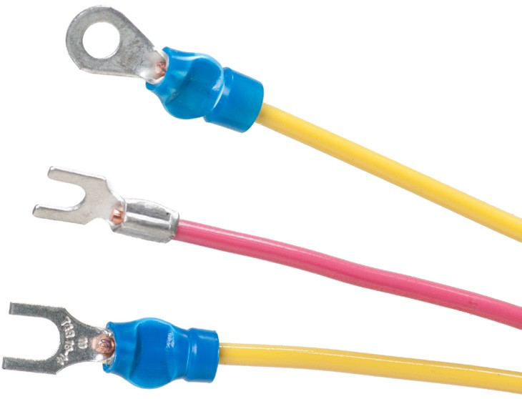
Figure 15 — One-part crimp-on connectors

Now complete the Learning Task Self-Test.

Self-Test 1
- Which term best describes a material that allows electrical energy to pass through it?
  - Resister
  - Insulator
  - Conductor
  - Connector

- Which of the following best describes the term electrical cable?
  - Any wire
  - Any insulated wire
  - Multiple wires grouped together in a common insulation
  - Multiple insulated wires grouped together in a common sheathing

- What is the primary purpose of insulation on wires?
  - To protect the wire
  - To make installation easier
  - To prevent unwanted current flow
  - So the wire can be colour coded

- When is stranded wire used?
  - On short wires
  - When cost is a factor
  - On straight runs of wire
  - When flexibility is needed

- Wire is sized by gauge: the higher the number, the larger the wire.
  - True
  - False

- What should be done to stranded wire prior to bending?
  - It should be curled.
  - It should be tinned.
  - It should be wound.
  - It should be twisted.

- Solderless connections are more costly than soldering.
  - True
  - False

- What is one advantage to a twist-on connector?
  - It is permanent.
  - One size fits all.
  - It will not come apart.
  - It can be removed easily.

- It doesn’t matter what material the conductor is made from when making a connection.
  - True
  - False

- What type of connector should be used to create a permanent splice?
  - Twist
  - Winged
  - Crimp-on
  - Set screw

LEARNING TASK 2
Describe appropriate soldering techniques
Most components are fitted with leads, pins, lugs, or some other means of interconnecting them electrically. Most soldering involves bonding these leads to other leads, circuit wires, copper pads, or other circuit parts. The primary purpose of soldering an electrical connection is to ensure an efficient flow of current between the joined parts.

Soldering properly is an important skill. Correct operation of electric circuitry depends on correct soldering. Poor soldering will often lead to poor operation of the circuit.

Safety
Your safety must always be a concern while you are soldering. There is a risk of inhaling fumes from soldering operations that can irritate the nose, throat, and lungs. Studies show that prolonged exposure to certain fumes may result in occupational asthma and contribute to chronic lung disease. In addition, fumes that you breathe may contain invisible particles, such as lead and zinc, that could cause poisoning. Always complete soldering operations in well-
ventilated spaces. You should also carefully wash your hands before eating, drinking, or smoking. You should wear safety glasses with side shields to protect yourself from splashing solder.

Solder bonding
The soldering process depends on molten solder flowing into all the microscopic surface imperfections of the metals to be soldered and even penetrating very slightly below their surface. In this process, a chemical reaction occurs in which the solder actually melts some of the metals and alloys with them. Upon cooling, this combination of penetration and alloying results in a very strong bond between the solder and metal. When two pieces of metal are soldered together, a thin layer of solder adheres between them and completes the connection.

The process of surface penetration and alloying is known as wetting of the host metals (Figure 1). Some metals are very receptive to wetting and can readily be soldered, while others are non- receptive and cannot be soldered at all. Copper is very receptive to wetting by tin/lead solders.
Tin also wets readily, as do silver and gold, but to a lesser extent. Solder wetting is displayed by a smooth, shiny flow of solder onto the metal surface. The process is often called tinning. Metals such as aluminum and iron will not wet properly. The solder forms stubborn flecks and balls and fails to penetrate or adhere. Effective solder bonding of these metals is not possible.
Solder

Copper

Intermetallic bond

Figure 1 — Wetting action

Solder flux
Solder wetting of metal is severely curtailed by the presence of surface oxides. This is one of the reasons aluminum cannot be tinned and soldered. Its surface is oxidized almost instantly by the presence of atmospheric oxygen. A clean, oxide-free surface cannot be obtained for soldering. Oxidization also restricts wetting of copper, so any copper parts to be soldered should be as clean as possible. Fortunately, copper oxidizes rather slowly, so surfaces cleaned by scraping or sanding will remain pure copper for some time before a tarnishing film of copper oxide reforms.

Unfortunately, oxidization is hastened by heat. Application of a heated soldering iron or molten solder will start surface oxidation, even on a freshly cleaned surface. For this reason, it is very hard to solder even clean copper without applying a soldering flux.

The primary function of a soldering flux is to eliminate oxidation during the soldering process. Flux melts and flows when heated, effectively sealing the surfaces against the entry of oxygen. Flux also lowers the surface tension of the molten solder, allowing it to flow and spread more easily. Flux contains a small quantity of an active antioxidant material, which serves as a mild cleaner to remove any surface tarnish.

Historically, soldering flux has been caustic liquids or pastes containing acids. This is because part of their function has been to scour and roughen the surfaces. The problem with acid flux is that it never completely vaporizes during heating and continues to corrode the metal surfaces indefinitely.

The flux most commonly used in electric soldering is rosin. Rosin is an organic material derived from certain tree saps. It is non-corrosive, reasonably non-toxic, and readily liquefied by heat. Its residues are also easily removed after soldering. Rosin flux is usually a continuous single or multiple core inside the wire solder (Figure 2). Because it melts at a much lower temperature than solder, rosin is readily dispersed onto the job both before and during the melting of the solder. Low-odour solder and solders without flux are available.
Figure 2 — Flux-cored solder wire
Rosin core solder is the only kind you should use in electric work. Never use acid core or other solder containing corrosive flux. Never use any form of paste or liquid flux containing acid. Not only will the ongoing corrosion eventually
cause mechanical deterioration, it will rapidly destroy the connection’s ability to conduct current.

Composition of solder
Solder is an alloy of different metals, commonly tin and lead, that have a lower melting point than the base metal. Both metals are reasonably good electrical conductors. The ratio of tin to lead has a great deal to do with the melting point and hardness of solder and also with its conductivity.
Tin melts at about 327°C (620°F) and lead at about 232°C (450°F). When these metals are combined, the melting point of the mixture goes down. The melting point varies with the ratio of tin to lead, with the lowest occurring at about 183°C (360°F) for a 63/37 tin-lead mixture.

This lowest melting temperature is called the eutectic point. It marks the temperature at which the solder changes directly from solid to liquid with no semi-liquid or plastic state in between. Since a narrow plastic state is desirable in soldering operations, a 60/40 mix is very common. This raises the melting point slightly to about 188°C (370°F) and gives a temperature range for plasticity of about 4°C to 6°C (40°F to 43°F). It also produces optimum conduction characteristics and hardness for electronics soldering.
Note that the ratios for solder composition always state the tin content first. 60/40 solder is composed of 60% tin and 40% lead (by weight).
Wire solder is available in a variety of diameters. Which to use depends on the sizes of the component leads and terminals to be soldered. Diameters of 0.75 mm (1/16ø) and 0.38 mm (1/32ø) are the most commonly used sizes.

Soldering tools
Historically, heating the host metals and melting the solder was done by firing in a forge or by pouring molten solder onto the metals and wiping it into place with leather pads. Later, heat was applied by means of an iron bit that was heated in the forge. The name soldering iron has carried forward to this day. Today, heat is applied by various electrically heated soldering tools called irons or pencils or guns. Figure 3 shows two examples. The majority of electronic soldering done during electronic repair, for example, is completed with a low-wattage soldering pencil.
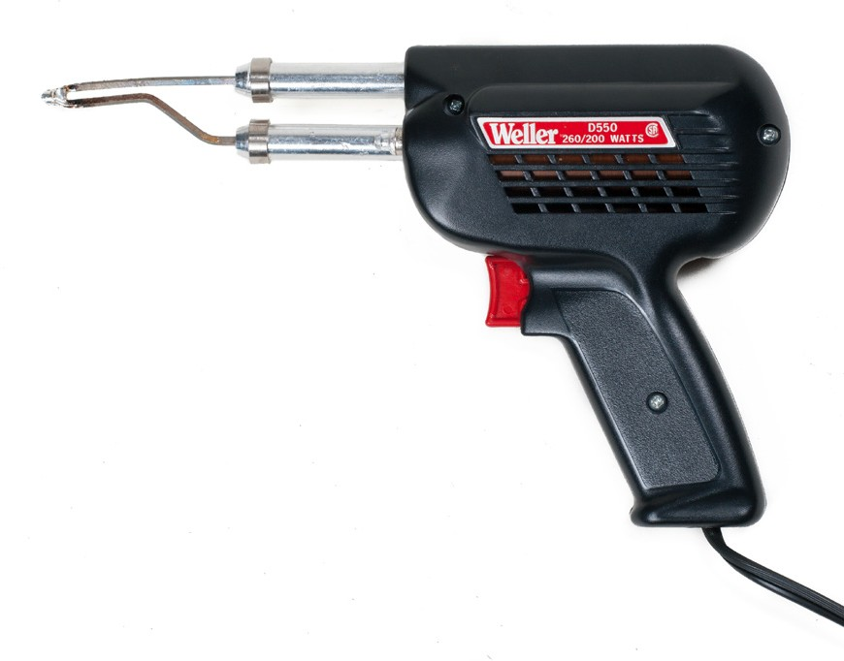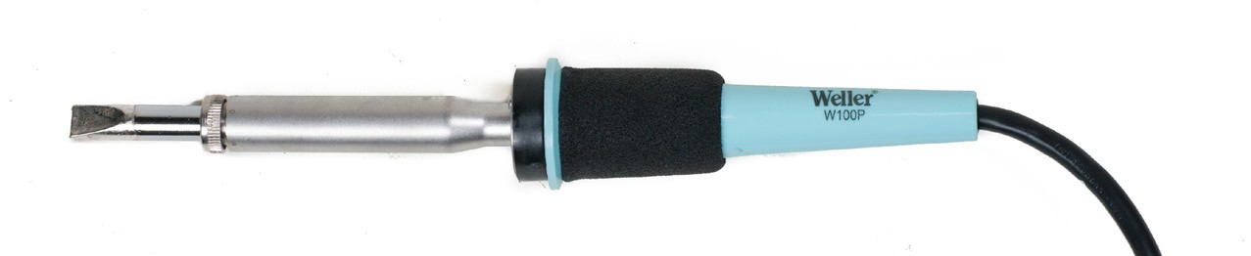
Figure 3 — Some common soldering tools

Soldering irons
Electric soldering irons consist of a resistive heating element encased in a metal sleeve, into which a copper soldering bit is threaded or clamped. The bit is replaceable and generally in one size, although some models will take a variety of sizes. The tips and handles are well insulated electrically from the heating elements.

Power consumption ranges from about 70 watts to over 500 watts. Irons are available with temperature control. Some have a simple rheostat control to regulate current. Others have thermostatic controls that permit you to set the temperature over a range from 95°C to 480°C (200°F to 900°F). Lower temperatures are used when working with temperature-sensitive components such as semiconductors.

Soldering pencils
Soldering pencils are smaller and lighter than irons. Their handles are shaped for three-finger rather than whole-hand grasping like soldering irons. However, they have the same kinds of resistance heating elements that transfer heat to copper soldering tips through the sleeve. There is no electrical connection between the bit and the element.

The tips on soldering pencils are much smaller and better suited to the finer soldering required on printed circuit boards. With power ratings from about 6 to 30 watts, they are also suitable for modern electronic assemblies. They are available in various sizes and shapes. Some tips are steel-clad for longer life.

Soldering guns
Soldering guns are intermittent heat-type soldering tools: The tips are heated only during the actual soldering process. They are usually pistol-shaped, with a copper wire loop extending from the barrel that serves as the soldering tip. When the trigger is pulled, this loop is heated very quickly by a large current at low voltage. This current is supplied from a transformer mounted in the body of the gun. The tip produces very high heat that changes rapidly as it is energized and de-energized.

The soldering tip
Selecting the appropriate soldering iron and tip is very important for obtaining quality soldered connections.

For general-purpose printed circuit board soldering, a 1/16" to 1/8" screwdriver blade or chisel tip is most commonly used. Figure 4 shows four of the most commonly used tip shapes.

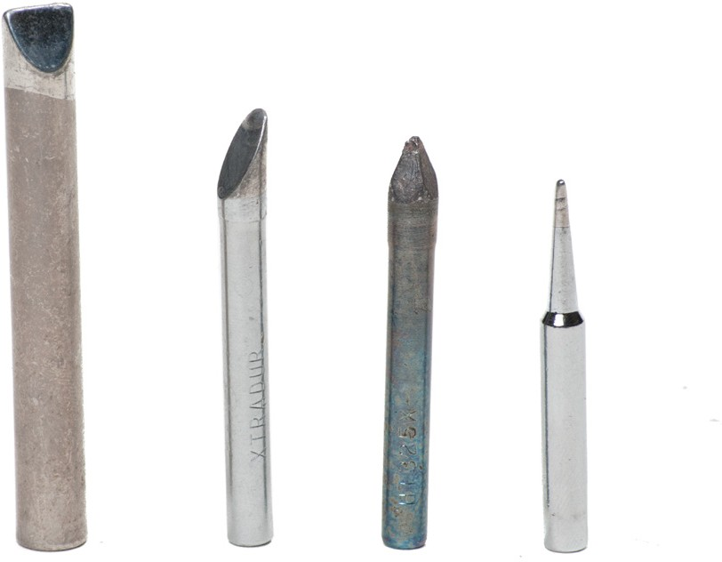
Figure 4 — Soldering tip shapes

Regardless of the shape, size, or design of the iron, the tip must be tinned. Tinning the tip is the process of applying a thin layer of solder to the tip to keep atmospheric oxygen and other contaminants off the soldering surface and help with the flow of the solder. A poorly tinned tip will make it virtually impossible to achieve a sound solder joint.

Soldering iron manufacturers specify an operating temperature range for each type of tip. This requires mating the heating capability of iron and tip. Insufficient iron capability will result
in tip temperatures that are lower than needed for quality solder work or in rapid drop in tip temperature during soldering. Excessive heat will quickly deteriorate the tip and may possibly damage the components and printed circuit board being soldered.

You can estimate tip temperature by following this two-step process:
- Apply a small amount of solder to the flat surface of the tip and immediately wipe the tip with a damp cellulose sponge or paper towel.
- Observe tip colour immediately after wiping.
▸ If the color of the surface is silver, the temperature is between 315°C and 370°C (600°F and 698°F).
▸ If the tip shows gold streaks, the temperature is approaching 425°C (797°F).

The copper tips of irons and pencils are progressively dissolved by solder, and they soon become pitted and corroded. This is particularly true of the continuous-heat types. It is virtually impossible to do quality soldering with a corroded tip. Corroding can be slowed down by keeping the tip clean and well tinned.

Clean the tip by wiping it frequently with a damp cloth or cellulose sponge. The damp wipe will shock the built-up burned flux from the tip. Immediately re-tin the tip and leave a thin coating to keep atmospheric oxygen off the soldering surface. Wipe the excess solder off the tip before the next use. Reclean and recoat with solder when you finish each soldering task.

When pitting becomes significant, you should dress the tip and reshape it to clean metal with a fine file. This can be done with the tip hot so that the refreshed tip can immediately be re- tinned. Excess solder should be wiped away after re-tinning. Steel-clad tips suffer much less corrosion and should never be dressed with a file. Like copper tips, however, they should be cleaned frequently when hot.

Soldering techniques
To avoid soldering problems, it is extremely important to work with clean materials and the correct amount of heat. Soldering problems can normally be avoided by bringing the metals to soldering temperature quickly and completing the solder application in a short period of time. You know you have the proper heat when a joint can be completed in about two seconds. The heat will transfer most effectively to the work if a clean tip is lightly tinned with a film of solder. The film of solder will create a bridge between the iron and soldering surfaces by flowing into all gaps. Sometimes a small amount of solder must be added to help form this bridge by applying a small drop to the iron’s tip before applying it to the work surfaces.

Although learning the theories of good soldering is important in developing soldering skills, good soldering is primarily learned through practice. Holding the iron and applying it and the solder to the work surface must be done using techniques that are comfortable and natural to each individual. How you do the job is unimportant as long as the end result is a
quality soldered joint with no damage to the surrounding components and materials. At every opportunity, you should experiment with different techniques, always making certain that your soldering meets the requirements of effective soldering listed earlier.

Procedures
To solder effectively, follow these procedures:
- Follow safety precautions.
Always wear safety glasses with side shields when soldering. Ensure adequate ventilation or use solder fume extraction hoods to prevent accumulation of solder fumes. Wear closed- toed shoes and clothing made of natural fibres, with long sleeves and long trouser legs to protect against burns from solder splashes.
Avoid touching the solder pencil tip or freshly soldered joints. Use an iron holder and allow the iron to cool completely before putting it away. Never solder on equipment that has power supplied to it. Before eating, drinking, or smoking, always wash your hands to avoid accidentally ingesting lead.

- Clean and tin host materials.
The materials to be soldered (leads, pads, terminals, etc.) must be clean and tinned. Inspect all host metals and clean them to remove contaminants such as oxides, machine oil, hand lotion, and skin oils. Avoid touching cleaned surfaces.

Most component leads and hookup wires are factory tinned. Copper parts and solder pads that are untinned should be cleaned and tinned separately.

To tin a surface, clean it and then heat the surface with a soldering tip. Apply the solder to the surface and allow a thin coating to form on the surface. Allow the surface to cool.

When tinning stranded insulated wires, strip the wire to the appropriate length for the joint being made. Tin the wire, using only enough solder to make the stripped wire solid. The strands of wire should be visible through the solder. Avoid solder from wicking in the wire underneath the insulation.

When tinning and soldering, make a solder bridge to increase the linkage area and speed heating of the surface or joint (Figure 5).

Solder bridge
Lead
Tip

Small linkage area Large linkage area
Figure 5 — Cross-section view of iron tip on a round lead - “X” shows point of contact

- Form a mechanical joint between the host metals.
Cut wire leads and position wires and components neatly. The leads should bridge directly to the connection point without being strained or creating tangles of wires.

Make solid-tight mechanical connections. Components should be fastened to the mounting plate or board using appropriate fasteners.

- Protect components and surrounding materials from heat.
Heat must be applied to the joint long enough for the solder to flow freely throughout the connection, but not long enough to damage the components or its surroundings. To protect heat-sensitive components such as semiconductors, use an item such as needle-nose pliers to pull heat away from unwanted areas. This is called a heat sink. Connect the heat sink to the lead at a point near the body of the component (Figure 6). You can also use alligator clips to act as a heat sink.

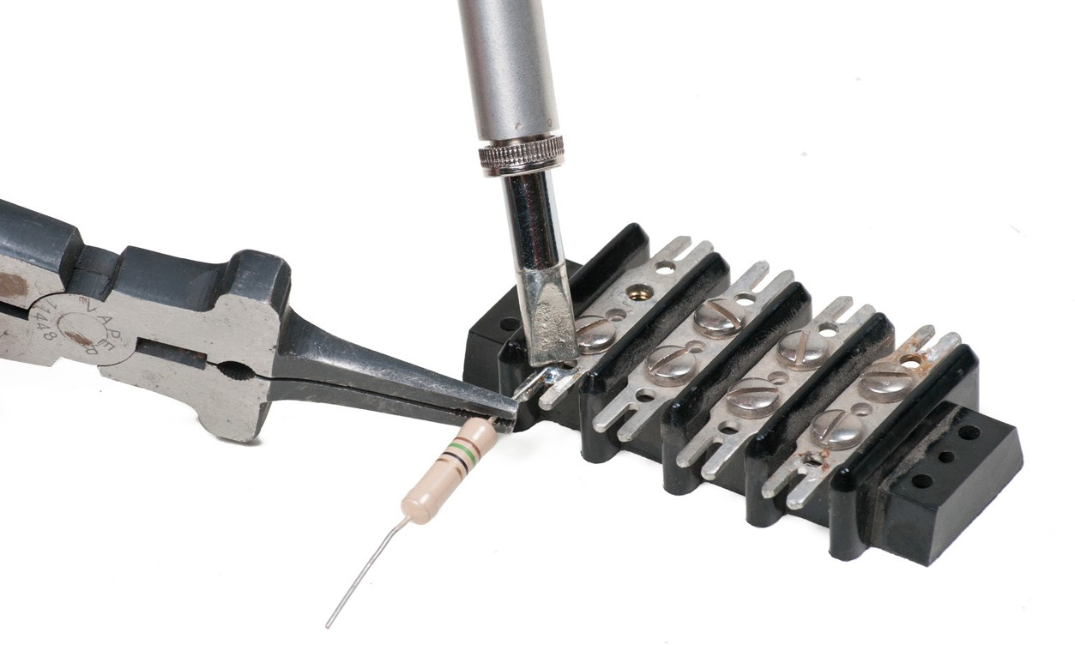
Figure 6 — Needle-nose pliers used as a heat sink

- Allow the connection to cool undisturbed.
The joint must be allowed to cool completely before being moved. If the joint moves prior to complete cooling, a fractured joint could result. After cooling, flux residue should be scraped or dissolved away.

Soldering terminals
When soldering turret-type terminals (Figure 7), apply heat to the point of maximum thermal mass. Make a solder bridge, then apply solder to the side opposite to the soldering tip. When the joint is complete, remove the tip with a forward wiping motion.

Apply the iron to
the point of maximum thermal mass.
Make a solder bridge to increase thermal linkage.
Apply solder to the side opposite the iron.
Remove the iron tip with a forward wiping motion.

Figure 7 — Steps to solder conductors to turret terminals

A cup terminal is a hollow cylinder into which a lead is inserted and then soldered. The solder is cut to the correct length and twisted together. The iron is held on the cup until solder melt occurs. The wire is then inserted into the terminal and held in place against the inside back of the cup (Figure 8).

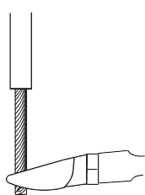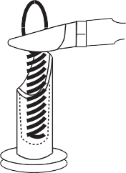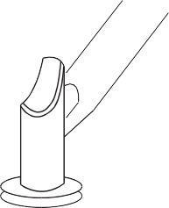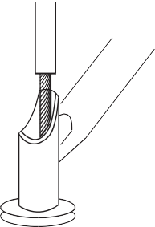

Trim the wire to the correct length.
Preform the solder by twisting the strands together.
Cut the preformed solder to the correct length.
Heat the cup until the solder melts.
Insert the wire and hold it in place against the back of the cup.
Insulation clearance should be 1–2 times.

Figure 8 — Soldering procedures for cup terminals

Acceptable solder joints
Good solder connections (Figures 9) have a smooth, bright appearance. They have evenly contoured (ball-shaped) fillets on both the component lead and the terminal, without excessive amounts of solder being used. The soldering is neat without any accidental splashes or solder bridges to other parts of the circuit. The components should not be heat damaged. The contour of wires and leads should be visible through the solder.
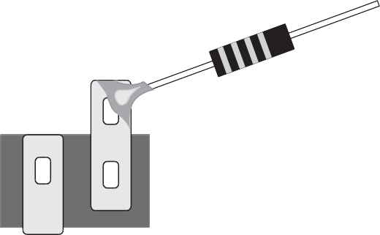
Figure 9 — Correctly soldered connection

Soldering defects
The following characteristics are unacceptable in a solder joint:
  - charred, burned, or melted insulation or parts
  - excessive solder, including peaks, icicles, and bridging
  - flux residue, solder splatter, or other foreign materials on circuitry of adjacent areas
  - insufficient solder
  - pits, holes, or voids or exposed base metal in the soldered connection
  - fractured or cracked solder connection or evidence of grain change

  - cut, nicked, gouged, or scraped conductors
  - improper conductor length
During the soldering process, you must be very careful to avoid defects in the solder joint itself. Soldering defects primarily reduce the efficiency of the electrical connection between the metals to be joined.

Cold solder joint
A cold solder joint occurs when the component leads have not been heated sufficiently. A lack of heat in the metals to be joined will reduce or eliminate proper wetting of the surfaces, as described earlier. Insufficient wetting will cause the solder to pile up on the joint surface rather than flow smoothly through the joint. An efficient electrical connection between the metals to be joined will not be made, resulting in resistance to current flow through the joint.

Cold joints commonly result from applying solder to the soldering iron’s tip rather than to the joint to be soldered. When the solder is touched to the iron rather than to the joint, the solder will melt before the joint has heated sufficiently. The melted solder will flow over the joint, but will not properly wet it. Unless heat is maintained well after the solder flows over the joint, a cold solder joint will usually occur.

The major indicator of a cold solder joint is a frosty appearance to the surface of the solder. In some instances, reheating the joint adequately will correct a cold joint. If the surface stays frosty, the used solder must be removed and the joint resoldered using correct procedures.

Fractured joint
A fractured joint occurs during the cooling process when the soldered joint is moved while the solder is in its plastic state. Movement during the plastic state will have a crystallizing effect on the solder and a very rough, inefficient joint will result.

The usual cause of a fractured joint is a poor mechanical connection of the metals before soldering begins. Components must be mounted firmly before soldering begins.

Reheating usually cures a fractured joint, but the addition of a small amount of fresh solder may be needed to reflux the exposed metals.

Rosin joint
A rosin joint occurs when part of the joint has been heated enough to melt the flux and coat the metals, but not enough to cause the solder to flow. The covering of flux acts as an insulator and consequently provides a very poor electrical connection or no connection at all.

Reheating and applying a small drop of fresh solder will often cure a rosin joint.

Now complete the Learning Task Self-Test.

Self-Test 2
- Safety factors such as toxic fumes and splashing flux should always be addressed when soldering.
  - True
  - False

- Which of the following best describes the process of surface penetration?
  - Bonding
  - Wetting
  - Soldering
  - Prepping

- Which of the following should apply when tinning stranded wire?
  - The strands should be thickly coated.
  - The strands should be visible under the solder.
  - The solder should wick up underneath the insulation.
  - A large blob of solder should form at the end of the wire.

- Metals like aluminum and iron wet easily.
  - True
  - False

- What is the purpose of flux?
  - To remove oxides
  - To clean the metal
  - To assist with heating
  - To remove the solder

- What is the most common alloy used for solder?
  - Tin-lead
  - Lead-silver
  - Tin-copper
  - Lead-copper

- Soldering pencils are used for heavy-duty applications.
  - True
  - False

- What must be done to a soldering tip prior to soldering?
  - Tin it.
  - Wash it.
  - Wire brush it.
  - Heat it red hot.

- What should be done to an overly corroded soldering tip?
  - Nothing.
  - Re-tin it.
  - Throw it away.
  - Dress it with a fine file.

- What is the purpose of a heatsink?
  - To protect the solder
  - To pull flux to the joint
  - To pull heat to the area for soldering
  - To pull heat away from certain components

- What would cause a solder joint to be piled up and lumpy in appearance?
  - Insufficient heat
  - Lack of flux
  - Poor tinning
  - A corroded tip

Answer Key

Self-Test 1
- c. Conductor
- d. Multiple insulated wires grouped together in a common sheathing
- c. To prevent unwanted current flow
- d. When flexibility is needed
- b. False
- b. It should be tinned.
- b. False
- d. It can be removed easily.
- b. False
- c. Crimp-on

Self-Test 2
- a. True
- b. Wetting
- b. The strands should be visible under the solder.
- b. False
- a. To remove oxides
- a. Tin-lead
- b. False
- a. Tin it.
- d. Dress it with a fine file.
- d. To pull heat away from certain components
- a. Insufficient heat

The British Columbia Open Textbook Project
The British Columbia Open Textbook Project is funded by the B.C. Ministry of Advanced Education, and managed by BCcampus, a publicly-funded organization that uses information technology to connect B.C. post-secondary institutions under a collaborative service delivery framework. The Open Textbook Project aims to make available
openly-licensed textbooks in the province’s high-impact subject areas. Visit open.bccampus.ca for more information.

7960003695

