Chapter 10

Persuasion

This chapter is short in comparison to the other chapters you have read. That is because you will be expected to complete your critique this week. In the next chapter, Developing a Convincing Argument, you will need to apply this information and structures in developing your persuasive paper, the last essay form you will learn in this course.

10.1 The Purpose of Persuasion

LEARNING OBJECTIVES
- Determine the purpose of persuasion in writing
The purpose of persuasion in writing is to convince, motivate, or move readers toward a certain point of view, or opinion. The act of trying to persuade automatically implies more than one opinion on the subject can be argued.
The idea of an argument often conjures up images of two people yelling and screaming in anger. In writing, however, an argument is very different. An argument is a reasoned opinion supported and explained by evidence. To argue in writing is to advance knowledge and ideas in a positive way. Written arguments often fail when they employ ranting rather than reasoning.
Most people have strong views on controversial topics (ones that inspire extreme points of view or opinions) and are often very willing to share those strong views. However, imagine you are having a discussion with someone who is only willing to share a particular point of view, ignoring yours, which may be in opposition. The ideas presented by that person would be very narrow, almost as if the person has tunnel vision and is merely expressing a personal opinion. If that person does provide you with facts, they may often be skewed or not from a credible source. After the discussion, there is only a slight chance you would be convinced of the other person’s point of view. You may have new ideas you had not considered before or a new perspective, but you would probably not be thoroughly convinced because that person has not made any attempt to present a well-rounded, fact-based point of view. This is why it is essential for you to not only provide your reader with strong, substantiated evidenced, but also to ensure you present an argument that looks at the topic from multiple angles.
Now, you may be asking yourself, “How can my argument be convincing if I present ideas contrary to my main point of view?” Well, while you need to concede there are other views different from your own, it is very important to show your reader you have thought about different angles and that the conclusions you have come to have been critically developed. This evidence of critical thinking will elevate your argument to a level so that your reader cannot really have any objections to. Also, when you look at the structures for persuasive writing, outlined in the next section, you will learn how you can rebut the possible objections you present, essentially smashing those contrary ideas and showing how your point of view is the convincing one.

Tip
Most of us feel inclined to try to win the arguments we engage in. On some level, we all want to be right, and we want others to see the error of their ways. More times than not, however, arguments in which both sides try to win end up producing losers all around. The more productive approach is to persuade your audience to consider your opinion as a valid one, not simply the right one.

10.2 The Structure of a Persuasive Essay

LEARNING OBJECTIVES
- Determine the structure of persuasion in writing
- Apply a formula for a classic persuasive argument

Writing a Persuasive Essay
You first need to choose a topic that you feel passionate about. If your instructor requires you to write about a specific topic, approach the subject from an angle that interests you. Begin your essay with an engaging introduction. Your thesis should typically appear somewhere in your introduction.
Next, need to acknowledge and explain points of view that may conflict with your own to build credibility and trust with your audience. You also should state the limits of your argument. This helps you sound more reasonable and honest to those who may naturally be inclined to disagree with your view. By respectfully acknowledging opposing arguments and conceding limitations to your own view, you set a measured and responsible tone for the essay.
Be sure to make your appeals in support of your thesis by using sound, credible evidence. Use a balance of facts and opinions from a wide range of sources, such as scientific studies, expert testimony, statistics, and personal anecdotes. Each piece of evidence should be fully explained and clearly stated. Also, write in a style and tone that is appropriate for your subject and audience. Tailor your language and word choice to these two factors, while still being true to your own voice. Finally, write a conclusion that effectively summarizes the main argument and reinforces your thesis.

Structuring a Persuasive Essay
The formula below for organizing a persuasive essay may be one with which you are familiar. It will present a convincing argument to your reader because your discussion is well rounded and thorough, and you leave your audience with your point of view at the end. Remember to consider each of these components in this formula as sections instead of paragraphs because you will probably want to discuss multiple ideas backing up your point of view to make it more convincing.
When writing a persuasive essay, it is best to begin with the most important point because it immediately captivates your readers and compels them to continue reading. For example, if you were supporting your thesis that homework is detrimental to the education of high school students, you would want to present your most convincing argument first, and then move on to the less important points for your case.
Some key transitional words you should use with this method of organization are: most importantly, almost as importantly, just as importantly, and finally.
The Formula
You will need to come up with objection points, but you will also need to think of direct rebuttals to each of those ideas.
Remember to consult your outline as you are writing because you may need to double-check that you have countered each of the possible opposing ideas you presented.
Section 1: Introduction
- Attention getter
- Thesis (showing main and controlling ideas)
- Background
- Signposts (make sure you outline the structure your argument will follow: Pros →Cons/Pros)
Section 2: (Multiple) Ideas in Support of Claim
- Give a topic sentence introducing the point (showing main and controlling ideas)
- Give explanations + evidence on first point
- Make concluding statement summarizing point discussion (possibly transitioning to next supporting idea)
- Repeat with multiple ideas in separate paragraphs
Section 3: Summary of (Some) Opposing Views
- Give topic sentence explaining this paragraph will be opposing points of view to provide thorough, convincing argument
- Present general summary of some opposing ideas
- Present some generalized evidence
- Provide brief concluding sentence for paragraph—transitioning into next rebuttal paragraph
Section 4: Response to Opposing Views
- Give topic sentence explaining this paragraph/section connects to or expands on previous paragraph
- [may recognize validity of some of points] then need to present how your ideas are stronger
- Present evidence directly countering/refuting ideas mentioned in previous section
- Give concluding statement summarizing the countering arguments
¶Section 5: Conclusion
- Restate your thesis
- Summarize your discussion points
- Leave the reader with a strong impression; do not waiver here
- May provide a “call for action”

Tip
In a persuasive essay, the writer’s point of view should be clearly expressed at the beginning of each paragraph in the topic sentence, which should contain the main idea of the paragraph and the writer’s controlling idea.

10.3 Being Critical

LEARNING OBJECTIVES
- Explain the importance and benefits of acknowledging opposing ideas
- Identify the importance of cautious use of tone in a persuasive essay
- Identify bias in writing
- Assess various rhetorical devices, including the use of I
- Distinguish between fact and opinion
- Understand the importance of visuals to strengthen arguments
In Chapter 7: Sources: Choosing the Right Ones, we discussed being critical when evaluating sources, the ideas presented in those sources, and how those ideas are presented. When writing a persuasive essay, you need to focus on the same elements, but you also need to ensure you are presenting an argument that considers other points of view on your topic; you need to acknowledge there are other angles, and you need to present ideas countering those objections in order to increase your chance at convincing your reader.

Style and Tone of Language
Just as with any essay, the way you write and the tone you use is very important to consider. Think back to the earlier mention of that one-sided argument. If you are talking with a person who uses aggressive and inflammatory words, are you more or less likely to listen to the whole argument and ultimately be convinced? If someone is waving his hands and swearing or yelling, the gestures and raised voice may actually distract you from what is being said. Also, when people are extremely animated in their discussions, their audience may become defensive if they do not agree with the ideas presented. In such a case, the audience may then respond in the same way, and no one ends up really hearing other points of view and will definitely not be convinced.
Consider the same discussion, but imagine the original speaker being calm and controlled. Do you think you would be more likely to listen and consider the ideas? That is what often happens; the speaker also allows you to give your input and views, and together, you can arrive at a blend of ideas. While you may not be convinced to change your mind completely, the way the speaker presents the argument (calmly and substantively) creates an environment or situation where you are more open to discussion.
This is the same when you write; if you choose inflammatory language not appropriate to your audience, the overall impact is almost “bloggish”—like someone ranting on a topic and just stating his or her opinion. This becomes a bigger issue if no substantive evidence or support is given for the discussion. The writer just seems like a radical expressing views, not someone you can use for credible support.
In short, remember to choose your words carefully. While you will need to use assertive language to support your ideas, you need to choose objective words. How you make your argument more convincing is by:
- Using strong, peer-reviewed, and reliable evidence to back up your ideas
- Presenting and rebutting at least one opposing idea

Acknowledging Opposing Ideas and Limits to Your Argument
Because an argument implies differing points of view on the subject, you must be sure to acknowledge those opposing ideas. Avoiding ideas that conflict with your own gives the reader the impression that you may be uncertain, fearful, or unaware of opposing ideas. Thus, it is essential that you not only address counterarguments but also do so respectfully.
Try to address opposing arguments earlier rather than later in your essay. Rhetorically speaking, ordering your positive arguments last allows you to better address ideas that conflict with your own, so you can spend the rest of the essay countering those arguments. This way, you leave your reader thinking about your argument rather than someone else’s. You have the last word.
Acknowledging different points of view also fosters more credibility between you and the audience. They know from the outset that you are aware of opposing ideas and that you are not afraid to give them space.
It is also helpful to establish the limits of your argument and what you are trying to accomplish. In effect, you are conceding early on that your argument is not the ultimate authority on a given topic. Such humility can go a long way toward earning credibility and trust with an audience. Your readers will know from the beginning that you are a reasonable writer, and they will trust your argument as a result. For example, in the following concessionary statement, the writer advocates for stricter gun control laws, but admits it will not solve all of our problems with crime:
Although tougher gun control laws are a powerful first step in decreasing violence in our streets, such legislation alone cannot end these problems since guns are not the only problem we face.
Such a concession will be welcome by those who might disagree with this writer’s argument in the first place. To effectively persuade their readers, writers need to be modest in their goals and humble in their approach to get readers to listen to the ideas. See Table 10.1: Phrases of Concession for some useful phrases of concession.
Table 10.1: Phrases of Concession
although | granted that | of course | still | though | yet

Bias in Writing
Everyone has various biases on any number of topics. For example, you might have a bias toward wearing black instead of brightly coloured clothes, or wearing jeans rather than formal wear. You might have a bias toward working at night rather than in the morning, or working by deadlines rather than getting tasks done in advance. These examples identify minor biases, of course, but they still indicate preferences and opinions.
In your first assignment a number of weeks ago, you were asked to sit somewhere, make observations, and write both a positive and negative description of the same scene—or to show two angles of vision. The purpose of this exercise was to make it evident to you how easily bias and angles can appear even through the smallest words you choose to use in your writing. Choosing each word carefully is even more significant in a persuasive paper because, as already mentioned, you want your reader to view your presentation of ideas as logical and not just a tirade. Using objective and neutral language and evidence and acknowledging you have a possible bias will help you present a well-rounded and developed argument.
Handling bias in writing and in daily life can be a useful skill. It will allow you to articulate your own points of view while also defending yourself against unreasonable points of view. The ideal in persuasive writing is to let your reader know your bias, but do not let that bias blind you to the primary components of good argumentation: sound, thoughtful evidence and a respectful and reasonable address of opposing sides.
- The strength of a personal bias is that it can motivate you to construct a strong argument. If you are invested in the topic, you are more likely to care about the piece of writing. Similarly, the more you care, the more time and effort you are apt to put forth and the better the final product will be.
- The weakness of personal bias is that it can take over the essay—when, for example, you neglect opposing ideas, exaggerate your points, or repeatedly insert yourself ahead of the subject by using I too often. Being aware of all three of these pitfalls will help you avoid them.

Fact and Opinion
Facts are statements that can be definitely proven using objective data. The statement that is a fact is absolutely valid. In other words, the statement can be pronounced as true or false. For example, 2 + 2 = 4. This expression identifies a true statement, or a fact, because it can be proved with objective data.
Opinions are personal views, or judgments. An opinion is what an individual believes about a particular subject. However, an opinion in argumentation must have legitimate backing; adequate evidence and credibility should support the opinion. Consider the credibility of expert opinions, as experts in a given field have the knowledge and credentials to make their opinion meaningful to a larger audience.
For example, you seek the opinion of your dentist when it comes to the health of your gums, and you seek the opinion of your mechanic when it comes to the maintenance of your car. Both have knowledge and credentials in those respective fields, which is why their opinions matter to you. But the authority of your dentist may be greatly diminished should he or she offer an opinion about your car, and vice versa.
In your writing, you want to strike a balance between credible facts and authoritative opinions. Relying on one or the other will likely lose more of your audience than it gains.

The Use of I in Writing
The use of I in writing is often a topic of debate, and the acceptance of its usage varies from instructor to instructor. It is difficult to predict the preferences for all your present and future instructors, but consider the effects it can potentially have on your writing.
Be mindful of the use of I in your writing because it can make your argument sound overly biased, for two primary reasons:
- Excessive repetition of any word will eventually catch the reader’s attention—and usually not in a good way. The use of I is no different.
- The insertion of I into a sentence alters not only the way a sentence might sound but also the composition of the sentence itself. I is often the subject of a sentence. If the subject of the essay is supposed to be, say, smoking, then by inserting yourself into the sentence, you are effectively displacing the subject of the essay into a secondary position. In the following example, the subject of the sentence is bolded and underlined:
Smoking is bad. vs. I think smoking is bad.
In the first sentence, the rightful subject, smoking, is in the subject position in the sentence. In the second sentence, the insertion of I and think replaces smoking as the subject, which draws attention to I and away from the topic that is supposed to be discussed. Remember to keep the message (the subject) and the messenger (the writer) separate.
You can use Checklist 10.1 Developing Sound Arguments, as you work on your persuasive essay.
Checklist 10.1 Developing Sound Arguments
Does my essay contain the following elements?
- An engaging introduction
- A reasonable, specific thesis that is able to be supported by evidence
- A varied range of evidence from credible sources
- Respectful acknowledgment and explanation of opposing ideas
- A style and tone of language that is appropriate for the subject and audience
- Acknowledgment of the argument’s limits
- A conclusion that will adequately summarize the essay and reinforce the thesis

Tip
The word prove is frequently used in the discussion of persuasive writing. Writers may claim that one piece of evidence or another proves the argument, but proving an argument is often not possible. No evidence proves a debatable topic one way or the other; that is why the topic is debatable. Facts can be proved, but opinions can only be supported, explained, and persuaded.

Using Visual Elements to Strengthen Arguments
Adding visual elements to a persuasive argument can often strengthen its persuasive effect. However, remember you want to use them to make a bigger impact for your reader, so you need to make sure they are:
- Relevant and essential. They should help your reader visualize your point.
- Easy to follow. The reader should not have to work too hard to understand.
- Appropriate to audience, tone, and purpose. Always keep the audience in mind.
- Appropriately cited and referenced. If you borrow from a source, be sure to include proper citations.
- NOT disrespectful. You want your writing to been seen as fair and non-biased.
- NOT used too often. They will become more of a distraction than a focal point if they are used too often
There are two main types of visual elements: quantitative visuals and qualitative visuals.
- Quantitative visuals present data graphically. They allow the audience to see statistics spatially. The purpose of using quantitative visuals is to make logical appeals to the audience. For example, sometimes it is easier to understand the disparity in certain statistics if it is displayed graphically. Bar graphs, pie charts, Venn diagrams, histograms, and line graphs are all ways of presenting quantitative data in spatial dimensions.
- Qualitative visuals present images that appeal to the audience’s emotions. Photographs and pictorial images are examples of qualitative visuals. Such images often try to convey a story, and seeing an actual example can carry more power than hearing or reading about the example. For example, one image of a child suffering from malnutrition will likely have more of an emotional impact than pages dedicated to describing that same condition in writing.

Writing at Work
When making a business presentation, you typically have limited time to get your idea across. Providing visual elements for your audience can be an effective timesaving tool. Quantitative visuals in business presentations serve the same purpose as they do in persuasive writing. They should make logical appeals by showing numerical data in a spatial design. Quantitative visuals should be pictures that might appeal to your audience’s emotions. You will find that many of the rhetorical devices used in writing are the same ones used in the workplace.

KEY TAKEAWAYS
- The purpose of persuasion in writing is to convince or move readers toward a certain point of view, or opinion.
- An argument is a reasoned opinion supported and explained by evidence. To argue, in writing, is to advance knowledge and ideas in a positive way.
- A thesis that expresses the opinion of the writer in more specific terms is better than one that is vague.
- It is essential that you address counterarguments and do so respectfully.
- It is helpful to establish the limits of your argument and what you are trying to accomplish through a concession statement.
- To persuade a skeptical audience, you need to use a wide range of evidence. Scientific studies, opinions from experts, historical precedent, statistics, personal anecdotes, and current events are all types of evidence that you might use in explaining your point.
- Word choice and writing style should be appropriate for both your subject and your audience.
- You should let your reader know your bias, but do not let that bias blind you to the primary components of good argumentation: sound, thoughtful evidence and respectfully and reasonably addressing opposing ideas.
- You should be mindful of the use of I in your writing because it can make your argument sound more biased than it needs to.
- Facts are statements that can be proven using objective data.
- Opinions are personal views, or judgments, that cannot be proven.
- In writing, you want to strike a balance between credible facts and authoritative opinions.
- Quantitative visuals present data graphically. The purpose of using quantitative visuals is to make logical appeals to the audience.
- Qualitative visuals present images that appeal to the audience’s emotions.

10.4 Examples: Persuasive Essay

LEARNING OBJECTIVES
- Read two examples of persuasive essays on the same topic

EXAMPLE 1
Justice: Retribution or Restoration?
Every day when I pick up my newspaper I read about crime. What strikes me as tragic in these discussions is that the solutions which are proposed are simply more of the same: bigger threats, more punishment. Few people ask more basic questions about whether punishment ought to be our main concern. Even fewer seem genuinely concerned about victims and what they need.
Consequently, victims’ needs and wishes continue to be ignored. Prisons are massively crowded, and the call for a return to the death penalty is back with a vengeance. The costs to us as taxpayers keep soaring.
Actually, there is good reason why we ignore victims and focus instead on more punishment for offenders. It has to do with our very definitions of what constitutes crime and what justice entails.
If you have been a victim, you know something about the fear, the anger, the shame, the sense of violation that this experience generates. You know something about the needs that result: needs for repayment, for a chance to talk, for support, for involvement, for an experience that feels like justice. Unfortunately, you may also know from personal experience how little help, information and involvement you can expect from the justice process.
If you have experienced crime, you know for a fact that you yourself are the victim, and you would like to be remembered in what happens thereafter. But the legal system does not define the offence that way and does not assume that you have a central role.
Legally, the essence of the crime lies in breaking a law rather than the actual damage done. More importantly, the official victim is the state, not you. It is no accident, then, that victims and their needs are so often forgotten: they are not even part of the equation, not part of the definition of the offence!
When a crime occurs, the state as victim decides what must be done, and the process of deciding focuses primarily on two questions: “Is the person guilty? If so, how much punishment does he or she deserve?” Our definitions of crime and justice, then, might be summarized like this:
Crime is a violation of the state and its laws.
Justice establishes blame and administers pain through a contest between offender and state.
This way of viewing crime might be called “retributive justice.” It has little place for victims, uses what some scholars have called a “battle model” for settling things, and, because it is centred so heavily on establishing blame, looks primarily to the past rather than the future. It assumes that punishment or pain, usually in the form of a prison term, is the normal outcome.
This process concentrates almost exclusively on offenders, but, ironically, does not hold them accountable. To be accountable, offenders ought to be helped to understand and acknowledge the human consequences of their actions. Then they ought to be encouraged to take responsibility for what happens thereafter, including taking steps to right the wrong. Yet this rarely happens; indeed, the justice process discourages responsibility. Thus neither victim nor offender is offered the kind of opportunities that might aid healing and resolution for both.
But what is the alternative? How should we understand crime and justice?
An alternate understanding of crime and justice might look something like this:
Crime is a violation of people and their relationships.
Justice identifies needs and obligations so that things can be made right through a process which encourages dialogue and involves both victims and offenders.
A restorative approach to justice would understand that the essence of crime is a violation of people and of harmonious relations between them. Instead of asking first of all, “Who ‘done’ it? What should they get?” (and rarely going beyond this), a restorative approach to justice would ask “Who has been hurt? What can be done to make things right, and whose responsibility is it?” True justice would have as its goals restoration, reconciliation, and responsibility rather than retribution.
Restorative justice would aim to be personal. Insofar as possible, it would seek to empower victims and offenders to be involved in their own cases and, in the process, to learn something about one another. As in the Victim-Offender Reconciliation Program (VORP), which operates in many communities in the U.S. and Canada, when circumstances permit, justice would offer victims and offenders an opportunity to meet in order to exchange information and decide what is to be done. Understanding of one another, acceptance of responsibility, healing of injuries, and empowerment of participants would be important goals.
Is restorative approach practical? Can it work? The experience of the VORP suggests that while there are limitations and pitfalls, restoration and reconciliation can happen, even in some tough cases. Moreover, our own history points in this direction. Through most of western history, most crimes were understood to be harms done to people by other people. Such wrongs created obligations to make right, and the normal process was to negotiate some sort of restitution agreement. Only in the past several centuries did our present retributive understanding displace this more reparative approach.
If our ancestors could view crime and justice this way, why can't we?

Adapted from: Zehr, H. (n.d.). Justice: Retribution or Restoration? Retrieved from: http://www.peaceworkmagazine.org/pwork/0499/049910.htm

EXAMPLE 2
Retribution
Retribution is perhaps the most intuitive—and the most questionable—aim of punishment in the criminal law. Quite contrary to the idea of rehabilitation and distinct from the utilitarian purposes of restraint and deterrence, the purpose of retribution is actively to injure criminal offenders, ideally in proportion with their injuries to society, and so expiate them of guilt.
The impulse to do harm to someone who does harm to you is older than human society, older than the human race itself (go to the zoo and watch the monkey cage for a demonstration.) It’s also one of the most powerful human impulses—so powerful that at times it can overwhelm all else. One of the hallmarks of civilization is to relinquish the personal right to act on this impulse, and transfer responsibility for retribution to some governing body that acts, presumably, on behalf of society entire. When society executes retribution on criminals by means of fines, incarceration, or death, these punishments are a social expression of the personal vengeance the criminal’s victims feel, rationally confined (it is hoped) to what is best for society as a whole.
While “it's natural” tends not to carry much weight in the criminal law, “it's morally right” can. Moral feelings and convictions are considered, even by the criminal law, to be some of the most powerful and binding expressions of our humanity. In binding criminal trial juries to restrict guilty verdicts to situations of the highest certainty, “beyond a reasonable doubt” is also often described as “to a moral certainty.” It is to their moral feelings of what is truly right that jury members are asked look before delivering a verdict. It’s perhaps not too much of a stretch, then, to argue that it’s morally right to make criminals suffer as their victims have suffered, if that’s the way one’s moral certainty points.
No matter what one’s moral feelings are about inflicting deliberate harm on a human being, the majority of the citizenry still holds that it’s right to exact retribution on criminal offenders. This is almost certainly true of the majority of victims, and their loved ones, for whom equanimity becomes more and more difficult depending on the severity of the crime. What rape victim does not wish to see her attacker suffer? What parent does not hate the one who killed their child? The outrage that would result from leaving these passions for revenge unsatisfied might be seen as a dramatic failure of the entire criminal justice system. It’s a good argument for retributive justice, then, that in this world public vengeance is necessary in order to avoid the chaos ensuing from individuals taking revenge into their own hands. And, until the moral certainty of a majority of society points towards compassion rather than revenge, this is the form the criminal law must take.

Adapted from: The Lectric Law Library. (n.d.). Retribution. Retrieved from: http://www.lectlaw.com/mjl/cl062.htm

Journal entry #10
Write a paragraph or two responding to the following.
- Briefly describe one or two topics on which you may want to base your persuasive essay.
- Why is this a good topic? What types of challenges do you think you may face in developing ideas on this topic?
Remember as mentioned in the Assessment Descriptions in your syllabus:
- You will be expected to respond to the questions by reflecting on and discussing your experiences with the week’s material.
- When writing your journals, you should focus on freewriting—writing without (overly) considering formal writing structures—but remember that it will be read by the instructor, who needs to be able to understand your ideas.
- Your instructor will be able to see if you have completed this entry by the end of the week but not read all of the journals until week 11.

Chapter 11

Developing a Convincing Argument

In this chapter, we will be applying the concepts presented to you in Chapter 10: Persuasion. Working through the self-practice exercise will help you to develop a strong, convincing argument on a topic of your choice. At the end of Section 11.3: Organizing Your Ideas, you will need to produce an outline to show to your instructor.
11.1 Coming Up With a Topic

LEARNING OBJECTIVES
- Identify the requirements for your persuasive essay
- Generate ideas on a topic for your persuasive essay
- Formulate a research question
- Create a working thesis showing your topic and your controlling point of view
- Conduct preliminary research

The Requirements
This assessment is divided into three parts (the requirements of each are described below):
- A formal outline due week 11
- A rough draft due week 12
- A final draft due week 13.
You will receive 2.5% each for parts 1 and 2, and the final essay is worth 25%.

Essay 3: Persuasion (2.5%+2.5%+25%)
Choose a controversial topic on which you can base a persuasive discussion of 1,350 to 1,500 words.
You must:
- Demonstrate the application of dialectics and consideration of altering points of view
- Construct and follow a logical argument discussion
- Provide supporting evidence from five to seven supplemental sources and include a reference page and citations.
Part A: Essay 3: Persuasive formal outline/5 marks (2.5%) **Due week 11**
Create a formal, sentence outline for your instructor’s approval. You must include:
- A working thesis
- A working outline
- Topic sentences for each supporting paragraph
- Notes of how you plan to develop your ideas
- The sourcing information of where you will get evidence to support your ideas.
You will be marked on level of completion of the five components described above. You do not have to stick to the outline exactly when you start working on your draft, but you will need to demonstrate you have done some of the preliminary work.
Part B: Essay 3: Persuasive draft/10 marks (2.5%) **Due week 12**
Create a first draft of your persuasive essay. You must include:
- A complete introduction
- A complete conclusion
- Paragraph development
- A demonstration of idea development
- A draft reference page
Part C: Essay 3: Persuasive final submission/100 marks (25%) **Due week 13**
Write a 1,350 to 1,500 word persuasive essay on a controversial topic. Use the thesis, evidence, opposing argument, and concessionary statement as the basis for writing a full persuasive essay. You must include:
  - An engaging introduction
  - Clear explanations of all the evidence you present
  - A strong conclusion.

The Controversy
A controversial topic is one on which people have strong views. Imagine the type of discussion that can become really heated, usually when the subject is something people are passionate about. But a person who is passionate about a particular issue does not necessarily mean he or she recognizes the merits of the other view (although that often happens); it just means that the person has collected evidence (from a variety of sources) and synthesized those ideas to arrive at a particular point of view.
When you are trying to choose your topic for your persuasive paper, it is easier if you choose a topic about which you feel very strongly. You probably have realized by this point that when you are writing, it is a lot easier to write about a topic you already have some background knowledge on, and something you are extremely interested in. This helps to engage you and keep you interested in the writing process.
No matter the topic you eventually decide to discuss, there are a few things you need to think about before you begin the writing process. You will need to make sure your subject is:
- Significant. Is a discussion of this topic one that has the potential to contribute to a field of study? Will it make an impact? This does not mean every discussion has to change lives, but it needs to be something relatively important. For example, a significant topic would be to convince your reader that eating at fast-food restaurants is detrimental to people’s cardiovascular system. A less significant discussion would be if you were to try to convince your reader why one fast-food restaurant is better than another.
- Singular. This means you need to focus on one subject. Using the fast-food restaurant example, if you were to focus on both the effects on the cardiovascular and endocrine system, the discussion would lose that singular focus and there would be too much for you to cover.
- Specific. Similar to the point above, your topic needs to be narrow enough to allow for you to really discuss the topic within the essay parameters (i.e., word count). Many writers are afraid of getting too specific because they feel they will run out of things to say. If you develop the idea completely and give thorough explanations and plenty of examples, the specificity should not be a problem.
- Supportable. Does evidence for what you want to discuss actually exist? There is probably some form of evidence out there even for the most obscure topics or points of view. However, you need to remember you should use credible sources. Someone’s opinions posted on a blog about why one fast-food restaurant is the best does not count as credible support for your ideas.

Self-Practice EXERCISE 11.1
- In previous chapters, you learned strategies for generating and narrowing a topic for a research paper. Review the list of general topics below. Also, think about which topics you feel very strongly.
- Freewrite for five minutes on one of the topics below. Remember, you will need to focus your ideas to a manageable size for a five- to seven-page research paper.
- You are also welcome to choose another topic; you may want to double-check with your instructor if it is suitable. It is important to remember that you want your paper to be unique and stand out from others’; writing on overly common topics may not help with this. Since we have already discussed the death penalty as a form of punishment in the last chapter and already developed ideas, you should probably not choose this topic because your instructor wants you to demonstrate you have applied the process of critical thinking on another topic.
- Identify the key words you will use in the next self-practice exercise to preliminary research to narrow down your topic.
Some appropriate controversial topics are:
- Illegal immigration in Canada
- Bias in the media
- The role of religion in educational systems
- The possibility of life in outer space
- Modern day slavery around the world, ie. Human trafficking
- Foreign policy
- Television and advertising
- Stereotypes and prejudice
- Gender roles and the workplace
- Driving and cell phones

Formulating a Research Question
In forming a research question, you are setting a goal for your research. Your main research question should be substantial enough to form the guiding principle of your paper, but focused enough to guide your research. A strong research question requires you not only to find information but also to put together different pieces of information, interpret and analyze them, and figure out what you think. As you consider potential research questions, ask yourself whether they would be too hard or too easy to answer.
To determine your research question, review the freewriting you completed earlier. Skim through books, articles, and websites and list the questions you have. (You may wish to use the 5WH strategy to help you formulate questions.) Include simple, factual questions and more complex questions that require analysis and interpretation. Determine your main question—the primary focus of your paper—and several subquestions that you will need to research to answer that main question.
Here are the research questions Jorge will use to focus his research. Notice that his main research question has no obvious, straightforward answer. Jorge will need to research his subquestions, which address narrower topics, to answer his main question.
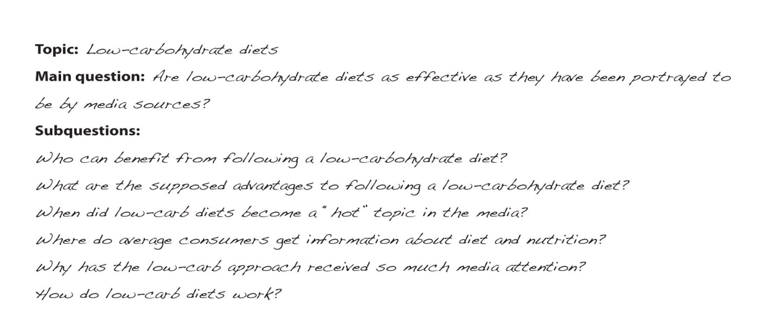

Self-Practice EXERCISE 11.2
Using the ideas you came up with in Self-Practice Exercise 11.1, create a research question you would like to find the answer to through your research and persuasive paper development. This is something you will use to help guide you in your writing and to check back with to make sure you are answering that question along the way.
_______________________________________________________________________________________________________________________________________________________________________________________________________________________________________________________________________________________
Collaborate with a partner and share your questions. Describe your topic and point of view and ask your partner if that question connects to that topic and point of view.

Self Practice EXERCISE 11.3
- Working with the topic you have identified, use the research skills you learned in previous chapters to locate approximately five potentially useful print or electronic sources of information about the topic.
Create a list that includes the following:
- One subject-specific periodicals database likely to include relevant articles on your topic
- Two articles about your topic written for an educated general audience
- At least one article about your topic written for an audience with specialized knowledge
2. Organize your list of resources into primary and secondary sources. What makes them either primary or secondary? Pick one primary source and one secondary source and write a sentence or two summarizing the information that each provides.
Then answer these questions:
- What type of primary source did you choose? Who wrote it, and why? Do you think this source provides accurate information, or is it biased in some way?
- Where did the information in the secondary source come from? Was the author citing an initial study, piece of literature, or work of art? Where could you find the primary source?

self-practice EXERCISE 11.4
With the topic from Self-Practice Exercise 11.1 and the preliminary research you conducted in Self-Practice 11.3 and referring to Section 10.2: The Structure of a Persuasive Essay, develop a working thesis and scratch outline.
Note that after reading Section 11.2: Dialectics, you will most likely revise your outline.
How to Be Really Convincing
Sometimes it can be very challenging to convince someone of your ideas and that your point of view is valid. If your reader has strong contrary views or has had emotional experiences in the past connected to that topic, your job in persuading will be more challenging. However, if you consider your audience and tone (as discussed in Section 10.3: Being Critical) and think about the answers to the following questions in Checklist 11.1, Who Is My Audience?, you will be better able to predict possible objections your reader may have to your argument and address those accordingly. It will also help you make recognize how much and what kind of background information you need to provide your reader with context for your discussion.
Checklist 11.1 Who Is My Audience?
- Who are my readers?
- What do they already know on the subject?
- What are they likely to be interested in?
- How impartial or biased are they?
- Is the subject one that may challenge their ethical or moral beliefs?
- What values do we share?
- What types of evidence will be most effective?

Self-practice EXERCISE 11.5
Look back at the two persuasive essay examples in Section 10.4: Examples: Persuasive Essays. With a partner, discuss the strengths and weaknesses of each example. Look at the credibility, tone, appropriateness to audience, and completeness of the ideas presented.

Example 1
Strengths | Weaknesses
Example 2
Strengths | Weaknesses

Collaboration: With your partner, discuss how you could make each of these arguments stronger.

11.2 Dialectics

LEARNING OBJECTIVES
- Explain the components, practice, and benefits of dialectical thinking
- Conduct a dialect discussion to consider other points of view on your topic

As you read in Chapter 10, Section 10.3: Being Critical, a strong persuasive essay will respectfully identify and discuss perspectives of the same topic. When you do this, you are presenting a well-rounded and complete discussion to your reader that shows you have critically thought about the topic and have been selective in choosing your points. As a result, there is a higher probably that you will convince your reader.
The process of looking at multiple sides of a topic is called dialectics.

Dialectics is the act of using logical reasoning to combine, juxtapose, or synthesize opposing ideas to arrive at a strong conclusion.
The Components of Dialectics
To begin the dialectic process, you first need to come up with an idea of what topic will be discussed; this is the thesis behind the discussion. Once you have determined your thesis, through various methods (the easiest being discussion with someone else), you will explore opposing sides to the topic, eventually discovering at least one antithesis.
Combining those two perspectives, you can then make your own conclusions. Maybe this process will result in you standing by the original thesis, or maybe the antithesis is incredibly convincing and you will switch sides of the argument, or maybe you still believe the original thesis but accept there are other conditions that have credibility as well. This end result is called the synthesis: the blending of ideas.
Essentially, the process would look like this:
Antithesis
Synthesis
Thesis

Considering both your thesis and the discovered antithetical perspectives will help you to arrive at a wider view of a topic: one that has more credibility.
Looking back to the persuasive essay samples you read in Section 10.4 and discussed in Self-Practice Exercise 11.5, consider to what degree the authors acknowledged opposing views. How did they justify their opinions? Consider how integrating dialectics into each of those arguments to a greater degree would have strengthened their points of view, ultimately making their arguments more convincing.

Self-practice EXERCISE 11.6
Based on the thesis “Governments use capital punishment as an effective tool for deterring violent crime,” answer the following questions and complete the table.
- What is your stance on this statement? To what extent do you agree/disagree?
__________________________________________________________________________________________________________________________________________________________________________________________________________________________________________________________________
- Complete the table considering the thesis statement given above.
- First complete the side of the table with ideas supporting the point of view you described in question #1.
- Then, challenge yourself to come up with ideas (you may need to do a little bit of research) that would support the other side of the discussion.
Supporting the statement | Against the statement
Collaboration: Discuss your answers with a partner. Do you both have the same ideas, or can you add to your list based on what your partner has come up with.
- After coming up with and considering the other perspective, has your point of view changed at all?
- Do you still stick by your same point of view 100 percent? Or do you concede that there are valid points from the other perspective?

Self-Practice Exercise 11.7/Discussion 3
- Using both the scratch outline and the working thesis you created in Self-Practice Exercise 11.4, create a table like the one you used in Self-Practice Exercise 11.6, only filling in the side with information that supports your thesis.
- Once you have created that table with your thesis given, share your table and thesis with a classmate.
- Collaborate: Conduct a dialectic discussion on your topic and possible for and against the working thesis you presented. Add any points to your original table.
- Remember to be aware of the process of synthesis you have gone through. Did your original point of view change at all? Is there anything you can make concessions on being valid? This may impact your thesis.
- Using one or two of the opposing ideas your partner helped you come up with, revise your scratch outline from Self-Practice Exercise 11.4.

11.3 Organizing Your Ideas

LEARNING OBJECTIVES
- Revise your working thesis
- Create an outline including your thesis and main and supporting points
- Determine an appropriate organizational structure for a persuasive essay that uses critical analysis to connect your ideas and information taken from sources

For this section, you will need to refer back to Section 10.2: The Structure of a Persuasive Essay to help you piece your supporting and opposing ideas together.

Creating an Introduction and Thesis
The persuasive essay begins with an engaging introduction that presents the general topic. The thesis typically appears somewhere in the introduction and states the writer’s point of view.

Re-evaluate Your Working Thesis
A careful analysis of your notes will help you re-evaluate your working thesis and determine whether you need to revise it. Remember that your working thesis was the starting point—not necessarily the end point—of your research. You should revise your working thesis if your ideas changed based on what you read. Even if your sources generally confirmed your preliminary thinking on the topic, it is still a good idea to tweak the wording of your thesis to incorporate the specific details you learned from research.
Jorge realized that his working thesis oversimplified the issues. He still believed that the media was exaggerating the benefits of low-carb diets. However, his research led him to conclude that these diets did have some advantages. Read Jorge’s revised thesis.

Tip
Avoid forming a thesis based on a negative claim. For example, “The hourly minimum wage is not high enough for the average worker to live on.” This is probably a true statement, but persuasive arguments should make a positive case. That is, the thesis statement should focus on how the hourly minimum wage is low or insufficient.

self-practice EXERCISE 11.8
On a sheet of paper, use your working thesis and the revised outline from Self-Practice Exercise 11.7 and list the types of evidence you might use in support of that thesis. Essentially, you are expanding your outline to include more source information.

Synthesizing and Organizing Information
By now, your thinking on your topic is taking shape. You have a sense of what major ideas to address in your paper, what points you can easily support, and what questions or subtopics might need a little more thought. In short, you have begun the process of synthesizing information—that is, of putting the pieces together into a coherent whole.
It is normal to find this part of the process a little difficult. Some questions or concepts may still be unclear to you. You may not yet know how you will tie all of your research together. Synthesizing information is a complex, demanding mental task, and even experienced researchers struggle with it at times. A little uncertainty is often a good sign! It means you are challenging yourself to work thoughtfully with your topic instead of simply restating the same information.

Synthesizing Information
You have already considered how your notes fit with your working thesis. Now, take your synthesis a step further. Organize your notes with headings that correspond to points and subpoints you came up with through dialectics and compiled in your outline, which you presented to your instructor. As you proceed, you might identify some more important subtopics that were not part of your original plan, or you might decide that some points are not relevant to your paper.
Categorize information carefully and continue to think critically about the material. Ask yourself whether the sources are reliable and whether the connections between ideas are clear.
Remember, your ideas and conclusions will shape the paper. They are the glue that holds the rest of the content together. As you work, begin jotting down the big ideas you will use to connect the dots for your reader. (If you are not sure where to begin, try answering your major research question and subquestions. Add and answer new questions as appropriate.) You might record these big ideas on sticky notes or type and highlight them within an electronic document.
Jorge looked back on the list of research questions that he had written down earlier. He changed a few to match his new thesis, and he began a rough outline for his paper.
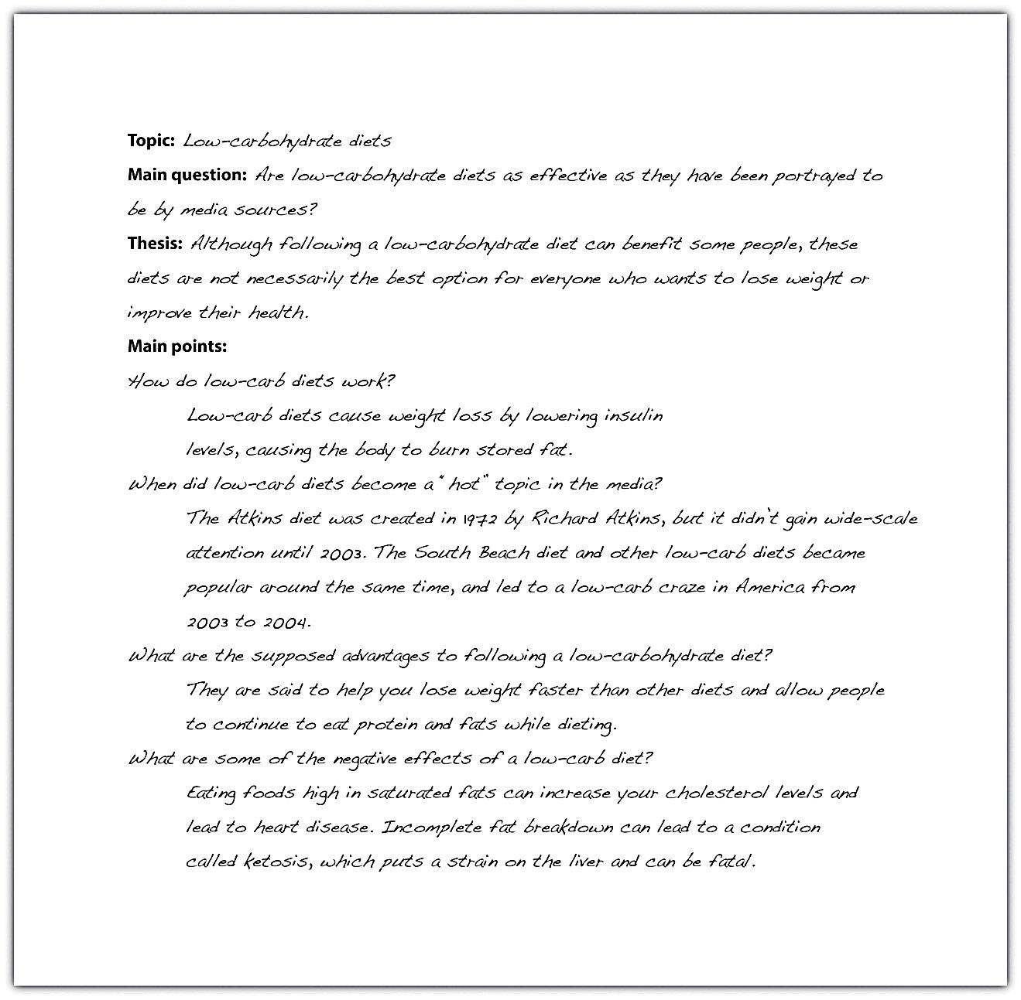
You may be wondering how your ideas are supposed to shape the paper, especially since you are writing a research paper based on your research. Integrating your ideas and your information from research is a complex process, and sometimes it can be difficult to separate the two.
Some paragraphs in your paper will consist mostly of details from your research. That is fine, as long as you explain what those details mean or how they are linked. You should also include sentences and transitions that show the relationship between different facts from your research by grouping related ideas or pointing out connections or contrasts. The result is that you are not simply presenting information; you are synthesizing, analyzing, and interpreting it.

Plan How to Organize Your Paper
The final step to complete before beginning your draft is to choose an organizational structure. For some assignments, this may be determined by the instructor’s requirements. For instance, if you are asked to explore the impact of a new communications device, a cause-and-effect structure is obviously appropriate. In other cases, you will need to determine the structure based on what suits your topic and purpose.
The purpose of Jorge’s paper was primarily to persuade. With that in mind, he planned the following outline.
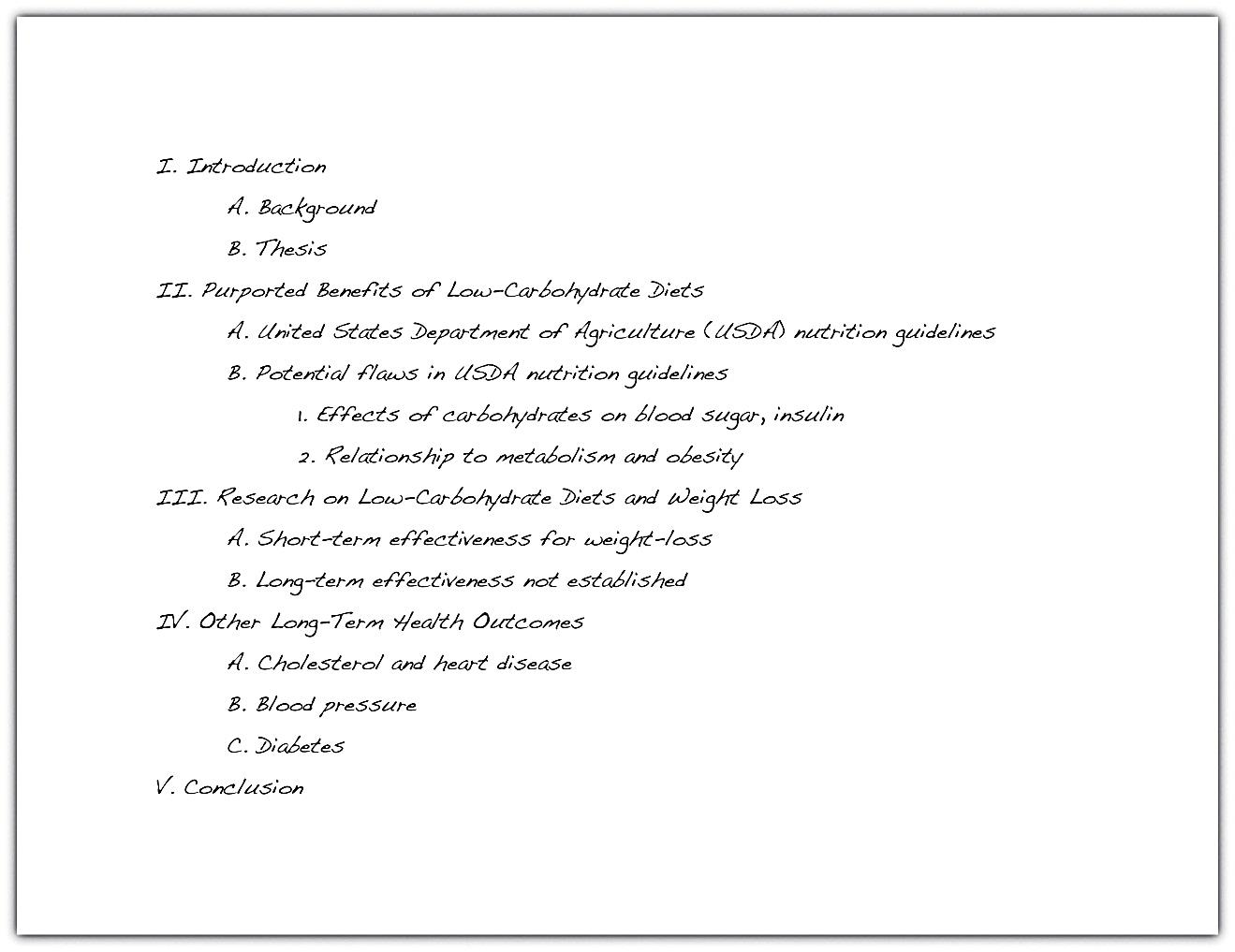

Essay 3: outline (2.5%)
Review the organizational structure discussed in Chapter 10: Persuasion. Working with the notes you organized earlier, follow these steps to begin planning how to organize your paper.
- Create an outline that includes your working thesis, major subtopics, and supporting points.
- The major headings in your outline will become sections or paragraphs in your paper. Remember that your ideas should form the backbone of the paper. For each major section of your outline, write a topic sentence stating the main point you will make in that section.
- As you complete step 2, you may find that some points are too complex to explain in a sentence. Consider whether any major sections of your outline need to be broken up and jot down additional topic sentences as needed.
- Review your notes and determine how the different pieces of information fit into your outline as supporting points.
- Add any sources you have identified that you plan on using to support your ideas.
Collaboration
- Please share the outline you created with a classmate.
- Examine your classmate’s outline and see if any questions come to mind or if you see any area that would benefit from an additional point or clarification. Return the outlines to each other and compare observations.
- After you have discussed your formal outline with a classmate, submit it to your instructor for approval.
You will receive up to 2.5% toward your final grade depending on how thoroughly you have conducted a dialectical discussion and developed your outline.

11.4 Critical Thinking and Research Applications

LEARNING OBJECTIVES
- Analyze source materials to determine how they support or refute the thesis
- Identify connections between source materials and eliminate redundant or irrelevant source materials
At this point in your project, you are preparing to move from the research phase to the writing phase. You have gathered much of the information you will use, and soon you will be ready to begin writing your draft. This section helps you transition smoothly from one phase to the next.
Beginning writers sometimes attempt to transform a pile of note cards into a formal research paper without any intermediary step. This approach presents problems. The writer’s original question and thesis may be buried in a flood of disconnected details taken from research sources. The first draft may present redundant or contradictory information. Worst of all, the writer’s ideas and voice may be lost.
An effective research paper focuses on the writer’s ideas—from the question that sparked the research process to how the writer answers that question based on the research findings. Before beginning a draft, or even an outline, good writers pause and reflect. They ask themselves questions such as the following:
- How has my thinking changed based on my research? What have I learned?
- Was my working thesis on target? Do I need to rework my thesis based on what I have learned?
- How does the information in my sources mesh with my research questions and help me answer those questions? Have any additional important questions or subtopics come up that I will need to address in my paper?
- How do my sources complement each other? What ideas or facts recur in multiple sources?
- Where do my sources disagree with each other, and why?
In this section, you will reflect on your research and review the information you have gathered. You will determine what you now think about your topic. You will synthesize, or put together, different pieces of information that help you answer your research questions. Finally, you will determine the organizational structure that works best for your paper and revise the outline you have already made and had approved to be a more formal sentence outline (an outline that contains more information like topic sentences, your supporting ideas organized more appropriately, and the sources you plan to use.

Selecting Useful Information
At this point in the research process, you have gathered information from a wide variety of sources. Now it is time to think about how you will use this information as a writer.
When you conduct research, you keep an open mind and seek out many promising sources. You take notes on any information that looks like it might help you answer your research questions. Often, new ideas and terms come up in your reading, and these, too, find their way into your notes. You may record facts or quotations that catch your attention even if they did not seem immediately relevant to your research question. By now, you have probably amassed an impressively detailed collection of notes. You will not use all of your notes in your paper.
Good researchers are thorough. They look at multiple perspectives, facts, and ideas related to their topic, and they gather a great deal of information. Effective writers, however, are selective. They determine which information is most relevant and appropriate for their purpose. They include details that develop or explain their ideas—and they leave out details that do not. The writer, not the pile of notes, is the controlling force. The writer shapes the content of the research paper.
In Chapter 7: Sources: Choosing the Right Ones, you used strategies to filter out unreliable or irrelevant sources and details. Now you will apply your critical thinking skills to the information you recorded—analyzing how it is relevant, determining how it meshes with your ideas, and finding how it forms connections and patterns.

Writing at Work
When you create workplace documents based on research, selectivity remains important. A project team may spend months conducting market surveys to prepare for rolling out a new product, but few managers have time to read the research in its entirety. Most employees want the research distilled into a few well-supported points. Focused, concise writing is highly valued in the workplace.

Identify Information That Supports Your Thesis
Begin by identifying the notes that clearly support your thesis. Mark or group these, either physically or using the cut-and-paste function in your word processing program. As you identify the crucial details that support your thesis, make sure you analyze them critically. Ask the following questions to focus your thinking:
- Is this detail from a reliable, high-quality source? Is it appropriate for me to cite this source in an academic paper? The bulk of the support for your thesis should come from reliable, reputable sources. If most of the details that support your thesis are from less-reliable sources, you may need to do additional research or modify your thesis.
- Is the link between this information and my thesis obvious, or will I need to explain it to my readers? Remember, you have spent more time thinking and reading about this topic than your audience. Some connections might be obvious to both you and your readers. More often, however, you will need to provide the analysis or explanation that shows how the information supports your thesis. As you read through your notes, jot down ideas you have for making those connections clear.
- What personal biases or experiences might affect the way I interpret this information? No researcher is 100 percent objective. We all have personal opinions and experiences that influence our reactions to what we read and learn. Good researchers are aware of this human tendency. They keep an open mind when they read opinions or facts that contradict their beliefs.

Tip
It can be tempting to ignore information that does not support your thesis or that contradicts it outright. However, such information is important. At the very least, it gives you a sense of what has been written about the issue. More importantly, it can help you question and refine your own thinking so that writing your research paper is a true learning process.

Find Connections between Your Sources
As you find connections between your ideas and information in your sources, also look for information that connects your sources. Do most sources seem to agree on a particular idea? Are some facts mentioned repeatedly in many different sources? What key terms or major concepts come up in most of your sources regardless of whether the sources agree on the finer points? Identifying these connections will help you identify important ideas to discuss in your paper.
Look for subtler ways your sources complement one another, too. Does one author refer to another’s book or article? How do sources that are more recent build upon the ideas developed in earlier sources?
Be aware of any redundancies in your sources. If you have amassed solid support from a reputable source, such as a scholarly journal, there is no need to cite the same facts from an online encyclopedia article that is many steps removed from any primary research. If a given source adds nothing new to your discussion and you can cite a stronger source for the same information, use the stronger source.
Determine how you will address any contradictions found among different sources. For instance, if one source cites a startling fact that you cannot confirm anywhere else, it is safe to dismiss the information as unreliable. However, if you find significant disagreements among reliable sources, you will need to review them and evaluate each source. Which source presents a more sound argument or more solid evidence? It is up to you to determine which source is the most credible and why.
Finally, do not ignore any information simply because it does not support your thesis. Carefully consider how that information fits into the big picture of your research. You may decide that the source is unreliable or the information is not relevant, or you may decide that it is an important point you need to bring up. What matters is that you give it careful consideration.

self-practice EXERCISE 11.9
Consider the information you have included in the outline that was approved by your instructor and the source information you compiled in Self-Practice Exercise 11.8. Apply the information in this section to critically evaluate the usefulness, relevance, and appropriateness of the sources you have selected to support your ideas. Eliminate any that you feel take you off topic or are not credible sources.

KEY TAKEAWAYS
- An effective research paper focuses on presenting the writer’s ideas using information from research as support.
- Effective writers spend time reviewing, synthesizing, and organizing their research notes before they begin drafting a research paper.
- It is important for writers to revisit their research questions and working thesis as they transition from the research phase to the writing phrase of a project. Usually, the working thesis will need at least minor adjustments.
- To organize a research paper, writers choose a structure that is appropriate for the topic and purpose. Longer papers may make use of more than one structure.

Journal entry #11
Write multiple paragraphs responding to the following. This is your final journal entry, so you want to make sure you reflect on what you have learned throughout the semester and your general writing skills.
- What is the topic around which you would like to base your persuasive essay discussion?
- Why did you choose this topic?
- What challenges do you think you may face when writing about this topic?
- Reflect on your writing skill development over the semester. Be as specific as possible.
- What are you most confident doing? What do you still need to practise?
- What do you think is your biggest accomplishment this semester?
Remember as mentioned in the Assessment Descriptions in your syllabus:
- You will be expected to respond to the questions by reflecting on and discussing your experiences with the semester’s material.
- When writing your journals, you should focus on freewriting—writing without (overly) considering formal writing structures – but remember that it will be read by the instructor, who needs to be able to understand your ideas.
Your instructor will begin reading your Journal Package 2 this week. (2.5%)

Chapter 12

Peer Review and Final Revisions

12.1 Revision

LEARNING OBJECTIVES
- Identify major areas of concern in the draft essay during revising
- Use peer reviews and checklists to assist revising
- Revise your paper to improve organization and cohesion
- Determine an appropriate style and tone for your paper
- Revise to ensure that your tone is consistent
- Revise the first draft of your essay and produce a final draft
Revising and editing are the two tasks you undertake to significantly improve your essay. Both are very important elements of the writing process. You may think that a completed first draft means that little improvement is needed. However, even experienced writers need to improve their drafts and rely on peers during revising and editing. You may know that athletes miss catches, fumble balls, or overshoot goals. Dancers forget steps, turn too slowly, or miss beats. For both athletes and dancers, the more they practise, the stronger their performance will become. Web designers seek better images, a more clever design, or a more appealing background for their web pages. Writing has the same capacity to profit from improvement and revision.
You should revise and edit in stages: do not expect to catch everything in one go. If each time you review your essay you focus on a different aspect of construction, you will be more likely to catch any mistakes or identify any issues. Throughout this chapter, you will see a number of checklists containing specific things to look for with each revision. For example, you will first look at how the overall paper and your ideas are organized.

In the second section of this chapter, you will focus more on editing: correcting the mechanical issues. Also at the end of the chapter, you will see a comprehensive but more general list of things you should be looking for.

Understanding the Purpose of Revising and Editing
Revising and editing allow you to examine two important aspects of your writing separately, so that you can give each task your undivided attention.
- When you revise, you take a second look at your ideas. You might add, cut, move, or change information in order to make your ideas clearer, more accurate, more interesting, or more convincing.
- When you edit, you take a second look at how you expressed your ideas. You add or change words. You fix any problems in grammar, punctuation, and sentence structure. You improve your writing style. You make your essay into a polished, mature piece of writing, the end product of your best efforts.

Tip
How do you get the best out of your revisions and editing? Here are some strategies that writers have developed to look at their first drafts from a fresh perspective. Try them throughout the writing process; then keep using the ones that bring results.
- Take a break. You are proud of what you wrote, but you might be too close to it to make changes. Set aside your writing for a few hours or even a day until you can look at it objectively.
- Ask someone you trust for feedback and constructive criticism.
- Pretend you are one of your readers. Are you satisfied or dissatisfied? Why?
For many people, the words critic, critical, and criticism provoke only negative feelings that make them blush, grumble, or shout. However, as a writer and a thinker, you need to learn to be critical of yourself in a positive way and have high expectations for your work. You also need to train your eye and trust your ability to fix what needs fixing. To do this, you need to teach yourself where to look.

Revising Your Paper: Organization, Cohesion, and Unity
When writing a research paper, it is easy to become overly focused on editorial details, such as the proper format for bibliographical entries. These details do matter. However, before you begin to address them, it is important to spend time reviewing and revising the content of the paper.
A good research paper is both organized and cohesive. Organization means that your argument flows logically from one point to the next. Cohesion means that the elements of your paper work together smoothly and naturally. In a cohesive research paper, information from research is seamlessly integrated with the writer’s ideas.

Revise to Improve Organization
When you revise to improve organization, you look at the flow of ideas throughout the essay as a whole and within individual paragraphs. You check to see that your essay moves logically from the introduction to the body paragraphs to the conclusion, and that each section reinforces your thesis. Use Checklist 12.1: Revise for Organization to help you.

Checklist 12.1: Revise for Organization
At the essay level
- Does my introduction proceed clearly from the opening to the thesis?
- Does each body paragraph have a clear main idea that relates to the thesis?
- Do the main ideas in the body paragraphs flow in a logical order? Is each paragraph connected to the one before it?
- Do I need to add or revise topic sentences or transitions to make the overall flow of ideas clearer?
- Does my conclusion summarize my main ideas and revisit my thesis?
At the paragraph level
- Does the topic sentence clearly state the main idea?
- Do the details in the paragraph relate to the main idea?
- Do I need to recast any sentences or add transitions to improve the flow of sentences?
Jorge reread his draft paragraph by paragraph. As he read, he highlighted the main idea of each paragraph so he could see whether his ideas proceeded in a logical order. For the most part, the flow of ideas was clear. However, he did notice that one paragraph did not have a clear main idea. It interrupted the flow of the writing. During revision, Jorge added a topic sentence that clearly connected the paragraph to the one that had preceded it. He also added transitions to improve the flow of ideas from sentence to sentence.
Read the following paragraphs twice, the first time without Jorge’s changes, and the second time with them.
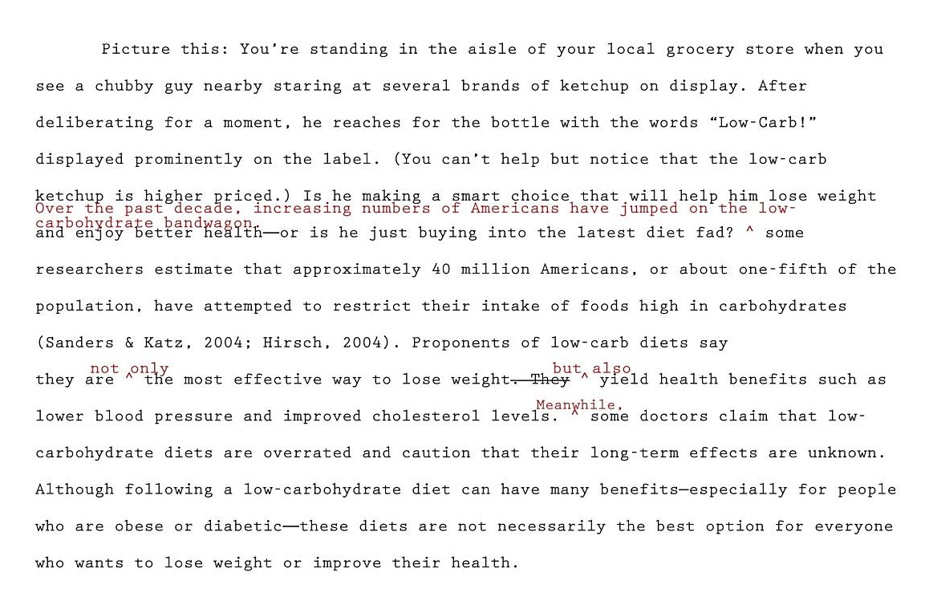

self-practice EXERCISE 12.1
Follow these steps to begin revising your paper’s overall organization.
- Print out a hard copy of your paper. (You will use this for multiple self-practice exercises in this chapter.)
- Read your paper paragraph by paragraph. Highlight your thesis and the topic sentence of each paragraph.
- Using the thesis and topic sentences as starting points, outline the ideas you presented—just as you would do if you were outlining a chapter in a textbook. Do not look at the outline you created during prewriting. You may write in the margins of your draft or create a formal outline on a separate sheet of paper.
- Next, reread your paper more slowly, looking for how ideas flow from sentence to sentence. Identify places where adding a transition or recasting a sentence would make the ideas flow more logically.
- Review the topics on your outline. Is there a logical flow of ideas? Identify any places where you may need to reorganize ideas.
- Begin to revise your paper to improve organization. Start with any major issues, such as needing to move an entire paragraph. Then proceed to minor revisions, such as adding a transitional phrase or tweaking a topic sentence so it connects ideas more clearly.
Optional collaboration: Please share your paper with a classmate. Repeat the six steps and take notes on a separate piece of paper. Share and compare notes.

Tip
Writers choose transitions carefully to show the relationships between ideas—for instance, to make a comparison or elaborate on a point with examples. Make sure your transitions suit your purpose and avoid overusing the same ones.

Creating Coherence
Careful writers use transitions to clarify how the ideas in their sentences and paragraphs are related. These words and phrases help the writing flow smoothly. Adding transitions is not the only way to improve coherence, but they are often useful and give a mature feel to your essays. Earlier chapters have discussed using transitions for specific purposes in the planning of your writing. Table 12.1: Common Transitional Words and Phrases groups many common transitions according to their purpose.
Table 12.1: Common Transitional Words and Phrases According to Purpose
Transitions That Show Sequence or Time
after | before | later
afterward | before long | meanwhile
as soon as | finally | next
at first | first, second, third | soon
at last | in the first place | then
Transitions That Show Position
above | across | at the bottom
at the top | behind | below
beside | beyond | inside
near | next to | opposite
to the left, to the right, to the side | under | where
Transitions That Show a Conclusion
indeed | hence | in conclusion
in the final analysis | therefore | thus
Transitions That Continue a Line of Thought
consequently | furthermore | additionally
because | besides the fact | following this idea further
in addition | in the same way | moreover
looking further | considering…, it is clear that
Transitions That Change a Line of Thought
but | yet | however
nevertheless | on the contrary | on the other hand
Transitions That Show Importance
above all | best | especially
in fact | more important | most important
most | worst
Transitions That Introduce the Final Thoughts in a Paragraph or Essay
finally | last | in conclusion
most of all | least of all | last of all
All Purpose Transitions to Open Paragraphs or to Connect Ideas Inside Paragraphs
admittedly | at this point | certainly
granted | it is true | generally speaking
in general | in this situation | no doubt
no one denies | obviously | of course
to be sure | undoubtedly | unquestionably
Transitions that Introduce Examples
for instance | for example | such as
Transitions That Clarify the Order of Events or Steps
first, second, third | generally, furthermore, finally | in the first place, also, last
in the first place, furthermore, finally | in the first place, likewise, lastly
When Mariah (who you were introduced to in Chapters 5 and 6) revised her essay for unity, she examined her paragraph about televisions to check for coherence. She looked for places where she needed to add a transition or perhaps reword the text to make the flow of ideas clear. In the version that follows, she has already deleted the sentences that were off topic.

Tip
Many writers make their revisions on a printed copy and then transfer them to the version on screen. They conventionally use a small arrow called a caret (^) to show where to insert an addition or correction.

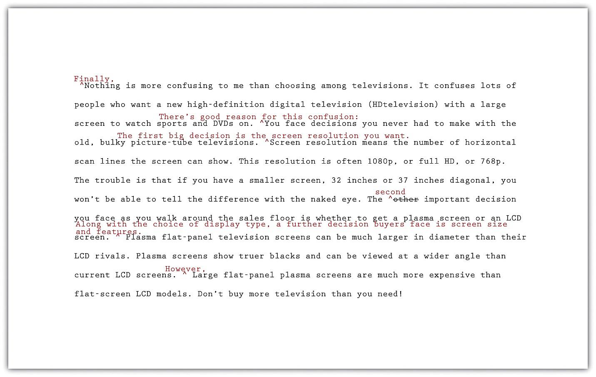

self-practice EXERCISE 12.2
Answer the following questions about Mariah’s revised paragraph.
  - Do you agree with the transitions and other changes that Mariah made to her paragraph? Which would you keep and which were unnecessary? Explain.
  - What transition words or phrases did Mariah add to her paragraph? Why did she choose each one?
  - What effect does adding additional sentences have on the coherence of the paragraph? Explain. When you read both versions aloud, which version has a more logical flow of ideas? Explain.

Revise to Improve Cohesion
When you revise to improve cohesion, you analyze how the parts of your paper work together. You look for anything that seems awkward or out of place. Revision may involve deleting unnecessary material or rewriting parts of the paper so that the out of place material fits in smoothly.
In a research paper, problems with cohesion usually occur when a writer has trouble integrating source material. If facts or quotations have been awkwardly dropped into a paragraph, they distract or confuse the reader instead of working to support the writer’s point. Overusing paraphrased and quoted material has the same effect. Use Checklist 12.2: Revise for Cohesion to review your essay for cohesion.

Checklist 12.2: Revise for Cohesion
- Does the opening of the paper clearly connect to the broader topic and thesis? Make sure entertaining quotes or anecdotes serve a purpose.
- Have I included support from research for each main point in the body of my paper?
- Have I included introductory material before any quotations? Quotations should never stand alone in a paragraph.
- Does paraphrased and quoted material clearly serve to develop my own points?
- Do I need to add to or revise parts of the paper to help the reader understand how certain information from a source is relevant?
- Are there any places where I have overused material from sources?
- Does my conclusion make sense based on the rest of the paper? Make sure any new questions or suggestions in the conclusion are clearly linked to earlier material.
As Jorge reread his draft, he looked to see how the different pieces fit together to prove his thesis. He realized that some of his supporting information needed to be integrated more carefully and decided to omit some details entirely. Read the following paragraph, first without Jorge’s revisions and then with them.
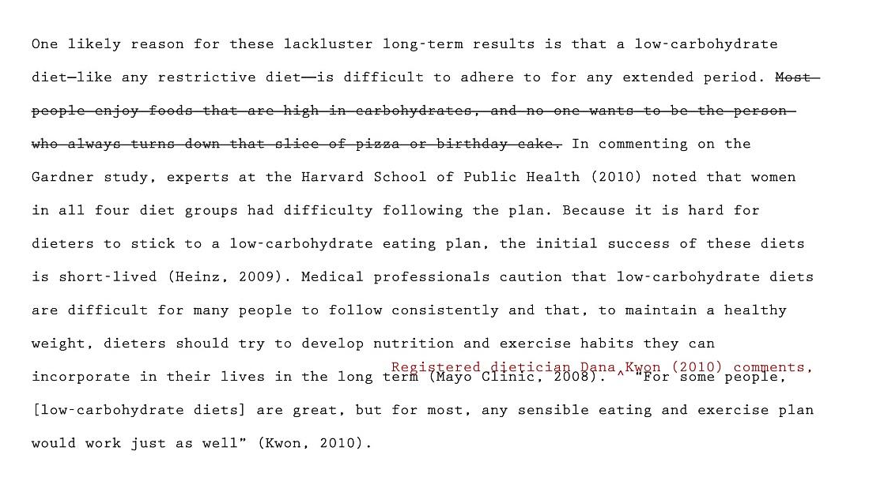
Jorge decided that his comment about pizza and birthday cake came across as subjective and was not necessary to make his point, so he deleted it. He also realized that the quotation at the end of the paragraph was awkward and ineffective. How would his readers know who Kwon was or why her opinion should be taken seriously? Adding an introductory phrase helped Jorge integrate this quotation smoothly and establish the credibility of his source.

self-practice EXERCISE 12.3
Follow these steps to begin revising your paper to improve cohesion.
- Print out a hard copy of your paper, or work with your printout from Self-Practice Exercise 12.1.
- Read the body paragraphs of your paper first. Each time you come to a place that cites information from sources, ask yourself what purpose this information serves. Check that it helps support a point and that it is clearly related to the other sentences in the paragraph.
- Identify unnecessary information from sources that you can delete.
- Identify places where you need to revise your writing so that readers understand the significance of the details cited from sources.
- Skim the body paragraphs once more, looking for any paragraphs that seem packed with citations. Review these paragraphs carefully for cohesion.
- Review your introduction and conclusion. Make sure the information presented works with ideas in the body of the paper.
- Revise the places you identified in your paper to improve cohesion.
Optional collaboration: Please exchange papers with a classmate. Complete step 4. On a separate piece of paper, note any areas that would benefit from clarification. Return and compare notes.

Writing at Work
Understanding cohesion can also benefit you in the workplace, especially when you have to write and deliver a presentation. Speakers sometimes rely on cute graphics or funny quotations to hold their audience’s attention. If you choose to use these elements, make sure they work well with the substantive content of your presentation. For example, if you are asked to give a financial presentation, and the financial report shows that the company lost money, funny illustrations would not be relevant or appropriate for the presentation.

Tip
Reading your writing aloud will often help you find problems with unity and coherence. Listen for the clarity and flow of your ideas. Identify places where you find yourself confused, and write a note to yourself about possible fixes.

Creating Unity
Sometimes writers get caught up in the moment and cannot resist a good digression. Even though you might enjoy such detours when you chat with friends, unplanned digressions usually harm a piece of writing.
Following your outline closely offers you a reasonable guarantee that your writing will stay on purpose and not drift away from the controlling idea. However, when writers are rushed, are tired, or cannot find the right words, their writing may become less than they want it to be. Their writing may no longer be clear and concise, and they may add information that is not needed to develop the main idea.
When a piece of writing has unity, all the ideas in each paragraph and in the entire essay clearly belong and are arranged in an order that makes logical sense. When the writing has coherence, the ideas flow smoothly. The wording clearly indicates how one idea leads to another within a paragraph and from paragraph to paragraph.
Mariah stayed close to her outline when she drafted the three body paragraphs of her essay she tentatively titled “Digital Technology: The Newest and the Best at What Price?” But a recent shopping trip for an HDTV upset her enough that she digressed from the main topic of her third paragraph and included comments about the sales staff at the electronics store she visited. When she revised her essay, she deleted the off-topic sentences that affected the unity of the paragraph.
Read the following paragraph twice, the first time without Mariah’s changes and the second time with them.
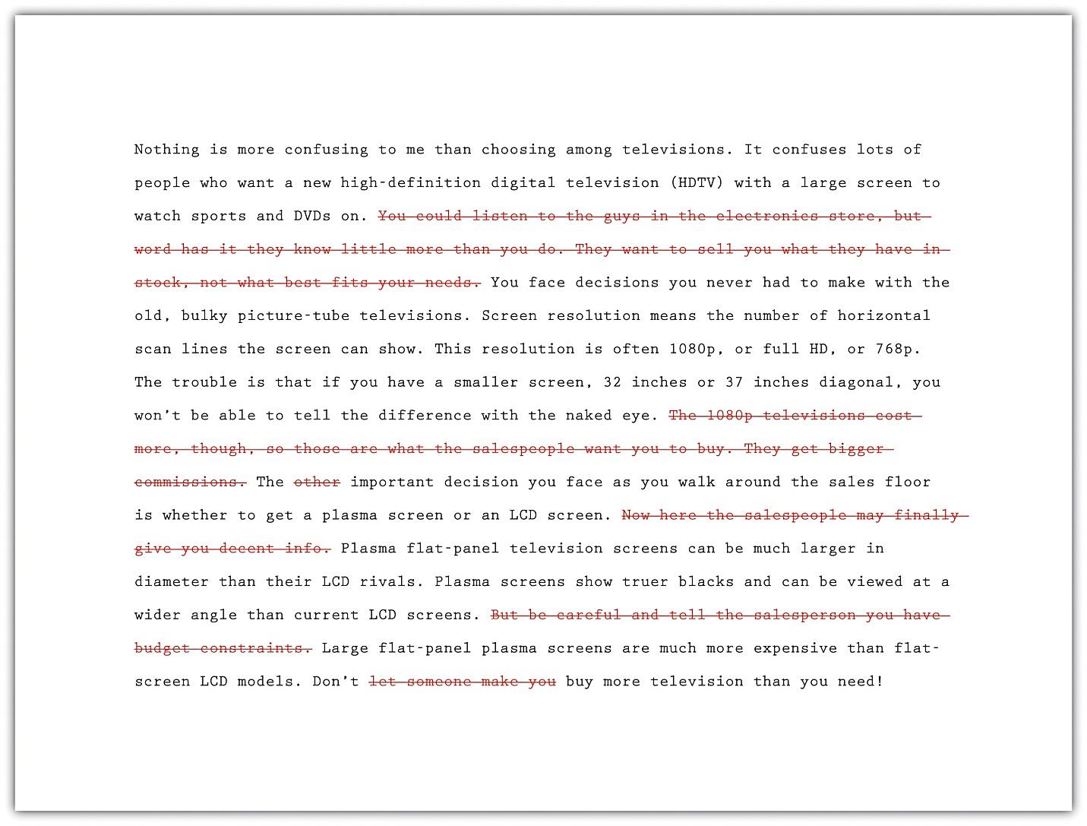

Self-practice EXERCISE 12.4
Answer the following two questions about Mariah’s paragraph:
  - Do you agree with Mariah’s decision to make the deletions she made? Did she cut too much, too little, or just enough? Explain.
  - Is the explanation of what screen resolution means a digression? Or is it audience friendly and essential to understanding the paragraph? Explain.
Collaboration: Please share with a classmate and compare your answers.
Now, print out another copy of your essay or use the printed version(s) you used in Self-Practice Exercises 12.1 and 12.3. Reread it to find any statements that affect the unity of your writing. Decide how best to revise.

Tip
When you reread your writing to find revisions to make, look for each type of problem in a separate sweep. Read it straight through once to locate any problems with unity. Read it straight through a second time to find problems with coherence. You may follow this same practice during many stages of the writing process.

Writing at Work
Many companies hire copy editors and proofreaders to help them produce the cleanest possible final drafts of large writing projects. Copy editors are responsible for suggesting revisions and style changes; proofreaders check documents for any errors in capitalization, spelling, and punctuation that have crept in. Many times, these tasks are done on a freelance basis, with one freelancer working for a variety of clients.

Using a Consistent Style and Tone
Once you are certain that the content of your paper fulfills your purpose, you can begin revising to improve style and tone. Together, your style and tone create the voice of your paper, or how you come across to readers. Style refers to the way you use language as a writer—the sentence structures you use and the word choices you make. Tone is the attitude toward your subject and audience that you convey through your word choice.

Determining an Appropriate Style and Tone
Although accepted writing styles will vary within different disciplines, the underlying goal is the same—to come across to your readers as a knowledgeable, authoritative guide. Writing about research is like being a tour guide who walks readers through a topic. A stuffy, overly formal tour guide can make readers feel put off or intimidated. Too much informality or humour can make readers wonder whether the tour guide really knows what he or she is talking about. Extreme or emotionally charged language comes across as unbalanced.
To help prevent being overly formal or informal, determine an appropriate style and tone at the beginning of the research process. Consider your topic and audience because these can help dictate style and tone. For example, a paper on new breakthroughs in cancer research should be more formal than a paper on ways to get a good night’s sleep.
A strong research paper comes across as straightforward, appropriately academic, and serious. It is generally best to avoid writing in the first person, as this can make your paper seem overly subjective and opinion based. Use Checklist 12.3: Revise for Style to review your paper for other issues that affect style and tone. You can check for consistency at the end of the writing process. Checking for consistency is discussed later in this section.

Checklist 12.3: Revise for Style
- My paper avoids excessive wordiness.
- My sentences are varied in length and structure.
- I have avoided using first person pronouns such as I and we.
- I have used the active voice whenever possible.
- I have defined specialized terms that might be unfamiliar to readers.
- I have used clear, straightforward language whenever possible and avoided unnecessary jargon.
- My paper states my point of view using a balanced tone—neither too indecisive nor too forceful.

Word Choice
Note that word choice is an especially important aspect of style. In addition to checking the points noted on Checklist 12.3, review your paper to make sure your language is precise, conveys no unintended connotations, and is free of bias. Here are some of the points to check for:
- Vague or imprecise terms
- Slang
- Repetition of the same phrases (“Smith states…, Jones states…”) to introduce quoted and paraphrased material (For a full list of strong verbs to use with in text citations, see Chapter 9: Citations and Referencing.)
- Exclusive use of masculine pronouns or awkward use of he or she
- Use of language with negative connotations, such as haughty or ridiculous
- Use of outdated or offensive terms to refer to specific ethnic, racial, or religious groups

Tip
Using plural nouns and pronouns or recasting a sentence can help you keep your language gender neutral while avoiding awkwardness. Consider the following examples.
- Gender biased: When a writer cites a source in the body of his paper, he must list it on his references page.
- Awkward: When a writer cites a source in the body of his or her paper, he or she must list it on his or her references page.
- Improved: Writers must list any sources cited in the body of a paper on the references page.

Keeping Your Style Consistent
As you revise your paper, make sure your style is consistent throughout. Look for instances where a word, phrase, or sentence does not seem to fit with the rest of the writing. It is best to reread for style after you have completed the other revisions so that you are not distracted by any larger content issues. Revising strategies you can use include the following:
- Read your paper aloud. Sometimes your ears catch inconsistencies that your eyes miss.
- Share your paper with another reader whom you trust to give you honest feedback. It is often difficult to evaluate one’s own style objectively—especially in the final phase of a challenging writing project. Another reader may be more likely to notice instances of wordiness, confusing language, or other issues that affect style and tone.
- Edit your paper slowly, sentence by sentence. You may even wish to use a sheet of paper to cover up everything on the page except the paragraph you are editing. This practice forces you to read slowly and carefully. Mark any areas where you notice problems in style or tone, and then take time to rework those sections.
On reviewing his paper, Jorge found that he had generally used an appropriately academic style and tone. However, he noticed one glaring exception—his first paragraph. He realized there were places where his overly informal writing could come across as unserious or, worse, disparaging. Revising his word choice and omitting a humorous aside helped Jorge maintain a consistent tone. Read his revisions.
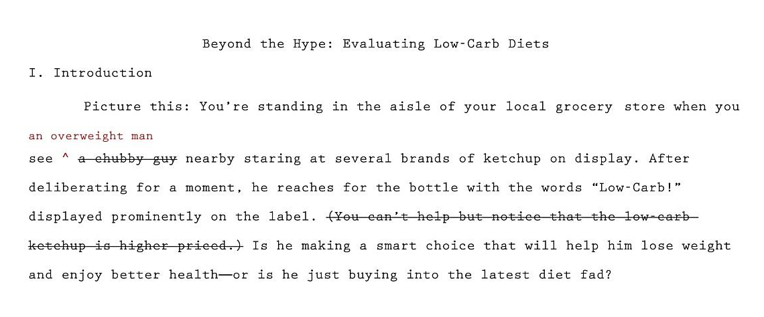

self-practice EXERCISE 12.5
Using Checklist 12.3: Revise for Style, revise your paper line by line. You may use either of these techniques:
- Print out a hard copy of your paper or work with your printout from Self-Practice Exercise 12.1. Read it line by line. Check for the issues noted on Checklist 12.3, as well as any other aspects of your writing style you have previously identified as areas for improvement. Mark any areas where you notice problems in style or tone, and then take time to rework those sections.
- If you prefer to work with an electronic document, use the menu options in your word processing program to enlarge the text to 150 or 200 percent of the original size. Make sure the type is large enough that you can focus on one paragraph at a time. Read the paper line by line as described in step 1. Highlight any areas where you notice problems in style or tone, and then take time to rework those sections.
Optional collaboration: Please exchange papers with a classmate. On a separate piece of paper, note places where the essay does not seem to flow or you have questions about what was written. Return the essay and compare notes.

Completing a Peer Review
After working so closely with a piece of writing, writers often need to step back and ask for a more objective reader. What writers need most is feedback from readers who can respond only to the words on the page. When they are ready, writers show their drafts to someone they respect and who can give an honest response about its strengths and weaknesses.
You, too, can ask a peer to read your draft when it is ready. After evaluating the feedback and assessing what is most helpful, the reader’s feedback will help you when you revise your draft. This process is called peer review.
You can work with a partner in your class and identify specific ways to strengthen each other’s essays. Although you may be uncomfortable sharing your writing at first, remember that each writer is working toward the same goal: a final draft that fits the audience and the purpose. Maintaining a positive attitude when providing feedback will put you and your partner at ease. The box that follows provides a useful framework for the peer review session.

Questions for Peer Review: Organization, Unity, and Coherence
Title of essay: ____________________________________________
Date: ____________________________________________
Writer’s name: ____________________________________________
Peer reviewer’s name: _________________________________________
- This essay is about____________________________________________.
- Your main points in this essay are____________________________________________.
- What I most liked about this essay is____________________________________________.
- These three points struck me as your strongest:
- Point: ____________________________________________
Why: ____________________________________________
- Point: ____________________________________________
Why: ____________________________________________
- Point: ____________________________________________
Why: ____________________________________________
- These places in your essay are not clear to me:
- Where: ____________________________________________
Needs improvement because__________________________________________
- Where: ____________________________________________
Needs improvement because ____________________________________________
- Where: ____________________________________________
Needs improvement because ____________________________________________
- The one additional change you could make that would improve this essay significantly is ____________________________________________.

Writing at Work
One of the reasons why word processing programs build in a reviewing feature is that work groups have become a common feature in many businesses. Writing is often collaborative, and the members of a work group and their supervisors often critique group members’ work and offer feedback that will lead to a better final product.

self-practice EXERCISE 12.6
Exchange essays with a classmate and complete a peer review of each other’s draft in progress. Remember to give positive feedback and to be courteous and polite in your responses. Focus on providing one positive comment and one question for more information to the author.

Using Feedback Objectively
The purpose of peer feedback is to receive constructive criticism of your essay. Your peer reviewer is your first real audience, and you have the opportunity to learn what confuses and delights a reader so that you can improve your work before sharing the final draft with a wider audience (or your intended audience).
It may not be necessary to incorporate every recommendation your peer reviewer makes. However, if you start to observe a pattern in the responses you receive from peer reviewers, you might want to consider that feedback in future assignments. For example, if you read consistent comments about a need for more research, then you may want to consider including more research in future assignments.

Using Feedback from Multiple Sources
You might get feedback from more than one reader as you share different stages of your revised draft. In this situation, you may receive feedback from readers who do not understand the assignment or who lack your involvement with and enthusiasm for it.
You need to evaluate the responses you receive according to two important criteria:
- Determine if the feedback supports the purpose of the assignment.
- Determine if the suggested revisions are appropriate to the audience.
Then, using these standards, accept or reject revision feedback.

self-practice EXERCISE 12.7
Consider the feedback you received from the peer review and all of the revision exercises throughout this section. Compile a final draft of your revisions that you can use in the next section to complete your final edits.

KEY TAKEAWAYS
- Revising and editing are the stages of the writing process in which you improve your work before producing a final draft.
- Unity in writing means that all the ideas in each paragraph and in the entire essay clearly belong together and are arranged in an order that makes logical sense.
- Coherence in writing means that the writer’s wording clearly indicates how one idea leads to another within a paragraph and between paragraphs.
- Transitional words and phrases effectively make writing more coherent.
- Writing should be clear and concise, with no unnecessary words.
- Effective formal writing uses specific, appropriate words and avoids slang, contractions, clichés, and overly general words.
- Peer reviews, done properly, can give writers objective feedback about their writing. It is the writer’s responsibility to evaluate the results of peer reviews and incorporate only useful feedback.

12.2 Editing and Developing a Final Draft of a Research Paper

LEARNING OBJECTIVES
- Edit your paper to ensure that language, citations, and formatting are correct
Given all the time and effort you have put into your research paper, you will want to make sure that your final draft represents your best work. This requires taking the time to revise and edit your paper carefully.
You may feel like you need a break from your paper before you edit it. That feeling is understandable, so you want to be sure to leave yourself enough time to complete this important stage of the writing process. This section presents a number of opportunities for you to focus on different aspects of the editing process; as with revising a draft, you should approach editing in different stages.
Some of the content in this section may seem repetitive, but again, it provides you with a chance to double-check any revisions you have made at a detailed level.

Editing Your Draft
If you have been incorporating each set of revisions as Mariah and Jorge have, you have produced multiple drafts of your writing. So far, all your changes have been content changes. Perhaps with the help of peer feedback, you have made sure that you sufficiently supported your ideas. You have checked for problems with unity and coherence. You have examined your essay for word choice, revising to cut unnecessary words and to replace weak wording with specific and appropriate wording.
The next step after revising the content is editing. When you edit, you examine the surface features of your text. You examine your spelling, grammar, usage, and punctuation. You also make sure you use the proper format when creating your finished assignment.

Tip
Editing takes time. Be sure to budget time into the writing process to complete additional edits after revising. Editing and proofreading your writing helps you create a finished work that represents your best efforts. Here are a few more tips to remember about your readers:
- Readers do not notice correct spelling, but they do notice misspellings.
- Readers look past your sentences to get to your ideas—unless the sentences are awkward, poorly constructed, and frustrating to read.
- Readers notice when every sentence has the same rhythm as every other sentence, with no variety.
- Readers do not cheer when you use there, their, and they’re correctly, but they notice when you do not.
- Readers will notice the care with which you handled your assignment and your attention to detail in the delivery of an error-free document.

Being Clear and Concise
Some writers are very methodical and painstaking when they write a first draft. Other writers unleash a lot of words in order to get out all that they feel they need to say. Do either of these methods match your style? Or is your composing style somewhere in between? No matter which description best fits you, the first draft of almost every piece of writing, no matter its author, can be made clearer and more concise.
If you have a tendency to write too much, you will need to look for unnecessary words. If you have a tendency to be vague or imprecise in your wording, you will need to find specific words to replace any overly general language.

Identifying Wordiness
Sometimes writers use too many words when fewer words will appeal more to their audience and better fit their purpose. Here are some common examples of wordiness to look for in your draft. Eliminating wordiness helps all readers, because it makes your ideas clear, direct, and straightforward.
- Sentences that begin with There is or There are

- Wordy: There are two major experiments that the Biology Department sponsors.
- Revised: The Biology Department sponsors two major experiments.
- Sentences with unnecessary modifiers

- Wordy: Two extremely famous and well-known consumer advocates spoke eloquently in favour of the proposed important legislation.
- Revised: Two well-known consumer advocates spoke in favour of the proposed legislation.
- Sentences with deadwood phrases that add little to the meaning. Be judicious when you use phrases such as in terms of, with a mind to, on the subject of, as to whether or not, more or less, as far as…is concerned, and similar expressions. You can usually find a more straightforward way to state your point.

- Wordy: As a world leader in the field of green technology, the company plans to focus its efforts in the area of geothermal energy. A report as to whether or not to use geysers as an energy source is in the process of preparation.
- Revised: As a world leader in green technology, the company plans to focus on geothermal energy. Researchers are preparing a report about using geysers as an energy source.
- Sentences in the passive voice or with forms of the verb to be: Sentences with passive voice verbs often create confusion because the subject of the sentence does not perform an action. Sentences are clearer when the subject performs the action and is followed by a strong verb. Use strong active voice verbs in place of forms of to be, which can lead to wordiness. Avoid passive voice when you can.

- Wordy: It might perhaps be said that using a GPS device is something that is a benefit to drivers who have a poor sense of direction.
- Revised: Using a GPS device benefits drivers who have a poor sense of direction.
- Sentences with constructions that can be shortened
- Wordy: The e-book reader, which is a recent invention, may become as commonplace as the cell phone. My over-60 uncle bought an e-book reader, and his wife bought an e-book reader, too.
- Revised: The e-book reader, a recent invention, may become as commonplace as the cell phone. My over-60 uncle and his wife both bought e-book readers.

Choosing Specific, Appropriate Words
Most essays at the post-secondary level should be written in formal English suitable for an academic situation. Follow these principles to be sure that your word choice is appropriate. For more information about word choice, see Chapter 2: Working with Words: Which Word Is Right?
- Avoid slang. Find alternatives to bummer, kewl, and rad.
- Avoid language that is overly casual. Write about “men and women” rather than “girls and guys” unless you are trying to create a specific effect. A formal tone calls for formal language.
- Avoid contractions. Use do not in place of don’t, I am in place of I’m,have not in place of haven’t, and so on. Contractions are considered casual speech.
- Avoid clichés. Overused expressions such as green with envy, face the music, better late than never, and similar expressions are empty of meaning and may not appeal to your audience.
- Be careful when you use words that sound alike but have different meanings. Some examples are allusion/illusion; complement/compliment; council/counsel; concurrent/consecutive; founder/flounder; and historic/historical. When in doubt, check a dictionary.
- Choose words with the connotations you want. Choosing a word for its connotations is as important in formal essay writing as it is in all kinds of writing. Compare the positive connotations of the word proud and the negative connotations of arrogant and conceited.
- Use specific words rather than overly general words. Find synonyms for thing, people, nice, good, bad, interesting, and other vague words. Or use specific details to make your exact meaning clear.
Now read the revisions Mariah made to make her third paragraph clearer and more concise. She has already incorporated the changes she made to improve unity and coherence.
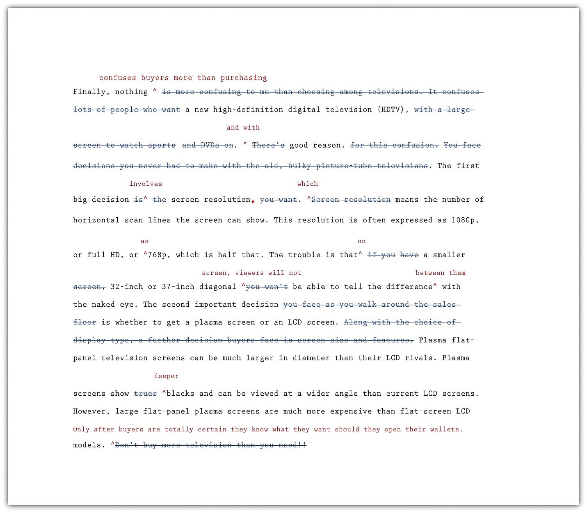

self-practice EXERCISE 12.8
Answer the following questions about Mariah’s revised paragraph:
  - Read the unrevised and the revised paragraphs aloud. Explain in your own words how changes in word choice have affected Mariah’s writing.
  - Do you agree with the changes that Mariah made to her paragraph? Which changes would you keep and which were unnecessary? Explain. What other changes would you have made?
  - What effect does removing contractions and the pronoun you have on the tone of the paragraph? How would you characterize the tone now? Why?
Now return once more to your essay in progress. Read carefully for problems with word choice. Be sure that your draft is written in formal language and that your word choice is specific and appropriate.

self-practice EXERCISE 12.9
Return once more to the first draft of the essay you have been revising. Check it for unnecessary words. Try making your sentences as concise as they can be.

Brief Punctuation Review
Throughout this book, you have been presented with a number of tables containing transitional words. Table 12.2: Punctuating Transitional Words and Phrases shows many of the transition words you have seen organized into different categories to help you know how to punctuate with each one.
Table 12.2: Punctuating Transitional Words and Phrases
Joining Independent Clauses (coordination)
2 IND | Coordinating conjunctions: FANBOYS |  | Conjunctive adverbs and other transitional expressions
IND; IND | IND, ____ IND |  | IND. _____, IND or IND; _____, IND
 | for |  | accordingly |  | after all
 | and |  | after a while |  | also
 | nor |  | anyhow |  | as a result
 | but |  | at any rate |  | at the same time
 | or |  | besides |  | consequently
 | yet |  | for example |  | for instance
 | so |  | furthermore |  | hence
 |  |  | henceforth |  | however
 |  |  | in addition |  | indeed
 |  |  | in fact |  | in other words
 |  |  | in particular |  | instead
 |  |  | in the first place |  | likewise
 |  |  | meanwhile |  | moreover
 |  |  | nevertheless |  | nonetheless
 |  |  | on the contrary |  | on the other hand
 |  |  | otherwise |  | still
 |  |  | then |  | therefore
 |  |  | thus
Forming Dependent Clauses (subordination)
IND + DEP or DEP , IND
after | although | as |  | as if |  | as though
because | before | if |  | in order that |  | since
so that | that | though |  | unless |  | until
when | whenever | where |  | wherever
*which | while | who |  | whom |  | whose
* This row contains relative pronouns, which may be punctuated differently.

Joining Independent Clauses
There are three ways to join independent clauses. By using a mix of all three methods and varying your transition words, you will add complexity to your writing and improve the flow. You will also be emphasizing to your reader which ideas you want to connect or to show things like cause and effect or contrast. For a more detailed review of independent clauses, look back at Chapter 3: Putting Ideas into Your Own Words and Paragraphs.
Option 1
By simply using a semicolon (;), you can make the ideas connect more than if you were to use a period. If you are trying to reinforce that connection, use a semicolon because it is not as strong of a pause as a period and reinforces the link.
Option 2
When you want to link two independent sentences and increase the flow between ideas, you can add a comma and a coordinating conjunction between them.
With coordinating conjunctions (FANBOYS: for, and, nor, but, or, yet, so), you do not use a comma every time: you would only do so if what is on either side of the conjunction is a complete sentence not just a phrase. You would not put a comma if you are only giving a list of two items. For example:
Comma: It is cold outside, so I wore an extra warm coat.
No comma: It is cold outside. I wore an extra warm coat and gloves.
The first example contains a complete sentence (independent clause) on either side of the conjunction so. Just the conjunction by itself or just a comma by itself is not strong enough to join two independent clauses. However, if you put the two together with so, you can link the two.
In the second example, and is simply connecting two noun phrases: warm coat and gloves. What comes after the conjunction is not a complete sentence, so you would not add a comma. To check if there is a complete, independent clause, ask yourself, “Can that part stand by itself as a complete sentence?” In the case of the no comma example, gloves is what comes after the comma. That is not a complete sentence, only a noun: that means it is part of a list and is not a complete sentence = no comma.
The point of these examples was to show you that you have to be careful how you use commas and conjunctions. As easy as it would be to just always toss in a comma, doing so would confuse your reader as what is and is not part of a list and what ideas are joined.
Option 3
Your third choice is to join two independent clauses with a conjunctive adverb or another transition word. These words are very useful because they clearly show your reader how you would like your ideas to connect. If you wanted to emphasize contrasting ideas, you would use on the other hand or however. If you wanted to show cause and effect, you could use as a result. Refer to the tables you have seen in other chapters to make sure you are using the transitions you actually mean to be using; then, check Table 12.2 to confirm how you should punctuate it.
After your first independent clause, you can choose to either use a period or a semicolon, again depending on how much of a link you want to show. You may also want to consider how many long sentences you have used prior to this. If you use a lot of complicated sentences, you should probably use a period to allow your reader to take a break. You must also remember to include a comma after the transition word.
Period: It is cold outside. Therefore, I wore an extra warm coat.
Semicolon: It is cold outside; therefore, I wore an extra warm coat.

Joining Dependent Clauses
If one of the clauses in a sentence is independent and can stand on its own, but the other is not, you have to construct the sentence a little differently. Whenever you add a subordinating conjunction or relative pronoun to an independent sentence, you create a dependent clause—one that can never stand alone.
In the examples below, notice that when the independent clause comes first, it is strong enough to carry the dependent clause at the end without any helping punctuation. However, if you want the dependent clause first, you must add a comma between it and the independent clause: the dependent clause is not strong enough to support the independent clause after without a little help. In the examples below, the independent clauses are double underlined and the dependent clause has a single underline.
IND first: I wore an extra warm coat as it is cold outside.
DEP first: As it is cold outside, I wore an extra warm coat.

Tip
If you want to start a sentence with Because, you need to make sure there is a second half to that sentence that is independent. A Because (dependent) clause can never stand by itself.
At the bottom on Table 12.2, you can see a list of five dependent markers that can be used a little differently. These are relative pronouns, and when you use them, you need to ask yourself if the information is 100 percent necessary for the reader to understand what you are describing. If it is optional, you can include a comma before the relative clause even if it comes after the independent clause.
Non-essential: As it is cold outside, I wore an extra warm coat, which was blue.
Essential: My coat which is blue is the one I wear when it is really cold outside.
In the non-essential example, the fact that the coat was warm was probably more important than that the coat was blue. The information that the coat is blue probably would not make a difference in keeping the person warm, so the information in that relative clause is not terribly important. Adding the comma before the clause tells the reader it is extra information.
In the essential example, the use of the same clause without a preceding comma shows that this information is important. The writer is implying he has other coats that are not as warm and are not blue, so he is emphasizing the importance of the blue coat.
These are the only five subordinators, or relative pronouns, for which you can do this; every other one needs to follow the previous explanation of how to use these dependent transition words. If you do decide to add a comma with one of the relative pronouns, you need to think critically about whether or not that description is completely essential.
Using any of these sentence joining strategies is helpful in providing sentence variety to help your reader stay engaged and reading attentively. By following these punctuation rules, you will also avoid creating sentence fragments, run-on sentences, and comma splices, all of which improves your end product.
Given how much work you have put into your research paper, you will want to check for any errors that could distract or confuse your readers. Using the spell checking feature in your word processing program can be helpful, it should not replace a full, careful review of your document. Be sure to check for any errors that may have come up frequently for you in the past. Use Checklist 12.4: Editing Your Writing to help you as you edit.

Checklist 12.4: Editing Your Writing
Grammar
- Are some sentences actually sentence fragments?
- Are some sentences run-on? How can I correct them?
- Do some sentences need conjunctions between independent clauses?
- Does every verb agree with its subject?
- Is every verb in the correct tense?
- Are tense forms, especially for irregular verbs, written correctly?
- Have I used subject, object, and possessive personal pronouns correctly?
- Have I used who and whom correctly?
- Is the antecedent of every pronoun clear?
- Do all personal pronouns agree with their antecedents?
- Have I used the correct comparative and superlative forms of adjectives and adverbs?
- Is it clear which word a participial phrase modifies, or is it a dangling modifier?
Sentence Structure
- Are all my sentences simple sentences, or do I vary my sentence structure?
- Have I chosen the best coordinating or subordinating conjunctions to join clauses?
- Have I created long, overpacked sentences that should be shortened for clarity?
- Do I see any mistakes in parallel structure?
Punctuation
- Does every sentence end with the correct end punctuation?
- Can I justify the use of every exclamation point?
- Have I used apostrophes correctly to write all singular and plural possessive forms?
- Have I used quotation marks correctly?
Mechanics and Usage
- Can I find any spelling errors? How can I correct them?
- Have I used capital letters where they are needed?
- Have I written abbreviations, where allowed, correctly?
- Can I find any errors in the use of commonly confused words, such as to/too/two?

Tip
Be careful about relying too much on spelling checkers and grammar checkers. A spelling checker cannot recognize that you meant to write principle but wrote principal instead. A grammar checker often queries constructions that are perfectly correct. The program does not understand your meaning; it makes its check against a general set of formulas that might not apply in each instance. If you use a grammar checker, accept the suggestions that make sense, but consider why the suggestions came up.

Tip
Proofreading requires patience; it is very easy to read past a mistake. Set your paper aside for at least a few hours, if not a day or more, so your mind will rest. Some professional proofreaders read a text backward so they can concentrate on spelling and punctuation. Another helpful technique is to slowly read a paper aloud, paying attention to every word, letter, and punctuation mark.
If you need additional proofreading help, ask a reliable friend, classmate, or peer tutor to make a final pass on your paper to look for anything you missed.

Formatting
Your finished assignment should be properly formatted, following the style required of you. Formatting includes the style of the title, margin size, page number placement, location of the writer’s name, and other factors. Your instructor or department may require a specific style to be used. The requirements may be more detailed and rigid for research projects and term papers, which often observe the American Psychological Association (APA) style guide, especially when citations of sources are included.
To ensure the format is correct and follows any specific instructions, make a final check before you submit an assignment.

self-practice EXERCISE 12.10
With the help of Checklist 12.4, edit and proofread your essay.

Checking Citations and Formatting
When editing a research paper, it is also important to check that you have cited sources properly and formatted your document according to the specified guidelines. There are two reasons for this. First, citing sources correctly ensures that you give proper credit to other people for ideas and information that helped you in your work. Second, using correct formatting establishes your paper as one student’s contribution to the work developed by and for a larger academic community. Increasingly, American Psychological Association (APA) style guidelines are the standard for many academic fields. Use Checklist 12.5: Citations and Formatting to help.

Checklist 12.5: Citations and Formatting

- Within the body of my paper, each fact or idea taken from a source is credited to the correct source.
- Each in-text citation includes the source author’s name (or, where applicable, the organization name or source title) and year of publication. I have used the correct format of in text and parenthetical citations.
- Each source cited in the body of my paper has a corresponding entry in the references section of my paper.
- My references section includes a heading and double-spaced alphabetized entries.
- Each entry in my references section is indented on the second line and all subsequent lines.
- Each entry in my references section includes all the necessary information for that source type, in the correct sequence and format.
- My paper includes a title page.
- My paper includes a running head.
- The margins of my paper are set at one inch. Text is double spaced and set in a standard 12-point font.
For detailed guidelines on APA citation and formatting, see Chapter 9: Citations and Referencing.

Writing at Work
Following APA citation and formatting guidelines may require time and effort. However, it is good practice for learning how to follow accepted conventions in any professional field. Many large corporations create a style manual with guidelines for editing and formatting documents produced by that corporation. Employees follow the style manual when creating internal documents and documents for publication.
During the process of revising and editing, Jorge made changes in the content and style of his paper. He also gave the paper a final review to check for overall correctness and, particularly, correct APA citations and formatting. Read the final draft of his paper.
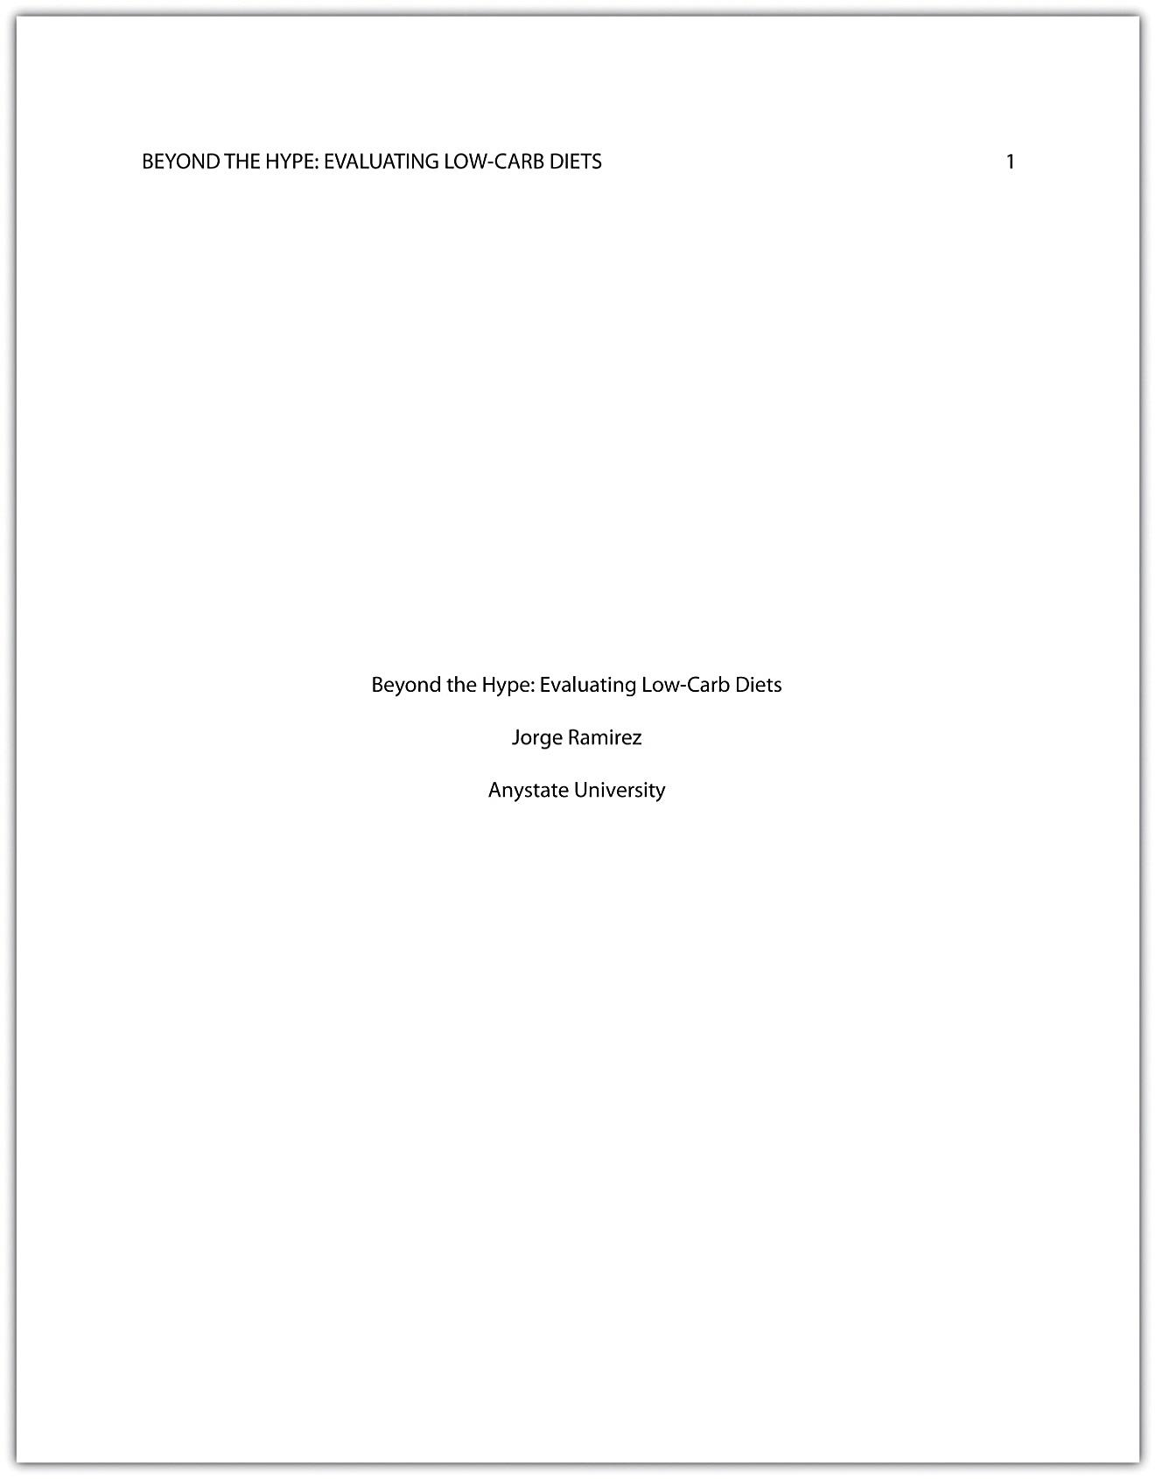
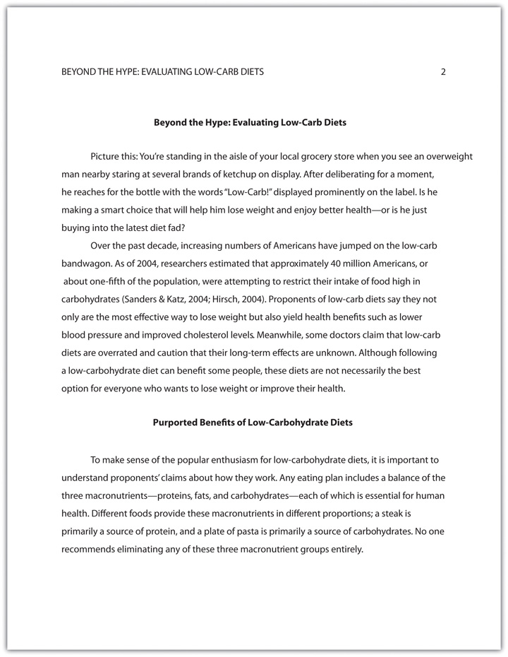
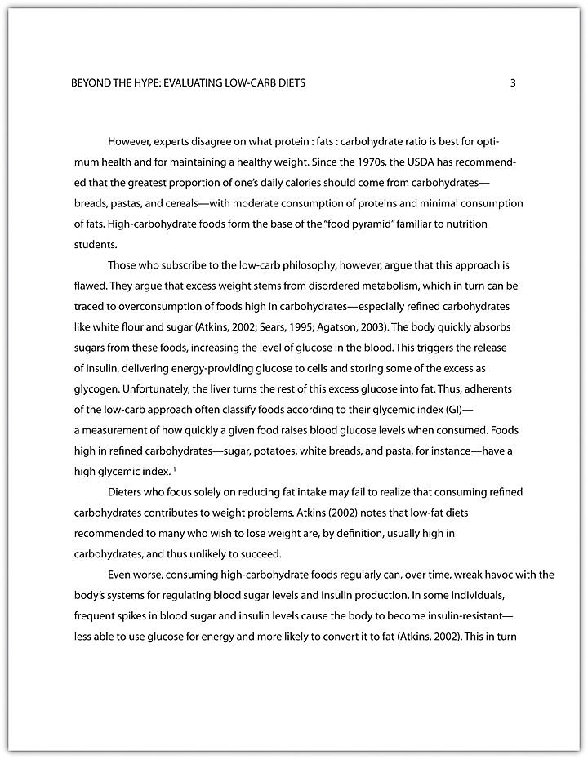
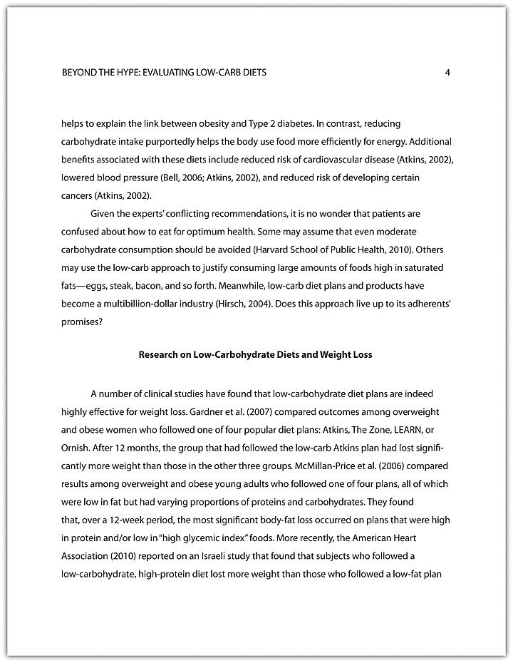

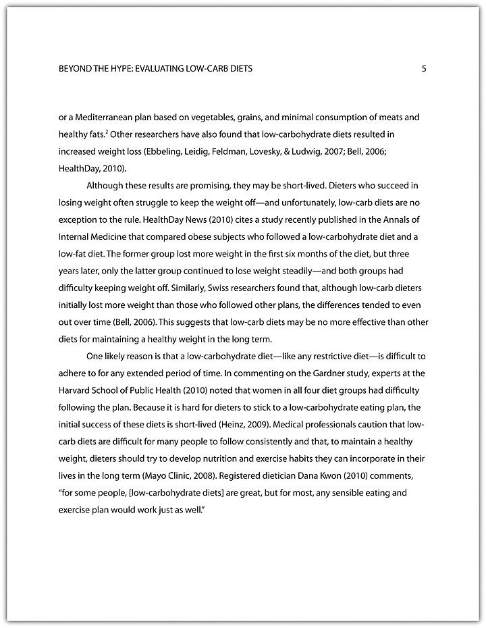
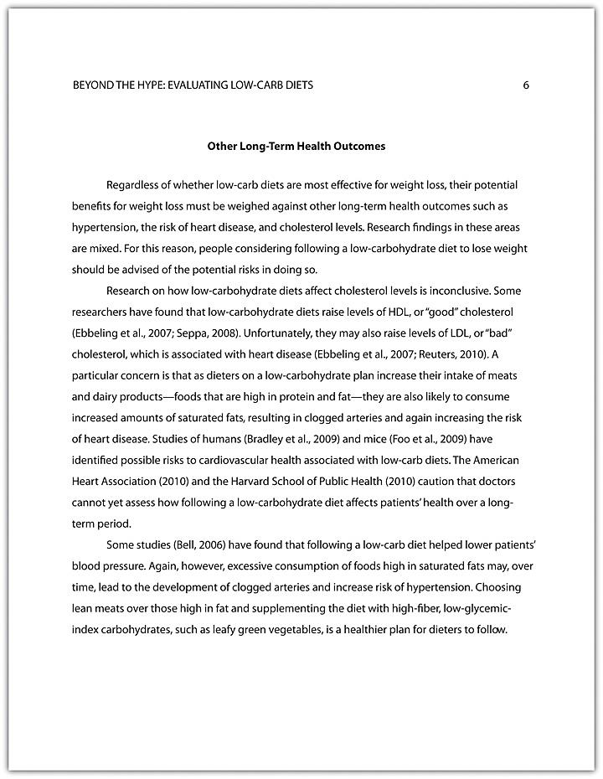
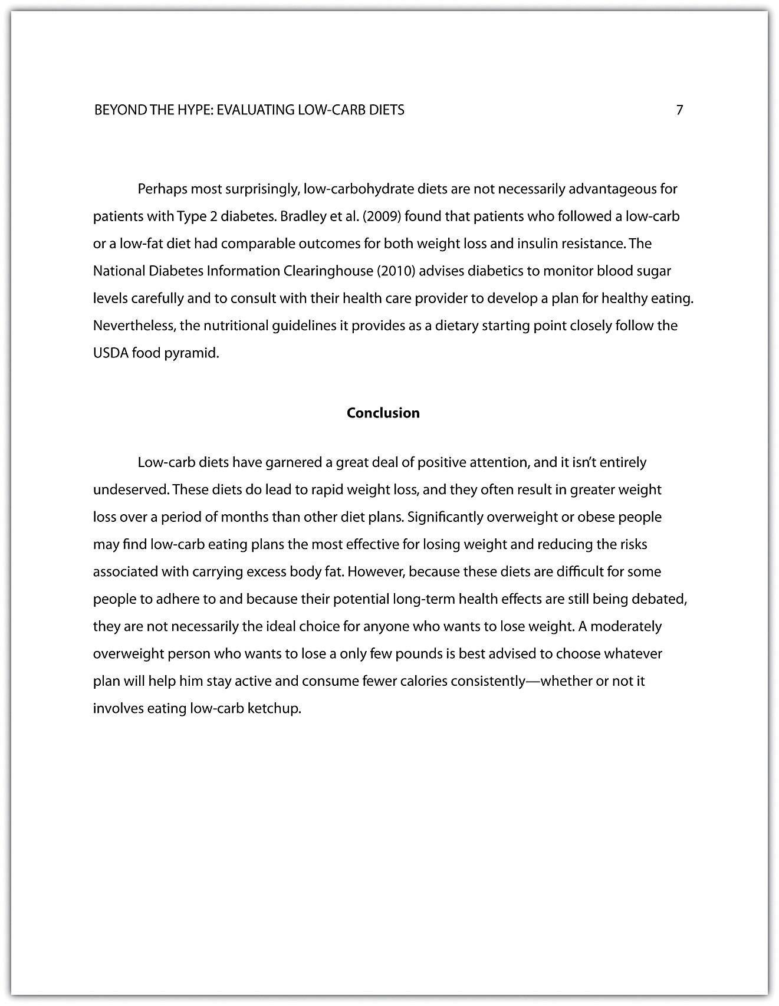
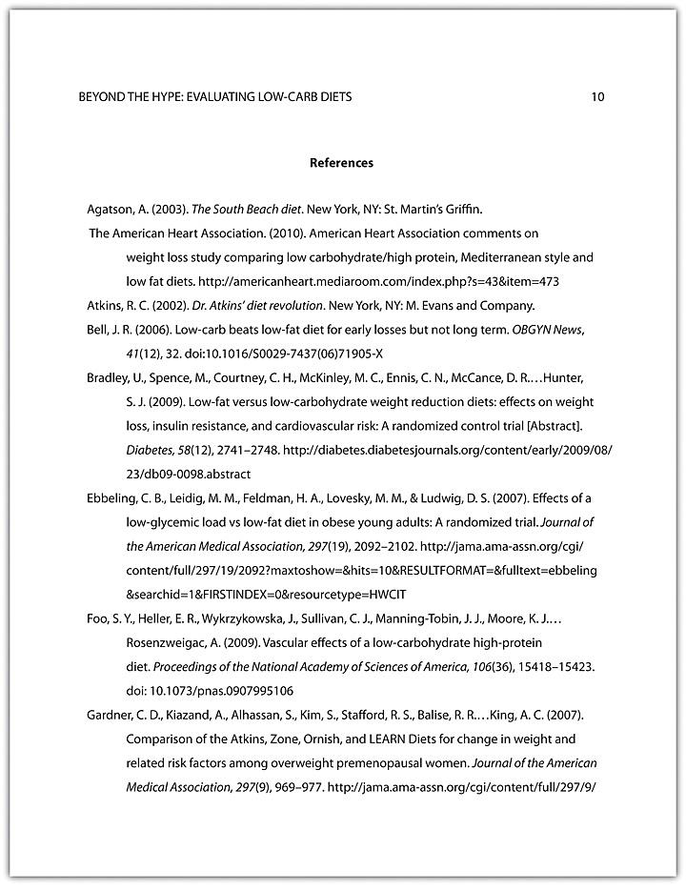

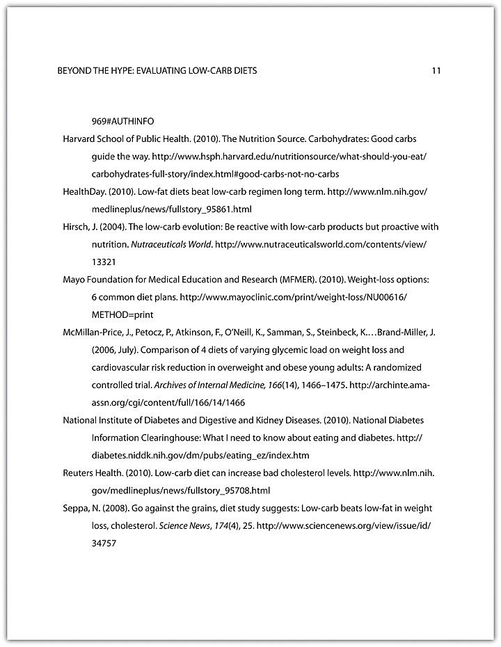

self-practice EXERCISE 12.11
With the help of Checklist 12.5, edit and proofread your essay.
Although you probably do not want to look at your paper again before you submit it to your instructor, take the time to do a final check. Since you have already worked through all of the checklists above focusing on certain aspects at one time, working through one final checklist should confirm you have written a strong, persuasive essay and that everything is the way you want it to be. As extra insurance you have produced a strong paper, you may even want someone else to double-check your essay using Checklist 12.6: Final Revision. Then you can compare to see how your perceptions of your paper match those of someone else, essentially having that person act as the one who will be grading your paper.

Checklist 12.6: Final Revision

First Revision 1: Organization
- Do you show you understand the assignment: purpose, audience, and genre?
- Focus: Have you clearly stated your thesis (your controlling idea) in the first paragraph?
- Does your thesis statement catch the reader’s attention?
- Unity: Write your opening and closing paragraphs and place each topic sentence in between. You should have a “mini essay” with several different main points supporting your thesis.
- Are your paragraphs organized in a logical manner?
- Does each topic sentence (per paragraph) logically follow the one preceding it?
- Do you have several points to support your thesis?
- Check whether your paragraphs are organized according to a specific pattern.
- Would rearranging your paragraphs support your thesis better?
- Have you provided a comprehensive conclusion to your essay? Does it summarize your main points (using different words)?

First Revision 2: Paragraphs and Sentences
- Does each paragraph have main points and supporting details?
- Does each paragraph have only one main point?
- Is your approach or pattern used to develop your paragraph’s main point followed?
- Check that each sentence is relevant to the main point of the paragraph.
- Are there several sentences giving details, facts, quotes, reasons, and arguments in each paragraph?
- Is each supporting detail specific, concrete, and relevant to the topic sentence?
- Does each sentence logically follow the preceding one?
- Have you used transitional words to help the reader follow your thoughts? If not, add them.
- Paragraph length: If too short, develop further. If too long, break into smaller paragraphs or consolidate some sentences.
- Check your essay for tone and point of view.

Second Revision 1: Sentences and Usage
- Confirm that each sentence has a subject and a verb.
- Revise fragments, splices, and run-on sentences.
- Check modifiers to see if they have been put in unclear places.
- Do you have a variety of sentence structures? (simple and complex)
- Scan for subject-verb agreement in each sentence.
- Are you consistent with your verb tenses? Check to make sure there are not any confusing or irrelevant tense changes.
- Make sure that words in lists are in parallel forms.
- Think through your pronouns; what is each one referring to?
- Check for confusing “person” shifts within paragraphs. Keep the subjects consistent.
- Identify all verbs and change any that are passive to active.
- Use strong verbs not weak adverbs. Say something “is” not that it “may be.”
- Check for wordiness.
- Scan to make sure you have not used the same word repeatedly in the same sentence and paragraph. Use a thesaurus.
- Look for and eliminate clichés.

Second Revision 2: Documentation
- Have you documented all your references?
- Have you used in text citations every time they were needed?
- Have you formatted all your citations correctly?
- Is your references’ section complete and correct according to the JIBC APA Referencing Guide.

Second Revision 3: Mechanics
- Check that all words and sentences are punctuated according to standard usage.
- Check for spelling and typographical errors.
Third Revision: Content
- Read your essay aloud. Do you believe what you have written?
- At this point do you develop your controlling idea in a way that makes sense?
- Have you provided enough background information? Is it relevant/necessary?
- Have you primarily used paraphrasing as opposed to direct quotations?
You should now be confident you have produced a strong argument that is wonderfully constructed and that you will be able to persuade your audience that your points and point of view are valid.

KEY TAKEAWAYS
- During revising, you add, cut, move, or change information in order to improve content.
- During editing, you take a second look at the words and sentences you used to express your ideas and fix any problems in grammar, punctuation, and sentence structure.
- Remember to budget time for careful editing and proofreading. Use all available resources, including editing checklists, peer editing, and your institution’s writing lab, to improve your editing skills.
- Organization in a research paper means that the argument proceeds logically from the introduction to the body to the conclusion. It flows logically from one point to the next. When revising a research paper, evaluate the organization of the paper as a whole and the organization of individual paragraphs.
- In a cohesive research paper, the elements of the paper work together smoothly and naturally. When revising a research paper, evaluate its cohesion. In particular, check that information from research is smoothly integrated with your ideas.
- An effective research paper uses a style and tone that are appropriately academic and serious. When revising a research paper, check that the style and tone are consistent throughout.
- Editing a research paper involves checking for errors in grammar, mechanics, punctuation, usage, spelling, citations, and formatting.

