Trades Access Common Core
Line A: Safe Work Practices
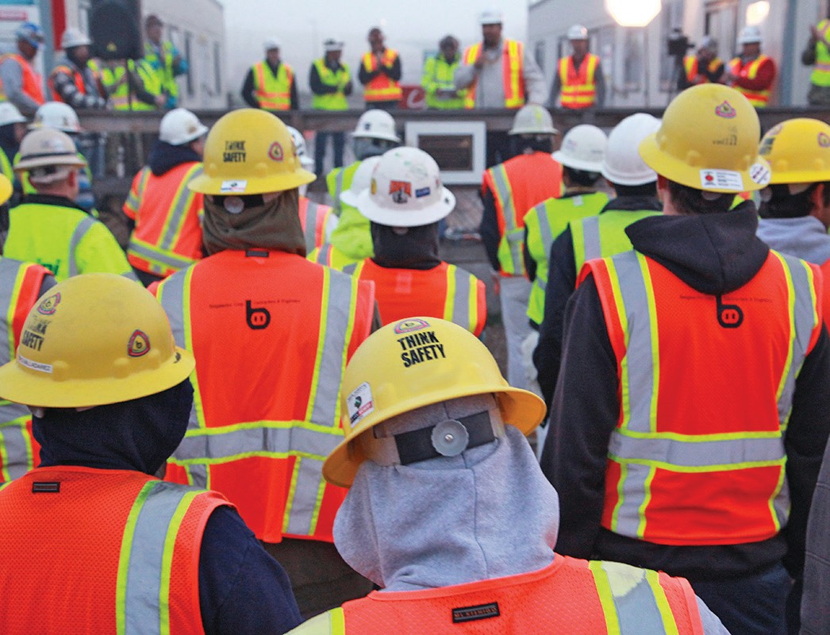
Competency A-5: Describe Fire Safety

Image to be placed here.

B.C. Open Textbook Project
OpenEd
open.bccampus.ca

Trades Access
COMMON CORE
Line A: Safe Work Practices Competency A-5: Describe Fire Safety

Acknowledgments and Copyright
To learn more about BCcampus Open Textbook project, visit http://open.bccampus.ca
© Camosun College. The Trades Access Common Core resources are licensed under the Creative Commons Attribution 4.0 Unported Licence ( http://creativecommons.org/licenses/by/4.0/ ), except where otherwise noted. Under this licence, any user of this textbook or the textbook contents herein must provide proper attribution as follows:
- If you redistribute this textbook in a digital format (including but not limited to EPUB, PDF, and HTML), then you must retain on every page the following attribution: Download for free at http:// open.bccampus.ca/find-open-textbooks/
- If you redistribute this textbook in a print format, then you must include on every physical page the following attribution: Download for free at http://open.bccampus.ca/find-open-textbooks/
- If you redistribute part of this textbook, then you must retain in every digital format page view (including but not limited to EPUB, PDF, and HTML) and on every physical printed page the following attribution: Download for free at http://open.bccampus.ca/find-open-textbooks/
- If you use this textbook as a bibliographic reference, then you should cite it as follows: BCcampus, Name of Textbook or OER. DATE. http://open.bccampus.ca/find-open-textbooks/.
For questions regarding this licensing, please contact opentext@bccampus.ca
All images copyright BC Industry Training Authority are licensed under the Creative Commons Attribution-NonCommercial-ShareAlike 4.0 licence.
http://creativecommons.org/licenses/by-nc-sa/4.0/
The issuing/publishing body is Crown Publications, Queen’s Printer, Ministry of Technology, Innovation and Citizens’ Services.
BCcampus would like to acknowledge the following individuals and organizations for their contributions in producing the Trades Access Common Core Open Textbook resources.

BCcampus
Open Education Team Hilda Anggraeni, Graphics

Camosun College
Olaf Nielsen, Chair, Trades Development and Special Projects, School of Trades and Technology Nannette Plant, Manager, Enterprise Point Operations & Special Projects, Office of the VP Strategic Development
Rod Lidstone, Instructor, Plumbing and Pipe Trades, Lead Writer/Reviewer Brian Coey, Instructor, Sheet Metal and Metal Fabrication, Writer/Reviewer Matt Zeleny, Camosun Innovates, 3D imaging

Open School BC
Monique Brewer, Director
Adrian Hill, Instructional Designer
Dennis Evans, Image Coordinator, Photographer, Graphics, Production Technician (layout) Farrah Patterson, Production Technician

Industry Training Authority of BC
The ITA works with employers, employees, industry, labour, training providers, and government to issue credentials, manage apprenticeships, set program standards, and increase opportunities in approximately 100 BC trades. Among its many functions are oversight of the development of training resources that align with program standards, outlines, and learning objectives, and authorizing permission to utilize these resources (text and images).
Erin Johnston, Director of Training Delivery Cory Williams, Manager, Industry Relations

Publishing Services, Queen’s Printer
Spencer Tickner, Director of QP Publishing Services Dwayne Gordon, Manager, Electronic Publishing
October 2015, Version 1
To order print copies of any of the Trades Access Common Core resources, please contact us:
Crown Publications, Queen’s Printer PO Box 9452 Stn Prov Govt
563 Superior St, 3rd Floor Victoria, BC V8W 9V7 Phone: 250-387-6409
Toll Free: 1-800-663-6105
Fax: 250-387-1120
crownpub@gov.bc.ca www.crownpub.bc.ca

Intellectual Property Program
Ilona Ugro, Copyright Officer, Ministry of Technology, Innovation and Citizens’ Services, Province of British Columbia

Creative Commons Attributions
Cover photo: (https://commons.wikimedia.org/wiki/File:Monthly_Safety_Stand_Down_%288552567928%29.jpg) by NAVFAC
(https://www.flickr.com/photos/39845951@N05/8552567928) by Jesse A. Lora, NAFAC (SW) under CC BY SA 2.0.
(https://creativecommons.org/licenses/by/2.0/)
Figure attributions for Competency A-5, Learning Task 1 include:
Figure 2—Fire tetrahedron
http://commons.wikimedia.org/wiki/File:Fire_tetrahedron.svg by Gustavb under Public Domain

Foreword
The BC Open Textbook Project began in 2012 with the goal of making post-secondary education in British Columbia more accessible by reducing student cost through the use of openly licensed textbooks. The
BC Open Textbook Project is administered by BCcampus and is funded by the British Columbia Ministry of Advanced Education.
Open textbooks are open educational resources (OER); they are instructional resources created and shared in ways so that more people have access to them. This is a different model than traditionally copyrighted materials. OER are defined as teaching, learning, and research resources that reside in the public domain or have been released under an intellectual property licence that permits their free use and repurposing by others (Hewlett Foundation). Our open textbooks are openly licensed using a Creative Commons licence, and are offered in various e-book formats free of charge, or as printed books that are available at cost. For more information about this project, please contact opentext@bccampus.ca. If you are an instructor who is using this book for a course, please let us know.

Preface
The concept of identifying and creating resources for skills that are common to many trades has a long history in the Province of British Columbia. This collection of Trades Access Common Core (TACC) resources was adapted from the 15 Trades Common Core line modules co-published by the Industry
Training and Apprenticeship Commission (ITAC) and the Centre for Curriculum Transfer and Technology (C2T2) in 2000-2002. Those modules were revisions of the original Common Core portion of the TRAC modules prepared by the Province of British Columbia Ministry of Post-Secondary Education in 1986. The TACC resources are still in use by a number of trades programs today and, with the permission from the Industry Training Authority (ITA), have been utilized in this project.
These open resources have been updated and realigned to match many of the line and competency titles found in the Province of BC’s trades apprenticeship program outlines. A review was carried out to analyze the provincial program outlines of a number of trades, with the intent of finding common entry-
level learning tasks that could be assembled into this package. This analysis provided the template for the outline used to update the existing modules. Many images found in ITA apprentice training modules were also incorporated into these resources to create books that are similar to what students will see when they continue their chosen trades training. The project team has also taken many new photographs for this project, which are available for use in other trades training resources.
The following list of lines and competencies was generated with the goal of creating an entry-level trades training resource, while still offering the flexibility for lines to be used as stand-alone books. This
flexibility—in addition to the textbook content being openly licensed—allows these resources to be used within other contexts as well. For example, instructors or institutions may incorporate these resources into foundation-level trades training programming or within an online learning management system (LMS).
Line A – Safe Work Practices
- A-1 Control Workplace Hazards
- A-2 Describe WorkSafeBC Regulations
- A-3 Handle Hazardous Materials Safely
- A-4 Describe Personal Safety Practices
- A-5 Describe Fire Safety
Line B – Employability Skills
- B-1 Apply Study and Learning Skills
- B-2 Describe Expectations and Responsibilities of Employers and Employees
- B-3 Use Interpersonal Communication Skills
- B-4 Describe the Apprenticeship System

Line C –Tools and Equipment
- C-1 Describe Common Hand Tools and Their Uses
- C-2 Describe Common Power Tools and Their Uses
- C-3 Describe Rigging and Hoisting Equipment
- C-4 Describe Ladders and Platforms
Line D – Organizational Skills
- D-1 Solve Trades Mathematical Problems
- D-2 Apply Science Concepts to Trades Applications
- D-3 Read Drawings and Specifications
- D-4 Use Codes, Regulations, and Standards
- D-5 Use Manufacturer and Supplier Documentation
- D-6 Plan Projects
Line E – Electrical Fundamentals
- E-1 Describe the Basic Principles of Electricity
- E-2 Identify Common Circuit Components and Their Symbols
- E-3 Explain Wiring Connections
- E-4 Use Multimeters
All of these textbooks are available in a variety of formats in addition to print:
- PDF—printable document with TOC and hyperlinks intact
- HTML—basic export of an HTML file and its assets, suitable for use in learning management systems
- Reflowable EPUB—format that is suitable for all screen sizes including phones
All of the self-test questions are also available from BCcampus as separate data, if instructors would like to use the questions for online quizzes or competency testing.

About This Book
In an effort to make this book a flexible resource for trainers and learners, the following features are included:
- An introduction outlining the high-level goal of the Competency, and a list of objectives reflecting the skills and knowledge a person would need to achieve to fulfill this goal.
- Discrete Learning Tasks designed to help a person achieve these objectives
- Self-tests at the end of each Learning Task, designed to informally test for understanding.
- A reminder at the end of each Competency to complete a Competency test. Individual trainers are expected to determine the requirements for this test, as required.
- Throughout the textbook, there may also be links and/or references to other resources that learners will need to access, some of which are only available online.
- Notes, cautions, and warnings are identified by special symbols. A list of those symbols is provided below.

Symbols Legend

Important: This icon highlights important information.

Poisonous: This icon is a reminder for a potentially toxic/poisonous situation.

Resources: The resource icon highlights any required or optional resources.

Flammable: This icon is a reminder for a potentially flammable situation.

Self-test: This icon reminds you to complete a self-test.

Explosive: This icon is a reminder for a possibly explosive situation.

Safety gear: The safety gear icon is an important reminder to use protective equipment.

Electric shock: This icon is a reminder for potential electric shock.

Safety Advisory
Be advised that references to the Workers’ Compensation Board of British Columbia safety regulations contained within these materials do not/may not reflect the most recent Occupational Health and Safety Regulation. The current Standards and Regulation in BC can be obtained at the following website: http:// www.worksafebc.com.
Please note that it is always the responsibility of any person using these materials to inform him/herself about the Occupational Health and Safety Regulation pertaining to his/her area of work.
BCcampus January 2015

Disclaimer
The materials in the Trades Access Common Core Open Textbook project are for use by students and instructional staff and have been compiled from sources believed to be reliable and to represent best current opinions on these subjects. These manuals are intended to serve as a starting point for good practices and may not specify all minimum legal standards. No warranty, guarantee or representation is made by BCcampus as to the accuracy or sufficiency of the information contained in these publications. These manuals are intended to provide basic guidelines for trade practices. Do not assume, therefore, that all necessary warnings and safety precautionary measures are contained in this module and that other or additional measures may not be required.

Contents
Introduction 8
Objectives 8
Resources 8
Learning Task 1: Describe the conditions necessary to support a fire 9
Fuel 9
Oxygen 9
Heat 9
Flashpoint and autoignition 9
Fire triangle 10
Fire tetrahedron 10
Self-Test 1 12
Learning Task 2: Identify classes of fires and extinguishers 15
Classes of fires 15
Types of fire extinguishers 15
Multi-purpose fire extinguishers 17
Self-Test 2 22
Learning Task 3: Apply preventive fire safety precautions 25
Preparation 25
Storage of flammable materials 25
Shop electrical wiring and equipment 27
Safe use of temporary heating 28
Self-Test 3 29
Learning Task 4: Describe first-response firefi ting 31
Steps to take prior to fighting a fire 31
Training 32
Using a portable fire extinguisher 32
Pull, Aim, Squeeze, Sweep (PASS) 32
Self-Test 4 35
Answer Key 36

Introduction
As a trades worker you have a responsibility to work safely, and fire prevention is a primary concern. Many of the work tasks you carry out include the application of heat and flame. You should be able to apply fire prevention practices, identify fire causes, and identify and apply fire extinguishing agents to control or extinguish a fire. You are not expected to be an expert firefighter, but you may have to deal with a fire to protect your safety and the safety of others.

Objectives
When you have completed the Learning Tasks in this Competency:
  - describe how fires start

  - identify the fire triangle

  - name the components of a fire triangle and explain how the fire triangle works

  - identify and name the classes of fire

  - identify and name the types of fire extinguishers

  - state the letters used to identify fire extinguishers

  - select the type of extinguisher for the type of fire

  - describe the procedures for extinguishing small fires

  - describe proper methods for preventing fires

Resources
You will be required to reference publications and videos available online at:
http://www.worksafebc.com/

LEARNING TASK 1

Describe the conditions necessary to support a fire
Fire or combustion is a form of oxidation (the union of a substance with oxygen). During the process of oxidation, energy is released in the form of heat, sometimes accompanied by light. Oxidation takes place at varying rates of speed. Here are some examples of oxidation occurring at differing rates of speed:
- very slow—the rusting of iron

- slow—the spontaneous heating of materials such as oil-soaked rags

- fast—the burning of paper or wood
- extremely fast—the exploding of gunpowder upon ignition Before a fire can occur, these three things must be present:
- fuel

- oxygen

- heat (sufficient to raise the fuel to its “ignition temperature”)

Fuel
Fuel is any combustible material in solid, liquid, or gas form that will combine with oxygen and heat to burn. Combustible material could be common materials such as wood, gasoline, paper, or cloth.

Oxygen
Oxygen supports combustion and is always present in the air we breathe at approximately a 21 percent concentration. A typical fire requires an atmosphere with only approximately 16 percent oxygen. If pure oxygen were present, some materials that would not normally be considered combustible, including some metals, will burn. The term oxidizing agent is now often used instead of oxygen, as it helps explain why some materials can burn in an atmosphere free of any other sources of oxygen.

Heat
Heat is anything that will raise the temperature of the fuel to a point where enough gases are given off to burn.

Flashpoint and autoignition
Flashpoint and autoignition refer to the level of heat needed for combustion, or, in other words, the lowest temperature needed for combustion.

The flashpoint of many fuels is quite low—room temperature or lower. Autoignition temperature is the lowest temperature that a fuel will spontaneously ignite without an external source of ignition like a spark or flame. For example, gasoline has a flashpoint of –450° C (–490° F) and an autoignition temperature of 2800° C (5360° F).

Fire triangle
The fire triangle is a simple model for understanding the necessary ingredients for most fires: oxygen, heat, and fuel. When they combine in proper amounts, as shown in the fire triangle diagram (Figure 1), a fire is created. Keeping these three components separated will prevent a fire from occurring. An existing fire can be extinguished by removing any one of the three components.

Figure 1 — Fire triangle
FUEL

Fire safety, at its most basic, is based on the principle of keeping fuel sources and ignition sources separate:
- Remove the fuel (combustible material) from the vicinity of the fire. For example, if you shut off the valve of a gas main, the result will be starvation.
- Remove the heat. For example, by applying water, the result will be cooling.

- Remove the oxygen. For example, if you cover the fire with a lid, a wet blanket, or some sand or use a carbon dioxide, foam, or dry chemical extinguisher, the result is smothering.

Fire tetrahedron
Today there are many newly developed chemicals, resins, materials, and metals that burn differently and have varying types of chemical chain reactions that do not fit the traditional theories of the fire triangle. A fourth component of a fire triangle may be a chemical reaction, creating a fi e tetrahedron.

The fire tetrahedron represents the addition of a chemical chain reaction to the fire triangle. Once a fire has started, the resulting chain reaction sustains the fire and allows it to continue. Just as the removal of one of the elements of the fire triangle will extinguish the fire, so will the use of an extinguishing agent that breaks the chain reaction.

Figure 2 — Fire tetrahedron

Now complete the Learning Task Self-Test.

Self-Test 1
- What three components must you have to support combustion?
  - Fuel, heat, carbon dioxide
  - Heat, oxygen, fuel
  - Carbon monoxide, fuel, heat
  - Fuel, oxygen, carbon dioxide

- Keeping the components of combustion separated will prevent a fire.
  - True
  - False

- Oxidation is the process of oxygen uniting with another element.
  - True
  - False

- When a gas fire is being extinguished how does shutting off the main valve affect the fire?
  - Cooling
  - Starvation
  - Smothering
  - Disconnecting

- When a wood fire is being extinguished, how does applying water affect the fire?
  - Cooling
  - Starvation
  - Saturation
  - Smothering

- When a fire is being extinguished, how does covering the fire with a lid or wet blanket affect the fire?
  - Cooling
  - Starvation
  - Pressurizing
  - Smothering

- What is the fourth component that creates the fire tetrahedron?
  - Aerobic reaction
  - Metabolic reaction
  - Chemical destabilizers
  - Chemical chain reaction

- When foam is applied to a fire, what is the result?
  - Cooling
  - Starvation
  - Reignition
  - Smothering

LEARNING TASK 2

Identify classes of fires and extinguishers
When, during combustion, sufficient heat is generated to raise the temperature of the fuel, vapours that will ignite are produced and the burning process will continue as long as there is sufficient fuel, heat, and oxygen to sustain it. The process must be interrupted by means of an extinguishing agent, such as a fire extinguisher.

Classes of fires
Fires are divided into four main classes: A, B, C, and D. The class of the fire is important to know as it dictates the type of extinguisher required. The symbols shown in Figure 1 may be the only indication you have of the best use for a fire extinguisher.

Class Letter and Symbol |  |  | Description
Green |  | OR | Fires involving ordinary combustibles (wood, cloth, paper, rubber, and many plastics); these require the heat-absorbing (cooling) effects of certain chemicals that retard combustion.
Red |  | OR 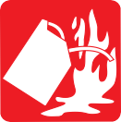 | Fires involving flammable or combustible vapours; extinguishers that prevent these vapours from being released or that interrupt the combustion are needed.
Blue |  | OR | Fires involving energized electrical equipment; non-conductive extinguishing agents are required to provide safety to the operator (only when  electrical equipment is de-energized may class A or B extinguishers be used).
Yellow |  |  | Fires involving certain combustible metals, such as magnesium, titanium, zirconium, sodium, or potassium; these require a heat-absorbing extinguishing medium that is not reactive with the burning material.
Figure 1 — Classes of fires

Some materials, when burning, may produce toxic gases.

Types of fire extinguishers
All work sites must have portable fire extinguishers. These come in many sizes and colours and have several markings on them. Although most extinguishers can be used on more than one class of fire, none can be successfully used for all types of fire situations.

It is important that you know the location of and how to operate each extinguisher in your workplace. Because each manufacturer uses a slightly different operating procedure, the best thing you can do is to look carefully at the markings and instructions on the extinguisher. They will tell you how to use the extinguisher and where it is most effective.

If you use the wrong type of fire extinguisher on the wrong class of fire, you can make matters worse. It is therefore very important to understand the four different fire classifications and visually recognize the identification symbols used on the fire extinguisher.

Class A fire extinguishers
Class A extinguishers work to cool the fire below its ignition temperature. They can use pressurized water, foaming agents, or multi-purpose dry chemical agents. The water-based extinguishers can be pressurized, gravity-fed, or manually pumped.

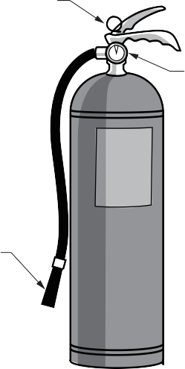
Locking pin

Gauge

Operating or discharge lever Discharge gas

Water level

Discharge tube

Nozzle

Strainer

Figure 2 — Pressurized water extinguisher for burning wood, paper, textiles, and other types of Class A fires

Class B fire extinguishers
Class B extinguishers should be used on flammable liquids or gases such as oils, paints, gasoline, and grease. These extinguishers may come in several types, including foam, carbon dioxide (CO2), ordinary dry chemical, and multi-purpose dry chemical.

Never use water to extinguish flammable liquid fires. Water is extremely ineffective at extinguishing this type of fire, and you may, in fact, spread the fire if you try to use water on it.

Class C fire extinguishers
Class C extinguishers are used on electrically energized equipment. These extinguishers may use carbon dioxide (CO2), ordinary dry chemicals, or multi-purpose dry chemicals. Carbon dioxide extinguishers are preferable for sensitive electrical equipment and computer components, as
they don’t leave any harmful residue.

Never use water or any other agent that is capable of conducting electricity to extinguish a Class C fire. Electrical equipment must be unplugged and/or de- energized before using a water extinguisher on it.

Class D fire extinguishers
For Class D fires you can use dry chemical extinguishers. However, the type of extinguisher depends on the type of metal that is burning. The extinguishing media can be made of dry graphite, dry cast iron turnings, other approved compounds with a graphite base, or a dry substance with a chloride base. When trying to suppress a Class D fire in its initial stage, localize the fire by scraping away any adjacent metal chips. The smothering material should then be applied gently to avoid scattering the fire. The material forms an air-excluding crust over the burning metal.

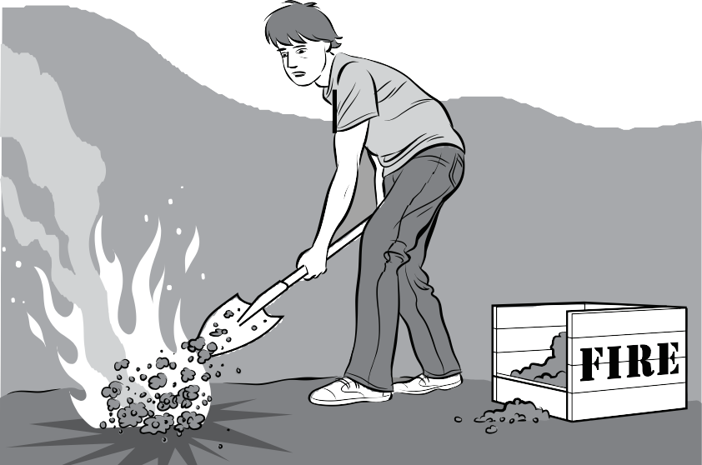
Figure 3 — Extinguishing powder applied by shovel or scoop

Under no circumstances should water or any standard fire extinguisher (of the pressurized or liquid type) be used to combat a magnesium fire.

Multi-purpose fire extinguishers
Manufacturers supply single fire extinguishers intended for multiple purposes. These extinguishers may have dry powders designed to suppress more than one type of fire such as Class A and B or C fires. Carbon dioxide (CO2) extinguishers are often labelled to fight both Class B and C fires.

Dry chemical extinguishers
Dry chemical extinguishers are filled with either foam or powder, usually sodium bicarbonate (baking soda) or potassium bicarbonate, and pressurized with nitrogen. Baking soda is effective because it decomposes at 700° C (1580° F) and releases carbon dioxide (which smothers oxygen) once it decomposes.

Dry chemical extinguishers interrupt the chemical reaction of the fire by coating the fuel with a thin layer of powder or foam, separating the fuel from the surrounding oxygen. When used
indoors, powder dry chemical extinguishers can obscure vision or damage goods and machinery.

Dry chemical extinguishers are designed for Class B and C fires or Class A, B, and C fires, depending on the type of agent contained in the cylinder.

Three of the most commonly used dry chemicals are:
    - Triplex Dry Chemical: a multi-purpose dry chemical agent effective in extinguishing Class, A, B, and C fires, generally considered the best all-round fire extinguisher
    - Quick-Aid Dry Chemical: a specially treated sodium bicarbonate dry chemical agent that is moisture resistant and free-flowing; it is effective and approved for use on Class B and C fires and offers the lowest cost per kilo of the three dry chemical agents
    - Purple K Dry Chemical: a specially treated potassium bicarbonate dry chemical agent that provides effective protection against Class B and C fires and is approximately twice as effective as the standard sodium bicarbonate dry chemical

Pressure gauge
Operating or discharge lever

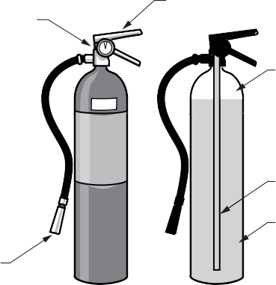
Discharge gas

Discharge tube

Nozzle
Dry chemical

Figure 4 — Dry chemical extinguisher

Carbon dioxide (CO2) extinguishers
A CO2 extinguisher is recognized by its fibre discharge horn. It is less effective than dry chemical
extinguishers but has the advantage of not leaving a residue that must be cleaned up.

CO2 cylinders are red and range in size from 2.26 kg (5 lb.) to 45 kg (100 lb.) or larger. In the larger sizes, the hard horn is located on the end of a long, flexible hose.

These extinguishers contain pressurized carbon dioxide gas. CO2 is heavier than oxygen, so these extinguishers work by displacing or taking away oxygen from the surrounding area. Additionally, CO2 is very cold and works by cooling the fuel.

Carbon dioxide is ideal for fires involving electrical apparatuses and will also extinguish Class B liquid fires. However, the fire could reignite if the cooling effect has not reached the ignition temperature of the fuel.

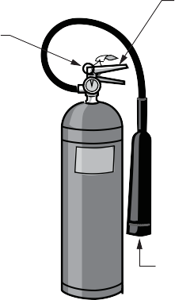
CO2 extinguishers are designed for Class B and C (flammable liquid and electrical) fires only. These extinguishers may be ineffective at extinguishing Class A fires because they may not be able to displace enough oxygen .

Locking pin and seal
Operating or discharge lever

Siphone tube
Carbon dioxide gas

Discharge horn
Figure 5 — CO2 extinguisher

Halon extinguishers
Halon extinguishers are designed for Class A, B, and C fires.
Liquid carbon dioxide

Halon is effective, but it is an ozone-depleter and has, therefore, been banned. Halon extinguishers may still be found in some locations, but once they are used, they cannot be refilled.

Emergency fire blanket
Emergency fire blankets are designed to smother the flames if someone’s clothing catches fire. The blankets are about 2 m × 2 m (6 ft. × 6 ft.) in size.

Fire extinguisher general requirements
The following are some general guidelines for maintaining and storing fire extinguishers:
    - Portable fire extinguishers must be mounted in identifiable and readily accessible locations.
    - The size of an extinguisher is often based on the weight of the extinguishing agent. For example, 1 kg (2.5 lb.) is a small extinguisher.
    - Class A and B extinguishers may have a number before the letter. These numbers allow you to compare the relative effectiveness of various fire extinguishers. For example, a multi-class extinguisher may be labelled as Class ABC – 2.25 kg (5 lb.), 3A:10B:C. The A rating is a water equivalency rating. The number preceding the A multiplied by 1.25 gives the equivalent extinguishing capability in gallons of water. The number preceding the B indicates the size of fire in square feet that an ordinary user should be able to cover. The C does not have a number assigned.
    - Portable fire extinguishers must be kept in a fully charged and operating condition.

    - Fire extinguishers must have an annual maintenance check at minimum.

    - Records must be kept that identify the inspection, testing, and maintenance dates and who completed the work.
    - When an extinguisher is removed for maintenance or recharge, an alternate must be provided.
    - Extinguishers should be located near exits. The location of the extinguisher should be well marked.
    - All employees must be trained in the general principles of fire extinguisher use and the application hazards involved with first response firefi ting.

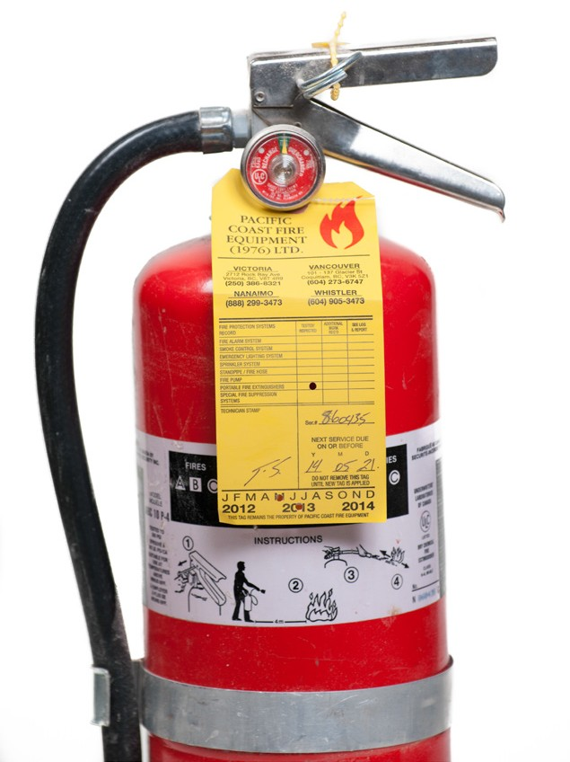
Figure 6 — ABC fire extinguisher

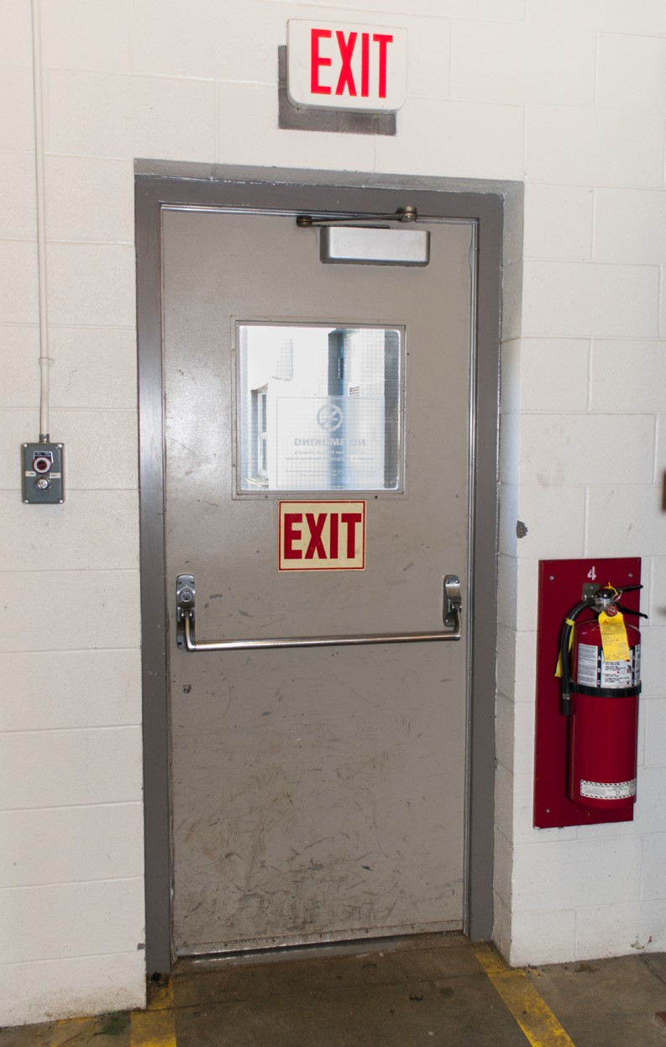
Figure 7 — Fire extinguisher near exit

Now complete the Learning Task Self-Test.

Self-Test 2
- What is the classification of an electrical fire?
  - Class A
  - Class B
  - Class C
  - Class D

- In a Class C fire, what is the burning material?
  - Flammable liquids
  - Combustible metals
  - Ordinary combustibles
  - Electrical conductors or components

- What class are fires involving gasoline and other flammable liquids?
  - Class A
  - Class B
  - Class C
  - Class D

- What is the symbol indicating that an extinguisher is suitable for Class C fires?
  - Star
  - Circle
  - Square
  - Triangle

- What is the symbol indicating that an extinguisher is suitable for Class B fires?
  - Star
  - Circle
  - Square
  - Triangle

- What class are fires involving ordinary combustibles such as wood?
  - Class A
  - Class B
  - Class C
  - Class D

- How are fire extinguishers classified
  - By local regulations
  - By the weight when full
  - By how long they will last
  - By the type of fire they will extinguish

- What is the symbol indicating that an extinguisher is suitable for Class A fires?
  - Star
  - Circle
  - Square
  - Triangle

- What is the symbol that is used to indicate that an extinguisher is suitable to extinguish a Class D fire?
  - Star
  - Circle
  - Square
  - Triangle

LEARNING TASK 3

Apply preventive fire safety precautions
As you already know, fire is only possible where there is a supply of combustible materials, oxygen, and heat. However, lack of caution, equipment failure, or simple human error can cause ignition.

Any fire in the workplace can cause serious injury or property damage. Workers are often required to work in various hazardous environments. Corrosive and explosive substances may be used or stored in these locations. Workers must be aware of the presence of these hazardous substances and take appropriate precautions.

Preparation
Preparation is the key to controlling any fires that do start. Take the following precautions to protect your workplace from fire:
- Keep the work area clean and clutter-free.

- Know what chemicals you work with.

- Know how to store and handle the chemicals on your work site.

- Make sure you are familiar with your company’s emergency action plan for fires.

- Know what you are expected to do in a fire emergency.

- Know how to report fires.

- Use caution when using power tools near flammable substances.

Hot work permit
Ideally all welding, cutting, or other torch work would be done in areas free of combustible materials; however, this is not always possible. In those cases you may be required to get a hot work permit in order to have all fire hazards in your area assessed and the necessary precautions listed. Usually this will involve posting fire watch personnel.

The person on fire watch should have access to fire extinguishers and alarms and know how to use them. The area where the hot work was done must also be monitored afterwards until there is no longer a risk of fire.

Storage of flammable materials
The nature of flammable materials makes them vulnerable to ignition. Consequently, storage precautions are necessary. Both WorkSafeBC and the BC Fire Code have regulations regarding maximum quantities of flammable materials that can be stored and how they are stored. The permitted quantities are affected by what their flashpoint temperature is.

Flammable liquids and related equipment
The nature of flammable liquids makes them very vulnerable to ignition, and the following storage precautions are consequently necessary:
  - All containers of flammable liquids must be of an approved type (CSA or ULC in Canada) and clearly marked.
  - All containers must have secure capping devices.

  - Open flames or lit cigarettes must be prohibited within or near any liquid-gas storage area.

  - Where drums are used as containers, they must have taps and a drip tray.

  - Transportation must only take place while containers are sealed.

  - All empty containers must be stored on end.

  - Spills must be cleaned up or covered with sand.

Any equipment that requires a flammable liquid needs the same basic precautionary measures as stored liquids. All tank or equipment leaks must be reported and then repaired immediately.

Drivers and operators must be warned of ignition hazards while refuelling such equipment. They must not smoke, and the engines must be stopped.

Flammable gases
Flammable gases used on work sites often include acetylene, hydrogen, ethane, and propane. These gases are stored in pressurized cylinders, which must be handled with care. (The storage and handling of these cylinders was discussed in Competency A-1: Control Workplace Hazards Learning Task 2.)

Also see the OHS Regulation Substances under pressure in Part 5 http://www2.worksafebc.com/ Publications/OHSRegulation/Part5.asp

Aerosol products can contain flammable gases and present a fire hazard. You should be familiar with how to handle and dispose of such products safely.

Ventilation
Flammable gases or vapours may accumulate in a room as part of the workplace process. It is important to properly ventilate the space to reduce the risk of fire and health hazards.

Do not cut or weld any container that you suspect may have contained a combustible substance. Even a gasoline tank, for example, that contains no liquid gasoline can have enough vapours present to cause an explosion. You must have the container thoroughly purged and inspected.

Combustible materials
Rubbish is a severe problem in fire prevention, but the problem can always be avoided by good management. Any buildup of packing materials, sawdust, wood shavings, oil waste, or other combustible material constitutes a potential fire hazard. The following precautions must always be taken:
- All waste liquids that are flammable must be placed in approved containers for disposal according to waste disposal regulations.
- Open fires require a permit, and they must be constantly supervised.

- Extinguishers must be available at or near any fire lit for the disposal of rubbish.

- All oily rags must be retained in metal bins with sealed lids.

- Don’t allow fine dust to build up, as it can be highly flammable and often explosive.

Shop electrical wiring and equipment
All wiring, whether permanent or temporary, must be made safe so it will not cause a fire. The following precautions are necessary for shop wiring:
- Any temporary or permanent wiring at ground level must be buried or protected from foot or vehicular traffic damage by use of ramps.
- All portable electric-powered hand tools must be connected with flexible rubber or sheathed PVC cables.
- Adequate breaker protection against excess current must be included.

A static grounding system must be used on fuel storage equipment to ensure there isn’t a buildup of static electricity that could arc spark to ground and cause an explosion.

Vehicle electrical systems
You should observe extreme caution when servicing electrical systems. Serious fires could result from short circuits in the wiring. Batteries that are being charged or exposed to a heavy
discharge such as a cold or no-start situation give off very explosive gases (hydrogen), which will cause an explosion if a spark is present.

When removing batteries, always disconnect the ground wire first. All wiring leading to the starter motor and switch must be protected from sharp edges and mechanical and/or heat damage. If installing a new cable, always route it in a manner to avoid damage.

Safe use of temporary heating
Temporary heating is often required on the job site. This heating may be powered by electricity or fuelled by propane, kerosene, or diesel. These heaters are usually non-ducted and are therefore considered space heaters—although they’re most commonly known as construction heaters. It is important to follow the manufacturer’s instructions and take extra precautions against burns and fire when working with construction heaters.

Now complete the Learning Task Self-Test.

Self-Test 3
- When might you require a hot work permit?
  - When working on hot materials
  - When doing any welding or cutting
  - When handling explosive chemicals
  - When doing welding or cutting in areas with combustible materials

- When the hot work is completed all personnel must exit the area immediately.
  - True
  - False

- What material characteristic affects the maximum quantities of flammable materials stored?
  - Latent heat
  - Specific heat
  - Lower explosive limit
  - Flashpoint temperature

- What precaution should be taken when removing a vehicle battery?
  - Cut the red wire.
  - Remove supply wire first.
  - Remove ground wire first.
  - Remove both wires simultaneously.

- What is another name for temporary construction heaters?
  - Ducted heaters
  - Electric heaters
  - Space heaters
  - Radiant heaters

LEARNING TASK 4

Describe first-response firefighting
First Response firefighting can best be described as extinguishing a fire in its initial stages by using whatever is readily at hand, before the fire can become too large. First-response
extinguishers are designed to deal with fires in their infancy. They are necessary even when an area is protected by a fire sprinkler system.

Small fires can often be put out quickly by a well-trained individual with a portable fire extinguisher. However, to do this safely, the person must understand the use and limitation of a portable fire extinguisher and the hazards associated with fighting fires.

Attempting to extinguish even a small fire carries some risk. Fires can increase in size and intensity in seconds, blocking the exit path and creating a hazardous atmosphere.

Employees are not expected to fight fires. Your responsibility in a fire situation is to alert others and to evacuate.

Steps to take prior to fighting a fire
Fires can be very dangerous and you should always be certain that you will not endanger yourself or others when attempting to put out a fire. For this reason, you must take these first steps when a fire is discovered:
- Assist any person in immediate danger to safety, keeping in mind your own safety.

- Activate the building fire alarm system or notify the fire department by dialling 911 (or designating someone else to notify the department for you).
- Position yourself with a means of egress at your back before you attempt to use an extinguisher to put out a fire.
Only after having done these three things and if the fire is small should you attempt to use an extinguisher to put it out.

Do not fight a fire when:
  - You don’t know what is burning. If you don’t know what is burning, you don’t know what type of extinguisher to use. Even if you have an ABC extinguisher, there may be
something in the fire that could explode or produce highly toxic smoke. Chances are you will know what’s burning, or at least have a pretty good idea, but if you don’t, let the fire department handle it.
  - The fire is spreading rapidly beyond the spot where it started. Exit the area to a safe location if the fire is already spreading quickly.

    - You don’t have appropriate firefighting equipment (correct type and size).

    - If you are unable to protect yourself from excessive smoke and fume inhalation (plastics and synthetics gases especially can be fatal in very small amounts).
    - Your instincts tell you not to. If you are uncomfortable with the situation for any reason, just let the fire department do its job.
In these situations, allow trained firefighters to deal with the fire.

Training
All workers required to use fire extinguishers should receive training that covers:
    - extinguisher locations

    - classes of fire most likely to break out and the appropriate extinguisher to use

    - when and how to use extinguishers

    - importance of sounding the alarm

    - health and safety hazards

    - personal protective equipment

Using a portable fire extinguisher
To extinguish a fire with a portable extinguisher, a person must have immediate access to the extinguisher, know how to actuate the unit, and know how to apply the agent effectively. Portable fire extinguishers contain a limited amount of extinguishing agent and can be discharged in a matter of seconds. Therefore, individuals should attempt to fight only very small or incipient-stage fires. There are various models and designs of extinguishers; some are manually operated, such as water pump type, while others are more automatic, such as
pressurized designs. The following description explains how a charged or pressurized portable fire extinguisher operates.

Pull, Aim, Squeeze, Sweep (PASS)
The proper use of portable fire extinguisher can be easily remembered using the acronym PASS.

Stand a safe distance from the fire, about 2 to 3 m (6 to 10 ft.) while holding the extinguisher upright. Standing closer may also cause burning objects to scatter, potentially spreading the fire.

Pull
Pull the pin out of the handle, breaking the plastic strap seal.

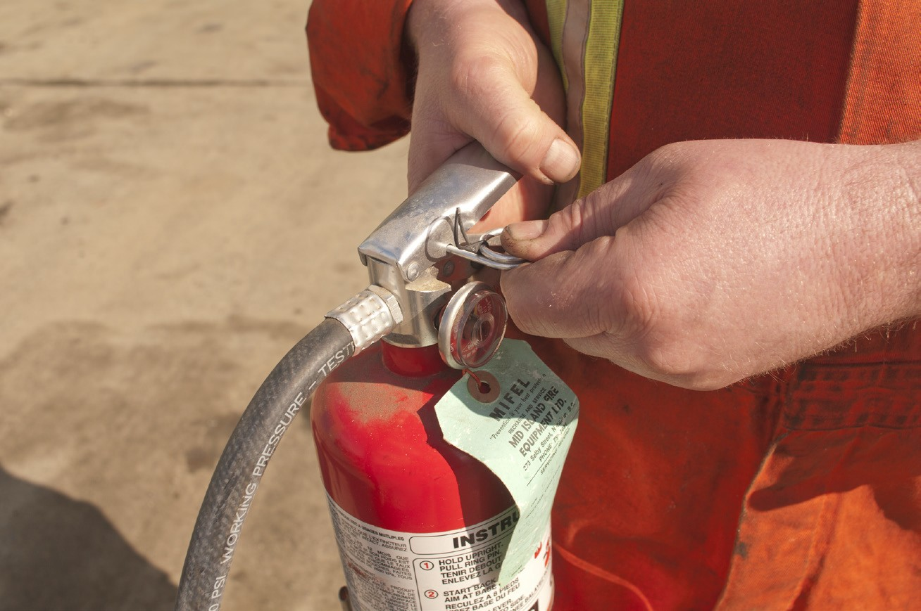
Figure 1 — Pull the pin

Aim
Aim the extinguisher nozzle at the base of the flames. This is where the burning material is located. If you aim at the flames, which is frequently the temptation, the extinguishing agent will fly right through and do no good. You want to hit the fuel.

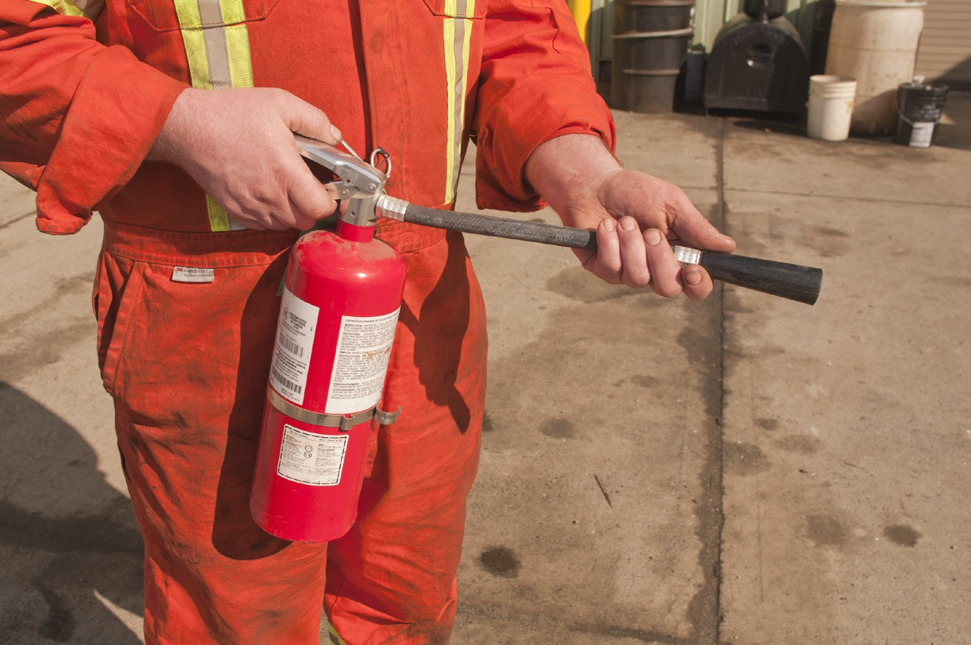
Figure 2 — Aim the nozzle

Squeeze and Sweep
Keep the extinguisher upright and squeeze the handles together to discharge the pressurized extinguishing agent.

Sweep the extinguisher from side to side, covering the fire with extinguishing agent. Start using the extinguisher from a safe distance away and then move forward (watch for scattering
material). The idea is to completely cover the fuel. Keep spraying until the fire is out; keep an eye on the area in case it reignites.

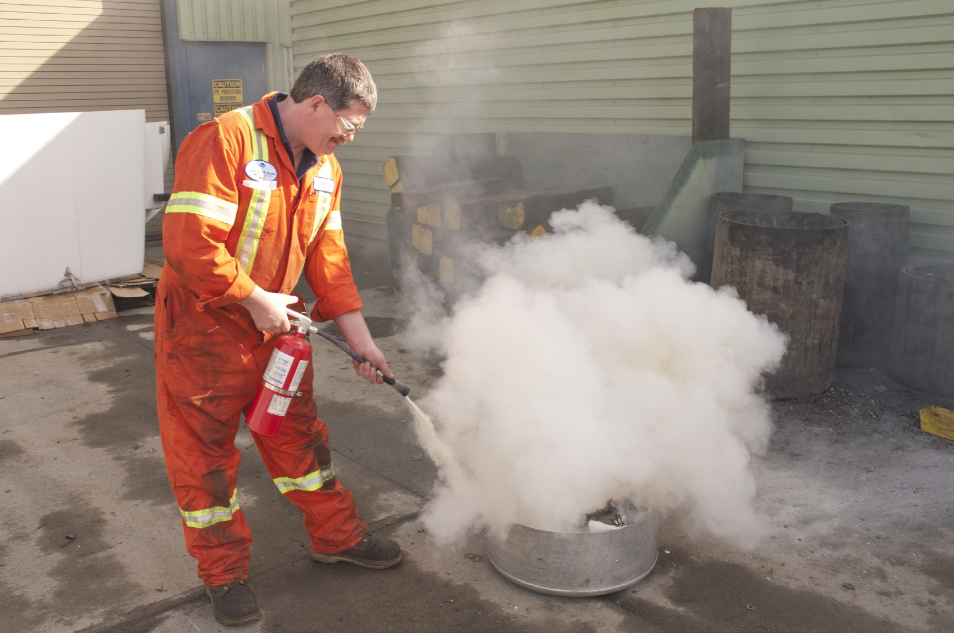
Figure 3 — Squeeze and sweep

Now complete the Learning Task Self-Test.

Self-Test 4
- What is the first step to take when a fire is discovered?
  - Use an extinguisher to put it out.
  - Activate the building fire alarm system.
  - Notify the fire department by dialling 911.
  - Assist any person in immediate danger to safety.

- If you don’t know what is burning, make sure that you use an ABC fire extinguisher.
  - True
  - False

- Any worker can and should use a fire extinguisher.
  - True
  - False

- What should you do if the fire is spreading rapidly?
  - Get a larger fire extinguisher.
  - Exit the area to a safe location.
  - Help the fire department extinguish the fire.
  - Get a fellow worker to help you extinguish it.

- Portable fire extinguishers contain a limited amount of extinguishing agent.
  - True
  - False

- What does the acronym PASS stand for?
  - Pin, Aim, Stand, Safe
  - Pull, Aim, Start, Sweep
  - Plastic, Access, Strap, Seal
  - Pull, Aim, Squeeze, Sweep

- You should stand as close to the fire as possible when using a fire extinguisher as long as you don’t feel too much heat.
  - True
  - False

Answer Key

Self-Test 1
1. | b. | Heat, oxygen, fuel
2. | a. | True
3. | a. | True
4. | b. | Starvation
5. | a. | Cooling
6. | d. | Smothering
7. | d. | Chemical chain reaction
8. | d. | Smothering
Self-Test 2
1. | c. | Class C
2. | d. | Electrical conductors or components
3. | b. | Class B
4. | b. | Circle
5. | c. | Square
6. | a. | Class A
7. | d. | By the type of fire they will extinguish
8. | d. | Triangle
9. | a. | Star
Self-Test 3
1. | d. | When doing welding or cutting in areas with combustible materials
2. | b. | False
3. | d. | Flashpoint temperature
4. | c. | Remove ground wire first.
5. | c. | Space heaters

Self-Test 4

1. | d. | Assist any person in immediate danger to safety.
2. | b. | False
3. | b. | False
4. | b. | Exit the area to a safe location.
5. | a. | True
6. | d. | Pull, Aim, Squeeze, Sweep
7. | b. | False

The British Columbia Open Textbook Project
The British Columbia Open Textbook Project is funded by the B.C. Ministry of Advanced Education, and managed by BCcampus, a publicly-funded organization that uses information technology to connect B.C. post-secondary institutions under a collaborative service delivery framework. The Open Textbook Project aims to make available
openly-licensed textbooks in the province’s high-impact subject areas. Visit open.bccampus.ca for more information.

7960003678

