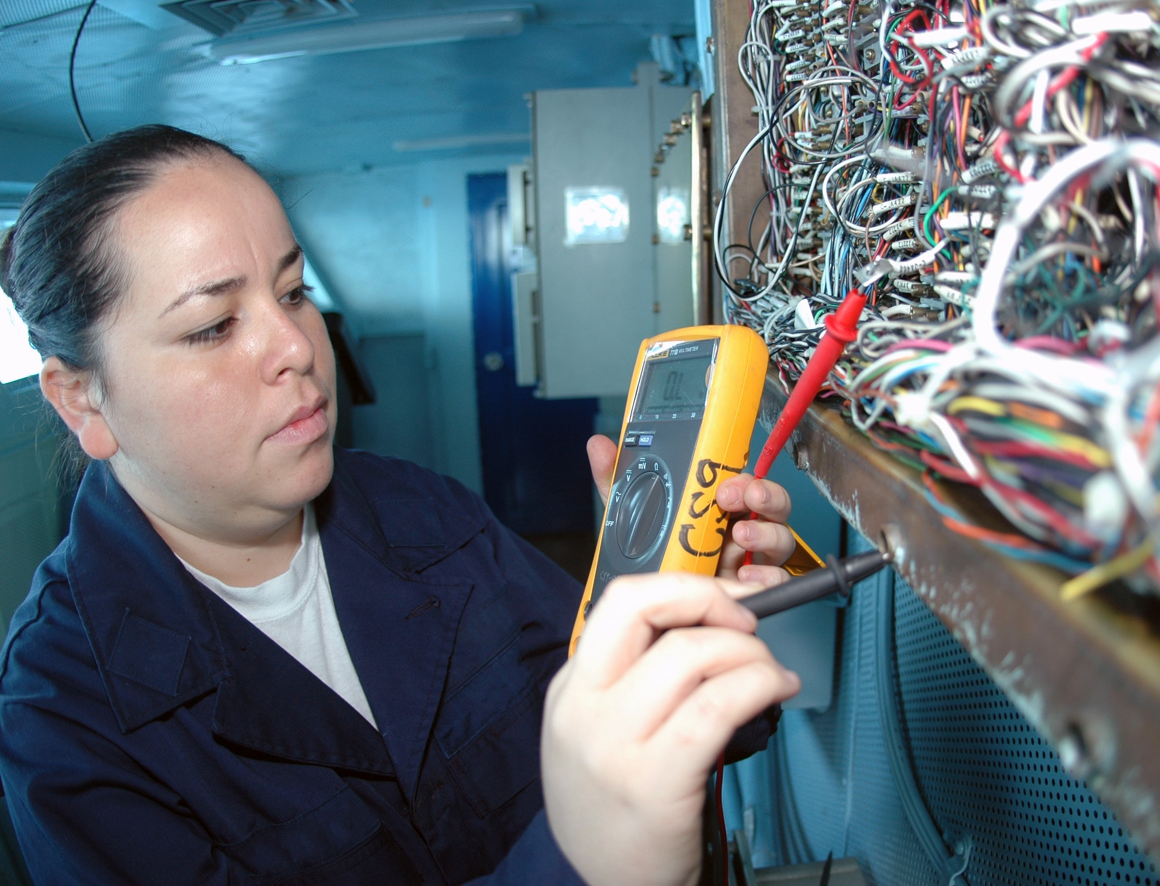

Trades Access Common Core

**Line E: Electrical Fundamentals Competency E-2: Identify Common Circuit Components and Their Symbols**

Image to be placed here.

**B.C. Open Textbook Project**



OpenEd

open.bccampus.ca

**Trades Access**

COMMON CORE

Line E: Electrical Fundamentals Competency E-2: Identify Common Circuit Components

and Their Symbols

#### Acknowledgments and Copyright

To learn more about BCcampus Open Education, visit [http://open.bccampus.ca](http://open.bccampus.ca/)

© 2015 Camosun College

The Trades Access Common Core resources are licensed under the [Creative Commons Attribution 4.0 Unported Licence](http://creativecommons.org/licenses/by/4.0/), except where otherwise noted. Under this licence, any user of this textbook or the textbook contents herein must provide proper attribution as follows:

* *Trades Access Common Core Competency E-2: Identify Common Circuit Components and Their Symbols* by Camosun College is used under a [Creative Commons Attribution 4.0 Licence](http://creativecommons.org/licenses/by/4.0/).
* If you redistribute all or part of this book, it is recommended the following statement be added to the copyright page so readers can access the original book at no cost: Download for free from the [B.C. Open Textbook Collection](https://open.bccampus.ca/browse-our-collection/find-open-textbooks/) (https://open.bccampus.ca/browse-our-collection/find-open-textbooks/).
* If you use this textbook as a bibliographic reference, then you should cite it as follows: Camosun College. (2015). *Trades Access Common Core Competency E-2: Identify Common Circuit Components and Their Symbols*. Victoria, B.C.: Crown Publications.

All images copyright BC Industry Training Authority are licensed under the [Creative Commons Attribution-NonCommercial-ShareAlike 4.0 licence](http://creativecommons.org/licenses/by-nc-sa/4.0/).

The issuing/publishing body is Crown Publications, Queen’s Printer, Ministry of Technology, Innovation and Citizens’ Services.

BCcampus would like to acknowledge the following individuals and organizations for their contributions in producing the Trades Access Common Core Open Textbook resources.

BCcampus

Open Education Team

Hilda Anggraeni, Graphics

Camosun College

Olaf Nielsen, Chair, Trades Development and Special Projects, School of Trades and Technology

Nannette Plant, Manager, Enterprise Point Operations & Special Projects, Office of the VP Strategic Development

Rod Lidstone, Instructor, Plumbing and Pipe Trades, Lead Writer/Reviewer

Brian Coey, Instructor, Sheet Metal and Metal Fabrication, Writer/Reviewer

Matt Zeleny, Camosun Innovates, 3D imaging

Open School BC

Monique Brewer, Director

Adrian Hill, Instructional Designer

Dennis Evans, Image Coordinator, Photographer, Graphics, Production Technician (layout)

Farrah Patterson, Production Technician

Industry Training Authority of BC

The ITA works with employers, employees, industry, labour, training providers, and government to issue credentials, manage apprenticeships, set program standards, and increase opportunities in approximately 100 BC trades. Among its many functions are oversight of the development of training resources that align with program standards, outlines, and learning objectives, and authorizing permission to utilize these resources (text and images).

Erin Johnston, Director of Training Delivery  
Cory Williams, Manager, Industry Relations

Publishing Services, Queen’s Printer

Spencer Tickner, Director of QP Publishing Services

Dwayne Gordon, Manager, Electronic Publishing

October 2015, Version 1

To order print copies of any of the Trades Access Common Core resources, please contact us:

Crown Publications, Queen’s Printer PO Box 9452 Stn Prov Govt

563 Superior St, 3rd Floor Victoria, BC V8W 9V7 Phone: 250-387-6409

Toll Free: 1-800-663-6105

Fax: 250-387-1120

[crownpub@gov.bc.ca](mailto:crownpub@gov.bc.ca) [www.crownpub.bc.ca](http://www.crownpub.bc.ca/)

Intellectual Property Program

Ilona Ugro, Copyright Officer, Ministry of Technology, Innovation and Citizens’ Services, Province of British Columbia

#### Creative Commons Attributions

**Cover photo:**

[US Navy 091004-N-8960W-014 Interior Communications Electrician 3rd Class Karla Martinez inspects wiring aboard the aircraft carrier USS Nimitz (CVN 68): U.S. Navy photo](https://commons.wikimedia.org/wiki/File:US_Navy_091004-N-8960W-014_Interior_Communications_Electrician_3rd_Class_Karla_Martinez_inspects_wiring_aboard_the_aircraft_carrier_USS_Nimitz_(CVN_68).jpg) by Mass Communication Specialist Seaman Apprentice Robert Winn is in the public domain.

#### Foreword

The BC Open Textbook Project began in 2012 with the goal of making post-secondary education in British Columbia more accessible by reducing student cost through the use of openly licensed textbooks. The

BC Open Textbook Project is administered by BCcampus and is funded by the British Columbia Ministry of Advanced Education.

Open textbooks are open educational resources (OER); they are instructional resources created and shared in ways so that more people have access to them. This is a different model than traditionally copyrighted materials. OER are defined as teaching, learning, and research resources that reside in the public domain or have been released under an intellectual property licence that permits their free use and repurposing by others (Hewlett Foundation). Our open textbooks are openly licensed using a Creative Commons licence, and are offered in various e-book formats free of charge, or as printed books that are available at cost. For more information about this project, please contact [opentext@bccampus.ca.](mailto:opentext@bccampus.ca) If you are an instructor who is using this book for a course, please let us know.

#### Preface

The concept of identifying and creating resources for skills that are common to many trades has a long history in the Province of British Columbia. This collection of Trades Access Common Core (TACC) resources was adapted from the 15 Trades Common Core line modules co-published by the Industry

Training and Apprenticeship Commission (ITAC) and the Centre for Curriculum Transfer and Technology (C2T2) in 2000-2002. Those modules were revisions of the original Common Core portion of the TRAC modules prepared by the Province of British Columbia Ministry of Post-Secondary Education in 1986. The TACC resources are still in use by a number of trades programs today and, with the permission from the Industry Training Authority (ITA), have been utilized in this project.

These open resources have been updated and realigned to match many of the line and competency titles found in the Province of BC’s trades apprenticeship program outlines. A review was carried out to analyze the provincial program outlines of a number of trades, with the intent of finding common entry-

level learning tasks that could be assembled into this package. This analysis provided the template for the outline used to update the existing modules. Many images found in ITA apprentice training modules were also incorporated into these resources to create books that are similar to what students will see when they continue their chosen trades training. The project team has also taken many new photographs for this project, which are available for use in other trades training resources.

The following list of lines and competencies was generated with the goal of creating an entry-level trades training resource, while still offering the flexibility for lines to be used as stand-alone books. This

flexibility—in addition to the textbook content being openly licensed—allows these resources to be used within other contexts as well. For example, instructors or institutions may incorporate these resources into foundation-level trades training programming or within an online learning management system (LMS).

**Line A – Safe Work Practices**

* A-1 Control Workplace Hazards
* A-2 Describe WorkSafeBC Regulations
* A-3 Handle Hazardous Materials Safely
* A-4 Describe Personal Safety Practices
* A-5 Describe Fire Safety

**Line B – Employability Skills**

* B-1 Apply Study and Learning Skills
* B-2 Describe Expectations and Responsibilities of Employers and Employees
* B-3 Use Interpersonal Communication Skills
* B-4 Describe the Apprenticeship System

**Line C – Tools and Equipment**

* C-1 Describe Common Hand Tools and Their Uses
* C-2 Describe Common Power Tools and Their Uses
* C-3 Describe Rigging and Hoisting Equipment
* C-4 Describe Ladders and Platforms

**Line D – Organizational Skills**

* D-1 Solve Trades Mathematical Problems
* D-2 Apply Science Concepts to Trades Applications
* D-3 Read Drawings and Specifications
* D-4 Use Codes, Regulations, and Standards
* D-5 Use Manufacturer and Supplier Documentation
* D-6 Plan Projects

**Line E – Electrical Fundamentals**

* E-1 Describe the Basic Principles of Electricity
* E-2 Identify Common Circuit Components and Their Symbols
* E-3 Explain Wiring Connections
* E-4 Use Multimeters

All of these textbooks are available in a variety of formats in addition to print:

* PDF—printable document with TOC and hyperlinks intact
* HTML—basic export of an HTML file and its assets, suitable for use in learning management systems
* Reflowable EPUB—format that is suitable for all screen sizes including phones

All of the self-test questions are also available from BCcampus as separate data, if instructors would like to use the questions for online quizzes or competency testing.

About This Book

In an effort to make this book a flexible resource for trainers and learners, the following features are included:

* An introduction outlining the high-level goal of the Competency, and a list of objectives reflecting the skills and knowledge a person would need to achieve to fulfill this goal.
* Discrete Learning Tasks designed to help a person achieve these objectives
* Self-tests at the end of each Learning Task, designed to informally test for understanding.
* A reminder at the end of each Competency to complete a Competency test. Individual trainers are expected to determine the requirements for this test, as required.
* Throughout the textbook, there may also be links and/or references to other resources that learners will need to access, some of which are only available online.
* Notes, cautions, and warnings are identified by special symbols. A list of those symbols is provided below.

#### Symbols Legend

**Important:** This icon highlights important information.

**Poisonous:** This icon is a reminder for a potentially toxic/poisonous situation.



**Resources:** The resource icon highlights any required or optional resources.



**Flammable:** This icon is a reminder for a potentially flammable situation.



**Self-test:** This icon reminds you to complete a self-test.

**Explosive:** This icon is a reminder for a possibly explosive situation.



**Safety gear:** The safety gear icon is an important reminder to use protective equipment.



**Electric shock:** This icon is a reminder for potential electric shock.



###### Safety Advisory

Be advised that references to the Workers’ Compensation Board of British Columbia safety regulations contained within these materials do not/may not reflect the most recent Occupational Health and Safety Regulation. The current Standards and Regulation in BC can be obtained at the following website: [http://](http://www.worksafebc.com/) [www.worksafebc.com](http://www.worksafebc.com/).

Please note that it is always the responsibility of any person using these materials to inform him/herself about the Occupational Health and Safety Regulation pertaining to his/her area of work.

BCcampus January 2015

###### Disclaimer

The materials in the Trades Access Common Core Open Textbook project are for use by students and instructional staff and have been compiled from sources believed to be reliable and to represent best current opinions on these subjects. These manuals are intended to serve as a starting point for good practices and may not specify all minimum legal standards. No warranty, guarantee or representation is made by BCcampus as to the accuracy or sufficiency of the information contained in these publications. These manuals are intended to provide basic guidelines for trade practices. Do not assume, therefore, that all necessary warnings and safety precautionary measures are contained in this module and that other or additional measures may not be required.

Contents

Introduction 8

Objectives 8

Learning Task 1: Identify circuit components and their schematic symbols 9

Electrical systems 9

Conductors 9

Receptacles 10

Circuit protection devices 11

Circuit control devices 14

Lamps 19

Transformers 20

Solid state components 21

Capacitors 21

Light-emitting diodes (LEDs) 21

Sealed components 22

Cells and batteries 22

Self-Test 1 24

Learning Task 2: Interpret wiring diagrams 27

Symbols used in schematic diagrams 27

Types of electrical diagrams 28

Self-Test 2 31

Learning Task 3: Describe common circuit characteristics 33

Series circuits 33

Parallel circuits 34

Voltage source circuits 35

Three-wire power supply system 37

Self-Test 3 41

Answer Key 43

# Introduction

Many types of electric devices are used in almost every trade. Mechanical trades will find electrical devices in every motor-driven vehicle. Construction trades will encounter them in most construction projects. To be able to recognize or troubleshoot electrical devices, you must be familiar with the correct terminology and symbols used to identify them.

# Objectives

When you have completed the Learning Tasks in this Competency you should be able to:

* + describe the components of a circuit
  + identify common electrical components
  + describe solid state devices
  + identify wiring connectors
  + describe the composition of simple wiring diagrams

LEARNING TASK 1

**Identify circuit components and their schematic symbols**

All electrical components are rated with different current, voltage, and other values, depending on their use. Replacing an electrical component with one of a different value could present

a serious safety hazard to the person using the equipment. Should you have to replace an electrical component at any time, always be sure that the current, voltage, and other electrical ratings of the replacement match those of the original.

In addition, to ensure public safety from electrical and fire hazards, the Canadian Standards Association (CSA) approves electrical components. Each component is tested before it can be sold on the Canadian market. Always use only CSA-approved equipment. The CSA approval should be clearly visible on the component or the package.

You may have to assemble devices in a circuit from plans or drawings in which symbols are used to represent basic electrical devices and components. Although some plans use pictures of the devices instead of symbols, you should be familiar with the symbols so that you can identify each individual device. Not all electrical symbols are standard, but most symbols can be easily recognized.

# Electrical systems

An electrical system has two main conditions: it is closed or it is open. *Closed* means the circuit is complete and conducting. *Open* means the circuit is incomplete and no current flows.

There are different electrical systems, identified by voltage. The term *low voltage* is relative and its definition varies by context. The Canadian Electrical Code defines low voltage as from 31 V to 750 V and systems operating at 30 volts or less.

Automotive systems normally use direct current and are rated up to 24 volts. Residential alternating current voltage may be 120 or 240 volts. Lighting and small appliances normally use 120 volts. Clothes dryers, stoves, and ovens use 240 volts. Shop equipment also uses either 120 or 240 volts. Most hand-held electric tools and many shop tools use 120 volts or battery power. Some equipment, such as electric welders, use 240 volts.

# Conductors

Conductors are required to create a circuit and carry the current that will operate different devices or loads. Conductors are normally made of copper with a plastic or fibre insulating coating covering them so that they do not contact anything. Exposed wires are not only a safety concern, they are a problem in the circuit if they contact each other.

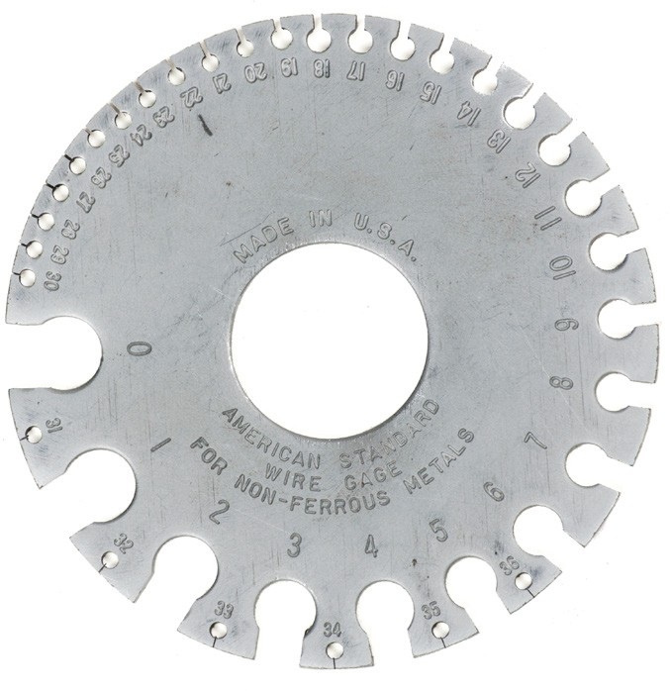Conductors are rated according to the American Wire Gauge (AWG) system, which designates different gauges for wires of different thickness. Most conductors found in vehicles and equipment are braided multi-strand conductors because they can withstand vibration and motion better than solid conductors. Most wiring found in residential and industrial applications is solid conductors. Special measuring gauges (Figure 1) are used to determine actual physical wire size.

Gauge number



4

Wire in slot

**Figure 1 —** Wire gauge

A conductor is normally shown on a wiring diagram by a straight line with a colour notation and often a gauge or size notation.

A power cord is a flexible conductor used to supply electrical energy to electrical equipment.

With plugs attached, these cords are used to attach appliances such as dryers and ranges to their receptacles. In industry, they are used to connect portable electrical equipment or

machinery to receptacles. Conductors are covered with insulating material to prevent unwanted flow of electric current. The type of insulating material is dictated by various conditions of use:

* + voltage rating
  + temperature rating
  + location (e.g., wet or dry or potential mechanical damage)

# Receptacles

Receptacles (Figure 2) are one-half of a two-piece multi-contact connector. The other half is the plug. Receptacles vary in shape, size, and application. Most 120 volt residential applications use the duplex U-ground receptacle. In addition, dryer and range receptacles are used in higher-voltage applications. The correct receptacle must be used with the correct plug for each application.

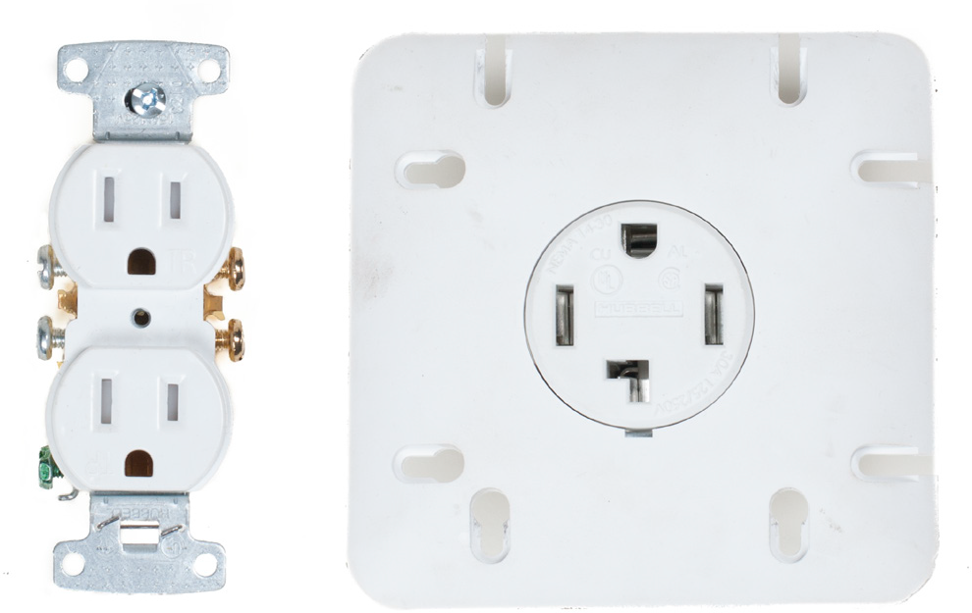 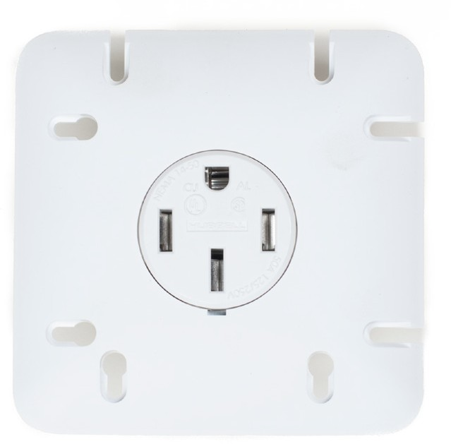

**Duplex “U” ground Dryer Range Figure 2 —** Receptacles

# Circuit protection devices

Protection is required to prevent damage to expensive components and all the equipment wiring if a circuit should overload due to excessive current flow. Protection can be provided by:

* + fuses
  + fusible links
  + circuit breakers
  + thermal limiters

### Fuses

The fuse is the most common circuit protection device. Fuses are available in different shapes and sizes and are rated to burn out or blow out at a specific amount of current flow. The material within the fuse provides excellent conductivity as long as the current flow stays below the rating of the fuse.

Once the current flow exceeds the rating, the material will melt and open the circuit. Blown fuses indicate a circuit fault that must be located and repaired. Simply replacing a burned fuse will not correct the problem. A burned fuse should never be replaced with another fuse that has a higher rating than what is recommended by the manufacturer.

Fuses can be located in a fuse box or in-line in a special holder. Small fuses, such as the glass tube fuse, are available in different lengths and sizes and have the amps rating printed on the end. Bayonet-type fuses are colour coded and have the amperage rating printed on the case. Larger cartridge fuses are used in high-voltage industrial applications. Plug or screw type fuses have a clear window on the face to check them. Figure 3 shows these four types of fuses.

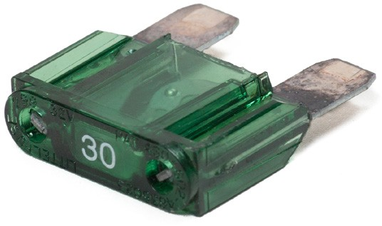 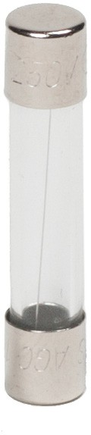 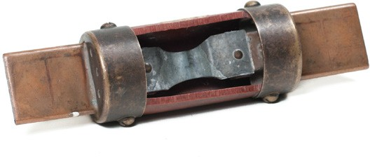 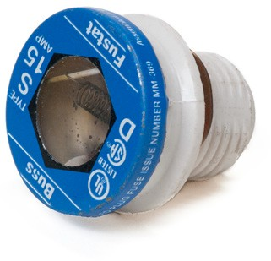

**Bayonet fuse Glass tube fuse Cartridge fuse Screw-type fuse**

**Figure 3 —** Fuses

### Fusible links

Fusible links (Figure 4) are special wires designed to burn out and open the circuit if the current flow exceeds the rated amount. These links are normally crimped into sealed connectors within the circuit. There should be a four-gauge difference between the conductors they protect. If the conductor is 16 gauge, the fusible link must be 20 gauge. Fusible links can be identified by a colour code or by a large insulation block with the gauge cast into the surface. They cannot be replaced with regular conductors.

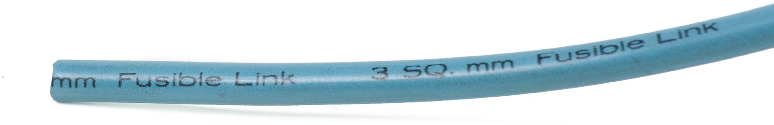

|  |  |
| --- | --- |
| **Fuse link wire size** | **Colour code** |
| 20 GA | Blue |
| 18 GA | Brown or red |
| 16 GA | Black or orange |
| 14 GA | Green |

**Figure 4 —** Fusible link and ratings

### Circuit breakers

Circuit breakers (Figure 5) are used in circuits that may have temporary overloads and must be restored to service quickly without permanent disruption. Headlight circuits are a typical low- voltage circuit that use a circuit breaker. Residential wiring for 120 and 240 volt systems also use circuit breakers.

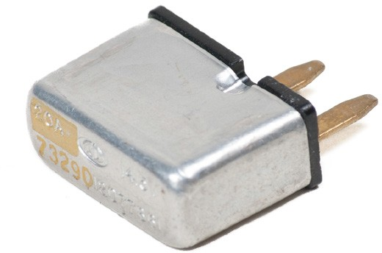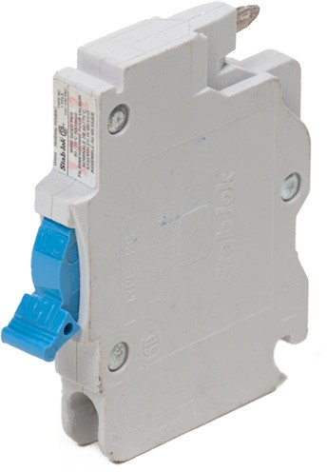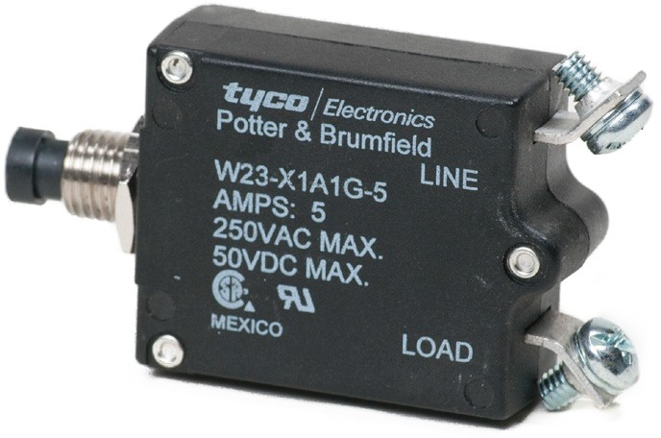

**Automotive Residential Electrical Figure 5 —** Circuit breakers

There are three different types of circuit breakers:

* + cycling
  + non-cycling
  + manual reset

##### Cycling circuit breaker

Cycling circuit breakers contain an arm constructed of two different types of metal: one that expands quickly when heated and one that expands more slowly. This allows the circuit breaker to cycle from open to closed automatically.

There is a contact point attached to one end of the arm that provides a closed circuit when it touches a fixed contact. If the current is too high for the circuit, the arm will heat and begin to bend, lifting the movable contact away from the fixed contact to open the circuit. When the arm cools, it will straighten out and touch the fixed contact again, closing the circuit.

This is the type of circuit breaker that is used in automobile lighting systems.

##### Non-cycling circuit breaker

Non-cycling circuit breakers use a high-resistance wire around the arm that will carry current when the contact points open. This provides heat that prevents the circuit breaker from cycling. To reset this type of circuit breaker, it must be disconnected from the power source so that the arm can cool.

##### Manual reset circuit breaker

Manual reset circuit breakers must be reset by pushing a button or reset bar. They will not cycle automatically. This type of circuit breaker is used in residential wiring.

### Thermal limiters

Thermal limiters are designed to melt if the device they are protecting exceeds a pre-set temperature. For example, the heating elements in a 120 volt portable electric heater are protected by a thermal limiter. If a thermal limiter melts, it must be replaced, just like a fuse.

# Circuit control devices

Controlling a circuit is an essential part of the electrical system. The control devices will turn circuits on and off as well as limit the conditions within the circuit, including amperage and voltage.

Circuit control devices include:

* + resistors
  + switches
  + relays
  + solenoids

### Resistors

Resistors are used in circuits where full current flow may not be required. One side effect of resistors is that they produce heat. There are three common resistors found in most circuits:

* + fixed
  + stepped
  + variable

##### Fixed resistors

Fixed resistors (Figure 6) restrict current flow or voltage and are connected into the circuit or built right into a component.

In some cases, this resistance is provided by wires. These are special wires that can be identified by markings that state “resistor wire—do not cut or splice.”

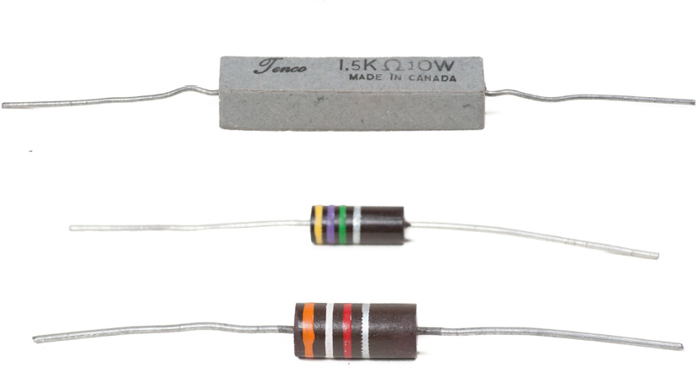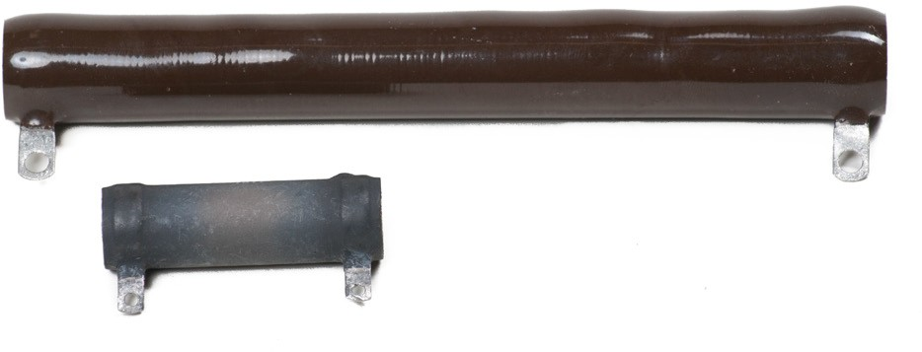

**Figure 6 —** Fixed resistors

##### Stepped resistors

Stepped or tapped resistors (Figure 7) have more than one fixed value and are connected into the circuit by wiring and a switch. The control system on a fan is a good example of one use for this type of resistor. By selecting different fan speeds with the switch, current will flow through different resistances and provide different fan motor speeds.

**Figure 7 —** Stepped resistor

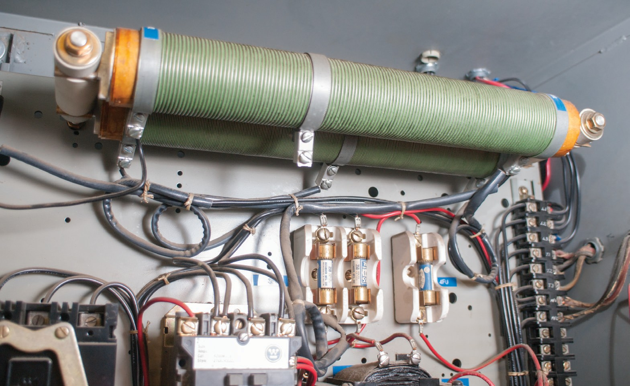

##### Variable resistors

Variable resistors (Figure 8) include potentiometers and rheostats. A variable resistor is called a *rheostat* when it is used to control current. A variable resistor is called a *potentiometer* when it is used to control voltage.

A rheostat has two connections and a movable wiper that contacts a winding. If the wiper is close to the power connection, there is high current flow. As the wiper is moved away from the power connection, the resistance in the circuit increases and the current drops.

A potentiometer has a winding that is in series rather than being open ended. Each end of the winding has a terminal for connection into a circuit, as does the movable arm. The movable arm provides an output voltage that varies from full source voltage to zero voltage as it moves along the winding.

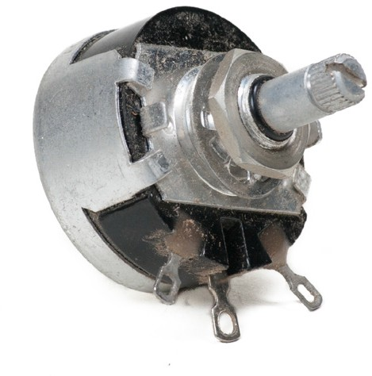 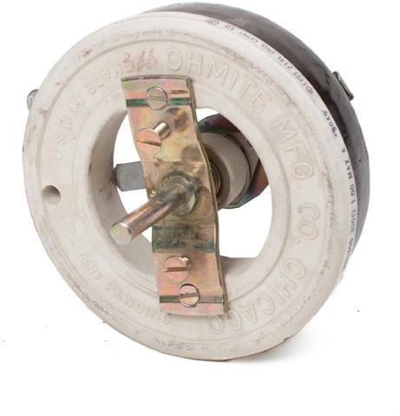

**Figure 8 —** Variable resistors

### Switches

Switches are the most common control device for electrical circuits. Switches are operated manually, hydraulically, electrically, or pneumatically. Switches operate a circuit by opening or closing the circuit.

Switches have different numbers of inputs, called *poles*, and different numbers of outputs, called

*throws*. The most common switch is the single pole, single-throw switch (SPST).

A switch that can make more than one contact is called a *single-pole, double-throw switch*

(SPDT). A slide switch, rocker switch and a toggle are shown in Figure 9.

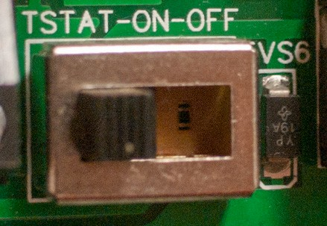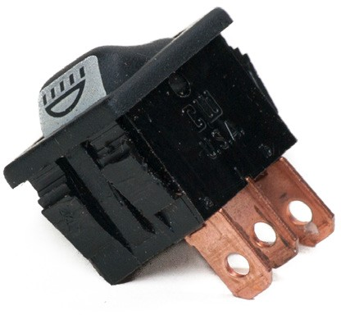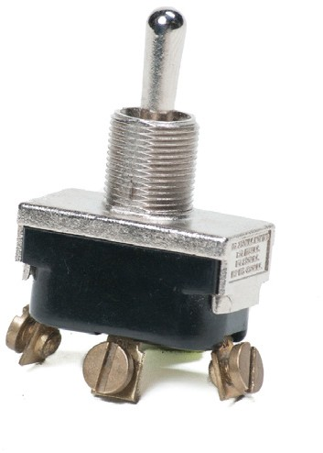

**Slide Rocker Toggle Figure 9 —** Slide, rocker, and toggle switches

If more than one switch is operated by the same control, it is called a *gang switch*. The arrangement of the fixed contact positions (called *throws*) and the moving contact (the *pole*), can be seen in the schematic symbol (Figure 10). It is called a *double-pole, double-throw switch* (DPDT).

**Figure 10 —** Double pole double throw switch



Another type of switch is the pushbutton switch. This type of switch can be used in different configurations, including SPST, SPDT, and DPDT.

A rotary switch, shown in Figure 11, has a single pole and two positions.

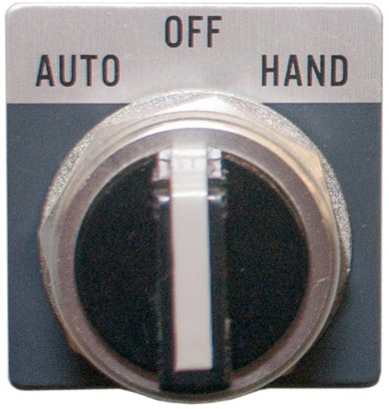

**Figure 11 —** Rotary switch

Momentary contact switches (Figure 12) require the operator to maintain pressure to keep the circuit open or closed, because the operating button is spring-loaded and will return to its at- rest position when released. A typical application is a horn switch.

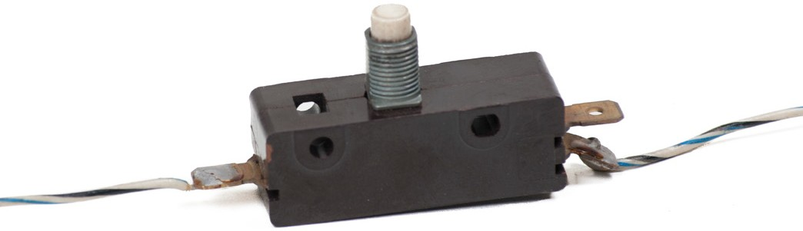

**Figure 12 —** Momentary contact switch

##### Temperature, pressure, and motion switches

A temperature-sensitive switch operates on the same principle as a cycling circuit breaker to make and break an electrical connection. These switches are called *flashers* and can be used to operate turn signals or emergency lights. In this type of switch the heater is included as part of the switch.

Other temperature-sensitive switches can be used to turn current flow on or off for operations such as cooling fans or electric defrosters. They sense the temperature of the engine or outside air and control the circuit by using a bimetal strip and contacts (Figure 13).

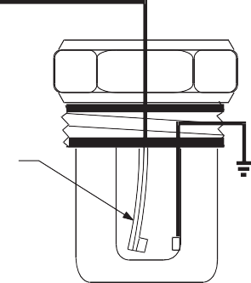From power source and load

Bimetal element

**Figure 13 —** Temperature-sensitive switch

Pressure-sensitive switches can sense the pressure in a pneumatic or hydraulic system and turn electrical devices on and off. These are used for electrical clutches in air conditioning, air pumps, and other similar systems.

### Relays

Relays are electrically activated switches that allow a very small current flow to control a large current flow. Every relay has a power circuit and a control circuit. The control circuit is energized by a switch and consists of a soft iron core with a wire winding.

When current flows through the winding, an electromagnetic field is created, that pulls an armature down to close contacts in the circuit. A typical application is a starter relay (Figure 14).

Control switch

From battery

Control circuit

From battery

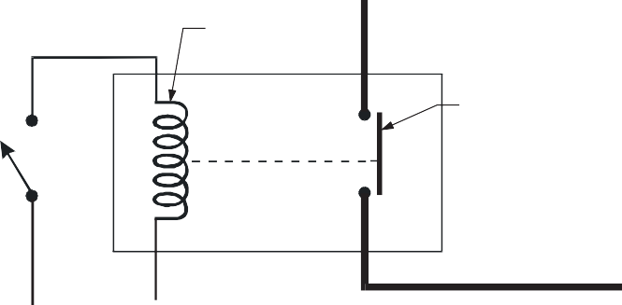Relay contact

To load

Dashed line shows mechanical connection

Relay contacts close with current through the coil.

**Figure 14 —** Relay

### Solenoids

A solenoid (Figure 15) is an electromagnet with a movable core that changes electrical energy into mechanical force. Some solenoids may activate contacts and act as a relay, such as in a starter solenoid.

Switch

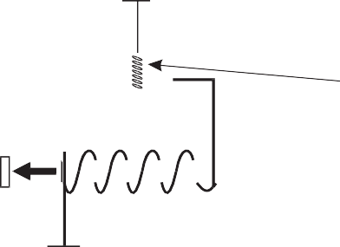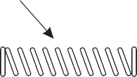

From power source

Spring

**Figure 15 —** Solenoid

# Lamps

Lamps turn electrical energy into light. There are many different types and styles of lamp. Some are used in small applications while others are used in residential or industrial sites. Light symbols vary with application and manufacturer. Typical residential incandescent and fluorescent lights are shown in Figure 16. The incandescent lamp is available in different watt ratings. The fluorescent lamp is available in different lengths, wattages, and types of illumination. It is easily recognizable by its long tube shape.

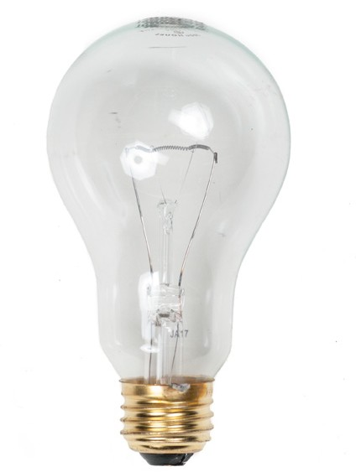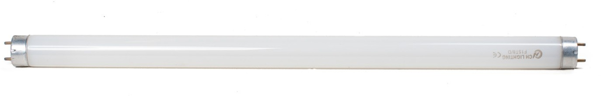

**Figure 16 —** Lamps

### Light-duty incandescent lamps

Light-duty incandescent lamps most commonly have bases that are either the screw type or the bayonet type Figure 17.

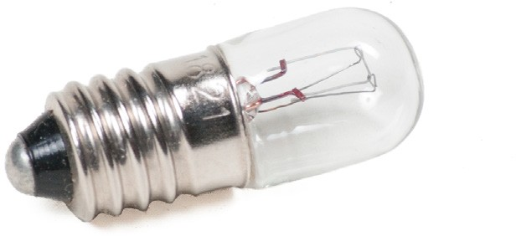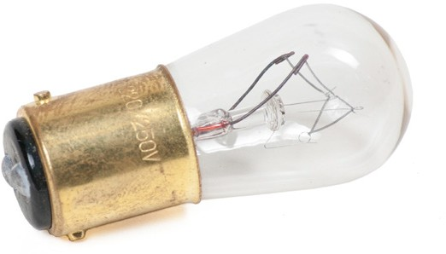

**Screw-type lamp Bayonet-type lamp Figure 17 —** Incandescent lamps

The amount of illumination from the neon lamp (Figure 18) is small. The neon lamp uses very little current but needs higher voltage.

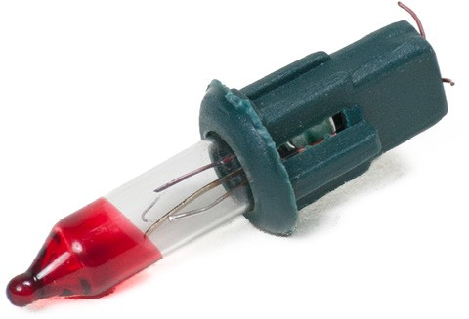

**Figure 18 —** Decorative neon lamp

### Lamp holders

Lamp holders (Figure 19) are used to hold lamps and provide a means of connecting the lamp to the electrical circuit. Incandescent lamps use a screw-type attachment. This may be housed in a plastic or porcelain body. Some lamp holders have built-in switches. Fluorescent lamp holders are available in different styles and sizes.

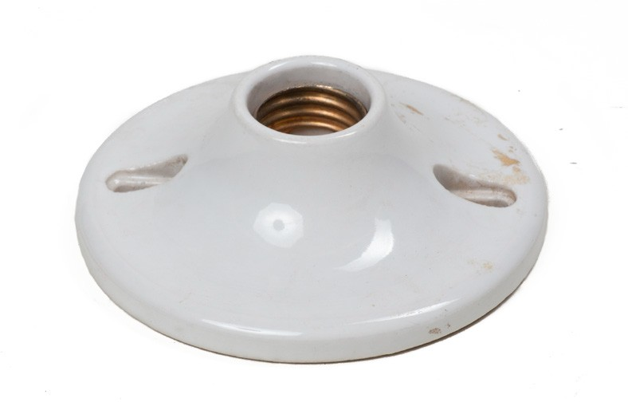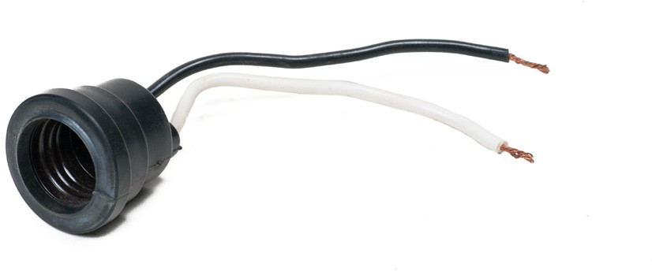

**Figure 19 —** Lamp holders

# Transformers

The transformer shown in Figure 20 is used to increase or decrease voltage in an electric circuit. Transformers are rated in volts and amps for specific applications. A typical application is a doorbell circuit, transforming 120 volts AC to 24 volts AC.

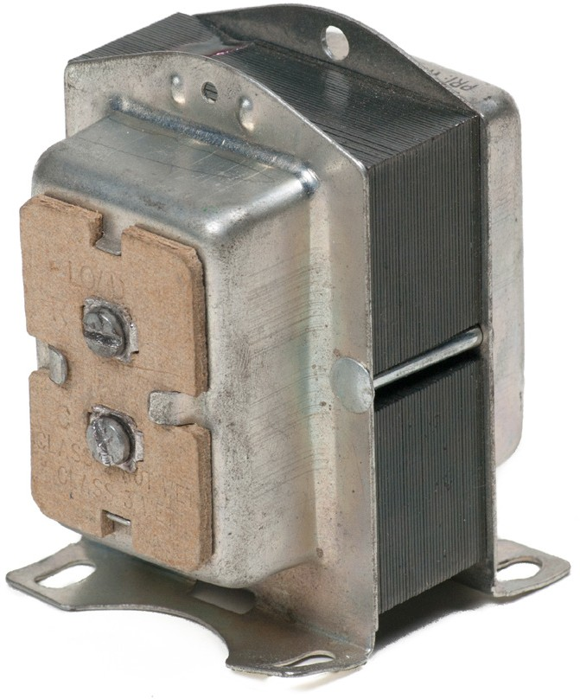

**Figure 20 —** Transformer

# Solid state components

Solid state components are made of semiconductor material. These are joined at a junction and can provide different types of control without mechanical movement, depending on how they are connected in a circuit.

# Capacitors

Capacitors (Figure 21) are devices used to absorb and store electric current to prevent damage to components. These components are made of two conductor plates with a non-conducting material between them. Capacitors will store energy if the circuit is broken and will remain charged until the circuit is restored.

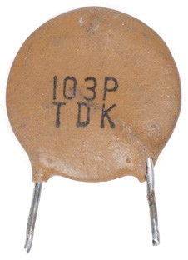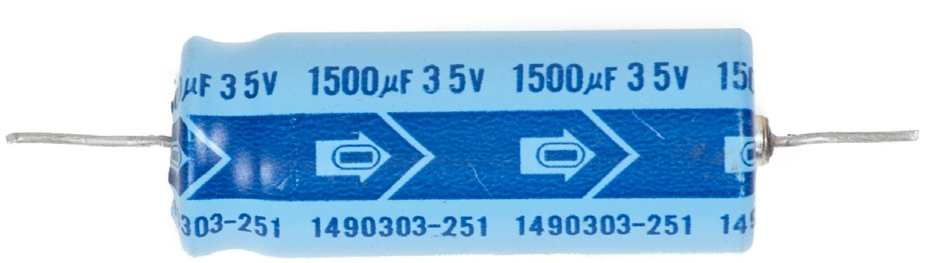

**Figure 21 —** Capacitors

Capacitors are useful for absorbing stray currents and preventing arcing across opening contacts. Variable capacitors are called *trimmers* or *tuners* and are used only in very sensitive circuits with low current flow.

# Light-emitting diodes (LEDs)

Light-emitting diodes (LEDs) produce light from electricity using semiconductor materials. They operate from a low DC voltage and produce little heat because there is no incandescent filament. They are available in a range of colours, with red, green, and yellow being the most common.

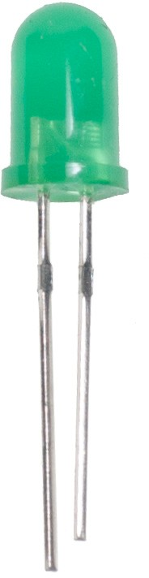

**Figure 22 —** Individual LED

The seven-segment number display (Figure 23) uses one LED for each section to create different numbers from 0 to 9.

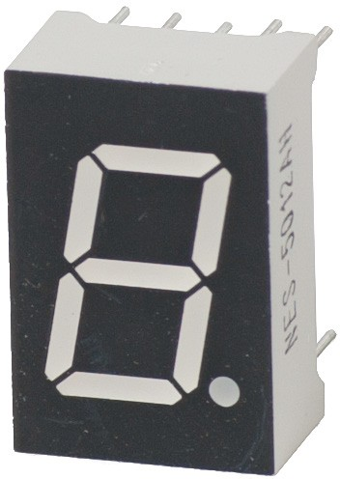

**Figure 23 —** Seven-segment display

# Sealed components

These components must not be opened. They can be found in applications such as engine controls, charging systems, electronic dash displays, and message modules. They are normally constructed in such a manner as to make entry difficult, if not impossible.

# Cells and batteries

Cells and batteries convert chemical energy to electrical energy. They are used to provide power to portable electronic equipment. They may also be used for backup power in the event of a power failure.

The single cells shown in Figure 24 can produce 1 to 4 volts, depending on their compositions. For example, cells may be carbon zinc, alkaline manganese, nickel cadmium, silver oxide or lithium types.

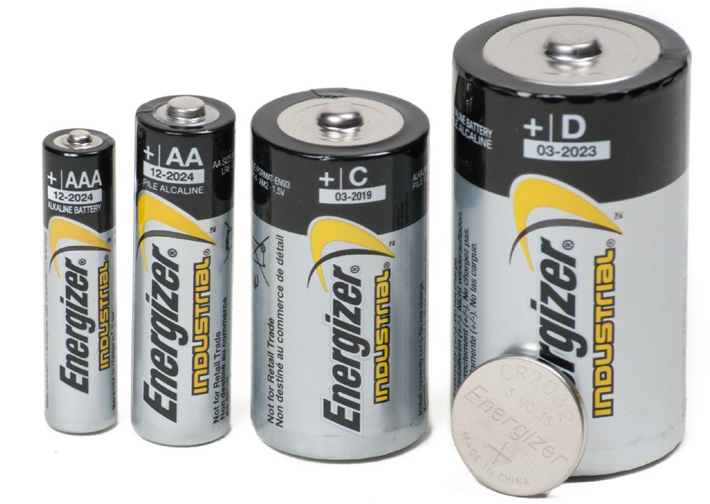

**Figure 24 —** Cells

Note the polarity of the symbol for a cell shown in Figure 25.

Negative

Positive



**Figure 25 —** Symbol for a cell

Cells may be connected in series within a case to make up a battery. Both the 12 volt automotive battery and the 9 volt clip-in battery (Figure 26) have multiple cells inside the case. The symbol for a battery is composed of the number of symbols for cells corresponding to the number of cells in the battery (Figure 27).

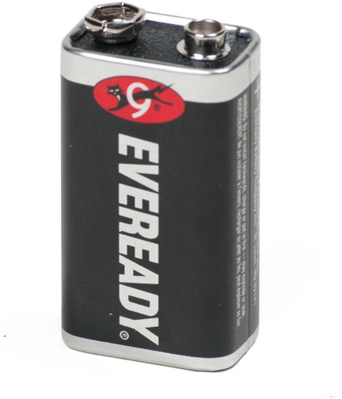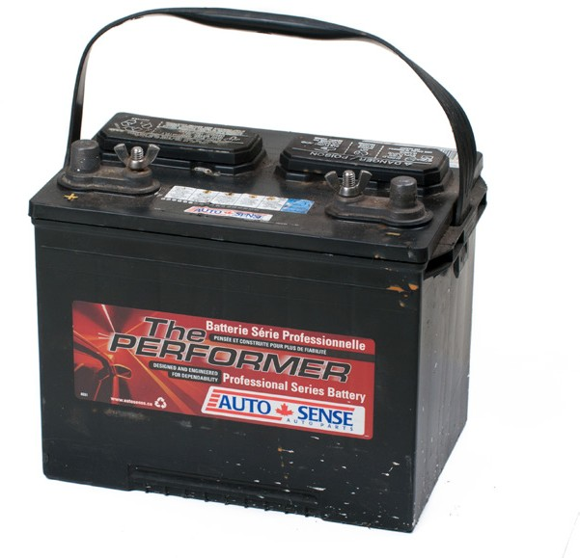

**Figure 26 —** Batteries

Three cell battery Six cell battery

**Figure 27 —** Symbols for batteries

Now complete the Learning Task Self-Test.

## Self-Test 1

1. Match the device on the left with its purpose on the right.
   1. Circuit breaker 1. Protects circuits
   2. Relay 2. Electric switch
   3. Solenoid 3. Variable control
   4. Rheostat 4. Movable core
2. What best describes tapped or stepped resistors?
   1. They have two or more fixed values.
   2. They have only one unchangeable rating.
   3. They have a variable range of resistance.
   4. They are used to control charging systems.
3. How is a fuse different from a circuit breaker?
   1. A fuse acts like a diode.
   2. A circuit breaker doesn’t need a ground.
   3. A fuse can be reset and a circuit breaker cannot.
   4. A circuit breaker can be reset and a fuse cannot.
4. 6 gauge wire is smaller than 18 gauge.
   1. True
   2. False
5. What are conductors normally made from?
   1. Steel
   2. Copper
   3. Soft iron
   4. Aluminum
6. Receptacles are one-half of a two-piece multi-contact connector.
   1. True
   2. False
7. What are circuit breakers, fuses, and thermal limiters all examples of?
   1. Relays
   2. Switches
   3. Receptacles
   4. Protection devices
8. How many gauges of difference must there be between a fusible link and a conductor?
   1. 2
   2. 4
   3. 6
   4. 8
9. Relays require a power circuit and a control circuit.
   1. True
   2. False
10. What are transformers used for?
    1. To act like a relay
    2. To increase amperage
    3. To increase or decrease voltage
    4. To change the current from DC to AC
11. Who is responsible for testing all electrical components?
    1. ITA
    2. NSA
    3. CSA
    4. DNA
12. *Closed* means the circuit is complete and conducting.
    1. True
    2. False
13. What voltage other than 120 V does a residential system use?
    1. 180 V
    2. 200 V
    3. 240 V
    4. 280 V

LEARNING TASK 2

**Interpret wiring diagrams**

The ability to read and understand a wiring diagram is important for any tradesperson. You may need to repair a power tool, install a heat pump, or try to find a fuse in a car. Any of these situations requires an ability to read and understand a wiring diagram.

# Symbols used in schematic diagrams

Electrical symbols may be different for each manufacturer, but in most cases they are standard. Every manufacturer’s diagram should have a symbol identification chart or “key” located in the wiring book. Some examples of electrical symbols are shown in Figure 1.



Fixed resistor Variable resistor Potentiometer Rheostat

Common Ground Fuse Circuit breaker

SPST switch SPDT switch DPST switch DPDT switch



Lamp Diode Transformer Capacitor

Single cell battery

Crossed new

Multiple cell battery

Crossed old



Joined old



Joined new

**Figure 1 —** Common electrical symbols

# Types of electrical diagrams

There are four basic types of electrical diagrams:

* schematic
* wiring
* block
* pictorial

##### Schematic diagrams

The schematic diagram (Figure 2), often called a *ladder diagram*, is intended to be the simplest form of an electrical circuit. This diagram shows the circuit components on horizontal lines without regard to their physical location. It is used for troubleshooting because it is easy to understand the operation of the circuit. The loads are located on the far right of the diagram and the controls for each load are located to the left. To understand the sequence of operation the drawing is read from the upper left corner and then from left to right and from top to bottom.

120 V

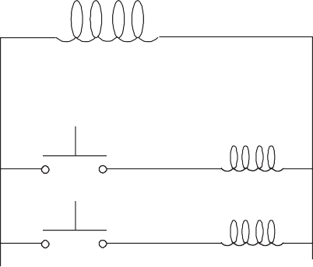

24 V

Front

Back

**Figure 2 —** Schematic of a doorbell system

##### Wiring diagrams

The wiring diagram (Figure 3) shows relative layout of the circuit components using the appropriate symbols and the wire connections. Although a wiring diagram is the easiest to use for wiring an installation, it is sometimes difficult to understand circuit operation and is not as applicable for troubleshooting.

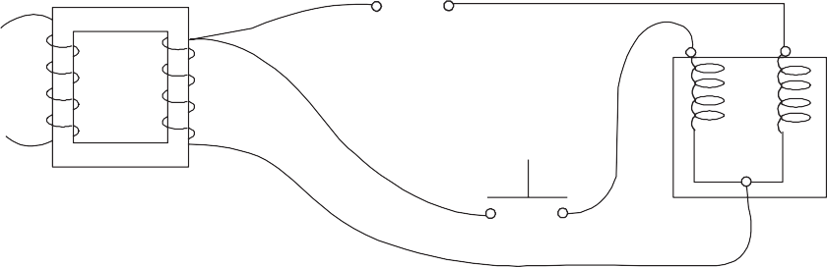

**Figure 3 —** Wiring diagram

##### Block diagrams

The block diagram (Figure 4), also called a *functional block diagram*, is used to describe the sequence of circuit operation. This diagram indicates by functional descriptions, showing which components must operate first in order to get a final outcome. They do not refer to specifics like device symbols or related wire connections.

Doorbell

h ton

Pus But

2

sh ton 1

Pu But

Transformer

**Figure 4 —** Block diagram



##### Pictorial diagrams

A pictorial diagram (Figure 5) shows the circuit components in more detail, as they really look, and indicates how the wiring is attached. These diagrams can be used to locate components in a complex system.

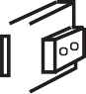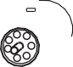

**Figure 5 —** Pictorial diagram

Now complete the Learning Task Self-Test.

**Self-Test 2**

1. A schematic diagram is often called a *ladder diagram*.
   1. True
   2. False
2. What is the fourth type of wiring diagram, in addition to schematic, wiring, and block diagrams?
   1. Line
   2. Oblique
   3. Pictorial
   4. Isometric
3. A schematic diagram shows all physical locations of components.
   1. True
   2. False
4. For which operations is a wiring diagram best suited?
   1. Diagnosing
   2. Sequencing
   3. Installation
   4. Troubleshooting
5. A pictorial diagram is used to locate components in complex systems.
   1. True
   2. False
6. A block diagram includes symbols.
   1. True
   2. False

LEARNING TASK 3

**Describe common circuit characteristics**

Electrical components can be connected in different configurations to form circuits for different power outputs and applications.

# Series circuits

A series circuit is constructed by connecting all of the circuit components in line with one another. The schematic diagram in Figure 1 is an example of a simple series circuit. In this case, a battery (source) is connected through a switch to three resistors (load devices), all of which are in line with one another.







**Figure 1 —** A simple series circuit

When the switch is closed, there is only one path for current flow. Any circuit that provides only one path for current flow is categorized as a series circuit.

If any part of a series circuit is opened, current cannot flow and none of the components will operate. The circuit may be opened by the switch or by the failure of a component in the circuit. For example, some decorative lights have clusters within the string that are connected as a series circuit. If one lamp burns out (or opens), all the other lamps go out. You then have to test each lamp individually to find the failed bulb, and this gets very challenging if two bulbs happen to be damaged.

### Application of series circuits

Electrical components or devices are generally connected in series whenever it is necessary to:

* control the amount of current flow in a circuit
* divide the total voltage of a supply For example:
* Switches are connected in series with loads so that you can energize or de-energize different loads.
* Protective devices such as fuses and overload relays are connected in series with line conductors.
* By connecting equal values of resistance in series, the same voltage drop can be obtained across each resistance. Twenty Christmas tree lights connected in series to a 120 V supply would have a voltage rating of 6 V per light.

### Disadvantages of series circuits

When designing a series circuit, consider these points:

* An open in any one device will also interrupt current flow to all remaining devices.
* A short in one device will cause an increase in current through all the devices.
* Changing the resistance value of one device will change the current, voltage, and power values of all remaining devices.

# Parallel circuits

The parallel circuit is probably the most common type of circuit you will encounter. Loads in power distribution systems are usually connected in parallel with each other in one way or another. A parallel circuit is constructed by connecting the terminals of all the individual load devices so that the same value of voltage appears across each component. In Figure 2, you can see that each of the three resistors receives the same voltage from the source.





**Figure 2 —** A parallel circuit

Figure 3 shows the more traditional schematic of the same circuit. Notice that:

* The total supply voltage appears across each of the three resistors.
* There are three separate paths (or branches) for current flow, each leaving the negative terminal of the supply and returning to the positive terminal.



**Figure 3 —** Schematic of a parallel circuit

The two fundamental characteristics of any parallel circuit are that:

* The voltage across each branch is the same.
* There is more than one path for current to flow through.

In contrast to a series circuit, current still flows to the remaining devices in the circuit if any one branch or component in a parallel circuit is opened.

# Voltage source circuits

Multiple power sources can be connected in series or parallel in order to meet the different voltage or current output requirements for various applications:

* Power sources are connected in series to increase the voltage output.
* Power sources are connected in parallel to increase the current capacity

### Series sources

Voltage sources are sometimes connected in series to produce a higher voltage value. This is common in devices such as flashlights and portable transistor radios, in which 1.5 V battery cells are used.

To obtain a higher voltage output from series-connected sources, you must observe correct polarity. In Figure 4, a net voltage of 6 V is obtained if the individual 1.5 V cells are acting in the same direction. This is called *series aiding*.

 



**Figure 4 —** Battery cells connected in series aiding

For the voltages to accumulate, the negative terminal of one source connects in series with the positive terminal of the next source, and so on.

When voltage sources are connected in *series opposing*, the net voltage value is derived by subtraction. This is illustrated in Figure 5.





**Figure 5 —** Battery cells connected in series opposing

* Three of the cells are connected series aiding to produce 4.5 V.
* One cell is connected with opposite polarity of 1.5 V.
* The net voltage is 4.5 V – 1.5 V = 3 V.

Overall polarity acts in the direction of the largest cell.

### Parallel sources

Voltage sources are connected in parallel whenever it is necessary to deliver a current output greater than the current output that a single source of supply can provide, without increasing voltage across a load.

An advantage of parallel-connected power sources is that one source can be removed for maintenance or repairs while reduced power to the load is maintained. This is common in RVs that have dual batteries. For parallel batteries, current capacity is equal to that of one battery multiplied by the number of parallel batteries. If a 6 V battery has a maximum current output of 1 amp, and if it is necessary to supply a load requiring 2 amps, then you can connect a second 6 V battery in parallel with the first, as shown in Figure 6.







**Figure 6 —** Two batteries in parallel

Whenever batteries or other power sources such as transformers or generators are to be connected in parallel, it is very important that the power sources have the following:

* The same terminal voltages

A lower voltage source connected to a higher one acts as a load itself, rather than helping share the real load current with the other sources of supply.

* Properly connected polarity.

Like terminals of the power sources must be connected together; that is, positive-to- positive and negative-to-negative.

# Three-wire power supply system

Electrical energy to most individual and small commercial buildings is distributed through a 120 V/240 V AC, single-phase, three-wire system.

Several advantages are gained by using this method of distribution:

* Copper conductor current requirements can be reduced.
* Two different voltages (120 V and 240 V) are available.
* Improved safety is established through grounding the neutral.

### Source connections

A three-wire circuit is accomplished by connecting two 120 V sources in a series-aiding configuration. The conductor taken from the common point between the two sources is called the *neutral conductor*. Conductors taken from the two outer points are called the *line* or *hot conductors*.

As shown in Figure 7:

* Voltage measured line-to-line is 240 V.
* Voltage measured from either line to neutral is 120 V.

This allows connection to either 120 V loads (such as lighting) or 240 V loads (such as ranges or clothes dryers). See Figure 8.

**Figure 7 —** Three-wire circuit

Note that polarities shown in Figure 7 change every 120th of a second for a 60 hertz AC power supply.





**Figure 8 —** Three-wire distribution

For safety reasons, it is important that circuit conductors are identified by colour:

* Insulation on the two-line conductors is usually black (or sometimes one is black and one is red).
* The neutral always has white insulation.

The neutral is also grounded (directly connected to earth) at the source of supply.

### Grounding the neutral conductor

Earth is a conductor of electricity. Therefore, to reduce the hazards of electrical shock and improve safety, electrical distribution systems usually have one of the circuit conductors connected to Earth, or as we say, *grounded*.

In most electrical systems, the neutral conductor is grounded at the supply by directly connecting it to Earth by another conductor (called the *system grounding conductor*) or by an electrode. Although grounding electrical distribution systems is an elaborate topic, consider the following simplified example.

Example

The fundamental purpose of grounding is to guard against electrical shocks and fire hazards. But what makes a grounded electrical system safer? Consider an ungrounded 120 V/240 V wiring system with a fault, as shown in Figure 9. Theoretically, if an insulation fault occurs at a piece of equipment (so that a line conductor makes accidental contact with the metal frame), nothing should happen. However, if an accidental ground should occur and a person comes in contact with the faulty equipment and ground, that person will experience a shock of 240 V (the line-to- line voltage).

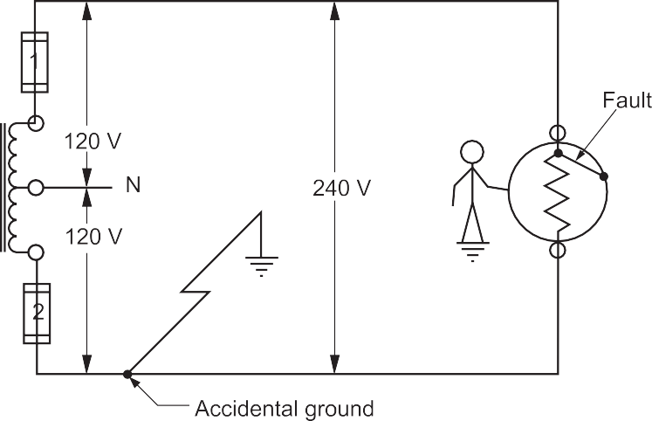

**Figure 9 —** Accidental fault in an ungrounded wiring system

Now look at the same wiring system with the neutral purposely grounded, as shown in Figure 10.

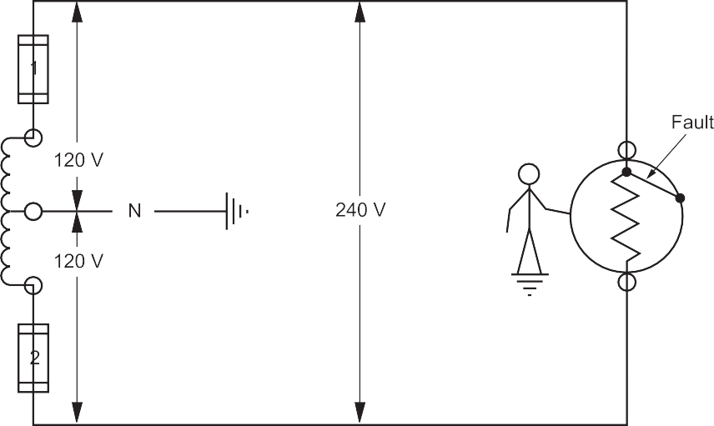

**Figure 10 —** Accidental fault in a grounded neutral writing system

With the neutral grounded and the same equipment fault as previously described, the person coming in contact with both the metal frame of the equipment and the Earth would experience a shock of only 120 V (which is the line-to-neutral voltage). The shock voltage has been reduced by 50%.

To further minimize shock hazard, not only is the wiring system grounded but also all metallic, non-current-carrying parts of equipment are grounded by using a bonding conductor. This is an important step if maximum safety is to be achieved.

As shown in Figure 11, if the equipment is also grounded intentionally, then a line-to-frame fault condition offers a low-resistance path for current flow back to the system neutral. Essentially this is a line-to-neutral short circuit, which causes the circuit overcurrent device to trip, thus eliminating the shock hazard from the system.

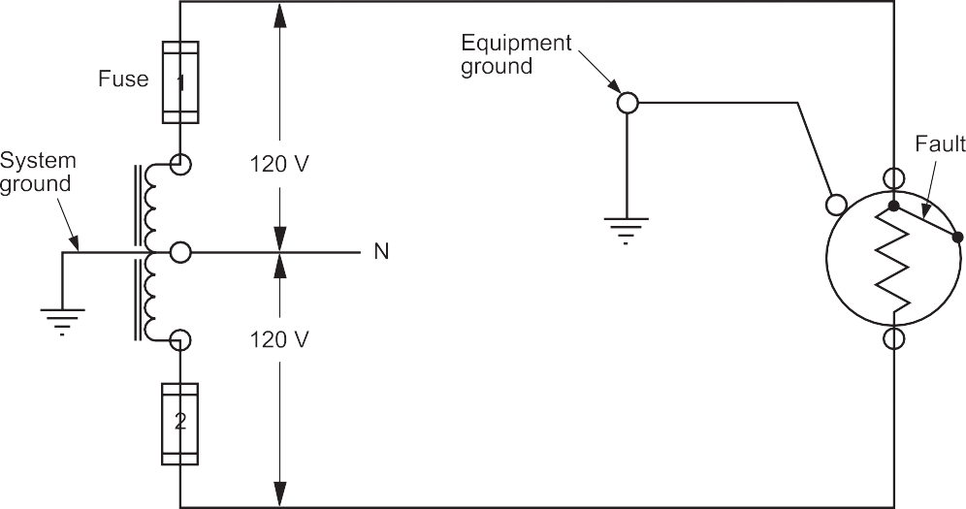

**Figure 11 —** A properly grounded wiring system

Although properly grounded wiring systems do not eliminate shock hazard, they certainly lower the odds of being shocked!

Now complete the Learning Task Self-Test.

**Self-Test 3**

1. Typical house wiring is an example of a series circuit.
   1. True
   2. False
2. If one load fails in a series circuit, what happens to the other loads?
   1. They will all fail.
   2. A fuse will blow.
   3. Nothing happens.
   4. The rest remain working.
3. As more resistors are added in series, what increases?
   1. Power
   2. Voltage
   3. Current
   4. Resistance
4. A series circuit allows the control of current flow.
   1. True
   2. False
5. Which of the following is true about a parallel circuit?
   1. Voltage will be different at each load.
   2. Voltage will be the same at each load.
   3. Current will be the same at each load.
   4. Resistance will be the same at each load.
6. The three-wire circuit is an example of which of the following?
   1. Hot jumping
   2. Series aiding
   3. Parallel aiding
   4. Backpacking circuit
7. For what purpose is a circuit grounded?
   1. Safety
   2. Series aiding
   3. Circuit protection
   4. Easier installation
8. What is the result of connecting three 6 V batteries in series?
   1. 12 volts are produced.
   2. 18 volts are produced.
   3. 24 volts are produced.
   4. The voltage doesn’t change.
9. Which of the following must apply to power sources connected in parallel?
   1. Unlike terminals must be connected.
   2. They must be connected with a fuse.
   3. Like terminals must be connected.
   4. They must have a transformer between them.
10. For voltages to accumulate in series aiding, what must occur?
    1. Correct polarity
    2. Circuit protection
    3. Similar amperages
    4. Dissimilar amperage
11. If two 12 V batteries are connected in parallel, what will the voltage be across any load?
    1. 6 V
    2. 12 V
    3. 24 V
    4. 48 V

## Answer Key

##### Self-Test 1

1. Match the device on the left with its purpose on the right.
   1. Circuit breaker (1. Protects circuits)
   2. Rheostat (3. Variable control)
   3. Relay (2. Electric switch)
   4. Solenoid (4. Movable core)
2. a. They have two or more fixed values.
3. d. A circuit breaker can be reset and a fuse cannot.
4. b. False
5. b. Copper
6. a. True
7. d. Protection devices 8. b. 4
8. a. True
9. c. To increase or decrease voltage
10. c. CSA
11. a. True 13. c. 240 V

##### Self-Test 2

1. a. True
2. c. Pictorial
3. b. False
4. c. Installations
5. a. True
6. b. False

##### Self-Test 3

1. b. False
2. a. They will all fail.
3. d. Resistance
4. a. True
5. b. Voltage will be the same at each load.
6. b. Series aiding
7. a. Safety
8. b. 18 volts are produced.
9. c. Like terminals must be connected.
10. a. Correct polarity

11. b. 12 V

**The British Columbia Open Textbook Project**



The British Columbia Open Textbook Project is funded by the B.C. Ministry of Advanced Education, and managed by BCcampus, a publicly-funded organization that uses information technology to connect B.C. post-secondary institutions under a collaborative service delivery framework. The Open Textbook Project aims to make available

openly-licensed textbooks in the province’s high-impact subject areas. Visit open.bccampus.ca for more information.



7960003694