This text was adapted by The Saylor Foundation under a Creative Commons Attribution-NonCommercial-ShareAlike 3.0 License without attribution as requested by the work’s original creator or licensee.

Chapter 1

Introduction to eMarketing

1.1 Introduction
There is no doubt about it—the Internet has changed the world we live in. Never before has it been so easy to access information; communicate with people all over the globe; and share articles, videos, photos, and all manner of media.
The Internet has led to an increasingly connected environment, and the growth of Internet usage has resulted in the declining distribution of traditional media: television, radio, newspapers, and magazines. Marketing in this connected environment and using that connectivity to market is eMarketing.
EMarketing embraces a wide range of strategies, but what underpins successful eMarketing is a user-centric and cohesive approach to these strategies.
While the Internet and the World Wide Web have enabled what we call new media, the theories that led to the development of the Internet have been developing since the 1950s.

1.2 A Brief Timeline in Internet Development

LEARNING OBJECTIVE
- Develop an understanding of how the Internet evolved.
The following is a brief timeline of the key events that led to the development of the Internet as it is known today:
- 1958. U.S. Advanced Research Projects Agency (ARPA) is established to lead science and military technological developments.
- 1961. Massachusetts Institute of Technology publishes a research paper on packet-switching theory.
- 1961–69. Research into intercomputer communications and networks is ongoing.
- 1969. Advanced Research Projects Agency Network (ARPANET), commissioned by the U.S. Department of Defense, goes live; U.S. universities connect network facilities for the first time.
- 1971. Ray Tomlinson creates the first network e-mail application.
- 1973. Protocols to enable multinetwork Internet opportunities are developed; first international ARPANET connections are made.
- 1976. Her Majesty Queen Elizabeth II sends an e-mail.
- 1978. First spam e-mail is recorded.
- 1980. Tim Berners-Lee develops rules for the World Wide Web and is credited as being the “Web’s father”; Alan Emtage develops the first search tool, known as “Archie.”
- 1982. Standard network protocols are established: transmission control protocol (TCP) and Internet protocol (IP), commonly referred to as TCP/IP.
- 1984. Joint Academic Network (JANET) is established, linking higher-education institutions; domain name system (DNS) is introduced.
- 1985. A company named Symbolics becomes the first registered dot-com domain.
- 1987. U.S. National Science Foundation is the catalyst for the surge in funded work into the Internet; number of Internet hosts increases significantly in this period.
- 1988–1990. Twenty-eight countries sign up to hook up to the National Science Foundation Network (NSFNET), reinforcing international Internet potential.
- 1990. U.S. Senator Al Gore coins the term “information superhighway.”
- 1991. Web father Tim Berners-Lee releases the World Wide Web (WWW) with scientists from the European Organization for Nuclear Research (CERN).
- 1992. America Online (AOL) is launched and raises $23 million in flotation; the phrase “surfing the Net” is introduced by Jean Armour Polly; the World Bank goes online.
- 1993. Mainstream media attention increases awareness of the Internet; first Internet publication, Wired, goes on sale; Mosaic introduces the first Web browser with graphical user interface and is the forerunner of Netscape Navigator; first online shopping malls and virtual banks emerge, as does evidence of spam; first clickable banner advertisement is sold by Global Network Navigator to a law firm.
- 1995. Amazon is launched by Jeff Bezos; trial dial-up systems such as AOL and CompuServe launch; charging is introduced for domain names; search technology companies such as Alta Vista, Infoseek, Excite, and MetaCrawler rapidly appear.
- 1996. Yahoo! is launched on the stock exchange, and shares are up nearly 300 percent on its first day.
- 1997. MP3.com is founded; the phrase “search engine optimization” is used for the first time in a Web forum.
- 1998. XML (extensible markup language) is released to enable compatibility between different computer systems; Google is founded by Larry Page and Sergey Brin.
- 1999. Peter Merholz coins the word “blog.”
- 2000. AOL and Time Warner announce they are merging; pay-per-click (PPC) campaigns are introduced for top-ten search rankings; Google AdWords launches, charging for advertisements on a cost-per-mille (CPM, or cost-per-thousand impressions) basis.
- 2002. UK online monthly consumer shopping breaks through the £1 billion barrier; Google AdWords charges on a PPC basis instead of a CPM.
- 2003. EBay topples Amazon as the most visited UK Web site.
- 2004. CD WOW! loses court case and rights to source cheaper compact discs (CDs) outside the European Union, undermining the global concept of the Internet.
- 2005. Iceland leads the world with broadband penetration: 26.7 inhabitants per 100 have broadband compared with 15.9 per 100 in the United Kingdom.
- 2006. Google buys YouTube for $1.6 billion; Facebook membership opens to anyone; Technorati.com notes that a blog is created every second of every day; Time magazine names “You” as person of the year due to online activity.
- 2008. Firefox 3.0 launches with over eight million downloads in twenty-four hours; Internet usage tops 1,407,724,920 worldwide.
- 2009. An estimated 1,802,330,457 are using the Internet worldwide as of December 31. ^{[1]}

[1] Miniwatts Marketing Group, “Internet Usage Statistics,” Internet World Stats, June 19, 2010, http://www.internetworldstats.com/stats.htm (accessed June 22, 2010).

1.3 It’s All about Being Connected!

LEARNING OBJECTIVE
- Understand how a domain name works.
In its simplest form, the Internet is a collection of connected documents or objects. Hyperlinks are what connect these documents.
The Internet is a worldwide network that allows for information to be shared between users (also known as “nodes”). The World Wide Web is a subset of this that caters specifically to Web sites.
A hyperlink is a virtual link from one document on the World Wide Web to another. It includes the uniform resource locator (URL) of the linked-to document, which describes where on the Internet a document is. It is what you enter in the address bar of the browser because it is the address of that document on the Internet.
A URL provides information to both browsers and people. URLs include domain names, which translate to Internet protocol (IP) addresses. Every Web site corresponds to an Internet protocol (IP) address, which is a structured series of dots and numbers indicating where it is physically located. When you enter a URL into the address bar of a browser, the DNS record indicates where the document is that you are linking to. Many domains can translate to the same IP address.
Confused? Look at the domain name and IP address for Quirk’s Web site:
- Domain name. http://www.quirk.biz
- IP address. 212.100.243.204
A domain name looks something like this:
http://www.domainname.com
But a lot more information can be included in this. Domain names can carry the following information:
subdomain.domain.tld/directory
- Domain. The registered domain name of the Web site.
- Subdomain. A domain that is part of a larger domain.
- TLD. The top-level domain, uppermost in the hierarchy of domain names, also known as the domain extension.
- Directory. A folder to organize content.
The TLD can indicate the country in which a domain is registered and can also give information about the nature of the domain:
- .com. The most common TLD.
- .co.za, .co.uk, .com.au. These TLDs give country information.
- .org. Used by nonprofit organizations.
- .gov. Used by governments.
- .ac, .edu. Used by academic institutions.
Domain names must be registered, and there is a fee for doing so.

KEY TAKEAWAYS
- The Internet is a worldwide network that allows for information to be shared between users (also known as “nodes”). The World Wide Web is a subset of this that caters specifically to Web sites.
- The anatomy of the domain is as follows: subdomain.domain.tld/directory
  - Domain: the registered domain name of the Web site
  - Subdomain: a domain that is part of a larger domain
  - TLD (also known as the domain extension): the top-level domain, uppermost in the hierarchy of domain names
  - Directory: a folder to organize content
- Domain names must be registered, and there is a fee for doing so.

1.4 How Do People Access the Internet?

LEARNING OBJECTIVE
- Understand the various ways in which people can access and connect to the Internet.
People connect to the Internet and access content in many different ways. When it comes to the physical connection to the Internet, the market presents a number of options:
- Dial-up
- 3G (third-generation mobile and wireless communication)
- Wi-Fi and WiMAX
- Broadband
- ADSL (asymmetric digital subscriber line)
And that list goes on. The devices people use vary from mobile phones and small handheld devices to personal notebooks and desktop computers. The environment that people are in when they access the Internet also differs:
- At home
- At the office or place of work
- In libraries and education centers
- In Internet cafés and coffee shops
Not only do these environmental factors affect how people use the Internet, but also their reasons for using the Internet can have an effect on how they interact online.
For some people, it is primarily a communication channel, and their online activity is focused on their e-mail in-box, while for others it may be a research channel, with search engines playing a large role in their online experience. Having such a diverse audience means that there are many channels available to marketers when it comes to eMarketing.
So what does this all have to do with marketing? Marketing is about conversations, and the Internet has become a hub of conversations. The connected nature of the Internet allows us to follow and track these conversations and provides entry points for all parties. What follows in this book are ways of conversing with potential and existing customers using the Internet.

KEY TAKEAWAYS
- People can access the Internet in a variety of ways.
- People access the Internet in a variety of places.
- People use the Internet in many different ways (e.g., for e-mail or research).

EXERCISE
- Marketing is about conversation. List a few examples of online conversations you have noticed as a user. Name some of the brands you have seen engage in online conversation.

1.5 References
Dave Crocker, “Email History,” http://www.livingInternet.com/e/ei.htm(accessed March 18, 2008).
Richard Gay, Alan Charlesworth, and Rita Esen, Online Marketing: A Customer-Led Approach (Oxford, England: Oxford University Press), 8–9.
Peter Merholz, “Play with Your Words,” peterme.com, May 17, 2002,http://www.peterme.com/archives/00000205.html (accessed May 27, 2008).
Rachel Rosmarin, “Open Facebook,” Forbes, September 11, 2006,http://www.forbes.com/2006/09/11/facebook-opens-up-cx_rr_0911facebook.html (accessed June 22, 2008).
David Sifry, “State of the Blogosphere, April 2006, Part 1: On Blogosphere Growth,” Sifry’s Alerts, April 17, 2006,http://www.sifry.com/alerts/archives/000432.html (accessed May 27, 2008).
William Stewart, “Living Internet,” http://www.livingInternet.com (accessed June 21, 2008).
Danny Sullivan, “Who Invented the Term ‘Search Engine Optimization’?” Search Engine Watch, June 14, 2004,http://forums.searchenginewatch.com/showthread.php?t=78 (accessed June 6, 2008).

Chapter 2

E-mail Marketing

2.1 Introduction
At its core, e-mail marketing is a tool for customer relationship management (CRM). Used effectively, this extension of permission-based marketing can deliver one of the highest returns on investment (ROI) of any eMarketing activity. Simply put, e-mail marketing is a form of direct marketing that utilizes electronic means to deliver commercial messages to an audience. It is one of the oldest and yet still one of the most powerful of all eMarketing tactics. The power comes from the fact that it is the following:
- Extremely cost effective due to a low cost per contact
- Highly targeted
- Customizable on a mass scale
- Completely measurable
Furthermore, e-mail marketing’s main strength is that it takes advantage of a customer’s most prolific touch point with the Internet: their in-box. E-mail marketing is a tool for building relationships with both existing and potential customers. It should maximize the retention and value of these customers, which should ultimately lead to greater profitability.

2.2 History

LEARNING OBJECTIVE
- Understand how e-mail developed into an important eMarketing tool.
E-mail is probably ubiquitous to you, but there was a time when there was no e-mail!
E-mail actually predates the Internet and was first used way back in 1961 as a way for users of the same computer to leave messages for each other. Ray Tomlinson is credited with creating the first network e-mail application in 1971. He initiated the use of the “@” sign and the address structure that we use today (username@hostname).^{[1]} E-mail was used to send messages to computers on the same network and is still used for this purpose today.
It was only in 1993 that large network service providers, such as America Online and Delphi, started to connect their proprietary e-mail systems to the Internet. This began the large-scale adoption of Internet e-mail as a global standard. Coupled with standards that had been created in the preceding twenty years, the Internet allowed users on different networks to send each other messages.
The first e-mail spam dates back to 1978. Spam is defined as unsolicited commercial or bulk e-mail. In fact, more than 97 percent of all e-mails sent over the Net are spam! ^{[2]}
Direct marketing has long played an integral part in marketing campaigns, but the high cost meant that only large companies were able to pursue it. However, with the growth of the Internet, and the use of e-mail to market directly to consumers, marketers have found these costs dropping and the effectiveness increasing.

KEY TAKEAWAYS
- E-mail was first used as a way for users of the same computer to leave messages for each other.
- Spam is defined as unsolicited commercial or bulk e-mail, and today is said to account for 97 percent of all e-mail.

[1] Dave Crocker, “Email History,” http://www.livingInternet.com/e/ei.htm (accessed March 18, 2008).
[2] Darren Waters, “Spam Overwhelms E-mail Messages,” BBC News, April 8, 2009, http://news.bbc.co.uk/2/hi/technology/7988579.stm (accessed May 7, 2010).

2.3 How It Works

LEARNING OBJECTIVE
- Understand the different types of e-mail and how they are used.
If you consider marketing as communicating with current and potential customers, you will see that every e-mail that is sent from your organization should be considered as part of your holistic e-mail marketing strategy. Does that sound a little complicated? Consider an online retailer, http://www.zappos.com. Zappos is an online shoe retailer. What are the ways that, as a customer, you might receive e-mails from Zappos?
- Transactional e-mails. When you place an order, there will be a number of e-mails that you receive, from confirmation of your order to notice of shipping. Should you need to return an item, you will no doubt communicate with Zappos via e-mail.
- Newsletters. These are e-mails that are sent to provide information and keep customers informed. They do not necessarily carry an overt promotion but instead ensure that a customer is in regular contact with the brand. These build relationships and foster trust between customers and their chosen brands.
- Promotional e-mails. Should Zappos have a summer sale, they will send an e-mail relating directly to that promotion.
The following are examples of other e-mails sent by Zappos:
- E-mails to suppliers
- Communication with affiliates
All the communication sent out can be used to convey your marketing message. Every touch point will market the organization. However, here we will focus on commercial e-mails.
There are two types of commercial e-mails:
- Promotional e-mails. These are more direct and are geared at enticing the user to take an immediate action. They always feature a call to action and are designed around a specific goal.
- Retention-based e-mails. Also referred to as newsletters, these may include promotional messages but should be focused on providing information of value to the user, geared at building a long-term relationship with the user.
As with all eMarketing activities, careful planning is called for, as is careful testing and evaluating, so as to optimize your revenue. E-mail marketing may be highly cost effective, but the cost of getting it wrong can be very high indeed.

KEY TAKEAWAYS
- There are two types of commercial e-mails: promotional e-mails and retention-based e-mails.
- E-mail can be categorized as follows: transactional e-mails, newsletters, and promotional e-mails.

EXERCISES
- Search through your e-mail in-box. Can you find an example of a newsletter? Of a promotional e-mail? Of a transactional e-mail?
- Using an advertiser of your choice, write mock copy that may be used in either a promotion e-mail or a newsletter.
- As indicated above, the cost of getting e-mail marketing wrong can be very high. Can you think of an example where that may be the case?

2.4 Nine Steps to Executing an E-mail Campaign

LEARNING OBJECTIVES
- Understand what the nine steps of an e-mail campaign are.
- Learn how to prepare for an e-mail campaign.
- Learn best practices for executing an e-mail campaign.
- Learn what steps to take after the completion of the campaign.
There are nine steps to executing an e-mail campaign properly. These nine steps should be considered best practices for e-mail campaigns. If followed closely, a marketer can expect great results.
The nine steps are as follows and will be addressed in the following subsections:
- Strategic planning
- Definition of list
- Creative execution
- Integration of campaign with other channels
- Personalization of the message
- Deployment
- Interaction handling
- Generation of reports
- Analysis of results

Figure 2.1 Steps to Executing an E-mail Campaign
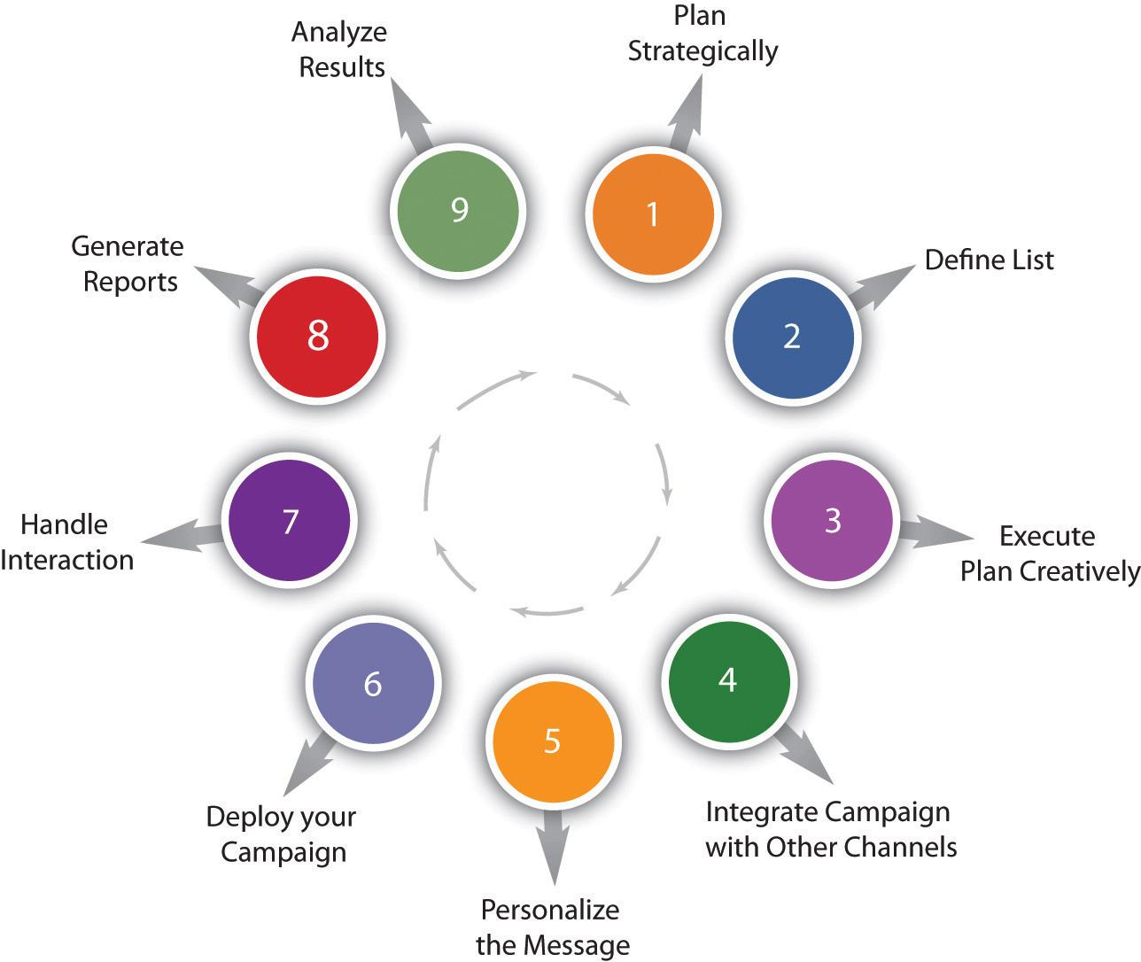

Precampaign

Step 1: Strategic Planning
The first part of any e-mail campaign should involve planning around the goals you want to achieve. These will probably be in line with the goals of your Web site, with e-mail marketing being used as a tool to help you achieve those goals. As discussed in , you will decide on the key performance indicators (KPIs)for your campaign as well. Promotional e-mails will usually have an immediate goal:
- Users make a purchase
- Users download a white paper
- Users request further information
Newsletters tend to focus on longer-term goals, and so your KPIs become more important here. KPIs include the following:
- Open rate
- Click-through rate
- Number of e-mails forwarded
- Return on investment (ROI)
ROI can be a goal of the campaign, and it can be used as a KPI.
A successful e-mail campaign is most likely to be the one geared at retaining and creating a long-term relationship with the reader.
Know your audience; they will dictate the interactions. For more information on writing for your audience, please refer to .

Step 2: Definition of List
Running a successful e-mail campaign requires that a business has a genuine opt-in database. This database, the list of subscribers who have agreed to allow a company to send them e-mails with marketing messages, is the most valuable asset of an e-mail campaign.
Permission must be explicitly given by all people to whom e-mails are sent. Companies that abuse this can put their reputation in jeopardy, and in some countries, legal action can be taken against companies that send unsolicited bulk e-mail—spam.
Growing this database, while keeping it targeted, is a key factor in any e-mail campaign. The database needs only one entry—the prospect’s e-mail—but the following should also be considered:
- First name, surname, and title
- Date permission granted
- Source of permission
- Gender
- Country
- Telephone number
- Date of birth
Fields such as name, surname, and title should be separated in your database. You should also gather date of birth as opposed to a prospect’s age—it ensures your database can stay up to date.
Don Pepper and Martha Rogers refer to gathering information over a period of time as “drip irrigation,” since it neither overwhelms nor parches the prospect. ^{[1]}
However, don’t be tempted to ask for more information than is required. The more information marketers can gather, the better they can customize their marketing messages. However, the more information a prospect is required to give, the more apprehensive he will be about parting with these details. This is in part because of the hassle involved and in part as a result of fear around Internet fraud. Following the initial sign-up, further information can be requested over a period of time.
There are a myriad of ways to attract prospects to opt in to a database. An e-mail sign-up form on a company Web site is key. Visitors to a Web site have already expressed an interest in a company by clicking through to the Web site—this is an opportunity to develop that interest further.
The best practice for sign-up forms is as follows:
- Put the sign-up form where it can be seen—on every page and above the fold (i.e., on the page where it can be seen without scrolling down).
- State your antispam stance explicitly, and be clear about how you value subscribers’ privacy.
- Use a clear call to action.
- Tell subscribers what they will get, and how often they will get it. Include a benefit statement.
- Ensure the e-mail address is correct by checking the syntax.
- Test to see what works best.
Every interaction can be used to ask permission to send e-mails.
- Offer something valuable for free (e.g., white paper, gift voucher, music track), and ask if they would sign up to your newsletter at the same time.
- Add a subscribe box to the checkout process of your retail site.
- Use interactions at trade shows to request e-mail addresses.
Opt-in and double opt-in: the integrity of the database can be safeguarded with a double opt-in process. An e-mail is sent to the e-mail address supplied, and the user has to click on a link within that e-mail to confirm their subscription. This means that dud e-mail addresses are kept out of the database and confirms that the user has granted explicit permission.

Step 3: Creative Execution
E-mails can be created and viewed as hypertext markup language (HTML) e-mails or as text e-mails. Bear in mind, though, that sometimes HTML e-mails are rendered as text e-mails.
Text e-mails are the plain ones—text only, as the name suggests. If you have a Windows computer and you open up Notepad and type there, then you will be creating a text file. These e-mails are smaller and plainer. While copy is always important, it is particularly critical in this case, as it is the key driver of action and interaction.
HTML e-mails are the e-mails with all the bells and whistles. These e-mails can contain images, different fonts, and hyperlinks. It’s probably what you’ve had in mind throughout this chapter when we have referred to e-mail marketing.

Parts of an E-mail
There are six main parts of an e-mail.
Header. This has the “to,” “from,” and “reply to” fields. These are also opportunities to build a relationship through creating a perception of familiarity. In other words, the reader needs to perceive that the newsletter is somewhat unique for them and sent personally by the publisher. Using a personalized company e-mail address (e.g., trevor@companyname.com) for the “reply” field creates familiarity and builds trust with the reader. The “from” address should also include the organization’s name. A meaningless “from” address that the reader cannot identify only serves to confuse the origin of the newsletter and spark apprehension.
Subject line. The subject line could be considered the most important part of an e-mail. Subject lines aid the reader in identifying the e-mail and also entice the reader to open it. The subject line is also scrutinized by spam filters and so should avoid words like “free,” “win,” and “buy now.” Consistent subject lines, using the name of the company and the newsletter edition, can build familiarity and help readers to sort their in-box. As with everything online, testing different subject lines will lead marketers to the formula that works for them.
Personalized greeting. With a database that has entries for readers’ names, it is possible to personalize the greeting of the e-mail. “Hi, Kim Morgan” can elicit far better responses than “Dear Valued Customer,” but it is possible to create a greeting with personality without personalizing it. Occasionally, the subject line can be personalized as well to boost responses.
Body. This is where the content of the e-mail goes. Don’t be tempted to use too many images: it can increase the size of the e-mail, and it can obscure text when images do not load. Be sure that text is not on the image but rather can be read without an image being loaded. Readers want value, so where images are used, make sure they are relevant and not just space fillers.
Footer. A standard footer for e-mails helps to build consistency, and is the customary place to keep the contact details of the company sending the e-mail. At the very least, this should include the name and contact e-mail of the company. It can also include the privacy policy of the sender. One way to grow the e-mail list is add a “forward to a friend” link in the footer. The most important part of the footer is a clear unsubscribe link.
Unsubscribe link. It is mandatory to have an unsubscribe link on all commercial e-mails. Interactive e-mails are best constructed with lightweight HTML capability allowing the e-mail to open quickly. This helps to capture the user’s attention before she moves on. The structure must allow readers to scan and navigate the e-mail easily. For more on usability, refer to . The length of paragraphs, emphasis through bolding and colors, as well as sectioning information with bullets and borders all contribute to a well-structured e-mail.
Figure 2.2 HTML E-mail with Key Elements Shown
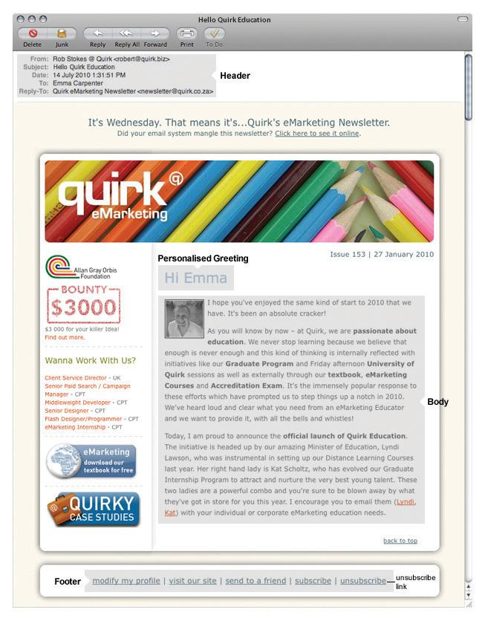

Create Content
Relevant and valuable e-mail content is vital to ensuring the success of an e-mail marketing campaign. Valuable content is informative and should address the problems and needs of readers. It is important to realize that the reader determines the value of the content, not the publisher.
Successful e-mail campaigns provide value to their readers. This value can vary from campaign to campaign. Newsletters can offer the following:
- Humor
- Research
- Information
- Promotions
However, avoid being marked as spam by staying away from words like “free,” “buy now,” and “discount.”

Test for Display and Deliverability
An e-mail client is the software or program that a person uses to access his or her e-mail. Some are Web based, like Gmail and Hotmail, but there are also plenty of software-based e-mail clients, like Outlook, Thunderbird, Eudora, and Lotus, to mention just a few. Theoretically, the same e-mail could look different in every single one of these, so be prepared. In addition to testing the e-mail to ensure that it will pass spam filters, the design should be tested to ensure that it renders clearly in as many e-mail clients as possible. Make sure that images line up, that copy is clear, and that all the links work.
E-mails can be tested for platform compatibility at http://litmusapp.com. An e-mail’s spam score can be checked at http://spamassassin.apache.org.

Step 4: Integration of Campaign with Other Channels
While e-mail marketing can operate as a stand-alone marketing campaign, integrating it with other channels, both online and offline, will serve to both reinforce a brand’s message and increase responses.
There should never be a disparity between the content, tone, or design of an e-mail when compared to the rest of a company’s offerings. In-store promotions can be reinforced and promoted to an e-mail database, or Web site information can be summarized for e-mail.
Custom landing pages, as required, should be created for any promotions being communicated in an e-mail communication.

Execution

Step 5: Personalization of the Message
The technology of e-mail marketing allows for mass customization—it is one-to-one marketing on a macro scale. Even simple personalization can see improved results.
Customization starts at using the recipient’s name and sending either HTML or text e-mails based on preference, to sophisticated measurement of a recipient’s preferences and tailoring content to suit them.
Segmenting a database can allow for customization across demographics or purchase history. Being able to reconcile browsing activity to an e-mail recipient can give further opportunities for customization.

Step 6: Deployment
By creating valuable content, establishing the correct frequency, and testing an e-mail for display and deliverability, an e-mail marketer should be able to ensure an excellent delivery rate. Consistency in deploying newsletters also aids in fostering trust and fulfilling expectation. E-mails should be delivered at consistent times, but the optimum time for best results should be tested.
E-mail reputation can determine whether or not your message is regarded as spam. It is determined by the general opinion of the Internet service providers (ISPs), the antispam community, and the recipients of an e-mail. It can relate to a sender’s Internet protocol (IP) address, sending domain, or both. This means that if someone sends e-mail using the same server that you use, you could be damaged if they spam. This opinion is a reputation score created by an ISP or a third-party provider. If the sender’s score falls within the ISP’s thresholds, a sender’s messages will be delivered to the in-box. If not, the sender’s e-mails may arrive in the bulk folder, be quarantined, or be bounced back to the sender.
Becoming an effective e-mail marketer requires constant list cleansing and hygiene. In fact, most lists shrink by 15 percent each year due to subscribers changing e-mail addresses. Make sure you are diligent about maintaining a current opt-in list to achieve maximum deliverability via reputation.
Tips to help a reputation score include the following:
- ISPs offer various sender’s authentication standards such as Sender ID, sender policy framework (SPF), and DomainKeys. Use these.
- Out with the old, in with the new—keep your database clean.
- Remove hard bounces after three deliveries (ISPs don’t like e-mail broadcasters who have a high bounce rate).
- Remember that a huge but inaccurate and outdated database is far less useful to an e-mail marketer than a tightly maintained, smaller database. Strive to boost your database, but don’t forget to clean it up as you go.
- Ensure e-mail broadcast rates are not too high.
- Respond to complaints and unsubscribe requests—if someone requests to be unsubscribed, do so.
- Educate users about white lists.
An e-mail white list is a list of contacts that the user deems are acceptable to receive e-mail from and should not be sent to the trash folder.
When should you send e-mails? Common sense tells you not on Monday morning or Friday afternoon, but it varies by audience. Testing will guide you.
When is e-mail an e-mail, and when is it spam? Spam is unsolicited bulk e-mail—it means that the recipient never gave permission to be sent that e-mail.
If the recipient has given permission to be sent marketing messages by e-mail, then it is not spam. Users give permission when they check a box that says, “Yes, please send me offers from your company by e-mail.” The e-mail address can only be provided to another company if the user ticks a box that says, “Yes, please send me offers from third parties selected by you by e-mail.”
Permission must be explicitly given to the company to be allowed to market to that user. Trying to gain explicit permission in a sneaky way will only annoy your users and might result in your e-mails being marked as spam, which subsequently damages your reputation.

Step 7: Interaction Handling
As well as the e-mails strategically planned as part of a campaign (promotional e-mails and newsletters), every interaction via e-mail should be considered as part of a company’s e-mail marketing practice. Automated e-mails, such as order confirmations and even out of office replies, are all opportunities to engage with customers. If a company has a particular tone or content style, this must be reinforced in these interactions. These e-mails can also be an opportunity to cross-advertise other promotions that a company is offering.

Postcampaign

Step 8: Report Generation
As with all things eMarketing, tracking, analyzing, and optimizing is key to growth. E-mail tracking systems produce statistics in a user-friendly manner.
The following are key measurables for understanding the performance of e-mail campaigns:
- Number of e-mails delivered.
- Number of bounces. This should be separated into hard bounces and soft bounces.
- Number of unique e-mails opened. An e-mail can be delivered, but that does not necessarily mean it was opened.
- Unsubscribes. Significant or consistent loss in subscribers is a key indication that you are not meeting the needs of your subscribers.
- Pass-on rate. High pass-on rate (forwards) indicates that your list values the content enough to constantly share with others. Putting an easy “forward to a friend” link in every e-mail can increase this. Adding a sign-up link to forwarded e-mails will organically grow the opt-in list.
- Click-through rates and conversion. This measures the effectiveness of an e-mail via the links placed in the content. When a reader clicks through to a Web page, these can be easily measured as a percentage against number of delivered, opened, or sent e-mails. It reveals which content or promotion was the most enticing for the reader.
Open rate does not necessarily indicate whether or not an e-mail has been read. How do you think a marketer can determine if e-mails are being read?

Step 9: Analysis of Results
Once the reports have been generated, it is time to work out what the numbers are revealing and to use this information to improve the next e-mail sent out.
With e-mail marketing, split testing across a host of factors will enable campaign optimization. The following are some factors to test:
- Open rates across different subject lines and delivery times
- Optimal number of links in an e-mail for click-through rates and conversions
- Different copy styles and copy length
- The effect of video on delivery rates, open rates, and conversions
First, an e-mail campaign needs a database. A plan for growing this database needs to be put in place. Most e-mail service providers will also provide tools for managing this database.
All e-mails need to be tested for e-mail client compatibility as well as for any potential spam problems. E-mail client compatibility can be reviewed at http://www.litmusapp.com, and an e-mail’s spam score can be checked at http://spamassassin.apache.org.
Once an e-mail has been sent, results need to be analyzed to pinpoint areas for growth for the next campaign.

KEY TAKEAWAYS
- ROI can be a goal of the campaign, and it can be used as a KPI.
- Growing a database, while keeping it targeted, is a key factor in any e-mail campaign.
- Failure to obtain permission to send e-mails to a person may result in legal action or may jeopardize a company’s reputation. Gaining explicit permission to send e-mail marketing to a person is a prerequisite for successful e-mail marketing; however, all e-mails sent by an organization and the individuals in that organization can be seen as marketing opportunities.
- There are six main parts of an e-mail: the header, subject line, personalized greeting, body, footer, and unsubscribe link.
- Successful e-mail marketing requires careful planning and testing. HTML e-mails need to be tested across a range of e-mail clients and should be tested for a spam score before being deployed.
- Being able to reconcile browsing activity to an e-mail recipient can give more opportunities for customization.
- Valuable content should produce an excellent delivery rate.
- The integrity of the database can be safeguarded with a double opt-in process.
- Campaigns can track a certain level of data. These data can give insight into the success of the campaign.

EXERCISES
- Why is it important for permission to be gained before marketing by e-mail to a prospect?
- What are the parts of an e-mail? Why should all marketers follow this format? Why is unsubscribe functionality important? Can you guess what might happen if a marketer failed to include this feature?
- As discussed in the text, marketers avoid words like “free,” “buy now,” and “discount” in order to prevent being marked as spam. What words might a marketer use instead?
- E-mail list cleansing and hygiene is very important to any marketer. Review the reasons why it is important. What do you think would happen if list cleaning and hygiene techniques were not applied regularly?
- A lot of testing goes into an e-mail marketing campaign. Describe one situation where testing is important. Describe how testing would improve campaign results in that particular situation.
- What is meant by “mass customization” and why is this so beneficial?
- E-mails that are expected and recognized are more likely to be read. How can a marketer use this knowledge to increase the readership of e-mails?
- What do you think might be happening if you have high click-through rates but low conversion rates?
- Why do you think it is important to test different factors in an e-mail? What knowledge does a marketer hope to gain?

[1] Don Peppers and Martha Rogers, Managing Customer Relationships: A Strategic Framework (Hoboken, NJ: Wiley, 2004).

2.5 References
Mark Brownlow, “Email Promotions vs Newsletters,” Email Marketing Reports,http://www.email-marketing-reports.com/newsletterspromotions.htm (accessed March 18, 2008).
Spencer Kollas, “2 Email Strategies Most Marketers Forget,” iMedia Connection, February 18, 2008, http://www.imediaconnection.com/content/18346.asp(accessed March 18, 2008).
Véro S. Pepperrell, “The Seven Deadly Sins of Email Marketing Management,”Digital Web Magazine, March 27, 2007, http://www.digital-web.com/articles/seven_sins_of_email_marketing (accessed March 18, 2008).
Brad Templeton, “Origin of the Term ‘Spam’ to Mean Net Abuse,” Brad Templeton's Home Page, http://www.templetons.com/brad/spamterm.html (accessed March 18, 2008).

Chapter 3

Online Advertising

3.1 Introduction
Simply put, online advertising is advertising on the Internet. Online advertising encompasses advertisements on search engine results pages, advertisements placed in e-mails, and other ways in which advertisers use the Internet. However, this chapter focuses on display advertising or rich-media advertising.
Whether online or off, the main objective of advertising is to increase sales. Advertising also aims to increase brand awareness. Advertising is based on the simple economics of supply and demand. Advertisers aim to stimulate a consumer need and then satisfy that need.
One of the greatest benefits of online display advertising is that the messages are not restricted by geography or time. Online advertisements are also much more interactive than offline advertising. While both online and offline advertising can be disruptive, interactive online advertising can be designed to be perceived as less so.
Online display advertising began as simple hyperlinked images shown on a Web site and has since progressed to include video, sound, and many other modern technologies. Today, messages and interactions can be contained within the advertising display without ever taking consumers to a landing page.
Although the Internet provides new scope for creative approaches to advertising, we see its true advantage when we realize how trackable, and therefore measurable, Internet advertising is. Or, to take it from Eric Schmidt, CEO of Google, “The Internet will transform advertising because of its trackability, not its beauty.” ^{[1]}

History
Online advertising rapidly followed the developing Internet. And, as consumers are increasingly spending more time online, and hours spent on the Internet start to eclipse hours spent watching television, the medium becomes increasingly important to any advertiser.
According to Wikipedia, the first clickable banner advertisement was sold to a law firm in 1993 by Global Network Navigator. HotWired, an early Web magazine, was the first to sell advertising space in large quantities to a number of advertisers. One of the very first advertisers was AT&T (a U.S. telecom company), which went online in October 1994. ^{[2]}
Figure 3.1 An Early Banner Ad for AT&T
Source: http://adland.tv/content/banner-ads-tenth-birthday.
This was part of a campaign that AT&T was running to promote the Internet to consumers, and included television and outdoor advertising. Believe it or not, but this was cutting edge back in 1994!
As Web technology has developed, so has the technology that is used to create and serve advertising online.

[1] Rebecca Lieb, “Immersive Advertising (Three Days’ Worth),” ClickZ, October 25, 2002,http://www.clickz.com/showPage.html?page=1488101 (accessed May 1, 2008).
[2] Wikipedia, s.v. “Web Banner,” http://en.wikipedia.org/wiki/Web_banner (accessed May 7, 2010).

3.2 How It Works

LEARNING OBJECTIVE
- Understand when best to use online advertising.
Advertising, whether online or offline, has a number of objectives:
- Building brand awareness
- Creating consumer demand
- Informing consumers of the advertiser’s ability to satisfy that demand
- Driving response and sales

Building Brand Awareness
Making people aware of a brand or product is an important long-term goal for any marketer. Once customers know about the brand, the marketer has taken the first step toward gaining the customer’s trust and patronage. The better known a brand is, the more business they can do. And the ultimate goal is to do more business and sell more of the product.
Online, creative advertising or banner advertising is largely visual, making it an ideal channel for promoting brand collateral.

Creating Consumer Demand
Consumers can’t want what they don’t know about. Advertising needs to convince consumers about what they should want and why they should want it. Modern online advertising provides a great way to communicate the USPs (unique selling points) of a product, thereby helping stimulate demand.

Satisfying Consumer Demand
Once the consumer is aware of and desires a product, they need to find out how to satisfy that desire. If brand building has been effective, they will know that a particular brand exists. At this point, it is important for the marketer to show the consumer how their particular brand or product will best meet that need.

Driving Response and Sales
All forms of online marketing need to drive traffic and sales in the long term. However, the immediacy of online advertising also drives traffic and sales in the short and medium terms. Unlike traditional media advertising, online advertising can turn the potential customer into an actual customer right there and then. What’s more, it is possible to measure accurately how effectively the online advertising campaign does this.

The Key Differentiator
Online advertising is able to drive instant sales and conversions. Unlike offline advertising mediums, the consumer can go from advertisement to merchant in one easy click. Because of the connected nature of the Internet, online activities are highly trackable and measurable, which makes it possible to target advertisements and to accurately track and gauge the effectiveness of the advertising. Each display advertisement can be tracked for success.

KEY TAKEAWAYS
- Advertising has four primary objectives: building brand awareness, creating consumer demand, informing consumers of the advertiser’s ability to satisfy that demand, and driving response and sales.
- These objectives are applicable to online and offline advertising.
- Online advertising is able to drive instant sales and conversions.
- Each display advertisements can be tracked for success.

EXERCISES
- Can you think of an example of when you would need to build brand awareness? Drive response and sales? Create consumer demand? Satisfy consumer demand?
- Online banner advertising and outdoor display advertising both use images to try to increase sales. In planning, both need to consider placement so as to be seen by their most likely audience. What are the key differences?

3.3 How to Show Your Message

LEARNING OBJECTIVE
- Become familiar with the different online advertising opportunities.

Types of Display Advertising
There are many different ways to display messages online, and as technology develops, so does online advertising. Here are some of the most common.

Interstitial Banners
Interstitial banners are shown between pages on a Web site. As you click from one page to another, you are shown this advertisement before the next page is shown. Sometimes, you are able to close the advertisement.

Pop-Ups and Pop-Unders
As the name suggests, these are advertisements that pop up, or under, the Web page being viewed. They open in a new, smaller window. You will see a pop-upright away but will probably only become aware of a pop-under after you close your browser window. These were very prominent in the early days of online advertising, but audience annoyance means that there are now “pop-up blockers” built into most good Web browsers. This can be problematic as sometimes a Web site will legitimately use a pop-up to display information to the user.

Map Advertisement
A map advertisement is advertising placed within the online mapping solutions available, such as Google Maps.

Figure 3.2 Google Map Showing an Advertisement for Holiday Inn
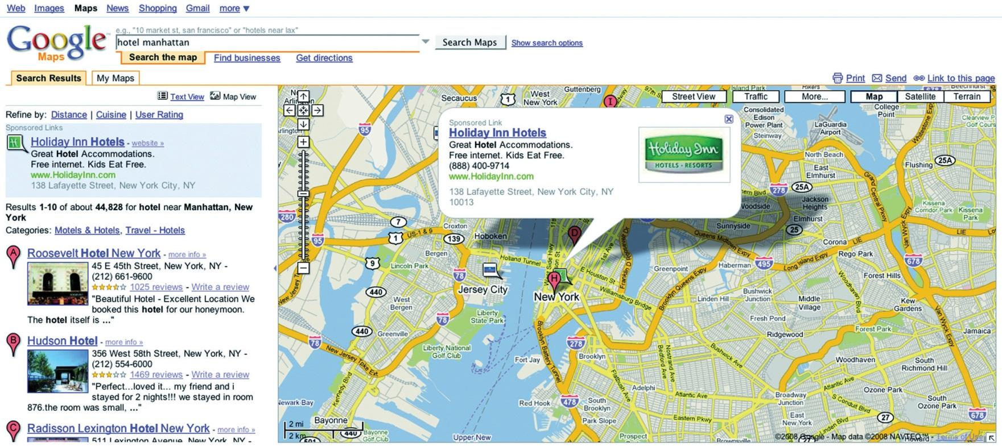

Floating Advertisement
A floating advertisement appears in a layer over the content, but is not in a separate window. Usually, the user can close this advertisement. These are sometimes referred to as “Shoshkeles,” a proprietary technology. Floating advertisements are created with dynamic hypertext markup language (DHTML) or Flash and float in a layer above a site’s content for a few seconds. Often, the animation ends by disappearing into a banner ad on the page.

Wallpaper Advertisement
A wallpaper advertisement changes the background of the Web page being viewed. Usually, it is not possible to click through this advertisement.

Banner Advertisement

Figure 3.3 Some of the Most Common Banners, Shown in Proportion
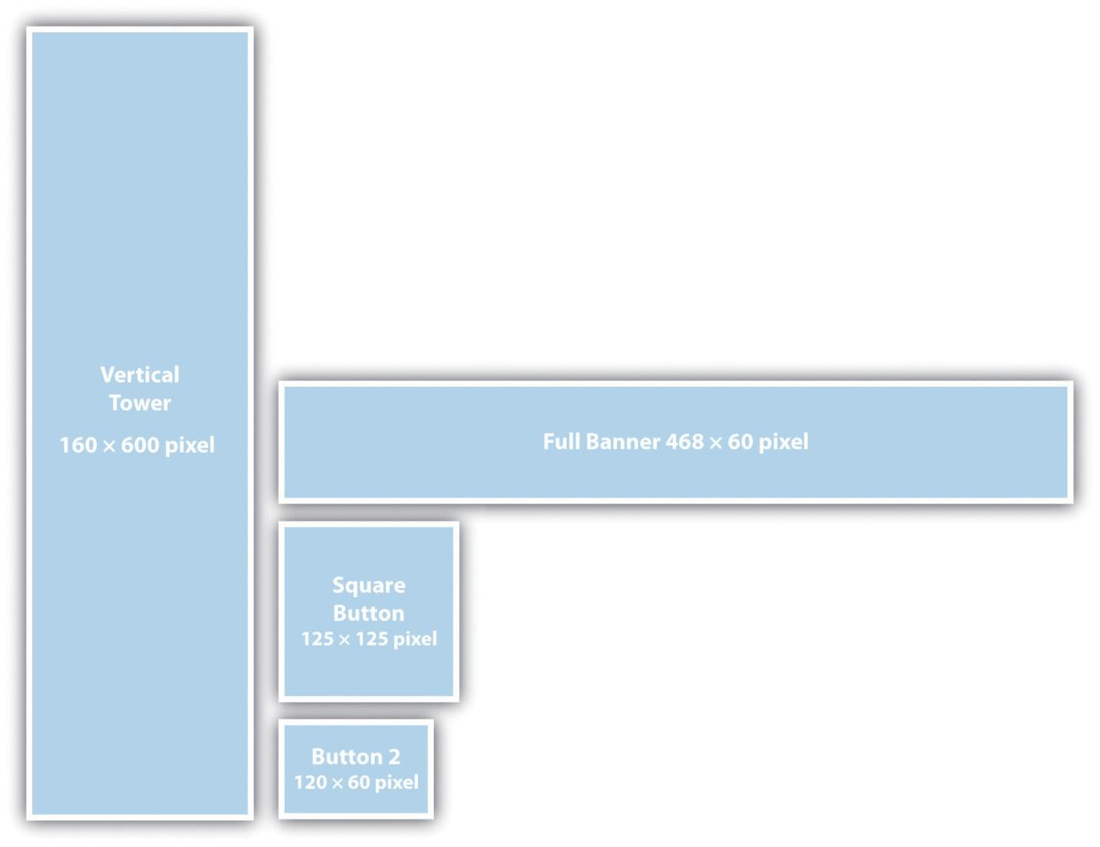
A banner advertisement is a graphic image or animation displayed on a Web site for advertising purposes. Static banners aregraphics interchange format (GIF) orJoint Photographic Experts Group (JPEG) images, but banners can also employ rich media such as Flash, video, JavaScript, and other interactive technologies. Interactive technology allows the viewer to interact and transact within the banner. Banners are not limited to the space that they occupy; some banners expand on mouseover or when clicked on.

When online, advertisements can be interactive. How do you think this can be used to increase the effectiveness of advertising?

KEY TAKEAWAYS
- Advertisers have many options when it comes to how to show their messages.
- More and more options appear as technology develops.

EXERCISE
- Explain why intrusive ads may be a good choice for an advertiser. Think of a situation where a user may see an intrusive ad and have a bad experience with it. Do you think that could change a user’s opinion of that brand? If so, how?

3.4 How to Pay

LEARNING OBJECTIVE
- Understand the different types of online payment models.

Payment Models for Display Advertising
As well as a variety of mediums, there are also a number of different payment models for display advertising.

Cost per Impression or Cost per Thousand Impressions
Cost per impression (CPI) means that the advertiser pays each time the advertisement appears on the publisher’s page. The most common way of referring to this model is cost per mille (CPM), or cost per thousandimpressions (the letter M is the Roman numeral for a thousand, or mille). This is how a campaign is normally priced when brand awareness or exposure is the primary goal.

Cost per Click
Cost per click (CPC) means that the advertiser only pays when their advertisement is clicked on by an interested party. CPC advertising is normally associated with paid search marketing, also called pay-per-click (PPC) advertising. Banners can be priced this way when the aim is to drive traffic. It is also a payment method sometimes used in affiliate marketing, when the aim is to drive traffic to a new Web site.

Cost per Acquisition
In the cost per acquisition (CPA) model, the advertiser only pays when an advertisement delivers an acquisition. Definitions of acquisitions vary from site to site and may be a user filling in a form, downloading a file, or buying a product. CPA is the best way for an advertiser to pay because they only pay when the advertising has met its goal. For this reason it is also the worst type for the publisher as they are only rewarded if the advertising is successful. The publisher has to rely on the conversion rate of the advertiser’s Web site, something that the publisher cannot control. The CPA model is not commonly used for banner advertising and is generally associated with affiliate marketing.

Flat Rate
Sometimes, owners of lower-traffic sites choose to sell banner space at aflat rate, that is, at a fixed cost per month regardless of the amount of traffic or impressions. This would appeal to a media buyer who may be testing an online campaign that targets niche markets.

Cost per Engagement
Cost per engagement is an emerging technology in which advertisers pay for the rollover advertisements, placed in videos or applications (such as Facebook applications), based on the interactions with that advertisement. “Engagement” is generally defined as a user-initiated rollover, or mouseover, action that results in a sustained advertisement expansion. Once expanded, an advertisement may contain a video, game, or other rich content. It happens without taking an Internet user away from her preferred Web page, and marketers only pay when an individual completes an action.
The word “engagement” implies a level of interaction and intent from the user. If you were using this type of advertising, how would you measure success?
CPM favors the publisher, while CPA favors the advertiser. Sometimes, a hybrid of the two payment models is pursued.
Typically, high-traffic, broad-audience Web sites will offer CPM advertising. Examples include Web portals such as http://www.yahoo.com or news sites likehttp://www.news24.com. Niche Web sites with a targeted audience are more likely to offer CPA advertising to advertisers with an appropriate product. These can also fall under the umbrella of affiliate marketing.
How do you think your campaign objectives would differ if you were advertising car insurance versus organic cat food? What sort of Web sites would you target for each?
Types of advertising can be seen on a scale from more intrusive (and thus potentially annoying to the consumer) to less intrusive. In the same way, payment models can be scaled to those that favor the publisher to those that favor the advertiser. When planning a campaign, it is important to know how the advertising will be paid for and what kinds of advertising are offered by publishers. A lot of this can be solved by using a company that specializes in advertisement serving, media planning, and media buying.

KEY TAKEAWAYS
- Advertising can be paid for in a number of ways, including the following:
  - Cost per impression (CPI) or cost per mille (CPM)
  - Cost per click (CPC)
  - Cost per acquisition (CPA)
  - Flat rate
  - Cost per engagement
- Emerging technology allows for an increased level of interaction within an advertisement and for advertising to be tailored to engagement media such as online videos and social network applications.

EXERCISE
- Which pricing model do you think would be best suited for a branding campaign? Why? For a direct response campaign? Why?

3.5 Ad Servers and Advertising Networks

LEARNING OBJECTIVES
- Learn what ad servers are and what their role in advertising is.
- Learn what advertising networks are and why they are effective.
Ad servers are servers that store advertisements and serve them to Web pages. Ad servers can be local, run by a publisher to serve advertisements to Web sites on the publisher’s domain, or they can be third-party ad servers that serve advertisements to Web pages on any domain. Ad servers facilitate advertisement trafficking and provide reports on advertisement performance.
An advertising network is a group of Web sites on which advertisements can be purchased through a single sales entity. It could be a collection of sites owned by the same publisher (e.g., AOL, CNN, and Sports Illustrated are all owned by AOL/Time Warner), or it could be an affiliation of sites that share a representative.
The advertising network acts as an intermediary between advertisers and publishers and provides a technology solution to both. As well as providing a centralized ad server that can serve advertisements to a number of Web sites, the networks offer tracking and reporting, as well as targeting.

The Benefits of Ad Servers
Rather than distribute copies of each piece of creative advertising to each publisher or media buyer, you can send out a line of code that calls up an advertisement directly from the ad server each time an advertisement is scheduled to run. The agency loads the creative to the server once and can modify rotations or add new units on the fly without needing to recontact the vendors.
The ad servers provide a wealth of data, including impressions served, advertisements clicked, click-through rate (CTR), and cost per click (CPC). Most of the ad servers also have the ability to provide performance against postclick activities such as sales, leads, downloads, or any other site-based action the advertiser may want to measure.
Ad servers provide a consistent counting methodology across the entire campaign enabling the advertiser to gain an “apples to apples” comparison of performance across the entire media schedule, which includes multiple Web sites.
The ad server also allows sophisticated targeting of display advertising.

Tracking
The trackability of online advertising is what makes it so superior to pasting pictures around town in a bid to boost your brand. An advertiser can tell not only how many times an advertisement was seen (impressions) but also how many times the advertisement was successful in sending visitors to the advertised Web site (clicks). The tracking needs to continue on the Web site to determine how successful the advertisement has been in creating more revenue for that Web site (conversions).
As well as tracking advertisements being served and clicked on, advertising networks can also provide information about the people who saw the advertisement as well as those who acted on it. Here is some of the information that can be provided:
- Connection type
- Browser
- Operating system
- Time of day
- Internet service provider (ISP)
Why do you think knowing the connection type and browser of your users is important? Think about the advertising that might be shown in the United States versus the advertising shown in South Africa.
Many ad servers will set a cookie on impression of an advertisement, not just on click-through, so it is possible to track latent conversions (within the cookie period).
And the best thing? Using this information, the advertising networks can target the display of advertising, helping advertisers optimize campaigns and get the most from the advertising spending.
Cookies are small text files that allow a Web site to capture information about a user. A cookie period is the duration for which a Web site will store that information. See Chapter 4 "Affiliate Marketing" for a description of cookies.

Targeting and Optimizing
Advertising networks serve advertisements across a number of Web sites and can track a user visiting Web sites in the network using cookies or Internet protocol (IP) addresses. This means that advertising networks can offer advertisers the following:
- Frequency capping. The network will limit the number of times a user sees the same advertisement in a session.
- Sequencing. The network can ensure that a user sees advertisements in a particular order.
- Exclusivity. The network will ensure that advertisements from direct competitors are not shown on the same page.
- Roadblocks. The network will allow an advertiser to own 100 percent of the advertising inventory on a page.
Privacy is a big deal, and the information collected via advertisements is kept anonymous. Cookies are not only used by Web sites for tracking. Cookies also allow Web sites to “remember” a visitor’s preferences, such as language and location. Where a visitor will not accept the cookie from an advertising network, either by opting out or because their browser deletes cookies, many networks will rely on the IP address of the visitor to track which Web sites are visited. Even though the information is anonymous, there are consumers who do not like having their browsing habits analyzed so that better advertising can be served to them.
The advertising network can also target advertisements based on the business rules of the advertiser or based on the profiles of the users:
- Geotargeting. Online advertising has the ability to target markets by country, province, or city and can even drill them down to something as specific as their IP address.
- Operating systems and browser types. Markets can further be targeted via operating systems such as Microsoft Windows, Mac OS, Linux, and Ubuntu or browser types such as Firefox, Internet Explorer, and Safari.
- Connection type. Users can be segmented and targeted according to their Internet connection type, for example, whether they use broadband or dial-up connections.
- Day and time. Advertisers can choose the time of day or day of the week when their advertisements are shown. Advertisers can specify when their campaign should air, down to the minute. This usually depends on the client’s objective for the campaign or the product itself.
- Social serving. Web sites gather personal data about users and then serve each user with targeted and relevant advertising. For example, Facebook will allow advertisers to select specific characteristics of users who will be shown an advertisement.
- Behavioral targeting. The advertising network uses the profile of a user (built up with information about previous Web sites visited) to determine which advertisements to show during a given visit. Networks can base this profile on cookies or on IP addresses. For example, the network may choose to show advertisements for pet insurance on a news page to a user who has visited the pets and animals section of a general-media site previously.
- Contextual advertising. The ad server infers the optimum advertisements to serve, based on the content of the page. For example, on an article about mountain bike holidays in Europe, the network would serve advertisements for new mountain bikes, or advertisements from travel companies offering flights to Europe, or perhaps advertisements for adventure travel insurance.
Contextual advertising can be problematic. For example, advertisements for a Hilton hotel could appear next to newspaper reports of a Paris Hilton arrest. Advertisements for yachts showed up next to coverage of Hurricane Katrina in New Orleans.

Figure 3.4
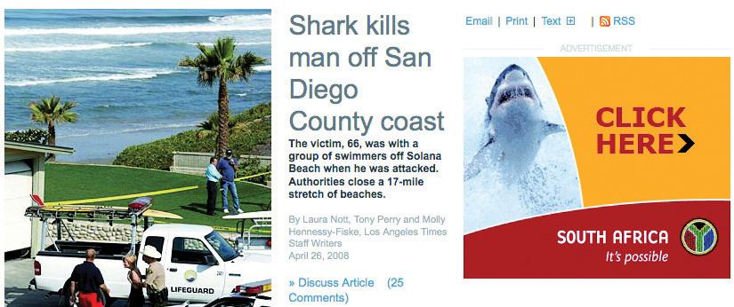
Contextual advertising can be humorous.

Advertising Exchanges
Advertising networks are also creating advertising exchanges, where publishers can place unsold inventory for bidding. The inventory is sold to the highest bidding advertiser. Giving advertisers far more control, this type of advertising mimics a pay-per-click (PPC) model of paid search bidding (generalized second price auction)—but bids are for audience profiles and space rather than for keywords. It allows publishers to fill unsold inventory at the highest available price and can give smaller advertisers access to this inventory.

KEY TAKEAWAYS
- Ad servers and ad networks provide trafficking, tracking, and reporting solutions to both advertisers and publishers. They allow advertisers to target display advertisements based on parameters, which include the following:
  - User profile (location, operating system, browser, and connection type)
  - Behavior
  - Frequency and sequencing
  - Exclusivity
  - Context of content
- Tracking via cookies is an important part of online advertising.

EXERCISES
- Explain the role an ad server plays in a campaign. Why is it important? What may happen if there isn’t an ad server?
- Describe a situation in which contextual advertising would be harmful to a campaign.
- Can you think of an example when an advertiser may find geotargeting useful? What about targeting by day and time?

3.6 Putting It All Together

LEARNING OBJECTIVE
- Understand how all the elements of online advertising work together.
Knowing the various types of display options and payment models available is helpful, but you might be wondering how to put this all together as you plan your campaign. The very first thing you need to determine when planning display advertising is the goal of your campaign. Are you embarking on a mainly branding campaign? Or is your main focus direct response?
Having determined the goals of your campaign, identify the key performance indicators (KPIs) that will let you know how you are succeeding. KPIs are factors that indicate how successful you are in reaching your goals. Click-through rate could be a KPI for a branding campaign, while for direct response you need to focus on conversion rates. (For more on KPIs, see .)
Online advertising is an acquisition channel. It does not require that users actively seek an interaction, as pay-per-click (PPC) advertising and e-mail marketing do. So it is crucial that the advertisements are placed in front of the audience that is most likely to convert.
Investigate your target audience. What Web sites are they likely to be visiting? It is likely that the type of creative you may use and the payment model you follow will be largely determined by the Web sites on which you wish to advertise.
Niche Web sites with a smaller but probably more targeted audience will most likely charge a flat rate for display advertising, or a cost per acquisition (CPA) rate. They could probably be flexible in display options that they give you, but you will need to take into account their bandwidth costs if they serve the advertisements.
High-traffic Web sites with a broad audience will most likely charge on a cost per mille (CPM) basis. They will broker their advertising inventory through an advertising network, or even a number of advertising networks.
Knowing your goals, your target audience, and the format of your advertisements, it’s time to brief your creative team to ensure that you have the optimum banners for your campaign.
Your online advertisements will need to do the following:
- Attract attention
- Convey a message
- Entice action
Second, all advertising needs an appropriate landing page. Whether this involves creating a microsite or merely checking that users reach an existing page on the Web site, ensure that click-throughs are not being wasted. Generally, sending advertising traffic to your home page is not a good idea as it allows the user to decide where to go next.
Animation attracts attention, but be wary of your ad being one of seven animated banners on a Web site. Banners should not be considered in isolation, but rather in the context of the Web site on which they will appear.
Web users respond well to being told what to do, and the content of an online advertisement should be concise and directional. Examples include the following:
- “Phone now for the best deals on insurance.”
- “Click here for fast home delivery.”
- “Donate now.”
While we have become used to the Internet as a free medium, where we can read and interact with any content we want, it is the fact that it is an advertiser’s medium that keeps the Internet free. That means that as the way we interact with content changes as technologies evolve, so advertising follows.
It used to be that the level of interaction a Web user has with a Web site could be measured by the number of pages of that Web site the user viewed. Now, technology such as Ajax and rich media such as video mean that the time spent on a Web page can be more meaningful than the number of pages viewed. The key word here is “engagement,” and technology and data analysis is working toward being able to determine how Web sites can quantify the level of engagement with a viewer.
VideoEgg (http://www.videoegg.com), which specializes in advertisements that appear in video clips and Facebook applications, introduced a pay-per-engagement pricing model on its advertising network in February 2008. With time spent by users on the site increasing, advertisers are able to build more interactive, more time-intensive advertisements. VideoEgg defines the engagement here as “a user-initiated rollover action that results in a sustained ad expansion. Once expanded, an ad may contain a video, game, or other rich content.” ^{[1]} Part of VideoEgg’s offering is to optimize the placement of so-called invitation ads to guarantee the requested number of engagements among an advertiser’s target demographic.
Figure 3.5
VideoEgg offers in-video advertising. The banner will show a video within the video.
But isn’t banner advertising dead?
A little research online will reveal plenty of commentary declaring the decline of display advertising. Increasingly, consumers are becoming both weary and wary of advertising. Click-through rates on banners are dropping, so some observers are questioning the effectiveness of display advertising. With the focus in eMarketing on tracking and measuring response and engagement, should a company spend money on less measurable activities such as “brand building,” where they are paying on a cost per mille (CPM) basis?
Consider this: Anecdotal evidence shows that banner advertising can increase click-through rates on contextual advertisements by 249 percent. ^{[2]} What does this tell us? Measurements should take place across all channels, and no channel should be utilized in isolation. The best results will be gained through an integrated and holistic approach to eMarketing.

KEY TAKEAWAYS
- The first thing you should do for a campaign is determine its goal. Is it branding or direct response?
- Identifying the goal first will help you establish what your key performance indicators (KPIs) will be.
- Online advertising is an acquisition channel.
- Landing pages are crucial to the success of a campaign.
- Content of an online advertisement should be concise and directional.

EXERCISES
- Why do you think it is important to define the goal of the campaign first?
- Explain in your own words why a holistic approach to eMarketing is important.

[1] Zachary Rodgers, “VideoEgg Offers ‘Per Engagement’ Pricing,” ClickZ, February 19, 2008, http://www.clickz.com/showPage.html?page=3628492 (accessed May 1, 2008).
[2] Seth Godin, “The 249% Solution,” Seth Godin’s Blog, October 27, 2006,http://sethgodin.typepad.com/seths_blog/2006/10/the_249_solutio.html (accessed May 1, 2008).

3.7 The Advantages of Online Advertising

LEARNING OBJECTIVE
- Understand why online advertising is a powerful eMarketing tactic.

Banner Ads and Their Similarity to Traditional Media
eMarketers regularly bemoan the fact that it’s often difficult to educate the market about the value of Internet marketing techniques. Traditional buyers of advertising have been conditioned in a certain fashion and have come to understand advertising in a certain way.
Banner advertising goes a long way toward bridging the advertising divide. Online ads have a set size, they can look very similar to print ads, and they occupy a particular bit of real estate in a publication with a particular number of eyeballs looking at it. They’re easy to understand, and they do the things buyers expect advertising to do.
Bottom line: if done correctly, online advertising builds brand awareness and increases sales!

Images: Display Can Offer a Rich, Brand-Building Experience
Some campaigns are better suited to having images rather than the plain text of a PPC (pay-per-click) campaign (although recently PPC image and video ads have been introduced in the United States). Consider the following methods for campaigns:
- Promoting travel packages. What stirs more emotion—an image of a tropical paradise or the words “tropical paradise”?
- Building a brand within a specific sphere. Use banner advertising to brand the Web sites of every major player in that niche.
- Running a competition. Keep the target market’s eye on the prize.
- Launching an exciting new sports car with a call to action. A possible call to action might be“Test drive it now”—or interactive rich media that highlight all the exciting new features as a user mouses over specific parts of the car on the image.
- Digital shadowing. Using banner advertisements that shadow the above-the-fold activity to drive the message both on- and offline.

Interactivity
Since banners can contain rich media, they offer levels of interaction that other forms of advertising cannot achieve. It allows your target market not only to see your banner but also to play with it. Interaction builds a bond and improves the chances of the consumer remembering your brand tomorrow. Cognitive learning is a powerful outcome of interactive display advertising.
Animations, games, video, Flash—modern online advertising is able to bring together a number of other online marketing tactics:
- Microsites. A few years ago, Flash microsites were all the rage; now the same functionality can exist right within the ad. This includes filling in a form or playing a game within the ad—no need to be taken to a separate page.
- Viral marketing. Clever viral marketing games or “send to a friend” functionality can be accessed all from within the ad.
- Video. Viewers can check out video previews or trailers from within the ad.

Measurability and Data Gathering
Banner ads, like all eMarketing tactics, are measurable. Tracking click-through rates, or click tracking, gives you an idea of exactly how many people are responding to your call to action. Some publishers even have the ability to do postclick tracking—that is, you can track the user all the way to a sale if that is the purpose of the advertisement.
An Online Publishers Association (OPA) study in 2007 revealed that of the 80 percent of viewers that were reported to have watched a video ad online, 52 percent took some action, including checking out a Web site (31 percent), searching for more information (22 percent), going into a store (15 percent), or actually making a purchase (12 percent). ^{[1]}

KEY TAKEAWAYS
- Online media offer highly targeted placement options for advertisers.
- Banner ads can operate much like traditional media placements. However, they are trackable.
- Images can offer a rich brand-building experience to a user.
- Banners are interactive and can offer deeper levels of interactivity that other forms of advertising cannot.

EXERCISES
- Refer to the paragraph about images. Think of another situation and explain of how images can be used.
- Go to http://www.wheels24.com and http://www.msnbc.msn.com. What advertising can you find on the front page of these two Web sites? What products are being advertised, and how are they being advertised? What can you infer about the target market for these products?

[1] Online Publishers Association Europe, “Online Publishers Association Unveils Online Video Advertising Effectiveness Study,” June 6, 2007, http://recette.opa-europe.org/spip.php?article207 (accessed June 17, 2010).

3.8 Disadvantages of Online Advertising

LEARNING OBJECTIVE
- Understand the disadvantages of online advertising and the challenges involved.

Technical Obstacles
The nature of a lot of display advertising is intrusive, so pop-up blockers can often prevent ads from being served as they were intended by the advertisers. Most browsers now block pop-ups. There are also extensions available for the Firefox browser, such as Adblock Plus, that will block advertising on Web pages. Technologically savvy consumers are increasingly using these methods to limit the advertising that they see.

Connection Speed
Bandwidth can also be an issue, although this is a shrinking problem. However, campaigns should be planned around demographics in determining the richness (and investment) of interaction. For example, heart disease medication is likely to appeal to an older community with less money and slower connection speeds.

Advertising Fatigue
Consumers are suffering from advertising fatigue, so while new technologies can provide great results, as soon as the market moves mainstream, it can get saturated. Consumers are increasingly ignoring advertisements.

KEY TAKEAWAY
- Despite all the benefits of online advertising, there are definitely some disadvantages, which include technical obstacles, connection speed, and advertising fatigue.

EXERCISE
- Connection speed is listed as one disadvantage of online advertising. Can you think of a product or service whose campaign results may be inhibited by bandwidth limitations? Can you think of certain demographics that may not be reached as well with this medium?

3.9 Case Study: BMW South Africa
BMW South Africa has been innovative in its use of online campaigns to complement its offline activities. When it came to marketing the new BMW 1 Series, BMW knew that drivers of the BMW 1 Series are generally slightly younger and at a different lifestyle age from the average BMW driver. So BMW looked at new and innovative ways as well as traditional and tested methods to reach this target market. Over July and August 2007, they ran an online campaign aimed at raising awareness of the new 1 Series BMW, generating test-drive bookings and, ultimately, driving sales leads.
The entire campaign was integrated, from print advertisements to the Internet, and aimed at driving people to the Web site http://bmw.co.za/1, where they were encouraged to engage with the campaign. Here, the campaign was an invitation to individuals to share their interpretation of “one” by creating a video or photo. As two different BMW 1 Series models were promoted, a two-door and a four-door, the payoff line across all channels of the campaign hinged on the difficulty to focus on “just one.”
BMW targeted individuals utilizing a variety of different ad formats, both online and on mobile phones. These included standard banners as well as banners that expanded over competitor images.

Figure 3.6 An Online Advertisement for the BMW South Africa Campaign from 2007
Source: Used by permission from BMW South Africa.
The target market was reached through driving and lifestyle associations and advertisements were placed in competitive environments on driving Web sites and on corporate blogs. As well as using mobizines (branded mobile phone content), BMW partnered with Zoopy, a South African video-sharing Web site, to tap into an existing community and invite them to interact with the brand.
The digital media campaign reached over 450,000 individuals and drove over 11 percent of the test-drive bookings concluded on the BMW Web site over the campaign period.

CASE STUDY QUESTIONS
- How do you think BMW benefited from adapting existing print advertising for the online campaign?
- Describe the target audience of the BMW 1 Series. Why is it suited to an online campaign??
- Consumers are unlikely to purchase a car online. How would you measure the success of this campaign?

3.10 References
Esther Dyson, “The Coming Ad Revolution,” Wall Street Journal, February 11, 2008, http://online.wsj.com/article_email/SB120269162692857749-lMyQjAxMDI4MDEyMjYxOTIxWj.html (accessed May 1, 2008).
Interactive Advertising Bureau, “Ad Unit Guidelines,”http://www.iab.net/iab_products_and_industry_services/1421/1443/1452(accessed May 1, 2008).
Jeff Jarvis, “Size Doesn’t Matter: The Distributed Media Economy,” BuzzMachine, December 27, 2006,http://www.buzzmachine.com/2006/12/27/size-doesnt-matter-the-distributed-media-economy (accessed May 1, 2008).
“Online Ad Spend to Hit $42 Billion by 2011,” press release, eMarketer, November 7, 2007, http://www.emarketer.com/Article.aspx?id=1005590(accessed May 1, 2008).
Starcom MediaVest Group, “New Study Shows That Heavy Clickers Distort Reality of Display Advertising Click-Through Metrics,” February 12, 2008,http://www.smvgroup.com/news_popup_flash.asp?pr=1643 (accessed May 1, 2008).
Tessa Wegert, “New Ad Networks Service Industry Trends,” ClickZ, February 21, 2008, http://www.clickz.com/showPage.html?page=3628487 (accessed May 1, 2008).

Chapter 4

Affiliate Marketing

4.1 Introduction
If you recommend a restaurant to a friend, and that friend visits the restaurant because of your recommendation, the restaurant’s revenue will have increased because of your referral. This is “word-of-mouth” marketing. But you, as the referrer, do not see any of the cash benefit that the restaurant does!
Imagine that the restaurant gave you 10 percent of the bill for every person that you referred to the restaurant. They would be paying you a finder’s fee for new customers. There are a number of businesses that market this way offline. Brokers for insurance products are an example, but these referrals can be hard to track. Online, they are very easy to track. This system of reward where compensation is based on referrals is called affiliate marketing and is used to describe this type of marketing in an online environment.
Affiliate marketing is used widely to promote Web sites, and affiliates are rewarded for every visitor, subscriber, or customer provided through their efforts. Because of this, affiliates are sometimes viewed as an extended sales force for a Web site. Affiliates are paid for performance, so affiliate marketing is also referred to as performance marketing.

History
Like many eMarketing innovations, the beginnings of affiliate marketing are to be found in the adult industry. Cybererotica was probably the first to run an affiliate campaign with its CPC (cost-per-click) program, where it would reward referrers for each click-through to its Web site.
Affiliate marketing moved closer to the mainstream, with programs offered by companies such as CDNow (its BuyWeb program launched in 1994), PC Flowers & Gifts (http://www.pcflowers.com), AutoWeb.com, and a handful of others. But the story that is most well known, and that ensured that affiliate marketing hit mainstream press articles, is that of the Amazon.com Associates Program.
Legend has it that Jeff Bezos (the CEO and founder of Amazon.com) was at a cocktail party, where a woman told him that she wanted to sell books through her Web site. She did not have the infrastructure to sell the books, but Jeff Bezos realized that she could send her targeted traffic to Amazon.com where users could buy books, and she could get paid for each successful referral. From this meeting, Jeff Bezos launched Amazon Associates, the Amazon.com affiliate marketing program. Referrers are rewarded for successful sales that occur as a result of their marketing efforts. The growth experienced by Amazon.com as a result of its affiliate program is well documented and probably accounts for about 40 percent of its revenue. ^{[1]}
According to Econsultancy’s Affiliate Marketing Networks Buyer’s Guide (2006), total sales generated through affiliate networks in 2006 was £2.16 billion in the United Kingdom alone. ^{[2]} And MarketingSherpa’s research estimates that in 2006, affiliates worldwide earned $6.5 billion in bounty and commissions! ^{[3]}
Affiliate networks, which act as intermediaries between affiliates and merchants, came onto the scene in 1996, with the launch of LinkShare and Be Free. Commission Junction, another big player, was launched in 1998 and was bought by ValueClick in 2003 for about $58 million.

[1] “The Amazon Story,” Alibaba.com, August 26, 2007,http://resources.alibaba.com/topic/191364/The_Amazon_story.htm (accessed June 23, 2010).
[2] Econsultancy, Affiliate Marketing Networks Buyer’s Guide (2006), October 2006,http://www.e-consultancy.com/publications/affiliate-marketing-networks-buyers-guide(accessed December 2, 2007).
[3] Anne Holland, “Affiliate Summit 2006 Wrap-Up Report—Commissions to Reach $6.5 Billion in 2006,” MarketingSherpa, January 11, 2006,https://www.marketingsherpa.com/barrier.php?contentID=3157 (accessed December 2, 2007).

4.2 How It Works

LEARNING OBJECTIVE
- Understand the fundamental concepts of affiliate marketing.
The core of affiliate marketing is a simple process:
- An affiliate refers potential customers to a merchant’s Web site.
- Some of those customers perform a desired action.
- The merchant rewards the affiliate for each desired action resulting from the affiliate’s referral.
Figure 4.1 The Affiliate Marketing Process
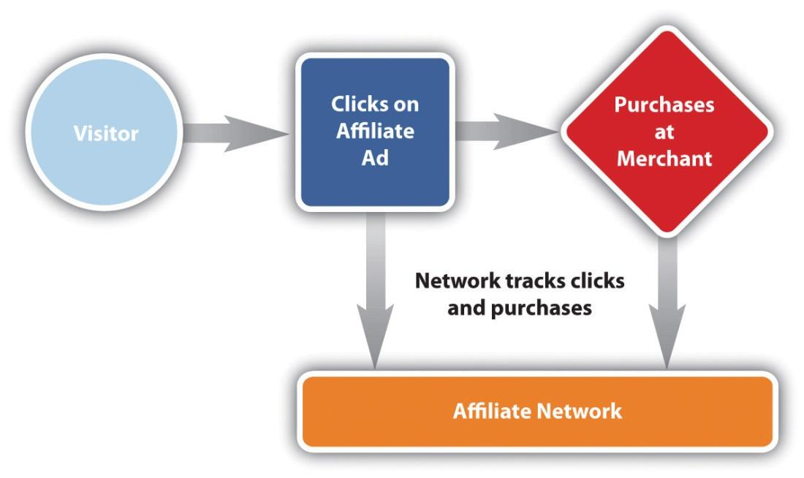
However, there are many different ways an affiliate might market a merchant’s offering, there are many different types of action that can be rewarded, and, most importantly, there needs to be some way of keeping track of the whole process.
We’re going to take a look at the different types of actions first of all, then discuss keeping track of it all, and lastly take a look at some of the many means that affiliates use to send customers to merchants, and of course, to make themselves cash.

Action and Reward
Affiliate marketing can be used to promote any type of Web site—there just needs to be an agreed-upon action that will result in an affiliate earning commission. Different types of merchants will have different required actions. The actions and the types of commission can be summarized in the following:
- Cost per action (CPA). A fixed commission for a particular action.
- Cost per lead (CPL). A fixed commission for a lead (i.e., a potential sale).
- Revenue share (also cost per sale [CPS]). An agreed-on percentage of the purchase amount is awarded.
- Cost per click (CPC). A very small part of the affiliate marketing mix, where the merchant pays a fixed amount for each click-through to their Web site.
Let’s look at an example of each of these actions.

CPA
Here the action could be anything from downloading a white paper or software to signing up for a newsletter.
Why do you think a merchant would be willing to offer a bounty for each download?

CPL
Merchants that offer CPL commissions are usually those that need to convert a lead into a sale offline. This means that they will generally need to complete the transaction over the phone with the customer or that the process is quite complicated. It is typically insurance companies and banking institutions that will offer this type of commission.
Membership sites that offer a free trial period, such as online DVD rental businesses, can also use this commission structure.
You might be wondering why merchants are willing to pay for a lead instead of only for completed transactions.
How do you think companies can ensure that the leads they get are qualified?
Well, affiliates prefer this model, as they are not in control of the offline conversion process. It is the merchant’s job to be able to complete the transaction. Some merchants may be wary that the leads will not be of a high enough quality. This is why they will usually have conversion targets with which the leads generated need to comply as a means of quality control.

Revenue Share
Revenue sharing is the ideal commission structure as both the merchant and the affiliate are rewarded for performance—the more sales, the more revenue generated for the merchant and the more commission for the affiliate. Web sites where a sale can be performed instantly are ideal for revenue sharing. Online retailers and instant online travel agents are perfect examples of merchants who offer a revenue share commission. The affiliate earns a percentage of the sale.
Figure 4.2
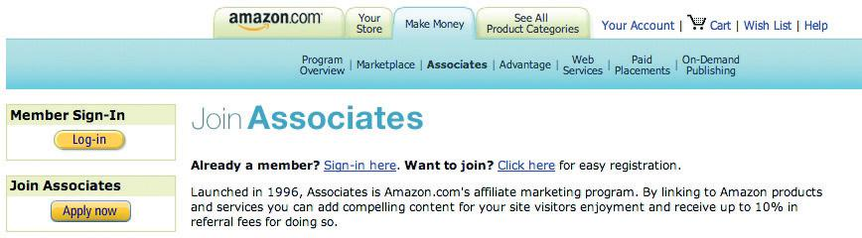
Amazon Associates is a popular revenue share affiliate program.

CPC
CPC commission is rarely used and is primarily a way of driving large volumes of traffic, usually to a new site. An affiliate would be awarded commission for every click-through to the merchant Web site. Although this type of commission was prevalent in the very early days of affiliate marketing, it has been largely abandoned due to click fraud. Click fraud occurs when a link is clicked on by a bot, or someone paid to click on links (see Chapter 7 "Pay per Click Advertising").
We have seen that there are different types of actions that can result in commissions being awarded and that these actions usually suit the Web site that is being promoted. This means that any industry that is online can most likely be promoted through affiliate marketing.
Affiliates have many options open to them to promote merchants’ Web sites. But before we get to that, we need to take a look at tracking—the thread that holds it all together.

KEY TAKEAWAYS
- There are different types of commissions whose uses are based on the merchant’s industry:
  - CPL (cost per lead)
  - CPA (cost per action)
  - Revenue share
  - CPC (cost per click)
- Tracking is what makes an affiliate marketing campaign work.

EXERCISES
- Aside from the examples given previously, think of products or services that may come from CPL (cost per lead), CPA (cost per action), and revenue share.
- What factors should be considered when determining what commissions should be when you are planning an affiliate campaign? How do these differ for revenue sharing campaigns and CPA campaigns?

4.3 Tracking: The Lifeline of Affiliate Marketing

LEARNING OBJECTIVE
- Learn why cookies are important to affiliate marketing.
The key to affiliate marketing is being able to track the whole process, from potential customers being sent to a Web site to completed action, so that the merchant is able to award the correct affiliate with the correct commission. This really is the crux of affiliate marketing.
Specialized affiliate tracking software is used to track affiliate campaigns, and this is usually supplied and supported by the affiliate network. Often, the merchant and the affiliate will also use their own tracking software to make sure that there are no major discrepancies.
Affiliates send traffic to merchants through links oruniform resource locators (URLs), and the tracking software allows each affiliate to have a unique identifier in the URL. These links set a cookie on the customer’s computer, which allows the software to track the sale.
For example, here is the URL of a product on a retailer’s Web site:
http://www.firebox.com/product/1201
Here is the URL for the same product with affiliate tracking:
http://scripts.affiliatefuture.com/AFClick.asp?affiliateID=238&merchantID= 214&programID=3897&mediaID=0&tracking=cube_world&url=http://www.firebox.com/index.html?dir=firebox&action=product&pid=1201
You can see some of the information being recorded. It has been shown in bold in the URL and includes the following:
- The affiliate network (Affiliate Future)
- The ID of the affiliate (238)
- The ID of the merchant (214)
- The ID of the program since a merchant might have more than one program on a network (3897)
- The media used (0)
- The destination of the click
Can you spot the original URL in the tracking URL??

Tip
Do you want to see what cookies have been set on your browser? If you use Mozilla Firefox, go to Tools > Options > Privacy, and click on “Show Cookies.” You can see all the domains for which cookies have been set, and you can see when the cookie will expire. You can delete cookies if you want to. For Internet Explorer, go to Tools > Internet Options > General, and click on “Settings” under “Temporary Internet Files.” Click on “View Files” to see cookies set and other temporary Internet files.
When the customer completes the required action on the merchant’s Web site, the cookie will allow the tracking software to collect the information needed to award the commission. For example, if a customer were to use an affiliate link to purchase a gift from a merchant (using the same URL as before as an example), the following information would be collected:
- Referring URL and affiliate
- Total sale amount for commission
- Date and time of sale
- Unique order number of sale
All this information will allow the merchant to confirm that the sale is valid, as well as the amount of commission that is due, without ever releasing any of the customer’s personal information.
Affiliate tracking software collects information even if no action is completed. This is vital to the affiliates and to the merchants to see where they can optimize their campaign.
Information collected includes the following:
- Impressions
- Clicks
- Conversions
All this information helps to build up data in order to strengthen the campaign.
Figure 4.3 Table Showing Data Used to Determine the Success of an Affiliate Campaign
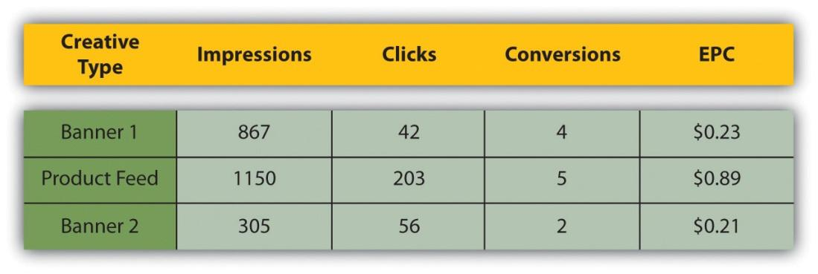

Discussion
What data would need to be collected? Does this differ for different types of affiliate marketing? Think of e-mail marketing versus PPC (pay per click), for example.
Affiliates will use this information to determine the success of their marketing efforts. Remember that affiliates invest money into marketing various merchants, and they only get rewarded on commission. An affiliate will use the above information to determine whether or not to promote a merchant and how much they should invest in promoting a particular merchant.
Merchants can use the information on their campaign to determine how best to optimize. For example, if a particular type of banner seems to do better than others, they could use that to improve other banners that they offer.

How Long Does a Cookie Last?
If you follow the steps mentioned above to see what cookies have been set on your browser, you’ll notice that there are a lot of different expiration periods for cookies. Cookies are not just used for affiliate marketing. They are also used to store information so that a Web site “remembers” who you are next time you visit it. The domain owner gets to determine the length of time a cookie should last. This is called the cookie period.
When it comes to affiliate marketing, it is up to the merchant to decide what the cookie period should be. The affiliate is only awarded commission should the desired action take place within the cookie period. Some merchants make the cookie last for the session only (i.e., if the user only makes purchases the following day, no commission is rewarded), whereas the standard cookie period for affiliate marketing is thirty to sixty days. Some merchants offer 999-day cookies, or even lifetime cookies.
There are merchants who offer what is called an affiliate lock-in. Here, the first affiliate to refer the customer earns commission for as long as the customer remains a customer; every purchase that the customer makes will earn the affiliate commission.

Discussion
Do you think there is an advantage to a 999-day cookie? What is the difference between a 999-day cookie and a lock-in?
Affiliates tend to prefer a longer cookie period it increases the likelihood of being awarded commission.

KEY TAKEAWAYS
- The most essential element to affiliate marketing is tracking. Tracking software places a cookie on a user’s browser when that user clicks on an affiliate link. The cookie period is determined by the merchant. If the user performs the desired action within the cookie period, the affiliate is awarded commission.
- Information collected during tracking includes impressions, clicks, and conversions.
- The original URL (uniform resource locator) should be easily identifiable in the URL used for affiliate tracking.
- Specialized software is used to manage the campaigns.

EXERCISES
- Describe the role cookies play in affiliate marketing. Why are they important? Could affiliate marketing work if cookies didn’t exist? What impact would it have on affiliate marketing?
- Do you think there is an advantage to a 999-day cookie? Think of a situation in which you might use one.
- What is the difference between a lifetime cookie and a lock-in cookie? How do you think lock-in cookies affect the commission levels offered by merchants?
- Compare tracking in affiliate marketing to that of e-mail and online advertising. What are the similarities? The differences?

4.4 When Things Go Wrong

LEARNING OBJECTIVES
- Understand why things may go wrong in affiliate marketing.
- Know what happens when things go wrong.
Successful tracking is fundamental to any eMarketing campaign, and especially so to affiliate marketing. As affiliates are only paid for performance, should anything go wrong in the tracking process, it is the affiliates that suffer. The merchant will still get the desired sales, but the affiliates won’t be rewarded.
So it is good to bear in mind some of the problems that can be faced with tracking.

Multiple Referrals, One Sale: Who Gets the Bounty?
With so many affiliates, it is not uncommon for a potential customer to visit a merchant’s Web site through the links of many different affiliates before finally making a purchase. Who do you think should receive the commission?
For example, a user sees a Web site banner promoting a weekend in Paris, booked with Eurostar. The user clicks on that banner and checks out the deals on the Eurostar Web site. A cookie is set, as the first Web site is an affiliate of Eurostar.
He doesn’t book right away, but after chatting to his girlfriend, they decide to book the trip. He goes to Google, searches for “Eurostar weekend in Paris,” and clicks on one of the PPC (pay-per-click) advertisements. This has also been placed by an affiliate, but a different one.
This time he books the trip. But which affiliate should be rewarded the commission?
It has become standard practice that the most recent referral is awarded the commission, though there are some merchants who also offer compensation to other affiliates involved in sale process. In the previous example, the affiliate who placed the PPC advertisement would get the commission for this sale.

Cookies Getting a Bad Reputation
Consumers sometimes get anxious when they hear things like “tracking” and “collecting information,” so they delete cookies from their computer. If this happens, then the sale will never be attributed to the affiliate. This practice, however, does not seem to have a drastic effect on numbers, so most affiliates will still calculate this into their return on investment (ROI).

Clashing Cookies
Merchants will often use some kind of tracking so that they can better optimize their own marketing efforts, or a merchant may make some kind of technical change to their Web site. It is crucial that any of these changes are tested first with the tracking software to make sure that they do not create any conflicts. It is generally accepted practice that even if it is a merchant’s marketing effort that is responsible for the final sale, the affiliate still gets the commission if it is within the affiliate’s cookie period.

Placing an Order by Another Method
If the customer completes the action but does not do so online, the affiliate will not receive commission. So, if a customer visits an online retailer through an affiliate link but places an order over the phone, the affiliate will miss out on commission.

KEY TAKEAWAYS
- It isn’t uncommon for there to be multiple referrals for one online sale.
- Best practices will give the most recent referrer the credit for the sale.
- Cookies get a bad reputation with consumers, who are afraid of being tracked. Consumers will sometimes delete their cookies as a result.
- Affiliates can miss out on commission if a customer places an order over the phone instead of online.

EXERCISES
- What impact might cookie deletion have on an affiliate marketing campaign?
- A user sees an ad online for ABC Glassware on Site A, an affiliate site, and clicks on it. Even though the ad promoted a great deal, she does not make a purchase at that time. Afterward, she visits several other sites, and finds another good deal for the same glassware on Site B, another affiliate site for ABC Glassware. She doesn’t make a purchase then, either, as she preferred to think about the purchase overnight. The next day, she goes back to Site A to buy the glassware. Who receives the commission?

4.5 How Do Affiliates Promote Merchants?

LEARNING OBJECTIVE
- Learn how affiliates promote merchants.
Affiliates are online marketers who are paid on a performance basis. Every type of marketing strategy will be found in the affiliate world, and affiliates can often be seen at the forefront of breaking technology and applying it to marketing strategies.
The basic aim of an affiliate is to send targeted traffic (that means customers who are very likely to perform the desired action) to a particular merchant’s Web site. Affiliates may promote as many merchants in as many industries with as many tactics as they wish, but usually affiliates will start to specialize.
Most of the tactics will be the same as those that the merchant employs but will reach a different part of the Internet population. Effective tracking takes care of any overlap and will help a merchant to adjust their spending for a most effective return on investment (ROI). The main types of affiliates can be broken up into the following:
- Personal Web sites
- Content and niche sites
- E-mail lists
- Loyalty sites (points or cash back or charitable donations)
- Coupon and promotions sites
- Comparison shopping (see also PPC [pay-per-click] advertising)
- Search affiliates (search arbitrage)

Figure 4.4
GreasyPalm.co.uk is a cash-back site that is an affiliate.
Affiliate marketing came to the fore as a way for personal Web sites to make money, though this now forms a small part of the marketing mix. Affiliate marketing does still provide some income for these Web sites. However, we will focus on those endeavors that are created purely for affiliate marketing.
Content and niche sites are Web sites created around a specific topic, and any products promoted will carry affiliate tracking. For example, an affiliate might create a site dedicated to digital cameras, with tips and downloads to help you get the most out of your camera. It could review a number of different cameras and offer links to purchase those cameras online. All those links will be affiliate links.
Seasonality is also an important consideration for content sites. Web sites can be created specifically for Christmas, Mother’s Day, and many more key retail seasons.
Some affiliates run large opt-in e-mail lists, and they market particular merchant offers through their e-mail newsletters. Some renegade affiliates use spam e-mail to promote merchant offers, but as affiliate marketing has matured, there are usually terms and conditions to prevent such promotion.
As affiliates earn a percentage of a sale, some affiliates “split” this with the customer and create cash-back or points-based shopping sites. There are also some that donate a percentage of the commission to a charity.
Some of the most successful affiliate marketers are those who promote various merchants through paid search PPC advertising on search engines. These affiliates seek to find the highest earnings per click (EPC) for the lowest cost per click (CPC), this is also referred to as search arbitrage.

Note
Arbitrage is the practice of taking advantage of a price differential between two or more markets. It’s a term that is usually used in financial trading. Some might say that search affiliates trade in PPC advertisements—their revenue is the EPC – CPC.
Affiliates will find any means possible to promote offers. As new products and platforms become available, marketers and affiliate marketers find new ways to make them work. Some other examples of affiliates promoting merchants include the following:
- Toolbars and other browser extensions
- Social network applications
All that is required is that the click-through to the merchant’s Web site is tracked.
Figure 4.5
GoodSearch.com offers a toolbar. Proceeds from affiliate links are shared with charities.

KEY TAKEAWAYS
- Affiliates use a number of means to promote merchants. These include the following:
  - Personal Web sites
  - Content and niche sites
  - E-mail lists
  - Loyalty sites that award points, cash back, or charitable donations
  - Coupon and promotions sites
  - Comparison shopping (see also PPC [pay-per-click] advertising)
  - Search affiliates (search arbitrage)
- Affiliates will find any means possible to promote offers. Examples may include toolbars or social network applications.
- Affiliate marketing came to the fore as a way for personal Web sites to make money.
- Sites may be developed for certain holidays, as dictated by the seasonality of retail.

EXERCISES
- How can a merchant try to ensure that its own marketing efforts do not overlap with those of the affiliates? Why would a merchant want to reduce overlap?
- Why do you think affiliates promote merchants in so many ways?

4.6 Affiliate Networks

LEARNING OBJECTIVE
- Learn what affiliate networks are and how they fit into affiliate marketing.
As well as the affiliate and the merchant, there is a generally a very important third party in the affiliate marketing mix—the affiliate network.
While some small affiliate programs and some very large affiliate programs (such as Amazon Associates) are run by the merchant, most merchants opt to use an affiliate network to provide most of the technical solutions required for an affiliate program.
Affiliate networks provide tracking solutions, reporting on programs to both affiliates and merchants, hosting of creative banners, commission payment options, and support to both affiliates and merchants. Affiliate networks have many affiliates, and many merchants, signed up to them, so they are ideal sources for recruiting affiliates if you are a merchant or for finding merchants to promote if you are an affiliate. Affiliate networks provide a one-payment solution to merchants, as the merchants will be invoiced for all the commission collectively owed, which is then dispersed to the affiliates.
Figure 4.6
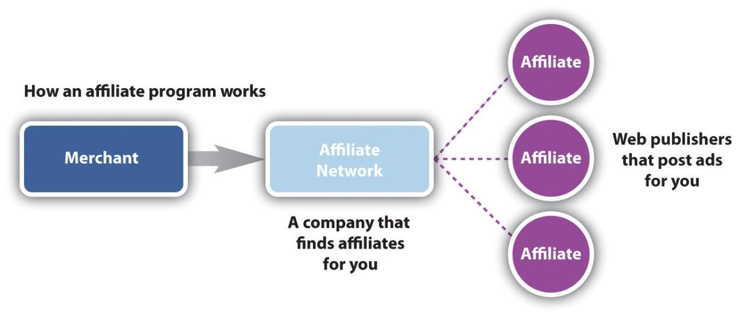
Affiliate networks act as a gateway between merchants and affiliates.
Affiliate networks usually charge the affiliates nothing to join. They can charge a merchant a setup fee, which will cover the cost, making sure that the tracking solution is successfully integrated, and can charge a monthly management fee, depending on the level of support offered to the merchant. Affiliate networks usually charge the merchant a percentage of the commission earned by the affiliate (called a commission override), so that there are incentives for the networks if they perform well. As a rough guide, this is typically 30 percent of the commission rewarded to the affiliate.
Some leading affiliate networks include the following:
- Commission Junction. http://www.cj.com
- LinkShare. http://www.linkshare.com
- Affiliate Window. http://www.affiliatewindow.com
- TradeDoubler. http://www.tradedoubler.com

KEY TAKEAWAYS
- Affiliate networks are often used as intermediaries between affiliates and merchants. Affiliate networks provide tracking solutions, reporting, and support to both affiliates and merchants.
- Affiliate programs may be with a merchant directly (as with Amazon.com) or through a network. Affiliate networks act as gateways between merchants and affiliates.

EXERCISE
- Why do you think some affiliates run affiliate programs for their own Web sites?

4.7 Tools of the Trade

LEARNING OBJECTIVE
- Learn what tools are important to affiliate marketing.
Affiliate marketing today forms a fundamental part of most e-retailers’ strategies. So what tools does a merchant need to have a successful program?
Any retailer should have a product feed, either XML (extensible markup language) or CSV (comma-separated values). A product feed is a way to provide information about the products on a merchant’s Web site in a way that breaks up the information easily and is standardized. A product feed will probably contain the following information for each product:
- Product name
- Product URL (uniform resource locator)
- Product picture
- Product price
- Description
- Shipping price
- Stock status
Affiliates, particularly search affiliates, can use this to promote individual products.
A product feed is made available on a simple URL and displays content that affiliates can use in their campaigns.
Merchants need to create a set of banners and buttons that can be placed on affiliate Web sites. At a minimum, the following sizes should be available:
- 468 × 60 (banner)
- 125 × 125 (square)
- 120 × 60 (button)
- 120 × 600 (skyscraper)
Having interactive banners, such as gift wizards or product searches, means that potential customers can interact with the brand before they even come through to the merchant’s Web site.
If the merchant or the affiliate network hosts the banners, the banners can be updated without the affiliates having to do anything. This means that the message can be kept current across all the merchant campaigns.
Merchants need to consider who will be keeping tabs on and driving the success of the affiliate campaign. Merchants might be able to run the program in-house with current staffing resources or can hire an affiliate manager. It is also possible to outsource the management of the affiliate program to an agency that specializes in affiliate marketing.
Lastly, merchants need to keep in touch with their affiliates the networks have channels for communicating with a large number of affiliates, but it is also worthwhile to interact on some of the affiliate marketing forums in order to keep informed.

What Tools Does an Affiliate Need?
Affiliates need to get to grips with the spectrum of eMarketing tactics, and choose what works best for them. Paid search affiliates will focus on PPC (pay-per-click) tactics, while affiliates running custom-made Web sites will probably put a lot of energy into SEO (search engine optimization). It depends on where their talent lies and where they see a gap in the market.
For affiliates, keeping up to date with merchants, other affiliates, and the industry is probably the key to growth. That, and finding the time to put it all into practice! Joining forums and keeping tabs on industry leaders will help do just that.
Some notable affiliate marketing forums include the following:
- Webmasterworld. http://www.Webmasterworld.com
- Affiliates4U forum. http://www.affiliates4u.com

KEY TAKEAWAYS
- All retailers should have a product feed.
- Merchants should have a set of banners that can be placed on affiliate sites.
- Merchants need to consider who will be keeping the tabs on and driving the success of the affiliate campaign. They may do this in-house or they can outsource.
- Merchants and affiliates should keep up with the industry to ensure growth.

EXERCISES
- Why do you think it is important for a merchant to have several different banners and buttons available to affiliates?
- Why do you think it is important for merchants to keep in touch with their affiliates?

4.8 Setting Up a Campaign

LEARNING OBJECTIVE
- Learn how best to set up an affiliate marketing campaign.
Affiliate marketing is becoming an integral part of eMarketing—how would you go about setting up and launching a new campaign without it? Affiliate marketing should grow your business, and grow with your business, so it’s important to plan and prepare for long-lasting success.
First, you need a clear idea of your business’s identity, goals and unique selling points. No doubt you will have competitors that affiliates already promote; you need to be able to give affiliates compelling reasons why your program is better.
With this in mind, you need to determine the goal of your affiliate marketing. If you are a new business, you might just want to build traffic and brand awareness. Depending on what industry you are in, your goal could be new customer leads or it could be increased retail sales. Make sure you are clear on what you want and that your Web site reflects this.
Then, you need to decide whether you are going to run your own program, from affiliate recruitment to tracking and paying, or whether you are going to use an affiliate network. If you are using an affiliate network, you’ll need to do your homework on the best network or networks to join. Look at the following:
- Where your competitors are
- Who has the kind of affiliates you want
- What the joining fees and monthly fees are
- How much support they can offer you
- What countries the network is in
You’ll also need to decide whether you will hire an affiliate manager to run your program, whether you might outsource your program management, or whether you already have the resources to run the program yourself. You need to do a full competitor analysis, focusing on your competitors’ affiliate programs. Look at the following:
- Commission tiers
- Cookie periods
- Creative offerings
- Affiliates they work with
- Networks
- Incentives offered to affiliates
Prepare the basics that you’ll need to start a program:
- Product feed
- Banners and other creative offerings
Using your competitor research, decide on commission, commission tiers, cookie period, and incentives.
Test the tracking software on your site and make sure that it does not conflict with any other tracking you are using.
Recruit affiliates. Use your competitor analysis to contact potential affiliates, promote your program through affiliate forums, use your affiliate network contact channels to approach affiliates, and approach sites that you think fit your user demographic.
And it doesn’t all stop once you’ve launched! The key to successful affiliate marketing is ongoing communication and marketing to your affiliates. You need to make sure you are on top of validating sales, so they get their commission. You need to ensure that you stay competitive with your commission offering, and you need to keep your affiliates up to date with any information that could make them send more customers your way—more revenue for you and thus more cash for them!

KEY TAKEAWAYS
- Determine the goal of your affiliate marketing.
- Decide if you will run your own program or if you’ll use an affiliate network.
- Decide if you’ll hire an affiliate manager or outsource the management.
- Do a competitive analysis.
- Test the tracking software on your site to avoid conflicts.
- Recruit affiliates.
- Make communication ongoing! One of the keys to successful affiliate marketing is ongoing communication between merchants and affiliates. This can be thought of as the merchant marketing the affiliate program to affiliates so that the affiliates in turn will market the merchant’s offering.

EXERCISES
- When do you think it would be best for a merchant to manage an affiliate in-house versus outsource it to an agency?
- When do you think it’s appropriate to run your own affiliate program versus hiring a manager? Versus outsourcing?
- Why do you think performing a competitor analysis is important?

4.9 Pros and Cons

LEARNING OBJECTIVE
- Understand the pros and cons of affiliate marketing.
While affiliate marketing certainly deserves increasing recognition for its key role in growth, it is still a young industry with all the growing pains that that involves.

What Is Holding People Back?
The following issues hold people back from fully utilizing affiliate marketing tactics:
- There are seldom contracts in place between affiliates and merchants. This means that an affiliate could decide to stop promoting the merchant’s program with no notice given. This could lead to a sudden drop in traffic and sales, depending on how reliant the merchant had been on that affiliate. Similarly, merchants may decide to terminate a program, meaning a loss of revenue for affiliates. Particularly if little notice is given, affiliates might have spent time and money setting up promotions, only to have the campaign pulled out from underneath. Most infamously, ASOS.com did this a couple of years ago.
- There is still little to no industry regulation, though the majority of the industry does strive to adopt best practices. While some affiliates have resorted to shady practices in the past (with adware and e-mail spam), the majority have banded together to blacklist this kind of behavior. The specter still remains though.
- Some merchants fear a loss of brand control. Affiliate programs are not easily scalable.
But of course, there are many benefits to affiliate marketing:
- It’s pay-for-performance marketing, so merchants are only paying for growth.
- The merchant sales force, as well as its branding potential, just got bigger.
- There is a very low barrier to entry for both affiliates and merchants.

KEY TAKEAWAYS
- Cons to affiliate marketing include the following:
  - Contracts between affiliates and merchants seldom exist.
  - There is little industry regulation.
  - Some merchants fear loss of brand control.
- Pros to affiliate marketing include the following:
  - It’s pay-for-performance marketing, so merchants are only paying for growth.
  - The merchant sales force, as well as its branding potential, just got bigger.
  - There is a very low barrier to entry for both affiliates and merchants.

4.10 Case Study: Prezzybox.com
Prezzybox.com is a UK online retailer in a very competitive market: gifts and gadgets. With many other players in the market competing for the same customers, Prezzybox.com runs a successful affiliate program that sees them leading the way in performance marketing.
Affiliate marketing has played a sizeable role in the growth of Prezzybox.com and now accounts for about 35 percent of sales. Affiliate marketing has contributed on two levels, namely, brand growth and sales generation. In fact,Prezzybox.com has won several industry awards for its affiliate program. In 2008, these awards included “Best Use of Creative” and “Best Merchant Innovation.”
A substantial element of affiliate marketing is managing relationships with affiliates. The Prezzybox.com affiliate program and its affiliate managers have been voted best by affiliates, and its affiliate managers are regularly invited to speak at industry events and conferences. How have they achieved this?
Figure 4.7
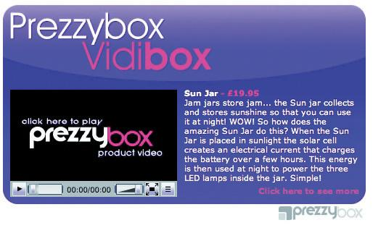
Vidibox is a new content item for affiliates ofPrezzybox.com.
Source: Used by permission fromPrezzybox.com.
Prezzybox.com has a wide affiliate base and constantly recruits new affiliates via affiliate get-togethers, affiliate forums and blogs, and through keyword searches on Google. Its super affiliates, those affiliates that drive the majority of affiliate sales, account for about 1 percent of all affiliates. Zak Edwards, managing director of Prezzybox.com, says, “We tend to offer all affiliates the same opportunities for promotion, but obviously focus a lot of our attention on our super affiliates.” ^{[1]}
Super affiliates can be given extra commission as an incentive, and the affiliate managers ensure that these affiliates are up to date with all the latest offers, new products, and promotions. Prezzybox.com communicates these details to all their affiliates as well. However, they use mass communication for all their affiliates and one-on-one communication, such as phone calls or instant messages, with their super affiliates. One of the features of the affiliate program is an affiliate resource center, which has extensive support information for affiliates such as real-time product bestseller reports.
In 2007, Prezzybox.com launched a brand-new content item for its affiliates: Vidibox. These are video content units—banners that contain a product video and a link to that product on the Prezzybox.com Web site. These video content units were very successful because the content was unique in the affiliate arena and so had a large take-up among affiliates. Being a more interesting way of displaying content, the Vidiboxes attracted a higher click-through rate, which again made them more appealing to affiliates.
Prezzybox.com’s commitment to an innovative and successful affiliate program has seen it earn immense respect in the affiliate arena, which is translating into ongoing, healthy sales growth. In fact, Prezzybox.com has outgrown its offices twice in six years and looks set to maintain this successful track record.

CASE STUDY QUESTIONS
- Part of affiliate marketing involves marketing a company to affiliates. How has Prezzybox.com achieved this, and what are its effects?
- Why does Prezzybox.com communicate differently to its super affiliates?
- What made the Vidiboxes enticing to affiliates?
- In a competitive market, how does affiliate marketing help build a company’s success? Are there any additional considerations when a market is competitive?

[1] Zak Edwards, personal communication via e-mail with Sarah Blake.

4.11 References
Shawn Collins, “History of Affiliate Marketing,” ClickZ, November 10, 2000,http://www.clickz.com/showPage.html?page=832131 (accessed December 2, 2007).
My Turnkey Business, http://www.myturnkeybusiness.com (accessed April 7, 2008).
Stefanie Olsen, “ValueClick Buys Marketer Commission Junction,” CNET, October 10, 2003, http://www.news.com/2100-1024-5090014.html (accessed December 2, 2007).

Chapter 5

Search Engine Marketing

5.1 Introduction
Every day, all around the world, millions of people use search engines to find content on the Internet. Search engines are Web-based programs that index the Web and allow people to find what they are looking for. “Search,” or “search marketing,” is often used to refer to the industry that has built up around search engines.

5.2 Search Engine Optimization

LEARNING OBJECTIVES
- Learn how search engines work.
- Understand the difference between PPC (pay per click) and SEO (search engine optimization).
Google, Yahoo! and now Bing are all well-known international search engines. Google is by far the leading player in the market. A comScore study of worldwide search engine activity, released in July 2009, showed that Google has just over 67 percent of the global search engine market share. ^{[1]}
When we talk “search,” we refer to two different kinds of results: organic search results and paid search results.

Figure 5.1 Global Search Engine Market Share
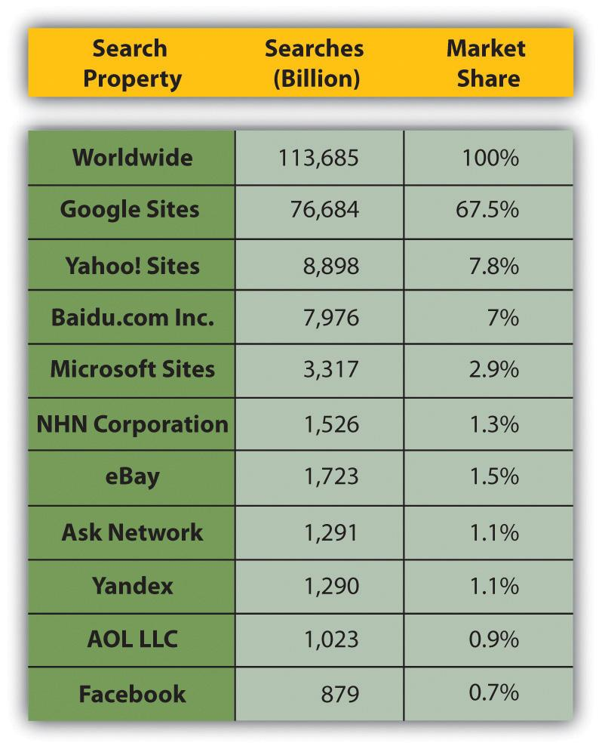

Organic Search Results
Organic search results are the primary product of a search engine. These results are the listings generally found on the left-hand side on the search engine results pages (SERPs). They are not influenced by financial payment and are therefore also called natural search results. Organic search results need to be consistently reliable to attract (and keep) users. Google’s growth and success as a search engine can be directly linked to its superior search algorithm, which returns highly relevant organic results.

Paid Search Results
Paid search, also known as pay-per-click (PPC) advertising, involves the displaying of sponsored results alongside the organic results. Advertisers bid for placement and pay the search engine when their advertisement is clicked on. Paid search results must be distinguished from organic results, since paid placement introduces bias. PPC advertisements are usually displayed at the top and on the right side of the SERPs. Search engines attract and keep users through organic search, but they make most of their money from paid search.
Figure 5.2 SERP Example
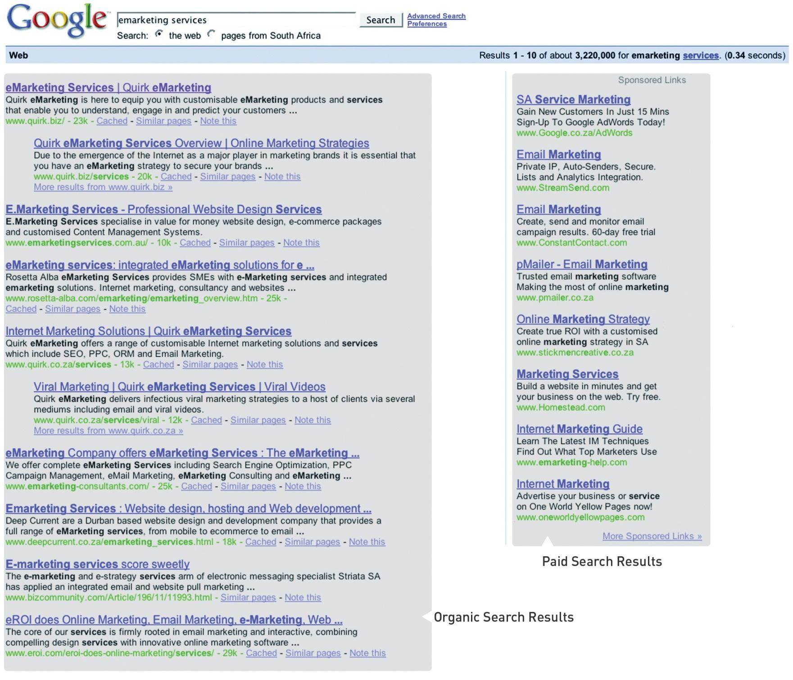

The Importance of Search to a Marketer
As search engines have become essential to a Web user’s Internet experience, so has search become essential to a marketer. Search is important for a number of reasons.

Search Is Goal Oriented: People Use Search to Find the Things They Want and Need
The Internet is a highly competitive environment, with literally billions of pages in existence. So how does anyone find the page they are after? Web users find what they need primarily via search. Search drives targeted traffic (and therefore sales) to Web sites. A Web search is a signal of intent from a Web user.

The Search Industry Is Big
The daily search-volume numbers are in the hundred millions. According to comScore figures, there were more than 14 billion searches in the United States alone in October 2009. ^{[2]} That’s around 466 million per day.

To Be Found, You Must Be Visible
If you want your Web site to generate a significant amount of traffic, then it needs to be listed on the major search engines and listed high up enough to be seen. Statistics show that users are not likely to view listings beyond the first thirty results, with the top six (above the fold) listings enjoying the lion’s share of clicks. ^{[3]}

Top of Search Equates to Top-of-Mind Awareness
Beyond traffic, a high-ranking Web site is valuable for brand perception. Web users often perceive search engine results as an indication of authority. Search visibility promotes brand recognition and research has shown that search engine listings can stimulate brand recall by a three-to-one margin. ^{[4]}

People Trust Organic Search
Research has shown that people find organic results more relevant and more trusted than paid search results. ^{[5]}

Catch Potential Customers at Every Phase of the Buying Cycle
Most purchases are subject to a buying cycle. At different points in that cycle, prospects are searching with different key phrases. Give them what they want at each phase, and they will keep coming back until they are ready to buy. In addition, they will be ready to buy more quickly because information is the best way to shorten the buying cycle.

Many People Have a Search Engine as Their Browser Home Page
Often, the home page of a browser is set to a search engine. Many users enter URLs (uniform resource locators) into the search engine instead of the address bar of the browser—meaning that even if they know the URL of a Web site, they are finding it through search.

A Three-Way Relationship: Search Engines, Webmasters, and Users
Search engines, Internet users, and Web site owners are involved in a symbiotic, three-way relationship. Each party depends on the other two to get what they need.

Users Want to Find What They Are Looking For on the Internet
Web users use search engines to lead them to Web sites, and they favor search engines that deliver the most relevant and useful results.

Search Engines Want to Make Money from Selling Advertising
The more users they have, the more advertising search engines can sell. Therefore, search engines must list their results according to relevance and importance in order to attract and keep users. In turn, search engines favor sites that are relevant and useful to users.

Web Site Owners, Webmasters, and Online Marketers Want Search Engines to Send Traffic to Their Site
Web site owners want search engines to send traffic their way. Therefore, they need to make sure that their sites are relevant and important in both the eyes of the search engines and the users.
Larry Page and Sergey Brin sum it up in their pre-Google paper, “The Anatomy of a Large-Scale Hypertextual Web Search Engine”: “The most important measure of a search engine is the quality of its search results.” ^{[6]}

What Does a Search Engine Do?
Search engines have four main functions:
- They crawl the Web (via spiders).
- They index the Web documents and pages they find.
- They process user queries.
- They return ranked results from the index.
A search engine is made up of a number of parts working together:
- A crawling spider, also known as a Web crawler, robot, or bot, is an automated indexing program. It goes from page to page, following links and indexing or recording what it finds.
- The index is what the spider creates. It is a “library” of pages on the Internet, and it consists of tens of billions of pages. The search engine creates databases for keywords, so it knows where to go to when a user enters a query.
- The engine is the part that does the actual searching. Users input a search query by typing a keyword or key phrase into the search bar. The engine then checks its index to find relevant pages and delivers them ordered from most relevant and important to least relevant and unimportant.
- The SERP (search engine results page) is the ordered listing of results for the user’s query. A SERP contains a description and link to the result.

Search Engine Marketing
Search engine marketing (SEM) has two parts: search engine optimization (SEO) and PPC advertising. These correspond to the two types of search results.

Figure 5.3 SEO + PPC = SEM
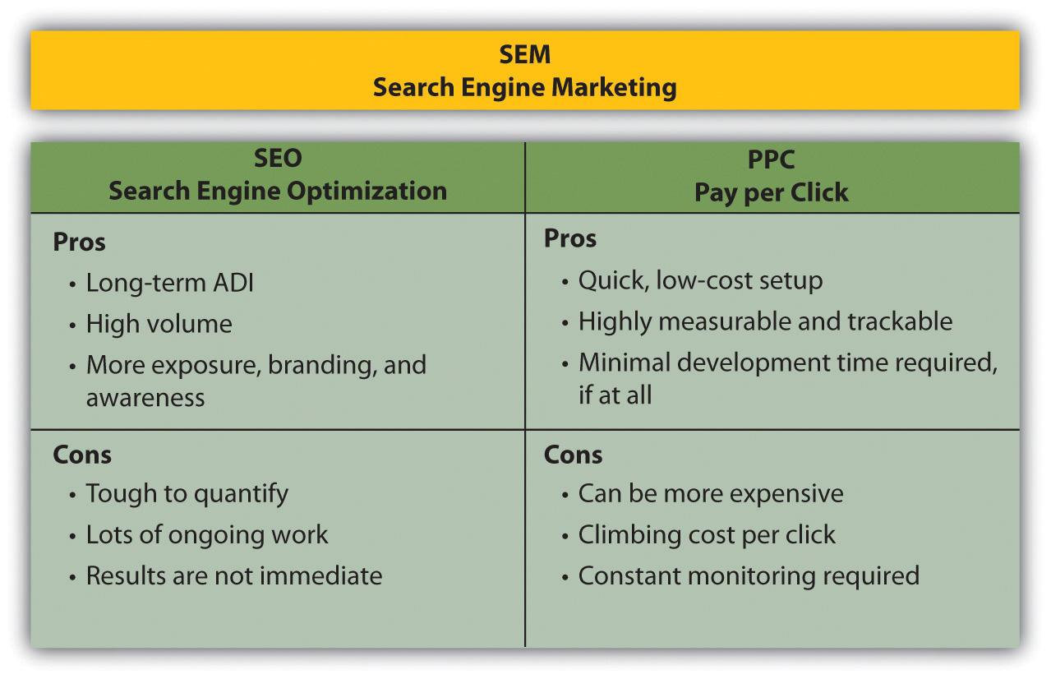
SEO aims at improving a Web site’s ranking in the natural search results. PPC advertising involves bidding for placement in the paid search results section of the SERP.
Both SEO and PPC advertising are based around the same fundamental concept: keywords.

Keywords: Making Sense of It All
Keywords, or key phrases, are what a user enters into a search engine query to find Web sites. Both SEO and PPC advertising involve selecting the keywords that are relevant to a company’s Web site and are used by potential customers. SEO aims to have a Web site rank in the natural results for its target keywords. In PPC advertising, the advertiser bids on desired keywords to achieve rankings in the paid results.
The following two chapters deal with the two divisions of search engine marketing: SEO and PPC.

KEY TAKEAWAYS
- Google owns the largest share of the search market.
- Organic search results typically appear on the left-hand side, while the paid placement typically appears on the right.
- Search is important for a variety of reasons:
  - Search is goal oriented: people use search to find things they want and need.
  - Search engines are the doorway to the Internet.
  - The search industry is big.
  - Top of search equates to top-of-mind awareness.
  - People trust organic search.
  - Search reaches people at every phase of the buying cycle.
  - Many users have a search engine as their browser home page.
- There is a three-way relationship among search engines, Webmasters, and users.
  - Users want to find what they are looking for on the Internet.
  - Search engines want to make money from selling advertising.
  - Webmasters and online marketers want search engines to send traffic to their site.
- There are four main functions of a search engine:
  - Crawl the Web (via spiders)
  - Index documents and pages
  - Process user queries
  - Return ranked results from the index
- SEO + PPC = SEM

EXERCISE
- Evaluate the list of pros and cons for SEM. Describe in your own words why you think it may be important to use both parts of SEM. What may happen if you only use PPC? Or only SEO?

[1] “Global Search Market Draws More Than 100 Billion Searches per Month,” press release, comScore, August 31, 2009,http://www.comscore.com/Press_Events/Press_Releases/2009/8/Global_Search_Market_Draws_More_than_100_ Billion_Searches_per_Month (accessed June 24, 2010).
[2] “comScore Releases October 2009 U.S. Search Engine Rankings,” press release, comScore, November 17, 2009,http://www.comscore.com/Press_Events/Press_Releases/2009/11/comScore_Releases_October_2009_U.S._Search_Engine_Rankings (accessed June 24, 2010).
[3] “Google Search’s Golden Triangle,” Eyetools,http://www.eyetools.com/inpage/research_google_eyetracking_heatmap.htm (accessed April 3, 2008).
[4] “The Brand Lift of Search,” Enquiro Search Solutions, December 2007,http://pages.enquiro.com/whitepaper-the-brand-lift-of-search.html (accessed June 24, 2010).
[5] “Inside the Mind of the Searcher,” Enquiro Search Solutions, March 2004,http://pages.enquiro.com/whitepaper-inside-the-mind-of-the-searcher.html (accessed June 24, 2010).
[6] Sergey Brin and Lawrence Page, “The Anatomy of a Large-Scale Hypertextual Web Search Engine,” http://infolab.stanford.edu/~backrub/google.html (accessed April 3, 2008).

5.3 References
“61 Billion Searches Conducted Worldwide in August,” press release, comScore, October 10, 2007, http://www.comscore.com/press/release.asp?press=1802(accessed June 9, 2008).
“comScore Releases 2008 U.S. Search Engine Rankings,” press release, comScore, February 21, 2008, http://www.comscore.com/press/release.asp?press=2068 (accessed April 3, 2008).
“comScore Releases March 2008 European Search Rankings,” press release, comScore, May 7, 2008, http://www.comscore.com/press/release.asp?press=2208 (accessed June 1, 2008).
“Global Search Market Share, July 2009 vs. July 2008,” Search Engine Watch, September 1, 2009, http://searchenginewatch.com/3634922 (accessed June 24, 2010).
Rand Fishkin, The Beginner’s Guide to SEO, SEOmoz, February 25, 2006,http://www.seomoz.org/article/beginners-guide-to-search-engine-optimization (accessed April 3, 2008).
“Technology Overview,” Google, http://www.google.com/technology(accessed April 3, 2008).

Chapter 6

Search Engine Optimization

6.1 Introduction
With millions of people performing millions of searches each day to find content on the Internet, it makes sense that marketers want their products to be found by potential consumers. Search engines use closely guarded algorithms to determine the results that are displayed. However, determining what factors these algorithms take into account has led to a growing practice known as search engine optimization.
Search engine optimization (SEO) is the practice of optimizing a Web site so as to achieve preferred ranking on the search engine results pages (SERPs). Someone who practices SEO professionally is also known as an SEO (search engine optimizer).
SEO can be split into two distinct camps: white-hat SEO and black-hat SEO (with some grey-hat wearers in between). Black-hat SEO refers to trying to game the search engines. These SEOs use dubious means to achieve high rankings, and their Web sites are occasionally blacklisted by the search engines. White-hat SEO, on the other hand, refers to working within the parameters set by search engines to optimize a Web site for better user experience. Search engines want to send users to the Web site that is most suited to their needs, so white-hat SEO should ensure that users can find what they are looking for.

History
By the mid-1990s, Webmasters had begun to optimize their sites for search engines due to a growing awareness of the importance of being listed by the various engines. Initially, all a Webmaster needed to do was submit the URL (uniform resource locator) of a Web page for it to be indexed. Search engines relied on the metadata, information that Webmasters inserted in the code of a Web page, to determine what a Web page was about and to index it appropriately.
Industry analyst Danny Sullivan records that the earliest known use of the term “search engine optimization” was a spam message posted on Usenet, an online forum or message board, on July 26, 1997. ^{[1]}
Realizing the importance of being ranked highly in search results, Webmasters began using the search engine’s reliance on metadata to manipulate the ranking for their Web sites. To combat this, search engines in turn have developed more complex algorithms including a number of other ranking factors.
While at Stanford University, Larry Page and Sergey Brin developed a search engine, called Backrub, that relied on a mathematical algorithm to rank Web pages. This was the precursor to Google. They founded Google in 1998, which relied on PageRank and hyperlink analysis as well as on-page factors to determine the prominence of a Web page. This enabled Google to avoid the same kind of manipulation of on-page factors to determine ranking.
PageRank relies on the uniquely democratic nature of the web by using its vast link structure as an indicator of an individual page’s value. In essence, Google interprets a link from page A to page B as a vote, by page A, for page B. But Google looks at more than the sheer volume of votes, or links a page receives; it also analyzes the page that casts the vote. Votes cast by pages that are themselves “important” weigh more heavily and help to make other pages “important.” ^{[2]}
PageRank was based on the practice of academic citations. The more times an academic paper is cited, the more likely it is an authority paper on the subject. Page and Brin used a similar theory for their search engine—the more times a Web page or Web site is linked to, the more likely it is that the community considers that page an authority. It should be noted that the importance of page rank has been greatly reduced over the years.
Ranking highly in search results is vital to Web sites, so Webmasters have adapted as search engines have updated their algorithms to avoid being “gamed.” Today, Google says it uses more than two hundred different factors in its algorithm (which changes over four hundred times yearly) to determine relevance and ranking. None of the major search engines disclose the elements they use to rank pages, but there are many SEO practitioners who spend time analyzing patent applications to try to determine what these are.

[1] Danny Sullivan, “Who Invented the Term ‘Search Engine Optimization’?” Search Engine Watch, June 14, 2004, http://forums.searchenginewatch.com/showpost.php?p=2119&postcount=10 (accessed June 6, 2008).
[2] “Understanding Google Page Rank,” Accu Web Hosting, May 20, 2006,http://www.accuwebhosting.com/Articles/Understanding_Google_Page_Rank.html(accessed June 18, 2010).

6.2 How It Works

LEARNING OBJECTIVE
- Learn what search engine optimization (SEO) is and how a Web site needs to be structured.
Search engines need to help users find what they’re looking for. To make sure they list the best results first, they look for signals of the following:
- Relevance
- Importance
- Popularity
- Trust
- Authority
Search engine optimization (SEO), also called organic or natural optimization, involves optimizing Web sites to achieve high rankings on the search engines for certain selected key phrases.
This is achieved by making changes to the hypertext markup language (HTML) code, content, and structure of a Web site, making it more accessible for search engines, and by extension, easier to find by users. These are also known as on-page factors. SEO also involves off-page factors—these generally build links to the Web site. Activities to increase links to a Web site, including social media and Web public relations (WebPR), are considered off-page SEO.
SEO is an extremely effective way of generating new business to a site. It is a continuous process and a way of thinking about how search engines see your Web site and how users use search engines to find your Web site. It’s search psychology.
SEO is a fairly technical practice, but it can easily be broken down into five main areas:
- A search engine–friendly Web site structure
- A well-researched list of key phrases
- Content optimized to target those key phrases
- Link popularity
- Emerging trends

Search Engine–Friendly Web Site Structure
Search engines encounter two kinds of obstacles:
- Technical challenges that prevent the search engine spider from accessing content
- A competitive marketing environment where everyone wants to rank highly
To ensure that search engines can access your content, you must remove technical barriers. Those who wish to achieve the best results must follow best Web development practices. These best practices are outlined in Chapter 13 "Web Site Development and Design".
Rand Fishkin of SEOmoz says, “The key to ensuring that a site’s contents are fully crawlable is to provide direct, HTML links to each page you want the search engine spiders to index. Remember that if a page cannot be accessed from the home page (where most spiders are likely to start their crawl) it is likely that it will not be indexed by the search engines.” ^{[1]}
Chapter 13 "Web Site Development and Design" delves more deeply into building a search engine–friendly Web site.

KEY TAKEAWAYS
- Search engines encounter two kinds of obstacles:
  - Technical challenges that prevent the search engine spider from accessing content
  - A competitive marketing environment where everyone wants to rank highly
- You must remove technical barriers.

[1] Rand Fishkin, The Beginner’s Guide to SEO, SEOmoz, February 25, 2006, http://www.seomoz.org/article/beginners-guide-to-search-engine-optimization (accessed April 3, 2008).

6.3 Well-Researched Key Phrases

LEARNING OBJECTIVES
- Understand how key phrases fit into search engine optimization (SEO).
- Understand how to research key phrases.
Key phrases are the very foundation of search. When a user enters a query on a search engine, she uses the words that she thinks are relevant to her search. The search engine then returns those pages it believes are most relevant to the words the searcher used.

Note
Keyword or key phrase? Key phrases are made up of keywords, but you can get away with referring to a key phrase as keywords.
Search engines have built a sophisticated understanding of semantics and the way we use language. So, if a user searches for “car rental,” the search engine will look for pages that are relevant to “car rental” as well as possibly “car hire,” “vehicle hire,” and so forth. Search engines have also built up knowledge around common misspellings and synonyms and common related searches so as to try to return the best results for a user.
Because of this, it is crucial that Web sites contain content with keywords that are likely to be used by their target audience. Web sites need to appear when their potential customers are searching for them.
As a Web site owner, or the marketer for a Web site, we need to build a list of some of the terms our potential customers are likely to use to find the things we are offering. A big part of keyword research is understanding search psychology. When we build our key phrase or keyword list, we are tapping into the mental process of searchers and putting together the right mix of keywords to target.
There are four things to consider when choosing a keyword:
- Search volume. How many searchers are using that phrase to find what they want? For example, there is an estimated monthly search volume of over two million for the keyword “hotel” but an estimated 385 searches per month for a keyword like “Cape Town waterfront hotel.”
- Competition. How many other Web sites out there are targeting that same phrase? For example, Google finds over 611,000,000 results for “hotel” but only 14,800 for “Cape Town Waterfront Hotel.”
- Propensity to convert. What is the likelihood that the searcher using that key phrase is going to convert on your site? A conversion is a desired action taken by the visitor to your Web site. Related to propensity to convert is the relevance of the selected term to what you are offering. If you are selling rooms at a hotel at the V&A Waterfront, which of the two terms (“hotel” and “Cape Town Waterfront hotel”) do you think will lead to more conversions?
- Value per conversion. What is the average value per prospect attracted by the keyword? Depending on the nature of your Web site, the average value per lead varies. Using the hotel example again, consider these two terms: “luxury Cape Town hotel” and “budget Cape Town hotel.”
Both are terms used by someone looking to book a hotel in Cape Town, but it is likely that someone looking for a luxury hotel is intending to spend more. That means that particular lead has a higher value, particularly if you have a hotel-booking Web site that offers a range of accommodation.

Keyword Research
How do you know where to start on building your keyword list? It requires a little thought and a fair amount of research using tools that are readily available to help you both grow and refine your list of keywords.

Brainstorm
Think about the words you would use to describe your business and about the questions or needs of your customers that it fulfills. How would someone ask for what you are offering? Consider synonyms and misspellings as well.
Bear in mind that people might not ask for your services in the same way you describe them. You might sell “herbal infusions,” whereas most people would ask for “herbal teas,” although some might request a “tisane.” If you are selling Tamagotchis, remember that the spelling can be tough to recall, and you might need to consider common misspellings like “tumagochi” or “tamagochi.”

Note
Misspellings are important, but when you are selling something, consider what the misspelling tells you about the traffic you are getting. With everything, analyze your traffic to assess for quality.

Survey Customers and Look at Your Web Site Referral Logs
Look to see what terms customers are already using to find you, and add those to your list. If they are already sending you some traffic, it is worth seeing if you can increase that traffic.

Use Keyword Research Tools
There are several tools available for keyword discovery, and some of them are free! Some tools will scan your Web site and suggest keywords based on your current content. Most will let you enter keywords and will then return suggestions based on past research data with the following:
- Similar keywords
- Common keywords used with that keyword
- Common misspellings
- Frequency of the keywords in search queries
- Industry-related keywords
- Keywords that are sending traffic to your competitors
- How many other sites are targeting your keywords
See “Tools of the Trade” in Chapter 6 "Search Engine Optimization", Section 6.6 "Emerging Trends" for some tools that you can use.
Bearing in mind the factors that make a good keyword, you need to aim for the right mix of keywords. Low-volume terms, with low levels of competition, may be a good way to get traffic in the short term, but don’t be scared off by high levels of competition in the high-value, high-volume areas. It might take longer to get there, but once there, the revenue can make it all worthwhile.
It is a good idea to create a spreadsheet of the list of keywords, where you can also store information relevant to that keyword.
Figure 6.1 How to Tabulate Your Keywords and Store Relevant Information
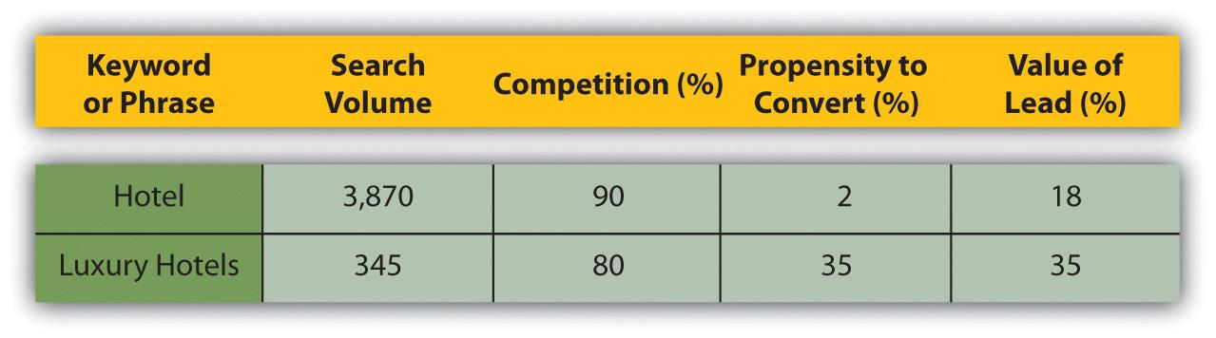
This will help you to choose the right keywords to target. These lists should be created for the whole Web site; they can then be broken down for each page you want to optimize.

KEY TAKEAWAYS
- Keywords are the foundation of search.
- Search engines have built a sophisticated understanding of semantics and they way we use language.
- Sites must use keywords that are likely to be used by their target audience.
- There are four things to consider when choosing a keyword:
  - Search volume
  - Competition
  - Propensity to convert
  - Value per conversion
- Keyword research is important for building a list of keywords. Brainstorming, surveying customers, and using keyword research tools are some of the best ways to get keywords.

EXERCISES
- Why do you think misspellings are important to consider when building keyword lists?
- Using Google’s keyword research tool (http://www.google.com/sktool), develop your own list of keywords for a particular brand.

6.4 Optimizing Content for Key Phrases

LEARNING OBJECTIVE
- Understand the importance of optimizing content for key phrases.
Once keywords and phrases are selected, we need to ensure that the site contains content to target those key phrases. We must ensure that the content is properly structured and that it sends signals of relevance. Content is the most important part of your Web site. We must create relevant, targeted content aiming at our selected key phrases. Content already has several roles to play on your site:
- It provides information to visitors.
- It must engage them.
- It must convince them to do what you want.
Now it must also send signals of relevance to search engines. You need to use the keywords on the content page in a way that search engines will pick up and users will understand.
Each Web page should be optimized for two to three key phrases: the primary key phrase, the secondary key phrase, and the tertiary key phrase. A page can be optimized for up to five key phrases, but it is better to have more niche pages than fewer unfocused pages. Here are some guidelines:
- Title tag. Use the key phrase in the title and as close to the beginning as possible.
- H1 header tag. Use the key phrase in the header tag and as much as possible in the other H tags.
- Body content. Use the key phrase at least three times, or more if there is a lot of content and it makes sense. Aim for about 350 words of content, but don’t overdo it! That could look like spam to the search engines.
- Bold. Use tags around the keyword at least once.
- Alt tag for an image. Use the key phrase at least once to describe an image on the page.
- URL (uniform resource locator). Use a URL rewrite so that it appears in the URL of the page.
- Meta description. Use it at least once in the meta description of the page. It should entice users to click through to your site from the search engine results page (SERP).
- Meta tags. Use the keywords in the meta tags to provide context to the search engines.
- Linked anchor text to another page. Don’t use it when linking to another page on your site. The anchor text describes the page being linked to, and so could dilute the relevance of the page you are linking from.
- Domain name. If possible, use the key phrase in your domain name, although favor usability or memorable domain names.

Optimizing Images
Images should also be optimized with the relevant keywords. Search engines cannot see images, so rely on the way that an image is described to determine what the image is about. Screen readers also read out the image descriptions, which can help visually impaired readers to make sense of a Web site. Lastly, images are sometimes also shown on the SERPs, and of course one can also search images using most of the major search engines.
Figure 6.2 Page Targeting Using the Phrase “Handmade Bags”
Source: http://www.babazeka.com.
Just as an image can help emphasize the content on a page, it can also help search engines in ranking pages, provided the image is labeled correctly.
Here are some ways to optimize images with key phrases for search engine optimization (SEO):
- Use descriptive filenames.
- Use specific alt tags and title attributes for the images.
- Meta information can be supplied in the image file. Make sure this information is relevant.
- Use descriptive captions, and keep relevant copy close to the relevant image.
- Make sure the header tags and images are relevant to each other.
SEO is both a science and an art. Focusing on writing quality content while sticking to a few guidelines when it comes to tags and URLs is the best way to ensure results. Remember, you want search engines to rank you highly for your content, but you also want to ensure that the content is a pleasure to read.
Adding fresh content that carries brand values regularly to your site will also encourage the search engines to crawl your site more frequently.
Use your Web site and its pages to establish and reinforce themes. Information can always be arranged in some kind of hierarchical structure. Just as a single page can have a heading and then get broken down into subheadings, a large Web site can have main themes that get broken down into subthemes. Search engines will see these themes and recognize that your Web site contains rich content.

KEY TAKEAWAYS
- Content is the most important part of your site. Content needs to target key phrases. Content must be properly structured and relevant.
- Content must also be relevant to search engines.
- Each Web page should be optimized for two to three key phrases. There are guidelines for this.
- Images should also be optimized with relevant keywords.

EXERCISE
- Review Web sites of your favorite brands. Can you identify a few examples where content has been optimized, as indicated in this section?

6.5 Link Popularity

LEARNING OBJECTIVES
- Understand why links are important to search engine optimization (SEO).
- Understand how a Web site can get more links.
Links are a vital part of how the Internet works. The purpose of a link is to allow a user to go from one Web page to another. Search engines, doing their best to mimic the behavior of humans, also follow links.
Besides allowing search engine spiders to find Web sites, links are also a way of validating relevance and indicating importance. When one page links to another, it is as if that page is voting or vouching for the destination page. Generally, the more votes a Web site receives, the more trusted it becomes, the more important it is deemed, and the better it will rank on search engines.
Links help send signals of trust. Signals of trust can only come from a third-party source. Few people will trust someone who says, “Don’t worry, you can trust me” unless someone else, who is already trusted says, “Don’t worry, I know him well. You can trust him.” It is the same with links and search engines. Trusted sites can transfer trust to unknown sites via links.
Links help validate relevance. Text links, by their very nature, contain text (thank you, Captain Obvious). The text that makes up the link can help validate relevance. A link like “Cape Town hotel” sends the message that says, “You can trust that the destination site is relevant to the term ‘Cape Town hotel.’” If the destination Web page has already used content to send a signal of relevance, the link simply validates that signal.

What Does a Link Look Like?
Here is the hypertext markup language (HTML) code for a link:
<a href=“http://www.targeturl.com/targetpage.htm”>Anchor Text</a>
“http://www.targeturl.com/targetpage.htm” is the page that the link leads to. “Anchor Text” is the text that forms the link.
The link sends a signal that the target URL (uniform resource locator) is important for the subject of the anchor text.

Discussion
Why might a site want to tell the search engine not to follow a link?
There is a lot more information that can be included in this anatomy, such as instructions telling the search engine not to follow the link or instructions to the browser as to whether the link should open in a new window or not.
<a href=http://www.targeturl.com/targetpage.htm rel=“nofollow”>Anchor Text</a>
The instruction rel=“nofollow” can be included in links when you don’t want to vouch for the target URL. Search engines do not count nofollow links for ranking purposes. It was initially introduced by Google to try to combat comment spam.

Not All Links Are Created Equal
Of course, not all links are equal. Some sites are more trusted than others. So if they are more trusted, then links from those sites are worth more. Likewise, some sites are more relevant than others to specific terms. The more relevant a site, the more value is transferred by the link. Well-known and established news sites, government sites (.gov), and university domains (.edu) are examples of sites from which links can carry more weight.
Search algorithms also consider relationships between linked sites. By analyzing various things, the engines try to determine if the links are natural links or if they are manipulative, artificial links created solely for ranking purposes. Manipulated links are worth very little compared to natural links and may lead to a drop in search engine rankings.
The search engine algorithm will also determine the relevancy of the referring Web site to the site being linked to. The more relevant the sites are to each other, the better.

Discussion
Why would government and university Web sites be considered to have more authority? What sort of Web sites would they be more likely to link to?

How Does a Web Site Get More Links?
With links playing such a vital role in search engine rankings and traffic for a Web site, everyone wants more of them. The more relevant the referring Web site is to your Web site, the better the link. There are certainly dubious means to generating links, most of which can actually result in being penalized by the search engines. However, here are some ways that ethical and honest Web site owners and marketers (and that’s what you are) go about increasing the number of links to their Web sites.

Writing Excellent, Valuable Content That Others Want to Read
If people find your site useful, they are more likely to link to it. It is not necessary, nor possible, to try to write content that will appeal to the whole Internet population. Focus on being the best in the industry you are in and in providing value to the members of that community. Make sure that valuable content is themed around your key phrases.

Create Tools and Documents That Others Want to Use
Interview experts in your field, and host those interviews on your Web site. Think outside the box for quirky, relevant items that people will link to. Calculators are popular tools, and we don’t just mean the ones that add two and two together. If you have a Web site selling diet books, for example, create a tool that helps users calculate their body mass index (BMI) and target weight.

Games
Creating a game that people want to play is a great way to generate links. Make sure that the theme of the game is based on the key phrases for your Web site, so that when others talk about and link to the game, they are using your key phrases!

Software and Widgets
Widgets, browser extensions, and other useful software that users love to use all help generate links for a Web site. Quirk has released a Firefox extension called SearchStatus that is exceptionally useful to the SEO community and is downloaded thousands of time each month. Each time someone mentions this SEO tool, they link to Quirk.

Web Public Relations (WebPR)
In Chapter 12 "Web Public Relations", you’ll learn how taking public relations (PR) online can provide valuable links to your content. This involves writing content relevant to your industry and then distributing that content.

Competitor Analysis
Find out who is linking to your competitors and which noncompeting sites are ranking highly for your key phrases. Use this information to identify sites to target for link requests.
Using Yahoo! Site Explorer, you can explore your sites—and your competitors’. Find it at http://siteexplorer.search.yahoo.com.
With all link-building tactics, make sure that you use your key phrases when communicating. You will be telling people how to link to you and ensuring that search engines notice your authority.

KEY TAKEAWAYS
- Links are vital to how the Internet works.
- The purpose of a link is to allow a user to go from one Web page to another.
- Links are also a way of validating relevance and indicating importance. The more important a site is deemed, the better it will rank on search engines.
- “Nofollow” was initially introduced by Google to try to combat comment spam.
- Not all links are created equal because some sites are more trusted than others and therefore are “worth” more.
- Manipulative links are worth very little compared to natural links and may lead to a drop in search engine rankings.
- There are many ways to get more links to your site:
  - Valuable content
  - Tools and documents
  - Games
  - Software and widgets
  - Web public relations (WebPR)
- A competitor analysis is valuable for determining what site to target for link requests.

EXERCISES
- Why do links send signals of trust to search engines?
- How can analyzing the links to a competitor’s Web site help aid your own link-building strategy?
- Think of an example of a game that a brand may include on its Web site that would encourage users to visit and possibly link to it. What about software?

6.6 Emerging Trends

LEARNING OBJECTIVE
- Understand where the future of SEO (search engine optimization) is headed.
SEO (search engine optimization) is a constantly evolving activity. As the search engine algorithms become more sophisticated, they assess Web sites in more complex ways to arrive at suitable search results. There are significant changes on the horizon in how search engines will index and present their results. These changes are aligned with a goal of sorting through the exponentially increasing amounts of data available on the Web and giving users better and more targeted search results, which they will find useful.
There are four strong emerging trends for SEO:
- Localization
- Personalized search
- Usage data
- Real-time search
These four trends are making optimizing Web sites for search engines even more complex.

Localization and Personalization
The first two trends revolve around how the search engines are trying to accommodate the geographic and personal preferences of a user so as to present them with the best contextual results. By localizing, the search engines are presenting information in the language and geographic context of the user.
In personalizing search, the search engines are trying to align with what they have determined would be more appropriate for that specific user. Personalized search targets users’ preferences on two bases: explicitly and implicitly.
Explicit personalized search is based on an interpretation, by the search engines, of data and information the users provide directly to search engines, such as location, age, language, and gender.
Implicit personalized search is based on data and information search engines gather by analyzing users’ behavior. Search engines will track the pages users frequently visit or how they use certain sites—such as Gmail or bookmarking sites. Based on this, the search engines will predict what a user is probably interested in and tailor the results it presents to that user accordingly.
Surveys suggest that users are generally in favor of personalization and are willing to trade personal information to benefit from better-quality results from the search engines. Large search engines, like Google, are even offering end users the opportunity to tell them what results they like—through the launch of user feedback mechanisms such as Google Search Wiki (launched in 2008).This kind of functionality allows the user to tell search engines what results they like or don’t like and would like to see (or not) again.
To optimize a site properly, factors like personalization and localization need to be taken into account and the site needs to be honed to do the following:
- Adapt to how the search engines will measure and index the sites
- Adapt to how users will expect to be presented with contextualized information

Usage Data
Search engines want their results to be highly relevant to Web users to make sure that Web users keep returning to the search engine for future searches. And the best way to establish relevance to users—how they use Web sites, of course!
Usage data are the most effective way of judging the true relevancy and value of a Web site. For example, if users arrive on a Web site and go back immediately, chances are it wasn’t relevant to their query in the first place. However, if a user repeatedly visits a Web site and spends a long time on the site, chances are it is extremely relevant. When it comes to search engines, relevant valuable sites get promoted, and irrelevant sites get demoted.

How Do Search Engines Access These Data?
Search engines use cookies to maintain a history of a user’s search activity. This will include keywords used and Web sites visited from the search engine. Search engines gather data on the click-through rate of results and on bounce rates.
Most search engines also provide other services, all of which can be used to gather data relevant to search. For Google, some examples of these services include the following:
- Google AdWords
- Google AdSense
- Google Analytics
- Google Web Site Optimizer
- Google Checkout
- Google Toolbar
As of 2010, this is a relatively new area of SEO. It no doubt plays a part in search engine rankings, and that contribution is set to grow. So what does this mean for SEO? When it comes to a Web site, SEO must do the following:
- Be valuable enough to attract both visitors and links naturally
- Retain visitors and make sure they return to the Web site
- Convert visitors

What Not to Do
Black-hat SEO refers to practices that attempt to game the search engines. Should a search engine uncover a Web site that is using unethical practices to achieve search engine rankings, it is likely to remove that Web site from its index.

Note
In 2006, Google found that the BMW Germany Web site http://bmw.de was using a JavaScript URL (uniform resource locator) redirect to send search engine spiders and Web visitors to different pages with different content. It was removed from the Google index until the Webmaster had ensured that the Web site met Google’s guidelines.
Google publishes guidelines for Webmasters, available through Google’s Webmaster Central (http://www.google.com/webmasters). As well as outlining best practice principles, Google has supplied the following list of precautions:
- Avoid hidden text or hidden links.
- Don’t use cloaking or sneaky redirects.
- Don’t send automated queries to Google.
- Don’t load pages with irrelevant keywords.
- Don’t create multiple pages, subdomains, or domains with substantially duplicate content.
- Don’t create pages with malicious behavior, such as phishing or installing viruses, trojans, or other malware.
- Avoid “doorway” pages created just for search engines, or other “cookie cutter” approaches such as affiliate programs with little or no original content.
- If your site participates in an affiliate program, make sure that your site adds value. Provide unique and relevant content that gives users a reason to visit your site first.
The bottom line: design Web sites for users first and foremost, and don’t try to trick the search engines.

Real-Time Search
Google offered a new feature called real-time search, which went live in December 2009. It’s designed to further increase the optimal user experience with search and follows earlier features on Google search engine results pages (SERPs), which now regularly include images, news items, videos, and shopping listings. With real-time search, Google now displays a dynamic function in its SERPS, where you can see the latest mentions or URLs published on the Web, related to your search term.
This is ideal for social media and microblogging purposes, and Google has partnered with the likes of Twitter, MySpace, FriendFeed, Jaiku, Identi.ca, and other online businesses to offer this initiative. It opens up a number of opportunities and increases the importance of a strong social media presence to augment your search engine marketing efforts.

Tools of the Trade
There are a number of tools available to assist with SEO. Some are made available by search engines, and some are developed by agencies and individuals who specialize in SEO. Most are available for free.

Google Webmaster Tools
URL: http://www.google.com/webmasters
Google provides guidelines to Webmasters and tools to help ensure your Web site is being indexed.

Quirk SearchStatus
URL: http://www.quirk.biz/searchstatus
Quirk SearchStatus is a Firefox extension that allows you to easily view key SEO information related to the page you are visiting. As well as linking to Alexa and Compete rankings and a Whois look up, Quirk SearchStatus will highlight keywords on a page and allow you to easily access link reports from each of the major search engines.

Tools from SEOBook.com
URL: http://tools.seobook.com
SEOBook.com provides a number of tools that assist any SEO. For example, Rank Checker is a Firefox extension that allows you to save a number of keywords and to perform regular searches on them, giving you the ranking of your chosen URL for each keyword in the search engines selected. They also have tools to help with keyword discovery.

Tools from SEOMoz
URL: http://www.seomoz.org/tools
SEOMoz provides a wealth of articles and forums, as well as excellent SEO tools and guides. Some are free, but become a “PRO” member to access them all.

Keyword Discovery Tools
There are a number of tools available, some free and some that require a fee, to assist with keyword discovery. Some include Trellion’s Keyword Discovery Tool (http://www.keyworddiscovery.com) and Wordtracker (http://www.wordtracker.com).

Online Forums
Webmaster World (http://www.webmasterworld.com) is frequented by SEOs and Webmasters aiming to stay current with latest trends and search engine updates.

Google’s Free Search Engine Optimization Guide
URL: http://www.google.com/webmasters/docs/search-engine-optimization-starter-guide.pdf
Google provides a free starter guide, useful for anyone new to SEO.

Google Insights for Search
URL: http://www.google.com/insights/search
This provides valuable information about search terms you may want to target for SEO purposes. It also provides regional interest (i.e., by geography) for search terms, which is increasingly important as search engines move toward localization and personalization in their search focus.

Pros and Cons
Optimizing a Web site for search engines should entail optimizing the Web site for users. Done properly, it should result in a better user experience, while ensuring that search engines index and rank the Web site well.
However, it can be tempting to focus on the technicalities of SEO while forgetting that both robots and humans need to read the same Web site. One should not be sacrificed for the other.
Search engines update their algorithms regularly. Each update is an attempt to improve search results but can result in loss of rankings for some Web sites, depending on the update. A contingency plan, such as a prepared PPC (pay-per-click) campaign, needs to be in place to cope with a sudden drop in rankings.
As with any eMarketing practice, SEO should not be the only focus of eMarketing efforts. It works best when part of a holistic eMarketing strategy.

KEY TAKEAWAYS
- Search engine optimization (SEO) is a constantly evolving activity. Search engine algorithms become more sophisticated and continue to evaluate Web sites in more complex ways.
- There are three strong emerging trends for SEO:
  - Localization
  - Personalization search
  - Usage data
- By localizing search, search engines are presenting information in the language and geographic context of the user.
- In personalizing search, the search engines are trying to align with what they have determined would be more appropriate for that user.
- To optimize a site properly, factors like personalization and localization need to be taken into account.
- Usage data are the most effective way of judging the true relevancy and value of a Web site. Relevant sites get promoted, while irrelevant ones get demoted.
- Search engines use cookies to maintain a history of a user’s search activity. These data include keywords used and Web sites visited with the search engine. Search engines provide search services, and can be used to gather data relevant to search.
- If a Web site uses black-hat SEO practices, and is caught by a search engine, the search engine is likely to remove the offending site from its index. Google has a list of dos and don’ts associated with SEO for those who run Web sites.

EXERCISES
- Why do you think search engines adjust their algorithms so many times during the course of a year? What would happen if they didn’t make these adjustments?
- Outline a mock Web page about a luxury auto brand. Using the techniques you have read about in this chapter, write two to three paragraphs optimized for the Web. What other elements would you include on this mock Web page that is relevant to the brand? Be creative!

6.7 Case Study: Yachting Partners International
Founded in 1972, Yachting Partners International (YPI) is one of the world’s premier yacht brokerage companies, offering services on everything from yacht chartering, acquisitions, and sales to construction and management from their head office in England.
The yacht business is extremely competitive, whether online or offline. The YPI Web site needed to stand out from the crowd and be recognized as the authority on yachting and charter holidays. To ensure that this was possible, the keyword strategy matched these objectives and gave YPI prominence on the search engine results pages (SERPs).
The search engine optimization (SEO) strategy dictated a need for high-traffic terms rather than niche, long-tail phrases. This would ensure that YPI was above the fold for important searches. During the keyword research phase, primary keywords were allocated to the key themes up for optimization. Secondary and tertiary keywords represented the supporting terms and any relevant synonyms.
Before optimization, the YPI site didn’t have many of the required elements for a successful SEO campaign. The technical considerations, essential to a site’s success, work hand in hand with traditional, keyword, and theme-focused SEO efforts.
Figure 6.3 The Yachting Partners Web Site
Source: Used by permission from Yachting Partners International.
The technical considerations that first needed to be addressed included the following:
- Metadata. The creation of descriptive and unique meta descriptions that included keyword-dense copy helped reflect the content found on each page while also issuing a call to action for the user on the SERPs.
- Title tags. The title tags were optimized to contain keywords that were specific and unique to the optimized pages. Used as links on SERPs, the tags were now both keyword rich and enticing.
- Header tags. The hypertext markup language (HTML) header tags, with their new keywords, put emphasis on themes by using properly styled and valid HTML markup.
Figure 6.4 Search Results for YPI
- World Wide Web Consortium (W3C) validity. Ensuring valid markups enabled the site to be viewed across various Web browsers and operating systems, while also allowing search engine spiders to easily navigate and index the site and determine the relevance of the content.
- Canonicalization. This was implemented to ensure that if a user types in a URL, or clicks on a link directing to http://ypi.co.uk, they will be redirected to the correct URL (uniform resource locator),http://www.ypi.co.uk. This is important to avoid losing out on traffic and “link juice,” which is the page rank or link authority passed on by the search engines indexing a page.
- 404 error pages. A customized error page provided an enhanced usability perspective. This assisted users who came upon an error page as a result of clicking on a broken link or who had found the site through a page that was still indexed but no longer existent.
- Site map. Updated and optimized HTML and XML (extensible markup language) site maps were added to the YPI Web site for seamless navigation by humans or search engine robots.
- JavaScript. JavaScript elements added enhanced functionality to the site (that is not present in standard HTML).
- Link building, Web public relations, and pay per click. Web public relations (WebPR), link-building articles, and an additional PPC (pay-per-click) campaign helped focus the complete search engine marketing (SEM) package.
The results that occurred after these changes were implemented really speak for themselves. During the initial stages of the optimization, the Yachting Partners International Web site had only a handful of inbound links and indexed pages but currently has 1,350 pages indexed by Google; 7,830 indexed by MSN; and 1,688 by Yahoo! HTML and XML site maps have been implemented to assist with search engine indexing.
Visit the YPI Web site at http://www.ypi.co.uk.

CASE STUDY QUESTIONS
- When it comes to SEO (search engine optimization), why should technical considerations be addressed first?
- What is the importance of optimized header and title tags?
- How do site maps help increase the number of pages indexed by the search engines?

6.8 References
Sergey Brin and Lawrence Page, “The Anatomy of a Large-Scale Hypertextual Web Search Engine,” http://infolab.stanford.edu/~backrub/google.html(accessed April 3, 2008).
“comScore Releases 2008 U.S. Search Engine Rankings,” press release, comScore, February 21, 2008, http://www.comscore.com/press/release.asp?press=2068 (accessed April 3, 2008).
Matt Cutts, “Ramping Up on International Webspam,” Matt Cutts: Gadgets, Google, and SEO, February 4, 2006, http://www.mattcutts.com/blog/ramping-up-on-international-webspam (accessed June 1, 2008).
“Google Search’s Golden Triangle,” Eyetools,http://www.eyetools.com/inpage/research_google_eyetracking_heatmap.htm(accessed April 3, 2008).
“Relevance Meets the Real-Time Web,” Google, December 7, 2009,http://googleblog.blogspot.com/2009/12/relevance-meets-real-time-web.html (accessed June 23, 2010).
Chris Sherman, “A New F-Word for Google Results,” Search Engine Watch, March 8, 2005, http://searchenginewatch.com/showPage.html?page=3488076 (accessed April 3, 2008).
“Technology Overview,” Google, http://www.google.com/technology(accessed April 3, 2008).

Chapter 7

Pay per Click Advertising

7.1 Introduction
Pay-per-click (PPC) advertising is an advertising system where the advertisers pay only for each click on their advertisements.
While it is most often used as an advertising system offered by search engines, such as Yahoo! and Google, it can also be used for banner advertising (where the advertiser pays for clicks on the advertisement as opposed to impressions). PPC is also the system on which many shopping engines and directories, such as NexTag and Shopping.com, are based. Sometimes PPC advertising on search engines is referred to as paid search.
PPC advertising revolutionized the online advertising industry, and today, advertising generates 97 percent of Google’s revenue. Google’s revenue for the quarter ending March 31, 2008, was $5.19 billion, and that figure continues to increase. ^{[1]}
In this chapter, we’ll use PPC to refer to paid-search advertising, that is, PPC advertising provided by search engines, but we will touch briefly on other advertising systems based on PPC.
PPC advertisements on search engines are easy to spot—they’re the results listed as “sponsored links.” They can appear on the top of the results page, usually in a box, and also on the right-hand side of the results page.
Figure 7.1 The Location of PPC Advertisements
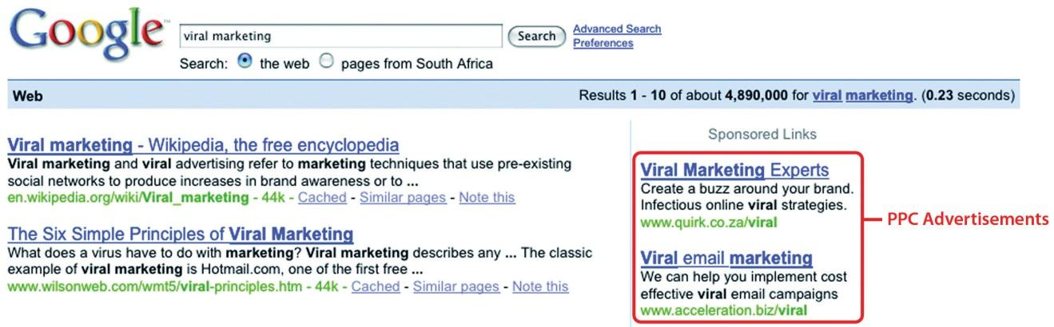
PPC advertising is keyword based—this means that it is based on the search term that a user enters into a search engine. A search term can have one word or be made up of many words. Sometimes a multiword search term is referred to as a “key phrase” or “keyword phrase.” Advertisers target those keywords for which they want their advertisement to appear.
For the advertiser, the beauty of PPC advertising on search engines is that their advertisements are displayed when potential customers are already expressing intent—they are searching for a product or service. It allows advertisers to present their offering to a potential customer who is already in the buying cycle.

History
You have learned that search engines display results to search queries based on proprietary algorithms. Each major search engine uses its own formula to determine what results to display for any term. All of this is available to Web users for free! With about 80 percent of Web users using search engines as a starting point, ^{[2]} that’s a lot of traffic going through search engines each day. So search engines require a way of generating revenue from all that traffic.
In 1996, the Open Text Index search engine began allowing Web sites to pay for a preferred ranking in selected results pages, to mixed response from business owners and other search engines. However, this was pay for placement, not that different from paid inclusion, where advertisers were paying to appear in the search results, whether or not a user clicked through to their site.
In February 1998, GoTo.com was launched. This was a new search engine that allowed Web site owners to bid for placement in the search results pages for specific search terms. Results were ranked according to how much the Web site owners were willing to bid, with the highest bid appearing at the top of the page. The Web site owner would only pay for each click, as opposed to for appearing on the results page. By July 1998, advertisers were paying up to a dollar for each click! GoTo.com changed its name to Overture Services, Inc., in 2001, and was acquired by Yahoo! in 2003. GoTo.com partnered with the portals Yahoo! and MSN to monetize their search queries.
Overture successfully patented their PPC mechanism for search engines (“system and method for influencing a position on a search result list generated by a computer network search engine” was patented in 2001) and has since then pursued, successfully, lawsuits against other PPC providers, including Google. ^{[3]} Overture initiated infringement proceedings under this patent in 2002 and settled with Google after it had been acquired by Yahoo! Google agreed to issue 2.7 million shares of common stock to Yahoo! in exchange for a perpetual license.
Google started search engine advertising in December 1999 and launched AdWords in October 2000. AdWords allowed advertisers to place keyword-targeted listings but charged advertisers on a CPM (cost per mille) basis. Google launched PPC advertising in February 2002, and today, advertising accounts for about 99 percent of Google’s revenue.

[1] Rob Hof, “Google Defies the Naysayers,” Bloomberg BusinessWeek, April 17, 2008,http://www.businessweek.com/the_thread/techbeat/archives/2008/04/google.html?campaign_id=rss_blog_techbeat (accessed June 18, 2010).
[2] Bernard Jansen and Paulo Molino, “The Effectiveness of Web Search Engines for Retrieving Relevant Ecommerce Links,” Information Processing and Management 42 (2006): 1077,http://ist.psu.edu/faculty_pages/jjansen/academic/pubs/jansen_ecommerce_ipm2006.pdf (accessed April 3, 2008).
[3] Danny Sullivan, “Overture Files Lawsuit against Google,” Search Engine Watch, May 6, 2002, http://searchenginewatch.com/2164761 (accessed June 18, 2010).

7.2 How It Works

LEARNING OBJECTIVES
- Understand how PPC (pay per click) works.
- Learn what makes up a PPC advertisement.
Each of the three major search engines (Google, Yahoo! and MSN Bing) has its own pay-per-click (PPC) advertising platform, namely, AdWords,Yahoo! Search Marketing, and adCenter. While the basic process remains the same for each one, there are some differences.
With PPC advertising, the advertiser does the following:
- Creates the content for an advertisement
- Selects the keywords for which that advertisement should appear
- Chooses the maximum amount they are willing to pay for a click on the advertisement (this amount can be unique to each keyword they have selected for an advertisement)
The search engine algorithm does the following:
- Checks the advertisement for compliance to editorial guidelines
- Displays the advertisement for relevant search queries
- Determines the rank, or position, of the advertisement based on the advertiser’s maximum bid and the relevance of the advertisement (which includes factors such as click-through rate [CTR], ad copy, keywords, and landing-page relevance to the search)

Search and Content Networks
Advertisers can choose to have their advertisements displayed on the search network only (which means on search engines), or they can select to have the advertisements displayed on the content network.
The search network will include the search engine that owns the platform (so Google for AdWords), as well as other search engines for which that platform provides paid results (e.g., currently Ask.com uses the AdWords platform for paid results).
Figure 7.2 Suppliers and Search Engines as of 2007 ^{[1]}
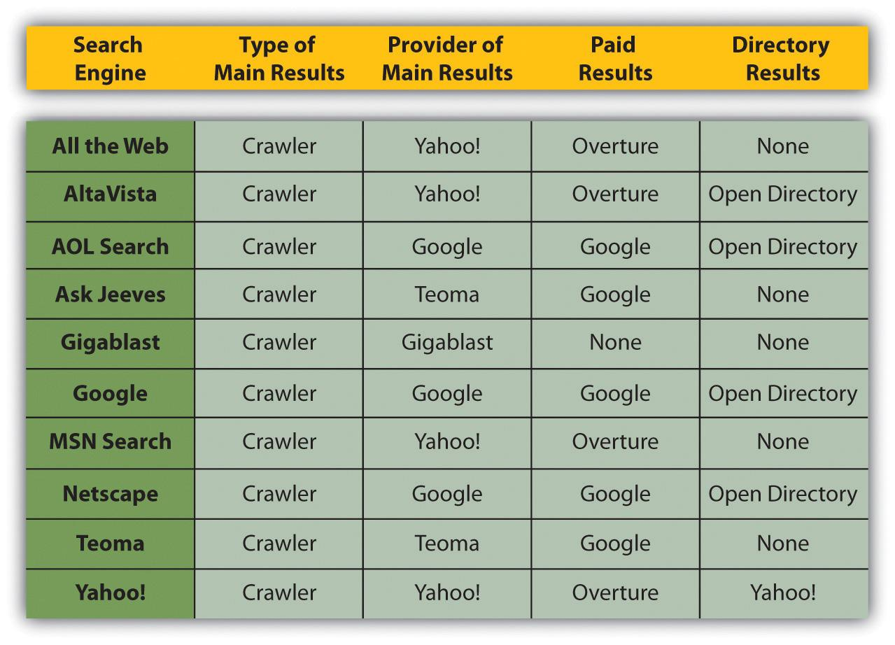
The content network refers to Web sites other than search engines that also display PPC advertisements. For Google AdWords, these are the Web sites and blogs that have joined Google AdSense, Google’s publishers’ platform. Google determines the content of the Web site and then displays appropriate PPC advertisements. Typically, the CPC (cost per click) for text ads is lower than on the search network, but the CTR and conversion rate can be much lower. The Google content network also allows image, video, and mobile ads.

Figure 7.3
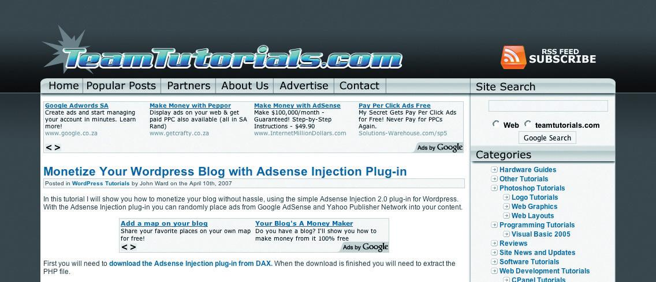
The site below is running AdSense. Notice how the advertisements correlate to the content of the article.

Discussion
Why do you think the CTR and conversion rate are lower on content PPC advertisements as opposed to search PPC advertisements?

What Makes Up a PPC Advertisement?
Text PPC advertisements follow the same basic structure:
Heading
Two lines of advertisement copy,
Which can be displayed on one line
www.DisplayURL.com
The URL (uniform resource locator) shown is not necessarily the URL that the user will click through to. When writing the copy, these are known as the display URL (what is shown on the advertisement) and the destination URL (what the actual URL of the page is). The display URL is sometimes also called a vanity URL. The aim should be to send users to a Web page as specific to their search, and the PPC advertisement, as possible. This is known as deep linking.

Discussion
What is the function of the display URL? Do you think that this is misleading to a searcher? Why do you think the display and the destination URL are different?
The display URL must be the same domain as the destination URL. Google will only show one advertisement per display URL. So an advertisement might look like this:
Roses for Valentine’s
A dozen red roses for your love;
Fast, free delivery in RSA.
www.flowers.co.za/roses
The search engines limit the characters in each line. There are also restrictions on what you are allowed to write in an advertisement. Here are some of the editorial guidelines from Google AdWords:
- Heading. Maximum twenty-five characters
- Line 1. Maximum thirty-five characters
- Line 2. Maximum thirty-five characters
- Display URL. Maximum thirty-five characters
- No repeated exclamation marks
- No word may be written in capitals only
- No nonsense words may be used
- No claims of “best,” “number one,” or superlatives may be used unless they can be verified by a reliable third-party source
- Product numbers may be used

KEY TAKEAWAYS
- In PPC (pay per click), an advertiser develops the content for an ad, selects keywords for the ad, and chooses the maximum amount they are willing to pay for a click.
- A search algorithm checks the ad for compliance with editorial guidelines, displays the ad for relevant search queries, determines the rank of the ad based on the max bid, and determines the relevance of the ad.
- Search engines have specific guidelines for advertisements.

EXERCISES
- What is the difference between the display URL and the landing page URL, and what is the function of each?
- How is the content network different from the search network? How do the differences affect the advertiser?

[1] “Search Engine Results Chart,” Search Engine Watch, March 23, 2007, http://searchenginewatch.com/2167981 (accessed June 18, 2010).

7.3 Keywords and Match Types

LEARNING OBJECTIVES
- Become familiar with match types.
- Learn why match types are important to PPC (pay per click).
We’ll take a look at keyword selection when we go through the process of setting up a campaign, but first you need to know a little bit more about the different ways we can define keywords in a PPC (pay-per-click) campaign.
Each search engine requires the advertiser to enter the keywords for which their advertisement should appear. This list of keywords determines the search queries for which the advertisements could appear.
On http://www.google.com in the United States, there were approximately 235 million searches performed each day, ^{[1]} and Google estimates that nearly 50 percent of all searches are unique. ^{[2]} It would be a tough, if not impossible, task to determine all the possible terms potential customers might use to find you. That is why there are different keyword match types for PPC advertising.
Google AdWords uses the following match types:
- Broad match
- Phrase match
- Exact match
- Negative match

Figure 7.4
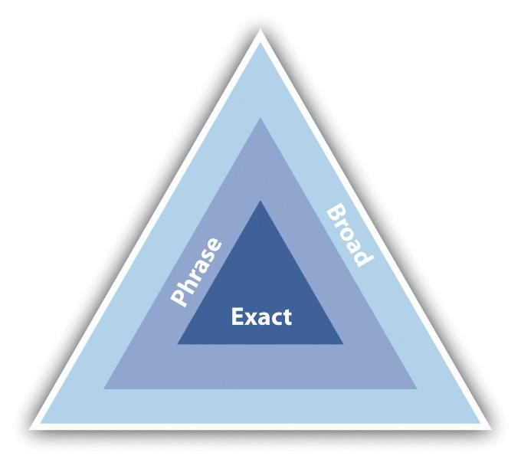
Depending on the match type, your advertisement can appear for more or fewer keywords.
Broad match means that your advertisement will appear for the keywords you have entered, as well as search terms that contain your keywords and any other words in any order, as well as some variations of your keywords (misspellings and synonyms).
Say you have chosen the following keywords, and this is set to broad match:
- tennis shoes
Your advertisement could appear for all the following searches:
- tennis shoes
- red tennis shoes
- tennis sneaker
- history of tennis shoes
Phrase match, which is denoted with quotation marks around the keywords (“phrase match”) means that your advertisement will appear only for search terms that have your keywords in them, in the same order, though other words may also be in the search term.
If you changed the same keywords to phrase match, they would look like the following:
- “tennis shoes”
Your advertisement would appear for the following:
- tennis shoes
- tennis shoes red
But your advertisement would not appear for the following:
- smart shoes red
Exact match, denoted by square brackets ([exact match]), means that the advertisement will only appear for search terms exactly the same as the keywords selected.
Now change the keyword to exact match:
- [tennis shoes]
Your advertisement will appear for searches for the following:
- tennis shoes
It would not appear for any other searches.
Figure 7.5 Match Types for Certain Search Terms
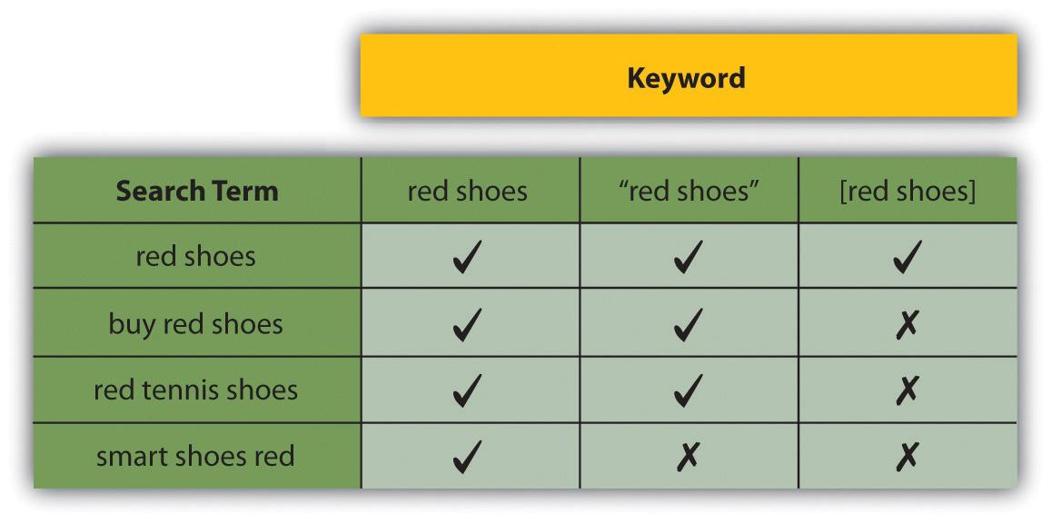
Negative match, denoted by using a dash in front of the keywords (-negative), means that your advertisement will not appear in searches using that word, no matter what other words are used.
Use the broad match example, and include a negative match:
- red shoes
- -tennis
Your advertisement would appear for the following:
- red shoes
- smart shoes red
Your advertisement would not appear for the following:
- red tennis shoes
Advertisers can assign as many keywords as they wish to an advertisement, but only one advertisement for each URL (uniform resource locator) will be shown. If two advertisers are bidding to show advertisements for the same domain, only one will be shown. Which advertisement will be shown is based on the bids being placed and on the quality of the advertisements.

Languages and Locations
You are able to target your campaigns, so you know that the traffic you are getting is relevant to your product. This is known as geotargeting.
You can choose the language of the search engine and the location. For example, you might only want your advertisement to show to English searches in Asia, or to English searches in London. Targeting your advertisement means that you won’t pay for traffic you don’t want.

Bidding and Ranking
Advertisers need to determine the maximum they are willing to pay for a click on their advertisement, and they need to decide this for each keyword they enter for an advertisement. This bid is the maximum CPC (cost per click), or max CPC, that the advertiser is willing to pay for the click.

Note
A Vickrey auction is an auction where bidders do not know what bids others have placed. It is a sealed auction. The Vickrey-Clarke-Groves mechanism is the generalization of the Vickrey auction that holds that bidders will bid truthfully. In PPC advertising, this is not always the case. Bidders sometimes bid to push prices for their competition instead of to maximize their own revenue.
However, this will not necessarily be the CPC that the advertiser must pay for a click. Every time a search query is entered, the search engine runs an auction to determine the placement of the advertisements where advertisers have bid on that search term. This auction is known as a generalized second price (GSP)auction, which is a variation on the Vickrey auction.
In the GSP auction, each advertiser will pay the bid of the advertiser below him, plus a standard increment (typically $0.01), for a click on the advertisement.
Say three advertisers, A1, A2, and A3, bid $2.50, $3.00, and $2.35, respectively, on the same keyword. The search engine has set a minimum price of $2.05 on that same keyword. Figure 7.6 "Example of Advertisers Bidding on the Same Keyword" shows how the advertisements would be positioned and what they would each pay for a click.
Figure 7.6 Example of Advertisers Bidding on the Same Keyword
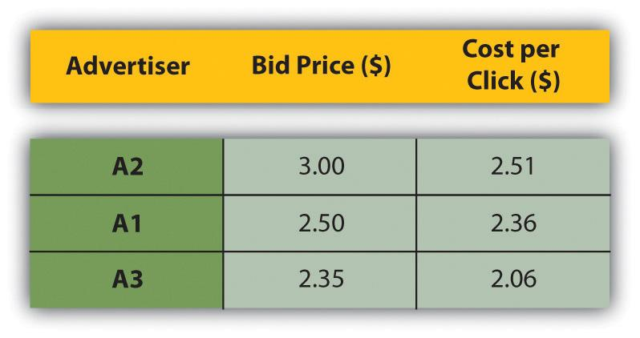
When it comes to ranking, of course, it’s not quite as simplistic as that. As well as the bid an advertiser places on a keyword, the search engine will take a number of other factors into account. In the case of Google AdWords, this is known as Quality Score.
The Quality Score is determined by the following, among other factors:
- The relevance of the keyword to the search term
- The relevance of the advertisement copy to the search term
- The relevance of the landing page to the search term
- The historic click-through rate (CTR) of that advertisement
Search engines look at factors such as relevancy to try to ensure that it is not just having deep pockets that can land advertisers the top spot. Search engines need to ensure that users find the advertisements relevant, otherwise they’ll be less likely to click on them—and no click means no revenue for the search engine.

Conversion Rates and Click-Through Rates
Figure 7.7 A Heat Map from Eyetools.com That Shows Where Users Look on a Search Engine Results Page (SERP)
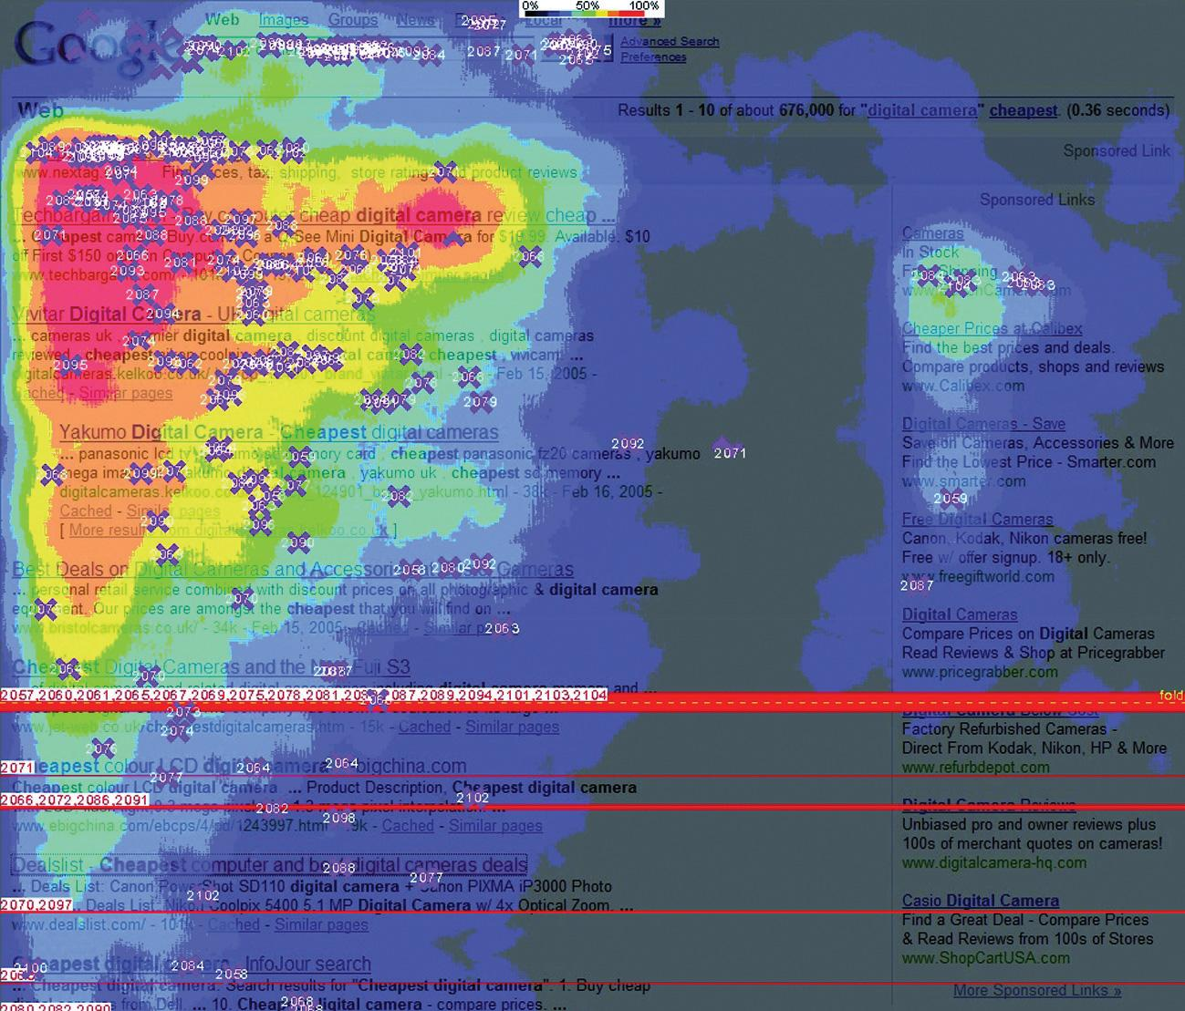
Source: Heatmap generated by Eyetools, Inc.
Studies repeatedly show that those advertisements nearer the top of the page (so the best ranked) attract the highest CTRs (click-through rates). They get the most clicks. And the clicks cost the advertisers more.
Looking at the heat map, you can see that getting in the blue box on Google will most likely generate even more clicks on an advertisement. You might think the more clicks the better, but is this necessarily the case?
Being in the top position means you will pay more per click. Many clicks at a higher price may use up your budget quickly. Also, many people click on the top advertisement believing it to be the top organic search result—often without reading the advertisement text.
Advertisers need to consider what a user does after clicking through to the advertiser’s Web site from the search engine. When planning a PPC campaign, it is therefore crucial to set up the goals of the campaign and make sure that these are being met. You can use your analytics package to set these up. With a goal set up, the advertiser can track how many of the users that click through to the Web site follow through to that goal. This is called a conversion.
Goals can be any of the following:
- Buying a product
- Filling in a form
- Downloading a white paper
- Sending an inquiry
- Booking a flight
We know that the CTR of an advertisement is the percentage of clicks divided byimpression.
The conversion rate of an advertisement is the percentage of conversions divided by click.
As the advertiser, you also need to know the value of each conversion. You need to know this so that you don’t pay too much for your clicks, and so that you bid to have the best CTR for maximum return on investment (ROI).
Figure 7.8 How to Adjust Bidding Strategies Based on Business Principles
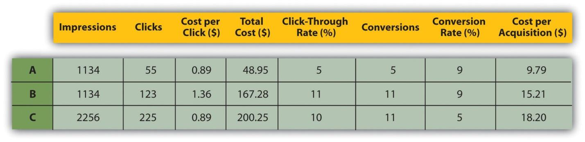
Figure 7.8 "How to Adjust Bidding Strategies Based on Business Principles"shows how you might adjust bidding strategies based on business principles such as the following:
- Example A. Bid on a keyword with phrase match.
- Example B. Bid on the same keyword with phrase match, but bid for a higher position. The conversion rate of the Web site remains the same, but because of the higher CPC, the CPA (cost per action) increases, although there are more conversions.
- Example C. Bid on the same keyword, but with broad match this time. Because the traffic is less targeted, the conversion rate on the Web site is lower. This means that the CPA increases again.
The campaign needs to be run according to business rules. A PPC campaign can aim for maximum conversions, but this is usually at a higher CPA.

Budgets
As well as deciding on your CPC bids for your keywords, you are able to determine the budgets for your campaign. You can set daily budgets, monthly budgets, or no budget. Once your budget is reached, your advertisements are paused, so you can be sure that you never overspend. If you are concerned about overspending, you can set a daily budget. However, this can mean that your advertisements do not run as often as you would wish them to.
The different advertising platforms offer advanced bidding options, all aimed at helping you to run your advertising campaign better. You can bid for placement on the search engine results page (SERP), or you can bid based on how much you are willing to pay for a click. You are able to bid for advertisements during certain times of the day only, called scheduling.

Note
Scheduling allows the advertiser to show their advertisements only at certain times of the day. For example, an advertiser might want to time their advertisements to show at the usual time for lunch breaks.

Which Platform Should I Choose?
There is some theory that different platforms are better for different industries. For example, some believe that Yahoo! fares better than Google on travel advertising. However, this is subjective, and most large advertisers will run PPC campaigns on a number of platforms. As with most things in eMarketing, it is all about testing.
There are some small differences with each platform in terms of editorial policy, and each system has a different user interface. Google AdWords, perhaps the most well known, allows users to transact in the currency of their choice and also offers training programs and certifications.
Google AdWords also currently has the best geotargeting worldwide, although geotargeting is offered by both Microsoft adCenter and Yahoo! Search Marketing.

The Long Tail
Google has estimated that 50 percent of searches are unique. This means that the sum of unique searches is about the same as the sum of nonunique searches. Looking a little more closely at search terms will show a small number of high-volume searches, and then a large number of lower volume searches stretching out to those unique searches.

Figure 7.9
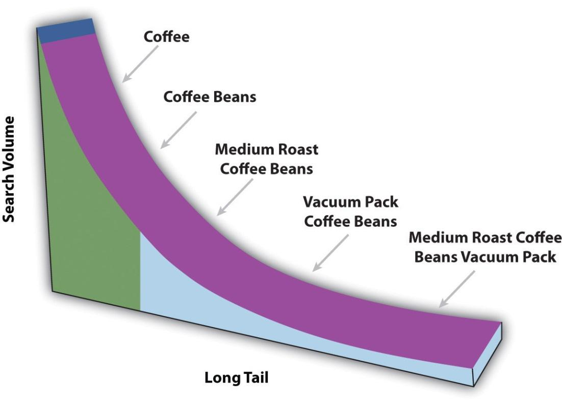
In the long tail, the sum of the low-volume searches matches the high-volume searches.
This is sometimes referred to as the long tail of search. Figuring out those low-volume, niche search terms can do wonders for a PPC campaign. Generally there is not much competition for those search terms, and the search term itself is very targeted.
AdWords offers an AdWords Starter Edition—sign up for an account to see how it works! You can sign up from http://adwords.google.com. Just choose “Starter edition” after you click to sign up.

KEY TAKEAWAYS
- Advertisers can define keywords for which their ad should appear.
- Google uses the following match types:
  - Broad
  - Phrase
  - Exact
  - Negative
- Advertisers can assign as many keywords as they wish to an ad, but only one ad for each URL (uniform resource locator) can be shown.
- Advertisers can target by location and language for added relevancy.
- Advertisers can determine the maximum they are willing to pay for a click on their ad. This is known as bidding, and it determines ranking.
- Every time a search query is entered, the search engine runs an auction to determine the placement of the advertisements where advertisers have bid on that search term.
- The Quality Score is determined by four main factors:
  - The relevance of the keyword to the search term
  - The relevance of the advertisement copy to the search term
  - The relevance of the landing page to the search term
  - The historic CTR (click-through rate) of that advertisement
- There are many things in a PPC (pay-per-click) campaign that can affect conversion rates and CTRs. An advertiser needs to evaluate goals to see what is best.
- Budgets are based on CPC (cost-per-click) bids. Advertisers have flexibility in how their budgets run.
- Testing is essential in determining what search platform is best.
- It is important to consider long-tail keywords in a campaign.

EXERCISES
- What is the importance of long-tail keywords in a PPC (pay-per-click) campaign?
- Following the examples above, give examples of when you’d use exact match and negative match. When is it OK to use broad match?

[1] Wendy Tanaka, “Google Hits Double Digits,” Forbes, September 5, 2008,http://www.forbes.com/2008/09/04/google-tenth-anniversary-tech-enterprise-cx_wt_0905google.html (accessed June 18, 2010).
[2] Patricia Hursh, “Marketing in the Search Tail: Is the Pain Worth the Gain?” Search Engine Watch, January 24, 2006, http://searchenginewatch.com/3579396 (accessed June 18, 2010).

7.4 Planning and Setting Up a Campaign

LEARNING OBJECTIVES
- Know the steps needed to get a campaign up and running.
- Understand the importance of landing pages.

Step 1: Do Your Homework
For a successful campaign, you need a full online and an offline analysis of the business, customer demographics, the industry, and competitors. While it is relatively quick to set up a campaign, preplanning will show dividends later. You need a brand, an identity, and a clear, unique selling point. You only get three lines to advertise, so you need to make sure you know what should be in there.

Step 2: Define Your Goals
You need to know what you want to achieve with your PPC (pay-per-click) campaign. Branding campaigns, for example, are very different from campaigns that increase sales. What do you want users to do once they click on your advertisement?

Step 3: Determine Your Budget, Cost per Action, and Targets
Determine how much you are willing to spend to achieve your goal—your target cost per action (CPA). Decide how much budget you are going to allocate to your PPC campaign. If your goal is to increase revenue, your budget might be unlimited so long as revenue is increasing and you are within your target CPA.

Step 4: Research Keywords
You need to determine what keywords potential customers are likely to use when searching for the service that you offer. Along with that, you need to know the following:
- What common misspellings a customer might use
- What words would show that they are not likely to purchase from you (words like free and cheap)
As part of your keyword research, you need to look at expected volumes for your keywords, so you know how to bid on keywords. See “Tools of the Trade” in for some suggestions.
There are also tools that will show you similar or related keywords, so you can expand your keyword list even further. Again, find suggestions in “Tools of the Trade” in .

Step 5: Write the Advertisements
Using your keyword research, write compelling advertisements to promote your products. Advertisements can be unique to a keyword, or you can group them and have a number of keywords for one advertisement.
Make sure you use an appropriate display URL (uniform resource locator) and that you target the landing page for each advertisement. Always include a call to action.

Step 6: Place Your Bids
Based on your goals and keyword research, set the maximum bids for your keywords. Don’t set these too high at this stage—you’ll tweak the bids as you test your campaign.

Step 7: Measure, Analyze, Test, Optimize!
With conversion tracking in place, you can analyze your ROI (return on investment) down to a keyword level, and then focus on those keywords that are converting best. Consider seeing how changing the text of your advertisement can increase the CTR (click-through rate) or perhaps better your conversion rate. Test different landing pages to see what converts better.

Landing Pages
PPC advertising is not just about creating advertisements and bidding for keywords. The process continues once a user has clicked on your advertisement. The page that the user reaches by clicking on an advertisement is called a landing page.
Landing pages can make or break an advertising campaign. Poorly executed PPC campaigns will send all users to the home page of a Web site. Campaigns that convert will make sure that users land on a page that is relevant to their search. The aim is to keep the user as focused on the goal—conversion—as possible. Sending the user to the home page gives him too many other options to choose from.
For example, if someone searched for “Canon EOS 450D,” a poorly run campaign would send that user to http://www.canon.co.uk. A better campaign would have the user clicking through to http://www.canon.co.uk/For_Home/Product_Finder/Cameras/Digital_SLR/EOS_450D/index.asp.
Landing pages also indicate relevance to the search engine, which can increase the Quality Score of the advertisement, and in turn lower the CPC (cost per click) of the keyword. Adding pages to the Web site that are keyword rich can also carry SEO (search engine optimization) benefits.
PPC campaigns often have thousands of keywords, which can mean that there will be a lot of landing pages to be built! Creating dynamic landing pages means that with a simple script, unique keyword-rich landing pages can be created for every search. The script will take the keyword that the searcher has used, and insert it in predefined places on the landing page. The user will then be landing on a page that is highly relevant to their search!
Dynamic landing pages can be created with a simple script that will allow for a landing page to be created for every keyword in the PPC campaign.

Note
The bounce rate of the landing page also affects the Quality Score of an advertisement. See for more information.

KEY TAKEAWAYS
- There are some clear steps one should take before launching a PPC (pay-per-click) campaign. It is important to take each one seriously for best results.
- Landing pages can make or break an advertising campaign. Sending a user to a home page is not wise. Instead, the page needs to be relevant for the user to get the most out of their search.
- Landing pages also impact the Quality Score, and in turn lower the CPC (cost per click).
- PPC campaigns often have thousands of keywords, which can result in many landing pages being built. For this, dynamic landing pages are helpful.

EXERCISE
- Search for some keywords specific to a major brand you know. Click on the ad and evaluate the landing page. Do the same with another brand. What comparisons can you make? What did the two brands do differently with their landing pages? What did they do the same?

7.5 Online Comparison Engines

LEARNING OBJECTIVE
- Learn how online comparison engines work.
As we mentioned, PPC (pay per click) does not only apply to search engine advertising. We have seen that advertisements can be placed on content sites. PPC can also refer to display advertising, where advertisers pay only for each click-through to their site, as opposed to each impression of the banner. PPC is also used by many online comparison engines.
You have probably come across online comparison engines when searching for a particular product. Popular comparison engines include the following:
- NexTag (http://www.nextag.com)
- PriceRunner (http://www.pricerunner.com)
- Kelkoo (http://www.kelkoo.co.uk)
- Pangora (http://www.pangora.com)
- Jump (http://www.jump.co.za)
These engines contract with retailers. The retailers supply the engine with a product feed (XML [extensible markup language] or CSV [comma-separated values]) that contains the following information:
- Product name
- Product price
- Product URL (uniform resource locator)
- Product serial number
- Product image
- Product description
- Product keywords
Figure 7.10
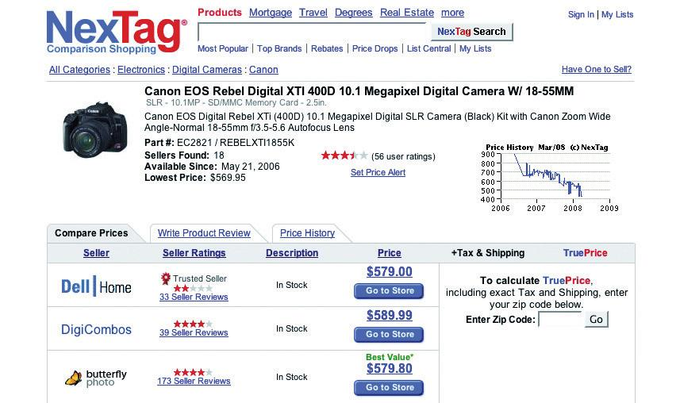
A shopping comparison engine will show offers from a number of retailers.
When a user searches for a product on one of the comparison engines, the engine will list all retailers who offer that product. When the engines contract the retailers, they also agree on how much the retailer is willing to pay for each click from the comparison engine through to the retailer’s Web site. The minimum CPC (cost per click) will vary from category to category (consumer electronics, for example, could have a higher CPC than baby clothes).
When results are shown, priority is given to those retailers who are willing to pay a higher CPC. However, the user has the option of sorting results by price, alphabetically, and so on.
Online comparison engines form an important part of the online marketing mix for an online retailer. As well as comparing products from different retailers, they also offer users the chance to review products as well as retailers. Many users prefer to start their product search on a comparison engine, as they can see a variety of prices for the same product in one place.
So what can you do to market your site more effectively through online comparison engines? You may try any of the following:
- Measure conversion from the clicks you get from the comparison engine. You’re paying for the traffic; make sure it’s worthwhile.
- Optimize the product feed you supply:
  - It should be up to date.
  - Product names should be clear.
  - Each product must have a unique URL.
  - The product should have a succinct description.
- Make sure your price is right:
  - Don’t overpay for clicks.
  - Ensure your pricing and customer service are competitive: you don’t have much space to entice the user to click through to your site.

Tools of the Trade
The foundation of search marketing is keyword research, and there are a number of tools that will both aid you in growing your keyword list and in determining keyword volumes. Some are free and some require a fee. Many keyword volume tools have relied on Overture, and as Yahoo! is no longer supporting this tool, the information is not necessarily accurate. All these tools should be used as guidelines only. Test the data with your own campaigns to determine what works best for you.
Figure 7.11 Google’s Ad Preview Tool
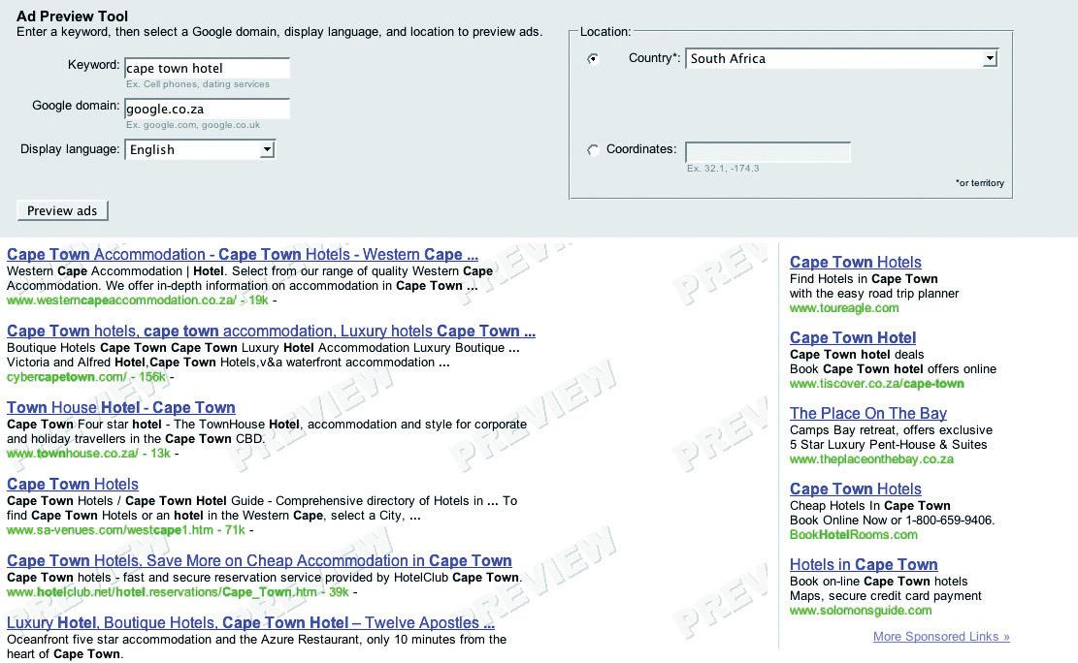
Keyword volume tools include the following:
- http://www.freekeywords.wordtracker.com
- http://www.yooter.com/keyword/overture.php
- http://tools.seobook.com/general/keyword
- http://www.google.com/trends
Keyword suggestion tools include the following:
- http://adwords.google.com/select/KeywordToolExternal
- http://www.keyworddiscovery.com/search.html
- http://tools.seobook.com/keyword-list/generator.php
Google AdWords has an Ad Preview Tool, which allows you to see where your advertisement would appear on the page (without using the search engine and thus skewing data). This can be accessed at http://adwords.google.com/select/AdTargetingPreviewTool.
Some paid services that aid with keyword research are the following:
- http://www.wordtracker.com
- http://www.keywordsecret.com
- http://www.nichebot.com
Spreadsheets, such as Microsoft’s Excel, are useful to aid you in building your keyword lists. Getting to grips with functions such as concatenation will be useful.

KEY TAKEAWAYS
- PPC (pay per click) can also refer to display advertising, where advertisers only pay for each click-through to their site.
- Online comparison engines are an important part of online marketing mix for an online retailer.
- There are steps you can take to market your site more effectively through these online comparison engines.
- Measure conversion from the clicks you get from the comparison engine. You’re paying for the traffic; make sure it’s worthwhile.
- Optimize the product feed you supply.
- Make sure your price is right.
- Be sure to use tools to help you. There are many free and paid tools that can be useful as you develop keywords.

EXERCISE
- Using some of the free keyword tools listed above, develop a sample list of keywords for a client of your choice.

7.6 Pros and Cons

LEARNING OBJECTIVE
- Fully understand the benefits of PPC (pay per click) while also understanding the negatives.
PPC (pay-per-click) campaigns are relatively quick to set up, can provide high volumes of traffic, and are by nature highly trackable—what’s not to love? But there are some pitfalls that you ought to be aware of.

Click Fraud
Click fraud occurs when your advertisement is clicked on by someone who is not a legitimate potential customer. Because an advertiser has to pay for every click on his advertisement, sometimes unscrupulous competitors can click on the advertisement to force the payment. There are even automated bots that can click on advertisements, costing advertisers millions.
Google said in February 2007 that click fraud accounts for only 0.02 percent of clicks. You can read more on its blog:http://adwords.blogspot.com/2007/02/invalid-clicks-googles-overall-numbers.html.
The search engines, however, have taken measures to combat this. Advertisers can report suspected click fraud, and the search engines will refund invalid or fraudulent clicks after investigation.
What can you do? Keep an eye on your campaign. Any sudden leap in CTRs (click-through rates) should be investigated, and you should pay particular attention to see if the conversion rate drops (which would indicate potential fraud) or stays the same. Pause the campaign if you suspect fraud, and alert the search engine.

Bidding Wars and Climbing Costs per Click
High-traffic keywords are expensive, and the battle to stay on top means that the CPC (cost per click) of these keywords is escalating. Convincing yourself that it’s number one or nothing can result in burning through your campaign budget quickly with nothing to show for it.
What can you do? Keep focused on your campaign goals and ROI (return on investment), and keep investigating to find the (cheaper) niche keywords that work for you.

Time Required to Keep an Eye on Things
PPC campaigns require a lot of monitoring, and the bigger your campaign gets, the more time this takes. PPC advertising can provide a fantastic ROI, but you need to check in and tweak regularly to make sure that it continues to perform for you.
What can you do? Make sure that you have allocated the time required to run a successful campaign. There are also tools available that make managing large campaigns easier. But remember the following good reasons (and many, many more) why PPC works for you:
- No- to low-cost barrier. You only pay for traffic; there are minimal setup fees involved.
- Tracking every cent. PPC advertising allows you to track your advertising spending down to a keyword level, so you can learn what works and what doesn’t on a small scale.
- Targeted advertisement placement. You can make your advertising relevant with the many filters available when selecting where to show your advertisements.
- Giving your customers what they want. PPC advertising lets you place your advertisement in front of people who are searching for your product. It lets you provide a solution, as opposed to creating an interruption. What more could you want?

KEY TAKEAWAYS
- While there are many advantages to PPC (pay per click), there are some things to be wary of:
  - Click fraud
  - Bidding wars and climbing CPCs (costs per click)
  - Time required to keep an eye on things
- However, there are many advantages. It’s important to weigh the pros and cons to see if PPC is right for you.

EXERCISE
- Both PPC (pay-per-click) advertising and SEO (search engine optimization) are based on keywords. How can PPC advertising and SEO be used to complement each other?

7.7 Case Study: Southern Sun
Southern Sun (http://www.southernsun.com) launched a new Web site in May 2006. The changes included an updated look and feel, a greater quantity and quality of information, and better booking functionality. As often happens with a site relaunch, Southern Sun lost all the previously good organic search engine rankings. A new Web site needs time to climb up the search engine rankings, and it can take a minimum of three months before it starts receiving organic traffic. Southern Sun could potentially have lost out on bookings because of the decrease in organic traffic. Therefore, they required a way of ensuring that their site still did the following:
- Continued to receive a steady flow of bookings despite temporarily poor organic rankings
- Received enough traffic to analyze user behavior and responses
- Received enough traffic to generate trust from search engines and climb up the SERPs (search engine results pages) as fast as possible
With the new site, Southern Sun hoped to increase the number of bookings made online and to tap into the international-tourist and business-travel market. This meant they needed to migrate a significant amount of their offline promotions and special offers to their Web site in such a way as to attract a favorable online response.
Quirk eMarketing, the online agency for Southern Sun, set up a PPC (pay-per-click) campaign with the following intentions:
- Sending traffic to the site
- Attracting international traffic
- Split-testing campaigns
Separate campaigns were built for the following:
- Local versus international traffic
- Brand- and hotel-specific versus place-specific traffic
- Special offers and campaigns versus normal traffic
Quirk did an extensive keyword research exercise to identify high-traffic-generating keywords in order to get as much traffic as possible, as well as niche long-tail keywords for better cost per conversion. Keywords specific to Southern Sun’s various customer groups were targeted, such as families, business travelers, couples, and tourists.
Furthermore, advertisements were set up that tested the best marketing message, that is, whether people responded best to the following:
- The Southern Sun brand
- A special offer
- A wide variety of hotels and brands
- Location and convenience
- Facilities
As a result, Quirk could assess whether different groups of people were influenced by different advertisements, as keyword research had been done according to customer groups.
In order to determine whether people responded better to special offers and campaigns or just hotel and area details, landing-page split tests were conducted. Tracking for various different stages of the hotel-booking process was implemented, including the hotel room quote and the final thank-you-for-payment page so that it would become evident where any drop-offs occurred.
One of the great advantages of PPC is that it gets immediate results. As soon as the new site went live, so did the PPC campaign, which meant traffic from day one. The traffic generated by the PPC advertising ensured that the site was noticed by search engines and was trusted as a valid South African hotel site.
Split testing revealed some very interesting and useful behaviors and trends:
- The overall best response was to the advertisements containing the Southern Sun brand, particularly from the local South African market. This was very positive for Southern Sun and gave them a distinct PPC advantage with regard to Google’s quality, as it meant high click-through on competitive key phrases like “Cape Town hotels.” It also showed that its brand was not as well recognized in the United Kingdom and the United States.
- Search marketing is driven by meeting a need, whereas offline marketing involves creating a need. Split testing picked up that the (very successful) offline marketing campaigns were not so successful when actively marketed through PPC and that they do better when advertised from within the Web site. The campaign had an average booking rate of 0.38 percent. The landing pages that supplied a list of hotels in an area or offering a service far outperformed this, with an average booking rate of 3.45 percent.
- International traffic responded differently to various offers and hotel details compared to local traffic. In general, there was a better response locally with an ROI (return on investment) of 780 percent versus 430 percent.
Running a PPC campaign when you launch or relaunch a site will do the following:
- Attract enough traffic to ensure you don’t lose business
- Test site structure and browser behavior
- Allow you to assess where traffic comes from, so you can test and optimize presentation of your product to your customers

CASE STUDY QUESTIONS
- What information from the PPC (pay-per-click) campaign could be used to help optimize the Web site?
- Why does a PPC campaign give instant traffic while SEO (search engine optimization) does not?
- What is the importance of landing pages in a PPC campaign? What sort of different landing pages do you think would be used?

7.8 References
Andrew Ellam, “Overture and Google: Internet Pay per Click (PPC) Advertising Auctions,” London Business School, March 2003, http://www.kellogg.northwestern.edu/Faculty/ottaviani/homepage/Papers/Overture%20and%20Google.pdf (accessed June 23, 2010).
“Financial Release,” press release, Google, January 31, 2008, http://www.google.com/intl/en/press/pressrel/revenues_q407.html(accessed April 3, 2008).
“Google Announces Plan for Two-Year Expiration, but…,” Google Watch, July 16, 2007, http://www.google-watch.org/cgi-bin/cookie.htm (accessed April 3, 2008).
“Google Search’s Golden Triangle,” Eyetools, http://www.eyetools.com/inpage/research_google_eyetracking_heatmap.htm(accessed April 3, 2008).
“Search Engine Results Chart,” Search Engine Watch, March 23, 2007, http://searchenginewatch.com/2167981 (accessed June 18, 2010).
Danny Sullivan, “Searches per Day,” Search Engine Watch, April 20, 2006, http://searchenginewatch.com/2156461 (accessed June 18, 2010).
“Traffic History Graph for Google.com,” Alexa, April 3, 2008, http://www.alexa.com/data/details/traffic_details/google.com (accessed April 3, 2008).

Chapter 8

Social Media

8.1 Introduction
Blogs, wikis, social bookmarks, and tag clouds: these are new words for new things and new ways to use words. You may be living in the world of social media, but to many it’s a jumbled jungle with no clear structure.
The many facets of social media are also called Web 2.0, consumer-generated media (CGM), participatory media, and new media. In fact, comparing social media to traditional media is probably the most useful way of defining what exactly this means.
Most simply put, social media are media (from written to visual to audio to audiovisual) that are designed to be shared. Sharing means that it is easy to comment on, that it is easy to send, and that there are no high costs associated with viewing the media. Because of the connected nature of the Internet, it means that sharing, commenting, and viewing can all be tracked and measured.

Figure 8.1 The Differences between Traditional and Social Media
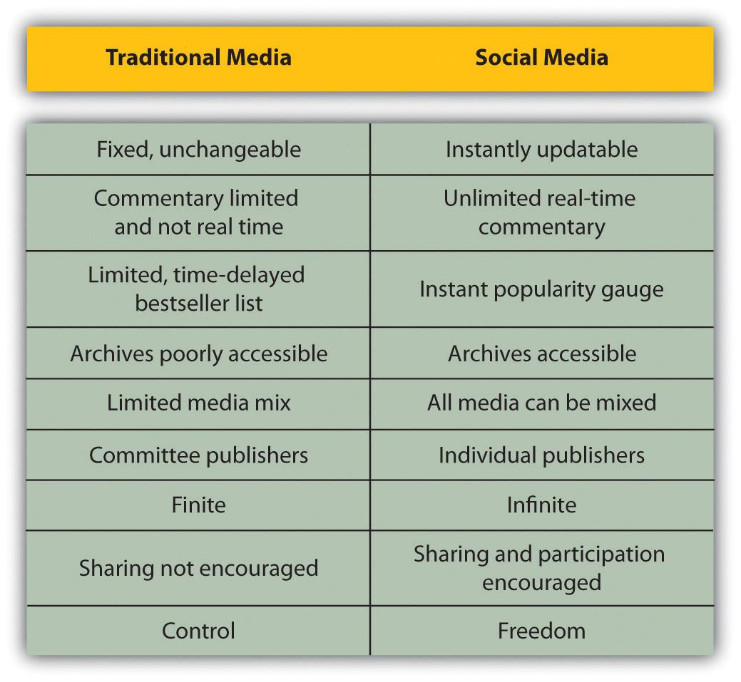
The Internet, and the software developed to run on it, has made it simple for anyone to publish and distribute content. It has also made it simple for anyone to access that content.
The realm of social media is about collaborating, generating content, sharing, and most of all, connecting.

History
Blogs are probably the best-known example of social media. One of the earliest online journals recorded was http://www.links.net, Justin Hall’s online diary, which he kept for eleven years from 1994. ^{[1]} From the very first days of the Internet, early adopters used it to create personal content.
These online diaries were referred to as “Weblogs,” for “Web” and “log,” but in April or May of 1999, Peter Merholz unwittingly coined the term “blog” by adding the following to the sidebar of his Web site peterme.com: “For What It’s Worth I’ve decided to pronounce the word ‘weblog’ as wee’-blog. Or “blog” for short.” ^{[2]}
Developers began creating tools that made it easier for anyone to start a blog. Blogger, a popular blogging platform, was launched in August 1999 and acquired by Google in 2003. In 2001, Wikipedia, probably the most well-known wiki, was created. (A wiki is a simple Web site that can be edited in real time by a number of users.)
Technorati, which tracks blogs and tagged social media, was launched in 2002. As of April 2008, Technorati was tracking 112.8 million blogs and noted in 2007 that 1.4 new blogs were being created every second.
Social media are not just about blogging, though, and several platforms that made sharing other kinds of content easier have come to the fore. Flickr, the online photo-sharing tool, was launched in February 2004 and bought by Yahoo! in June 2005.
By this stage, the social media buzzwords and neologisms were being picked up by the mainstream press, and in 2004, the Merriam-Webster dictionary chose “blog” as the word of the year.
YouTube (http://www.youtube.com), the online video-sharing Web site, was previewed in May 2005 and launched six months later. It was acquired by Google in November 2006 for $1.65 billion. Twitter, which allows for users to share 140-character “tweets,” was launched in October 2006.
In 2006, Time magazine named “You” as the Person of the Year for “the growth and influence of user-generated content on the Internet.” ^{[3]} In 2009, Google started including tweets in search results—something they call “real-time search”—indicating the importance of social media in terms of relevant content.

[1] Reyhan Harmanci, “Time to Get a Life—Pioneer Blogger Justin Hall Bows Out at 31,”San Francisco Chronicle, February 5, 2005, http://www.sfgate.com/cgi-bin/article.cgi?file=/c/a/2005/02/20/MNGBKBEJO01.DTL (accessed May 27, 2008).
[2] Peter Merholz, “Play with Your Words,” peterme.com, May 17, 2002,http://www.peterme.com/archives/00000205.html (accessed May 27, 2008).
[3] Lev Grossman, “Time’s Person of the Year: You,” Time, December 13, 2006,http://www.time.com/time/magazine/article/0,9171,1569514,00.html (accessed June 20, 2010).

8.2 How It Works

LEARNING OBJECTIVE
- Understand the fundamental concepts behind social media.
Social media have changed the world we market in and can be used as an integral part of an online marketing campaign. Social media are all about the ways that we create, connect, and share online.

Bookmarking and Aggregating: Sharing Things You Like
If there are Web sites that you visit often or that you would like to keep as a reference to come back to, it is easy to use your browser to “bookmark” them. This means that you store the URL (uniform resource locator) so that you can locate it again easily. It also gives you a personal library of Web sites that you can store on your computer.
Social bookmarking sites, however, allow you to store these links online, use tags to describe them, and share these lists with other users. Some of these sites let you submit URLs that other users vote on, while others allow you to use the saved tags to browse through the lists and libraries that have been generated.
Web sites that want to encourage users to submit content to bookmarking and aggregating sites use “chicklets.” These are buttons placed around the content that make it easier to submit and share the article.
These services allow you to see what the community of Web users finds useful, interesting, or humorous. You are able to find other users with similar interests to yours and explore Web sites that they have found that you might not have come across yet.
Social bookmarking allows like-minded people to share interesting and relevant content with one another easily. It can also be an excellent tool for members of a company or organization to earmark relevant Web sites and articles. Content submitted to a social bookmarking or aggregating site can dramatically increase traffic to a Web site and expose the site to many new eyeballs.
One such site, Delicious (http://delicious.com), was created in 2003 by Joshua Schacter ^{[1]} and today boasts over five million users. ^{[2]} It was designed to be a site that would help Internet users organize online media in a quick, easy-to-access, and user-friendly format. Now owned by Yahoo! the primary function of Delicious is to allow users to store all their bookmarks online and then to access those bookmarks from any computer anywhere in the world. Compared to other social bookmarking sites, Delicious is more of a community-based tool, as it allows others to see your bookmarks. Essentially it lets you identify other people whose interests and concerns parallel yours and grants you access to all of their bookmarks as well.
Check out http://delicious.com/quirkemarketingtextbook to see some of the URLs we think are relevant to your eMarketing studies and career.

Note
Alexa is a service that ranks the popularity of Web sites. It is based on the Internet habits of users of the Alexa toolbar as well as the Quirk SearchStatus Firefox extension, so these rankings are based on a percentage of the global Internet population.
Digg (http://www.digg.com), Muti (http://www.muti.co.za), and Reddit (http://www.reddit.com) are sites where users submit content that other users can then vote on. Popularity, based on votes, moves the submitted content up and down lists that are available on these sites. Submitting and voting requires registration, but there are many people who visit these sites to get an overview of content that is “hot.” In fact, in late 2009, Digg was at 102 in the Alexa rankings. Although its traffic is said to be declining, it is still generating plenty of traffic each day.
Appearing on the top of these lists generates a huge increase in traffic for content sites, so much so that servers can crash if the leap in visitors is unexpected. Getting into the top listings is a prize eyed by many a marketer, but any attempt to manipulate listings usually backfires and can generate plenty of community backlash.
The communities around these sites differ demographically, and this is reflected in the content. For example, Digg is technology focused, while Reddit tends to have more general news.
StumbleUpon (http://www.stumbleupon.com) lets you explore the Web through your interests, based on how other Web users tag content. Users select categories of interest and bookmark URLs in those categories. You can then choose to “stumble” through the Web using the category of your choice. The service will randomly show you a Web site that has been submitted to that category.

Note
Some Internet commentators refer to this taxonomy—the categorization of Web content based on labels and tags supplied by Web users—as a folksonomy—a way of categorizing content that the community creates, as opposed to hierarchical categorization by a central body.
StumbleUpon allows users to explore the Web based on the taxonomy applied by other users. Instead of looking to search engines for relevance, users are instead appealing to the knowledge of a community.
Technorati (http://www.technorati.com) started life as a real-time blog search engine but has since evolved to incorporate other forms of user-generated content, including images and videos. According to Technorati’s Web site, Technorati tracked over 112 million blogs and 250 million pieces of tagged social media as of early 2008. ^{[3]} Internationally it is the blog aggregator and an essential tool for anyone who operates online.
Technorati’s core is a tag-based index that allows users to conduct searches on topics that interest them. Contributors are able to tag their individual posts, and the better a post is tagged, the better its chance of being picked up by a relevant search. Instead of contributors being separated into categories, the content of each individual post is indexed. Technorati not only searches the blogs of subscribed members but also operates as a normal search engine.
Technorati can also be used to keep tabs on Internet buzz, both to monitor online reputation and to see what trends are emerging.

Bookmarking and Aggregating as Marketing Tools
Seeing how users categorize your content will give you an idea of how your Web site and company are perceived by your audience. It might be remarkably different from how you think they see you. Look at other Web sites that are tagged like yours. You might find new competitors and new ideas.
You can also use these services to share what other URLs your company finds interesting. This can be a useful resource to add to an online press room as well as a utility that fanatics of your company would get really excited about.
To create link love and traffic, investigate what sort of content your target audience loves voting for and create that content. A word of warning: never submit content and then vote yourself. It’s one surefire way to incur the wrath of these communities.
Organic growth is the only way to succeed here. It might take time as you build your reputation and worth among the community, but the end result can be very worthwhile. As a content provider, make sure you have the appropriate chicklets added to your content to make it easier to share.
Figure 8.2
Chicklets can be standard, like on http://www.gottaquirk.com on the left, or adapted, as http://www.timesonline.co.uk has done on the right.

KEY TAKEAWAYS
- Bookmarking sites can allow users to share content with others.
- Other sites allow users to share content with others who will then vote on it.
- Chicklets make it easy for users to submit and share an article.
- Marketers can evaluate tagged pages to see who is saving your content. You may be surprised to learn who is interested in you!

EXERCISES
- Visit http://www.timesonline.co.uk. List the ways that this print publication is embracing social media.
- Visit Digg or Reddit. Search for information on one of your favorite brands. See what has been tagged. What did you find? Were you surprised at what you found?

[1] Michael Arrington, “Exclusive: Screen Shots and Feature Overview of Delicious 2.0 Preview,” TechCrunch, September 6, 2007,http://www.techcrunch.com/2007/09/06/exclusive-screen-shots-and-feature-overview-of-delicious-20-preview (accessed April 2, 2008).
[2] Wikipedia, s.v. “Delicious (website),”http://en.wikipedia.org/wiki/Delicious_%28website%29 (accessed June 22, 2010).
[3] Wikipedia, s.v. “Technorati,” http://en.wikipedia.org/wiki/Technorati (accessed June 22, 2010).

8.3 Content Sharing: Create and Share

LEARNING OBJECTIVE
- Learn how creating content and sharing content work together.
YouTube (http://www.youtube.com) may be the first content-sharing site that comes to mind, but users share images, audio, and information as well as video. If it can be created, then it can be shared. There are many sites that facilitate free sharing of videos, images, and audio, and they are exceptionally popular. From Flickr to YouTube, they have all tapped into the fact that we love to create content for others to view.
The key word here is “free”: there are no fees for joining, whether you are uploading content or viewing content (although premium paid-for memberships can allow access to further features). This means that these sites attract an enormous audience. In fact, according to Alexa rankings, YouTube is the fourth most visited site in the world!
Many of these services also encourage distribution of their content. YouTube allows videos to be embedded easily into other Web sites, and Flickr has generated a number of applications and widgets that allows the images to be shown all over the Web (and even printed onto cards and stickers viahttp://www.moo.com).
Most of these Web sites rely on advertising to support the free services they offer, and some have a premium paid-for membership version, which is without advertisements.

Video Sharing
YouTube (http://www.youtube.com) is essentially a Web site that, by using Flash technology, allows users to upload, view, and share videos with the rest of the connected world. These videos can range from music, movie, and television clips to homemade amateur videos and vlogs, or video blogs.
YouTube has 60 percent of all online video viewers with over one hundred million viewers in an evening and over twenty hours of video uploaded every minute. ^{[1]} This makes it both the premier online video site and social video-sharing site. This implies that most video consumption on the Web is already based on social media and that there are over 130 million online viewers of videos overall. ^{[2]} YouTube was acquired by Google in 2006 for $1.65 billion. In fact, according to comScore data, the number of searches on YouTube makes it the second largest search engine. ^{[3]}
YouTube is a complex site offering numerous features, yet it is simple to use. While it is possible for unregistered users to watch most of the publicly available videos, a quick, straightforward registration process allows members to upload an unlimited number of clips, comment on and add video responses to them, and subscribe to content feeds that catch their attention and interest. Frequently enhanced functionality and clever features on YouTube continually push this site to deliver bigger and better services to its ever-increasing user base.
Many marketers have adopted the opportunities afforded by YouTube. There are two aspects of marketing through YouTube: self-promotion of people and products, such as music videos, movie previews, interviews, video advertisements, and sponsored advertisements, supplied by Google AdWords.
YouTube has changed the way we view video advertisements. Marketers such as BMW have shown that if an advertisement is good enough, then many people will choose to watch it. BMW has created a BMW South Africa channel on YouTube and has uploaded many of their advertisements. One of them (http://www.youtube.com/user/BMWSouthAfrica#p/a/u/6/a7Ny5BYc-Fs) has been viewed over 1.6 million times since August 2006.
These people have chosen to watch this advertisement at a media cost of zero. Other advertisers have realized that longer advertisements can be created and uploaded. As long as the content is good, there will be viewers. Time constraints are not the same as they are for television networks.

Figure 8.3 BMW South Africa’s YouTube Success
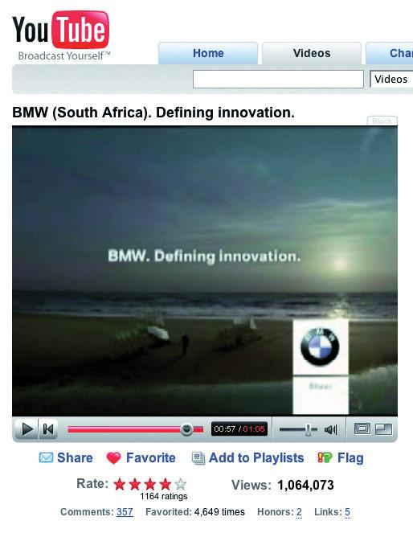
Source: Used by permission from BMW South Africa.
Savvy marketers also realize the potential of watching for organic mentions of their brand and then capitalizing on this. An unknown teenage girl, with the YouTube account name Bowiechick, made a seventy-five-second video clip about her breakup with a boyfriend. While making the clip, she played with some of the effects on her new Webcam, like putting ears on her head and a moustache on her face with its facial tracking software. Three days after uploading the video, 178,000 people had seen this video and 900 had commented on it. The comments had nothing to do with the breakup but with the Logitech Webcam she had used in the video. Following this, the camera broke into Amazon’s Top 100 best-selling-products list. Logitech were obviously listening and made the most of the opportunity by becoming YouTube’s official partner. ^{[4]}
The medium of online video sharing also means that conferences are able to generate a far larger audience than ever before. The companies that sponsor or run these conferences are able to engage with a larger audience by making freely available videos of the various sessions held. TED (Technology, Entertainment, Design; http://www.ted.com) and Nokia’s Nokia World are excellent examples of organizations that increase interest by making their remarkable presentations available for free.

Knowledge Sharing: The Wiki
Howard G. “Ward” Cunningham, pioneer of the wiki, began programming the WikiWikiWeb software in 1994 and installed it on the Web site of his software consultancy in 1995. Back then he described a wiki as “the simplest online database that could possibly work.” ^{[5]} Thirteen years later, this is probably still the most accurate description.

Note
“Wiki wiki” means “rapidly” in the Hawaiian language.
Essentially, a wiki is a piece of software that users can create and edit online, using simple markup language via a Web browser. They support hyperlinks and have a simple text syntax for creating new pages and links between internal pages. In its most basic form, a wiki is a Web site that supports user collaboration through a variety of functions.
There are numerous types of wiki software available that share the following characteristics:
- Create and update documents. Wiki users have the ability to create and update documents easily.
- Review versions. Most wikis store each version of a document. This functionality makes it easy for users to view the various modifications that a document has undergone over time.
- Build community-oriented tools. Most wikis provide users with an ability to engage in some form of discussion about the documents on which they are collaborating.
Wikis can be open to all, such as Wikipedia (http://www.wikipedia.org) and Wikitravel (http://www.wikitravel.org); they can be open to or aimed at certain communities only, such as Geek Dinner attendees (http://geekdinner.pbwiki.com); or they can be private and open only to individuals within an organization. Internal wikis are exceptionally useful for creating knowledge bases within organizations and companies.

Note
If you’d like to try out setting up your own wiki, http://www.pbwiki.comprovides free wikis and has a host of features.
Figure 8.4
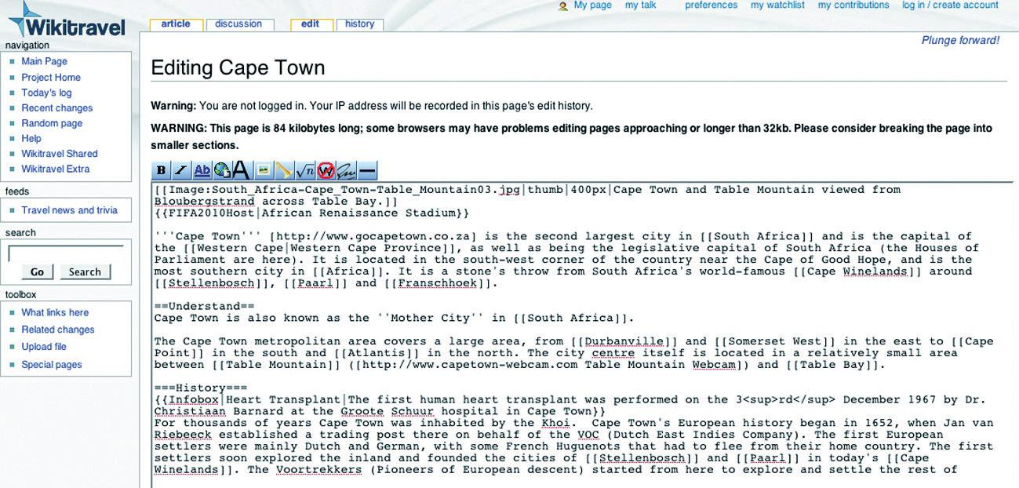
A wiki can be edited by anyone who can access it.

Wikipedia: The Most Famous Wiki of All
Wikipedia (http://www.wikipedia.org) is a free, Web-based encyclopedia that is rated one of the top-ten most visited sites in the world. Originally created in 2001 by James Wales and Larry Sanger, this online encyclopedia has received both praise and criticism. Roughly fifteen times the size of Encyclopaedia Britannica, with more than 14 million articles in over 262 languages, this encyclopedia is increasing in size at an exponential level. ^{[6]} However, with the increased adoption of this tool, criticism has also increased as to the validity of the definitions.
All definitions seen on Wikipedia are written by a collaborative team of volunteers from around the world. Anyone can submit a definition, and these can then be edited by anyone who has access to the Internet. This combination of contributors leads to a democratic way of including the most up-to-date information. Since definitions are reviewed frequently, it should decrease the amount of bias and inaccuracy while building a unique social network, with people of similar interests contributing.
All Wikipedia definitions should also be referenced externally. Although anyone can contribute to Wikipedia, there is a permission ranking system that has been instituted to maintain the level of credibility that is associated with Wikipedia. Further measures include a discussion tab on most articles where academics can question the validity of the sources and its content.
Wikipedia articles tend to rank highly in the search engine results pages (SERPs), so the allure of a link to your Web site from a relevant article is tempting indeed. Wikipedia has instituted a policy that all external links are “nofollow” links so as to combat spam.

Note
“Nofollow” means that Wikipedia is indicating to the search engines that these links do not necessarily endorse the Web sites being linked to.
Wikipedia is a useful research tool. With so much information on the Internet, many users are starting to look at a human-edited (as opposed to search-engine-algorithm-distilled) way to embark on research. For a company to be reachable via a link from this research base can be very traffic and reputation worthy.
Companies should also take note of what is being written about them on Wikipedia and make transparent efforts to correct information.

Content Creation and Sharing as Marketing Tools
Content-sharing sites, from video to photos to music to knowledge, provide marketers with a snapshot of how users interact with and perceive their brand. Most of the sites have really simple syndication (RSS) feeds available, where marketers can keep a tab on mentions of their brand.
These sites and services allow marketers the opportunity to capitalize on the creativity of their consumers to further amplify their brand. By making content easily available and removing restrictions on use of that content, companies can nurture creative interactions that are likely to spread.
Wikis can be used when creating an event with a network. Encouraging users to interact allows them greater connection and ownership of the outcome and provides a means for ongoing communication.

KEY TAKEAWAYS
- Marketers place their ads on YouTube knowing that if it is good, users will choose to watch it.
- Wikipedia can be a useful research tool for brands. It can also be a way for a company to be reachable because a link from a research Web site can be very traffic and reputation worthy.
- Companies should know what is being said about them on Wikipedia. If it is negative, they should make transparent efforts to correct the information.
- Content-sharing sites of all types provide marketers with a snapshot of how users interact with and perceive their brand.

EXERCISES
- Visit http://www.wikipedia.com. Check to see if one of your favorite brands has a presence on the site. What observations can you make about the entry or entries?
- Visit one of your favorite content-creating and -sharing sites. Try to identify how a brand uses that site. Give some examples.

[1] “YouTube Traffic Exceeds 100 Million Unique Visitors for First Time in January 2009,” LawyerCasting, March 20, 2009, http://www.lawyercasting.com/2009/03/youtube-gets-100-million-unique-visitors-in-january.html (accessed May 10, 2010).
[2] “March Video Streaming Soars Nearly 40% Compared to Last Year,” NielsenWire, April 13, 2009, http://blog.nielsen.com/nielsenwire/online_mobile/march-video -streaming-soars-nearly-40-compared-to-last-year (accessed June 22, 2010).
[3] “YouTube.com Accounted for 1 Out of Every 3 U.S. Online Videos Viewed in January,” press release, comScore, March 14, 2008, http://www.comscore.com/press/release.asp?press=2111 (accessed May 27, 2008).
[4] Greg Sandoval, “YouTube’s ‘Bowiechick’ and the Spiders from Marketing,” ZDNet, April 4, 2006, http://www.zdnet.com/news/youtubes-bowiechick-and-the -spiders-from-marketing/147526 (accessed May 27, 2008).
[5] “What Is Wiki,” Wiki, June 27, 2002, http://wiki.org/wiki.cgi?WhatIsWiki (accessed June 23, 2010).
[6] Wikipedia, s.v. “Wikipedia: About,” http://en.wikipedia.org/wiki/Wikipedia:About(accessed June 20, 2010).

8.4 Crowdsourcing: Unleashing the Power of the Online Community

LEARNING OBJECTIVES
- Learn how to use the online community in eMarketing efforts.
- Learn when it is appropriate for marketers to use crowdsourcing.
A term first used in Wired magazine back in 2006, crowdsourcing has become a powerful and cost-effective method of achieving business goals through the use of the masses. Simply put, business and corporations invite the public to submit ideas and innovations for new and existing products in exchange for a one-off or a small percentage of future royalties.
Social media have spurred on this innovation and have allowed the business world to tap into the consumer psyche with little financial outlay.
Idea Bounty (http://www.ideabounty.com) is a perfect example of crowdsourcing in action, utilizing a potentially massive online global think tank in order to come up with innovative ideas according to briefs submitted by brands that register on the site.

Connecting: Social Networking
Social networking refers to the forming and substantiating of online social networks for communities of people. The communities are people who share interests and activities or are interested in exploring the interests and activities of others. The building of these social networks requires the use of software. Social networking is all about using the tools of the Internet to connect and build relationships with others. Social networking sites such as Facebook (http://www.facebook.com), MySpace (http://www.myspace.com), and LinkedIn (http://www.linkedin.com) allow users to create personal profiles and then interact with their connections through sharing media, sending messages, and blogging. Social networking sites not only allow you to interact with the members of your own virtual Rolodex but also allow you to extend beyond your personal network.
Social networks have created new meaning for the term “friend,” as many connections exist solely online. In the realm of social networking, it is unnecessary to have met someone in order to connect with them. Personal profile pages remove much of the anonymity of the Internet. Users of social networks reveal a great deal of information about themselves, from basic demographics such as age, gender, and location, to nuanced and detailed lists of likes and dislikes. Although explicitly made known to a user’s connections, users are also divulging this information to the networks, and hence to the networks’ advertisers. Users tend not to be aware of the data that are amassing regarding their online profiles, and it takes features such as Facebook’s Beacon to reveal just how much information users are making available.
In 2007, Facebook launched Beacon, a service that shared a person’s online-purchase activities on select Web sites with their list of Facebook friends and with Facebook. This caused an outcry, as Facebook users did not want to have freely available the list of purchases that they had made. Facebook quickly amended the way Beacon works, but the fact remains that it is able to collect these data about its users.
Social networks can be general, such as Facebook, or niche, such as LinkedIn (http://www.linkedin.com) or Dopplr (http://www.dopplr.com). LinkedIn is a network for professionals. Members connect to others that they know professionally and are able to recommend members that they have worked with. Dopplr is a social network for frequent travelers. Members can share their trips and make plans to meet up when schedules overlap.
How is someone’s Facebook profile likely to differ from his or her LinkedIn profile?
Many social networks, including Facebook, Orkut (http://www.orkut.com), and MySpace, have opened up their platform to outside developers, allowing the development of applications for the members of the social networks. Generally, use of an application requires a member to allow the application developer access to their personal information.

Social Networking as a Marketing Tool
Social networks, free for their members, tend to rely on advertising for their revenue. Because of demographic information collected by the social networks, advertisers are able to target their advertisements to a particular audience.
Just because it is a social network does not mean it is the right place for every company to be marketing in. First, determine if your target market is using the social network, and then determine if it is the right place to be marketing to them.
Applications are another way to market products. Creating a useful application that is relevant to a product can expose a whole new audience to a company’s offering as well as allow the company to collect detailed information on their users. However, although Facebook applications were the big marketing story of 2007, there are few success stories to emerge from the buzz. It is very much a developing market.
Profiles are not limited to people. Bands, for example, have found immense success creating MySpace profiles and using the profiles as a means of connecting with their current and potential fan base.
Facebook pages provide a venue for an online presence for groups, organizations, and small businesses. Quirk eMarketing has a page athttp://www.facebook.com/Quirk-eMarketing.
Marketers can also use social networks to identify how users are perceiving or interacting with their brand and open up new avenues of communication with them. For example, if you are marketing a bar, look to see how many people are using a social network to organize events at your bar. Find a way of rewarding those who are bringing you extra customers.
Social networks are also an avenue for members to voice frustrations and annoyances, and these should be closely watched by marketers to gauge sentiment.

KEY TAKEAWAYS
- Social media have allowed the business world to tap into the consumer psyche with little financial outlay.
- Social networking sites allow users to not only create personal profiles and then interact with those they already know but also extend beyond their personal network.

EXERCISES
- Find an example of how a brand uses a social networking page, such as Facebook or MySpace. Compare it to an individual user’s profile. What comparisons can you make?
- Think of how these different types of companies may use social networking: A nonprofit? A restaurant? An automaker?

8.5 Creating Content and Opinion: Blogging and Podcasting

LEARNING OBJECTIVE
- Understand how content creation and opinion are important to social media.
Everyone has an opinion, and the Internet allows for everyone to share their opinion. Blogs and podcasts have emerged as social media that are being embraced across the Internet population.

Blogging
A blog is a Web site where entries (blog posts) are typically displayed in reverse chronological order. Technorati, a blog and social media–tracking engine, defines a blog as a “regularly updated journal published on the web.” ^{[1]} Blogs usually allow for comments on blog posts. A typical blog will feature text, images, and links to other blogs and Web sites related to the topic of the blog. Blogs range from the personal to the political and everything in between. They can be written by one person or by a group of people. Some are aimed at the blogger’s immediate family and friends, and others rival leading newspapers in terms of reach and readership. Blogs are mostly textual but can be composed solely of images, videos, audio, or any combination of these.
According to Technorati data, there are over 175,000 new blogs created and over 1.6 million posts updated every day (over eighteen updates a second). That’s a lot.
The power of blogs is that they allow anyone to publish and share ideas, and anyone can read and respond to these. They have given consumers and companies a voice, and blogging has opened up a world of information-sharing possibilities.
The basic elements of a blog post are the following:
- Author. The person who wrote the blog post.
- Blog-post title. The title of the blog post, which is usually used to create a unique URL, or permalink, for the blog post.
- Tag. The categories used to describe the blog post and aid services such as Technorati in categorizing blog posts.
- Comment. Comments left by readers of the blog that are shown with the blog post.
- TrackBack. A notification of other blogs linking to a post, often displayed below the blog post.
Some other elements of a blog include the following:
- RSS feed. A way for readers to subscribe easily to the blog.
- Categories. Blog posts can be grouped into categories by their topic.
- Blogroll. A collection of links to other blogs or Web sites commonly read or used by the blogger.
- Archives. Previous posts that remain available for visitors to search through. Archives are usually categorized by date.
RSS readers can be integrated with an e-mail client, can work offline, or can be online only. Some are free, and some are not. Look at your e-mail client to see if you can set one up there, or try http://www.bloglines.com,http://www.google.com/reader, or http://www.feeddemon.com. Find the one with the features that suit your needs.

Note
RSS stands for “really simple syndication” and allows for information to be syndicated. This means that instead of you visiting various Web sites for updates and information, information is packaged and sent to your RSS reader. Information is supplied by Web sites in a standard feed format, and your RSS reader knows how to turn that into something that makes sense to you. As soon as an RSS feed is updated, that is, new information is added, it appears in your RSS reader.
RSS readers are a useful way to keep up to date with blogs, as most supply an RSS feed of their posts. Still confused? Take a look athttp://commoncraft.com/rss_plain_english.
Whether blogging as an individual or a company, plenty can be gained from the process. You can do the following:
- Create an online identity
- Create a voice for yourself or your company
- Promote engagement with your audience
- Create a community

Blogging and SEO
Search engines value regular, fresh content, and by blogging you can create just that. The more you post, the more often search engines will spider your site looking for additional, relevant content. Basing your blog on your keyword strategy created in the search engine optimization (SEO) process can also aid your Web site in ranking for those key phrases. Blogs, by their social nature, can also increase the incoming links to your Web site. Using a blog platform that has been designed to be search engine friendly is crucial to harnessing the SEO power of blogging. Some features of SEO-friendly blogging software include the following:
- Each blog post should be assigned a unique page that can be easily accessed and indexed by the search engines. This is called a permalink.
- Pages should be able to be tagged with keywords relevant to your SEO strategy.
- Each post should be able to have its own unique metadata (title, description, and key phrases).
- Social-bookmarking functionality should be built in.

Corporate Blogging
Blogs can be very successful marketing tools. They are an excellent way to communicate with staff, investors, industry members, journalists, and prospective customers. Blogging also helps to foster a community around a brand and provides an opportunity to garner immediate feedback on developments. This is an audience made up of players key to the success of a company: that makes it important to get blogging right.
Generally the tasks that a blogger undertakes include:
- Writing posts
- Replying to comments from readers
- Monitoring other blogs within the industry
- Keeping up to date with the latest industry news
- Building relationships with other bloggers in the community
- Commenting on other blogs
For corporate blogs, it is important to outline a strategy and establish guidelines before starting the blog, especially as there will most likely be a number of contributors. Transparency and honesty are important, but companies also need to be aware of sensitive information being blogged. If there are “no go” areas, they need to be clearly defined to the parties involved. While certain topics can be restricted, ultimately the bloggers should be granted the freedom to express both negative and positive points of view about the approved topics.
Positive claims are more believable if the blogger is able to express negative views as well. For example, Robert Scoble in his popular bloghttp://www.scobleizer.com admitted that the Firefox browser was better than Microsoft’s Internet Explorer. Robert Scoble was an employee of Microsoft at the time. This honesty gave him a credible voice, and so his positive views on Microsoft are respected by the community.
Corporate blog content should be:
- Industry relevant
- Appealing to your target market
- Transparent and honest
- Personal and entertaining
- Related to what’s going on in the blogosphere
- Posted regularly

Promoting Blogs
While Technorati may be tracking 112.8 million blogs, it doesn’t mean that all of these blogs will still be active by the end of the year—in fact, only 55 percent of blogs make it past the first three months. ^{[2]} Longevity rests in the hands of the blogger, but here are some tips to raise the profile of a blog:
- List the blog in blog directories. While they are not as popular as search engines, many Internet users do in fact visit them while looking for information. Examples include Google’s Directory (http://www.google.com/dirhp) and BlogCatalog (http://www.blogcatalog.com).
- Ping Web services with updated content. Sites like Ping-o-Matic (http://pingomatic.com) and Feed Shark (http://feedshark.brainbliss.com) offer a service whereby they ping multiple Web services, blog directories, and search engines to let them know that a blog has fresh content.
- Use TrackBacks. If a blogger writes a new entry commenting on, or referring to, an entry on your blog, and both blogging tools support the TrackBackprotocol, then the commenting blogger can notify your blog with a “TrackBack ping”; the receiving blog will typically display summaries of, and links to, all the commenting entries below the original entry. This allows for conversations spanning several blogs that readers can easily follow.
- Participate in the blogosphere. You cannot expect anyone to engage on your blog if you are not engaging on theirs. It is all about fostering a sense of community.
- Make use of aggregators. Examples of aggregators include Technorati, Amatomu, and Afrigator.
- Use traffic-generating tools like MyBlogLog. The MyBlogLog (http://www.mybloglog.com) widget allows you to see who in the MyBlogLog community has visited your site and they can see if you have visited their site in return. Bloggers will more often than not click through to your site from this widget, as they are interested in learning more about who is reading their blog. If they like what they see when they get there, they may become regular readers.

Microblogging
Microblogging is a form of blogging that allows a user to publish short text updates, usually limited to two hundred characters that can be viewed by anyone or restricted to a specified community as specified by the microblogger. This can be accomplished using various communication tools such as instant messaging (IM) via the Web, text messaging on your mobile phone, and even a Facebook application. Microblogging can also refer to the publishing of short posts using a limited number of images, audio, or video files. Currently, the most popular text microblogging service is called Twitter (http://www.twitter.com), which was launched in July 2006. Other similar sites include the likes of Jaiku (http://www.jaiku.com), Identi.ca (http://www.identi.ca), as well as Yammer (http://www.yammer.com). Examples of rich media-based microblogs include Tumblr (http://www.tumblr.com), Streem (http://www.streem.us), and Soup (http://www.soup.io). On Twitter, posts are called tweets and are limited to 140 characters. Despite frequent disruptions to Twitter’s service, its users are fiercely loyal. These posts are usually short thoughts or URLs to interesting articles.
Twitter has also become massively popular due to the nature of its immediacy. Major news events such as the Mumbai attacks in November 2008 were extensively covered by Twitterers, and breaking news can also regularly be found here first. A year-on-year study from February 2008 to February 2009 saw Twitter’s monthly unique visitors increase by 1,382 percent. ^{[3]} Twitter has entered the mainstream, with public figures such as Barack Obama (http://www.twitter.com/barackobama) and Britney Spears (http://www.twitter.com/britneyspears) having set up accounts.

Figure 8.5 A Twitter Feed Appearing
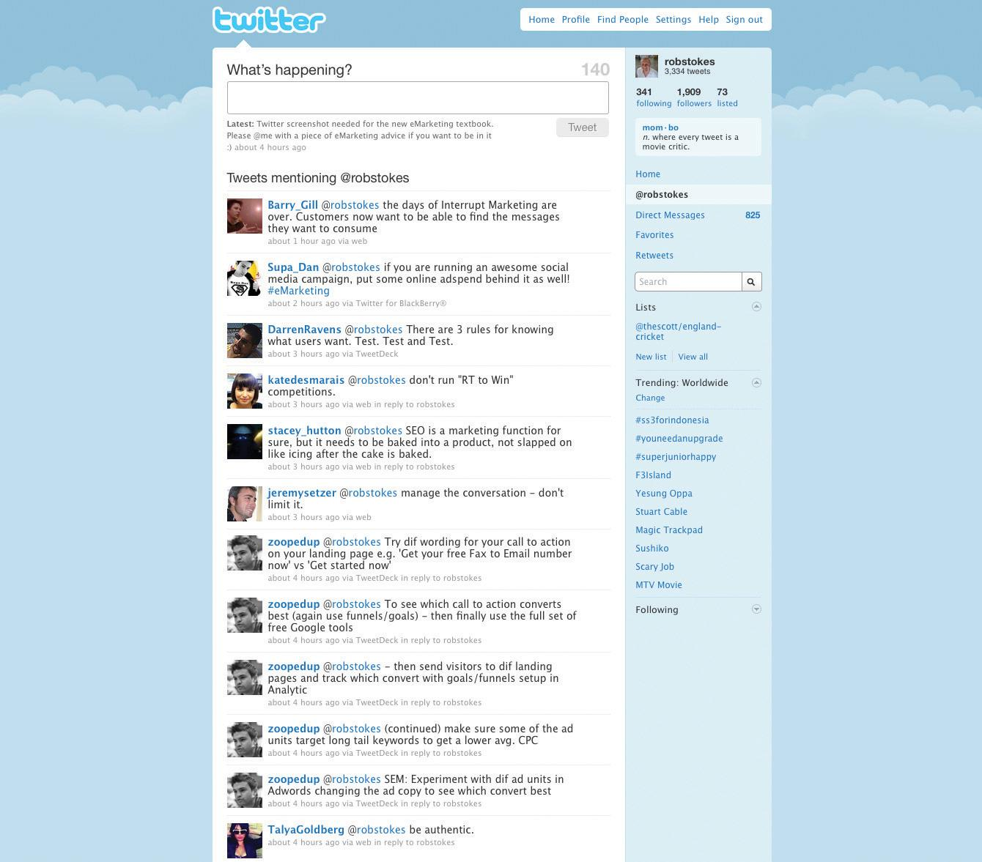

Blogs as a Marketing Tool: Listen and Engage
Blogs are powerful because of their reach, their archives (information is seldom deleted and is thus available long after it has been posted), and the trust that other consumers place in them. For a marketer, they present opportunities to learn how others perceive your brand and to engage with your audience. Some brands get this right; some get it wrong.
Above are some guidelines for corporate blogging, but marketers do not need to be bloggers to use this tool. As with all other social media, blogs provide a snapshot of audience sentiment regarding a brand. Marketers can also listen to blog activity around competitors in order to gain market insights.
Although blogging is the best way to respond to and engage with bloggers, companies can also interact with bloggers by commenting on relevant posts. Demonstrating the capacity to listen to bloggers, and then respond using the same medium, can reap tremendous benefits with this community.

Podcasting
A podcast is a digital radio (or video) program downloadable from the Internet. Podcasting started to take off around 2004, and it zoomed from “geekdom” to mainstream so quickly that “podcast” was voted 2005 Word of the Year by the editors of the New Oxford American Dictionary. ^{[4]} Podcasts started as audio blogs. People then figured out a way of distributing them using the same RSS feeds that were being used to distribute blog post information. It was then possible to subscribe to a podcast as one would a blog. Suddenly you could listen to a whole range of programs and voices whenever and wherever you wanted. It was radio without a station telling what you could hear and when. Just as blogs have allowed people to become writers without having to deal with a media channel controlled by someone else, podcasting has allowed anyone who fancies it to become a broadcaster.
With the right kind of “podcatching” software on your computer, the latest edition of any podcast you subscribe to is automatically downloaded every time you log on. Most people use iTunes. Go tohttp://www.apple.com/itunes/store for more information on podcasting and a huge list of available podcasts. You can listen on your computer or transfer the file to an iPod or any other kind of MP3 player. You don’t have to have an iPod to listen; the name came from the fact that the iPod was taking off at the same time and the “pod” (play on demand) part fitted this new medium. Podcasts are usually free.

Creating a Podcast
Podcasts are usually recorded and edited using home equipment and done for the love of it. There is specialized podcasting software available like Apple’s Garage Band or QuickTime Pro. These packages make it quite simple to record, mix, and format the audio files correctly. Just like bloggers, though, many podcasters are trying to figure out ways of making money from their podcasts and turning listeners into revenue.

Note
Go and have a look at Paul Colligan’s site (http://www.paulcolligan.com). He’s one person who says he knows how you can make money via podcasting.
Many people are producing music podcasts. This has meant a huge move to circumvent traditional rights issues about downloading music from the Internet. There is now a large body of music that is classified “podsafe.” This has either been composed especially for podcasts (as jingles, etc.) or the artist has specifically decided that they want their music to be available via the Net for all who want to hear it.
Radio stations have realized that they have a whole new way of using their content. They began packaging their output so that fans could listen to their favorite shows whenever they wanted to (without the music). The British Broadcasting Corporation (BBC) is awash with podcasts (http://www.bbc.co.uk/podcast). In South Africa, 5FM (http://www.5fm.co.za) was the first station to use them. Now nearly every radio station offers them—have a look at radio stations such as Classic FM (http://www.classicfm.co.za), Talk Radio 702 (http://www.702.co.za), and East Coast Radio (http://www.ecr.co.za).

Note
In 2005, the BBC’s award-winning Naked Scientists program became the first example of a BBC local radio program to enter the podcast arena. Naked Scientists has since gone on to become one of the most downloaded science podcasts internationally, returning a larger audience via podcast than the live aired program (http://www.thenakedscientists.com).
Educators and teaching institutions have latched onto podcasting as a way of sharing content and providing tuition for learners who cannot be present at lectures or tutorials. The corporate world is also realizing that podcasting can add huge value to communications mixes. The term “podcast” is increasingly being used to cover any audio or video that is embedded in an organization’s Web site.

Podcasts as Marketing Tools
Podcasts offer an incredible opportunity for marketers. The bottom line is that you now have a way of getting content to your target markets without having to persuade a media channel to carry it or to pay huge advertising rates.
Podcasts have the following traits:
- Targetable. You can create highly relevant, niche content and then promote it to a specific target market.
- Measurable. You can see exactly how many downloads and subscribers you have.
- Controllable. It’s your content.
- Responsive. Set up a blog alongside your podcast, alter content according to the comments, and you are actually having a conversation with your market.
- Boundary free. It’s the Internet.
- Relatively inexpensive. They don’t cost a lot to maintain.
However, the content must have the following traits:
- Excellent quality. Like anything on the Internet, it is just as easy to unsubscribe as it is to subscribe. Quality content is what keeps listeners coming back.
- Real. While there is value in having product or service information embedded in a Web site, there is no point at all in producing an audio version of a company brochure as a regular podcast. Consumers are losing faith in the content of traditional media. Even if editorial is not actually paid for, much of the time it has been influenced in some way by advertisers. Although there are podcasts that carry advertisements, people can fast-forward straight past them, and the chance of real success lies in branded content.
This is not about advertising or even just product information. It is about coming up with ideas for real programs that, through informing or entertaining, enhance your customers’ experiences of your brand.

KEY TAKEAWAYS
- The Internet allows for everyone to share their opinion.
- Blogs are powerful because they allow anyone to publish and share ideas. Anyone can read and respond to these ideas. As a result, both consumers and companies have a voice.
- There are several elements of a blog. The basic ones include the author, the blog-post title, tags, comments, and TrackBack. Other elements include RSS feeds, categories, blogrolls, and archives.
- Blogs can increase the incoming links to your Web site. Using a blog platform that has been designed to be search engine friendly is crucial to getting the full benefits of SEO.
- Corporate blogs can connect staff, investors, industry members, journalists, and prospective customers.
- It is important for corporate blogs to outline a strategy and establish guidelines before starting to blog.
- It is important to promote blogs, and there are many useful tools to do so.
- Microblogging is a powerful way for brands to engage with consumers using short posts.
- Podcasting is a way to distribute a brand’s message via audio. There are many benefits; however, the podcast must be of excellent quality.

EXERCISES
- Why is transparency so important to marketing using social media? Has this halted or accelerated the use of social media for marketing?
- Give an example of how a brand can use a podcast to market itself. How it can use microblogging?
- Identify a corporate blog. Who authors the blog?

[1] Thad McIlroy, “The Future of Blogs,” The Future of Publishing, June 24, 2008,http://www.thefutureofpublishing.com/industries/the_future_of_blogs.html (accessed June 23, 2010).
[2] David Sifry, “State of the Blogosphere, April 2006, Part 1: On Blogosphere Growth,” Sifry’s Alerts, April 17, 2006, http://www.sifry.com/alerts/archives/000432.html(accessed May 27, 2008).
[3] Michelle McGiboney, “Twitter’s Tweet Smell of Success,” NielsenWire, March 18, 2009,http://blog.nielsen.com/nielsenwire/online_mobile/twitters-tweet-smell-of-success(accessed June 20, 2010).
[4] Lamat Rezaul Hasan, “Lingowise: Top Word of the Year 2005,” Hindustan Times, February 4, 2006, http://www.hindustantimes.com/LINGOWISE-Top-word-of-the-year-2005/Article-59368.aspx (accessed June 20, 2010); “‘Podcast’ Is the Word of the Year,” Oxford University Press, 2005, http://www.oup.com/us/brochure/NOAD_podcast/?view=usa (accessed June 24, 2010).

8.6 Social Media and Marketing: Rules of Engagement

LEARNING OBJECTIVE
- Learn the rules of engagement in social media and what the benefits are.
Social media imply a democratization of information and require authenticity and openness from those who would deliberately use them for marketing. Relying on the Internet, this means that good stories as well as bad stories spread and stick around. Jeff Jarvis may have had problems with Dell in 2005, but you can easily find all relevant communication with a quick Google search.
Although they are engaging publicly with a wide audience, marketers need to remember that they are communicating with individuals. While marketers should engage in the conversation and can lead it, they cannot control it.

Marketing to Content Creators
The influence of bloggers means that they should form a part of any public relations (PR) strategy (see Chapter 12 "Web Public Relations" for further details).
Supply content creators with the tools and resources they need so that they can easily talk about your product.

Marketing to Content Consumers
Social media allow anyone to have a say, and the same tools that are available to individuals are available to companies. Company blogs allow a brand to build a personality and to interact with its target market. Entertainment created and spread via social media increases brand touch points. Using the same channels that are available to your consumer aids in understanding the consumer and evens the plane of conversation.
When using social media to reach out to content consumers, go to where your consumers are. The media used are dictated by your users.
For example, a nightclub for students can create a Facebook group to advertise its weekly specials and interact with fans, while Land Rover enthusiasts would probably be more comfortable with a forum.
With all interactions, marketing messages need to be labeled as marketing messages, with a disclaimer added if necessary. Trying to hide them as something else will only decrease authenticity.

Marketing to Content Sharers
Content sharers are content consumers who also pass your message on, whether by using chat or e-mail, by sharing a link on a blog, or by submitting your content to a bookmarking or aggregating service. They are a crucial link in the chain that passes your message around. Make it as easy as possible for sharers to share by using chicklets and unique and easy-to-read URLs.

Advertising on Social Media Platforms
While marketers can use the tools of social media to convey their message, the user characteristics that define a social media Web site are also important. Social media allow users to express themselves, and this means that demographic information can be compiled to allow for more useful and targeted advertising. This presents many opportunities for targeting advertising and for finding creative ways to reach an advertisement-fatigued demographic.

The Benefits of Social Media to Marketers
There are many benefits to companies and marketers for taking advantage of the services that social media sites offer. The following are just some of these benefits:
- People are finding it easier to switch off or ignore traditional advertising, particularly through traditional media environments such as television or radio. Social media give brands the opportunity to interact with customers through targeted communications that customers can choose to engage with on their terms. For example, a consumer may visit a branded YouTube channel as opposed to deliberately ignoring advertisement breaks on television.
- Social media’s potential to go viral is one of its greatest benefits; if users like the content, then they will share it with their communities.
- Social media allow you to create an online community for your brand and its supporters.
- Social media can tie in nicely with any of your other online marketing tactics; a holistic e-marketing strategy is always the best strategy.
- Social media allow you to engage with an online community and allow you to connect your brand to the appropriate audience.
- Social media have created a forum for brand evangelists. Companies should embrace as well as monitor this, as users with negative opinions of your brand have access to the same forum.
- The various platforms allow you to access a community with similar interests to your own, that is, networking without borders.
- The numerous interactions allow you to garner feedback from your communities.
- Feedback from social media sites helps drive both future business as well as marketing strategies.
- The range of media enables you to learn more about your audience’s likes, dislikes, behavior, and so on. Never before has this much information been available to marketers; market research just got a whole lot cheaper.
- Niche targeting just got a whole lot easier.
There are huge risks as well as opportunities. Social media facilitate a two-way conversation between customer and company. This necessitates that the company shifts approach from “deploy and watch” to one of constant involvement with the audience.

Social Media and the Changing Media Landscape
To keep up with their audiences, traditional media have had to adapt. This has changed the way that they publish, both online and off, as well as how they can sell advertising.
For example, many newspapers now publish their content online as well as in their print publications. Online, they can allow for instant commentary on their articles. It allows an instant snapshot of what their readers think, which can then be used to make editorial decisions. Print stories can be supplemented online with video, and this has been embraced by many news organizations. Visit http://www.thetimes.co.za to see how one newspaper is using video online.
As mentioned, television advertisements can be placed online for free via channels such as YouTube. This opens advertisements to a new audience and allows for advertisements that can be created without the restrictions of television. Advertisements can be extended, and now additional footage can become as important as the original. Quality advertisements are voluntarily and deliberately viewed, as opposed to deliberately ignored.

Tools of the Trade
As a creator of content, there is a plethora of platforms for the budding social media enthusiast. Throughout the chapter, we have listed the URLs for some of the most popular services, most of which are free. Instead of going back through the chapter, visit http://delicious.com/quirkemarketingtextbook. Use the tags to navigate to the social media tools you need to get started.

Pros and Cons
Social media allow marketers insights into their demographic and the chance to engage with their audience in a channel selected, and preferred, by the audience.
They allow marketers to capitalize on the creativity of their consumers to spread their message further, often at very low costs.
Lastly, social media provide avenues for establishing direct, personal contact on a level not available to traditional marketing campaigns.
However, companies also need to be aware that bad messages spread as well as good ones, and the connectedness that can prove so useful can also be a conduit for the distribution of negative messages.
This new landscape is one in which the customer really is king, and any attempt to dethrone the king can have dire consequences. Efforts to control the conversation in social media are soon found out and can backfire horribly.
Any company embarking on a social media strategy needs to be sure to monitor its reputation online. It is crucial to know what is being said in order to be able to respond and communicate in the social media sphere.
Social media are also known as consumer-generated media (CGM); this refers to the creation and sharing of content by consumers on the Internet. It has allowed a democratization of the Internet, where all Internet users now also have the opportunity to be creators as well as consumers of content.
Social media refer to the online technology platforms that allow users to do the following:
- Bookmark and aggregate content
- Create and share content
- Use other Internet users’ preferences to find content
Most social media services are free to all participants and rely on advertising for revenue. Social media provide targeted demographic information to advertisers looking to direct their advertising.

The Bigger Picture: How It All Fits Together
Social media can have SEO benefits for a Web site, particularly when a company engages in the various social media. By using the services of social media, either to create or share content, Web sites can attract links, all helping enhance search engine rankings. Companies can also use their SEO keyword strategy to focus their social media efforts.
Social media can provide a targeted network for online advertising, allowing detailed demographic information to play a role in media planning and buying. Companies can also make use of the increased engagement of consumers to create engaging advertising for these mediums, such as advertising within videos and social-network applications, or merely making use of increased time-on-page metrics to create more intricate advertising.
Affiliates often use the new opportunities presented by social media to find new avenues for targeted traffic, resulting in revenue growth for the company being marketed.
Social media play a crucial role in viral marketing, due to the large, connected audience; in online reputation management (ORM), due to the way that users talk about brands; and in WebPR. Social media are used to express opinions and so are the bedrock of ORM. Any company or brand that is hoping to communicate to this connected audience needs to learn to use social media. ORM is all about the tools of listening and using social media to guide the conversation.
Viral marketing, online reputation management, and WebPR are expanded on in the following chapters.

KEY TAKEAWAYS
- Social media allow anyone to have a say.
- Brands need to go where their customers are. Media selection is dictated by the users.
- Marketing messages should be dictated by the users and where they are.
- Marketers should make it easy for content sharers to pass on content by using chicklets and easy-to-read URLs.
- Demographic information can be compiled to allow for more useful and targeted advertising.
- There are many benefits of social media to marketers. However, there are also huge risks.
- Social media have changed how traditional media operate.

EXERCISES
- What is the difference between advertising using social media and marketing using social media?
- What are the benefits of social media to each, and what are the challenges?

8.7 Case Study: FNB and Idea Bounty
FirstRand Bank Limited is one of South Africa’s largest listed companies. It features on the Johannesburg Stock Exchange’s Top 100 index, with First National Bank (FNB) as its retail and commercial banking brand. FNB employs twenty-five thousand people in South Africa and serves over six million customers.
Figure 8.6
Source: Used by permission from First National Bank.
The nature of banking in South Africa is rapidly changing, though, and FNB is striving to remain at the forefront of social developments with progressive marketing and advertising strategies. One of the early adopters of holistic eMarketing in the finance sector, FNB is a proponent of social media as a way to reach its consumers and engage with them. FNB uses Facebook as a way to communicate with its community of clients and fans, and it maintains pages that promote FNB-sponsored events such as the FNB Whiskey Live Festival. These groups inform consumers about promotions, events, and happenings within the financial-services industry, allowing two-way communication and a high level of consumer engagement.
In October 2008, a segment of FNB, FNB Premier Banking, took its commitment to social media one step further: the bank committed itself to a rapidly growing social media tactic known as crowdsourcing through the newly launched social think tank Idea Bounty (http://www.ideabounty.com). In contrast to the traditional agency model in which creative output is paid for in accordance with the amount of resources assigned to the project, Idea Bounty opens up advertising briefs to the global community, allowing anyone, anywhere, to come up with the most creative solution. Brands then pay for the idea that they like the best, though if no idea is up to scratch, they don’t pay at all.
Figure 8.7
Source: Used by permission from Idea Bounty.
In the case of FNB, a $2,500 bounty was offered for the best idea to promote the use of online banking to its Premier Banking clients. The campaign was promoted through a number of on- and offline channels, with a heavy emphasis on social media. This holistic approach meant that FNB promoted its involvement through discussions on its fan page and through channels such as Twitter, with the support of the Idea Bounty team, who used their blog, Facebook, and Twitter to drive conversation around this creative strategy.
While FNB’s involvement in this project was brave, it was also very enlightened. The response was phenomenal. While the FNB brief was live, over eight hundred creative individuals registered on the Idea Bounty site. Out of these, 130 ideas were submitted in response to the brief. During the campaign, the site was visited over seven thousand times, and the online community was kept very busy, talking about FNB, proving that word of mouth spreads fast and social media engagement is contagious and has the potential to amass great creativity.
In the case of FNB, crowdsourcing, supported by social media, resulted in substantial PR value and an excess of ideas from which to choose, as well as the successful integration of consumers into the company. The use of Idea Bounty allowed for the growth of brand awareness and close relationships with a large prospective client base.
For more information, visit First National Bank (http://www.fnb.co.za) and Idea Bounty (http://www.ideabounty.com).

CASE STUDY QUESTIONS
- How do you think institutions such as banks can make use of social media? How would they measure success?
- What do you think some of the challenges are for banks when it comes to the social media channel?
- What are the benefits of crowdsourcing to an organization such as FNB?

8.8 References
“About Digg,” Alexa, April 2, 2008,http://www.alexa.com/data/details/traffic_details/digg.com (accessed April 2, 2008).
“About Technorati,” Technorati, http://technorati.com/about-technorati(accessed June 24, 2010).
“About YouTube,” Alexa, April 2, 2008,http://www.alexa.com/siteinfo/youtube.com (accessed April 2, 2008).
Geoff Livingston, “Beware of Facebook Frenzy,” The Buzz Bin, August 28, 2007,http://www.livingstonbuzz.com/2007/08/28/beware-of-facebook-frenzy(accessed June 16, 2008).
Richard MacManus, “Report: Social Media Challenging Traditional Media,” ReadWriteWeb, April 28, 2008,http://www.readwriteweb.com/archives/report_social_media_challenging_traditional_media .php (accessed May 27, 2008).
“U.S. Internet Users Viewed 10 Billion Videos Online in Record-Breaking Month of December, according to comScore Video Metrix,” press release, comScore, February 8, 2008, http://www.comscore.com/press/release.asp?press=2051(accessed May 27, 2008).
Yi-Wyn Yen, “YouTube Looks for the Money Clip,” Fortune, March 25, 2008,http://techland.blogs.fortune.cnn.com/2008/03/25/youtube-looks-for-the-money-clip (accessed April 2, 2008).

Chapter 9

Crowdsourcing

9.1 Introduction
You’ve used the Internet before, so it’s very possible that you’ve come across one of the best examples of crowdsourcing in the online world: Wikipedia (http://www.wikipedia.org).
Wikipedia, the online encyclopedia with over three million articles in the English-language version alone, has been created and maintained by people just like you. Each week, thousands of articles are added and thousands edited by a global community of students, professors, and everyday experts around the world.
This is not just an example of a community creating a lot of information. The community, or crowd, ensures that the information is accurate. In fact, a 2005 study found Wikipedia’s accuracy on a par with that of Encyclopaedia Britannica. ^{[1]}
According to Wikipedia, crowdsourcing is “the act of taking tasks traditionally performed by an employee or contractor, and outsourcing it to a group of people or community (the crowd), in the form of an ‘open call.’ The short explanation—crowdsourcing is a distributed problem-solving and production model.” ^{[2]}
For example, quirky (http://www.quirky.com) is a social product-development business. Anyone can submit a product idea, the community rates and improves on product ideas, and the best rated products are then manufactured. An example is Cordies, an on-your-desk cable management system that organizes your assorted computer cables while also keeping them weighted down so they don’t slide off your desk when disconnected. Cordies is a crowdsourced product.
Even larger businesses are turning to crowdsourcing instead of relying on internal research and development (R&D). Asking the public to come up with a new package design, for example, is an example of crowdsourcing. Typically, the crowd that responds to this type of request (and competition) is online.
Crowdsourced solutions are often owned by the entity that broadcasts the problem in the first place, and the individuals responsible for the solution are rewarded.
Many crowdsourcing platforms have democratized creative work, placing the professional and the amateur side by side. On crowdsourcing platform iStockphoto (http://www.istockphoto.com), only 4 percent of contributors claim to be professional photographers. That means that 96 percent of their community are amateurs who are creating stock photography that you can purchase. Crowdsourcing may produce solutions from amateurs or volunteers working in their spare time.
Crowdsourcing can be found almost everywhere once you start looking. Even Google essentially uses a form of crowdsourcing to organize its results—Web sites that are linked to more and have more traffic tend to rank more highly. The behavior of the crowd of Web users is used to rank Web sites.

History
The term “crowdsourcing” was first coined a by Jeff Howe in a Wired magazine article in June 2006. ^{[3]} It’s a relatively new term, but the concept dates back as far as the 1700s. Early editions of the Oxford English Dictionary were crowdsourced—thousands of volunteers submitted entries on slips of paper and these were compiled into the dictionary.
Another early example of crowdsourcing is the Longitude Prize, an open contest run by the British government in 1714. The competition was looking for a simple and practical method for the precise determination of a ship’s longitude, something that had so far stumped the experts. A clockmaker named John Harrison made the most significant contribution to the solution of this problem with his work on chronometers and is considered the winner of the competition.
With the advent of the Internet, launching a crowdsourcing project has become much easier. The Internet has enabled us to connect crowds of diverse people from all over the world in order to tackle a problem.
One of the earliest known examples of a crowdsourcing project that made use of the Internet is the 1998 Tunnel Journal project in Leidschendam. The Tunnel Journal was an interactive artwork: an LED (light-emitting diode) display integrated into the walls of a tunnel along Leidschendam’s main traffic routes. The community could feed the LED display with their own text messages via the tunnel’s Web site. The project was discontinued by Leidschendam councilors because uncensored messages began reaching the Tunnel Journal’s electronic message board directly from the Internet. After revamping the tunnel’s Web site in July 2000, a new feature was added—a dynamic filter that allowed visitors to ban texts from the electronic display. Thus the public became its own filter, preventing derogatory remarks from featuring.
Since the launch of the Tunnel Journal, Web-based crowdsourcing has slowly gained a stronger footing and crowdsourcing projects on a massive scale have been launched in recent years. The scale of these crowdsourcing projects has grown at such a rapid rate only because of the Internet and its ability to let us form large and diverse crowds, often in a short space of time. Early players in Web-based crowdsourcing such as Threadless (http://www.threadless.com) and iStockphoto came into being in 2000 and InnoCentive in 2001. Since then, the number of crowdsourcing platforms has skyrocketed. Today it seems anything can be crowdsourced, from tattoo designs to films, medical problems, music, and even engineering.

[1] “Wikipedia, Britannica: A Toss-Up,” Wired, December 15, 2005,http://www.wired.com/culture/lifestyle/news/2005/12/69844 (accessed May 11, 2010).
[2] Wikipedia, s.v. “Crowdsourcing,” http://en.wikipedia.org/wiki/Crowdsourcing(accessed January 8, 2010).
[3] Jeff Howe, “The Rise of Crowdsourcing,” Wired, June 2006,http://www.wired.com/wired/archive/14.06/crowds.html?pg=1&topic=crowds&topic_set=(accessed June 20, 2010).

9.2 How It Works

LEARNING OBJECTIVES
- Understand the different types of crowdsourcing.
- Understand the different ways in which crowdsourcing is used.
- Learn the different platforms that exist online.
- Understand the importance of the community.
There are four types of crowdsourcing: ^{[1]}
- Invention. Crowdsourcing is used to source ideas, often for new or existing product development. The crowd also helps by improving on and ranking ideas. Examples of invention include Dell’s Idea Storm and My Starbucks Idea. On My Starbucks Idea, the community is asked to share, vote for, and discuss ideas to improve Starbucks’ products and service.
- Creation. New content is created, owned, and maintained by the creators. The crowd can contribute finished work or just an idea. Good examples of this include Threadless, Wikipedia, and Idea Bounty. Idea Bounty, for instance, works on a system through which a client will post a brief that is then distributed among the community. The community then responds to the brief with creative solutions. The best solution to the problem posed is chosen and its creator rewarded.
- Organization. Here crowdsourcing is used to create new content by organizing existing content. Examples here include Digg and StumbleUpon. StumbleUpon is an online community where users discover and rate Web pages, Web sites, images, and video content. It acts as a personalized recommendation engine using peer voting and social-networking principles.
- Prediction. Prediction aims to predict trends by asking the community to submit ideas and vote for them. Here, examples include Yahoo! Buzz, Ramussen Markets, and Media Predict. On Media Predict, users bet on media trends such as television viewership and books that are likely to sell well. Media Predict can generate predictions as to what will and what won’t succeed. Essentially it helps media companies understand what people really want.
In the commercial context, there are three dominant ways in which crowdsourcing is used:
- Product development. The crowd’s knowledge is used to improve an existing product or suggest new products. The consumer interaction and buzz also provide a valuable branding effect. Examples include Dell’s Idea Storm and GM’s (General Motors) Fast Lane blog.
- Initiatives and new business. In this case, crowdsourcing is used to generate business ideas or product concepts and often funding as well. Crowdsourcing can also connect those who have business ideas with those who can provide the funding to get them off the ground. Examples include a competition held by LG in June 2009 where it crowdsourced the design for its next mobile phone and “The Sling Back,” a universal wire retractor that holds any type of cord, which was designed by the community from the crowdsourcing platform http://www.quirky.com, who also designed the Cordie that we mentioned earlier.
- Communications ideas. This exists primarily within the advertising and marketing industry. It involves the crowdsourcing of ideas for the communication of a brand message, advertising message, or value proposition. For example, you could crowdsource the design of logos, televisions advertisement scripts, or new marketing concepts in any shape or form. Some examples include Doritos’ crowdsourcing of its Super Bowl television advertisement since 2007.
Furthermore, crowdsourcing platforms come in two flavors. Generally, these platforms exist online:
- Centrally controlled. Where the process is centrally controlled, a guiding force channels and formalizes the process. Idea Bounty is an example of this: a specialist team helps define the challenge and the brief, and the client chooses the winning idea rather than a community voting for the best idea.
- Community controlled. This works the opposite way. Here the community controls the outcome. Threadless is an example of this: users vote for their favorite t-shirt designs, and the top-rated designs are printed onto t-shirts for sale.

The Importance of the Community
A strong community is the key to successful crowdsourcing. The community can be viewed as a crowdsourcing platform’s most important asset—it is essentially an economically productive unit. Without it, a crowdsourcing project would be impossible to run. The creative product produced by the community is in fact what the crowdsourcing platform sells. So without creators there is no product to sell. Keeping a community interested, engaged, and rewarded is essential in retaining that community.
Unfortunately, the importance of a community, how it works, and what keeps it motivated can be often overlooked. A good example of this is a crowdsourcing platform called Cambrian House. The platform was set up as a place where the community could post new business or product ideas. The aim was to get the community to help refine, build, and test these product ideas and then the original owner of the idea could sell it. With the snappy catchphrase “You think it; Crowds test it; Crowds build it; You sell it,” Cambrian looked set for success.
Initially Cambrian House was flooded with new product ideas. However, soon it became clear that the crowd was great when it can to coming up with ideas and refining them, but when it came to building or executing them, the crowd lost interest. It was either too time consuming or too difficult to build or execute the ideas produced by the community, and the reward was not a fair trade-off for the amount of work required. The result: the site never made any money and eventually closed down. The founders of Cambrian House have gone on to found another crowdsourcing platform, Chaordix (http://www.chaordix.com).

Motivations to Participate
Communities using crowdsourcing platforms exist for different reasons. Communities like Dell’s Idea Storm and My Starbucks Idea exist because there are lots of people who have a large interest and affinity to those brands. They participate in the community because they want to influence the products and services they receive.
Idea Bounty keeps the community interested and engaged by offering the chance to tackle problems and brands that the community might not otherwise be exposed to. Individuals are rewarded for their contributions with awards for outstanding ideas, and the owner of the best solution receives a monetary prize. These are all elements that keep Idea Bounty’s creatives actively involved and motivated.
Idea Bounty, like iStockphoto, offers keen hobbyists a platform to meaningfully contribute to a cause and, importantly, be rewarded for their contributions.
In the case of Idea Bounty, it is also very clearly stated that creatives own their ideas, and legally their work is protected as their own. This ensures that creatives feel in control and unexploited. Their ideas remain highly confidential—creating a safe zone to submit ideas and explore their creativity.
For businesses and brands, there are many reasons to get involved with crowdsourcing. Foremost is the ability to tap into a diverse crowd and source varied solutions to their problems. Businesses and brands simultaneously access huge amounts of customer and consumer insight, at lower costs. With sites like Idea Bounty, brands only pay for what they use, making crowdsourcing the most effective way of sourcing solutions and ideas out there.

KEY TAKEAWAYS
- There are four types of crowdsourcing:
  - Invention
  - Creation
  - Organization
  - Prediction
- There are three ways in which crowdsourcing is used:
  - Product development
  - Initiatives and new business
  - Communications ideas
- Crowdsourcing platforms come in two flavors:
  - Centrally controlled
  - Community controlled
- The community is an essential part of crowdsourcing. It is important to keep it engaged and interested.
- The importance of a community, how it works, and what keeps it motivated can’t be overlooked.
- Users participate in communities for various reasons, such as wanting to influence the products and services they receive.

EXERCISES
- What is the definition of crowdsourcing?
- Find some examples of online crowdsourcing platforms not mentioned in the chapter. How can you tell whether or not they are successful?

[1] Josh Catone, “Crowdsourcing: A Million Heads Is Better Than One,” ReadWriteWeb, March 22, 2007 http://www.readwriteweb.com/archives/crowdsourcing _million_heads.php (accessed May 11, 2010).

9.3 The Bigger Picture

LEARNING OBJECTIVES
- Understand how crowdsourcing may impact the bigger picture of eMarketing.
- Understand the role of the amateur in crowdsourcing.
- Understand the concept of the wisdom of the crowd.
- Learn how a new agency model may be needed.
The concept of crowdsourcing has had an enormous impact on the marketing and advertising industry, and its repercussions are not fully realized yet.
The Internet can be seen as a catalyst as well as an enabler that propelled crowdsourcing to the fore. In the past we had to be together physically to create crowds. Now with technology, crowds can be well connected although geographically distant. A savvy organization can tap a wider range of talent and knowledge than that present within its own resources. And once more, crowdsourcing, as Jeff Howe states in his book by the same name, is now “faster, cheaper, smarter, easier.” ^{[1]}
Crowds can also contribute in many ways based on a range of skill levels. Everyone from professional engineers to stay-at-home moms can be working on the same communications problem, for example, and each has the opportunity to come up with the best solution to the problem.
For clients, solutions to problems can be explored at a relatively low cost and often very quickly. Unlike traditional agency models where an individual is paid per hour, crowdsourcing permits a client to pay a single cost for an exponential amount of solutions. Ultimately a client only pays for the solutions it makes use of, while those in the community who are not paid usually retain their intellectual property. This is the case with Idea Bounty.
By listening to the crowd and requesting their contributions, organizations can gain first-hand insight into their customers’ needs and desires and build products and services that meet those needs and desires.
With an earned sense of ownership, communities may feel a brand-building kinship with the community through collaboration and contribution. Less experienced individuals can show and hone their skills, and more established practitioners can earn money without long-term commitment.

The Rise of the Amateur
When it comes to crowdsourcing, amateurs are competing with professionals in fields ranging from computer programming to design, and from journalism to the sciences. These people are hobbyists and enthusiasts who may not have the relevant professional qualifications but may possess talent and passion in a given field. The energy and passionate devotion to a particular subject is ultimately what drives the crowdsourcing vehicle. To a large extent, the development of technology is again the great enabler here. First, people have access to a wider pool of information through the Web. Software such as Photoshop and iMovie has made graphic design and film editing relatively easy to learn and even master.

An Ideas or Knowledge Economy
Thanks to the Internet, one can publish information at a faster pace than ever and make it available globally. An idea is now worth something—supply and demand is not regulated by money or time anymore, but rather by the value of what’s offered. An idea that took ten minutes to come up with may be just as good as, if not better than, an idea that took ten hours of ruminating.

Open Call—A Great Idea Can Come from Anywhere
It is now possible to form or access a crowd from diverse professional backgrounds and that possesses a wide range of talents in a short span of time. This wide range of talent is also known as intellectual capital.
InnoCentive (http://www.innocentive.com), a crowdsourcing platform funded by pharmaceutical maker Eli Lilly, connects with brainpower outside the company by giving outsiders access to scientific problems. Anyone on InnoCentive’s network can solve these problems. This is an example of anopen call.
Colgate-Palmolive solved what appeared to be an unsolvable problem by listing it on InnoCentive. The massive packaged-goods company needed a way to inject fluoride powder into a toothpaste tube without it dispersing into the surrounding air. The research and development (R&D) team at Colgate-Palmolive were stumped, and so Colgate-Palmolive posed the problem to the InnoCentive crowd. An individual from InnoCentive’s online community drew on his experience and knowledge as a physicist to provide the solution (and claimed he knew he had a solution by the time he’d finished reading the challenge). A collaborative approach like this wouldn’t have been possible for the R&D team at Colgate-Palmolive.
Crowdsourcing blurs the lines between consumer and producer. This also means that solutions to problems can come from the most unlikely places. Crowdsourcing allows you widen the net when searching for solutions to problems, which of course increases the chance of finding the best solution.

The Difference between Crowdsourcing and the Wisdom of the Crowd
Crowdsourcing and the wisdom of the crowd are two different, though closely related, concepts.
The wisdom of the crowd can be referred to as open-source production. It is an activity initiated and voluntarily undertaken by members of the community. James Surowiecki, author of The Wisdom of Crowds, puts it this way: “the aggregation of information in groups, [results] in decisions that…are often better than could have been made by any single member of the group.” ^{[2]}
One of the best examples of the wisdom of crowds or open-source production is Media Predict. Users bet on media trends such as television viewership and books that are likely to sell well. As a group, the Media Predict community is able to generate quite accurate predictions as to what will and what won’t succeed—something an individual could never do as efficiently or accurately.
In contrast, with crowdsourcing the activity is initiated by a client and the solution usually comes from an individual. The example of Colgate-Palmolive’s experience on InnoCentive is a good example of pure crowdsourcing.
Some platforms make use of a mix of both crowdsourcing and wisdom of the crowd. Threadless (an online community where users can submit t-shirt designs, vote on their favorites, and then purchase the top design each month) is a good example of this. It is crowdsourcing when individuals submit their t-shirt designs. When the community collectively votes on the best designs, Threadless is making use of the wisdom of the crowd to determine which design to print and sell that month.
Others platforms, such as Idea Bounty, are pure crowdsourcing platforms where a solution comes from an individual and is no way influenced by the rest of the community.

How Is Crowdsourcing Changing the Communications Industry?
Crowdsourcing is producing a new way of sourcing creative ideas, especially in the marketing and communications industry.
In an industry where creativity is the product, crowdsourcing allows us to access an enormous source of untapped creativity that marketing and advertising agencies do not have within their organizations. This creativity comes with very little risk and at a low cost.

The New Agency Model
Instead of allowing the marketing and branding process to be owned and managed by one agency, brands are pioneering an innovative new model with the use of crowdsourcing platforms.
A new agency model would manage idea creation as follows:
- A brand puts a brief on a crowdsourcing platform, such as Idea Bounty, looking for the best solution to a problem. It offers a reward (usually money) in return for the best solution.
- The brand selects the best solution and then approaches either a preselected production partner or the best-suited agency to execute the solution.
The new agency model may be the next stage in the evolution of marketing. It is inherently more sensitive to market forces as it levels the playing fields among amateur and professional creatives. Amateurs have the opportunity to communicate ideas to global brands, something they might never have had the chance to do. This also exposes the brand to a wider and more varied range of ideas and solutions. As an added benefit, positive PR (public relations) is generated and direct interaction with a consumer base can provide unexpected insights. It also helps that crowdsourcing offers a very fast and cheap way to source solutions to creative problems.
The crowd is now rivaling the corporation. With the Internet and cheap tools, consumers and communities have the power once restricted to companies with capital resources. When it comes to intellectual resources, which are king in crowdsourcing, ad agencies are lagging far behind.

Pros and Cons
Crowdsourcing can be of enormous benefit to any organization, large or small. All you need is a passionate, problem-solving community. The pros of crowdsourcing include the following:
- Handing over the ownership of your brand encourages consumer involvement.
- Interdisciplinary collaboration brings fresh input.
- Individuals have opportunities and connections that did not exist before.
- Problems can be explored at a low cost and often very quickly.
- A client pays for results and only for what is used.
- The organization can tap a wider range of talent and brainpower, which may not be present within its own resources.
- Organizations can gain valuable insight into the desires of their customers.
- As a result of collaboration and contribution, the community may feel a brand-building relationship with the given organization.
But it’s not all sunshine. Anyone exploring crowdsourcing, from either side of the equation, needs to be aware of the pitfalls, which include the following:
- Contributing individuals can be taken advantage of.
- Many clients have no agency guidance and in some cases have very little control over production value, especially if the end result of the project is completed or finished work.
- When it comes to spec work, as opposed to merely an idea, the risk-to-reward ratio is fairly high. Not only is this taking advantage of an individual’s efforts, but it can also lead to work of a lesser quality.
- Legal issues are often overlooked and the IP of an individual’s work is disregarded with no written contracts, nondisclosure agreements, employee agreements, or agreeable terms with crowdsourced employees.
- The crowd’s reliability can be somewhat altered by the Internet. As an example, many articles on Wikipedia may be of a high quality and edited by multiple people—taking advantage of the crowd’s collective wisdom. Other articles can be maintained by a single editor with questionable ethics and opinions. As a result, articles may be incorrectly assumed to be reliable.
- Added costs may be needed to bring a project to an acceptable conclusion.
- A crowdsourced project may fail due the lack of financial motivation or reward. As a consequence, a project may be subjected to fewer participants, a lower quality of work, a lack of personal interest, global language barriers, or difficulty managing a large-scale crowdsourced project.
- A crowdsourcer may have difficulties maintaining a working relationship with the community throughout the duration of a project.

KEY TAKEAWAYS
- All the repercussions of crowdsourcing are not fully realized as of yet.
- In the past, we had to be physically together to create crowds. Now we have technology to help us connect while remaining geographically distant.
- Crowds can contribute based on a range of skill levels.
- Less experienced individuals can show and hone their skills, while more established practitioners can earn money without long-term commitment.
- Amateurs are competing in a wide variety of fields.
- One is able to publish information faster than ever, thanks to the Internet. This information can be available globally.
- Crowds can have a wide variety of professional backgrounds with different talents. This is known as intellectual capital.
- Wisdom of the crowd can be referred to as open-source production, which is an activity initiated and voluntarily undertaken by members of the community.
- Crowdsourcing is producing a new way of sourcing creative ideas. It allows us to access an enormous source of untapped creativity that agencies don’t have within their organizations, with low risk and cost.
- A new agency model is needed to manage idea creation.

EXERCISES
- What are the main reasons for crowdsourcing taking off in the last few years?
- What are the benefits of crowdsourcing for both consumers and brands?
- What is the difference between the wisdom of the crowd and crowdsourcing?

[1] Jeff Howe, Crowdsourcing: Why the Power of the Crowd Is Driving the Future of Business(New York: Crown Business, 2008).
[2] James Surowiecki, The Wisdom of Crowds (New York: Anchor Books, 2005).

9.4 Case Study: Peperami
Peperami, one of the largest UK consumer brands, is a pork sausage snack manufactured by Unilever in Germany and Britain. Launched over fifteen years ago, the brand was in the hands of creative agency Lowe since its conception until August 2009, when Unilever announced that it was going to drop the agency and work with Idea Bounty to crowdsource the concept for their new campaign.
In the past, The Animal, a crazed, masochistic sausage character, represented the brand in advertising communications. The character is well known and much loved for his uninhibited, unapologetic, and politically incorrect behavior. For the last fifteen years, he has been a central part of every Peperami campaign.
However, Unilever felt that after fifteen years with the same agency, the Peperami brand and The Animal character needed an injection of fresh ideas for the brand’s next print and television advertisements. Enter Idea Bounty.
Idea Bounty was involved in the writing of the brief from the beginning of the project. The brief was very specific with its requirements and stipulated that the winning idea had to be able to support the development of scripts and storyboards. This ensured that the ideas submitted would be well thought-out and of a high quality.
The brief also included examples of the past Peperami campaigns as well as templates for storyboards and scripts.
As a reward, a bounty of $10,000 was set with the option of an extra $5,000 for extreme creativity.
The Idea Bounty team also produced a full-page print ad promoting the brief, which was published in the United Kingdom’s Campaign Magazine as well as on online banners displayed on various marketing- and advertising-related sites across the globe.
Furthermore, the brief attracted a considerable amount of PR (public relations), with extensive coverage both online and offline, due to the controversial nature of crowdsourcing in advertising at the time of the brief running.
The Idea Bounty team was also greatly involved in the final selection process, ensuring an effective idea filtering system. In addition, an idea selection workshop held with Unilever assisted in the selection of the final idea.
The brief closed a full two months after launch and in total received 1,185 submissions. This was an extraordinarily large amount of ideas considering every entry met the basic requirements laid out in the brief.
Submissions made by creatives were of exceptional quality. Overall the hosting of the brief was a massive success. The large amount of quality submissions was due to the brief coming from a well-known brand with an engaging problem. The cherry on top was the bounty offered that encouraged people to invest their time and energy in their submission.
After much deliberation and due to the quality of submissions, Idea Bounty and Unilever announced two outstanding winning ideas.

CASE STUDY QUESTIONS
- How and where does Idea Bounty fit into the new agency model?
- What possible risks were posed by moving the Peperami account from agency Lowe to crowdsourcing platform Idea Bounty?
- Why is it important to stipulate requirements clearly in a brief to the community?
- Why was it important that the brief contained examples of previous Peperami campaigns?

9.5 Reference
Paul Marsden, “Crowdsourcing: Your Recession-Proof Marketing Strategy?”Contagious 18 (May 2009): 24–27,http://www.viralculture.com/downloads/crowdsourcing.pdf (accessed January 8, 2010).

Chapter 10

Viral Marketing

10.1 Introduction
Word-of-mouth marketing is powerful. Edelman’s 2010 Trust Barometer shows that 44 percent of respondents trust “a person like me” as a spokesperson. ^{[1]} In, you learned some of the ways that marketers can tap into the media that promote this kind of trust. Messages passed on from “a person like me” is word-of-mouth marketing, and online that same message can be passed on through social media.
Viral marketing is a form of word-of-mouth marketing that aims to result in a message spreading exponentially. It takes its name from a virus because of the similarities that marketers aim to emulate:
- It is easily passed on.
- The number of people who have been “infected” grows exponentially.

History
The term “viral marketing” was probably first coined by Jeffrey Rayport in an article “The Virus of Marketing” in the December 1996 issue of Fast Company.^{[2]} That’s not to say that there weren’t viral marketing campaigns before that, but as the Internet developed, so have the electronic tools for passing on information.
Word of mouth has existed as long as there have been words and mouths, but it is a fairly recent phenomenon in the world of marketing. Positive word of mouth can have a tremendous impact on a brand and can take up little to nothing of the marketing department’s budget. However, planning for and measuring word of mouth can be tricky and unpredictable.
As the connected nature of the Internet has allowed for easier spreading and tracking of word-of-mouth information, it has become possible to see how this can be modeled on the spread of a virus in a population.

[1] “Edelman Trust Barometer 2010,” Edelman, 2010,http://www.edelman.co.uk/trustbarometer/files/edelman-trust-barometer-2010.pdf(accessed May 10, 2010).
[2] Jeffrey Rayport, “The Virus of Marketing,” Fast Company, December 31, 1996,http://www.fastcompany.com/magazine/06/virus.html (accessed May 10, 2008).

10.2 How It Works

LEARNING OBJECTIVE
- Understand the different types of viral marketing and their differences.
Viral growth occurs when a message is spread exponentially. Viral marketing campaigns work when a message is spread exponentially and it results in a desired outcome for a brand. Viral marketing utilizes electronic means to spread messages. It harnesses the electronic connectivity of individuals to ensure marketing messages are referred from one person to another.
Viral marketing campaigns can be tricky and unpredictable. However, the lure of exponential growth, at a very low marginal cost, means that they are being attempted more often.

MSN Hotmail: From Zero to Thirty Million
MSN Hotmail, the Web e-mail service purchased by Microsoft, grew to thirty million members in just two and a half years from its launch in July 1996. A large part of its exponential growth is attributed to the sign-up link that was in the footer of every e-mail sent with the service. When the company launched, every outgoing message from this platform contained an advertisement for Hotmail and a link to its Web site at the bottom of the e-mail. As people e-mailed their friends and colleagues, they were also advertising the service. Recipients could simply click on the link and sign themselves up, and as they continued to e-mail friends from their new account, the message spread within existing social networks and was passed along with little effort from the company. Hotmail went from zero to thirty million users within the first three years, and today has over five hundred million users worldwide.
There are two types of viral marketing campaigns:
- Organic (or in-the-wild) campaigns
- Amplified (or controlled) campaigns

Organic Viral Marketing
Organic (or in-the-wild) viral campaigns grow with little or no input from the marketer. Sometimes, a message is passed around in a viral nature without any intention from the marketer. Usually this happens with negative messages about a brand, but it can also be a happy coincidence for a brand if the message is positive.
Organic word of mouth is credited with the sudden increase in the popularity of Hush Puppies shoes in the mid-1990s. Word of mouth increased sales from an all time low of 30,000 in 1994, to 430,000 in 1995, and to four times that the following year.
This is an example of an organic viral campaign:
- It was not planned (though it was very welcomed) by Hush Puppies.
- Participants made an active choice to pass on the message.
When successful, this type of campaign can build tremendous brand equity at a marginal cost. Because the communication takes place directly between consumers, the marketer has to be prepared to let go of their brand so that the message and flow of communication is not restricted. This is vital to ensuring the viral campaign is a success, as people are more likely to try a new product or fulfill the campaign goal if their friend or a trusted source referred them.

Amplified Viral Marketing
Amplified (or controlled) campaigns have been strategically planned, have defined goals for the brand being marketed, and usually have a distinct method of passing on the message (that can be tracked and quantified by the marketer). The Hotmail example above is a controlled campaign:
- The goal was to grow membership.
- The e-mails being sent were automatically passing on the message.
A viral campaign can be an important part of an eMarketing strategy. Viral marketing campaigns contribute in a number of ways:
- With correct planning, a viral campaign can provide plenty of link love for your search engine optimization (SEO) strategy. Campaigns should be built with that in mind. While there might be a microsite created for the viral campaign, ensure that it is easy to link to the main Web site.
- It can be difficult to measure brand awareness, but this is usually the chief aim of any viral campaign. Bear that in mind, and make sure that the campaign is targeting the right demographic and that branding is clear without detracting from the social nature of a viral campaign.
- Viral campaigns can also drive direct response, from newsletter sign-ups, to collaboration on consumer-generated media (CGM), to purchases that can be directly correlated to the campaign.

Stormhoek and Threshers: A Voucher Frenzy
Threshers is an off-license chain in the United Kingdom. Stormhoek, a South African winery, is one of the brands that they sell. In November 2006, Threshers put a voucher on its Web site offering 40 percent off all wines and champagnes between November 30 and December 10. Stormhoek, which had a large following online through its blog athttp://www.stormhoek.com, asked if it could pass on the offer to its audience. Threshers’ response: “Of course, it’s just a blog.” Stormhoek posted the voucher to its blog on Friday, November 24. Hugh MacLeod, a partner in the winery who was also working with Stormhoek on its online strategy, also posted the voucher to his popular blog,http://www.gapingvoid.com.
On Monday, November 27 there were 37,000 downloads of the voucher; Tuesday saw 56,000 downloads; and on Friday, December 1, the day the promotion started, the voucher was downloaded 715,000 times.

Figure 10.1
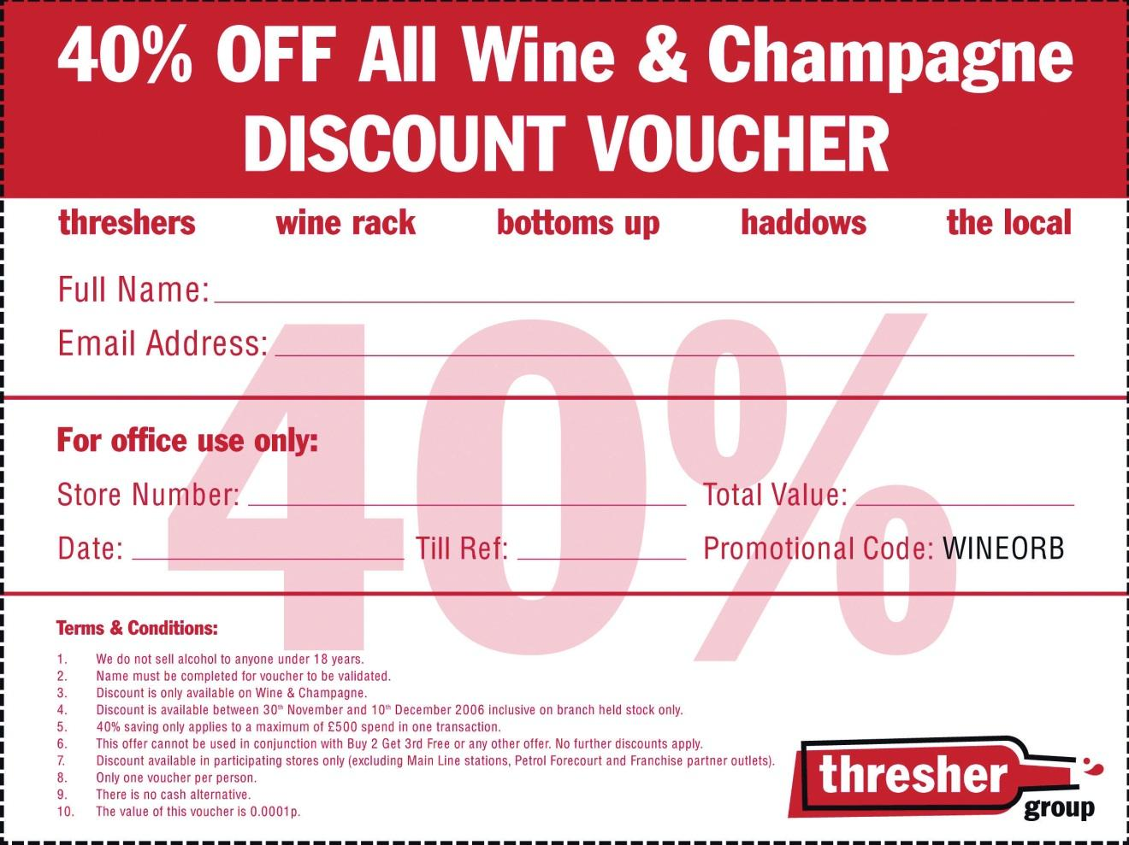
Source: Used by permission from Stormhoek.
By December 5, the voucher had been downloaded 3.5 million times. BBC News reported on December 1 that “queues have formed at one store while the Threshers Web site has crashed under the strain of demand for the offer.” And within the first five days of the offer, Threshers reported a 60 percent increase in weekend sales, with many stores selling one week’s worth of wine in a single day, queues out the door, and stocks depleted by 80 percent in some shops.
The Threshers Web site (http://www.threshergroup.com) saw 30,000 downloads of the voucher, about 1 percent of the total downloads. Stormhoek found that being at the center of a viral marketing phenomenon saw branding and sales increase. In addition to television and print press mentions, Stormhoek saw sales of its wines increase at other stores, not just at Threshers. There was no promotion or discount at the other stores.
Stormhoek has won awards for its innovative use of social media to disrupt the wine market and increase wine sales, and Christmas 2006 saw that happen once again.

KEY TAKEAWAYS
- Viral growth occurs when a message is spread exponentially.
- Viral marketing campaigns are tricky and unpredictable. But exponential growth means that they are being attempted more often.
- There are two main types of viral marketing campaigns: amplified (or controlled) and organic (or in the wild).
- Viral marketing uses people’s electronic connectivity to increase the velocity of word of mouth. People with similar interests, needs, and lifestyles tend to pass on and share interesting and entertaining content.
- When sponsored by a brand, the message builds awareness of a product or service and can provide qualified prospects for the organization to pursue.

EXERCISES
- Think of an example of when organic viral marketing is appropriate for an advertiser.
- Think of an example of when controlled viral marketing is appropriate for an advertiser.

10.3 Preparing to Go Viral

LEARNING OBJECTIVE
- Learn the steps necessary before a viral campaign goes to market.
Viral campaigns are unpredictable. As the market becomes saturated with more campaigns competing for attention, it is increasingly difficult for marketers to ensure a hit. However, careful planning means that you are ready when your campaign takes off. Careful planning also means that you have given the campaign the best chance of success.

Step 1: Define the Aims of the Campaign and How You Will Measure Success
A video created by your department and watched by millions of people on the Internet is certainly an attractive proposition, but if it does nothing to contribute to your business goals, it is a fun but pointless exercise. Can this medium reach your target market?
Determine if your campaign will be aimed at building brand awareness, driving traffic to your Web site, growing anticipation for a new product, building lots of SEO links, or making sure customers make a purchase right away. Viral campaigns should always build you links, whether or not that is a main aim of the campaign. Because of this, you should try to influence the anchor text—or the visible, clickable text in a link—being used.

Step 2: Plan a Message or Content That Users Want to Share
On the Internet, there is a lot going on. For a campaign to be worthy of sending on, it has to stand out from the clutter. You need to be original by doing some of the following things:
- Make something scarce
- Make something free and abundant
- Be very funny
- Be very interesting
- Be very informative
- Be very educational
- Be very unusual
- Be a little cryptic
- Be the best
- Create something users want to copy
- Present the tools for a mashup

Note
A mashup is when content from two or more sources is combined. Search for “mashup” on YouTube to watch some examples.
Burger King created the Web site “Subservient Chicken” (http://www.subservientchicken.com), where anyone could tell a man dressed up in a chicken suit what to do. It is very funny and quite bizarre. It got a lot of traffic. Hotmail made their e-mail service available to anyone. When Gmail was launched, it was by invitation only, and Google ensured that the invites were scarce. People talked about both services quite a bit.
Using controversial or enticing names for viral content makes it more likely that your audience will want to investigate further. For videos, thumbnails are exceptionally important in enticing visitors to hit the play button.

Step 3: Make Your Content Easy to Share
The easier a message is to pass on, the more likely it will be passed on. E-mails should include “forward to a friend” links, and a “send to a friend” link can be added easily to any Web page.
Viral marketers can make use of existing social media both as an environment in which to host their message and as a means to share their message. For example, using a popular video-hosting site, such as YouTube, for a viral video makes it easy for users to embed the video onto their own sites.
For best response, personalize e-mails automated by the sharing process (with subject lines like “Your friend Mark Hunter thought you’d find this amusing”). And for best SEO practice, tell users how to link to your content.

Step 4: Make It as Simple as Possible for Users to Get Involved
For campaigns that require interaction, it should be as easy as possible for users to sign up and get interacting. Lengthy sign-up forms asking for lots of information will slow and can even halt your campaign.

Step 5: Be Authentic and Transparent
It’s a viral marketing campaign for a brand, and marketers who pretend otherwise can see the attempt blowing up in their faces. Studies have shown that branding does not have a significant detrimental effect to the contagious nature of a viral campaign.

Step 6: Provide an Incentive for Sharing and Interacting
The greatest incentive for users sharing your content is social currency: something that users will want to share. People like to be seen by their friends and colleagues as resourceful, caring, or humorous, and the content you create should tie in with those values. Tailoring your content for your target market will give you even better results.
Incentives can be financial: a gift voucher for every five friends the campaign is sent to. Or users could be entered into a competition for every ten friends they refer. However, campaigns work best when the prize does not eclipse the content. Increasing social currency works for a brand, too; it will increase brand equity.

Note
Alternate reality games (ARGs) are often used successfully as viral marketing campaigns. One prominent successful campaign was “I Love Bees” for the launch of Halo 2. Do a quick search online—it’s fascinating.

Step 7: Make the Message Available
Sophisticated alternate reality games (ARGs) usually involve hiding messages and making them cryptic, but for the most part, marketers want their campaign to be very available. Research your target market and make sure that they can access your campaign easily based on their usual online habits.
With any successful campaign, the spread of the message can usually be traced to several core influencers: those people responsible for the viral growth. Influencers tend to affect a large number of people either by sending the message to lots of people or by causing lots of people to want to emulate them. However, influencers are difficult to identify prior to success, and so seeding a campaign should attract as large an audience as possible.
Be aware, as well, that editorial mentions in traditional media can also create a huge amount of traffic for a campaign, so press releases still need to be part of the seeding process.
Using forums and inciting blog comments can all help get content out there.

Step 8: Use a Strong Call to Action
Be sure that the medium does not eclipse your message. If you have taken the time to create compelling and engaging content, make the most of the interaction you have with a potential customer. Be very clear about yourcall to action, or the action you want the user to take next:
- Send this video to a friend.
- Play now!

Step 9: Track, Analyze, and Optimize
Monitor interactions with your brand from consumers so you can see growth and response. Make sure you are aware of the many ways that users could be talking about you. provides guidelines for the process of listening online. If the campaign is growing, but the message is not as intended, there might need to be some adjustments made.

Figure 10.2
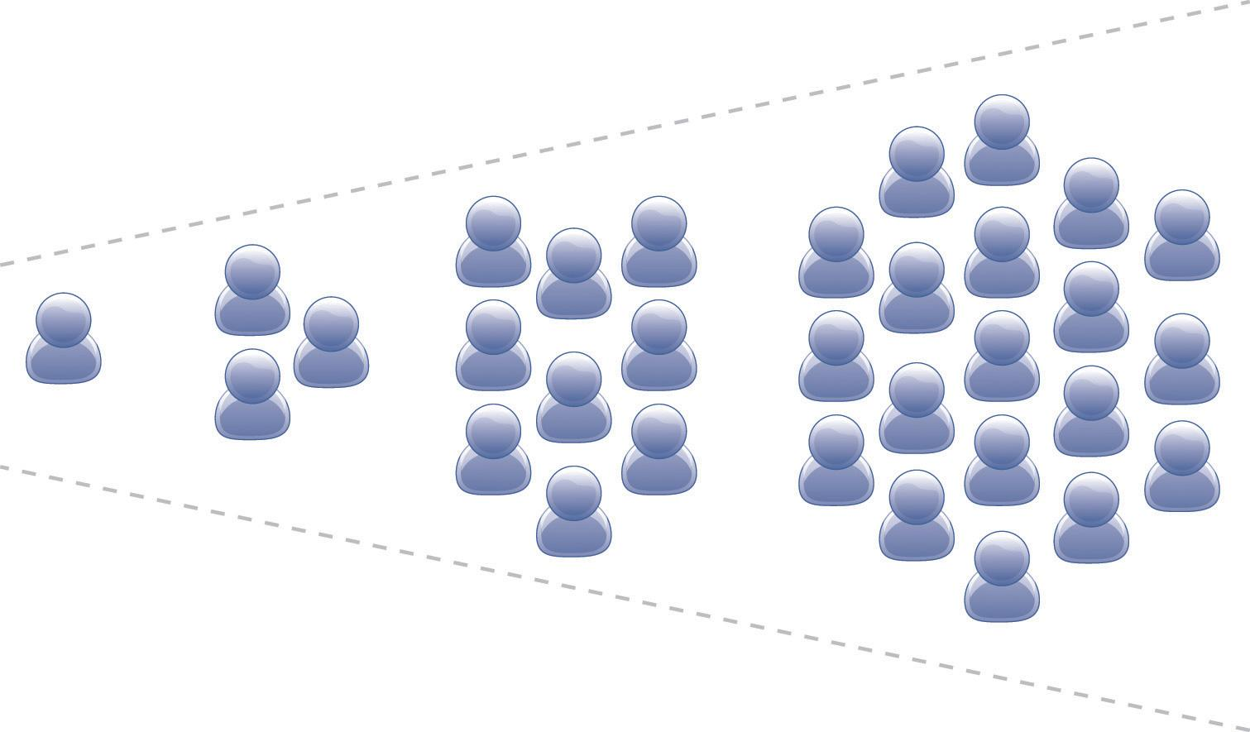
Viral marketing uses communities to broadcast your message.
Analyze what elements of the campaign work, so that when the next one is launched, these can be optimized.
Tracking software ForwardTrack (http://forwardtrack.eyebeamresearch.org) shows the geographical spread of a campaign over time and also lets participants see the spread of the campaign. This tracking solution can become a part of the marketing of the viral message.
TubeMogul (http://www.tubemogul.com) and VidMetrix (http://www.vidmetrix .com) both provide tracking and audience analysis for online videos.

Step 10: Get Lucky
Careful planning and great content with an enticing incentive should all result in a campaign that is successful. A little bit of luck is usually required for a campaign to fly.

KEY TAKEAWAYS
- Viral marketing campaigns can be unpredictable, but careful planning can go a long way to ensuring success.
- Define the aims of the campaign and determine how success will be measured.
  - Create something that people want to share.
  - Use social media to ensure that content is easy to share.
  - Remove all barriers to participation.
  - Be authentic.
  - Provide incentives.
  - Make the message available.
  - Use a strong call to action.
  - Track, analyze, and optimize.
  - Get a little lucky.

EXERCISES
- Why is planning so important to viral marketing campaigns?
- Are viral campaigns better suited to a niche audience or a mass audience?

10.4 Now What?

LEARNING OBJECTIVE
- Learn what to do after the campaign goes live.
With a viral campaign flying around the Internet, a company should be ready to capitalize on the benefits of the campaign.

Be Prepared for the Traffic
Anticipate wild success and ensure that the server can cope with the additional traffic. Nothing will kill a campaign faster than it being unavailable, and this has happened countless times.
Ensure that all parties know about the viral marketing campaign so that they can be prepared for any feedback that arises from this. If there is a cryptic element involved, or information that should not be released, ensure that all employees know about this.
If the campaign is to increase sales, be sure that there is sufficient stock in place.

Start Relationships
With millions of people being exposed to a brand, a company should plan to make the most of this first contact. As well providing all the tools to send a campaign on, a well-planned campaign will also ask their audience permission to keep in touch with them. Build on the nature of the campaign and ensure that future communications are not far removed from the viral campaign.

Prepare a Marketing Success Report
Consider the additional traffic and traction if the campaign becomes a case study, archived and accessed by marketers, journalists, and other interested parties. Make the most of this additional latent traffic avenue by preparing useful case studies, screenshots, and contact details. Even though the viral marketing campaign may be over, make sure it appears in online conversations and continues to generate traffic and links for your company.
If possible, keep relevant Web sites up and running and games still available once a campaign has finished.

Getting It Wrong: Astroturfing
Astroturfing refers to parties trying to manipulate word of mouth and comes from the term “grassroots campaigning.” Sometimes referred to as “stealth marketing,” it can also be a viral campaign killer.
Astroturfing usually occurs in the seeding period of a campaign. Employees may use fake names to try to seed a campaign on forums, in blog comments, and through services such as Digg (http://www.digg.com). Communities are quick to pick up on false commentary, and this can be disastrous for a campaign. As with all social media interactions, transparency and authenticity can be far better for traction.

KEY TAKEAWAYS
- If a viral campaign takes off, it may produce a lot of traffic to the advertiser’s Web site. The advertiser needs to be prepared for this increase.
- Companies should plan to make the most of the first contact with potential customers. A well-planned campaign will ask their audience for permission to keep in touch with them.
- A marketing success report is good idea, as online conversations continue to generate traffic and links to a company’s site.
- Astroturfing is not considered a best practice in viral marketing. Users can see through this type of marketing very easily.

EXERCISES
- Why is transparency so important in viral marketing?
- What effects can seeding have on a campaign?

10.5 Case Study: Firebox.com and Speedy Santa
Firebox.com, a leading UK gifts and gadgets e-tailer, hired agency Inbox.co.uk to create the most popular Christmas viral of December 2004. The viral concept also needed to drive traffic to the Firebox.com site to boost sales of toys and gadgets. Inbox.co.uk created an addictive game based on a simple idea: drag Santa around his Lapland track in the quickest time.
Figure 10.3 The Speedy Santa Game on Firebox.com
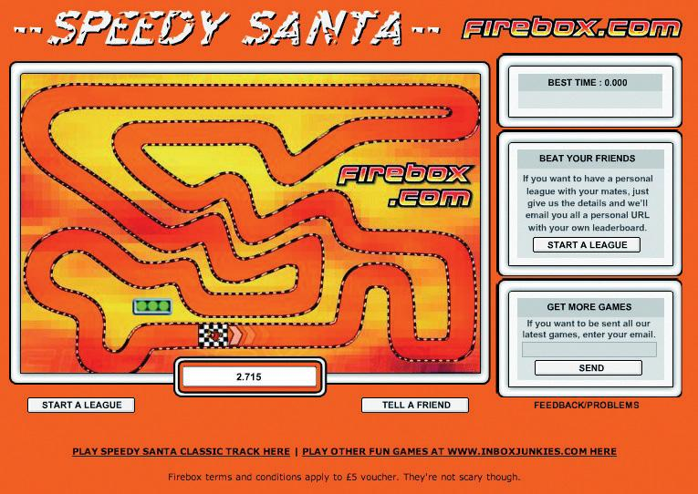
Source: Used by permission from Firebox.com.
Players were given a global position at the end of each lap, and every player who completed a lap of the Firebox track won a £5 Firebox voucher.
The hook: A system of private leagues was devised where players could invite four friends or colleagues to join a leader board. Everyone in that league was e-mailed a personal Web site link and scores were updated in real time.
These leagues proved to be a big hit and created a lot of office buzz. Within four days, the game was number one in the FHM Top 100 games. The Speedy Santa game was played over twenty-two million times in the run-up to Christmas. On average, people played the game over sixty times each. Of people who played the Firebox Speedy Santa game, 87 percent clicked through to the Firebox.com site, at a cost to Firebox of under $0.02 per click-through. And they each had a Firebox voucher to spend right before Christmas.
Christian Robinson, marketing director of Firebox.com, said, “It has definitely been one of the most successful promotions we have ever run, generated hundreds of thousands of pounds in revenue and bringing the Firebox brand to tens of thousands of new customers.” ^{[1]}

CASE STUDY QUESTIONS
- Why do you think leader boards were an important contributing factor to the success of this campaign?
- How did Firebox.com capitalize on the success of the game?
- How was the game suited to its target audience and time of year?

[1] Christian Robinson, personal communication with Sarah Blake.

10.6 References
“3.5 Million Thresher’s Vouchers and Counting: How Stormhoek—a Small South African Winery—Is Changing the Way That Wine Is Communicated and Sold Forever,” PR Newswire, December 5, 2006,http://www.prnewswire.de/cgi/news/release?id=185858 (accessed May 10, 2008).
“Firebox: New Viral Game for Dotcom,” Inbox DMG, http://in-box.co.uk/work.php?cid=Firebox (accessed May 10, 2008).
Malcolm Gladwell, The Tipping Point: How Little Things Can Make a Big Difference (New York: Back Bay Books, 2002).
Heather Hopkins, “Threshers Voucher Creates Storm Online,” Hitwise, December 5, 2006, http://weblogs.hitwise.com/heather-hopkins/2006/12/threshers_voucher_creates_stor.html (accessed May 10, 2008).
“The Likelihood That People Will Share Branded Versus Non-branded Content,” Viral Manager,http://www.viralmanager.com/strategy/research_documents/The_Impact_of_Branding_on_Virals (accessed May 10, 2008).
“MSN Hotmail: From Zero to 30 Million Members in 30 Months,” Microsoft, February 8, 1999, http://www.microsoft.com/presspass/features/1999/02-08hotmail.mspx (accessed May 10, 2008).
“Private Sale at Thresher’s,” Stormhoek, November 24, 2006,http://www.stormhoek.com/archives/2006/11/private_web_onl.php(accessed May 10, 2008).
“Web Discount Frenzy at Threshers,” BBC News, December 1, 2006,http://news.bbc.co.uk/2/hi/business/6198828.stm (accessed May 10, 2010).

Chapter 11

Online Reputation Management

11.1 Introduction
If Dell were really smart, they’d hire me (yes, me) to come to them and teach them about blogs, about how their customers now have a voice; about how their customers are a community—a community often in revolt; about how they could find out what their customers really think; about how they could fix their customers’ problems before they become revolts; about how they could become a better company with the help of their customers.
If they’d only listen.
Jeff Jarvis on his blog, Buzzmachine.com, in 2005
Online conversations are taking place all the time: about politics, about Britney Spears, about a pet dog, about nearly anything. People everywhere are engaging in and creating blogs, videos, mashups, and more. It’s calledconsumer-generated media (CGM), and it’s big news for any company or personality today.
We’ve learned about the tools of social media and the importance of word of mouth when it comes to viral marketing. Consumers trust each other, and search engines find that trust very relevant. Increasingly, CGM is showing up in the top results of the search engine results pages (SERPs).
The use of social media has equipped consumers with a voice, a platform, and the ability to amplify their views. The connected nature of the Internet makes these views easy to share, and the accessibility of social media tools makes it easy for other consumers to respond. Whether positive, negative, or just slightly off center, consumers are making their views known and brands are taking heed.
Added to this is the rising prevalence of CGM in search results, particularly with the recent integration of Twitter into search results and Google’s Social Search. Entries that companies have no control over are ranking highly in brand search results. A Google search on “brand name + complaints” will display a whole lot more CGM.
A company’s reputation can make a difference to its bottom line. Companies that listen to and engage with their customers and appear honest and transparent can benefit from a growing fan base of loyal customers who can then turn into passionate spokespeople. Companies who ignore the voices of their customers will see diminishing loyalty and a growing resentment among the vocal online consumers. So much so that the recent King III report on corporate governance requires that stakeholder reputation is managed in order for compliance. ^{[1]}
Research by Edelman in 2008 found that 54 percent of individuals trusted fellow consumers ahead of any other source; similarly, Nielsen’s “Trust in Advertising” found that 78 percent of people trust the recommendations of others. ^{[2]} Companies and individuals need to listen to what is being said about them and learn how to respond to and engage with their consumers in this world of shifting power.

Figure 11.1
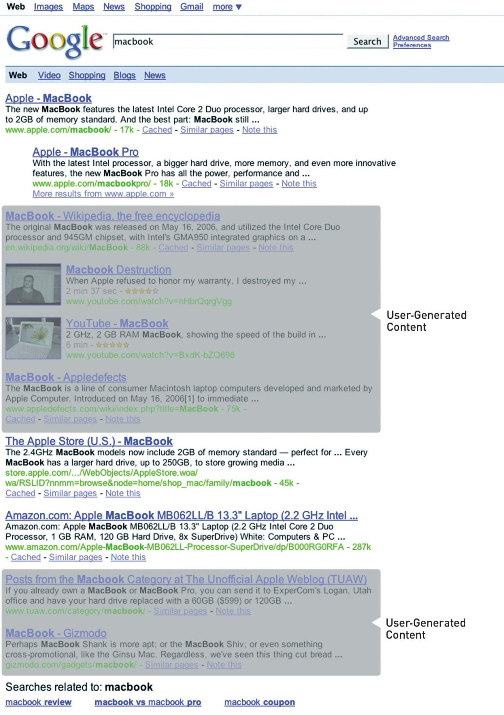
A search for “Macbook” shows that there are many entries on the SERP (search engine results page) that Apple does not control.

[1] “King III Report,” PricewaterhouseCoopers, 2009,http://www.pwc.com/za/en/king3/index.jhtml (accessed June 23, 2010).
[2] “Edelman Trust Barometer 2008,” Edelman, 2008,http://www.edelman.com/TRUST/2008/TrustBarometer08_FINAL.pdf (accessed June 22, 2010); “Trust in Advertising: A Global Nielsen Consumer Report,” Nielsen, October 2007,http://asiapacific.acnielsen.com/site/documents/TrustinAdvertisingOct07.pdf (accessed June 22, 2010).

11.2 The First Step: Monitor the Conversation

LEARNING OBJECTIVE
- Understand that listening to the buzz online is a crucial step in the online reputation management process.
Focus groups are not required for gauging customer sentiment on the Internet. It’s all out there, connected via hyperlinks and crawled regularly by search engine spiders.
Keywords—the foundation of categorizing and indexing the Web—make it relatively simple (though possibly time consuming) to listen to the chatter online. Customers are not using channels designated by a company to talk about that organization, but the good news is that the Internet makes it easy for a company to use the channels that customers have selected.

Online Reputation Management Keywords
Online reputation management (ORM) allows a company to track mentions of itself, its staff, its products, its industry, and its competitors. In fact, the tools allow for the tracking of anything; it just comes down to deciding what is relevant to you.
In terms of the company, one can track the following:
- Brand name
- URL (uniform resource locator)
- Key products
- Key personnel (names, job titles, etc.)
In terms of the industry, one can track the following:
- Conferences
- Patents
- News
In terms of competitors, one can track the following:
- Brand names
- Product launches
- Web site updates
- Job vacancies
For example, if Apple were to use these tools to monitor its reputation, some keywords used for the company might be the following:
- Apple
- “apple.com”
- Macbook, iPod, Macbook Air, iTunes
- “Steve Jobs”
For its industry, Apple might use the following:
- Consumer Electronics Show Las Vegas
- CeBIT
For its competitors, Apple might use the following:
- Microsoft, Creative
It is also important to track common misspellings, all related companies, and all related Web sites.
Tracking the names of people key to a company can highlight potential brand attacks or can demonstrate new areas of outreach for a company.
Brand names, employee names, product names, and even competitor names are not unique. To avoid monitoring too much, identify keywords that will indicate that a post has nothing to do with your company and negative match that keyword in your searches.
For example, “apple” could refer to a consumer electronics company, or it could appear in a post about the health benefits of fruit. Finding keywords that will indicate context can help save time. So you could negative match words like “fruit,” “tasty,” and “Granny Smith.”

How to Track: CGM and Search
Thankfully, ORM does not entail hourly searches on your favorite search engine to see what is appearing on the search engine results page (SERPs), although being aware of your search space is vital as well. There are a number of search engines that allow users to narrow a search to particular media or industries, and using RSS (really simple syndication) means that these results can be updated regularly and kept conveniently in one place.

Note
Remember RSS from ? It means that you can keep track of everything in one central place.
Monitoring all mentions means that the following need to be tracked:
- Blogs
- Twitter
- News
- Forums
- Comment boards
- Photos
- Videos
- Job listings
- Events
- Patents
- Web site changes
There are a number of different tools that monitor these areas and supply the results via e-mail alerts or RSS feeds. The following are some free tools that are available.
Google has several search services, some of which have been mentioned previously, and periodically adds more to the list. With the services below, an RSS feed is available for the search (Google Alerts sends weekly or daily e-mails with updates), so that all updates can be available through a feed reader.
- Google Alerts. http://www.google.com/alerts. Google Alerts will send an e-mail when the keyword is used in either a news item or a blog post.
- Google News. http://news.google.com. Google News searches all news items for mentions of a keyword.
- Google Blog Search. http://blogsearch.google.com. Google Blog Search searches all blog posts for mentions of a keyword.
- Google Patent Search. http://www.google.com/patents. Google Patent Search allows you to keep track of all filings related to an industry, and searches can be done to see if there are patent filings that might infringe on other patents.
- Google Video Search. http://video.google.com/videosearch. Video Search relies on the data that have been added to describe a video and will return results based on keyword matches.
There are several search engines that focus solely on tracking blogs, news, and other social media and can provide trends for searches. As well as providing regular updates of new postings, these search engines can provide an overview of a certain period of time.
- Blogpulse. http://www.blogpulse.com. Blogpulse tracks conversations and trends and supplies an RSS feed for updates.
- Technorati. http://www.technorati.com. Technorati tracks blogs and tagged social media.
Keeping track of blog posts is one thing, but mentions of a company can also appear in blog comments and on forum postings. The following two services assist in monitoring comments and forums.
- Boardtracker. http://www.boardtracker.com. Boardtracker monitors popular forums and provides alerts via short message service (SMS) for keywords mentioned in a thread.
- Co.mments. http://co.mments.com. RSS alerts can be created for mentions of a keyword in the comments of blog posts.
Yahoo! has a number of social media companies under its umbrella, and most provide the opportunity to monitor mentions via RSS.
- Flickr. http://www.flickr.com/search. RSS updates for searches on a particular keyword will reveal when a brand name has been used in tagging a photo.
- Yahoo! Upcoming. http://upcoming.yahoo.com. Yahoo! Upcoming will alert you via RSS to any upcoming events related to the keyword you have selected.
- Delicious. http://delicious.com. An RSS feed can be created for URLs tagged with keywords or for new bookmarkings of a URL.
- Yahoo! Pipes. http://pipes.yahoo.com/pipes. Yahoo! Pipes allows anyone to set up a custom buzz-monitoring tool with previously chosen filters.
There might be Web sites that a company would like to monitor for keyword mentions that do not offer RSS feeds. Using a service such as Rollyo (http://www.rollyo.com) allows the creation of a custom search engine that will search those specific sites only.
Listening is the first step to getting involved in the conversation surrounding a company. Using search tools and RSS feeds means that information can be accessed quickly and in one place without the need to visit hundreds of Web sites.

KEY TAKEAWAYS
- With ORM, there is no need for costly focus groups to know a brand’s reputation.
- Conversations are taking place all the time on the Internet, and it is crucial for companies to be aware of what is being said about them. Customers are now dictating the channels of communication, and companies that cannot engage with their consumers in this way stand to lose them.
- ORM is about using the tools of the Internet, the same tools that customers are using, to monitor, analyze, and ultimately influence the conversation. Companies need to learn to listen and engage.
- There are many free and paid-for tools available for monitoring online conversations, and with most it is easy to set up custom RSS feeds that will update with any new mentions. Mentions need to be analyzed for sentiment, credibility, influence, and source, and appropriate action to be taken.

EXERCISE
- Using the Yahoo! properties mentioned above, evaluate a particular brand by using relevant keywords to see what comes up in a search. What did you find? Give examples. Are you surprised by what you saw?

11.3 The Second Step: Measure What’s Being Said by Whom

LEARNING OBJECTIVE
- Understand how to analyze what is being said online.
As a marketer, the first step in looking at who is saying what is to take stock of the messages being sent by your own company. This includes all Web sites and domains owned by a company, all blogs maintained by employees (whether company blogs or personal blogs), and all blogs maintained by former employees. An audit should give an idea of the content that is available to the public and what that content is saying.
With regular RSS updates declaring that selected keywords have been used in some form of social media, a growing list is being created of mentions surrounding a brand. Now what?
Even in the democratized world of the Internet, not all mentions are equal. They vary in terms of positivity or negativity and influence. Not all mentions require action from a company, but some require drastic measures to be taken. But all, no matter how quiet or how loud, are an indication of consumer sentiment.
Whether a post is positive, negative, or indifferent can be quickly assessed by reading it. Influence can be a little harder to establish.
Indicators such as traffic, links, and subscriber numbers can all assist in assessing the influence of a blog. There are also services such as Social Meter (http://www.socialmeter.com) that will show an entered URL’s audience and reach.
However, statements, particularly inflammatory ones, should still be monitored, as traffic can increase substantially and quickly online.
Influence can also assist in establishing the credibility of the author. Factors that can indicate credibility include the size of the blog’s audience, the frequency of posts, and the age of the blog. From this, metrics such as credibility, sentiment, and media distribution can be extrapolated. Furthermore, metrics such as reputation scores and volume of conversation provide insight into the health of a brand and the success of marketing and communication campaigns.
The source should also be looked at: is the mention a news item or a tag on a photo from someone’s holiday? The first would be a credible source, but the second would not be high in credibility.
To be able to monitor reputation over time, it can be a good idea to aggregate the information into a spreadsheet or database along with the factors mentioned previously. It is necessary to determine what is important to the reputation of the company you are monitoring and perhaps adapt factors accordingly.
Your database might look something like this:
Figure 11.2
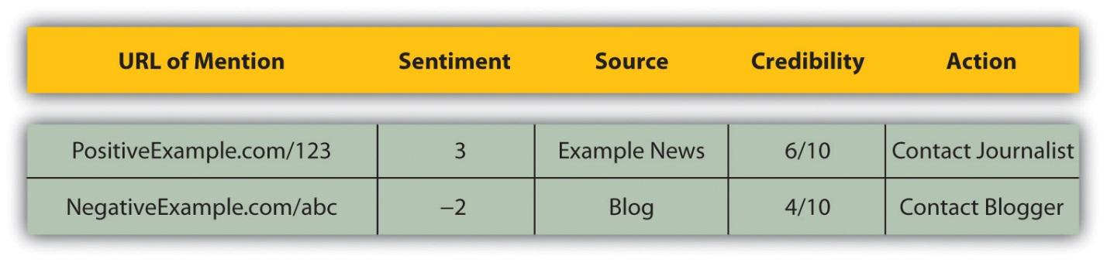
There are also a number of paid-for services on the market that will assist in monitoring and aggregating this information.
BrandsEye (http://www.brandseye.com) is a tool launched in 2008 that does just that. Not only does it track mentions, but it also allows the user to assign sentiment and importance to mentions and provides a benchmark of a brand’s reputation. Trackur (http://www.trackur.com) is another tool that monitors the volume of mentions but provides limited analysis.

KEY TAKEAWAYS
- Not all mentions are equal online. They may vary in terms of positivity or negativity.
- Posts that are positive, negative, or indifferent can be quickly assessed by reading them. But influence can be harder to establish.
- Statements, especially inflammatory ones, should be monitored, as traffic can increase substantially and quickly online.
- ORM can help a company to gain an inherent understanding of how consumers perceive and interact with their brand and thus can provide a platform for planning marketing campaigns.
- ORM should monitor all mentions of a brand and guide a brand in using social media to communicate. It can help identify hot spots for viral word-of-mouth marketing and should be used to ensure that that word of mouth is positive. ORM should also be used for determining the success of any marketing campaign that is not directly related to sales. It can show growing brand recognition as well as consumer sentiment.

EXERCISE
- Using the tools listed in this section, pick a brand of your choice and monitor it for a period of one week or more. See what you learn about the brand. Observe what people say and how they say it. Observe if the brand talks back and, if they do, what they say.

11.4 The Third Step: Manage—Engaging In and Leading the Conversation

LEARNING OBJECTIVES
- Learn how to engage in and lead conversation.
- Learn why it is important to engage in and lead conversation.
The best way to show that you are listening is by engaging. Online, there are many channels available to companies to respond to the conversation and to become an active participant in it.
What if everything being said is nice?
A fantastic position to be in is that every possible mention that includes your company, its employees, and products is overwhelmingly positive. Well done. However, that does not mean that there is nothing to do. Consumers want to know that a company is listening; it needs to respond. Positive comments should be acknowledged.
All of these mentions can also indicate new avenues for marketing and growth.

What If Everything Being Said Is Neutral?
If everything being said is neutral, then it sounds like the company is very boring. As Seth Godin puts it, “safe is risky.” ^{[1]} If a company is playing it so safe that no one can be bothered to either send praise or criticism its way, it’s in danger of being forgotten. The next step is no one talking about the company at all.

What If Negative Things Are Being Said?
Negative statements should be seen as an opportunity for growth. Negative statements can be complaints or criticisms, and both should be dealt with.
Complaints are from stakeholders who have had dealings with a company. By complaining, a customer is giving the company the opportunity to make things right and is probably indicating where the company can improve. Usually, the skilled customer service department of a company should deal with complaints.
If a complaint is online, the resolution should be there as well, although you can try to have it taken offline first. Even though the customer service will likely take place either over e-mail or by phone, posting a comment in a blog post, for example, will show the community that the company both listens and responds.
Criticism need not necessarily come from customers, but it is important to be aware of it. If a criticism includes false information, it should be corrected. And if the criticism is true, then it should be dealt with as such.

Responding
Responding involves recognizing that consumers dictate the channels of communication and that a company needs to go to the consumer, not the other way around.
In South Africa, “vodacom3G” is the name of a Vodacom representative who monitors the forum http://mybroadband.co.za and resolves complaints and queries and offers assistance. Instead of directing customers to an FAQ (frequently asked question) section on a Vodacom site, Vodacom has followed their consumers to the channel that the consumers prefer.

Tip
Visit http://www.mybroadband.co.za to see how Vodacom is using the forum to interact with customers.
Not only does Vodacom resolve questions on the forum, but the company also uses it to provide key information that consumers want. If you are responding to a blog post, find the writer’s contact details on the blog and e-mail her directly. As a last resort, use the comments to make contact with the blogger.
When responding, be transparent and honest. Remember that e-mails can be reproduced on blogs. At all times, remember that you are engaged in conversation, not dictation.

Influencing
In and , there are guidelines for companies to lead the conversation using the tools of social media and Web public relations (WebPR). Influencing and leading the conversation can also have the consequence of there being more results that are led by your company in the SERPs.
Companies can also be proactive by purchasing negative name domains, such as http:// www.companynamesucks.com, to prevent angry customers from buying them and having them hit the SERPs.
Lastly, take a look at negative brand-name searches on major search engines and consider PPC (pay-per-click) advertising to offer the company’s point of view.

KEY TAKEAWAYS
- The best way to show that you are listening is by responding.
- If everything that’s said is nice, marketers should still find ways to show they are listening by acknowledging positive comments.
- If what is said is neutral, the company is in danger of being forgotten.
- If what is said is negative, the company needs to see this as an opportunity for growth. Try to resolve things online. The customer service department should handle this.
- Be transparent when responding.
- WebPR works hand in hand with ORM. ORM tools are used to listen, and WebPR helps a company to respond and engage.

EXERCISES
- When dealing with complaints or criticism, why should a company try to take them offline first?
- How do you think a company can encourage customers to use established customer-service channels as opposed to social media, and what are the benefits of doing so?
- Vodacom has a representative on the forum http://www.mybroadband.co.za. Visit the forum and consider the style the representative, “vodacom3G,” uses when posting. Does it sound like a corporation or like an individual? What is the effect of the style that the poster uses?
- Think of an example of a negative brand-name search, and what a PPC (paid-per-click) ad that offers the company’s point of view may look like.

[1] Seth Godin, “Safe Is Risky,” Seth Godin’s Blog, October 22, 2004, http://sethgodin.typepad.com/seths_blog/2004/10/safe_is_risky.html (accessed June 20, 2010).

11.5 The Fourth Step: Maximize—Evolve Your Strategy

LEARNING OBJECTIVE
- Understand the importance of constantly evolving your strategy.
Online reputation management (ORM) should not simply be seen as a tool in the measurement and engagement arsenal. It provides a great deal more insight that can be applied to many other elements of the business to maximize results.
Within the marketing realm, ORM provides key insights into how particular tactics are performing and how it impacts the overall marketing strategy. By measuring how your stakeholders respond to particular activities (be it marketing, communications, or branding) it becomes possible to learn through each campaign and mold the tactic based on empirical data to maximize returns. This provides a great way for both offline and online campaigns to constantly improve and stay relevant to stakeholders’ needs.
These same outputs can also be shared with other departments, such as human resources (HR), to provide additional ways to impact the internal workings of your company. In HR’s case, a measure might be of how staff view the company itself.
Similarly, these insights can be applied to the overall business strategy to assist both with data collection and providing early insights on competitor and environmental changes that may drive strategic decision making. The Internet is the largest focus group, and if it’s looked at from a market research perspective, there is a huge opportunity to apply “wisdom of the crowd” and evolve business to be more aligned with your stakeholders’ needs.

KEY TAKEAWAYS
- ORM provides key insights into how particular tactics are performing and how they impact the overall marketing strategy.
- It is possible with ORM for campaigns to constantly improve and stay relevant to stakeholders’ needs. These outputs can be used by other departments, such as HR.
- The Internet is the largest focus group.

EXERCISE
- Can you think of another situation where these insights can be beneficial to a company?

11.6 Ten Rules to Recover from an Online Brand Attack

LEARNING OBJECTIVE
- Learn how brands can best recover from an online threat.
These ten rules to recovery should provide a practical approach for brands facing an online threat.

Rule 1: Humility
Before you can recover from an online brand attack, you have to be aware that your brand can be attacked, no matter how big it is or how untouchable it may seem.

Rule 2: Listen
Once you have a clear understanding of the scope of the possible effects of an online attack and are committed to maintaining a good reputation online, you’re halfway there. Next you’ve got to understand how the process of consumer complaints has evolved. Use this understanding to guide your actions.

Rule 3: Act Immediately
One of the easiest ways to solve the majority of brand attacks is to respond quickly. A brand that shows it is listening and does indeed care will go far when it comes to ensuring a solid online reputation. A conscious reaction is the only way forward—that is, acknowledging what has been said and reacting accordingly.

Rule 4: If What They’re Saying Is False…
If the mention of your brand is factually incorrect, in a friendly tone, send the blogger (90 percent of the time it will be a blogger) evidence that they are wrong, ask for removal or retraction of the entry, and offer to keep them informed of future news. If no action is taken by the blog author, then add a comment.

Rule 5: If What They’re Saying Is True…
If it is true, learn from the “Dell Hell” phenomenon, a term coined from the situation in which a blogger wrote about his bad experience with computer maker Dell. Dell failed to respond, and the negative word spread—resulting in insurmountable damage for the company. If the mention is negative but true, then tell your side of the story and try as hard as you can to take it offline.
On January 22, 2009, a story was published on CNN’s iReport claiming that Steve Jobs had had a heart attack. While it was later found out to be a hoax, it had an immediate effect on Apple’s stock price, dropping it by 6.6 percent, amounting to a $5.62 billion loss in market capital.

Rule 6: Keep the Negative Pages out of the Search Engines
Keeping more people from reading negative things about your brand is imperative. What you can do is knock them off the first page of the results with basic SEO topped with some social media page setups such as Squidoo and MySpace or forum posts. Keep adding pages and links until you’ve forced the offending pages out of sight. This tactic doesn’t lack transparency but rather gives consumers the opportunity to view positive mentions of your brand before they come across the negative ones. All brands have negative conversation surrounding them in some form or another.

Rule 7: Maintain Communication
If you aren’t an active member of the online community, it will be a little harder to recover from an online attack. If your company doesn’t have a blog, start one. Participate in industry forums and chat rooms. Build genuine credibility as a member of these conversations, and you’ll find that people will have more respect for you and your brand.

Rule 8: Engage in the Conversation
Keep your brand in the face of consumers by engaging in the conversation. This could be done by making use of blogs, communicating with customers, and being as open and honest as possible. Engaging in, and leading, the conversation allows you to build an authentic voice. If a crisis hits, you will be well placed to respond in a way that is authentic.

Rule 9: Care
If you truly care what your customers think, then most of this will come naturally. That’s all people want. They give you their money; they just want some good service and respect in return.

Rule 10: Be Prepared
No brand is immune to an online brand attack. The best brands have strategies in place to immediately identify a reputation crisis and respond to it quickly enough to stop the negative word of mouth from spreading.
If all else fails, apologize and move on.
Bottom line, by making bloggers familiar with your voice, you will be better placed to respond to criticism. Consumers can spot last-minute corporate firefighting—they should know and trust your voice already.

KEY TAKEAWAYS
- There are ten steps to recovery from an online brand attack: humility, listen, act immediately, if what they’re saying is false, if what they’re saying is true, keep the negative pages out of the search engines, maintain communication, engage in the conversation, care, and be prepared.
- Following these steps will help a brand’s reputation.

EXERCISE
- Choose a company and use at least one of the services listed in this chapter to gain an overview of its online reputation. Find a positive mention, a neutral mention, and a negative mention and determine the influence of each. What action would you recommend for each?

11.7 Case Study: Four South African Banks
Using a tool to measure one company’s reputation will give an indication of consumer sentiment, but it is far better to be able to compare that to competitors’ reputations. Using the online reputation management (ORM) monitoring and analyzing tool BrandsEye, the online reputation of four prominent South African banks was measured for the period November 26, 2006, to February 13, 2007.
Banks, and particularly their customer service, generate a lot of conversation, both online and off. BrandsEye was used to monitor mentions of the banks, to filter out duplicate mentions, and to generate a daily reputation score for each bank that could then be measured over time.
Figure 11.3 Graph Showing the Differences in Reputation of Four South African Banks
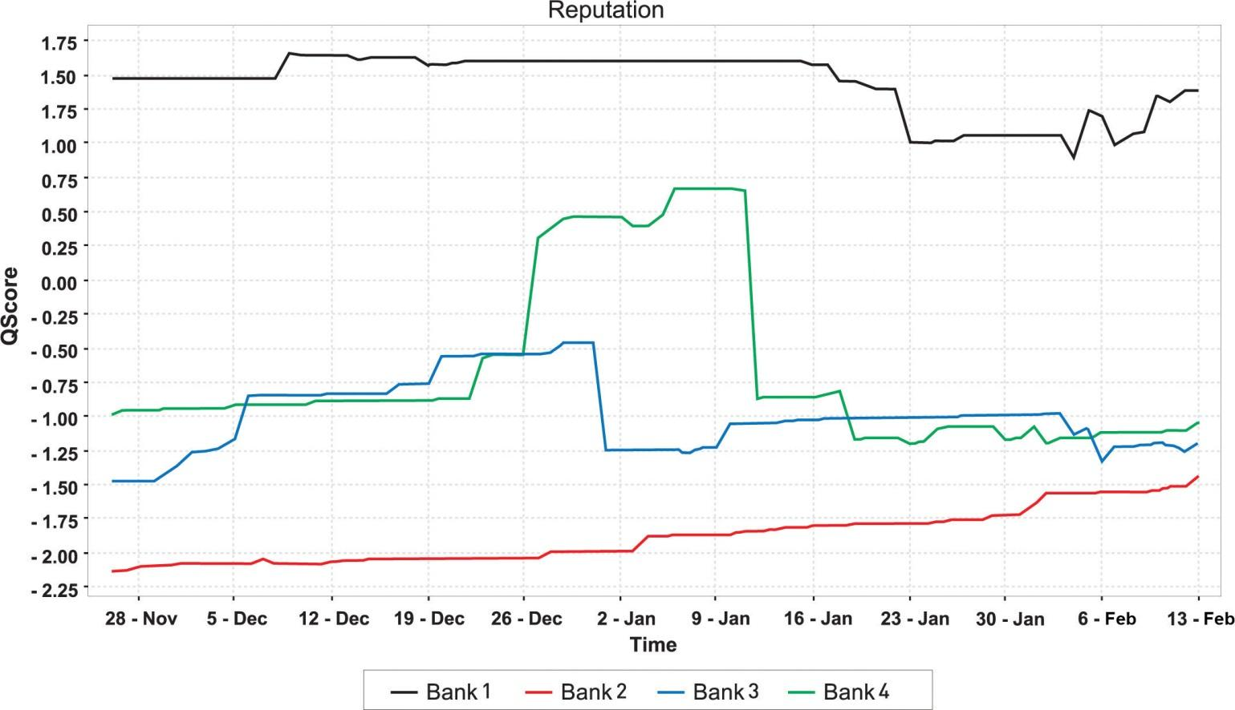
Changes in reputation, especially jumps such as the one experienced by Bank 4 just after December 26, can then be correlated to real-world events.
Bank 1 has superior customer service levels, and this is shown in the reputation score. However, toward the end of January, Bank 1 experienced a backlash from local government when attempting to launch a public-service campaign. The offline media coverage was far reaching, loud, and venomous, and within a short while the effects on the bank’s reputation were expected to be seen online. On the contrary, what actually happened was quite surprising. While the ORM tool picked up a number of negative mentions, these were in fact directed at local government for seemingly coercing the bank into withdrawing their campaign.
With a temporary dip in reputation score, the result was that throughout February, Bank 1’s online reputation grew stronger and stronger. Having their hand forced created a sense of public empathy, with the majority of criticism deflected away from the bank itself. Furthermore, when critics of the bank’s withdrawal voiced their opinions, a number of respondents actually jumped to its defense. With an already high online reputation score, not only did Bank 1 survive what could have potentially been a major crisis, but its reputation thrived as a result.
Bank 2, on the other hand, had the lowest reputation score throughout the investigation, although tending to the positive toward the end of the test period. Their poor customer service levels, as perceived by their online customers, were negatively affecting their online reputation.
In fact, one of South Africa’s most prolific online forums had an established tradition of using Bank 2 as an example of what was wrong with the industry in general. A comment by one forum member went, “Bank 2 is evil! Evil! Evil! Evil!” The majority of Bank 2’s negative mentions originated from this particular forum, and interestingly, where it was criticized, Bank 1 was offered as a suitable alternative.

CASE STUDY QUESTIONS
- For Bank 1, media coverage regarding its public service campaign was negative, while social media coverage was supportive of the bank. How does each affect the bank’s reputation?
- How would you recommend that Bank 2 combats negative mentions on forums?
- Bank 1 appears to be at the top of its game. What would you recommend to maintain and grow its reputation?

11.8 References
Andy Beal, “Social Media Monitoring Tools: 26 Free Online Reputation Tools,” Marketing Pilgrim, August 27, 2007,http://www.marketingpilgrim.com/2007/08/26-free-tools-for-buzz-monitoring.html (accessed March 3, 2008).
Pete Blackshaw, “Search and Reputation: Your Brand Standing Is Your Shelf Landing,” ClickZ, January 22, 2008, http://www.clickz.com/showPage.html?page=3628171 (accessed March 3, 2008).
Thomas Hoffman, “Online Reputation Management Is Hot—But Is It Ethical?” Computerworld, February 12, 2008,http://www.computerworld.com/action/article.do?command=viewArticleBasic&articleId=9060960 (accessed March 3, 2008).
Jeff Jarvis, “Dell Hell,” BuzzMachine, July 1, 2005,http://www.buzzmachine.com/archives/cat_dell.html (accessed March 3, 2008).
Jeff Jarvis, “My Dell Hell,” The Guardian, August 29, 2005,http://www.guardian.co.uk/technology/2005/aug/29/mondaymediasection.blogging (accessed March 3, 2008).
Susan Kinzie and Ellen Nakashima, “Calling In Pros to Refine Your Google Image,” Washington Post, July 2, 2007, http://www.washingtonpost.com/wp-dyn/content/article/2007/07/01/AR2007070101355 .html?hpid=artslot(accessed March 3, 2008).
“Online Reputation Management,” Elixir Systems, 2006,http://www.sempo.org/learning_center/articles/ElixirSystemsOnlineRepMgmt.pdf (accessed March 3, 2008).

Chapter 12

Web Public Relations

12.1 Introduction
Public Relations is a set of management, supervisory, and technical functions that foster an organization’s ability to strategically listen to, appreciate, and respond to those persons whose mutually beneficial relationships with the organization are necessary if it is to achieve its missions and values.
Robert Heath, Encyclopedia of Public Relations
Traditional PR (public relations) has focused on crafted press releases and company image. It has provided a controlled release of information and a communication process that relies on journalists and traditional media such as newspapers. This modus operandi has been enormously impacted by the spread and influence of the Internet.
While the Internet provides excellent tools to the PR industry, the shift in communications afforded by the Internet has also caused a ruckus in the world of public relations. Information is freely available and accessible to a far greater audience, as opposed to being controlled through a select group of journalists. Communication is taking place in the realm where the consumer feels most comfortable, as opposed to the channels dictated by the company.
PR needs to follow this shift, especially as consumers are increasingly turning to a “person like me” for trusted advice, as opposed to mainstream media outlets.^{[1]}
In 2009, Google introduced Google Social Search, which finds relevant public content from your friends and contacts and highlights it for you at the bottom of your search results. This further illustrates how consumers will be shifting their trust from traditional media.
The Internet provides savvy PR professionals with plenty of tools for listening to and engaging with a far wider community and can have immense benefits for companies that are willing to be transparent in their communications. It also allows companies to engage in a more immediate form of communication.
Web public relations (WebPR) collectively stands for the ways in which you can get your message out online. It is used to connect with customers and enhance brand awareness, exposure, and SEO (search engine optimization) efforts using various online channels like article directories, press release sites, industry related sites, online newsrooms, blogs, forums, and social media.

In a connected, digital world, PR isn’t just about the press release; it’s about connecting with customers.
Heidi Cohen ^{[2]}

History
As new communication tools became available with the developments of the Internet, so they became available to the PR industry. It also revealed a wider audience for a company’s stories and developed new channels for promoting them. With the rise of social media, and especially the growing influence of bloggers, it became clear that PR officers needed to reach out to more than just journalists.
However, the road has been rocky, and traditional PR has in some instances struggled to cope with the new rules of engagement.
In February 2006, Tom Foremski wrote in his post “Die! Press Release! Die! Die! Die!”: “I’ve been telling the PR industry for some time now that things cannot go along as they are…business as usual while mainstream media goes to hell in a hand basket.” ^{[3]}
Chris Anderson, editor in chief of Wired and author of The Long Tail, announced on his blog in October 2007 that he was blocking “lazy flacks [who] send press releases to the Editor in Chief of Wired because they can’t be bothered to find out who on my staff, if anyone, might actually be interested in what they’re pitching.” ^{[4]}
However, a 2005 experiment showed that press releases can garner a better ROI (return on investment) than a PPC (pay-per-click) campaign. ^{[5]} So it’s worth ensuring you know how to be an effective practitioner in today’s connected environment in order to do the following:
- Get new business
- Extend reach
- Promote current product offering and services

[1] “‘A Person Like Me’ Now Most Credible Spokesperson for Companies,” press release, Edelman, January 23, 2006, http://www.edelman.com/news/showone.asp?id=102(accessed May 28, 2008).
[2] Heidi Cohen, “More Than a Press Release: Extending Your Online PR Efforts,” ClickZ, March 30, 2006, http://www.clickz.com/showPage.html?page=3594951 (accessed May 28, 2008).
[3] Tom Foremski, “Die! Press Release! Die! Die! Die!” Silicon Valley Watcher, February 27, 2006, http://www.siliconvalleywatcher.com/mt/archives/2006/02/ die_press_relea.php(accessed May 28, 2008).
[4] Chris Anderson, “Sorry PR People: You're Blocked,” The Long Tail, October 29, 2007, http://www.longtail.com/the_long_tail/2007/10/sorry-pr-people.html (accessed May 11, 2010).
[5] Sean Carton, “How Is Information Passed Around the Web?” ClickZ, October 3, 2005, http://www.clickz.com/showPage.html?page=3552876 (accessed May 28, 2008).

12.2 How It Works

LEARNING OBJECTIVE
- Understand the basic fundamentals of Web public relations (WebPR).
The most important component of successful public relations (PR) is listening to your customers. They are telling you not only what they want but also how well your message is being received. In Chapter 11 "Online Reputation Management", the tools used to listen online were discussed.
If PR is about connecting with your customers, it should also be about responding to them by engaging them in conversation in the channels where that conversation is taking place.
WebPR allows you to build your own voice. Though you cannot control the message, you should lead the conversation through transparent communications.

Listen to Your Customers
Online reputation management (ORM) will enable a company to listen to what is being said about it online. Particularly important is to regularly monitor all channels that a customer might use to contact or talk about a company. This includes forums and consumer action Web sites, as well as personal blogs.
Not only does this allow a trend in general sentiment related to the company to emerge, but it will also highlight issues that need attention and areas that are being orchestrated successfully.

Respond to Others
ORM described the tools that can be used to find out what is being said about a company online. A key function of WebPR is to respond to those conversations with a consistent voice. Consumer-generated media can and must be responded to. Being publicly available, and publicly searchable, means that consumer-generated media (CGM) form part of the public perception of a company. As discussed in Chapter 11 "Online Reputation Management", search results often show CGM—messages that a company cannot control.
Blogs and forums are key starting points for responding. Responding in these mediums ensures that the company’s response may be viewed along with the original message—making the response more personal and thus credible in the eyes of the consumer.

What to Consider
Transparency and honesty are vital. Any semblance of “PR speak” or “spin” could see this worthy outreach backfiring and creating even more negative hype. An authentic voice works best, as does a thick skin. Respond to the good and the bad—it shows that the company is listening to all conversations.

Build Your Own Voice
Whether or not a company has a Web site, it most likely has a Web presence. Not only are businesses listed in online directories, but they are also mentioned in CGM. However, companies need to pay attention to the voice that is portrayed by their online presence and use the tools of the Internet to enhance that voice and meet strategic business objectives.
Establishing long-term, trusting consumer relationships through online article syndications, press releases, and blogs aids a company to craft online credibility, placing it in a better position to respond to future criticism and receive future praise. These tools also help build links to a company’s Web site. And, of course, links increase traffic and havesearch engine optimization (SEO) benefits that can ultimately lead to conversion, sales, and an increased readership.

Note
Social media, ORM, and WebPR are all intertwined—have you noticed? It’s all about conversations, how to listen to the chatter, and how to get involved in it as well.
While it used to be that messages were dispersed to journalists who would then broadcast them to a reading public, today that practice does not always exist to disseminate the information being transmitted. This provides tremendous opportunity for companies to be fully involved in engaging with their customers.
WebPR is not about throwing out the PR rule book. It’s about using the Internet to fully realize its communication potential.

KEY TAKEAWAYS
- WebPR is about responding and engaging with customers.
- WebPR is best used for:
  - Listening to customers
  - Responding to others
  - Building your own voice
- Being transparent and honest is vital.

EXERCISES
- Why do you think it might be appropriate to respond to others when they are online?
- Why do you think it is important to respond to good and bad comments?

12.3 WebPR Tactics

LEARNING OBJECTIVES
- Become familiar with the various tactics involved in Web public relations (WebPR).
- Learn the best practices for writing an article for online syndication.

Online Article Syndication
Online article syndication is one of WebPR’s (Web public relations) principal and most successful tactics. It involves writing articles that are in no way a direct promotion of your site. These are not press releases; they are written to provide information and valuable content. Articles are submitted to online article directories, where they are picked up and republished on other sites.
As the articles contain a link and keywords relevant to your site, product offerings, or services, the benefits for search engine optimization (SEO) are excellent. But the strategy won’t work unless people want your articles. Thus, they need to be broad, informative, and not just thinly disguised advertisements. Each article will also have an “About the Author” section. This could contain up to three links to your site, and many article directories will allow you to include a backlink in the body of the article as well.

The Aim
The article gets republished on many Web and blog sites in the weeks after it is published. In order to ensure your site remains the search engine authority on the article’s subject, the article should be published and indexed there first. Online article syndication not only allows you to introduce fresh, optimized content to your site but also enables you to generate valuable SEO backlinks.
Articles containing relevant information are value adding and therefore attract links naturally. And, if published on a third-party site, they should carry a link back to your own Web site. This drives visitors to the site that are automatically predisposed to your brand and are therefore more likely to engage and buy the products you offer.

Writing an Article for Online Syndication

Choose a Topic
By looking at your Web site’s content themes, and the key phrases associated with them, you will be able to write targeted, key-phrase-rich articles. Listening to the conversations around your brand, and seeing what customers are saying, can also lead you to topics relevant to your Web site and your customers. Refer to your SEO strategy, and the keywords you are targeting, to create articles that complement your SEO efforts.
A WebPR article should aim to be the following:
- Interesting
- Helpful
- Insightful and informative
- Enticing
- Relevant
- Straightforward

Optimize the Article and Publish It on Your Own Site
Using SEO and Web copy guidelines, ensure that the content is optimized for search engines, as well as engaging for readers. Publish the article to your own Web site first to establish the authority of your Web site. This will do the following:
- Allow you to reap the SEO benefits of fresh, optimized copy
- Enable your site to be regarded as the expert on that subject
- Avoid Google’s strict duplicate-content policies
First, the article needs to be optimized for your Web site. Implement all the tactics covered in Chapter 14 "Online Copywriting", such as metadata that adheres to search engine standards, optimized title and key phrases, optimal use of <h> tags, and links. Once it is live, you will need to wait for it to be indexed by the search engines: if you type the article title into the search engine and it returns the page with your article on it as a result, it has been indexed and it’s now ready to be submitted to the online article syndication sites and directories.
The article then needs to be edited for syndicating. Different directories have their own requirements and guidelines that need to be adhered to.
For example, some directories require that all links to your Web site in the body of the text, bar one, would need to be removed, as well as all mentions of your company as a brand name. You will also need to create an “About the Author” section at the end of the article. This can tell readers more about your company and the information they can access by visiting the site. You will be able to add two or three links in this section, depending on the directory. Send one link to the home page and the other(s) to pages within the site.
If these guidelines aren’t met, your articles will not be published and you may be flagged as writing irrelevant content and, in the worst case, be blocked from any further submissions.
Most directories allow the inclusion of keywords relevant to the article. Ensure these are relevant to the article and that you include the key phrases for which you have optimized the article. These key phrases will allow readers to find your article, using the search function on the directories. This is also called tagging your article.
Many directories also allow a description. This description will be displayed, along with the title of the article, when someone has searched the directory for a key phrase or category for which you have tagged your article. The description should entice the user to read your article, so it needs to be succinct and gripping. It also needs to inform the readers what the article is about and how they will benefit from reading it.
Once you have done this, you will then need to convert the article into HTML. The HTML is very basic, and while the different directories have their own HTML guidelines that you will need to familiarize yourself with, the standard tags are as follows.
- To bold: <strong>phrase you wish to bold</strong>
- To italicize: <em>phrase you wish to italicize</em>
- To underline: <u>phrase you wish to underline</u>
- To list: <li>lines you wish to list</li>
- To create a paragraph: <p>paragraph here</p>
- To insert a line break: <br/>
- To insert a link: <a href=“page url”>phrase you wish to link</a>
For each directory, the submission guidelines will indicate requirements for the text.

Submit the Article to Directories
Publishing the articles to directories means they can be picked up and republished on other sites, which contributes significantly to link-building efforts. There are hundreds of online article directories out there, but you need to be selective when choosing which ones to submit to. The good article directories usually allow up to four links to be placed in each article.
Here is a list of ten directories that you could publish your articles to:
- http://www.ezinearticles.com
- http://www.goarticles.com
- http://www.articlecube.com
- http://www.articlesbase.com
- http://www.articlerich.com
- http://www.isnare.com
- http://www.articledashboard.com
- http://www.articlealley.com
- http://www.amazines.com
- http://www.sooperarticles.com
These directories all allow three to four links, they all give statistics on how the articles are doing, and they all allow you to preview the article before you publish it—it is important to be able to preview it to ensure that no mistakes were made during the HTML conversion process.
All the previous article directories are free, though you will need to register for an account.
Once you have submitted the article, it will undergo a review process—the directories do this to ensure that the articles are actually useful and relevant rather than simply advertorials. It will then be approved and available to read on the site. From here people who are interested in republishing the article on their own sites or blogs can do so as long as they reproduce the content exactly as you have submitted it. If the article is well written and informative, it has thecapacity to go viral, which is the ultimate goal as the more times it is republished the more links you will acquire—and all at no cost to you.

Monitor Its Progress
A bit of basic online reputation monitoring will enable you to keep an eye on where your article is being republished and ensure that it is being republished correctly. There’s no use in sites republishing it if they’re going to strip out all the links and the “About the Author” section that you included, as this is ultimately the driving force for business opportunities.

KEY TAKEAWAYS
- Online article syndication allows you to introduce fresh, optimized content to your site and enables you to generate SEO backlinks.
- Optimize the article and publish it to your site. Then you need to wait for it to be indexed.
- Be sure to submit keywords and description when using directories.
- Submit the article to a directory.
- Monitor its progress using ORM techniques.
- There are several directories you can use.

EXERCISES
- Explain how tagging is important when submitting articles to online syndication.
- Consider why articles should be reviewed before going live on a site. Give an example of a situation where this would be a best practice.

12.4 Press Releases: Optimized for Search and for Social Media

LEARNING OBJECTIVE
- Understand how search and social media are a powerful combination for press releases.
The press release is a stalwart of public relations (PR). It is a standardized format for releasing information. Originally intended to provide information to journalists, press releases are increasingly being read without going through the journalists first. PR has also realized the tremendous impact of bloggers, and many PR professionals are using the same press releases in their communications with bloggers. Today, with many offline press offices moving online, journalists are also bloggers, and bloggers are the new citizen journalists, so the lines are becoming even further blurred.
Newswires, like article directories, allow for online submission of press releases. In turn, these are syndicated via RSS (really simple syndication), and so are picked up by the news engines, such as Google News, Yahoo! News, and MSN News. Many people pick up their news via these online news engines, which aggregate news from a number of publications and newswires, and so the press release is becoming an ever more crucial means of reaching a growing audience.
As well as promoting conversation around your company and its products, online press releases should drive traffic to your site. To achieve this, press releases need to be optimized to contain related key phrases and links. Not only is this important for the press releases being picked up by news engines, but there are many journalists who will simply reproduce the copy of a well-written press release. Ensure that these reproductions positively impact your SEO (search engine optimization) efforts by optimizing your press releases for key phrases and links.
Don’t forget to publish your press releases on your own site before sending them to the release sites. You’ll want to be considered as the “expert” in the search engine’s eyes on the subject, and journalists also need to be able to find all the information they need on a company Web site.

Discussion
Journalists usually extract information from a press release and supply commentary when they write an article. How do you think the fact that the press releases are now being read directly by the public affects the press release?
Like articles, you will need to write a description and allocate keywords to the press release. You will need to ensure that all media contact information is listed, usually in the boilerplate or in the “About the Author” section. Each site will specify exactly what information is required. Very few of the press release sites allow you to convert your releases into HTML (especially the free-release sites). Apart from the keywords, the category you select for your press release is extremely important, so be sure to have a good look at the categories the site offers and make sure that you select the most appropriate one.
Most of the sites offer a free option and a paid option. The paid option provides a host of additional benefits, and it is worth considering paying for a membership to one of them.

Benefits of Online Press Releases
The benefits of online press releases are numerous and include the following:
- Online press releases allow for almost instant publishing of news online.
- A well-written press release can garner top rankings in the news engines (Google News, Yahoo! News, MSN News, etc.). Adequate optimization can also result in higher SERP (search engine results page) rankings.
- Content is syndicated quickly via RSS.
- Links are built naturally and effectively from online publishing.
- Distribution is increased beyond your contact list.
- Reach is far greater than that of a traditional press release.
- Reach and distribution can be easily tracked online.
Here are some press release sites to consider:
- http://www.i-newswire.com
- http://www.pr.com
- http://www.pressexposure.com
- http://www.1888pressrelease.com
- http://www.sanepr.com
- http://www.pressbuzz.com
- http://www.pressbox.com
- http://www.pressreleasepoint.com

Social Media Press Release
Blogs and other consumer-generated media (CGM) are sometimes referred to as citizen journalism. The reach and influence of CGM means that press releases are often finding their way to the in-boxes of content creators. While many journalists are becoming disillusioned with the standard press release format, the press release can be seen as overhyped corporate speak by time-starved and transparency-focused bloggers.

Figure 12.1 Template for a Social Media News Release
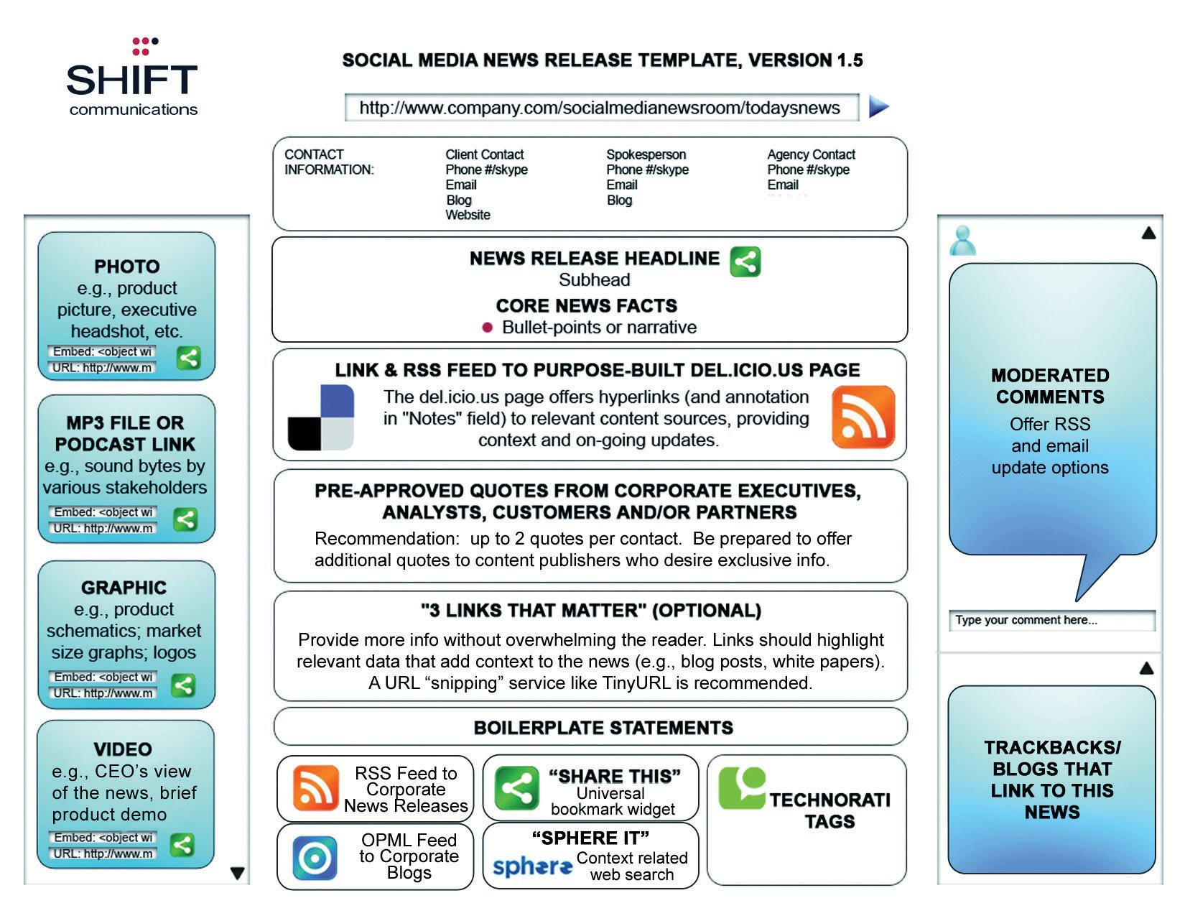
Source: http://www.shiftcomm.com/downloads/smr_v1.5.pdf.
Pitching to bloggers can be a sensitive task, and there are some guidelines outlined in this chapter, but PR firms such as Edelman and Shift Communications have created templates for a social media press release (SMPR) designed to communicate facts more clearly and concisely and to use the tools provided by social media.
This is the outcome of an evolving conversation among PR companies, journalists, and bloggers. It is a work in progress, and there is plenty being said both for and against this approach, but it is an elegant example of PR firms listening to the conversation, engaging, and responding.

Tip
Go to http://www.edelman.com/news for some examples of the Edelman version of the SMPR in action.

Blogging
Writing a blog is one of the best ways for a company to build its own voice in the new world of social media and citizen journalism. Not only do blogs play a role in SEO (with fresh content written with key phrases in mind), they also play a strategically important role in reaching out to customers and connecting with them.
Blogging takes a company right into the heart of the conversation and demonstrates the company’s comfort with this direct communication channel. A blog means that there is regular commentary that is spoken in the voice of the company. Additionally, blogging teaches companies how to engage personally with their customers.

KEY TAKEAWAYS
- PR is greatly influenced by press releases and bloggers.
- Online press releases should drive traffic to your site.
- Press releases should be optimized to contain related keywords and links.
- Don’t forget to publish press releases on your own site, too.
- There are many benefits of online press releases.
- A blog can be a great way for a campaign to build its own voice.

EXERCISES
- Using one of your favorite brands, develop a list of categories you would submit articles to.
- What is the difference between optimizing a press release for search versus optimizing a press release for social media?
- What are the main differences between a traditional press release and a social media press release, and what are the similarities?

12.5 Online Press Room

LEARNING OBJECTIVES
- Understand how the online press room works.
- Understand the importance of pitching to bloggers.
As the Internet increases the ease of access to information, an essential part of WebPR (Web public relations) is ensuring that pertinent information is easy to access. Making sure that journalists, customers, and investors are able to find all key company information quickly and easily means that you are able to slip into that conversation as a key contributor that much more easily.
A 2003 Nielsen Norman study found that when journalists used a corporate Web site to find basic information, they were successful only 73 percent of the time. ^{[1]} Journalists often work on tight deadlines, and having the required information on hand could make the difference between whether a company is written about or not. An online press room can ensure a company is able to meet journalists’ needs.
An online press room must have the following:
- Company history
- Key executive biographies
- Pertinent background information
- Logos and images in a variety of sizes, resolutions (for Web and for print), and formats
- All press releases previously featured
- Multimedia gallery (video, audio, and visual)
- Contact information for the company and PR representatives
- Search function
- RSS (really simple syndication) and e-mail alerts
- Tagging capabilities
- Information in a variety of formats

Figure 12.2 Social Media Newsroom Template
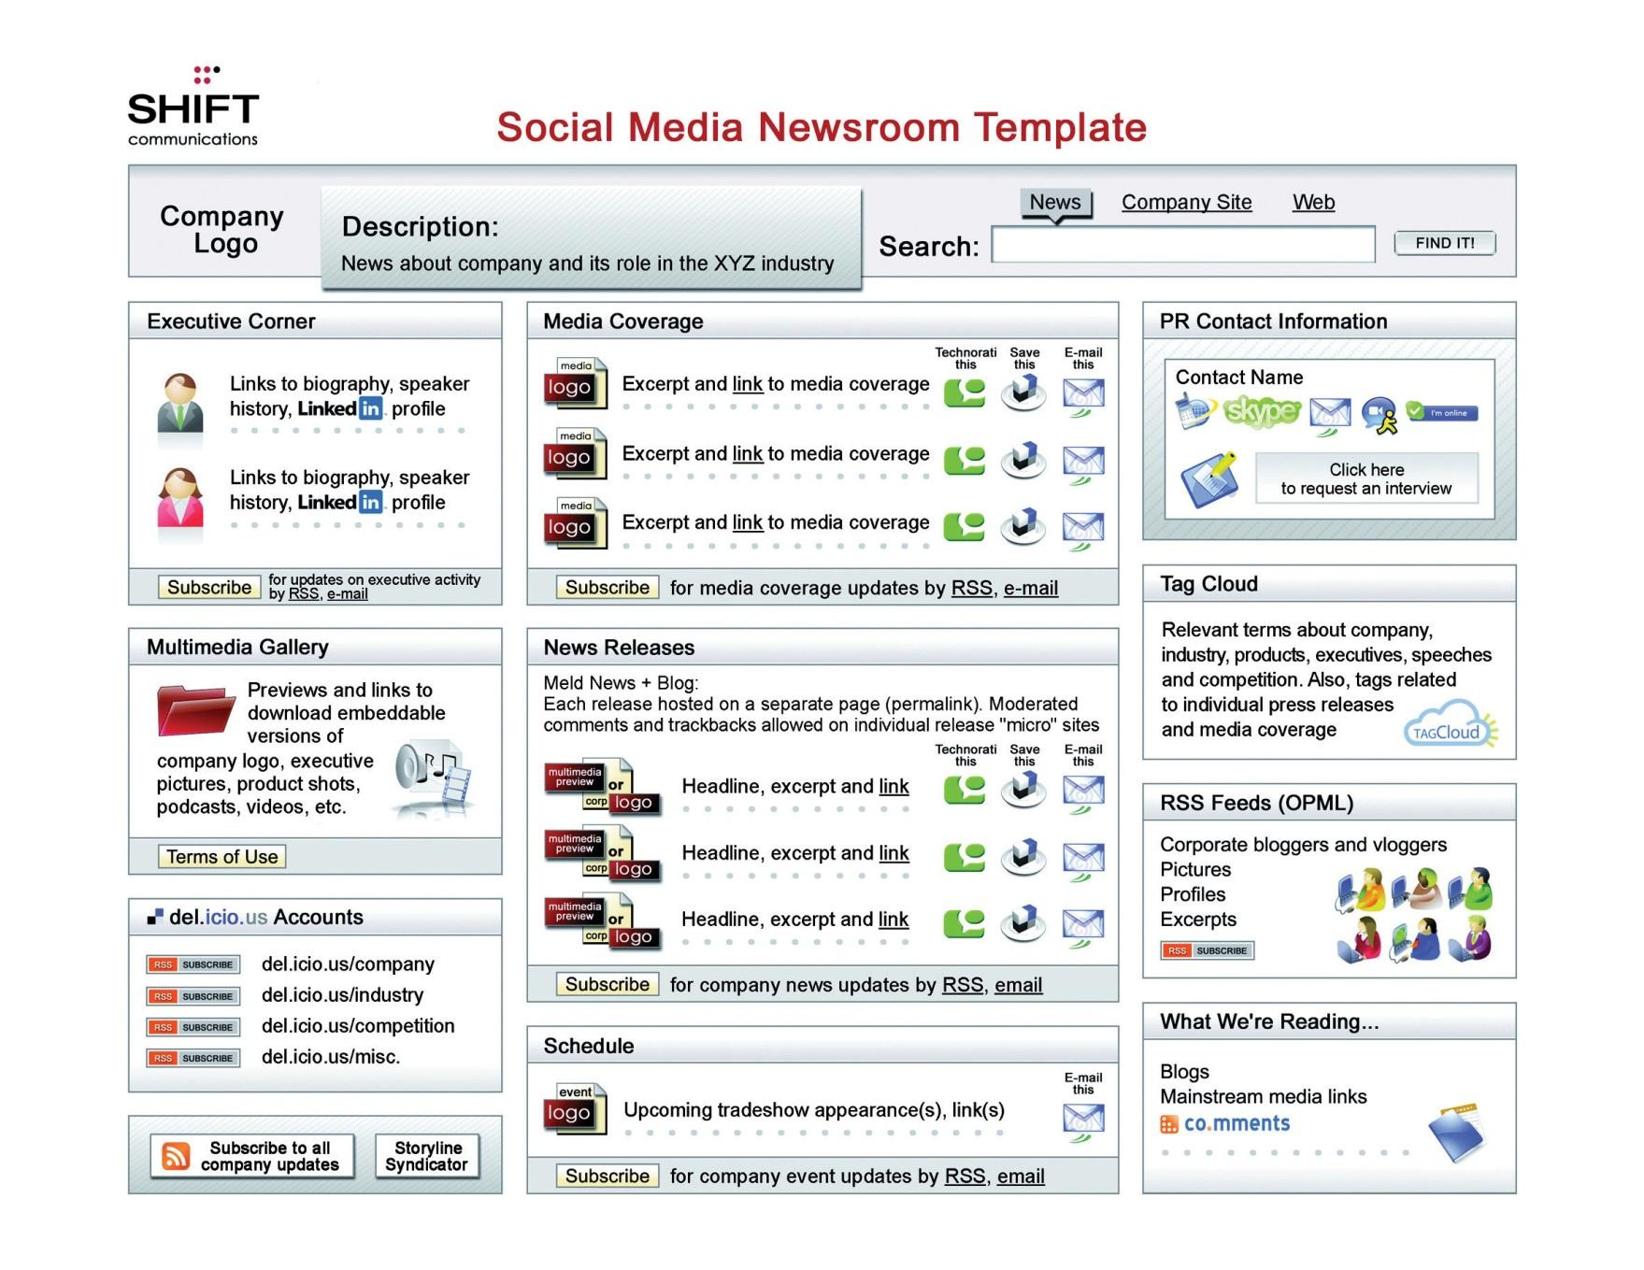
Source: http://www.shiftcomm.com/downloads/social-media-newsroom-presentation.pdf.
Keeping the information accessible and accurate saves time for both the PR team and for the researcher and shows an openness to communication.

Pitching to Bloggers
Although many journalists are bloggers, bloggers are not all journalists. They do not have to answer to their editor or publisher. They generally do not write to pay their bills; they tend to write about things that they are passionate about. They measure success in number of comments, trackbacks, and traffic.
To pitch effectively to bloggers, you need to understand these subtleties. There are many useful blog posts by bloggers who get pitched too often that offer guidelines for the PR industry. The effective PR hack will take note.
As with journalists, building a relationship is the best way to pitch to a blogger. Remember, journalist or blogger, you are reaching out to an individual. To build a relationship, try the following:
- Read the blog and engage by commenting or responding.
- Make pitches personal and relevant.
- Provide accurate key information. Be descriptive but concise.
- Do not try to spin a story.
- Show you are aware of who is talking about you and who is talking about the blog.
- Be transparent.
- Provide links to images, logos, and press releases. Never send large attachments.
In the United States, the beauty PR industry has been noticing the power of bloggers, and some of the cosmetics houses send samples and swag (an industry term for gifts) to bloggers as well as journalists. ^{[2]} There is a difference, however. Journalists are generally restricted in the value of the gift they are allowed to accept and tend to reveal when reviewed products are free samples. The publishing houses need to maintain an unbiased reputation. Bloggers, however, are self-publishers and can make up their own rules as they go along. Some of them accept lavish gifts in return for coverage—coverage that can appear more authentic (even if it isn’t) as it comes from a blogger and not a journalist.

Tools of the Trade
WebPR is about engaging in a conversation, so the essential tools that are required are the following:
- Tools for listening
- Tools for responding
- Tools for tracking success
RSS feeds tracking mentions of pertinent keywords are the best way to get an overview of mentions of a brand or company. These are outlined in detail inChapter 11 "Online Reputation Management".
Responding can take place through the various social media channels such as blogs, Twitter, and forums.
Online article directories and press-release directories are also crucial to publishing and spreading information. Having a thorough and up-to-date online newsroom ensures that relevant information is available.
The most important tool is relationship building. Whether with journalists, bloggers, or consumers, transparent conversations pave the way for effective public relations.

WebPR: Should I or Shouldn’t I?
There is no question about it: the media landscape has changed, and those who need to broadcast messages in the new media need to adapt along with it.
The Internet allows for greater distribution and reach of all messages, but that means that companies can no longer control these messages in the ways that they used to. Public relations on the Web allows companies increased access to what their customers are saying and a direct channel to respond to that.
Having so many new recipients of information requires more work from the PR team. As well as building relationships with journalists, you also need to include bloggers and other generators of content. The rules of engagement are changing, and power is increasingly moving from the companies who create messages to those that they need to broadcast it for them.

KEY TAKEAWAYS
- Online press rooms can ensure a company is able to meet journalists’ needs.
- There are several things an online press room must have to be useful.
- Although many journalists are bloggers, bloggers are not all journalists.
- Relationship-building is the best way to pitch to a blogger.

EXERCISES
- Consider the beauty PR industry. What effect do you think journalists have on gift giving versus bloggers? What affect do you think this has or can have on the industry?
- What do you think could happen if an online press room doesn’t have all the information listed in this section?
- How do you think social media have changed the role of a public relations professional?

[1] Jakob Nielsen, “PR on Web Sites: Increasing Usability,” Jakob Nielsen’s Alertbox, March 10, 2003, http://www.useit.com/alertbox/pr-2nd-study.html (accessed May 28, 2008).
[2] Kayleen Schaefer, “Beauty Blogs Come of Age: Swag, Please!” New York Times, January 31, 2008, http://www.nytimes.com/2008/01/31/fashion/31SKIN.html?ei=5088&en= 9e67baddbc42c4a5&ex=1359435600&partner=rssnyt&emc=rss&pagewanted=all(accessed May 28, 2008).

12.6 Case Study: Pilkington Self-Cleaning Glass
Writing articles for online syndication both provides useful information to potential customers and enhances SEO (search engine optimization) efforts. Quirk, the digital agency for Pilkington Self-Cleaning Glass (http://www.pilkingtonselfcleaningglass.co.uk), has been writing articles based on key phrases that are being promoted on the Web site.
Once a key phrase (e.g., “self-cleaning glass,” “conservatory glass”) has been selected, research then reveals what information consumers are searching for. An informative article is then written, which is usually two pages in length around the selected key phrase.
The article is then submitted to eight online article-syndication sites. As each article contains three links and is submitted to eight directories, twenty-four links are garnered as soon as the article is published.
Articles containing valuable content tend to attract links naturally and are republished on other sites. Over the last two years, twenty articles have been written and published for Pilkington Self-Cleaning Glass. Each has been republished approximately ten times: That’s approximately 54 new links pointing toward the Web site from just one article. And that’s about 1,080 links overall.
The following article was written in January 2006 and was published to 8 directory sites from which it garnered 24 links and 5,050 reads. What’s more, it was republished on a wide array of sources: 339 sites were indexed for it on a Google Search, which is a maximum of 1,017 quality links.

The Use of Glass in Architecture
By Sarah Manners
Acclaimed architect Bruno Taut said, “If we want our culture to rise to a higher level, we are obligated for better or for worse, to change our architecture. And this only becomes possible if we take away the closed character from the rooms in which we live. We can only do that by introducing glass architecture, which lets in the light of the sun, the moon, and the stars.”
A New Architectural Era
Built in Hyde Park, London to house the Great Exhibition in 1851 the Crystal Palace is commonly considered as a significant turning point in architectural history. This magnificent structure built from steel and glass paved the way for further exploration of glass as an architectural element. The glass sail of the new Milan trade fair and Louvre pyramid are other stunning examples of the use of glass as a structural as well as a design element. Other examples of glass architecture include the London Bridge, Agbar and Federazija Towers as well as the Tokyo International Forum.
While the use of glass in construction was previously quite limited to grand designs and office buildings it is starting to become a core structural and design element in many homes. Glass facilitates natural light and opens up rooms allowing smaller spaces to look bigger as well as facilitating a natural indoor/outdoor flow, which often enhances the tranquility as well as the value of your home. Glass is also relatively inexpensive and fully recyclable, an important consideration in the current era of heightened environmental consciousness. Glass use in construction has increased dramatically due to the rapid changes in glass production and technology. Previously glass was thought to be quite a fragile building material and many steered away from it because of this. Modern glass, however, is not only spectacular to look through but it is safer, stronger and energy efficient.
Glass in the Home
In the past glass was mainly utilized for windows to allow some air and light in to rooms. Today glass is utilized in the construction of several elements of exterior and interior architecture. Exterior glass architecture includes facades, display windows’ skylights, skywalks, entrances, revolving doors, canopies, winter gardens and conservatories. All of which allow homes to be bathed in natural sunlight with gorgeous outdoor views. Interior glass architecture can be used for staircases, elevated walkways and even as traditional walls. There are some houses in which all the walls are actually glass. Such high quantities of glass previously compromised other aspects such as the heating and cooling requirements. Often glass architecture would incur high heating costs in winter and cooling costs in summer. Fortunately such great progress has been made in the glass industry that we now have access a variety of different kinds of glass each with fantastic benefits. One such example is glass with spectrally selective qualities, which allows light to stream into the house without being harmful or degenerative to occupants and their belongings.
Caring for Your Glass
To keep your glass looking great and streak free you will need to ensure that it is cleaned often. Try a few different cleaning solutions before you decide which one to use, options vary from store bought to homemade solutions. Many use products such as ammonia, vinegar, borax, alcohol or Epsom salts to clean glass. An important point to remember is that when using your own solutions never combine an acid and an alkaline, for example vinegar and ammonia, as they neutralize one another. After washing use a dry cotton towel rather than paper towels or newspaper as they tend to disintegrate and leave deposits on your glass. For a great shine a dry blackboard eraser can be used.
To keep frost from accumulating on exterior windows during the winter, add two cups of antifreeze or rubbing alcohol to each gallon of wash water. For deposits of paint, resin or glue, wet the surface and then scrape them off using a razor blade scraper. Take care to scrape in one direction only in order to avoid scratching the surface.
Another option, and a fantastic one at that, is the breakthrough technology that has brought us self-cleaning glass. An ultra-thin coating is applied to the glass during the manufacturing process; this coating has two highly beneficial effects on the glass. First organic residue on the glass [is] broken down by the ultraviolet wavelengths in sunlight then when it rains the dirt is washed off. As the coating is hydrophilic when rain hits the glass, it doesn’t form droplets and in turn eradicates streaking. Rain water flows down the glass in a sheet and washes the dirt away. If you don’t have time to wait for the rain a simple garden hose will be just as effective. Self-cleaning glass is making the lives of homeowners far easier and is giving home owners absolutely no reason to hesitate to use of glass in the construction of their homes. What could be better than bright, open rooms with excellent outdoor views facilitated by huge sheets of glass, without having to spend your days cleaning them?
Modern day architectural trends have elevated the way we think about the use of glass in our own homes. It is no longer simply a material for windows and the occasional sliding door; it is a design component in its own right. With each passing day glass becomes a more important element in architecture not only in grand public structures but also in the lives and homes of families across the world. The beauty of glass lies in its simplicity, it enables us to be enveloped by nature while living comfortably in doors.
About the Author
Many architects, designers and construction companies recommend Pilkington when it comes to glass. Having been in the glass industry for 179 years, Pilkington is recognized as the world’s technological leader in glass. Out of all of their innovative products, Pilkington Activ™—the world’s first self-cleaning glass is one of their greatest products and is an ideal material in glass architecture.

CASE STUDY QUESTIONS
- Why is it important to research what consumers look for once you have chosen your key phrases?
- How is the article different from a press release?
- What key phrase is being targeted, and how is it being used in the article?

12.7 Reference
Darren Rowse, “How to Pitch to Bloggers,” ProBlogger, October 30, 2007,http://www.problogger.net/archives/2007/10/30/how-to-pitch-to-bloggers-21-tips (accessed May 28, 2008).

Chapter 13

Web Site Development and Design

13.1 Introduction
Web development and design are at the heart of successful eMarketing, yet many marketers do not understand the importance of laying solid foundations here. Like building a house, solid foundations are key to stability, longevity, and even scalability. Developing a Web site involves more than choosing colors and header images.
While it is tempting to focus on the design aesthetics of Web sites, and eye-catching Web sites can be converting Web sites, it is important to remember that a Web site is a marketing tool that should be increasing revenue for the company. Web sites should be built to serve the needs of the user. A Web site is not something that users stare at—navigation usually requires action and interaction from the Web visitor. If the user’s needs are served, the Web site will be more likely to enable the company to achieve its goals.
Figure 13.1 Important Factors to Consider When Optimizing for Search
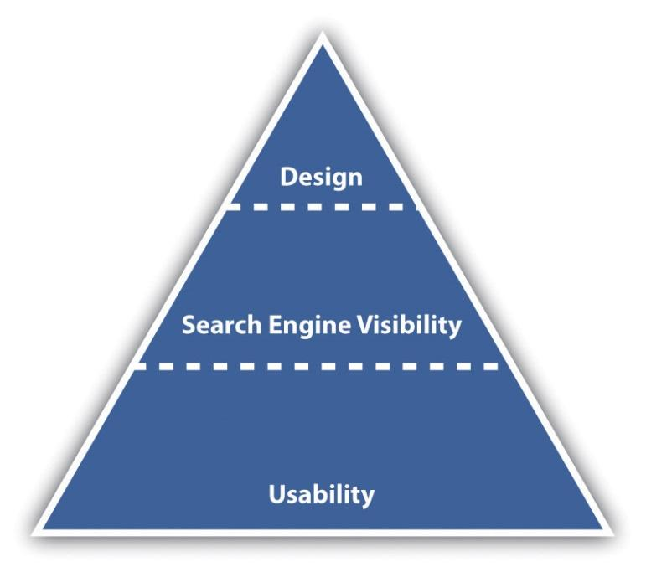
While designers tend to talk about vision and can find conventions constraining, users of Web sites like conventions. They like Web sites that just work, without any thinking on their behalf.

How It Works
Usability is the number one element that needs to be considered when developing a site. Search engine visibility is the second most important factor. No one can negate the importance that search engines play in online marketing—and if their spiders cannot find a site, it is almost certain that potential customers won’t either. (Bear in mind that there are some Web sites that are designed to be found in other ways—the importance of search traffic needs to be determined before the Web site is built.) Aesthetic design is now the least important factor—but that certainly doesn’t mean that sites need to be so ugly that they turn visitors into stone. It just means that design needs to be hinged on usability and search engine visibility rather than vice versa. Web sites can still be gorgeous; they just need to fulfill other goals as well—the key here is usability and conversion-oriented design.

Note
“Design” can refer to the structural design of a Web site—which is fundamental—or to the aesthetic presentation of a Web site. We’ll use design to refer to aesthetic presentation.
While it is critical that a site is built for optimal crawling, indexing, and ranking by search engines (its search engine visibility), the site also needs to be worthy of traffic. It needs to be built for users. It should be usable and accessible with great content and conversion-oriented design. Fortunately, optimizing a site for usability and accessibility usually enhances search engine friendliness.

13.2 Usability

LEARNING OBJECTIVE
- Understand the fundamental concepts of usability.
When Steve Krug wrote his excellent Web usability book, he aptly called it Don’t Make Me Think! ^{[1]} Designing a site for best usability means that users don’t have to figure out what to do; they are just able to do it.
Use standard conventions, such as links that are distinct (blue and underlined is standard), menus top or left, and the logo in the top left-hand corner. Search boxes are usually on the top of the page and should use standard wording such as “search” on buttons. Following standards for important elements that are familiar to Web users means that they know immediately where to look for or how to use them. Important elements (such as menus, logos, colors, and layout) should be distinct, easy to find, and consistent throughout the Web site.

Note
Common page elements are those elements that are on every page of the Web site. These can include main navigation, a search box, a link to the home page, and sign-up forms.
The information architecture of a site is crucial to usability. Topics and categorization should flow from broad to narrow and should be built around users’ needs and not company structure. An intuitively designed structure will guide users to their goals.
The site map should be available from every page and should clearly show the information architecture of the Web site. Dynamic site maps can be employed so that the site map is updated automatically as information is added to the Web site.
As well as carefully thought-out information architecture, the navigation should guide users easily through both top-level and deeper pages. Navigation should also let users know where they are in the site (especially since not all users arrive via the home page). Breadcrumb links, clear page titles, URLs (uniform resource locators), and menu changes all help show the user where she is.
Figure 13.2
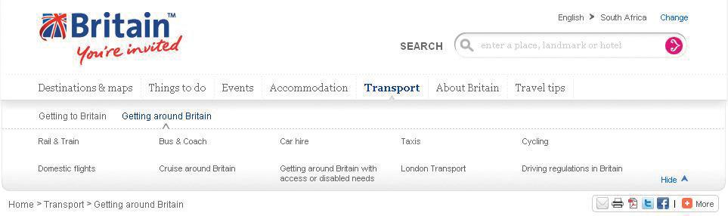
VisitBritain.com uses breadcrumb links and menu changes so that the users know where they are in the Web site.
Accessibility makes Web sites easy to use and easy to scale. In some countries, accessibility is a legal requirement of government Web sites. Some key points of accessibility include the following:
- Ensuring that the Web site and all its functions are compatible across a range of browsers, including text-only and mobile browsers
- Making sure that the Web site is functional to users who might have a disability. Some ways of doing so include the easy increasing or decreasing of text size and using meaningful descriptive tags in the code for when the site is accessed through a screen reader.
- Not designing for high-bandwidth users only but instead making sure that low-bandwidth users do not have to wait for heavy page loads to access your Web site (unless you have a good marketing reason for keeping those users out)
- Having a search box (that works) available

Note
Just like in Hansel and Gretel, breadcrumb links help show users the path they have taken in the Web site. Unlike the fairy story, these breadcrumbs shouldn’t disappear as you navigate through the Web site.

Discussion
Scaling and scalability—why is it important that Web sites can scale?
Content needs to be written so that users can grab the information they need in as little time as possible. Text can be made more easily readable by doing the following:
- Highlighting or making bold key phrases and words
- Using bulleted lists
- Using paragraphs to break up information
- Using descriptive and distinct headings
On the page, use an inverted pyramid style, or newspaper style, for your copy. The bulk of the information should be at the top of the page to make for easy scanning.
There are some key “don’ts” when it comes to building a user-friendly Web site:
- Never resize windows or launch the site in a pop-up.
- Don’t use splash pages. These are pages at the entry to a site that are usually animated and contain some variation of the phrase “click here to enter this site.”
- Never build a site entirely in Flash—most search engine spiders cannot even crawl Flash sites.
- Don’t distract users with “Christmas trees” (blinking images, flashing lights, automatic sound, scrolling text, unusual fonts, etc.).
Usability and accessibility guidelines are useful for checking that all elements have been dealt with. Massachusetts Institute of Technology (MIT) Information Services and Technology provides a usability checklist online athttp://ist.mit.edu/services/consulting/usability/guidelines.
The following is a copy of some of the items on the MIT checklist. Use it to see how your favorite Web site measures up.
Figure 13.3 Some of the Usability Guidelines from the MIT Checklist
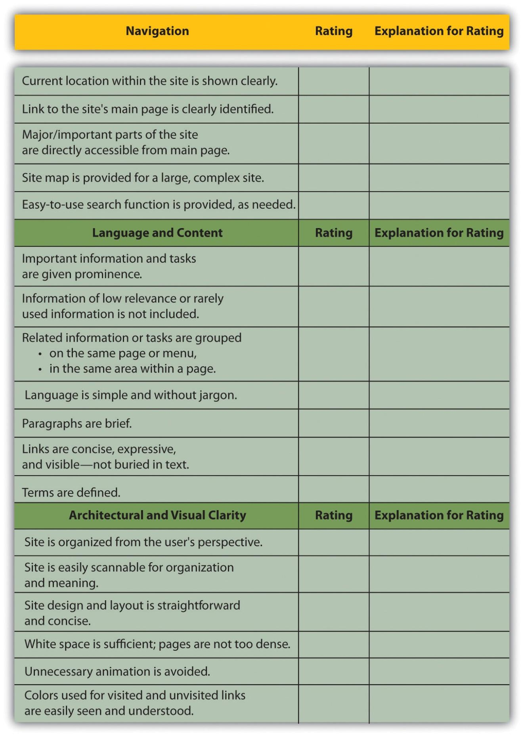

KEY TAKEAWAYS
- The foundations of a successful site are usability and accessibility.
- Sites should feature the standard conventions.
- Informational architecture is essential to variety.
- A site map should be available from each page.
- The navigation should guide users easily through top-level and deeper pages.
- Accessibility makes sites easy to use and easy to scale.
- Content needs to be written so that users can grab information in as little time as possible.

EXERCISE
- Why is it fundamental to build Web sites for users’ needs first? What are some ways that user requirements inform the Web development and design process?

[1] Steve Krug, Don’t Make Me Think! A Common Sense Approach to Web Usability, 2nd ed. (Berkeley, CA: New Riders, 2005).

13.3 Search Engine Visibility

LEARNING OBJECTIVES
- Understand the importance of visibility within search engines.
- Understand the basics of how to become visible to the search engines.
Search engine traffic is vital to a Web site; without it, chances are the site will never fulfill its marketing functions. It is essential that the search engines can see the entire publicly visible Web site, index it fully, and consider it relevant for its chosen keywords.
Here are the key considerations for search engine optimization when it comes to Web development and design.

Labeling Things Correctly
URLs (uniform resource locators), alt tags, title tags, and metadata all describe a Web site and its pages to both search engine spiders and people. (And don’t worry: these words are all described for you in what follows.) Chances are, clear descriptive use of these elements will appeal to both.

URLs
URLs should be as brief and descriptive as possible. This may mean that URLs require server-side rewriting so as to cope with dynamic parameters in URLs. Does that sound a little heavy? The examples below should make this clearer.

Comparison of URLs for a Product
The following is a comparison of the URLs for Diamante Dog Collars, an imaginary product for sale on two imaginary Web sites:
- DogToys.com. http://www.dogtoys.com/index.html?dir=423&action=product&pid=1201
- CoolPuppies.co.uk. http://www.coolpuppies.co.uk/Products/Collars/Fancy/DiamanteDogCollars.htm
The first example has dynamic parameters—these are shown by the question mark and the ampersand—and uses categories that make sense to the database (e.g., pid=1201), but they make little sense to the user. Dynamic parameters are so called as they change depending on the information being requested. Next time you use a search engine to search for information, take a look at the URL and see if you can spot the dynamic parameters.
The second example is far more user friendly and clearly indicates where in the site the user is. You even start getting a good idea of the architecture of the Web site from just one URL.
More than two dynamic parameters in a URL increase the risk that the URL may not be spidered. The search engine would not even index the content on that page.
Lastly, well-written URLs can make great anchor text. If another site is linking to yours and they use just the URL, the search engine will do a better job of knowing what the page is about if you have a descriptive URL.

Alt Tags
Have you ever waited for a page to load and seen little boxes of writing where the images should be? Sometimes they say things like “topimg.jpg” and sometimes they are much clearer and you have “Cocktails at sunset at Camps Bay.”
Since search engines read text, not images, descriptive tags are the only way to tell them what the images are, but these are still essentially for users. Text readers for browsers will also read out these tags to tell the user what is there. Meaningful descriptions certainly sound a lot better than “image1,” “image2,” and “image3.”

Title Attributes
Just as you can have the alt tag on an image hypertext markup language (HTML) element, you can have a title attribute on almost any HTML element—most commonly on a link. This is the text that is seen when a user hovers over the element with the mouse pointer. It is used to describe the element or what the link is about. As this is text, it will also be read by search engine spiders.

Title Tags
Title tags, or what appears on the top bar of your browser, are used by search engines to determine the content of that page. They are also often used by search engines as the link text on the search engines results’ page, so targeted title tags help drive click-through rates. Title tags should be clear and concise (it’s a general rule of thumb that all tags be clear and concise, you’ll find). Title tags are also used when bookmarking a Web page.
Figure 13.4
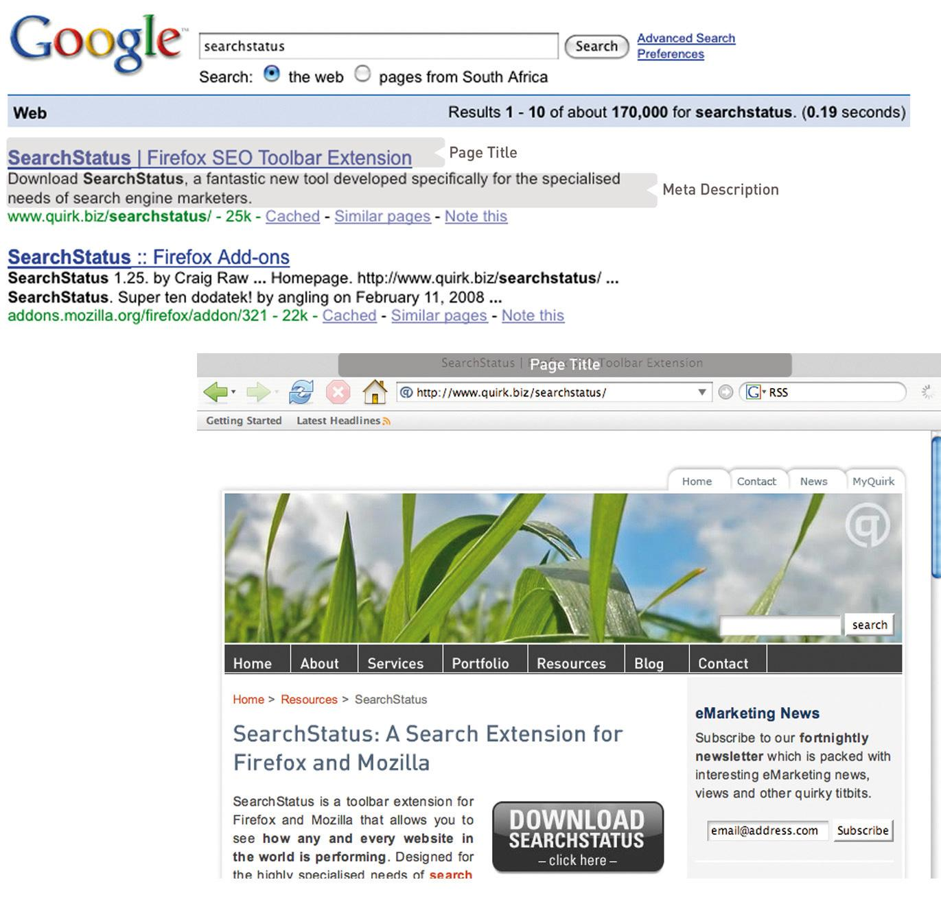
The title tag appears in the browser and on the search engine results page (SERP), and the meta description can appear on the SERP as well.

Meta Tags
Meta tags are where the developer can fill in information about a Web page. These tags are not normally seen by users. If you right click on a page in a browser and select “view source,” you should see a list of entries for “<meta name=.”
These are the metadata. In the past, the meta tags were used extensively by search engine spiders, but since so many people used this to try to manipulate search results, they are now less important. Metadata now act to provide context and relevancy rather than higher rankings. However, the meta tag called “description” often appears on the search engine results page (SERP) as the snippet of text to describe the Web page being linked to. This is illustrated inFigure 13.4. If the description is accurate, well written, and relevant to the searcher’s query, these descriptions are more likely to be used by the search engine. And if it meets all those criteria, it also means the link is more likely to be clicked on by the searcher.

Search Engine–Optimized Copy
When it comes to Web development, the copy that is shown on the Web page needs to be kept separate from the code that tells the browser how to display the Web page. This means that the search engine spider can discern easily between what is content to be read (and hence scanned by the spider) and what are instructions to the browser. A cascading style sheet (CSS) can take care of that and is covered further in this chapter.
The following text styles cannot be indexed by search engines:
- Text embedded in a Java application or a Macromedia Flash file
- Text in an image file (that’s why you need descriptive alt tags and title attributes)
- Text only accessible after submitting a form, logging in, and so on
If the search engine cannot see the text on the page, it means that it cannot spider and index that page.
If an XML (extensible markup language) file is used for the content in a Macromedia Flash file, then the content can be easily read by search engine spiders.

Information Architecture
Well-organized information is as vital for search engines as it is for users. An effective link structure will provide benefits to search rankings and helps to ensure that a search engine indexes every page of your site.
Make use of a site map, linked to and from every other page in the site. The search engine spiders follow the links on a page, and this way, they will be able to index the whole site. A well-planned site map will also ensure that every page on the site is within a few clicks of the home page.
There are two site maps that can be used: an HTML site map that a visitor to the Web site can see, use, and make sense of and anXML (extensible markup language) site map that contains additional information for the search engine spiders. An XML site map can be submitted to search engines to promote full and regular indexing. Again, a dynamically generated site map will update automatically when content is added.
Using a category structure that flows from broad to narrow also indicates to search engines that your site is highly relevant and covers a topic in depth.

Canonical Issues: There Can Be Only One
Have you noticed that sometimes several URLs can all give you the same Web page? For example, refer to the following:
- http://www.websitename.com
- http://websitename.com
- http://www.websitename.com/index.html
All the above can be used for the same home page of a Web site. However, search engines see these as three separate pages with duplicate content. Search engines look for unique documents and content, and when duplicates are encountered, a search engine will select one as canonical, and display that page in the SERPs (search engine results pages). However, it will also dish out a lower rank to that page and all its copies. Any value is diluted by having multiple versions.
Lazy Webmasters sometimes forget to put any kind of redirect in place, meaning that http:// websitename.com doesn’t exist, while http://www.websitename.com does. This is termed “Lame-Ass Syndrome” (LAS) by Quirk, a fitting moniker.
Having multiple pages with the same content, however that came about, hurts the Web site’s search engine rankings. There is a solution: 301 redirects can be used to point all versions to a single, canonical version.

Robots.txt
A robots.txt file restricts a search engine spider from crawling and indexing certain pages of a Web site by giving instructions to the search engine spider, or bot. This is called the Robots Exclusion Protocol. So, if there are pages or directories on a Web site that should not appear in the SERPs, the robots.txt file should be used to indicate this to search engines.
If a search engine robot wants to crawl a Web site URL—for example, http://www.websitename.com/welcome.html—it will first check for http://www.web sitename.com/robots.txt.
Visiting the second URL will show a text file with the following:
- User-agent: *
- Disallow: /
Here, “User-agent: *” means that the instruction is for all bots. If the instruction is to specific bots, it should be identified here. The “Disallow: /” is an instruction that no pages of the Web site should be indexed. If there are only certain pages or directories that should not be indexed, they should be included here.
For example, if there is both an HTML and a PDF (portable document format) version of the same content, the wise Webmaster will instruct search engine bots to index only one of the two to avoid being penalized for duplicate content.
The robots.txt file is publicly accessible, so although it does not show restricted content, it can give an idea of the content that a Web site owner wants to keep private. A robots.txt file needs to be created for each subdomain.
Here is a robots.txt file with additional information.
Figure 13.5
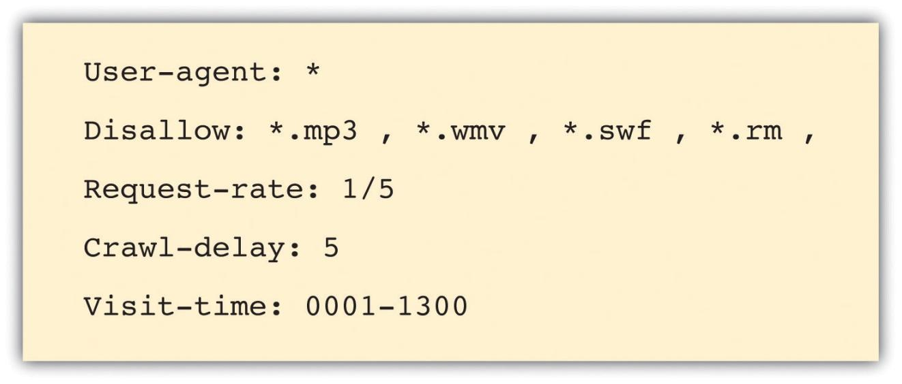
Instructions to search engine robots can also be given in the meta tags. This means that instructions can still be given if you only have access to the meta tags and not to the robots.txt file.

Make Sure It’s Not Broken
Make sure that both visitors to your Web site and search engines can see it all by following these guidelines:
- Check for broken links—anything that you click that gives an error should be considered broken and in need of fixing.
- Validate your HTML and CSS in accordance withWorld Wide Web Consortium (W3C) guidelines.
- Make sure all forms and applications work as they ought to.
- Keep file size as small as possible and never greater than 150 kilobytes for a page. It ensures a faster download speed for users and means that the content can be fully cached by the search engines.

KEY TAKEAWAYS
- One of the foundations of a successful site is search engine visibility.
- It is important to make sure everything on the site is labeled correctly.
- It is important to write copy optimized for search engines.
- Information architecture is important on a site, as content needs to be presented in a way that makes sense for the user.
- Make sure there aren’t multiple URLs for one set of content. This will dilute the rank.
- Robots can be used if a certain Web page shouldn’t appear in the SERPs.
- Make sure your site is fully functional and that it follows best practices.

EXERCISES
- Visit a retail Web site, such as http://www.amazon.com, and a news Web site, such as http://www.news.bbc.co.uk, and identify the common page elements of each. What elements are common to both Web sites?
- Why do you think Web site owners would want to keep search engines out of certain pages, or even whole Web sites?
- What are the differences between an HTML site map and an XML site map?

13.4 Design

LEARNING OBJECTIVE
- Learn how Web design can affect Web site performance.
With the foundations of usability and search engine visibility in mind, it is time to turn to making it all presentable with the design of the Web site.
Looks may not matter to search engines, but they go a long way toward assuring visitors of your credibility and turning them into customers.
Every Web site needs to be designed with clear goals (or conversions) in mind. Conversions take many forms and may include the following:
- Sale. Where the user purchases a product online using a credit card
- Lead. Where the user submits contact details and asks for more information
- Sign-up. Where the user opts in for e-mail marketing newsletters
- Download. Where the user downloads a file from the site
Before designing a Web site, research your audience and competitors to determine expectations and common elements to your industry. Mock up every layer of interaction. This means that before any coding begins, there is clear map of how the Web site should work. It’s all about foundations.

Design to Establish Credibility
Here are some of the cues that visitors use to determine the credibility of a Web site:
- Place phone numbers and addresses above the fold. This assures the visitor that there is a real person behind the Web site and that he or she is in easy reach.
- Create an informative and personal “about us.” Your customers want to see the inner workings of a company and are especially interested in learning more about the head honchos. Include employee pictures or profiles. It puts a face to an organization.
- Feature genuine testimonials on each page. This is a great way to show potential customers what your current customers have to say about your organization. Trust is vital, and this is one way to encourage it.
- Feature logos of associations and awards. If you belong to any relevant industry associations or have won any awards, feature them. Not only does this go a long way to establish your credibility, but it will show that you’re at the top of your game and a notch above the competition.
- Link to credible third-party references. This is a way to assert your credibility without tooting your own horn.
- Keep content fresh and updated. This shows that you are knowledgeable and up to date in your industry.
- Ensure that your site is free of errors. Spelling and grammar mistakes are exceptionally unprofessional, and while the large majority of readers may not pick up on them, the one or two who do will question your credibility.
- Include a portfolio of past work. Give your Web site visitors examples of your previous work to show what you are capable of.
Design also affects the accessibility of a Web site. You need to take into account screen resolutions, as designing for the biggest screen available could leave many of your users scrolling across and down to see the Web page. Subtle shading, background colors to text, and fancy fonts can also mean that many users cannot even see your Web site properly.

Figure 13.6
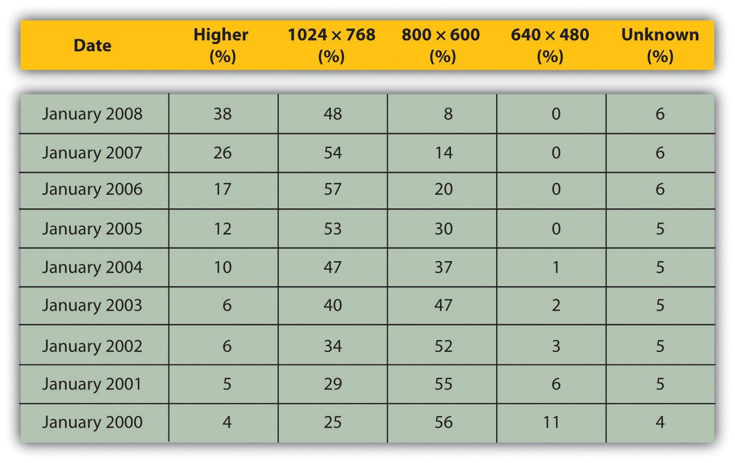
Figures show that screen resolution just keeps getting higher.
Source: Based on information from http://www.w3schools.com.
Screens just keep getting bigger, so does that mean that Web sites should as well? What about users who never hit the “maximize” button on their browser? How effective do you think sales data for laptops are in determining optimal screen resolution?

Using Cascading Style Sheets
A cascading style sheet (CSS) is defined by W3C (World Wide Web Consortium) as “a simple mechanism for adding style (e.g., fonts, colors, spacing) to Web documents.” ^{[1]}
In the early days of the Web, designers tended to use tables to lay out content for a Web page, and many Web sites still do so today. However, different browsers, and even different versions of browsers, all support code differently, resulting in Web sites that only work on certain browsers or bulky code needed to cope with all the different versions.
The W3C (http://www.w3.org) was created in 1994 and since then has been responsible for specifications and guidelines to promote the evolution of the Web, while ensuring that Web technologies work well together. The Web Standards Project (http://www.webstandards.org) launched in 1998 and labeled key guidelines as “Web standards.” Modern browsers should be built to support these standards, which should vastly reduce cross-browser compatibility problems, such as Web sites displaying differently in different browsers.
Web standards include the following:
- HTML (hypertext markup language)
- CSS (cascading style sheet)
- XML (extensible markup language)
- XHTML (extensible hypertext markup language)
- DOM (document object model)
CSS is standard layout language. It controls colors, typography, and the size and placement of elements on a Web page. Previously, Web developers have had to create instructions for every page in a Web site. With CSS, a single file can control the appearance of an entire site.
CSS allows designers and developers to separate presentation from content. This has several key benefits:
- Sites are easier to maintain and update and are more accessible.
- Content may be updated easily by someone who is not a Web designer or developer.
- Global changes can be applied quickly and easily.
CSS can also do the following:
- Reduce bandwidth and page-loading times
- Increase cross-browser compatibility
To see CSS in action, visit http://www.csszengarden.com, where you can make a single HTML page look very different, depending on which one of the many designer-contributed style sheets you apply to it.

Using a Content Management System
As the name implies, a content management system (CMS) is used to manage the content of a Web site. If a site is updated frequently and if people other than Web developers need to update the content of a Web site, a CMS is used. Today, many sites are built on a CMS. The CMS can also allow content of a Web site to be updated from any location in the world.
A CMS can be built specifically for a Web site, and many Web development companies build their own CMS that can be used by their clients. A CMS can also be bought prebuilt, and there are many open-source, prebuilt CMSs available, some of which are free.
A CMS should be selected with the goals and functions of the Web site in mind. A CMS needs to be able to scale along with the Web site and business that it supports, and not the other way around.
Of course, the CMS selected should result in a Web site that is search engine friendly.
Here are some key features to look out for when selecting or building a CMS:
- Meta and title tag customization. The CMS should allow you to enter your own meta tags and fully customize title tags for each page.
- HTML tag customization. The CMS should allow for full customization of HTML tags, such as nofollow links. See Chapter 6 "Search Engine Optimization" for an explanation of nofollow links.
- URLs. Instead of using dynamic parameters, the CMS should allow for server-side rewriting of URLs (uniform resource locators). It should allow for the creation of URLs that have the following characteristics:
  - Static
  - Rewritable
  - Keyword rich
- Customizable navigation. A good CMS will allow flexibility when it comes to creating the information architecture for a Web site. For the purposes of adding additional content for search engines, a CMS should not require that all content pages be linked to from the home page navigation. This allows content to be added for SEO (search engine optimization) purposes, without adding it to the main navigation.
- 301 redirect functionality. It is imperative that a CMS offers the ability to put in place 301 redirects to prevent penalization for duplicate content on different URLs.
- Customizable image naming and alt tags for images. A good CMS will allow you to create custom alt tags and title attributes for images.
- Robots.txt management. Ensure you are able to customize the robots.txt to your needs, or that this can at least be managed using meta tags.
- Content search. Make sure you are able to include a useful site search.

Figure 13.7
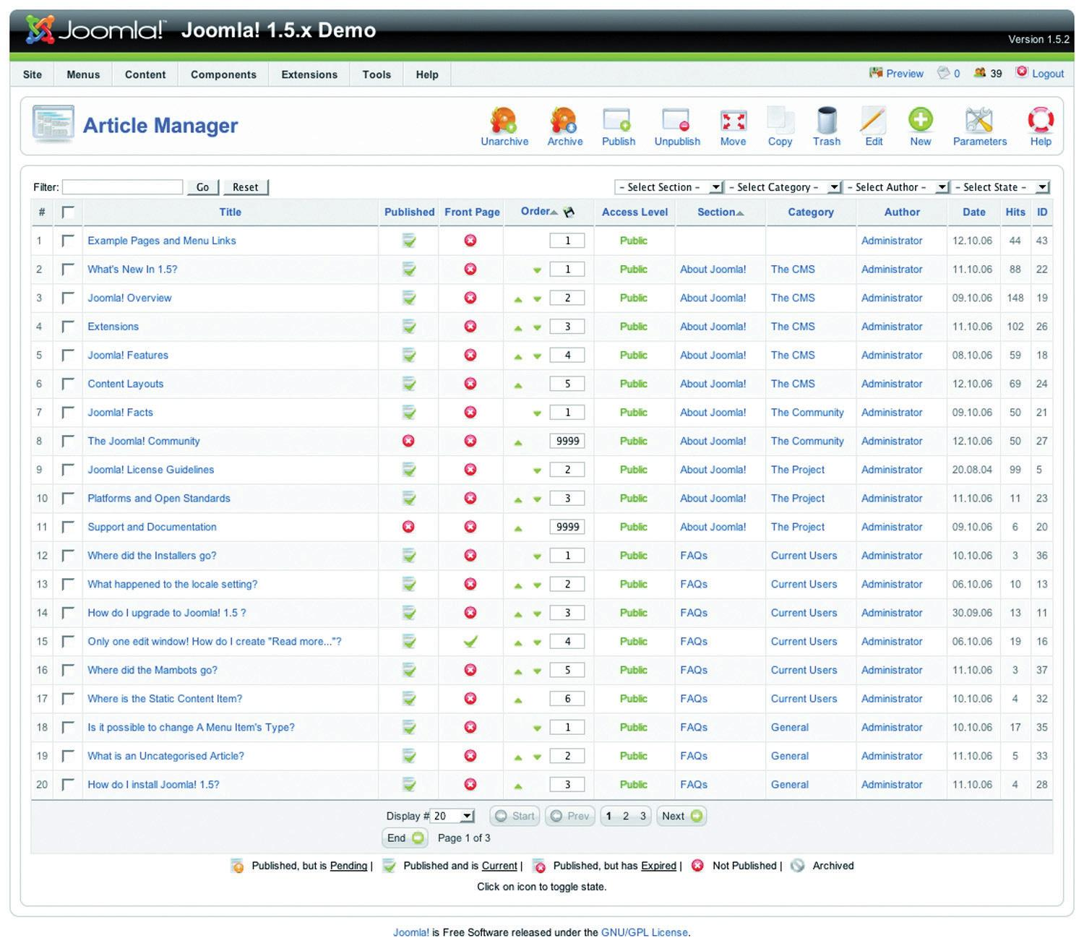
Joomla! is an open-source content management system (CMS). Here you can see how the CMS allows you to manage the articles on the Web site.
Be aware when building clean, descriptive, and dynamic URLs from CMS content. Should you use a news heading (“Storm” in this example) as part of your URL (http://www.websitename.com/cape/storm) and someone changes the heading to “Tornado” (http://www.websitename.com/cape/tornado), this will alter the URL and the search engines will index this as a new page, but with the same content as the URL that had the old heading. Bear this in mind before adding dynamic parameters to your URLs.
Finally, using a CMS that supports standards compliant HTML and CSS is very important—without it inconsistencies may be rendered across various browsers. It also ensures faster loading time and reduced bandwidth, makes markup easier to maintain, supports SEO efforts, and ensures that every single visitor to a Web site, no matter what browser they are using, will be able to see everything on the site.

Technical Considerations
As a whole, technology should act only as an enabler. It should never be a site’s main focus. Here are some technical considerations vital for a good Web site.

Proprietary versus Open Source
Whether you use proprietary or open-source software is an important consideration when building a new site, and all avenues should be explored. Open-source software is fully customizable and benefits from a large developer community. Propriety software usually includes support in its price.

URL Rewriting
It is vital that important URLs in your site are indexable by the search engines. Ensure that URL rewriting is enabled according to the guidelines in this chapter. URL rewriting should be able to handle extra dynamic parameters that might be added by search engines for tracking purposes.

GZIP Compression
Compression helps to speed up download times of a Web page, improving user experience.

Server-Side Form Validation
Form validation is the process whereby the data entered into a form are verified in order to meet certain preset conditions (e.g., ensuring that the name and e-mail address fields are filled in).
Client-side validation relies on JavaScript, which is not necessarily available to all visitors. Client-side validation can alert a visitor to an incorrectly filled-in form most quickly, but server-side validation is the most accurate. It is also important to have a tool to collect all the failed tests and present appropriate error messages neatly above the form the user is trying to complete. This will ensure that correctly entered data are not lost but repopulated in the form to save time and reduce frustration.

International Character Support
The Internet has afforded the opportunity to conduct business globally, but this means that Web sites need to make provision for non-English visitors. It is advisable to support international characters via UTF-8 (8-bit unicode transformation format) encoding; both on the Web site itself and in the form data submitted to it.

Search-Friendly Sessions
Sessions can be used to recognize individual visitors on a Web site, which is useful for click-path analysis. Cookies can be used to maintain sessions, but URL rewriting can be used to compensate for users who do not have cookies activated. This means that as visitors move through a Web site, their session information is stored in a dynamically generated Web address.
Why does URL rewriting create a moving target for a search engine spider?
Search engine spiders do not support cookies, so many Web sites will attempt URL rewriting to maintain the session as the spider crawls the Web site. However, these URLs are not liked by search engine spiders (as they appear to create a moving target for the robot) and can hinder crawling and indexing. The work-around: use technology to detect if a visitor to the site is a person or a robot, and do not rewrite URLs for the search engine robots.

Auto-Generated Human-Readable Site Maps and XML Site Maps
Site maps are exceptionally important, both to visitors and to search engines. Technology can be implemented that automatically generates and updates both the human-readable and XML site maps, ensuring spiders can find new content.

RSS Feed Generation
Really simple syndication (RSS) is an absolute necessity. With all the millions of Web and blog sites in existence, Web users can no longer afford to spend time browsing their favorite sites to see if new content has been added. By enabling RSS feeds on certain sections on the site, especially those that are frequently updated, users will have the content delivered directly to them. Visitors should be able to pick and choose the sections they like to get updates from via a feed.

KEY TAKEAWAYS
- Every site needs to be designed with clear conversions in mind. Conversions take many forms.
- There are many cues that visitors use to determine the credibility of a site.
- A cascading style sheet (CSS) is what gives a site its look and feel. With CSS, the following are true:
  - Sites are easier to maintain and update and are more accessible.
  - Content may be updated easily by someone who is not a Web designer or developer.
  - Global changes can be applied quickly and easily.
  - Bandwidth and page-load times are reduced.
  - Cross-browser compatibility is increased.
- The World Wide Web Consortium (W3C) is responsible for specifications and guidelines to promote the evolution of the Web.
- A content management system (CMS) is used to manage the content of a Web site. Today, most sites are built on a CMS.
- A CMS should be selected with the goals and functions of the Web site in mind.

EXERCISE
- Visit Web sites for three different popular brands. Identify what you think are elements of good design based on what you read in this section. Did you see any elements of bad design? If so, how do you think those elements could be improved?

[1] “Cascading Style Sheets Home Page,” World Wide Web Consortium, June 3, 2010,http://www.w3c.org/Style/css (accessed June 23, 2010).

13.5 Landing Pages

LEARNING OBJECTIVE
- Learn what goes into a successful landing page.
A landing page is the page users are directed to from any campaign designed to drive traffic to a specific URL (uniform resource locator). The traffic to a landing page could be from a banner or PPC (pay-per-click) advertisement, an e-mail, a print advertisement, a television or radio spot, or direct marketing. Users are being sent there for a very specific reason, including the following:
- Enter a competition (lead)
- Buy a product (sale)
- Subscribe to a newsletter (sign-up)
As far as landing pages go, first impressions really do count. They need to capture the user immediately and make him want to complete the desired action. Users who land on these pages make the decision to complete the desired action based on two criteria:
- Whether the page looks complicated or time consuming
- Whether it is relevant to their needs
Effective design and benefit statements can help users to make the decision to complete the desired action.

Guidelines for Successful Landing Pages
Focus the page on a single call to action. These are purpose-built, purpose-driven pages, and extraneous information should be avoided.
The landing page does not need to carry the same navigation of the Web site and can look slightly different (though a large deviation in style is not advised). The aim is to keep users on a path to the goal.
Landing pages can detract from SEO (search engine optimization) efforts, as there might be many similar landing pages created. Use the robots.txt file to keep search engine spiders out.
There are no cons to designing a Web site for your users first and foremost. It can require some creative thinking when it comes to ensuring that wacky ideas are accessible and usable, but the benefits of taking the time to ensure that Web sites are coded according to best practice will show in the longevity of the Web site.
Beautiful Web sites do not need to be sacrificed for standards compliance.

KEY TAKEAWAYS
- Users are sent to a landing page for a very specific reason, such as to enter a competition, to buy a product, or to subscribe to a newsletter.
- First impressions really do count when it comes to landing pages.
- Effective design and benefit statements can help users make the decision to complete the desired action.
- Focus the page on single call to action.
- Landing pages do not need to carry the same navigation as the Web site.

EXERCISE
- Find a banner advertisement from a popular brand online and click on it. Where does it take you? Now compare that landing page to the company’s direct URL.

13.6 Case Study: Wicked Uncle
Wicked Uncle (http://www.wickeduncle.com) had just launched its new Web site (and business), when they realized that its Web site was not easy to use. The premise of its service is easy and quick buying of children’s presents, and the layout of its Web site was a hindrance. Even though it had just launched, a Web site redevelopment was in order.
Figure 13.8 Home Page of the Wicked Uncle Web Site
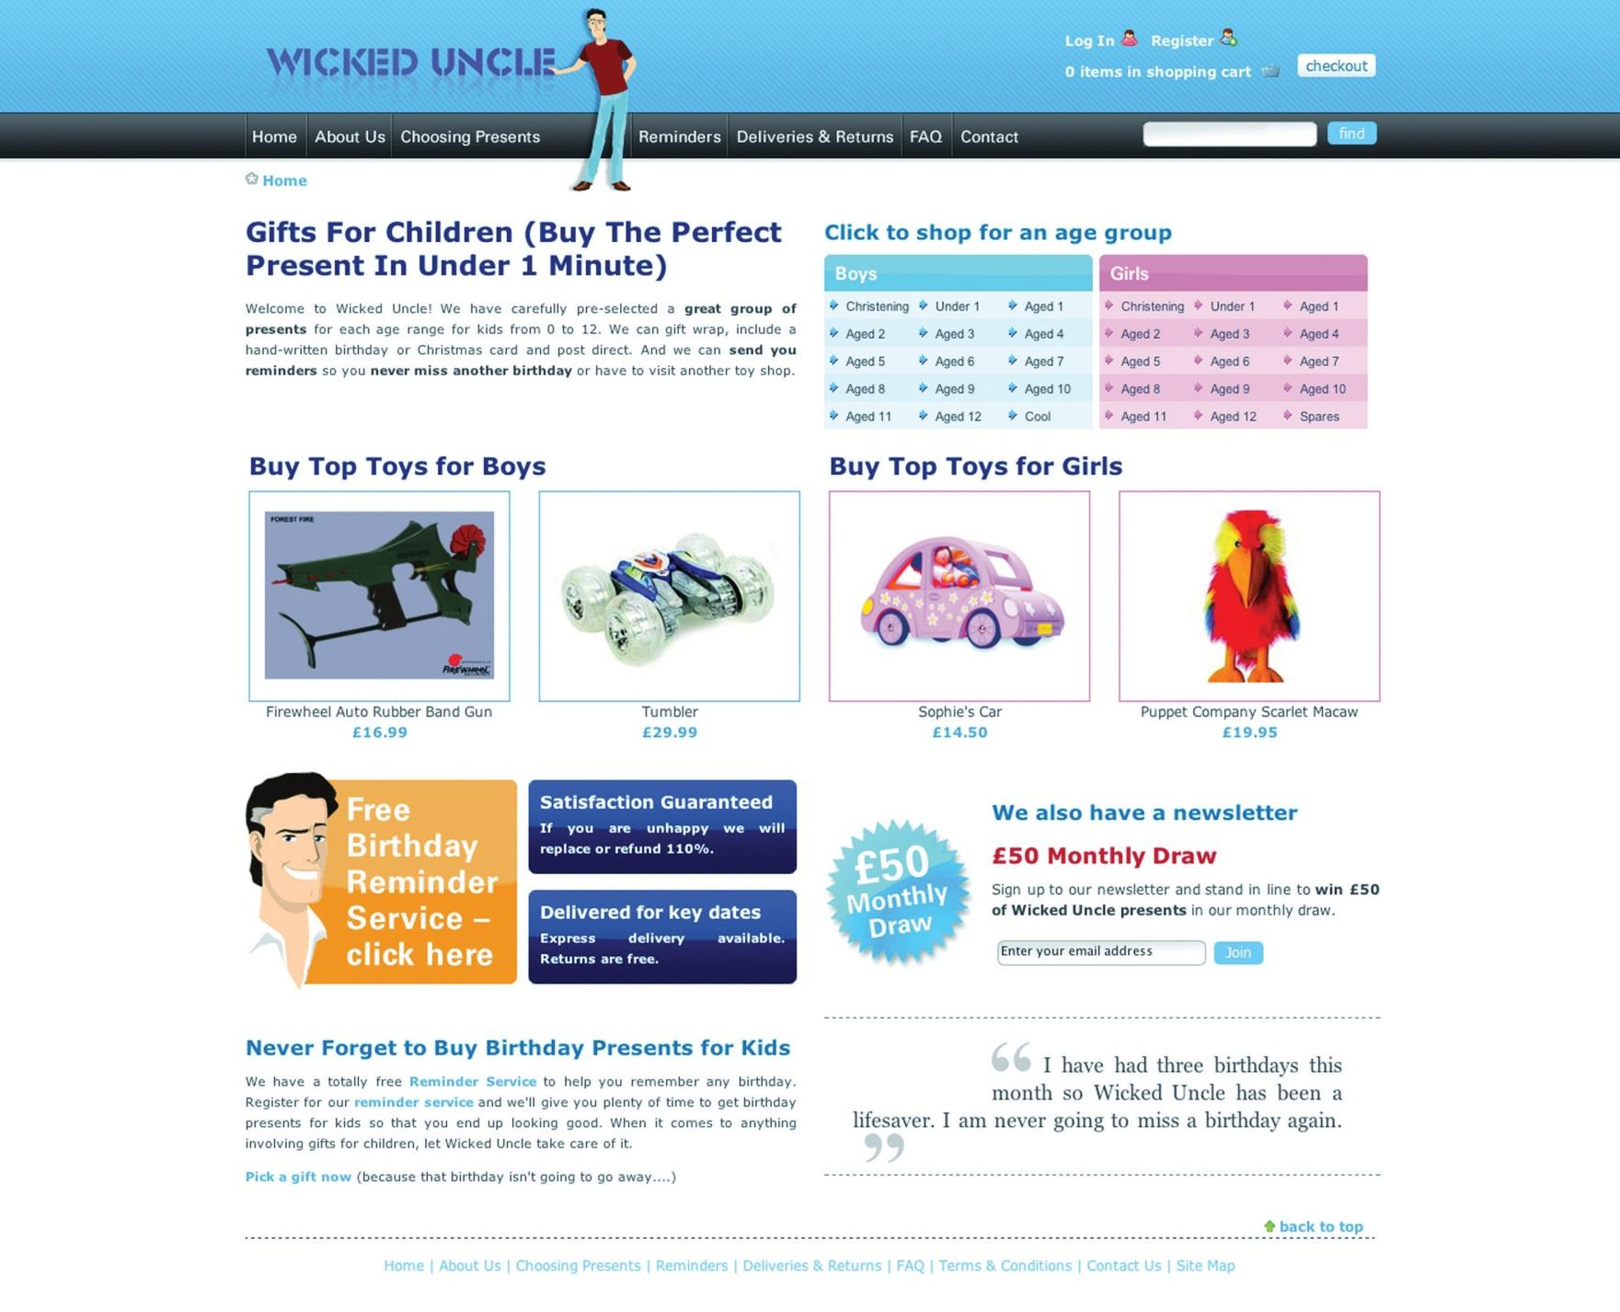
Source: Used by permission from Wicked Uncle.
The aim of the redevelopment was to make a gift buyable in under a minute. The new Web site would also allow Wicked Uncle to build up a database of users so that it could start one-to-one marketing to a database of subscribers. The look and feel of the first Web site was maintained, but the Web site was restructured to be more usable and to make the content more available to search engines.
Figure 13.9
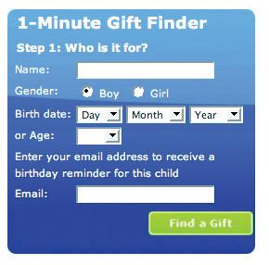
Find a gift in under one minute.
Source: Used by permission from Wicked Uncle.
The site was previously built to be 800 × 600 pixels, which is a resolution used by only 7 percent of the target market. The new Web site was built in 1024 × 768 pixels, which not only allowed more room but also is much better suited to the target market. More than 92 percent of the target UK market has high-resolution monitors.

Figure 13.10
The help line is prominently displayed on each page.
Source: Used by permission from Wicked Uncle.
On the product pages, all product images were increased in size, and more images were included so that Web users could see the product from a variety of angles. Gifts for boys and gifts for girls were color coded to ensure easy navigation. The help line was prominently displayed on each page, as was an easy add-to-cart button. Pertinent information showing whether the item was in stock and how long it would take to ship was also easily available.
A birthday-reminder tool was implemented on the Web site. When users register with Wicked Uncle and register a child’s age, they get yearly birthday reminders of the child’s birthday. This has been very successful and has built up a database of e-mail addresses—from zero to fifteen thousand in less than a year!
The shopping process is exceptionally smooth, with functionality being carefully thought out. Within the process, the user is able to register different children with their own delivery address. The colors used in the shopping cart complement the Web site but are unique to the cart, so the cart stands out. There is always a clear indication of what the next step in the check-out process is.
Lastly, for those shoppers in a hurry, the Web site features a 1-Minute Gift Finder. With a new Web site that is easy to use, Wicked Uncle was able to run campaigns to drive targeted traffic to the Web site.

CASE STUDY QUESTIONS
- Selling gifts online can be difficult if the shopper cannot see the actual product he or she is buying. What are some ways that the Web site design aims to overcome this?
- How does the navigation of Wicked Uncle meet users’ needs?
- How is the Web site able to be used for a number of eMarketing activities?

13.7 References
Rand Fishkin, The Beginner’s Guide to SEO, SEOmoz, February 25, 2006,http://www.seomoz.org/article/beginners-guide-to-search-engine-optimization(accessed April 3, 2008).
Peter Seebach, “The Cranky User: How Not to Make Your Site Accessible,” IBM, March 13, 2001, http://www-128.ibm.com/developerworks/library/us-cranky1.html (accessed March 3, 2008).
“Usability Guidelines,” MIT Information Services and Technology,http://ist.mit.edu/services/consulting/usability/guidelines (accessed March 3, 2008).
Jeffrey Zeldman, Designing with Web Standards, 2nd ed. (Berkeley, CA: New Riders, 2006).

Chapter 14

Online Copywriting

14.1 Introduction
When it comes to writing copy on the Internet, content is king. The copy on a Web page is a hardworking multitasker. It needs to provide information to visitors, engage with them, and lead them to perform a desired action—all while conveying brand ethos. It also needs to provide context and relevance to search engines. And it needs to achieve all this fluidly without appearing to be trying too hard.
Copywriting is a fundamental element of effective online marketing. Whether writing an e-mail to a colleague or PPC (pay-per-click) advertisements for a new product launch, learning how to write effective online copy will make you a better communicator.
Online copywriting entails everything from the copy of Web site pages, to the content of an e-mail, and all written elements in between. From eight-hundred-word WebPR (Web public relations) articles to three-line PPC advertisements, if it’s being read on a screen, it’s online copy. Ultimately, you are writing on the Web to meet business objectives, so it is important to never sway from the strategic element and potential of your online copy.
Focus on writing in a strategic, persuasive, compelling manner.

14.2 How It Works

LEARNING OBJECTIVE
- Understand how online copywriting works.
When writing for the Web, it does not mean that traditional approaches to copywriting need to be ditched. The foundations remain—they just need to be adapted to an online environment. The first step you need to take is to research your target audience, understand their needs, and write copy that solves their problems and answers their questions while engaging with them.
Understanding your audience will guide you in determining the topics that they want to read about and will help you to organize information in a way that makes sense to your audience. It will direct the tone of your copy as well as the content.

Tip
Sometimes it helps to write for just one person. Pick out someone you know who fits your audience, or make someone up, and write for that person. In copywriting, this person who fits your audience is a persona.
The Internet has led to an audience of one. ^{[1]} What does this mean? While your audience is not literally one person (and if it is, thank your mom for reading your Web site, but spend some time on growing your readership), it is not a vast, vaguely defined crowd. Instead, online we have many niche audiences who are used to being addressed as individuals. Online, many of the individuals in our audience also exchange information via blogs, forums, and other forms of social media.
Holly Buchanan of FutureNow (http://www.futurenowinc.com) sums this up with three questions you should ask:
- Who is my audience?
- What actions do I want them to take?
- What information do they need in order to feel confident taking my desired action? ^{[2]}

Personas
Personas are based on the profile of readers of your copy—the visitors to your Web site and potential customers. Creating a profile is all about considering the needs and desires of your Web site visitors and effectively meeting them. For example, How do they make purchase decisions? Do they compare lots of service providers before selecting one? Do they make lists of questions and call in for assistance with decision making? Or do they make purchase decisions spontaneously based on a special offer?
Web site copy can be structured in such a way that it caters for several personas, but you need to spend time understanding their needs before you are able to write copy that addresses these needs with conviction.
Understanding the profiles of your readers is an important element, and the best copy usually results from extensive time spent figuring out who your audience is.
When writing on behalf of clients, it is very important that you have clearly understood what their corporate “personality” is so that you can convey this in your copy without deviating from their corporate identity or diluting their brand ethos.
Writing an online copy—guidelines document will enable you to fall back on the styles, conventions, and voice that you are required to write for. Understanding and sticking to this corporate voice is just as important as the audience you are tailoring your content for. The two need to work together and draw from one another for direction.
By sticking to style conventions, you will assist the audience in familiarizing themselves with author personas. This way, they will know what bits of content go where in a document, and this allows for easier navigation.

Copy That Is Easy to Read
Online copy is judged first and foremost on its layout, regardless of the content. It needs to appear to be well structured and easy to read before a visitor will choose to read it.
A good online copywriter will also be able to use basic HTML (hypertext markup language), knowing that it is the appealing layout of the page that will get their words read. It should be easy for users to skip and skim the copy, effortlessly finding the parts that are most relevant to them.
Online copy should be pleasant to read and easy to scan. This means making use of the following:
- Bulleted and numbered lists
- Short paragraphs
- Clear and concise headings
- Bold and italic text
- Descriptive links
- Calls to action (CTAs) above the fold
It’s easy to see this in practice.
Figure 14.1 What Text Looks Like after It Has Been Edited for Online
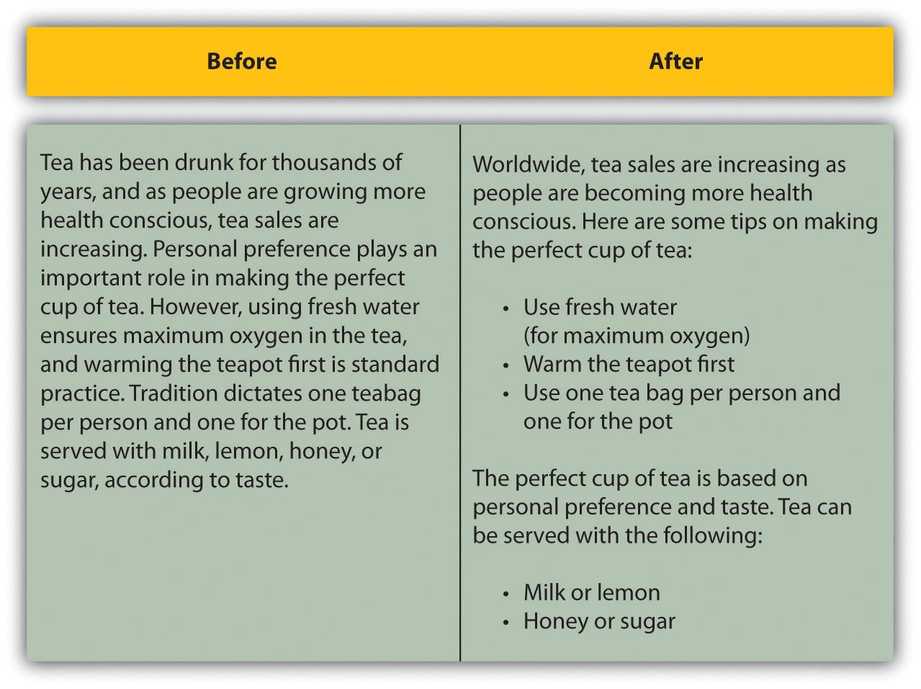
Readers online are usually strapped for time and need to decide quickly whether or not to read a page. This means that the most important information needs to be at the top of the page. Start with the summary or conclusion—the main idea or gist of the article.
Figure 14.2 The Structure of Online Copy
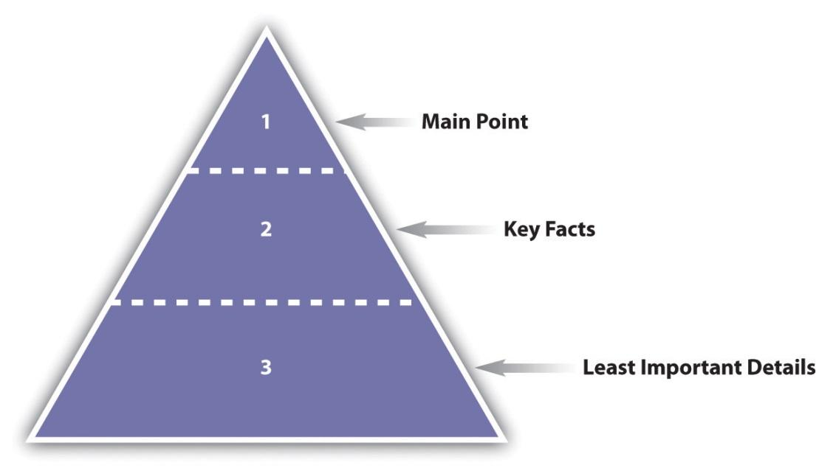
While clever wordplay in headings and titles can attract some attention, online these need to be written as descriptively as possible. The copy is multitasking: not only is it informing visitors of what to expect, it is also telling search engine spiders what the page is about. Be creative, but keep it relevant.

Learning to Use HTML
HTML stands for hypertext markup language, and it’s the foundation of documents on the Internet. HTML tags tell browsers how to present content. HTML tags are in the brackets that look like arrows: < and >.
When writing online copy, you can use an HTML editor, where you insert the tags yourself, or a WYSIWYG (What You See Is What You Get) editor, which works in a similar way to a word processor.
Basic HTML is simple to implement and will help you to lay out your content in an easy-to-read way. Here are some basic HTML tags:
- Bold. <b>phrase you wish to bold</b>
- Italicize. <i>phrase you wish to italicize</i>
- Underline. <u>phrase you wish to underline</u>
- List. <li>lines you wish to list</li>
- Create a paragraph. <p>paragraph text</p>
- Insert a line break. <br/>
- Insert a link. <a href=“page url”>phrase you wish to link</a>
The tags also help search engines to identify how the content has been laid out on the page.
The best way to get to grips with HTML is to start using it online where you can see how the tags work.

KEY TAKEAWAYS
- Knowing your audience will guide you in determining the topics that they want.
- It can be helpful to develop a persona when writing for a site. Personas are based on the profile of readers of your copy. The best copy usually results from extensive time spent figuring out your audience.
- Online copy is judged not just on content but on its layout. It must appear easy to read before the user will choose to read it.
- It should be easy for users to skip and skim the copy so that it is easy for them to find the parts that are most relevant to them.
- Copy is informing visitors of what to expect and also telling the search engine spiders what the page is about.

EXERCISES
- When writing for the Web, why are descriptive titles better than titles that play on words?
- Why does Web copy need to be easy to read?

[1] Jonathan Price and Lisa Price, Hot Text: Web Writing That Works (Indianapolis: New Riders, 2002).
[2] Holly Buchanan, “What Is Web Copy and How Should I Use It?” FutureNow, March 17, 2008, http://www.grokdotcom.com/2008/03/17/what-is-web-copy (accessed June 17, 2008).

14.3 Short Copy

LEARNING OBJECTIVE
- Know what short copy is and how it should be used in online copywriting.
Online copy often has only a limited amount of space and short amount of time to get a message across to visitors and entice them to take action. This is especially true of banner advertising and PPC (pay-per-click) advertisements on search engines, but it is also is important across all eMarketing disciplines. The most important short copy of online marketing is thecall to action (CTA).

Call to Action: Telling People What to Do
A crucial element to online copywriting is the CTA. Users scan Web pages and look for clues as to what to do. Don’t make them think; tell them what action to perform.
A call to action is a short, descriptive instruction that explicitly tells a Web visitor what to do. Banner advertising usually involves a clear call to action, and it can also be used in paid search advertising. Call-to-action copy is not limited to short copy: e-mail newsletters and promotions should also make use of call to action, and we even see them all over Web pages. Calls to action should always be above the fold to drive action.

Note
Use active verbs for sentences in the active voice. This sentence is in the active voice. Passive verbs can be used but tend to make for less instructive copy. Passive voice is being used in this sentence.
Any time that there is an action that you want a Web visitor to take, a call to action should instruct the visitor what to do. This means using active verbs when you write and crafting hyperlinks to be clear instructions that resonate with your visitor at each step in the conversion process.

Passive Sentences
- When your e-mail has been received, an order number will be issued.
- A big difference can be made in a child’s life by donating today.
- By joining our database, great prizes can be won.

Active Sentences
- Send us an e-mail, and we will issue you an order number.
- Sign up to our newsletter and receive interesting marketing news!
- Donate today and make a difference in a child’s life!
- Join our database and win great prizes.
A strong call to action resonates with the action that the visitor needs to take, as opposed to the technical function that is performed. For example, if a user has entered an e-mail address to sign up to your e-mail newsletter, the action button should say “sign up” (which is what a user understands) and not “submit” (which is the database action).
Consider what actions mean offline:
- With e-mail newsletters, “sign up” can have very different connotations from “subscribe.”
- “Subscribe” is very different from “subscribe for free.”
Whereas subscriptions connote regularity as to the times when newsletters are sent (e.g., once a week, on a particular day at a particular time), “sign up” does not carry the same burden. There is only one way to know what call to action works best on a Web page, in an e-mail, on a banner, or in an advertisement: test, test, test. You could do this by performing A/B split tests to see which CTA drives the most clicks or actions.

Features and Benefits
Writing compelling copy means conveying to readers why they should perform an action. While features may seem all-important, you need to communicate the benefits of the features to the user, as this is the ultimate driver of action. Features and benefits are described as follows:
- Feature. A prominent aspect of a product or service that can provide benefit to users. It describes what the product does.
- Benefit. The positive outcome for a user that a feature provides. It can be the emotional component of what the user gets out of the product.
Features and benefits are very different. Features are what are important to the company that provides the product or service. Benefits are what are important to those who decide to use the product or service. This part of the copy could be the make-or-break selling point, so be direct and illustrate why they should choose your product instead of your competitor’s.
For example, consider a home entertainment system. Features could include surround sound and a large flat-screen television. The benefit is a cinema-quality experience in your own home.
Persuasive writing makes use of features, benefits, and active verbs to create appealing messages for your personas: Enjoy cinema-quality movie nights in your own home with a surround sound home entertainment system.
Be personal, be descriptive, and illustrate that their needs will be met and even surpassed.

PPC Advertisements
PPC advertisements have a very limited space, and very limited time, to get a message across, as well as plenty of competition for an Internet user’s attention. These four lines of copy need to work hard to be convincing and compelling to ensure a top return on investment.
PPC advertisements follow the same basic structure:

Heading
A heading in PPC advertising looks like the following:

Two lines of advertisement copy,
Which can be displayed on one line
www.DisplayURL.com
Refer to Chapter 7 "Pay per Click Advertising" for Google’s editorial guidelines.
When the copy of the advertisement matches the user’s search term, those words are often displayed in bold in the advertisement. This makes the advertisement more prominent and can improve click-through rates. This is also why keyword research is very important.
For example, if the search term used was “roses,” an advertisement with “roses” in the copy might look like this:

Roses for Valentine’s
A dozen red roses for your love;
Fast, free delivery in RSA.
www.flowers.co.za/roses
Using keywords in the advertisement copy can help improve click-through rates. However, this can mean writing thousands of advertisements—one for each keyword in the PPC campaign! The paid search advertising platforms have a neat tool to bypass this problem: dynamic keyword insertion.
Dynamic keyword insertion allows for the search term used to be inserted into the advertisement copy. This means that you can write one advertisement, and every time it appears for a different search term, that search term will be inserted into the advertisement. In the copy for the advertisement, it looks like this:
{keyword:alternative word}
The brackets indicate that this is where the dynamic keyword should go. The copywriter also needs to select an alternative keyword to show if the search term used does not fit into the space available.
Google’s tutorial on dynamic keyword insertion has the following examples that explain this best. ^{[1]}
The following advertisement text is created:

Brand-New {KeyWord:Phones}
Huge selection of phones. Great prices.
{Keyword:phones} in stock. Free shipping!
www.BestDealer.com
The previous advertisement is then seen by searchers as the following:
Advertisement 1. Keyword: nokia n90

Brand-New Nokia N90
Huge selection of phones. Great prices.
Nokia n90 in stock. Free shipping!
www.BestDealer.com
Advertisement 2. Keyword: samsung d500

Brand-New Samsung D500
Huge selection of phones. Great prices.
Samsung D500 in stock. Free shipping!
www.BestDealer.com
Advertisement 3. Keyword: motorola razor silver

Brand-New Phones
Huge selection of phones. Great prices.
Phones in stock. Free shipping!
www.BestDealer.com
With limited word count available, it can seem a daunting task to communicate information that entices the right traffic to click through and that differentiates you from your competition. Testing variations of copy is the best way to determine what works best for your campaign.

KEY TAKEAWAYS
- The call to action is a short descriptive instruction that explicitly tells a Web visitor what to do.
- PPC advertisements have a very limited space to get a message across, so this copy must be effectively written.
- Dynamic keyword insertion will help make PPC copy more effective.
- Testing different variations of the copy is the best way to find out what works best for your campaign.

EXERCISE
- Visit a search engine and find some examples of PPC advertisement copy. Evaluate the different types of copy and how they are written. Do you think they are effective for the keyword used? Find an example of one that may not be effective. Indicate how you would rewrite the copy so that it would perform better.

[1] Google, “How Do I Use Keyword Insertion?” tutorial, Google AdWords Help Center,http://adwords.google.com/support/aw/bin/answer.py?hl=en&query=dki&answer=74996&type=f (accessed June 17, 2008).

14.4 Long Copy

LEARNING OBJECTIVE
- Know what long copy is and how it should be used in online copywriting.
Online copywriting is not just about short, sharp, call-to-action copy; however, Web users tend to scan pages quickly to determine whether or not they will read further. Even when writing longer copy, you need to take this into consideration.
Longer online copy allows you to foster a relationship with a reader, whether it is on a blog, through e-mail communications, or through articles and news releases. With more words and space available to use, you are able to establish a voice and a personality to make your copy more convincing and personal.

Getting Read: Titles and Subject Lines
Titles and subject lines are there for a very important reason: they inform readers whether or not they are likely to want to read further by giving a sneak preview into what is to come in the article. They are the gateway to your content.
Consider the following two titles:
- Guide to Online Copywriting
- Ten Steps to Writing Online Copy That Sells
The second title conveys more information to the reader that helps the reader decide to read further. Minor word manipulation that tells the reader how he or she will benefit from reading that content can make a huge difference.
Subject lines are like titles for e-mails and can make the difference between an e-mail being deleted instantly and being opened and read. Subject lines also work hand in hand with the “from” field of an e-mail. Both fields usually appear side by side in an in-box and are used to determine relevance, familiarity, and trust.
Use a consistent and easy-to-recognize sender alias—the “from” field—so that readers can recognize your e-mails easily. With familiarity and trust established using this field, the subject line can be used more creatively, allowing you to build on the already-established relationships with your readers.
As with a title, use the subject line to make clear what the e-mail is about. For example, if there is a promotion in the e-mail, consider putting it in the subject line as well.
Titles, headlines, and subject lines need to be both persuasive and enticing. Consider what need your copy is meeting for your readers and express that first. Be honest and straightforward and never misrepresent the content of an e-mail as this will prevent readers from opening them in the future.

Copywriting for Search Engine Optimization
As well as the copy on the Web page, HTML (hypertext markup language) tags and metadata are also used by a search engine optimization (SEO)copywriter. In addition to assisting you with structuring your content, these tags indicate relevancy and context to search engines. Some of the tags are used by screenreaders, and so they assist visitors with disabilities to access your content. The meta description can also be used by search engines on the search engine results pages (SERPs).
A keyword refers to the word or words that are used in a search query on a search engine. Multiword keywords are sometimes referred to as key phrases.
The first step in SEO copywriting is keyword research. Having identified the themes of your Web site and Web pages, keyword research should be used to identify what keywords your target audience uses when searching for you.
Each page should be optimized for a primary key phrase and can be optimized for a secondary and tertiary key phrase as well. Usually a Web page is optimized for three key phrases but can be optimized for up to five (though only if the page is very long). Any more than that and you are better off creating new, niche Web pages.
In , there is more detail on the process of keyword discovery and keyword selection.
The following are guidelines for using key phrases on a Web page:
Remember that each page on a Web site must have a unique URL (uniform resource locator), title, meta keywords, and meta description.

Note
Each page on a Web site must have a unique URL, title, meta keywords, and meta description.

Page URL
The main key phrase for the page should be used in the URL for the page. Often, the URL is generated from the page title, so using the key phrase in the page title should ensure that it is in the URL as well. This also helps readers to glance at the URL and get an idea what they are reading about.

Page Title
The page title appears at the top of a user’s browser and should be able to tell the user (and the search engine spiders, of course) what the main theme of the page is. The page title is limited to sixty-six characters (including spaces). The key phrase should be used as close to the beginning of the title as possible—keeping it relevant and interesting.

Meta Description
The meta description is a short paragraph describing the page content. This summary is usually shown on the SERPs if it contains the search term searched for, which means that it needs to entice users to click through. The spiders use the meta description to deduce the topic of the page, and the use of targeted key phrases is important here. Copy is limited to no more than 166 characters (including spaces).

Note
Keyword stuffing refers to putting too many keywords into the meta keywords’ tagging and using keywords that are not relevant to the Web page. Search engines can penalize this as a spam practice.

Meta Keywords
The meta keywords are a list of the words and phrases that are important on a Web page. The use of targeted key phrases is important here, but remember: no keyword stuffing. The meta keywords are limited to two hundred characters (including spaces). Take time to consider how to make this relevant as well as convincing enough to get a searcher to click on your page instead of your competitor’s.

Headings and Subheadings
Spiders assign more relevance to the text used in headings, so it is important to use your key phrases in the headings on your page. It also helps to structure your content.
Heading structures include the following:
<h1>Page heading. What the page content is about</h1>
<h2>Subheadings. “Chapters” of content breakdown</h2>
<h3>Information under the subheadings. Elaboration of main headings and more detail</h3>
Having a good heading hierarchy is important as spiders use it to move through your page. The hierarchy indicates what is more important and how the content is broken up. It also makes it easier for the reader to take in your content if it is arranged in a way that makes sense to her.

Page Copy
The number of times you use the key phrases is entirely dependent on how long the page of copy is. You want to optimize the page for the key phrases without their use being overt.
For SEO effectiveness, a page of Web copy should not be less than 250 words. On a 250-word page you could use the primary key phrase eight times (this includes use in metadata, headings, title, and body copy) and the secondary key phrase four times.

Discussion
Why should you avoid requiring the user to scroll many times to read a page of content?
The average Web page should not be so long that the user needs to scroll and scroll to get to the end of it. If you find the page is getting exceptionally long, consider breaking it into different sections. This way you could add more pages of optimized copy focused on one theme, instead of one very long page. This also allows for you to optimize pages for more keywords, targeting various search queries.

Links to Your Optimized Page
The text used to link from one page to another is considered important by the search engine spiders, so try to ensure that your key phrase is used when linking to the optimized page. The anchor text of links should include the key phrase of the page being linked to and not the page being linked from.

Images: Alt Text and Title Tags
Alt text refers to the “alt” attribute for the IMG HTML (image HTML element) tag: this is the text that appears in the caption. It is used in HTML to attribute a text field to an image on a Web page, normally with a descriptive function, telling a user what an image is about and displaying the text in instances where the image is unable to load. While this is handy for readers, we also do it for another reason: search engine spiders can’t read images, but they can read the alt text. The image title tag is what shows when you hover with your mouse over an image and can also be read by the search engine spider. It also appears on a page where images may have been blocked or take time to load.

Neologisms and Buzzwords
Sometimes the World Wide Web is referred to as the “Wild Wild Web,” as it can seem to be an environment where anything goes. The ever-expanding numbers of social media participants play fast and loose with grammar.
With new services and products being developed daily, it can feel like the list of new words, and the new ways to use words, is building faster than you can keep up with it. Dictionaries and reference guides celebrate this regularly with a “word of the year,” usually one that has been in heavy use by the Internet audience for the three years preceding its entrance into a dictionary.
For example, in 2009, “unfriend” was voted the word of the year by the editors of the New Oxford American Dictionary, while “w00t” had its day in 2007 when it was featured on Merriam-Webster’s selection for word of the year.

Note
Firefox is a free, open-source browser developed by the Mozilla Foundation. As well as having improved and safer browsing, you can download extensions that let you customize your browser. You can download it for free from http://www.mozilla.org.
Online services can quickly become verbs in everyday language, so we talk of “googling something” instead of “searching on Google” and of “friending someone” on Facebook rather than “adding someone as a Facebook friend.”
Always remember to tailor your content to your target audience. If your content is aimed at cutting-edge early adopters, then litter it with the latest buzz words. If your audience does not know the difference between Firefox and Internet Explorer, then be cautious when using one of these new words.
Users dictate the direction and content of your copy. It’s up to you to make it worth the read!

A Brief Synopsis on the Process of Writing
The following is a brief list of the steps for writing online copy:
- Research and understand your audience.
- Establish your tone using copy guidelines.
- Establish your business objectives (what your copy aims to achieve).
- Conceptualize the angle you will take to get this across in your copy and meet your business objectives.
- Write the framework, that is, the <h1> tags that will dictate the hierarchy of the content as well as a powerful title. Then elaborate in the body of the copy under the subheadings.

Things to Avoid
Even if you are a brilliant copywriter, the moment you stop sticking to online copy rules and regulations, your writing will hold very little weight on the search engine. These are some of the examples of bad practice that can have some very serious repercussions:
- Keyword stuffing. If you try to squash too many targeted phrases or keywords into a piece of copy, the search engine spiders will immediately pick this up, and you will stand the chance of being wiped right off the SERPs. Keyword stuffing makes copy sound forced and unnatural and is unpleasant to read. Stick to relevant content that offers the readers real value; this will naturally attract links and visitors.
- Misrepresented titles. Titles are often the first touch points that readers come across before deciding to pursue a page of copy. Therefore, they need to encompass what the page is about and get the gist of the content. Be sure to be true to your title; otherwise readers will feel cheated and taken advantage of and there is a strong chance that they will not want to visit again. Misrepresented titles breed mistrust—avoid this at all costs!
- Irrelevant content. No reader wants to go through the mission of searching a search engine only to land on a page that has no relevance to him. Your content will be seen as waffle, and you will lose authority as a credible source—in fact, you will probably chase many visitors away.

KEY TAKEAWAYS
- Copywriting for SEO involves optimizing copy for select key phrases in order to give context to search engines. A page can be optimized for up to five key phrases, but it is usually optimized for three of them. SEO copywriting involves the metadata and title tags, as well as the copy that is read on a page.
- The dynamic nature of the Internet means that new words are entering a user’s vocabulary every day. For best copywriting, know your audience and use the language that resonates most strongly with them.

EXERCISES
- Why should users dictate your content? List some ways that users’ needs determine content.
- For some real online copywriting practice, choose an article in a magazine or newspaper and rewrite it for an Internet audience.

14.5 Reference
Rand Fishkin, The Beginner’s Guide to SEO, SEOmoz, February 25, 2006,http://www.seomoz.org/article/beginners-guide-to-search-engine-optimization(accessed April 3, 2008).

Chapter 15

Web Analytics and Conversion Optimization

15.1 Introduction
Picture the scene: you’ve opened up a new fashion retail outlet in the trendiest shopping center in town. You’ve spent a small fortune on advertising and branding. You’ve gone to great lengths to ensure that you’re stocking all the prestige brands. Come opening day, your store is inundated with visitors and potential customers. And yet, you are hardly making any sales. Could it be because you have one cashier for every hundred customers? Or maybe it’s the fact that the smell of your freshly painted walls is chasing customers away before they complete a purchase. While it can be difficult to isolate and track the factors affecting your revenue in this fictional store, move it online and you have a wealth of resources available to assist you with tracking, analyzing, and optimizing your performance.
To a marketer, the Internet offers more than new avenues of creativity. By its very nature, the Internet allows you to track each click to your site and through your site. It takes the guesswork out of pinpointing the successful elements of a campaign and can show you very quickly what’s not working. It all comes down to knowing where to look, knowing what to look for, and knowing what to do with the information you find.

History
Testing, analyzing, and optimizing are not new to marketing. Being able to gauge the success of any campaign is crucial to growth.
Early Web analytics packages came to the fore in the mid-1990s, a couple of years after the first Mosaic browser was launched. Early analysis reflected the nature of the early Web, focusing only on hits with some very basic click-stream analysis. With one-page Web sites being the norm, it was enough to know how many clicks came to the Web site. Traffic meant you were doing well. You can still see hit counters on some Web sites today. These Web sites usually look as sophisticated as this tool.
However, as Web sites became more complex, and as more people had access to the Internet, better analysis became more important. Measuring hits was, and is, not enough. In fact, measuring hits is a fairly meaningless task. Web analytics split into two types of tools: page tags and log files. Both continue to become more sophisticated, capturing information about visitors to a Web site, and recording detailed information related to their time on the site. There are several log-file analysis tools that cost nothing to use. Sophisticated page-tag Web analytics became available for free when Google bought Urchin in March 2005 and launched Google Analytics as a free service. Are you wondering what the difference is between page tagging and log-file analysis? Don’t worry, it’s coming!

15.2 How It Works

LEARNING OBJECTIVES
- Learn the basic fundamentals of Web analytics and conversion optimization.
- Understand why Web analytics are important to eMarketing.
- Understand why conversion optimization is important to eMarketing.
When it comes to Web analytics and conversion optimization, it is all about preparation. It is not just about collecting data; you need to know what data you are going to use. Once data have been collected, you need to analyze them and let the numbers inform your optimization tasks.

Goals, Events, and Key Performance Indicators
The key to the success of any Web site or online campaign is that it is designed with clearly defined goals in mind. These will be used to measure the success of the Web site or campaign and are crucial to maintaining focus within online activities.
The goal of a Web site or campaign may depend on the type of industry, but usually it will be an action that results in revenue for the company. The goal of a Web site is also intrinsically linked to the action that you want visitors to perform.
Although a Web site has an ultimate goal, the process of achieving that goal can be broken down into several steps. These are called events or microconversions. Analyzing each step in the process is called funnel analysis or path analysis and is critical to understanding where problems in the conversion process may lie. The clicks visitors make once landed on a site, whether they follow the desired steps or not, are referred to as a click path.

Figure 15.1 Funnel Analysis
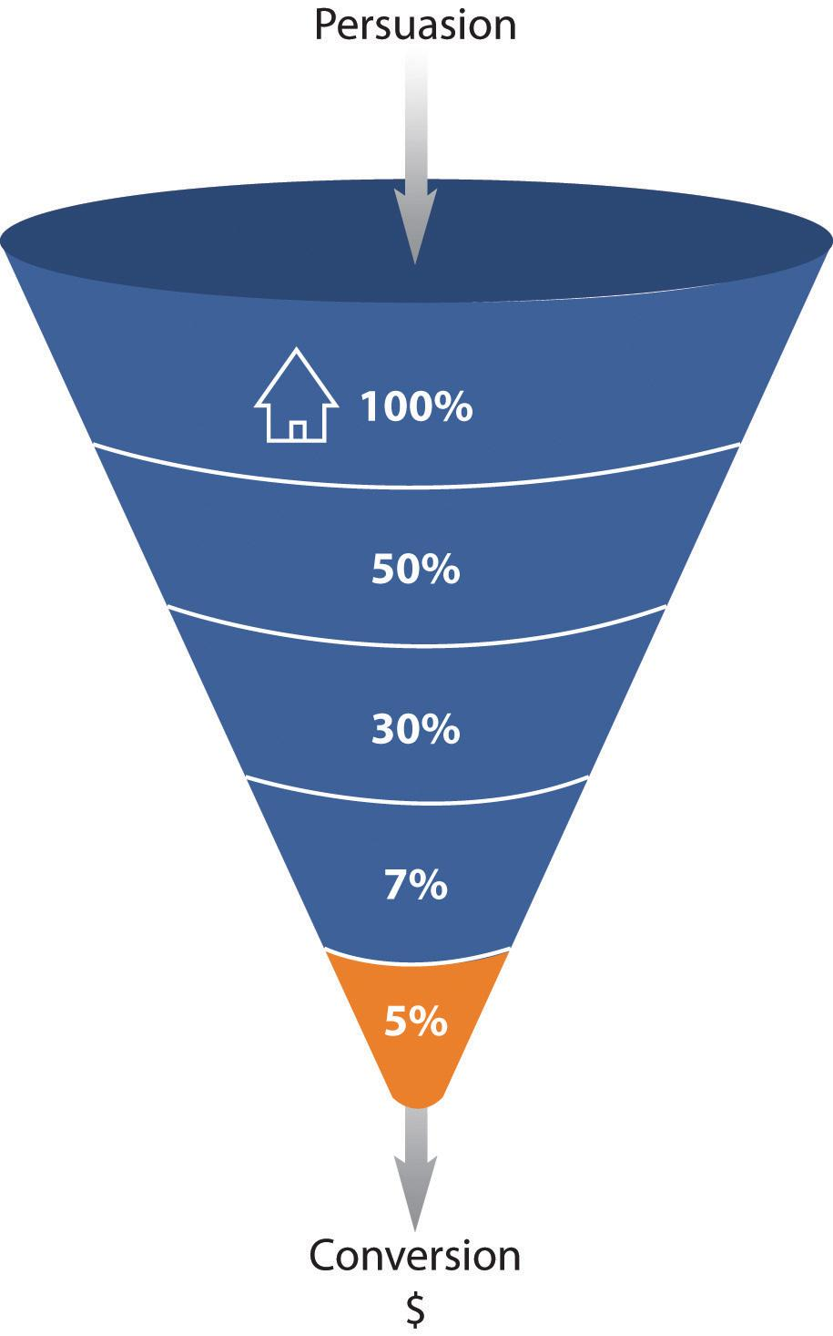
For example, on a hotel Web site, the ultimate goal is that visitors to the site make a booking on the Web site with a credit card.
Each step in the process is an event that can be analyzed as a conversion point:
- Event 1. Perform a search for available dates for hotels in the desired area.
- Event 2. Check prices and amenities for available hotels.
- Event 3. Select a hotel and go to checkout.
- Event 4. Enter personal and payment details and confirm booking (conversion).
One expects fewer users at each step; that’s why it’s called a funnel. Increasing the number of visitors who progress from one step to the next will go a long way to improving the overall conversion rate of the site.
There are also other pointers, or indicators, that you are achieving your goals. These are factors that can be optimized to ensure that your ultimate goal is being met. In Web analytics, these are referred to as key performance indicators (KPIs). These need to be defined so you monitor the entire process to achieving your Web site goal. They can also give clues as to what factors you need to work on so as to reach your goal.

Note
Events and KPIs are not the same thing. Events can be seen as steps toward a goal and are usually an action performed by a visitor. KPIs are indicators that the Web site’s goals are being met.
Here are some example goals and KPIs for different Web sites:
For a hospitality e-commerce site, such as http://www.expedia.com, one would expect the following goals:
- Increase bookings
- Decrease marketing expenses
For the same site, one would expect the following KPIs:
- Conversion rate
- Cost per visitor
- Average order value
For news and content sites, such as http://www.news24.com, one would expect the following goals:
- Increase readership and level of interest
- Increase time visitors spend on Web site
For the same site, one would expect the following KPIs:
- Length of visit
- Average time spent on Web site
- Percentage of returning visitors
KPIs help you to look at the factors that you can influence. For example, if your goal is to increase revenue, you could look at ways of increasing your conversion rate (that is the number of visitors who purchase something). One way of increasing conversion rate could be to offer a discount. So you would have more sales but probably a lower average order value. Or you could look at ways of increasing the average order value, so the conversion rate would stay the same, but you increase the revenue from each conversion.
Once you have established your goals, events, and KPIs, you need to be able to track the data that will help you analyze how you are performing and how you can optimize your Web site or campaign.
KPIs and events break down the factors and steps that can be influences so as to achieve the goals of the Web site. They allow you to see on a micro level what is affecting performance on a macro level.

KEY TAKEAWAYS
- The trackability of the Internet allows for analysis at every level of an eMarketing campaign, which should lead to improved results over time.
- Analysis of a Web site has an ultimate goal, which can be broken down into several steps, which are called events or microconversions.
- Each step in the process is called funnel analysis. Each step in the process is an event that can be analyzed as a conversion point.
- Fewer users will engage at each step of the purchase funnel, which is why it’s called a funnel.
- The foundation of successful analysis and optimization is to determine campaign and business goals up front and use these to determine KPIs (key performance indicators) for that campaign. Analyzing metrics that are not indicators of success will detract from timely optimization.

EXERCISE
- What is the difference between goals, events, and KPIs? Considerhttp://www.facebook.com and http://www.boingboing.net, and list what you think the goals of each Web site are and what events and KPIs would be used to measure these.

15.3 Tracking and Collecting Data

LEARNING OBJECTIVE
- Understand why tracking and data collection are important to eMarketing.
Currently, there are two main technology approaches for collecting Web analytics data: log-file analysis and page tagging.
Log-file analysis software reads the records, called log files, on the Web server, which record all clicks that take place on the server. Web servers have always stored all the clicks that take place in a log file, so the software interprets data that have always been available. A new line is written in a log file with each new request. For example, clicking on a link, an Ajax call, or submitting a form will each result in a new line being written.
Page tagging, on the other hand, sends information to a third-party server, where statistics can be generated. The browser executes JavaScript code that communicates with the tracking software, creating page tags.
Pixel tracking can be used to track e-mail campaigns. Here, a tiny, transparent pixel is placed in the e-mail. When you load the images in the e-mail, you will also load the tiny image that tracks your activity.

Note
Caching is when a browser stores some of the information for a Web page so it can retrieve the page more quickly when you return to it. If a Web page is cached by your browser, when you look at the page again, it will not send a request to the Web server. This means that that particular visit will not show in the log files. Page tagging, however, would capture this visit. But some browsers do not support JavaScript, and page tagging would not capture those visits. This is why there is often a discrepancy in the numbers reported by the two services.

Log-File Analysis
In terms of log-file analysis, you should know the following:
- Log files are normally produced by Web servers, so the raw data are readily available. Page tagging, however, requires changes to the Web site.
- Log files are very accurate—they record every click. Page tagging can be less accurate. If a user’s browser does not support JavaScript, for example, no information will be captured.
- Log files are in a standard format, so it is possible to switch vendors and still be able to analyze historical data. Page tagging is proprietary to each vendor, so switching can mean losing historical data.
- Log files record visits from search engine spiders—useful for search engine optimization.
- Log files record failed requests, whereas page tagging only shows successful requests.

Page Tagging
In terms of page tagging, you should know the following:
- JavaScript makes it easier to capture more information (e.g., products purchased or screen size of a user’s browser). You can use log-file analysis to capture this information, but it will involve modifying the URLs (uniform resource locators).
- Page tagging can report on events, such as interactions with a Flash movie, that log-file analysis cannot.
- Page tagging can be used by companies that do not run their own Web servers.
- Page tagging service providers usually offer a greater level of support. This is because it is a third-party service, whereas log-file analysis software is often managed in-house.
Because of the different methods of collecting data, the raw figures produced by the two services will differ. Sometimes, both are used to analyze a Web site. However, raw figures not matching up should not be a problem. It is through interpreting these figures that you will be able to understand how effective your eMarketing efforts are.
Web site analytics packages can be used to measure most, if not all, eMarketing campaigns. Web site analysis should always account for the various campaigns being run. For example, generating high traffic volumes by employing various eMarketing tactics like SEO (search engine optimization), PPC (pay per click), and e-mail marketing can prove to be a pointless and costly exercise if the visitors are leaving your site without achieving one (or more) of your Web site’s goals. Conversion optimization aims to convert as many of a Web site’s visitors as possible into active customers.

What Information Is Captured
There are three types of Web analytics metrics:
- Count. These are the raw figures captured that will be used for analysis.
- Ratio. This is an interpretation of the data that are counted.
- KPI (key performance indicator). Either a count or a ratio, these are the figures that help you to determine your success in reaching your goals.

Discussion
Why would you want to look at the activity of a single visitor? Why would you want to segment the traffic for analysis?
In analysis, metrics can be applied to three different universes:
- Aggregate. All traffic to the Web site for a defined period of time.
- Segmented. A subset of all traffic according to a specific filter, such as by campaign (PPC) or visitor type (new visitor vs. returning visitor).
- Individual. The activity of a single visitor for a defined period of time.

Building Block Terms
Here are some of the key metrics you will need to get started on Web site analytics:
- Hit. A request to the server (and a fairly meaningless number on its own).
- Page. Unit of content (so downloads and Flash files can be defined as a page).
- Page views. The number of times a page was successfully requested.
- Visit or session. An interaction by an individual with a Web site consisting of one or more page views within a specified period of time.
- Unique visitors. The number of individual people visiting the Web site one or more times within a period of time. Each individual is only counted once. Types of visitors can be categorized as follows:
  - New visitor. A unique visitor who visits the Web site for the first time ever in the period of time being analyzed.
  - Repeat visitor. A unique visitor with two or more visits within the time period being analyzed.
  - Return visitor. A unique visitor who is not a new visitor.

Note
A repeat visitor may be either a new visitor or a return visitor, depending on the number of times he or she has visited the site within the time period being analyzed.
These are the most basic Web metrics. They tell you how much traffic your Web site is receiving. Looking at repeat and returning visitors can tell you about how your Web site creates loyalty. As well as growing overall visitor numbers, a Web site needs to grow the number of visitors who come back. An exception might be a support Web site—repeat visitors could indicate that the Web site has not been successful in solving the visitor’s problem. Each Web site needs to be analyzed based on its purpose.

Visit Characterization
The following help characterize the visit to a particular Web site:
- Entry page. The first page of a visit.
- Landing page. The page intended to identify the beginning of the user experience resulting from a defined marketing effort.
- Exit page. The last page of a visit.
- Visit duration. The length of time in a session.
- Referrer. The URL (uniform resource locator) that originally generated the request for the current page.
  - Internal referrer. A URL that is part of the same Web site.
  - External referrer. A URL that is outside of the Web site.
  - Search referrer. The URL has been generated by a search function.
  - Visit referrer. The URL that originated a particular visit.
  - Original referrer. The URL that sent a new visitor to the Web site.
- Click-through. The number of times a link was clicked by a visitor.
- Click-through rate. The number of times a link was clicked divided by the number of times it was seen (impressions).
- Page views per visit. The number of page views in a reporting period divided by the number of visits in that same period.
These are the terms that tell you how visitors reach your Web site and how they move through the Web site. The way that a visitor navigates a Web site is called a click path. Looking at the referrers, both internal and internal, allows you to gauge a click path that visitors take.

Content Characterization
The following help characterize how visitors move through the Web site:
- Page exit ratio. Number of exits from a page divided by total number of page views of that page.
- Single-page visits. Visits that consist of one page, even if that page was viewed a number of times.
- Bounces (single page-view visits). Visits consisting of a single page view.
- Bounce rate. Single page-view visits divided by entry pages.
When visitors view a page, they have two options: leave the Web site, or view another page on the Web site. These metrics tell you how visitors react to your content. Bounce rate can be one of the most important metrics that you measure! There are a few exceptions, but a high bounce rate usually means high dissatisfaction with a Web page.

Conversion Metrics
Other metrics that apply to eMarketing tactics include the following:
- Event. A recorded action that has a specific time assigned to it by the browser or the server.
- Conversion. A visitor completing a target action.
- Impression. Each time an advertisement or a page is served.
- Open. Each e-mail that is deemed open. Usually if the images are loaded, an e-mail is considered open.

Note
For the most up-to-date definitions, visithttp://www.webanalyticsassociation.org to download the latest definitions in PDF (portable document format).
In order to test the success of your Web site, you need to remember the TAO of conversion optimization:
- Track
- Analyze
- Optimize
Using your goals and KPIs, you’ll know what metrics you will be tracking. You will then need to analyze these results and take appropriate actions. And the testing begins again!

KEY TAKEAWAYS
- Web analytics packages come in two flavors: log-file analysis and page-tagging analysis, although some packages combine both methods.
- Metrics use the following:
  - Counts
  - Ratios
  - KPIs (key performance indicators), which are either counts or ratios

EXERCISES
- How can site search data be used to optimize a Web site?
- Why is “hit” a meaningless measure of Web site success?

15.4 Analyzing Data

LEARNING OBJECTIVE
- Gain an understanding of data analysis and why it is important to eMarketing.
A number is just a number until you can interpret it. Typically, it is not the raw figures that you will be looking at, but what they can tell you about how your users are interacting with your Web site.

How and What to Test
Avinash Kaushik, author of Web Analytics: An Hour a Day, recommends a three-prong approach to Web analytics:
- Analyze behavior data that infer the intent of a Web site’s visitors.
- Analyze outcome metrics that show how many visitors performed the goal actions on a Web site.
- Test and analyze data that tell us about the user experience. ^{[1]}

Behavior Data: Intent
Web users’ behavior can indicate a lot about their intent. Looking at referral URLs (uniform resource locators) and search terms used to find the Web site can tell you a great deal about what problems visitors are expecting your site to solve.
Click density analysis, segmentation, metrics that define the visit, and content can all be used to gauge the intent of your visitors.

Figure 15.2 The Trinity Approach to Analytics
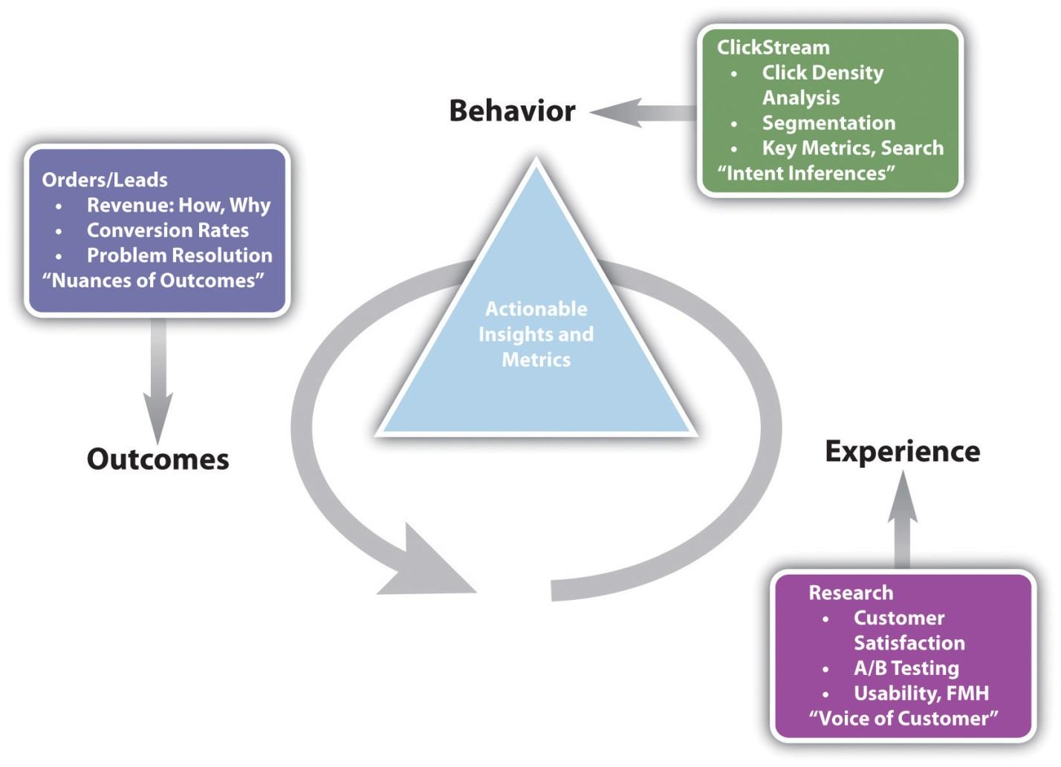
Source: Adapted from http://www.kaushik.net/avinash/wp-content/uploads/2006/08/trinity_strategy.jpg. Used by permission from Avinash Kaushik.
A crucial, and often overlooked, part of this analysis is that of internal search. Internal search refers to the searches that users perform on the Web site of the Web site’s content. While a great deal of time is spent analyzing and optimizing external search—using search engines to reach the Web site in question—analyzing internal search goes a long way toward determining how effective a Web site is in delivering solutions to visitors.
Internal and external search data are likely to be very different and can go a long way to exposing weaknesses in site navigation and the internal search itself and can expose gaps in inventory on which a Web site can capitalize.
For example, consider the keywords a user might use when searching for a hotel Web site and keywords that might be used by a the user when on the Web site.
Keywords to search for a hotel Web site might be the following:
- Cape Town hotel
- Bed and breakfast Cape Town
Once on the Web site, the user might use the site search function to find out further information. Keywords he or she might use include the following:
- Table Mountain
- Pets
- Babysitting service
Analytics tools can show what keywords users search for, what pages they visit after searching, and, of course, whether they search again with a variation of or different keywords.

Outcomes: Meeting Expectations
At the end of the day, you want people who visit your Web site to perform an action that increases the Web site’s revenue. Analysis of goals and KPIs (key performance indicators) indicate where there is room for improvement. Look at user intent to establish how your Web site meets the user’s goals and if they match with the Web site goals. Look at user experience to determine how outcomes can be influenced.

Figure 15.3 Analyzing Each Step in the Conversion Process
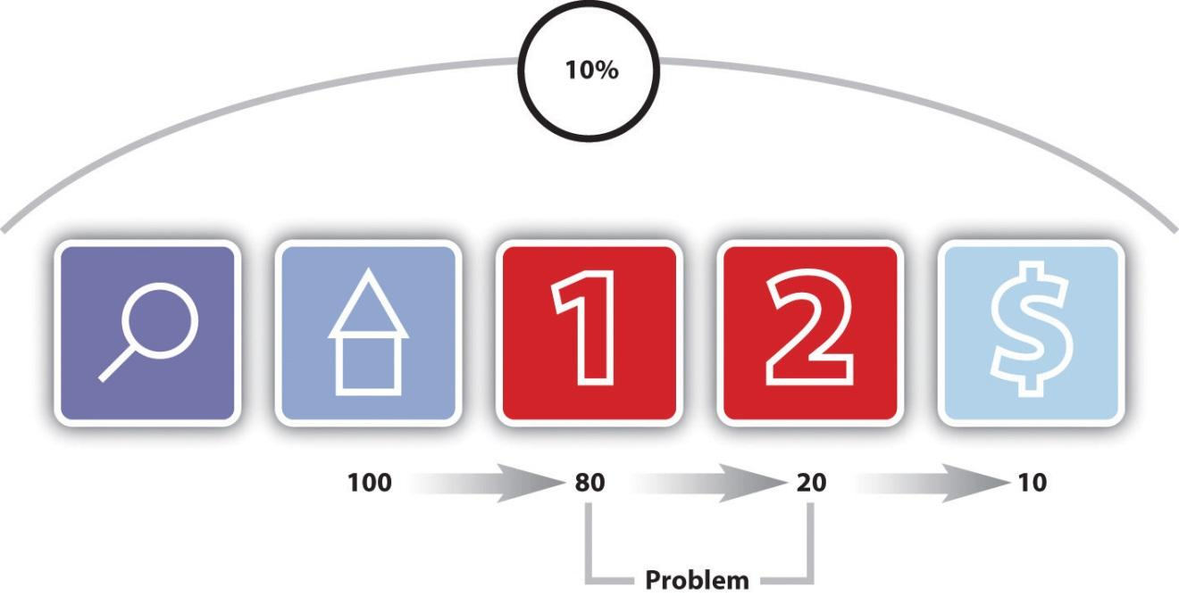
Figure 15.3 "Analyzing Each Step in the Conversion Process" shows how analyzing each event can show where the Web site is not meeting expectations.
After performing a search, one hundred visitors land on the home page of a Web site. From there, eighty visitors visit the first page toward the goal. This event has an 80 percent conversion rate. Twenty visitors take the next step. This event has a 25 percent conversion rate. Ten visitors convert into paying customers. This event has a 50 percent conversion rate. The conversion rate of all visitors who performed the search is 10 percent, but by breaking this up into events we can analyze and improve the conversion rate of each event.

Experience: Why Users Acted the Way They Did, and How That Can Be Influenced
Determining the factors that affect user experience involves testing to determine why users do what they do. Understanding why users behave in a certain way on your Web site will show you how that behavior can be influenced so as increase successful outcomes.
Testing can be performed in a number of ways:
- A/B split testing
- Multivariate testing
- Listening labs
- Single page heat maps

A/B Split Testing
A/B split testing measures one variable at a time to determine its effect on an outcome. Different versions are created for the variable you want to test. For example, consider the following tests:
- Two e-mail subject lines for the same e-mail to see which produces a superior open rate
- Different placements of the “buy now” on a product page to see which results in increased sales
- Different copy styles on PPC (pay-per-click) advertisements to see which gives a higher CTR (click-through rate)
In these cases, only one variable is tested at a time, and all other elements on the Web page, in the e-mail, or part of the PPC advertisement remain the same. You can test more than one version of the variable; it just means that you will need to test for longer.
Traffic is then randomly distributed to the different versions, and the outcomes are measured for each version of the variable. The results are then interpreted to see if there is a statistically significant difference between the variables. The version producing the best results can then be employed.
Remember studying statistics? It’s going to come in handy here. You don’t need to send huge amounts of traffic to a different version of a Web page to determine success. In fact, it can be risky to do so.

Multivariate Testing
Multivariate testing allows you to test many variables at once and still determine which version of each variable has a statistically significant effect on your outcomes. For Web sites, there are a number of vendors who will host pages that are being tested in this way remotely, if you do not have the technology to do this in-house.
Multivariate testing allows you to test, for example, the following:
- Subject lines and copy style for e-mails
- Color, font size, and image size for Web sites
The combinations are endless, and because of that, it is easy to get stuck analyzing every tiny detail. Successful testing relies on having clear objectives to begin with, and sufficient traffic to warrant such detail.

Listening Labs
A listening lab could also be called a watching lab, as this involves watching users interact with your site and listening to their comments. Professional listening labs can be hired, or as Steve Krug points out in his book Don’t Make Me Think! they can be set up fairly easily in a quiet part of an office. ^{[2]}
In a listening lab, a moderator asks users to perform tasks on a Web site and asks them to describe what they are thinking and doing. These exercises can provide important information that looking at data cannot.

Single-Page Heat Maps
Companies such as Crazy Egg (http://www.crazyegg.com) have software that can show you exactly where users click on a Web page, regardless of whether they are clicking on links or not.

Figure 15.4 A Heat Map on Crazy Egg
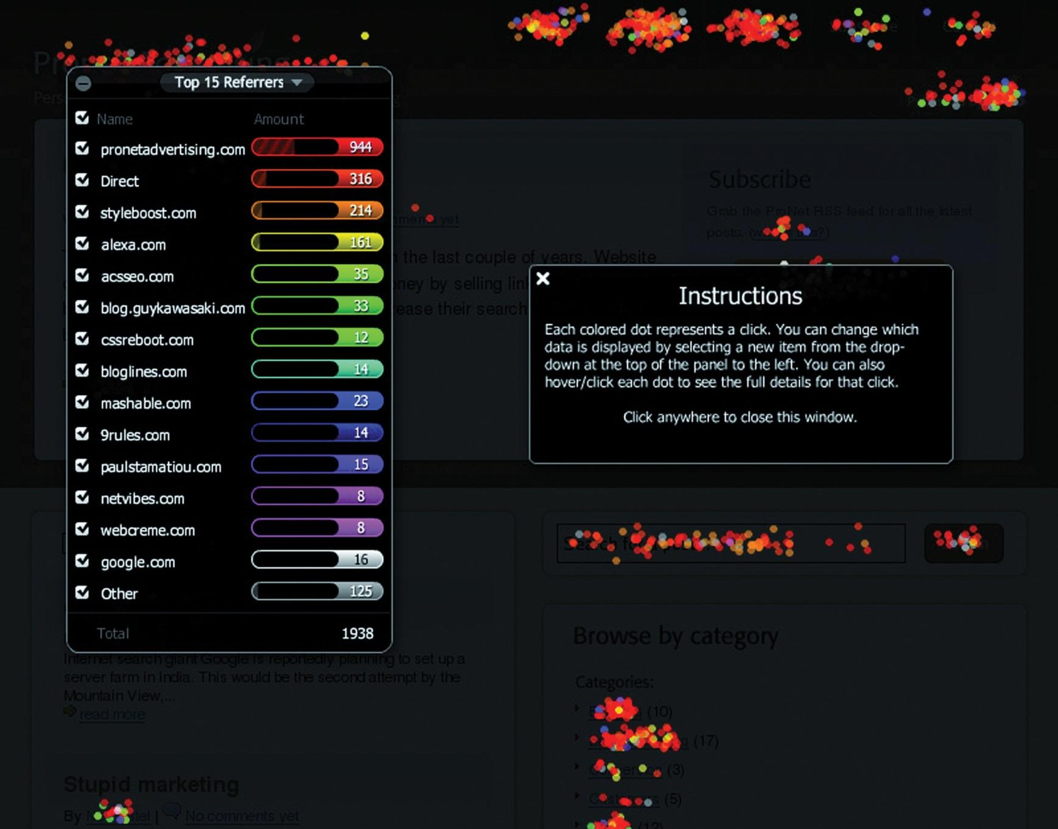
It produces information that helps you know what areas of a Web site are clickable but attract few or no clicks, and areas that are not clickable but have users attempting to click there. This can show you what visual clues on your Web page influence where your visitors click, and this can be used to optimize the click path of your visitors.
There are many factors that could be preventing your visitors from achieving specific end goals. From the tone of the copy to the color of the page, everything on your Web site may affect conversions. Possible factors are often so glaringly obvious that one tends to miss them or so small that they are dismissed as trivial. Changing one factor may result in other unforeseen consequences, and it is vital to ensure that we don’t jump to the wrong conclusions.
There are many techniques that can be used to improve conversion rates, depending on which area is being improved. A better landing page, for example, can reduce the drop-off between a PPC and adding a product to the shopping cart. And reducing that drop-off can go a long way to improving the cost per acquisition (CPA). Figure 15.5 shows how small changes in conversion rate can make a big difference to the CPA.
One of the most important aspects of conversion optimization is keeping visitors focused on their goals. To do this, it is important to maintain a highly visible and influential click path from the landing page to the goal or action page that is as short as possible. The more links and irrelevant distractions that are present on a site, the less likely visitors are to remain focused on achieving your desired objectives.
Figure 15.5
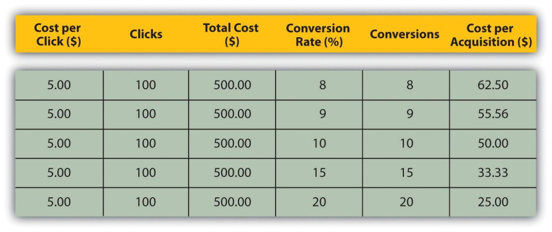
Find out if people are looking for something specifically and whether it can be tied to a source. Don’t take people to your home page by default if they’re looking for specific keywords and are clicking through on designated links or (more importantly) are coming through a PPC campaign. Again, keep them focused on the defined goal; rather, let them enter where they are most comfortable thereby keeping the path to conversion as short as possible.

Segmentation
Every visitor to a Web site is different, but there are some ways we can characterize groups of users and analyze metrics for each group. This is called segmentation. Some segments include the following:

Referral URL
Users who arrive at your site via search engines, those who type in the URL directly, and those who come from a link in an online newspaper article are all likely to behave differently. As well as conversion rates, click path and exit pages are important metrics to consider. Consider the page on which these visitors land to enter your Web site—can anything be done to improve their experience?

Landing Pages
Users who enter your Web site through different pages can behave very differently. What can you do to affect the page on which they are landing, or what elements of the landing page can be changed to influence outcomes?

Connection Speed, Operating System, and Browser
Consider the effects of technology on the behavior of your users. High bounce rate for low-bandwidth users, for example, could indicate that your site is taking too long to load. Visitors who use open-source technology might expect different things from your Web site to other visitors. Different browsers might show your Web site differently—how does this affect these visitors?

Geographical Location
Do users from different countries, provinces, or towns behave differently on your Web site? How can you optimize user experience for these different groups?

First-Time Visitors
How is the click path of a first-time visitor different from that of a returning visitor? What parts of the Web site are more important to first-time visitors?

Tools of the Trade
The very first thing you need when it comes to Web analytics is a Web analytics tool for gathering data. Some are free and some require a fee. You will need to determine which package best serves your needs. Bear in mind that it is possible to switch vendors with log-file analysis software without losing historical data, but it is not as easy to do so with page-tagging software.
The following are some leading providers:
- Google Analytics (page-tagging analysis).http://www.google.com/analytics
- Lyris HQ, formerly ClickTracks (log file and page tagging).http://www.lyris.com/solutions/lyris-hq/web-analytics
- AWStats (log-file analysis). http://awstats.sourceforge.net
- Webalizer (log-file analysis). http://www.mrunix.net/webalizer
When it comes to running split tests, if you don’t have the technical capacity to run these in-house, there are a number of third-party services that can host these for you. Google’s Web site Optimizer (http://www.google.com/websiteoptimizer) can help you do just that.
A basic split-test calculator is available at http://www.usereffect.com/split-test-calculator. Crazy Egg (http://www.crazyegg.com) is a strange-sounding name, but this tool can help you to see exactly where visitors are clicking on a Web page.

Pros and Cons
Tracking, analyzing, and optimizing are vital to the success of any marketing efforts, and even more so with online marketing efforts. eMarketing allows for easy and fast tracking and the ability to optimize frequently.
However, it can be easy to become fixated on figures instead of using them to optimize campaign growth. Generally, macro, or global, metrics should be looked at before starting to analyze micro elements of a Web site. Testing variables is vital to success. Results always need to be statistically analyzed, and marketers should let these numbers make the decisions. Never assume the outcome—wait for the numbers to inform you.

KEY TAKEAWAYS
- Data can be analyzed to infer user behavior and intent, outcomes achieved, and user experience. Testing to optimize user experience can demonstrate ways to influence user behavior so that more successful outcomes are achieved.
- Testing can be performed via the following:
  - Listening labs
  - A/B split testing
  - Multivariate testing
  - One-page analytics
- Segmenting the audience allows for analysis and optimizing for specific groups of users.

EXERCISE
- Why should changes be tested with a small number of Web visitors before being rolled out?

[1] Avinash Kaushik, Web Analytics: An Hour a Day (Hoboken, NJ: Wiley, 2007), 15–19.
[2] Steve Krug, Don’t Make Me Think! A Common Sense Approach to Web Usability, 2nd ed. (Berkeley, CA: New Riders, 2005).

15.5 Case Study: Firefox 3
Web sites with high volumes of traffic have the opportunity to test regularly and make sure that they are optimizing conversions. Online retailers such as Amazon.com make frequent small changes, hardly noticed by their visitors, to ensure that they are converting as many visitors into buyers as possible. Likewise, the high volume of traffic to Google’s home page allows it to test new features with a small percentage of visitors before rolling them out to all users.
Firefox is a free, open-source browser that is currently used by about 47 percent of the market, and it is gaining market share. When launching version 3 of the browser, Firefox 3, Firefox developer Mozilla (http://www.mozilla.org) aimed to enter the Guinness Book of Records for most software downloads in twenty-four hours starting June 17, 2008. The aim was 5 million downloads. Firefox 2.0 registered 1.6 million downloads on the first day it was made available on October 24, 2006.
Mozilla wanted visitors to the Web site to perform one action: download Firefox. With a publicized record attempt, it was necessary to make the process as smooth as possible. The landing page for Firefox 2 was already successful. FutureNow conversion analyst Josh Hay noted that “their Call to Action does so many things right. The non-standard shape stands out from the background of the page, and has been given a persuasive color that draws the eyes to it. They’ve even used it to reinforce their brand. Within the Call to Action, Firefox lists the benefit and tells the visitor exactly what he is getting.” ^{[1]}

Figure 15.6 Firefox 2 Download Available for Free fromhttp://www.mozilla.com/firefox
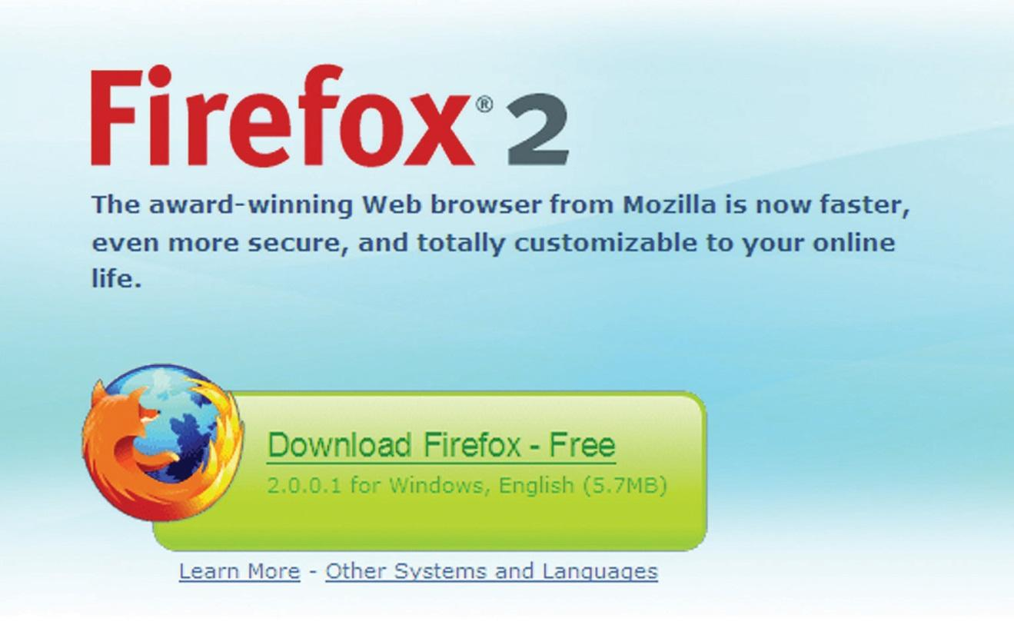
Figure 15.7 Firefox 3 Download Available for Free fromhttp://www.mozilla.com/firefox
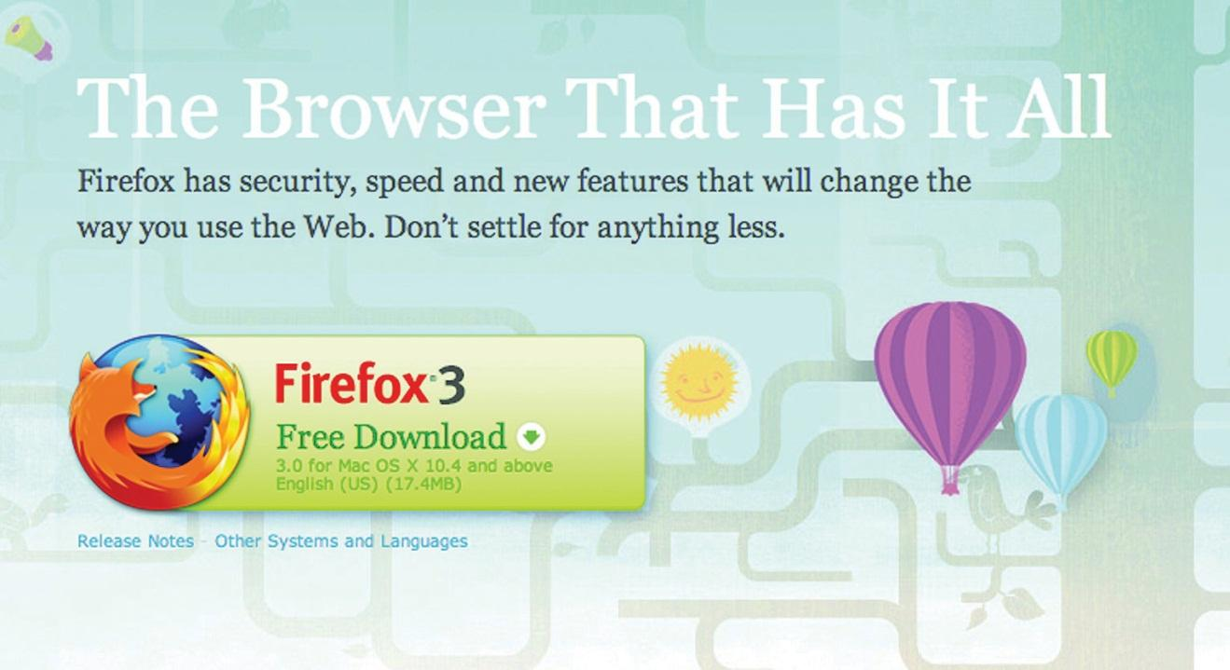
So, with something that works, what can be done to make it work better?
With the new download page, the download button is in the same basic design, but with a few nuanced changes.
First, the name and version of the browser has changed position on the page. It has moved from a large on-page heading and onto the actual download button. The text on the button has also changed, from “Download Firefox—Free” to “Free Download.” There is also a little image on the Firefox 3 download button that was not used on the Firefox 2 landing page—an arrow to indicate the download action. The information about the version of the browser has also been split over two lines in the Firefox 3 download button.
The download button and the placement of the Firefox logo (the fox around the globe) have had a subtle revision. The logo is now clearly integrated into the download button. On the Firefox 3 page, the hyperlinks are not underlined, emphasizing the single purpose of the download button.
Did it work? Mozilla records that there were over 8 million downloads of Firefox 3 in its first twenty-four hours of release—over 5,500 downloads a minute! Mozilla’s commitment to optimizing the all-important Firefox 3 landing page paid off.

CASE STUDY QUESTIONS
- Why do Web sites with high traffic volumes have the opportunity to test frequently?
- The text on the download button was changed, as was the layout of the text. What do you think the effect was of each change?
- What tests would you set up to decide how effective each change is? Describe how the tests would work.

[1] Josh Hay, “Large Red Buttons? Oh My!” FutureNow, February 15, 2007,http://www.grokdotcom.com/2007/02/15/large-red-buttons-oh-my (accessed June 20, 2010).

15.6 References
Jason Burby, Angie Brown, and the WAA Standards Committee, “Web Analytics Definitions—Version 4.0,” Web Analytics Association, August 16, 2007,http://www.webanalyticsassociation.org/resource/resmgr/PDF_standards/WebAnalyticsDefinitionsVol1.pdf (accessed March 3, 2008).
Robert Gorell, “Firefox 3: How to Convert Seven Million Visitors in a Day,” GrokDotCom, June 18, 2008,http://www.grokdotcom.com/2008/06/18/mozilla-firefox-3-download(accessed March 3, 2008).
“Help Yourself to a KPI!” GrokDotCom, June 1, 2004,http://www.grokdotcom.com/topics/helpyourselftoakpi.htm (accessed March 3, 2008).
Avinash Kaushik, “Are You Into Internal Site Search Analysis? You Should Be,” Occam’s Razor, June 26, 2006,http://www.kaushik.net/avinash/2006/06/are-you-into-internal-site-search-analysis-you -should-be.html (accessed March 3, 2008).
Avinash Kaushik, “Kick Butt with Internal Site Search Analytics,” Occam’s Razor, October 20, 2007, http://www.kaushik.net/avinash/2007/10/kick-butt-with-internal-site-search -analytics.html (accessed March 3, 2008).
Avinash Kaushik, “Trinity: A Mindset and Strategic Approach,” Occam’s Razor, August 10, 2006, http://www.kaushik.net/avinash/2006/08/trinity-a-mindset-strategic-approach.html (accessed March 3, 2008).

Chapter 16

Mobile Marketing

16.1 Introduction
The mobile phone is a small gadget that has had a huge impact on our day-to-day lives. It has already had a profound impact on the way we communicate and conduct ourselves daily. This continues to be felt as the mobile phone enables new ways to market and new markets in which to transact.
The Internet transformed our world in two fundamental ways: it has given anyone with access to the Internet the opportunity to interact easily with others (and with companies and brands), and through search, it has made information easily available. Content and information have become readily and freely available. Developed as a platform for academics to share information, the Web has a strong ethos of free content.
Mobile phones are a developing technology, which means that new and better features are being packed into ever smaller devices, adding to the interactivity and searchability of the Internet with several fundamental features native to the mobile phone and the way we use it.
While the Internet and the personal computer have had a profound impact on the world we transact in, it is the mobile phone that presents an exciting opportunity for even more of the world to access the benefits of these inventions.
Consider that there are 1.7 billion people worldwide with access to the Internet. Of those, 1.3 billion are active users of e-mail. With the world’s population at 6.7 billion, that’s almost a fifth of the population who can be reached by e-mail. That needs to be compared to 4.1 billion mobile phone subscribers—more than half of the world’s population. And of that 4.1 billion, 3 billion were active users of short message service (SMS) text messaging in 2007. ^{[1]}
Looking at figures like that, it’s obvious why so many organizations are investigating the mobile phone as a marketing platform.

[1] Tomi Ahonen, Tomi Ahonen Almanac 2010: The Mobile Telecoms Industry Annual Review, http://www.tomiahonen.com/ebook/almanac.html (accessed May 11, 2010); Mocom2020, “4.1 Billion Mobile Phone Subscribers Worldwide,” March 27, 2009,http://www.mocom2020.com/2009/03/41-billion-mobile-phone- subscribers-worldwide(accessed December 17, 2009).

16.2 Why the Mobile Phone?

LEARNING OBJECTIVE
- Understand how mobile marketing became an important eMarketing tool.
The mobile phone is a sophisticated device. Today’s phones can act as alarm clocks, cameras, video recorders, MP3 players, calendars, notebooks, and messaging devices, and they can even make voice calls. However, it is not the aforementioned plethora of features that makes the mobile phone such an attractive device. The following seven features are what turn mobile phones into something truly remarkable for marketers:
- The mobile phone is personal.
- The mobile phone is always carried.
- The mobile phone is always on.
- The mobile phone has a built-in payment system.
- The mobile phone is available at the point of creative inspiration.
- The mobile phone can provide accurate audience measurements.
- The mobile phone captures the social context of media consumption. ^{[1]}
If you consider your relationship with your mobile phone, these features should make sense. However, a few facts and figures never hurt anyone, and the following elaborates more fully on the aforementioned features.

The Mobile Phone Is Personal
A 2006 survey found that 63 percent of respondents would not share their phones with anyone (90 percent of those surveyed in Japan would not share their phones). ^{[2]} While laptops do present a personal connection to the Internet, they are not as personal a device as the mobile phone.
The implication for marketers is that respect for privacy and permission is exceptionally important in all aspects of marketing, and particularly so when it comes to mobile phones.

The Mobile Phone Is Always Carried
What do you take with you when you leave your house? Wallet, keys, and mobile phone. What do you keep always near you when you are in your house? Mobile phone. According to 2007 research by Morgan Stanley, 91 percent of mobile phone owners keep their phone within three feet, twenty-four hours a day. ^{[3]} People have their phones with them at all times of the day, even in the bathroom.
The implication for marketers is that messages sent to recipients can be read and acted on immediately. Unlike, for example, e-mail, which requires that the recipient be in front of his or her computer and connected to the Internet, messages sent to mobile phones will most likely be accessed within minutes of being received.

The Mobile Phone Is Always On
In order to fulfill its primary function—as a telephone—the mobile phone is always on. Messages and services can be sent and acted on at all times of the day.
As with the previous feature of the phone, the fact that the phone is always on has implications for marketers; it changes the services and messages that can be developed for the phone. It also means that marketers need to be perhaps even more sensitive with their marketing communications. Not many people would appreciate a short message service (SMS) at four in the morning informing them of a special offer.

The Mobile Phone Has a Built-In Payment System
This is perhaps the key feature of the mobile phone and one reason why content for mobile phones in many areas generates as much or more revenue than content for the Internet. Every mobile phone has a built-in payment mechanism—the subscriber identity module (SIM) card. Billing is easily handled through the user’s mobile network. Not only do mobile phones have this built-in payment mechanism, but also paying for content and downloads has been built into the way that consumers use their phones. There is less of an expectation that goods and services will be free, although as the mobile app market expands, this is changing.
There are also a number of services that turn the mobile into a virtual wallet or bank card, bringing banking and payment services to people all around the world.
iChannel, a mobile news ticker feed in Japan, generates US$192 million per year in subscriptions for its US$2-a-month service. It has more paying subscribers on this single service that all online newspapers in the world combined. ^{[4]}Similar cases can be made for games, music, and other mobile content.
The implication for marketers is that consumers are willing to pay for services and content on their mobile phone. Advertising is not the only way to generate revenue for content.

The Mobile Phone Is Available at the Point of Creative Inspiration
As the mobile phone is always carried and always on, it is always available as a creative tool. Phones today feature a number of tools that let users act on creative impulse, from taking photos and videos, to becoming a scribbling pad on which to jot down ideas.
The implication for marketers is that these features can be used to encourage interactivity with campaigns created for mobile phones. It presents the mobile phone as a useful tool in viral campaigns based on consumer-generated content.

Note
Accurate measurement is not available in all countries due to network guidelines.

The Mobile Phone Can Provide Accurate Audience Measurements
While the Internet is vastly superior to other media in its ability to track and measure advertising and marketing campaigns, it is eclipsed by the mobile phone. Every transaction made on a mobile phone can be uniquely tracked to that mobile phone number, whether the transaction is a voice call, an SMS message, or accessing the Internet.
The implication for marketers is that aggregated data provide extensive profiling and segmenting opportunities for targeting the right audience. Campaigns can also be accurately measured and tracked for ROI (return on investment). Bear in mind as well that this accurate measurement means that mobile phone users have far less anonymity than Internet users. Even though at least 50 percent of mobile phones worldwide are on a prepaid or pay-as-you-go type of contract (which means that the network operators do not have the phone user’s name and demographic details to go with the mobile number), each transaction made by the phone user can still be measured.
The Mobile Marketing Association has an in-depth glossary of mobile marketing terminology available as a free download from its Web site,http://www.mmaglobal.com.

The Mobile Phone Captures the Social Context of Media Consumption
This represents emerging thinking on the benefits of the mobile phone. Because of the nature of the mobile phone to be able to accurately track transactions to any particular phone number (user), it can track transactions between mobile numbers (between users). This means that sophisticated data mining can identify patterns that indicate information about and preferences of mobile phone users. Not only can alpha users be identified, but they may also be identified within their social context.
The implication for marketers is that this information will represent rich data that can be used to both create and market products, content, and services online.

Limitations of the Mobile Phone
The mobile phone is a feature-packed gadget used all around the world by almost half the world’s population. However, as much as the mobile phone has a number of unique benefits, it does come with its own challenges.
The mobile phone is small. This means that it has a small screen and a small keypad. While some phones have a full QWERTY keypad, many have the standard numeric keypad. When it comes to the mobile Web, consider that phones do not have a mouse. There are a few models that have touch screens, but for the most part, navigation of the mobile Web is through the keypad or scroll buttons on the phone.
Mobile phones are also even less standard than PCs. Not only do phone models present a myriad of screen sizes, there are also several operating systems and browsers that are used by mobile phones.
Use of more advanced features of phones can require an extensive education process. While mobile phones have a host of features, these devices are for the most part underused.

KEY TAKEAWAYS
- Mobile phones are sophisticated devices that serve as everything from alarm clocks to messaging devices.
- There are seven reasons that turn mobile phones into great eMarketing tools:
  - The mobile phone is personal.
  - The mobile phone is always carried.
  - The mobile phone is always on.
  - The mobile phone has a built-in payment system.
  - The mobile phone is available at the point of creative inspiration.
  - The mobile phone presents accurate audience measurement.
  - The mobile phone captures the social context of media consumption.
- As with many eMarketing channels, there are limitations.

EXERCISES
- Based on the limitations listed in this section, can you think of a major brand that would have difficulty using mobile marketing as an eMarketing channel? List the reasons why.
- Using your favorite search engine, see if you can find the mobile marketing association in your country and the code of conduct for marketers. Do you think this can be better communicated to consumers?
- Privacy and permission are important factors in eMarketing and mobile marketing. How can these be communicated when using the mobile phone as a marketing channel?

[1] Tomi Ahonen, “Deeper Insights into the 7th Mass Media Channel, Mobile Is to the Internet, What TV Is to Radio,” Communities Dominate Brands, May 2, 2008,http://www.communities-dominate.blogs.com/brands/2008/05/deeper-insights.html(accessed December 15, 2008).
[2] “Wireless Works,” BBDO and Proximity, April 2006.
[3] Tomi Ahonen, “Deeper Insights into the 7th Mass Media Channel, Mobile Is to the Internet, What TV Is to Radio,” Communities Dominate Brands, May 2, 2008,http://www.communities-dominate.blogs.com/brands/2008/05/deeper-insights.html(accessed December 15, 2008).
[4] Alan Moore, “The Glittering Allure of the Mobile Society,” white paper, SMLXL, November 2008, http://andrewgrill.com/download/AlanMoore_Allure_Mobile _Society.pdf (accessed December 3, 2008).

16.3 Mobile Phones: More than Phone Calls

LEARNING OBJECTIVE
- Learn about the three categories of mobile phones and how they fit into the eMarketing landscape.
There are three categories of mobile phones.
Basic phones can make voice calls, send and receive SMS (short message service) messages and make use of USSD (unstructured supplementary services data).
Feature phones offer features additional to a basic phone, including cameras and increased storage, as well as the ability to access the Internet. Feature phones usually have a standard numeric keypad.

Note
QWERTY refers to a full keypad like the keyboard of a computer.
Smartphones offer advanced capabilities and features over feature phones, notably allowing users to add applications to their phones. These phones run a full-featured operating system; most have 3G (third-generation) as well as Wi-Fi (wireless-fidelity) capabilities and generally have a QWERTY keypad.
Note that there is not yet an industry-standard definition of a smartphone, and many feature phones are now being developed with technology similar to smartphones. Smartphones tend to have bigger screens than feature phones.

Figure 16.1 Features of a Mobile Phone
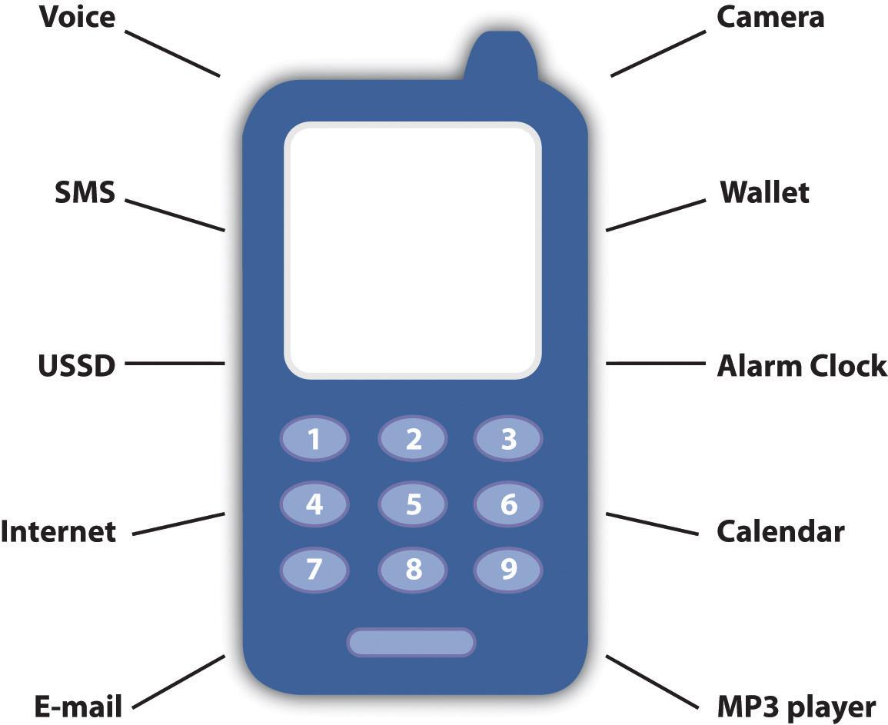

How to Reach Your Audience
Just as the Web is used in a myriad of ways as a marketing, advertising, and distribution channel, so is the mobile phone. There are a number of technologies available to reach a mobile audience. Some of the most prevalent are detailed further.
Mobile phones started as literally phones that are mobile (thank you again, Captain Obvious). Before we look at mobile phones as devices used to access the World Wide Web, to take photographs, or to make payments, we need to address their primary function: communication. The primary use of a mobile phone is to enable communication, either through voice calls or through messages. Messaging services on a mobile phone use either short message service (SMS) to send text messages ormultimedia message service (MMS) to send graphics, audio, photos, and video as well as text. Messages can, of course, also be sent via e-mail depending on the phone’s features.

Note
Do u find it tricky to transl8 txt msgs? http://www.transl8it.com translates from text speak into everyday English and back again.

KEY TAKEAWAYS
- There are three categories of mobile phones: basic phones, feature phones, and smartphones.
- Smartphones are equipped with a QWERTY keypad.
- The mobile phone is primarily a communication device that uses voice, SMS, or MMS.

EXERCISES
- Consider the three categories of mobile phone. Envision the advertising opportunities available on each.
- What types of mobile phones have you ever used? Have you been marketed to before on these phone(s)? If so, how?

16.4 Short Message Service (SMS)

LEARNING OBJECTIVES
- Understand short message service (SMS) and how it works.
- Learn how SMS can be used in eMarketing.
Short message service (SMS) supports messages of about 160 characters in length, though it is possible to string several messages together to send longer messages. Messages can be sent from one phone to another, or from a PC to a phone and vice versa.
SMS also supports a service known as common short codes (CSCs). CSCs are phone numbers (short ones, as the name implies) to which users can send a text message from a mobile phone, usually to get something in return. CSCs can be used to sign up for services, to enter competitions, or to indicate permission (or to end permission) to receive marketing messages. Messages sent to CSCs can also be used to make a payment or a donation, with a set amount being deducted from a user’s prepaid airtime or monthly airtime bill.

Mini Case Study: CSC for Short-Term Insurance
Metropolitan Life, a South African insurance company, launched a new service called Cover2Go in 2007. Cover2Go is aimed at those on lower incomes in South Africa and has made innovative use of mobile phone technology in order to reach its target market. Cover2Go insurance can be purchased by SMS; a single transaction can purchase instant life insurance for six days.
All a customer needs to do to purchase coverage is to SMS their name and identity number to a premium-rate CSC. The system, powered by Clickatell, replies with a confirmation and policy number, requests the name of a beneficiary, and reminds the policyholder to inform an associate about the life insurance. All this costs the customer only about $1, which is automatically deducted from the phone’s airtime and gives him six days’ worth of coverage.
Cover2Go’s innovative use of mobile phone technology makes insurance incredibly accessible to this market. The use of SMS technology ensures that the insurance is easy to purchase, and deducting the cost of the coverage from the phone’s airtime makes it easy to pay for the insurance.
You can access the Cover2Go and Clickatell Web sites at http://www.cover2go.co.za and http://www.clickatell.com, respectively.

SMS and Marketing
With twice as many SMS users worldwide as e-mail, SMS should be a no-brainer for marketers. However, mobile phone users have proved reluctant to hand over their phone number for marketing messages, perhaps fearing a similar deluge of spam for which e-mail has such a poor reputation.
This is changing to some extent, with the prevalence of CSCs being used in marketing and advertising campaigns. As consumers are so comfortable with using text messages for their communication, no extensive education process is required to have consumers access marketing campaigns based on CSCs.
CSCs can be used to receive messages from consumers and to send messages to consumers. CSCs can be either dedicated (used by one company and presumably for one campaign) or shared. When CSCs are shared, keywords in the text message are used to separate the messages. There are two standard keywords that should always elicit a standard response:
- STOP. Unsubscribe the sender’s number from the service.
- HELP. A support request from the sender’s number.

Note
Another standard number is the international emergency number, which is in use in most countries in the world—112.

Sending Messages
Once prospects have given you permission to communicate with them and their mobile number, timely messages can be sent to their mobile phone. These can be promotional or sales messages, such as special offers in stores or information about upcoming events. On many phones, prospects need to at least open an SMS message in order to delete it. As well as this, mobile phones are generally kept with a prospect at all times, meaning that messages are more likely to be read very soon after they have been broadcast.
There are several ways that SMS messages can be utilized to complement an existing marketing strategy.

Customer Relationship Management
SMS updates can be an exceptionally useful tool for customer relationship management (CRM). In the travel industry, hotel and airplane reservations can be sent by mobile phone, with updates being sent close to the time of travel. These short messages can include directions or details of a flight’s status.
When it comes to insurance claims or order processing, SMS updates as to the progress of a claim or order can reduce call center volume and go a long way to ensuring that a client feels valued and cared for.

Promotions
SMS messages present a way to send timely sales promotion information to a large database for a relatively low cost. These can be targeted to a particular time of day when prospects are most likely to be out shopping. SMS messages can also be used when promoting events.
Despite their pithy nature—these messages have a limit of 160 characters—they can carry a strong call to action.

Receiving Messages
CSCs are often used to receive messages from prospects or customers. They provide a fast, instant, and trackable means for the public to enter competitions, voice opinions, or make requests. Even better for a company, the costs can often be passed on to the consumer, meaning that it can be a cost-effective way to receive marketing messages.
As CSCs can be shared, keywords can be used to separate communications and campaigns. For example, a user might be asked to text the word “LUXURY” to a number in order to enter a competition.

Entering Competitions
Requiring less data-entry time than entries by postcard, SMS messages to a CSC are a hassle-free way to run competitions. Entries can be almost immediately entered into a database, with fast automatic responses to ensure that the consumer knows her entry has been received. In addition, costs can be passed on to the consumer by charging entry SMS messages at premium rates.

Note
Network and other charges mean charities do not receive the full donation.

Texting to Donate
A concept that is being taken up by the fund-raising community, text messages can be sent by donors to donate a fixed amount to a campaign. The fixed amount is deducted from the user’s airtime or added to their monthly bill.

Texting to Participate
Text messages provide an almost instantaneous way to elicit response from an audience, whether it be to a radio program, television show, newspaper or magazine advertising, or billboard. Some newspapers allow readers to send SMS messages instead of lengthy letters to the editor.

Combining Sending and Receiving SMS
Once users have indicated their interest by sending a text message, a company can then send messages back to them. In the United Kingdom, the mobile phone network Orange ran a successful campaign around movies. All Orange customers could go the movies for half price on a Wednesday. All they had to do was text the word “MOVIE” to a particular number, and in return they would receive a unique code with which to claim their discounted tickets.
In return, Orange then sent the list of prospects who requested discounts information about the movies being shown at their local cinema. How did Orange know which was the local cinema? Simple: all it had to do was match the unique code to the number it was sent to and the cinema where it was used. ^{[1]}

KEY TAKEAWAYS
- SMS (short message service) can be sent from one phone to another, or from a PC to a phone and vice versa.
- Common short codes (CSCs) are short phone numbers to which users can send a text message from a mobile phone, usually to get something in return.
- Users have proved to be reluctant to turn over their phone number for marketing messages.
- Once users have provided permission to communicate with them and their mobile number, timely messages may be sent to their mobile phones.
- There are several ways that SMS messages can be utilized to complement an existing marketing strategy:
  - CRM (customer relationship management)
  - Promotions
  - Receiving messages
  - Entering competitions
  - Texting to donate
  - Texting to participate
  - Combining the sending and receiving, where users text to opt in for something, and the marketer sends them something in return

EXERCISE
- It can be considered that SMS (short message service) to the mobile phone is what e-mail is to the Internet. In what ways is this true, and how can this be used by marketers?

[1] David Harper, “Unfolding a Decade in Mobile Marketing,” Flytxt, July 2009,http://www.flytxt.com/Newsletter/unfolding-a-decade-in-mobile-marketing.html(accessed June 20, 2010).

16.5 Multimedia Message Service

LEARNING OBJECTIVES
- Learn what MMS (multimedia message service) is and understand its role in eMarketing.
- Learn what USSD (unstructured supplementary services data) is and understand its role in eMarketing.
Multimedia message service (MMS) messages are messages that contain graphics, audio, video, or images as well as text. These messages allow for richer information to be sent to prospects, but the costs are considerably higher. They use wireless application protocol (WAP) to download rich content onto mobile phones.
MMS messages are particularly useful in viral campaigns, whether encouraging participants to use their phones to create content (photographic, audio, or video) or encouraging users to pass on content.
Because there is no standard screen size across all mobile devices, MMS messages may display differently on different phone models.

Bluetooth and Infrared
Most modern mobile phones present an array of means for connecting. As well as using the cellular network, many phones have 3G (third-generation) and Wi-Fi (wireless-fidelity) capabilities, and the ability to connect via Bluetooth or infrared.
If a user sets his Bluetooth enabled mobile phone to “discoverable,” Bluetooth devices within range of the phone can request to connect to the phone and exchange messages and data. This can be used to send location-specific marketing messages, such as discount codes in a shopping mall.

Note
Smartphones are susceptible to receiving viruses via Bluetooth, so this is not necessarily the ideal channel to reach smartphone users.
Outdoor display advertising can be fitted to send Bluetooth messages to people within range of the advertising. The messages can contain further information to offer a richer, longer lasting experience. Note that these messages are often unexpected, so care must be taken not to be intrusive. There should be marketing collateral easily available and accessible that describes what the campaign is about.

USSD (Unstructured Supplementary Services Data)
USSD (unstructured supplementary services data) is an alternative messaging system to SMS (short message service) and is available on most GSM (Global System for Mobile Communications) networks. Unlike SMS, USSD is a protocol that allows for a query-and-response type of action between the customer and a service center, where these transactions can be seen to be similar to a session on a Web site. USSD services are usually initiated by the user who enters a code on his phone and then sends that as a request to the network. The code differs from the number an SMS is sent to because it includes the symbols # and *. For example, *100# can be used to check the balance of a prepaid service on some networks. These services are often used by networks to provide a service to a customer, such as requesting balance information, adding credit to a prepaid contract, or passing on credit to another mobile phone user. A popular service is a “call back” functionality, where a mobile phone user sends a request by USSD for another user to phone him. The requested number receives an SMS informing her of the request. Often, this SMS message also includes an advertising message.
A USSD query often initiates a session where the response from the service includes a simple text menu with further options or a response with instructions for the user. Users need to respond within a limited time frame, usually thirty seconds but up to two minutes, in order to maintain the session. If the session is not maintained, the user will need to initiate the service again. Users can select menu options by returning a message with the number of the appropriate menu selection. This continues until the appropriate content has been displayed. It is a rudimentary navigation, but with far faster response times and lower costs when compared to SMS or to mobile browsing.

USSD and Marketing
USSD is being used as a payment application, turning the mobile phone into a virtual wallet.
USSD is exceptionally useful as self-service customer service and is attractive to customers when it is offered for free. Advertising can easily be displayed in the messages returned when using this service.
Voting, such as for a reality television program, and entering of competitions can all be handled through USSD. USSD services allow greater flexibility than SMS services as they allow a query-and-response type of interaction as opposed to a single message to perform these tasks. This allows the marketer to request additional information from consumers using these services.
USSD can be used to provide information to, and collect information from, customers and potential customers. However, from a marketing and advertising perspective, its adoption has not been as great as that of SMS. While USSD services are more cost effective than SMS services and can allow for more detailed data to be collected, SMS services are often preferred by the customer. SMS common short codes (CSCs) are easier to remember than USSD codes, and the concept of sending a text message is more familiar to the customer.

KEY TAKEAWAYS
- MSS (multimedia message service) messages are messages that contain graphics, audio, video, or images as well as text.
- The costs are considerably higher for MMS, but in return for richer content.
- MMS message are useful in viral campaigns.
- Because there is no standard for screens on mobile devices, MMS messages may display differently.
- Many MMS phones have the ability to connect via Bluetooth or infrared.
- USSD (unstructured supplementary services data) is an alternative messaging system to SMS (short message service).
- USSD is more rudimentary, but has far faster response times and lower costs when compared to SMS or to mobile browsing.
- USSD is being used as a virtual wallet.
- USSD can be used for things like voting on reality television shows and entering competitions.
- USSD can be used for information collection.
- USSD services are more cost effective, but consumers prefer SMS because the concept is easier for the consumer to remember, and the CSCs (common short codes) are, too.

EXERCISES
- Can you think of an example of when a marketer may want to use USSD (unstructured supplementary services data) versus SMS (short message service) or MMS (multimedia message service)?
- Think of an example of when it would be better to use MMS over SMS for a brand. Give an example of when it would be a good idea to use SMS over MMS.

16.6 Mobile Web

LEARNING OBJECTIVES
- Understand how the Web works on mobile devices.
- Understand the role that the mobile Web plays in eMarketing.
As much as Web sites need to cater to a number of browsers, they now need to cater to a number of devices, as more and more people are using their mobile phones, PDAs (personal digital assistants), and other mobile devices to connect to the Internet. However, visits from mobile devices are likely to be quite different from the visits from PCs. Visits from mobile phone users are likely to be more purpose driven or task specific, as opposed to leisurely browsing from PCs.
Just as with PCs, mobile phones can have different operating systems and different browsers, both affecting the way that Web sites and Web pages are viewed and used. In addition to this, Web pages are viewed on far smaller (and nonstandard) screens, and navigation is controlled through a keyboard or limited scrolling device. There are also a number of different ways that mobile phones and devices connect to the Internet. In particular, mobile phones can use the GSM (Global System for Mobile Communications) network—where access is via GPRS (General Packet Radio Service),EDGE (Enhanced Data Rates of GSM Evolution), or 3G (third generation), depending on availability—or Wi-Fi-enabled devices can connect to wireless networks.
WAP stands for wireless application protocol and is a technology platform aimed at making Web sites accessible to mobile phones, despite the small screens and keypad limitations. WAP is essentially a wireless data connection and browser that can read a pared-down version of HTML (hypertext markup language). If a phone has only WAP access, it can only access Web sites that have been developed for this type of access.
More sophisticated phones and devices, and increasingly almost all phones sold are falling into this category, can use HTML browsers that have been specifically designed for mobile phones. These are pared-down versions of browsers that run on PCs or notebooks and have been specifically designed to take into account the limitations of mobile devices. In particular, browsers need to accommodate both the low bandwidth and the low memory capacity of mobile devices. Mobile browsers also need to cater to the navigation limitations of mobile devices as well as the fact that navigation is not standard across the various models of phones.

Note
Chapter 13 "Web Site Development and Design" has more information on using a CSS (cascading style sheet) and W3C (World Wide Web Consortium) standards when building Web sites. If you are commissioning an agency to build a Web site for you, and mobile technology is important, ask to see what the Web site will look like without presentation markup or on a mobile phone.
When it comes to Web sites and mobile phones, there are three options for Webmasters:
- Do nothing and hope that the Web experience is not too painful for mobile visitors.
- Make sure that your Web site is built using a W3C (World Wide Web Consortium) compliant CSS (cascading style sheet) so that it can be more easily navigated by mobile visitors.
- Build a separate version of your Web site tailored to mobile visitors.
For certain kinds of Web sites, there are “quick fixes” that allow a mobile version of the Web site to be created fairly easily. For example,http://mobilepress.co.za from Younique allows for Web sites and blogs based on the WordPress platform to be made mobile browser friendly. A quick search on Google will also give instructions on how to make small changes to your code in order to create a mobile friendly version of a Web site.

Tailoring Web Sites for Mobile Access
Some Web sites are more likely to be accessed from mobile phones than others, and savvy Webmasters can make sure that visitors have an excellent experience by building mobile versions.
As with all good Web design, the first step is in understanding users’ needs. When accessing a Web site from a mobile phone, a user is generally very task driven, time sensitive, and also likely to be location aware.
Task driven means that the user has a very specific purpose for visiting a Web site, and the Web site needs to help the user to achieve his objective with minimum fuss. For example, a user might want go to a Web site to check the score of a football game.
Time sensitive means that the user is even less likely to be able to spend time hunting for a solution to her problem; instead, the user expects to achieve tasks quickly. For example, a user en route to the airport may want to check to see if her flight is on time.
Location aware means that the location of the user often plays a large role in determining her objectives. For example, a user might be looking for restaurant suggestions in a town she is vacationing in.
These need to be factored in when creating Web sites for mobile users. Mobile Web sites need to be easy to navigate, should not contain more information than they need to, and should have services tailored to a user’s location.
Here are some tips when it comes to designing or optimizing Web sites for mobile users:
- Keep it simple. Flash is, for now, still only a dream on most phones. Animated graphics interchangeable format (GIF) images are probably your best bet if you want movement, but make sure the main message is contained in the first frame, as this at least will be displayed.
- Stay away from tables. Most devices will ignore tables, and content will get completely scrambled. Use lists where possible.
- Use enough links. Have sufficient links at the top and bottom of each page to easily navigate to other pages on the site, and don’t try to cram too much content onto a page. Unless you have a touch-screen device, scrolling using the keypad is never much fun.
- Keep it portrait oriented. As most devices are still only able to display content in portrait mode, it is important to keep horizontal scrolling down to a minimum—avoid it completely if possible. Some browsers may resize content to fit the width of the screen, so keep this in mind—it might distort the graphical impact. Depending on requirements, aligning content to the left or center of the screen works quite well.
- Keep images as small as possible. Most graphical editing tools have a “save for Web or devices” option—use this when possible.
- Avoid transparency. Hover effects on anchor tags are not supported for the most part and making use of the “background-image” directive is bound to give problems on a number of devices.
- Use JavaScript and Ajax sparingly. Even though a couple of WAP browsers have been “supporting” JavaScript for a while now, it is still advised to use it sparingly, if at all.

One Web
“One Web” refers to ensuring, as far as possible, that the same information and content is available to Web users, regardless of the device they are using to access the Web. So while Web sites should be optimized for presentation on various devices, proponents of “one Web” would argue that the actual content should not be different.
The W3C (World Wide Web Consortium) publishes guidelines for mobile Web standards as well as for regular Web standards. These can be accessed at http://www.w3.org/TR/mobile-bp.

Getting Users to the Mobile Web
Creating content and Web sites is one thing, but how do you actually get users to access them via their mobile phone?

WAP Push
WAP push messages are messages sent to a mobile phone that direct the user toward WAP content. While they may appear similar to SMS messages, these are a different type of message. The WAP push message contains a link that a user can follow to access WAP content.
Sending rich messages to mobile phone users can be tricky. Until there is increased general awareness of the types of messages that can be sent to and from mobile phones, MMS (multimedia message service) messages can represent a problematic push-marketing medium. However, a WAP push message can direct users to rich content, enabling a sense of user control over content viewed.
Semacode is the name of the company that developed software for reading two-dimensional (2D) bar codes. It has an application that integrates Semacode tags with Facebook. Check it out at http:// www.semacode.com.
Two-dimensional (2D) bar codes are similar to one-dimensional bar codes in that they can be scanned to access the information encoded, but 2D codes can contain a lot more information. In addition to this, with appropriate software, these codes can be photographed with a mobile phone, which then unpacks the information contained within the bar code.
Figure 16.2 The Two-Dimensional (2D) Bar Code forhttp://www.quirk.biz
Does that sound a little complicated? Essentially, the software that can be installed on the mobile phone turns the phone into a scanner. Information such as URLs (uniform resource locators), telephone numbers, or business names can be encoded in the bar code. When the code is scanned, the information is displayed on the phone. If this is a URL, for instance, the user can then visit that Web site without having to enter any additional information into the phone.
There are two encoding types in use: Datamatix (DM) bar codes or Quick Response (QR) bar codes. These can be open source or proprietary. The type of bar code affects the amount of information that may be stored in the bar code, while the standards used can affect the number of bar code readers that can successfully read the bar code.
2D bar codes are often also referred to as tags. These tags can be used in offline advertising and marketing campaigns to push consumers toward specific Web sites. Instead of having to remember and type in a URL, a user simply has to photograph the tag in order to visit the Web site.
Tags can be printed on billboards, on magazine pages, on t-shirts—in fact, on just about anything. The image here is the tag for http://www.quirk.biz. Download the software to your mobile phone, photograph it, and visit the Quirk Web site on your mobile!

Mobile URLs
Most companies now think nothing of including their Web site address on marketing collateral. However, in many cases, when this collateral is being viewed by potential customers, it is the mobile phone that is closer to hand than the PC. Remember, the phone is always carried and always on. Some organizations are cognizant of this and are now printing their mobile Web site URLs instead of or as well as their standard Web site address.

Mobile Search
Internet search has become an integral part of our lives and is an important part of the mobile marketing mix. However, as with users’ intentions when accessing the mobile Internet, the needs of the user are different when compared to search on a PC.
The limitations of the device, the mobile phone, and the needs of the user are what drive the differences for mobile search.
First, with smaller keypads, whether QWERTY, touch screen, or numeric, users are likely to enter shorter queries into search engines on mobile phones. Search engine results need to be displayed on a smaller screen and need to be easy to navigate.
Users are more task driven when using mobile phones to search, seeking concise information that answers their queries as opposed to using search as part of a discovery process. Just as with search on a PC, there are two types of search listings for mobile phones: natural or organic results and paid-for results.

Natural Search
Optimizing Web content for mobile search involves optimizing content for mobile use in general. Navigation needs to be simple to use without a mouse, and Web site owners should consider ensuring that content most relevant to the mobile user is readily available.

Paid Search
Mobile search engines are seeking to create revenue from their services by offering paid listings in a similar fashion to traditional search. As technology develops, search providers are able to offer more sophisticated targeting options to advertisers. Geotargeting can be incredibly specific, allowing businesses to offer targeted advertising when a customer is located nearby.

Applications
It’s not only Web sites that can be designed specifically for mobile devices. Applications and widgets can be created that are specifically for the mobile phone. For example, Google’s popular e-mail service Gmail can be accessed via the mobile Web, or Gmail users can download a Java application to their phone that gives them access to their Gmail account. The application presents a user experience that has been tailored to the mobile phone and can even be tailored to a particular handset.
Similarly, Apple’s popular iPhone uses apps, allowing iPhone users to access all manner of Web applications.
As of 2008, apps represent a marketing opportunity for products and companies reaching out to a tech-savvy, affluent community. Widgets can be products on their own, such as the Baby Monitor for the iPhone, or they can be used to market other products, such as a widget that provides easy access to the blog BoingBoing.net.

MXit
MXit (http://www.mxit.com), which is pronounced “mix it,” is a free instant-messaging software application that was developed in South Africa for use on mobile phones and PCs. It runs on GPRS and 3G mobile phones that have Java support, as well on PCs using the Adobe Flash player. It allows users to send and receive text and multimedia messages to and from other users who are connected to the Internet, whether it be between mobile phones, PCs, or between the two. The messages are sent and received via the Internet instead of using SMS technology and also allow users to exchange messages with other IM programs such as MSN Messenger. Although the networks do charge for data costs, this is usually far cheaper than SMS costs, which has driven the large adoption of this service, fourteen million registered users, particularly in the youth market.
As well as being a chat platform, MXit allows its users to customize their profiles by downloading “skinz” (customized profiles, with specific fonts, images, colors, etc.), wallpapers, and emoticards and has its own e-commerce platform (supported by its own currency, Moola) and a music platform.

MXit for Marketers
There are many similarities between Web-based social networks and MXit when it comes to opportunities for marketers. MXit provides social profiling, so that advertising can be served to particular demographics. MXit also allows organizations to set up profiles that users can connect with and chat with. These can be celebrities who want to keep in touch with brands, or cinema chains such as South Africa’s Ster Kinekor, which distribute movie information via the MXit channel.

Augmented Reality
Augmented reality (AR) is a variation of virtual reality. Rather than immersing the user in a virtual world, however, AR takes computer graphics and superimposes them into “reality”—the physical space around the person operating an AR device. These graphics can be 3D images or simply information tags about a location.
While AR devices are relatively new, they do have a history outside their use in mobile phones. They can and have been used in medicine (superimposing surgical information onto a patient’s body), in architecture (superimposing virtual buildings into a space where they are yet to be built), or for cross-continental collaboration where participants can’t be in the same room.
Ronald Azuma defines AR as involving three characteristics:
- It combines the real and virtual.
- It is interactive in real time.
- It is registered in 3D. ^{[1]}
Technical components generally necessary for AR include a CPU (central processing unit), a camera, and accelerometer and GPS (global positioning system)—all things that are present in the conveniently sized mobile phone (especially smartphones). It’s no wonder that AR through mobile phones presents such exciting possibilities for communicating with people.

Augmented Reality in Brand Communications
The first use of AR in advertising was by HIT Lab NZ and Saatchi & Saatchi in 2007 for an application for the Wellington Zoo, which allowed users to view virtual animals by pointing their phone cameras at printed bar codes. ^{[2]}
At present, applications have been interesting but often more gimmicky than useful. Some of the examples include an Ikea campaign that allowed people to view virtual versions of their furniture in their homes through their phone cameras.
Various applications suggest other uses, though. Tweetmondo is an application that lets you see what Twitter “tweets” have been sent from the area you are in at any given time. In Japan, users of the Sekai mobile application can leave messages about particular locations for other users to view when they arrive in the same location. ^{[3]}

The Future of Augmented Reality
AR is quite new and still has a long way to go. Barriers like costs in development have held it back, but with smartphones becoming more common, potential for AR applications is increasing as well. There has been discussion, for example, of the possibility that AR applications could not only superimpose graphics but also perhaps remove real objects from view through mobile cameras (by recreating a background out of the colors surrounding a desk lamp, for example, and then covering the lamp).
Going forward, there are a number of challenges AR faces, investment in development and the potential for serous privacy concerns being the most notable. The images below illustrate what is possible when the realms of social media, identity recognition, and geographical location are combined—both exciting and scary stuff.
Figure 16.3 Future of Social Networking with Augmented Reality
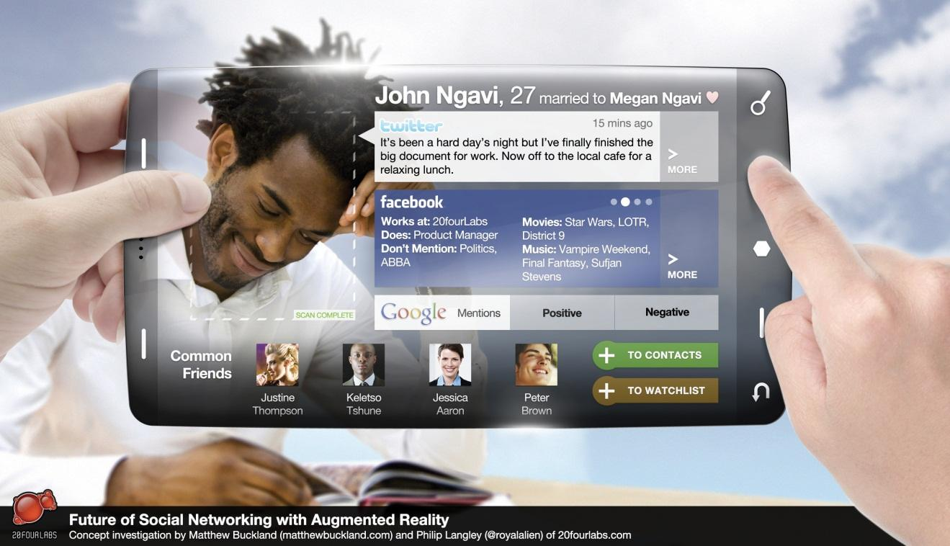
Source: http://www.matthewbuckland.com.
As a mobile marketing channel, the possibilities of AR are so significant that they should really be explored by any marketer hoping to make an impression, provided that their target market can afford smartphones, that is.

Planning to Go Mobile
There is no doubt that the mobile phone presents an enticing marketing opportunity and market space. Early movers in the mobile space have seen remarkable success, and some have made remarkable amounts of money. How do you prepare to go mobile?
First, as with any marketing activity, planning and setting goals are key. What do you want your campaign to achieve? How can mobile be used to help you achieve those goals?
Second, you need to consider your audience. Who do you need to reach? What sort of phones and features of their phones do they have and, importantly, use? iPhone applications may be more fun to develop than a campaign based on SMS, but iPhone applications can only reach iPhone users, while SMS can reach almost everyone who has a mobile phone. (Many developers of iPhone apps do, however, make similar or identical apps for other smartphones.)
Third, how will users actually access your campaign? Do you need permission first to send them messages, or will you be advertising or marketing the campaign to get them to access it?
You also need to choose partners for your campaign for their technology and distribution networks and, of course, for their expertise. Ensure that the partners you choose adhere to your country’s mobile ethics and standards code, as well as those of your brand.
Lastly, you need to determine how mobile marketing fits into your overall marketing strategy. Will mobile marketing be complementing existing services and campaigns, or will you be developing campaigns, goods, and services specifically for the mobile environment?

Pros and Cons
The mobile phone has many benefits (there are those seven unique features after all) but comes with its own challenges. The reach of the mobile phone alone makes it a very attractive marketing channel.
Many mobile marketing mediums need little audience education, but marketers need to be aware of creating more complicated campaigns and applications. If there is an extensive education process required in order for a campaign to succeed, it probably needs to be rethought.
Because the mobile phone is so personal, permission and privacy need to be at the foundation of any mobile campaign. Unlike an e-mail or Web pages where there is space available on screen to explain privacy and permission, there is very little real estate on the mobile phone to do so. Ensure that you have very clear permission to market to the phone numbers on your database and that it is easy for users to opt out of receiving your messages.

KEY TAKEAWAYS
- Mobile phones have different operating systems. There are also multiple ways for a device to connect with the Internet.
- Mobile devices can access the Internet via WAP (Wireless Application Protocol) sites or more sophisticated HTML (hypertext markup language) browsers. However, the HTML browsers are pared-down versions as mobile devices have low memory and low bandwidth.
- Webmasters can take some best practices into consideration for making Web sites appropriate for mobile browsing.
- 2D (two-dimensional) bar codes, also known as tags, are another way for marketers to deliver their message to a user’s phone.
- Mobile search is becoming increasingly more important. Natural and paid search also applies here.
- Mobile apps are another eMarketing channel that is becoming increasingly important.
- Augmented reality (AR) is a variation of virtual reality that superimposes graphics into “reality.”

EXERCISES
- Why do you think that visits from mobile phones are different from other Web visits? How can this be used in marketing strategy?
- Mobile marketing is a growing area of eMarketing. Can you list major brands that promote their mobile offerings? How do they promote their offerings?
- Can you think of a situation where 2D (two-dimensional) bar codes can be appropriate for an advertiser?
- Think of an example of how to include augmented reality (AR) into a brand’s eMarketing efforts. Be creative.

[1] Ronald T. Azuma, “A Survey of Augmented Reality,” Presence: Teleoperators and Virtual Environments 6, no. 4 (August 1997): 355–85,http://www.cs.unc.edu/~azuma/ARpresence.pdf (accessed June 20, 2010).
[2] “History of Mobile Augmented Reality,” Institute for Computer Graphics and Vision,https://www.icg.tugraz.at/~daniel/HistoryOfMobileAR (accessed June 20, 2010).
[3] “Mobile Augmented Reality Builds Deep Consumer Engagement,” MobiAD News, November 12, 2009, http://www.mobiadnews.com/?p=4204 (accessed June 20, 2010).

16.7 Case Study: Peugeot 107’s Break Free Campaign
South Africa’s mobile community grossly outweighs the number of people with access to the Internet, so it was up to Saatchi & Saatchi’s digital department, AtPlay, to find a way to bring the interactive Peugeot Break Free campaign to a Web and mobile market.
Figure 16.4 Web Site That Hosted the Peugeot 107 Break Free Campaign
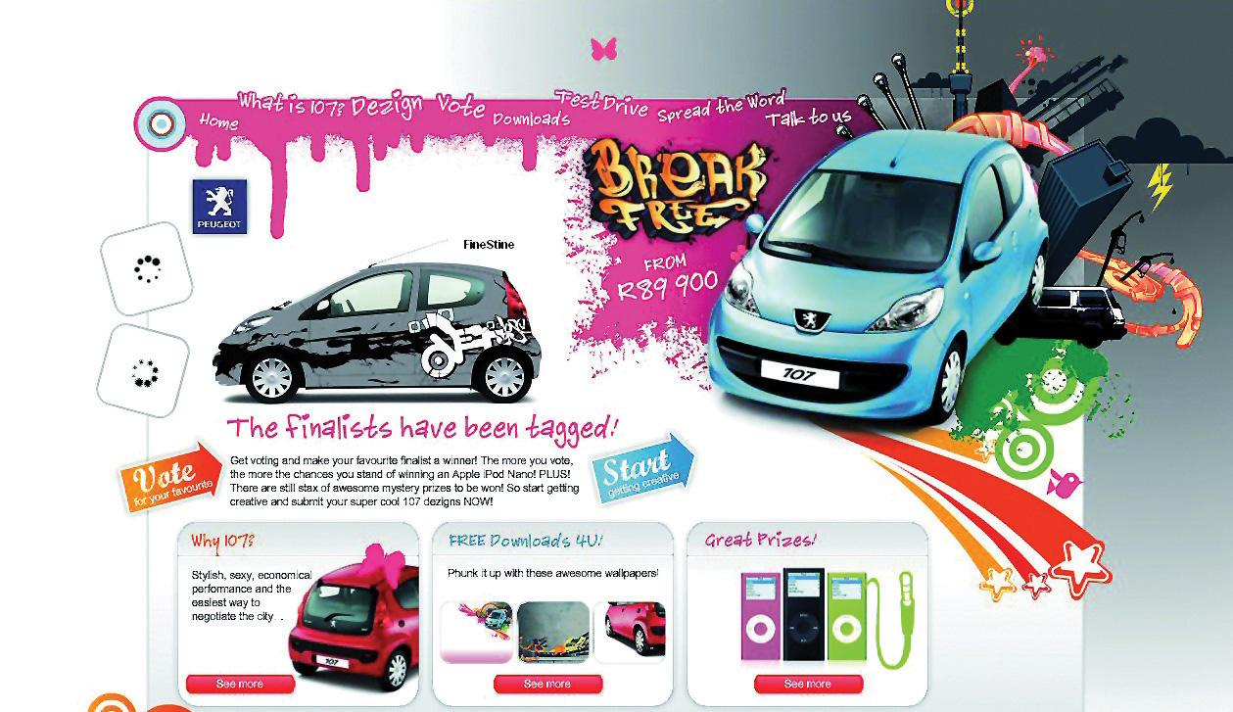
Source: Used by permission from AtPlay.
The mobile chat network, MXit, has nine million users in the country and was the perfect portal to seed a comprehensive campaign—along with support across other social networks such as Facebook and MySpace. Competing with the Toyota Aygo and Citroen C1, which were launched around the same time, Peugeot’s 107 campaign reached out to the younger, style-conscious generation on MXit who may not be buying cars just yet but are influential with their car-purchasing parents.
The first step was to create a branded splash screen and Peugeot 107 profile. The 107 MXit profile fed information about the campaign from the Web site directly to the users—some content being hidden for the only the keenest eye to spot.
Templates of the car allowed the public to design their dream Peugeot 107, and it was up to the voters to pick the winner. The finalists were all sent t-shirts featuring a unique Semacode, or bar-coded URL (uniform resource locator) address, to give to their friends and family. Taking a photo of the encrypted image with a Semacode-enabled camera phone meant that the users could navigate directly to the voting page via their mobile device.
MXit background themes, or “skinz,” based on the finalists’ designs were also specially created, and seven thousand were downloaded within an hour.

CASE STUDY QUESTIONS
- How did the use of mobile technology increase interactivity with this campaign?
- How was mobile technology used to complement other campaign channels?
- How was the success of the campaign measured? What other metrics could be used to judge the success of a campaign like this?

16.8 References
Tomi Ahonen, “Trillion with a T, the Newest Giant Industry Has Arrived: The Money and Meaning of Mobile,” Communities Dominate Brands, December 10, 2008, http://www.communities-dominate .blogs.com/brands/2008/12/trillion-with-a.html (accessed December 15, 2008).
Matthew Buckland, “The Future of Social Networking—A Concept Investigation with Augmented Reality,” matthewbuckland.com, October 1, 2009,http://www.matthewbuckland.com/ ?p=1041 (accessed June 24, 2010).
“Clickatell: Get Instant Cover before Travelling; Metropolitan Life and Clickatell Introduce the World’s First Insurance by Mobile Phone in South Africa,” InsuranceNewsNet, May 8, 2006, http://insurancenewsnet.com/article.asp?n=1&neID=200705083600.3_70ed00196de34624 (accessed November 14, 2008).
Kim Dushinski, “Text-to-Donate Alive and Well in U.S.,” Mobile Marketing Watch, July 18, 2008, http://www.mobilemarketingwatch.com/text-to-donate-alive-and-well-in-us-1107 (accessed June 24, 2010).
Katie Fehrenbacher, “10 Things to Know About Short Codes,” GigaOM, March 16, 2007, http://gigaom.com/2007/03/16/10-things-to-know-about-short-codes (accessed November 14, 2008).
Jonathan Fildes, “Texts Tackle HIV in South Africa,” BBC News, October 24, 2008, http://news.bbc.co.uk/2/hi/technology/7688268.stm (accessed November 14, 2008).
Internet World Stats, http://www.Internetworldstats.com (accessed December 17, 2009).
“Introduction to Mobile Search,” Mobile Marketing Association, August 2008,http://www.mmaglobal.com/mobilesearchintro.pdf (accessed June 24, 2010).
Ivan Komarov, “Economic Crisis and USSD: Time to be Reasonable!” Eyeline Communications, November 20, 2008,http://www.eyeline.mobi/blog/category/ussd/Eyeline (accessed November 14, 2008).
Ignacio Mas and Kabir Kumar, “Banking on Mobiles: Why, How, for Whom?”CGAP Focus Note 48 (June 2008),http://www.cgap.org/p/site/c/template.rc/1.9.4400 (accessed June 24, 2010).
Alan Moore, “Mobile as the 7th Mass Media: An Evolving Story,” white paper, SMLXL, May 2007, http://smlxtralarge.com/wp-content/uploads/2008/03/smlxl-m7mm-copy.pdf (accessed June 24, 2010).
“MXit Users Exceed 14 Million,” IT News Africa, July 14, 2009,http://www.itnewsafrica.com/?p=2881 (accessed December 11, 2009).
“Understanding Mobile Marketing: Technology and Reach,” Mobile Marketing Association, May 2007,http://www.mmaglobal.com/uploads/MMAMobileMarketing102.pdf (accessed June 24, 2010).

Chapter 17

Customer Relationship Management

17.1 Introduction
If anything, the Internet and the World Wide Web have highlighted the importance of a customer- focused approach to business and marketing. It may seem obvious now, but the heydays of mass media marketing seemed to assume that people could be persuaded to purchase anything, provided there was sufficient advertising to promote a product. While signs declaring “The Customer Is Always Right” may have been stuck to the walls of shops and restaurants, the customer did not have much of a voice outside of that shop or restaurant.
Move forward a few decades to an increasingly connected society and marketplace, and the customer’s voice is being heard in blogs, forums, reviews, and other forms of social media. It is easier for consumers to connect with one another, albeit virtually, to share experiences with services and products.
Customer relationship management (CRM) is, as the name suggests, about managing relationships with customers. It should imply a customer-focused approach to business for fostering real relationships with these important stakeholders: customers.
Often, online marketing is referred to as e-CRM (electronic customer relationship management). This appears to underline the importance of technology in CRM. It also highlights the most important consideration of any eMarketing tactic: customers.

17.2 Why Electronic Customer Relationship Management?

LEARNING OBJECTIVES
- Learn why e-CRM (electronic customer relationship management) is an important part of business.
- Become familiar with the different types of e-CRM.
Customers can be seen as the most important stakeholders in a business’s success. Without customers purchasing goods or services, most businesses would not have a revenue stream. But it can be difficult to shift from realizing this important fact to implementing it into day-to-day business decisions and strategy.
A successful relationship with a customer is based on meeting (and perhaps even exceeding) his or her needs. It is in determining what problems the customer has and in providing solutions to those problems.
Maintaining good customer relationships is critical to the success of a business. The costs associated with acquiring a new customer are generally far higher than the cost of maintaining an existing customer relationship. This is why investing in customer relationship management (CRM) should result in increasing revenue for the business.
The cycle of CRM starts with determining what problems potential customers might have and then presenting solutions to those problems. Solutions are implemented, and then ongoing service maintains the relationship with the customer.
Take, for example, two people booking an overseas holiday. One is a twenty-three-year-old recent graduate who is visiting Argentina for three months with a friend; one is a thirty-eight-year-old mother of two young children planning a family holiday to Thailand. If they both walked into a travel agency, the travel agents would make judgments on their dress and appearance to determine how they will aid each of them in booking their holiday (and how much commission the agent will be able to earn). The travel agent will also ask further face-to-face questions to try to sell additional services to these two customers. For the twenty-three-year-old, additional services might include travel insurance that covers extreme-sports activities and a calling card that allows her to call home from anywhere in the world. For the thirty-eight-year-old, additional services could include babysitting services included in a hotel reservation.
Seat the two potential travelers in front of their computers, and you no longer have human travel agents to make snap judgments based on appearance or to try to sell additional services based on the type of traveler they see. Of course, you also no longer have the overhead costs of a travel agency and agents. However, Web technology does allow for similar, and often superior, judgments and sales opportunities.
For example, both travelers are likely to have started researching their trips using a search engine. Creating landing pages tailored to the types of searches being made can allow the opportunity to tailor the products being presented to each traveler.
Technology can also be used to allow the online business to interact personally with a Web visitor and also to provide the visitor with information she might not get in a travel agency—unbiased reviews from other customers. Technology can and should be used to treat different customers differently.
Web technology allows for customer-related marketing decisions to be made and tested relatively quickly and adjusted as required.
For example, in 2002, Jeff Bezos of Amazon.com launched free shipping for orders over $99 in value. While the offer was advertised as being for a limited time only, this time limit enabled Amazon to test the effect of the offer on its bottom line and still retract it if necessary. Over the months, the order threshold for free shipping dropped, and today U.S. Amazon.com orders over $25 ship for free. However, free shipping does not mean priority shipping, so orders can still be delivered in a shorter period of time—for a delivery fee.
Electronic customer relationship management (e-CRM) uses technology in a number of ways to cement CRM into the way that organizations conduct themselves. Once a business shifts its focus to consumer needs, it will find that all these technologies feed each other. However, the fundamental principle of e-CRM is to remember that technology should be used to enable customer relationships, not replace meaningful relationships.

Discussion
Why is knowing what keywords purchasing customers use helpful for CRM?
First, the data that are collected online should be used to build meaningful profiles of potential customers, and that information should be used in fostering relationships. Web analytics tools gather a wealth of data that can inform customer relationships, from search keywords used to reach a Web site, to navigation paths on a Web site. It is even possible to capture this kind of information about specific customers when they perform an action such as purchasing or subscribing on a Web site. Without the customer knowing, the referral source of their visit and even an indication of their navigation path can be captured, along with their order or registration details, and stored for future use.
CRM software enables businesses to manage all customer and lead information across all departments in a centralized place. No matter whom a customer speaks to within a business, all employees can access the same information recorded over time—a 360-degree view of the customer. This means that any time someone inside the organization looks up the customer, he can see every interaction the organization has had with the customer, what previous queries have been raised, and how these have been solved in the past.
CRM software also enables businesses to automate much of the sales cycle, freeing salespeople to spend time on creating personal relationships where it matters—with potential and existing customers.
Technology, of course, has also changed the ways that customers can contact companies. In Chapter 8 "Social Media" and Chapter 11 "Online Reputation Management", the importance of letting the customer select communication channels was highlighted. Customer relationships are no longer driven by telephone call centers, but instead blogs, Twitter, e-mail, and instant messenger (IM) are all used as customer-service channels both pre- and postsale.

Customer-centric and Customer Driven
It is one thing to place the customer at the center of an organization’s planning and execution of business plans and another to have customers driving the direction of a business. Many new, Web-based businesses rely on the latter for their business to succeed and actively encourage customers to take the lead and add value to the business. Services such as Flickr (http://www.flickr.com), Delicious (http://delicious.com), and Twitter (http://www.twitter.com) are examples of services that are user driven rather than user-centric. They provide tools that enable users to make the service their own, often by allowing outside developers access in order to create supplementary services.
Savvy organizations can also provide tools to customers to drive their business, passing on tasks to customers that might ordinarily have been performed by the organization. For example, many airlines now allow travelers to check in online prior to arriving at the airport. Although they are giving travelers convenient tools and increased options when it comes to checking in, the airlines are also outsourcing the check-in process to their travelers. As more travelers select to check themselves in, staff costs for airlines can be reduced. The travelers are doing the job for free.

Types of CRM in Organizations
CRM should infuse every aspect of a business (in the same way that marketing should infuse every aspect of a business), but it is useful to look at the different ways that CRM is implemented.
Operational CRM refers to the most obvious channels that relate to customers: the front end of a business and its customer service. From a Web technology point of view, operational CRM informs the Web site a customer sees as well as his entire online user experience. Technology also enables effective customer service, from providing numerous contact channels to presenting technology that records all customer contacts.

Note
Data mining is the analysis of large volumes of data in order to determine patterns, correlations, relationships, and trends in the data.
Analytical CRM analyzes data collected by a business to determine information about customers that can inform sales and marketing decisions. Data mining is a crucial step to effective CRM. Web analytics and conversion optimization can be seen as part of the CRM process. Data collected about the nature of visits to your Web site can be used to make informed decisions about where to focus attention based on customer behavior. Past purchasing behavior of customers can be analyzed to predict future purchasing behavior. Data can be used to segment customers, and so communications can be tailored.
For example, Amazon.com uses the purchase history of a customer to make recommendations to that customer for future purchases. Thus, a customer who has purchased a number of cookbooks in the past will be sent offers related to cookbooks. Amazon.com also looks at the purchase behavior of customers who buy the same book and uses those data to recommend books based on similar customers’ preferences. This process is referred to as collaborative filtering.
Sales-force automation uses CRM software to manage sales cycles and to collect customer sales data. The software enables businesses to track leads, to schedule transactions and communications with potential and existing customers, and to generate detailed reporting on the sales process. There are numerous software providers, such as Salesforce.com.
Collaborative CRM refers to a process that combines customer data across all facets of a company. For example, queries regularly submitted to the technical support or customer service arm of a business can be used to inform Web site updates (updating content on the Web site to address a query that is regularly submitted) and to inform product development. Instead of various departments collecting their own customer data and using these in isolation, data are collaborated so that all channels are making informed decisions based on an entire customer experience.

KEY TAKEAWAYS
- A successful relationship with a customer is based on meeting or exceeding his or her needs.
- Maintaining good customer relationships is critical to the success of a business, as costs for most new relationships are more expensive than maintaining existing relationships.
- The cycle of CRM starts with determining what problems potential customers may have and then presenting solutions to them.
- Technology can be used to allow an online business to interact personally with a Web visitor. Customers can get unbiased reviews from others online.
- Customer relationships are no longer driven by telephone contact centers, but instead by blogs, Twitter, e-mail, and IM, as well as CRM channels both pre- and postsale.
- There are several types of CRM in organizations: operational, analytical, sales-force automation, and collaborative CRM.

EXERCISES
- Visit Comcast’s page on Twitter (http://www.twitter.com/comcastcares). Study the posts on the page to see how people are talking to Comcast, and how Comcast responds. Describe what you see.
- As discussed above, sales-force automation uses CRM software to manage sales cycles. Consider how this may impact business. How do you think businesses managed this type of data before CRM software existed?

17.3 Putting a Value on Customer Relationship Management

LEARNING OBJECTIVE
- Understand how businesses put a value on CRM (customer relationship management) for their organizations.
Broadly, customer relationship management (CRM) can be looked at from the following standpoints:
- A marketing perspective. Increasing the number of people who know about your service or product.
- A sales perspective. Turning the people who know about your service or product into people who have purchased your service or product.
- A service perspective. Ensuring that people who have interacted with you are satisfied and delighted.
Effective CRM across all three channels can also create a powerful new marketing and referral force for a company: its happy customers. Delighting customers fosters positive word of mouth.
While CRM is a customer-centric approach to doing business, CRM needs to be approached strategically—in line with the business objectives of a company.
The first step to any CRM initiative is to understand the value of a customer relationship to a business. While this is unique to each customer, data mining can be used to determine the value of segments of customers.
Figure 17.1 The Value of a Customer Relationship to a Business
The revenue generated by a customer is literally the sales made to the customer. This can be calculated on a one-off basis directly related to the cost of acquiring that particular sale, or it can be calculated over the lifetime of the customer relationship. However, referrals made by a customer can also be included as part of the revenue generated by the customer.
The cost of acquiring the customer refers to the marketing and advertising channels used to acquire that customer. In eMarketing, this is the CPA (cost per acquisition) of any of the channels used to acquire a customer. The benefit of eMarketing is that it is highly measurable and trackable, enabling a relatively accurate calculation of CPA.
The lifetime value of a customer refers to calculating the costs of both acquiring and retaining a customer against all purchases made over the lifetime of the customer relationship. One can also look at customer value in terms of the referrals that a customer generates for a company.
For example, a potential customer looking to purchase a digital camera is likely to search on Google for cameras. As a company selling digital cameras, your excellent PPC (pay-per-click) advertisement and compelling offer attracts the potential customer who clicks through to your Web site. Impressed with your product offering, she purchases a camera from you and signs up to your e-mail newsletter as part of the payment process.
Analyzing the spending on your PPC campaign against the sales attributed to the campaign will give the cost per acquisition of each sale. In this case, this is the cost of acquiring the new customer.
As she has now signed up to your newsletter, each month you send her compelling information about products she might be interested in. If you have taken note of her obvious interest in photography, these newsletters could be focused on photography and highlight additional products she can use with her new camera. The costs associated with sending these e-mails are the costs of maintaining the relationship with the customer. When she purchases from you again, these costs can be measured against the repeat sales she is likely to make.

Mini Case Study: Defining Loyalty and Customer Value
While most companies define customer loyalty based on the repeat purchases of happy customers, some business are built around one-off purchases. Wedding photography is one of those businesses. With so much time and effort invested in each customer relationship, how can this be returned into repeat business?
Bella Pictures (http://www.bellapictures.com) focuses on ensuring that its very satisfied brides refer its service to friends and family. In fact, 30 percent of new business comes from these referrals.
It also offers services to wedding guests, such as allowing them to make orders of wedding photos themselves, which increases its customers for each wedding. ^{[1]}
While CRM initiatives need to satisfy customer goals—increased customer satisfaction and approval—these need to be in line with business goals. Business goals are to increase overall revenue. In terms of CRM, this can be either to increase revenue generated by each customer, to increase the number of customers, to reduce the costs of acquiring a customer, or a combination of all three.
It is important to align CRM initiatives with business goals so that success of the initiatives can be measured. It is here that CRM goals can be set across marketing channels, sales channels, and service channels.

Mini Case Study: Customer Service as Public Relations
Zappos (http://www.zappos.com), a U.S. online shoe retailer, bases much of its success on its customer service. It offers free shipping on all its purchases, as well as free returns. In fact, goods are shipped with a preprinted return label, making the process straightforward for customers. Zappos also invests heavily in its customer service team, empowering each member of the team to do what he needs to do to delight customers.
For example, Zaz LaMarr blogged about her experience with Zappos. She had meant to return some shoes to Zappos, but her mother passed away, and naturally she just didn’t have time. Zappos arranged to have UPS come pick up the shoes and then sent her flowers.
Yahoo! shows nearly two thousand links to her blog post, which has generated comments like the following:
- “Zappos is the best company in America.”
- “Zappos is pretty amazing…you can sometimes find better prices at other stores for the same shoes, but its customer service is worth a few extra dollars.”
- “Wow, customer service still exists. This company will get my business.”
There is no doubt that Zappos’ customer service costs are high. Not only is shipping free, but its customer service team has been given the authority to make gestures like the one above. The return to Zappos in terms of goodwill is almost immeasurable (although its online reputation is excellent) but no doubt leads to increased referrals and sales and customer loyalty. ^{[2]}
When it comes to the marketing channel, CRM initiatives can be used both in the acquisition of new customers and in the marketing to existing customers (which can be seen as acquiring new sales from existing customers).

KEY TAKEAWAYS
- CRM can be looked at from several perspectives:
  - Marketing
  - Sales
  - Service
- Making customers happy fosters positive word of mouth.
- CRM must be approached strategically. The first step of any CRM initiative is to understand the value of a customer relationship to a business. Data mining can be used to help with this.
- CPA (cost per acquisition) refers to the cost of any channels used to acquire a customer (marketing and advertising).

EXERCISES
- Why it is important to align CRM initiatives with business goals? Can you give an example?
- Evaluate the mini case study about Zappos.com. Explain why you think Zappos has given its customer service team the authority to make gestures like these. Do you think most businesses would allow these types of gestures to happen?

[1] Nicole Lewis, “Marrying CRM to a New Definition of Loyalty,” InsideCRM, October 23, 2008, http://www.insidecrm.com/features/new-definition-loyalty-102308 (accessed June 24, 2010).
[2] Meg Marco, “Zappos Sends You Flowers,” The Consumerist, October 16, 2007,http://consumerist.com/consumer/above-and-beyond/zappos-sends-you-flowers-311369.php (accessed November 17, 2008).

17.4 Using Customer Relationship Management to Inform Your eMarketing Tactics

LEARNING OBJECTIVE
- Learn how using CRM (customer relationship management) can give a company useful information that can be applied to its eMarketing channels.
Successful e-mail marketing stems from a very basic customer need: privacy and permission. The very first step required in using e-mail to establish a relationship with a customer is in gaining his or her permission.
Data mining and segmenting customer databases allow for e-mail marketing to be tailored to customers, while e-mails allow for extensive personalization on a mass scale.
E-mail is often the primary point of contact for all customer-service-related messages, from automated e-mails dealing with the administration of orders, to contacts with the customer service team.
Online advertising is a double-edged sword when it comes to CRM (customer relationship management). It can be a very effective acquisition tool for new customers, but intrusive advertising can attract attention for all the wrong reasons. Effective online advertising speaks to customers’ needs and presents solutions to them, hopefully attracting attention without being overly intrusive.
Affiliate marketing started by making the most of existing relationships other parties have with potential customers. Affiliate marketing can be an excellent sales and acquisition channel, but it is not without its problems from a CRM perspective. Another entity is acquiring leads on your behalf, which can mean a loss of control when it comes to the messages used to attract leads. Ensure effective communication with affiliates so that they are sending the right message to your leads.
Search engine marketing, whether search engine optimization (SEO) or pay-per-click (PPC) advertising starts with customer intent. Existing customer data can indicate where to focus search engine marketing efforts, especially when it comes to analyzing how well a Web site caters to the intent indicated by a customer’s search term.
The use of social media is based on customer needs and preferences. Online reputation management tracks social media in particular (as well as other online sources) to establish consumer sentiment. These valuable data should then be used to inform an organization’s marketing strategy. Social media also present a powerful tool for turning delighted customers (who are expressive online) into advocates for an organization. Lastly, social media allow several new communication channels for an organization, enabling customer communications and customer service to take place where the customer feels most comfortable.
Effective Web development and design starts with customer needs and should focus on the experience of Web users. Designing for customers first and foremost should give Web visitors a seamless experience, presenting your goods and services to them without effort on their behalf.
Through all the eMarketing tactics, effective analytics is the most useful CRM tool. It allows each channel to be measured on its merits, and the customers acquired by each channel can be analyzed.

KEY TAKEAWAYS
- Successful e-mail marketing stems from the customer needs of privacy and permission.
- E-mail is the primary point of contact for all customer-service-related messages. But other eMarketing channels can act as CRM, as well.

EXERCISES
- Pick two channels discussed in this section and evaluate how they can each be a good CRM tool. Find an example of how a brand is currently using it.
- Evaluate the list of eMarketing channels listed in this section. Consider the pros and cons of each. Some of the cons seem to outweigh the pros of some channels, and vice versa. Knowing these pros and cons, do you think that marketers have a reason to completely avoid a channel altogether without testing it first?

17.5 Technology and Customer Relationship Management

LEARNING OBJECTIVE
- Understand how technology influences CRM (customer relationship management).
Technology, and especially the technology enabled by the Internet, has had enormous repercussions for CRM (customer relationship management). In many cases, technology has helped streamline many CRM processes as well as cut the costs of CRM initiatives.

Talking to Customers: Customer Service
It is amazing how much technology has changed the ways we communicate with each other. In the same way, it has changed the way that organizations and companies can communicate with us.

E-mail
Perhaps one of the first customer service developments to come from the Internet is customer service over e-mail. It is standard for Web sites to have contact addresses as well as telephone numbers, adding an additional channel for customer contacts. E-mails can also be automated to keep customers informed of progress of a transaction, whether it is shipping goods bought online or the progress of an insurance claim. Each action within an organization can trigger an automatic e-mail, serving to ensure customers feel informed at every step.

Mobile
Similarly to automated e-mails, the mobile phone is also being used to keep customers informed of the progress of transactions. Short message service (SMS) messages can be automated in the same way that e-mails are, again ensuring customer peace of mind.

Call centers
Technology such as VoIP (voice over Internet protocol) means that voice calls can be routed cheaply over the Internet. Thousands of people keep in touch around the globe with services such as Skype (http://www.skype.com), and this has impacted call centers as well.
Using similar technology, phone calls can be routed to call centers in any location around the globe. Many companies in developed nations have located their customer call centers in developing nations, where staff and other overhead costs are far lower. The Internet means that these calls can be routed for a lower cost than in-country calls, with minimal loss of call quality. That means that a UK customer calling Lastminute.com to book a flight, for example, could in fact be speaking to someone in India.
The staff in these call centers undergo extensive training on the culture of the people they will be speaking to, as well as on the ethos of the company they represent. Even though a customer is speaking to someone on another continent, it is imperative for the business that the experience matches its brand as closely as possible.

Instant Messengers and Chat Rooms
Instant messenger (IM) allows fast, instant text-based chat. Services such as Windows Live Messenger, Gtalk, and Jabber keep people around the world (and in the same room) connected. IM can also be an effective customer service channel.
When potential customers are on a Web site, they may have very quick questions or concerns that they need to have addressed before proceeding with an order. Sending an e-mail with these questions can mean a lengthy period before these questions are answered, and they may be loath to pick up a phone to have the queries answered. In instances such as these, an IM service can easily, quickly, and inexpensively solve these queries.
There are two main ways that IM is integrated onto Web sites. The first is customer initiated, and the second is initiated by a script on the Web page being viewed.
Customer-initiated IM involves indicating clearly to a customer that the IM channel is available, while giving clear instructions on how to use it. Many free chat clients may be easily integrated in this way, such as Skype and Meebo (http://www.meebo.com).
A script can also be used to initiate a chat with a potential customer. When a Web visitor has been on a Web page for a fixed period of time without performing any action (such as clicking on a link), a window can appear in the browser asking if he would like to chat with someone about the products offered. The Web visitor can then either close the window and continue on his own or choose to chat. If the latter is chosen, a customer service representative will then commence to chat to the consumer.
This can be extremely effective for complicated or expensive purchases. At the point of decision making, the organization can provide personal support and reassurance.

Managing Interaction Data
CRM software can be used to automate lead and sales processes and to collect customer information in a centralized place.
Organizations are large, and a customer may speak to any member of an organization, depending on the nature of the communication. It would be extremely frustrating for the customer to have to explain all previous dealings with the organization with each communication, and it can be extremely frustrating for an organization not to know who has spoken previously with a customer and what was dealt with.
Fortunately, there are many technology options that help record all this information in one place, whether it be related to potential, current, or past customers.
As well as enabling recording of data, most of these services can also schedule elements of the sales process and set reminders where appropriate for follow-up action.
Some notable examples include SalesForce (http://www.salesforce.com), Genius (http:// www.genius.com) and Highrise (http://www.highrisehq.com) from 37 Signals.

Analyzing Data
One of the most powerful features of interactions and transactions over the Internet is that everything is tracked and recorded in server logs, providing a wealth of data that can be analyzed to make business decisions.
Importantly for CRM, this means that the acquisition source of customers may be recorded and analyzed against sales data for customers from the source. This leads to a very accurate ROI (return on investment) calculation and indicates where CRM and marketing efforts should be focused.
The key to effective use of technology in CRM is integration. Ensure that all channels can be tracked and that that information is usable to all parties within an organization. Knowing where your customers come from but not what they purchase is pointless: these two metrics need to be compared in order to produce actionable insights.

Vendor Relationship Management: A New Way of Looking at Relationships
Vendor relationship management (VRM) is the reciprocal of CRM. VRM in this context describes an emerging, progressive school of thought, technology, tools, and services that help customers to manage relationships with vendors. VRM tools and services are still very much in their infancy, as is the concept of VRM.
If you are interested in reading further about VRM, the article “VRM in a Nutshell” is a great place to start: http://www.vrmlabs.net/vrm-in-a-nutshell.
VRM seeks to address the imbalance of power when it comes to customer and vendor relationships. Traditionally, vendors collect and hold information about a customer and use it to get the most out of their relationship with the customer. For many vendors, “get the most out of the customer relationship” translates to making the most revenue for the lowest cost from a particular customer or group of customers. VRM notes that customers can be far better custodians of data that are very useful to vendors. For example, Amazon.com collects data about a customer’s purchasing and browsing history and makes recommendations based on that history. However, the customer possesses information that Amazon.com doesn’t: for example, the customer knows which books were purchased as gifts and therefore are not indicative of personal preferences.
The goal of VRM, however, is not to make sure that vendors have access to this information; instead, it is to give customers the power over the information that is shared with vendors. Traditional CRM locks that data into a single relationship, while VRM seeks to give the customer the power to share pertinent data with vendors as he sees fit. These relationships can be controlled by the customer as opposed to being controlled by the vendor.
VRM is a dynamic way of looking at customer-vendor relationships. Although the terms and tools may be new, the principles and the frustration with current practices are not.
For more information on VRM, visit the Project VRM wiki at the following Web page http://cyber.law.harvard.edu/projectvrm/Main_Page, read the blog for the project at http:// blogs.law.harvard.edu/vrm, or visit VRM Hub athttp://www.vrmhub.net, or VRM Labs at http://www.vrmlabs.net.

KEY TAKEAWAYS
- Technology has changed how we communicate with each other, including how organizations and companies can communicate with us.
- eMarketing channels such as e-mail, mobile, call centers, and IM and chat rooms are great for helping organizations and companies communicate.
- CRM software can be used to automate lead and sales processes and to collect customer information in a centralized place.
- Data can be stored in server logs, which means the acquisition source of customers may be recorded and analyzed against sales data for customers from the source.
- Integration is a key to effective use of technology in CRM. Knowing where your customers come from but not what they purchase is pointless. It is best to compare them in order to produce actionable insights.
- VRM is the reciprocal of CRM, where the focus is on vendors. This is a new area of eMarketing.

EXERCISES
- Think of examples of business categories that would be appropriate for the eMarketing channels listed in this section (e-mail, mobile, call centers, and IM and chat rooms). Identify some of the brands in these categories. Try to identify actual examples of how these brands use these e-CRM channels.
- Taking into account what you know about CRM, do you think that it is worth it for most companies to invest in VRM? What types of businesses do you think would benefit from a VRM program? Why?

17.6 Case Study: Virtual Works and PG Glass
Like many service industries, the glass-replacement industry is about speed, efficiency, and convenience. If a customer’s glass cracks or breaks, the customer wants it repaired or replaced as swiftly and conveniently as possible.
Keenly aware of the consumer’s decision-making criteria, market-leading Southern African glass supplier PG Glass constantly looks for ways to serve customers faster and more responsively than the competition. So when figures revealed that there were about 4.6 million regular Internet users in South Africa, the company went about finding better ways to exploit the Web channel for competitive advantage.
Managing director Rob Curle recognized that the latest generation of the Internet was capable of vastly more than simple brochureware hosting (i.e., a Web site that is an online brochure) and was determined to put Web and mobile technology to use more effectively in order to satisfy customers’ needs—and leapfrog conventional Web site capabilities.
After extensive research, PG Glass selected The Virtual Works to supply the specialist expertise and systems to put the Web to work strategically for the firm. The Virtual Works’ locally developed V3 system was custom configured to suit and now administers the PG Glass Web site’s back end. It makes it easy for customers to post a service request on the Web site without having to navigate through the whole site to find a solution. The system uses intuitive rules to automatically match a customer’s profile and need for service to the right resource at the right PG Glass franchise—and instantly distributes the inquiry to the mobile phone of the right person on the PG Glass side. The technology sends a reference number to the customer and then tracks service fulfillment using customizable rules to automatically alert PG Glass staff and managers to workflow delays by e-mail and short message service (SMS). Detailed reports provide the PG Glass team with service measures and benchmark data in order to immediately identify service interruptions or areas requiring improvement, as well as the information required to identify and reward employees for superior service performance. The system securely stores customer data in a unified system, making them available via a password and user identification protocol to PG Glass franchisees over the Internet on demand.
Thanks to the V3 system, most leads are precisely routed to the branch in just a few seconds—putting customer inquiries into the hands of the right PG Glass people hours before they would have gone to competitors.
The results so far have shown that investing in technology to implement and maintain CRM (customer relationship management) is not only vital in business but also extremely profitable. In the first eight months of V3’s operation, PG Glass experienced a 110 percent increase in Internet-generated leads, which translates into a significant increase in sales and an impressive ROI (return on investment) for the technology.
Other paybacks to PG Glass following the strategic application of Web services include the following:
- The speed of response to customers’ needs and the reliability that flows from lead tracking have positively impacted the PG Glass brand.
- The measurement of service workflow has resulted in a greater employee focus on customer service delivery.
- The firm has achieved significant savings, as in-bound call volume has shifted to a significantly lower cost Internet channel. The costs of lead distribution and administration have also been reduced thanks to the Internet system.
- Customized reports can also track transactions from leads to completion in order to establish performance benchmarks.
The PG Glass and Virtual Works Web sites are available athttp://www.pgglass.co.za and http://www.virtualworks.co.za, respectively.

CASE STUDY QUESTIONS
- Why do you think it was important that PG Glass invested in this system? What do you think it says about the company? What do you think customers think about the company’s service, especially when compared to its competition?
- What elements of this CRM program make it more efficient and effective?

17.7 References
William Band, “The Right CRM Metrics for Your Organization,” Forrester Research, October 1, 2007,https://www.salesforce.com/assets/pdf/analysts/forrester_rightcrm.pdf(accessed June 24, 2010).
John Edwards, “Get It Together with Collaborative CRM,” InsideCRM, November 29, 2007, http://www.insidecrm.com/features/collaborative-crm-112907(accessed November 17, 2008).
“Meebo Launching Media-Enabled Chat Rooms,” 1b LiveBusiness, May 14, 2007,http://www.1ivebusiness.com/news/1850 (accessed November 17, 2008).
Keith Regan, “Amazon Posts Profit, Makes Free Shipping Permanent,” E-Commerce Times, January 24, 2003, http://www.crmbuyer.com/story/20562.html(accessed November 17, 2008).

Chapter 18

Market Research

18.1 Introduction
While the Internet was developed as a military project, the World Wide Web was developed as a tool for academics to allow information to be shared freely. This foundation of the Web as an information tool has had profound effects on the markets we transact in.
Consider that consumers are able to research companies and products easily, gathering information to compare prices and service with a few clicks of the mouse. Consumers are also able to share likes and dislikes easily, whether that information is shared with companies or with friends.
Figure 18.1
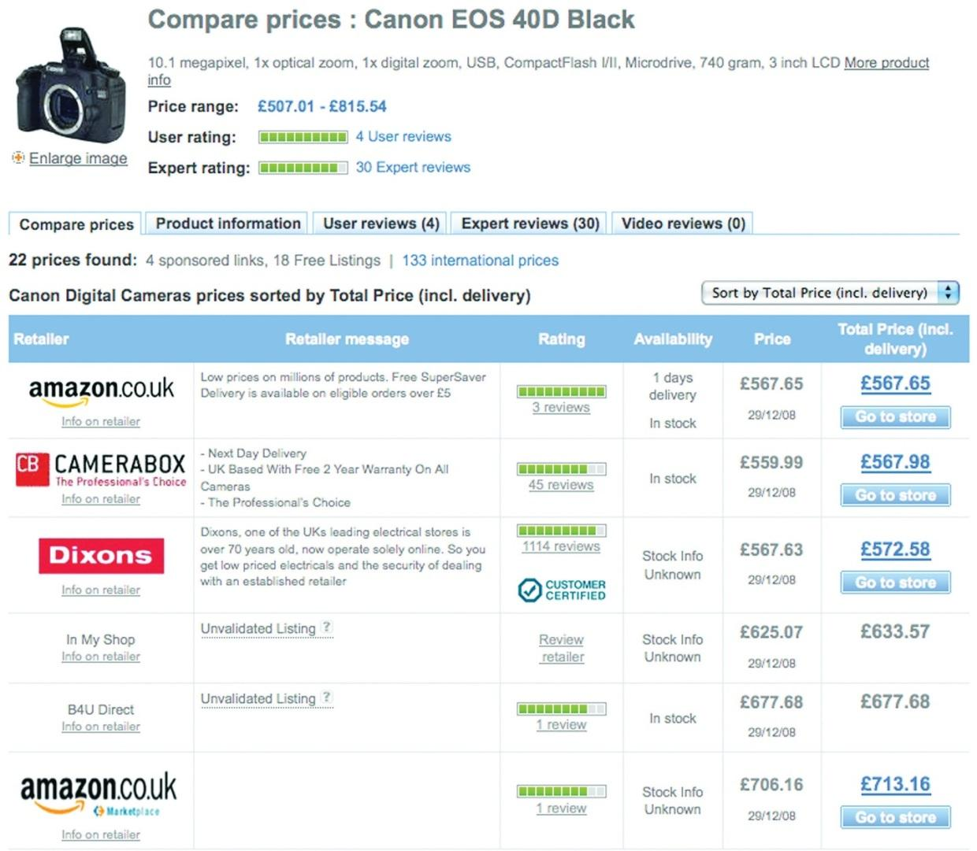
Services such as PriceRunner allow consumers to research product prices.
Likewise, the Web has an impact on market research. Its foundations in academia make it ideal for secondary research, with reports and data filed, indexed, and available via a few savvy searches. Technology can also be used to easily, and accurately, conduct surveys. The connected nature of the Web also makes it possible to record data about consumers’ online habits.
For example, when researching the penetration of broadband in a particular market, a few Web searches will reveal plenty of sources that can be compared and verified. If a company wants to gauge the demographics of visitors to its Web site, an online survey may be offered to Web site visitors. Third, online reputation management tools allow companies to track consumer sentiment expressed online.

What Is Market Research?
Market research is a process that aids business decisions. It involves systematically gathering, recording, and analyzing data and information about customers, competitors, and the market.
Research can be based on primary data and information or secondary data and information. Primary research is conducted when data or information is gathered for a particular product or hypothesis. This is where information does not exist already or is not accessible and so needs to be specifically collected from consumers or businesses. Surveys, focus groups, research panels, and research communities can all be used when conducting primary market research.
Secondary research uses existing, published data and research as a source of research. It can be more cost effective than conducting primary research, and the Internet opens a wealth of resources for conducting this research. However, the data would have originally been collected for solving problems other than the one at hand, so they might not be sufficiently specific. That being said, secondary research can be useful in identifying problems to be investigated through primary research.
Research can also be classified as qualitative or quantitative. Qualitative research can be classified as exploratory. Qualitative research aids in identifying potential hypotheses, whereas quantitative research puts hard numbers behind these hypotheses. Qualitative research seeks to find out what potential consumer perceptions and feelings exist around a given subject. This research can often be used to advise the design of quantitative research, which relies on numerical data to demonstrate statistically significant outcomes.
The Internet is a useful tool for both primary and secondary research and can be used to gather both qualitative and quantitative data. In fact, the communities on the Web can be viewed as one large focus group, regularly and willingly sharing their opinions on products, markets, and companies. Today, organizations transacting online have a wealth of research information freely available to them, as well as sophisticated tools for gathering further data.
Market research should produce information that leads to actions.

18.2 Quantitative and Qualitative Research

LEARNING OBJECTIVES
- Understand the differences between quantitative and qualitative research.
- Learn how to gather qualitative and quantitative research.
- Understand how important online research panels are to this research.
Quantitative research gathers data that can be statistically analyzed to determine results. Data must be formally gathered and should be collected to test a hypothesis as opposed to determine a hypothesis.
Qualitative data can be more difficult to quantify. Typically, because base sizes are smaller and not necessarily representative of the market under investigation (as it can be more expensive and time consuming to gather and analyze the data), qualitative data cannot be taken as quantified. They are, however, valuable in aiding a researcher in interpreting the market perspective. It is possible to combine approaches, producing data that can be used both qualitatively and quantitatively.

Note
With larger sample sizes, qualitative data may be analyzed quantitatively.
For example, in online reputation management (ORM), tools exist that can track brand-name mentions. These data can then be analyzed qualitatively, where researchers can examine the mentions and use their judgment to determine sentiment, or quantitatively, where mentions can be assigned numeric values across a range of categories that are used to generate a reputation score, such as BrandsEye’s online reputation algorithm.
When both qualitative and quantitative research are used, usually qualitative research takes place first to get an idea of the issues to be aware of, and then quantitative research tests the theories put forward in qualitative research.
Table 18.1 The Main Differences between Quantitative and Qualitative Research
Characteristic | Qualitative Research | Quantitative Research
Group size | Small number of participants—usually focus groups of 6 to 10 respondents led by a moderator | Large number of respondents—100 or more, depending on the size of the population, are generally surveyed
Approach | Generates ideas and concepts—leads to issues or hypotheses to be tested | Tests known issues or hypotheses
 | Ends with hypotheses for further research | Begins with hypotheses
 | Seeks complexity | Seeks consensus, the norm
 | Context of issues | Generalization
Disadvantages | Shouldn’t be used to evaluate preexisting ideas | Issues can only be measured if they are known prior to beginning the survey
 | Results are not predictors of the population | Sample size must be sufficient for predicting the population
Advantages | Looks at the context of issues and aims to understand perspectives | Statistically reliable results to determine if one option is better than the alternatives
Source:http://www.gifted.uconn.edu/siegle/research/Qualitative/qualquan.htm.tatr.

Gathering Data: Quantitative and Qualitative Research
Both quantitative and qualitative research can be conducted using primary or secondary data, and the Internet provides an ideal tool for both avenues.

Note
Sample size is an important factor in conducting research, and that sample should be representative of the population you are targeting as a whole. If your business transacts both online and offline, beware that using only online channels for market research might not be representative of your target market. However, if your business transacts only online, offline channels for your market research are less necessary.
Web analytics packages are a prime source of data. Using data such as search terms, referral URLs (uniform resource locators), and internal search data can lead to qualitative assumptions about the consumers visiting a Web site. However, when data are measurable and specific, such as impressions and click-through rates, this leads to quantitative data.

Online Research Panels and Online Research Communities
Research panels and research communities are two means for conducting research. Whereas research panels are primarily used when conducting qualitative research, research communities primarily providequantitative data. The Internet comes to the fore when considering research communities, as social media such as social networks and blogs already provide the framework for people to connect and interact with each other. Most panels, whether online or offline, are not about member-to-member interaction. Research panels seek to address the “what” using surveys to gather quantitative data. Research communities primarily use discussions, driven online by blogs and other media sharing communities.
For example, for the launch of a new product, a company might want to determine what customers have in their fridges. Quantitative analysis would be to develop a survey that could be completed by a representative sample of its target market, aimed at discovering what consumers have in their fridges..
Qualitative analysis would be to go to a community photo-sharing site, such ashttp://www.flickr.com, and use a simple search to look at the photos the members have uploaded of the content of their fridges (http://www.flickr.com/search/?q=in+my+fridge).

Discussion
Qualitative research and quantitative research must both be presented in such a way that they can lead to actionable insights. How would you use a community tool such as Flickr when presenting these data?
Surveys are an ideal means of gathering quantitative data, provided they are designed in such a way that the answers are assigned values that can be measured statistically.
Focus groups have long been a stalwart of market research, and the Internet provides a means to conduct regular focus groups. Focus groups can consist of one person, such as in a listening lab when testing the usability of a Web site, or can be of the entire Internet population, such as when looking at global search data.
If your online audience is large enough and vocal enough, their opinions can and should be tracked and measured as part of a market research process. Be aware, however, to account for the bias in this group.

KEY TAKEAWAYS
- Qualitative data can be more difficult to quantify because base sizes are smaller and not necessarily representative of the market under investigation.
- Qualitative research is generally used first to get an idea of the issues to be aware of, and then quantitative research tests the theories put forward in qualitative research.
- Both qualitative and quantitative data can be conducted using primary and secondary data. Web analytics packages are a prime source of data.
- Research is generally done through research panels and research communities.
- Research panels are generally used for quantitative data. The Internet can be very helpful for this type of data, especially with social media and blogs.

EXERCISE
- In what ways can the Internet be used as a focus group?

18.3 Primary and Secondary Research

LEARNING OBJECTIVE
- Understand how primary and secondary research work.
The Internet is a useful tool when conducting both primary research and secondary research. Not only are there a number of free tools available when it comes to calculating things such as sample size and confidence levels, but it is also an ideal medium to reach large numbers of people for a relatively low cost. Notably, the origins of the Web as a network for academics to share information make it a useful tool for researching existing research reports.
Figure 18.2 Sources of Primary and Secondary Research Data
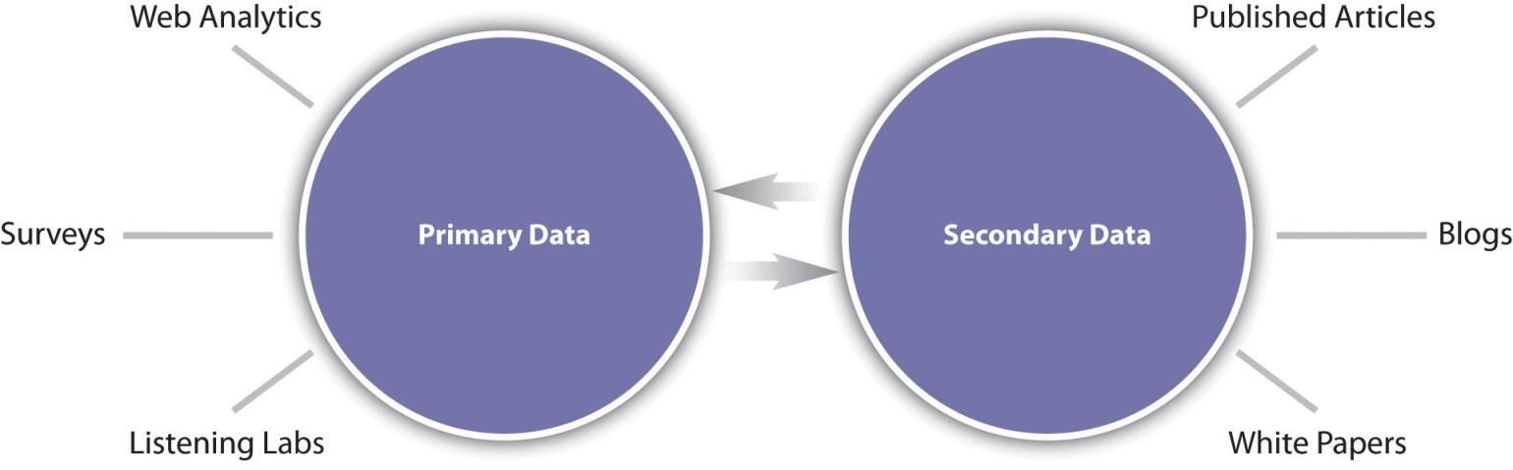

The Internet and Secondary Research
Market research based on secondary resources uses data that already exist for analysis. This includes both internal data and external data and is useful for exploring the market and marketing problems that exist.
Research based on secondary data should precede primary data research. It should be used in establishing the context and parameters for primary research.
Uses of secondary data include the following:
- The data can provide enough information to solve the problem at hand, thereby negating the need for further research.
- Secondary data can provide sources for hypotheses that can be explored through primary research.
- Sifting through secondary data is a necessary precursor for primary research, as it can provide information relevant to sample sizes and audience, for example.
- The data can be used as a reference base to measure the accuracy of primary research.
Companies that transact online have a wealth of data that can be mined that exist due to the nature of the Internet. Every action that is performed on the company Web site is recorded in the server logs for the Web site.
Customer communications are also a source of data that can be used, particularly communications with a customer service department. Committed customers who either complain, comment, or compliment are providing information that can form the foundation for researching customer satisfaction.
Social networks, blogs, and other forms of social media have emerged as forums where consumers discuss their likes and dislikes, and customers can be particularly vocal about companies and products. These data can, and should, be tracked and monitored to establish consumer sentiment. If a community is established for research purposes, this should be considered primary data, but using social media to research existing sentiments is considered secondary research.
The Internet is an ideal starting point for conducting secondary research based on published data and findings. But with so much information out there, it can be a daunting task to find reliable resources.
Figure 18.3
Google shows many entries for “research.”
The first point of call for research online is usually a search engine, such ashttp://www.google.com or http://www.yahoo.com. Search engines usually have an array of advanced features that can aid online research. For example, Google offers Advanced Search (http://www.google.com/advanced_ search?hl=en), Google Scholar (http://scholar.google.com), and Google Book Search (http://www.google.com/books).
Learning how to use search engines to find the information you need is a valuable skill in using the Internet for research.
Many research publications are available online, some for free and some for a fee. Many of the top research companies feature analyst blogs, which provide some industry data and analysis for free. Some notable resources are the following:
- http://www.e-consultancy.com
- http://www.jupiterresearch.com
- http://www.hitwise.com
- http://www.pewinternet.org (U.S. data)
- http://www.worldwideworx.com (South African data)

The Internet and Primary Research
Primary research involves gathering data for a specific research task. It is based on data that have not been gathered beforehand. Primary research can be either qualitative or quantitative.
Primary research can be used to explore a market and can help develop the hypotheses or research questions that must be answered by further research. Generally, qualitative data are gathered at this stage. For example, online research communities can be used to identify consumer needs that are not being met and brainstorm possible solutions. Further quantitative research can investigate what proportion of consumers share these problems and which potential solutions best meet those needs.

Online Research Communities
Although online communities are a valuable resource for secondary research, communities can also provide primary data. General Motors’ Fast Lane blog is an example of an online research community that aids in the gathering of research data. The blog can be used as a means to elicit feedback on a particular research problem. This is qualitative data that can aid the company in exploring its research problem further.

Listening Labs
When developing Web sites and online applications, usability testing is a vital process that will ensure that the Web site or application is able to meet consumers’ needs. Listening labs involve setting up a testing environment where the use of a Web site or application by a consumer may be observed.

Discussion
Who would you select to participate in listening lab exercises? How do you think the demographic of your population affects the outcome of these tests?

Conversion Optimization
Conversion optimization aims to determine the factors of an advertisement, Web site, or Web page that can be improved so as to make the Web site convert best. From PPC (pay-per-click) advertising, to e-mail subject lines, to shopping cart design, tests can be set up to test what variables are affecting the conversion rate of visitors to the Web site.
Chapter 15 "Web Analytics and Conversion Optimization" contains details and tools for running tests, such as A/B split testing and multivariate testing.

KEY TAKEAWAYS
- The Internet is an ideal way to reach a large number of people at a relatively low cost.
- Market research based on secondary resources uses data that already exist for analysis.
- Research based on secondary data should precede primary data research.
- There are four main uses of secondary data:
  - Data can provide enough information to solve the problem at hand, thereby negating the need for further research.
  - Secondary data can provide sources for hypotheses that can be explored through primary research.
  - Sifting through secondary data is a necessary precursor for primary research, as it can provide information relevant to sample sizes and audience.
  - The data can be used as a reference base to measure the accuracy of primary research.
- Companies that transact online have a wealth of data available to them.
- Social media have emerged as a forum where consumers discuss their likes and dislikes.

EXERCISE
- How does the Internet change the role of the researcher when it comes to market research?

18.4 Online Surveys: Gathering Data

LEARNING OBJECTIVES
- Learn how to develop surveys online.
- Learn how to get responses.
When developing surveys you can combine qualitative data with quantitative data—it just depends on how the questions are asked. Conducting online surveys allows for data to be captured immediately, and data analysis can be performed easily and quickly. By using e-mail or the Web for conducting surveys, geographical limitations for collecting data can be overcome cost effectively.
Developing technology also allows for sophisticated and user-friendly surveys to be compiled. For example, as opposed to indicating impressions on a sliding scale, respondents can indicate emotional response.
Figure 18.4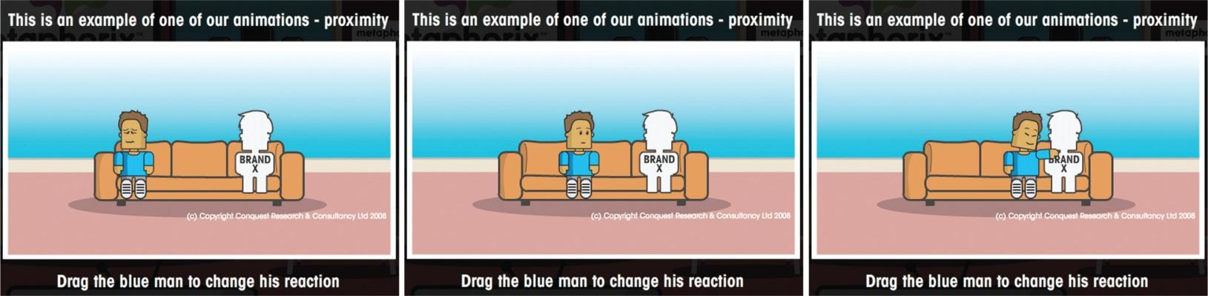
Metaphorix uses animations when creating surveys. Visithttp://www.metaphorixuk.com.
Compare the images above to the following survey question:
Rate how you feel about a brand:
negative | neither positive nor negative | positive

Developing Surveys: Asking Questions
The success of a survey in gathering useful data is largely determined by the design of the survey, and particularly by the questions that are asked. A survey can comprise any number and types of questions, and these should be structured in such a way that more complicated questions only appear once users are comfortable with the survey.
Be careful when creating questions that you do not introduce bias by asking leading questions.

Example of Leading Question Bias
An example question might be the following:
We have recently introduced new features on the Web site to become a first-class Web destination. What are your thoughts on the new site?
Replace this with the following to get rid of bias:
What are your thoughts on the changes to the Web site?
Questions in the survey should be brief, easy to understand, and most of all, easy to answer.

Types of Survey Questions

Open-Ended Types
Open-ended questions allow respondents to answer in their own words. This usually results in qualitative data. Take the following example:
What features would you like to see on the Web site for the eMarketing textbook?
If there are enough respondents to an open-ended question, the responses can be used quantitatively. For example, you can say with some certainty, “37 percent of people thought that case studies were an important feature.”

Closed-Ended Types
Closed-ended questions give respondents specific responses to choose from (i.e., they are multiple choice, with one answer or multiple answers). This results in quantitative data. Take the following examples:
Do you use the eMarketing textbook Web site? Choose one that applies.
—Yes
—No
What features of the eMarketing textbook Web site do you use? Check all that apply.
—Blog
—Case studies
—Free downloads
—Additional resources

Ranked or Ordinal Questions
These questions ask respondents to rank items in order of preference or relevance. Respondents are given a numeric scale to indicate order. This results in quantitative data. Take the following example:
Rate the features of the eMarketing textbook Web site, where 1 is the most useful and 4 is the least useful.
—Blog
—Case studies
—Free downloads
—Additional resources

Matrix and Rating Types
These types of questions can be used to quantify qualitative data. Respondents are asked to rank behavior or attitude. Take the following example:
The eMarketing textbook Web site is a useful tool for further studies.
Figure 18.5 Different Types of Rating Scales
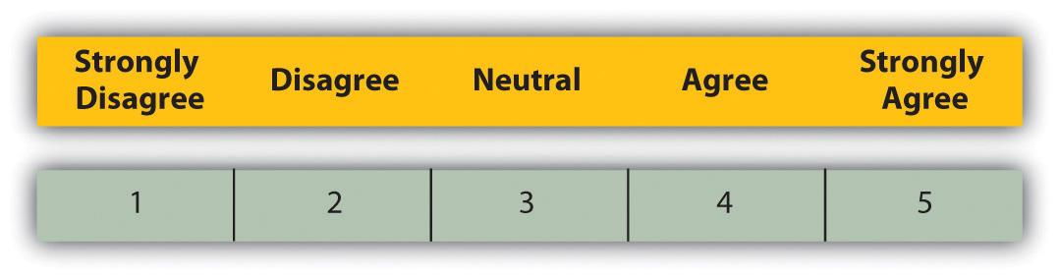
Or
The eMarketing textbook Web site is a useful tool for further studies.
Figure 18.6
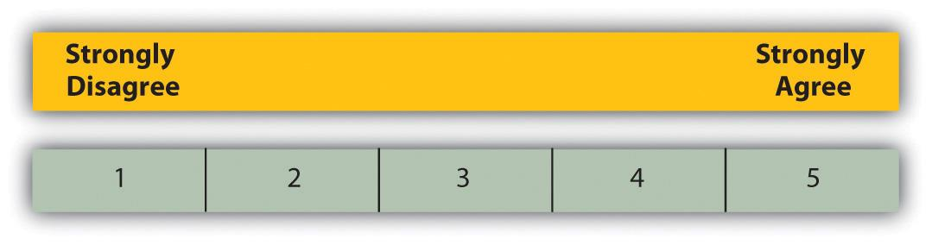
Rating scales can be balanced or unbalanced. When creating the questions and answers, choosing balanced or unbalanced scales will affect whether you are collecting data where someone can express a neutral opinion or not.

Figure 18.7
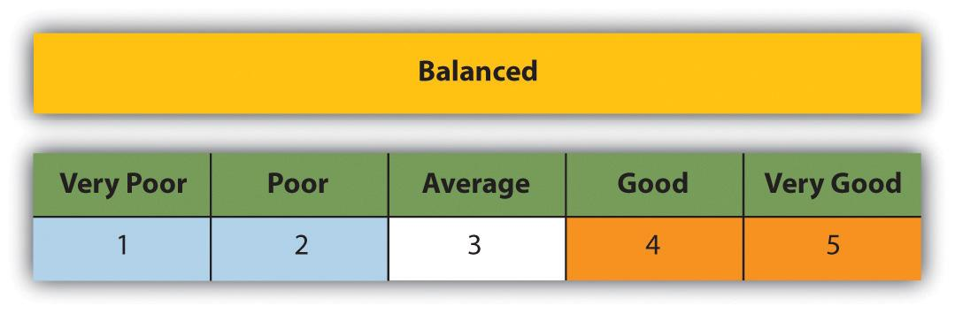
Figure 18.8
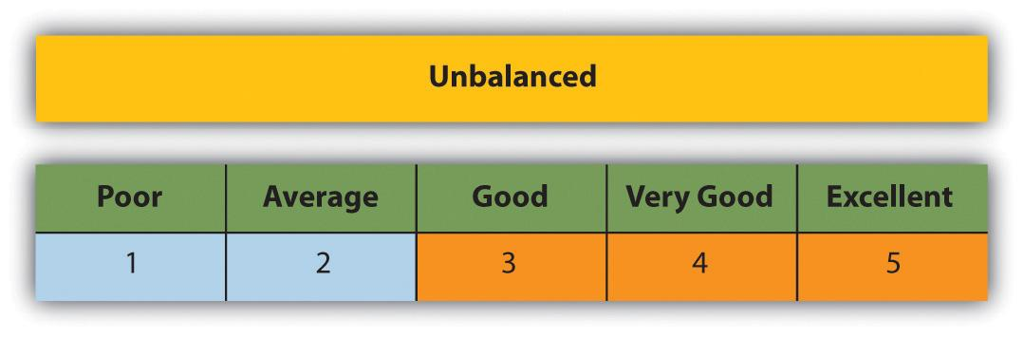

How to Get Responses: Incentives and Assurances
As the researcher, you know what’s in it for you in sending out a survey: you will receive valuable data that will aid in making business decisions. But what is in it for the respondents?
According to SurveyMonkey, the ways in which the surveys are administered play a role in response rates for surveys, and these can be relative:
- Mail. 50 percent adequate, 60 to 70 percent good to very good.
- Phone. 80 percent good.
- E-mail. 40 percent average, 50 to 60 percent good to very good.
- Online. 30 percent average.
- Classroom pager. More than 50 percent good.
- Face to face. 80 to 85 percent good. ^{[1]}
Response rates can be improved by offering respondents an incentive for completing the survey, such as a chance at winning a grand prize, a lower priced incentive for every respondent, or even the knowledge that they are improving a product or service that they care about.
There is a train of thought that paying incentives is not always a good thing. Among less affluent or educated respondents it may predispose them to feel that they need to give so-called good or correct answers that may bias your results. Alternatively you may attract respondents who are in it just for the reward. One approach could be to run the survey with no incentive with the option to offer one if responses are limited.
Figure 18.9
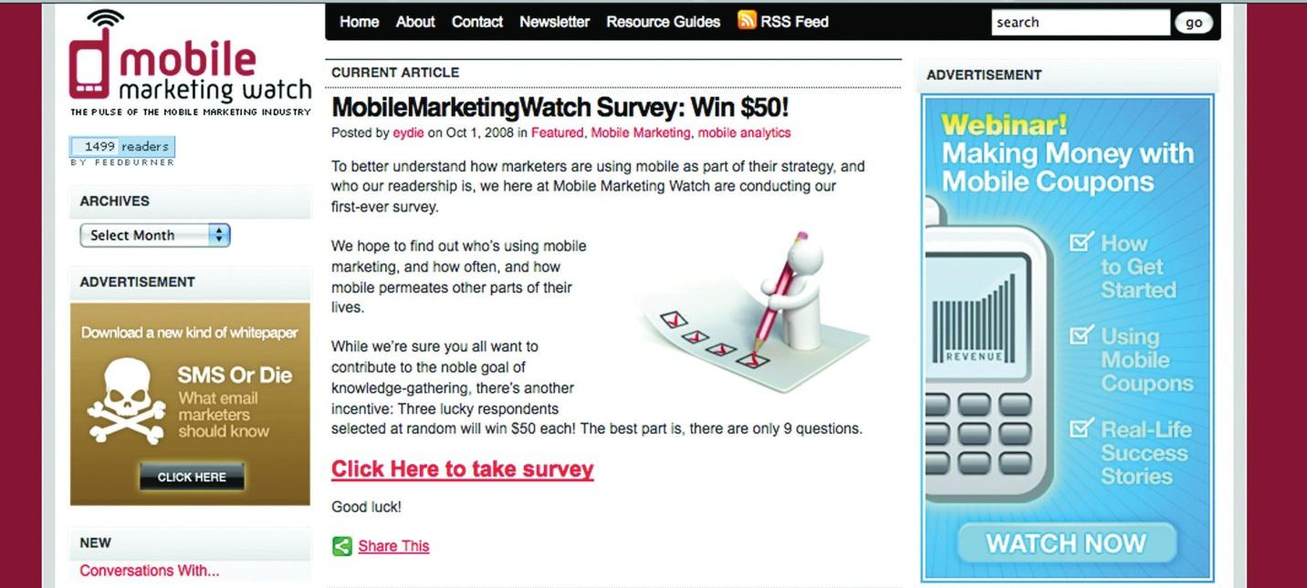
An incentive is offered for completing a survey.
Designing the survey so as to assure respondents of the time commitment, and privacy implications, of completing the survey can also help increase responses.

Conducting Research Surveys: A Step-by-Step Guide
As with all things eMarketing, careful planning goes a long way to determining success. As market research can be an expensive project, it is important that planning helps to determine the cost versus the benefit of the research. Qualitative research and secondary research are critical steps in determining whether a larger-scale research project is called for.
Bear in mind that many tasks that fall under the umbrella of research should be ongoing requirements of eMarketing activities, such as conversion testing and optimizing and online reputation management. Polls and small surveys can also be conducted regularly, and nonintrusively, among visitors to your Web site.

Step 1: Establish the Goals of the Project—What You Want to Learn
Secondary research can be used to give background and context to the business problem and the context in which the problem can be solved. It should also be used to determine alternative strategies for solving the problem, which can be evaluated through research. Qualitative research, particularly using established online research communities, can also help in determining what the business problems are that need to be solved. Ultimately, determine what are the actions you will be considering after the research is completed and what insights are required to make a decision on those actions.

Step 2: Determine Your Sample—Whom You Will Interview
You do not need to survey the entire population of your target market. Instead, a representative sample can be used to determine statistically relevant results. In selecting a sample, be careful to try to eliminate bias from the sample. Highly satisfied customers, for example, could give very different results compared to highly dissatisfied consumers.

Step 3: Choose Research Methodology—How You Will Gather Data
The Internet provides a multitude of channels for gathering data. Surveys can be conducted online or via e-mail. Online research panels and online research communities can all be used for gathering data. Web analytics can also be used to collect data, but this is a passive form of data collection. Determine what will provide you with the information you need to make decisions. Be sure to think about whether your research calls for qualitative or quantitative data as this determines the methodology as well.

Step 4: Create Your Questionnaire—What You Will Ask
Keep the survey and questions simple, and ensure that the length of the survey does not overwhelm respondents. A variety of questions can be used to make sure that the survey is not repetitive.
Be sure when creating the questions that you keep your goals in mind: don’t be tempted to try to collect too much data, or you will likely overwhelm respondents.

Step 5: Pretest the Questionnaire, If Practical—Whether You Are Asking the Right Questions
Test a questionnaire to determine if questions are clear and that it renders correctly in various browsers or e-mail clients. Ensure that test respondents understand the questions and that they are able to answer them satisfactorily.

Step 6: Conduct Interviews and Enter Data—How You Will Find Out Information
Run the survey! Online surveys can be completed by respondents without your presence; you just need to make sure that you get them in front of the right people. A survey can be sent to an e-mail database or can be advertised online.

Step 7: Analyze the Data—What You Find Out
Remember that quantitative data must be analyzed for statistical significance. The reports should aid in the decision-making process and produce actionable insights.

Room for Error
With all research, there is a given amount of error that needs to be dealt with. Errors may result from the interviewers administering a questionnaire (and possibly leading the respondents) to the design and wording of the questionnaire itself, sample errors, and respondent errors. Using the Internet to administer surveys and questionnaires removes the bias that may arise from an interviewer. However, with no interviewer to explain questions, there is potential for greater respondent error. This is why survey design is so important and why it is crucial to test and run pilots of the survey before going live.
Respondent error also arises when respondents become too used to the survey process. There is the possibility of respondents becoming desensitized. There is even a growing trend of professional survey takers, especially where there is an incentive involved. The general industry standard is to limit respondents to being interviewed once every six months.
Sample error is a fact of market research. Some people are just not interested in, nor will ever be interested in, taking part in surveys. Are these people fundamentally different, with different purchasing behavior, from those who do? Is there a way of finding out? To some extent, Web analytics, which tracks the behavior of all visitors to your Web site, can be useful in determining the answer to this question.
When conducting any survey, it is crucial to understand who is in the target universe and what the best way to reach that target universe is. Web surveys exclude elements of the population, due to access or ability. It is vital to determine if this is acceptable to the survey and to use other means of capturing data if it is not.

Conducting Research: Who’s Going to Pay?
Regular research is an important aspect of the growth strategy of any business, but it can be tough to justify the budget necessary for research without knowing the benefit to the business. Conducting research can cost little more than the time of someone who works for a company, depending on the skills base of employees, or it can be an expensive exercise involving external experts. Deciding where your business needs are on the investment scale depends on the depth of the research required and what the expected growth will be for the business. When embarking on a research initiative, the cost to benefit ratio should be determined.
Testing should be an ongoing feature of any eMarketing activity. Tracking is a characteristic of most eMarketing that allows for constant testing of the most basic hypothesis: is this campaign successful in reaching the goals of the business?

KEY TAKEAWAYS
- Conducting surveys online allows for data to be captured immediately.
- Developing technology allows for sophisticated and user-friendly surveys to be compiled.
- The success of a survey can be determined by how the survey is designed.
- Questions should be worded in a way that allows for an honest answer from the user. All questions should be easy to understand and answer.
- There are four main types of survey questions:
  - Open-ended
  - Closed-ended
  - Ranked or ordinal
  - Matrix and rating
- Survey respondents should get something in return for the data they provide you.
- Response rates improve greatly when there is an incentive for the respondents. However, some people do not believe this is good to do, as responses may be biased. Survey takers may be in it just for the incentive.
- Careful planning is essential to any market research initiative.
- The steps to executing market research properly are as follows:
  - Establish the goals of the project.
  - Determine your sample.
  - Choose research methodology.
  - Create your questionnaire.
  - Pretest the questionnaire, if practical.
  - Conduct interviews and enter data.
  - Analyze the data.
- Be aware that there is room for error.
- Costs for a research initiative can vary, depending on the scope of the project. It may be appropriate to do the study from within the company, or it may be necessary to hire external experts.

EXERCISES
- Develop survey question examples for each of the types of survey questions outlined in this section.
- Evaluate the seven steps to conducting research. What do you think might happen if one of these steps is missed or poorly handled? Give an example.

[1] SurveyMonkey, “Smart Survey Design,” June 12, 2008,http://s3.amazonaws.com/SurveyMonkeyFiles/SmartSurvey.pdf (accessed September 29, 2008).

18.5 Case Study: BrandsEye
BrandsEye (http://www.brandseye.com) is an online reputation management tool that was launched in March 2008. It scours the Internet in near real-time for mentions of specific keywords and then develops a reputation score based on those mentions. Online reputation-monitoring tools are fairly new to the online scene, which meant that business and technical developments following the launch of BrandsEye relied heavily on feedback from users, and potential users, of the system.
Figure 18.10 The Logo from BrandsEye.com
BrandsEye’s primary target is large businesses, and the service and pricing options on launch reflected this. Of course, one of the businesses that the tool has been tracking from day one is BrandsEye itself. While mentions are quantitatively analyzed to generate a reputation score, they can all be qualitatively analyzed to determine sentiment from specific individuals and to highlight product features that may be improved.
BrandsEye requires a rapid rate of development to ensure its product remains competitive. With a relatively small number of vocal individuals discussing its industry online, BrandsEye decided that traditional, and expensive, focus groups and surveys were out. These could instead be replaced by real-time analysis and one-to-one consumer engagement. BrandsEye also realized that in the relatively new field of online reputation measurement and management, it was important to have online evangelists on board in order to, over time, heighten brand awareness among its big-business target market.
In the week following its launch there were over 120 conversations about BrandsEye from many smaller companies and individuals. They loved the service but found the price prohibitive. Over the next three months more than three hundred unique conversations were tracked, with important outcomes for BrandsEye’s product offering.
An example comment that represented a common theme was “BrandsEye Online Reputation Management for Big Business ONLY.” ^{[1]}
While big business sales continued to grow, BrandsEye realized that the more people who engage with its product, the more feedback it could collect and, with that, increase the rate of market-driven development. Second, of doing this that it realize that there was a considerable untapped market among small businesses and individuals.
Instead of conducting focus groups, BrandsEye found that one already existed! Using feedback from early commenters, BrandsEye developed a small business and blogger product. The service was priced to be accessible to this target market at only $1 a month.
Since the launch of the new service, BrandsEye has grown considerably. Several new features have been added in direct response to market needs. BrandsEye has seen an over 800 percent turnover increase for its big-business offering and a 2,500 percent increase in the overall number of accounts. It just took a little research.
Visit the BrandsEye Web site at http://www.brandseye.com.

CASE STUDY QUESTIONS
- How are the data used both quantitatively and qualitatively?
- Why was BrandsEye able to conduct consumer research without conducting focus groups? What are the limitations of doing this that it would need to be aware of?
- How has market research helped BrandsEye’s business to grow?

[1] Nic Haralambous, “BrandsEye Online Reputation Management for Big Business ONLY,” nh [dot] com, March 13, 2008, http://nicharalambous.com/2008/03/13/brandseye-online-reputation-management-for-big-business-only (accessed June 20, 2010).

18.6 References
Reid Carr, “Qualitative vs. Quantitative Testing,” iMedia Connection, February 17, 2005, http://www.imediaconnection.com/content/5097.asp (accessed September 29, 2008).
Alicia Clegg, “Virtual Worlds Are the Reality,” Marketing Week, July 3, 2008,http://www.marketingweek.co.uk/in-depth-analysis/virtual-worlds-are-the-reality/2061442.article (accessed September 29, 2008).
Matt Foley, “Research Communities vs. Research Panels,” PluggedIN, September 22, 2008, http:// www.pluggedinco.com/blog/bid/8784/Research-communities-vs-research-panels (accessed September 29, 2008).
“Guide to the Design of Questionnaires,” University of Leeds Information Systems Services, August 12, 2008,http://iss.leeds.ac.uk/info/312/surveys/217/guide_to_the_design_of_questionnaires (accessed September 29, 2008).
Neville Hobson, “The GM FastLane Blog—The Poster Child for Executive Blogs,” Neville Hobson, May 2005, http://www.nevillehobson.com/resources/fastlane(accessed September 29, 2008).
Lee LeFever, “Interview with Michael Wiley of the GM Fastlane Blog,” Common Craft, February 21, 2005, http://www.commoncraft.com/interview-michael-wiley-gm-fastlane-blog (accessed September 29, 2008).
“Survey Design,” Creative Research Systems, May 2008,http://www.surveysystem.com/sdesign.htm (accessed September 29, 2008).

Chapter 19

eMarketing Strategy

19.1 Introduction
A strategy is a long-term plan of action aimed at achieving a particular outcome. Tactics refer to the immediate actions taken to execute a strategy. While most of the chapters in this textbook refer to the tactics that the Internet has afforded to marketing, the essential first step to executing any online campaign is in the planning: strategy.
“Strategy” comes from the Greek strategos, which itself is derived from two words:
- Stratos for “army”
- Ago for “leading”
“Tactic” also comes from Greek: taktika for deploying or arranging.
In wars and business, a strategy usually intends the same outcome: winning.
Treatises on strategy abound. The Art of War was written by Sun Tsu in the sixth century B.C., and this ancient Chinese text on military strategy often forms the foundation of business strategy today. Move forward a few millennia, and a course in marketing will include Porter’s five forces, McCarthy’s four Ps, and Humphrey’s SWOT analysis. At the time that the framework for the Internet was being researched and developed, economists and academics were laying the foundation for principles still leading marketing thought today.
The Internet has had a far greater impact on marketing and business than the ubiquitous e-mail newsletter and the need for search engine optimization (SEO). It is not just the way in which products and services can be marketed that has changed, but new products and services are being developed as well.

How the Internet Has Changed the World We Market In
Figure 19.1 Four Types of Markets
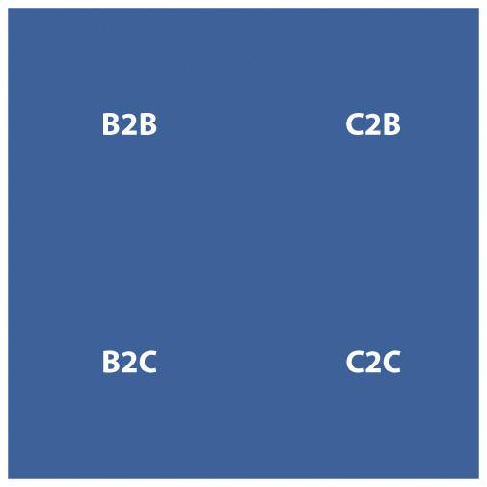
The Internet has changed the types of products that can be sold, has changed the market for products in terms of geography, has had a huge impact in the way products are sold and marketed, and has seen a significant shift in the balance of power between businesses and consumers. Where marketing once was seen as a one-way broadcast channel, with customer wants and needs driven by focus groups, today effective marketing is based on a two-way conversation that happens person to person.
However, the Internet does not necessarily mean throwing out the rule book of marketing and business foundations and principles. Instead, the Internet provides a new environment in which to build on these principles. Profit is still revenue less cost. The Internet does not change that.

19.2 The Internet and the Marketing Mix

LEARNING OBJECTIVE
- Learn how the four Ps of marketing have been influenced by the Internet.
McCarthy’s four Ps of marketing are product, price, placement, and promotion. Developing technology, naturally, has an effect on all of these, and the Internet in particular has seen fundamental shifts not only in the means available to promote products but also in the placement, or distribution, of products. Although tools for research, retention, distribution, and product creation have changed dramatically, the fundamental principles of marketing still guide strategy.

Products and Services
Products and services are what a company sells. From fast-moving consumer goods to digital products such as software to services such as consultancy, the Internet has allowed for a plethora of new products.
Technology allows for mass customization of products, seen in a growing trend of letting customers customize goods online before they are created. For example, NIKEiD (http://nikeid.nike.com) and Converse (http://www.converse.com) both allow customers to create their own trainers based on a number of preset options, which will then be manufactured to the customer requirements. In a similar fashion, computer products can be built to specifications, as the costs of offering this type of service to customers is reduced by the Internet.
Figure 19.2
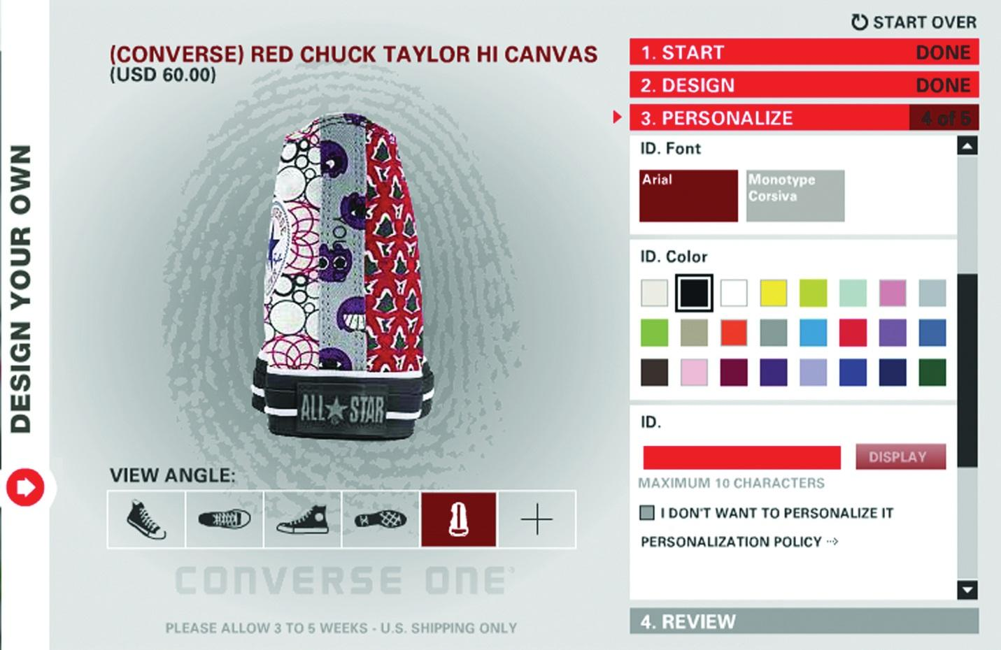
Converse allows customers to create their own shoes.
Digital products can exist because of the Internet. The very framework of the Internet allows for products such as software and digital music to be distributed. The Internet as a distribution medium is what makes these products possible.

Price
With customers able to easily access pricing information from a number of suppliers, the Internet is growing a market of near-perfect competition. ^{[1]} The prevalence of search engines and of shopping comparison Web sites, such ashttp://www.pricerunner.com and http://www.nextag.com, make it easy for customers to compare product prices across a number of retailers. The temptation for companies to differentiate themselves on price has led to decreased prices for many commodities, from the regularly reduced pricing of books on Amazon.com to ticket prices on low-cost airlines such as EasyJet (http://www.easyjet.com) in Europe.

Placement or Distribution
Particularly for digital products and services, the Internet gives companies access to a global marketplace. Product distribution and markets no longer have to be dictated by location. With efficient delivery and shipping channels, products that are not digital can also benefit from a far wider marketplace. The Internet allows the basic foundations of mail-order businesses to flourish online with a catalog that is cheaper to produce and update and cheaper to distribute: a Web site. In the travel industry, travel agents stopped issuing paper tickets as of May 31, 2008. ^{[2]} Nearly all airplane tickets are now e-tickets.

Note
An API is an application programming interface. Essentially, an API gives instructions and rules for communicating with another program or database. This allows, for example, different companies and developers to build different front-end systems that all communicate with the same database.
Technology such as APIs (application programming interfaces), SOAP (simple object access protocol) services, RSS (really simple syndication), and XML (extensible markup language) allow information and services to be distributed throughout the world. For example, the API for a hotel reservations database, Starfish Luxury Travel Distribution (http://starfishinteractive.com), allows a diverse range of Web sites to offer instant online bookings for hotels in the inventory. Partners with booking engines includehttp://starfishinteractive.com, http://www.spaworld.tv, andhttp://www.timesonline.co.uk.
This is both a huge opportunity and a huge challenge for businesses. On the one hand, it can allow niche products and markets to flourish in a global space. On the other hand, it can be tempting for a marketer to try to reach too many markets at once. A global marketplace is also not yet fully supported by national banking and tax legislation.

Promotion
The Internet as an information and entertainment medium naturally lends itself to be used to promote products. The online promotional mix is an extension of the offline but with some significant differences: online promotion can be tracked, measured, and targeted far more sophistically than offline. Advertising, personal sales, promotions-based marketing, and public relations are tactics that can all be conducted through the online medium.

New Ps and New Marketing
Well-known marketing guru Seth Godin says that marketing is actually about five elements:
- Data. That which we observe (and made easier to gather and mine through the use of the Internet).
- Stories. Everything you do and say.
- Products (services). The physical manifestation of the story.
- Interactions. All the tactics a marketer can use to “touch” the prospect or customer.
- Connection. The end goal; creating a relationship. ^{[3]}
- But Seth Godin is not the only smart marketer challenging the four Ps. Idris Mootee put forward four new Ps for marketing in the connected environment:
- Personalization
- Participation
- Peer-to-peer communities
- Predictive modeling ^{[4]}

Personalization
Databases and the use of cookies to remember Web visitors allow for online experiences to be tailored to particular Web visitors. Amazon makes use of personalization to recommend books to customers based on their past purchases.

Participation
With the growth in social media and consumer-generated content, customers are demanding, and taking, a stake in the brands that they use. Savvy companies can encourage participation through onsite reviews and allowing customers to upload images and video, and all companies should be aware of the many ways that consumers are participating.

Peer-to-Peer Communities
Peer-to-peer communities can be seen to work with customer participation. Through social media, existing customers can be a company’s greatest asset or greatest detractor. Equipping an engaged and active customer base with the tools to spread a message should be an integral part of a long-term eMarketing strategy.

Predictive Modeling
The connected nature of the Internet allows for every action online to be tracked, measured, and stored. Huge amounts of data, both anonymous and identifiable, are being stored daily. Analysis of these data can provide insight into solving marketing problems. For example, in PPC (pay-per-click) advertising, data are gathered that over time will indicate the optimal keywords and maximum CPC (cost-per-click) bids for effective bidding.
Godin’s five marketing elements are reminiscent ofThe Cluetrain Manifesto’s premise that “markets are conversations,” and both highlight the importance of marketing as people talking to people. This is not a new phenomenon brought on by the World Wide Web. Instead, the Web has served to act as a global focus group, with participants eager to share their thoughts, discoveries, likes, dislikes, and any other sentiment.
Mootee’s four Ps focus on what technology brings to the original marketing mix. Technology has allowed for mass customization, not just in marketing messages but also in content and product creation. It has seen brands that allow customer participation in spreading and even creating their messages and products succeed. The growth of social networks online and the recognized importance of product reviews in the buying cycle are reflected in peer-to-peer communities. Lastly, the Internet is useful in tracking and gathering data, which can be mined and analyzed for opportunities for growth.
What recent approaches to marketing strategy have in common is one growing theme: customer-centric marketing.
The strength of the Internet is demonstrated in the way it underlines connections. The very fabric of the Internet is based on hyperlinks—being able to link from one document to another. These technical connections are mirrored in the need for marketing to appeal to customer’s feeling of connection in the social sense.

Customer-centric Marketing
Customer-centric marketing infers that by understanding the needs of the customer first and foremost, business outcomes will be achieved. Looking at the marketing mix from a customer-centric perspective should result in products and strategies that are meeting the needs of potential customers, as opposed to a need to invest in expensive, interruptive advertising to convince customers of a need that they do not have.

Products
Products and services should be designed from a customer perspective based on their needs.

Price
When considering pricing from a customer perspective, it is tempting to believe that the lowest price is best. While that can attract customers in the short term, focusing on the value of the product and the services offered with it is a better strategy for long-term growth. The customer approach to pricing considers value. The key is to build a long-term cost advantage.

Placement
The customer-centric approach to placement recognizes that you cannot dictate the manner in which customers find you online: from the search engine and keywords they could use to find your service to the browser and device they are using when accessing your Web site.

Promotion
The Internet was not created as a marketing tool: it was created to share information. The number of people accessing the Internet, the amount of time spent online, and the commerce that takes place online make it an attractive marketing environment.

KEY TAKEAWAYS
- The following are the traditional four Ps of marketing:
  - Products and services
  - Price
  - Placement or distribution
  - Promotion
- The following are the new four Ps of marketing, according to Idris Mootee:
  - Personalization
  - Participation
  - Peer-to-peer communities
  - Predictive modeling
- Seth Godin argues that marketing is about five elements:
  - Data
  - Stories
  - Products (services)
  - Interactions
  - Connections
- The growing theme is customer-centric marketing.
- Customer-centric marketing infers that understanding the needs of the customer is first and foremost.

EXERCISE
- Think of a situation where the traditional four Ps may not work in today’s marketing landscape.

[1] Michael E. Porter, “Strategy and the Internet,” Harvard Business Review 9, no. 3 (March 2001): 62–78.
[2] “The End of the Paper Airline Ticket,” USA Today, June 1, 2008,http://www.usatoday.com/travel/columnist/grossman/2008-05-30 -paper-tickets_N.htm(accessed June 20, 2010); “Fact Sheet: Electronic Ticketing (ET),” International Air Transport Association, June 2010,http://www.iata.org/pressroom/facts_figures/fact_sheets/Pages/et.aspx (accessed June 23, 2010).
[3] Seth Godin, “Five Easy Pieces,” Seth Godin’s Blog, June 25, 2008,http://sethgodin.typepad.com/seths_blog/2008/06/five-easy-piece.html (accessed May 12, 2010).
[4] Idris Mootee, “Web 2.0 and the Marketing New 4Ps,” Futurelab, February 5, 2008,http://blog.futurelab.net/2007/07/web_20_and_the_marketing_new_4.html (accessed May 12, 2010).

19.3 Developing a Marketing Plan

LEARNING OBJECTIVE
- Learn the steps in developing a marketing plan.
Figure 19.3 Steps to Creating a Strategy
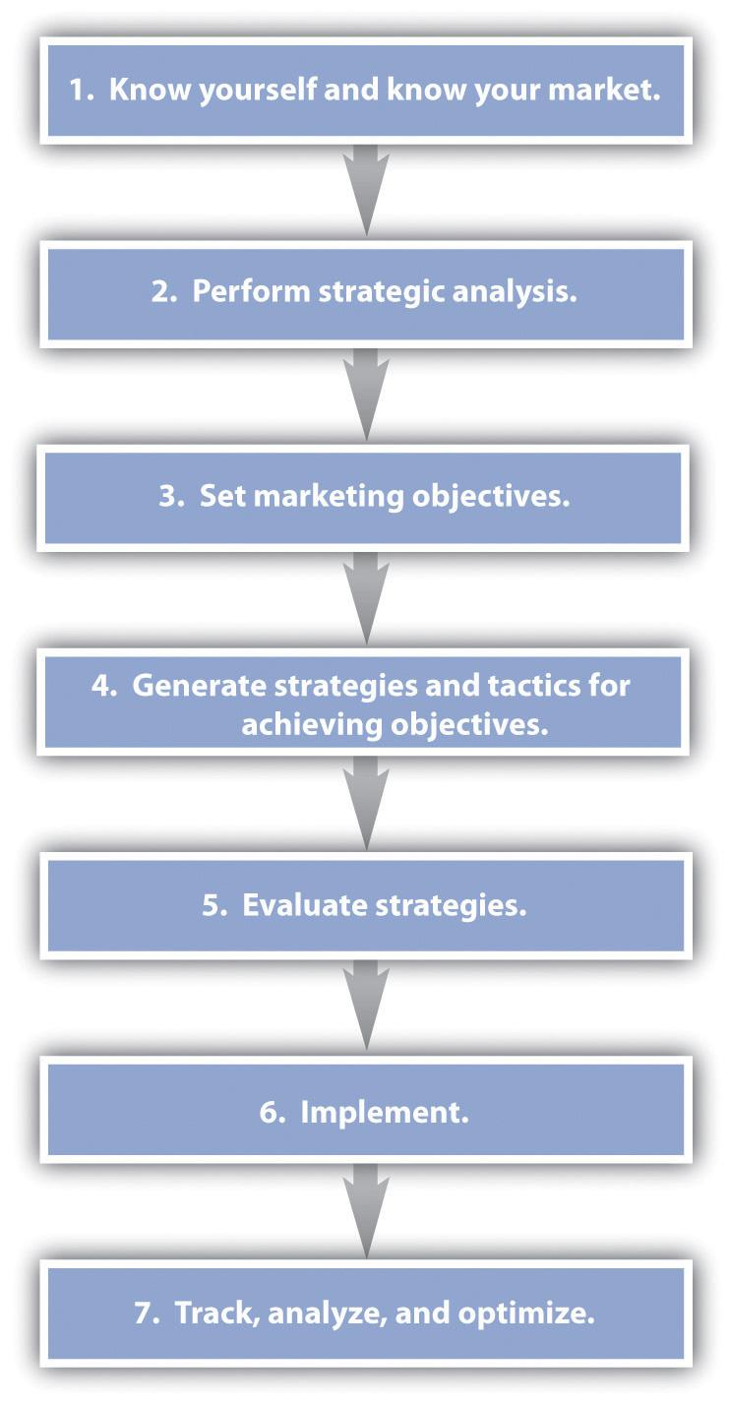
An eMarketing strategy should not be created in isolation from an offline strategy. Instead, marketers need to take a holistic view of all business objectives and marketing opportunities. Offline and online activities should complement each other, both having the potential to reach different audiences in different ways. However, the Internet is exceptionally useful as a research and information tool in the strategy process.

Step 1: Know Yourself and Know Your Market
The starting point for any business and marketing strategy is to know who you are. “You” refers to the organization as a whole (although, of course, a little bit of self-discovery is always advised). While this can, and should, be readdressed periodically, start by looking at what the business problems are right now so that a strategy can be developed that solves these problems:
- What is the nature of the organization now?
- Who are the customers and what are their needs? How can the organization fulfill the needs of the customer?
- What is the social context that the organization operates in?

Step 2: Perform Strategic Analysis
With a solid understanding of where the organization is right now, further analysis systematically evaluates the organization’s environmental and social context, objectives, and strategies so as to identify weaknesses and opportunities.

Porter’s Five Forces Analysis
Porter’s five forces analysis is useful in understanding the attractiveness of the market in which an organization is transacting. However, this framework for analysis was developed before the Internet, which has disrupted the markets in which we operate.
Production and distribution costs in many industries have been drastically lowered; the barriers to entry and costs of switching are reduced. This means that there are more competitors in the market as the barriers to entry for new organizations are reduced and that cost is less likely to inhibit customers from switching to a competing product as there are less likely to be high costs associated with doing so. Perhaps most importantly, the bargaining power of end users is increased as they have greater access to information when making a purchase decision.
Often, the Internet migrates competition primarily to price. ^{[1]} This means that organizations seek to attract and retain customers solely through offering services and goods at a lower price, though this is not necessarily the best strategy for companies to follow. Strategic differentiation comes from the value that a company can provide to a consumer.
Figure 19.4 Porter’s Five Forces
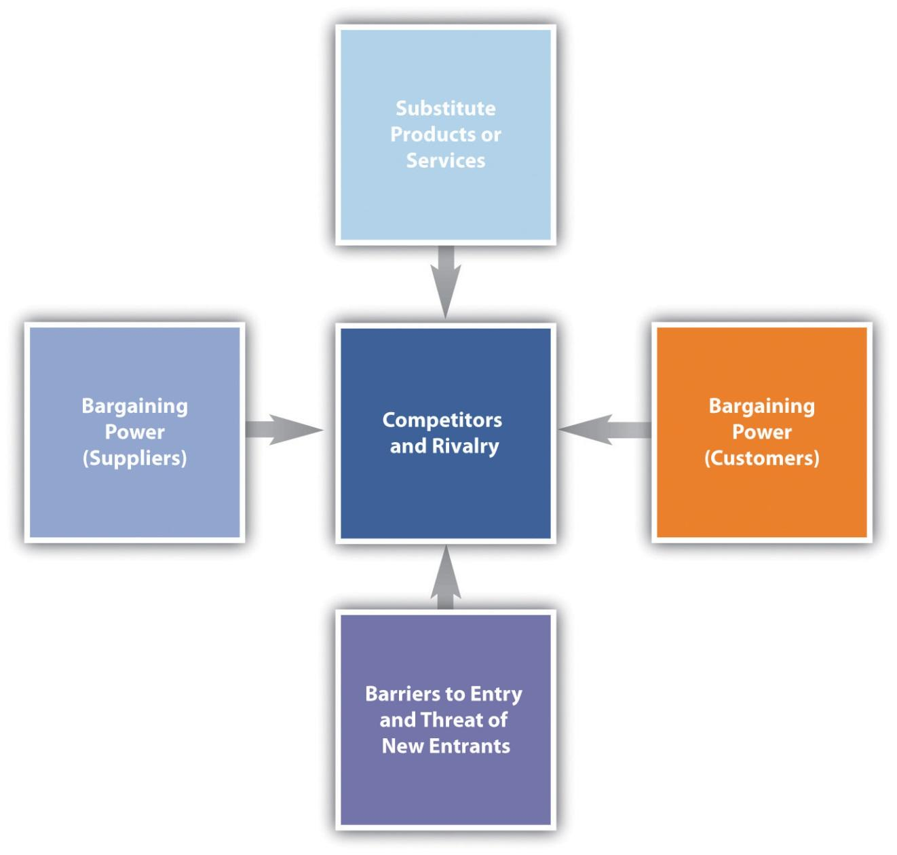

Competitors
When analyzing competitors, it is not only product and price that lead the discovery process. While there may be obvious competitors in the same industry, an organization needs to consider what (or who) else may be vying for consumers’ attention and valuable search engine traffic.
In identifying competitors, analyze the needs of your customers and determine how else customers might fulfill those needs. Products and services are not only competing for customers’ money: they are fundamentally competing for customers’ attention.
Considering the customized Converse shoes, the customers’ needs are not likely to be that they have to cover bare feet. Instead, the shoes are fulfilling a customer’s need for individuality and self-expression. NIKEiD is an obvious competitor, but so is a service like Face Your Manga (http://www.faceyourmanga.com) that allows Web users to create custom manga avatars (or computer users’ representations of themselves, which are shown in the form of icons or 3D characters) to use online.

Step 3: Set Marketing Objectives
Marketing objectives are the desired outcomes of the marketing plan. What are the specific goals that will indicate the success of the marketing strategy?
These should be unique to an organization and are based around the outcomes that will make money for the organization. This is a strategy, so the focus is on long-term success. Establish milestones that will indicate that the strategy is on the path to success.

Step 4: Generate Strategies and Tactics for Achieving Objectives
It’s time to put into practice the tactics covered in this textbook. Based on your analysis of your organization and its objectives, consider strategies and tactics that will help you to meet these objectives.
For example, an objective could be the acquisition of new customers. A tactic could be the display of advertising on content Web sites that reflect your target market. If customer retention is the objective, an e-mail newsletter strategy can help build relationships with an existing interested database of prospects.

Step 5: Evaluate Strategies
Figure 19.5 SWOT Analysis
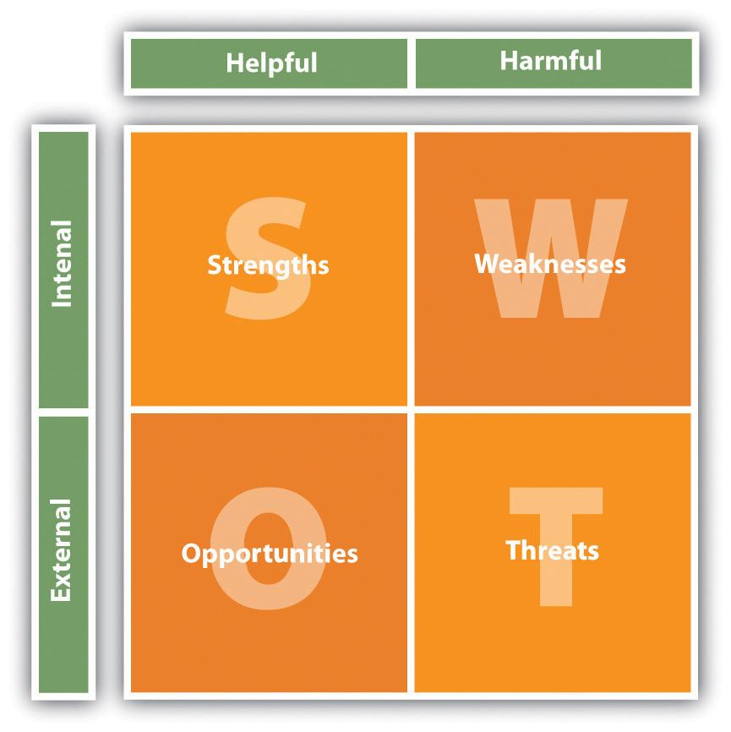
After generating strategies, they need to be evaluated against the needs and resources of your organization. At this stage, it can be useful to follow Humphrey’s SWOT (strengths, weaknesses, opportunities, and threats) analysis for a full analysis of the strategies generated.
For each strategy, a SWOT analysis reveals the strengths, weaknesses, opportunities, and threats afforded by a strategy (and of course can be used to evaluate the plan in its entirety).
SWOT analysis will reveal the feasibility and the attractiveness of the strategies generated. The needs of the organization include the following:
- Long-term goals
- Short-term objectives
- ROI (return on investment)
The resources of the organization include the following:
- In-house talent and staff
- Budget
- Contracted agencies

Step 6: Implement
You know what you want, and you’ve made a plan for how to get it. Now do it.

Step 7: Track, Analyze, and Optimize
What is eMarketing’s chief advantage over offline marketing? It uses hyperlinks to spread messages. This means that eMarketing can be tracked, the data can be analyzed, and this can then feed back into the planning to optimize the marketing strategy.
The Internet allows you to track each tactic on its own, and then intelligent analysis should allow you to consider how these tactics work together.

KEY TAKEAWAYS
- The seven steps to developing a marketing plan are as follows:
  - Know yourself and know your market.
  - Perform strategic analysis
  - Set marketing objectives
  - Generate strategies and tactics for achieving objectives
  - Evaluate strategies
  - Implement
  - Track, analyze, and optimize.
- An eMarketing strategy should not be created in isolation to an offline strategy but rather take a holistic view of all objectives.
- Offline and online activities should complement each other.

EXERCISES
- The textbook stresses the important of tracking, analyzing, and optimizing for any eMarketing campaign. Why?
- What is the difference between a strategy and a tactic?

[1] Michael E. Porter, “Strategy and the Internet,” Harvard Business Review 9, no. 3 (March 2001): 62–78.

19.4 eMarketing and Marketing

LEARNING OBJECTIVE
- Understand how eMarketing should fit into the overall marketing picture.
eMarketing refers specifically to marketing using the Internet, but holistic strategies allow companies to make the most of their budget through integrating online and offline activities. eMarketing should not be seen as separate or an afterthought to a marketing strategy. Instead, businesses should focus on their customers and use the channels most likely to reach their target market based on budget.
The cornerstone of a successful eMarketing strategy is flexibility. With near real-time reporting, the likely success of any campaign or channel can be gauged quickly. Flexibility allows for focus to be shifted as new opportunities and challenges arise.
Figure 19.6 eMarketing Tactics and Their Outcomes
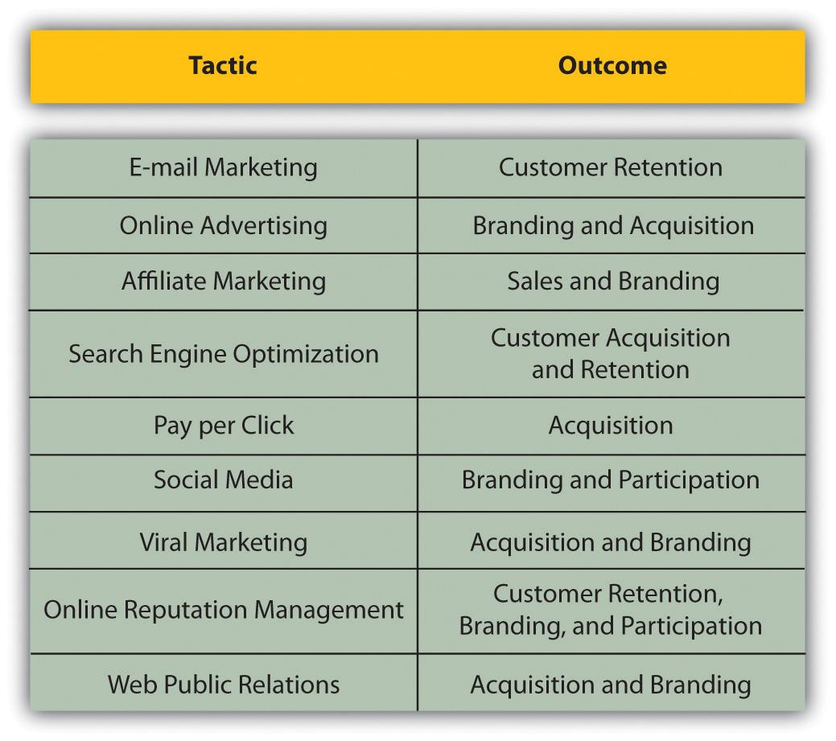

Online Tools for Gathering Market Intelligence
Many tools exist that allow an organization to gather information related to its business and those of competitors. These same tools also prove invaluable for market research, especially when keywords that are monitored are chosen to reflect industry trends.

Search Data for Both SEO (Search Engine Optimization) and PPC (Pay per Click)
- SpyFu. http://www.spyfu.com
- Quirk SearchStatus. http://www.quirk.biz/searchstatus
- SEO Book’s Rank Checker. http://tools.seobook.com/firefox/rank-checker

Watching Competitor Activities
- ChangeDetection. http://www.changedetection.com
- Google Alerts. http://www.google.com/alerts
- BrandsEye. http://www.brandseye.com
- Google Patent Search. http://www.google.com/patents

Trends and Market Research
- Google Insights. http://www.google.com/insights/search
- Flickr. http://www.flickr.com
- Delicious. http://delicious.com
- Google AdWords External Keyword Tool. http://www.adwords.google.com/select/KeywordToolExternal
When researching competitors, never forget the basics: visit their Web sites. Not only can you gather basic price and product information, but it also can be relatively easy to discover information about their marketing initiatives such as affiliate marketing.

KEY TAKEAWAYS
- Holistic strategies allow companies to make the most of their budget through integrating online and offline activities.
- The cornerstone of a successful eMarketing strategy is flexibility. Flexibility allows for focus to be shifted as new opportunities arise.

EXERCISE
- Why, when it comes to eMarketing in particular, is flexibility important in strategy?

19.5 Case Study: Barack Obama’s Strategic Use of the Internet
The 2008 U.S. presidential election was historic for many reasons and was keenly followed worldwide. Barack Obama’s campaign made unprecedented use of grassroots channels to generate support, encourage voter turnout, and raise funds with savvy use of the Internet to support its campaign. While with hindsight it may be plain to see how much the campaign got right, when Barack Obama started campaigning for the Democratic Party’s nomination, he was seen as an outsider. For much of that campaign, the media branded Barack Obama as the underdog.
The World Wide Web appears daunting to many big businesses and organizations. In politics, especially, few have incorporated the tools of the Web into successful campaigns to date. As with business, the Web was seen as an emerging channel in politics. This meant that the candidates that Obama was running against, in both the campaign for the Democratic nomination and in the presidential campaign, were focused on traditional tactics for gathering support. Not being the front-runner, Obama needed to engage with voters in new ways in order to succeed. The use of social media made the most of the Obama campaign’s greatest strength—its grassroots, community connections.
When it comes to elections in the United States, young voters are the toughest demographic to reach. It’s a challenge shared by many businesses and organizations trying to reach out to a younger audience. They find that traditional channels, such as television advertising, are having less and less of an impact. Instead of watching television, younger people are turning to the Internet and their mobile phones for entertainment and for interacting with their friends. Savvy brands that want to reach this market are turning to the same channels.
The Obama campaign realized early on that without the traditional support enjoyed by the other candidates, it would need to find new ways to raise funds and reach voters. As the Edelman Trust Barometer consistently shows, people are more likely to trust and listen to “someone like me.” ^{[1]} The best way to reach these “people like me” is to use existing social connections. The Obama campaign used this to create a social network, http://www.my.barackobama.com, that supporters could use to self-organize events, connect with other supporters, and receive feedback and support from the campaign. According to Quantcast figures, this network saw over a million visitors each month, eclipsing two million visitors in some months. ^{[2]}
Figure 19.7 Image from My.BarackObama
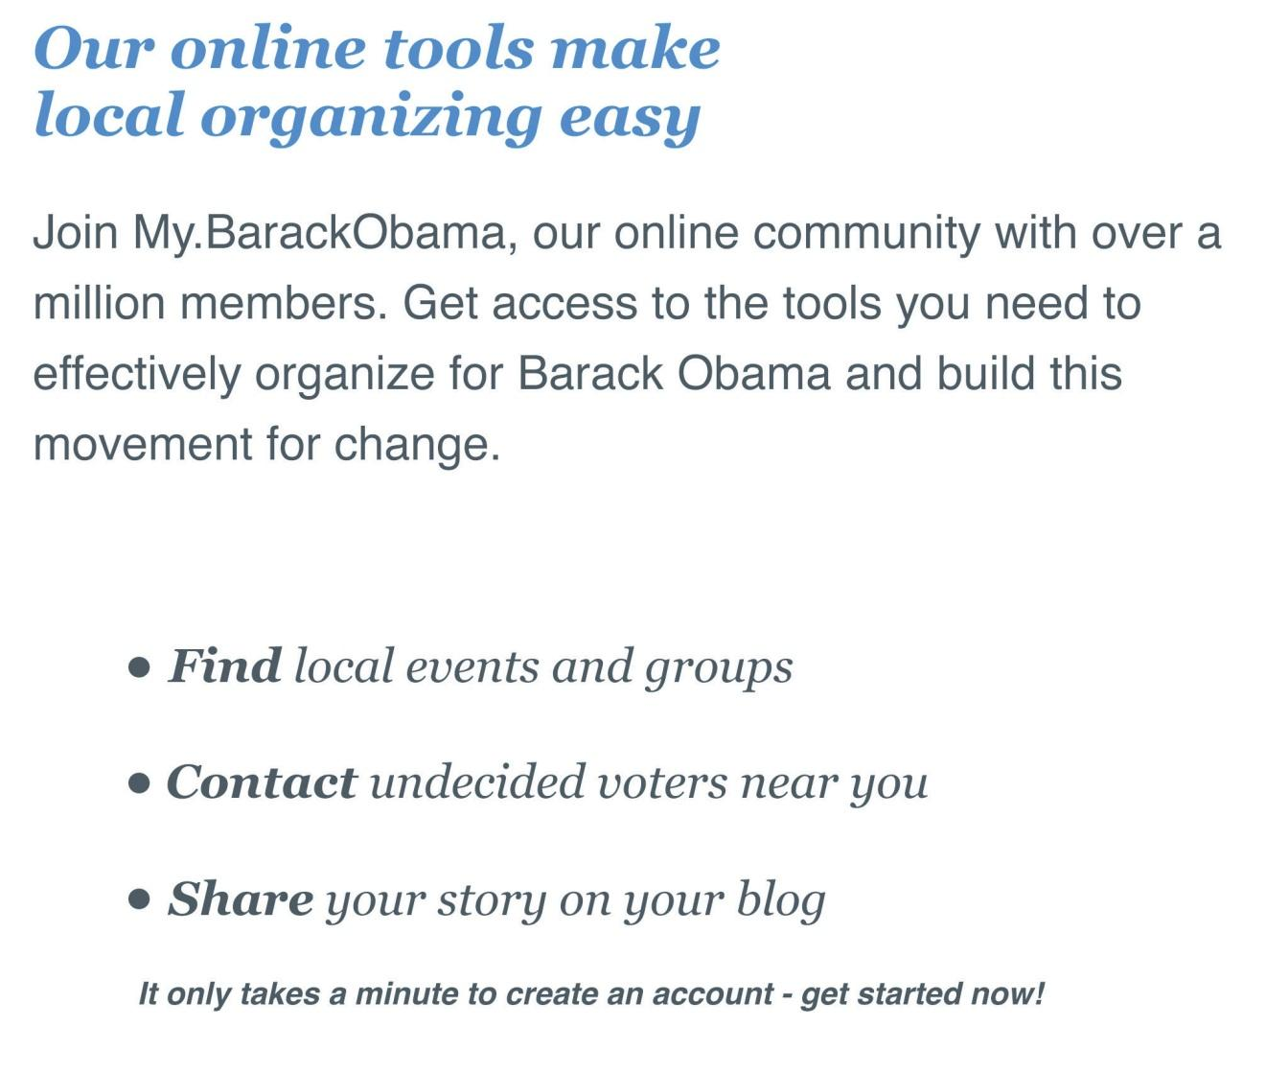
For best results in making use of social connections, existing social networks should also be utilized. Even though the previously mentioned social network my.barackobama.com was the hub of the campaign, profiles were created on all major social-networking Web sites to enable the campaign to reach out to supporters in as many channels as possible. Profiles, groups, and pages were created on Facebook, Twitter, and YouTube to name just a few. In fact, photographs from election night were released by the Obama campaign on Flickr. Top-viewed videos on the campaign’s official YouTube channel have received over five million views each.
The campaign also made excellent use of a number of other eMarketing tactics, all carefully co-coordinated to make supporters feel as engaged and involved in the campaign as possible. While Hillary Rodham Clinton raised $13.5 million in January 2008 to support her campaign, mostly through large, traditional fund-raising events, Barack Obama raised $36 million in the same month. Of that, $28 million was raised online with 90 percent of those transactions coming from people who donated $100 or less, and 40 percent from donors who gave $25 or less. Even small donors felt that they, personally, were making a difference.
The Obama campaign used every opportunity for interaction to collect information that would allow it to connect further with potential supporters, from e-mail addresses to mobile phone numbers and zip codes for precise e-mail marketing. In fact, in what was probably the largest mass short message service (SMS) communication to date, the Obama campaign announced Joe Biden as Obama’s running mate via SMS to an estimated 2.9 million supporters.
Search is playing an increasingly important role in current affairs, and with that comes online reputation management. All candidates realized this, and made good use of search marketing to complement their other media campaigns.
Figure 19.8 A PPC Advertisment for the Obama Campaign
For example, when the McCain campaign was talking about Obama’s association with Bill Ayers, a leader in U.S. education reform, many people turned to their favorite search engine to find out more. The Obama campaign ran a PPC (pay-per-click) campaign, buying contentious search terms and advertising a Web site that portrayed its side of the story: http://www.fightthesmears.com. Timely PPC and a well-run Web site helped it to manage its reputation online.
The swelling grassroots support was channeled and supported by the Obama campaign, leading to an unprecedented number of volunteers and donations that helped the campaign to victory in the U.S. presidential elections. However, like any organization that has found success in reaching out to its constituents in remarkably new ways, that success carries with it a lot of expectation. After feeling so heavily involved in the electoral campaign, many supporters are now expecting to be as involved in the new presidency. Barack Obama has continued to use social media channels to reach out. He now conducts a weekly address, not on television, but on YouTube. Americans are invited to follow his transition team, and offer their thoughts and suggestions, on the Web sitehttp://www.whitehouse.gov.
The Obama campaign’s strategic use of the Internet, and particularly online tools for connecting with supporters, has changed worldwide expectations of politics and the Internet. Savvy use of social networks and tools that encouraged and enabled mass participation may have made all the difference to this campaign.

CASE STUDY QUESTIONS
- How did the Obama campaign make the most of the opportunities afforded by grassroots support?
- Why is the Internet so well suited to a grassroots organizing strategy?
- Why was the success of the campaign also a challenge to Obama as he assumed office?

[1] Erica Iacono, “Edelman Trust Barometer Finds ‘Person Like Me’ as Most Credible Spokesperson,” PRWeek, January 26, 2006, http://www.prweekus.com/pages/login.aspx?returl=/edelman-trust-barometer-finds-person-like-me-as-most-credible -spokesperson/article/54048/&pagetypeid=28&articleid=54048&accesslevel=2& expireddays=0&accessAndPrice=0 (accessed June 20, 2010); “Edelman Trust Barometer 2010 Executive Summary,” Edelman, 2010, http://www.scribd.com/full/26268655?access_key=key -1ovbgbpawooot3hnsz3u (accessed June 20, 2010).
[2] “Quantcast Figures for my.barackobama.com,” Quantcast, June 2010,http://www.quantcast.com/www.my.barackobama.com (accessed June 23, 2010).

19.6 References
J. Scott Armstrong, “Don’t Do SWOT: A Note on Marketing Planning,” July 31, 2004,http://marketing.wharton.upenn.edu/ideas/pdf/Armstrong/educational_materials/dont_do_swot3.pdf (accessed November 16, 2008).
Herbert A. Simon, “Designing Organizations for an Information-Rich World,” inComputers, Communications, and the Public Interest, ed. Martin Greenberger (Baltimore, MD: The Johns Hopkins Press, 1971), 37–72.

