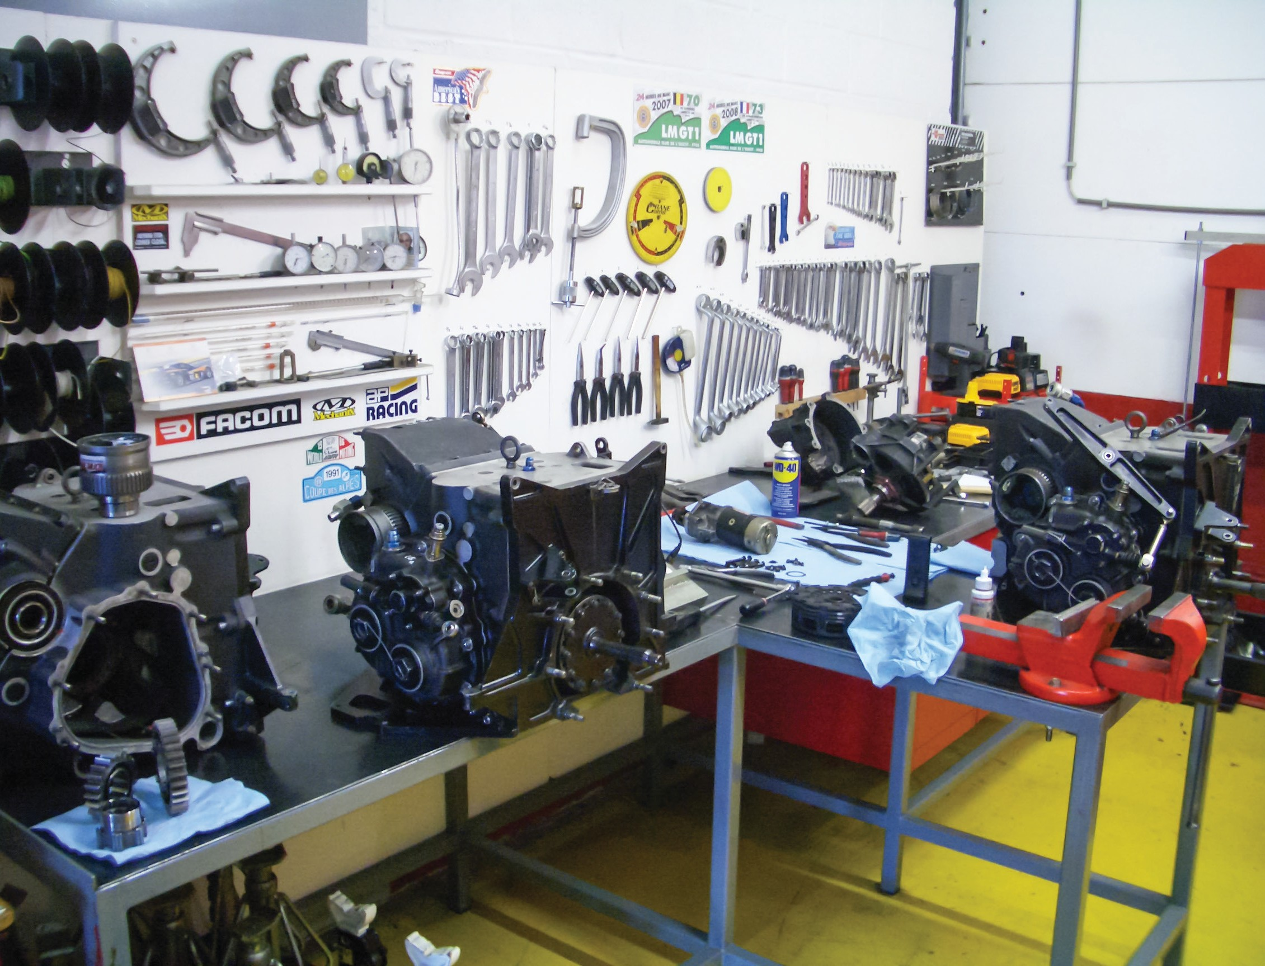

Trades Access Common Core
Line D: Organizational Skills
Competency D-5: Use Manufacturer and
Supplier Documentation
Image to be placed here.

B.C. Open Textbook Project
OpenEd
open.bccampus.ca

Trades Access
COMMON CORE
Line D: Organizational Skills Competency D-5: Use Manufacturer and Supplier
Documentation

Acknowledgments and Copyright
To learn more about BCcampus Open Education, visit http://open.bccampus.ca
© 2015 Camosun College.
The Trades Access Common Core resources are licensed under the Creative Commons Attribution 4.0 Unported Licence, except where otherwise noted. Under this licence, any user of this textbook or the textbook contents herein must provide proper attribution as follows:
- Trades Access Common Core Competency D-5: Use Manufacturer and Supplier Documentation by Camosun College is used under a Creative Commons Attribution 4.0 Licence.
- If you redistribute all or part of this book, it is recommended the following statement be added to the copyright page so readers can access the original book at no cost: Download for free from the B.C. Open Textbook Collection (https://open.bccampus.ca/browse-our-collection/find-open-textbooks/).
- If you use this textbook as a bibliographic reference, then you should cite it as follows: Camosun College. (2015). Trades Access Common Core Competency D-5: Use Manufacturer and Supplier Documentation. Victoria, B.C.: Crown Publications.
All images copyright BC Industry Training Authority are licensed under the Creative Commons Attribution-NonCommercial-ShareAlike 4.0 licence.
The issuing/publishing body is Crown Publications, Queen’s Printer, Ministry of Technology, Innovation and Citizens’ Services.
BCcampus would like to acknowledge the following individuals and organizations for their contributions in producing the Trades Access Common Core Open Textbook resources.

BCcampus
Open Education Team
Hilda Anggraeni, Graphics

Camosun College
Olaf Nielsen, Chair, Trades Development and Special Projects, School of Trades and Technology
Nannette Plant, Manager, Enterprise Point Operations & Special Projects, Office of the VP Strategic Development
Rod Lidstone, Instructor, Plumbing and Pipe Trades, Lead Writer/Reviewer
Brian Coey, Instructor, Sheet Metal and Metal Fabrication, Writer/Reviewer
Matt Zeleny, Camosun Innovates, 3D imaging

Open School BC
Monique Brewer, Director
Adrian Hill, Instructional Designer
Dennis Evans, Image Coordinator, Photographer, Graphics, Production Technician (layout)
Farrah Patterson, Production Technician

Industry Training Authority of BC
The ITA works with employers, employees, industry, labour, training providers, and government to issue credentials, manage apprenticeships, set program standards, and increase opportunities in approximately 100 BC trades. Among its many functions are oversight of the development of training resources that align with program standards, outlines, and learning objectives, and authorizing permission to utilize these resources (text and images).
Erin Johnston, Director of Training Delivery
Cory Williams, Manager, Industry Relations

Publishing Services, Queen’s Printer
Spencer Tickner, Director of QP Publishing Services
Dwayne Gordon, Manager, Electronic Publishing
October 2015, Version 1
To order print copies of any of the Trades Access Common Core resources, please contact us:
Crown Publications, Queen’s Printer PO Box 9452 Stn Prov Govt
563 Superior St, 3rd Floor Victoria, BC V8W 9V7 Phone: 250-387-6409
Toll Free: 1-800-663-6105
Fax: 250-387-1120
crownpub@gov.bc.ca www.crownpub.bc.ca

Intellectual Property Program
Ilona Ugro, Copyright Officer, Ministry of Technology, Innovation and Citizens’ Services, Province of British Columbia

Creative Commons Attributions
Cover photo:
DKR Workshop by DKR under a Creative Commons Attribution-ShareAlike 3.0 Unported licence.

Foreword
The BC Open Textbook Project began in 2012 with the goal of making post-secondary education in British Columbia more accessible by reducing student cost through the use of openly licensed textbooks. The
BC Open Textbook Project is administered by BCcampus and is funded by the British Columbia Ministry of Advanced Education.
Open textbooks are open educational resources (OER); they are instructional resources created and shared in ways so that more people have access to them. This is a different model than traditionally copyrighted materials. OER are defined as teaching, learning, and research resources that reside in the public domain or have been released under an intellectual property licence that permits their free use and repurposing by others (Hewlett Foundation). Our open textbooks are openly licensed using a Creative Commons licence, and are offered in various e-book formats free of charge, or as printed books that are available at cost. For more information about this project, please contact opentext@bccampus.ca. If you are an instructor who is using this book for a course, please let us know.

Preface
The concept of identifying and creating resources for skills that are common to many trades has a long history in the Province of British Columbia. This collection of Trades Access Common Core (TACC) resources was adapted from the 15 Trades Common Core line modules co-published by the Industry
Training and Apprenticeship Commission (ITAC) and the Centre for Curriculum Transfer and Technology (C2T2) in 2000-2002. Those modules were revisions of the original Common Core portion of the TRAC modules prepared by the Province of British Columbia Ministry of Post-Secondary Education in 1986. The TACC resources are still in use by a number of trades programs today and, with the permission from the Industry Training Authority (ITA), have been utilized in this project.
These open resources have been updated and realigned to match many of the line and competency titles found in the Province of BC’s trades apprenticeship program outlines. A review was carried out to analyze the provincial program outlines of a number of trades, with the intent of finding common entry-
level learning tasks that could be assembled into this package. This analysis provided the template for the outline used to update the existing modules. Many images found in ITA apprentice training modules were also incorporated into these resources to create books that are similar to what students will see when they continue their chosen trades training. The project team has also taken many new photographs for this project, which are available for use in other trades training resources.
The following list of lines and competencies was generated with the goal of creating an entry-level trades training resource, while still offering the flexibility for lines to be used as stand-alone books. This
flexibility—in addition to the textbook content being openly licensed—allows these resources to be used within other contexts as well. For example, instructors or institutions may incorporate these resources into foundation-level trades training programming or within an online learning management system (LMS).
Line A – Safe Work Practices
- A-1 Control Workplace Hazards
- A-2 Describe WorkSafeBC Regulations
- A-3 Handle Hazardous Materials Safely
- A-4 Describe Personal Safety Practices
- A-5 Describe Fire Safety
Line B – Employability Skills
- B-1 Apply Study and Learning Skills
- B-2 Describe Expectations and Responsibilities of Employers and Employees
- B-3 Use Interpersonal Communication Skills
- B-4 Describe the Apprenticeship System

Line C – Tools and Equipment
- C-1 Describe Common Hand Tools and Their Uses
- C-2 Describe Common Power Tools and Their Uses
- C-3 Describe Rigging and Hoisting Equipment
- C-4 Describe Ladders and Platforms
Line D – Organizational Skills
- D-1 Solve Trades Mathematical Problems
- D-2 Apply Science Concepts to Trades Applications
- D-3 Read Drawings and Specifications
- D-4 Use Codes, Regulations, and Standards
- D-5 Use Manufacturer and Supplier Documentation
- D-6 Plan Projects
Line E – Electrical Fundamentals
- E-1 Describe the Basic Principles of Electricity
- E-2 Identify Common Circuit Components and Their Symbols
- E-3 Explain Wiring Connections
- E-4 Use Multimeters
All of these textbooks are available in a variety of formats in addition to print:
- PDF—printable document with TOC and hyperlinks intact
- HTML—basic export of an HTML file and its assets, suitable for use in learning management systems
- Reflowable EPUB—format that is suitable for all screen sizes including phones
All of the self-test questions are also available from BCcampus as separate data, if instructors would like to use the questions for online quizzes or competency testing.

About This Book
In an effort to make this book a flexible resource for trainers and learners, the following features are included:
- An introduction outlining the high-level goal of the Competency, and a list of objectives reflecting the skills and knowledge a person would need to achieve to fulfill this goal.
- Discrete Learning Tasks designed to help a person achieve these objectives
- Self-tests at the end of each Learning Task, designed to informally test for understanding.
- A reminder at the end of each Competency to complete a Competency test. Individual trainers are expected to determine the requirements for this test, as required.
- Throughout the textbook, there may also be links and/or references to other resources that learners will need to access, some of which are only available online.
- Notes, cautions, and warnings are identified by special symbols. A list of those symbols is provided below.

Symbols Legend
Important: This icon highlights important information.

Poisonous: This icon is a reminder for a potentially toxic/poisonous situation.

Resources: The resource icon highlights any required or optional resources.

Flammable: This icon is a reminder for a potentially flammable situation.

Self-test: This icon reminds you to complete a self-test.

Explosive: This icon is a reminder for a possibly explosive situation.

Safety gear: The safety gear icon is an important reminder to use protective equipment.

Electric shock: This icon is a reminder for potential electric shock.

Safety Advisory
Be advised that references to the Workers’ Compensation Board of British Columbia safety regulations contained within these materials do not/may not reflect the most recent Occupational Health and Safety Regulation. The current Standards and Regulation in BC can be obtained at the following website: http:// www.worksafebc.com.
Please note that it is always the responsibility of any person using these materials to inform him/herself about the Occupational Health and Safety Regulation pertaining to his/her area of work.
BCcampus January 2015

Disclaimer
The materials in the Trades Access Common Core Open Textbook project are for use by students and instructional staff and have been compiled from sources believed to be reliable and to represent best current opinions on these subjects. These manuals are intended to serve as a starting point for good practices and may not specify all minimum legal standards. No warranty, guarantee or representation is made by BCcampus as to the accuracy or sufficiency of the information contained in these publications. These manuals are intended to provide basic guidelines for trade practices. Do not assume, therefore, that all necessary warnings and safety precautionary measures are contained in this module and that other or additional measures may not be required.

Contents
Introduction 8
Objectives 9
Resources 9
Learning Task 1: Describe documentation encountered in the trades 11
Common tool and equipment documentation 11
Safety data sheets 15
Proprietary product documentation 15
Certification agencies 16
Self-Test 1 17
Learning Task 2: Describe information contained in manufacturer
and supplier documentation 19
Installation instructions 19
Operation and maintenance manuals 19
Product specifications 19
Warranty information 20
Self-Test 2 21
Learning Task 3: Use trade-related documentation 23
Types of documents 23
Procedures for completing documentation 27
Self-Test 3 29
Learning Task 4: Use reference material 31
Tables 31
Graphs and charts 31
Product specifications 33
Blueprints or drawings 34
Shop drawings 35
Technical bulletins 35
Wholesaler catalogues 36
Self-Test 4 37
Learning Task 5: Describe how to use computers to source
and store manufacturer documentation 39
Manufacturer websites 39
Search engines 40
Managing files 40
Software 40
Self-Test 5 42
Answer Key 43

Introduction
Document use is one of the nine essential skills identified by the Government of Canada to be successful in the workplace. It refers to the skills needed to find, enter, and use letters, numbers, symbols, and images in electronic and paper form. In the trades, people use document literacy skills to find and enter information in forms, lists, tables, graphs, maps, and drawings.

In the workplace, document use focusses on finding information needed to get a task done, or on collecting and reporting information needed elsewhere in the process. Document use on the job is often more complex than reading and writing in school. In fact, sometimes an inability to use or interpret documents is treated lightly, as with the professor who can read volumes of philosophy journals but can’t program a microwave. This inability may be of little significance to the professor, but for anyone in the repair or service industry such a deficiency would be crippling.

Due to the growing complexity of our cities, our information systems, and our technologies, the sophistication and variety of skills related to document use needed in the workplace are increasing. Most workers now spend a portion of their day retrieving information from signs,
labels, lists, forms, directories, maps, databases, graphs, charts, and code books. They also spend time entering information in log books, checklists, entry forms, and computers. All these tasks, which are often cognitively complex, are vital to productivity and safety in the workplace.

Here is a list of some of the tasks related to document use identified by the Government of Canada as essential for success in the trades:
  - Scanning workplace signs, labels, and symbols to identify hazardous products
  - Reading a list of work-site procedures for each new work site
  - Interpreting signs for information about directions, cautions, and safety procedures
  - Completing time cards to record work hours
  - Reading safety symbols on movable parts
  - Referring to equipment catalogues to locate parts
  - Filling out a variety of documents, such as job estimates, warranties, inspection reports, and accident forms
  - Reading work schedules for projects to plan work and coordinate with other tradespeople
  - Reading digital displays, gauges, and dials on measuring devices
  - Reading invoices and packing slips to check and cross-reference materials received
  - Studying maps and refering to directions to find job sites
  - Reading and integrating information from several diagrams in a repair manual to troubleshoot a problem

  - Interpreting drawings when installing, assembling, or repairing equipment
  - Translating two-dimensional prints into three dimensions when studying drawings and schematics to troubleshoot problems with components
  - Reading and understanding codes that contain legal and highly technical language
  - Reading other tradespersons’ plans and specifications to understand the sequence of installation and locations of apparatus
  - Using work orders to find information on equipment to be serviced, such as repair needs and descriptions of previous problems
  - Finding system faults by interpreting diagnostic graphs and integrating information from other sources
  - Interpreting shop drawings and specifications for the sizes, locations, and types of materials required for a job
  - Preparing lists of materials
  - Making sketches of drawings or plans to use on job sites
  - Referring to load charts to determine load-bearing capacities when operating equipment

Objectives
When you have completed the Learning Tasks in this Competency, you will be able to:
  - Describe the various forms of documentation encountered in the trades
  - Recognize the correct document to be used for different purposes
  - Describe the information contained in manufacturer and supplier documentation
  - Know where and how to obtain the necessary information that must be entered on different documents
  - Use trade-related documentation and reference material
  - Use computers as a source of information to research and store manufacturer documentation such as:
▸ service information
▸ specifications
▸ replacement parts information
▸ diagrams

Resources
You will be required to reference publications and videos available online.

LEARNING TASK 1
Describe documentation encountered in the trades
A tradesperson may use different documentation every day. Whether it is instructions for using a piece of equipment, a troubleshooting guide for an air-conditioning unit, or safety information on a hazardous chemical, every tradesperson will encounter some form of documentation.

Common tool and equipment documentation
Every tool or piece of equipment sold comes with some form of documentation, such as a manual, instructions, warranty information, and registration information. Manufacturers provide this information because they feel it is necessary for operators to have. It is very important to review this information before installing or using any tool or equipment.

The following is a list of some of the topics that could be covered in manufacturer documentation:
  - safety
  - models
  - assembly/installation
  - programming
  - operation
  - maintenance
  - troubleshooting
  - warranty information
  - manufacturer’s contact information

Safety
Within the documentation, there will be a variety of symbols used. The most common are safety related. Figure 1 shows an example of a common safety symbol.

Figure 1 — Common safety symbol

It is important to read and understand all the information within the safety section. Doing so will keep the operator and the equipment safe. For example, a grinder may come packaged without the guard in place, and it would be very dangerous to use without installing the guard first.

Safety information may cover:
  - general safety
  - protective clothing
  - hazards of high-pressure fluids, high voltage, and high air pressures
  - protection against noise
  - operation safety
  - lifting and blocking precautions
  - safety checks on machinery
  - explosion and fire safety
  - battery safety
  - preparing machinery for repairs
  - shop ventilation and clean-up
  - first aid
Be sure to read and understand all safety information before operating any tool or equipment.

Models
A manual will normally include information on several different models. There may be specific information that pertains to one model and not another, as well as information that is relevant to all models.

Assembly/Installation
If a manual or instruction sheet includes assembly or installation instructions, it will usually contain a parts list, step-by-step instructions, and an exploded view. An exploded view is a three-dimensional illustration of the object with all the parts aligned but pulled apart (Figure 2). It may also include diagrams or pictures for each step.
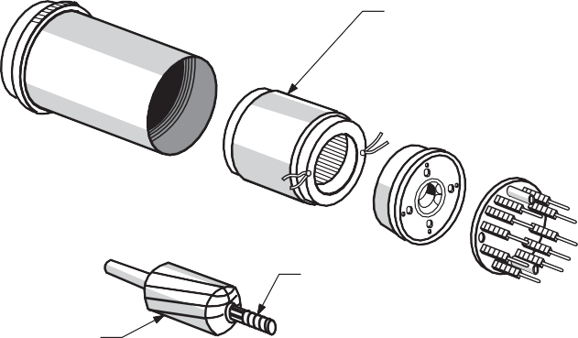
Stator
Slip rings
Rotor
Figure 2 — Exploded view

It is important to follow the instructions exactly, as certain steps may need to be performed before others. Damage to the item may be a result if the steps are not followed correctly.

Programming
As technology advances, so do the programming needs of equipment possessing computer controls. For example, automotive testing equipment needs to be programmed or calibrated before use, and may be upgraded over time. In this case, the manual will have a detailed instruction sheet on how to do the programming. Again, it is very important to follow the steps in the correct order to complete the set-up.

Operation
The operation section of the documentation is where all of the information on the safe and correct use of the tool or equipment will be found. It will contain information on certain uses and capabilities of the machine. For example, in the case of a cordless drill, this section would have information on forward and reverse controls and how to charge the batteries.

Maintenance
Most tools and equipment require some sort of routine maintenance. This section will outline what should be done and when. Just as a vehicle needs regular oil changes, so may a hydraulic shear. The manual may include a chart or log book so that all maintenance can be recorded.

Troubleshooting
Troubleshooting guides provide information on and solutions to common or specific problems. This information is usually presented in chart form (Figure 3) and lists symptoms, potential causes, and corrective measures.

Trouble | Possible Cause | Remedy
CONTACTS
Chatter | 1. Broken shading coil | 1. Replace armature parts.
 | 2. Poor contact in control circuit | 2. Improve contact or use circuit interlock (3-wire control).
 | 3. Low voltage | 3. Correct the voltage; check for momentary voltage dip during starting.
Welding or freezing | 1. Abnormal current inrush | 1. Use larger contactor or check for grounds, shorts, or excessive motor load current.
 | 2. Rapid jogging | 2. Install larger device rated for jogging service or caution the operator.
 | 3. Insufficient tip pressure | 3. Replace contact springs. Check contact carrier for damage.
 | 4. Low voltage preventing contacts from closing | 4. Correct the voltage; check for momentary voltage dip during starting.
 | 5. Foreign matter preventing contacts from closing | 5. Clean contacts with approved solvent.
 | 6. Short circuit | 6. Remove short fault and ensure that fuse or breaker size is correct.
Short contact life or overheating of tips | 1. Filling or dressing | 1. Do not file silver-faced contacts. Rough spots and discoloration will not harm them.
 | 2. Interrupting too-high currents | 2. Install larger device or check for grounds, shorts, or excessive motor  currents. Use silver-faced contacts.
 | 3. Excessive jogging | 3. Install larger device rated for jogging service or caution the  operator.
 | 4. Weak contact pressure | 4. Adjust or replace contact springs.
 | 5. Dirt or foreign matter on  contact surface | 5. Clean contacts with approved  solvent.
 | 6. Short circuit | 6. Remove short fault and ensure that  fuse or breaker size is correct.
 | 7. Loose connection | 7. Clean and tighten the connection.
 | 8. Sustained overload | 8. Install larger device or check for  excessive load current.
Figure 3 — Troubleshooting guide for motor controls

Warranty information
This section of the manual will contain information on the length, coverage, and limitations of the warranty. It may also include details about any specific action that may have to be taken, such as registering the tool with the company. Sometimes registration of the model and serial number, as well as other information, is required for a purchaser to receive the full warranty coverage.

Manufacturer’s contact information
Most manuals include the contact information of the manufacturer.

Safety data sheets
A safety data sheet (SDS), formally known as a material safety data sheet (MSDS), is a technical bulletin that provides specific hazard information, safe handling information, and emergency procedures for a controlled product. Since the SDS contains detailed health and safety information specific to each controlled product, it should be used as a key source of information for developing training programs and safe work procedures. It is also a valuable reference source for workers, health and safety committees, and emergency service personnel.

Proprietary product documentation
Proprietary product documentation can be thought of as “trade secrets.” If a company specifically licenses and owns a product or technology, it is proprietary. This limits others from duplicating or copying it. For example, the Sharkbite plumbing connection system (Figure 4) is a proprietary product. It is a push-on connection between pipes that requires no soldering and is removable at any time. It is very quick to install, making it a popular product.
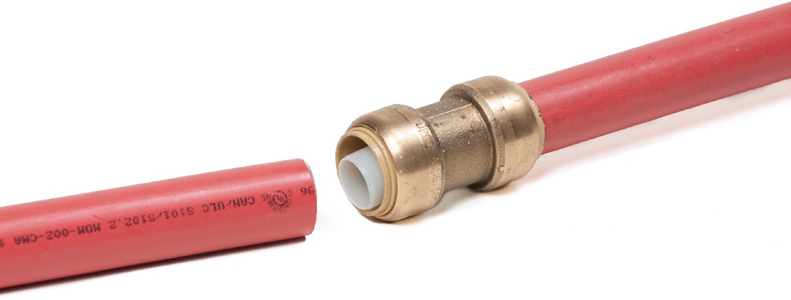
Figure 4 — Sharkbite fitting

Certification agencies
As a tradesperson, you may interact with many certification agencies. The Industry Training Authority (ITA) is the agency that certifies all tradespeople in BC. Once a tradesperson has completed an apprenticeship, he or she may achieve other specialized certifications.

In most trades, there are many different certifications available. Depending on the certificate, there may be courses and tests involved, or documentation of experience may be required. Being able to fill out and register the required documentation is part of the process.

Now complete the Learning Task Self-Test.

Self-Test 1
- Document use is one of the nine essential skills for the workplace.
  - True
  - False

- Which of the following is considered part of document use?
  - Reading signs
  - Completing time cards
  - Interpreting instructions
  - All of the above

- What do symbols in equipment manuals usually indicate?
  - Safety concerns
  - Equipment use
  - Troubleshooting
  - Assembly

- What section of a manual most commonly includes an exploded view?
  - Safety
  - Assembly
  - Programming
  - Operation

- Most equipment does not require any routine maintenance.
  - True
  - False

- What form is a troubleshooting guide usually in?
  - Written document
  - Pie chart
  - Bar graph
  - Table

- What is the name of the sheet that provides information on hazardous products?
  - Safety data sheet
  - Hazardous material sheet
  - Material safety sheet
  - Safety sheet

LEARNING TASK 2
Describe information contained in manufacturer and supplier documentation
In most trades, purchasing products and installing them is a large part of the job. If you are a sheet metal worker installing furnaces or an electrician installing a ceiling fan, you will refer to the documentation with the products purchased. This includes manuals, instructions, product specifications, and warranty information.

Installation instructions
Installation instructions are supplied with many products. They may be detailed and explained step by step or with a simple diagram or paragraph. Regardless of their complexity, it is important to read and understand the information supplied before beginning the installation. Safety could be compromised, time could be wasted, or product damage could occur if the instructions are not followed exactly.
Visit the following site to view an example of an instruction sheet:
http://lyric.honeywell.com/pdf/Lyric_QuickStartGuide_Dec18-Fillable.pdf

Operation and maintenance manuals
Operation manuals outline how the equipment will operate. If the proper operation is understood, a problem can be easily diagnosed when the equipment malfunctions. The item may have different modes or settings, and the information about such adjustments will be described in the manual.

Maintenance manuals describe what has to be done to the equipment—and when—for it to continue to operate correctly. Changing filters, batteries, or seals are examples of routine maintenance. Sometime a maintenance schedule is included in the manual.

Product specifications
Product specifications are the details of the equipment. Product dimensions, motor size, power requirements, wiring diagrams, and other connection requirements are a few examples of information included in this documentation.

Product specifications may also include information on compatibility with other components or equipment. For example, if you purchase a furnace and want to add an air conditioner to it, you could determine if this is possible by referring to the specifications.

Warranty information
Warranty information includes details on the length of the warranty, what is covered, and exclusions.

Sometimes the warranty information will include details on how to register the purchase with the manufacturer. Registration is sometimes required to obtain full warranty coverage. This requires filing paperwork with the manufacturer with information such as installation date, serial and model number of the equipment, and installer and owner names. Usually, registration must be completed within a specific time after installation.

Now complete the Learning Task Self-Test.

Self-Test 2
- An instruction sheet may be in the form of a simple diagram or chart.
  - True
  - False

- What type of manual explains the functions of a piece of equipment?
  - Safety manual
  - Maintenance manual
  - Operation manual
  - Product specifications

- A maintenance manual will include information such as size of motors or electrical requirements.
  - True
  - False

- What type of document includes information about compatibility between equipment and additional components?
  - Product specifications
  - Operation manual
  - Maintenance manual
  - Safety manual

- It is common to have to register a product to receive the full warranty.
  - True
  - False

LEARNING TASK 3
Use trade-related documentation
Knowing how to use documents is vital to a tradesperson. Registering warranties, filing repair orders, and keeping service and maintenance records are all examples of the types of paperwork that a tradesperson must deal with. There are many different forms of documentation, and it is important to know how to read, understand, and pull the relevant information from each type.

Types of documents
Many different types of documents are found in the trades, some of which are discussed below. The information may be displayed in words, numbers, symbols, or other visual features. A tradesperson must be skilled at reading and interpreting the information, however it is presented.

Repair order
A repair order (Figure 1), or work order, is a form that allows a company to track and keep records of all work done. It includes information such as the client’s name and contact information, problems, and/or work to be done. It also includes space for the service technician doing the work to record what was done, how long the job took, and any other important information.

Name of Company____________________________ Repair Order #________________
Customer information |  | Work performed
Name | City
Phone number | Province
Address | Postal Code
Other
Date | Staff
Payment
Cash | Credit
Cheque | Debit
Vehicle information
Model | Odometer
Make | Licence #
Year | VIN#
Rate
Labour | Hourly
Service call | After hours

Current problem(s)
Down payment
Yes | No
Amount
Charges
Labour hours
Gas/Oil/Grease
Outside repairs
Storage fee(s)
Tax
Amount due
Figure 1 — Repair order

Purchase order
A purchase order, or PO, is a document that provides the details of a purchase from a supplier. It includes information such as items, quantity, and agreed-upon prices. It serves as an agreement between the buyer and the supplier for the purchase of items listed. It also allows the supplier to track a job, as all items purchased for any particular job will be on one PO with a specific number. This number is given to the job and follows it through completion.

Preventive/predictive maintenance sheet
A maintenance sheet is a document that allows the maintenance of an item to be tracked and recorded. It sets out a schedule for certain tasks to be completed at certain time intervals.
For example, a gas forced-air furnace may require the filters to be changed every one or two months, but may only need a service to the gas burners every year or two. If no record of the maintenance is kept, there is a risk that the technician will miss doing important maintenance work or many do work that is not required.

Technical bulletin
Technical bulletins are often issued by agencies or companies to update the industry on developing technical issues. For example, an automotive manufacturer may issue a technical bulletin if it is having a recurring issue with a particular vehicle. The manufacturer will issue the bulletin, allowing the service departments and the technicians to diagnose and repair the

problem quickly and efficiently. In other cases, government bodies may issue code updates as regulations evolve and change. These bulletins enable tradespeople to stay abreast of changing practices and requirements.

Inspection form
An inspection form (Figure 2) is simply a checklist that details what should be checked on a particular product and that provides space to record the condition of the item. There are many examples of an inspection form being used, from a mechanic inspecting a vehicle for safety concerns to a home inspector inspecting a house before it is purchased. In both cases, the person doing the inspection uses the form to record the findings and to report back to the customer.

Courtesy Check

Date: | Customer name: |  | W/O #
Year: | Make: | Model: |  | Licence:
Mileage: |  | VIN:
Place a check mark if an item passes inspection or an X if it fails.

Item to be Checked Pass Fail Comments
Glass
Front windshield—cracked, chipped, broken
Rear window—cracked, chipped, broken
Side windows—cracked, chipped, broken
Driver’s window—operates up and down
Mirrors—interior and exterior
Lights
Headlights—low beam
Headlights—high beam
Tail lights
Licence plate light
Brake lights
Back-up lights
Rear turn signals
Front turn signals
Front running lights
Hazard lights
Side/clearance lights
Interior light
Fog lights
Other
Windshield wipers—cracked, broken, hard
Horn
Tire pressure check (x4)
Spare tire pressure check
Body damage
Shock bounce test (x4)
Clean windows inside
Clean windows outside
Vacuum inside
Technician’s signature:
Figure 2 — Inspection form

Service record
A service record is a document that records all service done to an item over its life. Technicians and consumers refer to a service record to know what service has been performed, which in turn helps indicate the condition of the item. For example, if you were going to purchase a used vehicle and the service record was empty, you might be suspicious of the vehicle’s condition. But if the service record showed that regular oil changes and all recommended service had been done at the recommended mileage, you would probably be satisfied that the vehicle is mechanically sound.

Warranty
A warranty, in general, is a guarantee from the manufacturer of a product regarding defects or damage. Warranties include documentation about the manufacturer’s coverage on a particular item. They range in length, coverage, and limitations.

Estimate
An estimate is a form a contractor or technician uses to communicate to a customer the cost of completing a job or service. It includes the labour or time needed to complete the job, a list of parts and supplies required, and the price. The estimate may be converted to a repair order or PO if the job is accepted.

Transportation of dangerous goods (TDG) form
The government requires any dangerous goods being shipped be accompanied by proper documentation. This document identifies the dangerous goods being transported.

Refrigerant management record
Because air conditioning and refrigeration systems contain refrigerant that can be harmful to the environment if released, there are strict regulations for handling them. Anyone doing any work on a refrigeration system must be certified and must keep records of their work.

Safety data sheets
Safety data sheets (SDS) are part of the Workplace Hazardous Materials Information System
(WHMIS) program, and they should be readily accessible at every workplace where there are any hazardous materials. It is the worker’s responsibility to be aware of the location and contents of these safety documents.

Time card/sheet
Many companies require their staff to fill out time sheets. Time sheets allow the company to track the amount of time spent on each job and how much to pay each employee. They usually involve multiple entries each day for the different tasks done.

Bill of materials
A bill of materials (Figure 3) outlines the parts, quantity, raw materials, and any other items required to build a product.

Mark | Name | Number required | Measurement | Thickness | Width | Length | Material | Remarks
A | Legs | 4 | 1 × 6 × 26" | 1" | 6" | 26" | Fir/hemlock | Cut at 4"/24"  angle
B | Top | 1 | 1 × 6 × 26" | 2" | 6" | 42" | Fir/hemlock | Notched at 4"/24" angle
C | Gussets | 2 | 1 × 6 × 26" | 1/2" | 11" | 8" | Plywood | Cut to fit
D | Rails | 2 | 1 × 6 × 26" | 1" | 4" | 48" | Fir/hemlock | Cut to fit
E | Wood screws | 36 | 1 × 6 × 26" | 11/4" | #8  F.H.
Figure 3 — Bill of materials to construct a sawhorse

Site safety survey
A site safety survey is a document produced before a construction project begins. It outlines all safety concerns that the job and work site may impose on the workers, such as any necessary asbestos abatement procedures or required personal protective equipment. It tells all workers on site what actions are required to keep the site safe.

Procedures for completing documentation
There are many ways to complete documentation, and today the most common is by using computers, although paper documents are still sometimes used. Numerous computer programs allow you to create and customize the documents required. For example, in the past, a contractor would use pen and paper along with a calculator to put together an estimate for a job, but today, you can use a spreadsheet or a proprietary estimating program to complete the process.

Computer-based documentation
There are too many documentation programs available to detail in this publication. However, generally, tradespeople should know the basics of readily available programs in the Microsoft Office suite. For example, Microsoft Excel can be used to create spreadsheets for estimating and bidding. Microsoft Word can be used to create repair orders, bills of materials, and purchase orders.

Figure 4 shows a technician transferring notes from a laptop computer to record all relevant information while the job is being completed. Accurate records of all diagnosis, test readings, parts supplied, labour, and other important information will be entered and stored to be reported to the customer.

Figure 4 — Computer diagnostic

Non-computer-based documentation
Even though computers are used extensively to create documentation today, it is still commonplace to fill out the forms on site by hand. For example, if a service technician responds to a house call for a furnace service, the technician will partly fill out the repair order while completing the job. As the technician is working, he or she may record airflow or electrical readings; this information must be recorded immediately for accuracy. Once the job is complete, everything that was done can be recorded using a computer for later reference.

It is very important to always follow some simple steps to complete documents correctly:
- Take your time. Someone has to read the form later; make sure they will be able to do so without difficulty.
- Use a form that was created for the task at hand.
- Take notes as you are working.
- Keep your paperwork organized. Losing a repair order could mean not getting paid.
- Make sure all information is correct. Check that the customer’s name, the problems reported, and any other necessary information are on the repair order.
- Be professional. Your name is always associated with the forms and documents you create.

Now complete the Learning Task Self-Test.

Self-Test 3
- What type of form is used to track repair jobs?
  - Purchase orders
  - Repair order
  - Maintenance sheet
  - Technical bulletin

- Which is sent to a supplier to complete an order?
  - Repair order
  - Work order
  - Purchase order
  - Acquisition sheet

- What purpose does a maintenance sheet serve?
  - It is used for billing purposes.
  - It is used for tracking purposes.
  - It is used for liability purposes.
  - It is used for resale purposes.

- If an automotive manufacturer discovers a recurring issue with a vehicle, how would that information be relayed to automotive dealers?
  - The manufacturer would phone or email them.
  - The manufacturer would ignore the issue.
  - The manufacturer would issue a technical bulletin.
  - The manufacturer would issue a specification sheet.

- What document would be used by a home inspector?
  - Inspection form
  - Service form
  - Review form
  - Assessment form

- What document would you read to tell if a used vehicle has been maintained?
  - History sheet
  - Operator’s manual
  - Inspection sheet
  - Service record

- A bill of materials will include all information to build a product.
  - True
  - False

- Before a construction project begins, what form should be completed?
  - Safety sheet
  - Site safety survey
  - Job analysis sheet
  - Inspection sheet

- An automotive service technician may use a laptop computer to record all information while he or she is completing the job.
  - True
  - False

- When testing equipment, why is important to record results as soon as they are obtained?
  - To make the job go faster
  - To maintain accuracy
  - To help with billing
  - To show the client what you have done

LEARNING TASK 4
Use reference material
Sometimes documentation is not in written form. It may be presented as tables, graphs, charts, or other types of drawings. Reading and understanding the visual information provided is just as important as reading and understanding a text document.

Tables
Tables offer a simple way to convey multiple pieces of related information. Tables consist of columns and rows that organize the information. The table shown in Figure 1 shows different tasks and how long each took. The table format makes the information much easier to retrieve and process at a glance.

Tasks | Start date | Duration (days) | Finish date
Task 1 | May 21 | 3 | May 24
Task 2 | May 21 | 7 | May 28
Task 3 | May 23 | 6 | May 29
Task 4 | May 25 | 5 | May 30
Task 5 | May 26 | 5 | May 31
Task 6 | May 27 | 8 | June 4
Task 7 | May 30 | 5 | June 4
Task 8 | June 1 | 3 | June 4
Figure 1 — Table itemizing tasks

Graphs and charts
Graphs and charts provide visual representations of information. They usually compare one or more factors. The type of information being displayed usually determines what form of graph or chart is best to use.

Pie chart
A pie chart (Figure 2) is effective for showing parts of a whole by percentage or to emphasize how different components make up a whole.

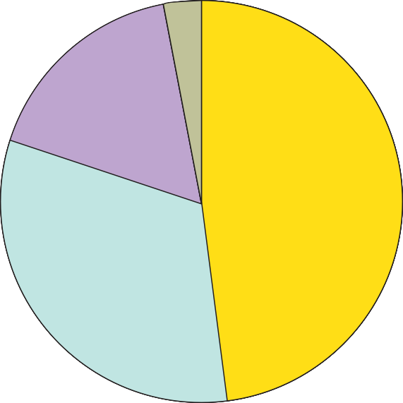Profit Crude costs Taxes
3%
17%
48%
32%
Refining and marketing costs
Figure 2 — Pie chart showing cost breakdown for Canadian gas prices, 2007

Bar chart
A bar chart generally compares values with two variables. Figure 3 is a bar chart that compares the cost of gasoline over several days. The two variables are cost and time. For example, if you look at the bar above July 22, you can see what the cost of gas was on that day.

129.5
Regular gas price CAN (c/L)
Three Week average Retail Price of Gas - 2015

129

128.5

128

127.5

127

126.5

126
17-Jul
18-Jul
19-Jul
20-Jul
21-Jul
22-Jul
23-Jul
24-Jul
25-Jul
26-Jul
27-Jul
28-Jul
29-Jul
30-Jul
31-Jul
01-Aug
02-Aug
03-Aug
04-Aug
05-Aug
06-Aug
07-Aug

Figure 3 — Bar chart showing gas prices over 22 days

Line graph
A line graph also compares two values. Line graphs are commonly used to compare something to time. Figure 4 shows the same information as the bar chart in Figure 3, displayed as a line graph.

Figure 4 — Line graph showing gas prices over 22 days
126.5

126

125.5

125

124.5
Series 1
128.5

128

127.5

127
Regular gas price CAN (c/L)
Three Week Average Retail Price of Gas 2015
129.5

129
09- Jul
- Jul
- Jul
- Jul
- Jul
- Jul
- Jul
- Jul
- Jul
- Jul
- Jul
- Jul
- Jul
- Jul
- Jul
- Jul
- Jul
- Jul
- Jul
- Jul
- Jul
- Jul
- Jul
- Aug
- Aug
- Aug
- Aug
- Aug
- Aug
- Aug

Product specifications
A product specification is a document, usually in chart form, that includes detailed information about different characteristics of an item. In Figure 5, the specification sheet provides information about colour, weight, size, and many other features of a roofing shingle. To determine the size of each tile, look at the information in the length and width rows on the chart.

Cube and Sphere Building Products
CS Fir Specification Sheet

Product | CS Fir is a natural looking and environmentally-friendly synthetic roofing shingle
Material | Recycled thermoplastic (plastic bags and milk bottles), limestone and minor additives for UV protection and colour
Length | 18” (± 0.125”)
Width | 4 different widths of shingles are supplied in each bundle: 11” (±0.125”), 7” (±0.125”), 5.5” (±0.125”) and 4” (±0.125”).
Nominal Thickness | 0.275” at butt; 0.200” at tip
Weight per Tile | ~3.0 lbs (±0.2 lbs) for an 11 inch wide shingle
Head Lap | 3”
Tiles per Bundle | 23 – consisting of 5 shingles 11” wide, 5 shingles 7” wide,  8 shingles 5.5” wide, and 5 shingles 4” wide
No.of Bundles per Roofing Square’ | 12.5
Weight per Bundle | 42 lbs
Weight per ‘Roofing Square’ | ~525 lbs
No. of Bundles per Pallet | 40
No. of ‘Roofing Squares’ per Pallet | 3.2 (~1,700 lbs.)
Exposed Area | 7.5”
Tests Performed | - Weathering Test, ASTM G-155 for 2000 hrs.  - Wind Uplift Resistance Test, CCMC Section 6.4.6 - passed the required interval wind load to 170 km/hr.  - Dynamic Water Infiltration Test, CCMC Section 6.4.6  - Heat Aging Test, CCMC Section 6.4.12  - Freeze Thaw Test, CCMC Section 6.4.13  - Dimensional Stability Test, CCMC Section 6.4.1  - Water Absorption Test, CCMC Section 6.4.2  - Flexural Strength Test, ASTM D790-07  - Traffic Load Test, ASTM E661  - Nail Pull Through Test, ASTM D1037
Colour | Weathered Cedar and Red-brown cedar.  Bundles will contain tiles with slight variation in color.
Storage | Do not stack more than 2 skids high
Expansion / Contraction | Product will expand 0.03” per feet with a variation of 100 degrees F.
Spacing | Space the tiles a minimum of 3/8” apart
Limited Product Warranty | 50 years - refer to detailed warranty documents
Installation | Refer to detailed installation guide.

Figure 5 — Specification sheet

Blueprints or drawings
Blueprints are technical drawings for a building or structure with all the information needed for construction. There are many different sections to a set of blueprints, such as mechanical, architectural, and structural, to name a few. Different trades will use different sections, but all
trades should check the other areas for potential conflicts. It takes many years of practice to read a set of blueprints, and this skill is covered in more detail in Competency D-3, Read Drawings and Specifications.

Shop drawings
Shop drawings (Figure 6) are produced from a large drawing or set of blueprints with many components to isolate a smaller item for construction or assembly. They include all the details needed to complete a job. Study the drawings carefully. Extract all information and familiarize yourself with all aspects. If you have questions, write them down so you won’t forget them. Plan the job procedure before you begin. Think about what is needed to complete the task before you actually begin. This can help identify any unseen issues.
115⁄16
3⁄8
40
25⁄16
115⁄16
19⁄16
1721⁄32
19⁄16
1721⁄32
19⁄16
¾"
3⁄8
1½"
36"
3½"
24"
40"

4½

1⁄8

36
26

3½ 2

24
Figure 6 — Shop drawings

Technical bulletins
Technical bulletins are important documents for keeping current with industry. Manufacturers will post technical bulletins to alert users of any new or up-to-date information about their products. Technical bulletins could be as simple as short written statements or charts. They are very common in the automotive industry for relaying information about any issues that arise with vehicles.

Be sure to read any technical bulletin carefully. Pay extra attention to any bold or highlighted areas, as they may be the main points of the document.

Wholesaler catalogues
Catalogues are commonly used to find and order parts or products. Whether you need a drill bit, sandpaper, or a hot water tank, you need to know how to find the information. Most catalogues are set up with a table of contents, dividing sections into general categories to make it easier to find what is required.

Now complete the Learning Task Self-Test.

Self-Test 4
- Trade-related documentation is always in written form.
  - True
  - False

- Which of the following best represents conveying information in a visual way?
  - Tables
  - Drawings
  - Charts and graphs
  - All of the above

- To compare the change in house prices over a year, which graph should be used?
  - A table
  - A bar graph
  - A pie chart
  - All of the above

- According to the graph below, what was the price of gas on July 19?
129.5
Regular gas price CAN (c/L)
Three Week average Retail Price of Gas - 2015

129

128.5

128

127.5

127

126.5

126
17-Jul
18-Jul
19-Jul
20-Jul
21-Jul
22-Jul
23-Jul
24-Jul
25-Jul
26-Jul
27-Jul
28-Jul
29-Jul
30-Jul
31-Jul
01-Aug
02-Aug
03-Aug
04-Aug
05-Aug
06-Aug
07-Aug

a. 127.5
b. 128
c. 128.5
d. 129

- Most product specifications are in the form of a line graph.
  - True
  - False

- When a small portion of a project is drawn, what is it called?
  - A blueprint
  - A shop drawing
  - A specific drawing
  - Mechanical drawings

- If there was an ongoing problem with a product, what document would the manufacturer release?
  - A technical bulletin
  - A product specification sheet
  - A maintenance sheet
  - An inspection sheet

- What is used to find information regarding parts or products to be ordered?
  - Catalogues
  - Shop drawings
  - Technical bulletins
  - Product specifications

- Percentages can be shown visually in a pie chart.
  - True
  - False

LEARNING TASK 5
Describe how to use computers to source and store manufacturer documentation
Using computers is the most common way to reference different materials and documentation. Different websites and programs make quick work of sourcing most documentation that could be needed. Manufacturers will post technical bulletins, warranty information, and catalogues on their websites. Search engines allow for quick and efficient research and location of documents and information needed.

Manufacturer websites
A manufacturer’s website can be an excellent source of information. Most will have any document pertaining to its products available. Catalogues, warranty documentation, service manuals, and installation guides are all documents that may be retrieved from the website.

As an example, let’s look at how to find warranty information about a customer’s York heat pump.
First, go to the website York: Home Air Conditioning, Furnace Systems, Residential Heat Pumps. http://www.york.com/residential/default.aspx Once there, look for the link for “owner of York products”:
York owners: Support and Service http://www.york.com/residential/york-owners/ default.aspx
With this link, you can find some warranty information on the heat pump. If you click on the warranty link, you will see that the product must be registered. If you follow the prompts, you will see that you can verify a warranty with the serial number of the heat pump. If you enter the number from the customer unit, you should be able to to determine the warranty coverage.

If you return to the home page, you can look under “products” and locate the unit. Then you can look at documents such as user manuals, technical guides, and technical specifications.

The link in this example takes you to the public website; there is much more technical information in a private website used by certified York professionals. To access the private website (which provides much more detailed information than would be required by an installer or service technician), you need to be registered with the manufacturer.

Search engines
A web search engine is a type of website that helps users find information on the Internet. You’ve probably already used one or more search engines; Google is the most common.Using search engines is a great way to find information quickly, but you need to be sure the information you find is correct. When searching on the Internet, be careful about which sources you rely on. Never take technical or installation advice that is not from the manufacturer of a product.

A search engine works by searching through web pages for keywords. To use a search engine you must enter at least one keyword in the search box. The search engine looks for matches between the keywords entered and its database of websites and words.

After a search is submitted the results are quickly returned as a list. The list usually shows web page names, short descriptions, and a link for each matching web page. You can click on any of the links to go to that website.

The effectiveness of a search engine depends on the relevance of the result set it gives back. While there may be millions of web pages that include a particular word or phrase, some pages may be more relevant or popular than others. Most search engines rank the results to provide the best results first.

Managing files
Keeping track of information is just as important as finding it. You must take care to record and file the documents properly. Invoices, service records, time sheets, and pay stubs are all examples of documentation that can be completed by using a computer.

Keep files organized and labelled well. Create different folders for different documents. As well, always have a backup plan. The last thing you want is to lose all records if something happened to your computer. Both online storage and external storage devices are available; consider using these for any documentation that is vital to maintain.

Software
Many programs are available to help you organize, sort, create, and design many of the tasks that are involved with trades. Usually, the software is very specialized to the required task. For example, the program AutoCad (a computer drawing program) is used extensively in the trades. You need extensive training to become proficient in this program.

Programs and software to design products are also available. A sheet metal worker could build a component by hand drawing and using specialized layout techniques, which are very time consuming. That same worker could also take advantage of a computer program like Design2Fab, which will design and lay out the part in minutes.

Whichever software is being used, take the time to learn it well and become skilful with it. The technology used in trades is ever evolving. Keep up with the technology and new software available.

Now complete the Learning Task Self-Test.

Self-Test 5
- The most common way to source manufacturer information is by using a computer and the Internet.
  - True
  - False

- Manufacturers will typically use a website to convey specific information.
  - True
  - False

- Where would you look for warranty information for a product?
  - The product manual
  - On the product itself
  - The manufacturer’s website
  - None of the above

- A Google search is a good way to find installation instructions for a product.
  - True
  - False

- Having documentation stored on a computer is always safe.
  - True
  - False

- What would be required to find specific information about a piece of equipment?
  - The product brochure
  - The equipment manual
  - The product serial number
  - All of the above

Answer Key

Self-Test 1
- a. True
- d. All of the above
- a. Safety concerns
- b. Assembly
- b. False
- d. Table
- a. Safety data sheet

Self-Test 2
- a. True
- c. Operation manual
- b. False
- a. Product specifications
- a. True

Self-Test 3
- b. Repair order
- c. Purchase order
- b. It is used for tracking purposes.
- c. The manufacturer would issue a technical bulletin.
- a. Inspection form
- d. Service record
- a. True
- b. Site safety survey
- a. True
- b. To maintain accuracy

Self-Test 4
- b. False
- d. All of the above
- b. A bar graph 4. a. 127.5
- b. False
- b. A shop drawing
- a. A technical bulletin
- a. Catalogues
- a. True

Self-Test 5
- a. True
- a. True
- c. The manufacturer’s website
- b. False
- b. False
- c. The product serial number

Self-Test 4
- b. False
- d. All of the above
- b. A bar graph 4. a. 127.5
- b. False
- b. A shop drawing
- a. A technical bulletin
- a. Catalogues
- a. True

Self-Test 5
- a. True
- a. True
- c. The manufacturer’s website
- b. False
- b. False
- c. The product serial number

The British Columbia Open Textbook Project
The British Columbia Open Textbook Project is funded by the B.C. Ministry of Advanced Education, and managed by BCcampus, a publicly-funded organization that uses information technology to connect B.C. post-secondary institutions under a collaborative service delivery framework. The Open Textbook Project aims to make available
openly-licensed textbooks in the province’s high-impact subject areas. Visit open.bccampus.ca for more information.

7960003691

