Trades Access Common Core

**Line A: Safe Work Practices**

**Competency A-4: Describe Personal Safety**

**Practices**

Image to be placed here.

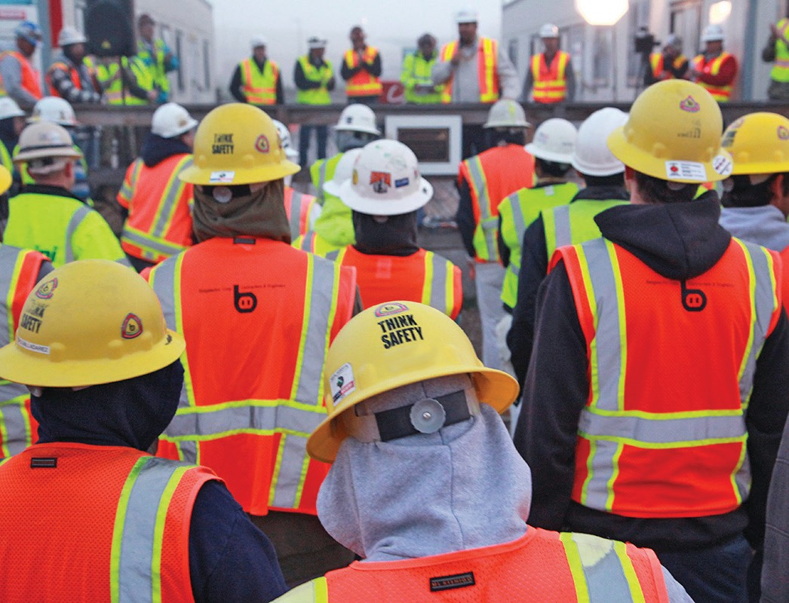

**B.C. Open Textbook Project**



OpenEd

open.bccampus.ca

**Trades Access**

COMMON CORE

Line A: Safe Work Practices Competency A-4: Describe Personal Safety Practices

##### Acknowledgments and Copyright

To learn more about BCcampus Open Textbook project, visit [http://open.bccampus.ca](http://open.bccampus.ca/)

© Camosun College. The Trades Access Common Core resources are licensed under the Creative Commons Attribution 4.0 Unported Licence ( <http://creativecommons.org/licenses/by/4.0/>), except where otherwise noted. Under this licence, any user of this textbook or the textbook contents herein must provide proper attribution as follows:

* If you redistribute this textbook in a digital format (including but not limited to EPUB, PDF, and HTML), then you must retain on every page the following attribution: Download for free at [http://](http://open.bccampus.ca/find-open-textbooks/)  [open.bccampus.ca/find-open-textbooks/](http://open.bccampus.ca/find-open-textbooks/)
* If you redistribute this textbook in a print format, then you must include on every physical page the following attribution: Download for free at <http://open.bccampus.ca/find-open-textbooks/>
* If you redistribute part of this textbook, then you must retain in every digital format page view (including but not limited to EPUB, PDF, and HTML) and on every physical printed page the following attribution: Download for free at <http://open.bccampus.ca/find-open-textbooks/>
* If you use this textbook as a bibliographic reference, then you should cite it as follows: BCcampus, Name of Textbook or OER. DATE. <http://open.bccampus.ca/find-open-textbooks/>.

For questions regarding this licensing, please contact [opentext@bccampus.ca](mailto:opentext@bccampus.ca)

All images copyright BC Industry Training Authority are licensed under the Creative Commons Attribution-NonCommercial-ShareAlike 4.0 licence.

<http://creativecommons.org/licenses/by-nc-sa/4.0/>

The issuing/publishing body is Crown Publications, Queen’s Printer, Ministry of Technology, Innovation and Citizens’ Services.

BCcampus would like to acknowledge the following individuals and organizations for their contributions in producing the Trades Access Common Core Open Textbook resources.

BCcampus

Open Education Team Hilda Anggraeni, Graphics

Camosun College

Olaf Nielsen, Chair, Trades Development and Special Projects, School of Trades and Technology Nannette Plant, Manager, Enterprise Point Operations & Special Projects, Office of the VP Strategic Development

Rod Lidstone, Instructor, Plumbing and Pipe Trades, Lead Writer/Reviewer Brian Coey, Instructor, Sheet Metal and Metal Fabrication, Writer/Reviewer Matt Zeleny, Camosun Innovates, 3D imaging

Open School BC

Monique Brewer, Director

Adrian Hill, Instructional Designer

Dennis Evans, Image Coordinator, Photographer, Graphics, Production Technician (layout) Farrah Patterson, Production Technician

Industry Training Authority of BC

The ITA works with employers, employees, industry, labour, training providers, and government to issue credentials, manage apprenticeships, set program standards, and increase opportunities in approximately 100 BC trades. Among its many functions are oversight of the development of training resources that align with program standards, outlines, and learning objectives, and authorizing permission to utilize these resources (text and images).

Erin Johnston, Director of Training Delivery Cory Williams, Manager, Industry Relations

Publishing Services, Queen’s Printer

Spencer Tickner, Director of QP Publishing Services Dwayne Gordon, Manager, Electronic Publishing

October 2015, Version 1

To order print copies of any of the Trades Access Common Core resources, please contact us:

Crown Publications, Queen’s Printer PO Box 9452 Stn Prov Govt

563 Superior St, 3rd Floor Victoria, BC V8W 9V7 Phone: 250-387-6409

Toll Free: 1-800-663-6105

Fax: 250-387-1120

[crownpub@gov.bc.ca](mailto:crownpub@gov.bc.ca)  [www.crownpub.bc.ca](http://www.crownpub.bc.ca/)

Intellectual Property Program

Ilona Ugro, Copyright Officer, Ministry of Technology, Innovation and Citizens’ Services, Province of British Columbia

##### Creative Commons Attributions

**Cover photo:** (https://commons.wikimedia.org/wiki/File:Monthly_Safety_Stand_Down_%288552567928%29.jpg) by NAVFAC

([https://www.flickr.com/photos/39845951@N05/8552567928](https://www.flickr.com/photos/39845951%40N05/8552567928)) by Jesse A. Lora, NAFAC (SW) under CC BY SA 2.0.

(<https://creativecommons.org/licenses/by/2.0/>)

**Figure attributions for Competency A-4, Learning Task 1 include:**

Figure 13—SCBA

(<https://commons.wikimedia.org/wiki/File:US_Navy_090711-N-5207L-102_Damage_Controlman_Fireman_Jason_Hazenfield,_assigned_to_the_guided-missile_frigate_USS_Crommelin_(FFG_37),_helps_a_Royal_Thai_Navy_sailor_don_a_self-contained_breathing_apparatus_(SCBA)_during_a_damag.jpg>) under Public Domain

##### Foreword

The BC Open Textbook Project began in 2012 with the goal of making post-secondary education in British Columbia more accessible by reducing student cost through the use of openly licensed textbooks. The

BC Open Textbook Project is administered by BCcampus and is funded by the British Columbia Ministry of Advanced Education.

Open textbooks are open educational resources (OER); they are instructional resources created and shared in ways so that more people have access to them. This is a different model than traditionally copyrighted materials. OER are defined as teaching, learning, and research resources that reside in the public domain or have been released under an intellectual property licence that permits their free use and repurposing by others (Hewlett Foundation). Our open textbooks are openly licensed using a Creative Commons licence, and are offered in various e-book formats free of charge, or as printed books that are available at cost. For more information about this project, please contact [opentext@bccampus.ca.](mailto:opentext@bccampus.ca) If you are an instructor who is using this book for a course, please let us know.

##### Preface

The concept of identifying and creating resources for skills that are common to many trades has a long history in the Province of British Columbia. This collection of Trades Access Common Core (TACC) resources was adapted from the 15 Trades Common Core line modules co-published by the Industry

Training and Apprenticeship Commission (ITAC) and the Centre for Curriculum Transfer and Technology (C2T2) in 2000-2002. Those modules were revisions of the original Common Core portion of the TRAC modules prepared by the Province of British Columbia Ministry of Post-Secondary Education in 1986. The TACC resources are still in use by a number of trades programs today and, with the permission from the Industry Training Authority (ITA), have been utilized in this project.

These open resources have been updated and realigned to match many of the line and competency titles found in the Province of BC’s trades apprenticeship program outlines. A review was carried out to analyze the provincial program outlines of a number of trades, with the intent of finding common entry-

level learning tasks that could be assembled into this package. This analysis provided the template for the outline used to update the existing modules. Many images found in ITA apprentice training modules were also incorporated into these resources to create books that are similar to what students will see when they continue their chosen trades training. The project team has also taken many new photographs for this project, which are available for use in other trades training resources.

The following list of lines and competencies was generated with the goal of creating an entry-level trades training resource, while still offering the flexibility for lines to be used as stand-alone books. This

flexibility—in addition to the textbook content being openly licensed—allows these resources to be used within other contexts as well. For example, instructors or institutions may incorporate these resources into foundation-level trades training programming or within an online learning management system (LMS).

**Line A – Safe Work Practices**

* A-1 Control Workplace Hazards
* A-2 Describe WorkSafeBC Regulations
* A-3 Handle Hazardous Materials Safely
* A-4 Describe Personal Safety Practices
* A-5 Describe Fire Safety

**Line B – Employability Skills**

* B-1 Apply Study and Learning Skills
* B-2 Describe Expectations and Responsibilities of Employers and Employees
* B-3 Use Interpersonal Communication Skills
* B-4 Describe the Apprenticeship System

**Line C –Tools and Equipment**

* C-1 Describe Common Hand Tools and Their Uses
* C-2 Describe Common Power Tools and Their Uses
* C-3 Describe Rigging and Hoisting Equipment
* C-4 Describe Ladders and Platforms

**Line D – Organizational Skills**

* D-1 Solve Trades Mathematical Problems
* D-2 Apply Science Concepts to Trades Applications
* D-3 Read Drawings and Specifications
* D-4 Use Codes, Regulations, and Standards
* D-5 Use Manufacturer and Supplier Documentation
* D-6 Plan Projects

**Line E – Electrical Fundamentals**

* E-1 Describe the Basic Principles of Electricity
* E-2 Identify Common Circuit Components and Their Symbols
* E-3 Explain Wiring Connections
* E-4 Use Multimeters

All of these textbooks are available in a variety of formats in addition to print:

* PDF—printable document with TOC and hyperlinks intact
* HTML—basic export of an HTML file and its assets, suitable for use in learning management systems
* Reflowable EPUB—format that is suitable for all screen sizes including phones

All of the self-test questions are also available from BCcampus as separate data, if instructors would like to use the questions for online quizzes or competency testing.

About This Book

In an effort to make this book a flexible resource for trainers and learners, the following features are included:

* An introduction outlining the high-level goal of the Competency, and a list of objectives reflecting the skills and knowledge a person would need to achieve to fulfill this goal.
* Discrete Learning Tasks designed to help a person achieve these objectives
* Self-tests at the end of each Learning Task, designed to informally test for understanding.
* A reminder at the end of each Competency to complete a Competency test. Individual trainers are expected to determine the requirements for this test, as required.
* Throughout the textbook, there may also be links and/or references to other resources that learners will need to access, some of which are only available online.
* Notes, cautions, and warnings are identified by special symbols. A list of those symbols is provided below.

##### Symbols Legend

**Important:** This icon highlights important information.

**Poisonous:** This icon is a reminder for a potentially toxic/poisonous situation.

**Resources:** The resource icon highlights any required or optional resources.

**Flammable:** This icon is a reminder for a potentially flammable situation.

**Self-test:** This icon reminds you to complete a self-test.

**Explosive:** This icon is a reminder for a possibly explosive situation.

**Safety gear:** The safety gear icon is an important reminder to use protective equipment.

**Electric shock:** This icon is a reminder for potential electric shock.

Safety Advisory

Be advised that references to the Workers’ Compensation Board of British Columbia safety regulations contained within these materials do not/may not reflect the most recent Occupational Health and Safety Regulation. The current Standards and Regulation in BC can be obtained at the following website: [http://](http://www.worksafebc.com/)  [www.worksafebc.com](http://www.worksafebc.com/).

Please note that it is always the responsibility of any person using these materials to inform him/herself about the Occupational Health and Safety Regulation pertaining to his/her area of work.

BCcampus January 2015

Disclaimer

The materials in the Trades Access Common Core Open Textbook project are for use by students and instructional staff and have been compiled from sources believed to be reliable and to represent best current opinions on these subjects. These manuals are intended to serve as a starting point for good practices and may not specify all minimum legal standards. No warranty, guarantee or representation is made by BCcampus as to the accuracy or sufficiency of the information contained in these publications. These manuals are intended to provide basic guidelines for trade practices. Do not assume, therefore, that all necessary warnings and safety precautionary measures are contained in this module and that other or additional measures may not be required.

Contents

Introduction 8

Objectives 8

Resources 8

Learning Task 1: Describe safety gear and work clothing 9

WorkSafeBC regulations 9

Personal apparel 10

Personal protection 12

Hand and skin protection 22

Foot protection 24

Fall protection 24

General care of PPE 25

Self-Test 1 26

Learning Task 2: Describe fall protection systems 29

Fall restraint system 29

Fall arrest system 30

Fall protection equipment 31

Self-Test 2 36

Learning Task 3: Lift and move objects safely 39

General rules for lifting and moving objects 39

Procedures for lifting specific objects 40

Back maintenance 46

Self-Test 3 47

Answer Key 49

## Introduction

These Learning Tasks describe the clothing and protective equipment workers must wear on the job site and the safety precautions they must take to protect themselves and others from injury.

Special personal protective equipment (PPE) is required on the job site. The equipment used will depend on the hazards anticipated.

When working at elevations, significant hazards are present and fall protection is normally required. Knowing the hazards allows workers to select methods to reduce the hazard and prevent injury.

Workers often lift and move heavy and awkward objects. Failure to follow proper lifting procedures can cause serious and permanent back damage.

## Objectives

When you have completed the Learning Tasks in this Competency, you should be able to:

* + describe safety precautions and procedures relating to personal apparel and personal protection equipment (PPE)
  + describe fall protection systems and the equipment
  + describe the proper methods of lifting and moving objects

## Resources

You will be required to reference publications and videos available online at:

<http://www.worksafebc.com/>

LEARNING TASK 1

**Describe safety gear and work clothing**

The most important concept to remember is that you are responsible for your own safety and the safety of others. Personal protective equipment (PPE) is the last line of defence against personal injury; using it properly and taking care of it are the first steps toward protecting yourself on the job.

The best protective equipment is of no use to you unless you do the following four things:

1. Regularly inspect it.
2. Properly care for it.
3. Use it properly and receive training when it is needed.
4. Never alter or modify it in any way.

The general areas that require your attention include:

* + personal apparel
  + personal protection

## WorkSafeBC regulations

WorkSafeBC regulations state that a worker is responsible for providing:

* + clothing needed for protection against the natural elements
  + general-purpose work gloves
  + appropriate footwear, including safety footwear
  + safety headgear

WorkSafeBC regulations state that the employer is responsible for providing, at no cost to the worker, all other items of personal protective equipment required by the regulations.

#### WorkSafeBC PPE information sheets

WorkSafeBC personal protective equipment (PPE) information sheets can be used to inform employers, supervisors, and workers about PPE in general. These sheets are ideal for worker orientation and crew talks and for posting on bulletin boards. The sheets explain the PPE required by the regulations for specific industries and hazards as well as describing when and how different types of PPE must be worn.

**Go to the WorkSafeBC website to see examples of PPE information sheets.**

[**http://www2.worksafebc.com/Topics/ppe/InformationSheets-Index.asp**](http://www2.worksafebc.com/Topics/ppe/InformationSheets-Index.asp)

## Personal apparel

Workers are required to supply the appropriate safety footwear and suitable clothing before being permitted to work in a shop or on a work site. There are a number of important safety considerations to be aware of for clothing, hair, and jewellery that are common to all job sites.

#### Clothing

Workers must wear close-fitted clothing (that is, not ragged or frayed) if they are working near moving machinery. Scarves, ties, shirts, pant cuffs, and gloves may become workplace hazards. For example, if your shirt cuff is loose, you risk getting it caught in a machine and injuring or breaking your arm if it is pulled around the shaft.

Oily, greasy, and/or synthetic clothes (e.g., rayon, nylon, polyester) are of concern when working near sparks or open flames. As well as being fire hazards, oily or greasy clothes may cause skin irritation.

Workers must use clothing to protect the body from as much dirt and as many chips and sparks as possible. Short pants, short-sleeved shirts, and sandals are not considered adequate on most job sites.

Pant legs should not be tucked inside boots when working with or near a torch, grinder, or chipper. Hot pieces of metal may fall inside a boot and cause a bad burn before the boot can be removed. Workers may also require flame-resistant clothing if they are working where they may be exposed to flash fires or similar hot work hazards.

###### High-visibility apparel

Wear high visibility clothing in a colour that contrasts with the environment so you can be seen at a distance. Make sure your high-visibility clothing is not covered by other garments. You must wear it when:

* + - working around any moving vehicles, equipment, or lines
    - working alone or in isolation
    - harvesting trees at night
    - performing traffic control in work areas where there is vehicle traffic moving through a work zone or for falling operations
    - directing helicopter movements

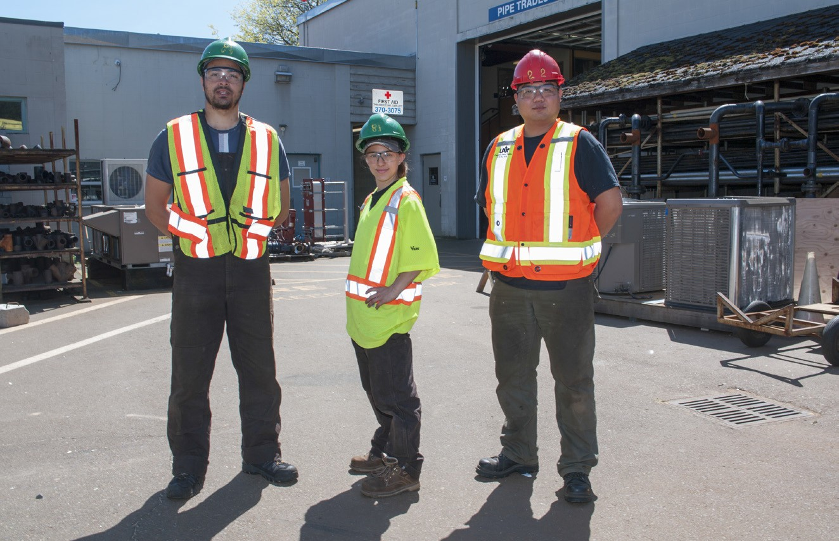

**Figure 1 —** High-visibility garments

Loose-fitted high-visibility outer clothing must be “tear-away” if worn for work where it could get caught on moving equipment or on objects such as branches or limbs.

#### Hair and beards

Workers with long hair should wear a cap or a hairnet. In addition, beards should be trimmed. Both hair and beards can get caught in machinery or catch fire from sparks or an open flame. Beards may also prevent respirators from fitting properly, which could result in the inhalation of hazardous materials.

#### Jewellery

Workers must not wear rings, metal watchbands, bracelets, neck chains, or necklaces on a job site. Wearing these items can cause:

* + a bad burn, if a metal object (for example, a watchband) touches a hot battery terminal and some other grounding object
  + a shock, if working on electrical equipment that has electrical power applied
  + loss of a finger, if a ring gets caught in a piece of machinery

#### Special clothing and gear for various weather conditions

Since many trades have to work in poor weather, workers must have adequate rain gear and warm clothing. Keeping dry is very important for staying warm. When you’re wet, you lose body heat faster.

Some raincoats are designed with vents, which help draw off perspiration. The raincoat should be large enough to allow arms to move freely. The collar should have a cloth cover to protect the neck from the coat’s cold, wet material.

Rain pants keep the lower body dry. If you wear only a raincoat, water dripping off the coat will make your legs wet and uncomfortable. It’s also important to keep your feet dry so they stay warm. Rubber boots with steel toe protectors and steel sole plates are available.

To work safely in cold weather, it is important to wear properly insulated headgear, footwear, and gloves. Wear layered clothing, as layers allow warm air to stay trapped but do not

trap perspiration next to the skin. The first layer of clothing should be a wicking fabric like polypropylene or knitted silk, which will allow the skin to breathe by allowing sweat to escape. The second layer of insulating clothing should be a fabric that absorbs perspiration but does not allow heat to escape. Wool is ideal because it keeps you warm even when wet. The final layer must be able to keep out water and wind.

## Personal protection

On the job site, workers need to wear special personal protective equipment. The equipment you wear will depend on the specific hazards you may expect to encounter. You may be supplied with all or some of the following equipment:

* + - goggles
    - face shield
    - gloves
    - safety lock
    - hard hat
    - welder’s apron
    - coveralls
    - respirator
    - hearing protection
    - high-visibility vest
    - body harness

Protective equipment can be divided into the following categories:

* + - head protection
    - eye protection
    - hearing protection
    - respiratory protection
    - hand and skin protection
    - foot protection
    - fall protection

#### Selecting PPE

All PPE clothing and equipment should feature a safe design and construction and should be well maintained. Workers should consider the fit and comfort of PPE when selecting appropriate items for their workplace. Most protective devices are available in multiple sizes, and care should be taken to select the proper size. If several different types of PPE are worn together,

make sure they are compatible. PPE that does not fit properly can make the difference between being safely covered or dangerously exposed. It may not provide the level of protection desired and may discourage use.

#### Head protection

Hard hats protect workers where there is a hazard of head injury from falling, flying, or thrown objects, or other harmful contacts. The headband made of webbing inside the hat (also known as a hard hat’s *suspension system*) provides a space between the shell and your head, which lessens the impact of anything falling on your head. The headband is adjustable.

Most job sites require that hard hats be worn at all times while on the site. The shells of most hard hats are now almost always made from high-impact plastic, but a few are still made from metal alloys. **Do not** wear a metal alloy hard hat when working on electrical equipment.

#### Hard hat types

The proper type or class of hard hat required will vary for specific areas or for specific jobs. Different hard hats protect against different types of hazards, such as:

* + banging your head on a sharp or hard object
  + being hit by a falling object
  + receiving a shock when working near electrical apparatus

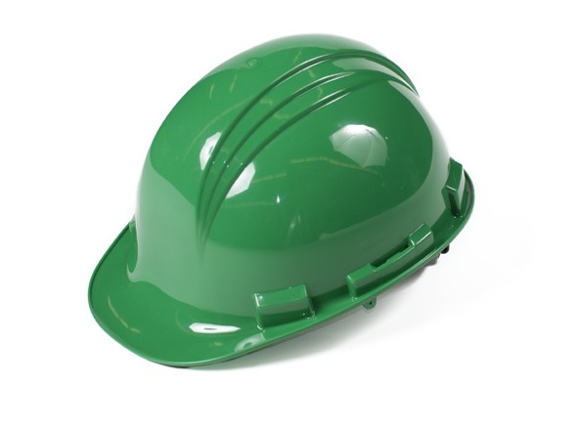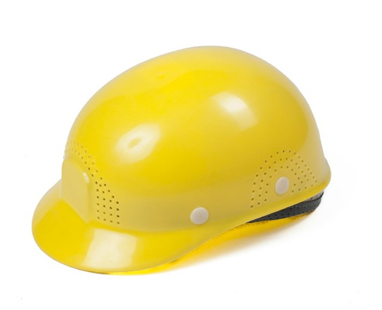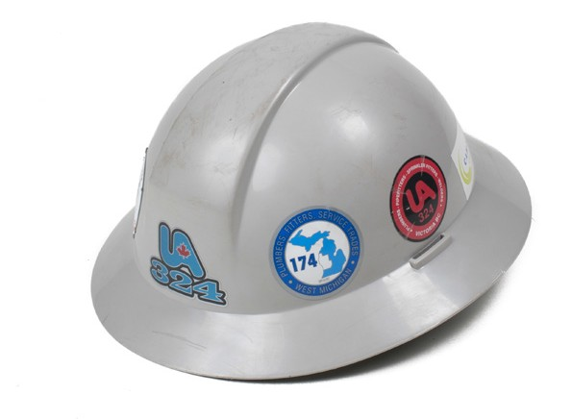

**Figure 2 —** Three types of protective headgear

Hard hats must have either CSA- or ANSI-approval. These standards are similar but not exactly the same. Many manufacturers have their head protection tested to meet both standards. These standards are divided into two types:

* + Type 1 for top protection only
  + Type 2 for top and lateral protection

Hard hats are also divided into three industrial classes:

* + - **Class A** hard hats provide impact and penetration resistance along with limited voltage protection (up to 2200 volts).
    - **Class B** hard hats provide the highest level of protection against electrical hazards, with high-voltage shock and burn protection (up to 20 000 volts). They also provide protection from impact and penetration hazards by flying/falling objects.
    - **Class C** hard hats provide lightweight comfort and impact protection but offer no protection from electrical hazards.

Another class of protective headgear on the market is called a “bump hat,” designed for use in areas with low head clearance. Bump hats are recommended for areas where protection is needed from head bumps and lacerations. They are not designed to protect against falling or flying objects.

Periodic cleaning and inspection will extend the useful life of protective headgear. A daily inspection of the hard hat shell, suspension system, and other accessories for holes, cracks, tears, or other damage that might compromise the protective value of the hat is essential. Paints, paint thinners, and some cleaning agents can weaken the shells of hard hats and may eliminate electrical resistance. Consult the helmet manufacturer for information on the effects of paint and cleaning materials on their hard hats. Never drill holes, paint, or apply labels to protective headgear, as doing so may reduce the integrity of the headgear’s materials. Do not store protective headgear in direct sunlight, such as on the rear window shelf of a car, since it can be damaged by sunlight and extreme heat.

Hard hats with any of the following defects should not be used and should be replaced:

* + - perforation, cracking, or deformity of the brim or shell
    - any indication of exposure of the brim or shell to heat, chemicals, or ultraviolet light and other radiation (in addition to a loss of surface gloss, such signs include chalking or flaking)

Always replace a hard hat if it sustains an impact, even if damage is not noticeable. It is not necessary to replace the entire hard hat if just the suspension system is damaged. Suspension systems are available as replacement parts if they are damaged or show excessive wear.

Some workers are more comfortable wearing their hard hats backwards. This still meets WorkSafeBC requirements if the hat’s suspension is also reversed, but if you can’t reverse the suspension, you must not reverse the hard hat.

#### Eye protection

Eye protection is one of the most important safety concerns of people on the job site. Eye hazards include:

* + splashes from liquids, such as acids and caustics
  + sparks flying off of a grinder
  + dust kicked up by compressed air
  + “flash” from a welder working nearby
  + exposure to laser pointer light

There are many types and styles of eye protection available. Some of the most common types include:

* + safety glasses
  + goggles
  + face shields
  + welding helmets
  + laser safety goggles

###### Safety glasses

These protective eyeglasses have safety frames constructed of metal or plastic and impact- resistant lenses. Side shields are available on some models.

Wear specially designed and manufactured safety glasses to protect your eyes in activities such as:

* + working on any live electrical equipment
  + using cutting pliers to cut material
  + soldering or de-soldering
  + using an electric hand drill
  + hammering
  + working with tool steel

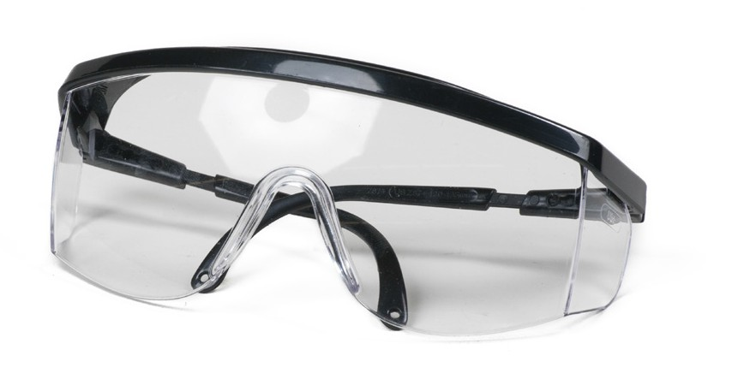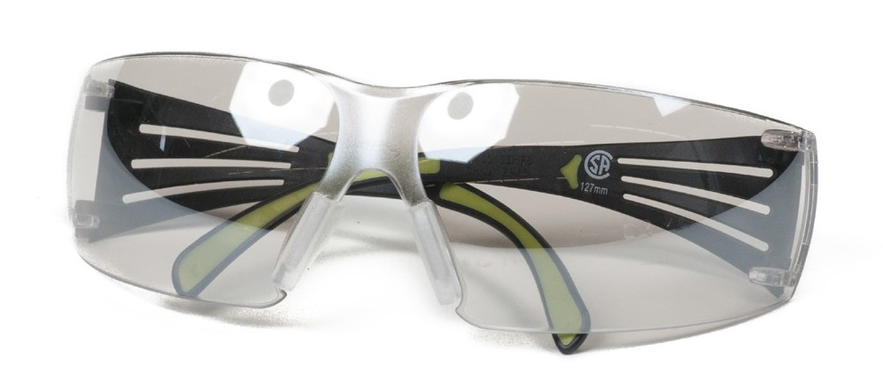

**Figure 3 —** Safety glasses

###### Goggles

Goggles are a type of tight-fitted eye protection that completely cover the eyes, eye sockets, and the facial area immediately surrounding the eyes. They provide protection from impact, dust, and splashes. Some goggles will fit over corrective lenses.

Wear goggles to protect your eyes when doing activities such as:

* + - drilling or chipping, hammering, and working with steel
    - using a powder-actuated tool

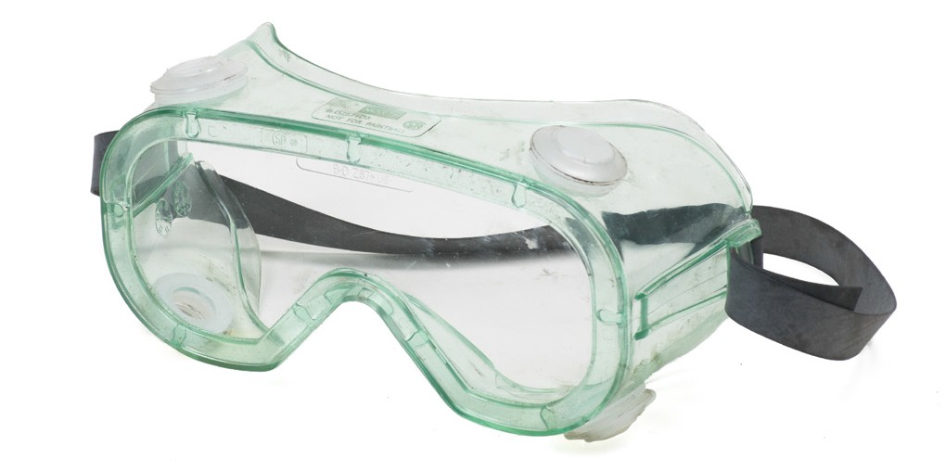

**Figure 4 —** Goggles

###### Face shields

These transparent sheets of plastic extend from the eyebrows to below the chin and across the entire width of the head. Some are polarized for glare protection. Face shields protect against nuisance dusts and potential splashes or sprays of hazardous liquids, but they will not provide adequate protection against impact hazards. Face shields used in combination with goggles or safety glasses will provide additional protection against impact hazards.

Wear a face shield to protect your face in activities such as:

* + - using a grinder
    - using a drill press
    - using compressed air for cleaning

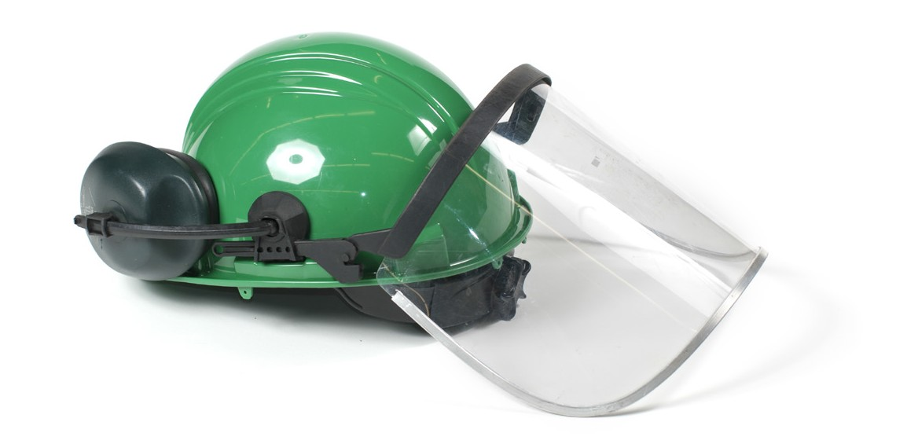

**Figure 5 —** Face shield

###### Welding helmets

Constructed of vulcanized fibre or fibreglass and fitted with a filtered lens, welding helmets protect eyes from burns caused by infrared or intense radiant light. They also protect both the eyes and face from flying sparks, metal spatter, and slag chips produced during welding, brazing, soldering, and cutting operations. Filter lenses have a shade number appropriate to protect against the specific hazards of the work being performed and against harmful light radiation.

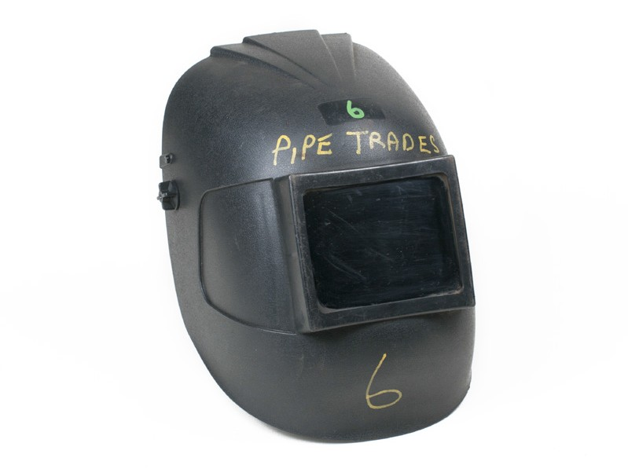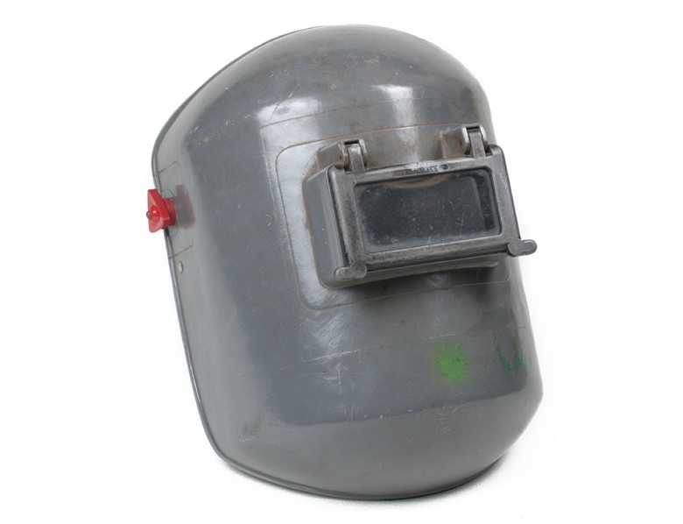

**Figure 6 —** Welding helmets

###### Laser safety goggles

These specialty goggles protect against intense concentrations of light produced by lasers. The type of laser safety goggles a worker chooses will depend on the equipment and operating conditions in the workplace.

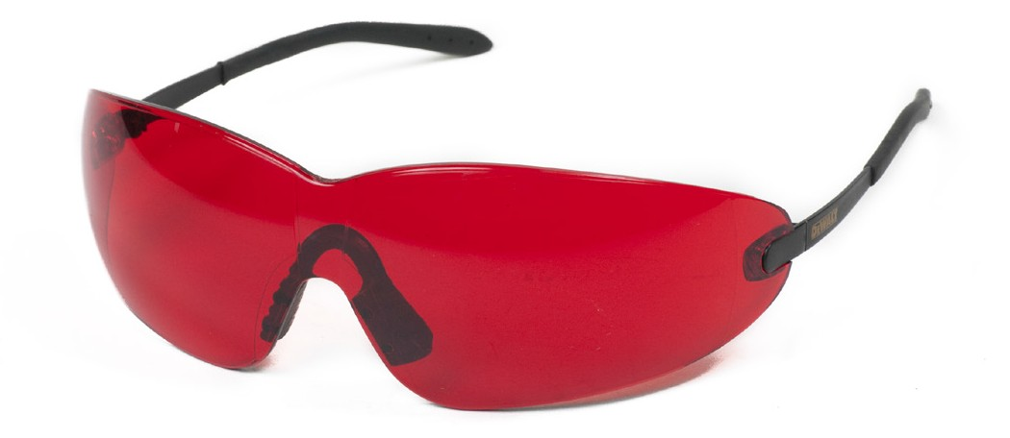

**Figure 7 —** Laser safety goggles

Never assume that regular prescription glasses, sunglasses, or contact lenses can provide adequate eye protection. Dust particles, wood chips, sparks, or welding flash may still cause eye damage if eyes are not properly protected.

Regardless of the job, whether grinding, chipping, drilling, or welding, always use adequate eye protection (welding goggles or helmets are not acceptable for grinding). Choose a type or style of eye protection that will protect you in the job that you are doing (e.g., goggles when chipping concrete, a welder’s helmet when welding). Also, always use safety-approved eye protection.

Improper or faulty protection devices can also be hazardous.

#### Hearing protection

Noise on the job site can affect you in different ways. Being exposed to high noise levels and moderate noise levels over a long period of time can impair your ability to hear specific types of sounds. For example, the noise from diesel-powered vehicles such as trucks can permanently

damage your hearing. High noise levels can affect your state of mind, making you easily annoyed, irritable and mentally fatigued, and can decrease your ability to concentrate and stay alert.

Hearing protection noise reduction ratings (NRR) are given in decibels (dB). If the noise level is 90 dB and a worker is wearing expandable foam plugs rated at 29 dB, the actual noise exposure will be 90 – 29 = 71 dB. When choosing hearing protection devices, you should choose a device that will reduce the noise exposure to a maximum of 85 decibels.

There are four main points to remember when choosing hearing protection:

1. Choose a type or style of protection suitable to the job you are doing.
2. Ear plugs should be pliable, fit each ear tightly, and be kept clean and free from damage.
3. Earmuffs make it easier to hear certain signals in noisy environments.
4. Headphones designed for listening to music do not offer suitable protection.

###### Single-use earplugs

These earplugs are made from material like expandable PVC or urethane foam. They are self- forming and, when properly inserted, they work as well as most moulded earplugs.



**Figure 8 —** Single-use earplugs

###### Pre-moulded reusable earplugs

Pre-moulded earplugs are made from biocompatible silicon, plastic, or rubber and are manufactured as either “one-size-fit” or in several sizes to fit small, medium, or large ear canals. Advantages of pre-moulded plugs are that they are relatively inexpensive, reusable, washable, convenient to carry, and come in a variety of sizes.

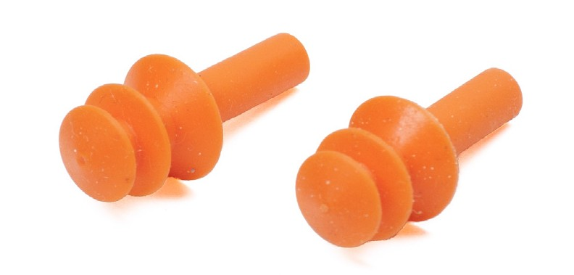

**Figure 9 —** Pre-moulded earplugs

###### Custom-fitted hearing earplugs

Made from impressions taken of an individual’s ear, custom-fitted earplugs completely fill the ear canal and match the ear shape of the wearer. Some custom-fitted plugs are designed to let the wearer hear conversations in noisy environments. Others have a communication speaker installed into them.

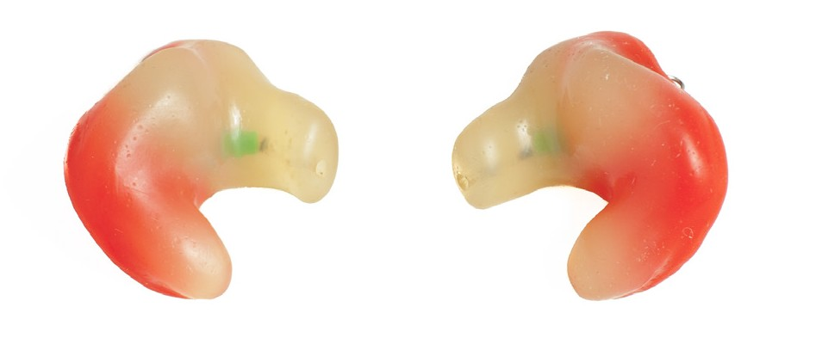

**Figure 10 —** Custom-fitted earplugs

###### Canal caps

Canal caps resemble earplugs on a flexible plastic or metal band. The earplug tips of a canal cap may be made of a formable or pre-moulded material. These have the convenience of being easily removed and replaced as needed.



**Figure 11 —** Canal caps

###### Earmuffs

Earmuffs come in many models designed to fit most people, and some styles can be connected to a hard hat. They work by blocking out noise by completely covering the outer ear.

To work properly, earmuffs must be perfectly sealed around the ears. Their effect may be reduced if glasses, facial hair, or long hair compromise the seal. Facial movements such as chewing may also affect the seal.



**Figure 12 —** Earmuffs

#### Respiratory protection

Workers must be aware of any airborne hazards present on the job and must take the necessary precautions to protect the respiratory system. Examples of hazards include airborne particles such as body filler, asbestos, or dust, as well as toxic gases or fumes. All of these are harmful if inhaled, but workers can protect themselves by wearing an approved respirator.

If you are required to use a respirator, you will need the appropriate training to select, test, wear, and maintain this equipment. Always use the appropriate respirator for the hazard involved

and the extent and nature of the work to be performed, which includes choosing the correct type of cartridge and filter. Respirators must be kept clean and sterilized according to the manufacturer’s instructions. It is very important to check a respirator carefully for damage and proper fit. All respirators must be properly fitted to your face, and the seal must be checked each time the respirator is used.

There are three types of respirators commonly used for various atmosphere conditions in the workplace. These are:

* + air-line or supplied air respirators
  + self-contained breathing apparatus
  + air-purifying respirators

###### Air-line respirators

Air-line or supplied air respirators have a mask or hood with a remote air supply available through a connected hose. This type of respirator is used where there is not enough oxygen or there are toxic gases or fumes in the air.

###### Self-contained breathing apparatus (SCBA)

An SCBA draws air from a compressed-air cylinder, which is strapped to the worker’s back.

This style of respirator is used when there is not enough oxygen on the work site or there are toxic gases or fumes in the air. An SCBA has the added advantage of an independent air supply without any length of hose to be concerned with. This is the main reason why this type of respirator is more commonly used in rescue and emergency situations.

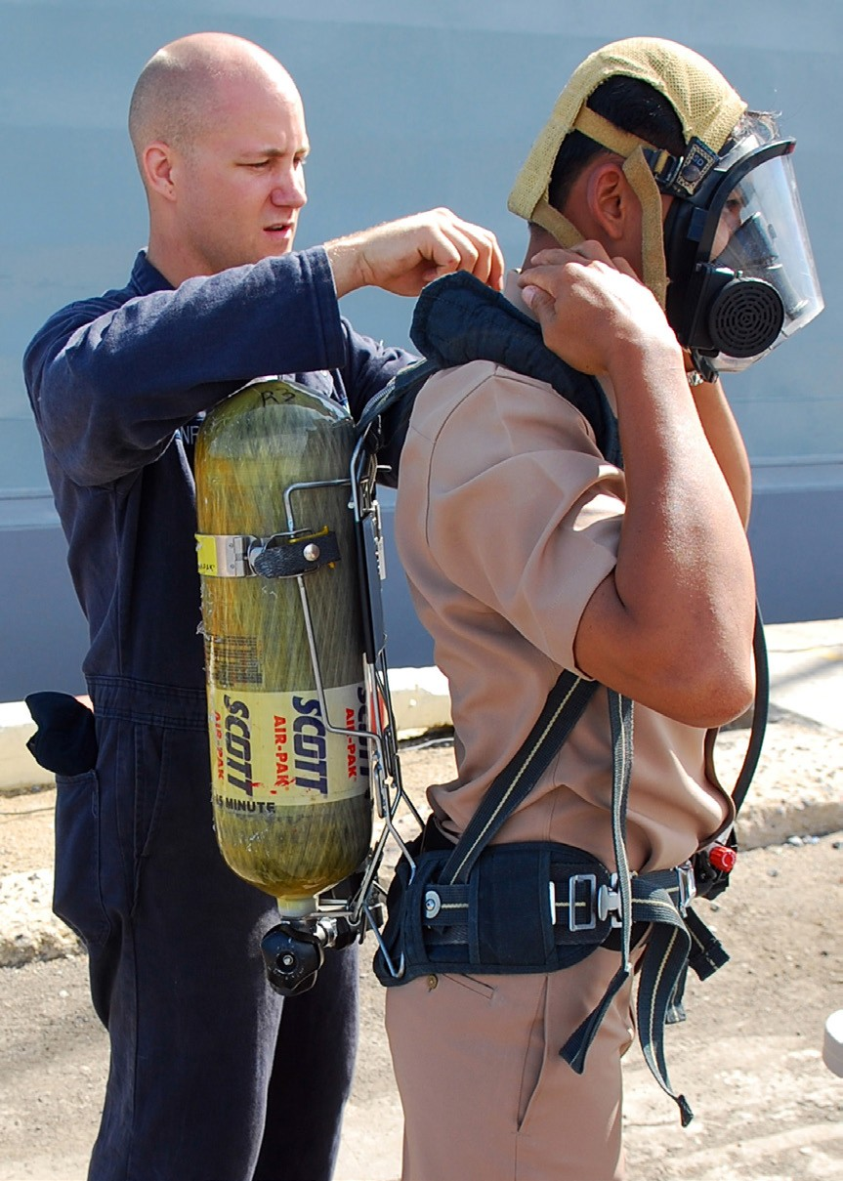

**Figure 13 —** SCBA

###### Air-purifying respirators

There are two common types of air-purifying respirators:

* + dust/mist masks
  + cartridge respirators

These types of respirators **cannot** be used in an oxygen-deficient environment. The full face piece mask with a chemical canister can be used to protect against short exposure to dangerous gases or fumes, such as an emergency escape situation, as the cartridge in the respirator is able to neutralize the gases for a very short time only.

###### Dust/mist masks

Dust masks are made of paper or soft non-woven fibre and simply fit over the mouth and nose. These generally offer protection against nuisance dusts and fine mists only. Some models have a built-in exhaust valve for more comfort.

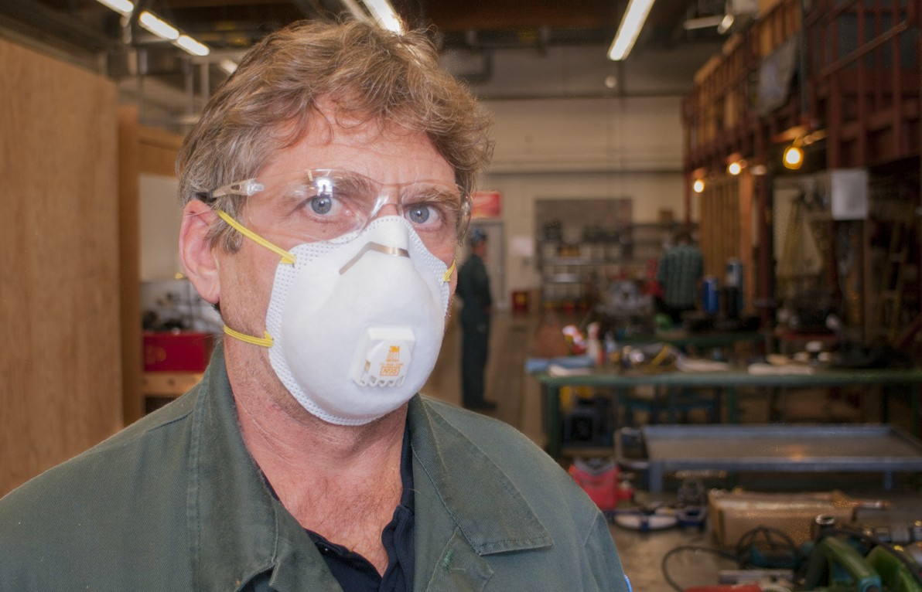

**Figure 14 —** Dust mask

###### Cartridge respirators

Cartridge respirators are commonly used in conditions where there are low concentrations of organic gases, pesticides, and paint vapours. These come in “half-mask” or “full face piece”

designs. Both of these designs are also made in one- or two-cartridge styles. Do not use these types of respirators to protect against highly toxic gases.

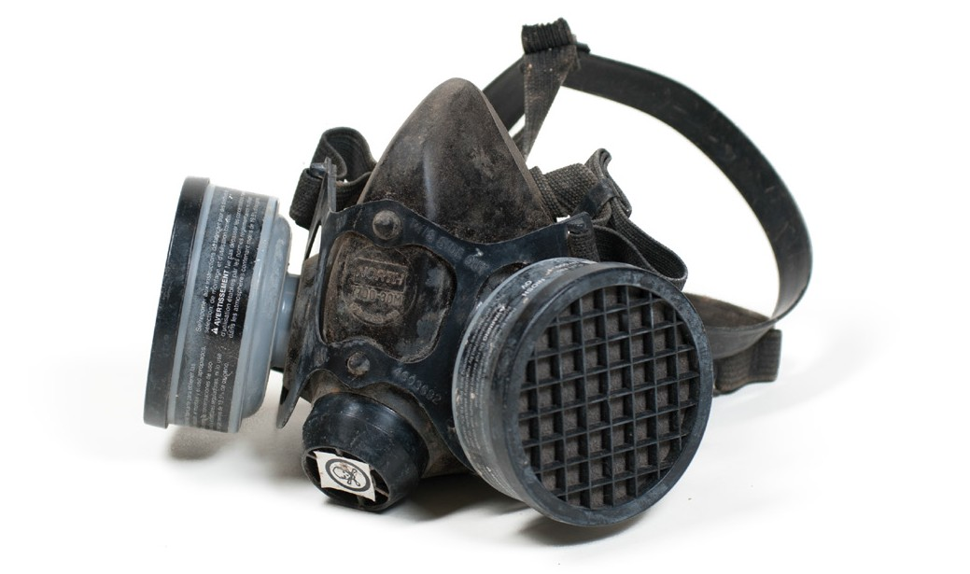

**Figure 15 —** Cartridge respirator

## Hand and skin protection

WorkSafeBC accident statistics indicate that over 30 percent of work injuries involve fingers, hands, and arms. Many of these accidents could be avoided by using appropriate hand protection. As a trades worker, you are ultimately responsible for ensuring that you use the correct hand protection for each hazardous situation.

#### Gloves

Gloves are manufactured from materials such as cotton, leather, rubber, metal, and other synthetics and are tailored to meet every need for hand protection in every trade area:

* + Leather or vinyl-coated gloves should be used when handling lumber or steel.
  + Gauntlet-type welder’s gloves should be used when welding or flame cutting.
  + Special heat-resistant gloves should be used when handling hot metal.
  + Rubber or approved plastic-treated gloves should be used when handling acids and cleaning solutions.

|  |  |
| --- | --- |
|  |  |
| **Split leather/cotton work glove** | **Welder's glove** |
|  |  |
| **All leather work glove** | **Nitrile glove** |
|  | |
| **Latex glove** | |

**Figure 16 —** Types of work gloves

#### Barrier creams

If you are exposed to chemicals that can strip oils from your skin, you are susceptible to developing dermatitis. Avoid this condition by using proper gloves along with a barrier cream if you notice your skin drying out.

## Foot protection

Your feet deserve as much consideration as your eyes, ears, or hands.

Potential hazards to your feet include:

* + - heavy objects falling on them
    - stepping on sharp objects
    - having hot sparks or slag fall inside your shoes

You must wear safety footwear appropriate to the job you are doing. For example, leather boots are required in the welding shop, where there are specific hazards from sparks and molten slag.

Leather is not impervious to all chemicals, and therefore is not a good choice when walking in wet concrete. In that case, rubber boots with steel toe and sole protectors would be better. Footwear should be inspected regularly and replaced if worn out.

#### CSA standards

Due to the dangers listed above, you must wear safety footwear that is CSA approved. Look for the green triangle with the CSA logo.

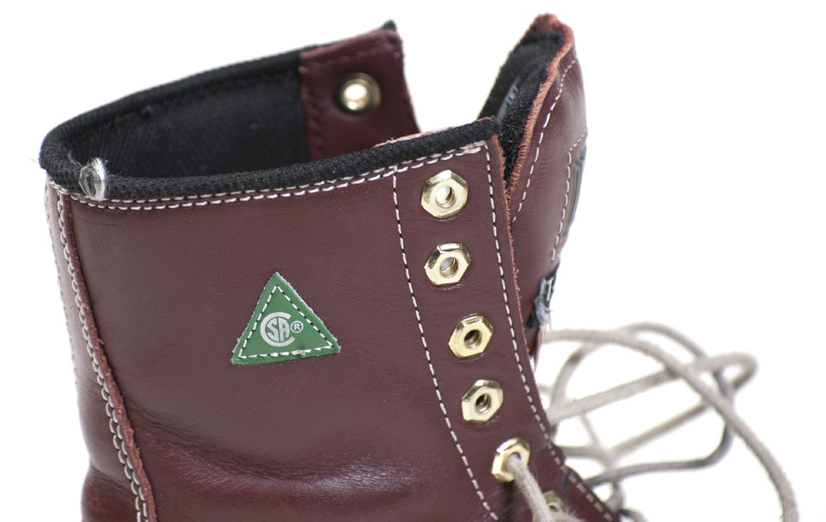

**Figure 17 —** CSA footwear logo

## Fall protection

One subset of personal protective equipment includes the various types of fall protection systems and their components. This category is covered in detail in Learning Task 2: Describe fall protection systems.

## General care of PPE

Remember that PPE is the last line of defence against personal injury, so using it properly and taking care of it are very important. Be sure to do all of the following:

* + Regularly inspect it.
  + Properly care for it.
  + Use properly when it is needed.
  + Never alter or modify it in any way.

Now complete the Learning Task Self-Test.

**Self-Test 1**

1. It is the worker’s responsibility to wear proper safety equipment on the job-site.
   1. True
   2. False
2. What makes loose or sloppy clothing dangerous in mechanical shops?
   1. It may catch fire.
   2. It may get caught in moving machinery.
   3. It may cover your hands, interfering with your grip.
   4. The sleeves may get into the solvent when washing parts.
3. You should tuck your pant legs inside your boots when working near a torch or grinder.
   1. True
   2. False
4. Rings and metal watchbands constitute a hazard on the job and can contribute to a shock or a burn.
   1. True
   2. False
5. What PPE are workers responsible for supplying?
   1. Headgear, eye protection, and ear protection
   2. Gloves, safety headgear, and safety footwear
   3. Safety boots, gloves, and eye and ear protection
   4. Fall-arresting, buoyancy, eye and ear protection devices
6. Bump hats are designed to be used in areas with low head clearance. They are used to protect against head bumps and lacerations, but can also be used to protect against falling or flying objects.
   1. True
   2. False
7. What type of footwear must be worn when working in the welding shop?
   1. Rubber boots
   2. Caulked boots
   3. Steel toed work boots
   4. Running shoes with safety toes
8. Never paint on or apply labels to a hard hat.
   1. True
   2. False
9. When must hard hats be worn?
   1. Whenever working outdoors
   2. If requested by your supervisor
   3. If it is necessary to be identified as an employee
   4. Whenever a hazard of flying or falling objects exists
10. When a hard hat has sustained an impact, it doesn’t need to be replaced unless it has noticeable damage.
    1. True
    2. False
11. What PPE must be worn when performing an operation that could create flying particles or chips?
    1. Gloves
    2. Coveralls
    3. Ear protection
    4. Eye and face protection
12. Which of the following is required for face protection when grinding?
    1. Safety glasses
    2. Plastic goggles
    3. Full face shield
    4. Laser safety goggles
13. When handling chemicals, what are rubber gloves and a face shield worn to protect against?
    1. Explosions
    2. Toxic vapours
    3. Spills and splashes
    4. Contaminating the product
14. What type of hearing protection can have a communication speaker installed into it?
    1. Canal caps
    2. Single-use earplugs
    3. Pre-moulded earplugs
    4. Custom-fitted earplugs
15. When wearing a respirator for lung protection, it is necessary to use the correct cartridge for the type of hazards to which you are exposed.
    1. True
    2. False
16. Cartridge respirators are commonly used when performing work in an environment contaminated with highly toxic gases.
    1. True
    2. False
17. Leather gloves should be used for handling acids, caustics, or solvents.
    1. True
    2. False

LEARNING TASK 2

**Describe fall protection systems**

There are different methods of providing fall protection. A fall protection system is defined in the OHS Regulation (Part 11) as:

* + a fall restraint system
  + a fall arrest system
  + work procedures that will minimize the risk of injury, such as using a safety net, that are acceptable to WorkSafeBC

## Fall restraint system

Fall restraint systems prevent a worker from falling from a work position, or travelling to an unguarded edge from which the worker could fall. Examples are guardrails or a personal fall protection system.

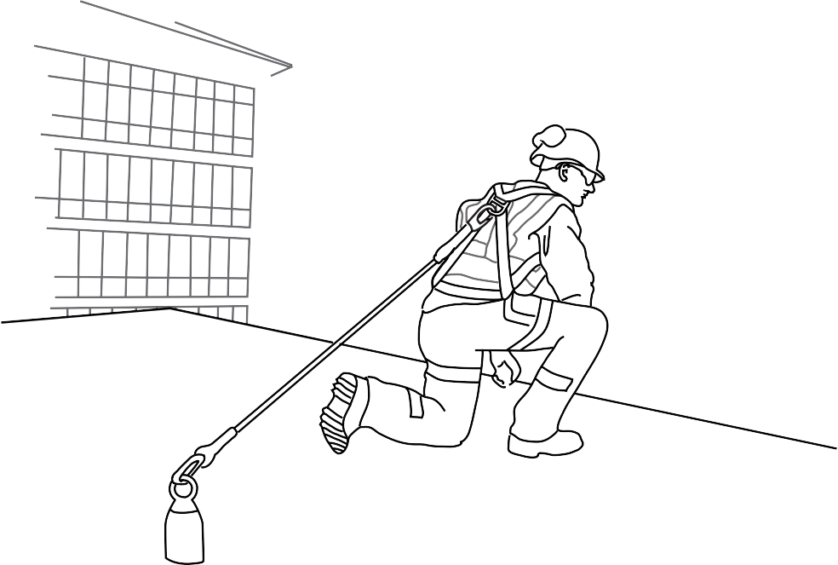

**Figure 1 —** Fall restraint

**Watch the WorkSafeBC video on fall restraint:** [**https://youtu.be/yCcBlhkGhTE**](https://youtu.be/yCcBlhkGhTE)

## Fall arrest system

Fall arrest systems stop a worker’s fall before the worker hits the surface below.

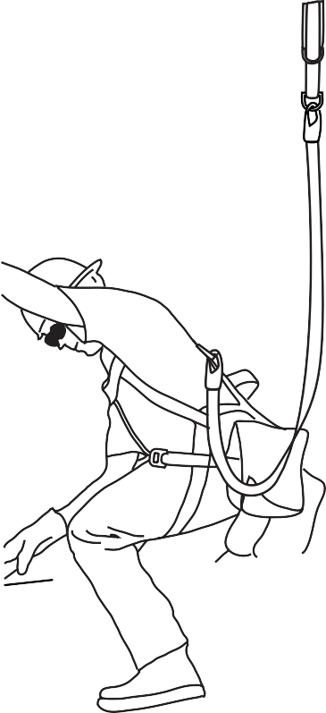

**Figure 2 —** Fall arrest

**Watch the WorkSafeBC video on fall arrest:** [**https://youtu.be/_dhlEovMkcw**](https://youtu.be/_dhlEovMkcw)

## Fall protection equipment

A worker’s personal fall protection system will have different equipment depending on whether it is a fall arrest or fall restraint system. It will include:

* + a safety belt or full body harness
  + a lanyard, lifeline, and any other connecting equipment that is used to secure the worker to an individual point of anchorage or to a horizontal lifeline system

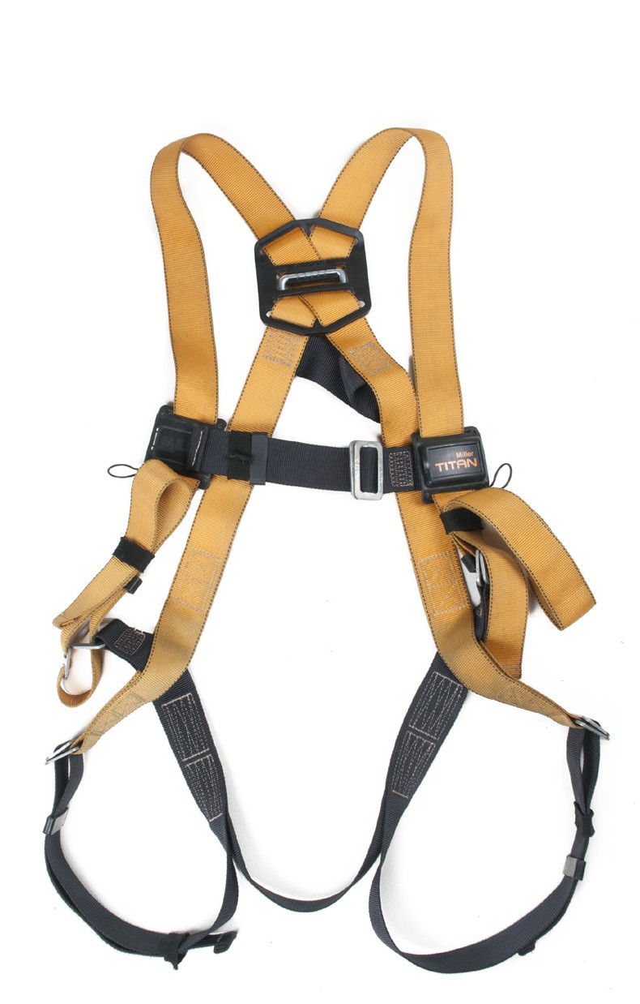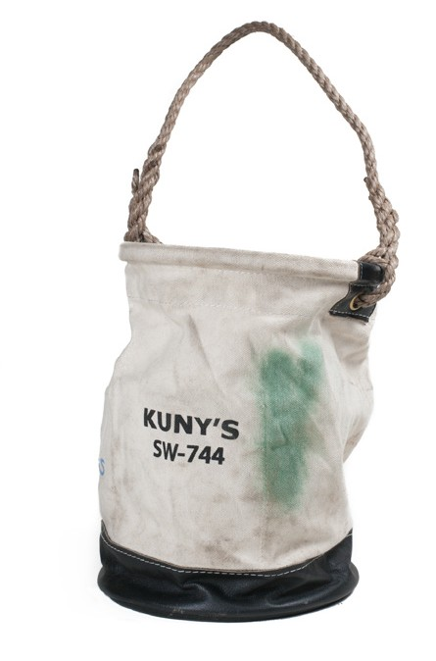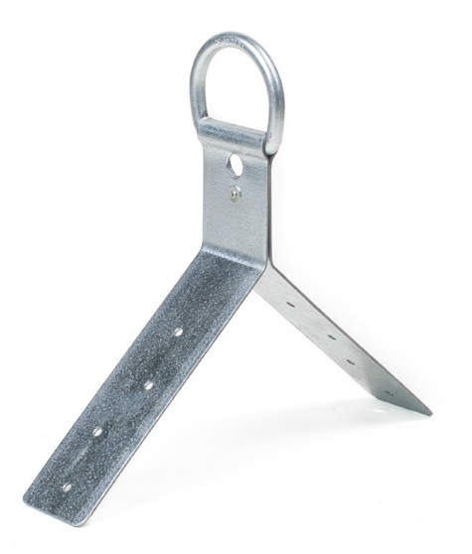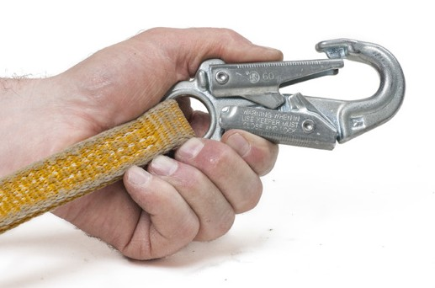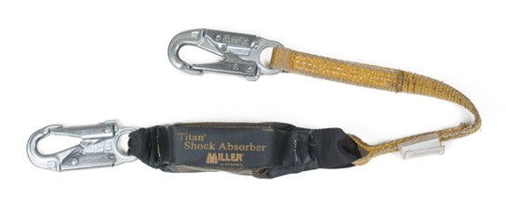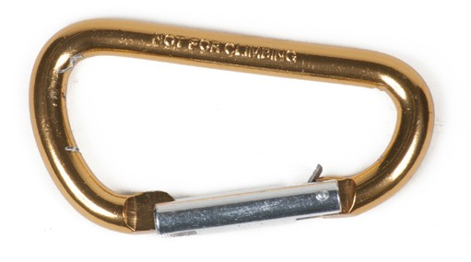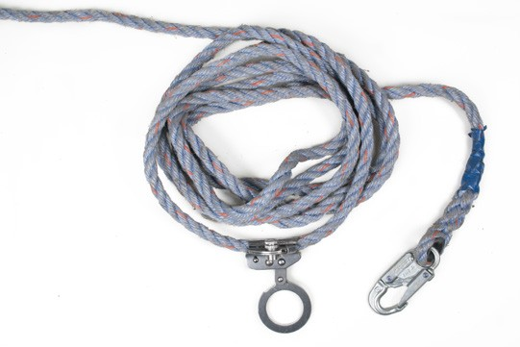

**Figure 3 —** Fall protection equipment

**Review OHS Regulation part 11 “Fall Protection”** [**http://www2.worksafebc.com/publications/OHSRegulation/Part11.**](http://www2.worksafebc.com/publications/OHSRegulation/Part11.asp#SectionNumber%3A11.4) [**asp#SectionNumber:11.4**](http://www2.worksafebc.com/publications/OHSRegulation/Part11.asp#SectionNumber%3A11.4)

#### Harness and belts

When using personal fall protection equipment, wear a full body harness if you are at risk of falling. A full body harness consists of straps passed over the shoulders, across the chest, and around the legs. It also has a d-ring or support point at the rear between the shoulder blades.

In a fall, a full body harness will protect you more than a safety belt because the harness distributes the force of impact over a greater area of your body. A belt should be used only as a part of a fall restraint system. It is important to adjust the harness to fit your body. A poorly fitting harness is uncomfortable and may not protect you.

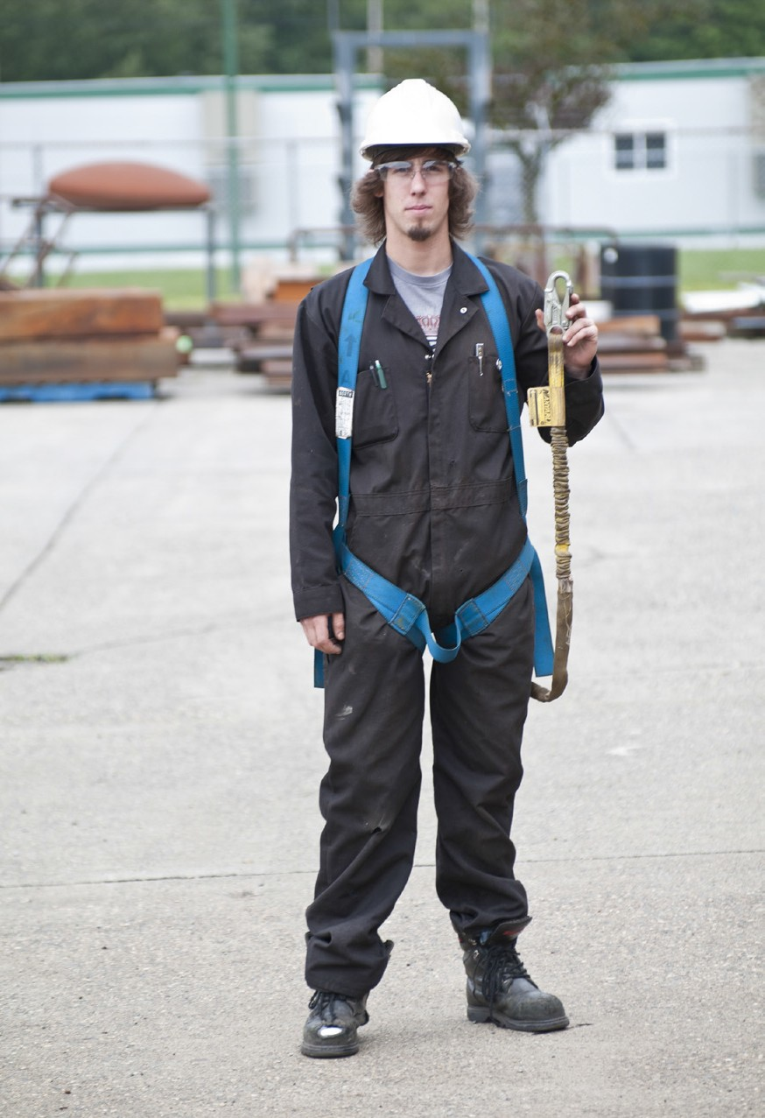 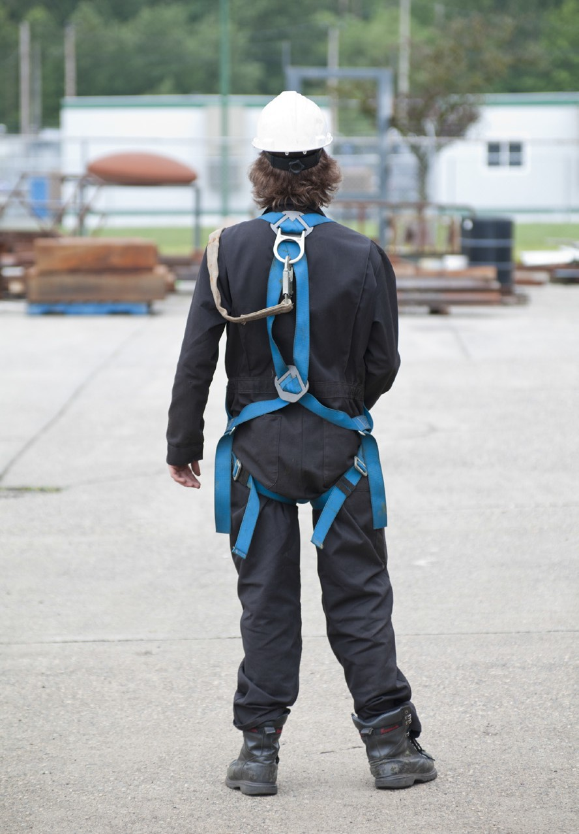

**Figure 4 —** Full body harness

#### Connecting equipment

There are various types of equipment that can be used to connect the harness to the anchor point.

###### Lanyard

A lanyard is a flexible line of webbing, or a synthetic or wire rope, used to secure a safety belt or full body harness to a lifeline or anchor.

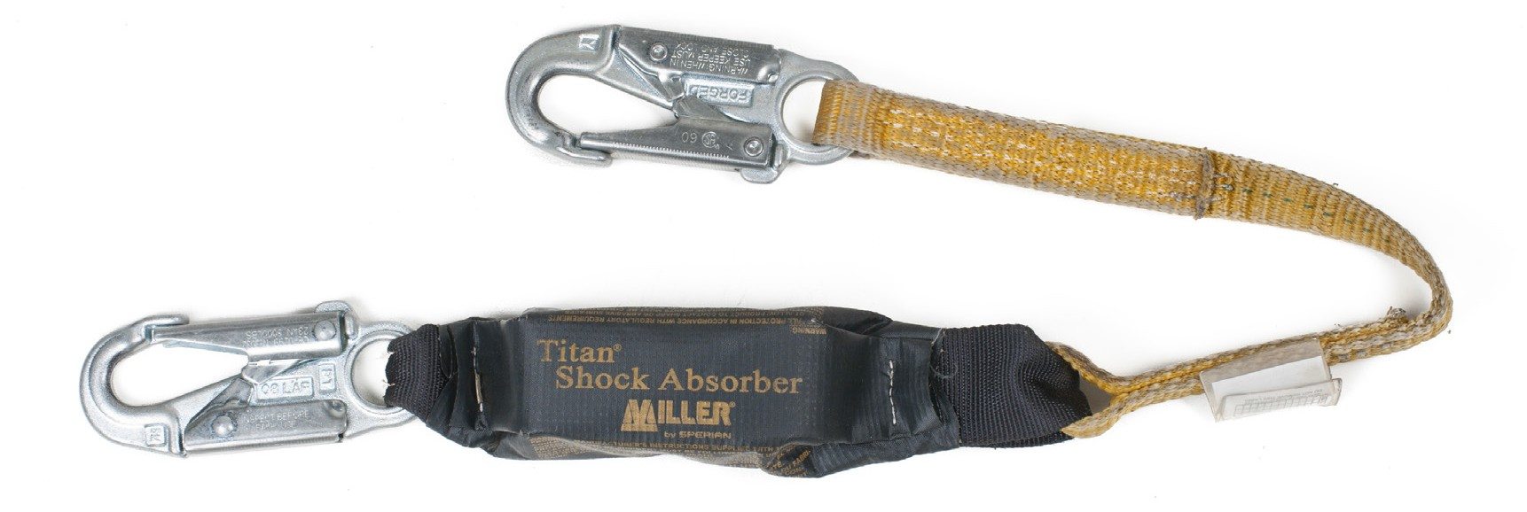

**Figure 5 —** Webbing

#### Deceleration device or shock absorber

A common method of reducing the impact strain on the body and the anchorage system is to use a deceleration device. These devices are designed to slowly allow a release of energy and absorb the initial shock. The device may be a spring or tear webbing design. It is important to know that this shock absorber may increase the length of the lanyard during a fall by as much as

* 1. m (4 ft.), which must be allowed for in the design of your personal fall protection system.

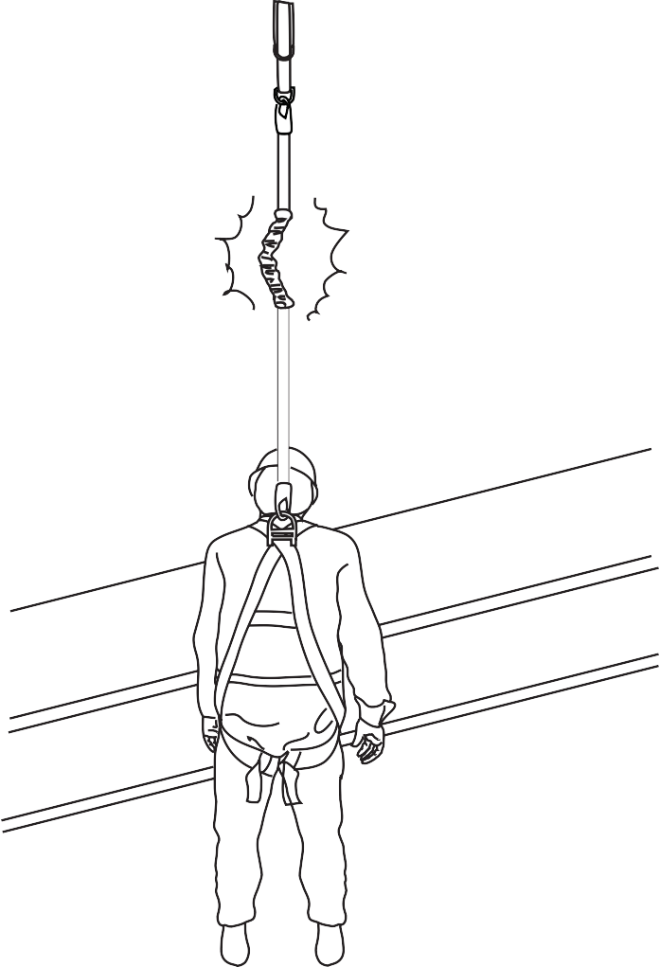

**Figure 6 —** Deployed shock absorber

###### Lifeline

Lifelines are used to extend the connection of a lanyard to an anchor point. They can be vertical, horizontal, or retractable. A retractable lifeline works like a seat belt in a car. The line is under constant tension, and the moment you fall the lifeline locks.

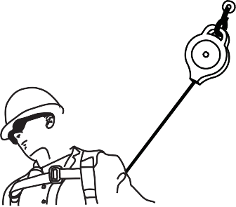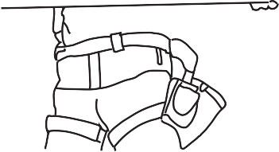

**Figure 7 —** Retractable lifeline

###### Rope grab

A rope grab is used to connect the lanyard to a vertical lifeline. The rope grab travels along the lifeline with you and will lock onto it if you fall.

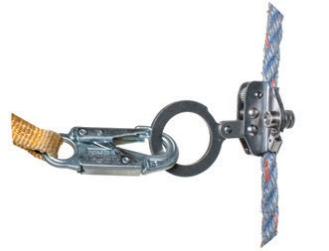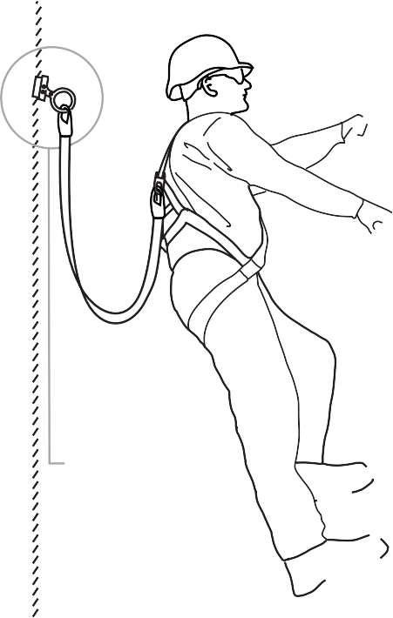

**Figure 8 —** Using a rope grab

###### Snap hook or carabiner

Snap hooks are used to connect lanyards to rope grabs, harnesses, and horizontal lifelines. Snap hooks must be self-locking so that the hook can’t be open unless you depress a separate locking mechanism before opening the keeper.

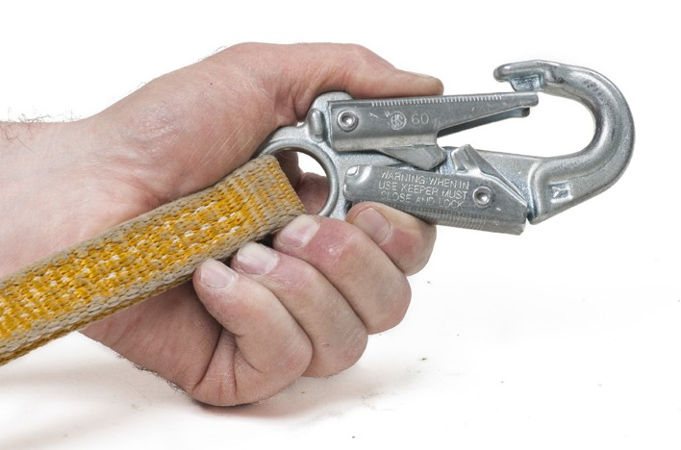

**Figure 9 —** Locking snap hook

A carabiner is an oblong-shaped connecting device also used to attach different components of a personal fall protection system. A carabiner should have gates that are both self-closing and self-locking with a breaking strength of at least 22 kN (5000 lb.). It should also have the manufacturer’s identity and load capacity clearly marked on it.

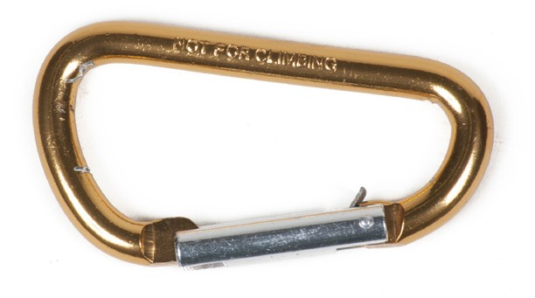

**Figure 10 —** Carabiner

#### Inspection, storage, and maintenance

To maintain service life and performance, all fall protection equipment should be inspected frequently. Damage can include burns, hardening due to chemical contact, and excessive wear. The fall protection equipment must be inspected by a qualified person and replaced or

recertified if any damage is found. Always store fall protection equipment in a dry location away from any substances that could cause deterioration.

Now complete the Learning Task Self-Test.

**Self-Test 2**

* + 1. What term best describes the combination of PPE that is used to protect workers who fall?
       1. Full body harness
       2. Fall arrest system
       3. Fall restraint system
       4. Fall protection system
    2. What is the fall protection component that connects a safety belt or harness to an anchor point?
       1. Lanyard
       2. Lifeline
       3. Rope grab
       4. Carabiner
    3. A safety belt could be used as a component of what type of fall protection system?
       1. Fall arrest system
       2. Fall restraint system
       3. Confined space system
       4. A safety belt is not approved for any fall protection system
    4. What piece of fall protection equipment reduces the impact on the body when a fall happens?
       1. Safety net
       2. Rope grabs
       3. Carabiners
       4. Deceleration device
    5. What piece of fall protection equipment must be self-locking?
       1. Lifeline
       2. Carabiner
       3. Snap hook
       4. Rope grab
    6. When using a shock absorber lanyard, what must be accounted for in the fall protection system design?
       1. Your harness should be adjusted to fit loosely.
       2. Lanyard length may increase by up to 1.2 m (4 ft.) during a fall.
       3. Lanyard length may decrease by up to 1.2 m (4 ft.) during a fall.
       4. The lanyard must be connected to the front of your body harness.

LEARNING TASK 3

**Lift and move objects safely**

Preventing lower back injury on the job is particularly important. You can keep your back healthy by paying attention to ergonomics (the relationship between you and your work environment) and the rules for safe lifting and carrying.

The design of the human body is such that the back is especially susceptible to injury if it is not treated with respect; know your own strengths and limitations. A high percentage of all workplace injuries involve the back. Basic precautions and lifting techniques are easy to learn and apply and greatly reduce the chances of serious back injury.

## General rules for lifting and moving objects

Always follow these rules, even for lifting light objects:

* Place your feet apart for good balance.
* Bend your knees.
* Hold the object as close to your body as possible.
* Lift smoothly and slowly.
* Pivot with your feet; don’t twist your back.
* Push, rather than pull the load.
* Share the load; work with a partner.
* Get mechanical assistance for heavy loads.

Many of the objects you may have to lift and move can be heavy and awkward, including beams, planks, plywood and panel products, ladders, and wheelbarrows. The following safe lifting procedures are recommended for most tasks.

#### Feet

Your feet should be spaced apart, one slightly ahead of you and the other slightly behind, in a normal standing position.

#### Back

Your back should be straight, not bent. If your back is arched or twisted, you may injure yourself.

#### Chin

Keep your chin in toward your chest. This will help to keep your back straight.

#### Palm

Use a palm grip. Your fingers should be close together so that both the palm and fingers do the lifting. Your palm is more than twice as strong as your fingers.

#### Body weight

Maintain your balance and distribute your weight evenly over both feet.

#### Arms

Tuck your arms into your sides. This will allow you to carry more weight with less chance of injuring yourself than if you held the item away from your body.

## Procedures for lifting specific objects

Before moving anything, make sure your path is clear of obstacles and that there’s space to put the object or material down. Depending how you have to move the object, your vision may be blocked on one side. Be sure you can see where you’re going.

Watch out for overhead power lines when lifting and carrying ladders, pipes, and other long objects.

**Plywood**

To pick up and carry a sheet of plywood, wear leather gloves and use this procedure:

* + - * 1. Stand the plywood on its narrow edge in a vertical position. If the plywood is lying flat on the ground, go to one end and pick up the narrow edge, then lift and walk toward the plywood until it is standing vertically on its narrow edge. This method requires you to lift only half the weight of the plywood from the ground.
        2. Place your hands at the midpoints of the long edges of the plywood. Roll the sheet onto your right or left hand. The sheet should be balanced in the carrying hand. This avoids straining your back when you try to keep the sheet from dropping at one end.
        3. If your grip feels uncomfortable, put the sheet down on its narrow edge, and take a new grip. If you lean the sheet of plywood into your shoulder, some of the weight will transfer from your hand. Figure 1 shows the correct way to hold and carry a large, lightweight panel product.

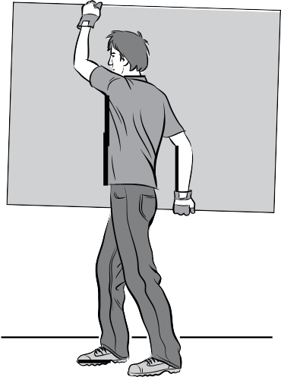

**Figure 1 —** Carrying a large sheet of a panel product

Always ask for help if you need it. For example, if there are obstacles to negotiate around, get someone to help you carry the sheet. In this situation, there should be one person at each end of the sheet. If it is windy, you may have difficulty carrying large sheets, so again, ask for help.

**Planks and beams**

If they are not too heavy, planks and beams can be carried on your hip or shoulder. If the plank or beam is too heavy for you to carry, get help or use mechanical assistance such as a hoist or forklift. The plank or beam should be up off the floor on blocking so that you can easily get your hands under it. To place blocking under the plank or beam, you may have to turn it on its edge or use a crowbar to lift it up.

The following is the procedure for carrying a beam:

1. Bend down, keeping your back straight and your feet slightly apart, pointed in the direction that you want to move.
2. Place one hand on each side of the beam near the middle, one hand slightly forward and the other slightly behind.
3. Lift slightly to check the weight and the balance, then relocate your hands until you have the proper balance.
4. Stand up slowly, keeping your back straight and using your leg muscles.
5. Hold the plank or beam close to your body and let your hip carry some of the weight.

If you want to carry the plank or beam on your shoulder, pick it up from one end and walk and lift it toward the other end until it is on your shoulder. With the beam on your shoulder, adjust the balance so that slightly more of the weight is behind than in front. This way you can pull the plank or beam down in front of you to keep your balance.

Before you move a plank or beam, make sure that the way is clear and that there is a space to place it. Both planks and beams should be put down on blocking if they are not put directly into place in the building structure.

Do not twist your back when moving heavy weights, and use your feet to change direction of travel. Do not carry any more than you can comfortably handle and control at all times. If you are forced to drop your load or if you lose control of it, you risk injuring yourself or a co-worker.

#### Steel pipe and rebar

Steel pipe can be carried in the same manner as the beams or planks. If there is more than one pipe to carry at the same time, bundle and tie them together at each end and in the middle. If you try to carry more than one pipe at a time, you can easily lose control of them as they will want to go in different directions.

#### Ladders

Extension ladders come in various lengths, and the longer the ladder, the heavier it is. Most trades workers should be able to handle a 5 m (16 ft.) ladder by themselves. Longer ladders should be handled by two people.

A ladder is usually carried on the shoulder, with one arm placed between the rails and the other hand used to balance it. The ladder should be picked up in the same manner as beams or planks.

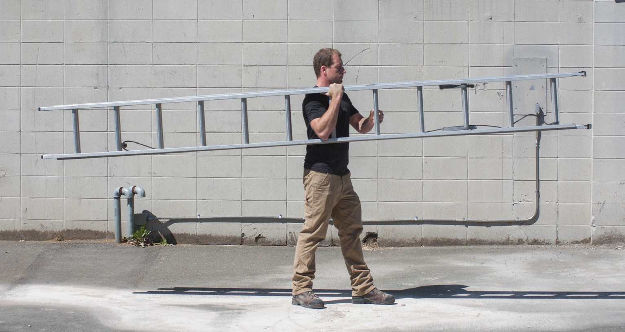

**Figure 2 —** Lifting a ladder

Do not drop a ladder or let it hit anything. You could crack the side rails and make the ladder unsafe for anyone to use.

#### Wheelbarrows

One worker can carry a very heavy load (up to 300 kg) in a wheelbarrow. Before using a wheelbarrow, check to ensure that the wheel of the barrow is properly inflated and centred on its axle.

When you use a wheelbarrow, always maintain your balance. Keep the bulk of the weight in a wheelbarrow toward its front for greater control, and make sure it’s not overfilled. When you turn a corner, tilt the barrow slightly in the direction of the turn just as you would tilt a bicycle— not too sharply or you may tip the load. When you go downhill, hold back the barrow to prevent losing control.

In the construction industry, wheelbarrows are primarily used to place concrete and gravel. They have a narrow spout to direct the concrete into the forms, and there is an extension of the handrails past the front wheel. This allows the barrow to be tipped and the contents dumped. Be sure to protect any surfaces that may break or chip from coming into direct contact with the handrail extensions when pouring.

When you move a wheelbarrow, use the following technique:

1. Bend your knees, keeping your back straight, your chin in, and your feet slightly apart.
2. Lift in a smooth motion and push the barrow in the direction you want to go, tilting the barrow to make the turns.
3. When you take a wheelbarrow up a ramp and you need help to move the barrow, only one person should do the pushing. The other should use a long hook on the front of the barrow and pull it up the ramp. If two people try to push the barrow, balance will be lost and the contents will spill.

#### Shovelling

Shovelling may seem like a simple task that couldn’t harm you, but if you shovel materials in the wrong manner, you may subject yourself to injury. There are basic rules for using a shovel comfortably and safely:

1. Keep your back as straight as possible.
2. Bend at the hips and keep your feet slightly apart, with one ahead of the other.
3. Place yourself in a comfortable position and have a cleared area to work in. You will find that a long-handled shovel is easiest to work with. Not only will it provide more leverage, but it will not require you to bend very far.
4. If you are right-handed, your left hand should grip the shovel just above the metal ferrule, and the right hand should be nearer the top of the shovel handle.
5. Slide or push the shovel into the material.
6. Drop the end of the shovel slightly to catch the material. Then draw the shovel toward you, allowing it to slide on the ground.
7. When the shovel is near you, you can then lift with your left hand and steady your right hand to move the material by tossing it off to the side or behind you.

You can also use your knee for leverage to help lift up a shovel. The motion of using the shovel should feel comfortable without any strain. If the load on the shovel is too heavy, take smaller loads.

Learn to pace yourself. If you start too vigorously, you will quickly tire and be unable to maintain a steady work pace.

The best shovelling method depends on the material to be moved. Drain rock or gravel should be picked up from the bottom edge of the pile, rather than from the middle or top. Sand can be picked up from any part of the pile.

Soil that has been dumped by truck can be taken near the bottom of the pile. Soil that has to be dug out of the ground may have to be loosened with a pick or maddock before it can be easily picked up.

#### Barrels and drums

Large barrels or drums are moved by rolling them on their rims. If a barrel is lying on its side, it must be placed in the upright position by using the following procedure:

1. Stand at the top end of the barrel and bend your legs (but keep your back straight) so that you can get a good grip on each side of the rim near the bottom.
2. Lift the barrel toward the upright position and, as it reaches the balance point, be ready to change your grip so that you can prevent the barrel from dropping on its end.

If the barrel is full, you will need the help of a second person or the use of a barrel dolly, which is designed to pick up and move barrels.

#### Small pails

Small pails (20 to 25 L, or 5 to 6 gal.) used for paints, adhesives, coatings, and the like are quite heavy, so you need to be careful when moving them.

Check that the handles are properly inserted into the holders at the sides of the containers. If the handle slips, the rim of the container could fall and land on your foot.

To pick up a heavy container, bend your legs, keeping your back straight. Reach down and grip the handle and then stand erect and carry the container to the desired location. To keep your balance, you may find it easier to carry two pails at the same time.

Containers to be moved up to a scaffold platform should be raised with a rope-and-pulley system. They are usually too heavy to be pulled up by a rope only.

#### Boxes

Many items come in heavy boxes or sacks. To pick up boxes from the floor or ground safely:

1. Bend your legs, keeping your back straight and your feet apart, one foot slightly ahead and the other slightly behind.
2. Move close to the box. Place your left hand on the top left corner away from you and place your right hand on the lower right corner next to you.
3. Tilt the box away from you, keeping the weight of the box on the floor. Then tilt the box to judge its weight.
4. Using the palm grip, grasp the bottom edges of the box (Figure 3) and use your leg muscles to stand up. Turn your feet in the direction you want to move.
5. When carrying a heavy object, do not twist your back to change direction.

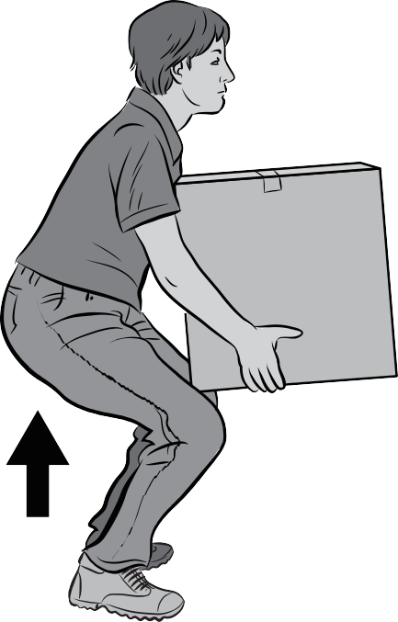

**Figure 3 —** Lifting a box

The instructions for lowering the box are the reverse of the directions for lifting. If the box is too heavy, get someone to help you. If it is too heavy for two people to lift, use a mechanical lift such as a forklift.

## Back maintenance

Strong, flexible muscles are essential to a healthy back. They support the spinal column and determine posture, which is the key to a healthy back. If your muscles are weak or tight, back injuries are more likely and recovery is more difficult.

#### Exercise and your back

Stay fit by exercising regularly to maintain a proper balance of flexibility, strength, and endurance. If you are receiving professional back care, do only those exercises you have been instructed to perform.

#### Stretching

Athletes warm up and do stretching exercises before practices and events to limber up the joints and get blood flowing to muscles. The same principles apply to lifting. By stretching and warming up, along with taking basic precautions and following proper lifting techniques, the chances of serious injury are greatly reduced.

**Go to the WorkSafeBC website to find additional information on back care and maintenance.** [**http://www.worksafebc.com/publications/health_and_safety/by_topic/**](http://www.worksafebc.com/publications/health_and_safety/by_topic/assets/pdf/back_talk.pdf) [**assets/pdf/back_talk.pdf**](http://www.worksafebc.com/publications/health_and_safety/by_topic/assets/pdf/back_talk.pdf)

Now complete the Learning Task Self-Test.

**Self-Test 3**

1. How far should the arms be from the body when lifting?
   1. Fully extended
   2. As close as possible
   3. Does not make any difference
   4. About 30 cm (1 ft.) out from the shoulder
2. When preparing to lift an object, how should you position your feet?
   1. Wider than shoulder width
   2. Foot position is not important
   3. One slightly ahead of the other
   4. Close together so the heels touch
3. When setting down an object, after having lifted it, what must be done?
   1. Drop the load.
   2. Shift the back.
   3. Bend the back.
   4. Bend the knees.
4. What should you do to turn or move an object in another direction?
   1. Just lift and twist.
   2. Lift the object then turn your feet.
   3. Twist your back and turn your feet.
   4. Clear area and twist your back to move object.
5. Where should the weight be positioned when lifting?
   1. At your elbows
   2. Below the knees
   3. Close to the body
   4. Far from the body
6. Lifting should be done primarily with the:
   1. Legs
   2. Arms
   3. Back
   4. Shoulders
7. When lifting, the back should be:
   1. Straight
   2. Immobile
   3. Slightly bent
   4. Perfectly horizontal
8. How far apart should the feet be when lifting?
   1. Very close
   2. Arm’s length apart
   3. Shoulder width apart
   4. 1½ shoulder width apart
9. Most back injuries are the result of:
   1. Incorrect posture
   2. Sitting on very soft chairs
   3. Failure to use a good back support
   4. Improper bending and lifting techniques
10. When standing for long periods of time at a working position, back strain can be reduced by:
    1. Leaning forward
    2. Leaning backward
    3. Resting one foot on a block about 20 cm (8 in.) high
    4. Resting one foot on a block about 50 cm (20 in.) high

### Answer Key

###### Self-Test 1

1. a. True
2. b. It may get caught in moving machinery.
3. b. False
4. a. True
5. b. Gloves, safety headgear, and safety footwear
6. b. False
7. c. Steel-toed work boots
8. a. True
9. d. Whenever a hazard of flying or falling objects exists
10. b. False
11. d. Eye and face protection
12. c. Full face shield
13. c. Spills and splashes
14. d. Custom-fitted earplugs
15. a. True
16. b. False
17. b. False

###### Self-Test 2

|  |  |  |
| --- | --- | --- |
| 1. | b. | Fall arrest system |
| 2. | a. | Lanyard |
| 3. | b. | Fall restraint system |
| 4. | d. | Deceleration device |
| 5. | c. | Snap hook |
| 6. | b. | Lanyard length may increase by up to 1.2 m (4 ft.) during a fall. |

###### Self-Test 3

* 1. b. As close as possible
  2. c. One slightly ahead of the other
  3. d. Bend the knees.
  4. b. Lift the object then turn your feet.
  5. c. Close to the body
  6. a. Legs
  7. a. Straight
  8. c. Shoulder width apart
  9. d. Improper bending and lifting techniques
  10. c. Resting one foot on a block about 20 cm (8 in.) high

**The British Columbia Open Textbook Project**

The British Columbia Open Textbook Project is funded by the B.C. Ministry of Advanced Education, and managed by BCcampus, a publicly-funded organization that uses information technology to connect B.C. post-secondary institutions under a collaborative service delivery framework. The Open Textbook Project aims to make available

openly-licensed textbooks in the province’s high-impact subject areas. Visit open.bccampus.ca for more information.



7960003677

