Trades Access Common Core
Line C: Tools and Equipment
Competency C-3: Describe Rigging and
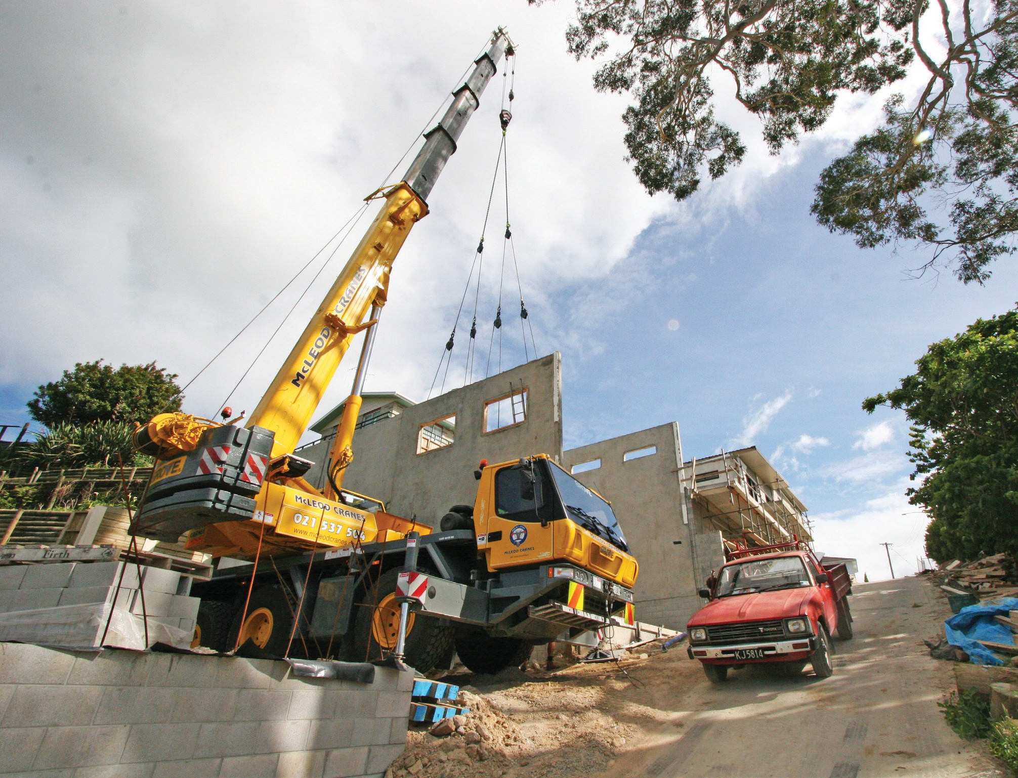Hoisting Equipment
Image to be placed here.

B.C. Open Textbook Project
OpenEd
open.bccampus.ca

Trades Access
COMMON CORE
Line C: Tools and Equipment Competency C-3: Describe Rigging and Hoisting
Equipment

Acknowledgments and Copyright
To learn more about BCcampus Open Education, visit http://open.bccampus.ca
© 2015 Camosun College
The Trades Access Common Core resources are licensed under the Creative Commons Attribution 4.0 Unported Licence, except where otherwise noted. Under this licence, any user of this textbook or the textbook contents herein must provide proper attribution as follows:
- Trades Access Common Core Competency C-3: Describe Rigging and Hoisting Equipment by Camosun College is used under a Creative Commons Attribution 4.0 Licence.
- If you redistribute all or part of this book, it is recommended the following statement be added to the copyright page so readers can access the original book at no cost: Download for free from the B.C. Open Textbook Collection (https://open.bccampus.ca/browse-our-collection/find-open-textbooks/).
- If you use this textbook as a bibliographic reference, then you should cite it as follows: Camosun College. (2015). Trades Access Common Core Competency C-3: Describe Rigging and Hoisting Equipment. Victoria, B.C.: Crown Publications.
All images copyright BC Industry Training Authority are licensed under the Creative Commons Attribution-NonCommercial-ShareAlike 4.0 licence.
The issuing/publishing body is Crown Publications, Queen’s Printer, Ministry of Technology, Innovation and Citizens’ Services.
BCcampus would like to acknowledge the following individuals and organizations for their contributions in producing the Trades Access Common Core Open Textbook resources.

BCcampus
Open Education Team
Hilda Anggraeni, Graphics

Camosun College
Olaf Nielsen, Chair, Trades Development and Special Projects, School of Trades and Technology
Nannette Plant, Manager, Enterprise Point Operations & Special Projects, Office of the VP Strategic Development
Rod Lidstone, Instructor, Plumbing and Pipe Trades, Lead Writer/Reviewer
Brian Coey, Instructor, Sheet Metal and Metal Fabrication, Writer/Reviewer
Matt Zeleny, Camosun Innovates, 3D imaging

Open School BC
Monique Brewer, Director
Adrian Hill, Instructional Designer
Dennis Evans, Image Coordinator, Photographer, Graphics, Production Technician (layout)
Farrah Patterson, Production Technician

Industry Training Authority of BC
The ITA works with employers, employees, industry, labour, training providers, and government to issue credentials, manage apprenticeships, set program standards, and increase opportunities in approximately 100 BC trades. Among its many functions are oversight of the development of training resources that align with program standards, outlines, and learning objectives, and authorizing permission to utilize these resources (text and images).
Erin Johnston, Director of Training Delivery
Cory Williams, Manager, Industry Relations

Publishing Services, Queen’s Printer
Spencer Tickner, Director of QP Publishing Services
Dwayne Gordon, Manager, Electronic Publishing
October 2015, Version 1
To order print copies of any of the Trades Access Common Core resources, please contact us:
Crown Publications, Queen’s Printer PO Box 9452 Stn Prov Govt
563 Superior St, 3rd Floor Victoria, BC V8W 9V7 Phone: 250-387-6409
Toll Free: 1-800-663-6105
Fax: 250-387-1120
crownpub@gov.bc.ca www.crownpub.bc.ca

Intellectual Property Program
Ilona Ugro, Copyright Officer, Ministry of Technology, Innovation and Citizens’ Services, Province of British Columbia
Creative Commons Attributions
Cover photo:
GMK3050 All Terrain Crane by Scottmss under Creative Commons Attribution-ShareAlike 3.0 Unported licence.
Figure attributions for Competency C-3, Learning Task 2 include:
Figure 4—Come-alongs (right image) is in the public domain.
Foreword
The BC Open Textbook Project began in 2012 with the goal of making post-secondary education in British Columbia more accessible by reducing student cost through the use of openly licensed textbooks. The
BC Open Textbook Project is administered by BCcampus and is funded by the British Columbia Ministry of Advanced Education.
Open textbooks are open educational resources (OER); they are instructional resources created and shared in ways so that more people have access to them. This is a different model than traditionally copyrighted materials. OER are defined as teaching, learning, and research resources that reside in the public domain or have been released under an intellectual property licence that permits their free use and repurposing by others (Hewlett Foundation). Our open textbooks are openly licensed using a Creative Commons licence, and are offered in various e-book formats free of charge, or as printed books that are available at cost. For more information about this project, please contact opentext@bccampus.ca. If you are an instructor who is using this book for a course, please let us know.
Preface
The concept of identifying and creating resources for skills that are common to many trades has a long history in the Province of British Columbia. This collection of Trades Access Common Core (TACC) resources was adapted from the 15 Trades Common Core line modules co-published by the Industry
Training and Apprenticeship Commission (ITAC) and the Centre for Curriculum Transfer and Technology (C2T2) in 2000-2002. Those modules were revisions of the original Common Core portion of the TRAC modules prepared by the Province of British Columbia Ministry of Post-Secondary Education in 1986. The TACC resources are still in use by a number of trades programs today and, with the permission from the Industry Training Authority (ITA), have been utilized in this project.
These open resources have been updated and realigned to match many of the line and competency titles found in the Province of BC’s trades apprenticeship program outlines. A review was carried out to analyze the provincial program outlines of a number of trades, with the intent of finding common entry-
level learning tasks that could be assembled into this package. This analysis provided the template for the outline used to update the existing modules. Many images found in ITA apprentice training modules were also incorporated into these resources to create books that are similar to what students will see when they continue their chosen trades training. The project team has also taken many new photographs for this project, which are available for use in other trades training resources.
The following list of lines and competencies was generated with the goal of creating an entry-level trades training resource, while still offering the flexibility for lines to be used as stand-alone books. This
flexibility—in addition to the textbook content being openly licensed—allows these resources to be used within other contexts as well. For example, instructors or institutions may incorporate these resources into foundation-level trades training programming or within an online learning management system (LMS).
Line A – Safe Work Practices
- A-1 Control Workplace Hazards
- A-2 Describe WorkSafeBC Regulations
- A-3 Handle Hazardous Materials Safely
- A-4 Describe Personal Safety Practices
- A-5 Describe Fire Safety
Line B – Employability Skills
- B-1 Apply Study and Learning Skills
- B-2 Describe Expectations and Responsibilities of Employers and Employees
- B-3 Use Interpersonal Communication Skills
- B-4 Describe the Apprenticeship System

Line C – Tools and Equipment
- C-1 Describe Common Hand Tools and Their Uses
- C-2 Describe Common Power Tools and Their Uses
- C-3 Describe Rigging and Hoisting Equipment
- C-4 Describe Ladders and Platforms
Line D – Organizational Skills
- D-1 Solve Trades Mathematical Problems
- D-2 Apply Science Concepts to Trades Applications
- D-3 Read Drawings and Specifications
- D-4 Use Codes, Regulations, and Standards
- D-5 Use Manufacturer and Supplier Documentation
- D-6 Plan Projects
Line E – Electrical Fundamentals
- E-1 Describe the Basic Principles of Electricity
- E-2 Identify Common Circuit Components and Their Symbols
- E-3 Explain Wiring Connections
- E-4 Use Multimeters
All of these textbooks are available in a variety of formats in addition to print:
- PDF—printable document with TOC and hyperlinks intact
- HTML—basic export of an HTML file and its assets, suitable for use in learning management systems
- Reflowable EPUB—format that is suitable for all screen sizes including phones
All of the self-test questions are also available from BCcampus as separate data, if instructors would like to use the questions for online quizzes or competency testing.

About This Book
In an effort to make this book a flexible resource for trainers and learners, the following features are included:
- An introduction outlining the high-level goal of the Competency, and a list of objectives reflecting the skills and knowledge a person would need to achieve to fulfill this goal.
- Discrete Learning Tasks designed to help a person achieve these objectives
- Self-tests at the end of each Learning Task, designed to informally test for understanding.
- A reminder at the end of each Competency to complete a Competency test. Individual trainers are expected to determine the requirements for this test, as required.
- Throughout the textbook, there may also be links and/or references to other resources that learners will need to access, some of which are only available online.
- Notes, cautions, and warnings are identified by special symbols. A list of those symbols is provided below.

Symbols Legend
Important: This icon highlights important information.

Poisonous: This icon is a reminder for a potentially toxic/poisonous situation.

Resources: The resource icon highlights any required or optional resources.

Flammable: This icon is a reminder for a potentially flammable situation.

Self-test: This icon reminds you to complete a self-test.

Explosive: This icon is a reminder for a possibly explosive situation.

Safety gear: The safety gear icon is an important reminder to use protective equipment.

Electric shock: This icon is a reminder for potential electric shock.

Safety Advisory
Be advised that references to the Workers’ Compensation Board of British Columbia safety regulations contained within these materials do not/may not reflect the most recent Occupational Health and Safety Regulation. The current Standards and Regulation in BC can be obtained at the following website: http:// www.worksafebc.com.
Please note that it is always the responsibility of any person using these materials to inform him/herself about the Occupational Health and Safety Regulation pertaining to his/her area of work.
BCcampus January 2015
Disclaimer
The materials in the Trades Access Common Core Open Textbook project are for use by students and instructional staff and have been compiled from sources believed to be reliable and to represent best current opinions on these subjects. These manuals are intended to serve as a starting point for good practices and may not specify all minimum legal standards. No warranty, guarantee or representation is made by BCcampus as to the accuracy or sufficiency of the information contained in these publications. These manuals are intended to provide basic guidelines for trade practices. Do not assume, therefore, that all necessary warnings and safety precautionary measures are contained in this module and that other or additional measures may not be required.

Contents

Introduction 9
Objectives 9
Resources 9
Learning Task 1: Describe the principles of lifting and hoisting 11
Mechanical advantage 11
Load stability 14
Self-Test 1 18
Learning Task 2: Describe lifting equipment 21
Manual hoists 21
Electric hoists 26
Floor hoists 27
Superstructures 27
Forklifts 30
Jacks 31
Load supports 37
Rollers 40
Self-Test 2 41
Learning Task 3: Describe rigging hardware 45
Slings 45
Snatch blocks 53
Turnbuckles 53
Eyebolts 55
Shackles 56
Wire rope clips 59
Hooks 61
Hitches 65
Spreader and equalizer bars 72
Storage, maintenance, and inspection of rigging hardware 73
Self-Test 3 79
Learning Task 4: Lifting and hoisting communication 83
Cranes 83
Load control 85
Hand signals for cranes 85
Vertical hoists 94
Radio communication and video systems 95
Self-Test 4 96
Learning Task 5: Describe knots, bends, and hitches 101
Natural and synthetic ropes 101
Natural fibre ropes 102
Synthetic fibre ropes 103
Working load limits 104
Use of ropes 105
Care and maintenance of rope 106
Tying knots, bends, and hitches 108
Self-Test 5 125
Answer Key 128

Introduction
Rigging loads for lifting requires the use of various hardware items. Knowing how to correctly select, inspect, and assemble of each of these items is critical to a safe lift.

To effectively use ropes in a work setting requires that you become familiar with several types of ropes, knots, bends, and hitches.

Objectives
When you have completed the Learning Tasks in this Competency, you will be able to:
  - describe the principles of lifting and hoisting
  - describe hoisting, lifting, and rigging equipment
  - describe lifting and hoisting communication
  - tie knots, bends, and hitches

Resources
You will be required to reference publications and videos available online.

LEARNING TASK 1
Describe the principles of lifting and hoisting
Lifting and hoisting equipment is used to move and install heavy equipment and material in practically every trade area from electrical to carpentry, from pipefitting to mechanics.

Equipment you might see could include a chain hoist used to lift engine blocks in heavy machinery, or a forklift used to move material in the lumber industry. Rigging equipment might include a big boom or tower crane on a big construction project, or a large superstructure crane used in a heavy-duty mechanic shop to assemble the huge power shovels and scrapers needed in the mining industry.

Here are some terms you should be familiar with, and which are discussed in the sections below:
  - mechanical advantage
  - lever
  - fulcrum
  - effort
  - resistance
  - pulley
  - centre of gravity
  - load stability
  - sling location
  - sling stress

Mechanical advantage
Lifting and hoisting equipment is used to perform work either by a change in the direction of an applied force or by the magnitude of the force. In general, mechanical advantage (also known as leverage) is used to multiply an applied force. This mechanical advantage can be determined by comparing the amount of force needed to move an object, such as a lift, with another force, for example gravity. Another way to determine mechanical advantage is to compare the distance an applied force moves with the distance a resistant force moves.

Lever, fulcrum, effort, and resistance
A lever is a bar or rod that pivots at a point called a fulcrum. The fulcrum divides the lever into two parts: an effort arm (EA) and a resistance arm (RA) (Figure 1). In order to move an object, force is applied to the effort arm. This will cause the lever to move.

R
ED
ø
ø

RD

E
Figure 1 — Lever movement

The ratio of the effort distance (ED) to the resistance distance (RD) is the same as the ratio of the effort arm (EA) to the resistance arm (RA). This ratio is the mechanical advantage of the lever, or the amount the lever amplifies the input force or effort (E) onto the resistance (R).

Pulley
A pulley is a wheel rotating on a centre shaft (axle) used to support and change the direction of a cable, rope, or belt. A pulley is one of the simple machines that can change the direction of
a force. When pulleys are combined to create a multiple moving pulley system (also known as
block and tackle), they can also magnify the force.

The mechanical advantage (MA) of a pulley is described as the effort distance (ED) compared with the resistance distance (RD). In a single fixed pulley machine (Figure 2), pulling on the effort arm moves the resistance side rope exactly the same length, in a one-to-one ratio.
Therefore, the MA = 1.

100 N
100 N
100 N
100 N

Figure 2 — Single fixed pulley

On a multiple moving pulley system, when the effort end of the rope is pulled, all the supporting ropes woven through the pulleys also move, though each moves for a shorter distance than the effort end. Thus, the load moves a shorter distance than the effort. The mechanical advantage
of an arrangement of pulleys, or the ratio of movement of the effort end to the resistance end, is simply the number of sections of rope that support the moving pulleys. These pulleys can all be combined onto one common axle and housing called a block.
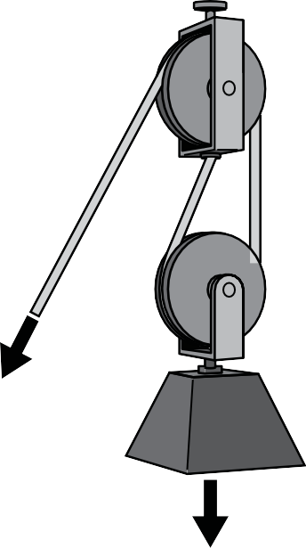
150 N
50 N
50 N
50 N
50 N
100 N
Figure 3 — Multiple movable pulley

The multiple pulley systems shown in Figure 4 have mechanical advantages of 2, 3, 4, 5, and 6, respectively.
1 : 2 1 : 3 1 : 4 1 : 5 1 : 6
Figure 4 — Block and tackle systems

Load stability
During a lifting operation the load must be connected to the lifting equipment, such as a crane. The link between the load and the lifting device is often done with connectors called slings that are usually made of synthetic, chain, or wire rope materials. The arrangement and connecting of these slings is referred to as rigging. Proper rigging of a load will keep the load level and stable as it is lifted into the air by a crane. A poorly rigged load will shift and can cause the load to
fall. Slings are used to connect the load to the lifting device. For a safe and stable lift, centre of gravity, sling location, and sling stress must be considered.

Centre of gravity
The centre of gravity of an object is the point at which the object will balance regardless of whether the object is upright or on its side, top, bottom, or end. A suspended object will always move so that its centre of gravity is located directly below its point of support.

The location of the centre of gravity must be considered whenever you rig a load to be lifted by a crane. Estimate the location of the centre of gravity for the object to be lifted. Use a sling arrangement that will position the lifting hook directly above the centre of gravity, as shown in Figure 5.

Centre of gravity

Figure 5 — Stable load

A load with the hook to the side of the centre of gravity will shift or tilt when lifted. This shift or tilt will continue until the centre of gravity comes to rest directly below the hook as illustrated in Figure 6.

Figure 6 — Movement of unstable load
NEVER rig a load for lifting with the centre of gravity above the lifting point (or points), as shown in Figure 7. Doing so may cause the load to topple. The natural position for the centre of gravity is below the point of attachment to the load.

Figure 7 — Load could tip over

Sling locations
The position of the sling attachment to the load is very important.

When using a sling (as shown in Figure 8), you must make sure the centre of gravity is located between the two slings. If the centre of gravity is located beyond the slings, as in Figure 8A, the load will topple over at the start of the lift. Rigging loads with their centre of gravity near one sling in this type of sling arrangement is considered poor practice and should be avoided. Always use a sling arrangement that places the centre of gravity below the sling’s point of attachment to the hook, as shown in Figure 8B.

B
A
Unstable double basket hitch Stable bridle hitch
Figure 8 — Sling application
Always start the initial lift very slowly, watching the load for any signs of tilting or shifting. If the load tilts more than 5 degrees, lower the load and rearrange the rigging.

Sling stress
As sling angle decreases, sling stress increases. This is one of the most important facts that you need to know to rig loads safely. When there is a two-legged sling arrangement with an angle of 90 degrees straight up and down (Figure 9), each leg will have 50% of the load. As the angle
decreases, the load on each leg will increase. If you were to reduce the angle to 30 degrees, each sling would actually have the full load of the object on it. The recommended safe lifting angle is 60 degrees. Sling angles of less than 45 degrees to horizontal are considered poor practice and should be avoided.

2000 lb.
Figure 9 — Sling angle and stress effects
Sling Angle 60°
2000 lb.

Vertical Sling Angle 90°

Sling Angle 45°
2000 lb.

Sling Angle 30º
2000 lb.

When rigging long loads, use slings with sufficient length that the dimension L is always greater than dimension S Figure 10). This will ensure that your sling angles are always greater than
60 degrees from horizontal.
L
60° min.
S
Figure 10 — Correct sling angle

Now complete the Learning Task Self-Test.

Self-Test 1
- What is the definition of the term mechanical advantage?
  - A term used instead of horsepower
  - The qualifications to work on vehicles
  - The use of tools or mechanical devices to multiply force
  - The rate of work with a hand tool compared to a power tool

- When using two slings to hoist a load, at what angle to horizontal is the stress on the slings the least?
  - 30 degrees
  - 45 degrees
  - 60 degrees
  - 90 degrees

- When using two slings to hoist a load, what happens to the sling stress as the sling angle to horizontal changes?
  - As the sling angle increases, the sling stress increases.
  - As the sling angle decreases, the sling stress increases.
  - As the sling angle decreases, the sling stress decreases.
  - As the sling angle increases, the sling stress remains the same.

- What is meant by the term centre of gravity?
  - The lowest portion of an object
  - The point at which the object will balance
  - The portion of an object that is the heaviest
  - The spot a latch point is placed on a piece of equipment

- How can the mechanical advantage of a pulley system be described?
  - The ratio of the rope movement to the pulley size
  - The effort distance compared to the resistance distance
  - The distance between the moving block and the fixed block
  - The thickness of the rope compared to the safe working load

- If a load is rigged with the centre of gravity off to one side, what will happen when it is hoisted in the air?
  - The load will swing to the left.
  - The load will topple out of the rigging.
  - The load will hoist cleanly without movement.
  - The load will tilt until the centre of gravity is directly below the hook.

- What happens if you hoist an object with the centre of gravity above the lifting points?
  - The load could topple.
  - The sling angle will be too great.
  - The centre of gravity will locate itself near one sling.
  - The hoist will be safe. This is a very common rigging practice.

- What is the safe and proper procedure if during a hoist the load tilts more than 5 degrees?
  - Lower the lift and rearrange the rigging.
  - Lower the lift and declare the load unsafe for rigging.
  - Continue with the lift, keeping a close eye on the load.
  - Continue with the lift, using the tag line to counter the tilt.

LEARNING TASK 2
Describe lifting equipment
The mechanical advantage necessary to hoist and move heavy objects is created by changing the direction of exerted force, multiplying the exerted force, or both.

This Learning Task will look at the description and function of the following rigging equipment:
- manual and electric hoists
- floor hoists
- superstructures
- forklifts
- jacks
- load supports
- rollers
No person shall operate any lifting equipment without training. All training must be provided by a qualified instructor who has received training from the original equipment manufacturer in the adequate operation of their specific equipment. No training materials other than the original equipment manufacturer’s operations manual may be used for training purposes.

Manual hoists
Manual hoisting devices include:
- block and tackle
- chain hoist
- come-along
- grip hoists or Tirfor jacks

Block and tackle
A set of multiple pulleys mounted on a single axle form a block. A block and tackle refers to an assembly of two blocks with one continuous rope threaded through them, called the tackle. A block and tackle is capable of increasing lifting capacity. This increase can be easily calculated by counting either the number of ropes that leave the travelling block, or by counting the number of wheels (also called sheaves) found inside a block. For example, a block and tackle with six sheaves (Figure 1), three on the fixed block and three on the movable block, could lift a 1000 kg load by exerting a pull of only 167 kg, or a mechanical advantage of 6:1 (not allowing for bearing friction). This is important to consider, as the load lifting capability could be considerably greater than the breaking strength of the rope.
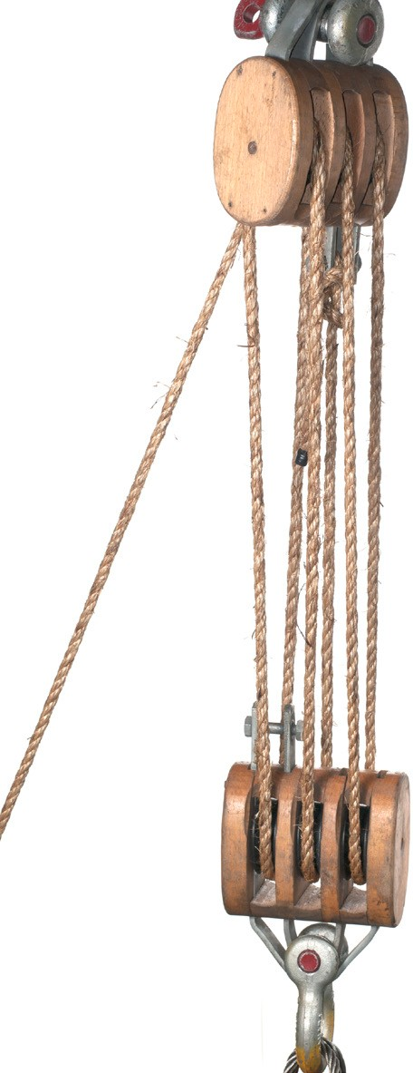
Figure 1 — Block and tackle

A block and tackle has no braking device or safety system. It cannot support a load unless the line is anchored.

Chain hoist
Chain hoists (also known as chain falls) are dependable and economical devices for vertical lifting. Both manually operated and electrically powered hoists are available.

The chain hoist (Figure 2) is designed for vertical lifts and is also effective for drifting—moving objects horizontally using more than one hoist. Care must be taken with horizontal movement, and the chain must stay below an angle of 30 degrees off vertical.

Chain hoists are available in a variety of capacities from 450 kg to 9000 kg (1/2 ton to 10 tons). The lifting capacity of a chain hoist must be clearly marked on the hoist, and this capacity must never be exceeded.
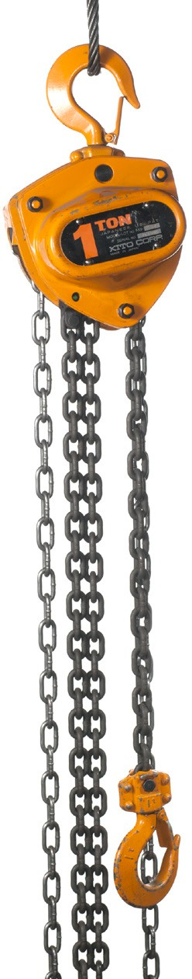
Figure 2 — Chain hoist

Figure 3 shows how a chain fall operates. The operating chain turns the drive pulley and is one continuous loop called an endless hand chain. The drive pulley is connected to the lifting chain by a series of reduction or worm gears that multiply the amount of force the operator exerts on the hand chain. To lower a load, you simply pull the hand chain in the opposite direction. The length of the lifting chain limits the range of movement of the load. The length of the endless chain should be ordered for the location in which it will be used. It should not be so long that that there is excessive chain lying on the floor to get tangled or damaged, or so short that it is too high to reach.

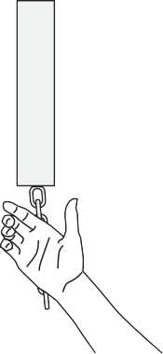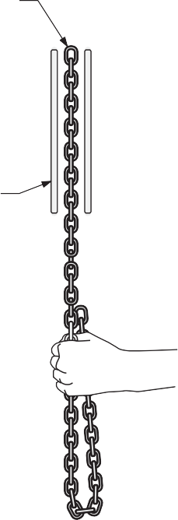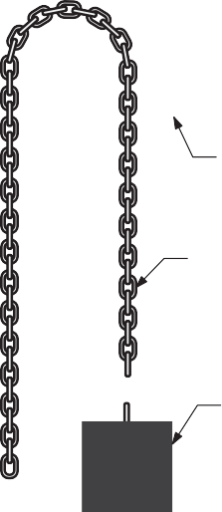
Endless hand chain
Bearing

Worm
Drive pulley
Worm wheel
Lifting chain
Load
Figure 3 — Endless hand chain hoist

Come-along
Come-alongs are similar to chain hoists but have different applications. Typical chain and cable come-alongs are shown in Figure 4. Come-alongs are designed for use in any position and are more convenient than chain hoists for short lifts. They are also designed for horizontal pulls.
They usually have a smaller capacity than chain hoists. As with chain hoists, their capacity must be clearly marked and never exceeded.
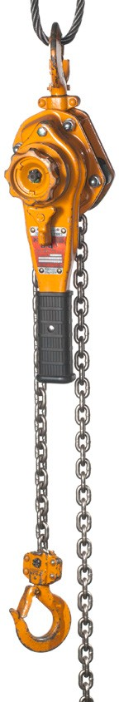
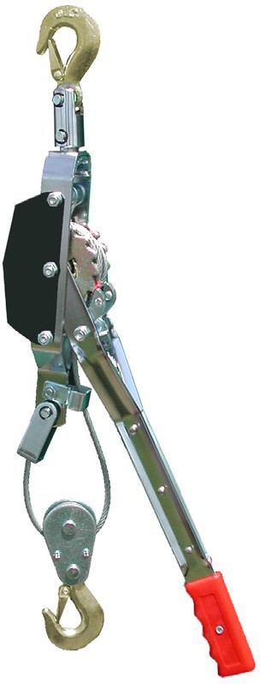
Figure 4 — Come-alongs

Chain-style come-alongs (ratchet lever hoists) have a ratchet lever instead of a running chain to activate a worm wheel to create mechanical advantage.

The cable-style come-alongs (pullers, hand winches) incorporate a pulley onto the load hook to increase the mechanical advantage. Check the manufacturer’s rating as some cable pullers are designed only for horizontal pulls, whereas others may have a reduced vertical lift rating. Some cable-style come-alongs have an added safety feature in the lever handle that is specifically designed to bend if the hoist is loaded past capacity.

Both of these styles of come-alongs are very useful for pulling heavy parts into position prior to welding or bolting.
Never substitute regular chain for the original lifting chain supplied with the come-along. Do not use any extensions on the handle to apply more force.

Grip hoist (Tirfor)
Grip hoists, or Tirfor jacks (Figure 5), are hand-operated cable-pulling devices with an unlimited amount of cable travel. They can be used to lift, pull, and position loads over great distances, depending on the wire rope length. They work by direct pull on a wire rope, with the pull applied by means of two pairs of self-energizing smooth jaws, which exert a grip on the cable in proportion to the load actually being lifted or pulled.

The two levers that activate these jaws provide a forward or backward motion to the wire rope, depending on which lever is used. The release lever should never be left in the released position. A removable pipe handle is used to operate these levers. The jack can be attached directly to the load or it can be anchored near the ground as shown in Figure 6. Never position the jack under the load.

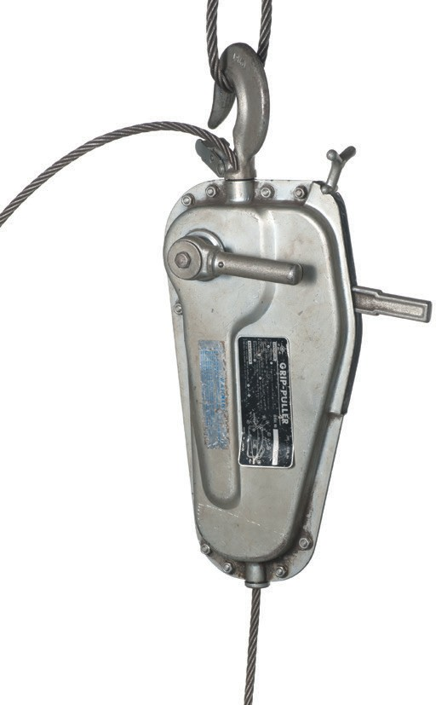Release lever Pull lever

Reverse lever

Figure 5 — Tirfor jack

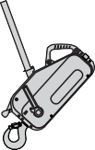
Figure 6 — Positioning a Tirfor jack

Tirfor jacks are available in three capacities (sizes): 750 kg (1600 lb.), 1600 kg (3500 lb.), and 3200 kg (7000 lb.). All Tirfor jacks are built with overload protection, which consists of a handle
shear pin that breaks when the load weight has been exceeded, preventing further movement of the load.
Never replace the specific application wire rope used with the Tirfor with another piece of wire rope unless it has the same specifications as the original.

Electric hoists
Electric hoists (Figure 7) are much more efficient than manual hoists. They usually have a push- button control suspended from a chain or wire rope. Both manual and electric hoists can be stationary or movable. The movable types are used on overhead runways, gantry cranes, jib cranes, and overhead travelling cranes.

Some hoists are manually pulled along the overhead runway or boom, while others may be motor driven. Electric hoists are manufactured in many capacities (sizes).
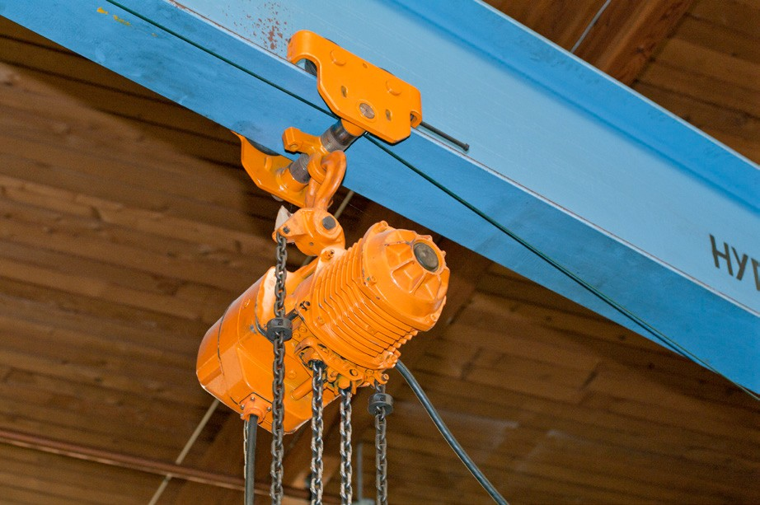
Figure 7 — Electric hoist

Floor hoists
A typical hydraulic floor hoist or floor crane is shown in Figure 8. Moving the boom in or out can change the lifting reach. However, as the boom extends, the lifting capacity decreases. The lifting capacity of these hoists is rated for lifts with the arm fully extended. Various sizes of floor hoists are available, and they may be manually or electrically powered.
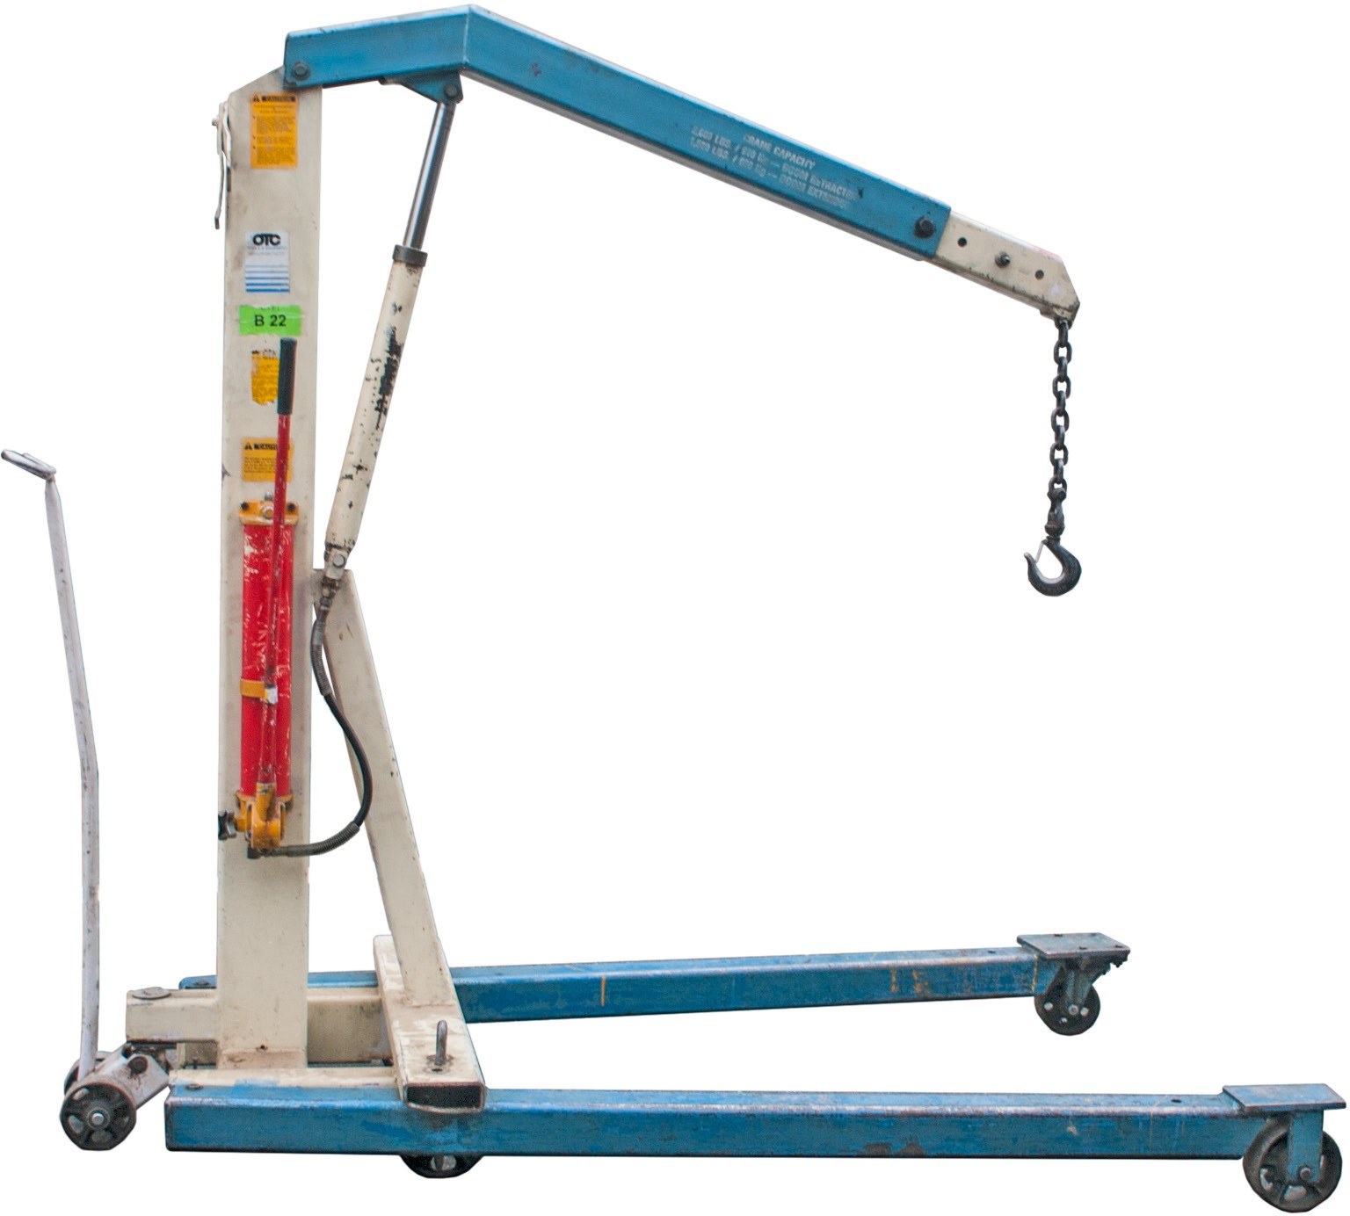
Figure 8 — Floor hoist

Superstructures
A superstructure is the overhead framework used to suspend hoisting equipment. Superstructures may be stationary and used only with vertical lifting, or they may also be used to move the load from one area to another. These support structures must have safe lifting capacities greater than the lifting capacity of the hoist, and the lifting capacity must be clearly marked on them.

All superstructures must be certified by the engineer or manufacturer for lifting capacity.

Gantry cranes
One of the most basic support structures that also provides mobility is the gantry crane (Figure 9). With this superstructure, the load can be lifted and then the entire crane assembly and the load can be moved to another area.
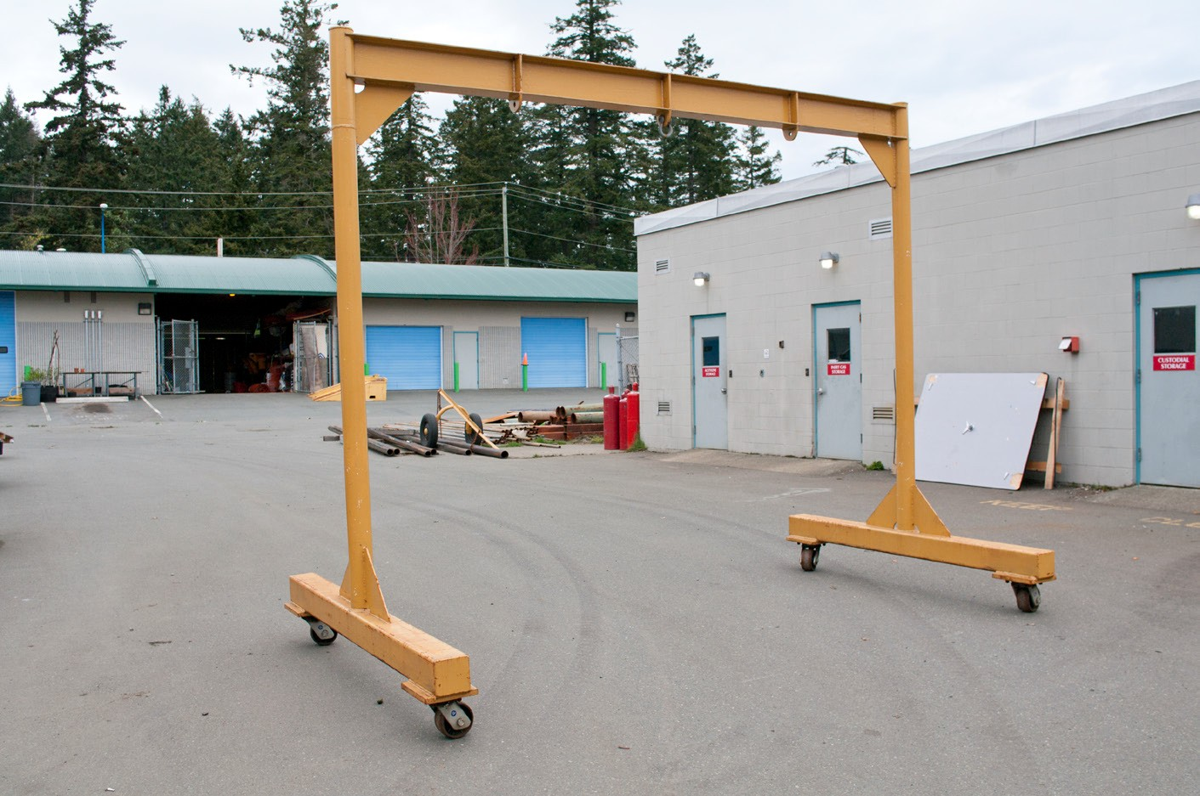
Figure 9 — Gantry crane

Overhead runways
Runways (Figure 10) usually consist of H-type or I-type structural steel beams that are either fastened to heavier crossbeams on the ceiling or mounted on floor supports. The hoist is attached to rollers or trolleys that run along the bottom flange of the beam.

Runways are used extensively in shops to move materials. They often extend from the outside loading area right into the shop.

Structural steel runway

Support beam

Hoist

Figure 10 — Runway section with electric hoist

Jib crane
Another type of support structure is the jib crane (Figure 11). The main identifying feature of the jib crane is a boom that is attached to a vertical member that rotates. Jib cranes may be wall mounted or mounted on a pedestal. The entire crane assembly can also be mounted on rails for moving material from one area of a shop to another.
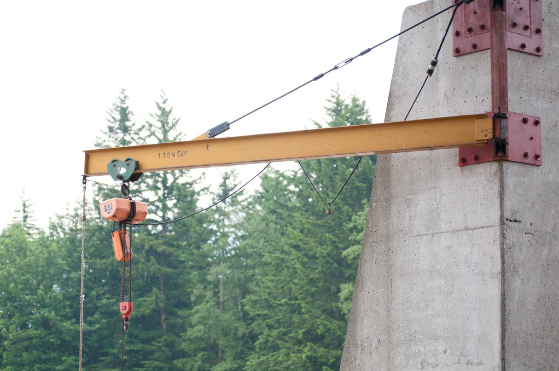
Figure 11 — Jib crane

Overhead travelling cranes
Overhead travelling cranes (also referred to as gantry or bridge cranes) can be classified either as top running (Figure 12) or under running, depending on where the hoist assembly is actually mounted. The top-running type generally has a greater load-carrying capacity. The trolley on which the hoist assembly moves is mounted on top of bogeys (end trucks) that move along parallel runways. Under-running travelling cranes are used for lighter loads, usually not more than 900 kg (2000 lb.). The hoist-carrying bridge or beam is mounted on the trolleys.
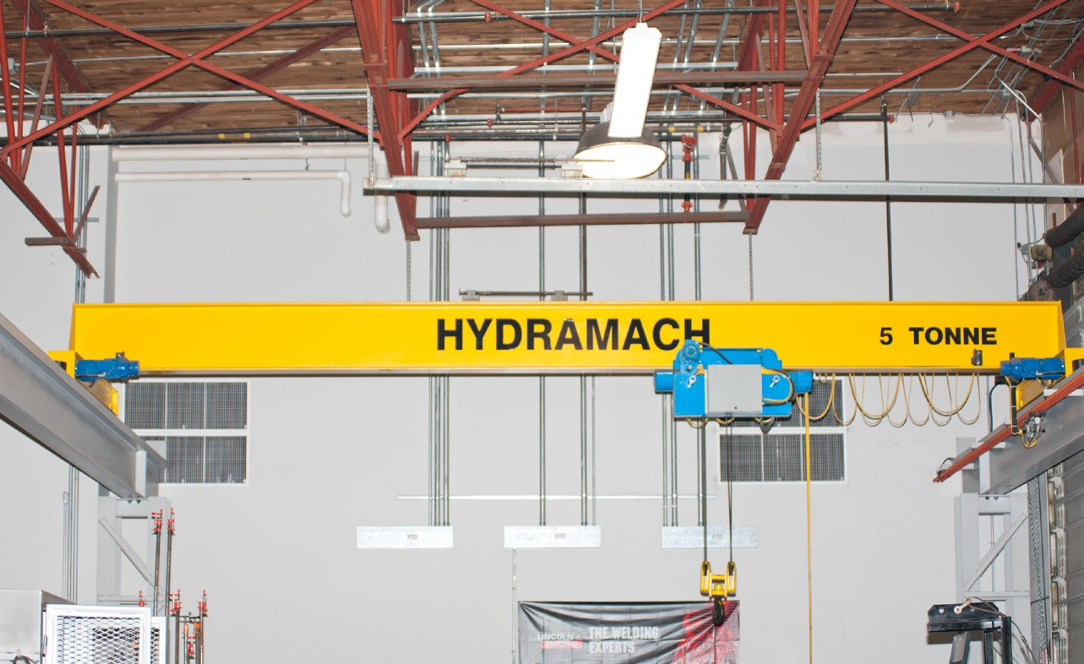
Figure 12 — Top-mounted overhead travelling crane

The Occupational Health and Safety Regulation requires that all trolleys be equipped with drop stops, which are devices that limit the amount of drop to 25 mm (1 in.) if a tire, wheel, or axle fails.

Forklifts
One of the most common types of materials-handling equipment is the motorized forklift. Forklifts are used for lifting and transporting materials that can be stacked or placed on pallets.
No person shall operate a forklift without training. All training must be provided in accordance with the requirements of CSA Standard B335-94, Industrial Lift Truck Training.
The main identifying features of the forklift are the two horizontal arms that protrude from the vertical mast (Figure 13). The mast can be tilted forward between 10 and 25 degrees.
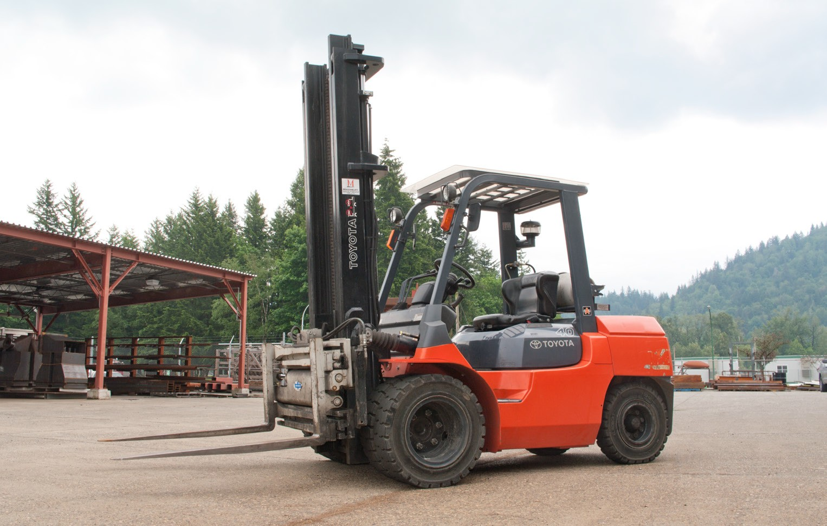
Figure 13 — Forklift

The load-lifting capacity of a forklift depends on the spacing of the forks, the height and tilt of the mast, and the floor or ground surface. Lifting capacities can range from 900 kg to 32 000 kg
(2000 lb. to 70 000 lb.). Forklifts can be powered by electricity or by an internal combustion engine.

Manual forklifts (pallet trucks) are hand-propelled units that hydraulically lift and move pallets on a smooth floor (Figure 14). They cannot be used to stack loads one on top of the other, as their maximum lift is 150 mm to 200 mm (6 in. to 8 in.) above the floor. They have small steel wheels under the forks and require smooth surfaces to travel on when loaded.
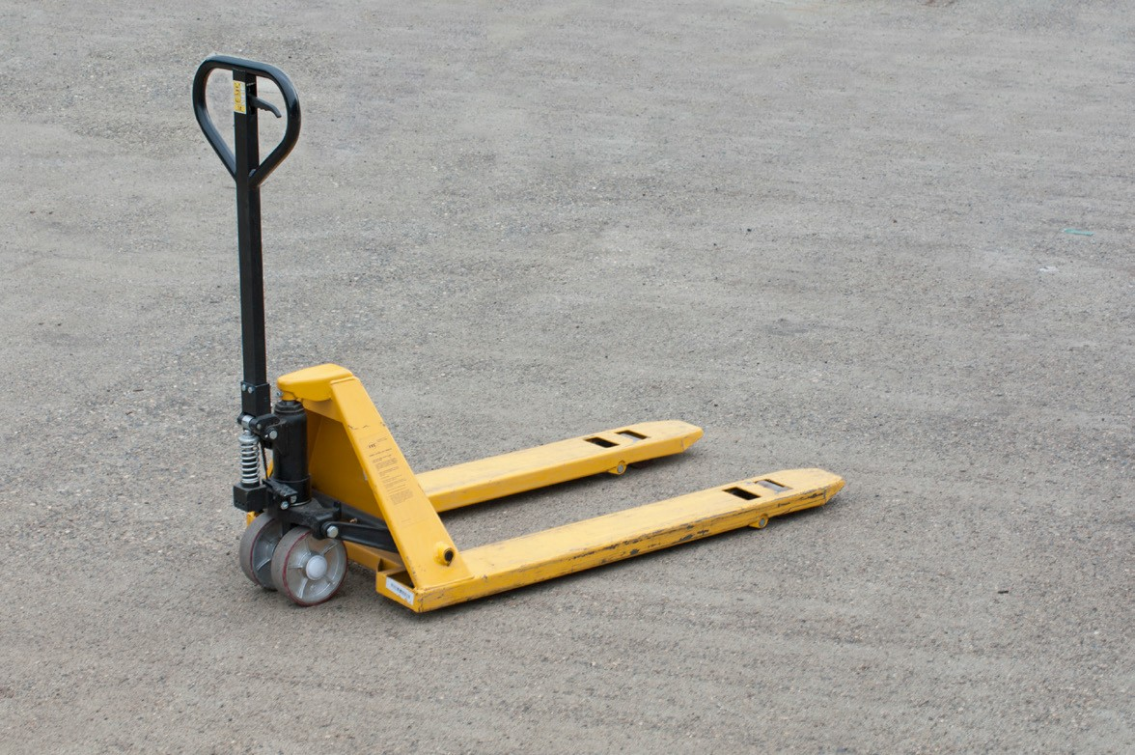
Figure 14 — Manual forklift

Jacks
A jack is a portable machine capable of heavy lifts without much force or power being applied by the operator. A jack is usually identified by its size in terms of its capacity — the number of tons it is capable of lifting.

There are two basic categories of jacks:
- mechanical jacks
- hydraulic jacks

Mechanical jacks
Mechanical jacks gain their mechanical advantage through the use of the screw, the lever, or a combination of both. Some common types include:
- screw jacks
- lever jacks
- scissors jacks

Screw jacks
Screw jacks (Figure 15) range in size from 450 kg (1/2 ton) to 45 000 kg (50 tons). Depending on their capacity, screw jacks can be used to raise automobiles, heavy equipment, and large industrial machinery.
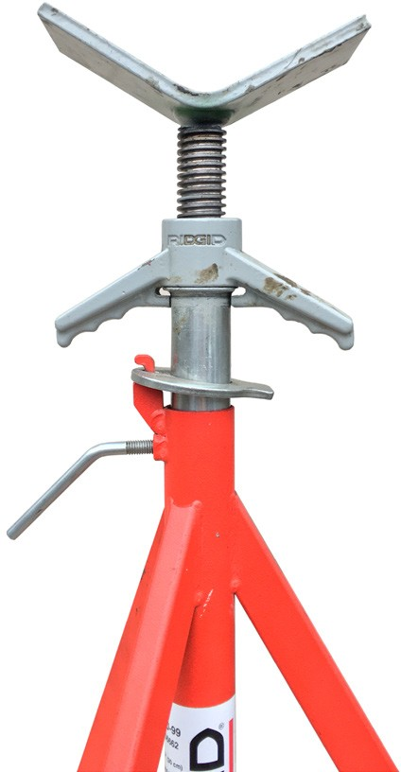
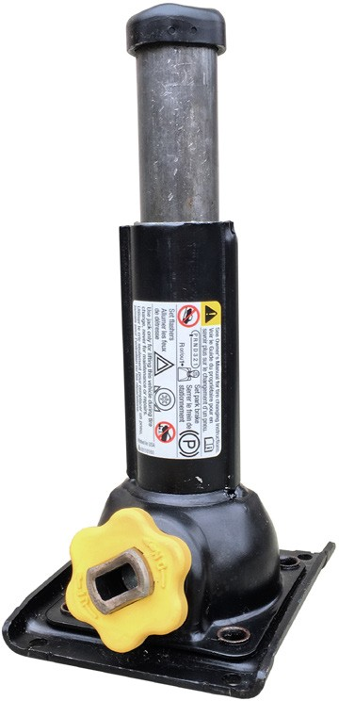
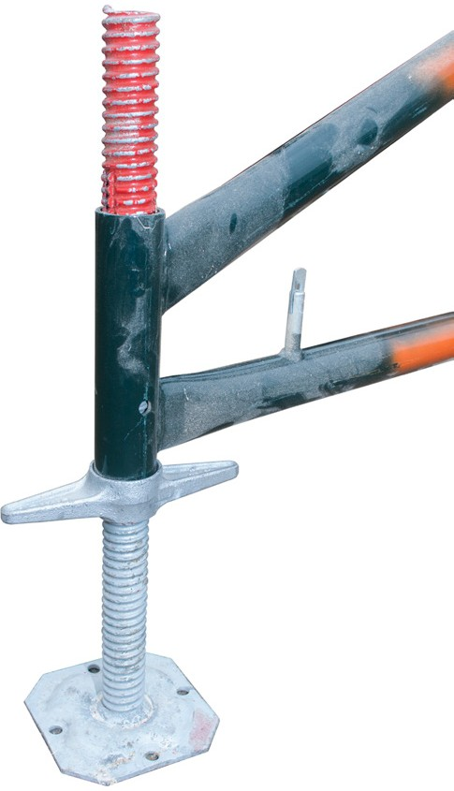
Figure 15 — Screw jack

Some screw jacks are operated by turning the large screw thread at the top. Others are turned by a crank handle through a gear mechanism at the base of the jack.

Lever jacks
Lever jacks (Figure 16) gain their mechanical advantage through the use of the lever. A ratchet permits the lifting to take place in small steps. Each time the lever handle is moved through a full stroke, the lifting mechanism either rises or falls one notch along the stem of the jack.
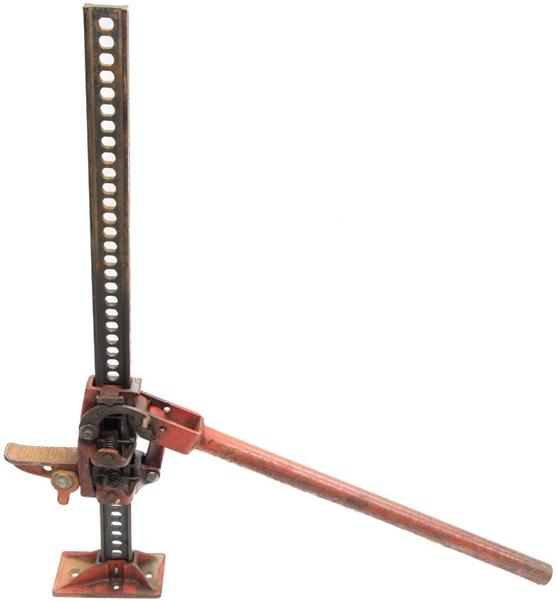
Figure 16 — Lever jack (jack-all)

A lever jack is operated by moving the handle up and down through a full stroke. The distance the jack moves up or down with each stroke is determined by the spacing of the notches in the upright.

A lever jack is generally placed at the perimeter of the object it is lifting rather than underneath it because of the room needed to operate the handle.

Lever jacks are available in a wide range of sizes (capacities), lengths, and shapes.

Scissors jacks
The scissors jack (Figure 17) combines the use of a screw and a lever. Turning the horizontal screw at the centre of the jack produces lift. The levers that provide the scissors action of the jack also provide a unique feature: as the jack is extended, its mechanical advantage increases. Scissors jacks are light-duty jacks, often used by vehicle owners, and they come as standard equipment in most vehicles. Always refer to manufacturer’s instructions before using this type of jack.
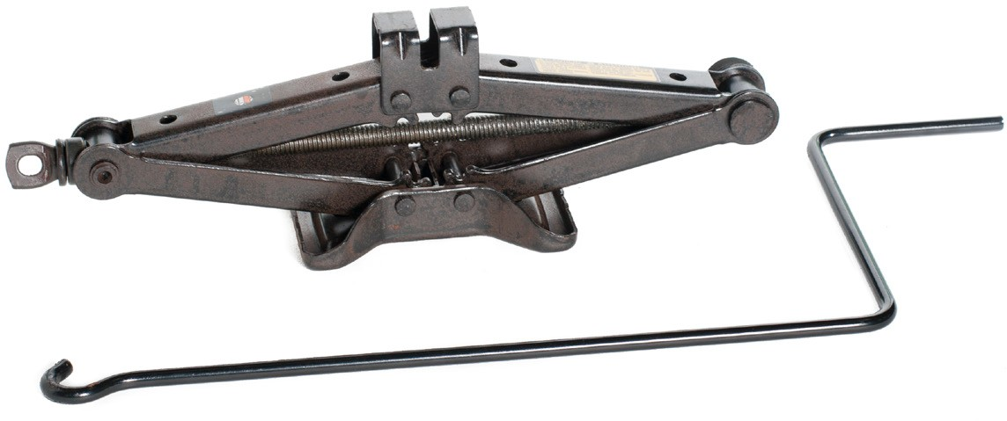
Figure 17 — Scissors jack

Hydraulic jacks
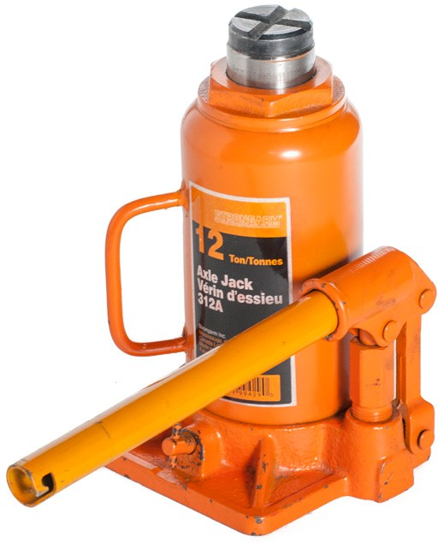
Hydraulic jacks (Figure 18) gain their mechanical advantage through the use of hydraulics, as their name implies. A small pump piston forces oil against a larger lifting piston. The mechanical advantage provided depends on the ratio of the area of the pump piston to the area of the lifting piston.

Hydraulic jacks range in size from 1360 kg (1 1/2 tons) to
90 000 kg (100 tons). Hydraulic jacks have a relatively short lifting distance: 90 mm to 200 mm (3 1/2 in. to 8 in.). Some hydraulic jacks have an adjustable screw head that can be used to adjust the total length of the jack before the start of a lift.

Figure 18 — Hydraulic jack

Hydraulic jacks can be used for any type of lifting or pressing. They are most useful in situations that require a large lifting capacity rather than when a load needs to be lifted to any great height.

The hydraulic jack has a detachable handle that is made from a short length of steel tubing and has a pair of notches at one end. This end is used to open and close the valve at the base of the jack.

Hydraulic jacks are generally considered safer than mechanical jacks. If the hydraulic jack is overloaded to the point of causing a lift failure, the object being lifted will be lowered slowly. In contrast, when a mechanical jack fails, the load drops suddenly and violently.

Do not rely on a hydraulic jack to remain in a loaded position for a long period. Often a small leakage of fluid will occur, gradually lowering the load.

Floor jacks
Floor jacks are used mainly for lifting vehicles, and they are capable of relatively high lifts. They must be used on hard, level surfaces such as the concrete floor in a shop. Floor jacks are designed to roll under a vehicle and to raise it without the mechanic having to reach underneath. This feature makes them safer to use than other jacks.

Floor jacks may be hydraulic (Figure 19) or air-over hydraulic. The capacity of a floor jack varies by model and type; the capacity is displayed on a specification plate attached to the jack.
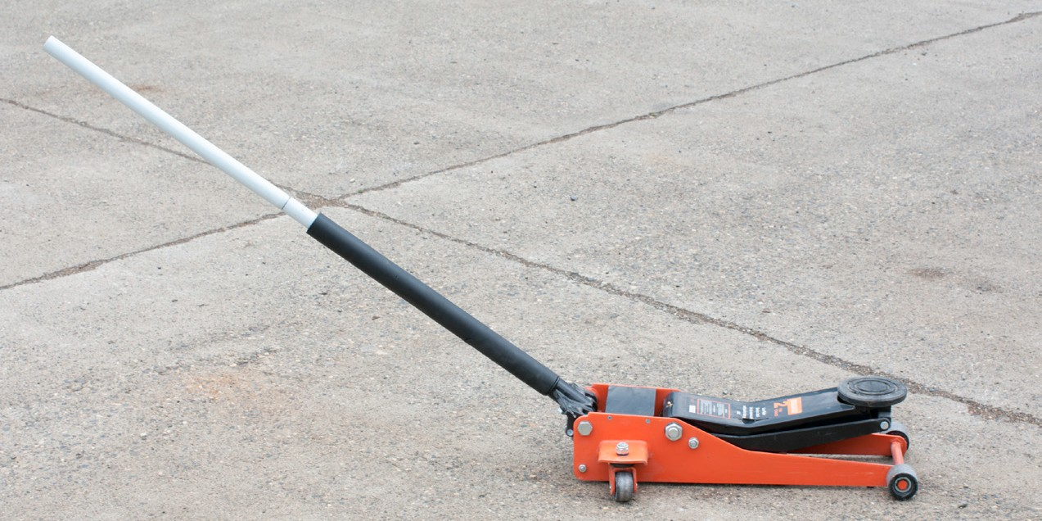
Figure 19 — Hydraulic floor jack

The long handle on a hydraulic floor jack is used to push, pull, or steer the jack into position. Turning the handle opens and closes the valve. When you pump the handle while the valve is closed, you raise the load. If the valve is open, you lower the load.

Hydraulic bumper jacks
Hydraulic bumper jacks are used in the automotive industry, usually to raise vehicles for tire changes. They are designed to lift a vehicle by its bumper. Most bumper jacks are capable of lifting approximately 900 mm (3 ft.); however, some models are able to reach as high as
1350 mm (4 1/2 ft.). Bumper jacks cannot be used on vehicles with energy-absorbing bumpers.

Bumper jacks range in capacity from 1360 kg (1 1/2 tons) to 2260 kg (2 1/2 tons). Most bumper jacks are equipped with a mechanical safety lock mechanism that prevents the vehicle from being lowered accidentally.

There are two basic types of hydraulic bumper jacks: those with a manually operated hydraulic oil pump and those that use compressed air as a power source.

Porta-power jack
The porta-power press or jack (Figure 20) is a hydraulic-powered lift controlled by a hand pump, and is useful for aligning flange assemblies or frame members. This jack consists of a power head and a reservoir and pump assembly that are connected by high-pressure hydraulic hoses.
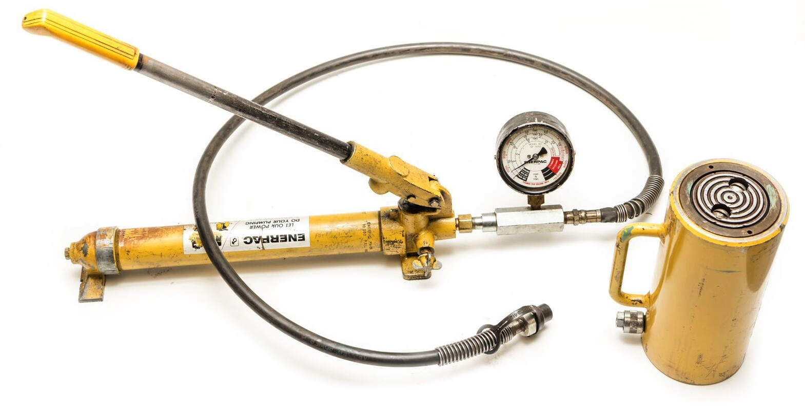
Figure 20 — Portable hydraulic press

The porta-power press is versatile. There are numerous attachments available for this unit, all of which increase the number of jobs the press can perform. As well, the porta-power press is available as a push-pull type capable of two-way action. The double action allows the power piston to be powered or pumped in both directions.

Jack safety and inspection
One of the first and most important rules to observe when using any kind of jack is to make sure the load does not exceed the capacity of the jack.

Before using any jack you should inspect it by looking for signs of:
- wear
- stress
- insufficient lubrication
- leaks

Wear
Wear usually shows up as a shiny or worn surface. Wear is detected both by sight and by feel. Badly worn parts should be replaced. To prevent further wear, moving parts should be lubricated.

Stress
Stress is detected visually. Stress on a jack or metal stand is indicated by cracked welds, cracked paint, freshly flaked-away rust, and bent or misaligned parts.

Cracked welds can be repaired by a competent welder, but bent pieces should be replaced.

Insufficient lubrication
If a jack squeaks or requires more force than usual to operate, it has probably not been adequately lubricated. Apply either oil or grease at all locations indicated by the manufacturer’s lubrication guide.

The screw threads on screw jacks, scissors jacks, and the top end of hydraulic jacks are often overlooked for lubrication. These threads should be brushed with a wire brush or washed in solvent to remove all dirt and dried lubricants. The threads should be lubricated with a heavy oil and the screw turned through its full length to assure that the oil coats the entire surface.

Leaks
Leaks can occur out of the oil filled port or the seals of either piston. If fluid has leaked past the seals, the addition of a little fluid may help your jack function properly, but it is generally a temporary solution to a more serious problem and you must put in new seals or possibly replace other parts.

Maintenance of jacks
For specific maintenance instructions, refer to the manufacturer’s maintenance guide and the information below. Some general guidelines for maintenance of jacks follow.

Lever jacks
Lever jacks have many moving parts that all must be kept clean and well lubricated. Check all parts for signs of stress and discard any jacks showing cracked or bent parts.

Be sure to inspect the teeth or notches for signs of wear. Discard the jack if either the notches or the dogs that engage the notches show excessive signs of wear.

Hydraulic jacks
Hydraulic jacks should be checked for signs of leaks. There are three places on a hydraulic jack where leaks may occur: the area where the lifting piston comes out of the jack, the top of the pump and the area around the valve. Excessive oil showing near these areas indicates a leak. Leaks can be repaired by dismantling the jack and replacing the seals.

Another type of leak in a hydraulic jack shows up when the jack will not support a load. If you have closed the valve tightly, yet the jack allows the load to slowly lower, the valve has an internal leak that is allowing the fluid to flow back to the reservoir. To remedy this problem you must replace the defective valve components.

A hydraulic jack that does not extend the lifting piston completely indicates the jack is low on fluid. You should refill the reservoir with the recommended grade of hydraulic fluid to permit full extension of the jack.

Floor jacks
All moving parts should be checked for wear, stress, and adequate lubrication. You should check and service the hydraulic system as you would any hydraulic jack.

General jack care
Jacks should be stored in a dry location. If they must be exposed to moisture they should be wiped with an oily cloth to keep them from rusting. Hydraulic jacks should not be exposed to excessive heat for long periods of time as the rubber seals will harden and begin to leak.

Use only the handle that was designed for the jack. Longer handles may offer too much leverage and thereby place too much strain on the jack. Handles that do not fit the handle receptacle tightly will eventually deform the receptacle.

Store jacks out of the line of traffic. If a jack is run over by a vehicle or if a heavy object is dropped on the jack, you risk cracking or breaking any cast metal parts or bending malleable iron parts. Such damage could make a jack ineffective and/or unsafe to use.

Many repair procedures require that equipment, components or devices be adequately and correctly supported for safety. Large, heavy pieces of equipment require correct support to prevent movement and allow access during repair procedures. This support can be supplied by the use of jack stands or blocking.

Load supports
Lifting equipment is not intended to act as support for extended periods of time. If a load is to remain raised for an extended time, you must provide support for the load by using other fixed devices. This additional support is also required when personnel must work under the raised load. This additional support includes:
- manufactured metal stands
- blocking
- lashing
The portion of a load that rests on supports must not be allowed to slide off the supports. If the equipment being supported is machinery that rests on wheels, the safest way to prevent the wheels from accidentally rolling is to block them with chocks. Any item being raised or lowered by jacks must be prevented from moving horizontally, as such movement will cause the supports to tip.

Manufactured metal stands
Manufactured metal stands are available in capacities from 1000 kg to 10 000 kg (1 to 10 tons). When you use a metal stand, remember that the load must not exceed the stand’s capacity.
Jack stands are available in many different heights, sizes, and forms. These stands can be either adjustable or fixed.

Adjustable stands (Figure 21) are normally used with moderate loads and can be set to different heights. It is important to note that this type of stand requires a solid, flat footing for safe use and should never be used on soft or uneven ground.

Metal stands are equipped with relatively small feet that sink into any surface softer than concrete. If you use a number of metal stands to support a load on hard-packed soil, gravel, or even asphalt paving, you risk having the load topple because the stands will sink into the ground at different rates.
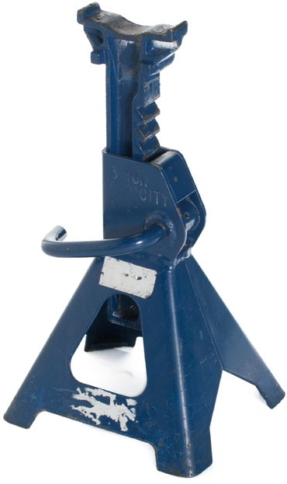
Figure 21 — Adjustable jack stand

Fixed stands (Figure 22) are used for heavy loads and are generally made of heavier materials such as solid steel. These stands will provide a better base for safer support but, like the adjustable stand, should not be used on soft or uneven ground. Custom-made stands must be certified by an engineer and stamped.
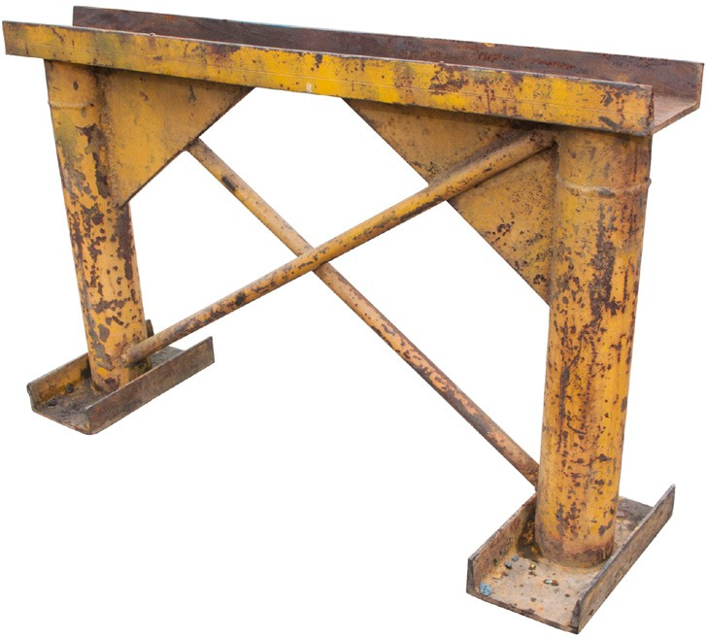
Figure 22 — Fixed stand

Maintenance of jack stands
Jack stands should be inspected regularly for damage and wear. Adjustable stands must be checked for bending and twisting, damage to the locking pin, and cracking of structural areas and welds. Fixed stands must be checked for twisting, cracking, and bending. Damaged stands should not be used.

Blocking
Rough lumber is used for blocking loads that must be raised and are too high, too heavy, or too large for conventional jack stands. It is also used for blocking on soft or uneven ground.

Using wood blocking helps prevent the load from sinking; wood blocking distributes the weight of a load over a larger area than a jack. The base area of wood blocking should be increased when blocking is used on soft ground. Wood blocking is built up by laying each tier or row at right angles to the previous tier. Each tier should be level before you proceed with the next tier. The placement of wood blocking varies with the type of load it supports. Always be sure that the base size of the tier you make is wide enough and properly placed to ensure good support.

Lashing
Lashing is used to secure loads that are temporarily placed and need to be safed-out. For example, pipe spools in a pipe rack or steel girders ready to be welded in place must be secured to the existing structure using wire rope and wire rope clips that are rated for the weight of the load. The rigging supports the load as the lashing is put in place. Once the lashing is complete, the rigging can then be removed since the lashing will safely support the load.

General safety requirements
When using jacks and stands you should be aware of the following safety requirements:
- Ensure that the jack is resting on a firm, level base.
- You must never use a jack to support loads for extended periods of time or while personnel work under the load. Use blocking or a manufactured metal stand.
- Always ensure that the jack is flat and square during a lift. Any leaning of the jack will cause a horizontal force to the load and could cause the load to shift sideways.
- Make sure the load cannot slip off the top of the jack. A jack with a flat top should lift only against flat, level surfaces. Vehicle axles and other cylindrical shapes should be cradled in concave jack-tops when they are being lifted.
- Never exceed the rated capacity of jacks or jack stands.
- Always use certified metal stands or wood blocking to support the load.
- Always use wheel chocks to prevent vehicles from moving during jacking.

Rollers
Rollers are an array of cylinders used to move heavy objects. They evenly distribute weight as the object is rolled in a controlled manner. Rollers can be used to move heavy objects by hand and can support many thousands of kilograms. The commercially available steel chain roller skate (Figure 23) consists of a series of roller bearings that roll about a central core. Rollers can also be put together on site from available equipment and materials such as steel pipe.
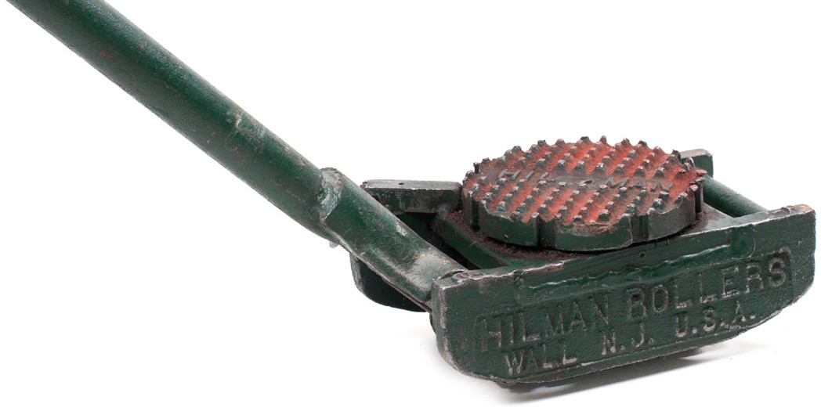
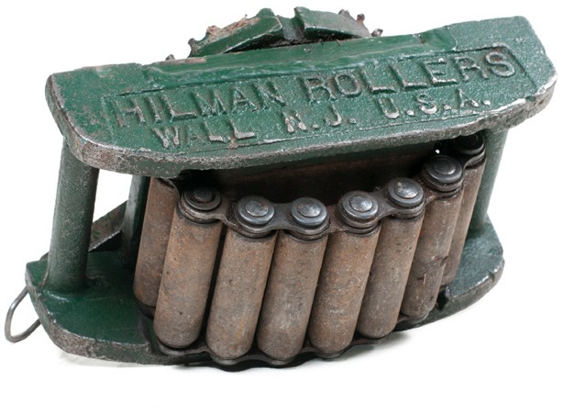
Figure 23 — Equipment moving roller

Now complete the Learning Task Self-Test.

Self-Test 2
- What is the mechanical advantage of a block and tackle with two sheaves on the fixed block and two sheaves on the travelling block?
a. 2:1
b. 3:1
c. 4:1
d. 6:1

- Where is the safety system located on the block and tackle?
  - At the fixed sheaves
  - At the travelling sheaves
  - At the running end of the fibre rope
  - The block and tackle has no safety system.

- Which lifting device is designed for vertical lifting but is limited in any horizontal application?
  - The Tirfor
  - The chain fall
  - The pallet jack
  - The come-along

- Which lifting device is designed for short vertical lifts as well as horizontal pulls?
  - The Tirfor
  - The chain fall
  - The pallet jack
  - The come-along

- Which lifting device is designed to pull in all positions, uses self-energizing jaws, and has an unlimited amount of cable travel?
  - The Tirfor
  - The chain fall
  - The pallet jack
  - The come-along

- What is the safety system found in the Tirfor?
  - The handle bends when overloaded.
  - The Tirfor does not have a safety system.
  - The safety stitching will break when overloaded.
  - A shear pin must break and seize the load when overloaded.

- What is the safety feature found on a cable-type come-along?
  - The handle bends when overloaded.
  - The safety stitching will break when overloaded.
  - A shear pin must break and seize the load when overloaded.
  - The cable type come-along does not have a safety system.

- What feature does the OHS Regulation require on all trolleys?
  - Drop stops
  - An alarm must sound when the trolley is overloaded.
  - The trolley motor must stop when there is an overload.
  - A shear pin must break and seize the load when the trolley is overloaded.

- What type of crane is referred to as a gantry or bridge crane?
  - A jib crane
  - A floor hoist
  - A boom hoist
  - An overhead travelling crane

- Which materials handling equipment is commonly known as a pallet truck?
  - A forklift
  - A screw jack
  - A gantry crane
  - A manual forklift

- Generally, which type of overhead travelling crane has a higher lifting capacity?
  - Boom
  - Derrick
  - Top running
  - Under running

- How is the size of a jack designated?
  - By weight
  - By length
  - By length or lift
  - By capacity

LEARNING TASK 3
Describe rigging hardware
Rigging loads for lifting requires the use of various hardware items. The correct selection, inspection, and assembly of each of these hardware items is critical to a safe lift. This hardware includes:
- slings
- snatch blocks
- turnbuckles
- eyebolts
- shackles
- wire rope clips
- hooks
- hitches
- spreader and equalizer bars

Slings
Many items that require hoisting have no provisions for attaching a hoisting line to them. Slings are used to connect the load to the lifting device. Slings may be attached to loads in a variety of ways. In this Learning Task, we will learn about three common types of slings (Figure 1) made of:
- wire rope, also known as cable
- chain
- synthetic materials
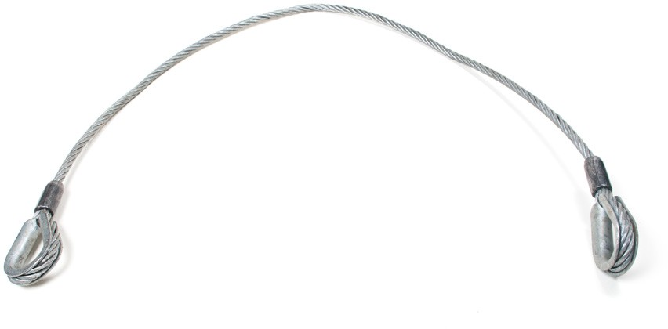
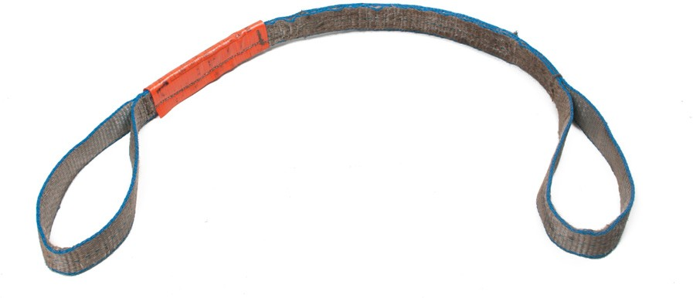
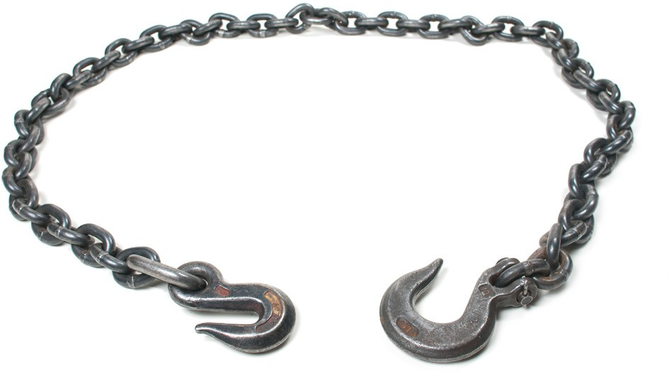

Figure 1 — Three types of slings

Tagging requirements
All slings must have an identification tag. This tag must be securely attached and clearly marked with the required information. For all three types of sling, that information includes the working load limit (WLL) for the type of hitch used with that sling. Some examples are shown in Figure 2.
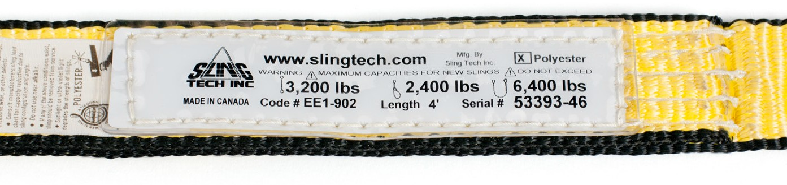
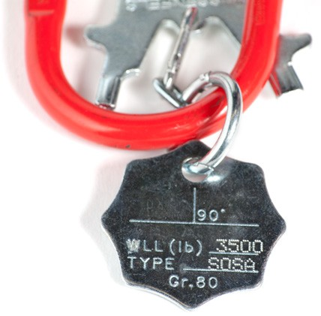
Figure 2 — Sling identification tags
Never use a sling for lifting unless it bears a tag indicating the working load limit.

Wire rope slings
Wire rope slings are lighter than chain slings and are therefore easier to handle. They can withstand a fair amount of abuse and relatively high temperatures. However, because wire rope slings can slip on hard surfaces or dig into some softer materials, synthetic slings are often preferred.

Wire rope is made of high-strength steel wires formed into strands, which are then wrapped around a centre core into a rope (Figure 3). There are many types of wire ropes available, each designed for a specific application or use. The manner in which a wire rope is made affects its strength, flexibility, and resistance to abrasion or crushing.

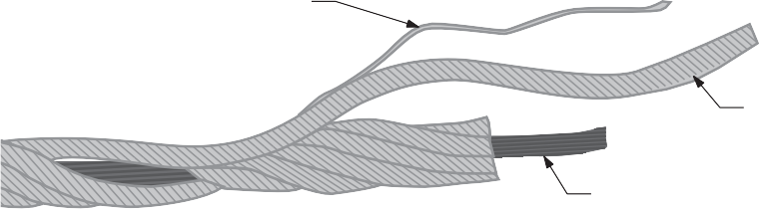
Wire

Strand

Core centre
Figure 3 — Wire rope components

You should be familiar with some terminology that describes the makeup of various wire ropes:
- Diameter refers to the measure of the rope at its thickest point.
- Strand classification refers to the number of strands and the number of wires per strand.
- Wire pattern refers to the combination and orientation of the wires within the strand. There are various different patterns, depending on the manufacturer.
- Wire rope lays refers to the direction or winding of the wire within the strands and the rotation of the strands within the rope.
- One rope lay refers to the lengthwise distance it takes for one strand to make one complete turn around the core.
Regular lay rope has the wires of the strand wound in the opposite direction to the strands. Lang lay rope has the wires within the stands and the strands wound in the same direction (Figure 4).

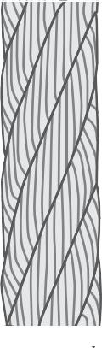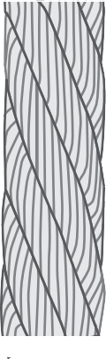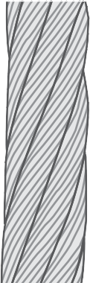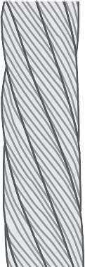

Right regular lay
Left regular lay
Right lang lay Left lang lay

Figure 4 — Regular lay and lang lay
Never use lang lay wire rope as a sling (WorkSafeBC OHS Regulation, Part 15.44).

Loops and thimbles
When the wire rope is terminated with a loop or eye, a thimble can be installed inside the loop to preserve its natural shape (Figure 5). This eliminates the risk of the loop being bent too tight, especially when the loop is connected to a device that spreads the load over a relatively small area. The thimble also protects the cable from pinching and abrading on the inside of the loop. The use of thimbles in loops is good industry practice.

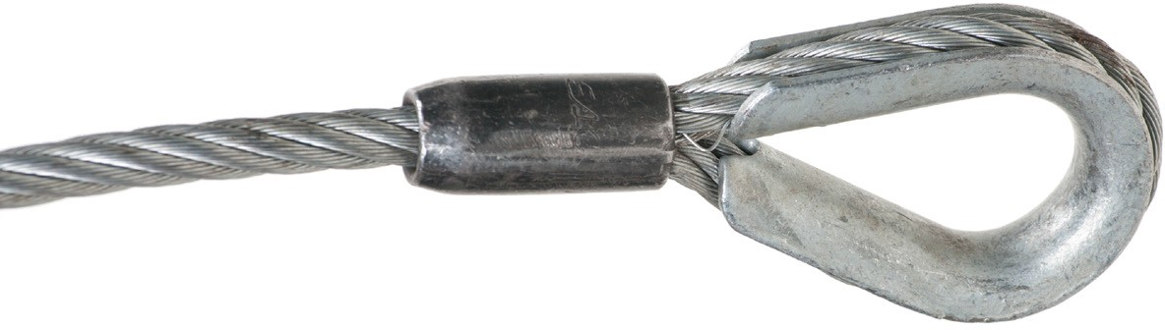
Figure 5 — Wire rope thimble

Wire rope safety
When working with wire rope slings, always wear gloves and eye protection. The following is a list of safety precautions to be taken when handling wire rope:
- Use the correct rope for the job.
- Inspect the wire rope regularly.
- Never overload the rope.
- Minimize shock loads by hoisting and stopping slowly.
- Avoid sudden loading in cold weather.
- Take special precautions and/or use a larger-sized rope whenever:
▸ the exact load is unknown,
▸ there is a possibility of shock loading,
▸ the conditions are abnormal or severe, or
▸ there is a hazard to personnel.
- Protect rope from sharp corners or edges with padding.
- Avoid dragging the rope under loads or over obstacles.
- Avoid dropping wire rope slings from heights.
- Avoid rolling loads over the slings.
- Store all unused ropes in a clean, dry place.
- Prevent loops in slack lines from being pulled tight and kinking. Once a kink has been made in a wire rope the damage is permanent. A weak spot will always remain no matter how well the kink seems to have been straightened out.
- Never use wire rope that has been cut, badly kinked, or crushed. Obtain approval to destroy and discard any slings or hoisting equipment found to be unsafe.
- Use thimbles when making eye fittings.

Chain slings
Alloy steel chains can be used in many different rigging operations. Chains are preferred in hoisting operations where the ability to withstand high temperatures and abrasion is required. They resist abrasion and corrosion better than wire rope and are good for lifting rough loads, such as heavy castings. Chains have no elasticity, and therefore they do not withstand shock loads very well.

When hoisting with a chain, never place a load on a twisted or knotted chain. Avoid sharp bends, as they tend to overload the links at the bend. Chains that are overloaded will also stretch. If any link shows stretching, do not use the chain for lifting. A chain that has been overloaded will display elongated links.

Heat will also have an adverse effect on the lifting capacity of chain. As temperature increases, there will be a temporary and possibly permanent effect on the chain’s capacity. WorkSafeBC OHS Regulation Part 15.51 states, “A chain sling must not be exposed to a temperature above 260°C (500°F) unless otherwise permitted by the manufacturer.”

Chains used as slings may be supplied with a master ring at one end and a hook at the other (Figure 6). The large master ring is designed to fit over a crane’s main hook. The chain’s own hook is hooked directly to loads that have attachment points.
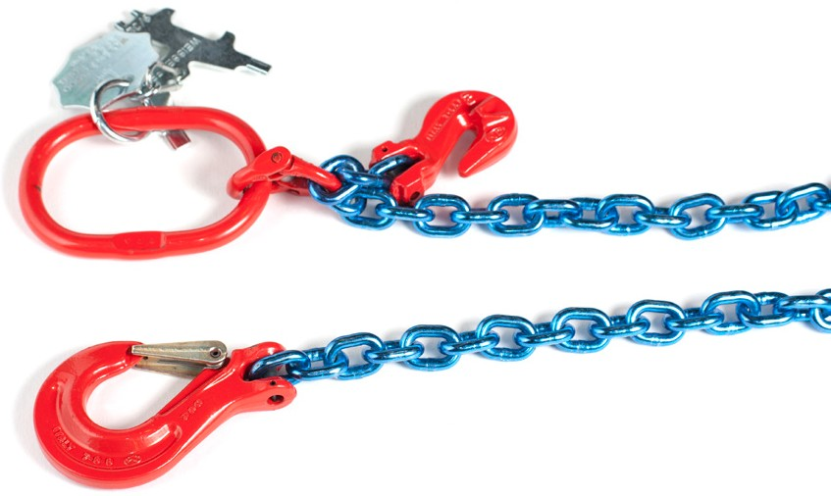
Figure 6 — Chain with master ring and hook

The chain can also be wrapped around the load and its hook secured to the master ring (Figure 7).
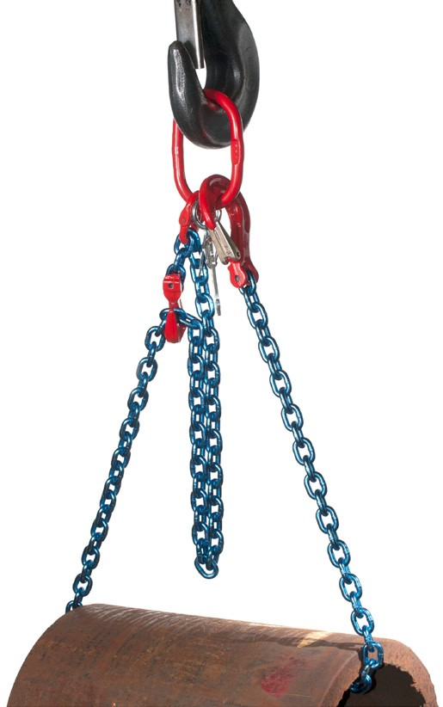
Figure 7 — Chain hook secured to master ring

Chain grades
Chains are identified by the grade and by stock diameter (size). Chain size is the diameter of the rod that is used to form each link of the chain. The grade number is an indicator of the ultimate break strength of chain: the higher the grade the greater the break strength. Chains will have a grade identification embossed into their surface at intervals not greater than 0.9 m (3 ft.) (Figure 8).
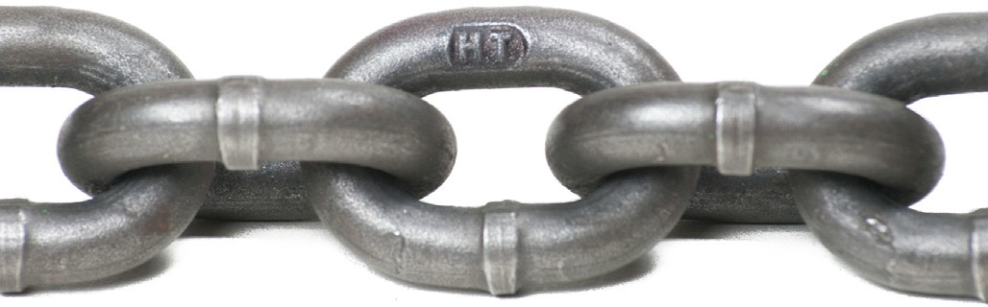
Figure 8 — Grade 43 link

The standards for manufacture and use of various chains are established by the National Association of Chain Manufacturers. Some of the common grades used are the following:
- Grade 43 High-Test chain is a carbon steel chain widely used in industry, construction, agricultural, and lumbering operations. Grade 43 chain is embossed with “HT.” This chain is not approved for overhead lifting.
- Grade 70 chain is manufactured in heat-treated carbon steel. Used as tie downs on over- the-road trailers, it’s never to be used for overhead lifting. Grade 70 chain is coloured gold to meet Department of Transport requirements, and so it’s easy to recognize. In addition to transport uses, it’s also commonly used in towing, logging, oil rigs, and safety chain applications. Grade 70 chain is embossed with 7, 70, or 700.

- Grade 80 chain is a heat-treated alloy steel chain with a high strength-to-weight ratio. Its strength makes it safe for overhead lifting and lifting slings. Grade 80 alloy chain is embossed with 8, 80, or 800. It may also bear the letter A, indicating “alloy,” along with the number.
- Grade 100 chain provides about 25% higher work load limits than Grade 80 chain and is approved for overhead lifting applications. Grade 100 alloy chain is embossed with 10, 100, or 1000.
- Grade 120 chain has a square link style that creates increased contact between the bearing surfaces on the links, which reduces pressure on the chain. This gives it work load limits that are 50% higher than grade 80 chain and 20% higher than grade 100 chain. Chain grade 120 is approved for overhead lifting. Grade 120 chains have a bright blue finish to make them easily recognizable.
The minimum grade acceptable for overhead hoisting is Grade 80 alloy chain.

Synthetic web slings
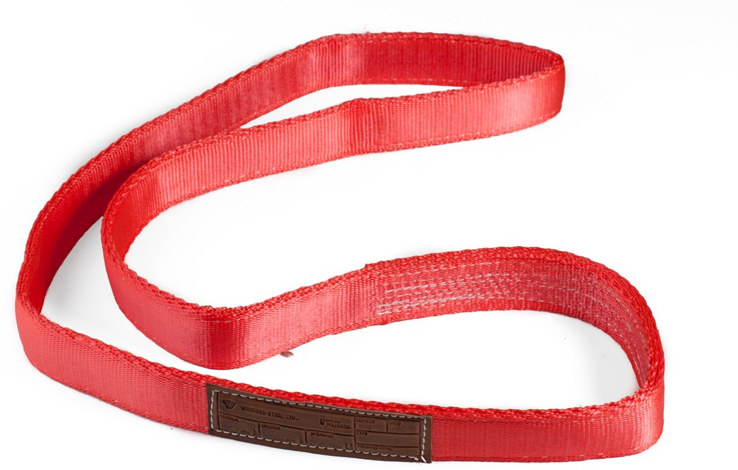
Synthetic web slings are available in a variety of shapes and widths. They are softer and wider than most other slings and so better protect the load against marring or scratching. Synthetic slings do not slip as easily as wire rope slings. The shapes most commonly found are illustrated in Figure 9.
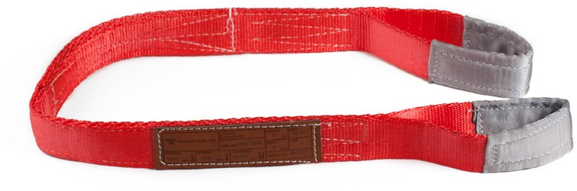
Standard eye web sling
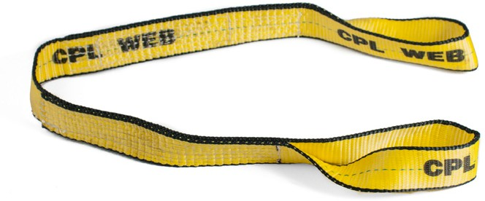
Twisted eye web sling Endless web sling
Figure 9 — Synthetic web slings

Some web slings have metal end fittings instead of sewn eyes. Two types are available
(Figure 10). A basket web sling has metal triangles of equal size at each end of the webbing. A choker web sling has a larger triangle containing a slot at one end and a smaller triangle at the other end. The smaller triangle can be passed through the slot of the larger triangle to form a choker hitch.

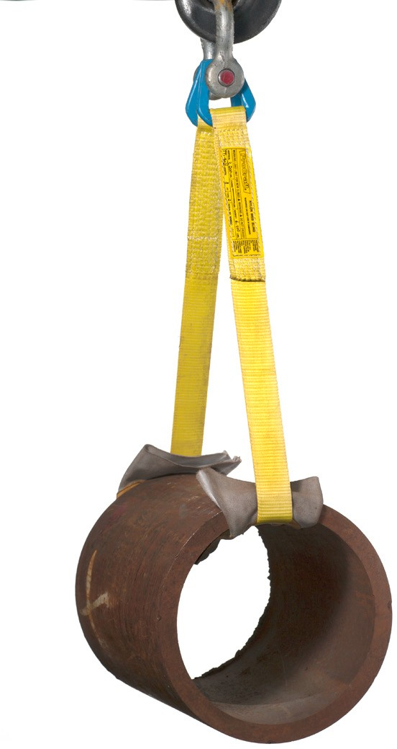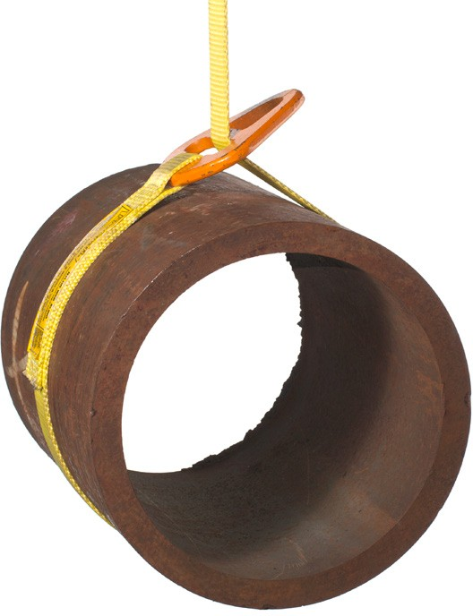

Figure 10 — Left: Basket web sling; Right: Choker web sling

Metal mesh slings
Loads that are too abrasive or too hot for synthetic webbing yet require the wide bearing surface of a web belt are rigged with slings made of metal mesh. These metal mesh slings are usually equipped with triangle ends that permit the use of either a basket or choker hitch.

Endless slings
Endless slings (also known as grommet slings) can be used in a variety of configurations (Figure 11).
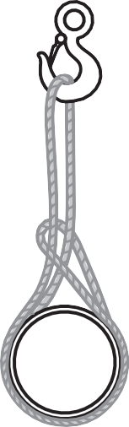
Figure 11 — Endless slings

Endless slings are usually made of fibre rope or synthetic webbing. They are light to handle and do not damage the loads, but because they are subjected to sharp bends, they tend to deteriorate more rapidly than do most other types of slings.

Snatch blocks
The snatch block is a pulley with a side plate that swings open (Figure 12). This allows you to fit the cable over the pulley, and then close the side plate instead of threading the entire cable through the opening.

A snatch block has two primary functions. One is to change the direction of the rigging cable when the anchor point is offset. The second is to increase the pulling power of a cable winch or Tirfor by connecting the snatch block to the load and running the cable through the block and back to an anchor point near the winch, creating a 2:1 mechanical advantage.
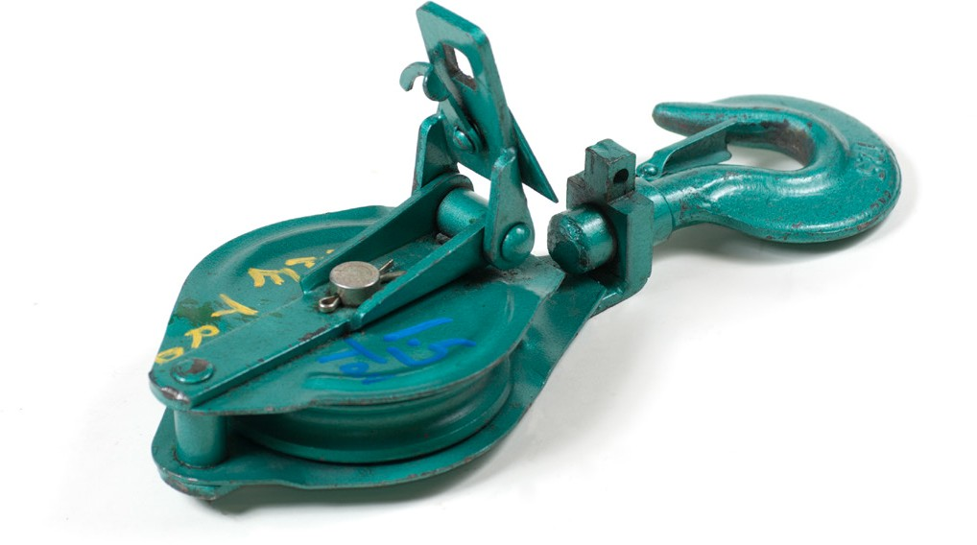
Figure 12 — Snatch block

Turnbuckles
Turnbuckles are used on applications that require a lot of tension and the ability to make adjustments (Figure 13).

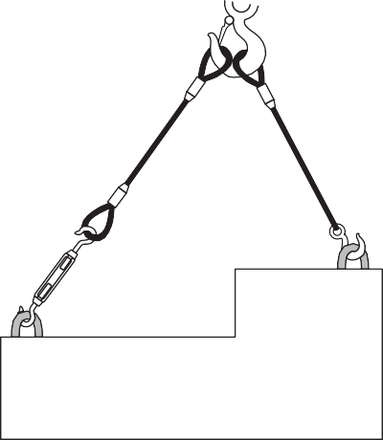
Turnbuckle

Figure 13 — Adjusting leg length with a turnbuckle

Turnbuckles (Figure 14) are metal sleeves with left-hand internal threads at one end and right- hand internal threads at the other. Threaded metal rods (extensions) are fitted into each end of the sleeve. The metal sleeve is rotated so that the rods are either extended or retracted from the sleeve.
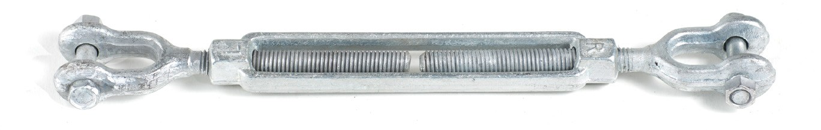
Figure 14 — Turnbuckle

The ends of these threaded rods are available as eyes, jaws, or hooks (Figure 15).
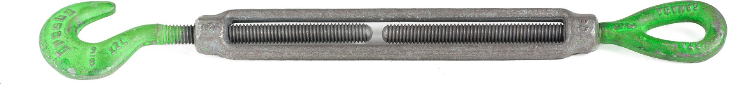

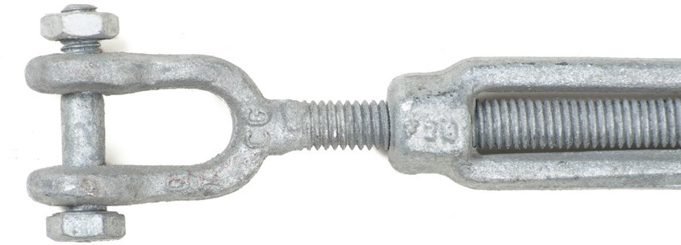
Figure 15 — Turnbuckle ends

It is important to prevent turnbuckle ends from rotating. Rotation can be caused by vibration or by tension on the rope attached to the turnbuckle. If there is any chance that the ends of the
turnbuckles could rotate within the sleeve, they should be wired to the sleeve with a lock wire as shown in Figure 16, unless the turnbuckle is supplied with lock nuts.
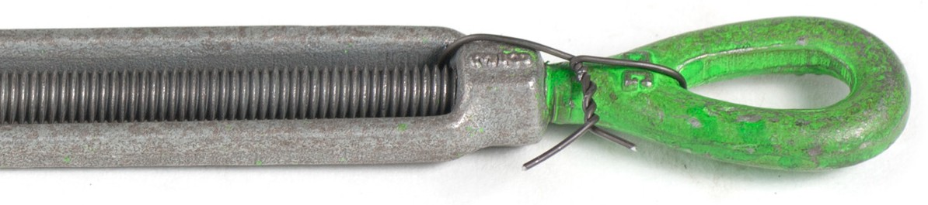
Figure 16 — Turnbuckle end with lock wire

Eyebolts
Eyebolts have a threaded shank that is attached directly to the load, to provide a point of attachment for rigging. There are two types, the shoulderless and the shoulder type.
Shoulderless eyebolts must not be used in overhead lifting, as force applied from the side at any angle will break the stem of the bolt (Figure 17).
Figure 17 — Incorrect use of shoulderless eyebolt

Shoulder eyebolts have a reinforced shoulder to prevent the bolt from bending when an angular strain is applied to them. They are able to withstand pulls up to 45 degrees from vertical, providing the pull is applied along the plane of the eye. Pulling at an angle that is not in the same plane will bend or break the eye (Figure 18).

Always make sure that the eyebolt is properly installed so that the shoulder is tight against the load. Do not use an eyebolt to lift with if there is any space between the shoulder and the load, as it will act as a shoulderless eyebolt and could break under stress.

Correct use
Do not use Do not use

Vertical 15°
30°

45°

do not use

End view Front view
Figure 18 — Angle of pull on shoulder eyebolts

The working load limits (WLL) for eyebolts are given for vertical pulls. When lifting at an angle you must reduce the WLL of the eyebolt as follows:
- vertical pull = no reduction in WLL
- 15 degrees from vertical = 45% reduction in WLL
- 30 degrees from vertical = 65% reduction in WLL
- 45 degrees from vertical = 75% reduction in WLL
- over 45 degrees from vertical = NOT RECOMMENDED

Shackles
A shackle consists of a U-shaped body with a removable pin. Shackles can be used to attach a sling to a load eyebolt or other connection point. They can also be used couple two or more slings together to be placed over a hook (Figure 19).
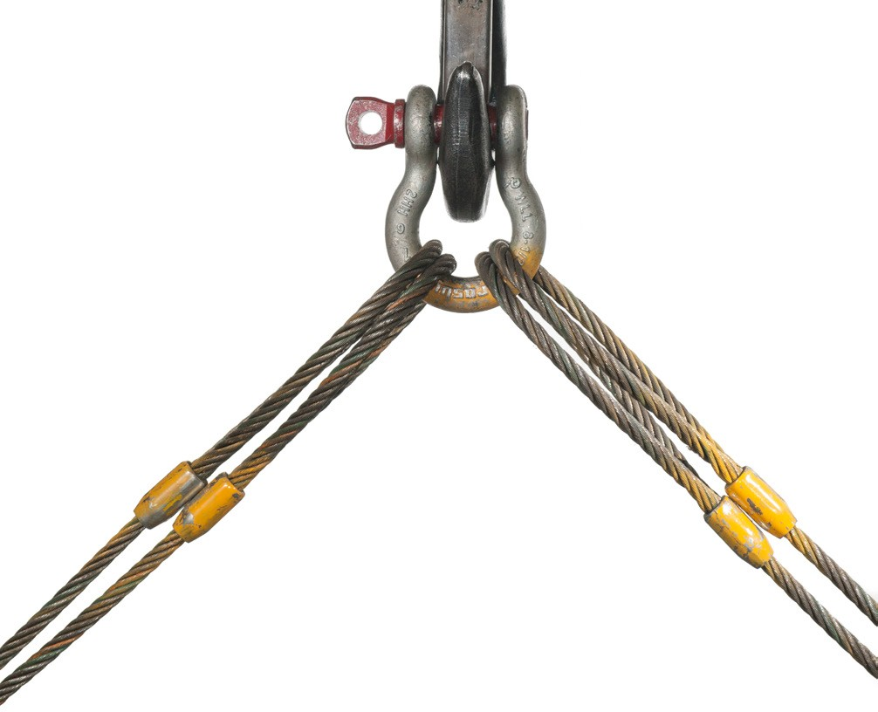
Figure 19 — Slings on shackle over hook

There are two basic classes of shackles, identifiable by their shapes (Figure 19):
- Anchor (bow) shackles have an “O” shaped loop that enables them to take loads from different directions without developing as much side load on the shackle. The larger loop shape reduces its overall reduced strength.
- Chain (D) shackles have a narrow loop like that of a chain. The small loop design can take high loads, but they must be in line, as side loads may twist or bend the shackle.
There are three basic types of pins available for both classes of shackles (Figure 20):
- screw pins
- round pins
- safety-type pins

The screw pin shackle is most commonly used.
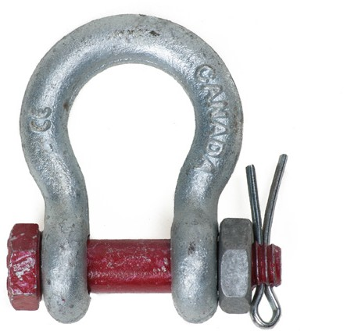
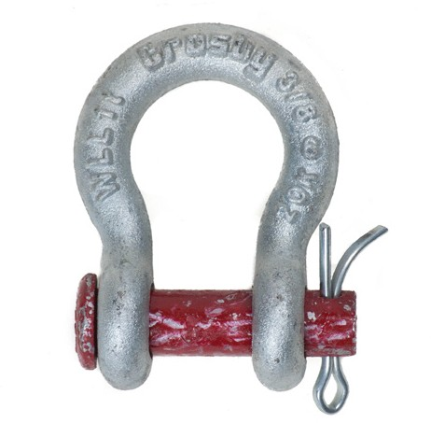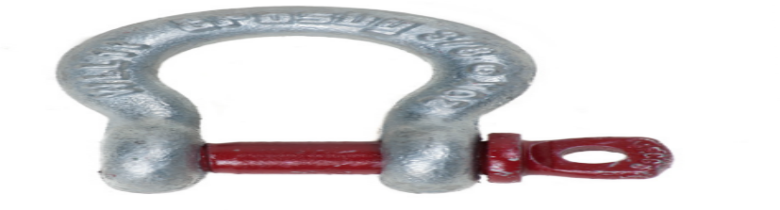
Safety type anchor shackle Screw pin anchor shackle Round pin anchor shackle
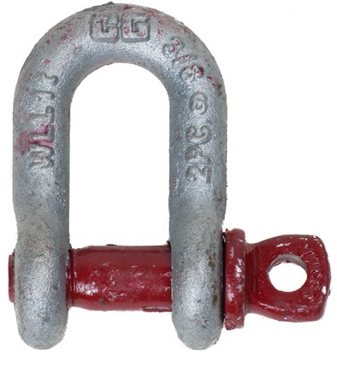
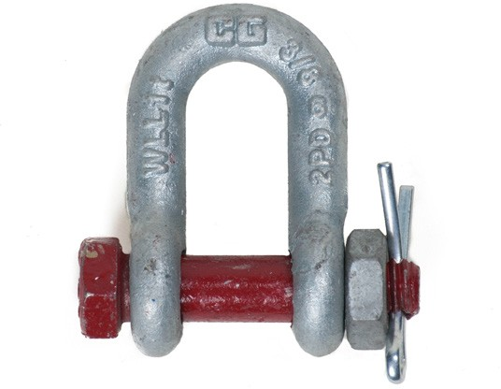
Screw pin chain shackle Safety type chain shackle Figure 20 — Shackles

The shackle should have a throat large enough to avoid crowding and pinching the loops. The load rating of a shackle must be shown as a stamped or embossed number on the body of the shackle. Do not use shackles that do not have a load rating.

You must never replace the pin of a shackle with an ordinary bolt. Shackle pins are made of hardened steel. Ordinary bolts will bend under load and will damage the shackles. In many applications, the shackle pin must be secured for safety. Screw pins may be wired off to prevent them from turning out.

Never connect a shackle in such a way that the movement of the sling could turn a screw pin (Figure 21).
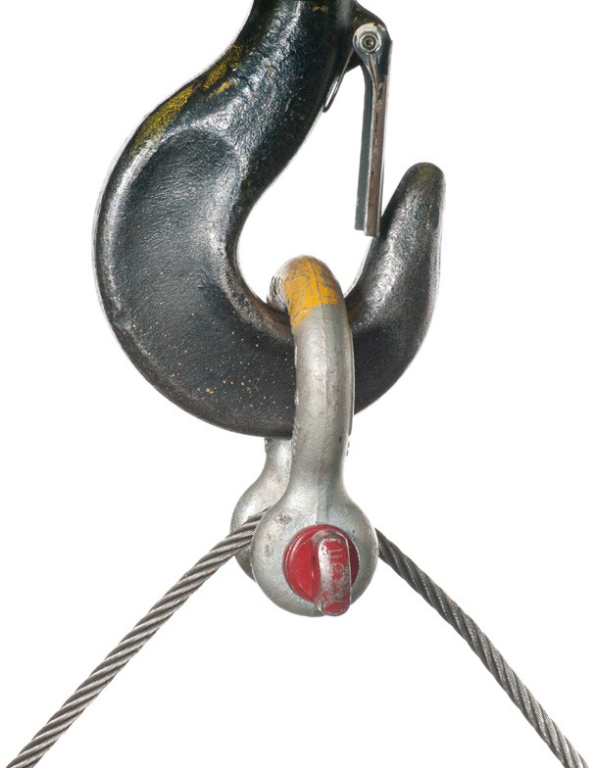
Figure 21 — Incorrect shackle attachment

The correct method for attaching a shackle to a lifting hook is illustrated in Figure 22. Note that if the width of the shackle’s opening is considerably greater than the thickness of the hook.
Packing washers should be used to centre the hook on the shackle.
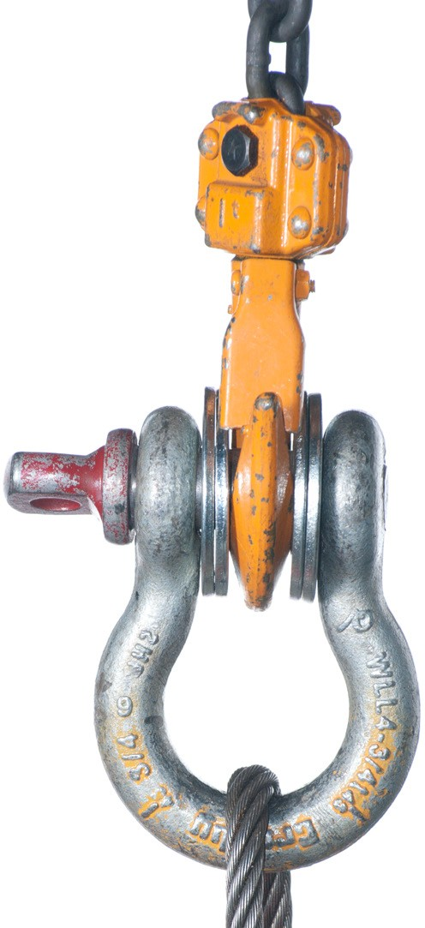
Figure 22 — Using packing washers

Never attach a shackle so that the load is applied to the sides of the shackle, called cross-bow loading. Always apply the load as shown in Figure 22, on the pin and on the end of the shackle.

To prevent cross-bow loading, never use a shackle with slings where the sling angle between the two slings at the shackle will exceed 45 degrees.

Shackles may be used to form a choker hitch as illustrated in Figure 23, but if you do this you must make sure the pin is not bearing on any moving part of the rope. The rope could cause a screw pin to turn and become loose.
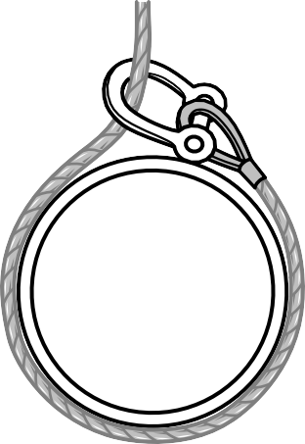
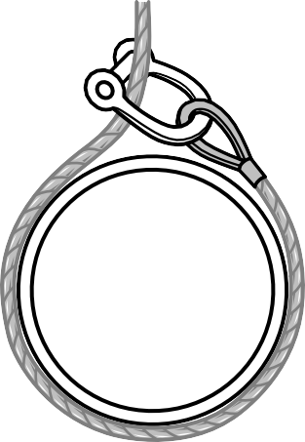
Correct Incorrect
Figure 23 — Using a shackle for a choker hitch

Wire rope clips
The wire rope clip is an alternative to a manufacturer’s wire rope eye. It is used to fasten the end of a wire rope onto its standing part to form a loop. Cable clips provide a relatively quick and easy method for tying wire rope. However, the crimping action of cable clips significantly reduces the breaking strength of wire rope (up to 20%).

The two most popular types of cable clips are the fist grip clip (or J clip) and the U-bolt clip (Figure 24). When making a loop, the U portion must be installed on the dead end of the line.

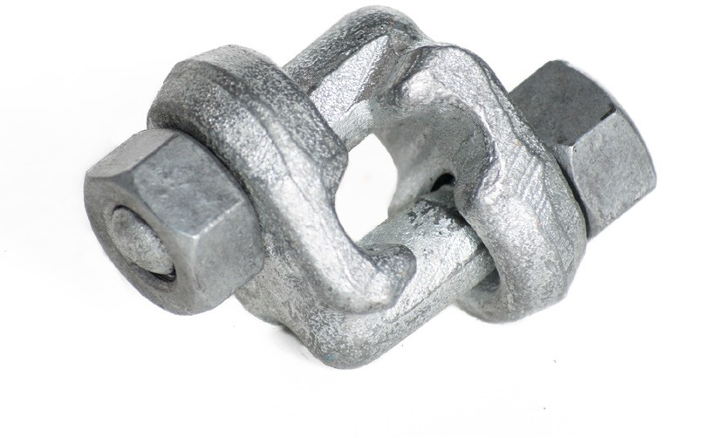
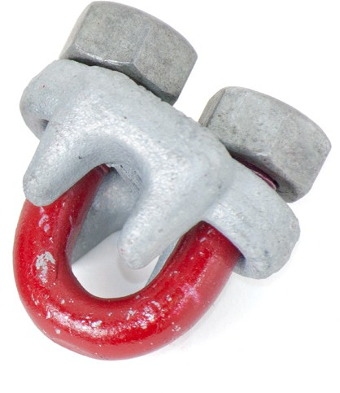
Fist grip clip U-bolt clip
Figure 24 — Cable clips

The number of clips required and their spacing are related to the diameter of the wire rope. The specification for these are listed in WorkSafeBC, OHS Regulation, Section 15.22 to 15.23. http://www2.worksafebc.com/publications/ OHSRegulation/Part15.asp#SectionNumber:15.23
There are also rule-of-thumb calculations used for cable clips:
- Number of clips = the diameter of the wire rope × 3 + 1 rounded up to the next whole number
- Spacing of clips = the diameter of the wire rope × 6
The distance from the rope end to the first cable clip should also be six or seven rope diameters.

Example for 1/2" wire rope:
- Number of clips required: 1/2" × 3 + 1 = 2 1/2, rounded up to 3 clips
- Clip spacing: 1/2" × 6 = 3"
The correct procedure for installing cable clips for 1/2 in. wire rope is as follows:
- Calculate the length required for the loop (number of clips required times six rope diameters). Install the first clip six rope diameters from the rope end (Figure 25). Tighten the nuts to the recommended torque using a torque wrench.

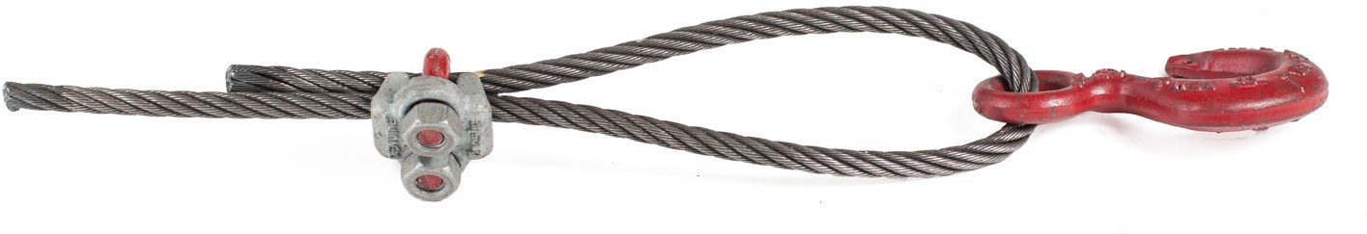
Figure 25 — Installing first cable clip

- Install the second clip as near to the thimble as possible (Figure 26). Tighten the nuts but do not torque.

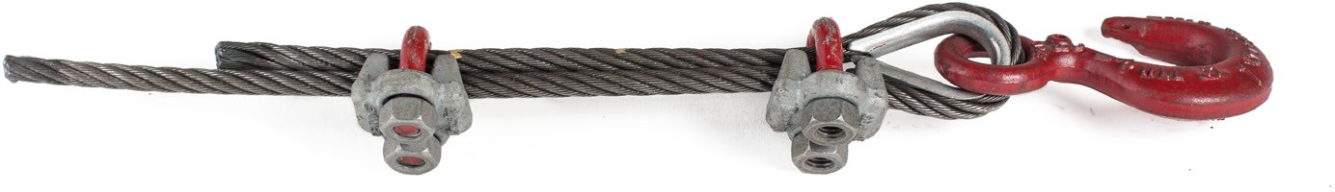
Figure 26 — Installing second cable clip

- Install all other clips at equal spacing, apply tension to the rope, and then torque all the nuts (Figure 27).

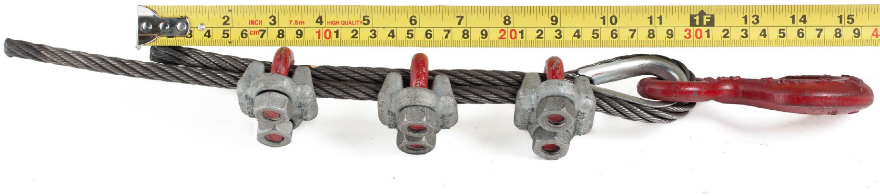
Figure 27 — Installing centre cable clip

Wire rope has a tendency to stretch a small amount when first put into service. Wire rope reduces in diameter as it stretches. Therefore, always tighten all of the cable clips after the first hour of service in a new connection. If the cable clip connection is under heavy strain, check the tightness of the nuts at regular intervals until no change in their tightness is observed.
Correctly installed cable clips can reduce the breaking strength of wire rope by 20%. Incorrectly installed cable clips can reduce the breaking strength up to 50%.

Hooks
Of the many types of hooks available, the most common are the slip, grab, and sorting
(Figure 28). Round eye connections shown on these hooks are the most common; they can be used to connect to the body of a pulley or directly to a cable.
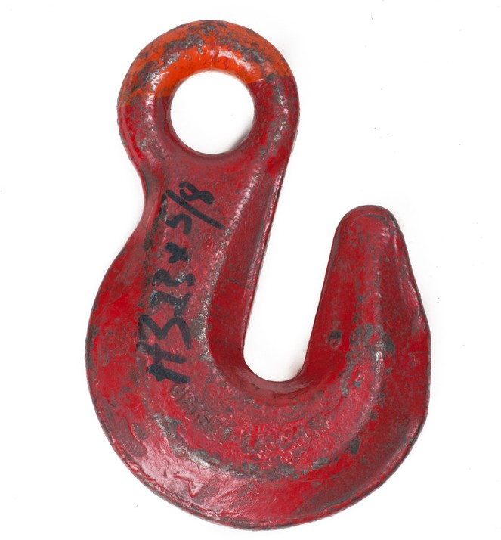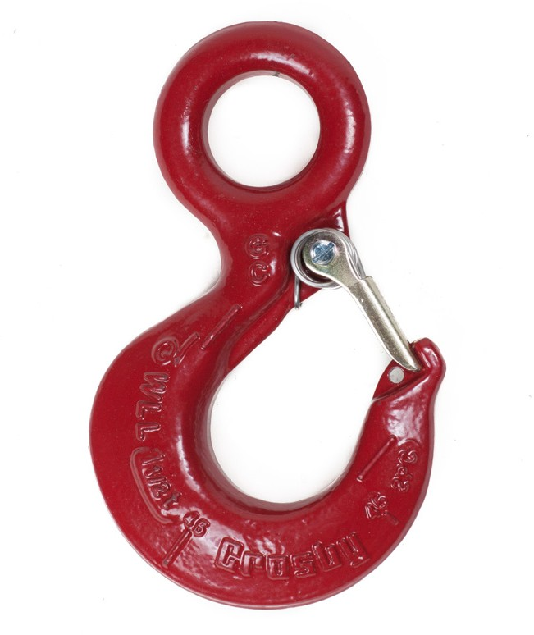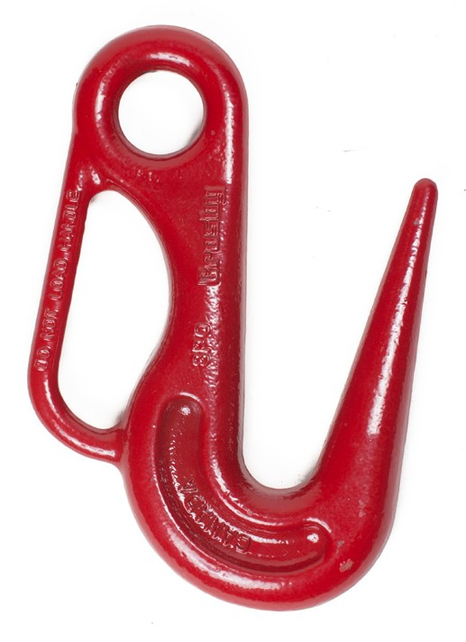
Slip Grab Sorting Figure 28 — Common hook types

All types of hooks are also available with clevis connections instead of an eye (Figure 29). A clevis connection has a u-shape with a pin that can connect directly to a chain.
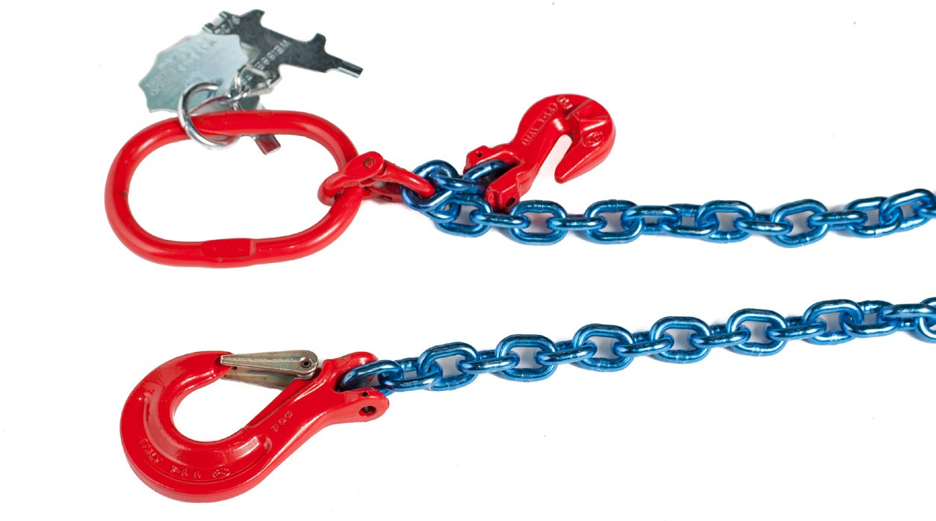
Figure 29 — Slip hook and grab hook with clevis connections

Slip hooks are generally attached to the ends of chain or wire rope slings and will allow connection points to move within the throat.

Grab hooks have a narrow throat with a saddle equal in size to the throat opening, which creates a slot. Grab hooks are designed to grab onto chain links by sliding one link through the hook slot, with the throat opening at an upward angle and the basket at the bottom. Figure 30 shows the grab hooks being used to shorten the length of the chain sling.
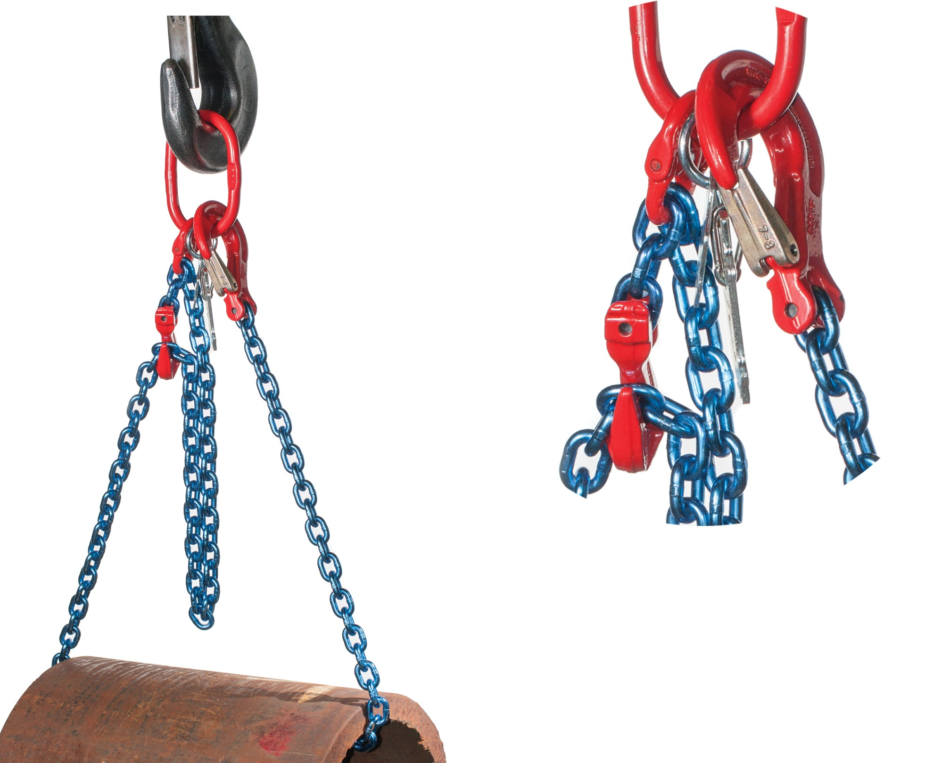
Figure 30 — Adjustable chain sling

Sorting hooks have a wide throat opening that tapers to a narrower basket with a slightly sharper tip than most other hooks. Sorting hooks are also referred to as shake-out hooks and are primarily used at the end of slips for picking up steel plate and other steel structural shapes. The long thin hook can slide in between closely stacked steel shapes. When sorting hooks are used to lift heavy loads, you must ensure the load sits squarely in the bottom or saddle of the hook.

Another type of hook connection is a swivel base (Figure 31). A swivel is a connection that allows the connected object to rotate.
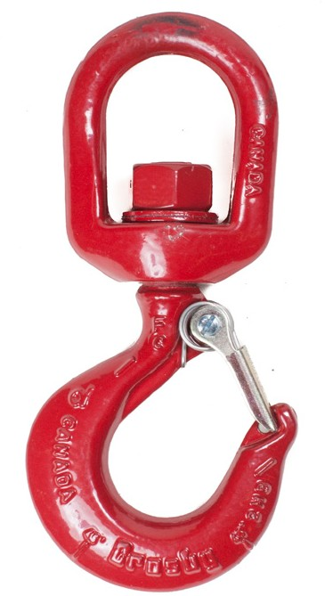
Figure 31 — Swivel hook
All hoisting hooks, except grab and sorting hooks, must have safety catches. Open hooks must not be used to lift a bucket, cage, or skip if there is a possibility the load could injure people.
Hooks are usually made of alloy steel, and their working load limit (WLL) should be stamped on them. It is important to remember that the WLL applies only when the load sits in the saddle of the hook. If the load is off centre or sits between the saddle and the tip, the WLL is significantly reduced (Figure 32).

Balanced
¼ off centre
½ off centre
¾ off centre
Point load

Load
Can carry 100% of rated load
Load
Can carry approx. 86% of rated load
Load
Can carry approx. 80% of rated load
Load
Can carry approx. 70% of rated load
Load
Can carry approx. 40% of rated load

Figure 32 — Effect of off-centre loads on hook capacity

To protect from the stress of twisting while under load, all hoisting chains should be equipped with swivels such as those shown in Figure 33.
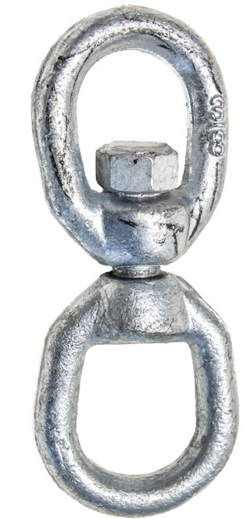
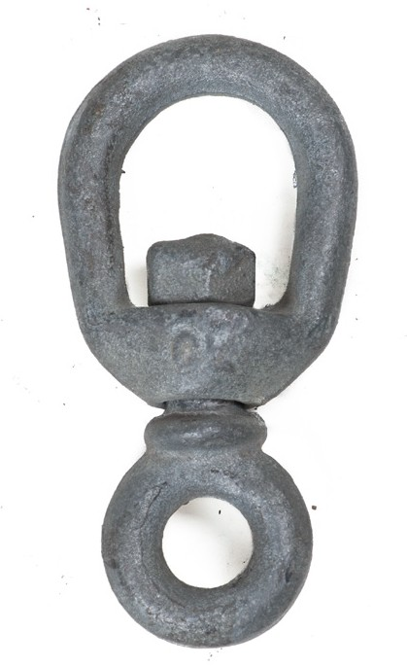
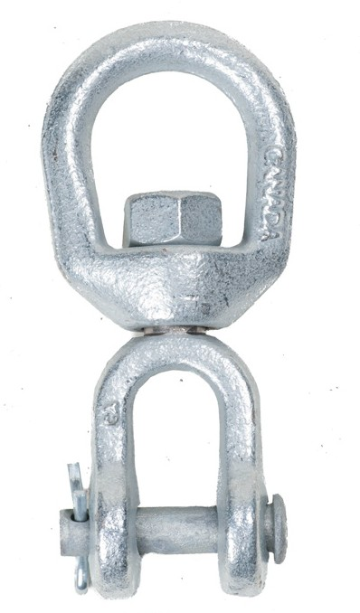
Figure 33 — Chain swivels

Choker hooks
Choker hooks are prefitted onto wire rope slings. They enable the rigger to connect a choker hitch to a load quickly while only working with one end of the sling. The width of the hook also protects the rope that the hook connects to from sharp bends. The standard choker hook is mounted on a sling and slides between the two ends. The sling is passed around a load and the ferrule is connected into the opening in the hook, which forms a choker hitch (Figure 34).
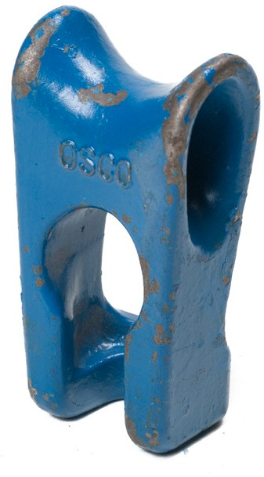
Figure 34 — Standard choker (midget) hook

The adjustable (or sliding) choker hook (Figure 35) is also mounted on a sling and slides between the two eyes at each end and the end eye is hooked over the sliding choker hook.
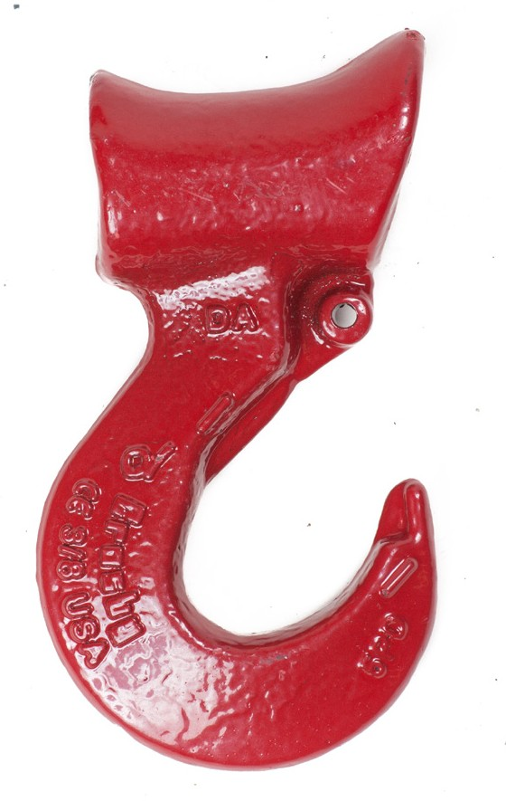
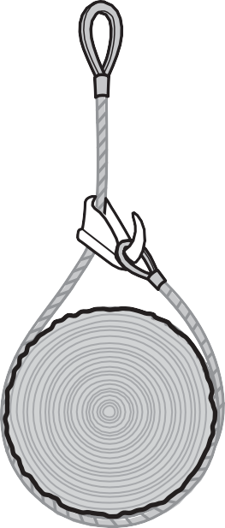
Figure 35 — Adjustable choker hook

Hitches
As you have learned, the link between the load and the lifting device is often a sling. A rigging configuration or hitch is the way in which the sling is arranged to hold the load. Some hitches can be made with just the sling, while others will require additional rigging hardware. The type of hitch you use will depend on the type of load and how you will control the intended movement.

There are three basic types of hitches that you will see on sling capacity rating tags:
  - vertical
  - choker
  - basket

Vertical hitches
There are two types of vertical hitches: single and bridle.

Single vertical hitch
The single vertical hitch (Figure 36) consists of a single leg of sling material with a hook or an eye at each end. The eyes on the fibre or wire rope should be lined with thimbles to protect the strands. This hitch is used to lift a load straight up, and some type of attachment hardware is typically needed to connect the sling to the load. This type of hitch allows the load to rotate freely. If this is not desirable, you will need to use some form of load control, like a tag line.

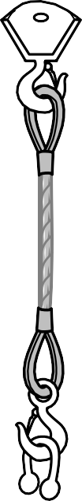
Figure 36 — Single vertical hitch

Bridle hitch
A bridle hitch is another form of vertical hitch. It consists of two or more single legs attached to the same hook, master link, or bull ring (Figure 37). Bridle hitches are generally used on loads that have suitable attachment points. To keep the load stable, the attachment points must be above the load’s centre of gravity.
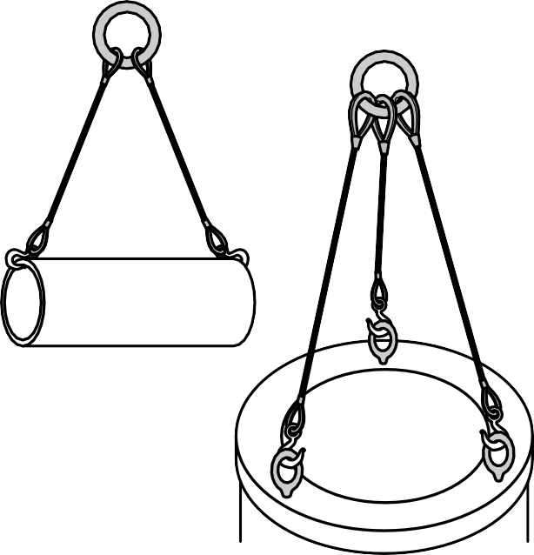
Figure 37 — Bridle hitches

When a bridle hitch has more than two legs, do not assume that all legs are sharing the load equally. Regardless of the total number of legs, the full weight of the load might be shared by only two legs. The other legs may simply be balancing the load (Figure 38). For this reason, the size of the slings in a multi-leg bridle hitch should be designed so that any one sling could safely support half the load.
Carrying full load
Balancing
Figure 38 — Load sharing

Choker hitches
Choker hitches are used when a load has no attachment points. Choker hitches are made with a single length of sling material hooked back to itself just above the load with a shackle or choker hook to create a restricting loop. It is important that the shackle be oriented correctly so the pin is not located against the running part of the sling. Using choker hitches reduces the capacity of a sling by a minimum of 25%.

To protect both the load and the sling, place padding (softeners) between the sling and any sharp corners (Figure 39). Note that the simplified diagrams in the following pages may not show the softeners, but it is essential you use them in practice.

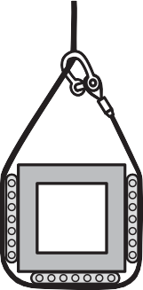

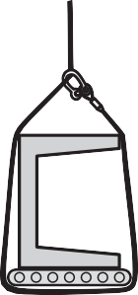
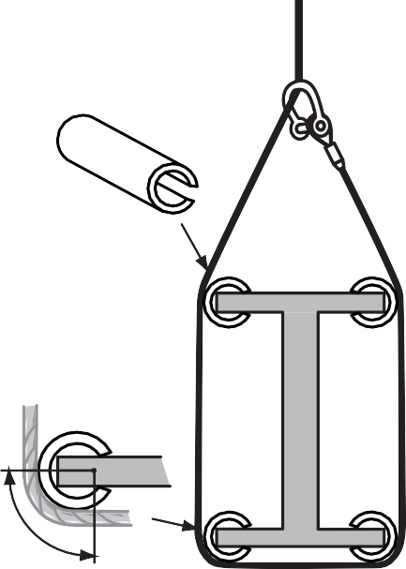Radius of contact
For heavy structural members
should be equal to one rope lay
Figure 39 — Protective padding

Single choker hitch
With a single choker hitch (Figure 40A), the sling is passed around the load once to create the restricting loop. The single choker hitch is not recommended for loose bundles of material, as it tends to push loose items up and out of the choker (Figure 40B and C).
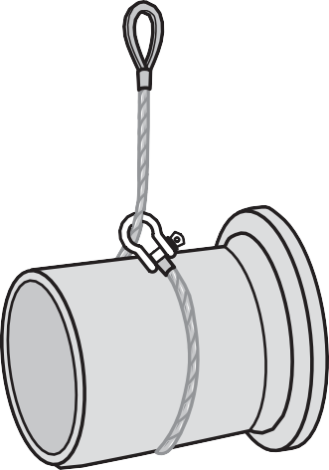
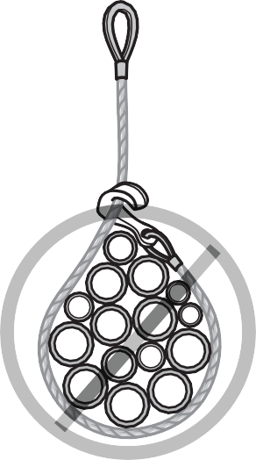
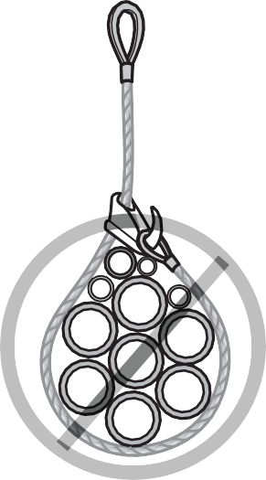
A B C
Figure 40 — Single choker hitches

Double choker hitches
When items are more than 3 m (10 ft.) long, it is best to use double choker slings spaced out far enough to provide stability (Figure 41).
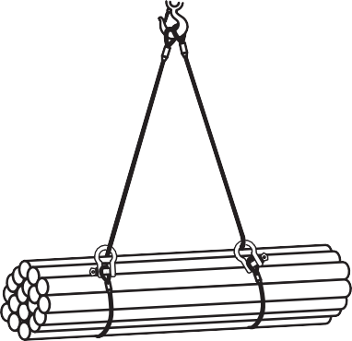
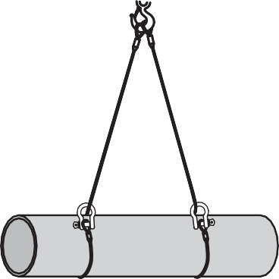
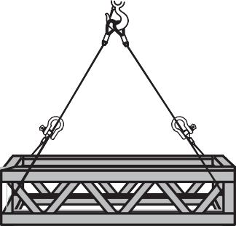
Figure 41 — Double choker hitches

Double-wrap choker hitch
To lift a bundle of loose items, a double-wrap choker hitch can be used (Figure 42). The double- wrap choker uses the weight of the load to create a constricting action on all sides of the load.
This keeps all of the pieces confined to the middle of the hitch, so that even the top pieces will not slide out of the rigging. As with the single-wrap choker hitch, two of these hitches are needed when the load is longer than 3 m (10 ft.).
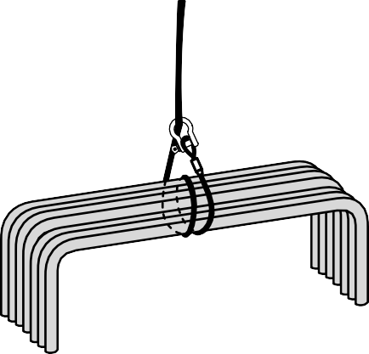
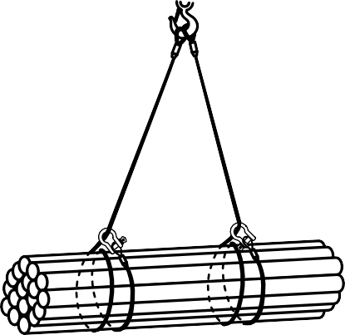
Figure 42 — Double-wrap choker hitches

Basket hitches
Basket hitches are very versatile and effectively double the capacity of the sling. This is because the sling is passed around or through the load and both eyes are connected to the hook, which creates two sling legs from one sling.

Single basket hitch
A single basket hitch (Figure 43) is made by passing the sling through an opening in a load with both ends of the sling attached to the main hook.
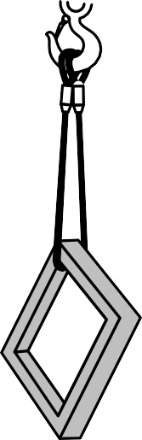
Figure 43 — Single basket hitches

Single basket hitches must not be used on loads that could tilt and slide out of the hitch. When a sling is wrapped around a square object, the sharp corners must be padded to protect both the sling and the object being lifted.

Double basket hitch
Loads that require support from underneath can be lifted with a double basket hitch (Figure 44). The double basket hitch has to be located so that the load is balanced between the two points of support. The two points must also be far enough apart to prevent the load from tipping and sliding out.
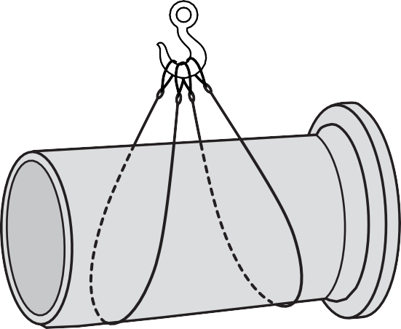
Figure 44 — Double basket hitch

The legs of a double basket hitch should be inclined at an angle of at least 60 degrees to the horizontal in order to prevent the legs from sliding toward each other (Figure 45). By using longer slings you can spread the legs further apart and still maintain the 60-degree slope.
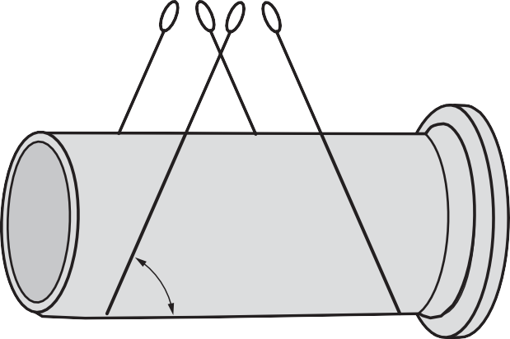
60° or more
Figure 45 — Necessary incline angle

Double-wrap basket hitches
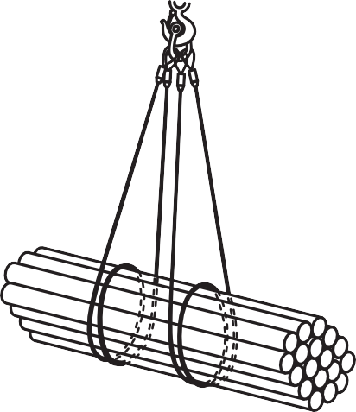
Loose loads can be securely rigged for hoisting with double basket hitches if you wrap the sling completely around the load (Figure 46A). Similar to a double-wrap choker hitch, this double wrapping compresses all the components together with the capacity advantages of a basket hitch (Figure 46B).
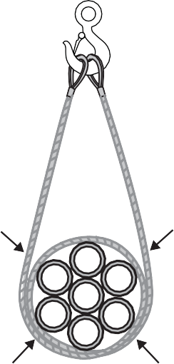
A B
Figure 46 — Double-wrap basket hitch

Spreader and equalizer bars
Long loads are often attached to spreader bars (beams) before they are hoisted in order to prevent the load from tipping or sliding out of their rigging. Equalizer bars ensure that the load is distributed evenly between the legs of a sling or between the hoist lines when more than one is used. Figure 47 shows spreader and equalizer bars and how they are used to keep loads evenly balanced.

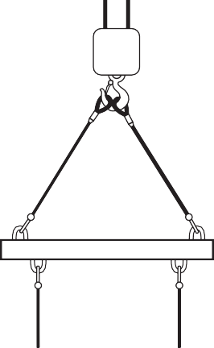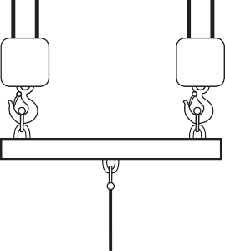

Spreader beam
A
Equalizer beam

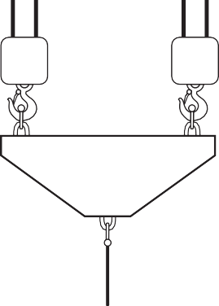
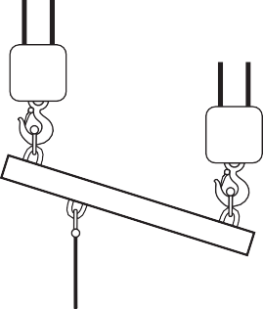A B C D
B
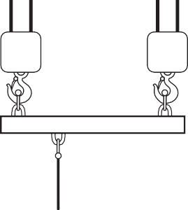
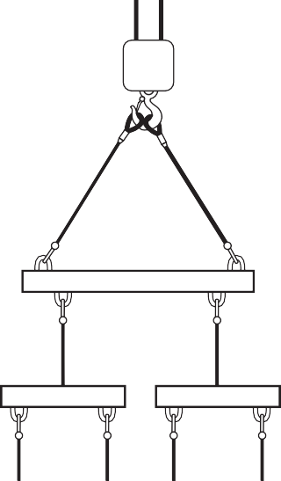
Loads in A and B do not change when the beam angle changes

Loads in C and D do not change when the beam angle changes

Figure 47 — Spreader and equalizer bars

Equalizer bars, spreader bars, and all lifting devices must be professionally designed and manufactured. They must be certified by a registered professional engineer, stamped with the certification, and marked with a safe working load. Homemade lifting devices, such as S hooks, are not permitted.

Storage, maintenance, and inspection of rigging hardware
Wire rope, chains, and synthetic slings should be stored in a dry location off the ground. The strength of a nylon sling is reduced when it is wet.

Chain and wire rope should be lubricated regularly with a light oil to prevent corrosion. The oil can be brushed on or the sling passed through a bath of the oil. In either case it is important to ensure complete penetration to the inner wires.

Wire rope inspection
Individual wire breakage may be found in almost any rope. In most cases, broken wires do not require removing the rope, provided the breaks are at well-spaced intervals. Note the area and watch carefully for any further wire breaks. Clean up broken wires by bending the wire back and forth until the wire breaks off. In this way, the wire is more likely to break inside the rope and the ends are left tucked away between the strands where they will do no harm. Cutting the broken ends off with pliers is likely to leave jagged ends that can cut and wear unbroken wires.

A wire rope used for lifting must be permanently removed from service if there are six or more randomly distributed broken wires in one rope lay, or three or more broken wires in one strand in one rope lay.

A rope must also be permanently removed from service if there is more than one broken wire near an attached fitting. Breaks that occur near attached fittings are usually the result of fatigue stresses concentrated in these localized sections. If there are wire breaks of this type, the rope should be replaced or the attachment should be renewed to eliminate the locally fatigued area.

Once broken wires appear in a rope operating under normal conditions, many more breaks will show up within a relatively short period. Attempting to use a rope beyond the allowable number of broken wires will create a hazard.

Worn and abraded wires
Each individual wire in a rope, when new, is a complete circle in cross-section. Wear due to friction on sheaves, rollers, drums, etc., eventually causes the outer wires to become flat on the outside, reducing the circle to a segment that gradually becomes smaller. These worn areas lose their lubrication and are characterized by their bright appearance. This is part of normal service deterioration and, in most installations where operating conditions are not particularly severe, relatively even abrasion will occur on the outer wires.

Peening
When wire rope strikes against a structural part of the machine or beats against a roller or itself, the wires and strands are flattened and distorted and become brittle. This continuous pounding is called peening. Often, peening can be avoided by placing protectors between the rope and the object it is striking.

Another common cause of peening is continuous working under high loads over a sheave or drum. Where peening action cannot be controlled, it is necessary to do more frequent inspections and to prepare for earlier rope replacement.

Scrubbing
Scrubbing refers to the displacement of wires and strands as a result of wire rope rubbing against itself or another object. This causes wear and displacement of wires and strands along one side of the rope.

Fatigue fracture
Wires that break with square ends and show little surface wear have usually failed as a result of fatigue. In almost all cases these failures are related to bending stresses or vibration. Fatigue fractures in wire ropes are most often found near a fitting.

Corrosion
While difficult to evaluate, corrosion is a more serious cause of wear than abrasion, and usually signifies lack of lubrication. Corrosion will often occur internally before there is any visible external evidence on the rope surface. If the wires are pitted, the rope should be removed from service immediately.

Usually a slight discoloration because of rusting merely indicates a need for lubrication. Severe rusting, on the other hand, leads to premature fatigue failures in the wires, necessitating the rope’s immediate removal from service. To retard corrosive deterioration, the rope should be kept well lubricated. In situations where extreme corrosive action can occur, it may be necessary to use galvanized wire rope.

Damaged strands
Replace the rope if the strands are crushed, flattened, or jammed. These conditions usually occur when there are multiple layers on drums. Independent steel wire–cored ropes should be used
to prevent crushing. Crushing can also occur if the hoist rope becomes slack and cross-coiled on the drum or trapped in the machinery. No further operations should be carried out until the rope has been paid out, examined for possible damage, and correctly re-spooled.

If the rope displays high stranding or unlaying, replace it or renew the end connection to reset the rope lay. In cases such as this, excessive wear and crushing take place and the other strands become overloaded.

Bird caging, kinks, and bulging
Bird caging (Figure 48) results from sudden stops, the rope being pulled through tight sheaves, or winding on too small of a drum. When this happens the rope must be replaced unless the affected section can be removed.
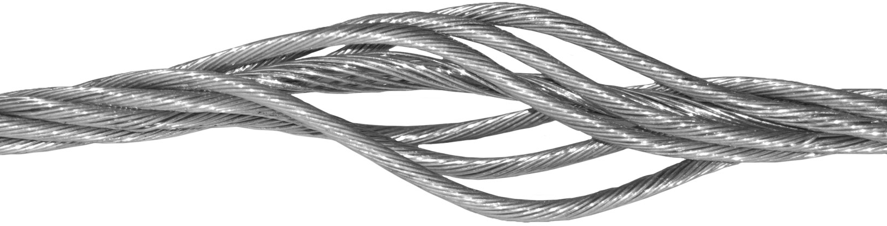
Figure 48 — Bird caging

Kinks are usually caused by faulty handling or reeving. The strands become doglegged and, where running on sheaves, are subject to excessive wear at the kink. If this happens, replace the rope or the affected section of the rope.

Bulging indicates core slippage or “turns” being put into or taken out of the rope. Replace the rope, particularly if it is of rotation-resistant construction.

If the rope has gaps, excessive clearance between strands, or core protrusion, replace the rope.

Heat damage
After a fire or exposure to elevated temperatures, there may be metal discoloration, an apparent loss of internal lubrication, or damage to fibre cores. Under these circumstances, the rope should be replaced.

Electric arc
Rope that has either been in contact with a live power line or been used as ground in an electric welding circuit will have wires that are fused, discoloured, and/or annealed. The rope must be removed from service.

Synthetic web sling inspection
Web slings should be inspected for:
  - worn or distorted fittings
  - cuts
  - holes
  - punches
  - tears
  - frayed material
  - broken stitching
  - burns from acid, caustic chemicals, or heat

If a sling is damaged, remove it from service immediately. Do not attempt to repair a damaged sling yourself.

Chain inspection
Chains should have a frequent link-by-link inspection. Check each link for cracks, bends, twisting, chips, or cuts (Figure 49). It is also important to immediately inspect any chain that has sustained a shock load.
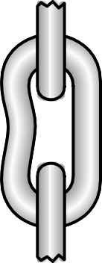
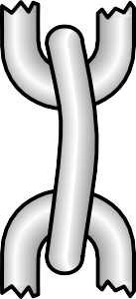
Figure 49 — Damaged links

Chains tend to show signs of wear at the bearing surfaces of each link (Figure 50). Check with the manufacturer for the maximum allowable wear before the chain must be removed from service.
If the manufacturer’s information is not available, then the wear must conform to WorkSafeBC OHS Regulaton Section 15.49.

Figure 50 — Worn link
Read WorkSafeBC, OHS Regulation, Part 15.

Removing slings from service
Inspect the slings carefully and make a decision. If you are not sure the sling is safe, tag it so that another worker will not use it, and then notify your supervisor about your decision. Have your supervisor make the necessary arrangements to have the sling inspected for safety before it is returned to service.

Hook inspection
Hooks, like all rigging hardware, must be inspected frequently. You must be alert for signs of wear, particularly in the saddle and the throat opening. Measure the throat opening to make sure it is not widening, a sign that the hook has been overloaded and weakened. Check for cracks, corrosion, and distortion. Figure 51 shows the areas of a hook that are most subject to wear. If you discover evidence of wear, immediately discard the hook. Destroy the hook before throwing it away to prevent someone else from attempting to use it.
Read OHS Regulation Part 15.29, Hook Rejection Criteria.
Check for wear and deformation

Check for cracks and twisting
Check throat opening for spread and signs of size increase

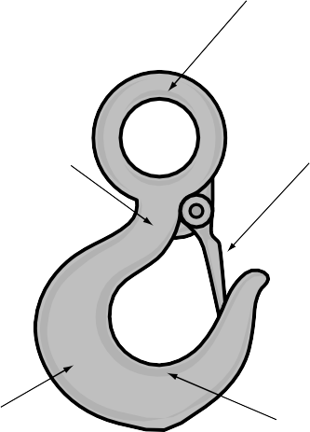
Saddle
Check hook for wear and cracks
Figure 51 — Hook inspection points

Inspection of other rigging hardware
The OHS Regulation requires that every piece of rigging hardware must be tagged with the working load limit (WLL).

Rings, links, and swivels
Inspect rings, links, and swivels regularly for wear, cracks, and abrasion.

Eyebolts and ring bolts
Inspect eyebolts and ring bolts regularly for wear, cracks, and abrasion. The angle that the sling forms with the eyebolt affects the WLL considerably. Always try to keep the pull of the sling
as close to in-line with the shank of the eyebolt as possible. Use a spreader bar if necessary to reduce the angle at the eyebolt.

Turnbuckles
Inspect turnbuckles regularly for wear, cracks, abrasion, and deformation.

Shackles
Inspect shackles regularly for wear, cracks, and abrasion.

Now complete the Learning Task Self-Test.

Self-Test 3
- What does the abbreviation WLL stand for?
  - Wire line load
  - Watch line load
  - Weight load limit
  - Working load limit

- In wire rope terminology, what does “one rope lay” refer to?
  - The number of wires per strand
  - The thickest point of a wire rope
  - The wire direction of winding within the strand
  - The lengthwise distance for one strand revolution

- What is the minimum grade of chain that can be used for overhead hoisting?
  - 70
  - 80
c. 100
d. 120

- What is it that enables both of the threaded rods in a turnbuckle to simultaneously tighten or loosen while turning the sleeve in one direction?
  - There are only threads on one end of the sleeve.
  - The threads are a larger diameter at one end than at the other.
  - The threads are locking at one end and non-locking at the other.
  - The threads are left handed at one end and right handed at the other.

- What type of synthetic web sling has metal triangles of equal size on each end?
  - Basket web sling
  - Choker web sling
  - Endless web sling
  - Twisted eye web sling

- What type of sling is best for loads that are abrasive or hot and require a wide bearing surface?
  - Grade 120 chain sling
  - Lang lay wire rope sling
  - Choker synthetic web sling
  - Triangle end metal mesh sling

- What type of eyebolt is illustrated in the graphic below?
  - Round eyebolt
  - Washerless eyebolt
  - Shoulderless eyebolt
  - Long shanked eyebolt

- What is the maximum pull angle that shoulder eyebolts are able to withstand?
  - 30 degrees to the side
  - 60 degrees to the vertical
  - 45 degrees to the vertical
  - 60 degrees to the horizontal

- When several slings are to be attached to a single hook, what is used to make the connection to the hook?
  - U bolt
  - Shackle
  - Turnbuckle
  - A series of cable clips

- To prevent cross-bow loading, what is the maximum angle between any two slings at a shackle?
  - 15 degrees
  - 30 degrees
  - 45 degrees
  - 60 degrees

- Besides allowing the rigger to quickly connect a choker hitch to a load, what other purpose does the design of a choker hitch serve?
  - It prevents cross-bow loading.
  - It allows the rigger to use a bridle hitch.
  - It allows the rigger to use a basket hitch.
  - It protects the sling from sharp ends at the choker point.

- What part of the loop must the U-bolt part of a cable clip grab onto?
  - Thimble
  - Whipping
  - Live end of the rope
  - Dead end of the rope

- What determines the number of cable clips required for a connection?
  - Type of clip used
  - Mass of the load
  - Strength of the rope
  - Diameter of the rope

- Correctly installed cable clips will reduce the breaking strength of wire rope by how much? a. 10%
b. 20%
c. 30%
d. 40%

- What style of hook is designed so the throat fits between the links of a chain?
  - Slip
  - Grab
  - Sorting
  - Master

- What is a rigging softener?
  - Web sling
  - Synthetic sling conditioning agent
  - Pad used to protect a sling from the sharp corners of a load
  - Pads layered on the ground to place the outriggers of the crane

- When lifting a bundle of pipe horizontally with slings, which hitch is recommended?
  - Bridle hitch
  - Vertical hitch
  - Single choker hitch
  - Double-wrap basket hitch

- What is the recommended safe lifting sling angle (from the horizontal)?
  - 60 degrees
  - 50 degrees
  - 30 degrees
  - 10 degrees

- Choker hitches are a good choice when you need to increase the sling capacity.
  - True
  - False

- What is it called when continuous pounding of a wire rope causes the strands to become flattened, distorted, and brittle?
  - Abraded
  - Peening
  - Scrubbing
  - Bird caging

- What is the term to describe the displacement of wires and strands as a result of wire rope rubbing against itself or another object?
  - Abraded
  - Peening
  - Scrubbing
  - Bird caging

- What can result from sudden stops or the wire rope being pulled through tight sheaves or winding on too small of a drum?
  - Abraded
  - Peening
  - Scrubbing
  - Bird caging

LEARNING TASK 4
Lifting and hoisting communication
Load navigation is accomplished by using either verbal signals given by radio, or hand signals. Whenever the operator of lifting or hoisting equipment is unable to obtain a clear view of the operation, a competent signaller must be stationed with a clear view of both the operation and the operator. That signaller must direct all movements of the load from this vantage point. Only one person should signal to the operator of hoisting or lifting equipment.

You should have general knowledge of some of the varieties of equipment that may require guidance on a job site. A separate book would be required to cover all of the possible styles of hoisting equipment; here we present some of the more common types to familiarize you with some of their characteristics that may affect your methods of communication.

Cranes
There are two main groupings of cranes: tower cranes and mobile cranes. Tower cranes (Figure 1) are not able to move themselves. They are transported to the job site on trailers and erected by qualified personnel. They are typically for jobs where the crane can remain in one position for long periods. For example, you will commonly see them on high-rise construction sites.
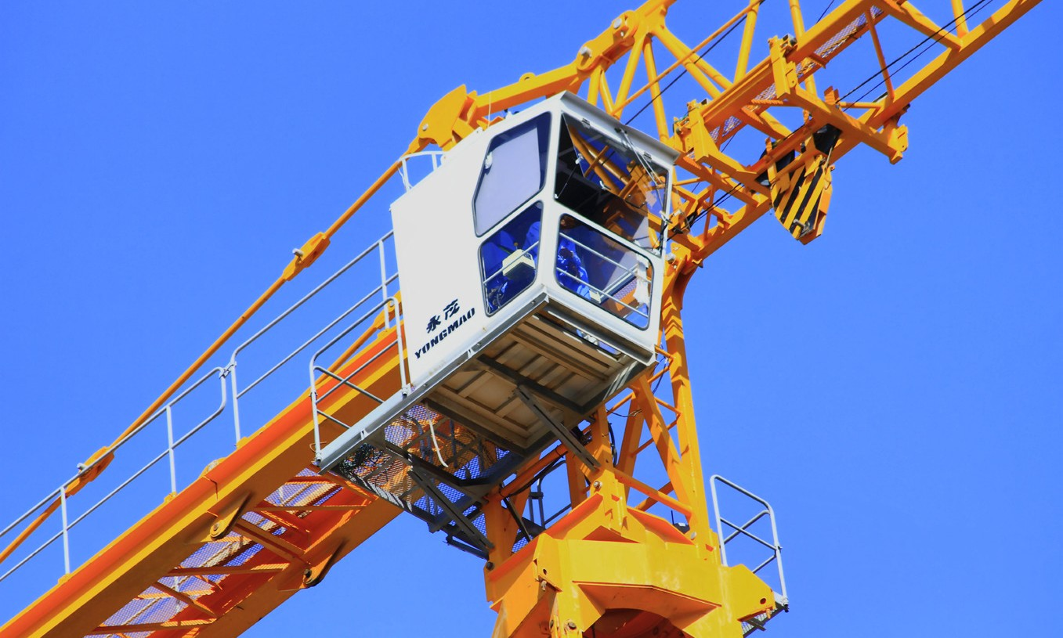
Figure 1 — Tower crane operator’s cabin

Mobile cranes can be driven to or within a job site under their own propulsion. There are many sizes and types of mobile cranes. These cranes are usually identified by the construction of their boom and the type of carrier. There are two main boom types: lattice booms (sometimes referred to as conventional cranes) (Figure 2), and hydraulic booms (Figure 3). The common carrier types are rough terrain cranes, truck cranes, and crawler cranes.

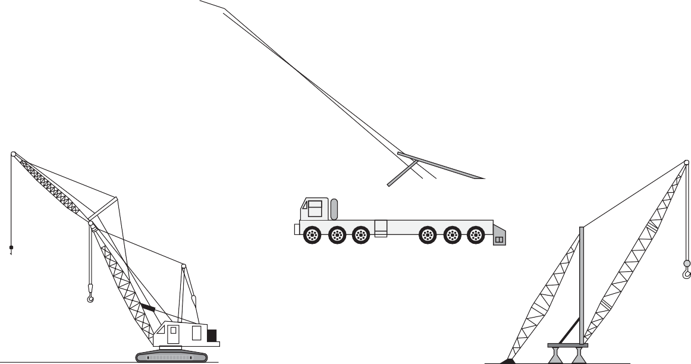
Carrier-mounted lattice boom crane

Crawler-mounted lattice boom crane

Figure 2 — Lattice boom cranes
Stiff leg derrick

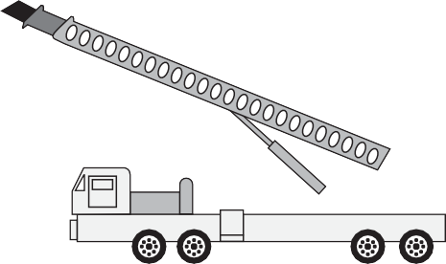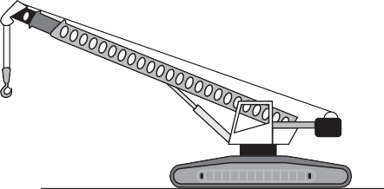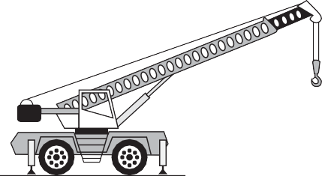
Rough terrain crane
Crawler-mounted hydraulic boom crane
Carrier-mounted hydraulic boom crane
Figure 3 — Types of hydraulic cranes
When working with large cranes moving objects near power lines, use a power line spotter to avoid moving the crane or the load within the safety zone.
Electric shock can kill!

Load control
The crane may require additional physical control of the load to guide it. Always use tag lines to help control the load. Tag lines permit you to control the load from a safe distance (Figure 4). Should the load shift or drop, you will be out of danger. Tag lines must be attached before the load is lifted.
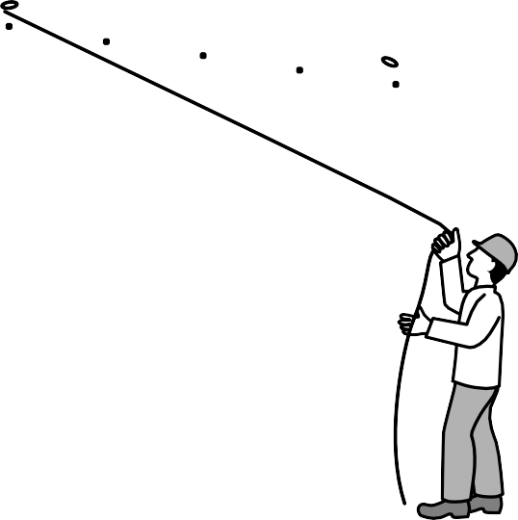
Figure 4 — Using a tag line

Hand signals for cranes
The movement of cranes and loads supported by cranes is controlled by the following internationally recognized hand signals. There are some crane signals that are specifically meant for particular types of cranes, depending on their method of movement and boom configuration.
The signals can also be found in Section 15.20 of the WorkSafeBC Regulations.

To signal“UP” or“HOIST”
With your forearm vertical and your forefinger pointing up, move your hand in small horizontal circles (Figure 5).
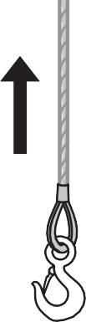
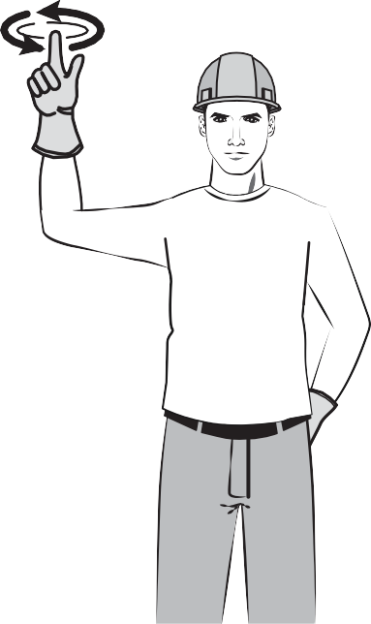
Figure 5 — Raise load or hoist up

To signal“LOWER”
With your forearm extended downward and your forefinger pointing down, move your hand in small horizontal circles (Figure 6).
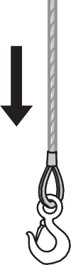
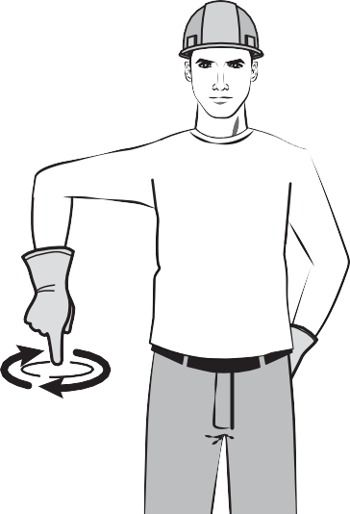
Figure 6 — Lower load or hoist down

To signal“STOP”
If both your hands are free, extend both arms horizontally with your fingers outstretched (Figure 7A). If only one hand is free, signal “STOP” by facing the palm of your hand toward the operator with your fingers outstretched and waving your hand from side to side (Figure 7B).
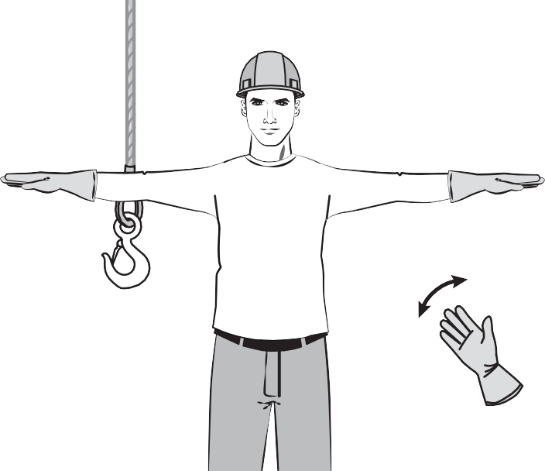
A
B
Figure 7 — Stop

To signal“MOVE SLOWLY”
Whenever slow movement is required, hold the palm of your free hand motionless above your other hand as it is giving any motion signal. Figure 8 shows the signal for “HOIST SLOWLY.”
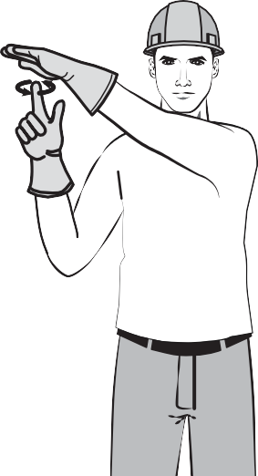
Figure 8 — Hoist slowly

To signal“DOG EVERYTHING”
The “DOG EVERYTHING” signal (Figure 9) is given by clasping your hands in front of your body. The crane operator locks all crane functions at this signal.
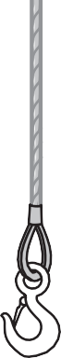
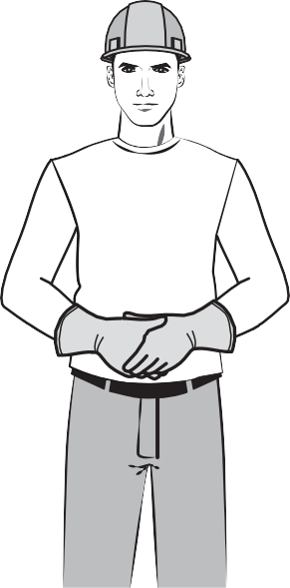
Figure 9 — Dog everything

Lifting line selection signals
Cranes are sometimes equipped with a jib to extend the crane’s reach (Figure 10). From this jib, a whip line or auxiliary hoist is attached while the main line is suspended from the boom.

Whip Line Headache Ball
Jib Tip Sheave

Jib Forestay
Jib Gantry
Jib
Jib Backstay

Boom Pendant
Main Hoist Line
Main Block
Boom

Hoist Reeving

Counterweight

Figure 10 — Crane equipped with jib

The following signals indicate to the crane operator which line to use:
- To signal the operator to use the main line, tap your fist to your head (Figure 11A). Then use regular signals to direct further movement.
- To signal the operator to use the whip line, tap your elbow with one hand or point to your shoulder (Figure 11B and C). Then use regular signals to direct further motion.
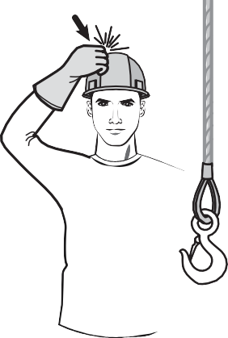
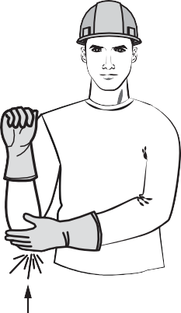
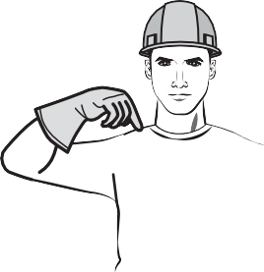
    - Use main line B. Use whip line C. Alternate use whip line
Figure 11 — Lifting line selection signals

Boom motion signals
To signal raising or lowering the boom, extend your arm with fingers closed. Use your thumb to indicate whether you want the boom raised or lowered (Figure 12). Note that the load will move laterally, not just up or down.
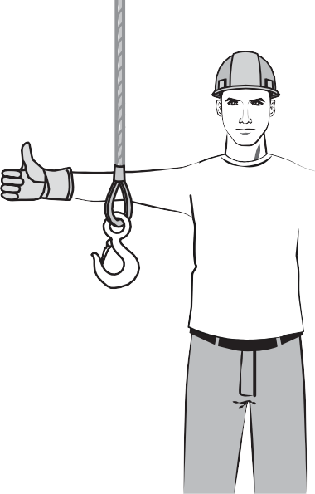
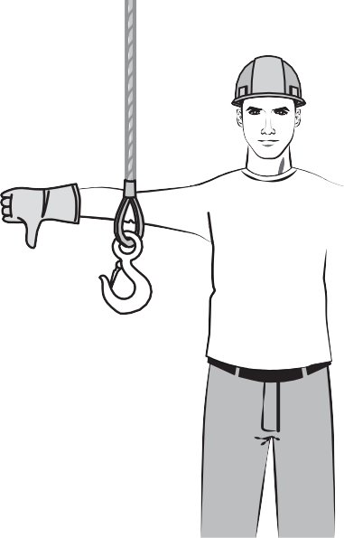
Figure 12 — Raise boom and lower boom

These signals may be done with only one hand when required.
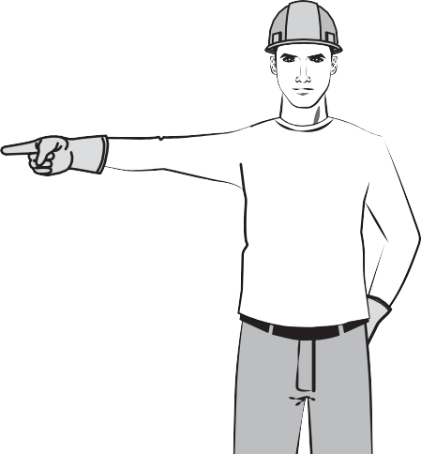
To signal the crane operator to swing the boom, extend one arm and point with the index finger to indicate the direction of the swing (Figure 13).

Figure 13 — Swing boom

Dual motions can be used to signal to the crane operator. Signalling the operator to lower the boom while raising the load at the same time will cause the load to move away from the crane. Raising the boom while lowering the load moves the load closer to the crane. You can do this with one or both hands. When you are using only one hand, your thumb indicates the direction of the boom, and flexing your fingers indicates the movement of the hook (Figure 14).
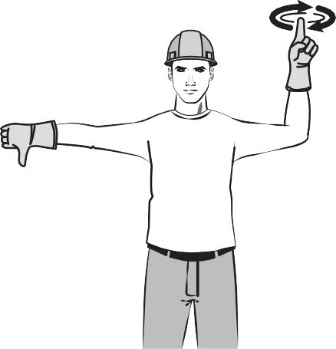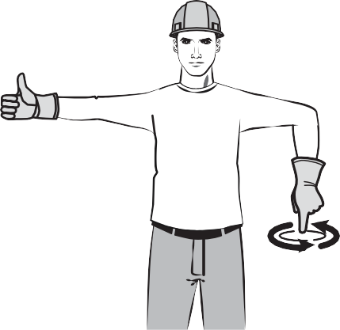
A.
A.
    - B.
Figure 14 — Left: Lower the boom and raise the load. Right: Raise the boom and lower the load.

Cranes that are equipped with an extendible boom (Figure 15) can be signalled to lengthen or shorten the boom.
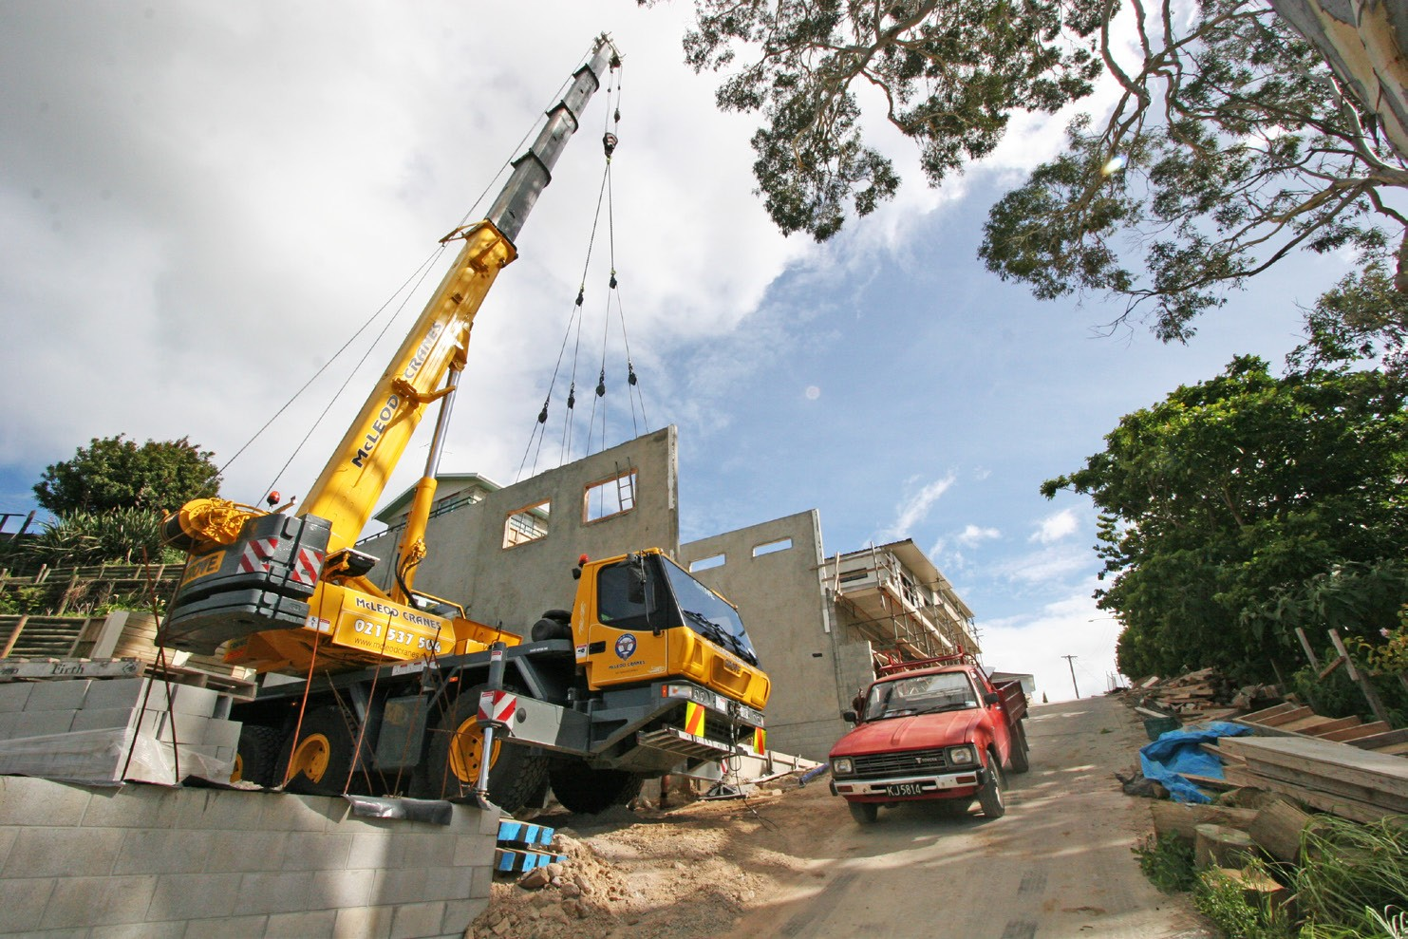
Figure 15 — Hydraulic boom truck crane

To signal “ADJUST THE BOOM LENGTH,” hold your fists in front of your body and point in or out with your thumbs (Figure 16).
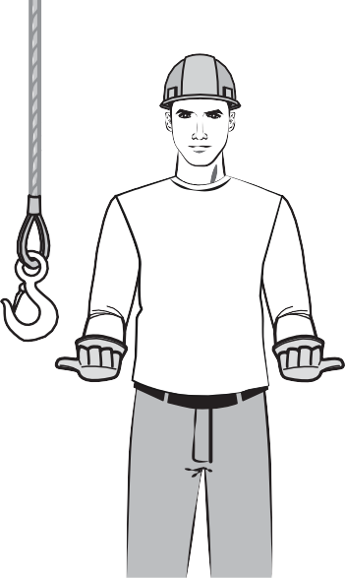
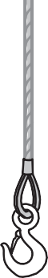
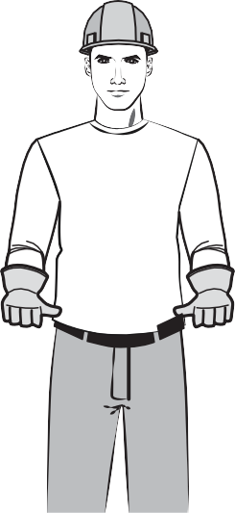
Figure 16 — Extend boom and retract boom

Crane movement signals
Some cranes are designed to change their position with a load, depending on the weight of the load and the position of the boom (Figure 17).
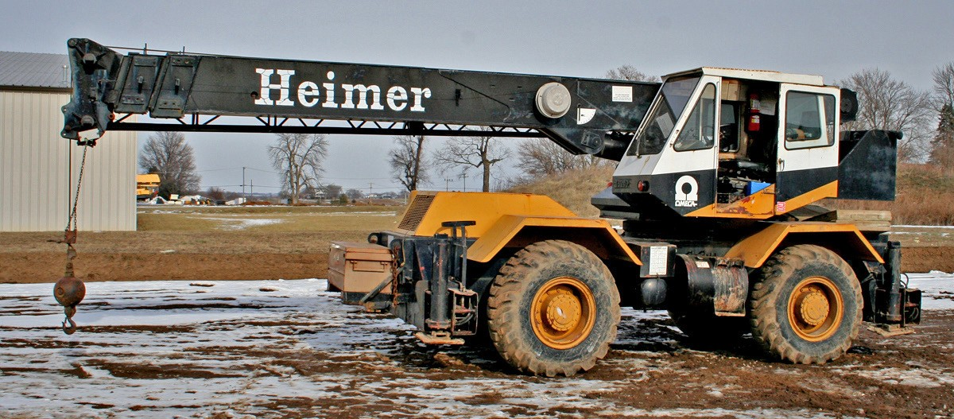
Figure 17 — Rough terrain crane with telescoping boom

To signal “TRAVEL,” extend your arm forward with hand open and slightly raised. Make a pushing motion in the direction of travel (Figure 18).
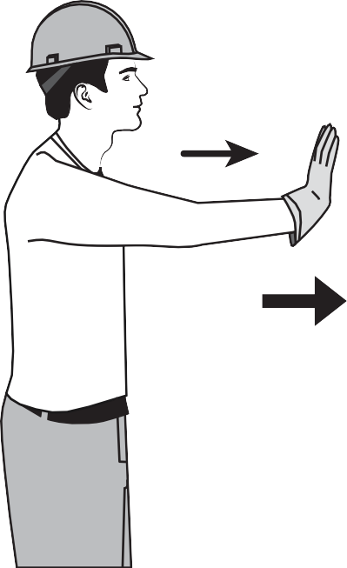
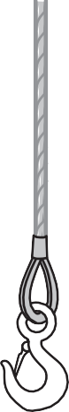
Figure 18 — Crane travel

If the crane is mounted on a crawler-style carrier (Figure 19), use the following signals for travelling.

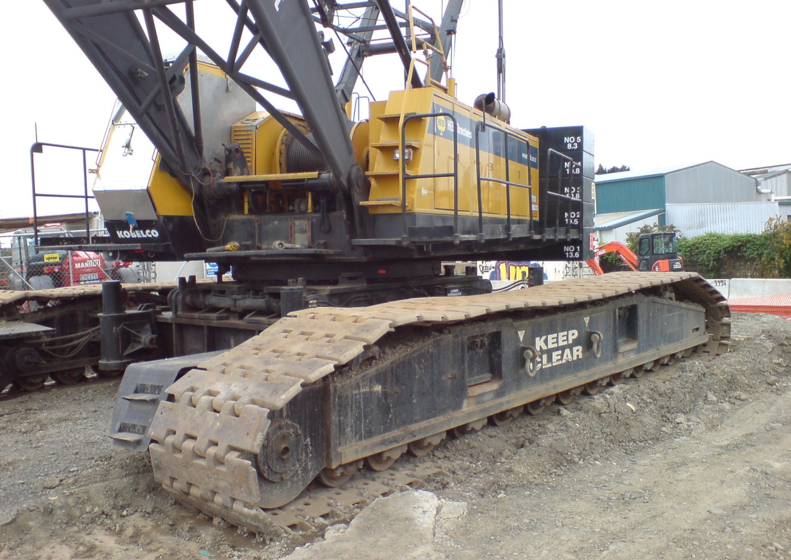
Figure 19 — Crawler crane

To signal “TRAVEL BOTH TRACKS AT EQUAL SPEED GIVING THE CRANE A STRAIGHT PATH,” place
both fists in front of your body. Make a circular motion with each fist, with both hands travelling in the same direction—the motion should resemble the pedalling of a bicycle. The direction of travel is indicated by the direction of your hand motion, either toward you or away from you (Figure 20).
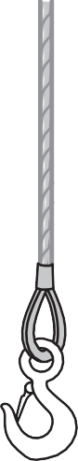
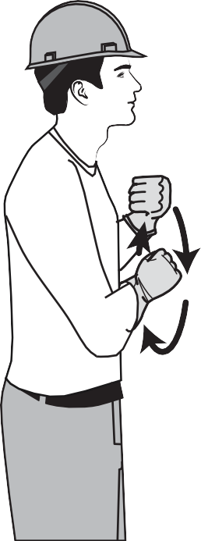
Figure 20 — Crawler travel, both tracks

To have the operator make a turn while travelling by rotating only one track (Figure 21), signal to lock the track on one side by raising the fist on that side. Indicate the direction of travel for the opposite track by making a circular motion with your other fist rotating vertically in front of your body.
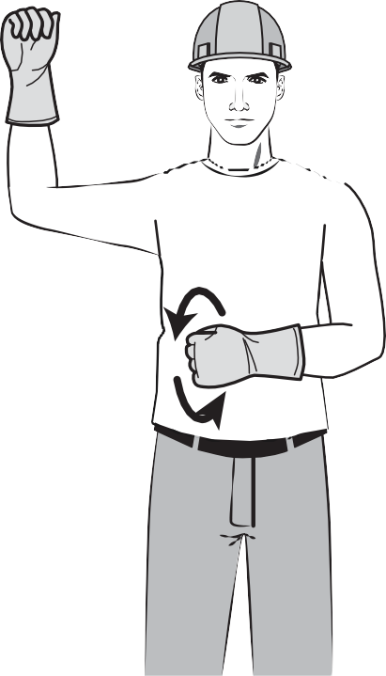
Figure 21 — Travel one track
Practise these hand signals until they become automatic to you. They are used by all trades that are involved with lifting or hoisting operations, and they are often used by workers to communicate with the crane signaller.

Vertical hoists
Construction material hoists are used on larger construction projects where the amount of material to be moved warrants the installation of the hoist. No worker may ride a material hoist.

Prior to the first lift of material, a registered professional engineer must inspect material hoists. Hoists must then be inspected weekly unless the manufacturer specifies more frequent
inspections. Light-duty hoists and shingle hoists for roofing are not required to be inspected as long as they are set up to the manufacturer’s specifications.

Sound and/or light signals for hoists
When the lifting apparatus is a hoist capable of moving only up or down and not sideways, the only signals used are “STOP,”“RAISE,”“LOWER,” and “ALL CLEAR.”
Hoists that can only move up or down (not sideways) generally have safety gates on them. When open, the safety gates prevent the hoists from being operated. Nevertheless, a hoist operator must not operate the hoist until the “ALL CLEAR” signal has been given.
The “ALL CLEAR” signal indicates that the workers using the hoist are finished with it, and that the hoist operator can again operate it safely.

Since the operator of such a hoist may not always be able to see the signaller, a system of sound signals or light signals has been devised. The sound signals are short bursts from a horn or rings of a bell, and the light signals are short flashes from a light source. Both use the same code:

- “STOP”: one bell or flash
- “RAISE”: two bells or flashes
- “LOWER”: three bells or flashes
- “ALL CLEAR”: four bells or flashes
During adverse conditions, light and sound signals may be used simultaneously.

An easy way to remember different sound or light signals is to consider the urgency of each. There is no urgency attached to the signal “ALL CLEAR,” so it is the longest: four bells. “STOP” could be an emergency, so it is the shortest: one bell. “RAISE” could have more urgency than “LOWER,” so it requires two bells, and “LOWER” is left with the signal of three bells.

Radio communication and video systems
Two-way radio or other audio or video systems must be used if distance, atmospheric conditions, or other circumstances make the use of hand signals hazardous or impracticable. Any audio and video communication systems used in a hoisting operation must be designed, installed, operated, and maintained according to a standard acceptable to WorkSafeBC.

Now complete the Learning Task Self-Test.

Self-Test 4
- Match the figures above to the signals listed below.
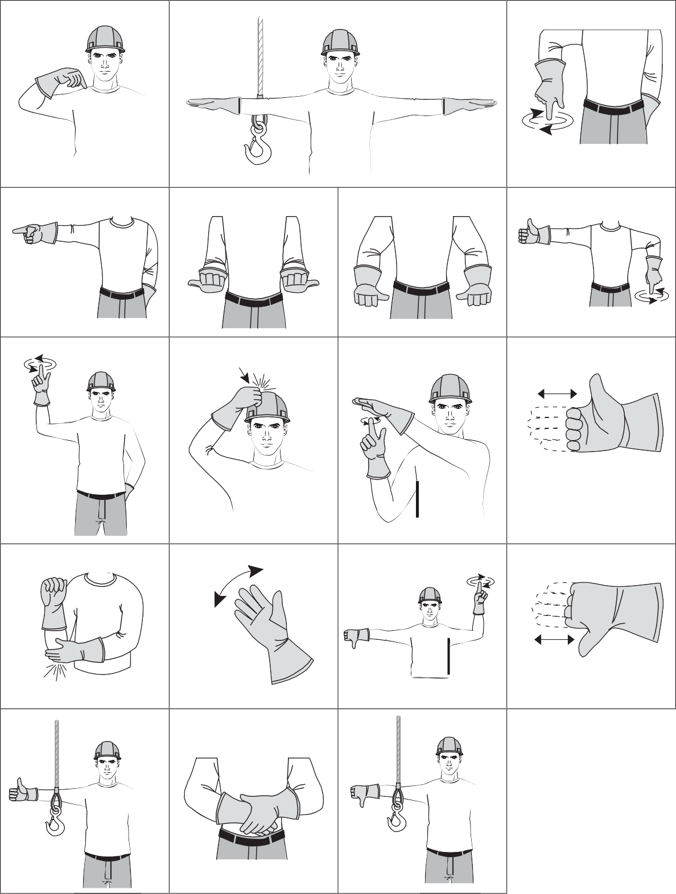
1 2 3

4 5 6 7

8 9 10 11
.

12 13 14 15

16 17 18

  - “USE THE MAIN LINE”
  - “STOP” (two hands)
  - “RETRACT BOOM”
  - “LOWER THE LOAD”
  - “HOIST SLOWLY”
  - “LOWER THE BOOM AND RAISE THE LOAD” (two hands)
  - “EXTEND THE BOOM”
  - “USE WHIP LINE” (two hands)
  - “SWING THE BOOM”
  - “RAISE THE BOOM AND LOWER THE LOAD” (two hands)
  - “HOIST”
  - “LOWER THE BOOM”
  - “DOG EVERYTHING”
  - “STOP” (one hand)
  - “LOWER THE BOOM AND RAISE THE LOAD” (one hand)
  - “RAISE THE BOOM”
  - “USE WHIP LINE” (one hand)
  - “RAISE THE BOOM AND LOWER THE LOAD” (one hand)

- What group of cranes are immobile and commonly used on high-rise construction sites?
  - Tower cranes
  - Conventional cranes
  - Hydraulic cranes
  - Rough terrain cranes

- Identify the crane shown below.
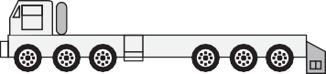

  - Rough terrain crane
  - Carrier-mounted lattice boom crane
  - Crawler-mounted lattice boom crane
  - Carrier-mounted hydraulic boom crane

- Identify the crane shown below.
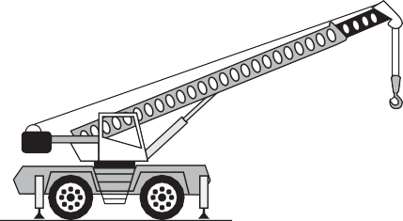

  - Rough terrain crane
  - Carrier-mounted lattice boom crane
  - Crawler-mounted lattice boom crane
  - Carrier-mounted hydraulic boom crane

- 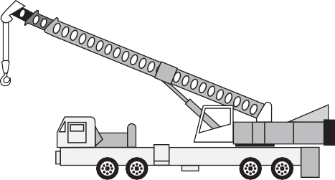Identify the crane shown below.

  - Rough terrain crane
  - Carrier-mounted lattice boom crane
  - Crawler-mounted lattice boom crane
  - Carrier-mounted hydraulic boom crane

- The travel signal shown below is used for what type of crane?
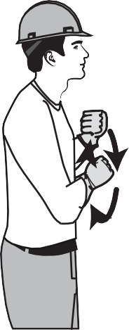

  - Tower crane
  - Carrier crane
  - Crawler crane
  - Rough terrain crane

- The sound or light signal for "LOWER" is
  - One bell or flash
  - Two bells or flashes
  - Three bells or flashes
  - Four bells or flashes

- The sound or light signal for "STOP" is
  - One bell or flash
  - Two bells or flashes
  - Three bells or flashes
  - Four bells or flashes

- The sound or light signal for "ALL CLEAR" is
  - One bell or flash
  - Two bells or flashes
  - Three bells or flashes
  - Four bells or flashes

- The sound or light signal for "RAISE" is
  - One bell or flash
  - Two bells or flashes
  - Three bells or flashes
  - Four bells or flashes

- Tag lines should be used to control loads because they allow control from where?
  - Above the load
  - Within the crane
  - Directly under the load
  - Out from under the load

LEARNING TASK 5
Describe knots, bends, and hitches
Very few people can make it through life without ever using ropes or tying knots. A task as simple as tying a load on the back of a truck becomes almost impossible unless you have some knowledge of ropes and knots. To effectively use ropes in a work setting requires you to become familiar with several types of ropes, knots, bends, and hitches.

Natural and synthetic ropes
Fibre rope may be made from either natural or synthetic fibres. Natural fibres include manila and sisal. Synthetic fibres include nylon, polypropylene, and polyester. Each of these fibres has unique properties. Fibre ropes are not the same as fibre slings. Fibre slings are designed and commercially fabricated for lifting purposes and have their safe working load indicated on a tag sewn to the sling.

Stranding
The individual fibres in ropes, whether natural or synthetic, are relatively weak. It is only when many hundreds of these fibres are woven or twisted into strands that fibre ropes become strong. The twists of the strands in a twisted or braided rope also serve to keep a rope together and enable the rope to more evenly distribute tension among the individual strands. Without any twist, the shortest strands would always be supporting a much higher proportion of the total load.

Braided ropes
Braided ropes are generally made from synthetic materials. A braided rope has no inherent twist to it, which makes it easy to handle. This type of rope consists of several strands of braided yarns, one inside the other.

Twisted rope
The traditional fibre rope consists of three strands twisted into a rope. The strands twist in a clockwise direction. Each strand is made up of many smaller strands called yarns, and in turn each yarn is made up of even smaller strands called fibres. The yarns within the strands are twisted in a counter-clockwise direction, and the fibres within the yarns are twisted in a
clockwise direction. By countering the twist in each layer, the overall rope will remain relatively stable when under a load.

A twisted synthetic rope is preferred for lifelines because it will stretch somewhat to cushion the fall of a worker.

Natural fibre ropes
Some examples of natural fibres used for rope are manila, hemp, linen, cotton, coir, jute, straw, and sisal (Figure 1). Here we cover only the two most common: manila and sisal.
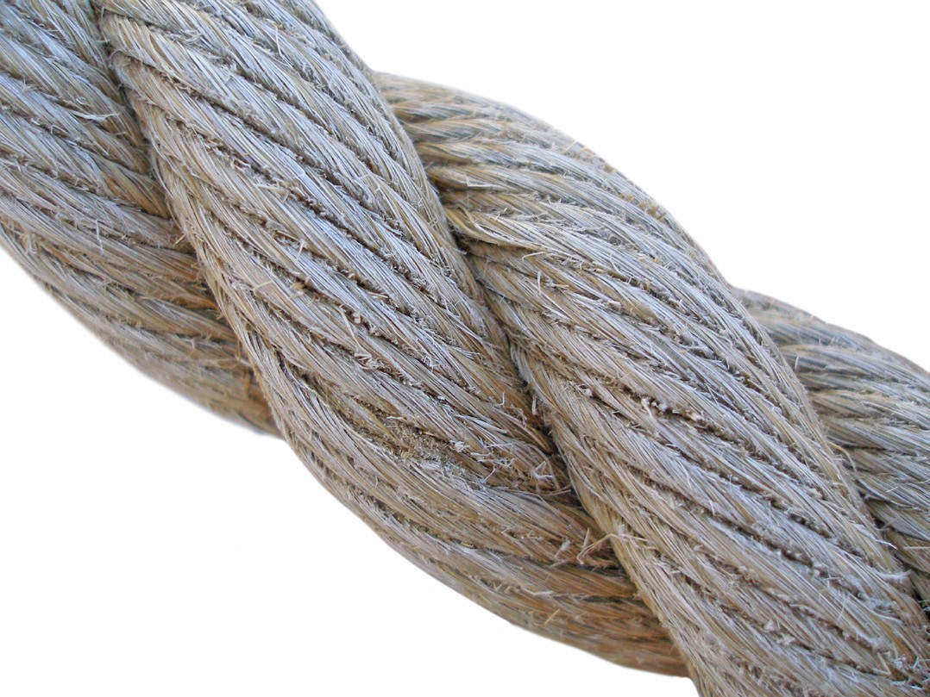
Figure 1 — Three-strand twisted natural fibre rope

Manila
Manila rope is available in six grades (Figure 2) and is not as strong as nylon rope. As the grade and strength decrease, the colour darkens.

GRADES OF MANILA ROPE
Grade | Description
Yacht rope | Considered the highest quality manila rope, yacht rope is a very pale yellow colour. It is expensive and because of this it is used only on special jobs.
Bolt rope | This is a high-grade, pale yellow rope. In strength it falls between yacht rope and No. 1 grade.
No. 1 grade | Usually containing one or more coloured strands as identification, No. 1 grade is light yellow and is the lowest grade suitable for overhead lifting.
No. 2 grade | This type is slightly darker than No. 1 rope and does not have coloured identity strands. It loses strength more rapidly than No. 1 grade.
No. 3 grade | Considerably darker than either No. 1 or No. 2 grade, No. 3 loses strength very rapidly when in service.
Hardware store rope | This is the darkest and poorest grade of manila rope. Since it is constructed with a high percentage of short fibres, it has little strength, a short life, and a much rougher texture with many fibre ends sticking up from the surface.
Figure 2 — Grades of manila rope

Sisal
Sisal rope is white, coarse-textured, and rough to the touch. Traditionally sisal was the leading material for agricultural twine (binder twine and baler twine). Sisal rope is weaker than manila and should be used only where cost rather than strength is the major factor.
Natural fibre rope must not be used for hoisting with a powered hoist.

Synthetic fibre ropes
Synthetic fibre ropes (Figure 3) are significantly stronger and more durable than natural fibre ropes.
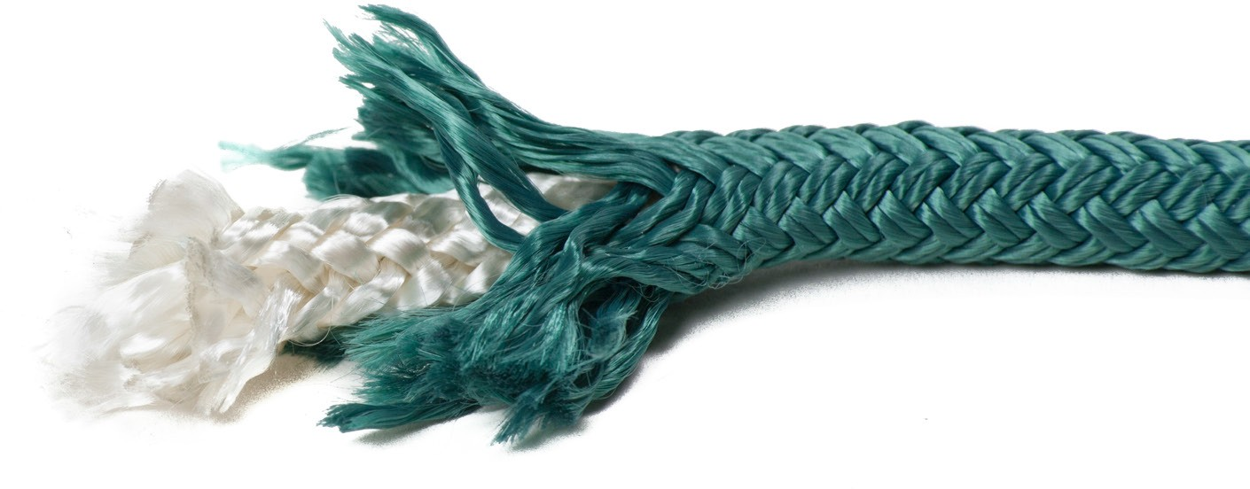
Figure 3 — Twisted nylon rope with braided sheath

Nylon
Nylon is approximately 2 1/2 times stronger than manila. Nylon rope is usually pure white, soft, pliable, and smooth to the touch. It has an elastic quality and will stretch up to 40% of its length.

Nylon rope loses about 10% of its strength when wet, but regains its original strength when dried. Nylon does not rot, is unaffected by mildew, and can withstand temperatures up to 150°C (300°F) without being damaged. Acids and alkalis adversely affect nylon rope.

The highly elastic nature of nylon rope makes it capable of withstanding repeated shock loads. However, this same elasticity can be a hindrance if you are trying to lift loads in areas with restricted headroom.

Polyester
Polyester rope is similar to nylon in appearance but is not as elastic. It will only stretch 5% before breaking.

Polyester rope is 87% as strong as nylon. Polyester is not as elastic as nylon and is capable of sustaining only 60% of nylon’s shock load.

Polyester does not lose any strength when wet and, unlike nylon, is unaffected by acids or alkalis. For your own protection, however, you should wash polyester ropes and slings with cold water whenever they have been exposed to any chemicals.

Polypropylene
Polypropylene rope is available in a wide range of colours, but yellow is the most common. It is smooth and somewhat slippery. It is also lightweight and floats on water.

Polypropylene gradually softens as temperatures increase and loses 40% of its strength at the temperature of boiling water (100°C or 212°F). Higher temperatures will eventually cause polypropylene to melt. This rope also deteriorates rapidly when exposed to sunlight.

Polypropylene rope is 60% as strong as nylon and is capable of absorbing only 40% of the shock load of nylon. Of all the rope types mentioned, polypropylene has the best insulating properties against electrical shock. It should be noted that only dry ropes should be used near sources of high voltage.

Working load limits
As you have learned, the working load limit (WLL) is the maximum load that a rigging component may carry and still meet the safety design factors set by WorkSafeBC. The WLL must be marked on rigging components or sufficient information must be given to determine the WLL. In the case of rope, for example, if the manufacturer supplied the breaking strength, the WLL can be determined by dividing the breaking strength by the minimum design factor listed in Part 15 of the OHS Regulation.

The minimum safety factor for rigging used to support workers is 10. For lifting materials the safety factor varies depending on the rigging component. For example, lifting materials with a sling made of nylon fibre rope requires a safety factor of 5 while for an alloy chain the factor is only 4.

Breaking strength
The breaking strength of rope is measured in newtons or pounds and is the minimum force necessary to break the rope.

The strengths of different ropes depends on the fibre used, the diameter of the rope, and the type of stranding used. For equal diameter and stranding, the strongest of the commonly used fibre rope is made with nylon. Polyester and polypropylene are not as strong as nylon, but other factors may make them a better choice.

For the actual breaking strength of a specific rope, it is best to consult the manufacturer of the rope.

Use of ropes
Fibre ropes are very useful in construction. Fibre ropes are easy to handle, and because they come in very long lengths they can readily be adapted to many custom situations. Some important points to remember when using ropes include:
- Always use the correct knot, bend, or hitch when connecting ropes together or to material to be lifted. If the incorrect knot is tied it may slip, causing the load to fall, or it may jam and leave the rope permanently damaged. Remember, tying a knot in a rope reduces its strength by 50%.
- New fibre bulk ropes come packaged in a plastic wrapper. To remove new rope from its shipping coil, place the coil on its side, reach down inside, and pull the rope up from inside the coil. Leave the outer wrapping intact.
- Ropes should not be overloaded. Ropes that have been subjected to loads beyond their working load limit should be taken out of service. For lifting materials, the maximum load should never exceed one-ninth of the rope’s breaking strength.
- Avoid exposing rope to direct sunlight for long periods of time. Excessive exposure causes fibres to break down.
- Do not use frozen rope. If you must handle rope that is frozen, do so very carefully, as any bending may break the strands. To prevent rope from freezing, dry it well before exposing it to cold weather.
- Avoid making sharp bends in rope. Sharp bends, including those made by knots, will reduce the rope’s strength by 50%. Always pad the sharp corners of a load before applying the rope.
- When attaching a small-diameter object such as a hook or ring to a rope, use a thimble to protect the eye of the rope (Figure 4).

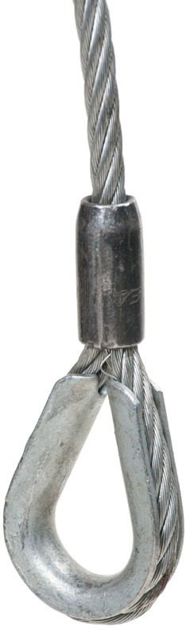Thimble

Figure 4 — A thimble protects the eye

Care and maintenance of rope
The life of any type of fibre rope can be greatly extended if you follow the basic care and maintenance procedures listed below.

Whipping
Whipping is a wrapping applied at the end of a rope to prevent the rope strands from unravelling. Whenever a rope is cut to a new length, the ends of the rope should have whipping applied before the rope is put into service.

Whipping is more than just a tidy decoration. It prevents the strands of the rope from slipping in relation to each other. Such slipping would cause one strand to carry more (or less) than its fair share of the load.

To apply whipping to a rope, use a strong, non-slipping twine. If the twine tends to slip, pulling it over soft tar, beeswax, or pine pitch will usually correct the problem. Tape may be used as whipping if applied tightly. Whipping should be replaced when it shows signs of fraying or loosening.

How to apply whipping
- Begin by holding one end of the twine (A in Figure 5) at the end of the rope. Then form a long loop along the rope.

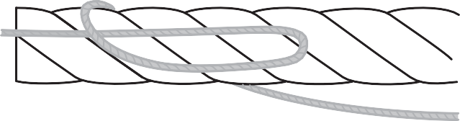
B
A

Figure 5 — Loop the twine

- Hold the end of the twine (A) and the left end of the loop with your left hand and begin wrapping the other end of the twine (B) around the rope over the long loop.
- Continue to apply wraps as close to each other and as tight as possible until you have covered a distance approximately 1 1/2 times the rope diameter.
- Take the twine end (B) and pass it through the loop as shown in Figure 6.

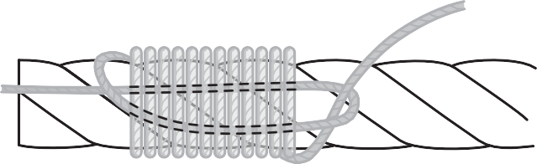A
B

Figure 6 — Pass the end through

- Pull on the twine end (A) until you feel the crossover point of the twines are approximately midway under the whipping (Figure 7).

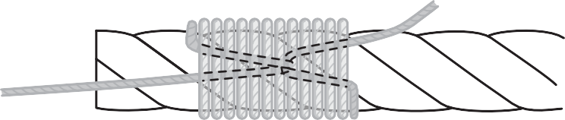A
B

Figure 7 — Pull the crossover point to the centre

- Trim the end of the twine as close as possible to the whipping; then trim the end of the rope so that a portion approximately half the rope’s diameter projects beyond the whipping (Figure 8).
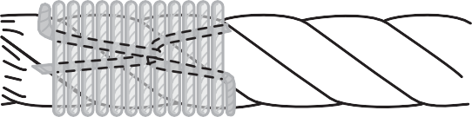
Figure 8 — Trim the ends

Instead of using whipping on nylon, polyester, or polypropylene ropes, you can melt the fibres together with a hot iron or flame. Roll the end of the melted rope between two flat surfaces (scraps of wood) while the rope cools or you may have the end larger than the diameter of the rope. When the ends of the rope are larger than the rope diameter, they become difficult to untie.
When you are using the hot iron or flame to melt the rope fibres, be careful to avoid burning yourself.

Storage
Rope should be kept clean. Soil embedded in the fibres acts as an abrasive, wearing it down. Soiled rope should be washed in cool water, loosely coiled, and hung in a well-ventilated area to dry before storing. Apart from this cleaning, rope requires very little maintenance.

Be sure to coil rope when you are preparing it for storage. The coiled rope should then be hung on large-diameter pegs in a cool, dry room with good air circulation to prevent mildew. Improper storage of fibre rope leads to rot, brittleness, crushed fibres, kinks, and many other defects. Any kinks or small loops should be carefully removed before a rope is pulled taut.

With basic care and proper storage, natural fibre rope will provide many years of service. If left lying on the ground in a damp environment, the rope will become useless in a very short time.

A thorough visual inspection should be done before performing any lifting tasks. When inspecting fibre ropes you should look for:
  - broken strands
  - wear and abrasion
  - heat damage, such as melting
  - contamination with petroleum products that can damage the rope
  - evidence of rot or damage from being exposed to the elements
  - crushing, twisting, or kinking
  - loose, broken, or damaged thimbles
Any damage will affect the lifting capacity of the rope.

Tying knots, bends, and hitches
The word knot can be used to describe any loop or entanglement of flexible material, created either intentionally or accidentally. In professional terms, the words knot, bend, and hitch have meanings based on their form and function:
  - A knot secures two ends of the same rope, like a parcel string or shoelace. Irrespective of form or function, the tying of all very small material (e.g., fishing line) can be called tying knots.
  - A bend is a knot that joins two separate ropes together.
  - A hitch attaches a rope to an object like a rail, post, or ring.
To make effective use of any rope, you must first be able to select the correct knot, bend, or hitch for a given situation and then be able to tie it. Any knot, bend, or hitch must support the load imposed on it, be quick and easy to tie, and be easy to untie once the load has been removed.

Ropework terms
To better understand the following instructions on knot tying, you will need to identify the parts of a rope.

A loop is the starting point for most knots. The portion of the rope that forms the loop is termed the bight. The long portion of the rope is termed the standing part. The end of the rope is called just that, the end.

The overhand loop in Figure 9 is formed by passing the end of the rope over or in front of the standing part of the rope.
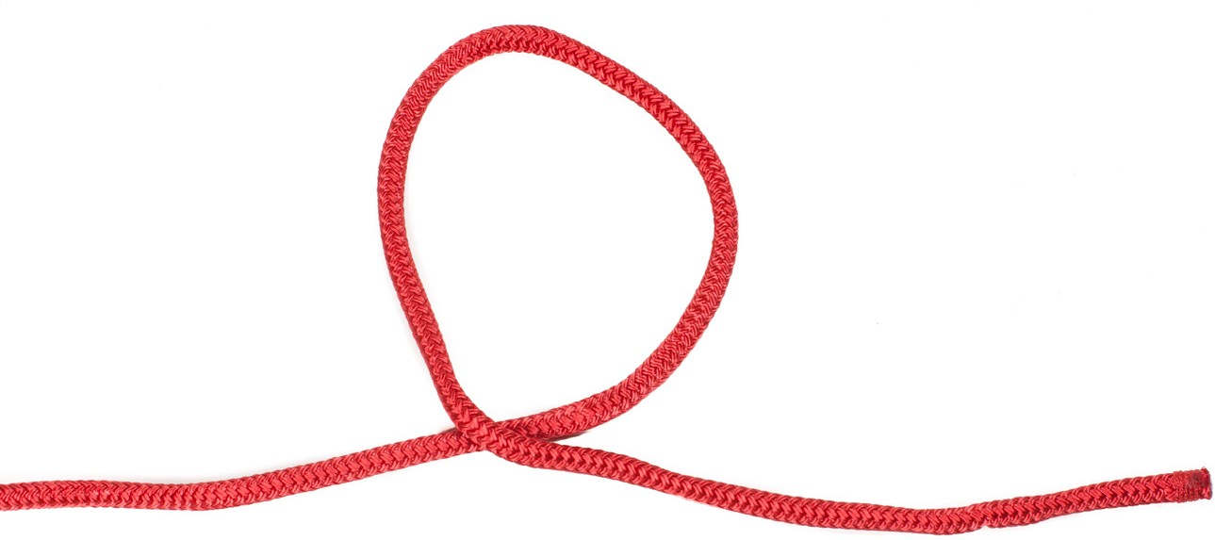
Figure 9 — Overhand loop

An underhand loop, shown in Figure 10 is formed by passing the end of the rope under or behind the standing part of the rope.
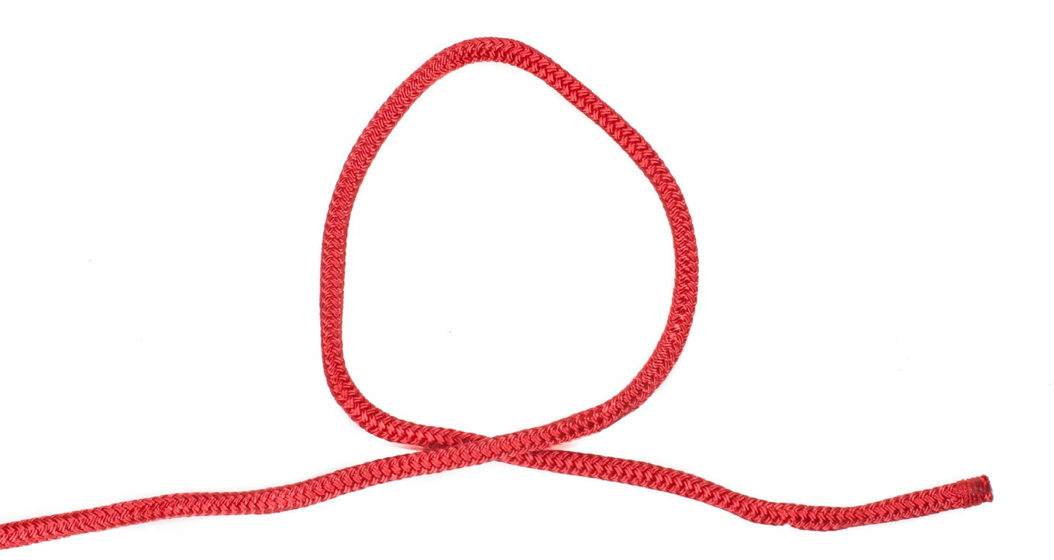
Figure 10 — Underhand loop

Bowline
The bowline knot (Figure 11) forms a non-slip loop at the end of a rope.

Start to tie a bowline by forming a small overhand loop, by passing the end of the rope over the standing part.
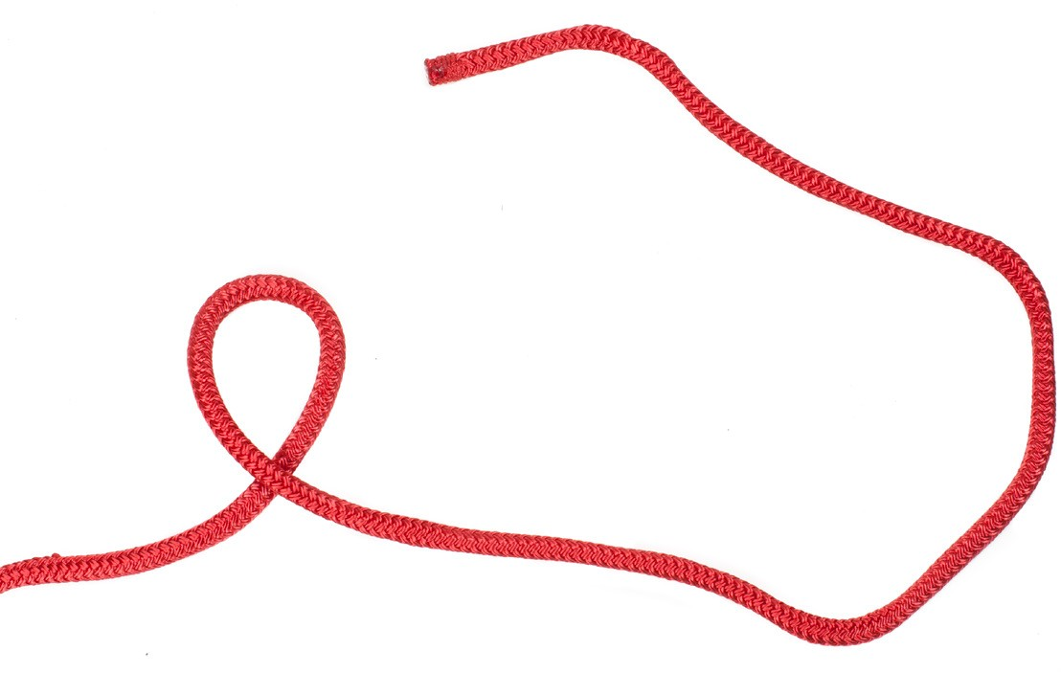
Step 1: Pass the end under the bight and pull it up through the loop.
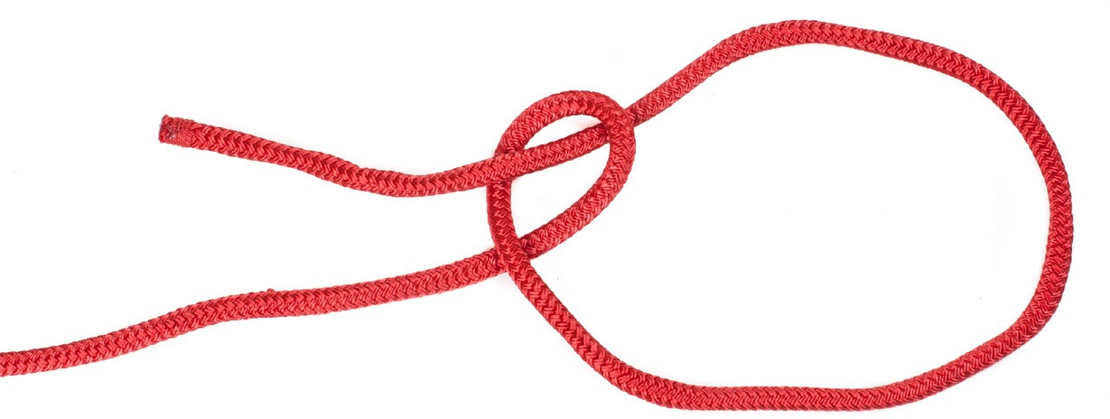
Step 2: Pass the end behind the standing part.
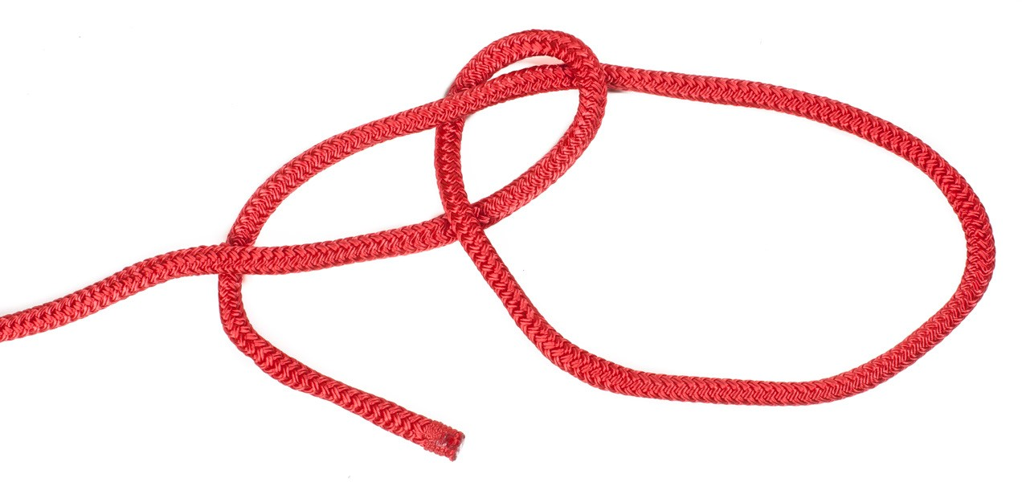
Step 3: Insert the end back down through the loop.

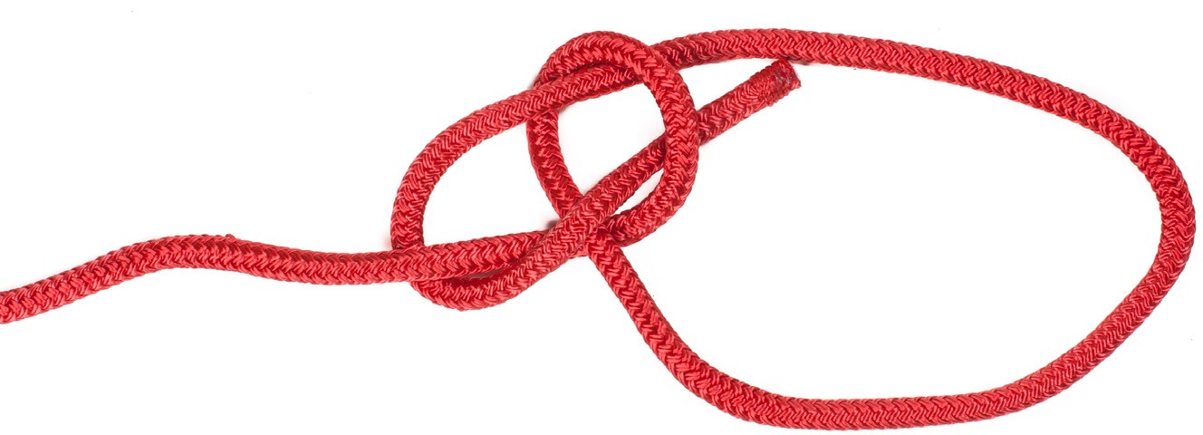

Step 4: Tighten the knot by holding the end of the rope and the loop in one hand and the standing part in the other hand, then pull until the knot is tight.
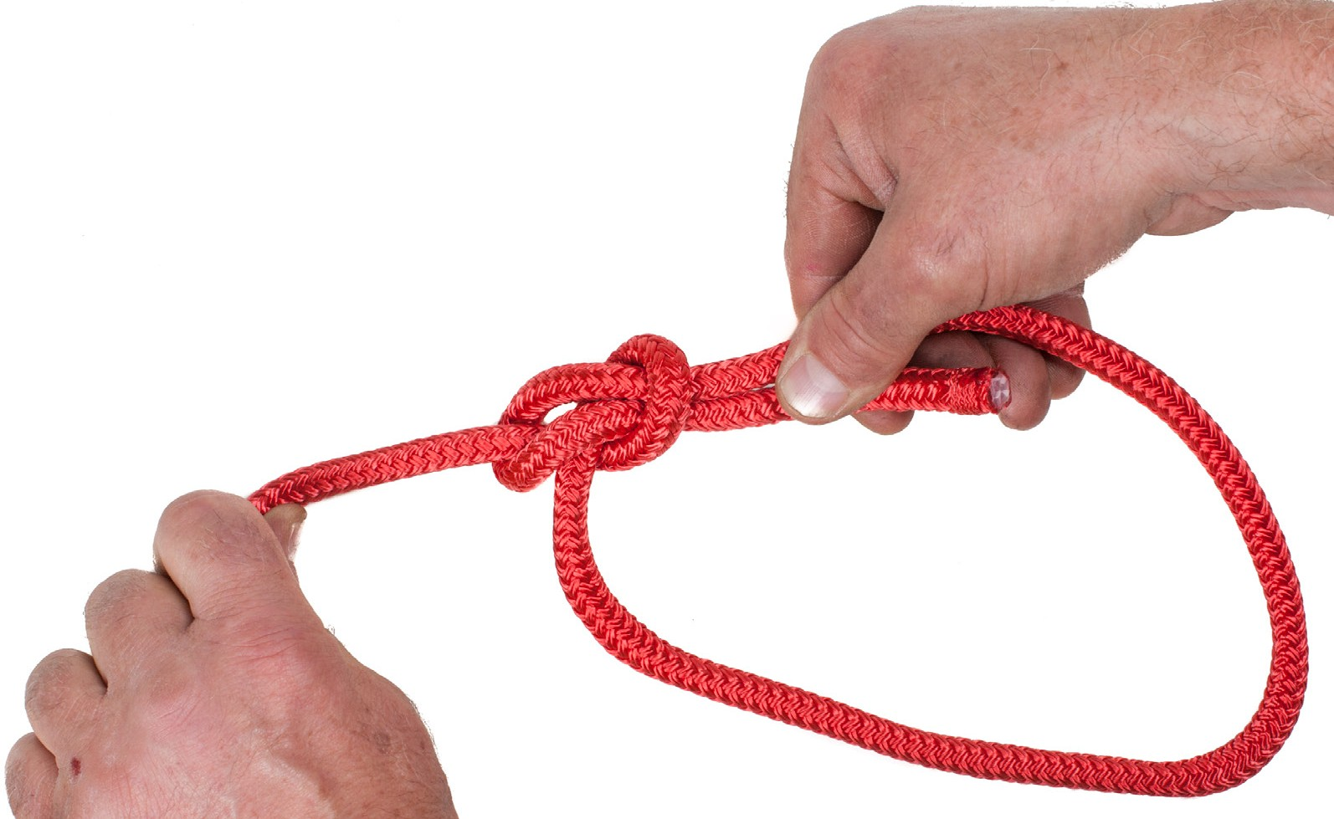
Figure 11 — Bowline knot

To untie the bowline, loosen the knot by pushing the loop that is around the standing part of the rope away from the knot. Once the knot is loosened it is easily untied.

The bowline is used when a slip-proof loop is needed. The bowline is used as an attachment when a loop is made around a fixed object.

Reef or square knot
The reef knot or square knot is used to fasten together two ropes of equal diameter. To tie the knot as illustrated in Figure 12, cross the ends of the ropes and turn one rope around the other. Then cross the ends again and turn one end around the other end, making sure the second turn is done in the opposite direction to the first.
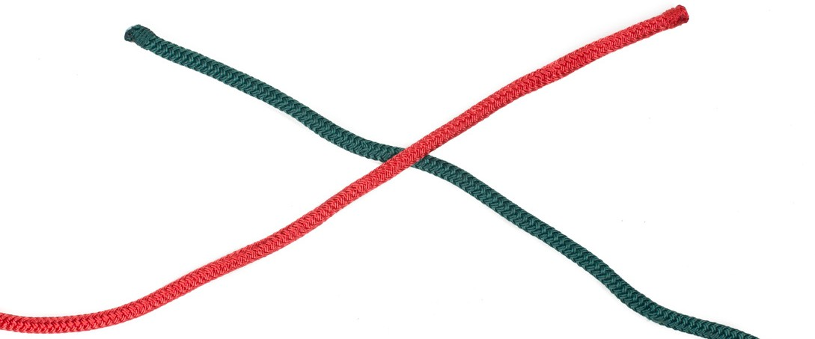
Step 1
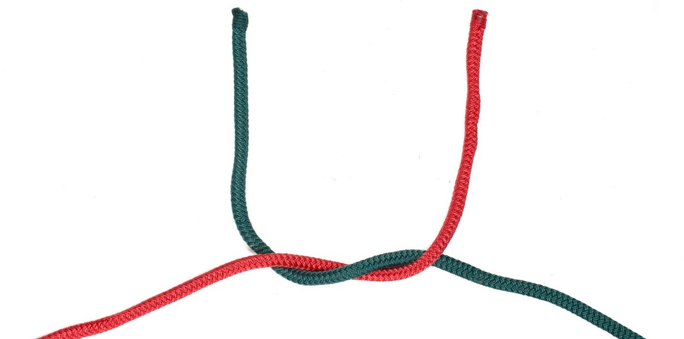
Step 2
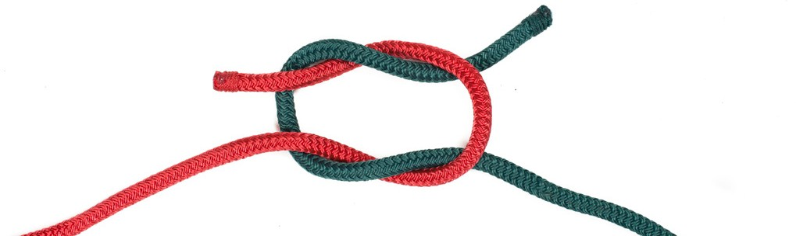
Step 3
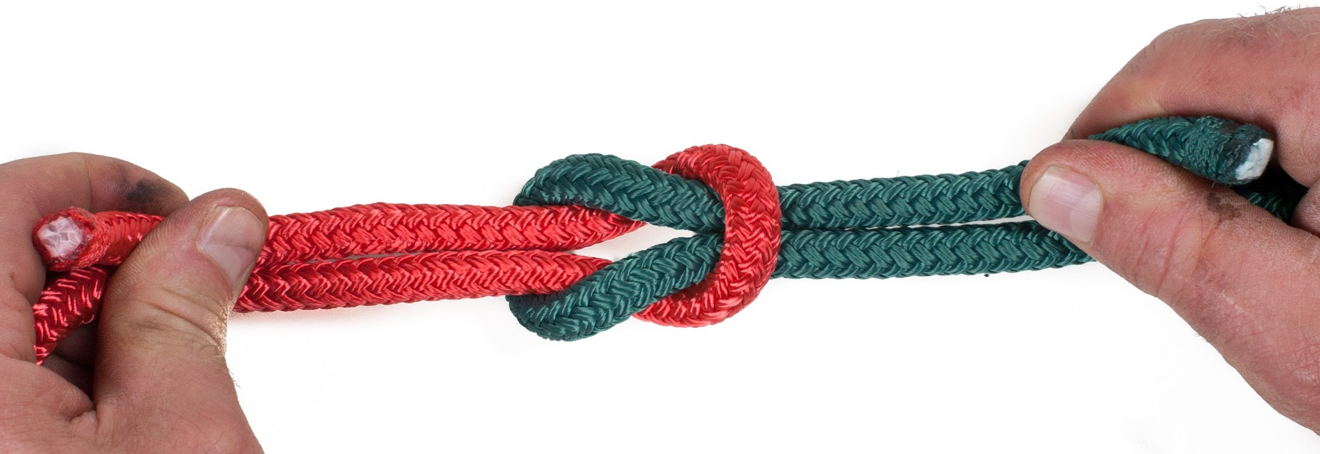
Step 4

Figure 12 — Reef or square knot

You can remind yourself how the reef knot is tied by using the following verse:

left over right and under then
right over left and under

The finished reef knot should have both the standing part and the end of each rope on the same side of the bight formed by the other rope.

Sheet bend
Use the sheet bend when attaching two ropes of unequal diameter together.

To tie the sheet bend as shown in Figure 13, form a bight in the larger diameter rope (left rope). Then pass the end of the smaller diameter rope up under the bight, around the back of the end and standing part of the larger rope. Then pass the end under the section of the smaller rope where it first came through the bight. Continue with the small end until it lies across the top
or face of the bight formed by the larger rope. Hold both the standing part and the end of the larger rope in each hand and pull in opposite directions to tighten the sheet bend.
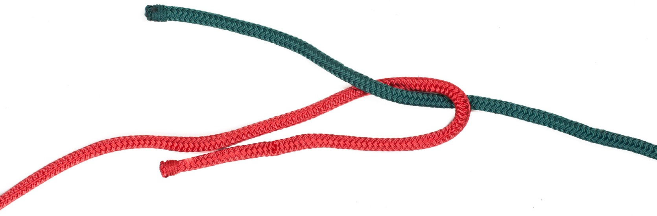
Step 1
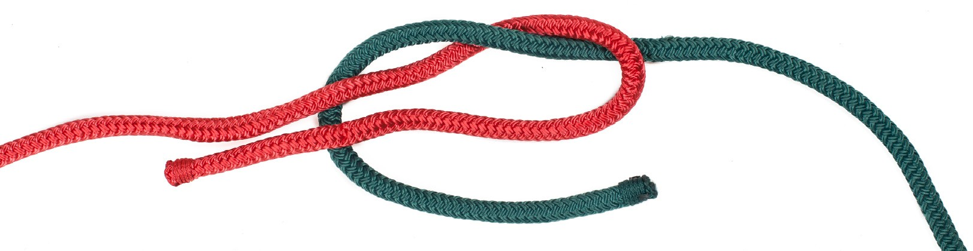
Step 2

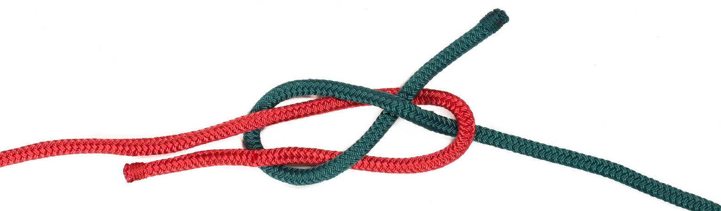
Step 3
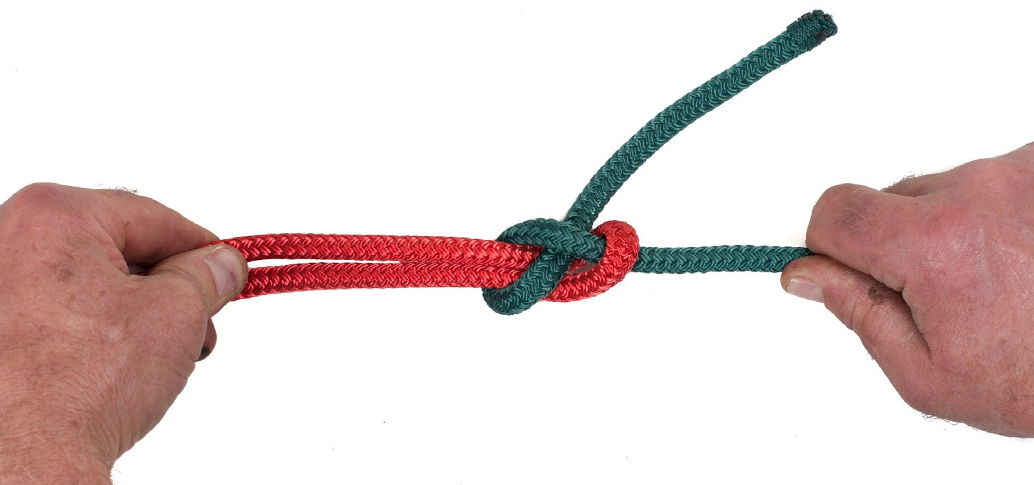
Step 4

Figure 13 — Sheet bend

For additional holding strength, pass the running end around and under the bight an second time to create a double sheet bend.
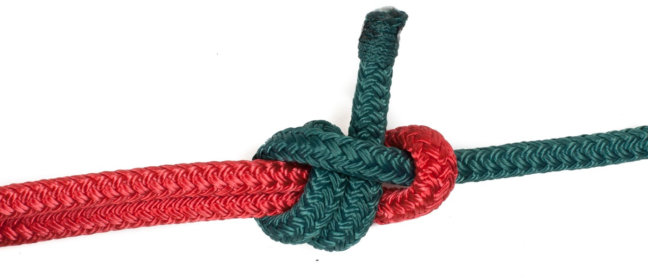
Figure 14 — Double sheet bend

Round turns with two half hitches
The round turn with two half hitches is used to secure the end of a rope to an affixed object (Figure 15). The more round turns of the object you make, the more secure the knot will be from slipping along the post or pipe. A common version of this, called a pipe hitch, is used for lifting pipe. The rope is wrapped around the pipe at least four times.

First wrap the rope completely around the object as many times as needed. Then pass the end of the rope around the standing part and pull the end between the object and the rope.
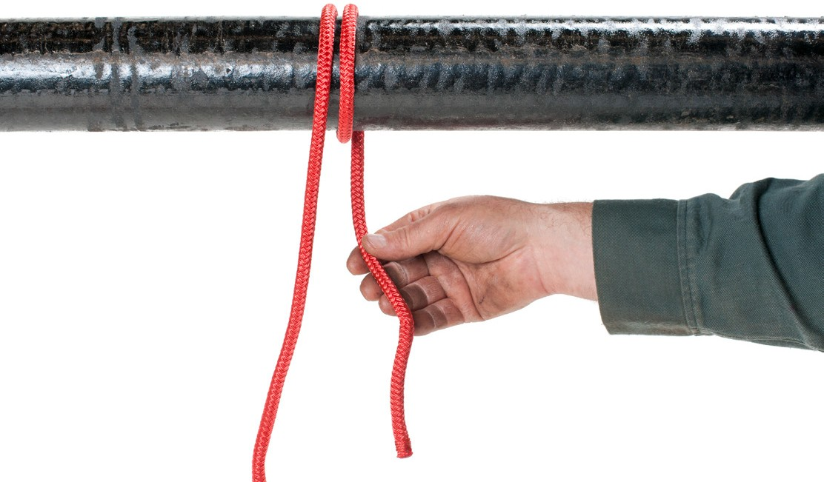
Step 1
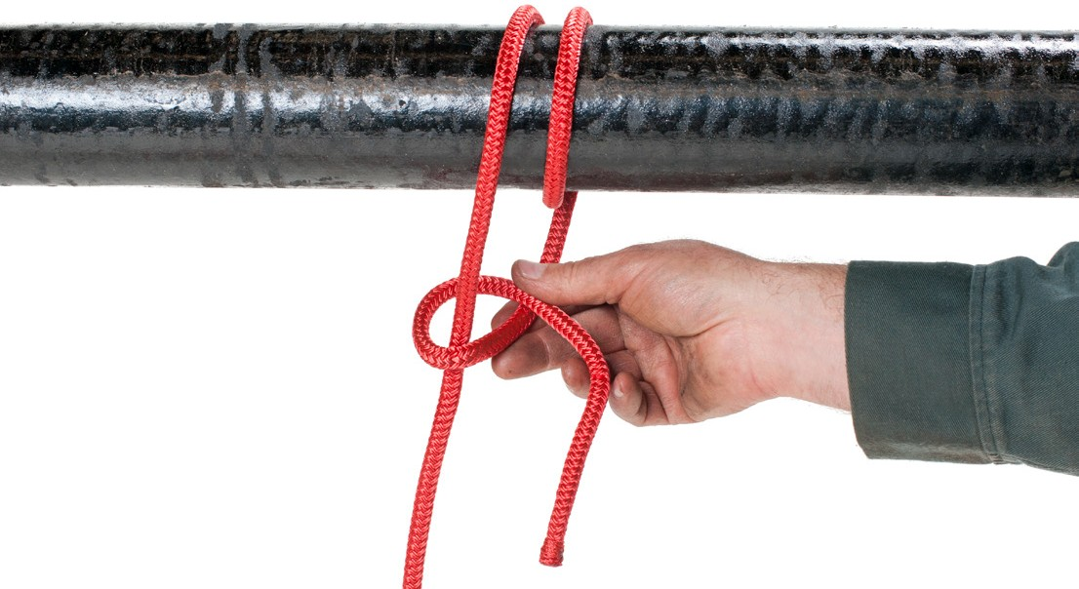
Step 2
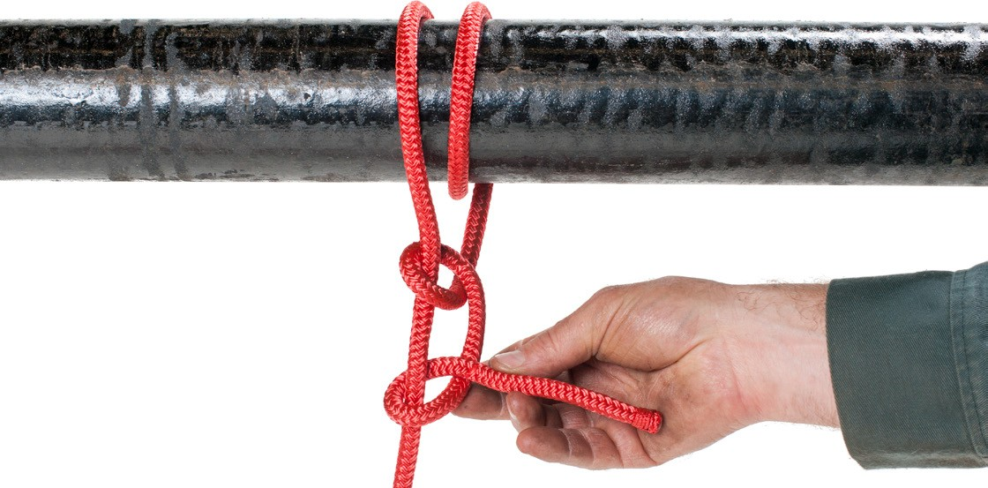
Step 3

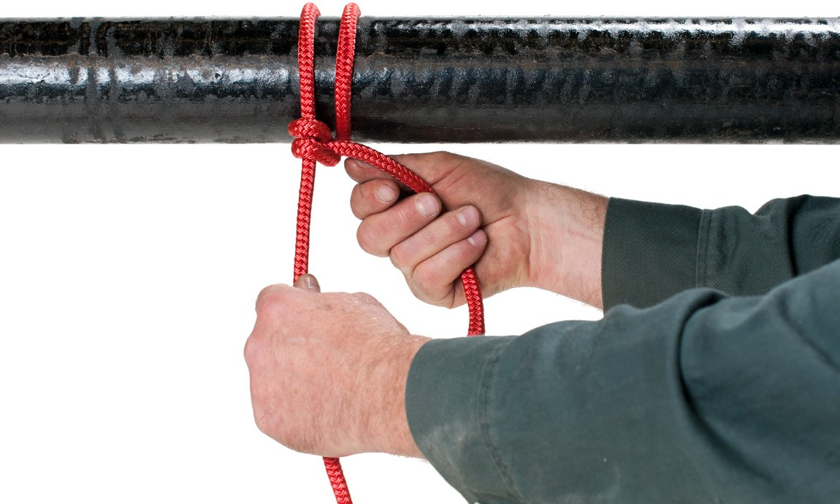
Step 4

Figure 15 — Round turn and two half hitches

Make a second loop around the standing part of the rope in the same direction as the first loop. (If one loop is clockwise and the other is counter-clockwise, the hitch will be difficult to untie.)

Finish by passing the end of the rope between the standing part and the two loops. As the standing part is pulled tight, the loop around the object will slip until the two half hitches have jammed tightly to the object. They will not come untied if the pull on the standing part is relaxed.

Clove hitch
The clove hitch is used to secure a rope to a fixed object, such as a post. To tie a clove hitch (Figure 16), take two wraps around the object. The first wrap is made to one side of the standing part and the second wrap must be to the opposite side of the standing part. The end of the rope is then passed between the object and the second wrap. The two wraps are pulled close to each other and the standing part and the end pulled in opposite directions. The clove hitch can be made even more secure by tying the end to the standing part with a single half hitch.
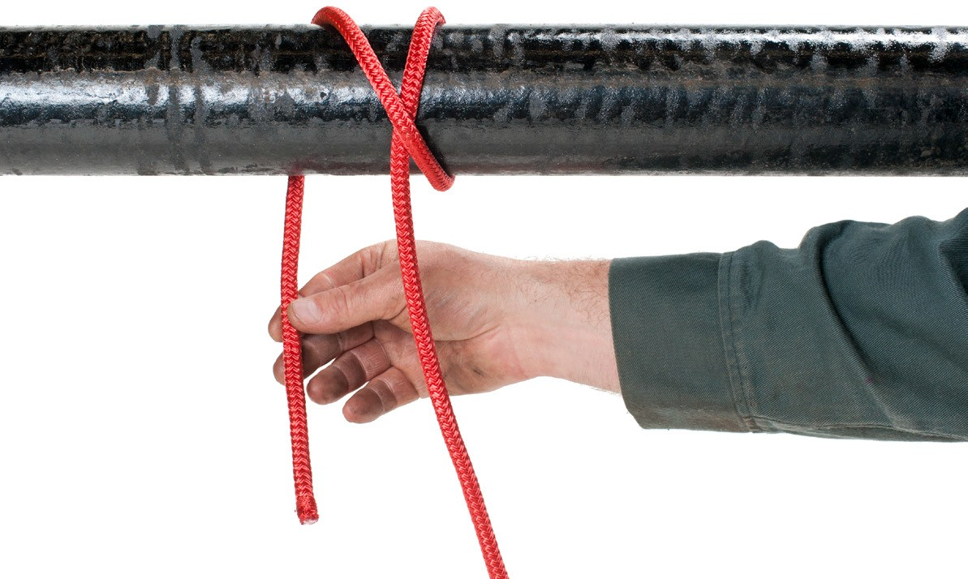
Step 1

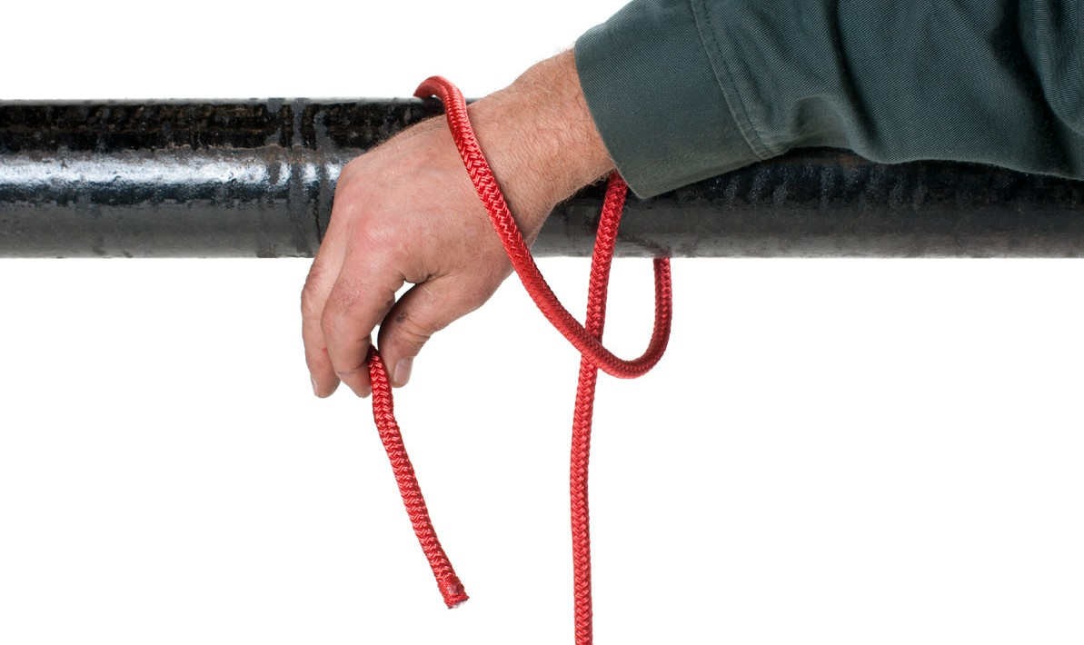
Step 2
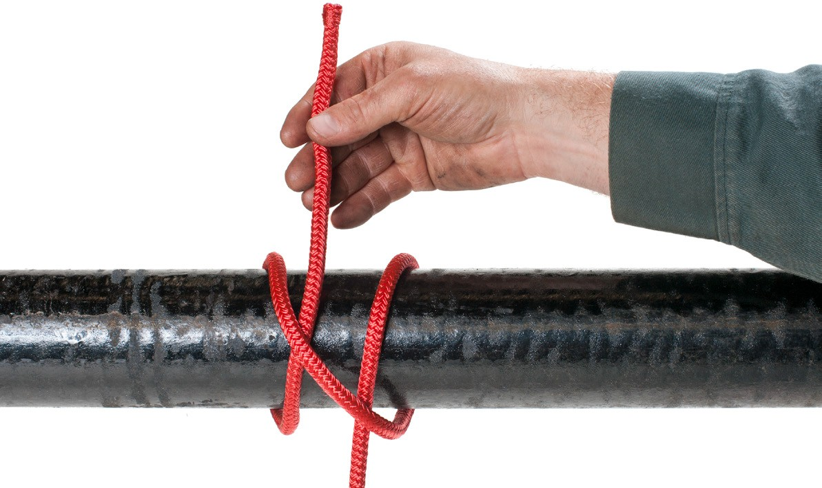
Step 3
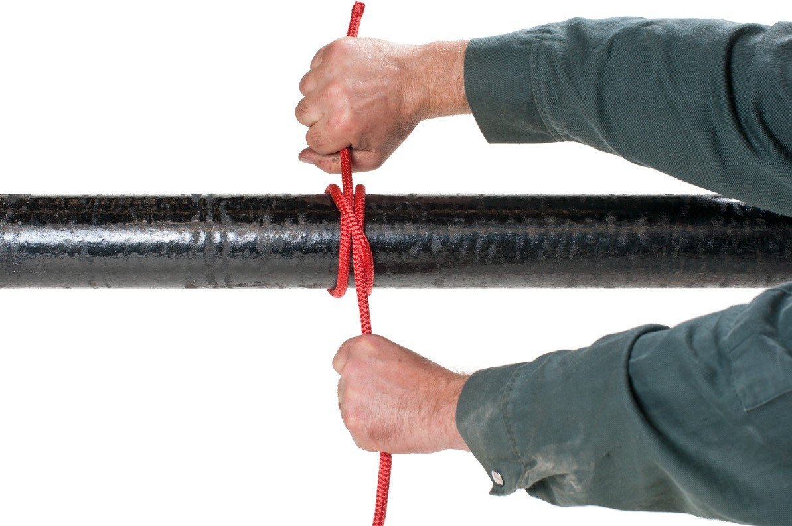
Step 4

Figure 16 — Clove hitch tied in position

If the knot is needed near the end of the pipe or post, the two loops can be made, then slipped over the end (Figure 17). This technique is good for quickly tying a tag line to the end of a pipe.

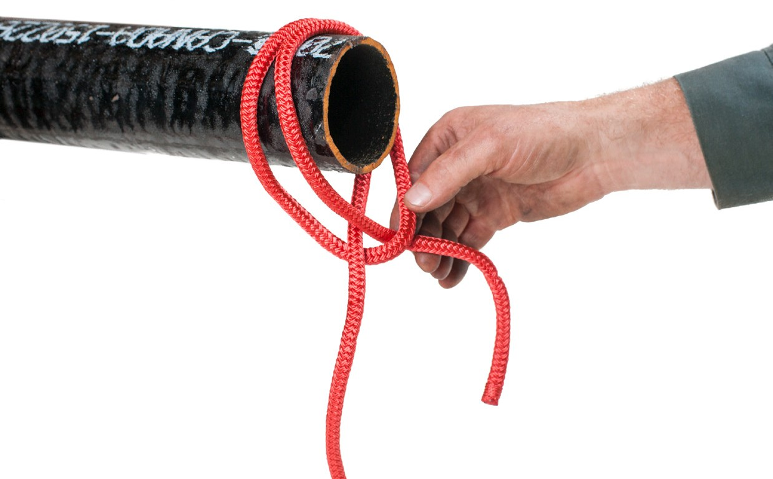
Figure 17 — Clove hitch pre-tied to slip over end of pipe

Timber hitch
The timber hitch is used to secure a rope to a plank, timber, post, or pipe when that object is to be lifted in an upright position

The timber hitch is a series of modified half hitches. To tie a timber hitch, begin by tying a single half hitch around the object as shown (Steps 1 and 2 in Figure 18). Then pass the free end of the rope between the object and rope two or more times as shown (Step 3). Pull the hitch tight by pulling the standing part of the rope at 90 degrees to the object (Step 4).
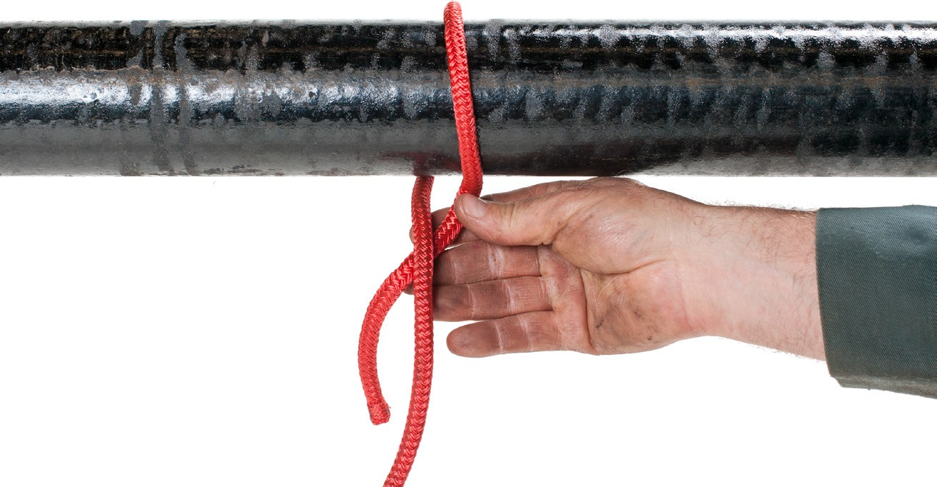
Step 1

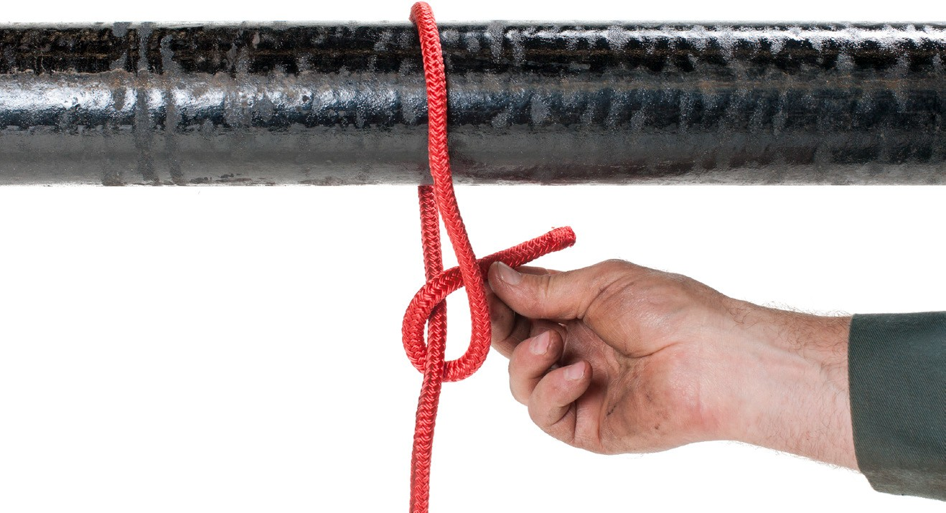
Step 2
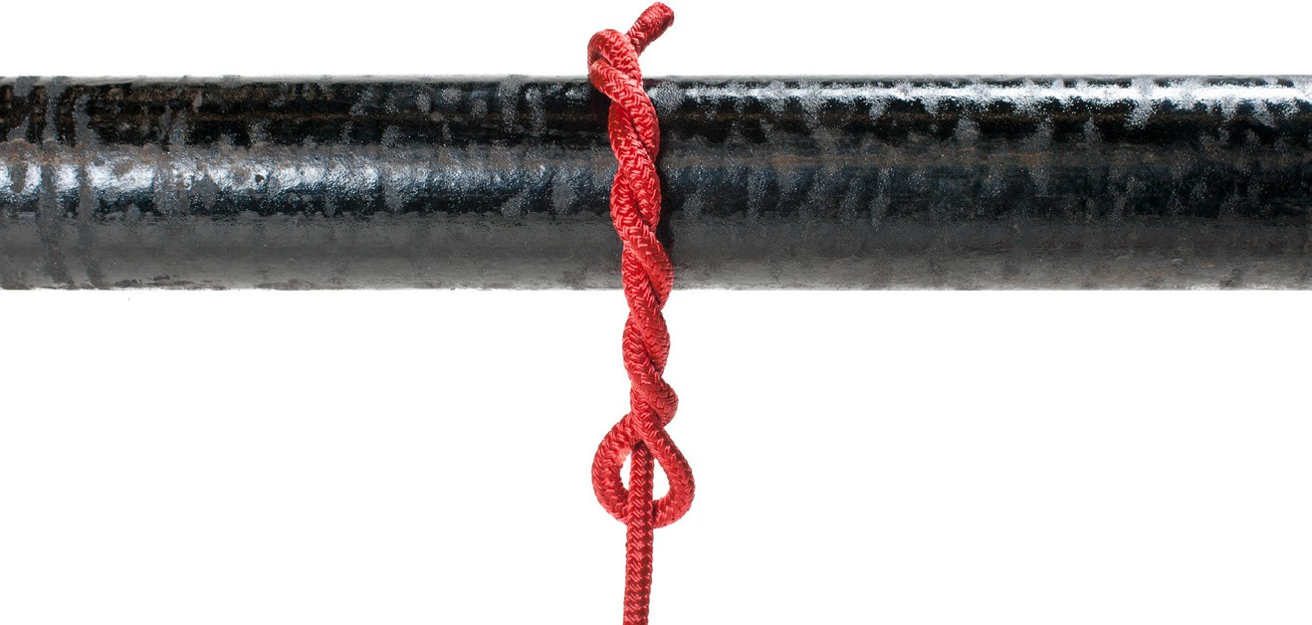
Step 3
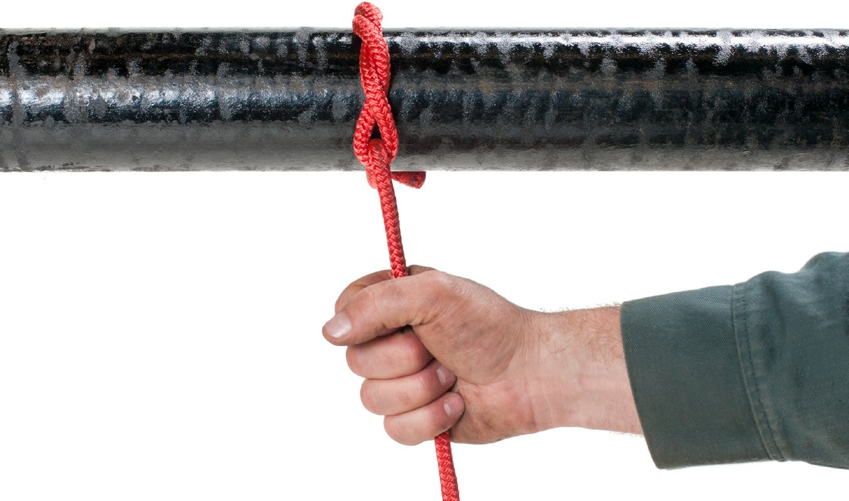
Step 4

Figure 18 — Timber hitch

Then using the standing part of the rope, tie one or more half hitches along the length of the object (Figure 19) to make the object secure and allow it to be hoisted vertically.
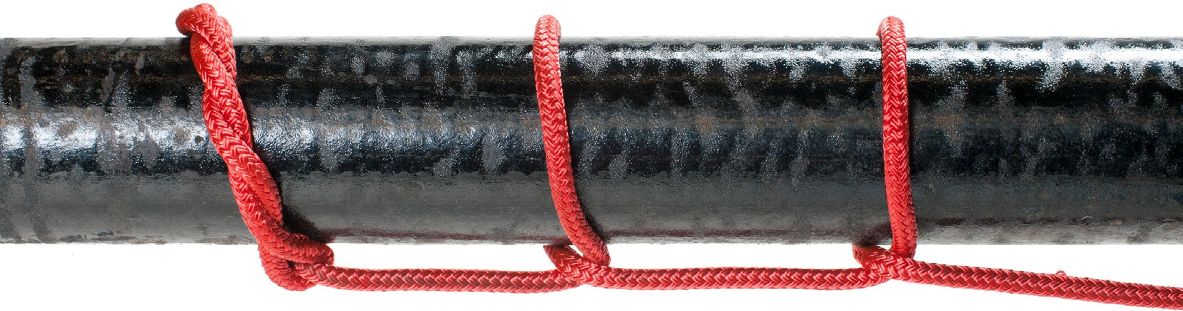
Figure 19 — Adding two half hitches

Trucker’s knot
The trucker’s knot (Figure 20) is a very useful knot for tying down a load. The knot forms a slip- resistant loop that acts like a pulley in a block-and-tackle system. You can generate almost three times as much tension on a rope using the trucker’s knot as you would if you just pulled on a straight rope.

To make the trucker’s knot, take a bend in the rope and twist the loop formed by the bend three times. Then take another bend in the dead end and pass this new bend (doubled) through the loop formed by the three twists. This second loop serves as your “pulley,” used to apply tension to the rope tying down your load.

Take the dead end of your rope, pass it through a tie-down or hook on your truck, then through the second loop formed by the trucker’s knot. Pull. Tie off with a double half-hitch.
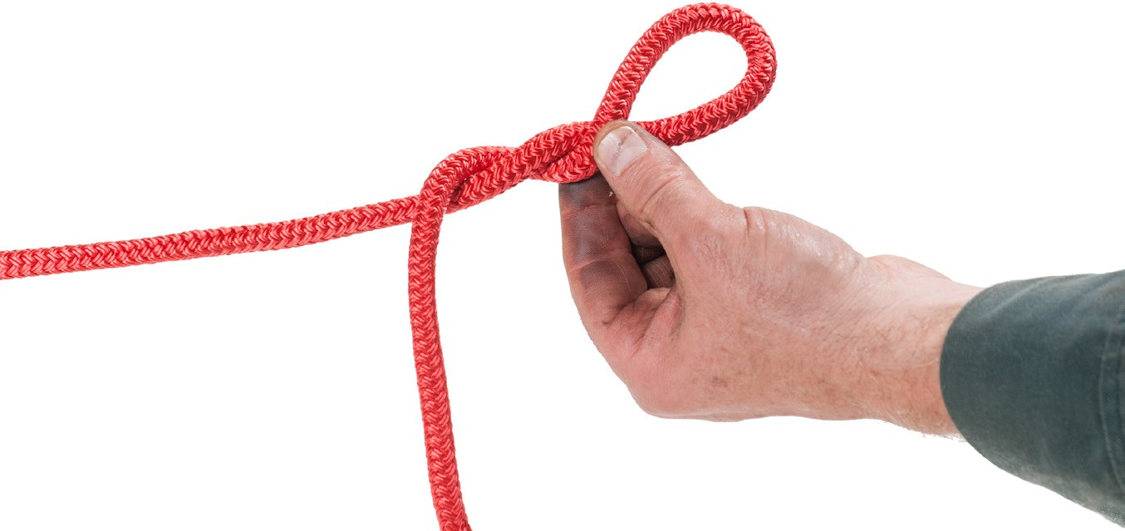
Step 1

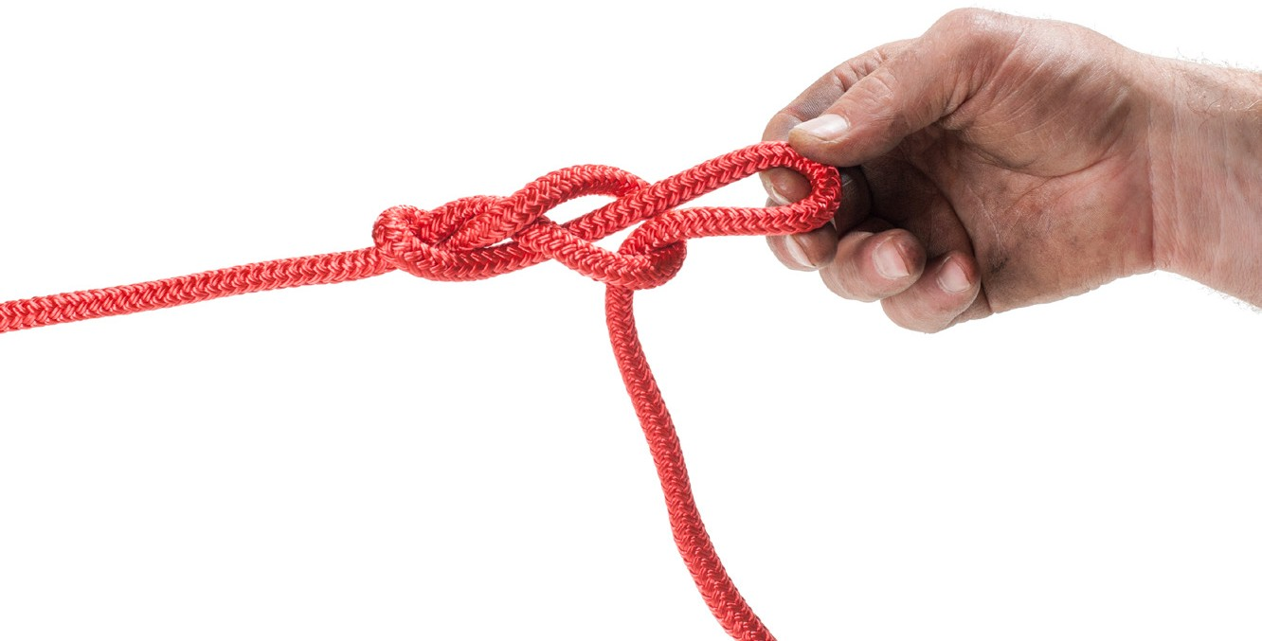
Step 2
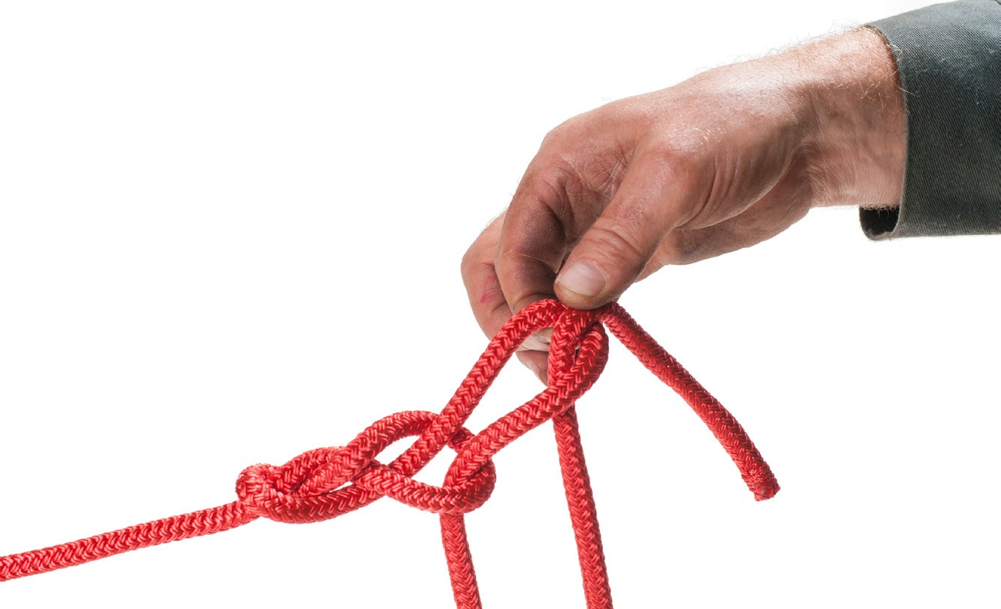
Step 3
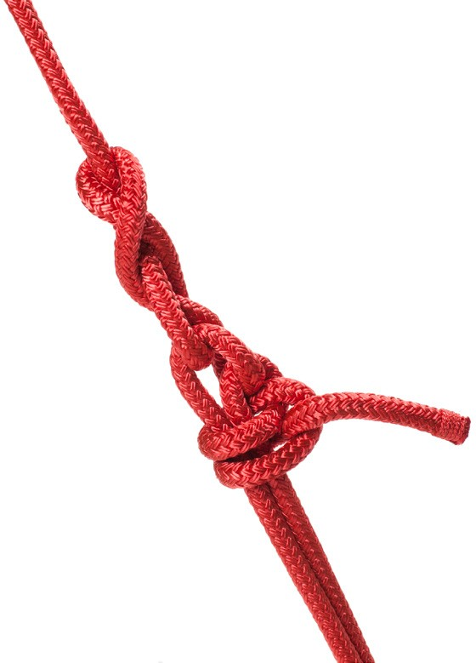
Step 4

Figure 20 — Trucker’s knot

Figure eight knot
The simple figure eight knot shown in Figure 21 is used to form a stopper on the end of a rope. This stopper is used to stop the rope from running through a sheave or pulley or to stop the rope from slipping through a knot.
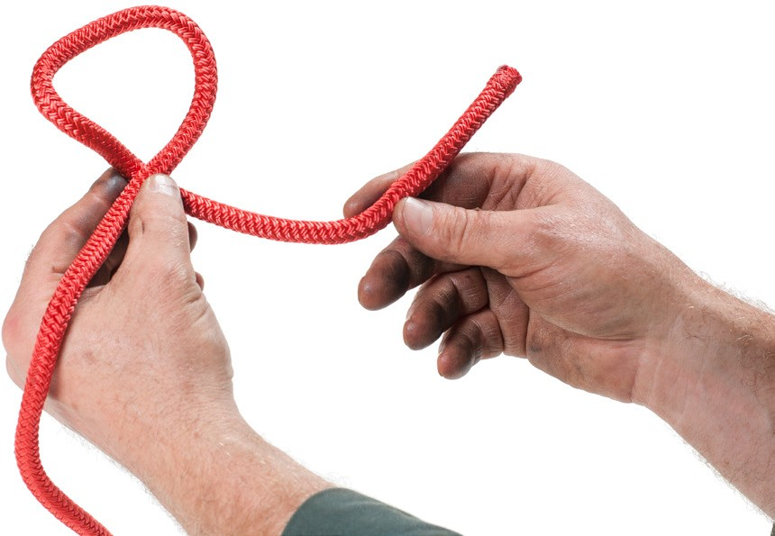
Step 1
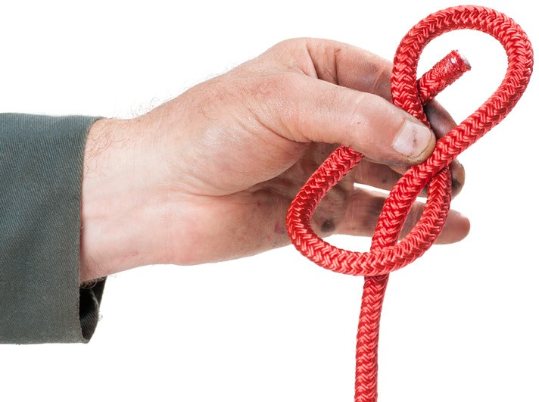
Step 2

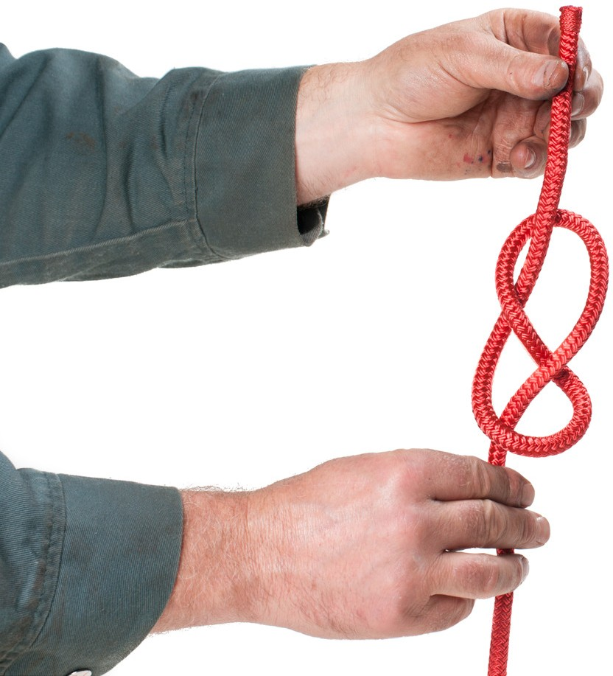
Step 3

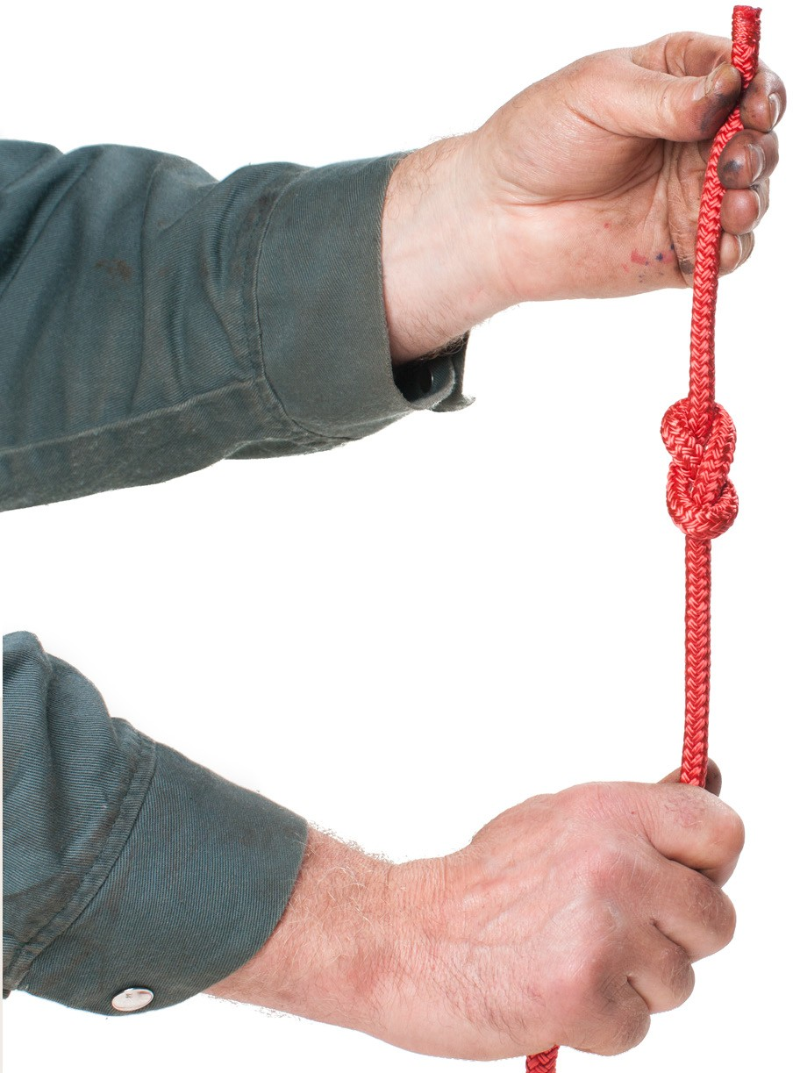
Step 4

Figure 21 — Figure eight “stopper” knot

A figure eight knot can also be tied into a non-slip loop as shown in Figure 22. To tie this loop, simply double over a section of rope and tie this double-up rope as if it were one. This loop can also be tied quite easily in the middle of a long line.
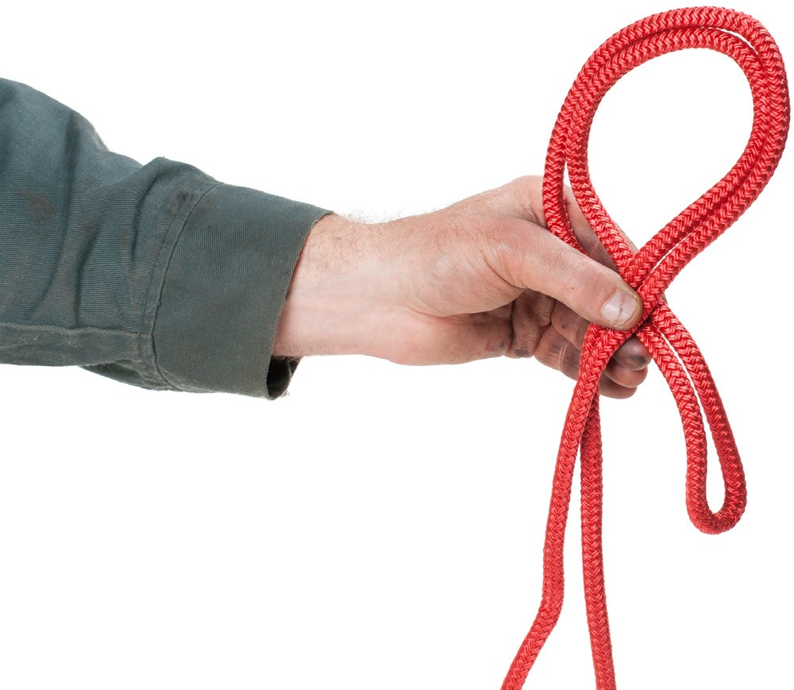
Step 1

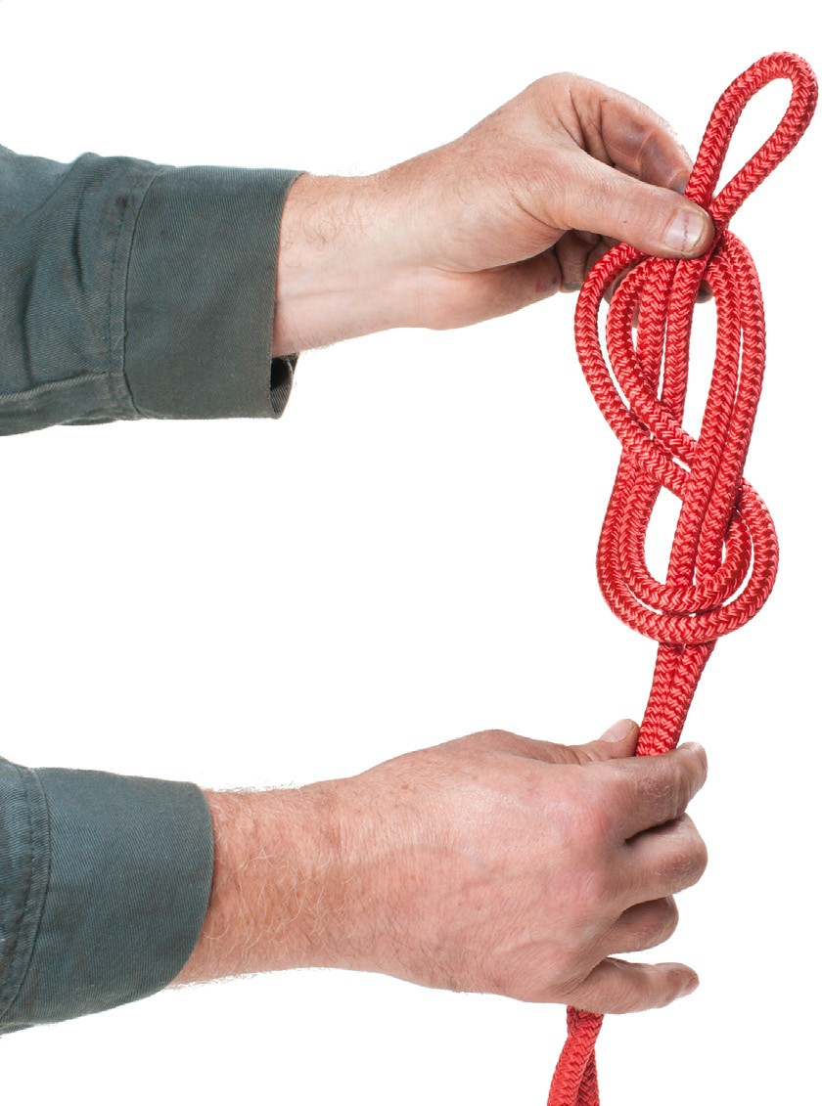
Step 2
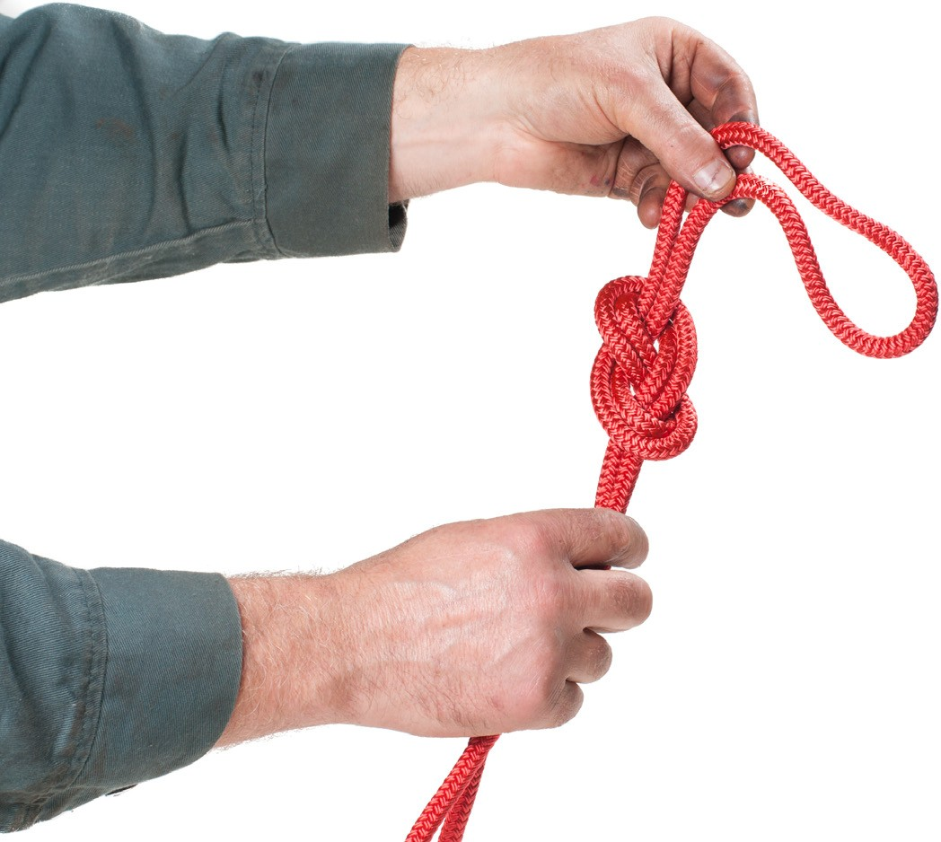
Step 3

Figure 22 — Non-slip loop
Do not join ropes for overhead lifting. Use only single-piece ropes.

Now complete the Learning Task Self-Test.

Self-Test 5
- What type of manila rope has one or more coloured strands?
  - Bolt rope
  - Yacht rope
  - Number 1 grade
  - Hardware store rope

- Which of the ropes listed below is the strongest?
  - Sisal
  - Manila
  - Polyester
  - Polypropylene

- Which type of dry rope has the best electrical insulating properties?
  - Nylon
  - Manila
  - Polyester
  - Polypropylene

- Which type of rope is usually pure white, soft, pliable, and smooth to the touch?
  - Nylon
  - Manila
  - Polyester
  - Polypropylene

- Up to how much will nylon rope stretch when loaded to the breaking point?
  - 10% of its original length
  - 20% of its original length
  - 30% of its original length
  - 40% of its original length

- How should you remove new rope from its shipping coil?
  - Mount the coil on an axle
  - Roll the coil across the floor
  - Pull it from the inside of the coil
  - Cut portions from the side of the coil

- In what conditions are ropes are best stored?
  - Moist
  - Well ventilated
  - Above 25°C (77°F)
  - Exposed to sunlight

- What is the maximum load that should be imposed on a rope for rigging?
  - 1/10 its breaking strength
  - 1/5 its breaking strength
  - 1/2 its breaking strength
  - 3/4 of its breaking strength

- How much can sharp bends and knots reduce the strength of a rope by? a. 25%
b. 40%
c. 50%
d. 85%

- When knot tying, what do you call the portion of the rope that forms the loop?
  - Circle
  - Bight
  - Middle
  - Standing part

- Which of the knots listed below forms a non-slip loop?
  - Bowline
  - Reef knot
  - Timber hitch
  - Square knot

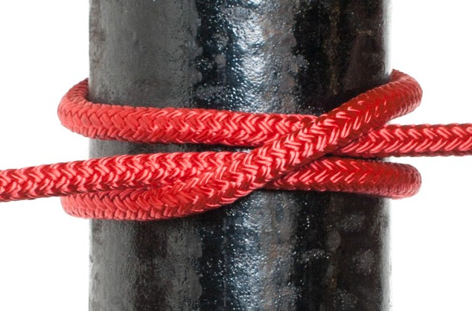
- Which knot, hitch, or bend is illustrated below?
  - Clove hitch
  - Timber hitch
  - Carrick bend
  - Trucker’s knot

- Which knot acts like a pulley for tying down a load?
  - Bowline
  - Sheet bend
  - Timber hitch
  - Trucker’s knot

- Which knot, hitch, or bend would you use to join a large-diameter rope to a small-diameter rope?
  - Half hitch
  - Sheet bend
  - Square knot
  - Carrick bend

- Which, knot, hitch, or bend, would you use to join two ropes of the same diameter together?
  - Reef knot
  - Sheet bend
  - Timber hitch
  - Double half hitch

Answer Key

Self-Test 1
- c. The use of tools or mechanical devices to multiply force
- d. 90 degrees
- b. As the sling angle decreases, the sling stress increases.
- b. The point at which the object will balance
- b. The effort distance compared to the resistance distance
- d. The load will tilt until the centre of gravity is directly below the hook.
- a. The load could topple.
- a. Lower the lift and rearrange the rigging.

Self-Test 2
1. c. 4:1
- d. The block and tackle has no safety system.
- b. The chain fall
- d. The come-along
- a. The Tirfor
- d. A shear pin must break and seize the load when overloaded.
- a. The handle bends when overloaded
- a. Drop stops
- d. An overhead travelling crane
- d. A manual forklift
- c. Top running
- d. By capacity

Self-Test 3
- d. Working load limit
- d. The lengthwise distance for one strand revolution 3. b. 80
- d. The threads are left handed at one end and right handed at the other.
- a. Basket web sling
- d. Triangle end metal mesh sling
- c. Shoulderless eyebolt
- c. 45 degrees to the vertical
- b. Shackle
- c. 45 degrees
- d. It protects the sling from sharp ends at the choker point.
- d. Dead end of the rope
- d. Diameter of the rope 14. b. 20%
- b. Grab
- c. Pad used to protect a sling from the sharp corners of a load
- d. Double-wrap basket hitch
- a. 60 degrees
- b. False
- b. Peening
- c. Scrubbing
- d. Bird caging

Self-Test 4
1. a. 9
- 2
- 6
- 3
- 10
- 14
- 5
- 12
- 4
- 7
- 8
- 18
- 17
- 13
- 15
- 16
- 1
- 11
- a. Tower cranes
- b. Carrier-mounted lattice boom crane
- a. Rough terrain crane
- d. Carrier-mounted hydraulic boom crane
- c. Crawler crane
- c. Three bells or flashes
- a. One bell or flash
- d. Four bells or flashes
- b. Two bells or flashes
- d. Out from under the load

Self-Test 5
- c. Number 1 grade
- c. Polyester
- d. Polypropylene
- a. Nylon
- d. 40% of its original length
- c. Pull it from the inside of the coil
- b. Well ventilated
- b. 1/5 its breaking strength 9. c. 50%
- b. Bight
- a. Bowline
- a. Clove hitch
- d. Trucker’s knot
- b. Sheet bend
- a. Reef knot

The British Columbia Open Textbook Project
The British Columbia Open Textbook Project is funded by the B.C. Ministry of Advanced Education, and managed by BCcampus, a publicly-funded organization that uses information technology to connect B.C. post-secondary institutions under a collaborative service delivery framework. The Open Textbook Project aims to make available
openly-licensed textbooks in the province’s high-impact subject areas. Visit open.bccampus.ca for more information.

7960003685

