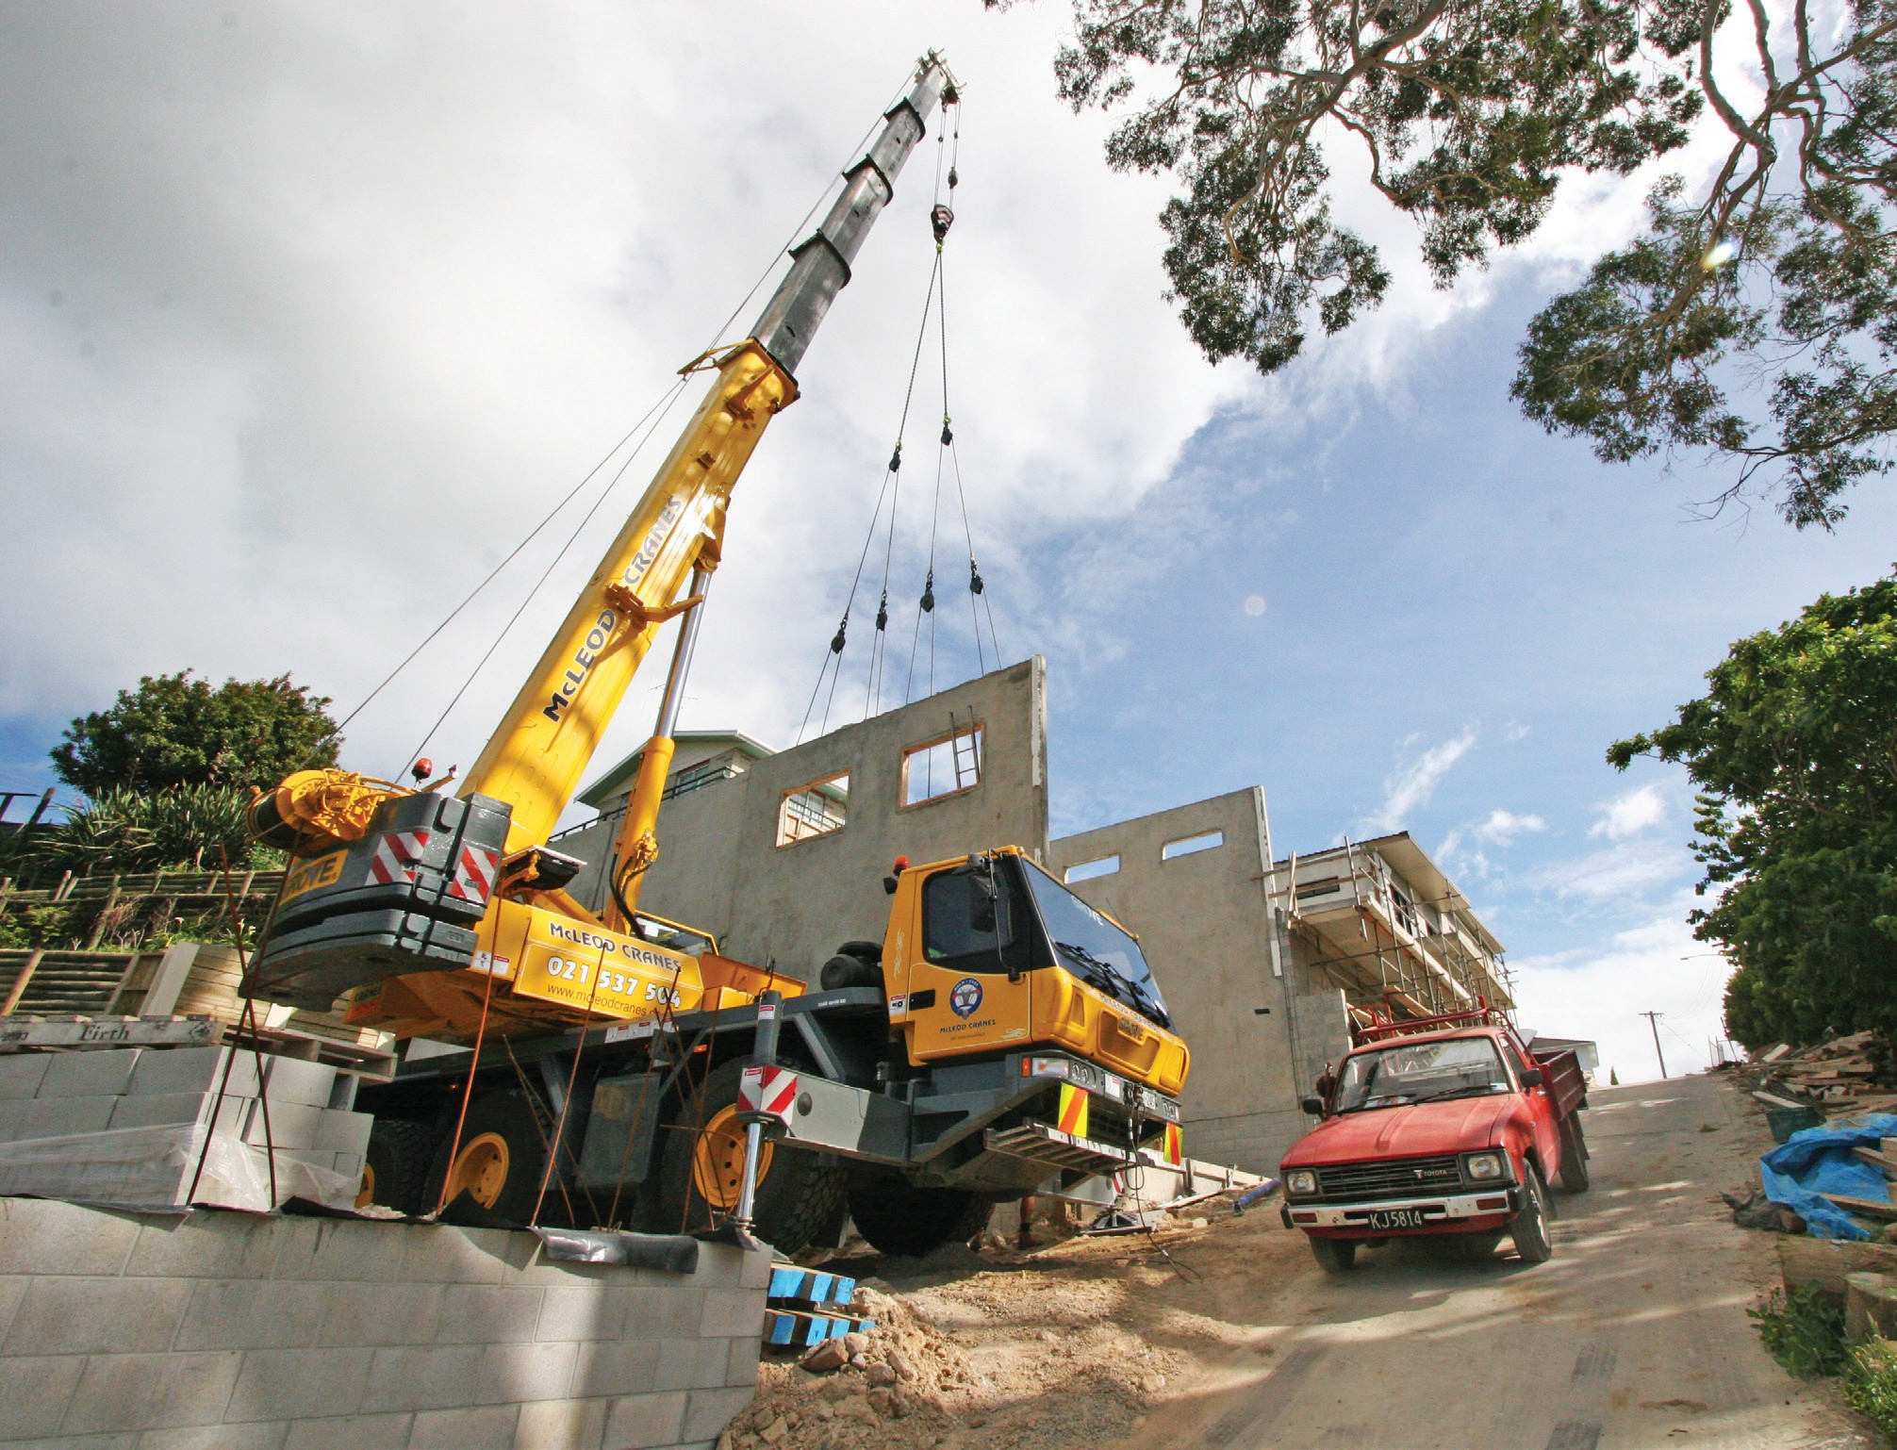

Trades Access Common Core
Line C: Tools and Equipment
Competency C-4: Describe Ladders and
Platforms
Image to be placed here.

B.C. Open Textbook Project
OpenEd
open.bccampus.ca

Trades Access
COMMON CORE
Line C: Tools and Equipment Competency C-4: Describe Ladders and Work Platforms

Acknowledgments and Copyright
To learn more about BCcampus Open Education, visit http://open.bccampus.ca
© 2015 Camosun College
The Trades Access Common Core resources are licensed under the Creative Commons Attribution 4.0 Unported Licence, except where otherwise noted. Under this licence, any user of this textbook or the textbook contents herein must provide proper attribution as follows:
- Trades Access Common Core Competency C-4: Describe Ladders and Work Platforms by Camosun College is used under a Creative Commons Attribution 4.0 Licence.
- If you redistribute all or part of this book, it is recommended the following statement be added to the copyright page so readers can access the original book at no cost: Download for free from the B.C. Open Textbook Collection (https://open.bccampus.ca/browse-our-collection/find-open-textbooks/).
- If you use this textbook as a bibliographic reference, then you should cite it as follows: Camosun College. (2015). Trades Access Common Core Competency C-4: Describe Ladders and Work Platforms. Victoria, B.C.: Crown Publications.
All images copyright BC Industry Training Authority are licensed under the Creative Commons Attribution-NonCommercial-ShareAlike 4.0 licence.
The issuing/publishing body is Crown Publications, Queen’s Printer, Ministry of Technology, Innovation and Citizens’ Services.
BCcampus would like to acknowledge the following individuals and organizations for their contributions in producing the Trades Access Common Core Open Textbook resources.

BCcampus
Open Education Team
Hilda Anggraeni, Graphics

Camosun College
Olaf Nielsen, Chair, Trades Development and Special Projects, School of Trades and Technology
Nannette Plant, Manager, Enterprise Point Operations & Special Projects, Office of the VP Strategic Development
Rod Lidstone, Instructor, Plumbing and Pipe Trades, Lead Writer/Reviewer
Brian Coey, Instructor, Sheet Metal and Metal Fabrication, Writer/Reviewer
Matt Zeleny, Camosun Innovates, 3D imaging

Open School BC
Monique Brewer, Director
Adrian Hill, Instructional Designer
Dennis Evans, Image Coordinator, Photographer, Graphics, Production Technician (layout)
Farrah Patterson, Production Technician

Industry Training Authority of BC
The ITA works with employers, employees, industry, labour, training providers, and government to issue credentials, manage apprenticeships, set program standards, and increase opportunities in approximately 100 BC trades. Among its many functions are oversight of the development of training resources that align with program standards, outlines, and learning objectives, and authorizing permission to utilize these resources (text and images).
Erin Johnston, Director of Training Delivery
Cory Williams, Manager, Industry Relations

Publishing Services, Queen’s Printer
Spencer Tickner, Director of QP Publishing Services
Dwayne Gordon, Manager, Electronic Publishing
October 2015, Version 1
To order print copies of any of the Trades Access Common Core resources, please contact us:
Crown Publications, Queen’s Printer PO Box 9452 Stn Prov Govt
563 Superior St, 3rd Floor Victoria, BC V8W 9V7 Phone: 250-387-6409
Toll Free: 1-800-663-6105
Fax: 250-387-1120
crownpub@gov.bc.ca www.crownpub.bc.ca

Intellectual Property Program
Ilona Ugro, Copyright Officer, Ministry of Technology, Innovation and Citizens’ Services, Province of British Columbia

Creative Commons Attributions
Cover photo:
GMK3050 All Terrain Crane by Scottmss under Creative Commons Attribution-ShareAlike 3.0 Unported licence.

Foreword
The BC Open Textbook Project began in 2012 with the goal of making post-secondary education in British Columbia more accessible by reducing student cost through the use of openly licensed textbooks. The
BC Open Textbook Project is administered by BCcampus and is funded by the British Columbia Ministry of Advanced Education.
Open textbooks are open educational resources (OER); they are instructional resources created and shared in ways so that more people have access to them. This is a different model than traditionally copyrighted materials. OER are defined as teaching, learning, and research resources that reside in the public domain or have been released under an intellectual property licence that permits their free use and repurposing by others (Hewlett Foundation). Our open textbooks are openly licensed using a Creative Commons licence, and are offered in various e-book formats free of charge, or as printed books that are available at cost. For more information about this project, please contact opentext@bccampus.ca. If you are an instructor who is using this book for a course, please let us know.

Preface
The concept of identifying and creating resources for skills that are common to many trades has a long history in the Province of British Columbia. This collection of Trades Access Common Core (TACC) resources was adapted from the 15 Trades Common Core line modules co-published by the Industry
Training and Apprenticeship Commission (ITAC) and the Centre for Curriculum Transfer and Technology (C2T2) in 2000-2002. Those modules were revisions of the original Common Core portion of the TRAC modules prepared by the Province of British Columbia Ministry of Post-Secondary Education in 1986. The TACC resources are still in use by a number of trades programs today and, with the permission from the Industry Training Authority (ITA), have been utilized in this project.
These open resources have been updated and realigned to match many of the line and competency titles found in the Province of BC’s trades apprenticeship program outlines. A review was carried out to analyze the provincial program outlines of a number of trades, with the intent of finding common entry-
level learning tasks that could be assembled into this package. This analysis provided the template for the outline used to update the existing modules. Many images found in ITA apprentice training modules were also incorporated into these resources to create books that are similar to what students will see when they continue their chosen trades training. The project team has also taken many new photographs for this project, which are available for use in other trades training resources.
The following list of lines and competencies was generated with the goal of creating an entry-level trades training resource, while still offering the flexibility for lines to be used as stand-alone books. This
flexibility—in addition to the textbook content being openly licensed—allows these resources to be used within other contexts as well. For example, instructors or institutions may incorporate these resources into foundation-level trades training programming or within an online learning management system (LMS).
Line A – Safe Work Practices
- A-1 Control Workplace Hazards
- A-2 Describe WorkSafeBC Regulations
- A-3 Handle Hazardous Materials Safely
- A-4 Describe Personal Safety Practices
- A-5 Describe Fire Safety
Line B – Employability Skills
- B-1 Apply Study and Learning Skills
- B-2 Describe Expectations and Responsibilities of Employers and Employees
- B-3 Use Interpersonal Communication Skills
- B-4 Describe the Apprenticeship System

Line C – Tools and Equipment
- C-1 Describe Common Hand Tools and Their Uses
- C-2 Describe Common Power Tools and Their Uses
- C-3 Describe Rigging and Hoisting Equipment
- C-4 Describe Ladders and Platforms
Line D – Organizational Skills
- D-1 Solve Trades Mathematical Problems
- D-2 Apply Science Concepts to Trades Applications
- D-3 Read Drawings and Specifications
- D-4 Use Codes, Regulations, and Standards
- D-5 Use Manufacturer and Supplier Documentation
- D-6 Plan Projects
Line E – Electrical Fundamentals
- E-1 Describe the Basic Principles of Electricity
- E-2 Identify Common Circuit Components and Their Symbols
- E-3 Explain Wiring Connections
- E-4 Use Multimeters
All of these textbooks are available in a variety of formats in addition to print:
- PDF—printable document with TOC and hyperlinks intact
- HTML—basic export of an HTML file and its assets, suitable for use in learning management systems
- Reflowable EPUB—format that is suitable for all screen sizes including phones
All of the self-test questions are also available from BCcampus as separate data, if instructors would like to use the questions for online quizzes or competency testing.

About This Book
In an effort to make this book a flexible resource for trainers and learners, the following features are included:
- An introduction outlining the high-level goal of the Competency, and a list of objectives reflecting the skills and knowledge a person would need to achieve to fulfill this goal.
- Discrete Learning Tasks designed to help a person achieve these objectives
- Self-tests at the end of each Learning Task, designed to informally test for understanding.
- A reminder at the end of each Competency to complete a Competency test. Individual trainers are expected to determine the requirements for this test, as required.
- Throughout the textbook, there may also be links and/or references to other resources that learners will need to access, some of which are only available online.
- Notes, cautions, and warnings are identified by special symbols. A list of those symbols is provided below.

Symbols Legend
Important: This icon highlights important information.

Poisonous: This icon is a reminder for a potentially toxic/poisonous situation.

Resources: The resource icon highlights any required or optional resources.

Flammable: This icon is a reminder for a potentially flammable situation.

Self-test: This icon reminds you to complete a self-test.

Explosive: This icon is a reminder for a possibly explosive situation.

Safety gear: The safety gear icon is an important reminder to use protective equipment.

Electric shock: This icon is a reminder for potential electric shock.

Safety Advisory
Be advised that references to the Workers’ Compensation Board of British Columbia safety regulations contained within these materials do not/may not reflect the most recent Occupational Health and Safety Regulation. The current Standards and Regulation in BC can be obtained at the following website: http:// www.worksafebc.com.
Please note that it is always the responsibility of any person using these materials to inform him/herself about the Occupational Health and Safety Regulation pertaining to his/her area of work.
BCcampus January 2015

Disclaimer
The materials in the Trades Access Common Core Open Textbook project are for use by students and instructional staff and have been compiled from sources believed to be reliable and to represent best current opinions on these subjects. These manuals are intended to serve as a starting point for good practices and may not specify all minimum legal standards. No warranty, guarantee or representation is made by BCcampus as to the accuracy or sufficiency of the information contained in these publications. These manuals are intended to provide basic guidelines for trade practices. Do not assume, therefore, that all necessary warnings and safety precautionary measures are contained in this module and that other or additional measures may not be required.

Contents
Introduction 8
Objectives 8
Resources 8
Learning Task 1: Describe ladders 9
Stepladders 10
Straight (single) ladders 10
Extension ladders 12
Using single and extension ladders 13
Ladder inspection 17
Self-Test 1 19
Learning Task 2: Describe scaffolds 21
Scaffold design 21
Scaffold types 22
Scaffold construction and use 34
Self-Test 2 39
Learning Task 3: Describe elevating work platforms 43
Self-propelled elevating work platforms 44
Boom lifts 46
Using self-propelled lifts 48
Self-Test 3 50
Answer Key 51

Introduction
In this Competency you will learn about some of the common equipment used for performing work at elevated locations. The safe use of ladders and scaffolds is required in all types of
jobs. A safely built scaffold provides a stable platform for workers to complete their work. The Occupational Health and Safety (OHS) Regulation has set minimum standards for erecting and using ladders and work platforms.

Objectives
When you have completed the Learning Tasks in this Competency, you should be able to:
  - describe the types of ladders, scaffolds, and elevating work platforms
  - identify the various components of different scaffold systems
  - describe the procedures required to erect and use various types of scaffolds and ladders
  - describe various kinds of aerial lifts

Resources
You will be required to reference publications and videos available online.

LEARNING TASK 1
Describe ladders
Ladders are used to access or perform work at elevated locations. Workers use ladders to do many jobs, and they must be familiar with the safe use of all types of ladders.

There are three basic types of ladder:
  - stepladders
  - straight (single) ladders
  - extension ladders
Stepladders and extension ladders are usually manufactured. Straight ladders may also be manufactured or they may be built at the job site. All three types are available in aluminum, fibreglass, or wood. Aluminum ladders are lightweight and corrosion resistant, so they are
a good choice where they will be exposed to the elements or frequently moved. Fibreglass ladders are very durable and can handle some amount of rough treatment. Wood ladders are heavier and sturdier that either aluminium or fibreglass but not as easily cleaned.

When choosing a ladder for a work activity, select one of the appropriate grade/type for the intended use (Figure 1). All ladders used in construction must be classified as CSA Grade 1 (or ANSI Type I/IA).

Intended use | Load rating | Ladder grade/Type | Agency
Construction, utilities, and industrial | Heavy duty | 1 | CSA
 |  | I or IA | ANSI
Light maintenance, office, and farm | Medium duty | 2 | CSA
 |  | II | ANSI
Household only | Light duty | 3 | CSA
 |  | III | ANSI
Figure 1 — CSA/ANSI ladder rating scale

Do not use metal ladders or wire-reinforced ladders near energized electrical equipment. Use fibreglass or unreinforced wood ladders where there are electrical hazards. Equipment that might be dangerous if contacted by a metal ladder includes junction boxes, fuse panels, overhead lines, and cable trays.
Watch this WorkSafeBC video: “Choosing the Right Ladder.”
https://youtu.be/O3E43P_hzmY

Stepladders
Stepladders (Figure 2) are self-supporting, meaning that they do not need to lean against a structure for use and can be folded flat for easy transport. They require a level surface to stand on, and for this reason are usually used indoors.

Stepladders are available in a wide range of sizes, styles, and materials. They are hinged at the top, with hinged arms called spreaders between the two sections, to stabilize and stop them from folding while in use.

Fold-down shelf

Rod truss step support
Back rungs

Spreader

Front rails

Figure 2 — Stepladder

Using stepladders
When using a stepladder, take the following precautions:
  - Fully spread the legs of the step-ladder.
  - Lock the spreaders at each side so that the legs cannot open or close during use.
  - Never stand on the top two steps.
  - Never use the fold-down shelf near the top of the ladder as a step.
  - Never climb the rear braces unless the ladder is designed as two-person ladder with actual steps on both sides.

Straight (single) ladders
Manufactured straight ladders have two rails with a set length, rungs between the rails, and safety feet at the bottom of the rails.

Job-built straight ladders
Straight ladders are often built on the job site. Before using a job-built ladder, make yourself familiar with the relevant WorkSafeBC standard (Figure 3).

Cleats
Fillers

300 mm (12 in.)

19 mm × 64 mm
(1 × 3 in.)
Side rail
38 mm × 89 mm
(2×4 in.)

Figure 3 — WorkSafeBC standards for job-built straight ladders up to 5 m (16 ft.) long

Whether the ladder has rungs or cleats, the following regulations apply:
  - Lumber for all components must be construction grade, which is No. 1 Grade and better.
  - Plywood may not be used for any ladder component.
  - Side rails (stiles) must be 38 × 89 mm (2 × 4 in.) for ladders up to 5 m (16 ft.) long.
  - Side rails (stiles) must be 38 × 140 mm (2 × 6 in.) for ladders up to 7.3 m (24 ft.) long.
  - Cleats or rungs must be 19 × 64 mm (1 × 3 in.) for ladders up to 5 m (16 ft.) long.
  - Cleats or rungs must be 19 × 89 mm (1 × 4 in.) for ladders over 5 m (16 ft.) long.
  - Do not notch the side rails (stiles) to receive cleats.
  - Nail the cleats to the narrow edges of the side rails (stiles).
  - Fill the spaces between the cleats with close-fitting, well-secured fillers, of the same thickness as the cleats (see Figure 3).
  - The distance between side rails (stiles) must be between 380 mm (15 in.) and 500 mm (20 in.).
  - Space the cleats at 300 mm (12 in.) centres.

  - Nail cleats made of 19 × 89 mm (1 × 4 in.) material with three 57 mm (2-1/4 in.) nails at each end.
Watch this WorkSafeBC video: “Job Constructed Ladders.”
https://youtu.be/tL2hWRwtCHg

Extension ladders
An extension ladder (Figure 4) is similar to a single ladder. The extension ladder has two or three sections that overlap, allowing it to reach variable heights. A rope connected to one or more pulleys is used to raise the movable sections.

The higher extending sections are supported by brackets, called rung locks, that rest on the rungs of lower sections. The area where the sections are still in contact with one another is referred to as the overlapped section. A minimum amount of overlap is required to keep the ladder rigid. Longer extension ladders require a longer overlap:
  - Minimum required overlap is 1 m (39 in.) for ladders extending up to 11 m (36 ft.).
  - Minimum required overlap is 1.2 m (4 ft.) for ladders extending to between 11 m (36 ft.) and 15 m (48 ft.).
  - Minimum required overlap is 1.5 m (5 ft.) for ladders extending to between 15 m (48 ft.) and 22 m (72 ft.).
  - Grade 1 extension ladders with two sections may be up to 18 m (60 ft.) long.
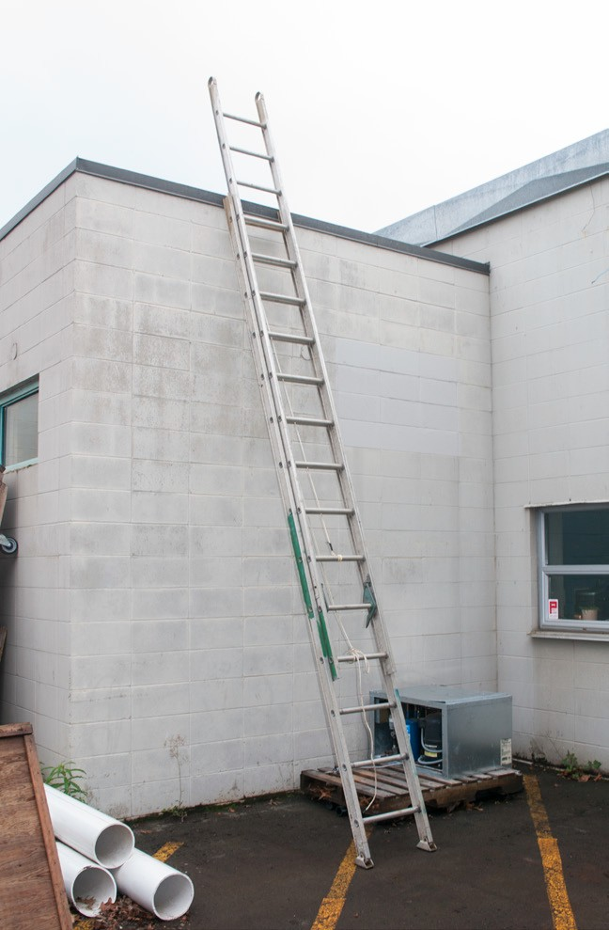
  - Grade 1 extension ladders with three sections may extend up to 22 m (72 ft.).
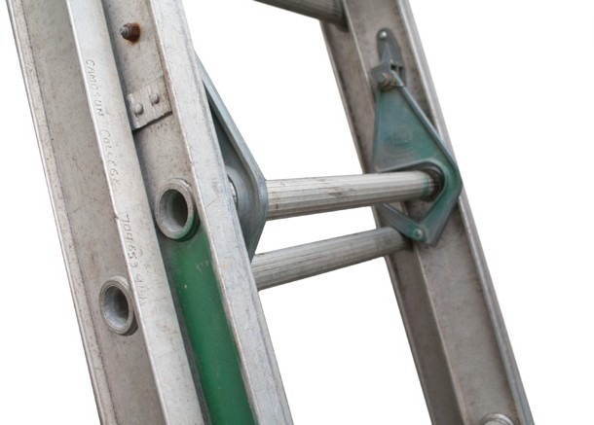
Rung lock in retracted position
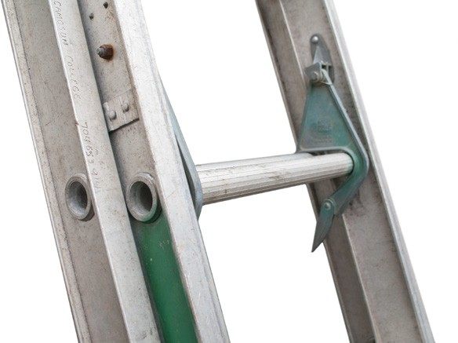
Rung lock in secured position Figure 4 — Extension ladder

Using single and extension ladders
The following rules apply to all portable ladders:
  - Inspect all portable ladders before use.
  - Do not use ladders with loose, broken, or missing rungs, split side rails, or other dangerous defects.
  - Ensure that aluminum ladders have all members true and straight.
  - Remove from use any aluminum ladder with bends, kinks, or other damage.
  - Have damaged ladders repaired by a qualified firm before putting them back into service.
  - Do not use metal ladders or wire-reinforced wood ladders near energized electrical equipment.
  - Use only transparent protective coatings or preservatives on wood ladders so that possible defects will remain visible on inspection.
  - Never reach more than one arm’s length beyond the side of the ladder.
  - Do not carry heavy or bulky items while going up or down ladders.
  - Always face the ladder when climbing up or down.
  - Maintain a three-point contact when climbing a ladder. This means either two hands and one foot or two feet and one hand touching the ladder constantly.
  - Ensure that all ladders used bear the appropriate Canadian Standards Association (CSA) label.
Watch this WorkSafeBC video: “Safe Ladder Use.”
https://youtu.be/odR0A9BywX8

Guidelines for placement of single and extension ladders
Single and extension ladders have the same basic requirements for safe placement:
  - Rest the foot of the ladder on a firm, level base.
  - Choose a ladder of sufficient length to project at least 1 m (3 ft.) above the level of the landing to which it provides access.
  - Do not stand on the top three rungs or cleats.
  - Ensure the correct slope is maintained. In Figure 5, if A is 4 m (13 ft.), then B should be approximately 1 m (3 ft.), and C should be approximately 1 m (3 ft.) above the level of the landing.

Figure 5 — Correct ladder slope

Ensure the ladder has slip-resistant safety feet or is secured to prevent slipping during use (Figure 6).
Figure 6 — Securing the base of single or extension ladders

Ensure the ladder is not resting on overhanging obstacles or a roof gutter. Use a ladder standoff, or stay (Figure 7), fitted to the top of the ladder to hold it away from the wall and to stabilize it.

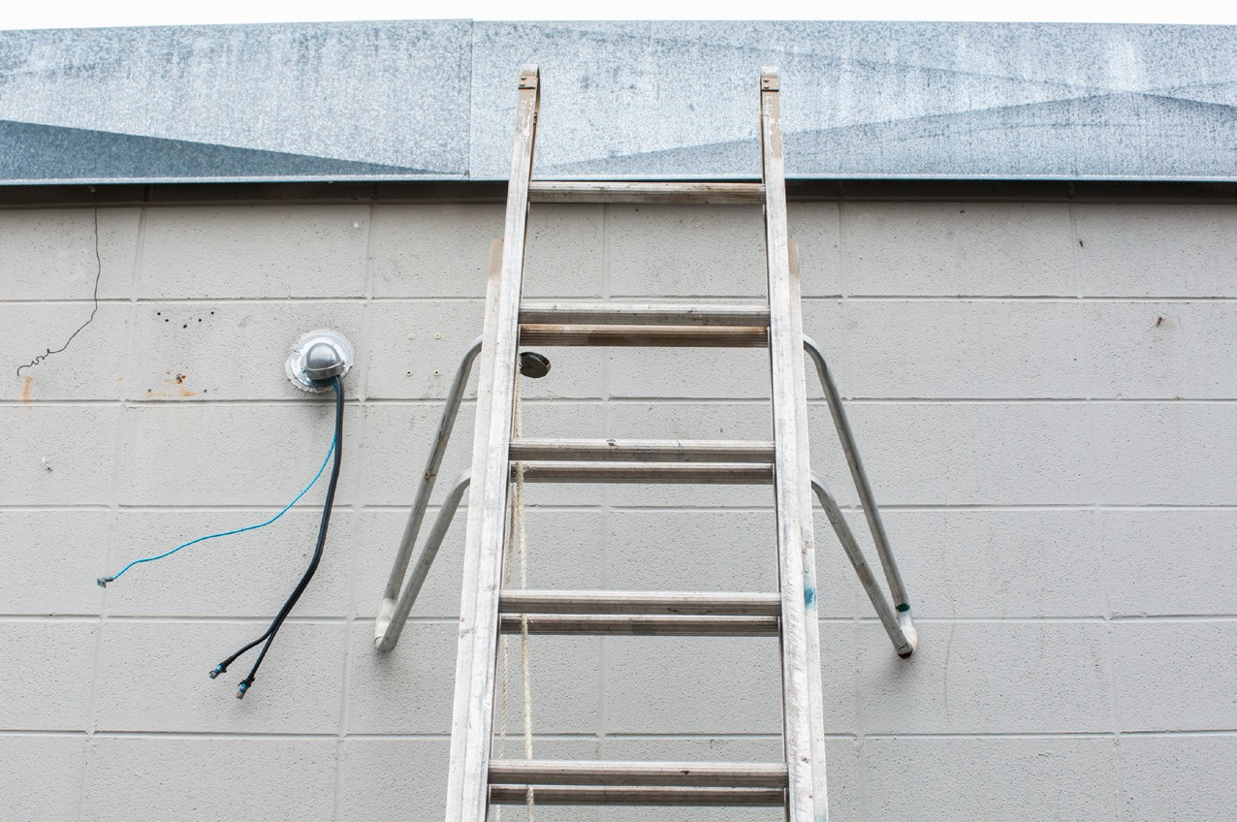
Figure 7 — Ladder standoff
Watch this WorkSafeBC video: “Ladder Setup.”
https://youtu.be/3O1rKk2F9Kk

Setting up single and extension ladders
It is important to use the correct set-up method to avoid injury to the person using the ladder or damage to the ladder itself. Before setting up, always check for overhead wires or other hazards before lifting the ladder.

Setting up alone
The following are the steps to set up or take down a single or extension ladder when you are alone:
- Lay the ladder on the ground with the base resting against the wall and the top pointing away from the wall.
- Starting at the top of the ladder, lift the end over your head and walk under the ladder toward the wall, moving your hands from rung to rung as you go (Figure 8).
- If you find you are unable to raise the ladder enough, set it back down and get help.
- Adjust the slope of the ladder so that the distance from the wall at the base is one-fourth of the height of the landing being accessed. You can count the rungs of the ladder to get a height measurement.
- If necessary, secure both the top and bottom to prevent dislodgment.
Reverse this process to take the ladder down. Remember that you will be walking backwards, so check your path for obstacles before you start. Lower the ladder slowly so that you keep it under control and prevent it from falling on you.

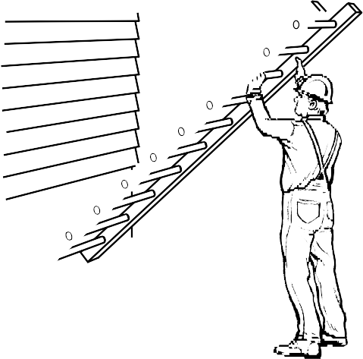
Figure 8 — Setting up a ladder alone
Watch this Camosun College video: “One Person Ladder 001.”
https://youtu.be/T0R9HWAggPM

Setting up with a helper
The following are the steps to set up or take down a single or extension ladder with someone else’s help:
- Lay the ladder flat on the ground, with its feet at the point where they will be placed during use, and with its length perpendicular to the surface against which it will be placed.
- With the helper holding the base of the ladder in place, lift the top of the ladder over your head.
- Walk down the length of the ladder, lifting as you go and moving your hands from rung to rung. Have your helper bear some of the weight of the ladder (Figure 9).
- When the ladder is straight up, lower the top gently against the wall.
- If necessary, secure both the top and bottom to prevent dislodgment.
Reverse this process to take down the ladder. Remember to check your path for obstacles because you will be walking backwards. Gravity will tend to make the ladder fall; do not lose control of the ladder.

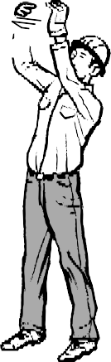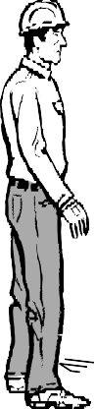
Figure 9 — Setting up a ladder with a helper
Watch this Camosun College video: “Two Person Ladder Setup.”
https://youtu.be/ZnPK6rCSd5w

Ladder inspection
The flowing inspections should be made regularly and before each use if you are not the sole user of that ladder.

All types of ladders
Check for all of the following:
  - The ladder is labelled or marked with its load and duty rating.
  - All parts are in place.
  - All parts are free of defects (cracks, dents, bends, breaks, splits, sharp edges, corrosion, rust, exposed fibreglass, rot, decay, or excessive wear).
  - Rungs and steps are free of mud, grease, oil, wet paint, snow, or other slippery substances.
  - Rungs, steps, and side rails are connected securely.
  - All bolts, rivets, nails, and screws are secure.
  - All moving parts move freely without binding or too much play.

  - Safety shoes or padded feet are in good repair and clean — not missing or loose.
  - Slip-resistant treads on feet are in good condition — not excessively worn.

Extension ladders
Check for all of the following:
  - Metal bearings in locks, wheels, and pulleys are lubricated.
  - Locks or latching mechanisms are not missing, broken, or loose.
  - Locking guides or brackets engage properly.
  - Rope tracks properly in the pulley.
  - Ropes are not frayed, cut, badly worn, burned, or showing mildew or rot.
  - Ropes are free of tangles.

Stepladders
Check for all of the following:
  - Spreader bars are tight and have all rivets.
  - Spreader bars open fully and lock.

Now complete the Learning Task Self-Test.

Self-Test 1
- What classification of ladders may be used for construction purposes?
  - Grade 1
  - Grade 2
  - Grade 3
  - Grades 1 and 2

- What is the correct incline of an extension ladder resting against a building?
  - 30 degrees
  - 5:1 ratio
  - 1 ft. vertical to 4 ft. horizontal
  - 1 ft. horizontal to 4 ft. vertical

- What is the name of the hinged arms between the two sections of a stepladder?
  - Rungs
  - Locks
  - Trusses
  - Spreaders

- On what steps of a step-ladder must the worker not stand to work?
  - Top two steps
  - Top three steps
  - Top step if the worker can reach the work
  - A worker can work off any step as long as he or she can keep balanced.

- What type of protective finish can be used on a wooden ladder?
  - Clear finish
  - Solid wood stain
  - Yellow latex paint
  - Yellow oil-based paint

- Which of the following ladders is free-standing?
  - Step
  - Single
  - Straight
  - Extension

- What is the centre-to-centre spacing of the cleats on a single ladder? a. 250 mm (10 in.)
b. 300 mm (12 in.)
c. 350 mm (14 in.)
d. 400 mm (16 in.)

- What is the correct slope for single or extension ladders?
  - 1 up the slope of the ladder to 4 horizontal
  - 2 up the slope of the ladder to 4 horizontal
  - 3 up the slope of the ladder to 1 horizontal
  - 4 up the slope of the ladder to 1 horizontal

- What is the minimum size for the side rail of a 3 m (10 ft.) job-built single ladder? a. 38 × 38 mm (2 × 2 in.)
b. 38 × 64 mm (2 × 3 in.)
c. 38 × 89 mm (2 × 4 in.)
d. 38 × 140 mm (2 × 6 in.)

- What is the minimum distance that a single or extension ladder is required to project above the level to which it gives access?
a. 500 mm (20 in.)
b. 600 mm (2 ft.)
c. 900 mm (3 ft.)
d. 1200 mm (4 ft.)

- The maximum depth allowed for notches in the side rails of a job-built ladder is 1 in.
  - True
  - False

- Longer extension ladders have a shorter overlap.
  - True
  - False

LEARNING TASK 2
Describe scaffolds
Working in an elevated situation can be very dangerous. Having a well-built scaffold or work platform provides the security needed to allow for efficient work. Employers must ensure that scaffolds used by their workers are safe, but workers themselves must also be vigilant and watch for unsafe situations.

Spend the time to review the Occupational Health and Safety (OHS) Regulation related to scaffolding before proceeding to construct a scaffold. Refer to the Regulation anytime you are unclear about any part of the construction process. Remember, the Regulation provides the minimum requirements; do not reduce or relax them in any situation.
OHS Regulation Part 13, Division 4, Sections 13.13 to 13.19
http://www2.worksafebc.com/Publications/OHSRegulation/Part13.asp
Some requirements that are relevant to all elevated work areas are in other sections of the OHS Regulation. For example:
- Part 4, General Conditions – Work Area Guards and Handrails
- Part 11, Fall Protection

Scaffold design
The OHS Regulation includes specifications for the construction of most types of scaffolds. Have the scaffold designed by a registered professional engineer if the specifications for its construction are not in the OHS Regulation.

A carpenter may design job-built wooden scaffolds and tube and clamp scaffolds following the specifications in the OHS Regulation.

The OHS Regulation does not give specifications for manufactured scaffolding components such as welded scaffold brackets and ladder-jack scaffolds. These components must have passed CSA tests and be approved for use according to the manufacturer’s specifications. Accessories that are custom built must be designed by a registered professional engineer and be certified that they are safe for use.

Manufactured scaffolds of steel and aluminum are widely used as work platforms because they are:
- strong
- lightweight
- easily assembled and dismantled
- portable

Scaffold types
There are four basic types of scaffolding:
- job-built wooden scaffolds
- job-built tube and clamp systems
- manufactured Allround systems
- manufactured welded steel frame systems
Tube and clamp systems, Allround systems, and wooden scaffolds are installed by professional specialists, and these are briefly described below. Welded frame scaffolds are supplied in ready- made units and are commonly assembled into small units of a couple of sections by many trades.

Allround scaffolding system
The Allround system is made up of four fundamental components based on a patented rosette and wedge joint (Figure 1).
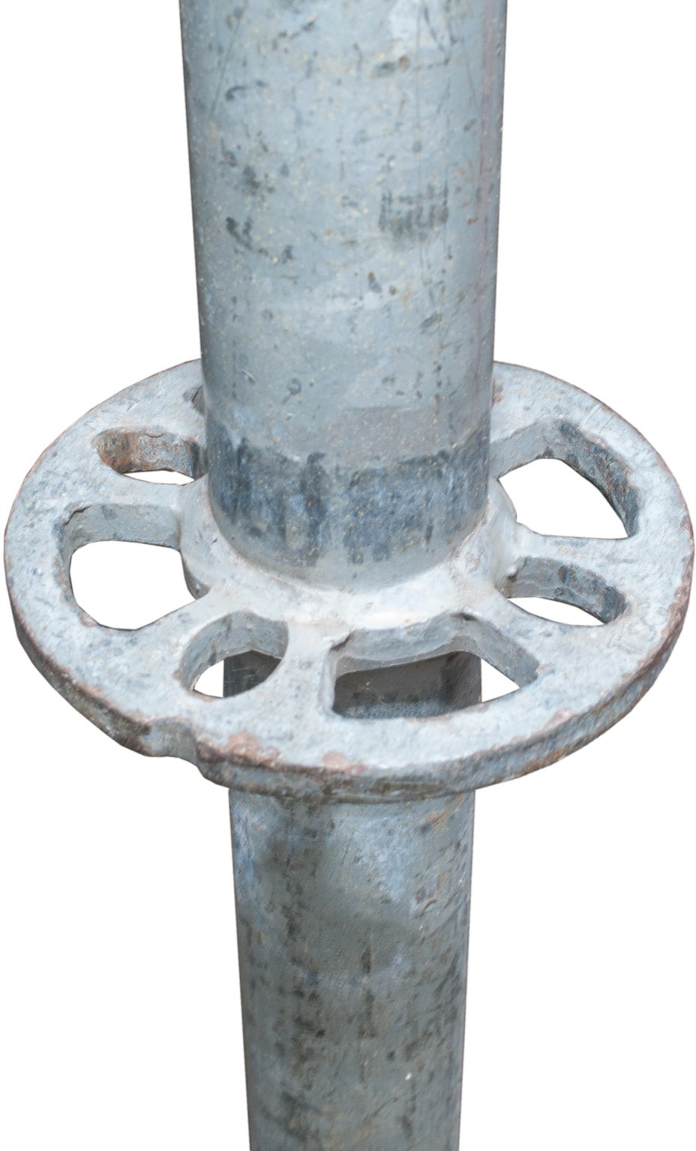
Figure 1 — Allround rosette

The basic parts are the standard ledger (Figure 2), diagonal brace (Figure 3), and adjustable base and collar shown here on an outrigger (Figure 4). This system allows the scaffold installer to build any size or shape structure without separate fittings or loose parts.
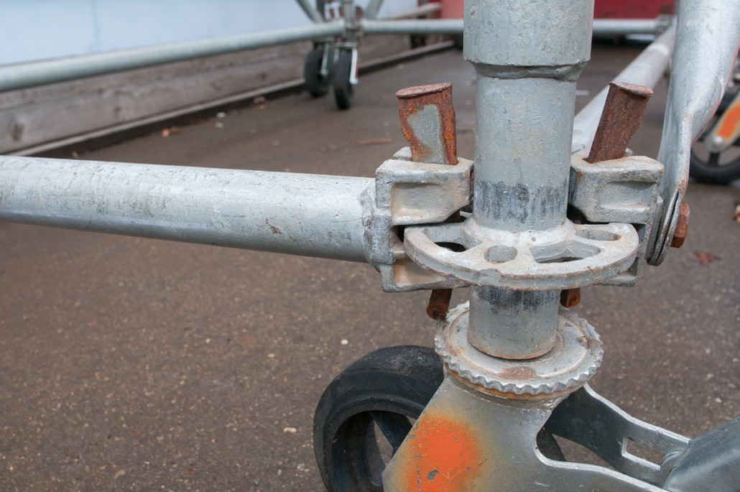
Figure 2 — Ledger and standard connection
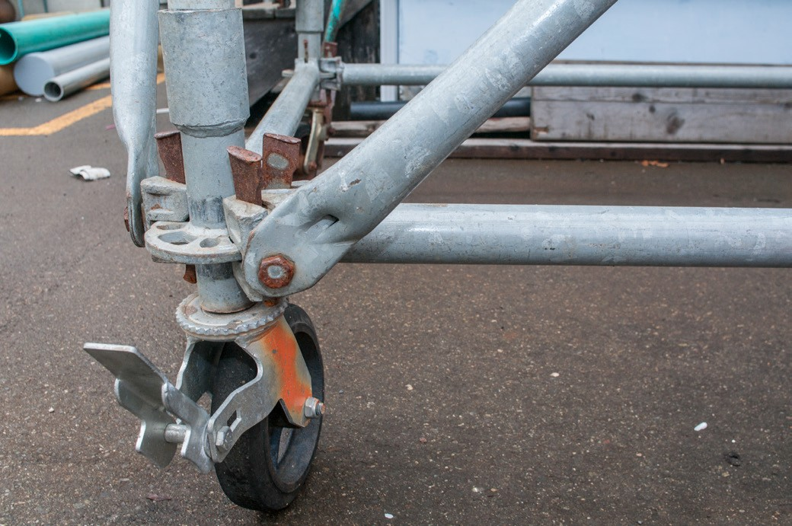
Figure 3 — Diagonal brace
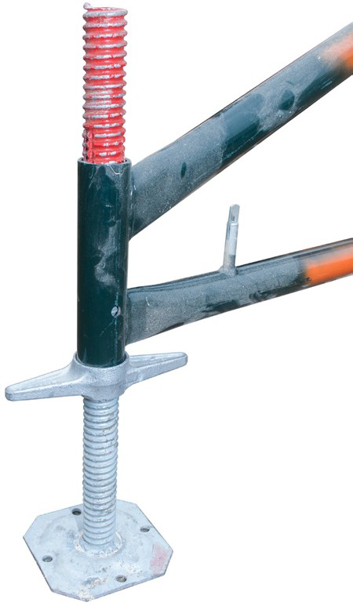
Figure 4 — Adjustable base and collar

Tube and clamp scaffolds
This highly versatile scaffolding system consists of steel tubes connected with various clamps and fixtures (Figures 5, 6 and 7). Long lengths of the tubing are available, which makes this scaffolding useful on sloping ground and in other special situations where a fixed-frame scaffold system could not be used.
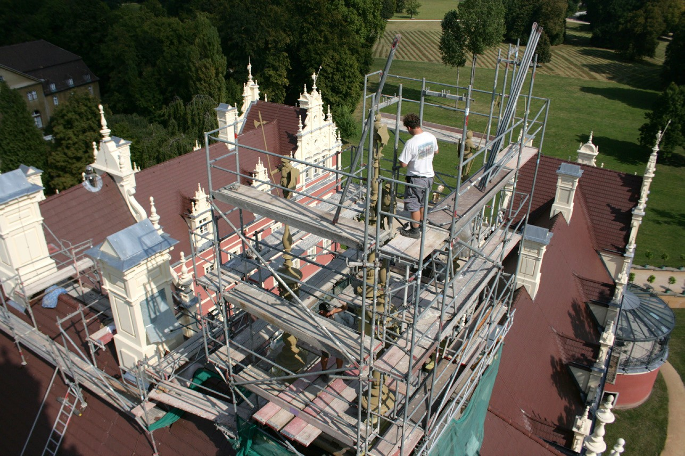
Figure 5 — A typical tube and clamp scaffold
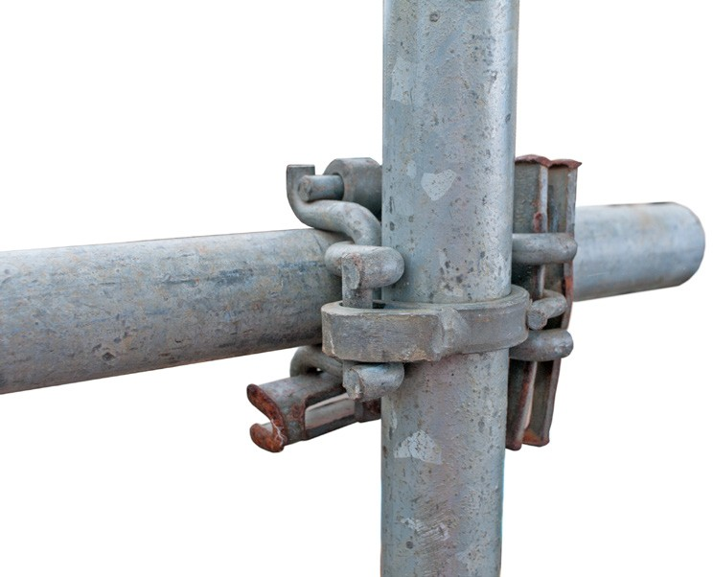
Figure 6 — Right-angle clamp
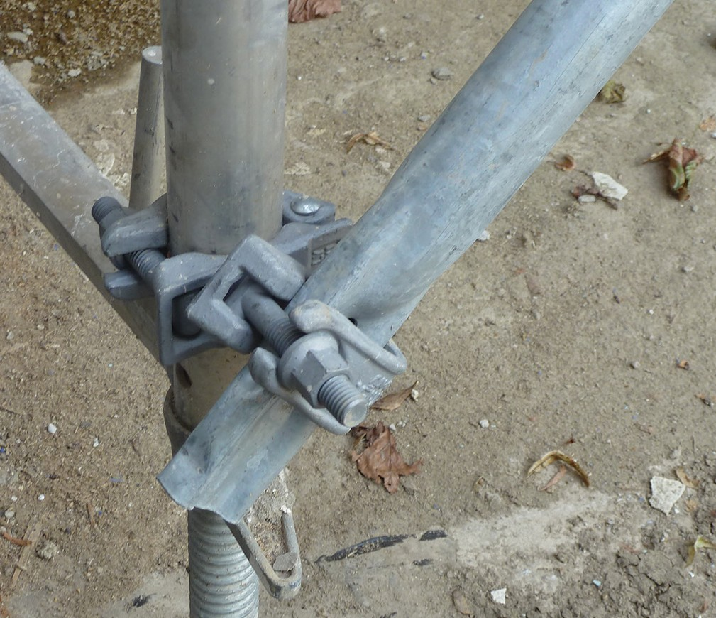
Figure 7 — Swivel clamp

Wooden scaffolds
Job-built wooden scaffolds are used when the area to which access is required is relatively close to the ground. In residential construction, where heights are relatively low and the ground is seldom level, wooden scaffolds are often used. They are very useful on sloping ground or in other situations where steel frame scaffolds cannot be used.
The OHS Regulation allows wooden scaffolds up to 15 m (50 ft.) high, but they are rarely used for work platforms above 6 m (20 ft.).
Erecting a safe wooden scaffold depends on two factors:
- an adequate supply of the correct size and grade of lumber
- qualified workers to construct the scaffold
There are two basic types of wooden scaffolds, single-pole and double-pole, and they are very similar in design and construction (Figures 8 and 9). The single-pole scaffold is for light-duty work only, but the double-pole scaffold can be used for both light- and heavy-duty work.

Upright
Top rail

Mid rail

Toe board

Bearer block Bearer

Plank

Ledger

Brace
Mud sill

Figure 8 — Single-pole scaffold

Handrail Midrail

1020 to 1120 mm
(40 to 44 in.)

Bearer

Upright

Deck

Toeboard
Ledger

Brace

Mud sill

Figure 9 — Double-pole scaffold

Welded steel frame scaffolds
On construction sites, welded steel frame scaffolds are the most widely used type of scaffold. They are often rented by the contractor for a specific job. When a large amount of scaffolding is required, there may be a separate contract for erecting and dismantling the scaffolds. Figure 10 shows a typical welded steel frame scaffold.

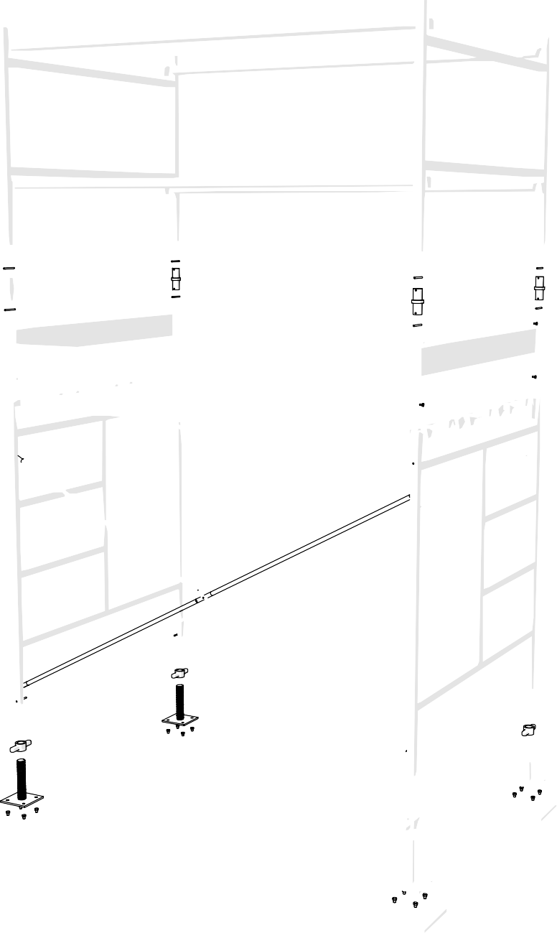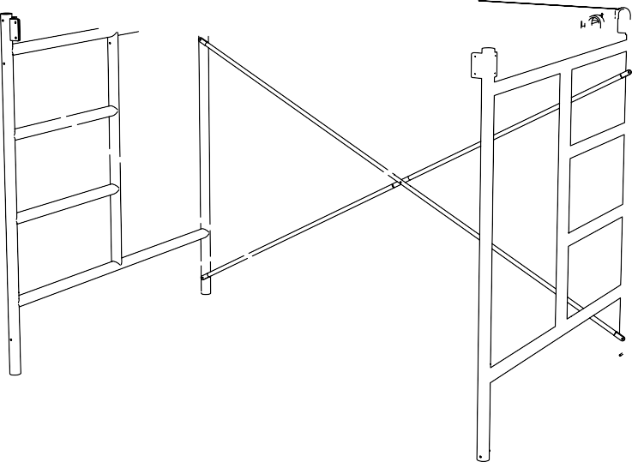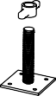Handrail

Guardrail
post

Mid rail

Coupling
Locking bolts

Toe board

Deck

Cross brace
Standard end frame

Adjustable base plate

Mud sill

Figure 10 — Welded steel frame scaffold

A welded steel frame scaffold has two basic structural parts, the end frame and the cross brace (Figure 11).
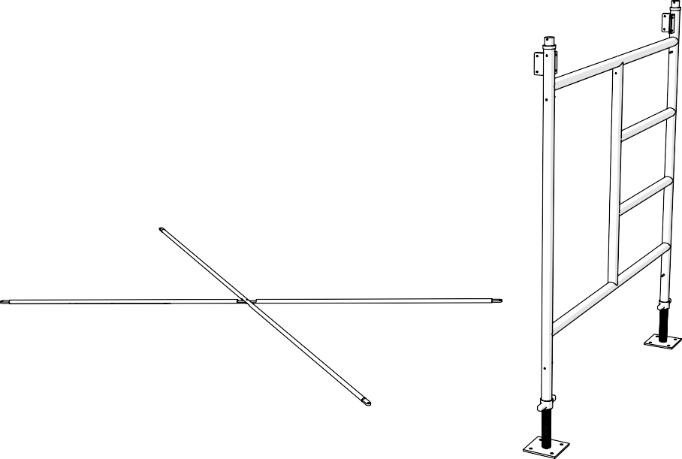
Figure 11 — End frame and cross brace

Assembling two end frames and two cross braces forms a single basic unit, as shown in Figure 12.
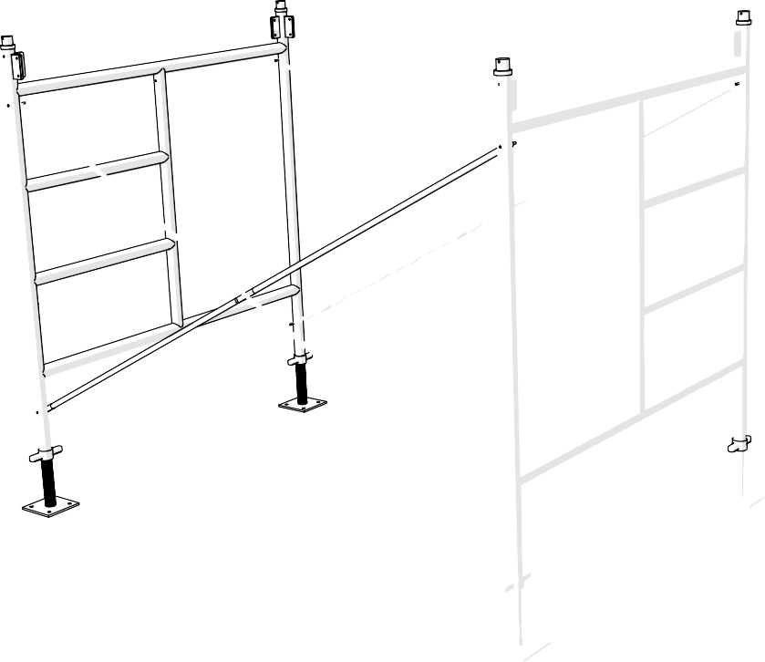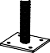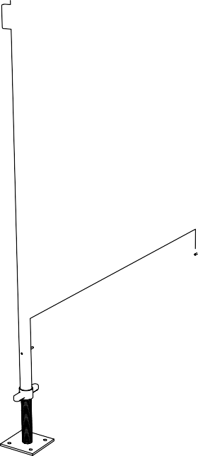
Figure 12 — The basic unit of a welded steel scaffold

It is important that the scaffold frames be level in both directions. Use levelling screw jacks if required.

When the scaffold is more than one unit high, the basic units are secured to each other by locking coupler pins inserted through the end frames (Figure 13). The pins are secured on both the top and bottom by using spring clips or bolts. The entire scaffold should be able to be lifted with a crane without the frames coming apart.
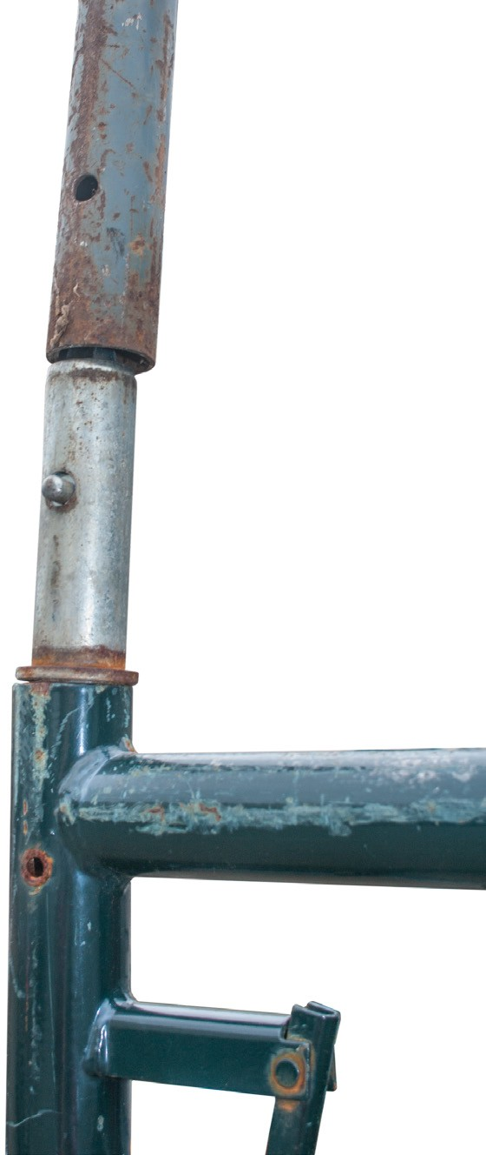
Figure 13 — Coupler pin and frames

Cross-bracing helps to keep the scaffold rigid (Figure 14). Basic units placed next to each other can be connected by cross-bracing to form longer or higher units. Cross braces do not provide the required protection to be used as a guardrail. If the work platform is above 3 m (10 ft.) from the surrounding grade, guardrails that meet the OHS Regulation standard must be installed.

Secure steel scaffolds to the building structure at 6.4 m (21 ft.) intervals horizontally. The first vertical attachment to the building must be within three times the minimum base dimension, usually 4.6 m (15 ft.), and then every 6 m (20 ft.) after that.
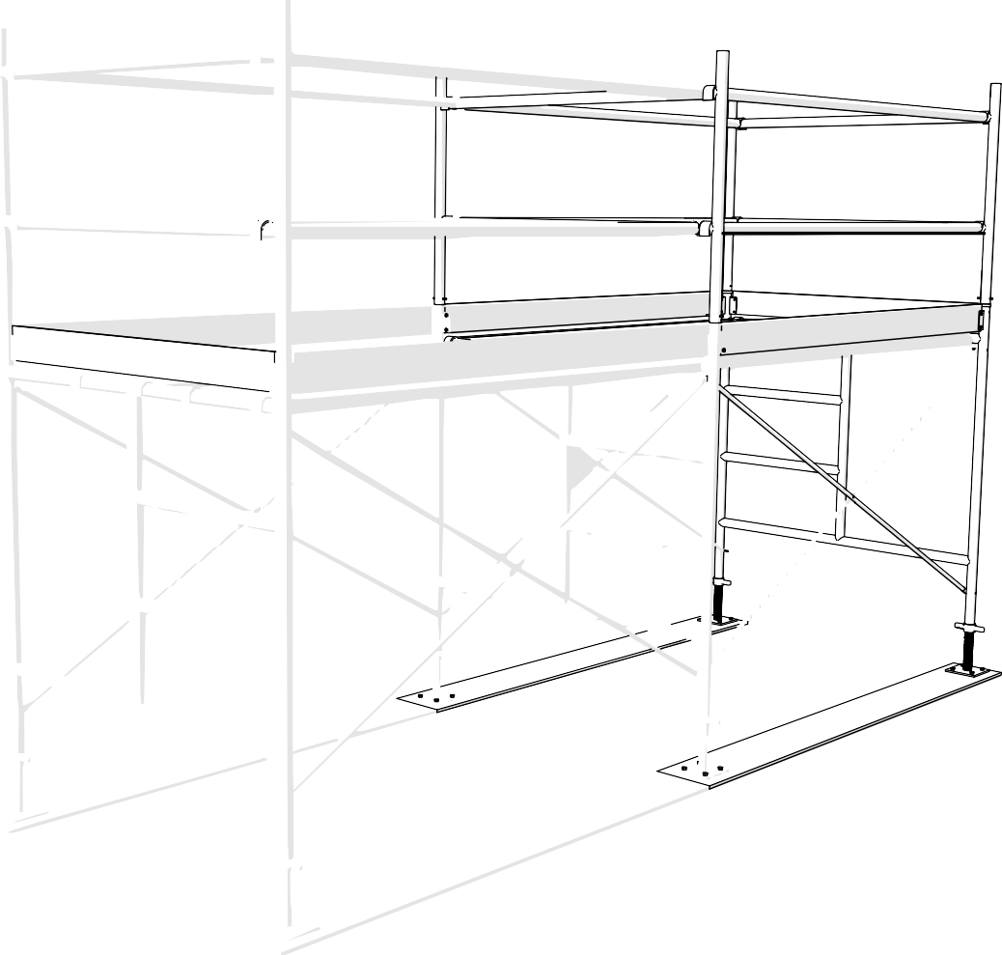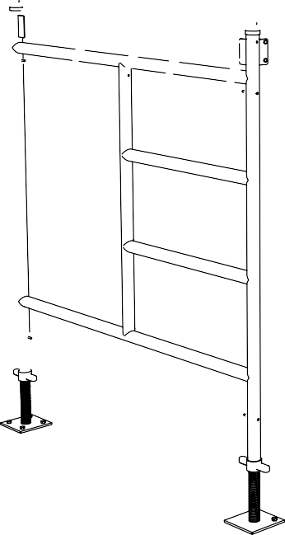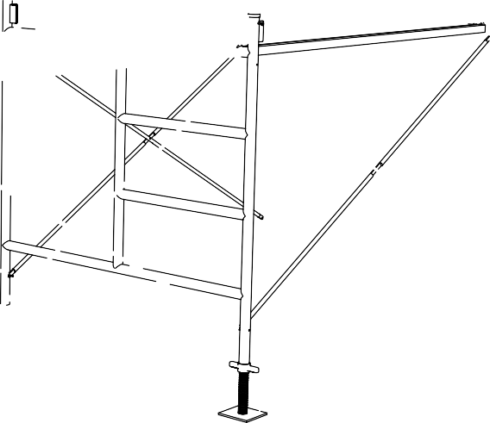
Figure 14 — Frames connected by bracing to form a long scaffold
Warning: There is a danger of electric shock when using metal scaffolds near energized electrical equipment. The structure must be grounded or equipped with resilient non-conductive tires.

Adjusting for ground conditions
Whenever scaffolds are erected they must be level and on a firm base. Soil should be well compacted to remove cavities.

If the ground is uneven, use screw jacks or adjustable base jacks to level the scaffold (Figure 15). Never use bricks, pallets, boxes, or building blocks to level the base of a scaffold.
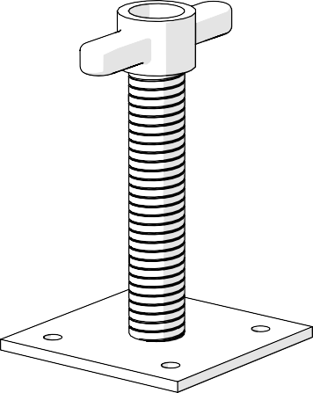
Figure 15 — Base jack

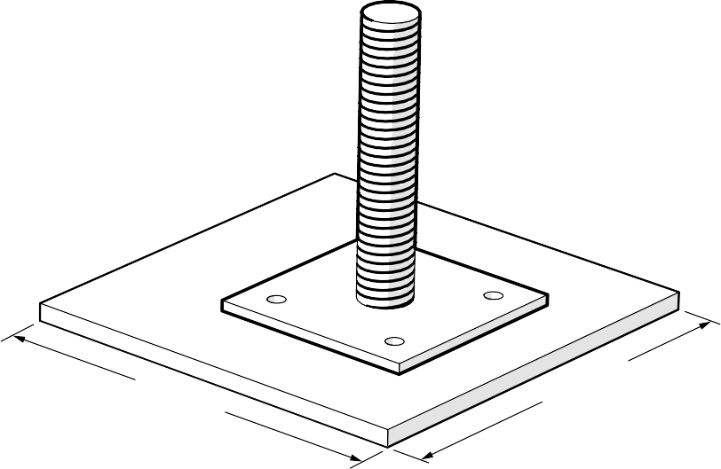
To prevent the vertical legs of the scaffold from sinking into soft surfaces, support them with mud sills, which are usually heavy wooden planks. For long mud sills, use lumber no smaller than 38 × 235 mm (2 × 10 in.). If a mud sill is placed under a single leg, it should be built from plywood with dimensions of 38 × 300 × 300 mm (1 1/2 × 12 × 12 in.). Use a base plate to spread the weight of the scaffold over the mud sill, as shown in Figure 16.

Figure 16 — Base plate on mud sill

Do not put mud sills directly onto frozen ground. Dig out the frozen ground down to a firm bearing section, or have an engineer approve the conditions.

Platforms
The planks used to build a work platform are often manufactured to match the steel scaffolding.
The planks shown in Figure 17 hook over the horizontal bars of the end frames and usually have a minimum width of 508 mm (20 in.). Manufactured planks must be designed to meet the requirements of the OHS Regulation.
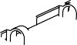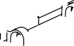
Figure 17 — Platform using three manufactured scaffold planks

If lumber planks are used instead of manufactured ones, they must be fitted with cleats on the underside to prevent them from sliding off the steel frames. Lumber planks must extend beyond the supports by at least 150 mm (6 in.) but not more than 300 mm (12 in.).

Guardrails
Whenever the work platform is 3 m (10 ft.) or more above the ground, guardrails are required on all open sides of the scaffold platform. The guardrail unit consists of a top rail, an intermediate rail, and a toe-board. The top rail is placed 1020 to 1120 mm (40 to 44 in.) above the platform; the intermediate rail is set halfway between the top rail and the toe-boards.

Guardrails can be erected at the top of steel scaffolding using manufactured guardrail posts (Figure 30) and metal guardrails (Figure 18).
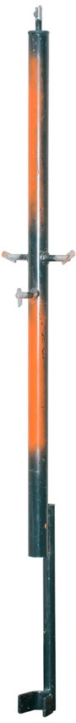
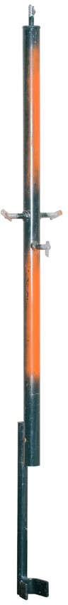
Figure 18 — Guardrail components

When manufactured guardrail components are not available, add an additional unit of scaffolding to the top of the scaffold. Attach wooden guardrails to this added section. Guardrails must be installed at the ends of the platforms as well as the sides.

Rolling scaffolds
A rolling scaffold is a steel scaffold fitted with casters (Figure 19) so that it can be moved easily. With the help of casters, even a heavy unit two or three frames high is easy to move. Rolling scaffolds must be used only on floors that are within 3 degrees of level and free of depressions and obstructions. Always cover floor openings and use curb protection when using rolling scaffolds.

All casters must be bolted or pinned to the frame so that they cannot fall out if one end of the scaffold is lifted. All casters must be bolted to the frame. Casters must be fitted with locking devices or brakes to be used when workers are on the scaffold more than 3 m (10 ft.) above floor level. Because the casters allow the basic unit to shift from corner to corner, a horizontal cross brace, called a sway brace, is installed to give the unit rigidity.
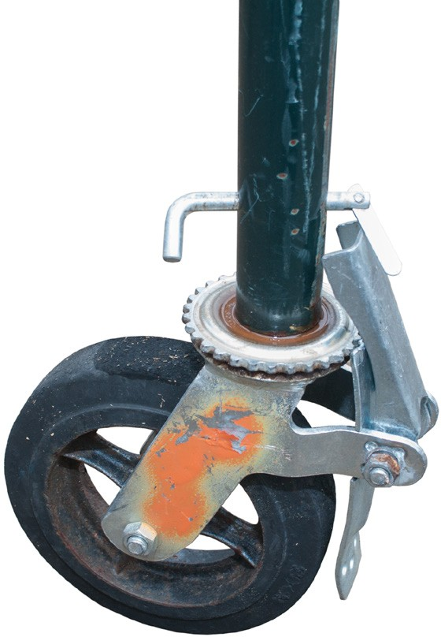

Figure 19 — Caster

The height of a rolling scaffold must not exceed three times the base dimension. When necessary, use outriggers to increase the base dimension and to allow for a higher free-standing scaffold.

The most common violation by users of rolling scaffolds is failing to install locking pins to secure the wheels in place. Accidents have happened because one of the wheels fell out when the scaffold was rolled over a depression in the ground.

Moving rolling scaffolds
If the height of the platform exceeds 1 1/2 times the minimum base dimension of a rolling scaffold, a worker on the work platform must not move the scaffold while on the scaffold.

If the height of the platform exceeds two times the minimum base dimension of a rolling scaffold, a worker must not remain on the scaffold while it is being moved from below.
To avoid accidents, follow the manufacturer’s instructions precisely when erecting manufactured scaffolds.

Ladder access to scaffolds
Ladders must comply with the OHS Regulation. Every ladder must stand on a firm and even base and be supported only by the side rails (stiles). If possible, set an inclined ladder at a slope of four vertical to one horizontal length, measured from the point of contact with the scaffold. Secure the ladder at the top and, if possible, at the bottom.

The ladder must extend at least 900 mm (3 ft.) above the platform or landing. Consult the manufacturer’s instructions for the maximum distance between platforms and the requirements for ladder heights.

The area where you access the working platform from the ladder is called the landing area, or the platform. Every landing platform must have guardrails, midrails, and toe-boards. If the landing is offset from the working platform, it must be at least 610 × 1220 mm (24 × 48 in.). Openings in the landing platform must not exceed 762 mm (30 in.).

Do not use landing platforms as work areas, and do not store materials on them.

Scaffold construction and use
It is the employer’s responsibility to ensure that scaffolds used by workers are safe, but before using any scaffold, a responsible worker always inspects it.

Keep these factors in mind:
- Only trained workers must construct and dismantle scaffolds.
- Do not use damaged materials or weakened scaffold parts when erecting a scaffold.
- When dismantling a scaffold, carefully remove each component. Pass the removed parts down to the ground. Remove any nails or other fasteners that might be a hazard.
- Take care not to overload the scaffold. Scaffolds are designed to support only workers and a suitable amount of material. Stockpiling of material is not recommended unless the scaffold is specifically designed to support the additional load.
Knowing how to assemble and use a steel scaffold safely does not guarantee freedom from accidents while working on one. Watch your step, and be prepared to hold on to something in case you lose your balance.

Erecting scaffolds
Scaffolds are not permanent structures. They need to be assembled and disassembled quickly. Despite the temporary nature of scaffolds, they must be erected on proper foundations, laid out properly, and built to specific tolerances.
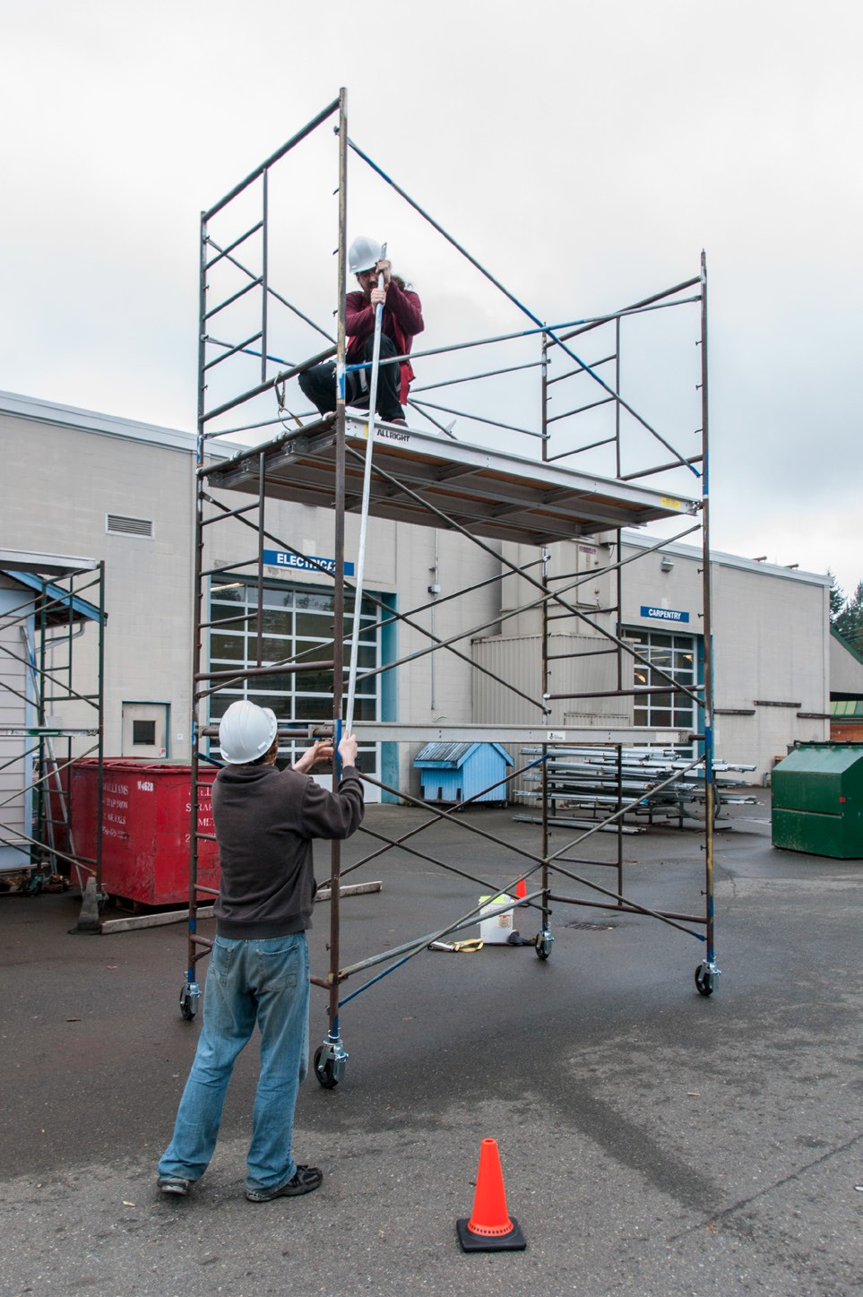
Figure 20 — Erecting a welded steel scaffold frame

Mud sills (foundations)
Scaffolds are used to access many different work areas, some very large and high. Like any structure, a scaffold needs an adequate foundation. A scaffold is a temporary structure, so usually there is no excavation or concrete footings. The foundation for a scaffold is usually a heavy wooden plank, called a mud sill.

When erecting scaffolds supported by the ground, the vertical supports must rest on a solid base. Where the ground is soft or the bearing pressure is great, spread the load over a larger area of the ground with a wood mud sill under each vertical support. A continuous mud sill supports the scaffold load over more than one vertical support. It is preferable to have continuous mud sills supporting multiple uprights at the same elevation. If that’s not possible, use a single mud sill. Mud sills must be level.

Members plumb and level
Horizontal scaffold supports must be level and vertical scaffold supports must be plumb. This is required for aesthetic as well as for structural reasons. A scaffold that looks good and is straight is a mark of a professional tradesperson and is usually safer.

Scaffold stability
A free-standing scaffold that is more than three times higher than its minimum base dimension must be fastened to the building or supported by other means.

Guardrail and toe-boards
A standard guardrail (Figure 21) must be installed if the working surface of the scaffold is 3 m (10 ft.) or more above the surrounding ground.

1020 to 1120 mm
(40–44 in.)
lumber plank overhang 150–300 mm
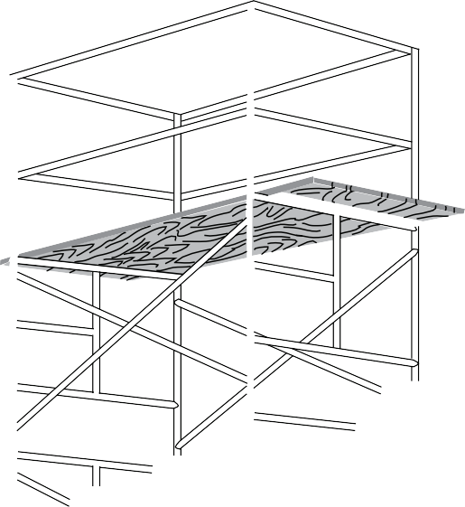(6–12")

Figure 21 — Standard guardrail

The standard guardrail shown in Figure 34 is for a steel frame scaffold, but the dimensions relating to this type of guardrail apply to all scaffolds. Fibre or wire ropes may not be used as guardrails or intermediate rails unless permission has been received from WorkSafeBC prior to erecting them.

Toe-boards prevent tools, materials, or equipment from falling off the scaffold platform. Figure 22 shows how they are installed around the open sides of scaffolds. Toe-boards must extend 100 mm (4 in.) in height above the work platform and must have no more than 13 mm
(1/2 in.) clearance between their low edges and the work platform. Toe-boards may be omitted at the access openings.

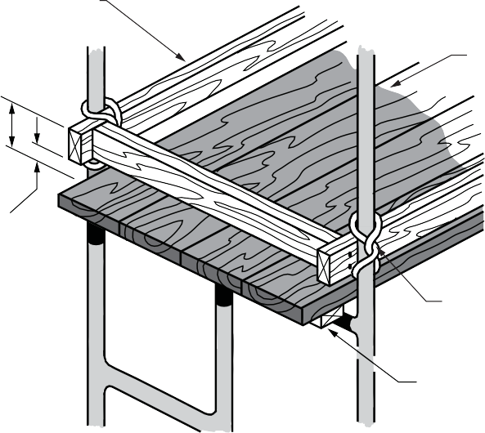
Toe-board

100 mm (4")

Maximum 13 mm (½") between toe-board and work platform
Work platform (scaffold planks)

Toe-board lashed to guardrail

Cleat

Figure 22 — Toe-board on a steel frame scaffold

Scaffold planks
Scaffold planks provide the work surface of the scaffold. They must be treated with care, and before being installed, each scaffold plank, new or old, must be inspected. If the strength of any plank is in question, it must be tested.

Lumber grades, types, and sizes for scaffold planks
The OHS Regulation requires that sawn wood scaffold planks be “select structural scaffold plank lumber” meeting National Lumber Grades Authority grading rules or equivalent. These planks must show the appropriate grade stamp.

Because most sawmills no longer deliver planks of this grade, it is generally not possible to comply with this OHS Regulation. Consequently, the OHS Regulation allows the following alternatives:

For a 3 m (10 ft.) span
- A double layer of 38 × 235 mm (2 × 10 in. nominal) dressed planks (one on top of the other with no need to nail or glue them together), graded No. 2 or better. Precautions must be taken where scaffold planking overlaps for continuous runs as the 75 mm (3 in.) height differential may create a tripping hazard.
or
- A single thickness of rough-sawn plank having actual dimensions of 48 × 251 mm (2 × 10 in.) graded No. 2 or better

For a 1.8 m (6 ft.) span
- A single thickness of 38 × 235 mm (2 × 10 in. nominal) dressed planks graded No. 2 or better

Be sure to hand pick scaffold planks for minimal knots and straight grain to ensure that they are suitable for use as scaffold planks. Use only the following lumber products for scaffold planks:
- Douglas Fir-Larch
- Hem-Fir
- Spruce-Pine-Fir
- Coast Sitka Spruce
Rough lumber is stronger and provides a slip-resistant surface. However, rough lumber is not usually graded and therefore must be inspected visually for defects before using. All planks must be of uniform thickness.

Manufactured planks
Manufactured scaffold planks must be CSA approved. Job-built planks are not approved by WorkSafeBC unless they are certified by a registered professional engineer.

Plank work platforms
Minimum work platform width is two planks or 500 mm (20 in.). Openings may not be more than the width of one plank. If the work platform is sloped, it must be slip resistant. Maximum slope is 600 mm (2 ft.) vertical in 3 m (10 ft.) horizontal, which is a 1:5 slope.

Plank support
Scaffold plank supports must be placed at least every 3 m (10 ft.) for light work, and at least every 2.1 m (7 ft.) for heavy work such as bricklaying and masonry. The planks must extend not less than 150 mm (6 in.) and not more than 300 mm (12 in.) beyond the supporting members.

General requirements for scaffolds
The following specifications apply to all scaffolds:
- Scaffolds must be erected, maintained, and dismantled under the direct personal supervision of an experienced worker.
- A spirit level should be used to set standards and ledgers accurately horizontally and vertically at each lift.
- All wood planks must be unpainted and regularly inspected for defects.
- The inner row of standards should be placed as close as possible to the wall. If they are more than one plank width from the wall, install an inside guardrail and midrail.
- The work platform must be fully planked.
- Standards must be spaced no more than 2.1 m (7 ft.) apart for heavy work and 3 m (10 ft.) apart for light work.

Now complete the Learning Task Self-Test.

Self-Test 2
- What are the two basic structural components of welded steel frame scaffolding?
  - Plank and end frame
  - Screw jack and end frame
  - End frame and cross brace
  - Coupler pin and cross brace

- Sections must be secured together when the scaffold is higher than one unit.
  - True
  - False

- What are used to connect the basic units for scaffold over one unit high?
  - Bolts
  - Screw jacks
  - Brace locks
  - Coupling pins

- Casters for steel scaffolds must have what?
  - Brakes
  - Rubber tires
  - Ball bearings
  - Levelling screws

- What is the maximum height of a rolling scaffold?
  - 2 times its minimum base dimension
  - 2 1/2 times its minimum base dimension
  - 3 times its minimum base dimension
  - 3 1/2 times its minimum base dimension

- When steel scaffolds are fitted with casters, what other component is required?
  - Mud sill
  - Screw jack
  - Base plate
  - Sway brace

- What must be used to level a scaffold on uneven terrain?
  - Mud sill
  - Screw jack
  - Base plate
  - Sway brace

- What is required when placing an end frame on a wooden mud sill?
  - Screw jack
  - Base plate
  - Brace lock
  - Sway brace

- What is the maximum allowed height for a rolling scaffold that is being moved by workers who are on the scaffold?
  - 1 1/2 times its minimum base dimension
  - 2 times its minimum base dimension
  - 2 1/2 times its minimum base dimension
  - 3 times its minimum base dimension

- What is the maximum allowed slope of the floor when using a rolling scaffold?
  - Within 1 degree of level
  - Within 3 degrees of level
  - Within 5 degrees of level
  - Within 10 degrees of level

- What is the maximum allowed height for a rolling scaffold that is being moved by workers other than those on the scaffold?
  - 1 1/2 times its minimum base dimension
  - 2 times its minimum base dimension
  - 2 1/2 times its minimum base dimension
  - 3 times its minimum base dimension

- How are connections made on the Allround scaffolding system?
  - Clamp connection
  - Coupling and bolt
  - Rosette and wedge
  - Standard and bracket

- Tube and clamp scaffolds are made of
  - Fixed units that stack up
  - Wooden members with clamps
  - Metal tubes and adjustable clamps
  - Tubular units with rosettes attached

- What is the minimum nominal width of a wooden scaffold plank? a. 140 mm (5 1/2 in.)
b. 184 mm (7 1/4 in.)
c. 235 mm (9 1/4 in.)
d. 286 mm (11 1/2 in.)

- What is the minimum height of a guardrail? a. 600 mm (24 in.)
b. 750 mm (30 in.)
c. 900 mm (36 in.)
d. 1020 mm (40 in.)

- At what height does a scaffold require a guardrail or some alternate form of fall protection? a. 1200 mm (4 ft.)
b. 2100 mm (7 ft.)
c. 2400 mm (8 ft.)
d. 3000 mm (10 ft.)

- What is the maximum amount that a scaffold plank may project beyond its support? a. 100 mm (4 in.)
b. 150 mm (6 in.)
c. 200 mm (8 in.)
d. 300 mm (12 in.)

- What is the maximum slope, vertical to horizontal, that is allowed for a work platform? a. 1:3
b. 1:5
c. 1:6
d. 1:10

- What is the maximum gap allowed under a toe-board? a. 3 mm (1/8 in.)
b. 6 mm (1/4 in.)
c. 13 mm (1/2 in.)
d. 19 mm (3/4 in.)

- What is the minimum width allowed for a work platform? a. 600 mm (24 in.)
b. 750 mm (30 in.)
  - 1 plank width
  - 2 plank widths

- What is the minimum amount that a scaffold plank may project beyond its supports? a. 100 mm (4 in.)
b. 150 mm (6 in.)
c. 200 mm (8 in.)
d. 300 mm (12 in.)

- What is the maximum spacing allowed for the supports of scaffold planks if the scaffold is to be used by a bricklayer?
a. 1800 mm (6 ft.)
b. 2100 mm (7 ft.)
c. 2400 mm (8 ft.)
d. 3000 mm (10 ft.)

LEARNING TASK 3
Describe elevating work platforms
You can see by the chart in Figure 1 that there are many types of work platforms besides scaffolds. Some platforms can be moved manually or by power, and either vertically or horizontally—or both ways.

The movable work platforms shown in the chart are broken into three groups:
- suspended staging platforms
- platforms supported by other equipment
- elevating work platforms
Suspended staging platforms are supported by lines from a building or structure and can be repositioned vertically during use.

Platforms that are positioned and supported by other equipment, such as lift trucks, cranes, or hoist-supported platforms, are movable but not elevating.

As their name indicates, elevating work platforms can self-elevate. They also include design features for lateral mobility (travel). Elevating work platforms are further divided into those that are moved by hand controls (self-propelled) and those that are attached to the deck of a powered vehicle (portable elevating work platforms).

A common example of a portable elevating work platform is a service truck with elevating equipment mounted onto it, commonly called a boom truck.

Self-propelled elevating work platforms travel under power when operated by controls on the work platform. There are two types of self-propelled units: those that are boom-supported and those that are not. The latter category includes other designs such as self-propelled scissor lifts; their versatility has made self-propelled elevated work platform very popular.

Self-propelled elevating work platforms have many other industry names, such as aerial work platforms, aerial devices, mobile elevated work platforms, and powered aerial lifts.

Other than boom supported
Boom support- ed
Self-propelled
elevating work platform
Portable
elevating work platform
Manual swing stage
Powered swing stage (portable powered platform)
Crane or hoist supported
Lift truck supported
Boatswain’s chair
Swing stage
Permanent powered platform
Elevating work platforms
Platforms supported by other equipment
Suspended staging
Movable work platforms
Scaffolds
Work Platforms
Figure 1 — Work platforms

This Learning Task looks at two types of self-propelled units: self-propelled scissor lifts and boom-supported designs. These are both generally used for temporary, flexible access purposes such as maintenance and construction work. They are designed to lift limited weights, usually less than about 1000 kg (200 lb.), and they are usually capable of being set up and operated by a single person.

Self-propelled elevating work platforms
There are several distinct types of self-propelled elevating work platforms, all of which have specific features making them more or less desirable for different applications.

Scissor and vertical lifts
A scissor lift (Figure 2) is a type of platform that can usually only move vertically. The movement is achieved through the use of linked, folding supports constructed in a criss-cross pattern.

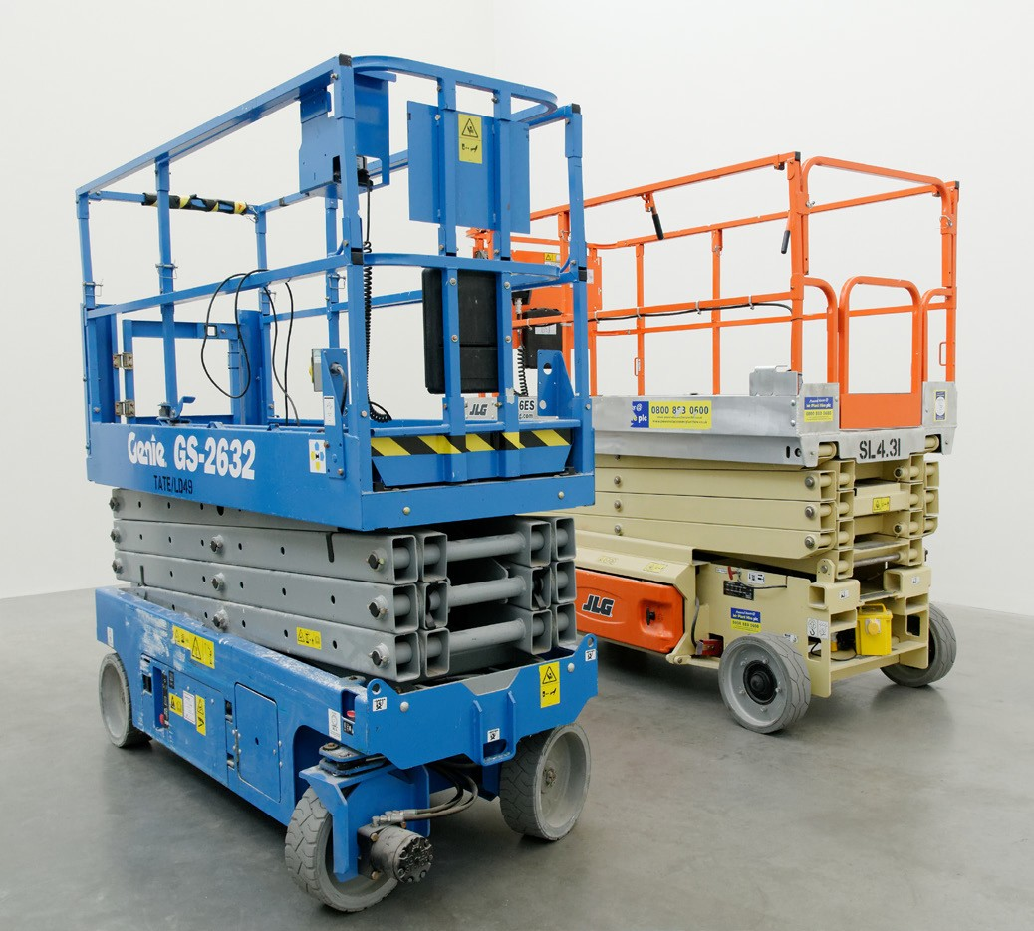
Figure 2 — Scissor lifts

The scissor action can be powered hydraulically, pneumatically, or mechanically. The platform may also have an extending bridge to allow closer access to the work area (Figure 3).
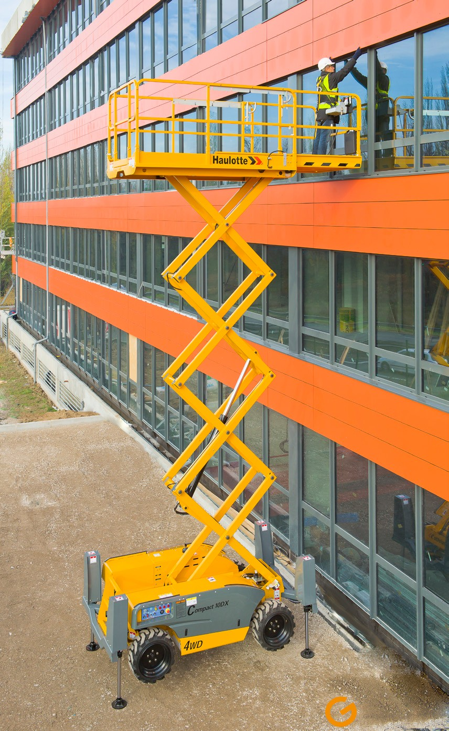
Figure 3 — An extended scissor lift with bridge in use

Boom lifts
Boom lifts come in the straight mast or articulated lift styles. These aerial devices are close in appearance to a crane, consisting of a number of jointed sections that can be controlled to extend the lift in different directions. The articulated styles can also be used for “up and over” applications.

The articulated type (Figure 4) is often referred to as a cherry picker owing to its origins, as it was designed for use in orchards. The term cherry picker has become generic and is commonly used to describe all articulated lifts.
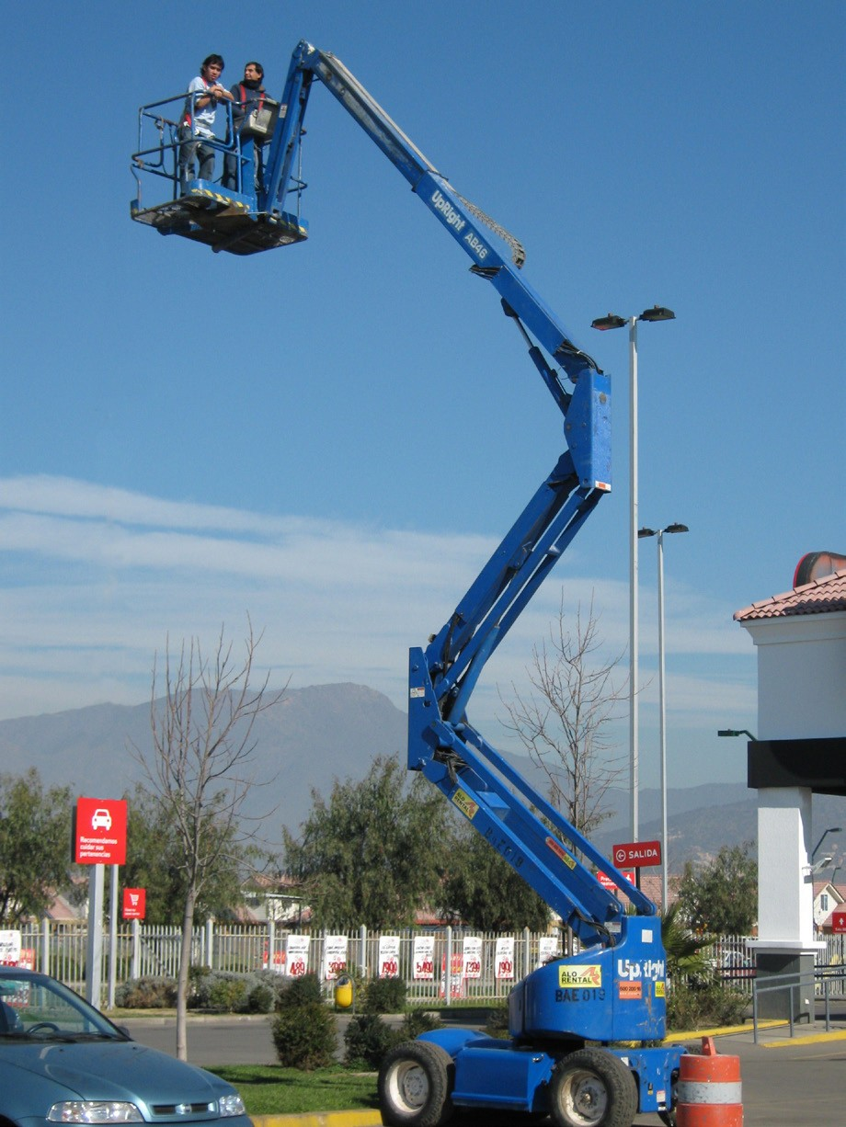
Figure 4 — Articulated boom lift

Some boom lifts are limited to the distance accessible by the length of each boom arm. However, by using telescoping sections, the range can be vastly increased (Figure 5). Some large hydraulic platforms reach heights of over 100 m (300 ft).

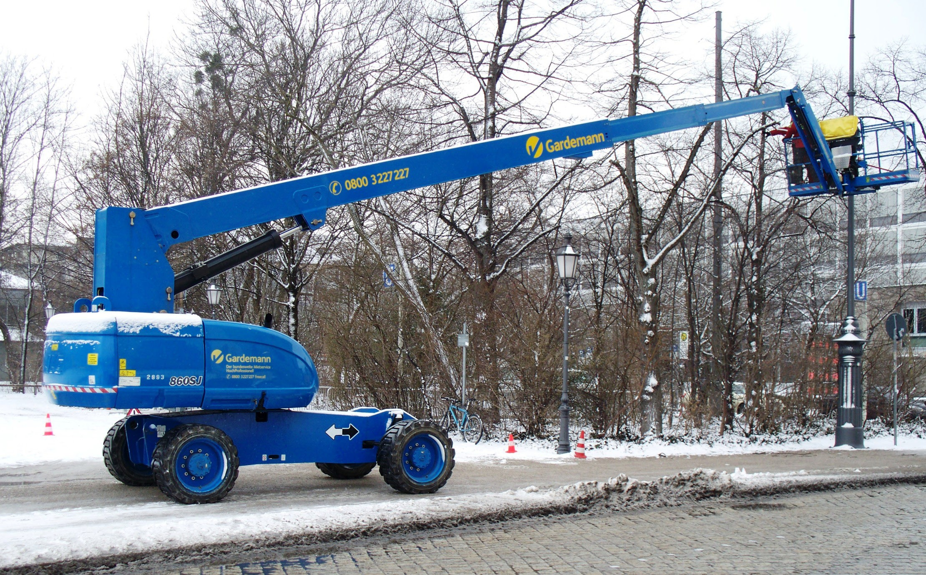
Figure 5 — Extending straight mast boom lift

Some aerial work platforms are called spiders due to the appearance of their extending legs that are required to give the unit a wider supportive base (Figure 6). Spiders are available in especially compact form to fit through doorways for use inside buildings.
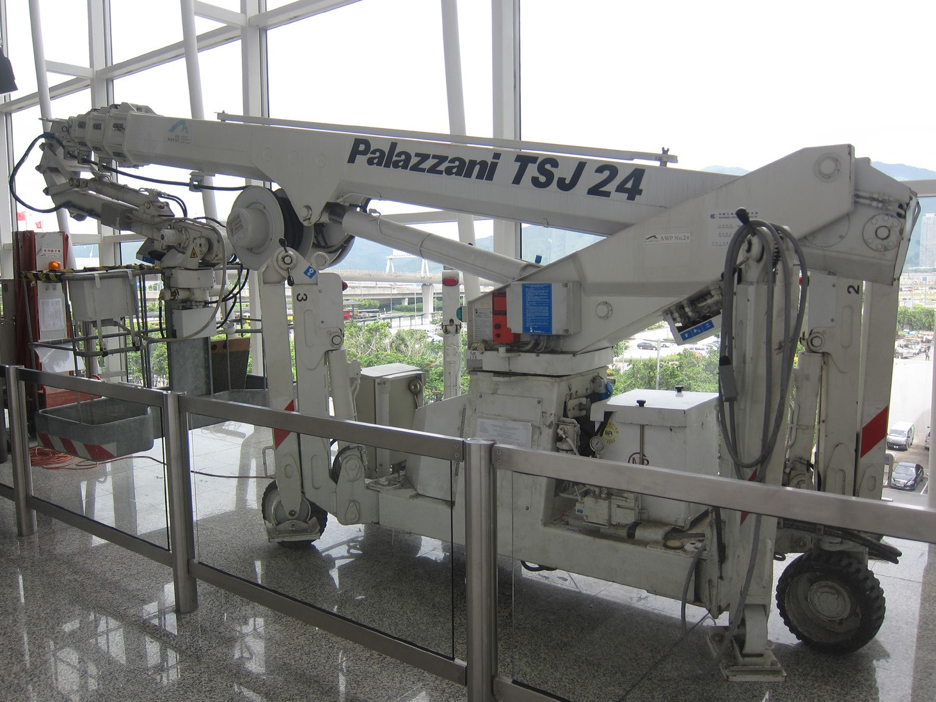
Figure 6 — “Spider” folded up, not in use, inside

Using self-propelled lifts
Employers must ensure the safe use of aerial lifts by their workers if they are required to use this equipment in the course of their employment. The majority of manufacturers and operators have strict safety criteria for the operation of these lifts.

Operating a lift
The lift functions of a self-propelled lift are controlled by an operator, who can be situated either on the work platform itself or at a control panel at the base of the unit. Some models are fitted with a panel at both locations, giving the operator a choice of position. A control panel at the base can also function as a safety feature if for any reason the operator is at height and becomes unable to operate the controls. Even those models not fitted with a control panel at the base are usually fitted with an emergency switch that allows manual lowering of the lift in the event of an emergency or power failure.

Controls vary by model, and the type and complexity of these depend on the functions the platform is able to perform. The controls can operate features such as:
- vertical movement
- lateral movement
- rotational movement
- platform/basket movement
- ground movement

Working on the platform
Elevating work platforms are fitted with safety or guardrails around the platform itself to contain operators and passengers. This is supplemented by a restraining point that is designed to secure a harness. Some work platforms also have a lip around the floor of the platform itself to avoid tools or supplies being accidentally kicked off the platform.

Limitations
Self-propelled lifts often come equipped with a variety of tilt sensors. The most common sensors include:
- height limits that cause the machine to refuse to raise the platform beyond a certain height
- platform weight off-balance limits that sense if there is risk of possible tip-over if the platform is raised further
- sensors that refuse to extend the platform if the machine is on a significant incline
- sensors that prevent operation if the weight on the platform exceeds the safe working load
As with most dangerous mechanical devices, all self-propelled lifts are fitted with an emergency stop button or buttons for use in the event of a malfunction or danger.

Extreme caution must be taken when using any aerial lifts in the vicinity of overhead power lines, as electrocution may result if the lift comes in contact with energized wiring.

Training requirements
In some countries, a licence and/or insurance is required to operate some types of aerial lifts. While there are no specific training requirements in British Columbia, best practice is to train every operator, whether mandated or not. Most manufacturers’ operating instructions prescribe a range of pre-usage checks of the unit and regular maintenance schedules.

Safety
- Make sure that workers who operate aerial lifts are properly trained in the safe use of the equipment.
- Maintain and operate elevating work platforms according to the manufacturer’s instructions.
- Never override hydraulic, mechanical, or electrical safety devices.
- Never move the equipment with workers in an elevated platform unless this is permitted by the manufacturer.
- Do not allow workers to position themselves between overhead hazards, such as joists and beams, and the rails of the basket. Movement of the lift could crush workers.
- Maintain a minimum clearance of at least 3 m (10 ft.) away from the nearest energized overhead power lines.
- Always treat power lines, wires, and other conductors as energized, even if they are down or appear to be insulated.
- Do not allow workers to belt off to an adjacent pole, structure, or equipment while working from an aerial lift.
- Always use a body harness with a lanyard attached to the boom or basket to prevent workers from being ejected or pulled from the basket.
- Set the brakes and use wheel chocks when on an incline.
- Use outriggers, if provided.
- Do not exceed the load limits of the equipment. Allow for the combined weight of the worker, tools, and materials.
- De-energize and lockout/tagout aerial lifts before performing any maintenance or repairs.

Now complete the Learning Task Self-Test.

Self-Test 3
- What best describes an elevating work platform?
  - A hoist-elevated platform
  - A platform that self-elevates
  - A platform elevated by a crane
  - A platform suspended and elevated from cables

- Which type of elevating work platform can only move vertically?
  - Spider lift
  - Boom lift
  - Scissor lift
  - Cherry picker

- What design feature gives the boom lift a large range?
  - Extending legs
  - Extending bridge
  - Telescoping sections
  - Criss-cross pattern supports

- Even though the elevating work platform is fitted with guardrails around the platform, you are still required to wear a body harness.
  - True
  - False

- What is the minimum clearance from any energized overhead power lines?
  - 1 m (3 ft.)
b. 3 m (10 ft.)
c. 5 m (16 ft.)
d. 10 m (33 ft.)

- When you have gotten the aerial lift into position to work from, you should connect your lanyard to the adjacent structure or equipment you are working on.
  - True
  - False

Answer Key

Self-Test 1
- a. Grade 1
- d. 1 ft. horizontal to 4 ft. vertical
- d. Spreaders
- a. Top two steps
- a. Clear finish
- a. Step
7. b. 300 mm (12 in.)
8. d. 4 up the slope of the ladder to 1 horizontal 9. c. 38 × 89 mm (2 × 4 in.)
10. c. 1000 mm (3 ft.)
- b. False
- b. False

Self-Test 2
- c. End frame and cross brace
- a. True
- d. Coupling pins
- a. Brakes
- c. 3 times its minimum base dimension
- d. Sway brace
- b. Screw jack
- b. Base plate
- a. 1 1/2 times its minimum base dimension
- b. Within 3 degrees of level
- b. 2 times its minimum base dimension
- c. Rosette and wedge
- c. Metal tubes and adjustable clamps

14. c. 235 mm (9 1/4 in.)
15. d. 1020 mm (40 in.)
16. d. 3000 mm (10 ft.)
17. d. 300 mm (12 in.)
18. b. 1:5
19. c. 13 mm (1/2 in.)
20. d. 2 plank widths 21. b. 150 mm (6 in.) 22. b. 2100 mm (7 ft.)

Self-Test 3
- b. A platform that self-elevates
- c. Scissor lift
- c. Telescoping sections
- a. True
5. b. 3 m (10 ft.)
6. b. False

The British Columbia Open Textbook Project
The British Columbia Open Textbook Project is funded by the B.C. Ministry of Advanced Education, and managed by BCcampus, a publicly-funded organization that uses information technology to connect B.C. post-secondary institutions under a collaborative service delivery framework. The Open Textbook Project aims to make available
openly-licensed textbooks in the province’s high-impact subject areas. Visit open.bccampus.ca for more information.

7960003686

