How to Find Creative Commons Materials Using the Creative Commons Search Portal
A Guide for Instructors and Students

Introduction
To make finding Creative Commons (CC) material as easy as possible, Creative Commons hosts a CC Search Portal on its website (www.creativecommons.org). Using the metadata that is part of all CC licences, the search portal can return results based on search terms and the type of use you want to make from a number of websites.
This guide was created to help teachers, students and curriculum units find CC-licensed material using the CC Search Portal. It forms one part of this Professional Communications OER resource pack. It is advised that you first read the chapter Adding Visuals to Enhance Communication [link] for a simple and helpful introduction to CC.

For further information visit the Professional Communications OER website at [link]

Licenses and Attributions
This work, How to Find Creative Commons Materials Using the Creative Commons Search Portal, is a derivative of How to Find Creative Commons Materials Using the Creative Commons Search Portal by the ARC Centre of Excellence for Creative Industries and Innovation, the National Copyright Unit and Creative Commons Australia, used under a CC-BY 2.5 Australia license. How to Find Creative Commons Materials Using the Creative Commons Search Portal is licensed under a Creative Commons Attribution-ShareAlike 4.0 International License by Alberta OER.

Images in this work are derivatives of web pages by Creative Commons, used under a CC BY 4.0 International License.

You should also know
The Creative Commons Search Portal is not the only way to search for CC material. You can also use Google, Yahoo! or the Mozilla Firefox search tool.
For information on how to use these different search engines, see the information guides available at http://www.smartcopying.edu.au/scw/go/pid/956

Finding CC materials using the Creative Commons Search Portal
This document is a step-by-step guide to using search tools in the CC Search Portal to find content released under Creative Commons licences. The CC Search Portal allows users to return very specific results from a number of sources. By reading the metadata embedded in the digital files of content licensed under Creative Commons, the search portal can find content that is available for certain kinds of uses, including works that are available for commercial reuse and works that are available for remixing. By limiting the search to specific sites that only include one type of content (eg videos, photos or music), the CC Search portal also lets you search for specific types of material. This can give it an advantage over the CC search tools provided by other search engines.

You should also know
It is important to consider how you want to use any CC material before you begin your search. This is because different CC licenses let you do different things. Knowing what you want to do with the material will help you choose the licence that is suitable for your use. For more information about the different license conditions, refer to https://creativecommons.org/licenses.

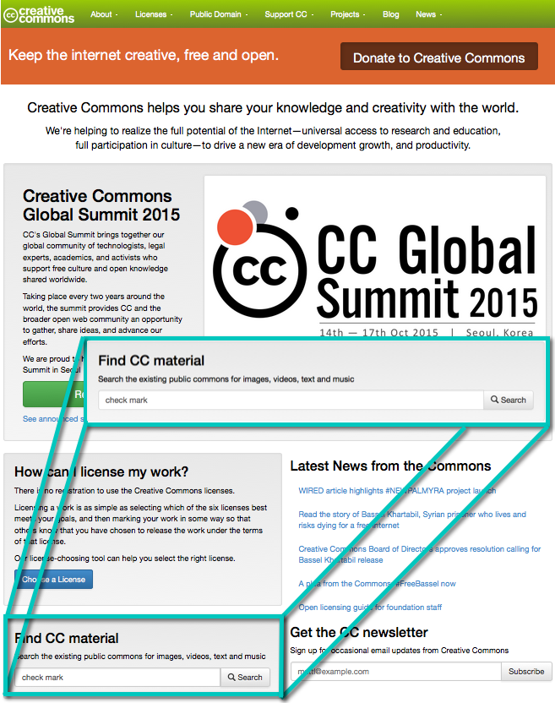
Step 1. Start a Creative Commons Search
There are two ways to get to the Creative Commons Search Portal. You can access it directly by navigating to the search portal at http://search.creativecommons.org, or you can get to it by entering your query in the 'Find CC Material' — which is about ⅔ of the way down the page on the Creative Commons website (https://creativecommons.org) — and clicking the ‘search’ button (see right).

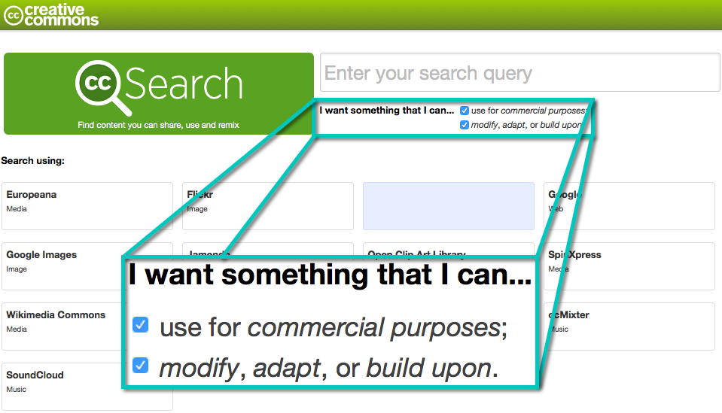
Step 2. Choose the right licence for what you want to do
To filter material based on the type of use you want to make, go to the box at the top right hand side of the search query field. This gives you two options to filter your results by: ‘use for commercial purposes’ and ‘modify, adapt, or build upon’. Select the option(s) appropriate for your use. You can select one, both, or none of the boxes. For example, if you select 'works I can use for commercial purposes', the search engine will exclude content under a licence which prohibits commercial use (i.e. that includes the Non-commercial term). Similarly, selecting 'works I can modify, adapt, or build upon' will exclude results that you cannot change (i.e. under a No Derivative Works licence). If you select both options, only results under the broadest CC licenses, Attribution and the Attribution-Share Alike, will be returned. If you don't select either of the boxes you will get material under all of the CC licences.

The table below shows how each option will filter the material by licence.
 |  | Filtering Options
 |  | Neither | Use for commercial purposes | Work I can modify, adapt, or build upon | Both
Results by License | BY | ✔ | ✔ | ✔ | ✔
 | BY-NC | ✔ | 𐄂 | ✔ | 𐄂
 | BY-ND | ✔ | ✔ | 𐄂 | 𐄂
 | BY-SA | ✔ | ✔ | ✔ | ✔
 | BY-NC-SA | ✔ | 𐄂 | ✔ | 𐄂
 | BY-NC-ND | ✔ | 𐄂 | 𐄂 | 𐄂

Step 3. Choosing the right type of material
Next you need to choose the type of content you are looking for. The Creative Commons Search Portal gives you access to a number of different search engines that let you search for different types of material. Each engine has its own tab on the search engine page.
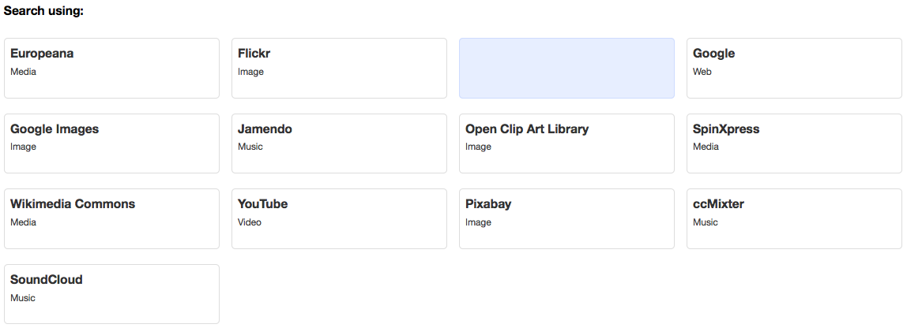
If you want to find content of all types you can use the general Google search tab, or you can limit your search to sites that only provide one type of content. The table below provides a summary of the type of content provided by each tab.

 |  | Results by License
 |  | Images | Music and Audio | Film and Moving Images | Text
Search Tab | Europeana | ✔ | ✔ | ✔ | 𐄂
 | Google | ✔ | ✔ | ✔ | ✔
 | Wikimedia Commons | ✔ | ✔ | ✔ | ✔
 | SoundCloud | 𐄂 | ✔ | 𐄂 | 𐄂
 | Flickr | ✔ | ✔ | ✔ | 𐄂
 | Jamendo | 𐄂 | ✔ | 𐄂 | 𐄂
 | YouTube | 𐄂 | ✔ | ✔ | 𐄂
 | Open Clip Art Library | ✔ | 𐄂 | ✔ | 𐄂
 | Pixabay | ✔ | 𐄂 | 𐄂 | 𐄂
 | ccMixter | 𐄂 | ✔ | 𐄂 | 𐄂

Step 4. Running the search
Now that you’ve chosen the type of licence and material you want to search for, you can enter keywords for your refined search in the search query field at the top of the page.
To run your search, you can press ‘enter/return’, 'Search', or simply click on the tab you would like to search.

Example
You are running a class project on river systems. The students are required to create a video on a river system of their choosing. In order to assist the students with this task, you are preparing a course pack that includes sample images for the students to use.
You want to conduct a search for CC images to include in the course pack. To do this you need to:
- Go to the Creative Commons Search Portal.
- As the project is designed for classroom use, there is no need to exclude noncommercial content. However, it is likely that the students will want to adapt the images so you need to limit your search for works that can be adapted or modified.
- Enter ‘rivers’ into the into the Creative Commons Search Portal query field.
- Select the ‘Flickr’ tab to look for images only and start the search.
Your search returns a number of photos that are exactly the kind of images you were looking for. You insert them into your course pack, along with the appropriate attribution details. For information on how to attribute CC material, see information guide ‘How to Attribute Creative Commons Material’ at http://www.smartcopying.edu.au/scw/go/pid/956.

This project/resource was funded by the Alberta Open Educational Resources (ABOER) Initiative, which is made possible through an investment from the Alberta government.

