Lina Gomaa
Portland State University
From MSA to CA: A Beginner’s Guide for Transitioning into Colloquial Arabic
From MSA to CA: A Beginner’s Guide for Transitioning into Colloquial Arabic
From MSA to CA: A Beginner’s Guide for Transitioning into Colloquial Arabic

© 2018 Lina Gomaa
Originally published in 2015

This work is licensed under a
Creative Commons Attribution-NonCommercial 4.0 International License
You are free to:
- Share — copy and redistribute the material in any medium or format
- Adapt — remix, transform, and build upon the material
The licensor cannot revoke these freedoms as long as you follow the license terms. Under the following terms:
- Attribution — You must give appropriate credit, provide a link to the license, and indicate if changes were made. You may do so in any reasonable manner, but not in any way that suggests the licensor endorses you or your use.
- NonCommercial — You may not use the material for commercial purposes

This publication was made possible by PDXOpen publishing initiative

Published by Portland State University Library
Portland, OR 97207-1151

About the Book: This book is for students who have studied Modern Standard Arabic (MSA) for one year or more and would like to learn colloquial Arabic basics using their knowledge of MSA. It aims at transitioning learners from Novice Mid level to Intermediate Low through presenting situations useful for living in an Arab country. The book has several features including hyperlinks, practice dialogues with open answers, cultural tips, and more.

About the Author: Lina Gomaa received an MA in Arabic/English Translation and Interpreting from University of Salford, UK. At Beloit College, USA, she obtained her BA in Creative Writing, with a minor in Journalism. Also at Beloit College, she obtained a certificate in Teaching English as a Second Language. In Egypt, Miss Gomaa obtained a BA in Arabic/English Translation and English Literature from the Faculty of Languages, Alsun, Ain Shams University. At the American University in Cairo, she received the Certificate of Teaching Arabic for non-native speakers. Miss Gomaa has taught Arabic and English to non-native-speakers at several universities in Egypt and the USA. She is a fully certified oral proficiency interviewer by ACTFL. Miss Gomaa’s research interests are second language acquisition and translation including holy texts, focusing on the Holy Quran translations into English.

Acknowledgments
This book would not have been possible without the support of the Arabic Section and World Languages and Literatures department at PSU. The Arabic Section fully encouraged me throughout the process of writing this book. Professor Yasmeen Hanoosh and Professor Jennifer Perlmutter provided full support especially when the book was just a new idea to be introduced to the Open Textbook project.
My dear colleague Cliff Breedlove’s insight, suggestions, discussions, editing and support made this book possible. He has been my fresh second pair of eyes; I am grateful to you. I thank Professor Dirgham Sbait for encouraging me to teach Colloquial Arabic and sharing his extensive experience with me.
The library team has been an asset to make this project a reality. Mrs. Karen Bjork’s knowledge in copyright, time management, and unlimited resources are priceless. She has been wonderful to work with, easing any hurdles in the way. Mrs. Stephanie Doig’s help and insight took the financial burden off my shoulders and allowed me to focus on writing. Thank you.
My dear students, John Flachetta and Mariah Denman, the delightful future of PSU Arabic studies, have been committed to learning Arabic and recording with me the dialogues for this book. Their clear and strong speaking skills are models for PSU Arabic students to follow.
I will not forget to thank all my students, whose questions, comments, and suggestions have shaped my teaching and perception of my own language, just like water is always shaping the rocks.
Thank you, Mum and Dad for your prayers, love, and belief in the importance of education and language learning.
Last but not least, I thank God: You are my light.

Table of contents
Introduction ………………………………………………………………..……….8
Abbreviations and Acronyms 12
Chapter 1 13
A: Transitioning to CA:Final voweling and greeting terms in MSA and CA 13
B: Greetings and ending conversations………………………………………...…18
1. Formal greetings conversation: at work 18
2. Informal greetings conversation: 20
3. Practice: Complete the dialogue………………………………………...….22
C: Cultural insight: Ending a conversation in a culturally acceptable manner 23
Chapter 2 24
A: Transitioning to CA: WH Question words in MSA and CA 25
Examples of using WH words in short dialogues 26
B: Requests…………………………………………………………………...…...28
1. Taxi ……………………………………………………………………….28
2. Requesting train tickets 32
3. At the restaurant……………………………………………………………..37
4. Practice: Complete the dialogue 42
C: Cultural insights: Giving directions 43

Chapter 3 44
A: Transitioning to CA: Verb tenses…………………...…………...……….….44
B: Dialogues………………………………………………………………….…46
1. At the sports club (present tense)…………………………………………….46
2. Missing a lecture at the university (future tense)……………………...……..51
3.What did you do yesterday? (past tense)…………………………………......65
4. Practice: Complete the dialogue………………………………………......…65
C: Cultural insights: Phone conversations and communicating among different age groups in the Arab world………………………………………………………….66
Chapter 4………………………..………………………………………………..67
A: Transitioning to CA: Negation in MSA vs CA……………………………….67
Mini-Dialogues: Examples of using negations and invitations…………….....70
B: Accepting and rejecting invitations……………………………………………73
- Accepting an invitation to lunch…………………………………………..…73
2. Politely rejecting an invitation to an outing…………………...……………...75
3. Practice: Complete the dialogue…………………………………………...…76 C: Cultural insights: Tips on dealing with culturally sensitive situations…….…..77
Glossary……………………………………………………………………...…...78

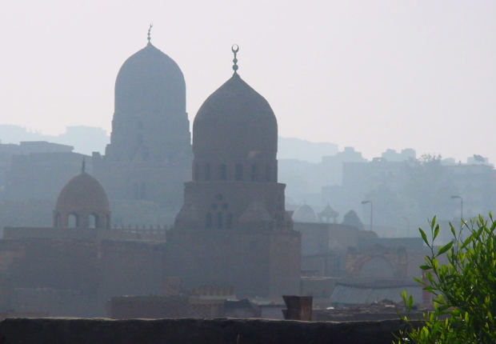
Image source: http://mrg.bz/O0aZ62

Introduction

The teaching methodology for Colloquial Arabic continues to engender controversy in the field of Arabic pedagogy. One approach is firstly teaching Modern Standard Arabic (MSA), then teaching colloquial Arabic (CA); another is introducing both MSA and CA at the same time. A third approach is starting with CA then introducing MSA, which is less common in USA and Middle East educational institutions.
At Portland State University (PSU), the Arabic program is designed to teach MSA for at least one year, after which the students can learn CA. Because of how the Arabic program at PSU is designed (similar to many programs in the USA), the importance of this book arises. This transition can be challenging for some students.
Many current texts do not address the transition from MSA to CA. Some authors assume that both varieties are taught at the same time, or that colloquial is taught first. These approaches are not the best fit for the PSU program design. This book provides information needed to transition from MSA to CA and is useful for PSU students and any student who is following the same pattern in learning Arabic.
The book targets students in NM (Novice Mid) who have studied Arabic for a year or more and aims to help them advance to IL (Intermediate Low) according to the Oral Proficiency Interview standards by ACTFL, the American Council on The Teaching of Foreign Languages. This book documents answers to questions from students in CA classes. It is also a reference for students to “get a feel” for MSA and CA similarities and differences.
Content is displayed at the beginning of each chapter. Section A discusses a feature in MSA and compares it with CA. Section B has dialogues with different topics related to section A; each dialogue is preceded by a table that has three columns: the word in Arabic, the word in English, and the equivalent word/expression in MSA. In the second column “the meaning in English,” I included both the literal meaning (LM) and the intended meaning (IM). Including the LM, as I noticed in class, makes the words/expressions more memorable to the students and more comprehensible even though it might not sound idiomatic or make full sense in English.
The last section of the chapter (C) is cultural insight related to the main topic, making the students more culturally familiar with acceptable behaviors and offering ideas to consider while living in an Arab country. At the end is a glossary organized in English for easier search.
This book is not meant to be a comprehensive treatment of all the issues arising when learning CA after learning MSA. Its goal is to transition students smoothly from MSA to CA, giving them confidence to explore both varieties while reaching the NH (Novice High) or IL level, navigate predictable social situations in CA, and utilize their previous knowledge in MSA to learn CA. The content and structure are based on my teaching experience and as an ACTFL OPI interviewer to assist students in their quest to speak CA with native speakers with relative ease.
In this book, you will notice several features, one of which is adding a practice dialogue at the end of each chapter to encourage speaking. From my interactions with beginning students, I noticed that they like to practice speaking with Arabic native speakers but are shy or not confident enough or do not know how to reach them. The practice dialogue section is a venue for gaining confidence, where the speaker in the recording pauses during the dialogue, leaving lines for the student to complete orally and in writing. This allows the student to have a real conversation during the recorded dialogue.
In addition, you will find voweling on some of the words when first introduced to help in correctly reading them. From the second time onwards, the voweling disappears. Thus, students receive help the first time when they read the full voweling of the word, then encouragement to remember the correct pronunciation by more practice, while having a reference.
Voweling is somewhat rare in CA books because this is how Arabic native speakers read. However, I noticed that students have struggled with reading and practicing many words even after listening to them in the audio recording. This is partially because many MSA books are heavily voweled. For some students studying MSA, switching to CA where the books have no vowels is unsettling. Thus, I have attempted to reach a middle ground between both approaches in this book where voweling is used only when a new word is introduced then disappears after its introduction.
Transliteration is not employed because the target students of this book have had one year of Arabic or more and can read Arabic script.
One final feature is having hyperlinks to resources, including more information about cultural items and songs. For songs in particular, I am not expecting the students to fully understand what is being said, but the exposure to the language can gradually lead to fluency, increase interest in the Arabic culture, and provide chances to listen to different speakers’ intonation and terminology.
Since I grew up in Cairo, this book introduces the Cairene Egyptian dialect; however, it also explains commonly used expressions in the Levant (Jordan, Syria, Lebanon, Palestine, and Israel). The goal is to introduce students to more varieties, allowing them to choose which dialect to specialize in and still be able to communicate with Arabic speakers. Although this book does not introduce Gulf dialects, many of the expressions and terms are frequently used in most of the Arab world, and many are derived from MSA.
I sincerely hope that this book will benefit students of Arabic at PSU and elsewhere, reduce their textbook expenses, and help them improve their CA speaking. I also hope that the dialogues (recorded by PSU students of Arabic) will be enjoyable for learners and provide successful examples for others to follow.
This book will be used in classes and the wider online audience. I welcome suggestions and comments to improve the content and format in future editions.

Learning outcomes:

On completion of this book, the students will be able to:

- Differentiate between MSA and CA (particularly Egyptian)
- Navigate predictable social situations in CA including:
- Greetings in formal and informal settings
- Asking questions and making requests
- Expressing themselves in the present, future and past in CA
- Using negation in the present
- Accepting and rejecting invitations

Abbreviations and Acronyms

CA | Colloquial Arabic
ECA | Egyptian Colloquial Arabic
LCA | Levantine Colloquial Arabic
MSA | Modern Standard Arabic
n. | noun
v. | verb
f.s. | feminine singular
m.s. | masculine singular
f.s.2 | feminine singular with second person (أنتِ)
m.s.2 | masculine singular with second person (َأنتِ)
LM | Literal Meaning (word for word meaning)
IM | Intended Meaning

Before reading this book, please keep in mind the following:

- When there are no vowels like damma, kasra, fatḥa ( تَشْكِيل، حَرَكَات ) on the last letter of the word, it is considered a sukon ْ.

Chapter 1

Contents:
A: Transitioning to CA: final voweling and greeting terms in Modern
Standard and Colloquial Arabic
B: Greetings and ending conversations:
- Formal greetings dialogue
- Informal greetings dialogue
- Practice: Complete the dialogue
C: Cultural insight: Ending a conversation in a culturally
acceptable manner

A: Transitioning to CA:Final voweling and greeting terms in MSA and CA

- One of the first points to keep in mind is that in CA, final voweling is almost absent except for words like: أهلاً، عفواً، شكراً
For example, you say in MSA, “Are you a student?”
هل أنتَ طالبٌ؟
But in CA, you will drop the final voweling as well as هل (we will explain in chapter 2 what changes take place regarding “WH-” words). So, the same question will be:
إنتَ طالبْ؟

- You might have noticed that the hamza همزة in أنتَ has changed from fatḥa to kasra but no changes have taken place on the ت. These changes will come easily to you with more listening, interacting, and practicing in CA.

Greetings terms in MSA and CA: السَلامَات و التَحيّات

- During your studies of MSA, you have probably learned greetings such as:
صباح الخير- مساء الخير- كيف حالك؟
Image source: http://mrg.bz/8JrQuM
Greetings do not significantly change from MSA to CA, but there are more expressions used in CA (with even some repetition in meaning). It is common to ask “how are you” several times using different expressions, as you will read in the coming dialogues. It is part of the Arabic culture to greet your friends or acquaintances by asking multiple times about them and their families to show warmth and care. Let’s see some examples:
التحية بالعامية  Greeting in CA | المعنى بالإنجليزية  English Translation | الرد بالعامية  Response  in CA | المعنى بالإنجليزية  English Translation | الشرح  Explanation
السّلامْ عَليكمْ | Peace be upon you. | عَليكمْ السلامْ-عليكو السلام | “On you” is peace, meaning peace be upon you. | In MSA, there is a final damma on the مُ; which is dropped in CA. This greeting is used in several settings. For example, when one is passing by a group of people and wants to say hello quickly. It will not be said to ask about how one is doing. In more religious settings, like the mosque, the م and/or final damma will be pronounced. In everyday settings, the م is often deleted and replaced by و. Listen to this funny song that might give you a feel of how native speakers use this greeting.
كِيفَك؟  كِيفِك؟ | How are you? male recipient  (LCA)  female recipient | الحَمدُلِله-  نِحْمِدْ الله-  نُشْكرْ الله-  تَمَامْ  مِنيحْ  مِنيحَة | Thank God  We Thank God  We thank God  perfect; fine  Good  When the speaker is male (LCA)  When the speaker is female. | In MSA, the attached possessive pronouns have the case endings:  كتابُكَ (your book for أنتَ)  كتابُكِ (your book for أنتِ)  In CA, the MSA final voweling shifts to the letter before the attached pronoun; كتابُكَ  becomes كتابَكْ. Similarly, كيفَكْ and كيفِكْ.
إزَيَّك؟  إزيِّك؟ | How are you? male recipient (ECA)  female recipient | Same responses as above but also you can say:  كُوَيِّس  كويِّسة | good (for a male speaker)  good (for a female speaker) | The responses listed in this row and the one above can be combined. For example, you can say:  “تَمَامْ الحَمدُلِله”; no order required or preferred.
أخْبَارَك إيه؟  عَامِل إيه؟ | How are you? male recipient (ECA) | Same answers as above
شُو أخْبَارَك؟  شُو أخْبَارِك؟ | How are you? male recipient (LCA)  female recipient | Same answers as above
صَبَاحْ الخِيرْ | Good morning | صباح النُور  صباح الفُل و(الياسمين) | Morning of light  Morning of  Jasmine  الفل:  is a kind of Jasmine | The MSA  damma on صباحُ  disappears in CA

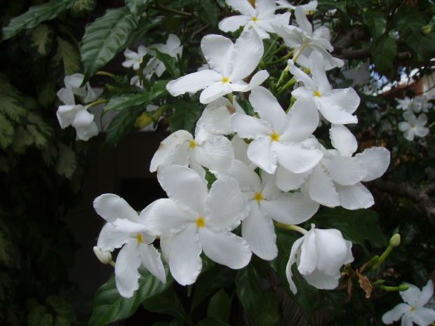
Image source: URI: http://mrg.bz/DTCpjF

B: Greetings and ending conversations

1. Formal greetings conversation: at work

مُحَادَثَة رَسْمِيَّة بالعَامِيَّة

كَلِمَات وتَعْبِيرَات مهمة:

الكلمة والتعبير بالعامية  The word and expression in CA | المعنى بالإنجليزية  The meaning in English | الكلمة والتعبير المساوي بالفصحى  The equivalent in MSA
النَّهارده | today | اليَوْم
بَسْ | but | also in CA لَكِن
شُغْل | work | also in CA عَمَل
كِتير | a lot | كثيراً  Notice that in some dialects (e.g., ECA, LCA), ث sometimes changes into ت. Other dialects (e.g., Gulf) keep it the same as in MSA.
كمان | as well/ too | also in CA أَيْضَاً
بعدين | after this/ then | ثُمّ / بَعْد ذَلِك
إنْ شَاء الله | God willing | The same expression is used in MSA.

الحِوَار رَقم (1)

This is a conversation between coworkers in a company as an example of a formal setting.

أحْمَد: صباح الخير يا سارة

سارة: صباح النور يا أحمد، إزيَّك؟ عامل إيه النَّهارده؟

أحمد: تمام، الحمد لله، وإنتِ عاملة إيه؟

سارة: كويسة، بَسْ عندي شُغْل كِتير

أحمد: وأنا كمان والله

سارة: طيب يا أحمد، نِتْكَلِّم بعدين إن شاء الله.

أحمد: إنْ شَاء الله!
Image source: Image URI: http://mrg.bz/Iy5S4b

      - Informal greetings conversation:

at a friends’ gathering

محادثة غير رسمية بالعامية

كَلِمَات وتَعْبِيرَات مهمة:

الكلمة والتعبير بالعامية  The word and expression in CA | المعنى بالإنجليزية  The meaning in English | الكلمة والتعبير المساوي بالفصحى  The equivalent in MSA
نِجِح | passed/succeeded | Same word with different internal voweling:  نَجَحَ
إمْتِحَانَاتُه | his exams:  إمتحان+ ات+ ه | same
أحْسَن مِن الأوّل | LM (literal meaning): “better than the first”  IM (Intended meaning):  the situation is better than before. | Almost the same in MSA except for changing one word:  أحْسن مِن قَبْل  You can use this above-mentioned expression in CA as well.
سؤالِك (إنتِ)  سُؤالَك (إنتَ) | your question  female recipient  your question  a male recipient | Same word with different internal voweling (on the attached pronoun):  سُؤالُكِ  سُؤالُك
حَبِيبْتِي | my dear one  a female recipient  Note, if this word is used between two people in love, it will mean “my loved one.” | Same word with different internal voweling  حَبِيبَتي

الحِوَار رَقم (2)

This is a conversation between two female friends at a gathering as an example of greetings in an informal setting.

نورا: أهلاً يا دُعاء، كيفِك؟

دعاء: ِمنيحة، نُشْكُرالله وأنتِ؟ كيفِك؟

نورا: تمام، الحمد لله. كيف (ال) ماما و(ال) بابا؟

دعاء: بِخير، الحمدلله. وشو أخبار ياسر، أخوكِ، نِجِح في إمْتِحَانَاتُه؟

نورا: الحمدلله، وكيف صحِّة جِدِّتِك؟

دعاء: أحْسَن مِن الأوّل، شكراً على سُؤالِك (يا) حبيبتي!

3. Practice: Complete the dialogue

This is an incomplete dialogue in the audio files. Practice speaking by completing the missing parts in this dialogue.

هالة: أهلاً! أهلاً! كيفك؟

إنتَ/ إنتِ: __________________، _________________

هالة: تمام، الحمد لله. كيف ماما؟

إنتَ/ إنتِ: __________________

هالة: وكيف بابا؟

إنتَ/ إنتِ: __________________، _________________

هالة: بخير، شكراً على سُؤالك!

C: Cultural insight: Ending a conversation in a culturally acceptable manner

It is polite to end a conversation gradually, whether with a coworker, a friend or a relative (especially if elderly or older than you). It is impolite to end
a conversation abruptly unless it is an emergency.
A very acceptable and polite way to end a conversation is explaining that you are sorry that you have to leave but will hopefully talk soon or meet soon (especially with older people). It is more relaxed with younger generations. Consider the following template for wrapping up a conversation, whether in person or over the phone:
أنا آسِف / آسفة بس لازم أمشي علشان . . . :

I am sorry but I have to leave (go away/ walk away) because:

عندي مِيعَاد I have an appointment
عندي شُغْل I have work
عندي إمْتِحَان I have an exam

نتكلِّم بَعْدِين / قُرَيِّب إن شاء الله.
We will talk later/ soon, God willing.

Chapter 2

Contents:

A: Transitioning to CA: WH Question words in MSA and CA with examples
B: Requests:
- Taxi
- Train tickets
- Restaurant
- Practice: Complete the dialogue
C: Cultural insights: Giving directions

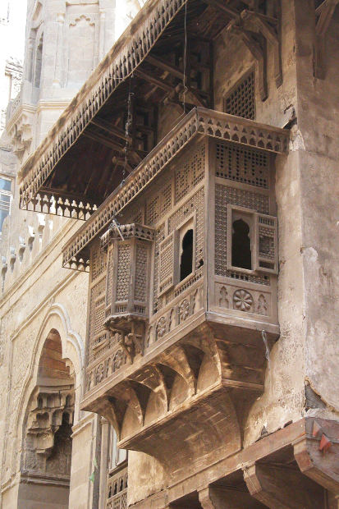
Image source: http://mrg.bz/hMIac6

A: Transitioning to CA: WH Question words in MSA

and CA

Generally, there are few internal voweling changes in the MSA WH question words when they are used in CA. Let’s have a look together:

الشرح  Explanation | المعنى بالإنجليزية  The meaning in English | أداة الاستفهام بالعامية  “WH-” word in CA | أداة الاستفهام بالفصحى  “WH-” word in MSA
Same uses as MSA | how | كِيفْ | كَيْفَ
Same uses as MSA | how much/many | كَام | كَم
Same uses as MSA | What is the cost of…? | بِكَام | بِكَم
Same uses as MSA | where (LCA)  where ( ECA) | وِيِنْ  فِيِن | أَيْنَ
Same uses as MSA | who | مِيِن | مَن
Same uses as MSA | when | إمْتَى | مَتى
Same uses as MSA | what | شُو (LCA)  إيه (ECA) | ماذا
Same uses as MSA but slight difference in pronunciation in MSA; it can be أيَّ أو أيِّ أو أيُّ depending on the words used with أيّ and its grammatical position in the sentence. | which | أيّ | أيّ
Not used in CA | for Yes/ No questions | Not used in conversations, replaced by rising intonation for yes or no questions | هل/ أ

أمْثِلَة لاستخدام أدوات الاستفهام

Examples of using WH words in short dialogues

أحمد: كيف الحال؟
سارة: الحمد لله، تمام.
__________________________________________________________
أحمد: الساعة كام؟
سارة: تقريباً واحدة.
__________________________________________________________
أحمد: الكمبيوتر ده بكام؟
سارة: ١٠٠٠ جنيه.
__________________________________________________________
سارة: فين الحمام لو سمحت؟
أحمد: على اليمين.

سارة: مين الأستاذة ديه؟
أحمد: ديه أستاذة فدوة، أستاذة الأدب الروسي.
__________________________________________________________
سارة: إمتى الحفلة؟
أحمد: الساعة خمسة.
_________________________________________________________
سارة: تحب تشرب إيه؟
أحمد: شاي لو سمحتِ.
_________________________________________________________
سارة: شو تحب تشرب؟
أحمد: قهوة من فضلِك.
_________________________________________________________
) في الصف (
سارة: الواجب في أيّ صفحة في الكتاب؟
أحمد: عشرين.
__________________________________________________________

B: Requests

1. Taxi

الحِوَار رَقم (1)

كَلِمَات وتَعْبِيرَات مهمة:

الكلمة والتعبير بالعامية  The word and expression in CA | المعنى بالإنجليزية  The meaning in English | الكلمة والتعبير المساوي بالفصحى  The equivalent in MSA
سوّاق | driver | سَائِق  Usually in CA, the ء is either deleted or changing in form. In this case, it is deleted and is replaced by a و and a ّ (shadda)
التاكسي | taxi | In MSA, sometimes سيارة أجرة is used. LM: “a car with a fare.”
آه | This word can mean “yes” in response to questions in Egyptian Arabic (as in the coming dialogue). It can also be a sound made when one is in pain. | نَعَم  Also used in CA
عَنْدَكْ (إنتَ)  عَنْدِكْ (إنتِ) | IM: “ you have”  LM: “at you” because عند means “at” & ك is an attached pronoun | Same word with different internal voweling.  أنتَ عِنْدُكَ  أنتِ عِنْدُكِ
عَدَّاد | meter | same
شوّية | a little bit  شويّة is the Egyptian for a few or little  شويّ is levant for a few or little.  Example:  I want a little water, please.  عايز شويّة ميه لو سمحت.  I want few apples, please.  عايز شويّة تفاح لو سمحت. | The equivalent in MSA is قليلاً and it can mean a few or little.
خُشْ (إنتَ) | enter (m.s.2 imperative) | No equivalent
شِمَال | left | It is used in MSA, together with يَسَار. Both are used in MSA and CA. In Gulf countries يسار is used more often
طَيِّب | OK/ alright  Note: this word has 3 meanings:  1) ok/alright  2) delicious (food)  3) kind a person) | same
شِمَال في يمِين | left then right  In this expression, means في “immediately after” (left then right immediately, with no streets/ roads in between). | Not used in MSA in this manner.

الحِوَار رَقم (1)

الزِبُونة: مصر الجِديِدة؟

سوّاق التاكسي: آه.

الزِبُونة: عَنْدك عَدَّاد؟

سوّاق التاكسي: أيوة.

الزِبُونة: تَمَام.

بَعد شوّية….

الزِبُونة: مِن فَضْلَك خُش شِمَال!

سوّاق التاكسي: طَيِّب.

الزِبُونة: عَند السوبر ماركت، خُش شِمَال في يمِين

سوّاق التاكسي: طَيِّب.

الزِبُونة: عَايزة أنْزِل هِنا لو سَمَحْت.

سوّاق التاكسي: هنا فين؟

الزِبُونة: عند السوبرماركت، إتْفضّل.

سوّاق التاكسي: شكراً.

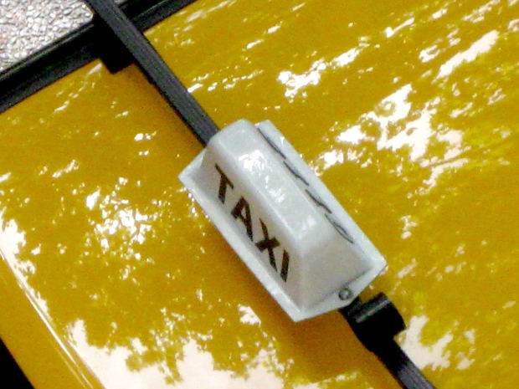
Image URI: http://mrg.bz/J9xXgG

2. Requesting train tickets

كلمات وتعبيرات مهمة:

الكلمة والتعبير بالعامية | المعنى بالإنجليزية | الكلمة و التعبير المساوي بالفصحى
لَوْ سَمَحْتِ (إنتِ)  لَوْ سَمَحْت (أنتَ) | If you please  female recipient  If you please  male recipient | Used in MSA and more formally إذا سمحت
مِن فَضْلِكْ (إنتِ)  مِن فَضْلَكْ (إنتَ) | If you please  female recipient  If you please  male recipient | Same words with different internal voweling;  مِن فَضْلُكَ (أنتَ)  مِن فَضْلُكِ (أنتِ)  As you might have noticed, أنتَ with the ء on the ‘Alif is MSA while in CA, the ء is below the ‘Alif, causing the difference in pronunciation; same with أنتِ in MSA becoming إنتِ or إنتي.
تَذْكَرَة | ticket  In some countries like Egypt and Sudan, the ذ changes in pronunciation to be z. In other countries, like in the gulf, the ذ is pronounced the same as in MSA. | same
على فين؟ | No exact English equivalent except the closest IM: “Where are you heading?”  LM: “To where?” | إلى أَيْن؟
رايح | IM is “is/are going” but it is not a verb in Arabic. It could be translated as the “goer” or in this dialogue “are going.” | ذاهب  It is اسم فاعل or active participle, meaning the doer of the action. It can replace the verb and be translated as  “going.”
رايح - جَيّ | IM: “return ticket”  LM: “ going and coming back” | ذِهَاب وإيّاب
ولّا | or | The equivalent in MSA is أو which is used in CA. But ولاّ is not used in MSA.  (Watch this song in CA where the signer is using ولاّ throughout the song).
قَطْر | train  Note: the ق in most of Egypt and parts of the Levant is pronounced as ء (a glottal stop). In some dialects, it is pronounced as ج or just like MSA. | قِطَار
الصُّبْح | the morning | الصَّبَاح
باليل | at night | باليل  Sometimes in MSA and CA في is used as well in place of ب to mean “at.”
دَرَجَة | In the context of the coming dialogue, it means “class” in a train. | Same and “step” or, if one is talking about the weather, it means  “degree temperature” درجة الحرارة
بسِتّين جنيه | IM: “60 Egyptian pounds (cost)”  LM: “ with 60  Egyptian pounds” | same
إتْفَضَّلي  إتْفَضَّل | here (offering s.th.)  female recipient  male recipient | Same but with the deletion of the initial إ in CA  تَفَضّلي  تَفَضّلْ
الفِلُوس | money | مَال
بالسلامة | IM: “travel safely”  LM: “with safety”

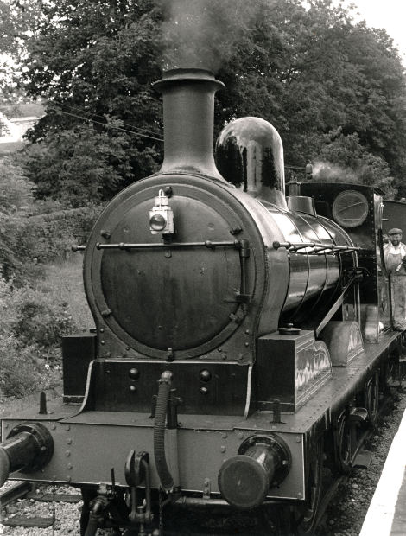
Image source: http://mrg.bz/QlDL7P

الحِوَار رَقم (2)

المُسافر: لَوْ سَمَحْتِ، ممكن تَذْكَرَة؟

المُوَظّفَة: على فين؟

المسافر: إسْكَنْدِريّة إن شاء الله

المُوَظّفَة: رايح بس ولّا رايح - جَيّ؟

المسافر: رايح بس مِن فَضْلِكْ

المُوَظّفَة: طيب، عَايِز قطر الصبح ولاّ باليل؟

المسافر: ممكن باليل.

الموظّفة: قطر الساعة كام؟ ستّة ولا تسعة؟

المسافر: تسعة.

الموظّفة: دَرَجَة أولى ولا تانية؟

المسافر: بكام تذكرة الدرجة الأولى والتانية؟

الموظّفة: الدرجة الأولى بسِتّين جنيه والتانية بأربعين.

المسافر: درجة أولى، إتْفَضَّلي الفِلُوس.

الموظّفة: بالسلامة إن شاء الله.

المسافر: شُكراً.

Note:
A very useful expression that is commonly used is “مُمْكِن” which means “It is possible.” When your intonation is rising, “مُمْكِن” means “Is it possible?” as in the previous dialogue.

3. At the restaurant

Image source: http://mrg.bz/efGBz0

كلمات وتعبيرات مهمة:

 | الكلمة والتعبير بالعامية | المعنى بالإنجليزية | الكلمة والتعبير المساوي بالفصحى
 | أهلا وسهلا فِيكِي  أهلا وسهلا فِيكْ  أهلا وسهلا بِيكِي  أهلا وسهلا بِيكْ | welcome  female recipient (LCA)  welcome  male recipient  welcome  female recipient (ECA)  welcome  male recipient | أهلاً وسهلاً بِكِ (أنتِ)  أهلاً وسهلاً بِكَ (أنتَ)
 | تحبّي…..( إنتِ) | LM: “you (f.) like”  IM: “ would you like?” when followed by a rise in intonation | same
 | المِنْيو | the menu | قائمة الطعام  Still used in restaurants and newspapers together with the borrowed word المِنْيو
 | بِدِّي  (عايز- عايزة) | I want  does not change with speaker’s gender
 | طَبق | dish or plate alternatively, unlike English. | same
 | مَلْفوف | stuffed leaves (LCA)  It is called مَحْشِي (ECA)
 | إشِي | something ( LCA)  حَاجَة  (ECA) | شَيء
 | تاني | In the context of the coming dialogue, it means “another” but it can also mean “second.” | ثاني second  "another” آخَر
 | رُز | rice | أُرز
 | حَلِيب | milk ( LCA)  (ECA) لَبَن  In Egypt, yogurt is زَبَادِي while in the Levant, لَبَن is yogurt. | same
 | شويّ | شويّ is levant for a few or little.  شويّة is the Egyptian for a few or little  Example:  I want little water, please.  عايز شويّة ميه لوسمحت  I want few apples, please.  عايز شويّة تفاح لو سمحت | قليلاً
عَجَبِكْ |  | The LM: “pleases you” | أَعْجَبكَ
طَيّب |  | delicious. See taxi conversation for more information. | same word or لَذِيِذ
الشِيك |  | LM: “check (n.)” IM: “receipt or bill” | This word can be used in MSA as a borrowed term.

الحِوَار رَقم (3)

الجارسونة: أهلا وسهلا فيكي.

الزبونة: أهلاً.

الجارسونة: شو تحبّي تِشرَبي؟

الزبونة: أَحب أشْرَب عصير لمون/ ليمون.

الجارسونة: إتفضلي المِنْيو، شو تحبّي تَأكلي؟

الزبونة: بدّي مَلْفوف وطَبق حُمّص كبير.

الجارسونة: إشِي تاني؟

الزبونة: لأ.

الجارسونة: أيّ حَلَويّات؟

الزبونة: ممكن رُز بالحَلِيب.

بعد شويّ…..

الجارسونة: الأَكْل عَجَبِك؟

الزبونة: كِتِير طَيّب، ممكن الشِيك؟

الجارسونة: إتْفضَلّي.

الزبونة: شكراً.

Image source: http://mrg.bz/e3qHas

4. Practice: Complete the dialogue

This is an incomplete dialogue in the audio files. Practice speaking by completing the missing parts in this dialogue:
كلمات وتعبيرات المهمة:

الكلمة بالعربية | المعنى بالإنجليزية
مِيدَان | (city) square
الصَيّدَلِيّة | pharmacy
الزبونة: ميدان شوبرا؟

سوّاق التاكسي: _______________________________

الزبونة: عندك عداد؟

سوّاق التاكسي: _______________________________

الزبونة: خُش شمال هنا لو سمحت عند البنك

سوّاق التاكسي: _______________________________

الزبونة: هنا لوسمحت…..هنا عند الصيدلية، إتفضّل

سوّاق التاكسي: _______________________________

C: Cultural insights: Giving directions
Giving directions in colloquial Arabic is giving hands-on directions, asking the person to take different turns and heavily using landmarks. GPS or Sat Nav has not been in much use in several Arab countries. Many people depend on each other for directions. For example, it is very common in Cairo for taxi drivers to ask pedestrians for directions or even drivers ask taxi drivers while waiting in a stop or sometimes while driving!
Landmarks can be supermarkets, pharmacies, restaurants, banks, etc. You can be given an address whose literal translation sounds like this:
17 Ahmed ‘Orabi Street by HSBC bank, first floor, apartment 5.
In Arabic:
١٧ شارع أحمد عرابي بجانب بنك مَصر، الدور الأول، شقة ٥
Therefore, when you are going to a new place, leave early and keep the phone number of the destination available to call in case you need further directions.

Chapter 3

Contents:
A: Transitioning to CA: Verb tenses

B: Dialogues:

- At the sports club (present tense)

- Missing a lecture at the university (future tense)

- What did you do yesterday? (past tense)

- Practice: Complete the dialogue

C: Cultural insight: Phone conversations and communicating with different age groups in the Arab world

A: Transitioning to CA: Verb tenses

In MSA, there are additions, known as prefixes and suffixes, added to the root when the verb is conjugated in the present tense. These remain largely the same in CA, but in some dialects (ECA, LCA), بَ is added at the beginning of the verb to indicate habitual action. For example:

MSA: آكُلُ التُفَاحَ في الصَبَاحِ

CA: بَآكُل التُفاحْ في الصَباحْ

Let’s read and listen to more examples of present tense conjugations in MSA and CA:

المعنى  Meaning | الفعل المضارع في العامية  Present Tense (CA) | الفعل المضارع في الفصحى  Present Tense (MSA) | الضمائر المنفصلة  Independent Pronouns
I understand | بَافْهَم / بَفْهَم | أَفْهَمُ | أنا
read (m.s.2) | بَتَقرا | تَقْرَأُ | إنتَ  (أنتَ MSA)
write (f.s.2) | بِتِكْتِبي | تَكْتُبِين | إنتِ  (أنتِ MSA)
he eats | بِيَاكُل | يَأْكُلُ | هو
she plays | بِتِلْعَب | تَلعَبُ | هي
we drink | بِنِشْرَب | نَشْرَبُ | إحنا  (نحن MSA)
you (all) cook | بِتُطْبُخُوا | تَطْبُخونَ | إنتو  (أنتم MSA)

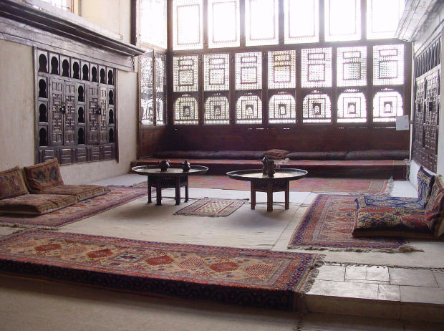
Image URI: http://mrg.bz/rG0zHj

B: Dialogues

At the sports club
كلمات وتعبيرات مهمة:
الكلمة والتعبير المساوي بالفصحى | المعنى بالإنجليزية | الكلمة والتعبير بالعامية
same | the club  Unlike English, where the club can be a night destination for dancing and partying, النادي in several Arab countries refers to a sporting club. For nightclub, “disco” or “night club” is used. | النادي
أين أنتَ؟  The expression مِن زمان means from a very long time. Listen to this song. | LM: “Where are you from a long time?”  IM: “Where have you been?” | أنتَ فين من زمان؟
N/A | LM: “Whoever sees you will live.” A compliment signifying happiness to see the person, usually said when two people have not seen each other in a long time. | عاش مِن شافِك  (إنتِ)
same | LM: “by God”  IM: emphasis | واللهِ
same | busy | مَشغول
same | work | شُغْل
same | LM: “to the extent that you forget your friends” | لدَرجة إنك تنسى أصحابك
أصْحُو أو أسْتَيقِظ | ب+اصحى  I wake up | باصحى
ثُمَّ | then | وبعدين
أفطر | ب+ افطر  I eat breakfast | بافْطر
N/A | LM: “along the length”  IM: “all the time”  The expression can also mean “immediately,”  or “straight” when giving directions, or “honest” when describing a person. | على طول
same | meetings  singular: إجْتِمَاع | إجْتِمَاعَات
same | discussions  singular: مُنَاقَشَة | مُنَاقَشَات
same | fights and arguments | خِناقات
ضَوْضَاء | noise | دَوشة
Same, but the preposition used after this verb is إلى. | I return  أرجع ل…  أرجع لبيت أحمد  I return to Ahmed’s house | أرْجَع
آكل العشاء  The ء in MSA changes in CA or sometimes deleted. | I eat dinner | باكل العَشا
أنام | I sleep | بانام
يَوْمُكَ m.s.2  يَوْمُكِ f.s.2 | your day (f.s.2) | يُومَك
مَليء | filled (objects)  chubby (person) | مَليان
same | boss/ director | المُدير
same | responsible for | مَسْؤول عَن
شيء | something ( ECA) | حَاجَة
same and also أطْفَالي | my children | أوْلادي
أُذَاكِرُ | I study | بازاكِرْ
same and “duties.” | homework (it is plural in Arabic)  LM: “ assignments” | الوَاجِبات
أَذْهَبُ | I go | بارُوح
الله مَعَك  ومعك | May God be with you  رب+ نا= Our  God/Lord  مع +ا+ ك (ي)=  With you  LM: “and with you”  IM: “May God be with you as well.” | رَبِّنا معاكي  ومعاك

الحِوَار رَقم (1)

(في النادي)

هُدى: مَحْمُود….يا محمود!

محمود: أهلا أهلا! هدى! ياه!

هدى: إنتَ فين من زمان؟

محمود: عاش مِن شافِك…. أنا و الله مَشغول في الشُغْل

هدى: ليه؟ لدَرجة إنك تنسى أصحابك! لا لا!

محمود: و الله كل يوم، باصحى بدري حوالي الساعة سِتة و بعدين أَسوق للشُغل و بعدين بافْطر هناك…و على طول إجْتِمَاعَات و مُناقشات و خِناقات….دَوشة… و بعدين بأرْجَع البيت وباكل العَشا و بانام.

هدى: ياه! إنتَ يُومَك مَليان شُغْل!

محمود: أنا المُدير و مَسْؤول عَن كُل حاجة…إنتِ عاملة إيه؟

هدى: و الله ، أنا كمان مشغولة مع أوْلادي...كُل يوم بازاكِر معاهم للوَاجِبات و بارُوح مَعاهم المَدرَسة و بنام الساعة عَشرة بَعد يوم طويل...بَس بِنْروح النادي كُل يوم جُمعة.

محمود: رَبِّنا معاكي يا هُدى

هدى: ومعاك يا محمود…تِحب نِلْعَب تِنس؟

محمود: يلا!

How to form the future tense:

In MSA, there are two ways to form the future, by adding سَ as a prefix or the word سَوْفَ , both before the present tense. For example

ألعب في النادي. I play in the (sporting) club.
سألعب في النادي. I will play in the (sporting) club.

In CA, the equivalent of س is the letter ه or ح.

حالعب في النادي. I will play in the (sporting) club.
هالعب في النادي. I will play in the (sporting) club.

2. Missing a lecture at the university

كلمات وتعبيرات مهمة:

الكلمة والتعبير المساوي بالفصحى | المعنى بالإنجليزية | الكلمة والتعبير بالعامية
It said in several different ways:  ماذا بِكِ يا نادية؟  هل هناك شيء ما؟ | What is wrong, Nadia? | إيه يا نادية؟
هل أنتِ مَرِيضة؟ | Are you sick? | إنتِ عَيّانة؟
same | LM: “At me is cold”  IM: “ I have cold” | عَنْدي بَرْد
سأذهب | I will go | حَارُوح
سأذهب إلى الدكتور.  أو  سأذهب إلى الطبيب.  Notice that the preposition after أذهب in MSA is إلى while it is لِ in CA. | I will go to the doctor. | حَارُوح لِلْدُكْتُور
غداً | tomorrow | بُكْرة
سأشتري  سوف أشتري | I will buy | حَاشْتِرِي
دواء | medicine | دَوَا
same | vitamin C | فيتامِين سِي
same | May you feel better. (root س.ل.م) | سَلامْتِك
same | response to the previous LM: “May God make you safe/sound” | الله يِسَلِّمِك
It means “correct.” | “correct” or “by the way,” as in the following dialogue. | صَحيح
هناك واجب فاتَني | There is = فيه  LM: “There is homework which I missed/passed by me.”  فاتني = فات + ن+ي  فات: gone  ن is added with the attached pronouns in verbs (an MSA rule extended to CA).  ي means mine (an MSA possessive pronouns used in CA). | فيه واجب فَاتْنِي
سنقرأ  سوف نقرأ | we will read | حنقرا
same | the first part/ chapter | الجُزْء الأول
same | the novel | الرُوَاية
same | for (the) lecture  ل+ محاضرة | لِمُحاضرة
same | English literature | الأدب الإنجليزي
سنكتُب  سوف نكتُب | we will write/compose | حَنِكْتِب
same | research/paper | بَحث
أخذُ  In some dialects, the ذ stays the same as MSA and in others like ECA, ذ changes into د. | I take | آخُد
آخذ منك | I take from you | آخُد مِنّك
same | lectures | المحاضرات
هذه | this (non-human plural as well as singular feminine) | ديه
same | Thursday | يوم الخميس
same | surely | أكيد
سأعطِيكِ  سوف أُعطيكِ | I will give you (f.s.2) | حادِّيكي
سأراك  سوف أراك | I will see you | حشوفك
same | at/in the cafeteria | في الكافيتريا
Complimenting and thanking for people’s help is crucial in the Arabic culture. This expression and its response can be said in different ways but the message is the same. | LM: “I made you tired with me.”  IM: “I caused you lots of trouble.” (an expression to thank a person for help)  The response LM: “there is neither tiredness nor anything.”  IM: “there is no trouble at all.” | تَعبْتِك معايا  مافيش تَعب ولا حاجة
same | LM: “peace.” (shortened form of good bye)  It is used among young people who are close friends. It is considered rude if it is at the end of a conversation with an elder.  The response is the same. | سلام
N/A | term of endearment  In the Arabic culture, they give each other endearing names. If the person’s name has a ن like in نادية, the endearing name could be نونو. If the person’s name is جمال, the endearing name could be جيمي or جوجو. Also also used with babies and children. | نونو
same | LM: "beautiful." (Used in this context to express endearment. Only used among close friends and loved ones.) | جَمِيلة

Listen to the conversation between two female friends over the phone; Nadia is sick and has missed lectures at the university.

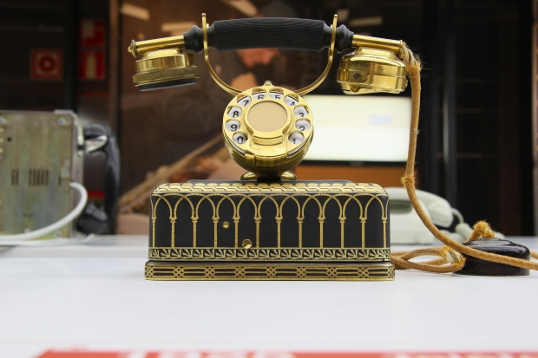

Image URI: http://mrg.bz/diRzJI

الحِوَار رَقَم (2)

نادية: آلو...مِين معايا؟

هُدى: أنا هدى...إيه يا نادية؟ إنتِ فين؟ إنتِ مِش في الجامعة ولا في النادي... إنتِ عَيّانة؟

نادية: أيوة، عَنْدي بَرْد. حَارُوح لِلْدُكْتُور بُكْرة و حَاشْتِرِي دوا و فيتامِين سِي.

هُدى: سَلامْتِك.

نادية: الله يِسَلِّمِك...صَحيح، فيه واجب فَاتْنِي إنَّهَارْده في الجامعة؟

هُدى: آه، حنقرا الجُزْء الأول من الرُوَاية لِمُحاضرة الأدب الإنجليزي و حَنِكْتب بَحث.

نادية: مُمكن آخُد مِنّك المحاضرات ديه يوم الخميس؟

هدى: أكيد إن شاء الله حادِّيكي المحاضرات وحشوفك في الكافيتريا يوم الخميس.

نادية: شكرا يا هدى، تَعبْتِك معايا.

هدى: مافيش تَعب ولا حاجة…سلام يا نونو.

نادية: سلام يا جَمِيلة.

How to form the past tense

Forming the past tense in CA is the same as MSA except that the final voweling is suppressed to be sukon and sometimes there are internal voweling changes:

MSA: كَتَبْتُ
CA: كَتَبْت

MSA: لَعِبْتُ
CA: لَعَبتْ

In the first example, the only changes were at the end of the word in CA. The final letter is unvoweled and pronounced with a sukon. In the second example, two changes took place in the CA. The first is the unvoweled last letter. The second change is the middle letter root of the verb ع. It has a كسرة in MSA, and it changed intoفتحة in CA.

The verbs شرب and فهم are examples of verb form 1 on the pattern of فَعِلَ in MSA; this pattern vowels changes to a--a or i--i in CA.
This means that in MSA verbs like شَرِبَ and فَهِم with kasra in the middle will be in CA a--a ( fatha--fathaa) or i--i ( kasra--kasra) on the first and the second letter of the pattern one verb. In some dialects and even within different towns in Egypt, they can be pronounced فَهَم and شَرَب.
Read and listen to the past tense conjugations sampling form 1 verbs:

التَعْليق | المعنى بالإنجليزية | الفعل الماضي في العامية | الفعل الماضي في الفصحى | الضمائر
ف takes kasra, and the final vowel is sukoon | I understood | فِهِمْتْ | فَهِمْتُ | أنا
final sukoon | entered (m.s.2) | دَخَلْتْ | دَخَلْتَ | إنتَ
no change | wrote (f.s.2) | كَتَبْتِ | كَتَبْتِ | إنتِ
final sukoon | he ate | أَكَلْ | أَكَلَ | هوَّ
ل takes kasra, and the final vowel is sukoon | she played | لِعِبِتْ | لَعِبَتْ | هيَّ
ش takes kasra | we drank | شِرِبْنَا | شَرِبْنا | إحنا
final و | you (all) cooked | طَبَخْتُو | طَبَخْتُمْ | إنتوا

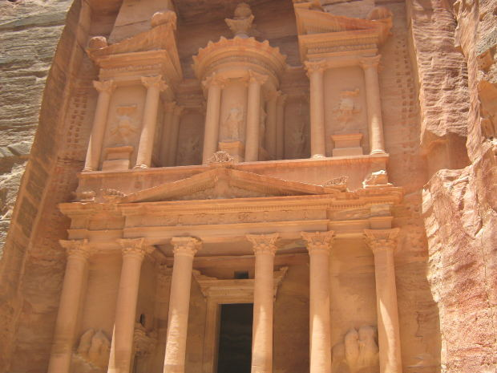
Image URI: http://mrg.bz/YQejBx

In the following dialogue, you will find verbs like إتْفَرَّجت and إتْكَلِّمْت. These are form 5 in MSA ، تَفَرّجَ تَكَلَّمَ. In CA, إ is added at the beginning of the verb (form 6 also). In addition, the vowel on the second root letter is kasra.
Examples: Form 5

MSA | CA
تَكَلَّمَ أحمد عن الدرس. | أحمد إتْكَلِّمْ عن الدرس.
تَعَلَّمَتْ الطالبة العربية. | الطالبة إتْعَلِّمِتْ عَرَبي.

As you can see, the ا is added in the verb form 5 in CA and kasra in the middle root letter. The root letters of تعلّم are ع. ل. م and for تكلّم are ك. ل. م.
On a different note, you might have noticed that in CA, the sentences are mostly nominal if the doer is mentioned.

After the following dialogue, some features of the weak verbs used in the dialogue are explained:
الكلمة والتعبير المساوي بالفصحى | المعنى بالإنجليزية | الكلمة والتعبير بالعامية
مَالُكَ | What’s wrong (with you)?  ( m.s.2) | مالَك؟
N/A | LM: “You look as if you need sleep.”  IM: “Your appearance needs sleep.” | شَكْلَك مِحْتاج نوم!
أمس | yesterday | إمبارح
الشغل أو العمل | work | الشُغل
من ….إلى | LM: “ from 7 o’clock in the morning to 10 o’clock  at night”  من … لِ | من الساعة سابعة الصُبح لعشرة بليل
اشتغل في أو أعمل في | I am working on | باشْتغل على
same | project | مَشْروع
ذهبتُ  note following the dialogue | I went | رُحْت
لأن | because | علشان
جوعان | hungry | جَعَّان
أخذتُ | I took | أَخَدْت/خَدت
رَجَعْتُ | I returned | رِجِعت
الساعة الثانية عشرة | 12 o’clock | الساعة إتْناشر
بالليل | at night | بليل
لِهذا | because of this | علشان كِده
same | tired | تَعْبان
اليَوْم | today | إنهارده
عَمِلْتُ | I made/I did | عَمَلْت
same | the market | السوق
إشْتَرَيْتُ | I bought | إشْتَرِيتْ
same | vegetables | خُضار
تَفَرَّجْتُ  Also different meanings including “spread out.” You can check its various meanings in MSA by clicking here. | I watched | إتفرّجت على
التلفازsame and | TV | التليفزيون
تَكَلّمت مع | I talked with | إتكلمت مع
صاحِبَتي | my female friend | صَاحْبِتي
نِمْتُ  See note following the dialogue | I slept | نِمْت
الساعة العاشِرة | ten o’clock | الساعة عشرة
نِصْف | half | نُص
same | LM: “God makes all your days sweet.”  IM: “May God make all your days pleasant.”  This is a compliment. | رَبّنا يجعَل أيامِك كّلها حلوة!
كمان replaced with أيْضاً | IM: “And yours as well, God willing.”  (one response to the previous compliment) | و أَيامَك إنتَ كمان إن شاء الله!

3. What did you do yesterday?

Listen to the conversation between two colleagues talking about what they did yesterday.

الحِوَار رَقم (3)

يُسرا: مالَك يا عَبْد الرَحْمَن؟ شَكْلَك مِحْتاج نوم!

عبد الرحمن: فِعلاً...إمبارح كان يوم طويل.

يسرا: عَملت إيه إمبارح؟

عبد الرحمن: كُنْت في الشُغل من الساعة سَبْعة الصُبح لعشرة بليل علشان باشْتغل على مَشْروع.

يسرا: ياه! عشرة بليل! وبعدين؟

عبد الرحمن: وبعدين رُحْت المطعم علشان كنت جَعَّان وأَخَدْت تاكسي ورِجِعت البيت حوالي الساعة إتْناشر بليل.

يسرا: علشان كِده أنتَ تَعْبان إنهارده.

عبد الرحمن: وإنتِ؟ عَمَلْتِ إيه إمبارح؟

يسرا: رُحت السوق وإشتريت خُضار وبعدين إتفرّجت على التليفزيون وإتكلمت مع صَاحْبِتي في التليفون ونِمْت حوالي الساعة عشرة و نُص.

عبد الرحمن: تمام...كان يومِك جميل...رَبِّنا يجعَل أيَّامِك كّلها حلوة!

يسرا: وأَيامَك إنتَ كمان إن شاء الله!

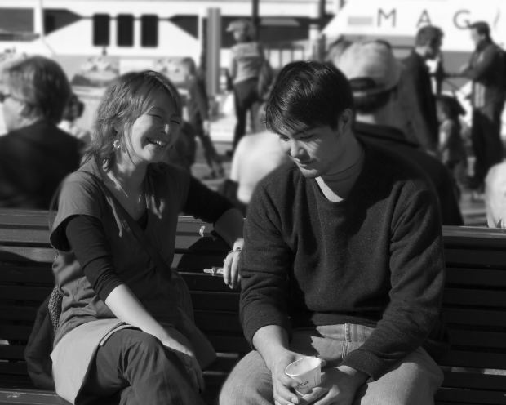
Image URI: http://mrg.bz/xcyuE4

Note:

In the previous dialogue, you have seen the weak verbs كنت ، رحت ، نمت. Let’s have a look at their conjugations:

Listen and read conjugations of some weak verbs in CA and MSA:

الضمائر  Pronouns  CA | المضارع في الفصحى  Present tense in MSA | الماضي في الفصحى  Past tense in MSA | الماضي في العامية  Past tense in CA (كان) | الماضي في العامية  Past tense in CA (راح) | الماضي في العامية  Past tense in CA (نام)
أنا | أكونُ | كُنْتُ | كُنتْ | رُحتْ | نِمتْ
إنتَ | تكونُ | كُنْتَ | كُنتْ | رُحت | نِمتْ
إنتِ | تكونينَ | كُنتِ | كُنتِ | رُحْتِ | نِمتِ
هو | يكونُ | كانَ | كانْ | راحْ | نَامْ
هي | تكونُ | كَانتْ | كانتْ | راحِتْ | نَامِتْ
إحنا | نكونُ | كُنّا | كُنّا | رُحْنا | نِمْنا

4. Practice: Complete the dialogue

This is an incomplete dialogue in the audio files. Practice speaking by completing the missing parts in this dialogue:

سارة: أهلا يا أحمد، عامل إيه؟

أحمد:_________________، ______________؟

سارة: الحمد لله. عملت إيه إمبارح؟

أحمد:____________________________

سارة: صحيح حتعمل إيه بكرة؟

أحمد:________________________

سارة: ياه، أنتَ مَشغول أوي. ممكن تيجي معايا الحفلة بكرة؟

أحمد: _____________________

سارة: تمام… على فكرة، لما حنروح الحفلة بكرة، ممكن نتعشّى. أنتَ كل يوم بتتعشّى إمتى؟

أحمد: ______________، _______؟

سارة: بتعشّى حوالى الساعة سابعة.

أحمد: ______________!

سارة: إن شاء الله، أشوفك بكرة.

C: Cultural insight: Phone conversations and communicating among different age groups in the Arab world

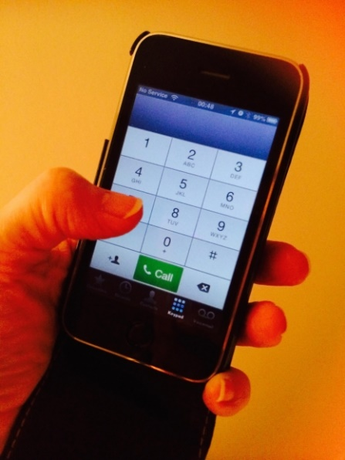
Image URI: http://mrg.bz/h4ds9X

Between young people in the Arab world, texting and social media like Facebook and applications like Whats App are commonly used instead of email to plan an outing or meeting. However, it is culturally inappropriate to only text an older person to set up an appointment. Calling an older person (friend or acquaintance) or a manager (in a work setting) is more appropriate for any kind of communication.
The concept of time is more fluid in the Arab culture where parties can extend for hours; showing up on time is not very common. This is why it is important to have a cell phone to check if the person is on the way to the meeting place or not, especially in big cities where traffic can be an issue.

Chapter 4

Contents:

A: Transitioning to CA: Negation in MSA vs CA
- Mini dialogues

B: Accepting and rejecting invitations:
- Accepting an invitation to lunch
- Politely rejecting an invitation to an outing
- Practice: Complete the dialogue

C: Cultural insights: Tips on dealing with culturally sensitive situations

A: Transitioning to CA: Negation in MSA vs CA

During your studies of MSA, you have probably noticed that the present tense is negated using لا, past tense using ما, and non-verbal sentences using ليس. There are more tools of negation like لم، لن، لا الناهية ، لا النافية. The good news is that in CA, the negation is much simpler with fewer tools to use.
One of the equivalents of ليس in the Egyptian dialect is مِش . In the Levant, it is ما, and in the Gulf, مو. You can add مش before non-verbs to negate, regardless of the gender.

Examples:

محمود مِش طويل.
Mahmoud is not tall.
سامية مِش طويلة.
Samiya is not tall.
الأولاد مش طِوال.
The boys are not tall.
الولدين مش طوال.
The two boys are not tall.

Note: The dual is used in CA but treated grammatically as plural. The word طوال is the broken plural for طويل. The dual pronouns like أنتما، هما are not used in CA.

.أحمد مش عايِز قهوة
I.M is: Ahmed does not want coffee.
L.M is: Ahmed is not the “wanter” of the coffee/is not wanting coffee.

.صفية مش عايزة قهوة
I.M: Safiyaa does not want coffee.
L.M: Safiyaa is not the “wanter” of the coffee/is not wanting coffee.

Note:
عايز‘ عايزة are not verbs in Arabic; they are active participles known as اسم فاعل. Read more here about the active participle in English. For more explanation and examples on the active participle in ECA, check this link.
To negate verbs, whether present or past, in ECA use ما before the verb and ش after it. For example, “We do not eat” is:
مَابْنَاكُلْش

Read and listen to following examples of present tense verbs and their negation:

المعنى باللغة الإنجليزية | الفعل المنفي في المضارع في جملة  Negated verb in a sentence | الفعل في المضارع | الضمائر
I do not understand French. | .مَابَفْهَمْش فَرَنْسَاوِي | بَافْهَم | أنا
You don’t read newspapers. | .مابْتقراش جَرَايِد | بِتِقْرا | إنتَ
Why don’t you (f.s.2) write in the papers? | مابْتكتبيش في الورق ليه؟ | بِتِكْتِبي | إنتِ
He doesn’t eat a lot. | .مابْيَاكُلش كتير | بِيَاكُل | هو
She doesn’t play in the sand. | .مابْتِلْعَبش في الَرَمْل | بِتِلْعَب | هي
We do not smoke shisha. (بنشرب also means “drink”) | .مابْنِشْرَبْش شِيشَة | بِنِشْرَب | إحنا
You (all) don’t cook in the morning. | مابتطبُخُوِش الصُبْح. | بِتُطْبُخُوا | إنتم

To negate the future, just formulate the future verb in ECA by adding ح before the present tense. The second step is using مش before the verb. For example:

مِش حنِلْعَب هنا.
We will not play here.

مش حَآكُل في المطعم ده!
I will not eat in this restaurant!

Note: In the future tense, the present-tense “ب” is deleted.

Mini-Dialogues: Examples of using negations and invitations

الكلمة والتعبير بالعامية | المعنى بالإنجليزية | الكلمة والتعبير المساوي في الفصحى
والله | LM: “by God”  IM: (emphasis) | same
نِروح | we go | نَذْهَب
حاجة سَاقْعة | LM: “something cold”  IM: “a cold drink”  (incl. soda pop) | شَراب ساقع أو  شراب بارد
أجري | I run | same
تيجي معايا | LM: “ come with me”  IM: “ join me” | تأتي معي
مَش فاضي | not free ( for a person)  not empty ( for an object) | N/A
بَس | but | (also used in CA)لكن
الأسبوع الجَاي | next (the coming) week | الأسبوع القَادِم
مَشْغُوُل | busy | same
ماعنديش وقت | I don’t have time. | ليس عندي وقت.
فُرْصَة تَانْيَة | LM: "second chance"  IM: "There will be another time to meet or do what was planned." | فرصة قَادِمَة
إمْتِحَان | exam | same
ماباكلش | ما+ باكل+ ش  I do not eat | لا آكُل
الهندي | Indian | same
الصيني | Chinese | same
عصير قصب | sugar cane juice | same
مابشربش | I do not drink | لا أشرب
عصير رُمَّان | pomegranate juice | same

سارة: تِحب ناكل أيس كريم يا بَاسِم؟

باسم: لا و الله / مِش عايز، بَس مُمْكِن نِروح الكُوفي شُوب و نِشَرب حاجة سَاقْعة.

__________________________________________________________

سامية: أنا عايزة أروح النادي علشان أجري في التراك، تيجي معايا؟

مايكل: والله أنا مَشْغول وماعنديش وقت، مُمكن فُرصة تانية؟
__________________________________________________________

نورا: يا مُصْطفى، عنْدَك وقت نِروح السينما يوم الجمعة؟

مُصْطفى: مِش فاضي، عَنْدي إمتحان بس ممكن نروح الأسبوع الجاي.

__________________________________________________________

نادية: يلا نروح المطعم الهندي!

عبد الله: أنا ماباكلش الأكل الهندي، بس ممكن نروح المطعم الصيني.

________________________________________________________

مُصْطفى: تحبي تيجي معايا نشرب عصير قصب؟

فرح: آه، حاجي مَعَاك، بس مابشربش عصير قصب، حاشرب عصير رُمّان.

_________________________________________________________________

B: Accepting and rejecting invitations:

1. Accepting an invitation to lunch
كلمات وتعبيرات مهمة:

الكلمة والتعبير بالعامية | المعنى بالإنجليزية | الكلمة والتعبير المساوي بالفصحى
تِحِبّي تِتْغَدّي؟  تِحِب تَتْغَدى؟ | Would you (f.s.2) like to have lunch?  (m.s.2) | هل تحبّين أن تأكلي الغداء؟  Note: MSA usually requires “أنْ” between two verbs (except in certain grammatical structures). In CA, you can put two verbs together without “ أنْ”.
معايا | With me ( regardless of gender) (ECA)  مَعِي (LCA) | مَعِي
بُكرة | tomorrow | غداً
حَوَالِي | approximately | حَوَالي
مُمْكِن | possible  (question or statement depending on intonation) | من المُمْكِن (أنْ)
يِنَاسْبِك؟ | LM: “Does it suit you?” (f.s.2)  IM: “Does it work for you?” | هل يُناسِبُكِ؟
والله إنتِ كُلّك ذُوُق (زوق). | LM: “By God, you are all thoughtfulness.”  (compliment)  IM: “By God (for emphasis), you are very thoughtful.”
إنتِ الّلي كلك ذوق. | LM: “You are the one who is thoughtful.”  (answer to the previous compliment) | الّلي is the relative pronoun equivalent to all of the MSA relative pronouns which include:  الذي، التي، الذين ...إلخ

الحِوَار رَقم (1)

هِشَام: أهلا يا مَرْيَم، عاملة إيه؟

مَرْيَم: الحمدلله وإنتَ؟

هشام: الحمدلله، تحبّي تِتْغَدي معايا بُكرة ومع سارة ومَحْمود؟

مريم: أَكِيد... بُكرة إمتى؟

هشام: حَوَالِي الساعة ثلاثة؟ يِنَاسْبِك؟

هدى:أكيد... مُمْكِن طَبْعاً، والله إنتَ كُلَّك ذُوُق (زوق).

هشام: إنتِ اللي كلك ذوق.

2. Politely rejecting an invitation to an outing

كلمات وتعبيرات مهمة:

الكلمة والتعبير بالعامية | المعنى بالإنجليزية | الكلمة والتعبير المساوي بالفصحى
حَنِطْلَع | we will go | سنذهب
تَعَالي (إنتِ) | Come! | same
مَعَاد | appointment | مِيعاد
ما في مُشْكلة | (there is) no problem | ليس هناك مشكلة
مَعْكُم | with you (plural)  (LCA) | same
مُسْتَحِيل | impossible | same

الحِوَار رَقم (2)

مايكل: نانسي، كيفك؟

نانسي: نحمد الله/ كيفك أنت؟

مايكل: منيح، صحيح، إحنا حنطلع على السينما بُكرة، إنتِ جاية طبعاً؟

نانسي: بُكرة؟ صَعْب، عندي معاد عند الدكتور.

مايكل: تَعَالِي على السينما بعد معاد الدكتور، ما في مُشْكلة.

نانسي: أحب أكون مَعْكُم بس والله مستحيل، مَرّة تَانْيَة إن شاء الله.

مايكل: أكيد إن شاء الله.

3. Practice: Complete the dialogue

This is an incomplete dialogue in the audio files. Practice speaking by completing the missing parts in this dialogue:

الكلمة والتعبير بالعامية | المعنى بالإنجليزية | الكلمة والتعبير المساوي بالفصحى
نروح | we go ( present tense) | نذهب
مَافِيشْ مُشْكِلة | (there is) no problem (ECA) | ليس هناك مشكلة

صفية: تِحِبْ نروح السينما؟

ياسين: _________________

صفية: ممكن الساعة خمسة؟

ياسين: ____________

صفية: ممكن الساعة ستة، مَافِيشْ مُشْكِلة!

ياسين: _____________

صفية: إن شاء الله، مع السلامة!

C: Cultural insights: Tips on dealing with culturally sensitive situations

Image URI: http://mrg.bz/W7M8Hk

Communicating between people of different cultures, speaking in their second or third language is exciting but presents frequent chances for misunderstanding. It is important to keep an open mind, especially if you encounter a sensitive or uncomfortable situation in an Arab country. For example, if you are busy and you are invited to lunch or an outing, but your friend cannot accept your “No,” what would you do so as not to offend your friend and still not attend the outing? You can explain the reason and offer to make it up another time. Some of the expressions used in these situations are listed in dialogue 2 and the mini-dialogues in this chapter.
Consider also questions that are culturally accepted in the Arab world in the first encounter but not in the US (for example, age, religion, marital status, etc). If you do not feel comfortable answering them, you can politely refuse by saying that in your culture, it is considered personal. Explaining why you cannot answer could also be a learning opportunity for the other person. Speaking a second language is an ongoing learning process that includes learning the target culture and will always provide perspectives on new ideas and ways of life.
Glossary

المعنى بالإنجليزية | الكلمة والتعبير بالعامية
a cold drink | حاجة سَاقْعة
12 o’clock | الساعة إتْناشر
a little bit | شوّية
approximately | حَوَالِي
Are you sick? | إنتِ عَيّانة؟
at night | باليل/ بليل
at the cafeteria | في الكافيتريا
beautiful | جَمِيلة
because | علشان
because of this | علشان كِده
boss/ director | المُدير
busy | مَشْغُوُل
but | بس
Chinese | الصيني
Come! (f.s.2) | تَعَالي (إنتِ)
Come! (m.s.2) | تَعَالى (إنتِ)
LM: “Come with me” | تيجي معايا
delicious/ OK/ kind | طَيّب
discussions | مُنَاقَشَات
dish/ plate | طَبق
driver | سوّاق
Does it work for you? (f.s.2) | يِنَاسْبِك؟
English literature | الأدب الإنجليزي
enter (m.s.2) | خُشْ (إنتَ)
exam | إمْتِحَان
wrote (f.s.2) | كَتَبْتِ
fights and arguments | خِناقات
filled | مَليان
from 7 o’clock in the morning to 10 o’clock at night | من الساعة سابعة الصُبح لعشرة بليل
God makes your days all sweet | ربنا يجعَل أيامِك كّلها حلوة!
good | مِنيحْ
good morning ( response) | صباح النُور
good morning | صَبَاحْ الخِيرْ
half | نُص
he ate | أَكَلْ
his exams | إمْتِحَانَاتُه
homework | الوَاجِبات
how | كِيفْ
How are you? ( ECA) | أخبارَكْ إيه؟
How are you? male recipient (ECA) | إزَيَّك؟
How are you? male recipient (LCA) | كِيفَك؟
how much/many | كَام
hungry | جَعَّان
I am working on | باشْتغل على
I don’t have time | ماعنديش وقت
I eat breakfast | بافْطر
I eat dinner | باكل العَشا
I go | بارُوح
I made/I did | عَمَلْت
I returned | رِجِعت
I run | أجري
I sleep | بانام
I slept | نِمْت
I study | بازاكِرْ
I take | آخُد
I talked with | إتكلمت مع
I took | أَخَدْت/ خدت
I understood | فِهِمْتْ
I wake up | باصحى
I want/would like (ECA) | بدّي
I want/would like (LCA) | (عايز- عايزة)
I watched | إتفرّجت على
I went | رُحْت
I will buy | حَاشْتِرِي
I will give you (f.s.2) | حادِّيكي
I will go | حَارُوح
I will go to the doctor | حَارُوح لِلْدُكْتُور
I will see you | حشوفك
I will take from you | آخُد مِنّك
If you please (female recipient) | لَوْ سَمَحْتِ (إنتِ)
If you please (female recipient) | مِن فَضْلِكْ (إنتِ)
If you please (male recipient) | لَوْ سَمَحْت (إنتَ)
If you please (male recipient) | مِن فَضْلَكْ (إنتَ)
IM: “where?” | على فين؟
IM: “going” | رايح
IM: “I don’t have the time.” | ماعنديش وقت
IM: “60 Egyptian pounds (cost)” | بسِتّين جنيه
IM: ‘better than before.” | أحسن من الأول
IM: “travel safely.” | بالسلامة
IM: “You have” | عَنْدَكْ (إنتَ)
IM: “You have” | عَنْدِكْ (إنتَ)
impossible | مُسْتَحِيل
milk | حَلِيب
Indian | الهندي
correct or by the way (depending on the context) | صَحيح
possible | مُمْكِن
Lectures  (singular محاضرة) | المحاضرات
left | شِمَال
left then right | شِمَال في يمِين
LM: "another chance"  IM: "There will be another time to meet or do what was planned." | فُرْصَة تَانْيَة
LM: “by God”  IM: For emphasis | والله
LM: “something cold”  IM: “a cold drink”  (incl. soda pop) | حاجة سَاقْعة
LM: “all the time” | على طول
IM: “There will be another time to meet or do what was planned to be done but did not.” | فُرْصَة تَانْيَة
LM: “at me is cold”  IM: “I have cold.” | عَنْدي بَرْد
LM: “by God” | واللهِ
IM: “by God, you are very thoughtful.”  (compliment) | والله إنتِ كُلّك ذُوُق (زوق)
IM: “the receipt or bill” | الشِيك
LM: “You are the one who is thoughtful” | إنتِ الّلي كلك ذوق
entered (m.s.2) | دَخَلْتْ
May God be with you | رَبِّنا معاكي
May you feel better | سَلامْتِك
medicine | دَوَا
meetings | إجْتِمَاعَات
meter | عداد
money | فِلُوس
my children | أوْلادي
my female friend | صَاحْبِتي
my loved/dear one | حَبِيبْتِي
next week | الأسبوع الجَاي
noise | دَوشة
not free ( for a person)  not empty ( for an object) | مَش فاضي
OK/alright | طَيَّب
One of its meanings is "class” in a train. | دَرَجَة
or | ولّا
passed/succeeded | نِجِح
Peace be upon you | السّلامْ عَليكمْ
pharmacy | الصَيّدَلِيّة
please/ go ahead/ here (female recipient) | إتْفَضَّلي
please/ go ahead/ here (male recipient) | إتْفَضَّل
pomegranate juice | عصير رُمَّان
project | مَشْروع
research | بَحث
responsible for | مَسْؤول عَن
return | أرْجَع
return ticket; | رايح - جَيّ
rice | رُز
she played | لِعبتْ
something (ECA) | حَاجَة
something (LCA) | إشِي
square | مِيدَان
stuffed leaves (LCA) | مَلْفوف
sugar cane juice | عصير قصب
surely | أكيد
taxi | التاكسي
ten o’clock | الساعة عشرة
the club | النادي
(the) morning | الصبح
(there is) no problem (LCA) | ما في مُشْكلة
(there is) no problem (ECA) | مَافِيشْ مُشْكِلة
the menu | المِنْيو
the novel | الرُوَاية
then | وبعدين
There is no trouble | مافيش تَعب ولا حاجة
There is homework which I missed | فيه واجب فَاتْنِي
this | ديه
Thursday | يوم الخميس
ticket | تَذْكَرَة
tired | تَعْبان
today | إنَّهَارْده
tomorrow | بُكرة
train | قَطْر
TV | التليفزيون
vegetables | خُضار
vitamin C | فيتامِين سِي
we drank | شِرِبْنَا
would you like? | تحبّي … ..( إنتِ)؟
Where are you from a long time? | أنتَ فين من زمان؟
we go ( present tense) | نروح
we will go | حَنِطْلَع
we will read | حنقرا
we will write/compose | حَنِكْتِب
welcome for a female recipient (LCA) | أهلا و سهلا فِيكِي
welcome for a male recipient (ECA) | أهلا و سهلا بِيكْ
What? | إيه - شو ؟
What is the cost of…? | بِكَام؟
What is wrong, Nadia? | إيه يا نادية؟
what is wrong? | مالَك؟
when? | إمْتِى؟
where? (ECA) | فِيِن؟
where? (LCA) | وِيِنْ؟
which? | أيّْ؟
who? | مِيِن؟
LM: “Whoever sees you will live!”  (compliment) | عاش مِن شافِك  (إنتِ)
With me (regardless of the gender) | معايا
with you (plural) | مَعْكُم
work | الشُغل
Would you (f.s.2) to eat lunch?  Would you (m.s.2) to eat lunch? | تِحِبّي تِتْغَدي  تِحِب تَتْغَدى
yesterday | إمبارح
you (all) cooked | طَبَخْتُو
You are forgetting your friends! | لدَرجة إنك تنسى أصحابك
You (m.s.2) look as if you need sleep | شَكْلَك مِحْتاج نوم!
your day ( f.s.2) | يُومَك
your question (male recipient) | سُؤالَك
your question (female recipient) | سؤالِك
ما+ باكل+ ش  I do not eat | ماباكلش
ما+ بشرب+ ش  I do not drink | مابشربش

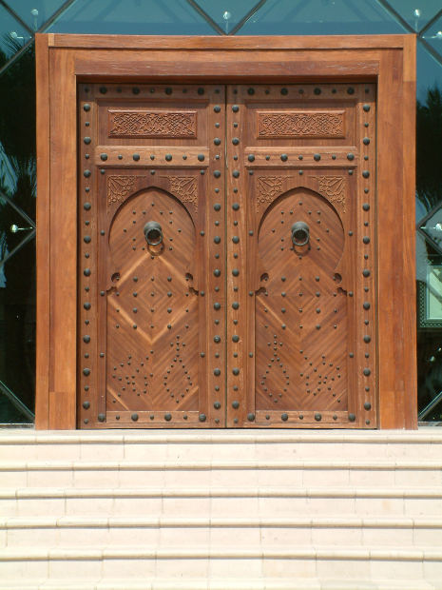
Image URI: http://mrg.bz/NFwrcZ

تمت بفضل الله

Abbas Al-Tonsi and Laila Al-Sawi, An Intensive Course in Egyptian Colloquial Arabic, Part 1 (American University in Cairo 1986) 8
Al-Tonsi,8

